Original Research Article
Characterization of interspecific F₁ hybrids of okra exploiting Abelmoschus caillei (A. Chev) Stevels

.
ABSTRACT

Wild okra germplasm offers a rich source for breeding programme focused on enhancing biotic and abiotic stress resistance, yield, and quality. Yellow Vein Mosaic Disease (YVMD) which affects quality and yield, is a major constraint in okra cultivation worldwide. Abelmoschus caillei (A.Chev.) Stevels is a promising source of resistance to YVMD which could be effectively utilized for interogressing resistance to cultivated okra Abelmoschus esculentus (L.) Moench. The present study envisaged to develop and characterize interspecific hybrids in okra by crossing the A. caillei genotype Susthira, directly and reciprocally with three A. esculentus genotypes that are susceptible to YVMD, viz., the green fruited type – NBPGR (National Bureau of Plant Genetic Resources) accession no. EC305635, the white fruited type – Anakomban and the red fruited type –Aruna. Agro-morphological characterization of the interspecific hybrids and their parents was carried out. The study revealed that the A. caillei and A. esculentus genotypes were cross compatible as all the crosses produced successful fruit and seed set. The interspecific hybrids showcased normal growth, vigour exceeding that of both parents and a combination of parental traits. Significant variation was observed among hybrids and their parents in terms of the quantitative characteristics studied indicating the potential for genetic improvement. Notably the yield-related traits of the F₁ hybrids, T5, T4, T3 and T6 were superior to those of all the other hybrids and parental lines, confirming the hypothesis of luxuriance in these interspecific hybrids. The present study lays the foundation for utilizing A. caillei for YVMD resistance breeding in okra and exploring promising hybrid combinations for future breeding programme.

Keywords: Abelmoschus caillei, Wild species, Interspecific hybrids characterization, YVMD resistance breeding
1. INTRODUCTION

Abelmoschus esculentus L. (Moench), which belongs to the Malvaceae family and is commonly referred to as okra, bhindi, or ladies' finger is an annual herbaceous plant. Okra is highly esteemed for its rich nutrient content and is extensively cultivated across tropical, subtropical, and warm temperate climates, spanning Africa, Asia, southern Europe, and America. Okra is a hardy plant, that is rich in dietary fibres, vitamins, potassium, calcium, and unsaturated fatty acids such as linolenic and oleic acids. Additionally, it contains bioactive chemicals, further emphasizing its nutritional importance (Moyin-Jesu, 2007). Although okra is hardy in nature, due to biotic and abiotic stresses considerable yield losses have been reported from various growing regions. Among the various challenges it faces, Yellow Vein Mosaic Virus (YVMV) transmitted by white fly (Bemisia tabaci) stands out as particularly detrimental, impacting both the growth and yield of the crop (Sastry & Singh, 1974). The wild relatives of crop plants serve as vital repositories of economically significant genes. Notably, they have been employed in breeding programme focused on enhancing resistance to diseases. This approach circumvents the need for chemical interventions, which not only increase production costs but also pose risks to human health and the ecosystem. Given the recurrent failure of resistance mechanisms and the absence of a consistent resistant strain within cultivated varieties, interspecific hybridization has emerged as a dependable strategy for establishing enduring resistance against this disease. Various wild species such as Abelmoschus caillei (A.Chev.) Stevels (Kousalya, 2005), Abelmoschus manihot (L.) Medik., Abelmoschus angulosus Wall. ex-Wight & Arn., Abelmoschus tetraphyllus (Roxb. ex Hornem.) Wall. and Abelmoschus crinitus Wall. have been found to be resistant to yellow vein mosaic disease (Singh et al., 2006). Although a number of wild relatives of A. esculentus have been identified as potential genetic sources of resistance to YVMD, their utilization in okra breeding is often limited. Various screening trials have revealed that A. caillei is immune to yellow vein mosaic disease (Prabu et al., 2007; Mogili et al., 2013; Seth et al., 2016). However commercial lines or breeding materials resistant to YVMD derived from interspecific crosses between A. caillei and A. esculentus have not been reported thus far. The resistance genes in A. caillei could be exploited for developing durable resistance against YVMD in A. esculentus. As a preliminary step, it is important to develop and characterize interspecific F₁ hybrids along with their parents. Characterization is essential for enabling genetic improvement, as it is the foundational step in any crop improvement programme. Accordingly, the, present study was undertaken to develop six interspecific F₁ hybrids in which A. caillei was used directly and reciprocally with the three genotypes representing 3 different fruit colour backgrounds that are susceptible to YVMD, viz., the green fruited type – (NBPGR accession no. EC305635), the white fruited type – (Anakomban) and the red fruited type – (Aruna). Morpho-agronomic characterization of the interspecific F₁ hybrids was also carried out on the basis of quantitative and qualitative characteristics.

2. material and methods

2.1 Plant material and experimental location

The study was conducted at the experimental field of the Department of Vegetable Science, College of Agriculture Vellanikkara, Thrissur, Kerala, from 2022-2024. The Abelmoschus caillei variety ‘Susthira’ is used as a male parent as well as a female parent for crossing with A. esculentus genotypes viz., NBPGR accession no. EC305635, Anakomban and Aruna. Hand emasculation was carried out on fully developed and mature buds of the female parent in the evening, prior to the day of pollination. Following emasculation, the buds were enclosed with perforated butter paper covers to prevent contamination from foreign pollen. Similarly, mature buds on the pollen parent were also covered to collect uncontaminated pollen for pollination. The pollen from the male parent was collected and smeared on the stigmatic surface of emasculated female flowers on the next morning using a brush. The pollinated flowers were properly labelled and tagged and again bagged with butter paper cover. Seeds of the interspecific F₁ hybrids were collected from the crossed fruits after full maturation.

2.2 Agromorphological characterization

The six interspecific hybrids along with their parents were sown in May 2023 and in the second season October 2023 with the statistical design CRD (completely randomized design). There were ten treatments with four no. of replication (Table 1). Morpho-agronomic characterization of F₁ hybrids and parents was carried out. Observations were recorded for qualitative characteristics viz., plant growth habit, branching habit, leaf lobing, colour between veins, colour of leaf vein, serration of leaf margin, petal colour, nature of calyx, immature fruit colour, mature fruit colour, fruit pubescence, fruit shape of apex, and fruit: constriction of basal part. The quantitative characteristics that have been documented include; plant height (cm), internodal length (cm), petiole length (cm), days to flower, days to first harvest, first fruiting node, length of fruit (cm), girth of fruit (cm), locules per pod, number of ridges per pod, number of fruits per plant, number of harvest, crop duration and yield per plant (kg) (Srivastava et al., 2001; DUS test guidelines, 2009).

2.3 Statistical analysis

The data gathered over two seasons were averaged and subjected to analysis of variance (ANOVA) via the software “GRAPES” version 1.1.0 (Gopinath et al., 2020) which was provided by Kerala Agricultural University. The treatment means were compared through Duncan's multiple range test (DMRT) to assess significant differences between interspecific F₁ hybrids and their parental lines.

Table 1: Details of the treatments

Treatment | Crosses / genotype
T1 | Anakomban X Susthira
T2 | Susthira X Anakomban
T3 | EC305635 X Susthira
T4 | Susthira X EC305635
T5 | Aruna X Susthira
T6 | Susthira X Aruna
 | Anakomban (A. esculentus)
 | EC 305635 (A. esculentus)
 | Aruna (A. esculentus)
 | Susthira (A. caillei)

3. RESULTS

A. esculentus genotypes and A. caillei variety Susthira were crossed directly (A. esculentus × A. caillei) and reciprocally (A. caillei × A. esculentus). All the crosses resulted in successful fruit set and seed set. The results of the qualitative and quantitative analyses of the parents and hybrids are presented in the Tables 2 and 3 respectively.

3.1 Qualitative analysis of interspecific F₁ hybrids and their parents

All interspecific F₁ hybrids and their parents were erectly growing and branched. The interspecific F₁ hybrids were highly vigorous with erect growing nature and profuse branching compared to either parental species. Leaf characters viz., the colour of the leaf vein and serration of the leaf margin were found to be intermediate in the hybrids resembling those of both parental species (Table 2). Whereas in case leaf lobing, hybrids tend to be similar to the A. esculentus parent. No differences in colour between veins were observed among T1 and T2 and their parents. However, T3 more closely resembled its cultivated parent for this trait, whereas T4, T5, and T6 resembled the wild parent (Fig 1).

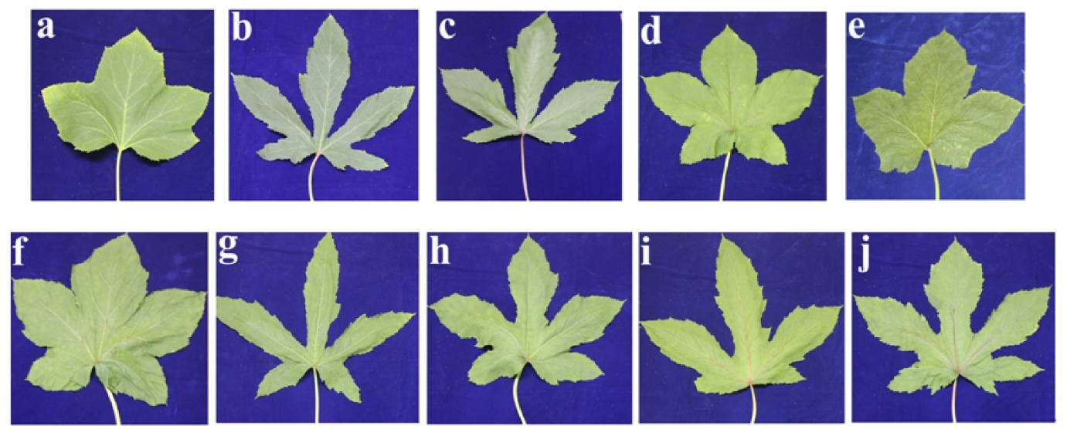
Fig.1 Leaf characteristics of interspecific F₁ hybrids and their parents

Leaf of (a) Anakomban (b) EC305635 (c) Aruna (d) Susthira (A. caillei) (e) T1 (f) T2 (g) T3 (h) T4 (i) T5 (j) T6

The flower color and petal base color were consistent across all the genotypes, with a lanceolate-shaped epicalyx observed in most, except for Anakomban, where the epicalyx was linear. The interspecific hybrid flowers were larger and closely resembled those of the wild parent whereas medium sized flowers were found in the parents, EC 305635 and Aruna
(Fig 2).

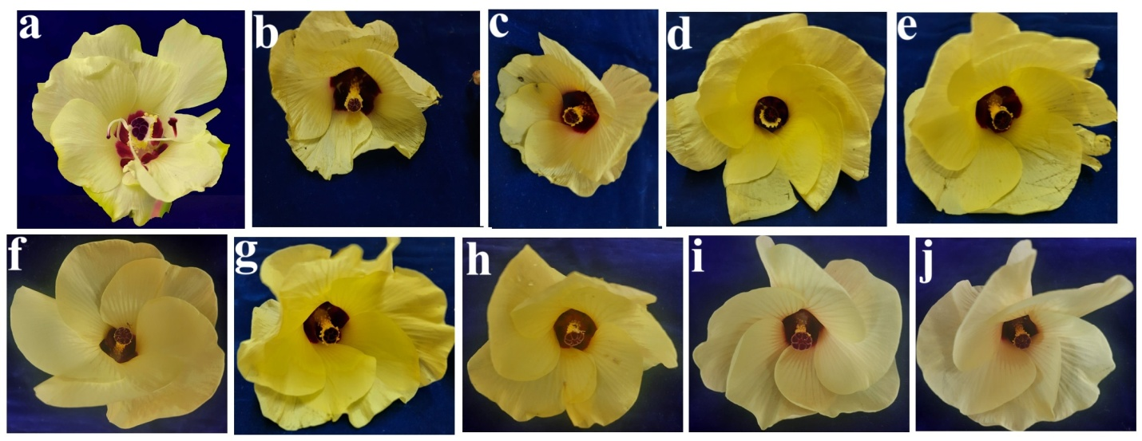
Fig. 2 Floral characteristics of interspecific F₁ hybrids and their parents

Flower of: (a) Anakomban (b) EC305635 (c) Aruna (d) Susthira (A. caillei) (e) T1 (f) T2 (g) T3 (h) T4 (i) T5 (j) T6

Regarding fruit characteristics, both the immature and mature fruit colors of the hybrids predominantly resembled those of the A. esculentus parent. The fruits of T1 and T2 were yellowish green in colour in both the immature and mature phases, similar to their parent Anakomban. Conversely T3 and T4 produced green immature fruits similar to those of their parents but their mature fruit colour transitioned to yellowish green. In contrast the immature and mature fruits of T5 and T6 exhibited a green color with a red tinge, representing an intermediate trait between their parental genotypes. The fruit apex shape was narrow in all the hybrids and parents except for the wild parent Susthira, which was acute (Fig 3). The presence of weak constriction at the basal part of the fruits was observed in the T1, T2, T5 and T6 hybrids, whereas it was absent in the T3 and T4 hybrids.
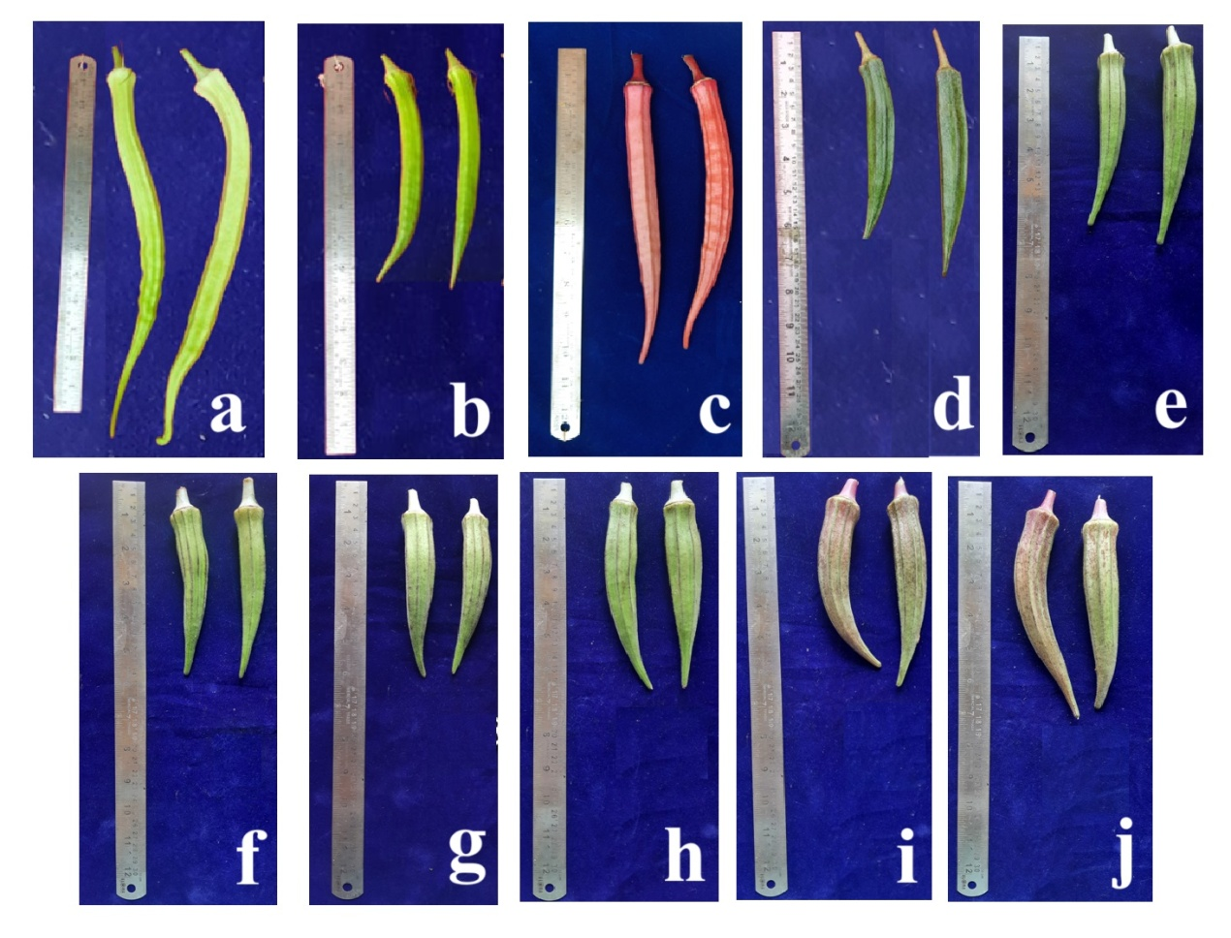
Fig. 3 Fruit characteristics of interspecific F₁ hybrids and their parents

Fruit of (a) Anakomban (b) EC305635 (c) Aruna (d) Susthira (A. caillei) (e) T1 (f) T2 (g) T3 (h) T4 (i) T5 (j) T6

Table:2 Qualitative characters of okra genotypes and hybrids
Characters |  | T1 | T2 | T3 | T4 | T5 | T6 | Anakomban | EC 305635 | Aruna | Susthira
Plant characters | Growth habit | Erect | Erect | Erect | Erect | Erect | Erect | Erect | Erect | Erect | Erect
Plant characters | Branching habit | Branched | Branched | Branched | Branched | Branched | Branched | Branched | Branched | Branched | Branched
Leaf character | Leaf lobing | Narrowly lobed | Narrowly lobed | Deeply lobed | Deeply lobed | Deeply lobed | Deeply lobed | Narrowly lobed | Deeply lobed | Deeply lobed | Narrowly lobed
Leaf character | Colour between veins | Green | Green | Dark green | Green | Green | Green | Green | Dark green | Dark green | Green
Leaf character | Colour of leaf vein | Light green with purple tinge | Light green with purple tinge | Light green with purple tinge | Light green with purple tinge | Purple green | Purple | Light green | Light green with purple tinge | Red purple | green with purple tinge
Leaf character | Serration of leaf margin | Dentate serrate | Dentate serrate | Dentate serrate | Dentate serrate | Dentate serrate | Dentate serrate | Double serrate | Dentate serrate | Dentate | Serrate
Flower character | Petal colour | Yellow | Yellow | Yellow | Yellow | Yellow | Yellow | Yellow | Yellow | Yellow | Yellow
Flower character | Size of flower | Large | Large | Large | Large | Large | Large | Large | Medium | Medium | Large
Flower character | Colour of petal base | Purple throat | Purple throat | Purple throat | Purple throat | Purple throat | Purple throat | Purple throat | Purple throat | Purple throat | Purple throat
Flower character | Shape of epicalyx | Lanceolate | Lanceolate | Lanceolate | Lanceolate | Lanceolate | Lanceolate | Linear | Lanceolate | Lanceolate | Lanceolate
Fruit character | Immature fruit colour | Yellowish green | Yellowish green | Green | Green | Green with red tinge | Green with red tinge | Yellowish green | Green | Red | Green
Fruit character | Mature fruit colour | Yellowish green | Yellowish green | Yellowish green | Yellowish green | Green with red tinge | Green with red tinge | Yellowish green | Green | Red | Green
Fruit character | Fruit pubescens | Downy | Downy | Downy | Downy | Downy | Downy | Downy | Downy | Downy | Downy
Fruit character | Fruit shape of apex | Narrow | Narrow | Narrow | Narrow | Narrow | Narrow | Narrow | Narrow | Narrow | Acute
Fruit character | Fruit constriction of basal part | Weak | Weak | Absent | Absent | Weak | Weak | Weak | Absent | Weak | Absent
Table:3 Quantitative characters of okra genotypes and hybrids

Characters | T1 | T2 | T3 | T4 | T5 | T6 | Anakomban | EC305 635 | Aruna | Susthira
Days to flower | 44.85e | 56.4 ª | 52.5 ^{c} | 53.85 ^{b} | 45.3 e | 44.4 ^{ef} | 48.4 ^{d} | 43.04 ^{f} | 45.44 e | 56.8 ª
Plant height (cm) | 392.94 ^{bc} | 416.10 ^{ab} | 424.89 ª | 414.79^{ab} | 358.10 ^{d} | 382.37 ^{c} | 179.85 ^{g} | 189.31^{g} | 228.52 ^{f} | 266.88 e
Internodal length (cm) | 6.31ª | 6.45 ª | 6.49 ª | 6.48 ª | 6.40 ª | 6.33 ª | 4.75 ^{c} | 5.92 ^{ab} | 6.50 ª | 5.44 ^{b}
Petiole length (cm) | 53.13ª | 50.8^{b} | 45.55^{d} | 42.24e | 34.82 ^{g} | 47.07 ^{b} | 39.62 ^{f} | 32.74 ^{h} | 35.83 ^{g} | 39.26 ^{f}
Days to first harvest | 55.04 ^{d} | 63.46 ª | 58.79 ^{c} | 60.63 ^{b} | 51.73 e | 51.60 e | 58.46 ^{c} | 49.02 ^{f} | 51.85 e | 62.56 ª
First fruiting node | 9.54 ^{cd} | 9.79 ^{bc} | 9.06 de | 10.73 ª | 10.21 ^{ab} | 8.98 de | 8.25 ^{fg} | 7.65 ^{gh} | 8.67 ^{ef} | 7.58 ^{h}
Length of fruit (cm) | 18.06 ^{d} | 16.3 ^{fg} | 15.24 ^{g} | 16.62 ^{ef} | 16.65 ^{ef} | 16.89 ^{def} | 30.18 ª | 21.97 ^{c} | 26.79 ^{b} | 17.77 de
Girth of fruit (cm) | 7.55 ^{bc} | 7.19 ^{cd} | 6.93 ^{d} | 7.59 ^{bc} | 7.66 ^{bc} | 8.58 ª | 6.75 ^{d} | 5.92 e | 6.01 e | 7.82 ^{b}
Average fruit weight (g) | 21.29 ^{c} | 17.88 de | 17.36 e | 19.36 ^{cde} | 20.17 ^{cd} | 19.46 ^{cde} | 27.8 ª | 20.76 ^{c} | 24.84 ^{b} | 21.84 ^{c}
Number of locules per pod | 6.00 ^{b} | 6.00 ^{b} | 6.04 ^{b} | 6.89 ª | 6.89 ª | 6.65 ª | 6.00 ^{b} | 5.00 ^{c} | 6.69 ª | 5.31 ^{c}
Number of ridges per pod | 6.25 ^{bc} | 6.00 ^{c} | 6.73 ^{ab} | 6.96 ª | 7.10 ª | 6.92 ª | 6.00 ^{c} | 5.00 ^{d} | 6.75 ^{ab} | 5.37 ^{d}
Number of fruits per plant | 33.92 ^{c} | 32.06 ^{c} | 52.81 ª | 51.17 ^{ab} | 49.86 ^{ab} | 48.98 ^{b} | 13.56 ^{f} | 26.63 ^{d} | 19.42 e | 24.50 ^{d}
Number of harvests | 14.67 ^{c} | 14.15 ^{c} | 17.35 ª | 17.33 ª | 16.15 ^{b} | 16.15 ^{b} | 9.46 ^{f} | 12.89 ^{d} | 11.50 e | 15.27 ^{bc}
Crop duration | 195.39 ^{c} | 195.00 ^{c} | 208.31 ª | 207.79 ª | 205.21 ^{ab} | 200.06 ^{bc} | 98.71 ^{f} | 113.50 e | 113.96 e | 162.45 ^{d}
Yield per plant (kg) | 0.76 ^{c} | 0.66 ^{d} | 0.97 ^{b} | 1.08 ª | 1.11 ª | 1.04 ^{ab} | 0.36 ^{g} | 0.57 e | 0.45 ^{f} | 0.52 ^{ef}

*Data show the means followed by different letters differ significantly at α= 0.05%, level of significance according to DMRT

3.2 Quantitative analysis of interspecific F₁ hybrids and their parents

Significant variation was observed between the hybrids and parents for the quantitative traits studied, indicating substantial genetic diversity that can be utilized for further selection and genetic improvement.
The days to first flowering and first fruiting node are the traits that contribute to earliness in okra. The A. esculentus genotype, EC305635 was the earliest to flower in 43.04 days, while A. caillei var. Susthira (56.8 days) and the interspecific F₁ hybrid, T2 (56.4 days) were late to flower (Table 3). All other interspecific F₁ hybrids were early when compared to their wild parent. Plant height showed significant variation among the treatments. Interspecific hybrids T3 (424.89 cm), T2 (416.10 cm) recorded maximum plant height, whereas the parents EC305635 (189.31 cm) and Anakomban (179.85 cm) were the shortest. All the interspecific hybrids outweighed their parents in terms of plant height indicating luxuriance. Compared with their parents, the hybrids presented longer internodes with the exception of Aruna, which had longer internodes as a parent. The least intermodal length was recorded by Anakomban, at 4.75 cm. The petiole length showed considerable variation among the genotypes, ranging from a maximum of 53.13 cm in T1 to a minimum of 32.74 cm in EC 305635, where hybrids expressed higher values compared to the parents.
The first fruiting node varied from 7.57 to 10.73 and the lowest fruit setting node was observed in A. caillei var. susthira (7.57) which was on par with EC 305635 (7.65). The highest value for this trait was observed in the hybrids T4 (10.73) and T5 (10.21) which was significantly higher than both their parents. A similar trend was observed with the remaining hybrids. Among all the genotypes, the parent EC305635 took least number of days (49.02 days) for first harvest. In contrast, hybrids T2 (62.56 days), T4 (60.63 days), and T3 (58.79 days) required more days for the first harvest and resembled their wild parent Susthira in terms of this trait. On the other hand, the remaining hybrids were more inclined towards their A. esculentus parent.
The interspecific hybrids exhibited fruit length and girth comparable to those of A. caillei var. Susthira. While the fruit length of the hybrids was generally shorter than that of their respective A.esculentus parent, an inverse pattern was observed for fruit girth, with the hybrids displaying greater girth. Fruit length varied from 15.24 cm (T3) to 30.18 cm (Anakomban). The highest value for fruit girth was observed in T6 (8.58cm), while EC 305635 (5.92 cm) recorded the lowest value for the trait, which was on par with Aruna (6.01 cm). Data on yield per plant and the number of fruits per plant revealed significantly higher values in F₁ hybrids compared to their parents. The F₁ hybrids, specifically T5 (1.11 kg/plant), T4 (1.08 kg/plant), and T6 (1.04 kg/plant) exhibited significantly higher yield per plant among all the treatments, while the maximum number of fruits per plant was recorded in T3 (52.81), T4 (51.17), and T5 (49.86). Conversely, Anakomban recorded the lowest values for both yield per plant (0.36 kg) and the number of fruits per plant (13.56). The average fruit weight of the hybrids was comparable to that of the wild parent and lower than that of the A. esculentus parent. Overall, the interspecific F₁ hybrids, T5, T4, T3 and T6 exhibited superior performance in yield-related traits, compared to both other hybrids and parental lines, revealing their potential as promising genotypes for future breeding programme.
Compared with their parents, the direct and reciprocal cross between Susthira and EC305635 (T3 and T4) exhibited a significantly higher number of ridges per fruit and more locules per pod. However, other hybrids were more inclined towards their respective A. esculentus parents for these attributes. The total number of fruits harvested from a plant is positively correlated with its crop duration. All the interspecific hybrids displayed high vigor and a perennial growth habit similar to that of A. caillei var. Susthira. The T3 (208.31 days), T4 (207.79 days) and T5 (205.21 days) hybrids presented longer crop durations, resulting in a greater number of harvests.

4. DISCUSSION

The present study demonstrated that the three Abelmoschus esculentus genotypes and the Abelmoschus caillei variety Susthira are cross-compatible, as they successfully produced fruit and seed sets in both direct and reciprocal crosses. This is in consonance with the findings of Prabu & Warade (2013).
Genetic variability, as evident from morpho-agronomic characterization, serves as the fundamental resource for any breeding program, enabling effective selection and the development of superior genotypes (Osawaru et al., 2013; Ogwu et al., 2018). The morpho-agronomical characterization of the interspecific F₁ hybrids revealed substantial amounts of variability in the evaluated traits, which can be strategically exploited through selection to develop YVMD resistant recombinants in advanced generations.
The interspecific F₁ hybrids exhibited normal growth, flowering and fruit development and they were more vigorous and expressed characteristics derived from both parental lines. The erect plant architecture and profuse branching of F₁ hybrids compared to their parents are beneficial as it ensures optimal and uniform exposure of vegetative parts for light interception which in turn contributes to higher yield (Sekyere et al., 2011). The leaf characteristics of the hybrids were found to be intermediate to those of both parents, while their flowers were larger and possess strong resemblance to those of the wild parent (Sandeep et al., 2022). However, fruit traits, such as immature and mature fruit colour, shape of fruit apex, and basal constriction tend to align more closely with those of the A. esculentus parent indicating that cultivated okra possesses dominance for these characters. Similar observations were reported by Kaur et al. (2023), who noted that interspecific F₁ hybrid derived from a cross between Punjab Padmini and A. moschatus exhibited qualitative traits closely aligned with those of A. esculentus cv. Punjab Padmini. Fruit color and quality can be enhanced through repeated backcrossing with cultivated okra, combined with the selection of desired traits during the breeding process (Kumar et al., 2016; Das et al., 2022; Kiran et al., 2024). Qualitative characteristics are crucial factors for identifying specific plant varieties as they are mainly controlled by genetic factors and have minimal effects from environmental conditions (Sinha & Mishra, 2013).
Okra breeding programme should be focused on traits such as medium to tall plant height, short internodes, a lower position of the first flowering and fruiting node, a high number of fruiting nodes on the main stem, early flowering, and early maturity to boost productivity. For improved fruit quality and appearance, desirable traits include being medium to short, green, smooth (downy), five-ridged, angular, and straight fruits with no grooves and a blunt tip. Additionally, tolerance to biotic stresses such as pod borer and YVMV is essential for stable and sustainable production (Reddy et al., 2012).
Earliness in flowering is a desirable trait in okra as it offers early picking and prolongs the fruit bearing period (Sandeep et al., 2022). While the wild relative A. caillei var. susthira exhibited late flowering, the consistent earliness observed in the majority of the interspecific F₁ hybrids compared to this wild parent strongly suggests that the A. esculentus parent carries valuable genetic factors for early flowering.
Plant height is another important trait in okra, as it influences the development of productive flowering branches and ultimately affects fruit yield. According to Anyaoha et al. (2023), the greater plant height observed in most A. caillei genotypes than in the A. esculentus group can likely be attributed to the extended vegetative phase and continuous flowering typically associated with A. caillei. The luxuriance in plant height observed in the interspecific hybrids underscores the potential for manipulation of this trait in okra breeding. A shorter internodal length is desirable in okra because it accommodates more nodes on the main stem, which in turn leads to increased fruit production and yield (Kumar and Reddy, 2015; Saleem et al., 2018). On the contrary, most hybrids exhibited longer internodes compared to their parents.
Direct selection for yield alone may not be the most effective approach for crop improvement. Instead, plant breeders often focus on selecting specific traits that indirectly enhance yield, as this strategy is generally more efficient for achieving genetic gains (Binalfew and Alemu, 2016). The yield contributing attributes in okra are the number of fruits per plant, individual fruit weight, fruit length and girth (Adeniji and Aremu, 2007; Patel, 2014; Saleem et al., 2018). In the present study, fruit length, girth and average fruit weight of the hybrids were more inclined towards the A. caillei parent susthira. These results corroborate the findings of Kiran et al. (2024), who characterized interspecific hybrids of okra produced by crossing cultivated okra with the wild species A. manihot var. tetraphyllus and A. moschatus. The yield related attributes of okra are polygenic and are highly influenced by environmental factors. The superior performance of the hybrids in terms of total yield per plant and number of fruits per plant validates the hypothesis of luxuriance in interspecific hybrids. The significant variability observed among hybrids and their parents for these characteristics emphasizes the possibility for exploiting this genetic diversity to improve overall okra yield and productivity through targeted breeding strategies. The interspecific hybrids showing more resemblance to the wild parent for the yield attributes suggest the feasibility of effectively combining the great yield potential and adaptability of A. caillei with the desirable earliness and other traits of A. esculentus (Anyaoha et al., 2023).

5. CONCLUSION

The okra genotypes A. esculentus and A. caillei were found to be compatible with each other both directly and reciprocally. The significant differences observed in the traits among the parents and the interspecific F₁ hybrids reflect considerable genetic variability and diversity. This genetic variation can be effectively harnessed in future okra breeding programs, providing opportunities for the enhancement of the studied attributes. The interspecific F₁ hybrids displayed high vigour, prolific bearing and manifested traits from both parents. Additionally, they showed greater potential in terms of yield related attributes as they outperformed their parents, indicating their usefulness as promising genotypes. This will help to select the most promising hybrid combinations for improving crop yield and other desirable traits and there is a possibility to recollect promising genotypes in advance generations.

REFERENCES

Adeniji, O.T., Aremu, C.O. (2007). Interrelationships among characters and path analysis for pod yield components in West African okra (Abelmoschus caillei A, Chev) Stevels). Journal of Agronomy, 6, 162‒166. https://doi.org/10.3923/ja.2007.162.166

Anyaoha, C. O., Arogundade, O., Akinkunmi, O. Y., Okoyo, M. E., & Ikoro, J. I. (2023). Agro-morphological characterization of Okra (Abelmoschus species) for biotic stress and yield contributing traits under rainfed conditions in South Western Nigeria. Plant Physiology Reports, 28(1), 92-106. https://doi.org/10.1007/s40502-023-00716-w

Binalfew, T., & Alemu, Y. (2016). Characterization of okra (Abelmoschus esculentus (L.) Moench) germplasms collected from Western Ethiopia. International Journal of Research in Agriculture and Forestry 3(2), 11-17

Das, A., Yadav, R. K., Bhardwaj, R., Choudhary, H., & Khade, Y. P. (2022). Study of heterotic potential for important antioxidant and nutritional traits in okra (Abelmoschus esculentus). Indian Journal of Agricultural Sciences, 92(8), 986-990. https://doi.org/10.56093/ijas.v92i8.110389

DUS test guidelines. (2009). Protection of Plant Varieties and Farmers Rights Authority (PPV & FRA). https://plantauthority.gov.in/crop-dus-guidelines.

Gopinath, P. P., Parsad, R., Joseph, B., & VS, A. (2021). grapesAgri1: collection of shiny apps for data analysis in agriculture. Journal of Open-Source Software, 6(63), 3437. https://www.kaugrapes.com/analysis-of-experiments/crd-analysis

Kaur, J., Pathak, M., & Pathak, D. (2023). Development and characterization of F₁ hybrids involving cultivated and related species of okra. Vegetable Science, 50(01), 73-77. https://doi.org/10.61180/vegsci.2023.v50.i1.10

Kiran, S.B., Yadav, R.K., Lata, S., Sharma, B.B., Tomar, B.S., & Tomer, A. (2024). Morpho-biochemical characterization and heterosis studies in interspecific derived F₁ hybrids of okra (Abelmoschus esculentus). Indian Journal of Agriciltural Sciences, 94(6), 613-619. https://doi.org/10.56093/ijas.v94i6.141866

Kousalya, V. (2005). Introgression of yellow vein mosaic virus resistance from Abelmoschus caillei (A. Cher) steveis into A. escuientus (L.) Moench. [Master’s thesis, Kerala Agricultural University, Thrissur].

Kumar, R., Yadav, R. K., Bhardwaj, R., Baranwal, V. K., Chaudhary, H., & Vinod, V. (2016). Assessment of genetic diversity among okra (Abelmoschus esculentus) genotypes for quality traits. Indian Journal of Agricultural Sciences, 86(6), 785-91. https://doi.org/10.56093/ijas.v86i6.58981

Kumar, S. (2015). Morphological characterization and agronomic evaluation of yellow vein mosaic virus resistant single cross hybrids for yield and quality traits in okra (Abelmoschus esculentus L. Moench). Open Access Library Journal, 2(07), 1. https://doi.org/10.4236/oalib.1101720

Mogili, Y., Babu, K. S., George, T. E., Prasanna, K. P., Mathew, S. K., & Krishnan, S. (2013). Evaluation of promising interspecific hybrid derivatives of okra (Abelmoschus esculentus (L.) Moench). Vegetable Science, 40(01), 99-101.

Moyin-Jesu, E. I. (2007). Use of plant residues for improving soil fertility, pod nutrients, root growth and pod weight of okra (Abelmoschus esculentum L). Bioresource technology, 98(11), 2057-2064.https://doi.org/10.1016/j.biortech.2006.03.007

Ogwu, M.C., Ohwo, U. O., & Osawaru, M. E. (2018). Morphological characterization of okra (Abelmoschus [Medik.]) accessions. Makara Journal of Science, 67-76. https://doi.org/10.7454/mss.v22i2.9126

Oppong-Sekyere, D., Akromah, R., Nyamah, E. Y., Brenya, E., & Yeboah, S. (2011). Characterization of okra (Abelmoschus spp. L.) germplasm based on morphological characters in Ghana. Journal of Plant Breeding and Crop Science, 3(13), 367-378. DOI: 10.5897/JPBCS11.069

Osawaru, M. E., Ogwu, M. C., & Dania-Ogbe, F. M. (2013). Morphological assessment of the genetic variability among 53 accessions of West African Okra [Abelmoschus caillei (A. Chev.) Stevels] from South Western Nigeria. Nigerian Journal of Basic and Applied Sciences, 21(3), 227-238. https://doi.org/10.4314/njbas.v21i3.8

Patel, R. K. (2014). Manifestation of Heterosis in Okra (Abelmoschus esculentus (L.) Moench). Trends in Biosciences, 7(5), 322-328.

Prabu, T., Warade, S. D., & Ghante, P. H. (2007). Resistance to okra yellow vein mosaic virus in Maharashtra. Vegetable science, 34, 119–22.

Prabu, T., & Warade, S. D. (2013). Crossability studies in genus Abelmoschus. Vegetable Science, 40(01), 11-16.

Reddy, T.M., Babu, H.K., Ganesh, M., Reddy, C.K., Begum, H., Reddy, P.B., & Narshimulu, G. (2012). Genetic variability analysis for the selection of elite genotypes based on pod yield and quality from the germplasm of okra (Abelmoschus esculentus L. Moench). Journal of Agricultural Technology, 8(2), 639-655.

Saleem, A. M., Muhammad Amjad, M. A., Khurram Ziaf, K. Z., & Sahi, S. T. (2018). Characterization of okra (Abelmoschus esculentus) genotypes for fruit firmness, other horticultural traits and heritability studies.

Saleem, A.M., Amjad, M., Ziaf, K., & Sahi, S.T. (2018). Characterization of okra (Abelmoschus esculentus) genotypes for fruit firmness, other horticultural traits and heritability studies. International Journal of Agriculture and Biology, 20, 345–352. https://doi.org/10.17957/ijab/15.0497

Sandeep, N., Dushyanthakumar, B.M., Sridhara, S., Dasaiah, L., Mahadevappa Satish, K., El-Shehawi, A.M., M Althaqafi, M., Aloufi, S., Sharma, H., Alaklabi, A., & Elansary, H.O. (2022). Characterization of okra Species, their hybrids and crossability relationships among Abelmoschus species of the Western Ghats Region. Horticulturae, 8, 587. https://doi.org/10.3390/horticulturae8070587

Sastry, K.S.M., & Singh, S.J. (1974). Effect of yellow vein mosaic virus infection on growth and yield of okra crop. Indian Phytopathology 27, 294-297.

Seth, T., Chattopadhyay, A., Chatterjee, S., Dutta, S., & Singh, B. (2016). Selecting parental lines among cultivated and wild species of okra for hybridization aiming at YVMV disease resistance. Journal of Agricultural Science and Technology, 18(3), 751-762.

Singh, B., Rai, M., Kalloo, G., Satpathy, Pandey, K.K. (2006). Wild taxa of okra (Abelmoschus species): reservoir of genes for resistance to biotic stresses. Acta Horticulturae, 752, 323-328. https://doi.org/10.17660/actahortic.2007.752.55

Sinha, A. K., & Mishra, P. K. (2013). Agro-morphological characterization and morphology based genetic diversity analysis of landraces of rice variety (Oryza sativa L.) of Bankura district of West Bengal. International Journal of Current Research, 5(10), 2764-2769.

Srivastava, U., Mahajan R.K., Gangopadhyay, K.K., Singh, M., & Dhillon, B. (2001). Minimal descriptors of agri-horticultural crops. Part II: vegetable crops, National Bureau of Plant Genetic Resources, Pusa Campus, New Delhi, India, p 262.

ABBREVIATIONS

YVMD - Yellow Vein Mosaic Disease
NBPGR - National Bureau of Plant Genetic Resources
YVMV - Yellow Vein Mosaic Virus
CRD – Completely Randomized Design
DUS - Distinctness, Uniformity, and Stability
ANOVA – Analysis of Variance
DMRT - Duncan's Multiple Range Test

