Short Research Article

Improved Bund Digging Tool for Apatani Farming System

.
ABSTRACT

Aims: To design and develop an improved bund digging tool for Apatani farming system.
Study design: Design and development of 3-teeth Damhu.
Place and Duration of Study: Testing of the developed 3-teeth Damhu was conducted in eight different places in Ziro, Arunachal Pradesh, and the data has been recorded and represented. The reported work was completed in a duration of one year.
Methodology: The Apatani system of farming is considered the most evolved & highly organized system of wet cultivation of rice. Along with rice cultivation, the Apatanis also cultivate fish in their rice fields and also cultivate crops on the bund. With this bund structure, the famous ‘Paddy-cum-fish farming’ is possible, which provides extra wages to the farmers. Seedlings are transplanted on the pre-digged hole which are dug using a traditional implement locally called Damhu. This work contains a detailed study of the traditional method of bund farming, the demerits of the traditional bund-digging tool used, and why there is a need for the development of an improved bund-digging tool. The bund dimensions were thoroughly studied and analyzed. Thereafter, a 3-teeth Damhu was designed and fabricated. This 3-teeth Damhu consists of three metallic teeth attached to a wooden frame which is later fixed with a handle. As for the performance evaluation, the depth of the holes dug with traditional Damhu and the newly fabricated 3-teeth Damhu was compared. Further, the time taken for digging 15 number of holes was also compared.
Results: The depth of the holes dug were found to be dependent on the type of the soil i.e. the depth varies from 4.1 cm to 7.3 cm depending on the location. Further, deeper holes can be dug with the use of the developed 3-teeth Damhu as compared with the traditional one. The time required for digging 15 holes was compared and it was found that about 40 % of the time was saved by using the developed 3-teeth Damhu.
Conclusion: Overall, the developed 3-teeth Damhu was found to be effective in terms of the depth of the hole and less time requirement. Therefore, the developed tool is recommended for the Apatani bund farming system.

Keywords: Apatani Farming System; Bund Digging Tool; Damhu

1. INTRODUCTION

The Apatani farming system is one of the traditional agricultural methods practiced by the Apatani people of Ziro Valley in Arunachal Pradesh, India. This farming system is popular due to its versatility and sustainability. It is an example of integrated agriculture wherein, rice and fish cultivation are carried out simultaneously. Other than rice, various crops such as maize, millet, vegetables, and beans are also cultivated. In the Apatani farming system, the water used for farming is managed by the construction of bunds. These bunds are the earthen embankments or elevated structures made around the flow of water. The fields are separated with the help of these bunds and are used to hold water in the field which helps in fish cultivation. These bunds also prevent soil erosion and at the same time, the Apatani people used these bunds for growing crops. Therefore, the bunds are used for growing crops, separating fields, and also a pathway. Figure 1 shows the steps involved in the cultivation of crops in the bunds which includes digging of the holes using traditional Damhu, transplanting and covering of the transplanted seedling. The seedlings to be planted on these bunds are raised in nursery beds. The seedlings are then transplanted into the pre-digged holes and are covered manually. Digging of these holes in the bund is done with the help of an implement which is locally called Damhu.
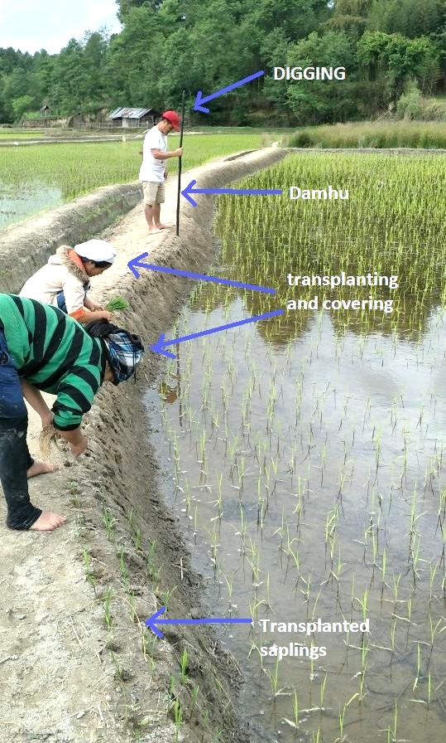
Fig. 1 Transplanting operation on the bund structure
Damhu is a traditional tool used by the Apatani farmers for digging bunds. It is made from a special branch of a tree having a diameter of approx 3-4 cm and having one end pointed (shown in Figure 2). The length of the Damhu varies from person to person depending on the user’s height. Traditional agricultural farm tools and implements are generally made from available materials such as wood, stone, iron, etc. Such tools are economical and user-friendly as they can be operated easily without specific skill (Karthikeyan et.al., 2009). Each tools and implements are used for different operations such as digging, sowing, weeding, harvesting, etc. One of the simplest tools used in agriculture for digging is Sabal (Sarkar et. al., 2015). It is used for making holes used for transplanting or to construct fencing. It is a solid rod with a flat end and is 1.3 – 1.4 m long. Another tool used for making furrows and covering soil is Spader (Plough). Spade (Kodal/Phaura) (Sarkar et. al., 2015) is a multipurpose tool used for making bunds, ridges, furrows, and shallow trenches which are used for sowing seeds and planting materials. It is also used for chopping weeds, and removal of unwanted waste from irrigation channels. It can also be used for digging of soil. Kedu or Nyadu is one of the ancient tools used by the old farmer who preferred to work by bending or sitting. This tool is used by Apatani women in millet and paddy plantations. Working length is 0.1-0.15 m.
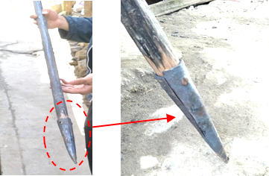
Fig. 2. Traditional Damhu
Apart from traditional implements, the drilling of holes can also be performed by modern technology. Auger digger is a specialized drilling tools which consist of a rotating helical screw blade which is mounted on a shaft (Rajankar et. al., 2021). There are various types of Augers depending on the mode of operation. They are handheld Augers, Power Augers and Hydraulic Augers. Handheld Augers are generally used for planting trees, and soil sampling, and can also be used for the installation of irrigation systems while Power Augers and Hydraulic Augers are used for heavy works such as construction. In the present context, the use of Augers for drilling holes in bunds for planting crops was not found suitable. Therefore, the present work is focused on enhancing the efficiency of the available traditional Damhu.
To design an improved bund digging tool, one of the important factors to be considered is the diameter of the handle as it is one of the important components in the hand tools and equipment. For the operation of the hand tools and manually operated equipment, the handle is grasped such that ﬁnger and thumb ﬂex around the handle (Nag et. al., 1988). Anthropometrically, the diameter of the handle should be such that, while an operator grips the handle, his longest ﬁnger should not touch the palm. At the same time, it should not exceed the internal grip diameter. Based on the studies of men and women concerning an ergonomic evaluation of different hand tools with household appliances, it was reported that the diameter of the handle should be a little lesser than the inside grip diameter to allow good grip on the handle. The recommended diameter of a handle is 3.7 cm (Dewangan et. al., 2010). The present work represents a fusion of traditional wisdom and modern innovation. The design aims to preserve the sustainable principles that define the Apatani farming system. By enhancing efficiency and precision, the improved bund digging tool aims to empower Apatani farmers to maintain their ancestral practices in the face of evolving environmental challenges and socioeconomic dynamics.

2. material and methods

2.1 Place of study
The study was carried out in the Ziro Valley of Arunachal Pradesh, India. It is the home to the Apatanis, which is a major tribal group of Arunachal Pradesh. The study site is surrounded by hills. The famous rice and fish farming system is practiced in this region. The commonly grown crops in this region are maize, millet, and rice.
2.2 Survey on bund dimensions
To determine the exact dimension of the bund used for Apatani farming, a detailed survey has been carried out. The measurements of the already available bunds were taken at different places in Ziro. For systematic study, the bund is considered as two regions. One as a non-cultivated bund region and the other as a cultivated bund region. The details of the bund cropping area were recorded for different regions as indicated in Figure 3. In the figure, Lane 1 and Lane 2 are the regions beside the footpath, and Lane 3 and Lane 4 are the regions at the slopes of the bund. The crop-to-crop distance and the row-to-row distance were also recorded in the present study. The details of the data recorded are listed in Table 1. The data was taken at different sections of the bund with a distance of 0.5 m apart.
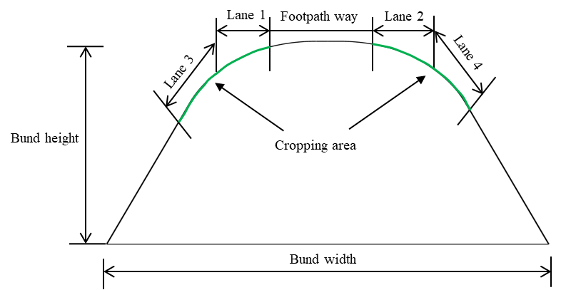
Fig. 3. Schematic diagram of the bund structure representing the cropping area
Table 1. Survey data for different sections of the lane considered for cropping
Sl. No. | Footpath width  (cm) | Lane 1  (cm) | Lane 2  (cm) | Lane 3  (cm) | Lane 4  (cm) | Crop to crop distance  (cm) | Row to row distance  (cm)
(i) | (ii) | (iii) | (iv) | (v) | (vi) | (vii) | (viii)
1. | 40 | 12 | 15 | 12 | 15 | 14 | 15
2. | 26 | 11 | 22 | 11 | 17 | 12 | 12
3. | 55 | 15 | 22 | 14 | 20 | 19 | 14
4. | 26 | 11 | 19 | 8 | 25 | 18 | 13
5. | 28 | 30 | 20 | 22 | 13 | 16 | 14
6. | 23 | 13 | 15 | 26 | 0 | 14 | 13
7. | 32 | 15 | 12 | 16 | 13 | 14 | 14
8. | 27 | 20 | 19 | 21 | 12 | 17 | 14
9. | 38 | 15 | 14 | 14 | 0 | 15 | 14
10. | 36 | 10 | 10 | 20 | 19 | 15 | 12
11. | 26 | 23 | 14 | 27 | 14 | 16 | 15
12. | 26 | 13 | 10 | 15 | 13 | 13 | 14
13. | 27 | 11 | 10 | 26 | 9 | 12 | 10
14. | 30 | 16 | 27 | 18 | 17 | 13 | 12
15. | 30 | 20 | 22 | 23 | 13 | 17 | 13
16. | 27 | 20 | 11 | 8 | 19 | 13 | 13
17. | 35 | 14 | 13 | 16 | 12 | 16 | 13
18. | 63 | 12 | 13 | 15 | 10 | 12 | 12
19. | 40 | 16 | 9 | 14 | 10 | 12 | 12
20. | 34 | 13 | 23 | 20 | 18 | 16 | 13
21. | 26 | 15 | 21 | 10 | 44 | 13 | 12
22. | 19 | 12 | 22 | 9 | 33 | 12 | 13
23. | 20 | 20 | 12 | 70 | 20 | 12 | 14
24. | 19 | 19 | 13 | 40 | 23 | 13 | 12
25. | 22 | 8 | 15 | 10 | 42 | 13 | 12
26. | 43 | 20 | 24 | 12 | 35 | 15 | 12
27. | 28 | 11 | 20 | 10 | 32 | 12 | 12
28. | 28 | 22 | 13 | 9 | 15 | 16 | 13
29. | 27 | 12 | 16 | 11 | 30 | 19 | 13
28. | 31 | 13 | 19 | 19 | 10 | 14 | 13
30. | 24 | 18 | 16 | 34 | 25 | 11 | 12
31. | 30 | 14 | 18 | 20 | 26 | 15 | 13
32. | 34 | 12 | 14 | 16 | 15 | 13 | 13
33. | 23 | 23 | 18 | 18 | 10 | 13 | 13
34. | 26 | 20 | 10 | 10 | 14 | 13 | 12
35. | 24 | 20 | 10 | 9 | 11 | 16 | 12
36. | 38 | 17 | 12 | 17 | 12 | 15 | 12
37. | 26 | 12 | 14 | 11 | 26 | 14 | 11
38. | 25 | 15 | 11 | 15 | 12 | 16 | 17
39. | 46 | 16 | 18 | 12 | 23 | 13 | 13
40. | 18 | 8 | 16 | 24 | 10 | 16 | 13
41. | 24 | 19 | 16 | 10 | 32 | 15 | 13
42. | 23 | 26 | 17 | 28 | 24 | 20 | 15
43. | 34 | 18 | 15 | 28 | 17 | 17 | 15
44. | 28 | 10 | 20 | 10 | 10 | 16 | 12
45. | 50 | 24 | 24 | 45 | 44 | 15 | 12
46. | 37 | 20 | 10 | 22 | 65 | 17 | 13
47. | 26 | 25 | 15 | 56 | 22 | 16 | 14
Avg. | 30.58 | 16.02 | 15.81 | 18.35 | 18.77 | 14.66 | 12.97
The column (ii) of Table 1 shows the variation of footpath width at 47 different sections which are 0.5 m distance apart. From the data collected, it was found that the largest footpath width was 63 cm and the smallest was 18 cm. The average of the 47 values was found to be 30.58 cm. There is no cropping done in the footpath region. Further, column (iii) of Table 1 list the width of lane 1 at different sections. This is one of the cropping regions on the left side of the footpath as indicated in the Figure 3. From the table it was observed that the highest value was 30 cm and the least was 18 cm. Similarly for Lane 2 (column (iv) of Table 1), which is on the right side of the footpath, the highest and the least value recorded was 27 cm and 9 cm respectively. In addition, column (v) and (vi) of Table 1 list the cropping distance available at the slopes of the bund as shown in Figure 3. The highest and least values for lane 3 was found to be 70 cm and 8 cm respectively. Similarly for lane 4, the highest value was 65 cm and the least was 9 cm. It was also observed that at certain sections, there was no cropping done at the slopes and hence the value was recorded as zero in the table. The variation in the footpath width and width of the cropping regions at different sections is due to the irregular structure of the bund at different regions.
From the data collected, it was observed that on average, the length of cropping regions indicated as Lane 1, Lane 2, Lane 3, and Lane 4 are 16.02 cm, 15.81 cm, 18.35 cm, and 18.77 cm respectively. Therefore, the total width of the cropping region is approximately 70 cm which is quite a significant amount of land available for cropping.
Further, the crop-to-crop distance was found to be at an average of 14.66 cm and the row-to-row spacing was 13 cm as indicated in column (vii) and (viii) of table 1 respectively. After a thorough analysis of the data, the key point to be considered for developing the equipment is that the hole to be dug should be a zig-zag pattern having a crop-to-crop distance of 12 to 15 cm and row spacing of 8 to 10 cm.
2.3 Fabrication of 3-teeth Damhu
Based on the survey made, an improved bund digging tool, termed 3-teeth Damhu has been designed and fabricated. The components of the 3-teeth Damhu are:-
Teeth: It is the main component for digging the hole. The teeth was specially designed in the form of a pointed tip to ensure efficient digging of the field. It is made up of mild steel for its high rigidity and strength. The teeth needs to be attached to a support frame. For this, at one end of the teeth, a threaded bolt was attached (shown in Figure 4(a)) so that a washer and a nut can be used to fix the teeth on the support frame. The total length of the teeth from the tip to the end of the thread is 22 cm and weighs 400 g.
Support frame: The support frame is the part on which teeth and the handle are to be attached. It is made up of a wood flank having dimensions of 21 × 18 × 2 cm. The holes in the frame are according to the spacing of the crop i.e. 12 × 10 cm as shown in Figure 4(b). The spacing of the holes is kept based on the survey conducted and discussed in Table 1.
Handle: The handle is made up of special wood (used in traditional Damhu). One end of the handle is attached to a metallic hollow cylinder by using a bolt and nut assembly. Further the end is attached to a threaded bolt so that it can be fixed with the support frame along with the teeth as shown in Figure 4(c). The length of the handle depends upon the users' accessibility.
Assembly of the parts: Three number of teeth were fabricated. The fabricated teeth were attached to the support frame and then to the handle by using the bolt and nut assembly. The complete setup for 3-teeth Damhu is shown in Figure 4 (d).
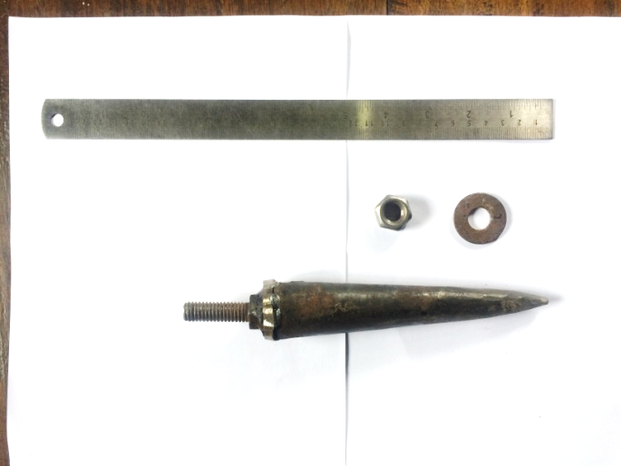  - Teeth | 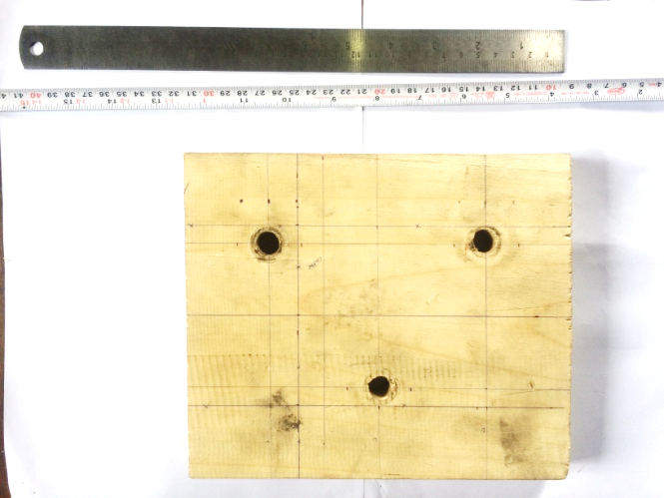  - Support frame
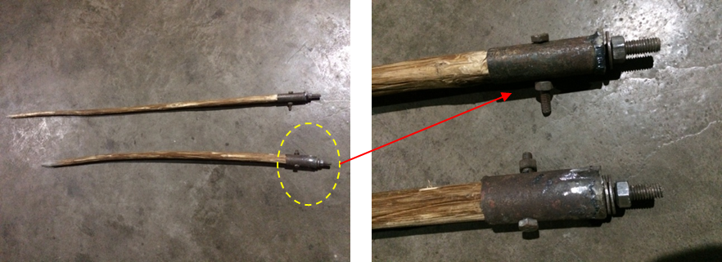
- Handle
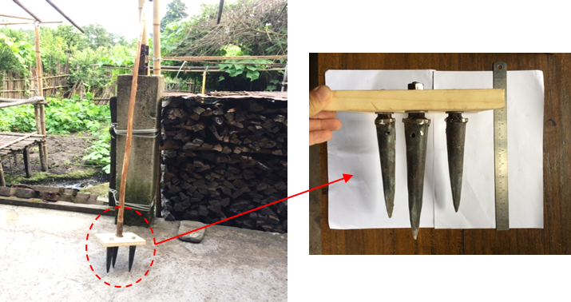
- Assembled 3-teeth Damhu
Fig. 4. Images of the components and assembled 3-teeth Damhu
2.4 Field Testing
Field testing of the fabricated 3-teeth Damhu was done on the bund of Ziro paddy fields. The tests were conducted at five different regions of Ziro Valley namely Ayo Sisang, Akang Sisang, Mani Polyang, Ukopo, and Rakhe. To check the performance of the developed 3-teeth Damhu, a comparative study was made with the traditionally available Damhu. The following steps were followed in the study for testing the fabricated 3-teeth Damhu.
Preparation of land: The first step for performing the test was the preparation of the land. For the present study, non-cultivated bunds were first selected at different locations. Before performing the digging operation, the land was first cleaned with a spade so that the measurements could be carried out accurately. Figure 5 shows the preparation of land for testing. The length of the bund considered for the study was 2.9 m.
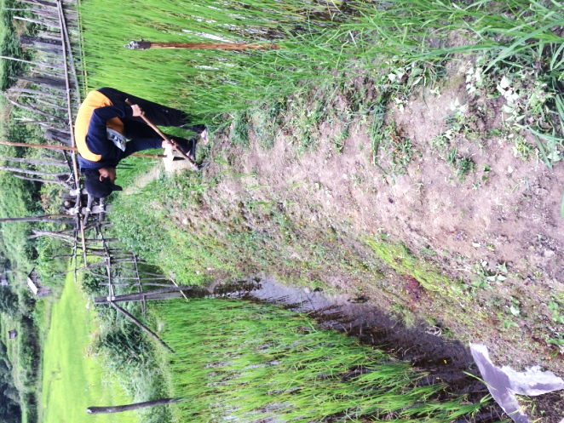 | 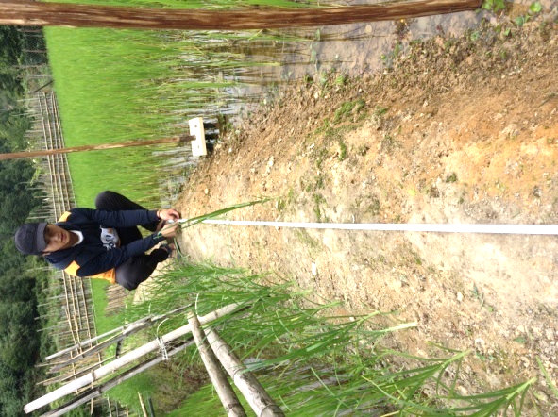
(a) | (b)
Fig. 5. Preparation of land for testing

Digging operation: After the preparation of the land, test was carried out in two separate halves of the bund. On one half of the bund, digging was carried out using traditional Damhu while on the other side, the developed 3-teeth Damhu was used. And then the reading has been taken accordingly. Figure 6 shows the digging operation carried out. Altogether, 15 numbers of holes each by traditional Damhu and 3-teeth Damhu were dug at eight different places. The time taken to dig 15 holes was also recorded.
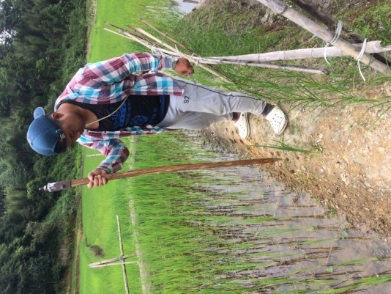 | 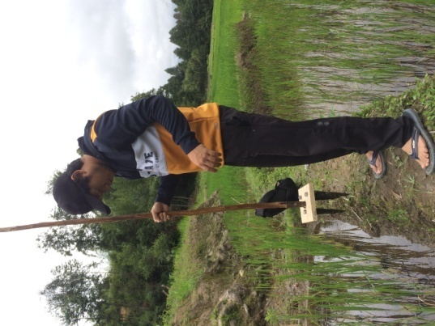
(a) | (b)
Fig. 6. Digging operation using (a) traditional Damhu and (b) 3-teeth Damhu

Measurement of depth of the hole: After the digging operation, the depth of the holes were measured. To measure the depth, a short stick was inserted inside the hole till it reaches the bottom soil and a mark was made on the stick. The stick was then removed and the depth was measured using a ruler. The measurements were taken separately for all the holes dug using traditional Damhu and 3-teeth Damhu. Figure 7 shows the steps discussed for taking the measurement.
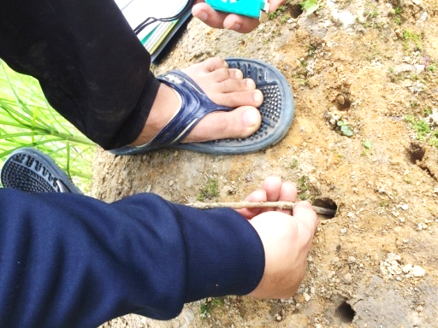 | 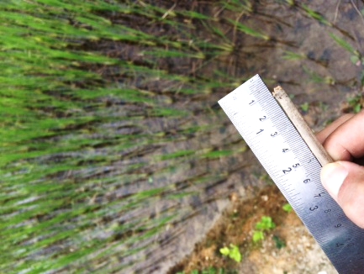
(a) | (b)
Fig. 7. Steps for measuring depth of the hole

3. results and discussion

3.1 Depth of the hole
The details of the depth of 15 holes at eight different places using traditional Damhu and 3-teeth Damhu are tabulated in Table 2. The average and the standard deviation of the 15 values were calculated for all the eight locations. From the table, it was observed that the depth of the hole dug by using the two tools were same i.e. 4.1 cm for Ukopo location. While, for the location Ayo Sisang - 2, it was found that the depth of the hole dug by traditional Damhu was 4.4 cm and that with 3-teeth Damhu was 6.4 cm. Further, for the remaining six locations it was observed that deeper hole can be dug with the use of the developed 3-teeth Damhu. From this, it can be stated that with the same strength/energy of an individual, the 3-teeth Damhu can dig a deeper hole comparatively.
A bar graph comparing the average depth of 15 holes at different places by using different tools is shown in Figure 8. On comparing the depth of the holes at all the eight different locations, it was observed that the depth of the hole was least for the location Ukopo which is 4.1 cm. However, for the location Akang Sisang 2, the depth was 7.3 cm. This difference in the depth at different locations was due to the varying property of the soil. A detailed study on the property of the soil can be conducted to study the effect of soil on the depth of the hole.
Table 2. Depth (in cm) of 15 holes at eight different places [A denotes traditional Damhu and B denotes 3-teeth Damhu]

Sl. No. | Place of study
Sl. No. | Ayo  Sisang -1 |  | Ayo Sisang -2 |  | Akang Sisang - 1 |  | Akang Sisang - 2 |  | Mani Polyang |  | Ukopo |  | Rakhe-1 |  | Rakhe-2
Sl. No. | A | B | A | B | A | B | A | B | A | B | A | B | A | B | A | B
1 | 4 | 5 | 4 | 5 | 6 | 7 | 6 | 7 | 6 | 6 | 3 | 4 | 3 | 4 | 4 | 4
2 | 5 | 5 | 3 | 5 | 6 | 7 | 6 | 7 | 6 | 6 | 3 | 5 | 3 | 5 | 5 | 5
3 | 4 | 5 | 4 | 8 | 8 | 8 | 7 | 8 | 5 | 5 | 4 | 4 | 4 | 4 | 4 | 4
4 | 6 | 7 | 5 | 7 | 7 | 7 | 7 | 7 | 6 | 5 | 5 | 3 | 5 | 3 | 5 | 7
5 | 4 | 6 | 3 | 6 | 7 | 7 | 7 | 8 | 5 | 5 | 4 | 3 | 4 | 6 | 4 | 6
6 | 4 | 7 | 4 | 7 | 6 | 7 | 8 | 7 | 5 | 7 | 4 | 4 | 4 | 4 | 4 | 4
7 | 5 | 7 | 5 | 7 | 7 | 7 | 7 | 7 | 5 | 7 | 5 | 4 | 5 | 4 | 5 | 4
8 | 4 | 6 | 4 | 8 | 8 | 8 | 8 | 8 | 6 | 5 | 4 | 3 | 4 | 3 | 6 | 7
9 | 6 | 5 | 6 | 5 | 8 | 8 | 8 | 8 | 5 | 6 | 5 | 5 | 4 | 5 | 4 | 5
10 | 5 | 5 | 5 | 5 | 6 | 7 | 6 | 7 | 6 | 7 | 5 | 5 | 5 | 5 | 5 | 5
11 | 5 | 6 | 3 | 6 | 7 | 7 | 7 | 7 | 5 | 5 | 3 | 3 | 3 | 6 | 6 | 6
12 | 5 | 6 | 5 | 6 | 7 | 7 | 8 | 7 | 5 | 5 | 5 | 4 | 5 | 4 | 5 | 4
13 | 6 | 5 | 6 | 5 | 6 | 8 | 8 | 7 | 6 | 6 | 4 | 5 | 4 | 5 | 4 | 7
14 | 6 | 7 | 4 | 8 | 6 | 7 | 6 | 8 | 6 | 6 | 3 | 4 | 4 | 6 | 6 | 6
15 | 4 | 7 | 4 | 7 | 8 | 7 | 7 | 7 | 5 | 7 | 4 | 5 | 4 | 5 | 4 | 5
Avg.  (cm) | 4.9 | 5.9 | 4.4 | 6.4 | 6.9 | 7.3 | 7.1 | 7.3 | 5.5 | 5.9 | 4.1 | 4.1 | 4.1 | 4.6 | 4.7 | 5.3
St. Dev. | 0.8 | 0.4 | 0.9 | 1.1 | 0.8 | 0.5 | 0.8 | 0.5 | 0.5 | 0.8 | 0.8 | 0.8 | 0.7 | 0.9 | 0.8 | 1.2

Fig. 8. Average depth of 15 holes at eight different places
3.2 Time taken
The time taken to dig 15 holes by the developed 3-teeth Damhu and traditional Damhu separately was recorded for all the eight places considered and is tabulated in Table 3. From the table, it is observed that the time taken ranges from a least value of 16.61 s to 17.18 s by using the traditional Damhu. However, the 3-teeth Damhu took a minimum duration of 9.23 s to a maximum of 10.48 s. It was observed that the time taken for digging the holes was not affected by the locations. The difference observed was about 1 s only and it can be considered negligible. A comparison was also made for the time required based on the type of tool used. Figure 9 shows the bar graph comparing the time taken to dig 15 holes at eight different places by using the developed 3-teeth Damhu and traditional Damhu. From the figure, it can be observed that the there is a remarkable difference in the time taken. The average time taken to dig 15 holes was found to be 16.85 s and 10.03 s for traditional Damhu and 3-teeth Damhu respectively. About 40 % time is saved by using the developed 3-teeth Damhu as compared to the traditional Damhu. This is due to the fact that only 5 strikes was required to dig the mentioned 15 holes by using the developed 3-teeth Damhu, while with the use of traditional Damhu, 15 strikes was required. This indicates that the developed 3-teeth Damhu is quite effective in terms of time savings. A study on the human energy consumption in future, can give a clear picture of the benefit of the developed 3-teeth Damhu.
Table 3. Time taken to dig 15 holes
Sl. No. | Name of the places | Time taken (s)
Sl. No. | Name of the places | Traditional Damhu | 3-teeth Damhu
1. | Ayo Sisang1 | 16.71 | 9.93
2. | Ayo Sisang 2 | 16.61 | 10.48
3. | Akang Sisang 1 | 17.18 | 10.6
4. | Akang Sisang 2 | 16.72 | 10.05
5. | Mani Polyang | 17.11 | 10.16
6. | Ukopo | 16.65 | 9.86
7. | Rahe 1 | 17.17 | 9.95
8. | Rakhe 2 | 16.65 | 9.23
Average |  | 16.85 | 10.03

Fig. 9. Comparison of the time taken to dig 15 holes at eight different places

4. Conclusion

The work presented a systematic approach to developing and testing an improved bund digging tool that can be used in the Apatani farming system. The following conclusions can be made from the present study:
- The cropping pattern and the dimensions of the bund were thoroughly studied and 3-teeth Damhu was successfully designed and fabricated
- The depth of the holes dug were found to be dependent on the type of the soil i.e. the depth varies from 4.1 cm to 7.3 cm depending on the location. Further, deeper holes can be dug with the use of the developed 3-teeth Damhu as compared with the traditional one.
- The time required for digging 15 holes was compared and it was found that about 40 % of the time was saved by using the developed 3-teeth Damhu.
- Results indicated that the developed 3-teeth Damhu is comparatively more efficient than the traditional Damhu.

References

Dewangan, K. N., Owary, C. & Datta, R. K. (2010). Anthropometry of male agricultural workers of north-eastern India and its use in design of agricultural tools and equipment. Int. J. Ind. Ergon. 40, 560–573.
Karthikeyan, C., Veeraragavathatham, D., Karpagam, D., Firdouse, S. A. (2009). Traditional tools in agricultural practices. Indian J. Tradit. Knowl. 8, 212–217.
Nag, P. K., Goswami, A., Ashtekar, S. P., Pradhan, C. K. (1988).Ergonomics in sickle operation. Appl. Ergon. 19, 233–239.
Rajankar, A. A., Vilaytar A. G., Kale A. N., Motghare P. P., Meshram A. M., Deshmukh C. D. (2021). To Study of Digging Machine. Int. Res. J. Eng. Technol. 2237–2240.
Sarkar, B., Icar, S., Kumar, U., Sarma, K. (2015). Traditional Agricultural Tools used by Tribal Farmers in Eastern India. Res. J. Agric. Sci. 6, 215–219.

