Sustainable Processing of Banana Agro-Waste: Development and Evaluation of a Banana Stem Fiber Extraction Machine

Abstract:
Banana cultivation generates approximately 30–40 million tons of agro-waste globally each year, with pseudo-stems constituting a significant portion. These pseudo-stems are a rich source of high-strength natural fibers, yet they remain largely underutilized, often discarded as waste. Banana fiber has garnered attention for its biodegradability, tensile strength, and potential applications in textiles, composites, and eco-friendly products. This study presents the design, fabrication, and performance evaluation of a mechanized banana stem fiber extractor aimed at addressing the limitations of labor-intensive manual extraction methods. The developed machine features a robust frame, AC motor, rollers, pulleys, and metal stripping components, designed to ensure durability, user safety, and optimal fiber yield. Critical design parameters—including roller diameter, blade geometry, motor rating, and belt coupling—were systematically optimized to achieve reliable operation, minimize fiber breakage, and reduce processing time. The comparative performance tests revealed that the mechanized extractor produced a fiber yield of 65–70%, substantially higher than the 47–50% yield obtained manually. Labor requirements decreased from 2–5 operators to a single user, while processing time per kilogram of pseudo-stem was reduced from 21 minutes to 6 minutes. Waste generation dropped from 50–55% to 25–30%, demonstrating improved resource efficiency. The extracted fibers were uniform in size and quality, suitable for diverse industrial applications. By converting agricultural residues into high-value materials, the mechanized extractor supports sustainable practices, rural income diversification, and scalable green manufacturing. This study highlights the transformative potential of banana fiber mechanization, contributing to environmental sustainability and economic development in banana-growing communities. The findings underscore the importance of integrating technological innovation with agro-waste management to create eco-friendly and economically viable solutions.
Keywords: banana, fibre, extractor, sustainable, crafts, mats
- Introduction
Bananas (Musa spp.) are among the world’s most significant commercial tropical fruits, valued not only for their widespread consumption but also for rich cultural and historical symbolism—they are often termed the “Apple of Paradise” or “Adam’s Fig.” Originating in Southeast Asia and the Indian subcontinent, these herbaceous perennials have become staples across more than 120 countries and serve diverse human needs beyond food, including fiber, healing, and ceremonial uses. As of 2024, global banana production stood at approximately 5.9 million hectares of harvested area, yielding some 36 million tonnes of fruit annually. Global average yield hovers around 23 tonnes per hectare, with a peak of 24 tonnes/ha in 2023. More extensive FAO-based figures report a combined production of bananas and plantains at 179 million tonnes, underscoring the scale of the industry. India is the largest banana producer globally, contributing over a third of world output. In 2024, India alone produced approximately 36–37 million tonnes of bananas, far exceeding the production of second-place China (~12 million tonnes). Within the country, bananas account for about 13% of total fruit cultivation area yet contribute to 33% of fruit production. In Tamil Nadu, banana cultivation spans roughly 300,000 hectares, with annual production estimated at 6.2 to 6.3 million tonnes. The state is also the fourth-largest banana producer in India and boasts over 18 banana varieties. Despite area expansion, production has stabilized around 4 million tonnes, following a dip in yield from 43.1 tonnes/ha to ~40.8 tonnes/ha. Recent efforts by ICAR-NRCB in Trichy to distribute high-yield, disease-resistant varieties like Nei Poovan, Nendran, and NRCB Selection 16 & 19 may significantly enhance productivity and resilience. Bananas are not only consumed fresh but also exported, processed, and utilized for multiple value chains; however, the banana plant produces a huge amount of biomass waste after harvest, especially the pseudo-stem, which is generally discarded. This poses a disposal problem but also provides an untapped opportunity to extract high-strength, biodegradable banana fibers. Traditionally, fibers are obtained manually, which is labor-intensive, time-consuming, and often results in non-uniform, low-quality fiber. Hence, the development of banana stem fiber extraction machines has become essential to mechanize the process, improve efficiency, reduce drudgery, and produce uniform fibers with fewer impurities. Such machines not only enhance fiber yield and quality but also promote value-addition by enabling the production of eco-friendly textiles, ropes, composites, sanitary products, and handicrafts. The necessity for mechanized extraction lies in its potential to transform agricultural waste into wealth, support rural livelihoods, reduce environmental load, and provide sustainable raw materials for diverse industries.
- Literature Review
The mechanization of banana fiber extraction has been a focal point in agricultural engineering, aiming to enhance efficiency and quality in processing banana pseudostems. This review synthesizes key developments in the design, fabrication, and evaluation of banana fiber extraction machines, highlighting advancements and challenges in the field. Early efforts in mechanizing banana fiber extraction focused on reducing manual labor and improving fiber quality. For instance, Ramamoorthy et al. (2021) developed a manually operated machine featuring horizontal beams and a comb mechanism, which significantly reduced drudgery and maintenance costs. Similarly, Vadivel et al. (2017) addressed common issues like fiber breakage and knot formation by introducing structural modifications, including optimized blade designs and controlled roller distances, to enhance fiber continuity and quality. Advancements continued with the introduction of electrically powered machines. Mahmoud et al. (2023) designed a prototype utilizing a 0.75 kW electric motor to power a beater cylinder, demonstrating improved efficiency over manual methods. Further innovations included the development of low-cost machines tailored for small-scale farmers, emphasizing portability, durability, and ease of operation to facilitate widespread adoption (Onyenanu, 2024). Recent studies have incorporated advanced technologies to refine the extraction process. Liang et al. (2025) introduced a pulsating rubbing-based extractor, employing a cam-driven pressing system to minimize mechanical damage and preserve fiber integrity. This approach demonstrated the potential for high-quality fiber extraction with reduced processing times. Material selection and structural analysis have also been pivotal in enhancing machine performance. Finite element analysis, as applied by Shrivastava et al. (2023), has been instrumental in simulating and optimizing the structural strength of extraction machines, ensuring durability and reliability under operational stresses. The mechanization of banana fiber extraction offers significant economic benefits, particularly for smallholder farmers. By reducing labor costs and increasing fiber yield, mechanized machines provide an alternative income source and contribute to the commercialization of banana cultivation (Onyenanu, 2024). Environmentally, utilizing banana pseudostems, a byproduct of banana cultivation, for fiber extraction promotes sustainable practices by reducing agricultural waste and providing biodegradable materials for various applications. The development of banana fiber extraction machines has gained attention due to their potential in reducing labor, improving yield, and promoting sustainability. A multi-fiber extractor designed for banana, sisal, and papyrus stems proved more cost-effective than automatic extractors while improving productivity (Ahmed et al., 2019). Compact extractors optimized for roller speed and feed angle were shown to minimize impurities and knots, thereby improving fiber quality for mass production (Sonwane et al., 2020), while improved blade design and reduced roller clearance further enhanced output and reduced damage (Shinde et al., 2022). Machines tailored for handicraft industries also demonstrated reliable extraction rates, with maximum efficiency observed at 900 rpm (Tran Cong Chi et al., 2023). Similarly, mechanized designs using CAD achieved high efficiency, extracting fibers from pseudostems within 26 seconds, offering a safer and more sustainable alternative to traditional methods (Soomro & Rossi, 2024). Earlier optimization studies also confirmed that roller speed and feed angle significantly reduced fiber breakage and improved fiber quality (Vadivel et al., 2017). Beyond machines, banana fiber itself has been highlighted for its biodegradability, mechanical strength, and UV resistance, though much of the pseudostem remains underutilized in textiles, packaging, and handicrafts (Vigneswaran et al., 2015). Social innovations include sanitary pads made from banana fibers, which demonstrated higher absorbency and eco-friendliness compared to conventional alternatives, though adoption remains limited (Kumar, 2023). Larger-scale innovations introduced automated extractors with dual rollers and conveyors, improving quality and reducing labor (Sheikh & Awata, 2016), while structural modifications like multiple rollers and inclined hoppers boosted efficiency (Kunte & Amale, 2016). Electrically powered extractors further reduced processing time to 27–42 seconds, producing fibers more efficiently than retting methods (Oreko et al., 2018). Comparisons of extraction techniques revealed that chemical retting yielded up to 0.55% fiber, though mechanical methods were more sustainable (Ebisik et al., 2013). Recent optimization studies have shown that roller speed of 1400 rpm, scraper gaps of 2.5 mm, and eight scrapers minimized impurities and maximized yield (Yue et al., 2024). Similarly, enzyme-assisted extraction methods increased fiber strength by 40% compared to mechanical extraction in Sri Lankan cultivars (Abdul Cader Salahudeen Mumthas et al., 2019). In Thai cultivars, fibers from outer pseudostem layers exhibited the highest tensile strength and elongation, confirming their potential for high-strength applications (Heliyon, 2024). Technological innovations such as pulsating rubbing-based extractors achieved ~61% extraction efficiency with minimal impurities, ensuring high fiber integrity (Agriculture, 2025). Conceptual designs focusing on safety and ease of use were also developed for small-scale adoption (Rukmi Sai Rupa Sri & Ankitha, 2021). Biochemical approaches, including biosoftening with cellulase and pectinase, improved fiber morphology, though overtreatment reduced strength (Journal of Genetic Engineering and Biotechnology, 2023). Enzymatic treatments using Staphylococcus sciuri produced banana fibers with properties comparable to cotton in terms of strength and elongation (Cast Journal, 2023). Broader comparative studies revealed banana fibers’ superior tensile strength (221 MPa) compared to sugarcane and Napier grass, underlining their robustness for composites (Scientific.Net, 2024). Furthermore, ultrasound-assisted NaOH treatments improved cellulose purity (99.5%), crystallinity (67.9%), and thermal stability compared to conventional methods (PubMed, 2024).
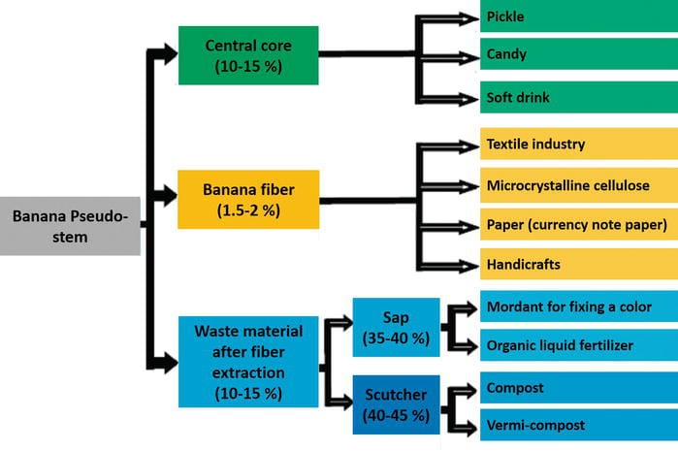
Figure 1. Potential applications of components from the banana pseudo-stem

Table.1. Summary of Banana Fiber Extractor Machine Designs and Studies
S.No | Author(s), Year | Scale of Use | Key Features / Innovations | Outcomes
1 | Ahmed et al., 2019 | Lab/Prototype | Integrated rollers and stripping unit | Extracts multiple fibers, reduces manual effort
2 | Sonwane et al., 2020 | Small-scale | Simple blade and roller design | Low-cost, suitable for farmers
3 | Shinde et al., 2022 | Pilot-scale | Modified roller spacing & sharp blades | Higher efficiency and better fiber quality
4 | Chi et al., 2023 | Small/medium handicraft | Compact, portable machine | Produces uniform fiber for handicrafts
5 | Soomro & Rossi, 2024 | Industrial | CAD-designed with optimized components | High productivity, durable machine
6 | Vadivel et al., 2017 | Review study | Comparative study of machine types | Highlighted fiber quality and property evaluation
7 | Vigneswaran et al., 2015 | Conceptual study | Not machine-specific | Discussed scope for textiles and handicrafts
8 | Sheikh & Awata, 2016 | Review | Design challenges identified | Need for cost-effective machines
9 | Oreko et al., 2018 | Field-scale | Adapted for plantain pseudostem | Efficient extraction with minimal waste
10 | Mohamed et al., 2023 | Pilot-scale | Knife–roller system for slice-based feeding | Improved fiber recovery
11 | Yue et al., 2024 | Simulation & Lab | Stress analysis for rollers & blades | Optimized load & speed for higher yield
12 | Pandey, 2022 | Pilot-scale | Designed extractor with cost analysis | Economical and practical for rural use

- Materials and Methods
The banana stem fiber extractor was fabricated using a variety of mechanical and structural components carefully selected for durability, cost-effectiveness, and ability to withstand load and operational stresses. The frame of the machine was fabricated using mild steel pipes, angles, and sheets to provide structural stability and reduce vibration (Ariho, 2014); (Balda et al., 2021); (Chi et al., 2023); (Khan et al., 2014). A 0.5 HP, 240 V, single-phase AC motor was used as the power source to drive the rollers through a pulley-belt arrangement. A V-type rubber belt of 70 inches length ensured proper power transmission between the motor and roller, while cast iron pulleys of 300 mm and 40 mm diameters enabled torque transfer with minimal slippage. Cylindrical rollers of 30 mm diameter and 400 mm length, machined from mild steel, were employed for feeding and pressing the banana pseudo-stem. Circular discs of 250 mm diameter with teeth provided grip and guiding action, while shafts made of mild steel transmitted torque from the motor to the rollers. Stainless steel strips were used as connectors and supporting elements, while mild steel sheets served as cover plates and structural support. Six ball bearings were used to support the shafts and facilitate smooth rotation of the rollers. For efficient fiber extraction, four serrated and four plain-edged blades of 300 mm length were incorporated into the machine design.
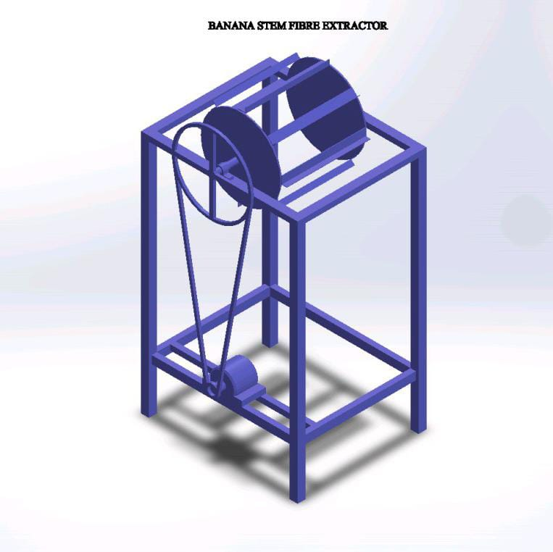
Figure 2. Banana Fibre Extractor (Mainframe Diagram)

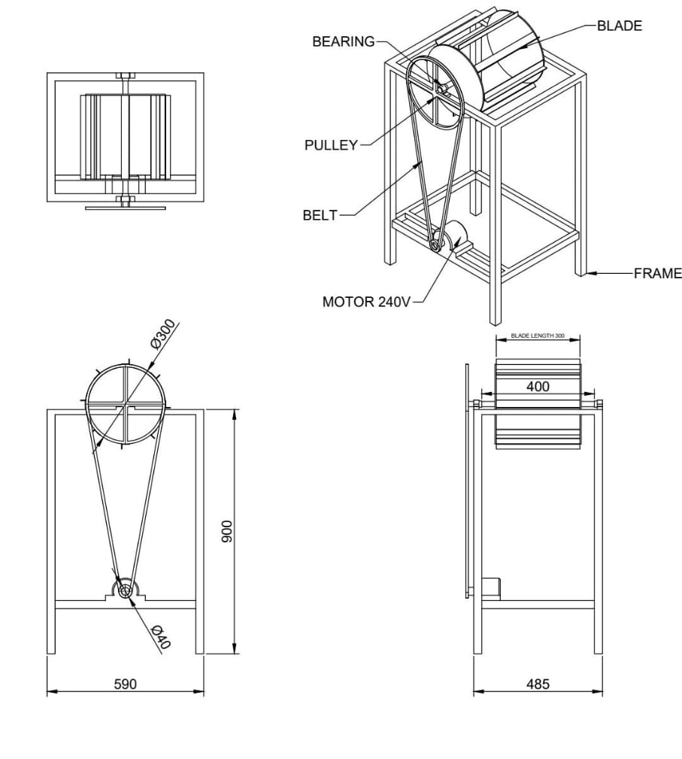
Figure 3. Banana Fibre Extractor (Wireframe Diagram)
The design of the extractor was carried out in both 2D and 3D CAD models to finalize the dimensions and alignment of the components (Pitimaneeyakul, 2009); (Priyadarshana et al., 2022); (Sheikh & Awata, 2016); (Taleat et al., 2021). The frame dimensions were determined as 590 mm in length, 485 mm in width, and 900 mm in height without the dome, and 1220 mm in height with the dome. Design considerations prioritized operator safety, ease of feeding, stability, and minimization of vibration. The fabrication of the machine was completed through a series of manufacturing processes. In the cutting stage, mild steel pipes, sheets, and strips were cut to the required dimensions using mechanical cutting machines. The lathe process was then used to machine rollers, shafts, and pulleys to achieve accurate dimensions, concentricity, and smooth finish. The frame structure and sheet supports were joined through arc welding, which provided strength and rigidity. Once the individual components were ready, they were assembled to form the complete machine, ensuring proper alignment of rollers and shafts for smooth functioning. Finally, grinding was carried out on welded joints and contact surfaces to improve the surface finish, reduce sharp edges, and ensure dimensional tolerance. The operating principle of the extractor is based on the transmission of rotary motion from the motor to the rollers via the belt and pulley system. The operator manually feeds banana pseudo-stems into the rollers, which grip and pass them against the blades. The scraping action of the blades separates the fibers from the surrounding biomass. The extracted fibers are collected for further processing, while the residual waste material is discarded.
- Results and Discussion
The banana stem fiber extractor was fabricated successfully and tested under actual operating conditions. The performance of the machine was compared with the traditional manual fiber extraction method, focusing on labor requirement, time consumption, wastage percentage, and extraction efficiency (Kunte & Amale, 2016); (Mohamed et al., 2023); (Onyenanu et al., 2024); (Pandey, 2022). The results presented in Table.2 show a clear improvement in efficiency when using the machine compared to the manual method. The manual process typically requires 2–5 persons, depending on the workload, while the machine can be operated effectively by a single person. This significantly reduces labor costs and dependency.
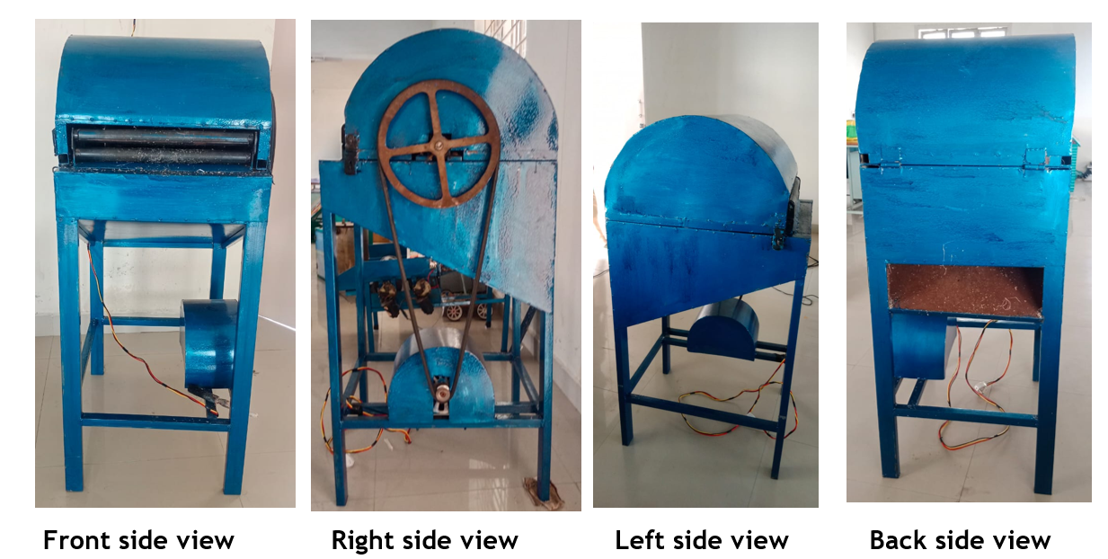
Figure 4. Prototype Banana Fibre Extractor
In terms of time, the manual method required an average of 21 minutes to process 1000 g of banana stem, whereas the machine processed the same quantity in only 6 minutes. This reduction in processing time highlights the machine’s potential for large-scale fiber extraction and commercial use. The wastage was found to be considerably higher in manual extraction, ranging from 50 to 55 percent, primarily due to incomplete separation of fibers and inconsistent scraping. The banana stem fiber extractor reduced wastage to around 25–30 percent, demonstrating better resource utilization and higher yield. As a result, the efficiency of the machine ranged between 65 and 70 percent, compared to 47–50 percent for the manual method.
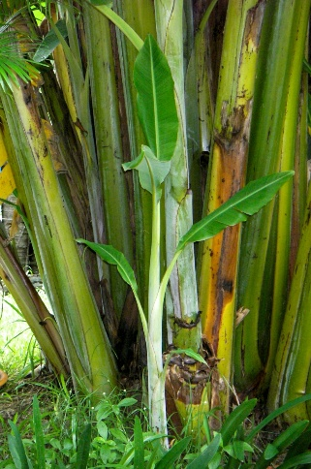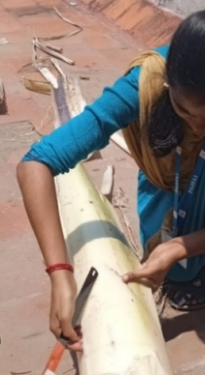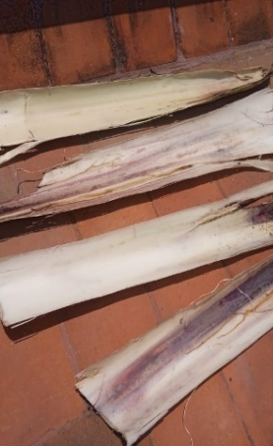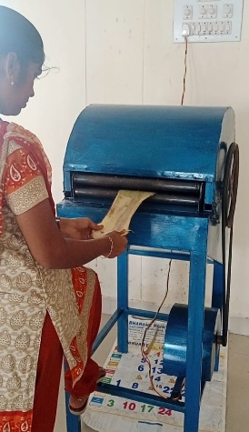
Figure.5. Fibre Extraction Process
These findings confirm that the fabricated machine not only enhances fiber yield but also ensures uniform quality of extracted fibers. Figure.3 further illustrates this improvement using a bar chart comparison. Apart from fiber recovery, an additional byproduct obtained during the extraction process was a nutrient-rich pulp. This pulp can be repurposed as an organic fertilizer or used as animal feed, thereby promoting sustainable waste management and generating additional value for farmers. Such byproduct utilization ensures that the machine contributes to both economic and environmental sustainability. A basic field survey was also conducted in the Paavai banana plantation area to assess the potential application of the machine. The survey revealed that an area of 108.49 m² contained 34 plants of Rasthali and Monthan varieties, each with an approximate plant height of 180 cm. Based on the standard spacing of 2.8 × 2.8 m, the unit area per plant was calculated as 7.84 m². Accordingly, the plantation density was estimated as 14 plants per 108.49 m², which can be scaled up to calculate the number of plants per acre. These findings emphasize that the machine, when applied at the field level, can process significant quantities of banana stems per unit area, thus improving productivity and fiber availability.
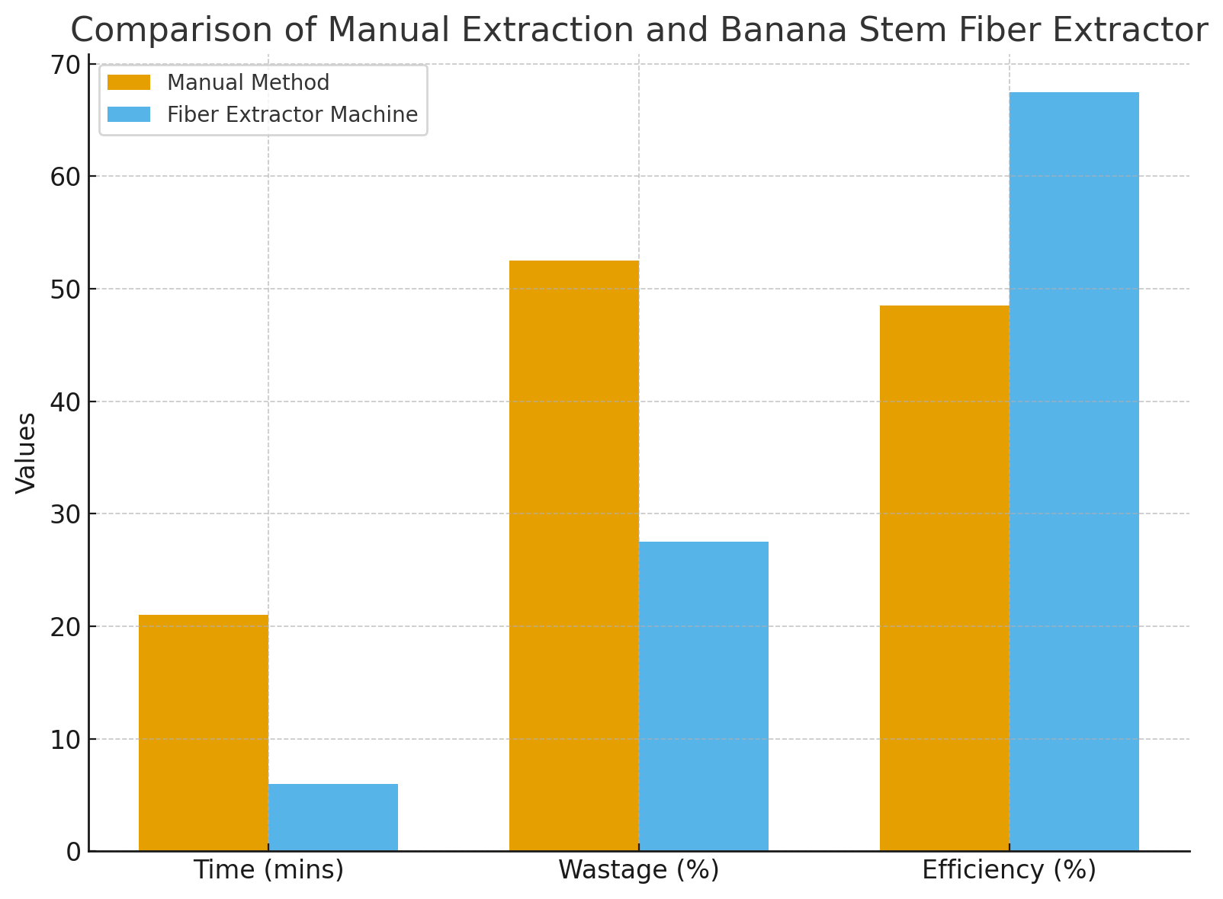
Figure.6 Comparison of Banana Fibre Extraction (Time, Wastage and Efficiency)

Table.2 Manual method vs Banana stem fiber extractor
S.No. | Particulars | Manual method | Banana stem fiber extractor
1 | Labour requirement | Based on needs (2–5 persons) | One Person / Machine
2 | Time taken (1000g of banana stem in mins) | 21 mins | 6 mins
3 | Wastage (%) | 50 – 55 % | 25 – 30 %
4 | Efficiency (%) | 47 – 50 % | 65 – 70 %

- Conclusion
The mechanized banana stem fiber extractor developed in this study substantially improves the efficiency, consistency, and scalability of banana fiber production relative to traditional manual methods. The machine features a simple, robust design powered by a 0.5 HP electric motor, incorporating optimized roller and blade configurations to maximize fiber separation and minimize waste. Evaluation revealed a marked reduction in process labor and time and significant gains in fiber yield and quality, facilitating mass production for both local use and industrial applications.

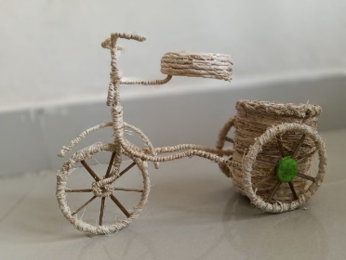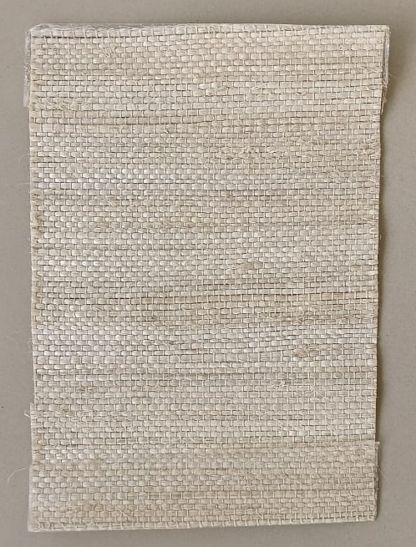
Figure.7 Value Added Banana Fibre Products (Crafts and Mats)
The broader impact of this innovation encompasses not only enhanced utilization of banana agro-waste but also the provision of high-quality, biodegradable fiber for textiles, handicrafts, and bio-composite products. The extracted by-product pulp, rich in nutrients, has potential utility as organic fertilizer or animal feed, further contributing to sustainable farming systems. Adoption of this technology can help address labor shortages, particularly during harvest periods, and promote economic and environmental sustainability in banana-producing regions. The findings support the integration of such mechanization into rural agro-processing, paving the way for eco-friendly value chain development and reduced agricultural waste.
- References
- Ahmed, F. E., Tilahun, M., & Gemeso, F. (2019). Design and fabrication of multi fiber extraction machine. International Journal for Modern Trends in Science and Technology, 5(6), 1–7. ISSN 2455-3778.
- Ariho, I. (2014). Design and construction of banana fiber pseudostem extractor machine (Doctoral dissertation, Busitema University).
- Balda, S., Sharma, A., Capalash, N., & Sharma, P. (2021). Banana fibre: A natural and sustainable bioresource for eco-friendly applications. Clean Technologies and Environmental Policy, 23, 1389–1401. https://doi.org/10.1007/s10098-021-02073-7
- Chi, T. C., Hoa, T. T. P., Dai, V. H., & Van Tinh, P. (2023). Design and manufacture a banana fiber extraction machine for small and medium-scale handicraft production. Journal of Forestry Science and Technology, (15), 148–157.
- Ebisike, K., AttahDaniel, B. E., Babatope, B., & Olusunle, S. O. O. (2013). Studies on the extraction of naturally-occurring banana fibers. International Journal of Engineering Science, 2(9), 9–13.
- Khan, M. Z. H., Sarkar, M. A. R., Al Imam, F. I., & Malinen, R. O. (2014). Paper making from banana pseudo-stem: Characterization and comparison. Journal of Natural Fibers, 11(3), 199–211. https://doi.org/10.1080/15440478.2013.853327
- Kumar, M. M. J. A. (2023). A study on creating awareness on eco-friendly sanitary pads made from banana fiber in Navi Mumbai region. International Journal of Scientific Research in Engineering and Management, 7(3), 1–7.
- Kunte, S. N., & Amale, A. B. (2016). A review paper of structure modification in banana fiber extraction machine. In Proceedings of National Conference on Innovative Trends in Science and Engineering (NC-ITSE'16) (Vol. 4, No. 7, pp. 127–130).
- Liang, D., Zhang, X., & Liu, Y. (2025). Design and experimental evaluation of a pulsating rubbing-based banana fiber extractor. Agronomy, 15(16), 1746. https://doi.org/10.3390/agronomy15161746
- Mahmoud, W. A. E. M., Elkaoud, N., Eissa, A. S., & Mousa, A. M. (2023). Mechanical processing of banana slices-stem for fiber extraction. CIGR Journal, 25(1), 1–10. https://cigrjournal.org/index.php/Ejounral/article/view/8809
- Onyenanu, I. U. (2024). Development of a low-cost banana fiber extractor. International Journal of Innovative Science and Research Technology, 9(5), 1–7. https://www.ijisrt.com/development-of-a-lowcost-banana-fiber-extractor
- Oreko, B. U., Okiy, S., Emagbetere, E., & Okwu, M. (2018). Design and development of plantain fibre extraction machine. Nigerian Journal of Technology, 37(2), 397–406. https://doi.org/10.4314/njt.v37i2.15
- Pandey, S. (2022). Design, development & techno-economic evaluation of banana fiber extractor machine (Doctoral dissertation, Indira Gandhi Krishi Vishwavidyalaya, Raipur, Chhattisgarh).
- Pitimaneeyakul, U. (2009). Banana fiber: Environment friendly fabric. In Proceedings of the Environmental Engineering Association of Thailand (Vol. 5, pp. 1–6).
- Priyadarshana, R. W. I. B., Kaliyadasa, P. E., Ranawana, S. R. W. M. C. J. K., & Senarathna, K. G. C. (2022). Biowaste management: Banana fiber utilization for product development. Journal of Natural Fibers, 19(4), 1461–1471. https://doi.org/10.1080/15440478.2020.1854146
- Ramamoorthy, K., Ajay, C., & Kumar, S. (2021). Design and fabrication of manually operated banana fiber extracting machine for agriculture applications. Materials Science and Engineering Applications, 9(4), 1–7. https://www.researchgate.net/publication/350482188
- Sheikh, S., & Awata, N. P. (2016). A review paper on design and development of banana fibre extraction machine. International Journal of Engineering Sciences and Research Technology, 5(3), 841–847.
- Shinde, P., Magade, P., & Magade, S. B. (2022). Design, development and testing of banana fiber extraction machine. Mathematical Statistician and Engineering Applications, 71(4), 1325–1339.
- Shrivastava, P., & Singh, R. (2023). Design and simulation of banana pseudo-stem fibre extracting raspador cylinder using FEA technique. Journal of Mechanical Engineering and Technology, 12(2), 1–8. https://www.researchgate.net/publication/370214887
- Sonwane, R., Shinde, S., Palde, P., & Matte, R. (2020). Design and fabrication of banana fiber extracting machine. International Journal of Future Generation Communication and Networking, 13(2), 858–863.
- Soomro, A. R., & Rossi, F. (2024). SOLIDWORKS design, fabrication and performance analysis of a banana fiber extraction machine and its components. Mehran University Research Journal of Engineering & Technology, 43(3), 190–204.
- Taleat, A. A. T., Akanfe, F. A., & Gbadamosi, T. R. (2021). Pulp extraction and paper production from banana pseudostem and its characterization. In Proceedings of International Conference on Science, Engineering, Environment and Technology (ICONSEET) (Vol. 6, No. 18, pp. 129–134).
- Vadivel, K., Vijayakumar, A., Solomon, S., & Santhoshkumar, R. (2017). A review paper on design and fabrication of banana fiber extraction machine and evaluation of banana fiber properties. International Journal of Advanced Research in Electrical, Electronics and Instrumentation Engineering, 6(3), 1–5.
- Vigneswaran, C., Pavithra, V., Gayathri, V., & Mythili, K. (2015). Banana fiber: Scope and value-added product development. Journal of Textile and Apparel, Technology and Management, 9(2), 1–12.
- Yue, L., Yang, G., Chun, H., Shiquan, W., Yuan, L., & Dong, L. (2024). Mechanical research and optimization of banana stalk fiber extraction. Engenharia Agrícola, 44, e20240061. https://doi.org/10.1590/1809-4430-Eng.Agric.v44nep20240061/2024

