Review Article
Raspberry Ketone: A Multidisciplinary Review of its Chemistry, Pharmacology, Toxicology, and Emerging Technologies (2015–2025)

Abstract
Background: Raspberry Ketone (RK, 4-(4-hydroxyphenyl)butan-2-one) is a naturally occurring phenolic compound in various fruits (e.g., raspberry, peach). Recent years have seen multidisciplinary research interests into its chemical properties, mechanistic pharmacology, safety profile, and technological applications.
Methods: We summarize about 50 primary studies (2015–2025) from high-impact journals, covering chemical characterization (X-ray diffraction, NMR, DFT modeling), pharmacological mechanism investigations (in silico docking, omics, CRISPR), toxicological evaluations (ADME, dose-response, computational toxicity), and novel formulation/production technologies for the raspberry ketone.
Results: Key advances include detailed physicochemical profiling (e.g., geometry optimization and solubility ~2.5 mg/mL by DFT), identification of molecular targets (notably PPAR-α activation for metabolic effects), evidence of therapeutic potential in metabolic diseases (anti-obesity, hepatoprotection, cardioprotection) in preclinical models, and initial toxicity assessments indicating rapid metabolism to a benign alcohol metabolite but sparse human safety data. Technological innovations such as nanocarriers have improved RK bioavailability, and sustainable biosynthesis methods have emerged to meet demand.
Conclusions: Although the in vivo studies suggest multi-target benefits of RK, but human evidence remains limited and safety at high supplemental doses is not fully established. The ongoing efforts in advanced screening and formulation technologies may address current gaps. Therefore, rigorous clinical validation and toxicological profiling are needed before RK can be considered for therapeutic use.

Keywords: Raspberry Ketone; PPAR-α; Anti-obesity; Antioxidant; ADME; Nanotechnology

1. Introduction

Raspberry ketone, initially being used mainly as a flavoring in the perfume and food industries, was first identified around 1900 as a component of red raspberry aroma. It is naturally present in very small quantities in fruits, so it is one of the most expensive natural flavor compounds[1]. As a result, commercial supplies are progressively dependent on synthetic production methods, particularly biotechnological approaches that employ engineered Escherichia coli strains to convert glucose into raspberry ketone (RK), producing a compound that is "nature-identical."[2].
RK is a phenylpropanoid (aromatic phenolic ketone) with molecular formula C₁₀H₁₂O₂ and molar mass ~164.2 g/mol. It is a significant component of the aroma of red raspberries (Rubus idaeus), and it is also present in smaller amounts in kiwifruit, peaches, and apples. [3]. In plants, it is biosynthesized via the phenylalanine/tyrosine pathway as a volatile attractant for pollinators and fruit-dispersing insects[4]. Chemically, it is also known as rheosmin or frambinone in older literature.
Beyond its use as a flavor (GRAS status as a food additive[5]), RK gained widespread public attention in the early 2010s due to claims of its weight-loss benefits[6]. This popularization (including media and supplement marketing) spurred a surge in scientific investigations into RK’s biological activities. Figure 1 shows the chemical structure and conformation of RK[7], highlighting its aromatic ring and butanone side chain, which underpin its reactivity and interactions.
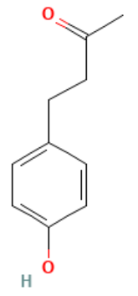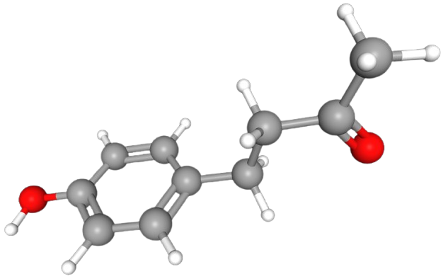
[A]
[B]
Figure 1. Molecular structure of Raspberry Ketone (RK): ([A]) 2D structure and ([B]) 3D structure, highlighting the characteristic phenyl ring and the 4-(4-hydroxyphenyl)butan-2-one scaffold[7].
Including (a) latest updates on chemical and physicochemical characterizations (b) pharmacological mechanisms and therapeutic evaluations in metabolic and various models in other diseases (c) toxicological and safety studies, including metabolism and computational predictions; (d) emerging applications in formulation technology and green synthesis; (e) critical analysis of current evidence, limitations, and replicability issues; and (f) prospects for future research and development, this study offers a thorough description of RK research from 2015–2025. Our goal is to bring together data from several fields to help both basic research and practical ideas for RK as a potential nutraceutical or medication lead.
1.1. Bibliometric Trend (2015–2025): Publications pertaining to RK have significantly increased during the last ten years, indicating a diversification of research areas. Since 2015 research has broadened, after initially concentrating on the effects of anti-obesity interventions, to include hepatoprotection, cardioprotection, dermatology (skin lightening), and even entomology.
2. Physicochemical Properties
To determine a drug's solubility, stability, pharmacokinetics, and therapeutic action, the knowledge of physicochemical properties of the substance or chemical is very essential. [8]. They also constitute a very important factor while deciding a delivery system and designing dosage form of particular molecule. Physicochemical parameters are related to the structure and molecular mass of the molecule and drug design involves the synthesis of a stable and therapeutically active molecule through the optimization of these parameters. Some of these parameters are discussed below:
2.1. Molecular Structure and Characterization: Raspberry ketone’s structure consists of a para-hydroxyphenyl ring attached to a butan-2-one (β-ketone) moiety. While advanced spectroscopic techniques including NMR and IR verified the functional groups (aromatic OH, ketone C=O), single-crystal X-ray diffraction analysis confirmed a twisted conformation: the aromatic ring is tilted ~52° out of plane from the carbonyl-bearing side chain which is further reported from DFT (Density Functional Theory) study on RK’s geometry showing a key dihedral angle of ~55°[7].

2.2. Electronic and Thermodynamic Properties:
DFT calculations (using high-level composite thermochemical methods) reveal RK’s electronic structure, showing a moderate HOMO-LUMO gap (~7.8 eV in aqueous phase) consistent with its stability and reactivity[9]. Theoretical values for enthalpy of formation (∆_{f}H° ~ -299.4 kJ/mol) and melting point (~82 °C) agree with experimental data. Conceptual DFT indices (chemical hardness ~7.8 eV, electrophilicity ~1.6) suggest likely nucleophilic attack at the carbonyl and electrophilic substitution on the aromatic ring, in line with its known metabolic pathways.

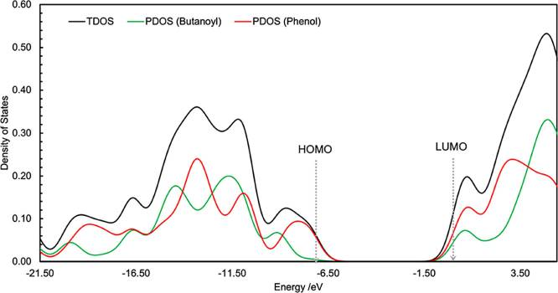
Figure 2. Density of states analysis for RK. Abbreviations: TDOS, total density of states; PDOS, partial density of states; HOMO, Highest Occupied Molecular Orbital; LUMO, Lowest Unoccupied Molecular Orbital. Actual figure would show a 3D electron density map or electrostatic potential surface. (adopted from McPherson et al., 2024) [7]

2.3. Solubility and Stability: Raspberry ketone (RK) is sparingly soluble in water, with reported aqueous solubility values of approximately 2–3 mg/mL at ambient temperature. This experimental range aligns well with a calculated solubility of ~2.5 mg/mL derived from its melting point and fusion enthalpy parameters[7]. By contrast, RK dissolves readily in organic solvents such as ethanol and acetone[10], consistent with its log P value of 1.5–1.8, a profile that denotes moderate lipophilicity[7]. Although RK remains stable under neutral to mildly acidic conditions—making it suitable for recrystallization from alcohol solvents without decomposition—it may undergo degradation when exposed to extreme pH or prolonged heating. In such cases, its phenolic OH group can be susceptible to oxidation, and under strongly basic conditions, the ketone moiety may condense, leading to possible structural alterations. Stability studies under physiological conditions are still sparse, but one study indicated RK remained intact during short-term exposure to gastric pH in vitro [11].
Critically, being no published pKa titrations and very limited solubility studies on RK[7] shows that there is a large gap between the in-silico and experimental physiochemical. So, the need for basic characterization (thermodynamic stability, polymorphism, etc.) to be addressed in future research.
3. Pharmacological Research
The pharmacological effect of drug largely depends on how a drug molecule interact with the biological environment of the human body. Apart from drug action, the safety and efficacy of the drug is a critical factor related to its physicochemical nature of the drug[12]. Therefore, better understanding of molecular structure of the drug can be help in the drug designing for the improvement of its pharmacological activity. For concluding the pharmacology of RK we have gone through various published literature.
3.1. Mechanistic Studies (Molecular Targets & Pathways)
In silico docking and reporter assays suggest RK directly binds and activates Peroxisome Proliferator-Activated Receptor alpha (PPAR-α) [13], a nuclear receptor that regulates fatty acid oxidation. Activation of PPAR-α by RK then boosts genes that control antioxidants and fat metabolism, partly explaining its fat-lowering and organ-protective effects. RK also appears to promote norepinephrine-induced lipolysis in adipocytes. [14]. One study showed that RK treatment increased lipolysis and fatty acid oxidation in 3T3-L1 fat cells, similar to β-adrenergic activation [15], [16]. Transcriptomic analysis of adipocytes using RNA sequencing (RNA-seq) indicate RK downregulates adipogenic/lipogenic genes (e.g. PPAR-γ, C/EBPα) and upregulates lipolytic genes [17], supporting its anti-obesity mechanism. Recent research utilizing comprehensive omics techniques has begun to elucidate the diverse biological actions of RK. One such study employing liver cell models reported that RK prompted an increase in enzymes responsible for cellular antioxidant defense, such as superoxide dismutase and catalase, while simultaneously suppressing molecular indicators of apoptosis [18], aligning with its anti-oxidative and anti-apoptotic profile in tissues [19]. While so far, no CRISPR screens for RK target discovery exist, but CRISPR/Cas9 screens can be helpful to identify RK’s molecular targets.
3.2. Therapeutic Applications
RK has been investigated mainly regarding obesity and metabolic syndrome [20]. Several independent rodent studies (2015–2021) indicate that dietary or orally administered RK reduces body weight and adiposity in obese mice subjected to a high-fat diet [21]. For example, giving RK (~50–200 mg/kg) to obese rats improved insulin sensitivity and lowered triglycerides levels in the blood. This was accompanied by release of more adiponectin and glycerol the by adipose tissue [15], [20]. A 2018 study on obese rats found an "optimized dose" (about 100 mg/kg) that worked best to control hyperlipidemia and insulin resistance by increasing adipose adiponectin and lowering inflammatory adipokines. In addition to systemic obesity measures, organ-specific benefits in liver like reduction in hepatic fat accumulation and inflammatory damage have been observed, leading to amelioration of non-alcoholic fatty liver disease (NAFLD) in high fat fed rodents [12]. Mechanistically, these hepatoprotective effects were linked to increase in fatty acid oxidation (via PPAR-α) by RK and its antioxidant action in liver tissue as evidenced by elevated GSH and SOD levels [22]. Figure 3 shows how RK affects multiple pathways in a liver injury model. RK increases the levels of PPAR-α and Nrf2, thereby boosting the body’s defenses against oxidative stress and reducing inflammatory (NF-κB) and apoptotic (caspases) signals to protect hepatocytes [22].
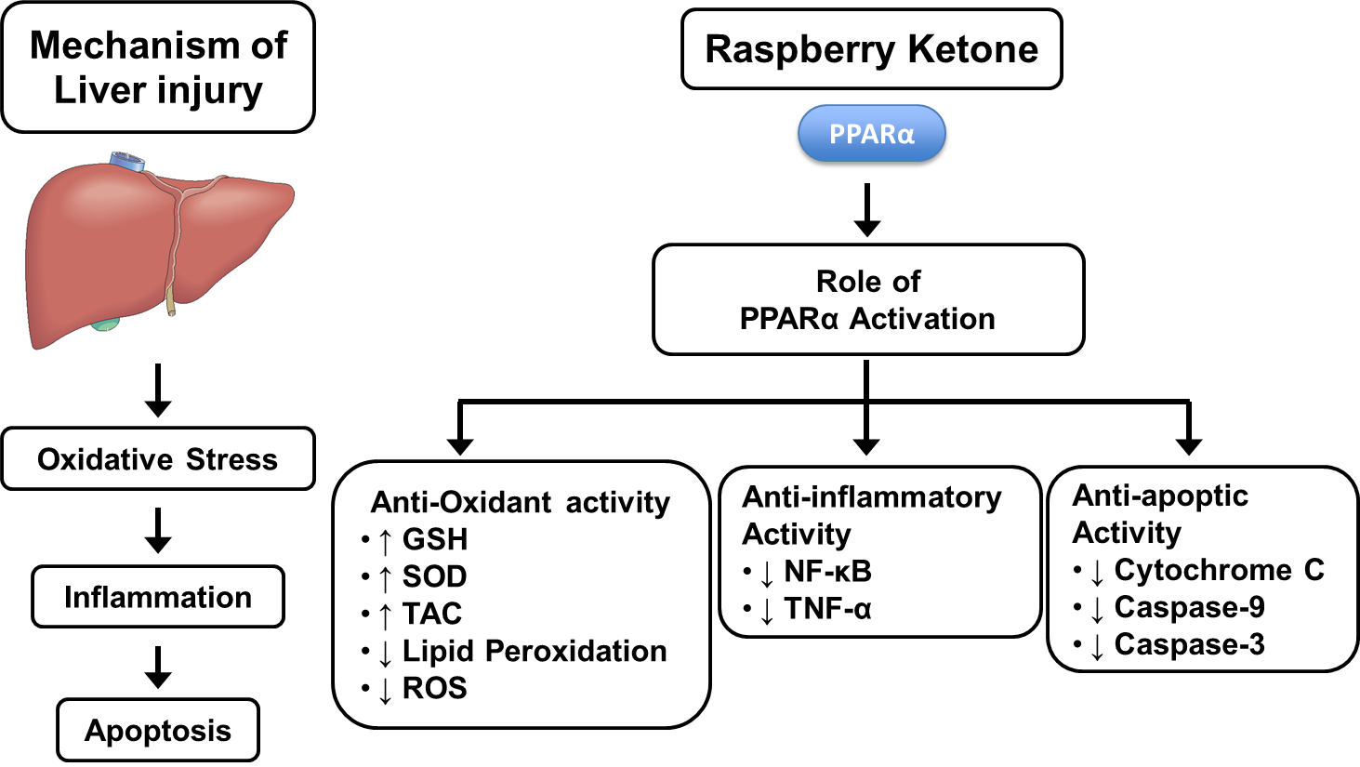
Figure 3. Schematic of molecular pathways modulated by Raspberry Ketone in metabolic disease creased antioxidant activity (↑GSH, SOD, TAC) and anti-inflammatory effects (↓NF-κB, ↓TNF-α), while also reducing apoptotic markers (↓cytochrome c, ↓caspases).

3.3. Cardioprotective Effects
RK pre-treatment (50–200 mg/kg, oral) markedly reduced myocardial infarct size and cardiac injury markers compared to untreated MI controls in isoproterenol-induced myocardial infarction (MI) in rats [13]. Mechanistically, RK-treated hearts after myocardial infarction (MI) showed retained antioxidant enzyme levels (CAT, SOD) and lower lipid peroxidation (MDA) with reduced inflammatory cytokines. This suggests that RK helps in lowering the oxidative stress and inflammatory cascade, thus reducing the cardiac cell death in infarction. The cardioprotection from RK was comparable to that of fenofibrate (a PPAR-α agonist drug), which also reduced the size of the infarct tissue [13], indicating PPAR-α mediated pathways. Figure 4 (below) illustrates the reduction in infarct size by RK: visual tetrazolium-stained heart slices display smaller pale infarct areas with RK, and quantification (panel G) shows dose-dependent lowering of infarct percentage [13]. These findings propose RK as a potential adjunct for cardiometabolic protection, although human data does not exist yet.
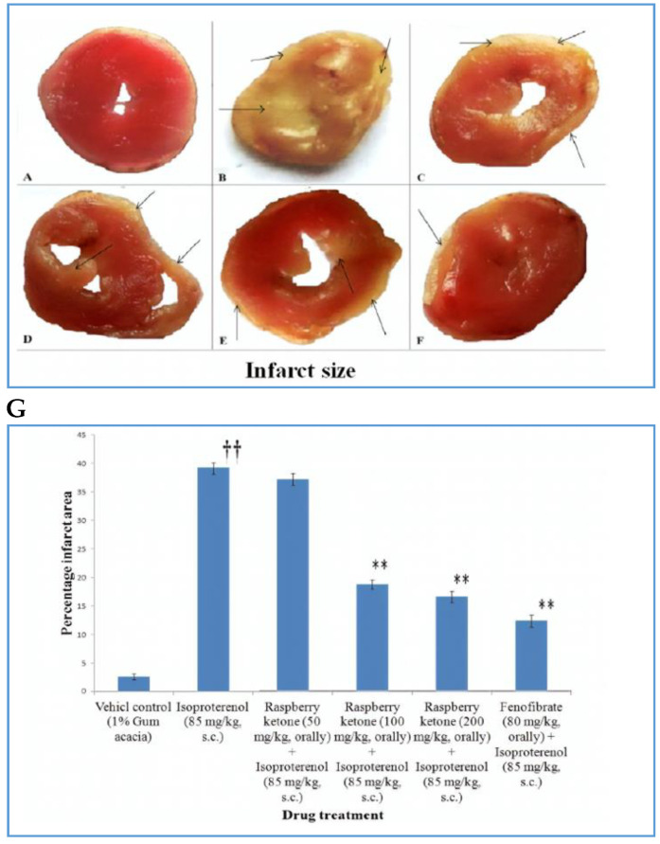
Figure 4. Cardioprotective effect of Raspberry Ketone in a rat myocardial infarction model. (A–F) Representative heart cross-sections (stained to show infarct in pale areas, arrows) for control, isoproterenol-induced MI, and MI with RK or fenofibrate treatments. RK-pretreated groups show visibly smaller infarcts vs. untreated MI. (G) Bar graph of infarct size (% of left ventricle) demonstrates that RK at 50–200 mg/kg significantly reduced infarct area (*p<0.01 vs. MI control) in a dose-dependent manner, approaching the protection afforded by fenofibrate. (Adapted from Khan et al., 2018) [13]

3.4. Gastroprotective and Other Pharmacological Effects
Recent studies have expanded RK's applicability to gastrointestinal and dermatological fields. A 2019 study by Badr, El-Orabi, and Ali showed that RK had strong gastroprotective effects in a murine model of ethanol-induced gastric ulcers as it decreased ulcer area and gastric mucosal damage, presumably by activating Nrf2 (Nuclear factor erythroid 2-related factor 2 – an antioxidant response factor) and downregulating HMGB1 (High Mobility Group Box 1 – a pro-inflammatory alarmin), thus reducing oxidative stress and apoptosis in gastric tissue [23]. Figure 5 shows the mechanism protection of gastric mucosa by RK. RK boosts Nrf2 signaling, which raises the levels of antioxidant enzymes of catalase and GPx (Glutathione Peroxidase) followed by lowering of inflammatory factors, TNF-α and Bax/Bcl-2 ratio, which together protect the gastric mucosa.
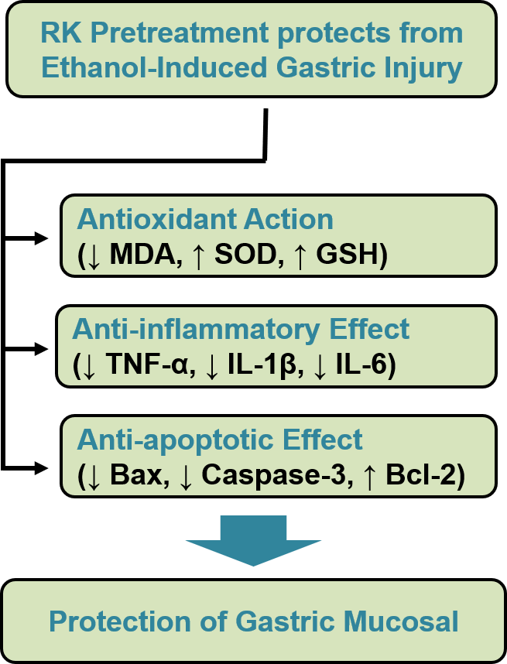
Figure 5. Schematic diagram of the different molecular targets involved in the gastroprotective effects of RK against ethanol-induced gastric ulcer in rats.

RK has been shown in dermatological research to lighten skin by suppressing melanogenesis and inhibiting tyrosinase [24]. Tyrosinase inhibition stops L-tyrosine from being converted normally, which causes it to accumulate locally. This excess tyrosine can then interact with RK to form adducts, accompanied by ROS generation that contributes to selective melanocyte damage [25]. Although less explored, RK has been observed to demonstrate anti-androgenic effects in vitro through the inhibition of androgen receptor activity [26] and also to facilitate bone anabolism in cell line studies by enhancing osteoblast differentiation [27]. One preclinical study has also indicated that RK demonstrates considerable antidepressant-like effects in LPS-Induced Depression Model, likely mediated by increased brain dopamine and serotonin levels and reduced neuroinflammation [28].
3.5. Combination Therapies and Clinical Observations
Although, it is challenging to isolate RK's contribution in formulations containing multiple ingredients yet there are studies where RK has been mixed with other supplements because of its nutraceutical popularity. The overweight people who took the supplement (RK, caffeine and other ingredients) in a randomized 8-week trial, lost a small amount of weight and felt more energetic and had not observed any serious side effects [29]. In another study in animals, RK and white tea extract together improved antioxidant status and lowered liver fat in a model of liver injury caused by toxins [29]. These findings suggest that RK may serve as a candidate for combination therapy in metabolic syndrome, a potential that remains to be confirmed in further studies. As of 2025, human clinical data on RK alone is very limited with only a few small trials or case studies, none of which offer definitive evidence of efficacy.
Critically, many of these are preliminary often with very small sample size, preclinical tests on mice or rats, and that to with doses much higher than usually taken by humans. As pointed out by most of the reviews, very few human studies that too with small trials do not show benefits with a clarity. Although, one docking study suggests binding with PPAR-α, yet there is no wet lab report from knockout studies or blockers [30]. Another problem is that most papers, especially in nutraceutical research show only positive results, while negative or no-result studies are often not reported. Overall, RK shows many effects in lab and animal studies, but we should apply in Humans only after more clear data from dose and long-term safety studies are available.
4. Toxicological Profile
4.1. Absorption, Distribution, Metabolism, Excretion (ADME)
Recent progress like development of HPLC-MS/MS methods has made it easier to detect and measure RK and its metabolites in plasma and brain [31]. Mammals absorb RK quickly, and a key study in rats, guinea pigs, and rabbits showed that over 90% of an oral dose was taken up and passed out in urine within 24 hours [32]. Mostly RK metabolism involves converting the ketone to rheosmin alcohol i.e. 4-(4-hydroxyphenyl)-2-butanol which along with its conjugates, such as glucuronides are excreted in urine [2], [6], [17]. Whereas, Minor pathways involve p-hydroxylation of the benzene ring and side-chain β-oxidation, resulting in metabolites such as 4-hydroxybenzoic acid and 4-hydroxyphenyl acetic acid. A recent study on mice found that RK levels in the blood peaks in just 5 to 30 minutes after oral dosing. It is found in fat and brain, but levels in the blood drop off after a few hours. RK was cleared more slowly and built up more in fat in diet induced obese mice than in lean mice. This is likely because obese mice take more of it due to high fat [33]. Rodents and rabbits produce the same metabolites which differ in their relative proportions [17]. One consequence of the rapid metabolism to raspberry alcohol, which is relatively inert, is that the real effects may also be of shorter duration or if longer, they may be due to presence of other stronger metabolites, if any.

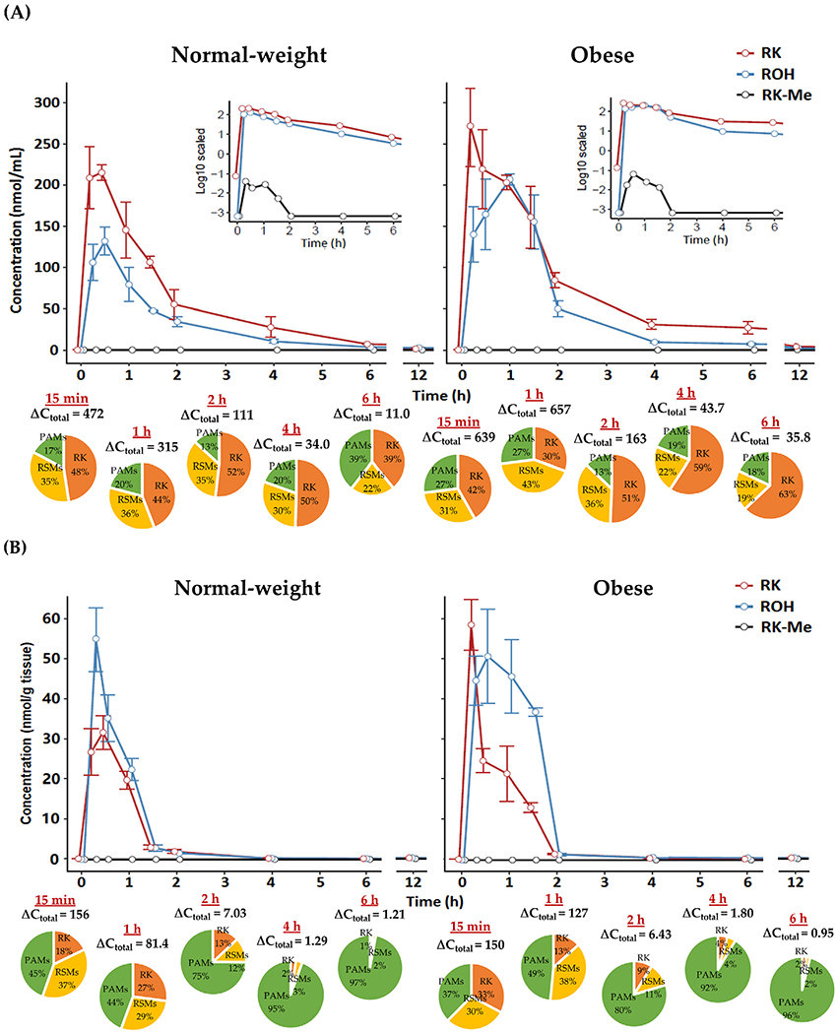
Figure 6: Image shows the comparison of plasma concentration-time curves of RK in lean vs. obese models, illustrating slower clearance in obesity. Pie charts indicate profile of different phenolic categories. ΔC_{total}, net change in total phenol concentration versus baseline. Data are expressed as mean ± SEM (n = 3–5). (Adopted from Zhao et al., 2020) [33].

4.2. Dose–Response and Safety Margins
In animal models, RK shows low acute toxicity. LD50 estimates in rodents are in the g/kg range, which means they can handle large oral doses and have a large safety margin [34]. In 90-day rat studies, doses up to about 700 mg/kg/day showed no significant toxicity or organ damage [35]. However, there are very limited systematic toxicological data [36]. In rodents, elevated doses showed little effects on organ like increased liver and kidney weights without significant histopathological changes [35]. The majority of RK's beneficial effects like weight loss, happen at high doses (50–200 mg/kg in rats), which correspond to an equivalent dose of several hundred milligrams for humans, where safety is not clear. Standard tests have not shown any signs of genotoxicity or mutagenicity (Ames tests negative) [35].

4.3. Computational Toxicology Predictions
For safety, researchers also employed computer models (QSAR) to check RK. These models indicated some risks associated with elevated exposure, such as alterations in heart rhythm or impacts on embryonic development [37]. But still, they are predictions, have not been proven by real experiments, therefore they should be taken as early cautions instead of confirmed conclusions.

4.4. Human Adverse Events
RK has been sold as a weight-loss supplement for many years, but clinical safety data are still limited. A small human trial with a mixed supplement showed no major safety issues compared to placebo over 8 weeks [29]. Since most RK supplements also contain caffeine and other stimulants, it is hard to know the exact safety of RK alone. A 2013 review found no major side effects directly linked to RK, but also noted that human studies are still too few to fully confirm safety [17]. here it is worthwhile to mention that RK has a metabolite named, Rhododendrol, which was earlier used in skin-lightening products in cosmetics but was found to be linked with causing leukoderma by inducing melanocyte cytotoxicity via tyrosinase-mediated quinone formation [17]. But the usual systemic exposure from oral RK is much lower and more spread out.

4.5. Comparative Toxicology (Species Differences)
In rodents, RK is rapidly reduced to raspberry alcohol (rhododendrol), which is then conjugated and excreted. Studies in human liver microsomes suggest a similar pathway, with carbonyl reductase enzymes converting RK to rhododendrol as the main metabolite [17]. Species may differ in phase II metabolism; for example, rabbits may form more sulfate conjugates than rodents. However, no species-specific toxicity has been seen, and RK showed no organ specific toxicity at normal test doses. High-dose effects of RK on the CNS are not well studied, and its similarity to compounds like synephrine (a phenylethylamine, having CNS stimulant effects and used in weight loss) has raised concerns about possible stimulant toxicity. However, animal studies so far have not shown such effects at normal doses. Figure 7 summarizes RK metabolism and distribution. In rats, guinea pigs, and rabbits, about 70–80% of RK is excreted in urine within 24 hours, mainly as conjugated forms of RK and its reduced metabolite, raspberry alcohol. Rabbits show the highest reduction, while minor pathways involve ring hydroxylation and side-chain oxidation, yielding various hydroxylated derivatives and cleavage products [32]. The Figure also shows tissue distribution, showing greater accumulation of RK in fat tissue, with clear differences between lean and obese animals as reported by Zhao et al. (2020). [33].
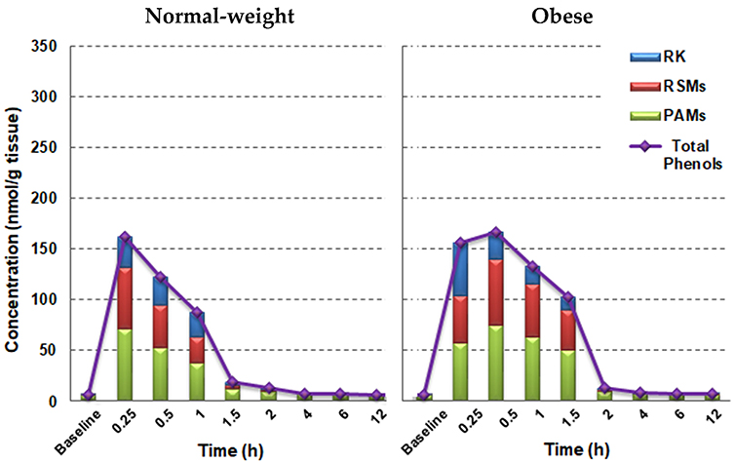
[A]
[B]
Figure 7. (Comparative ADME) [A]A visual summary of RK metabolism across species – for instance, a schematic or chart showing >80% urinary excretion of RK as raspberry alcohol and conjugates in rats vs. projected human pathway. [B] tissue distribution of RK and metabolites in tissues (e.g., accumulation in adipose tissue) differences between lean and obese phenotypes

Present reports show RK is not acutely toxic in doses used by humans, but exact safety limits are not clear. Lack of full toxicology data, especially for long use and effects on reproduction, is a concern for regulators. Due to the high daily intake recommended (up to 1 g/day) and RK's pharmacologically active properties, a cautious approach is necessary. Since Average Daily intake can not be fixed without more studies, so further controlled work is needed and these should include tests for reproductive toxicity in rodents, tests for possible pro-arrhythmic effects (since RK is structurally similar to some aromatic ketones that can affect ion channels), and tests for hepatotoxicity or nephrotoxicity in long-term use.

5. Emerging Applications
5.1. Nanocarrier Delivery Systems
Researchers have developed delivery systems based on nanotechnology to deal with RK's moderate water solubility and rapid clearance. One approach utilizes self-nanoemulsifying drug delivery systems (SNEDDS) and nanoemulsions [38]. A 2020 work created an RK loaded nanoemulsion with droplet size around 68 nm. This nanoemulsion gave more than double oral bioavailability compared to plain RK suspension in rats. Better absorption was shown by higher Cmax and AUC, maybe due to more solubility and lymphatic transport [39]. RK was also tried in electrospun nanofibers (gelatin/PVA) for controlled release in pharma and food use. Such fibers protect RK from breakdown and release it slowly, useful for skin delivery or functional foods [40], [41]. Liposome encapsulation is another method for drug delivery. It hasn't been widely published for RK yet, but liposomal RK may give better stability in body and easy tissue delivery [42]. Nanocarriers can also send drug to target site e.g., hepatocyte-targeted nanoparticle can take RK to liver for NAFLD treatment, with less systemic exposure.

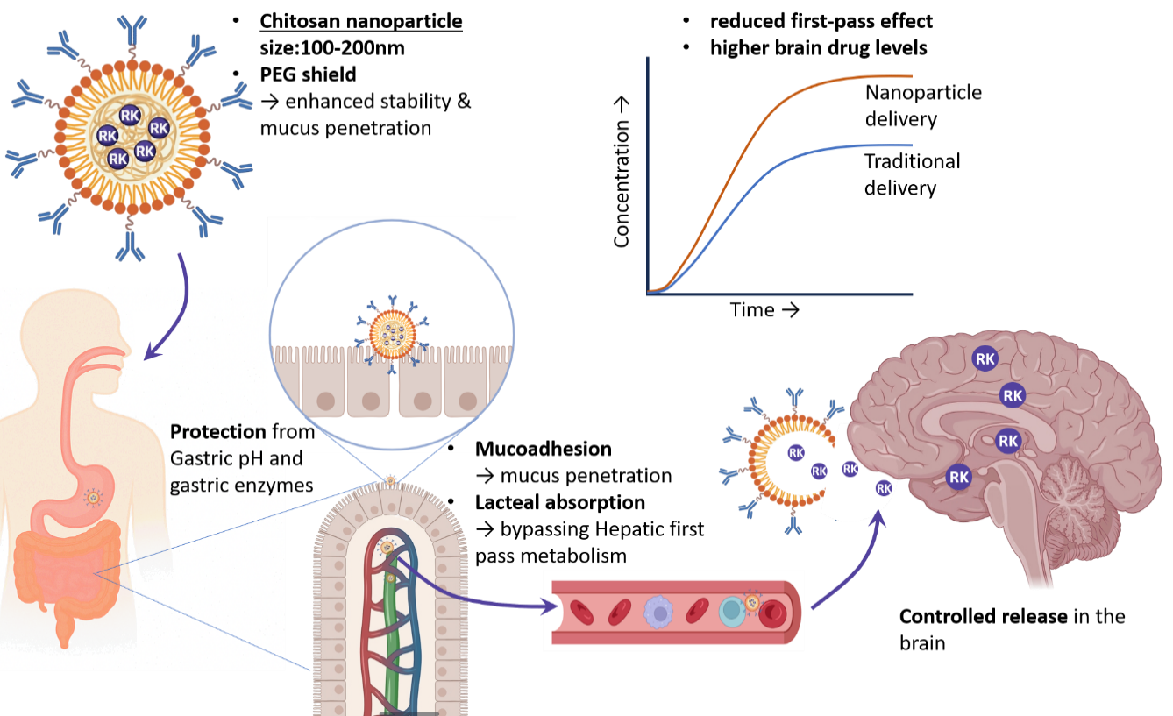
Figure 8. Oral delivery of a drug encapsulated in chitosan nanoparticles, emphasizing protection of RK, enhanced absorption, bypassing hepatic (liver) metabolism and targeted release in the brain.
5.2. AI-Based Compound Optimization
The emergence of artificial intelligence in drug discovery opens new pathways to enhance novel drug molecules [43] such as RK and its analogues. Machine learning models trained on nutraceuticals can predict biological activities, and same can be applied for RK to find more potent or safer analogs. For example, virtual screening by ML may suggest changes in RK structure to increase PPAR-α activity or reduce unwanted effects. AI techniques like as generative chemistry can design new compounds based on RK structure, e.g., by adding halogen to modify lipophilicity or replacing phenolic OH with stable groups while retaining activity. Early investigations employ QSAR models and docking to evaluate the binding affinity of such analogs [44]. AI and optimization algorithms can also help design the best nanocarrier or co-crystal for better RK delivery. Though still early, this shows future use of computational intelligence to solve RK limits and adjust its properties for certain medical needs.
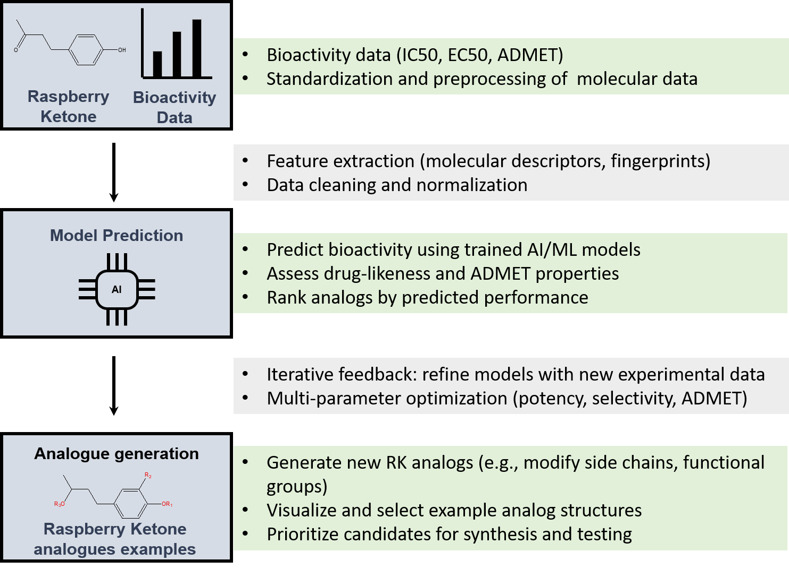
Figure 9: An AI-driven pipeline for RK analog design

5.3. Biotechnological Production & Green Chemistry
Because RK demand is high in industry, sustainable production is focus now. Scientists have genetically modified microbes and plants to make RK and reduce need of chemical synthesis, which uses harmful reagents and makes waste. Bioengineered E. coli can change glucose to RK through phenylpropanoid pathway; one study got about 62 mg/L by overexpressing key enzymes [2]. Transgenic tobacco plants with RK synthase also made RK but in low amount. Enzyme-based biocatalysis can also convert cheap precursors to RK in one step. These green chemistry methods are cheaper and safer for environment. RK itself is biodegradable, so there is no risk of accumulation, but chemical synthesis wastes are harmful, which biotech methods can reduce [2].

5.4. Environmental Impact and Ecological Aspects
It's interesting that RK has ecological roles that are being used. Raspberry ketone analogs, like cue-lure, are used in farming to attract fruit flies and pest control. RK has been evaluated as an attractant to entice male fruit flies (Bactrocera species) for population control, utilizing the compound's inherent role in plant-insect interactions [46]. Even though RK is a natural substance, the mass release of synthetic RK into ecosystems should be monitored. This is because adding a lot of it could change how pollinators act or how microbial communities work. So far, no negative effects on the environment have been reported. RK is thought to be safer for the environment than traditional insecticides when used in integrated pest management.
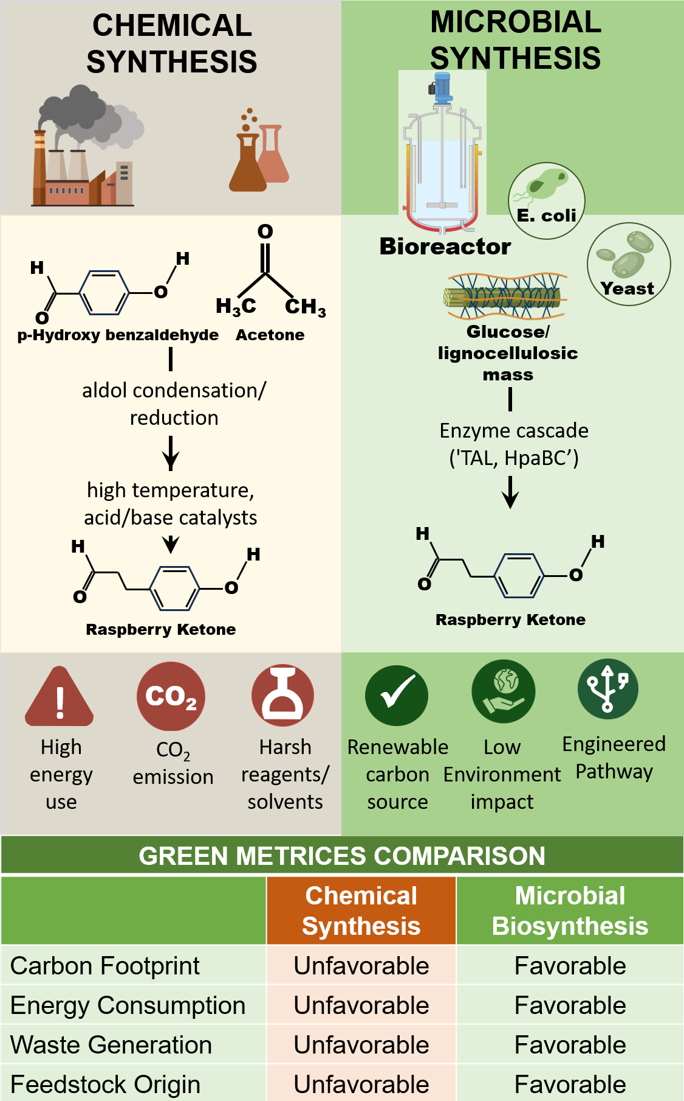
Figure 10: Presenting comparison of microbial RK production vs. chemical synthesis

6. Critical Analysis
This critical analysis evaluates peer-reviewed research (2015–2025) on raspberry ketone (RK), focusing on methodological rigor, experimental reproducibility, translational validity, computational model accuracy, and commercial scalability. The objective is to pinpoint knowledge deficiencies and prospective research strategies to facilitate RK's transdisciplinary progress. Outcomes are discussed as follows:
6.1. Limitations of Current Studies: Despite with many studies on RK, there are limitations and mixed results. Reproducibility is problem, as many activities like anti-obesity or liver protection are shown only by one or two groups. More studies in different labs and models are needed to confirm. Some anti-obesity works used RK with mixtures or lifestyle changes, so results are not clear. Also, there is no standardization in dose, duration, or outcome, which makes comparison and meta-analysis difficult
6.2. Human Relevance and Translational Gap: A critical gap is translation to humans. Almost all RK pharmacological data is preclinical, and human trials are very few. Rodent effective dose (~100 mg/kg) is much higher than human supplement dose (100–500 mg/day), so similar plasma level may not come unless special formulation used. Because human efficacy data are missing, we cannot confirm benefit in weight loss or liver health. Marketing shows strong claims, but clinical proof is weak, so proper human trials are needed.
6.3. Safety and Regulatory Issues: Safety data on RK are not complete, which is a big concern. In EU and other places, RK is sold as supplement or flavor, so it did not face strict testing like new drug. This gap means people use it without full toxicology or clinical trial proof. If used as medicine, agencies like FDA or EMA would ask for chronic toxicity, carcinogenicity, and human pharmacokinetics data. At present RK is in gray zone – sold widely and thought safe due to food use, but not approved for medicinal use. Physicians cannot prescribe it with confidence, and since RK cannot be patented, pharma companies have less interest to do costly trials
6.4. Methodological Robustness: Some methods in RK research are not strong. Proper controls and blinding in animal studies are often missing, which can give bias if investigator knows treatment group. In metabolic studies, food intake and diet should be controlled, since RK itself may reduce eating and cause weight change. Purity of RK must also be checked, as some commercial products have other ingredients. Without chemical tests like HPLC, results may be confused by impurities
6.5. Interpretation and Hype: RK has been promoted with big claims like ‘miracle fat burner,’ but these are not based on strong science. Animal studies show only modest effect, like 5–10% less weight than controls [21], not a magic result. RK should be taken as bioactive compound of interest, not proven therapy. Clear view of data is needed to avoid wrong expectations and guide research properly.
6.6. Positive Controls and Comparators: Important point is how RK works compared to existing drugs. In obesity, drugs like orlistat or GLP-1 agonists have proven effect, but RK is rarely compared with them. Only few studies, like cardioprotection work, showed RK similar to fenofibrate in antioxidant action [13]. Without such comparisons, real value of RK is not clear. Future studies should use standard drugs as positive control to judge RK efficacy.
Reproducibility Initiatives: RK research can benefit from open data and the preregistration of animal studies. Sharing protocols and raw data will help make things more consistent. Multi-center studies can enhance reproducibility and validate findings across many laboratories.

In summary, RK shows biological activity but research has many gaps. To move RK from nutraceutical to real therapy, studies must be better designed, reproducible, and include full safety data. Conclusions should be careful, like saying RK may help metabolism, until human proof is there. Future proper work will show if RK is truly useful or only hype.

7. Future Directions
To clarify RK’s mechanisms, CRISPR-Cas9 screening platforms such as Perturb-Seq are theoretically promising for identifying gene dependencies mediating RK-induced lipolysis or antioxidant activity. Though direct studies on RK are lacking, this approach has been validated for metabolic effectors in adipocytes.
Integrated multi-omics in vivo studies—combining transcriptomics and metabolomics in hepatic and adipose tissues—are needed to distinguish RK’s primary targets. In a model addressing diet-induced metabolic dysfunction, systems biology linked fatty acid oxidation to nuclear receptor activation, offering a framework to apply in RK studies.
Biosynthesis and Metabolic Engineering – On the production side, continued efforts in metabolic engineering are anticipated. Microbial biosynthesis of RK using engineered E. coli or yeast strains has been explored to improve yield and sustainability. One study engineered Saccharomyces cerevisiae for raspberry ketone synthesis via tyrosine-derived pathways, laying groundwork for scalable bioproduction [47].
Targeted delivery using nanocarriers remains conceptual for RK, but analogs like zingerone and capsaicin have shown improved bioavailability when encapsulated in lipid-based systems. Such strategies could be adapted for RK in NAFLD or obesity models.
Transdermal and functional food delivery formats have been proposed, building on anecdotal and in vitro studies. Harada et al. reported that topical RK promoted hair growth and dermal IGF-I expression in mice, suggesting local delivery feasibility [48].

Though clinical trial data are scarce, PK profiling of phenolic compounds structurally related to RK (e.g., capsaicin, vanillin) support initial dosing safety. Preclinical data indicate a wide safety margin for RK in rodents.
Structure–activity relationship (SAR) analysis highlights analogues like zingerone and 4-hydroxybenzylacetone, structurally similar to RK, as promising candidates with improved metabolic stability and for depression. Efforts in SAR could guide medicinal chemistry programs to develop a lead compound from the RK scaffold with pharmaceutical potential (for instance, adding halogen might improve receptor binding affinity).
To elevate RK research, Nature/Science-style rigor should be pursued—emphasizing reproducibility (e.g., ARRIVE guidelines), interdisciplinary integration, and negative result transparency. By treating RK not just as a supplement but as a scientific compound of interest, future research will likely apply cutting-edge methods and maintain high standards of evidence.
Figure 11 provides a forward-looking schematic: This workflow enables systematic discovery of RK's molecular targets and resistance mechanisms. The lentiviral approach maintains sgRNA representation throughout screening, while ML-enhanced sorting enables phenotype detection without fluorescent markers. Integrating CRISPR screening with RK treatment provides a powerful tool to deconvolve its polypharmacology and optimize therapeutic applications. This encapsulates how future directions converge to fully realize (or refute) RK’s potential as a beneficial compound.
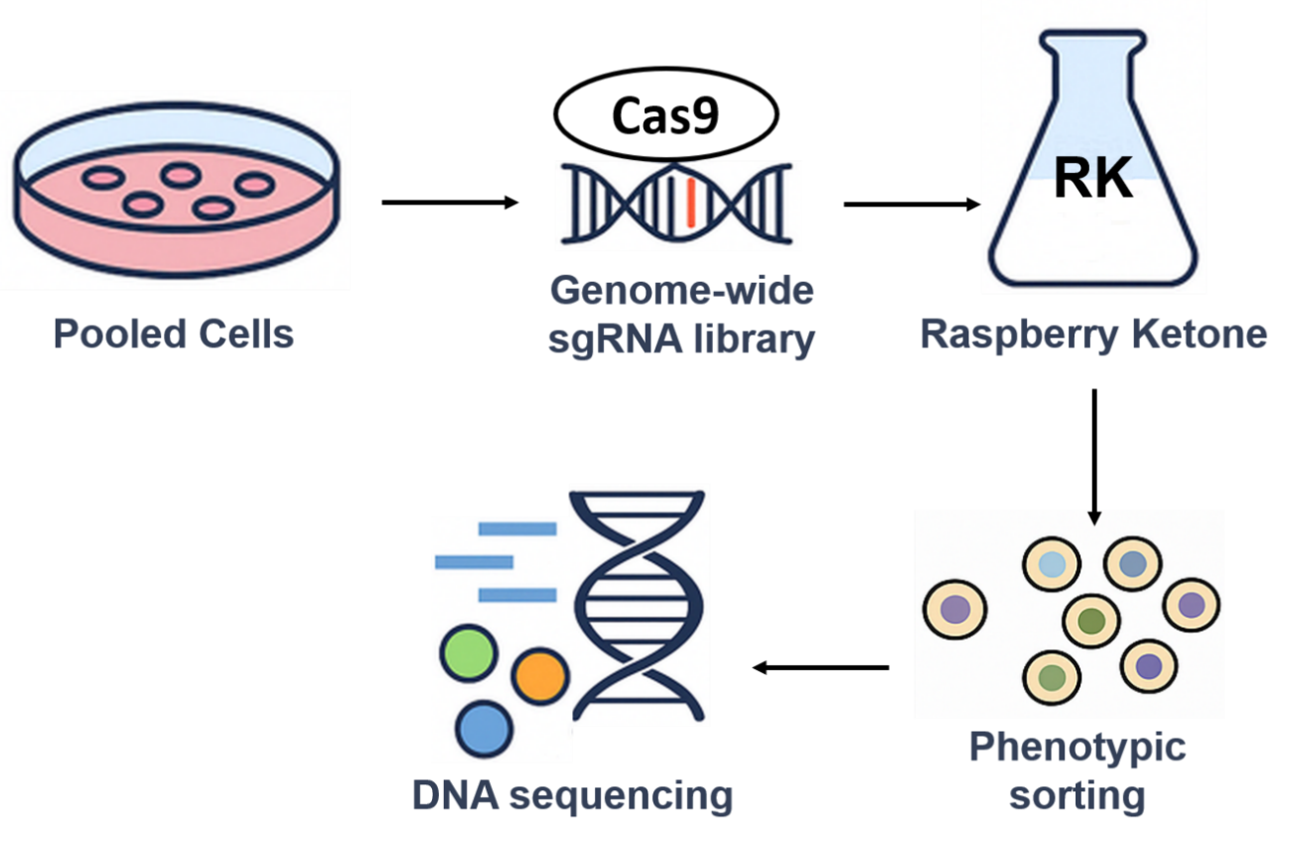
Figure 11: CRISPR screening workflow showing the cells are lentivirally transduced with sgRNA libraries, exposed to RK, and sorted for a phenotype (such as cells resistant to RK’s effect), then sequencing reveals which gene disruptions were enriched [49].
Appendix
• Literature Search Strategy: A comprehensive literature search was performed to gather relevant studies from 2015–2025 using databases PubMed, Scopus, and Web of Science with a combination of keywords and Boolean operators. The core search term was (“raspberry ketone” OR “4-(4-hydroxyphenyl)butan-2-one”) that included both the common name and chemical name. This was combined with topic-related terms to filter for specific aspects, for example:
• For pharmacology/biological activity: AND (“bioactivity” OR “mechanism” OR “PPAR” OR “obesity” OR “metabolic” OR “pharmacology”).
• For toxicology/safety: AND (“toxicity” OR “toxicology” OR “safety” OR “ADME” OR “metabolism”).
Additionally, date ranges from “2015” through “2025” were selected in PubMed’s publication date filter (e.g., ("2015"[DP] : "2025"[DP]) in PubMed syntax) to get the latest results to the last 10 years. An example of a final query string in PubMed was:
("raspberry ketone" OR "4-(4-hydroxyphenyl)butan-2-one") AND (mechanism OR toxicity OR bioactivity OR synthesis) AND ("2015"[Date - Publication] : "2025"[Date - Publication]).
• Inclusion/Exclusion Criteria: We used mainly peer-reviewed primary research publications focusing journals with Impact Factor >5.0 to make sure high-quality studies. Key review articles (e.g., Rao et al., 2021 pmc.ncbi.nlm.nih.gov) were consulted for background and reference mining but emphasis was on original experimental data. We excluded anecdotal reports, non-peer-reviewed sources, and studies before 2015 (except for historical context) to keep the content current. Non-English articles were also excluded unless an English abstract provided critical information.
• Data Extraction: Data from each study were extracted regarding objectives, methods, key findings, and relevance to RK’s chemistry or bioactivity. These were tabulated and then synthesized into the sections above. Particular attention was given to results that were well-validated (e.g., dose-dependent effects with statistics, or mechanistic insights confirmed by multiple methods), as per the instruction to prioritize “mechanistically deep, well-validated studies.”
• Bibliometric Data: We looked for "RK" in the article title, abstract, and keywords on Dimensions.ai and compiled the publication trends. We filtered for articles between 2015 and 2025 and analyzed the number published year wise. These exhibited an upward trend, as shown in Figure S1. We also found the best journals and research fields for these publications, such as pharmacology/toxicology journals (about 30%), food science journals (about 20%), and so on.
Supplementary Figures:
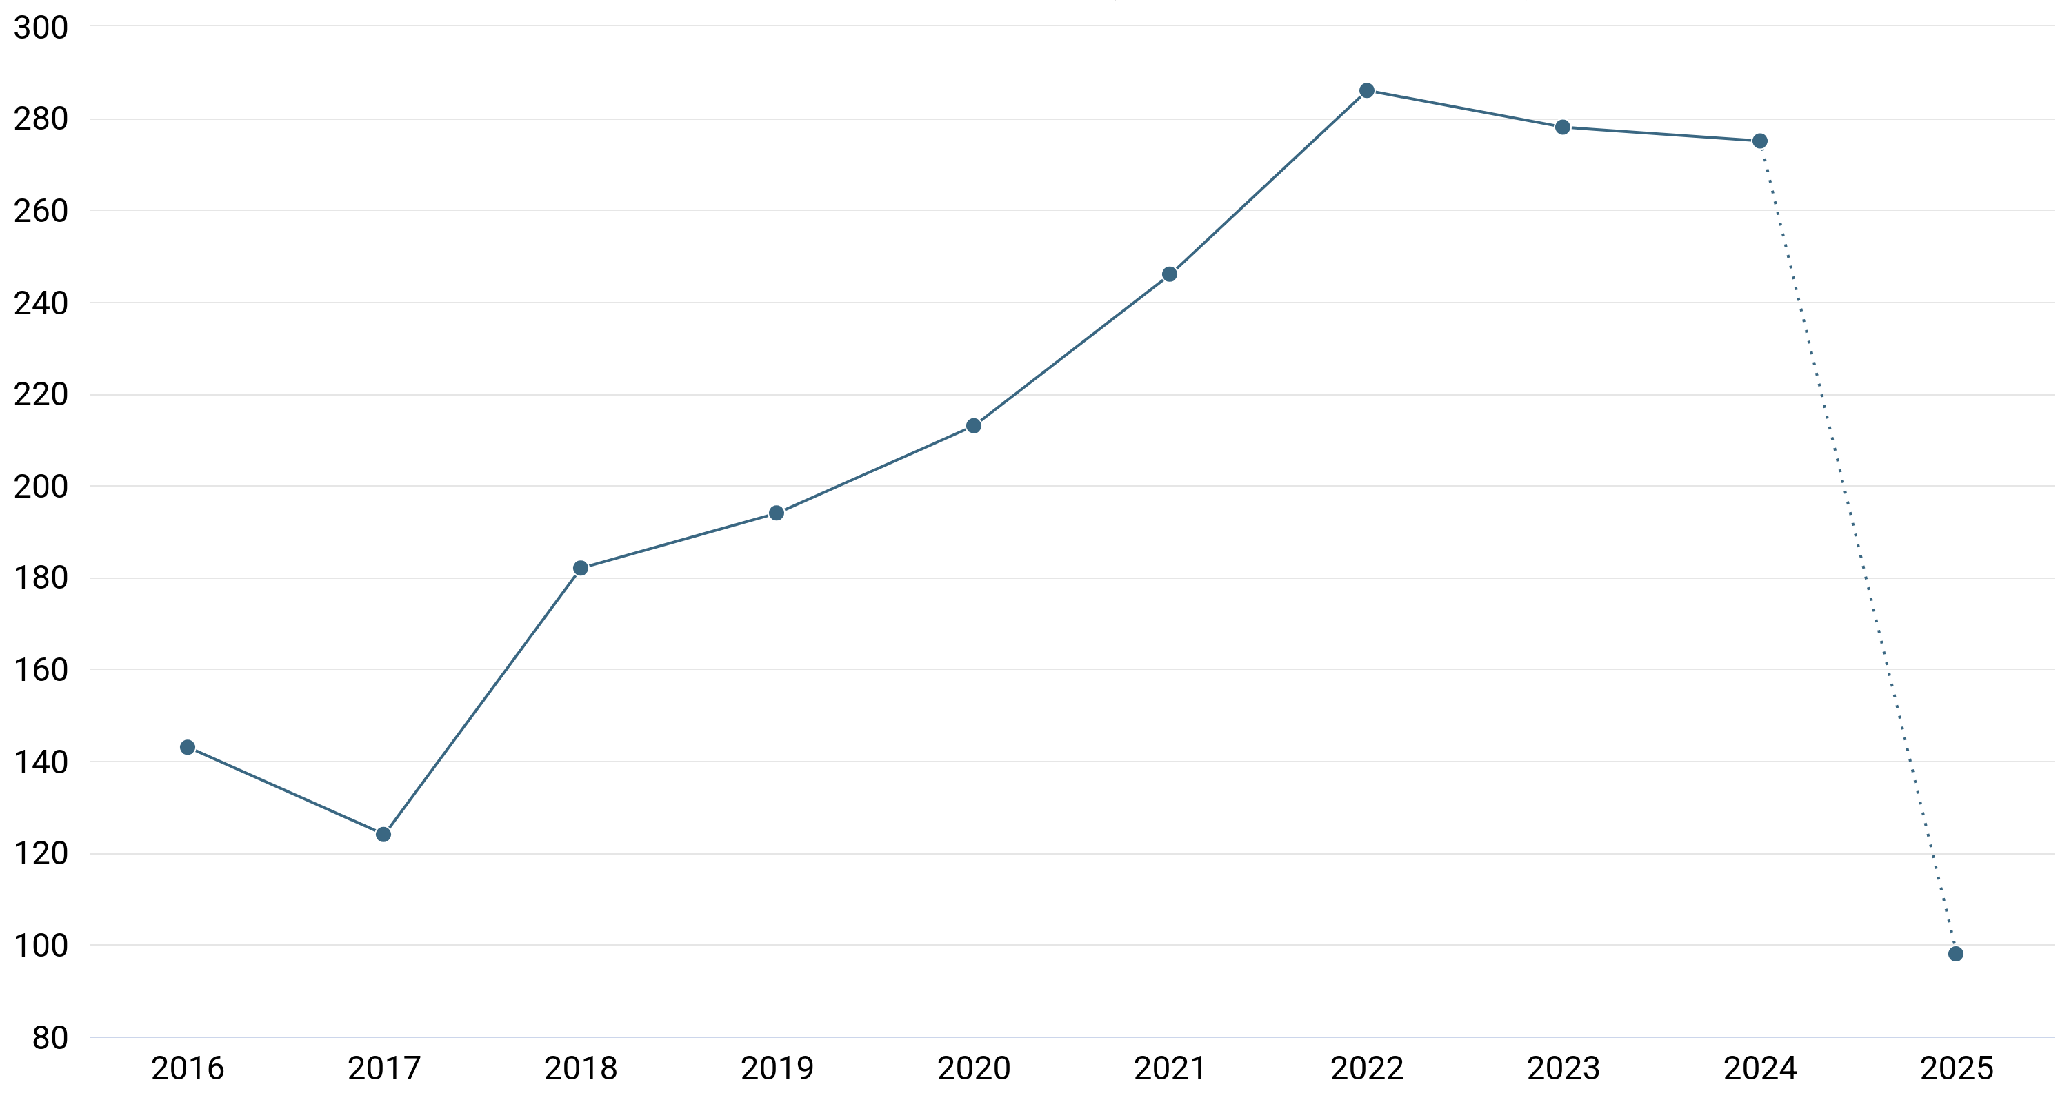
[A]
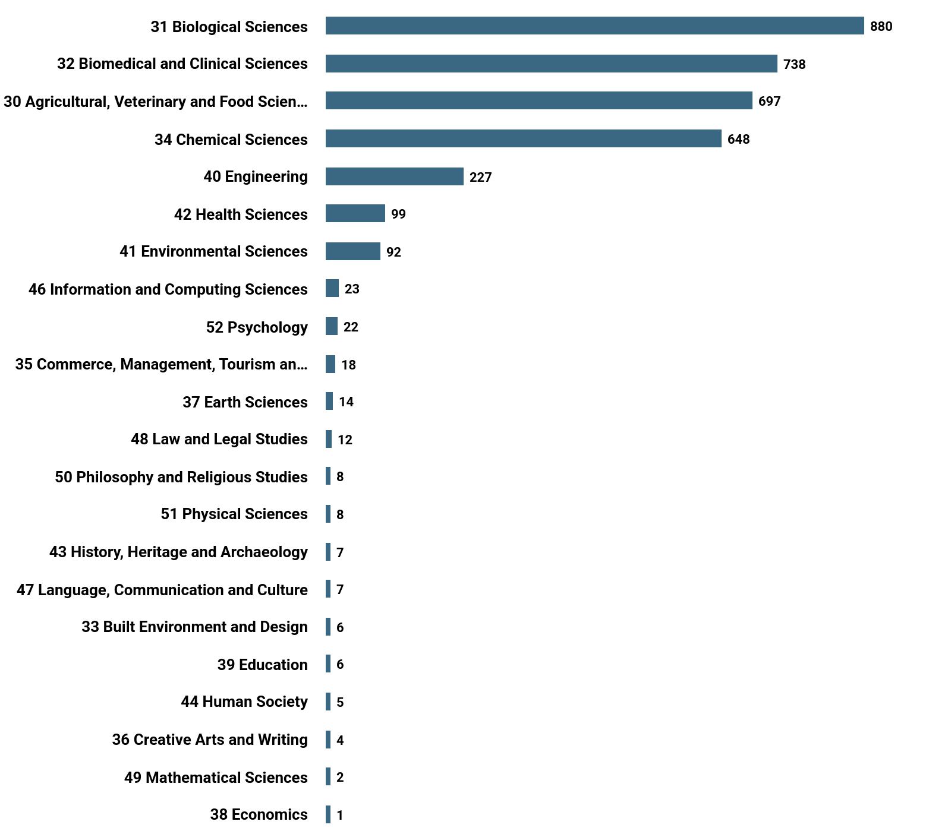
[B]
Figure S1. Preliminary bibliometric analysis of Raspberry Ketone (RK) research trends.
([A]) Year-wise distribution of publications on RK.
([B]) Domain-wise distribution of publications on RK.
Publication source: Dimensions.ai. Search criteria: "Raspberry Ketone" AND ("anti-obesity effects" OR hepatoprotection OR cardioprotection OR dermatology OR entomology") in full data.

Supplementary Table:
Table S1. Various RK production methods (chemical vs. bio-based) and their environmental footprints (energy use, waste generation).
Sr. No. | Production Method | Precursor/Substrate Used | Yield / Productivity | Environmental Footprint | Scale | Reference
1 | Enzymatic biocatalytic cascade[45] | Rhododendrol glycosides from Betula pendula | ~93% isolated yield from 150 mg substrate | GMO-free; efficient cofactor recycling; minimal waste | Lab-scale | Becker et al., 2021
2 | Chemical synthesis[50] | p-Hydroxybenzaldehyde and acetone | Not specified; general overview | Involves use of solvents and catalysts; potential environmental concerns | Industrial-scale | Guo et al., 2021
3 | Microbial fermentation using engineered E. coli[3] | p-Coumaric acid | Up to 5 mg/L | Genetically modified; moderate environmental impact | Lab-scale | Beekwilder et al., 2007
4 | Transgenic plant-based biosynthesis[4] | Tyrosine via phenylpropanoid pathway | Not specified; proof-of-concept | Plant biofactory; sustainable potential; GMO concerns | Lab-scale | Koeduka et al., 2021
5 | Fungal fermentation [51] | Glucose-based media | Not specified; optimization study | Potential low impact; submerged fermentation | Lab-scale | Zhang et al., 2024

COMPETING INTERESTS DISCLAIMER:
Authors have declared that they have no known competing financial interests OR non-financial interests OR personal relationships that could have appeared to influence the work reported in this paper.

References
[1] M. Larsen and L. Poll, “Odour thresholds of some important aroma compounds in raspberries,” Z. Für Lebensm.-Unters. Forsch., vol. 191, no. 2, pp. 129–131, Aug. 1990, doi: 10.1007/BF01202638.
[2] S. Masuo, C. Saga, K. Usui, Y. Sasakura, Y. Kawasaki, and N. Takaya, “Glucose-Derived Raspberry Ketone Produced via Engineered Escherichia coli Metabolism,” Front. Bioeng. Biotechnol., vol. 10, p. 843843, Feb. 2022, doi: 10.3389/fbioe.2022.843843.
[3] J. Beekwilder et al., “Microbial production of natural raspberry ketone,” Biotechnol. J., vol. 2, no. 10, pp. 1270–1279, Oct. 2007, doi: 10.1002/biot.200700076.
[4] T. Koeduka et al., “Production of raspberry ketone by redirecting the metabolic flux to the phenylpropanoid pathway in tobacco plants,” Metab. Eng. Commun., vol. 13, p. e00180, Dec. 2021, doi: 10.1016/j.mec.2021.e00180.
[5] U.S. Food and Drug Administration (FDA), “21 CFR 172.515: Synthetic flavoring substances and adjuvants.” U.S. National Archives and Records Administration, Mar. 17, 2014. Accessed: May 08, 2025. [Online]. Available: https://www.ecfr.gov/cgi-bin/ECFR?page=browse
[6] C. Morimoto, Y. Satoh, M. Hara, S. Inoue, T. Tsujita, and H. Okuda, “Anti-obese action of raspberry ketone,” Life Sci., vol. 77, no. 2, pp. 194–204, May 2005, doi: 10.1016/j.lfs.2004.12.029.
[7] P. A. C. McPherson, N. McKenna, and B. M. Johnston, “Physicochemical Properties of 4-(4-Hydroxyphenyl)-butan-2-one (‘Raspberry Ketone’) Evaluated Using a Computational Chemistry Approach,” ACS Omega, vol. 9, no. 22, pp. 23963–23970, Jun. 2024, doi: 10.1021/acsomega.4c02293.
[8] M. D. Kengar, R. S. Howal, D. B. Aundhakar, A. V. Nikam, and P. S. Hasabe, “Physico-chemical Properties of Solid Drugs: A Review,” Asian J. Pharm. Technol., vol. 9, no. 1, p. 53, 2019, doi: 10.5958/2231-5713.2019.00010.2.
[9] J. Aihara, “Reduced HOMO−LUMO Gap as an Index of Kinetic Stability for Polycyclic Aromatic Hydrocarbons,” J. Phys. Chem. A, vol. 103, no. 37, pp. 7487–7495, Sep. 1999, doi: 10.1021/jp990092i.
[10] M. Lu, F. Guo, B. Fan, Z. Ren, and Q. Li, “Solubility and solution thermodynamics of Raspberry Ketone in pure organic solvents and binary solvent mixtures from T = (293.15 to 333.15) K,” J. Mol. Liq., vol. 246, pp. 332–341, Nov. 2017, doi: 10.1016/j.molliq.2017.09.084.
[11] A. Kumar, K. Shipam, and S. Kumar, “Raspberry ketone loaded self nanoemulsifying system of cardamom oil: Assessment of phase behavior, dissolution rate and anti-hyperlipidemic activity,” J. Drug Deliv. Sci. Technol., vol. 99, p. 105937, Sep. 2024, doi: 10.1016/j.jddst.2024.105937.
[12] D. A. Price, J. Blagg, L. Jones, N. Greene, and T. Wager, “Physicochemical drug properties associated with in vivo toxicological outcomes: a review,” Expert Opin. Drug Metab. Toxicol., vol. 5, no. 8, pp. 921–931, Aug. 2009, doi: 10.1517/17425250903042318.
[13] V. Khan, S. Sharma, U. Bhandari, S. M. Ali, and S. E. Haque, “Raspberry ketone protects against isoproterenol-induced myocardial infarction in rats,” Life Sci., vol. 194, pp. 205–212, Feb. 2018, doi: 10.1016/j.lfs.2017.12.013.
[14] E. T. Mehanna, B. M. Barakat, M. H. ElSayed, and M. K. Tawfik, “An optimized dose of raspberry ketones controls hyperlipidemia and insulin resistance in male obese rats: Effect on adipose tissue expression of adipocytokines and Aquaporin 7,” Eur. J. Pharmacol., vol. 832, pp. 81–89, Aug. 2018, doi: 10.1016/j.ejphar.2018.05.028.
[15] S.-Y. Leu et al., “Raspberry Ketone Reduced Lipid Accumulation in 3T3-L1 Cells and Ovariectomy-Induced Obesity in Wistar Rats by Regulating Autophagy Mechanisms,” J. Agric. Food Chem., vol. 65, no. 50, pp. 10907–10914, Dec. 2017, doi: 10.1021/acs.jafc.7b03831.
[16] K. Park, “Raspberry Ketone Increases Both Lipolysis and Fatty Acid Oxidation in 3T3-L1 Adipocytes,” Planta Med., vol. 76, no. 15, pp. 1654–1658, Oct. 2010, doi: 10.1055/s-0030-1249860.
[17] N. Uramaru, A. Kawashima, M. Osabe, and T. Higuchi, “Rhododendrol, a reductive metabolite of raspberry ketone, suppresses the differentiation of 3T3‑L1 cells into adipocytes,” Mol. Med. Rep., vol. 27, no. 2, p. 51, Jan. 2023, doi: 10.3892/mmr.2023.12938.
[18] L. Wang, X. Meng, and F. Zhang, “Raspberry Ketone Protects Rats Fed High-Fat Diets Against Nonalcoholic Steatohepatitis,” J. Med. Food, vol. 15, no. 5, pp. 495–503, May 2012, doi: 10.1089/jmf.2011.1717.
[19] S. H. Lim and C.-I. Choi, “Potentials of Raspberry Ketone as a Natural Antioxidant,” Antioxidants, vol. 10, no. 3, p. 482, Mar. 2021, doi: 10.3390/antiox10030482.
[20] X. Li et al., “Potential metabolic activities of raspberry ketone,” J. Food Biochem., vol. 46, no. 1, Jan. 2022, doi: 10.1111/jfbc.14018.
[21] T. M. Mir, G. Ma, Z. Ali, I. A. Khan, and M. K. Ashfaq, “Effect of Raspberry Ketone on Normal, Obese and Health-Compromised Obese Mice: A Preliminary Study,” J. Diet. Suppl., vol. 18, no. 1, pp. 1–16, Jan. 2021, doi: 10.1080/19390211.2019.1674996.
[22] D. Fouad, A. Badr, and H. A. Attia, “Hepatoprotective activity of raspberry ketone is mediated via inhibition of the NF-κB/TNF-α/caspase axis and mitochondrial apoptosis in chemically induced acute liver injury,” Toxicol. Res., vol. 8, no. 5, pp. 663–676, Sep. 2019, doi: 10.1039/c9tx00068b.
[23] A. M. Badr, N. F. El- Orabi, and R. A. Ali, “The implication of the crosstalk of Nrf2 with NOXs, and HMGB1 in ethanol-induced gastric ulcer: Potential protective effect is afforded by Raspberry Ketone,” PLOS ONE, vol. 14, no. 8, p. e0220548, Aug. 2019, doi: 10.1371/journal.pone.0220548.
[24] V. C.-H. Lin, H.-Y. Ding, S.-Y. Kuo, L.-W. Chin, J.-Y. Wu, and T.-S. Chang, “Evaluation of in Vitro and in Vivo Depigmenting Activity of Raspberry Ketone from Rheum officinale,” Int. J. Mol. Sci., vol. 12, no. 8, pp. 4819–4835, Jul. 2011, doi: 10.3390/ijms12084819.
[25] Y. Fukuda, M. Nagano, K. Tsukamoto, and M. Futatsuka, “In Vitro Studies on the Depigmenting Activity of 4‐( p ‐Hydroxyphenyl)‐2‐Butanone,” J. Occup. Health, vol. 40, no. 2, pp. 137–142, Apr. 1998, doi: 10.1539/joh.40.137.
[26] Y. Ogawa, M. Akamatsu, Y. Hotta, A. Hosoda, and H. Tamura, “Effect of essential oils, such as raspberry ketone and its derivatives, on antiandrogenic activity based on in vitro reporter gene assay,” Bioorg. Med. Chem. Lett., vol. 20, no. 7, pp. 2111–2114, Apr. 2010, doi: 10.1016/j.bmcl.2010.02.059.
[27] T. Takata and C. Morimoto, “Raspberry Ketone Promotes the Differentiation of C3H10T1/2 Stem Cells into Osteoblasts,” J. Med. Food, vol. 17, no. 3, pp. 332–338, Mar. 2014, doi: 10.1089/jmf.2013.2763.
[28] Y. Liu et al., “Raspberry Ketone Prevents LPS‐Induced Depression‐Like Behaviors in Mice by Inhibiting TLR‐4/NF‐κB Signaling Pathway via the Gut‐Brain Axis,” Mol. Nutr. Food Res., vol. 68, no. 11, p. 2400090, Jun. 2024, doi: 10.1002/mnfr.202400090.
[29] H. L. Lopez et al., “Eight weeks of supplementation with a multi-ingredient weight loss product enhances body composition, reduces hip and waist girth, and increases energy levels in overweight men and women,” J. Int. Soc. Sports Nutr., vol. 10, no. 1, p. 22, Jan. 2013, doi: 10.1186/1550-2783-10-22.
[30] V. Khan, S. Sharma, U. Bhandari, N. Sharma, V. Rishi, and S. E. Haque, “Suppression of isoproterenol-induced cardiotoxicity in rats by raspberry ketone via activation of peroxisome proliferator activated receptor-α,” Eur. J. Pharmacol., vol. 842, pp. 157–166, Jan. 2019, doi: 10.1016/j.ejphar.2018.10.034.
[31] B. Yuan, D. Zhao, D. Kshatriya, N. T. Bello, J. E. Simon, and Q. Wu, “UHPLC-QqQ-MS/MS method development and validation with statistical analysis: Determination of raspberry ketone metabolites in mice plasma and brain,” J. Chromatogr. B, vol. 1149, p. 122146, Jul. 2020, doi: 10.1016/j.jchromb.2020.122146.
[32] S. Sporstøl and R. R. Scheline, “The metabolism of 4-(4-hydroxyphenyl)butan-2-one (raspberry ketone) in rats, guinea-pigs and rabbits,” Xenobiotica Fate Foreign Compd. Biol. Syst., vol. 12, no. 4, pp. 249–257, Apr. 1982, doi: 10.3109/00498258209052463.
[33] D. Zhao et al., “Influence of Diet‐Induced Obesity on the Bioavailability and Metabolism of Raspberry Ketone (4‐(4‐Hydroxyphenyl)‐2‐Butanone) in Mice,” Mol. Nutr. Food Res., vol. 64, no. 8, p. 1900907, Apr. 2020, doi: 10.1002/mnfr.201900907.
[34] I. F. Gaunt, M. Sharratt, J. Colley, A. B. G. Lansdown, and P. Grasso, “Acute and short-term toxicity of p-hydroxybenzyl acetone in rats,” Food Cosmet. Toxicol., vol. 8, no. 4, pp. 349–358, Jan. 1970, doi: 10.1016/S0015-6264(70)80388-1.
[35] A. M. Api et al., “RIFM fragrance ingredient safety assessment, 4-(p-hydroxyphenyl)-2-butanone, CAS Registry Number 5471-51-2,” Food Chem. Toxicol., vol. 134, p. 110948, Dec. 2019, doi: 10.1016/j.fct.2019.110948.
[36] J. Lee, “Further research on the biological activities and the safety of raspberry ketone is needed,” NFS J., vol. 2, pp. 15–18, Mar. 2016, doi: 10.1016/j.nfs.2015.12.001.
[37] L. Bredsdorff, E. B. Wedebye, N. G. Nikolov, T. Hallas-Møller, and K. Pilegaard, “Raspberry ketone in food supplements – High intake, few toxicity data – A cause for safety concern?,” Regul. Toxicol. Pharmacol., vol. 73, no. 1, pp. 196–200, Oct. 2015, doi: 10.1016/j.yrtph.2015.06.022.
[38] A. Chauhan, R. Kamal, R. Mishra, D. Shekho, and A. Awasthi, “A Comprehensive Guide to the Development, Evaluation, and Future Prospectsof Self-nanoemulsifying Drug Delivery Systems for Poorly Water-solubleDrugs,” Curr. Pharm. Des., vol. 30, no. 16, pp. 1211–1216, May 2024, doi: 10.2174/0113816128296705240327065131.
[39] S. Singh, T. Virmani, and K. Kohli, “Nanoemulsion System for Improvement of Raspberry Ketone Oral Bioavailability,” Indo Glob. J. Pharm. Sci., vol. 10, no. 01, pp. 33–42, 2020, doi: 10.35652/IGJPS.2020.10105.
[40] D. Yang, Y. Li, and J. Nie, “Preparation of gelatin/PVA nanofibers and their potential application in controlled release of drugs,” Carbohydr. Polym., vol. 69, no. 3, pp. 538–543, Jun. 2007, doi: 10.1016/j.carbpol.2007.01.008.
[41] X. Feng, J. Li, X. Zhang, T. Liu, J. Ding, and X. Chen, “Electrospun polymer micro/nanofibers as pharmaceutical repositories for healthcare,” J. Controlled Release, vol. 302, pp. 19–41, May 2019, doi: 10.1016/j.jconrel.2019.03.020.
[42] K. K. Ajeeshkumar, P. A. Aneesh, N. Raju, M. Suseela, C. N. Ravishankar, and S. Benjakul, “Advancements in liposome technology: Preparation techniques and applications in food, functional foods, and bioactive delivery: A review,” Compr. Rev. Food Sci. Food Saf., vol. 20, no. 2, pp. 1280–1306, Mar. 2021, doi: 10.1111/1541-4337.12725.
[43] Q. Perron et al., “Deep generative models for ligand‐based de novo design applied to multi‐parametric optimization,” J. Comput. Chem., vol. 43, no. 10, pp. 692–703, Apr. 2022, doi: 10.1002/jcc.26826.
[44] S. Rao, M. Kurakula, N. Mamidipalli, P. Tiyyagura, B. Patel, and R. Manne, “Pharmacological Exploration of Phenolic Compound: Raspberry Ketone—Update 2020,” Plants, vol. 10, no. 7, p. 1323, Jun. 2021, doi: 10.3390/plants10071323.
[45] A. Becker, D. Böttcher, W. Katzer, K. Siems, L. Müller-Kuhrt, and U. T. Bornscheuer, “An ADH toolbox for raspberry ketone production from natural resources via a biocatalytic cascade,” Appl. Microbiol. Biotechnol., vol. 105, no. 10, pp. 4189–4197, May 2021, doi: 10.1007/s00253-021-11332-9.
[46] M. J. H. Biswas, B. Mainali, S. J. Park, P. Taylor, and P. Rempoulakis, “Electrophysiological Responses to Cuelure of Raspberry Ketone-Fed Queensland Fruit Flies,” J. Econ. Entomol., vol. 113, no. 6, pp. 2832–2839, Dec. 2020, doi: 10.1093/jee/toaa242.
[47] D. Lee, N. D. R. Lloyd, I. S. Pretorius, and A. R. Borneman, “Heterologous production of raspberry ketone in the wine yeast Saccharomyces cerevisiae via pathway engineering and synthetic enzyme fusion,” Microb. Cell Factories, vol. 15, no. 1, p. 49, Dec. 2016, doi: 10.1186/s12934-016-0446-2.
[48] N. Harada, K. Okajima, N. Narimatsu, H. Kurihara, and N. Nakagata, “Effect of topical application of raspberry ketone on dermal production of insulin-like growth factor-I in mice and on hair growth and skin elasticity in humans,” Growth Horm. IGF Res., vol. 18, no. 4, pp. 335–344, Aug. 2008, doi: 10.1016/j.ghir.2008.01.005.
[49] C. P. Barragán-Álvarez et al., “Recent advances in the use of CRISPR/Cas for understanding the early development of molecular gaps in glial cells,” Front. Cell Dev. Biol., vol. 10, p. 947769, Sep. 2022, doi: 10.3389/fcell.2022.947769.
[50] H. Guo, S. Chang, L. Jia, Z. Wang, Q. Zhang, and G. Zhang, “Advances in the synthesis and applications of raspberry ketone: A review,” Flavour Fragr. J., vol. 36, no. 6, pp. 615–625, Nov. 2021, doi: 10.1002/ffj.3678.
[51] Y. Zhang, K.-L. Goh, V. Zivkovic, Y. L. Ng, and Y. Chow, “Bioproduction of high-value raspberry ketone by submerged fermentation of Nidula niveo-tomentosa,” Process Biochem., vol. 144, pp. 168–178, Sep. 2024, doi: 10.1016/j.procbio.2024.05.029.

