Review Article
A REVIEW: AN EVALUATION OF AI IN PHARMACEUTICAL MEDICAL DEVICES USING NANOTECHNOLOGY AND NANOMATERIAL

ABSTRACT:
The combination of Artificial Intelligence (AI) and nanotechnology is transforming the development of modern pharmaceutical and medical devices. This review explains how nanomaterials—because of their small size, high surface area, and strong interaction with biological systems—improve the performance, sensitivity, and safety of these devices. AI supports this progress by predicting nanomaterial behavior, designing better drug delivery systems, and improving imaging accuracy through data modelling. Nanomaterial-based flexible sensors enable advanced wearable devices and virtual or augmented reality applications for continuous health monitoring. Nanocarriers and nanoparticles allow precise and targeted drug delivery, helping to treat diseases such as eye and kidney disorders more effectively. The study also highlights the growing importance of nanotoxicology research to ensure biocompatibility and minimize safety risks. Furthermore, AI-driven databases and predictive tools are now being used to speed up regulatory evaluations and product approval. Together, AI and nanotechnology represent a major step toward intelligent, adaptive, and patient-focused healthcare devices that provide safer and more personalized treatment options for the future
KEY WORDS: Articles on nanomaterials, AI in biomedicine, flexible sensors, drug delivery, nanotoxicology, and regulatory science.

- INTRODUCTION:
Materials used in or produced using medical devices that combine nanomaterials and nanotechnology range into the nanoscale spectrum (about 1 nm to 100 nm) or exhibit characteristics or phenomena that rely on their size. Nanomaterials have a broader range of possible uses in medical devices than standard materials due to their improved nanoscale effects. Medical device engineering principles incorporating nanoparticles include structural modifications, immunoregulation, and cellular behavior modification. These concepts are demonstrated by enhanced biocompatibility and mechanical qualities, quicker tissue regeneration and healing, and novel features for medical devices, like scalability and interactive interfaces in flexible wearables. There are now two challenges in managing medical devices that use nanomaterials. On the one hand, authorities and organizations are required to provide accurate risk assessments and regulatory paths; only the European Union (EU) and NMPA are offering comprehensive regulatory guidelines. We give an overview of the ways that nanotechnology and nanomaterials are used in a number of clinically used medical devices in accordance with the current regulatory framework. We concentrate on the regulatory requirements for these devices since clinical translation must follow these rules ^{[1]}.
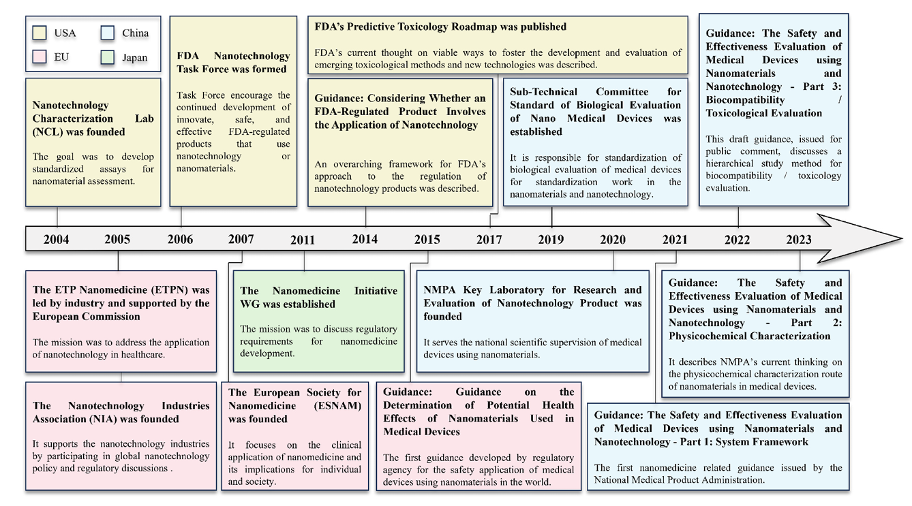
Fig. 1. Worldwide perspective on the regulatory scientific timeframe for medical devices that incorporate nanomaterials and nanotechnology ^{[1].}
Because of their purported antibacterial and therapeutic qualities, nanomaterials—particularly metals like silver and gold—have been used since ancient times. Furthermore, the use of nanotechnology in healthcare goes beyond just the distribution of drugs and antimicrobials. Recent studies into the creation of diagnostic tools and nanoscale biosensors that could identify harmful alterations at extremely early stages have the potential to revolutionize the field of disease prevention and control ^{[2-3]}.
Cell migration into porous biomaterial frameworks with bioactive inner surfaces is essential for tissue engineering, tumour metastasis, and in situ tissue formation. Although several strategies have been proposed to enhance cell adhesion and associated elements, comparatively little is known about how to encourage cell migration at the nanoscale. The spider's tiered self-assembled structure during fibre spinning is what gives spider silk its remarkable strength and durability. In order to create ultra-thin nanofibrils in polyelectrolyte synthetic spider silk, this research improves the flexibility of polymer chains. To control polymer chain separation and evaporation-induced self-assembly under external stress, ions are added. Furthermore, due of the temperature, the synthetic spider silk has the capacity to super constrict. It displays the arrangement of fibre materials with excellent functionality ^{[4-5]}.
2. NANOTECHNOLOGY ^{[6]}:
Various methods for accurately detecting and modifying substances at the atomic and molecular level are included in the multidisciplinary field of nanotechnology. Through the prediction of material properties and behaviours and the control of necessary experimental energy, artificial intelligence (AI) has the potential to advance nanotechnology. Researchers are using AI systems to investigate nanoparticle configuration and biomolecule influence in order to address preprocessing issues related to AI used in cancer cell segmentation, which requires specific image contrast approaches for optimal identification. The development of more focused and efficient image contrast agents is the result of this.
In theory, a new high-level contrast might be produced via scanning transmission electron microscopy by Imaging mostly depends on phase contrast detection, which can be accomplished in a single AI simulation application by combining deep learning-based AI methods with a traditional physical model approach. By merging AI with electron microscopy, the relationship between nanoparticles and cells may be better understood. According to recent hybrid research, artificial intelligence (AI) may be used to predict surface interface-environment interactions of any nanomaterial, allowing for the control of these complex dynamic biological properties. AI-driven techniques are also available for forecasting the body's unpredictable reaction to nanoparticles, in addition to monitoring the equilibrium binding constant, which is impacted by surface charge and encapsulation, and the residence time—a crucial component for forecasting the behavior of nanomaterials within the human body.
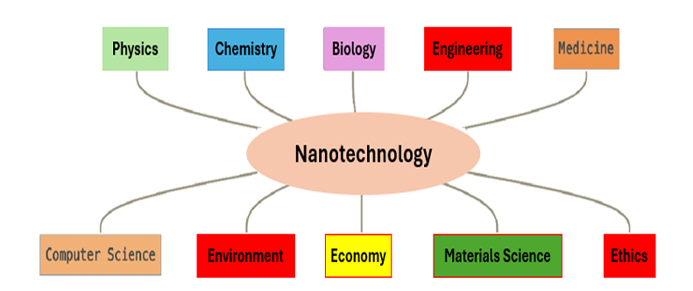
Fig no: 2- Vast fields in nanotechnology ^{[6]}
3. NANOMATERIAL:
Nanomaterials or nano-enhanced goods have flourished in the last few decades and are widely used in a variety of industries, including medical, industry, energy, aerospace, and agriculture. The toxicity of nanoparticles to a wide range of animals, including people and environmental species, remains a major concern despite the fact
that nanotechnology has greatly benefited humanity. Any material with at least one dimension smaller than 1000 nm is considered a nanomaterial, according to the FDA, and an object with all three exterior dimensions falling between 1 and 100 nm is considered a nanoparticle ^{[7-8]}. Nanomaterial-driven drug delivery has been widely used in biomedical research, including medication distribution, imaging, and photothermal therapy ^{[9]}. Excellent biocompatibility and biodegradability make nanomaterials the best choice for biomedical applications. The total surface area increases by several orders of magnitude as the particle size gets closer to the nanometer range compared to materials that are typically used in diagnostic and treatment. This increases the possibility of medication interaction with the system. However, in-depth research on their toxicity is also required to ensure safety in clinical settings ^{[10]}.
The distinguishing feature of nanotechnology is its ability to manipulate materials at the nanoscale, where distinct physical and chemical characteristics develop. AI enhances this potential by offering accurate control. on the design of nanomaterials customized for particular uses. Researchers can, for instance, develop nanomaterials with specific properties by using the crystal graph convolutional neural network framework, which can precisely predict material properties by utilizing density functional theory (DFT) and atomic-level chemical insights. To meet certain needs, AI algorithms can improve the properties, architecture, and composition of nanomaterials. To enhance catalytic performance, for example, AI may design nanoparticles with precisely manipulated surface patterns ^{[11]}.
Multifunctional materials have advanced as a result of nanotechnology. Nanomaterials have exceptional physio-chemical properties because of their small size, including enhanced reactivity and absorption, surface area, and molar extinction coefficients, tenable plasmonic features, quantum phenomena, magnetic, and optical properties. Modern science has produced a nanomaterial that, in response to minute changes in its surroundings, significantly changes its physical, chemical, or biological properties. In early studies, some nanomaterials, such as those containing zinc or selenium, have shown promise as antioxidants. The capacity to create nanomaterials with specific antioxidant properties could lead to novel solutions for these problems. Nanotechnology also helps in the fight against biofilms and well-known parasites like Plasmodium, which causes malaria.
These microscopic germs can cause serious issues. Nanomaterials have been investigated as potential antibacterial and antiparasitic agents, targeting distinct stages of their life cycle. To disrupt cell membranes, disrupt metabolic processes, or even deliver drugs straight to the infection site, for example, nanoparticles can be designed. There is a lot of promise in this area of research for developing novel treatments for a variety of microbially-induced illnesses. For optimal nano-smart functionality, nanomaterials should be biocompatible, have focused cell growth and death, evade macrophage identification, inhibit immunological responses, and release therapeutic chemicals in a controlled manner that directly interacts with target cells ^{[6]}.
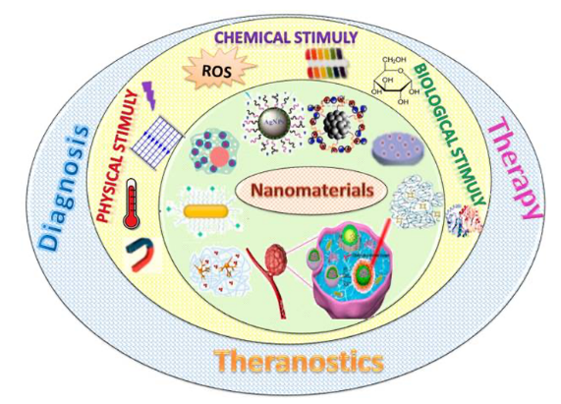
Fig no. 3- Classification and biomedical uses of intelligent nanomaterials based on their nanostructure ^{[6]}
4. NANOMATERIALS-BASED FLEXIBLE SENSORS ^{[12]}:
The concepts of the metaverse/virtual reality (VR) have been brought forward to seamlessly weave mobile Internet into individuals' professional and personal spheres to full-fill everyday requirements like traveling, conferencing, shopping, and more. Notably, the metaverse embodies an immersive, multi-sensory, real-time experience that interactive world based on VR devices. Traditional VR systems rely mainly on silicon sensors, which offer high resolution and minimal noise for superior imaging quality. These devices are linked to discomfort when worn, restricted skin sensitivity, and poor biocompatibility, among other issues. Flexible and lightweight electronic gadgets can be positioned in a stable and intimate manner against human skin without causing any discomfort, enabling precise detection of even minor movements. This review assesses the functionality of flexible sensors based on their mechanical, physical, chemical, and electrical characteristics. The current NMFSs are analyzed concerning mechanical and electrical metrics like conductivity, stretchability, stability, sensitivity, energy usage, and biocompatibility.
4.1. In comparison to conventional flexible sensors, NMFSs offer the subsequent benefits ^{[12]}:
(1) High sensitivity: given that nanomaterials possess a significant surface-to-volume ratio, they are capable of interacting more efficiently with the surrounding environment, thereby enhancing the sensitivity of the sensor.
(2) Low power con sumption: Nanomaterials function effectively at low power, making them beneficial for applications like mobile gadgets and VR headsets. Sensors created with nanomaterials can deliver superior performance while minimizing energy usage and prolonging battery longevity.
(3) Malleability: Nanomaterials exhibit great versatility and can be manufactured in numerous forms and dimensions for diverse application contexts. They can be smoothly incorporated into sensor frameworks, enhancing the adaptability of the system.
(4) Reliability: The characteristics of nanomaterials can enhance the stability and reliability of sensors. For instance, certain nanomaterials exhibit improved resistance to oxidation and corrosion, resulting in sensors that are more robust and enduring
(5) Large-scale fabrication: An increasing number of nanomaterial production methods are being introduced, and the creation of extensive flexible sensors is another significant benefit of nanomaterials compared to conventional flexible sensors. These advancements can assist VR/metaverse systems in improving their integration with various parts of the humanbody.
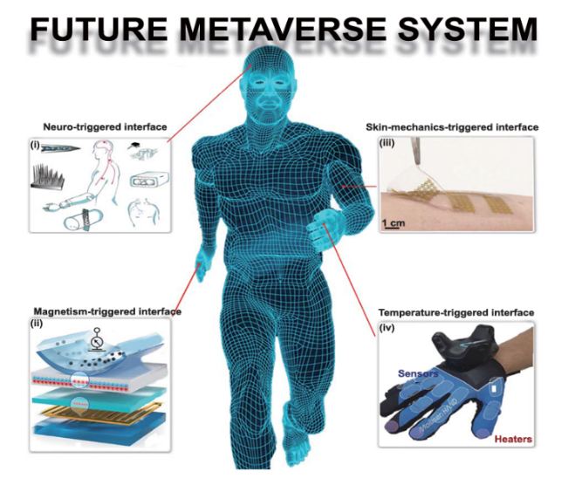
Fig. 4. Illustration of a conceptual future metaverse system designed for multimodal perceptual interfaces.^{[12]}
4.2. These substances can be assessed according to their mechanical, chemical, and electrical characteristics as well as their usage, and offer the subsequent benefits for NMFSs in VR devices ^{[12]}:
- Better flexibility and adaptability: NMFSs can conform to the surfaces of various objects with distinct shapes and curves, thereby aligning more effectively with the contours of the human form, which subsequently enhances the sensor's accuracy and precision.
- Lighter: NMFSs are extremely lightweight, which decreases the overall weight of a VR device, allowing users to wear it for extended durations without experiencing discomfort or exhaustion.
- Lower power consumption: NMFSs can function under low power scenarios, leading to decreased energy usage and prolonging the lifespan of energy storage units.
- Better biocompatibility: The favourable biocompatibility of NMFSs can enhance the safety and comfort of VR devices.
- Higher sensitivity: NMFSs are capable of sensing minor movements and variations, improve the engagement and precision of VR equipment, and give users amorerealistic experience.
- Better durability: NMFSs are typically capable of enduring extended usage along with considerable bending and twisting, and possess a longer lifespan, minimizing maintenance and replacement expenses. These characteristics can offer a more precise, authentic, and enjoyable experience for VR equipment.
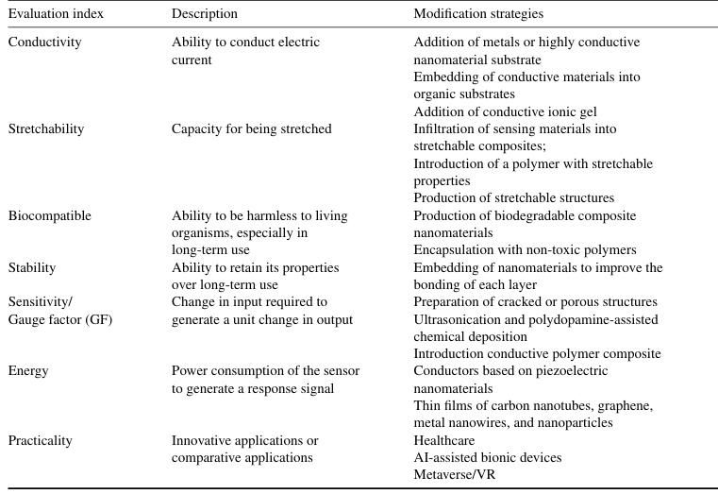
Table 1. Mechanical, chemical, and electrical characteristics of flexible sensors utilizing advanced nanomaterials.^{[12]}
4.3. Nanomaterial-Based Sensors Categorize ^{[12]}:
This section includes a classification of recently reported nanomaterial-based sensors based on their dimensions: 0D (e.g., nanoparticles, or NPs), 1D (e.g., graphene and multilayer nanofilms), 2D (e.g., graphene and nanofilms), and mixed degrees (e.g., nanofilms and NPs composites or NWs and NPs composites). Nanomaterials' unique properties, ease of production, and material compatibility have led to their widespread usage in flexible sensors. Using various nanomaterial shapes including as nanoparticles, nanowires, and nanofilms, this review highlights the most recent advancements in NMFSs.
- 1D nanomaterials:
The 1D nanomaterials for fabricating flexible sensors are typically selected considering the conductive component and elasticity coefficient. Highly conductive materials can enhance the conductivity of the sensors. Typical 1D nanomaterial preparation methods such as chemical vapor deposition (CVD), electric-arc discharge, laser ablation, laser cutting, and liquid electrolysis are frequently utilized to prepare CNTs. While anodic oxidation techniques, electron beam lithography, nano-imprint lithography, hydro/solvothermal synthesis, template-assisted, electrochemical deposition, and physical vapor deposition are commonly utilized to prepare NWs. This section focuses on the1D nanomaterials used for fabricating flexible sensors, such as CNTs, metal and metal oxide NWs (gold, silver, copper, zincoxide). The below figure 3 talks about the applications of 1D nanomaterials
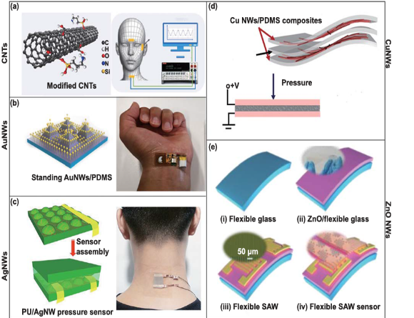
Fig. 5: The uses of 1D nanomaterials in adaptable sensors ^{[12]}.
- 2D nanomaterials:
The electrical conductivity of flexible electronic devices can be improved by increasing the number of pathways for charge movement within the material. Since electrons can travel in a biaxial manner in 2D nanomaterials, these materials exhibit greater conductivity than 1D nanomaterials. As a result, 2D nanomaterials have garnered considerable research attention. Choi and Kim conducted a thorough evaluation of the progress and challenges of 2D nanomaterial approaches in biomedical engineering, taking into account the distinctive physical, chemical, electronic, and optical characteristics provided by the planar structure of 2D nanomaterials. This section emphasizes the hierarchical structural benefits and uses of 2D nanomaterials, Ti3 C2Tx titanium alloy, graphene and its variants, titanium carbide, transition metal dichalcogenides, and transition metal oxides in flexible and wearable electronic devices. The architecture of 2D nanomaterials can be enhanced to address the current constraints of 1D nanomaterials (e.g. larger surface area, enhanced elasticity, and enhanced electrical proper ties) and prepare high-performance flexible electronic devices.
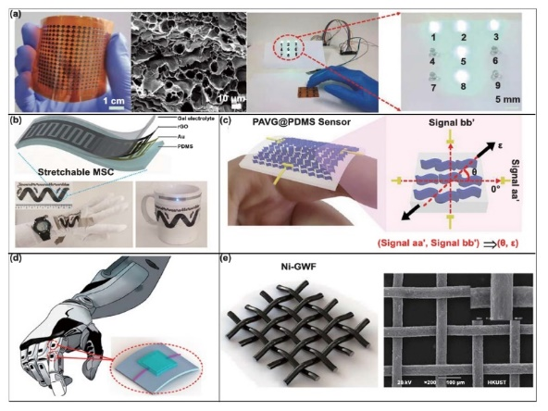
Fig. 6: The applications of graphene nanomaterials in flexible sensors ^{[12]}.
5. NANOTECHNOLOGY IN MEDICATION ADVANCEMENT:
Currently, preclinical and clinical data support the feasibility of targeted treatment for renal diseases using nanomaterial-based drug delivery systems. Using carriers with high biocompatibility, such as nanoparticles, hydrogels, liposomes, micelles, dendrimer polymers, adenoviruses, lysozymes, and elastin-like polypeptides, is essential for using nanomedicine to treat kidney diseases ^{[10]}.
Drug molecules typically cannot reach their designated site of action precisely; therefore, transporters that can efficiently deliver the required dosage of the treatment to its destination are required. Because of special structural features like the barrier function, the tissues in the eye, particularly the posterior segment, are difficult for drugs to reach. As a result, the field of ophthalmology has seen a large number of studies on nanoscale drug delivery devices ^{[13]}.
  - Creation of a drug delivery system (DDS) through the application of nanotechnology:
The creation of a drug delivery system (DDS) suitable for the posterior segment of the eye, utilizing nanocarriers to address the challenge of frequent intravitreal injections, has garnered significant interest. DDSs with suitable spatiotemporal attributes are engineered to enable medications to influence the intended tissue. effectively, and typically, three categories of methods are employed:
- absorption enhancement – facilitation of a drug's movement across tissue that acts as a barrier;
- controlled release – effective time-regulated prolonged release of a locally delivered medication; and
- drug targeting – to enable it to function effectively and solely on the intended tissue. Among ophthalmic drug delivery systems (DDS) utilizing nanocarriers, liposomes and micro/nanospheres have been researched the most thoroughly; additional systems comprise emulsions and dendrimers.^{[13]}
- NANOCARRIERS:
Pharmaceutical nanocarriers are highly versatile delivery devices that are submicron in size. They include liposomes, nanotubes, nanocomplexes, and inorganic, lipid-based, and polymer-based nanoparticles. In essence, ligands can be attached to the outside of nanocarriers to improve target selectivity and absorption. Drugs may be positioned between the nanocarrier's layers or dispersed throughout the nanocarrier matrix. Because their size, charge, and surface can be more easily customized, nanocarriers provide many advantages over traditional medication therapies. To control their absorption, distribution, targeting, and elimination, use properties and targeting agents. There are several ways to administer them, including parenteral, nasal, topical, and oral techniques.
The necessity for developing nanocarriers to treat a variety of diseases is increasing as a result of these advantages. Thus, in recent decades, a variety of characterisation techniques have been proposed and applied to control and predict the behavior of nanocarriers in vitro and in vivo. The commonly employed characterization methodologies assess the nanocarriers' mechanical qualities, stability, tissue permeability, possible toxicity, physicochemical properties, drug loading capacity, release rates, and in vivo results. For the majority of nanocarrier drug delivery systems (DDSs), we describe in this study the fundamental characterisation methods that are often used. The limitations of these techniques are also covered, along with the scalability issues and regulatory obstacles associated with nanocarrier production ^{[14]}.
- LIPOSOMES:
Liposomes are sealed vesicles (tiny lipid vesicles) made up of a phospholipid bilayer, with water-soluble drugs being able to be integrated into their aqueous phase, while lipid-soluble drugs can be included in their lipid phase. Liposomes offer numerous benefits as drug delivery systems:
- Their lipid composition, size, and electrical charge are easily controlled since they are noncovalent assemblies.
- It is simple to modify them utilizing surface polymers, sugars, and antibodies to improve targeting. Liposomes are essentially non-toxic and have a low antigenicity.
- Features like membrane permeability can be somewhat controlled;
- Liposomes can encapsulate a variety of solutes with different molecular weights and properties, such as hydrophobic, hydrophilic, and amphipathic molecules;
- Liposomes may be biodegradable and metabolized within a living organism.
In a previous study, both liposome-encapsulated and unencapsulated ganciclovir (GCV) were injected into the rabbits' vitreous bodies with the goal of eventually using GCV in the treatment of cytomegalovirus retinitis during AIDS patients. Using an enzyme-linked immunosorbent test (ELISA) of the vitreous after a single intravitreal injection, the amount of GCV in the eye was measured. injections of 1 mg of liposome-encased GCV or different concentrations of the unencapsulated drug (0.2–20 mg). Only the rabbits' vitreous showed therapeutic concentrations of GCV three days after the intravitreal injection if they had been given a free dose of at least 5 mg.
At doses of 15 mg or more, unencapsulated GCV also caused retinopathy. The group given 1 mg of liposome-encapsulated GCV, on the other hand, did not have any retinopathy, and the drug's concentration remained at therapeutic levels for up to 14 days after injection. Additionally, in patients with AIDS-related cytomegalovirus retinitis, intravitreal injection of 0.25 mL (1 mg) of liposome-encapsulated GCV prevented the progression of retinal haemorrhages, retinal detachment, and cytomegalovirus (CMV) retinitis when compared to the results of injecting free GCV as a control. Furthermore, prior research has shown that liposome-encapsulated GCV required fewer intravitreal injections than free GCV. Adding polyethylene glycol (PEG) to the liposome surfaces can further improve the drug's stability in the vitreous body because PEG-modified liposomes offer steric stabilization by encircling the liposomal surface with a uniform aqueous layer ^{[13]}.
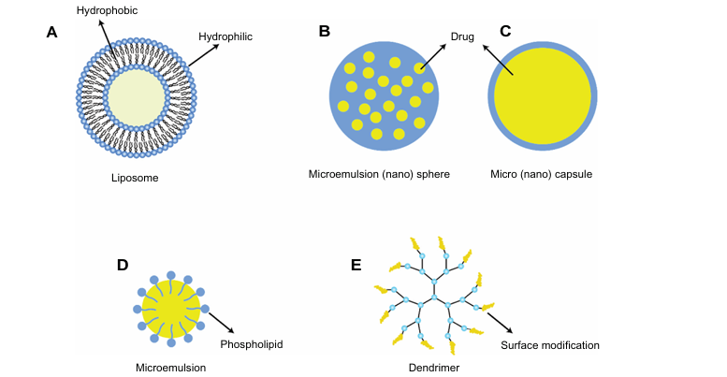
Fig. 7. different formulations of injectable particles ^{[13]}.
- MICRO / NANOSPHERES:
Round compositions of particles with sizes ranging from 1 μm to several hundred micrometers or fewer are called microspheres. Nanospheres are sometimes used to describe particles that are smaller. Drugs are encased in both natural and manmade polymers to allow for targeted delivery to particular tissues and sustained local release. Poly (lactic acid) (PLA), polyglycolic acid (PGA), and their copolymer, poly (lactic co-glycolic acid) (PLGA), are the most commonly utilized materials. The body does not break down or destroy these compounds enzymatically. PLA and PLGA given intravitreally do not exhibit any histological or electrophysiological toxicity in the retina. Using non-biodegradable devices in vivo results in steady drug release over a lengthy period of time, however it is usually difficult to surgically remove the instrument after prolonged drug emission. Many patients' visual clarity has improved after VEGF inhibitors were first administered intravitreally. Ongoing treatment may be required for the rest of the patient's life in some cases, as ceasing the infusion of anti-VEGF antibodies frequently results in a recurrence of CNV ^{[13]}.
The following table 2 presents the benefits and drawbacks of various kinds of nanocarriers.^{[13]}
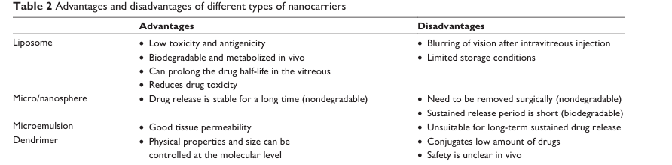
Table no. 2: Advantage and disadvantage types of nanocarriers ^{[13]}.
6. NANOPARTICLES:
A standardized definition of ‘nanoparticle’ varies among organizations and countries. Although a specified size limit is not always relevant for scientific or medical applications, it is needed for regulatory purposes and is defined (albeit differently) both in the EU and in the USA. The FDA defines nanomaterial as any material with at least one dimension smaller than 1000nm and a nanoparticle as an object with all three external dimensions in the 1–100nm size range. Nanoparticles are commonly known as "zero-dimensional" nanomaterials. This is because, in contrast to one-dimensional nanomaterials, which have one dimension larger than the nanoscale (like nanowires and nanotubes), and two-dimensional nanomaterials, which have two dimensions larger than the nanoscale (like self-assembled monolayer films), all of their dimensions are contained within the nanoscale. Using nanoparticles in imaging Nanoparticles can significantly improve both sophisticated magnetic resonance imaging (MRI) of various body parts and traditional biological imaging of cells and tissues using fluorescence microscopy ^{[8-15]}.
6.1 Nanoparticles in medical imaging ^{[15]}:
Nanoparticles can significantly improve both modern magnetic resonance imaging (MRI) of various body parts and traditional biological imaging of cells and tissues using fluorescence microscopy. The nanoparticles used in these two techniques differ in their chemical composition ^{[19]}.

- Optical Imaging:
Traditionally, organic dyes are injected into tissue samples and cells to do imaging. Usually, chemicals that particularly interact with cells or cell structures through ligand/receptor interaction are linked to dyes like rhodamine and fluorescein isocyanate (FITC). Photobleaching and inadequate fluorescence intensity are two frequent issues with this imaging method. Quantum dots, which are composed of inorganic semiconductor compounds, are the nanoparticle form of optical imaging. Site-specific imaging in vivo is the main in vivo application. Imaging of neoplasms, lung vasculature, and lymphatic nodes. improved durability and intensity against photobleaching in comparison to conventional methods. modifying the surface to target particular locations. The main characteristic of optical imaging is non-invasive subcutaneous imaging that does not require surgical incisions.
- Nanoparticles in Medication and Gene Transfer:
This type of nanoparticle, which is mostly used to treat cancer, is built on polymers and liposomes. The following characteristics:
- Surface modification for targeted distribution.
- Techniques for prolonging residence times in vivo, such as PEG linkage.
- Methods for dissolving medications (like paclitaxel) that don't dissolve in water.
- multifaceted and multifunctional (e.g., anti-angiogenic and chemotherapeutic).
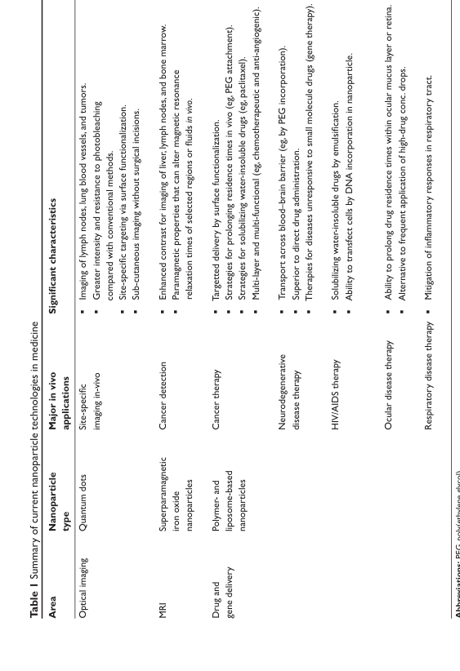
TABLE 3. Nanoparticle technology in healthcare ^{[15]}.
- NANOTOXICOLOGY ^{[1]}:
With the publication of the British journal Nanotoxicology in 2005, nanotoxicology got its start. Nanotoxicology is the study of potential effects of nanoparticles on human health. It is widely accepted that the toxicity of medical devices that contain nanomaterials is impacted by the devices' exposure potential, which is consistent with exposure assessment approaches. Factors that may influence the outcomes of toxicological studies must be taken into account in order to increase the accuracy of toxicity and risk assessments for nanomaterials.
- Primary issues in evaluations of nano toxicology/biocompatibility include the following ^{[1]}:
1) Sample Preparation: The characteristics and characteristics of nanoparticles are influenced by the testing medium's composition as well as the nanomaterials' state (e.g., dispersion or aggregation).
2) Concentration/Dose: The distribution state of the nanomaterials influences the amount or level. Consistency and steadiness are essential.
3) Dose Unit: Given the size and surface properties of nanomaterials, it is crucial to apply more appropriate dosage metrics (such as specific surface area or particle number concentration) based on the situation.
4) Disruption of the testing system: Test results could be affected by things like endotoxins and interactions with biomolecules.
5) Potential Toxicity Mechanisms: The dimensions and shape of nanomaterials can impact toxicity results. For instance, phagocytosis may play a role in the ultimate outcomes.
- Toxicity of Manufractured Nanomaterials ^{[7]}:
Nanomaterials' chemical makeup, contaminants, functionalization strategies, surface characteristics (surface charge, hydrophobicity, and ligands), dimensions, morphology, agglomeration, and biocorona are some of the key features that influence nano-bio interactions at different levels. This section concentrates on clarifying the toxicological consequences of various nanomaterial characteristics, specifically how these characteristics affect the toxicity mechanisms, cellular absorption, and toxicokinetics of nanomaterials, in order to fully investigate nanotoxicity. "Testing Programme of Manufactured Nanomaterials – Overview" lists 11 categories of nanomaterials that are currently or soon will be used, including dendrimers, fullerenes, gold nanoparticles (Au NPs), silver nanoparticles (Ag NPs), multi-walled carbon nanotubes (MWCNTs), single-walled carbon nanotubes (SWCNTs), nanoclays, silicon dioxide (SiO2), zinc oxide (ZnO), cerium oxide (CeO2), zinc oxide (ZnO), titanium dioxide (TiO2), and gold nanoparticles (Au NPs). Furthermore, various widely utilized produced nanomaterials are also mentioned as examples when talking about property-related nanotoxicity, including liposomes, the graphene family, MoS2 nanosheets, etc.
- Regulatory toxicity studies ^{[8]}:
Authorities mandate preclinical safety and PK evaluation in animals in accordance with good laboratory practice (GLP) rules prior to clinical trials. As a result, gulatory toxicity studies are frequently contracted out to a fully functional and established Contract Research Organization (CRO). Pharmacology, general toxicity, toxicokietic (TK), non-clinical pharmacokinetic, reproduction, and genotoxicity investigations are typically included in the non-clinical safety evaluation required for a pharmaceutical's marketing approval.
- Characteristics of Nanoparticles That Affect Toxicities ^{[16]}:
The characteristics of NPs that affect toxicity include size, surface area, shape, aspect ratio, surface coating, crystallinity, dissolution, and agglomeration.
- Size and Surface Area: The ratio of surface area to volume increases exponentially with decreasing nanoparticle size, hence increasing chemical and biological reactivities.
- Shape: A key factor that greatly affects the toxicity and biological reactivity of nanoparticles is their structure. Nanoparticles frequently have the shape of spheres, cylinders, cubes, sheets, or rods (Figure 1). When evaluating the nanoparticle's absorption by cells, its form is crucial.
- Aspect Ratio:The nanoparticle aspect ratio refers to the ratio of width to height. An aspect ratio of 1 indicates a spherical particle, whereas a nanotube has an aspect ratio nearing zero.
- Crystallinity: The crystalline structure of nanomaterials can affect their toxicity. Different crystalline forms of the same chemical composition, known as polymorphs, have unique physical and chemical properties.
- Surface Coating or Surface Functionalization: Surface coatings of nanoparticles are used to change their properties. Different layers (the "shell") encircle a particle's exterior (the "core"). Customizing the surface coating's stability, wettability, dissolution, or usefulness may be its goal. While less hazardous particles may become more poisonous as a result of increased bioavailability, the surface coating has the power to transform hazardous particles into harmless forms.
- Dissolution: One crucial property that affects safety, absorption, and associated toxicological pathways is the capacity of nanoparticles to dissolve. Due to distinct surface changes, two identical nanoparticles with similar size and composition can show completely different dissolving behaviors. Different ion channels and ion transport systems are usually the preferred entry paths into cells of nanoparticles that dissolve in the media before being absorbed by animals.
- Agglomeration: Because of their high free surface energy, nanomaterials have a tendency to aggregate in solution. Nanomaterials are covered with protective materials to stop this clumping. Additionally, the presence or absence of aggregation affects the toxicity of nanomaterials. Nanoparticle aggregation may cause inflammatory lung diseases in people. More often, carbon nanotubes and oxide nanoparticles exhibit the toxicity of agglomeration-based nanomaterials. Compared to agglomerated carbon nanotubes, well-dispersed carbon nanotubes are observed to be less hazardous.
- APPLICATIONS:
- Comprehensive Overview of the Application of Various Metal-Based Nanomaterials in Medicine ^{[2]}:
With centuries-old roots and significant scientific progress in recent decades, the use of metal-based nanomaterials in medicine represents an interesting intersection of material science and healthcare practice. This section explores the development, important discoveries, and ground-breaking applications of various metal-based nanomaterials in the realm of medicine. Silver nanoparticles' potent antibacterial properties prompted a great deal of research in the 20th century. By the end of the 1960s, researchers had developed techniques for producing silver nanoparticles, which were then used as coatings on implants and medical equipment to prevent bacterial infections.
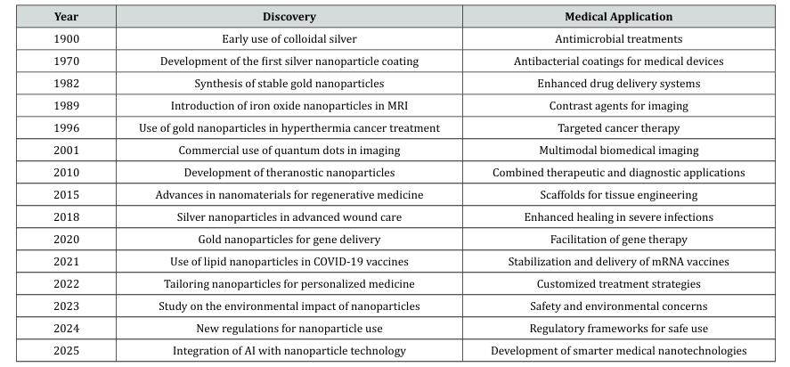
TABLE 4: Progression of Metal-Based Nanoparticles ^{[2]}.

- Nanotechnology Applications ^{[17]}:
    - Application of Nanotechnology in Various Sectors:
The following sectors—where nanotechnology is producing amazing applications—have been analysed, assessed, and selected for inclusion in this review after thorough and careful studies. Notably, numerous subcategories of industrial linkages might be covered under a single heading to further highlight the wide range of industries in which nanotechnology finds considerable use. Several industries affected by nanotechnology are shown in a graphic abstract at the beginning of this article; the details are briefly described under individual headings in the following section.
- Nanotechnology and Computer Industry:
The fundamentals of microengineering from physics and materials science are the foundation of nanotechnology. The concept of nano scaling is not new to the computing industry, as engineers and experts have long been working to create modified computer systems that use the least amount of space to function at their best. As a result, there is increasing testing of using nanotubes in computing equipment instead of silicon chips. Feynman and Drexler's efforts have greatly inspired computer scientists to develop innovative nano computers that could yield significant benefits. I think that more sophisticated, lighter, and more sophisticated computer devices will eventually become commonplace. A few years ago, it was unthinkable to think of laptops, smartphones, and other useful devices as tiny as we have today. This potential could be made possible by nanotechnology.
- Nanotechnology and Food Industry:
Nanotechnology has several applications in the food industry, including food production, packaging, safety procedures, targeted drug administration, smart diets, and a variety of modern preservatives. Packaging uses nanomaterials like polymer/clay nanocomposites because of their superior ability to withstand environmental impacts. Similarly, combinations of nanoparticles act as antimicrobials to protect food products from rapid microbial deterioration, especially in canned foods. Additionally, a variety of assays developed from nano sensors and nano assemblies are used to identify bacteria in the food production and storage industries.
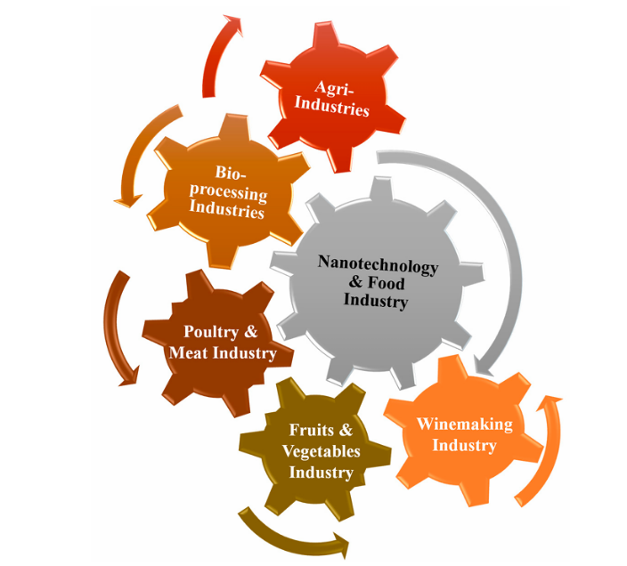
Fig. 8. Applications of nanotechnology in the food sector and related industries ^{[17]}.
    - Nanotechnology, Healthcare, and Medical Industry:
It is impossible to ignore the emergence of nanomedicine while talking about the broad fields of biotechnology, medicine, and biological sciences. As seen from the broad perspective of nanobiotechnology, nanotechnology is already becoming more and more prevalent. The development of improved diagnostics, therapies, screenings, sequencing, disease prevention techniques, and preventative healthcare measures has been made possible by this breakthrough. The development of nano-based genomics, tissue engineering, and gene therapy may also enable these approaches to include drug manufacture, design, conjugation, and enhanced delivery systems. Numerous subfields within the medical industry, including the biological sciences, biotechnology, and medicine, use nanotechnology. Already, nanotechnology is progressing beyond what can be imagined from the broad standpoint of nanobiotechnology.
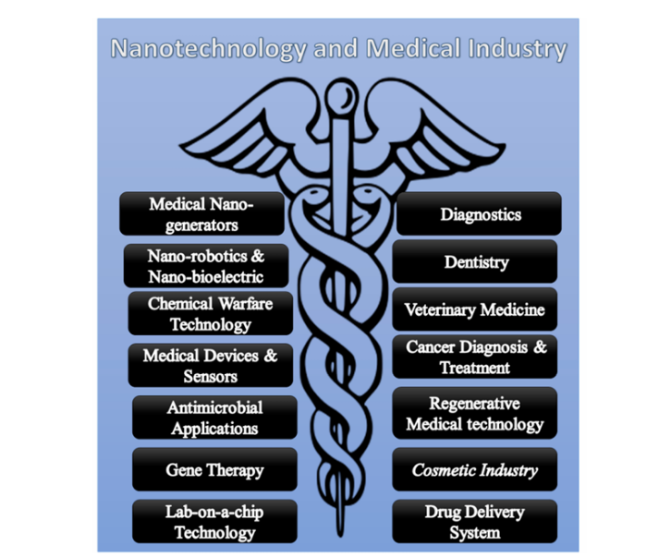
Fig.9. Nanotechnology applications in medical industry. Nanotechnology has a broad range of applications in various diagnostics and treatments using nanorobotics and drug delivery
Systems ^{[17]}.

- Uses of AI in the Creation and Enhancement of Nanocarriers ^{[18]}:
Reaching several receptors within the body and reducing the efficacy of a particular function is a persistent problem with medication delivery. Drug delivery to specific cells or tissues has been found to be facilitated by nanocarriers, which can be tailored to target disease-specific cells while preventing toxicity in healthy cells. Nanocarriers' size, shape, chemical composition, and surface features are some of the features that aid in medication delivery. However, creating the optimal drug delivery system (DDS) using nanocarriers is difficult. By evaluating drug loading, retention, and formulation stability, artificial intelligence (AI) and computational methods can help improve the compatibility between the medication and the nanocarrier.
Studies using molecular modeling of nanocarrier DDSs have mostly focused on
- analyzing the formation and structure of nanocarriers,
- analyzing their delivery and interactions,
- analyzing the surface characteristics of nanocarriers, and
- adsorption of nanocarriers on different surfaces.
9. NEW TRENDS AND ADVANCEMENTS:
The development of a database using deep learning and artificial intelligence (AI) techniques has the potential to significantly increase regulatory quality and efficiency, promote thorough regulatory and risk prediction, and guarantee the safety and quality of medical devices. According to the FDA's most recent report on the CDRH's (Centre for Devices and Radiological Health) regulatory science priorities, almost all ten of the priorities contain AI-supported research. From the time applications are filed until certification is obtained, the medical device regulation procedure frequently takes years. Data evaluation and forecasting procedures can be streamlined by using AI-powered big data analytics and contemporary computer models. By including data from medical devices' whole lifecycle, Modeling can enhance risk assessment and management. Understanding the manufacturing, approval, marketing, use, and adverse events related to various medical device devices is crucial to achieving this objective. Furthermore, enhancing the cybersecurity procedures of digital health systems will be necessary to build a robust database ^{[1]}.
With notable advancements in the creation of intelligent nanoparticles, the field of nanomedicine is continuously changing. These sophisticated nanoparticles can respond to physiological changes, such changes in temperature or pH, to provide targeted treatments at disease sites. Nanoparticle technologies are increasingly helping to advance personalized treatment. It is possible to tailor specially designed nanoparticles to each patient's own profile, which includes genetic information and specific disease characteristics. This level of customization guarantees that therapies are tailored to each patient's unique health concerns, improving health outcomes and reducing treatment-related problems. New regulatory frameworks are becoming more and more necessary as the area of nanoparticle medicine expands. In order to address possible risks and ethical issues related to the broad use of nanoparticles, recent regulatory revisions aim to guarantee their safe and efficient use in clinical settings. Regulations of this kind are essential for safeguarding patient safety and encouraging advancements in nanotechnology ^{[2]}.
Related social, ethical, environmental, and human safety concerns surface as new technologies are implemented in various fields, potentially impeding advancement. As nanotechnology advances, it is imperative that these issues be methodically addressed and analyzed to guarantee its seamless integration into a range of sectors without causing moral, ethical, or societal repercussions. Technologists, engineers, biologists, and industry professionals must work together to advance a promising future linked to the widespread use of nanotechnology in many fields ^{[17]}.
- SUMMARY:
This review examines the collaborative use of artificial intelligence (AI) and nanotechnology in the design, development, and regulation of pharmaceutical medical devices. It stresses how nanomaterials, with their unique nanoscale features such as improved biocompatibility, reactivity, and surface functioning, have transformed the performance of diagnostic and therapeutic devices. The paper examines a wide range of nanomaterial types and their biomedical applications, including flexible nanomaterial-based sensors for wearable and virtual reality medical systems, nanocarriers for targeted medication administration, and nanoparticles for advanced imaging and gene transfer. AI integration is critical in predicting nanomaterial behavior, optimizing drug delivery systems, and improving imaging contrast through data-driven modelling. The review also discusses the nanotoxicological aspects, addressing physicochemical Characterization, exposure hazards, and predictive in silico modelling for safety evaluations. It also examines changing regulatory frameworks and the role of AI in creating predictive nano-informatics databases that simplify approval processes. Emerging developments in personalized nanomedicine, smart nanoparticles, and AI-guided regulatory modelling are also highlighted, emphasizing how these advances are transforming healthcare technologies into safer, more efficient, and patient-specific applications.

- Conclusion:
The integration of artificial intelligence (AI) and nanotechnology is revolutionizing pharmaceutical and biomedical devices by enabling exceptional precision, functionality, and personalization. Nanomaterials contribute advanced capabilities in diagnostics, therapy, and monitoring, while AI enhances these applications through predictive modeling, real-time analysis, and system optimization. Together, they enable intelligent, adaptive, and safer healthcare technologies. However, rapid innovation demands parallel progress in regulatory science to ensure quality, reproducibility, and biosafety. Addressing challenges related to nanotoxicity, ethics, and data governance remains essential for sustainable implementation.
Future advancements will rely on robust databases, harmonized standards, and AI-driven regulatory frameworks that accelerate innovation while safeguarding public trust. Overall, AI-enhanced nanotechnology represents a transformative step toward smart, responsive, and patient-centric medical devices that redefine modern healthcare.

COMPETING INTERESTS DISCLAIMER:
Authors have declared that they have no known competing financial interests OR non-financial interests OR personal relationships that could have appeared to influence the work reported in this paper.

- REFERENCE:
- Chubing Lina, Xin Huanga, Yueguang Xuea, Shasha Jiangd, Chunying Chen, Ying Liuc , Kuan Chen, Advances in medical devices using nanomaterials and nanotechnology: Innovation and regulatory science, Bioactive Materials 48 (2025) 353–369, https://doi.org/10.1016/j.bioactmat.2025.02.017
- Ali Umar, Misbah Ullah Khan, Zeeshan Ulfat, Muhammad Shoaib Sharif, Muhammad Yasir Abbas, Waseem Ghafoor, Noman Nazeer, Muhammad Waseem Aslam, Muhammad Saqib Rafique, Komal Farghama, Aruba, Fehmida and Muhammad Saleem Khan, Advancing Healthcare: Emerging Trends and Applications of Nanomaterials in Medicine, JOJ Material Sci 8(4): JOJMS.MS.ID.555745 (2024), DOI: 10.19080/JOJMS.2024.08.555745
- Da-Yuan Wang Linqi Shi b, Linzhu Su, Henk J. Busscher, Beyond surface modification strategies to control infections associated with implanted biomaterials and devices - Addressing the opportunities offered by nanotechnology, Biomaterials 308 (2024) 122576, https://doi.org/10.1016/j.biomaterials.2024.122576
- Qiong Liu, Jiale Huang, Shuang Zheng, Yexin Gu a, Kai Ye , Jiandong Ding, Cell migration regulated by RGD nanospacing and enhanced under moderate cell adhesion on biomaterials, Biomaterials 263 (2020) 120327, https://doi.org/10.1016/j.biomaterials.2020.120327
- Wenqian He, MeilinWang, GuangkaiMei, ShiyongLiu, Abdul Qadeer Khan, Chao Li, Danyang Feng, ZihaoSu, LiliBao, GeWang, Enzhao Liu, Yutian Zhu, JieBai, Meifang Zhu, Xiang Zhou & ZunfengLiu, Wenqian He, MeilinWang, GuangkaiMei, ShiyongLiu, Abdul Qadeer Khan, Chao Li, Danyang Feng, ZihaoSu, LiliBao, GeWang, Enzhao Liu, Yutian Zhu, JieBai, Meifang Zhu, Xiang Zhou & Zunfeng Liu, Nature Communications| (2024) 15:3485, https://doi.org/10.1038/s41467-024-47796-2
- Saif Al-Deen H. Hassan, Mohsin Najim Sarayyih Almaliki , Zahraa Abed Hussein , Hayder M. Albehadili , Shaima R. Banoon, Aswan Al-Abboodi , Moumal Al-Saady, Development of Nanotechnology by Artificial Intelligence: A Comprehensive Review, J Nanostruct, 2023; 13(4):915-932, DOI: 10.22052/JNS.2023.04.002
- Yaping Liua, Shuang Zhua, Zhanjun Gua, Chunying Chena, Yuliang Zhao, Toxicity of manufactured nanomaterials, Particuology 69 (2022) 31–48, https://doi.org/10.1016/j.partic.2021.11.007
- Iwona Cicha, Ce´dric Chauvierre, Isabelle Texier, Claudia Cabella, Josbert M. Metselaar, Ja´nos Szebeni, La´szlo´ De´zsi, Christoph Alexiou, Franc¸ oisRouzet, Gert Storm, Erik Stroes, Donald Bruce, Neil MacRitchie, Pasquale Maffia, and Didier Letourneur, From design to the clinic: practical guidelines for translating cardiovascular nanomedicine, Cardiovascular Research(2018)114,1714–1727, doi:10.1093/cvr/cvy219
- Linyang Fan, Weizhi Wang, Zihua Wang & Minzhi Zhao, NATURE COMMUNICATIONS| (2021) 12:6371, https://doi.org/10.1038/s41467-021-26694-x
- Shunlai Shanga, Xiangmeng Lia, Haoran Wangd, Yena Zhoue, Keying Pangf, Ping Lid, Xiaomin Liud, Min Zhangg, Wenge Lia, Qinggang Lid, Xiangmei Chen, Targeted therapy of kidney disease with nanoparticle drug delivery materials, BioactiveMaterials37(2024)206–221, https://doi.org/10.1016/j.bioactmat.2024.03.014
- David B. Olawade, Adedapo O. Adeola, Abimbola O. Ige, Abimbola G. Olaremu, James O. Ijiwade, The synergy of artificial intelligence and nanotechnology towards advancing innovation and sustainability - A mini-review, Nano Trends 8 (2024) 100052, https://doi.org/10.1016/j.nwnano.2024.100052
- Jianfei Wang, Jiao Suo, Zhengxun Song, Wen Jung Li and Zuobin Wang, Nanomaterial-based flexible sensors for metaverse and virtual reality applications, Int. J. Extrem. Manuf. 5 (2023) 032013, https://doi.org/10.1088/2631-7990/acded1
- Miki Honda, Tomohiro Asai, Naoto Oku, Yoshihiko Araki, Minoru Tanaka, Nobuyuki Ebihara, Liposomes and nanotechnology in drug development: focus on ocular targets, International Journal of Nanomedicine 2013:8, http://dx.doi.org/10.2147/IJN.S30725
- Samar Zuhair Alshawwa, Abeer Ahmed Kassem, Ragwa Mohamed Farid and Gihan Salah Labib, Shaimaa Khamis Mostafa, Nanocarrier Drug Delivery Systems: Characterization, Limitations, Future Perspectives and Implementation of Artificial Intelligence, Pharmaceutics 2022, 14, 883, https://doi.org/10.3390/ pharmaceutics14040883
- Shashi K Murthy, Nanoparticles in modern medicine: State of the art and future challenges, International Journal of Nanomedicine 2007:2(2).
- Chukwuebuka Egbuna, Vijaykumar K. Parmar, Jaison Jeevanandam, Shahira M. Ezzat, Kingsley C. Patrick-Iwuanyanwu, Charles Oluwaseun Adetunji, Johra Khan, Eugene N. Onyeike, Chukwuemelie Zedech Uche, Muhammad Akram, Mervat S. Ibrahim, Nihal M. El Mahdy, Chinaza Godswill Awuchi, Kaliyaperumal Saravanan Uchenna Estella Odoh, Mohammed Messaoudi, Habibu Tijjani, Jonathan C. Ifemeje, Michael C. Olisah, Nebechi Jane Ezeofor, Chukwudi Jude Chikwendu, and Chinwe Gloria Ibeabuchi, Toxicity of Nanoparticles in Biomedical Application: Nanotoxicology, Journal of Toxicology Volume 2021, https://doi.org/10.1155/2021/9954443
- Shiza Malik, Khalid Muhammad and Yasir Waheed, Nanotechnology: A Revolution in Modern Industry, Molecules 2023, 28, 661, https://doi.org/10.3390/molecules28020661
- Jiajun Luo, Matthew Walker, Yinbo Xiao, Hannah Donnelly, Matthew J. Dalby, Manuel Salmeron-Sanchez, The influence of nanotopography on cell behaviour through interactions with the extracellular matrix – A review, Bioactive Materials 15 (2022) 145–159, https://doi.org/10.1016/j.bioactmat.2021.11.024
- Qianyu Wan, Xinrui Zhang, Dongfang Zhou, Rui Xie, Yue Cai, Kehao Zhang and Xuanrong Sun, Inhaled nano-based therapeutics for pulmonary fibrosis: recent advances and future prospects, Wan et al. Journal of Nanobiotechnology (2023)21:215, https://doi.org/10.1186/s12951-023-01971-7
- Y. Dai, R. Wang, F. Chen, Y. Zhang, Y. Liu, H. Huang, P. Yang, R. Zhang, B. Zheng, C. Gao, Y. Chen, L. Tao, Clinical outcomes in 2481 unselected real-world patients treated with a polymer-free sirolimus-eluting stent: 3 years results from the NANO multicenter registry, BMC Cardiovasc. Disord. 21 (2021) 537, https://doi. org/10.1186/s12872-021-02356-0.
- Y. Liu, Y. Zhang, Y. Li, T. Qi, D. Pan, H. Wang, C. Liu, D. Ma, Z. Fang, R. Zhang, F. Mou, L. Tao, NANO All-Comers Registry Investigators, One-year clinical results of the NANO registry: a multicenter, prospective all-comers registry study in patients receiving implantation of a polymer-free sirolimus-eluting stent, Cathet. Cardiovasc. Interv.: Off. J. Soc. Card. Angiogr. Interv. 95 (Suppl 1) (2020) 658–664, https://doi.org/10.1002/ccd.28734.
- O. Ciofu, C. Moser, P.Ø. Jensen, N. Høiby, Tolerance and resistance of microbial biofilms, Nat. Rev. Microbiol. 20 (2022) 621–635, https://doi.org/10.1038/ s41579-022-00682-4.
- C. Wang, W. Zhao, B. Cao, Z. Wang, Q. Zhou, S. Lu, L. Lu, M. Zhan, X. Hu, Biofilm- responsive polymeric nanoparticles with self-adaptive deep penetration for in vivo photothermal treatment of implant infection, Chem. Mater. 32 (2020) 7725–7738, https://doi.org/10.1021/acs.chemmater.0c02055.
- C. Santino, M. Zeeshan, M. Hamidi, K. Hanna, A.T. Saljuqi, N. Kulvatunyou, Z. Haddadin, A. Northcutt, B. Joseph, Prospective evaluation of health-related quality of life in geriatric trauma patients, Surgery 166 (2019) 403–407, https:// doi.org/10.1016/j.surg.2019.04.031.
- V. Carniello, B.W. Peterson, H.C. van der Mei, H.J. Busscher, Physico-chemistry from initial bacterial adhesion to surface-programmed biofilm growth, Adv. Colloid Interf. Sci. 261 (2018) 1–14, https://doi.org/10.1016/j.cis.2018.10.005.
- K. Quan, J.P. Hou, Z. Zhang, Y. Ren, B.W. Peterson, H.-C. Flemming, C. Mayer, H. J. Busscher, H.C. Van der Mei, Water in bacterial biofilms: pores and channels, storage and transport functions, Crit. Rev. Microbiol. 48 (2022) 283–302, https:// doi.org/10.1080/1040841x.2021.1962802.
- W. Jaber, Artificial Intelligence and Nanotechnology: Transforming the Future. In Artificial Intelligence in the Age of Nanotechnology, IGI Global, 2024, pp. 1–24, https://doi.org/10.4018/979-8-3693-0368-9.ch001.
- S. Natale, A. Ballatore, Imagining the thinking machine: technological myths and the rise of artificial intelligence, Convergence 26 (1) (2020) 3–18, https://doi. org/10.1177/1354856517715164.
- Y. Duan, J.S. Edwards, Y.K. Dwivedi, Artificial intelligence for decision making in the era of big data–evolution, challenges and research agenda, Int. J. Inf. Manage. 48 (2019) 63–71, https://doi.org/10.1016/j.ijinfomgt.2019.01.021.
- Y.K. Dwivedi, L. Hughes, E. Ismagilova, G. Aarts, C. Coombs, T. Crick, Y. Duan, R. Dwivedi, J. Edwards, A. Eirug, V. Galanos, Artificial Intelligence (AI): multidisciplinary perspectives on emerging challenges, opportunities, and agenda for research, practice and policy, Int. J. Inf. Manage. 57 (2021) 101994, https:// doi.org/10.1016/j.ijinfomgt.2019.08.002.
- Torfi A., Shirvani R.A., Keneshloo Y., Tavaf N., Fox E.A. Natural language processing advancements by deep learning: a survey. arXiv preprint arXiv: 2003.01200. 2020 Mar 2. https://arxiv.org/abs/2003.01200.
- I.H. Sarker, Deep learning: a comprehensive overview on techniques, taxonomy, applications and research directions, SN Comput. Sci. 2 (6) (2021) 420, https:// doi.org/10.1007/s42979-021-00815-1.
- N. Singh, H. Sabrol, Convolutional neural networks-an extensive arena of deep learning. A comprehensive study, Arch. Comput. Meth. Eng. 28 (7) (2021) 4755–4780, https://doi.org/10.1007/s11831-021-09551-4.
- J.K. Patel, A. Patel, D. Bhatia, Introduction to Nanomaterials and nanotechnology. InEmerging technologies For Nanoparticle Manufacturing, Springer International Publishing, Cham, 2021, pp. 3–23, https://doi.org/ 10.1007/978-3-030-50703-9_1.
- Y.N. Liu, F.Y. Wu, R.Y. Tian, Y.X. Shi, Z.Q. Xu, J.Y. Liu, J. Huang, F.F. Xue, B. Y. Liu, G.Q. Liu, The bHLH-zip transcription factor SREBP regulates triterpenoid and lipid metabolisms in the medicinal fungus Ganoderma lingzhi, Commun. Biol. 6 (1) (2023) 1, https://doi.org/10.1038/s42003-022-04154-6.
- Y.T. Kwon, H. Kim, M. Mahmood, Y.S. Kim, C. Demolder, W.H. Yeo, Printed, wireless, soft bioelectronics and deep learning algorithm for smart human–machine interfaces, ACS Appl. Mater. Interfaces 12 (44) (2020) 49398–49406, https://doi.org/10.1021/acsami.0c14193.
- J.F. Arinez, Q. Chang, R.X. Gao, C. Xu, J. Zhang, Artificial intelligence in advanced manufacturing: current status and future outlook, J. Manuf. Sci. Eng. 142 (11) (2020) 110804, https://doi.org/10.1115/1.4047855.
- M.A. Hoffmann, R. Lasch, Tackling industrial downtimes with artificial intelligence in data-driven maintenance, ACM Comput. Surv. 56 (4) (2023) 1–33, https://doi.org/10.1145/3623378.
- S. Wang, Z. Shen, Z. Shen, Y. Dong, Y. Li, Y. Cao, Y. Zhang, S. Guo, J. Shuai, Y. Yang, C. Lin, Machine-learning micropattern manufacturing, Nano Today 38 (2021) 101152, https://doi.org/10.1016/J.NANTOD.2021.101152.
- Chaudhary V Sonu, A paradigm of internet-of-nano-things inspired intelligent plant pathogen-diagnostic biosensors, ECS Sens. Plus 1 (3) (2022) 031401, https://doi.org/10.1149/2754-2726/ac92ed.
- A. Masood, K. Ahmad, A review on emerging artificial intelligence (AI) techniques for air pollution forecasting: fundamentals, application and performance, J Clean Prod 322 (2021) 129072, https://doi.org/10.1016/j. jclepro.2021.129072.
- A.A. Beni, H. Jabbari, Nanomaterials for environmental applications, Results Eng. 15 (2022) 100467, https://doi.org/10.1016/j.rineng.2022.100467.
- L. Lei, R. Pang, Z. Han, D. Wu, B. Xie, Y. Su, Current applications and future impact of machine learning in emerging contaminants: a review, Crit. Rev. Environ. Sci. Technol. 53 (20) (2023) 1817–1835, https://doi.org/10.1080/ 10643389.2023.2190313.
- X. Yan, T. Yue, D.A. Winkler, Y. Yin, H. Zhu, G. Jiang, B. Yan, converting nanotoxicity data to information using artificial intelligence and simulation, Chem. Rev. 123 (13) (2023) 8575–8637, https://doi.org/10.1021/acs. chemrev.3c00070.
- A. Sarrami-Foroushani, T. Lassila, M. MacRaild, J. Asquith, K.C.B. Roes, J. V. Byrne, A.F. Frangi, In-silico trial of intracranial flow diverters replicates and expands insights from conventional clinical trials, Nat. Commun. 12 (2021) 3861, https://doi.org/10.1038/s41467-021-23998-w.
- [138] Faris Owen, Shuren Jeffrey, An FDA Viewpoint on unique considerations for medical-device clinical trials, N. Engl. J. Med. 376 (2017) 1350–1357, https:// doi.org/10.1056/NEJMra1512592.
- V. Subbiah, The next generation of evidence-based medicine, Nat Med 29 (2023) 49–58, https://doi.org/10.1038/s41591-022-02160-z.
- G. Marquis-Gravel, M.T. Roe, M.P. Turakhia, W. Boden, R. Temple, A. Sharma, B. Hirshberg, P. Slater, N. Craft, N. Stockbridge, B. McDowell, J. Waldstreicher, A. Bourla, S. Bansilal, J.L. Wong, C. Meunier, H. Kassahun, P. Coran, L. Bataille, B. Patrick-Lake, B. Hirsch, J. Reites, R. Mehta, E.D. Muse, K.J. Chandross, J. C. Silverstein, C. Silcox, J.M. Overhage, R.M. Califf, E.D. Peterson, Technology- enabled clinical trials, Circulation 140 (2019) 1426–1436, https://doi.org/ 10.1161/CIRCULATIONAHA.119.040798.
- D.C. Klonoff, the new FDA real-world evidence program to support development of drugs and Biologics, J. Diabetes Sci. Technol. 14 (2019) 345–349, https://doi. org/10.1177/1932296819832661.
- C.A. Purpura, E.M. Garry, N. Honig, A. Case, J.A. Rassen, The role of real-world evidence in FDA-approved new drug and Biologics License applications, Clin. Pharmacol. Ther. 111 (2022) 135–144, https://doi.org/10.1002/cpt.2474.
- T. Yu, G. Jiang, R. Gao, G. Chen, Y. Ren, J. Liu, H.C. van der Mei, H.J. Busscher, Circumventing antimicrobial-resistance and preventing its development in novel, bacterial infection-control strategies, Exp. Opinion Drug Deliv 17 (8) (2020) 1151–1164, https://doi.org/10.1080/17425247.2020.1779697.
- A.R. Kirtane, M. Verma, P. Karandikar, J. Furin, R. Langer, G. Traverso, Nanotechnology approaches for global infectious diseases, Nat. Nanotech. 16 (2021) 369–384, https://doi.org/10.1038/s41565-021-00866-8.
- J. Butler, R.D. Handy, M. Upton, A. Besinis, Review of antimicrobial nanocoatings in medicine and dentistry: mechanisms of action, biocompatibility performance, safety, and benefits compared to antibiotics, ACS Nano 17 (2023) 7064–7092, https://doi.org/10.1021/acsnano.2c12488.
- F. Aflakian, F. Mirzavi, H.T. Aiyelabegan, A. Soleimani, J.G. Navashenaq, I. Karimi- Sani, A.R. Zomorodi, R. Vakili-Ghartavol, Nanoparticles-based therapeutics for the management of bacterial infections: a special emphasis on FDA approved products and clinical trials, Eur. J. Pharm. Sci. 188 (2023) 106515, https://doi.org/ 10.1016/j.ejps.2023.106515.
- M.J. Mitchell, M.M. Billingsley, R.M. Haley, M.E. Wechsler, N.A. Peppas, R. Langer, Engineering precision nanoparticles for drug delivery, Nat. Rev. Drug Discov. 20 (2021) 101–124, https://doi.org/10.1038/s41573-020-0090-8.

