Case Study

A Case Study of Pyriform Sinus Carcinoma with Cervical Lymph Node Metastasis

ABSTRACT:

Pyriform sinus carcinoma, a common hypopharyngeal malignancy, often presents late due to the silent progression of symptoms and early submucosal spread. We report the case of a 55-year-old male who presented with progressively enlarging neck swelling for 10 months. Clinical evaluation and imaging revealed a lesion in the right pyriform fossa with multiple cervical lymph node metastases and possible distant spread. Histopathology confirmed a moderately differentiated squamous cell carcinoma. The patient was initiated on systemic chemotherapy with Paclitaxel and Carboplatin, supported by premedications and palliative care measures. This case highlights the classical late presentation of pyriform sinus carcinoma, diagnostic challenges, and the importance of multimodality treatment. Despite advances in oncology, the prognosis for advanced hypopharyngeal carcinoma remains poor, underscoring the need for early detection and preventive strategies.

KEYWORDS:
Pyriform sinus carcinoma, hypopharyngeal cancer, squamous cell carcinoma, cervical lymphadenopathy, PET-CT, chemotherapy
INTRODUCTION:
Cancers of the hypopharynx are aggressive malignancies with poor prognosis, representing approximately 3–5% of all head and neck cancers.¹ Among them, pyriform sinus carcinoma is the most common, accounting for nearly 70% of cases.² It typically affects middle-aged men with a history of tobacco and alcohol consumption, although it can also occur in non-users. The anatomical location of the pyriform fossa, rich in submucosal lymphatics, facilitates early nodal spread, resulting in >70% of patients presenting with cervical lymphadenopathy at the time of diagnosis.³ Unfortunately, the disease is often detected in advanced stages, where curative options are limited, and management becomes largely palliative. This case study presents a 55-year-old male with pyriform sinus carcinoma diagnosed at an advanced stage, and discusses the diagnostic approach, therapeutic plan, and the clinical implications of late presentation.

CASE PRESENTATION:
A) Patient Profile:
- Name: Mr. Amarappa Pojari
- Age/Sex: 55 years / Male
- Date of onset: 16/03/2025
- Primary symptoms: Swelling on left side of the neck for 10 months
- Medical history: Complaints of fever. However, no history of acute illness.
- Social History: None
- Family History: None
- Medication and treatment applied: None
B) Chief Complaints:
- Swelling in the left side of the neck for 10 months
- Occasional pain and difficulty swallowing
C) History of Present Illness:
- The swelling appeared insidiously and progressively increased in size over 10 months. No history of fever, chronic cough, hemoptysis, or significant weight loss was reported. There was no past history of tuberculosis, hypertension, diabetes mellitus, or thyroid disorders.
D) Examination Findings:
- Large firm-to-hard swelling in the left cervical region
- Post-biopsy scar visible on left neck
- No airway compromise at presentation
- Systemic examination: mild anemia, otherwise unremarkable

INVESTIGATIONS:
A) Hematology:
- Hemoglobin: 9.1 g/dL (anemia)
- WBC Count: 10,830/cumm (mild leukocytosis)
- Platelets: 5.59 lakhs/cumm (thrombocytosis)
- PT: 15.0 sec, APTT: 38.1 sec (mildly prolonged)
B) Biochemistry:
- Sodium: 131 mmol/L (hyponatremia)
- Chloride: 89 mmol/L (low)
- Creatinine: 0.4 mg/dL (normal renal function)
C) Histopathology:
- Tru-cut biopsy from left cervical lymph node showed malignant squamous cells with pleomorphism, hyperchromatic nuclei, and areas of necrosis. Impression: Metastatic moderately differentiated squamous cell carcinoma.
D) PET-CT Findings:
- FDG-avid lesion in right pyriform fossa (SUVmax 15.8, size 1.7 × 1.7 cm)
- Multiple left cervical nodes (largest 5.9 × 4.5 × 5.7 cm, SUVmax 12.8)
- Left axillary and mediastinal nodes positive
- FDG uptake in left pleura (SUVmax 5.1)

- Diagnosis: Advanced pyriform sinus carcinoma with nodal and probable distant metastasis

FIGURES:
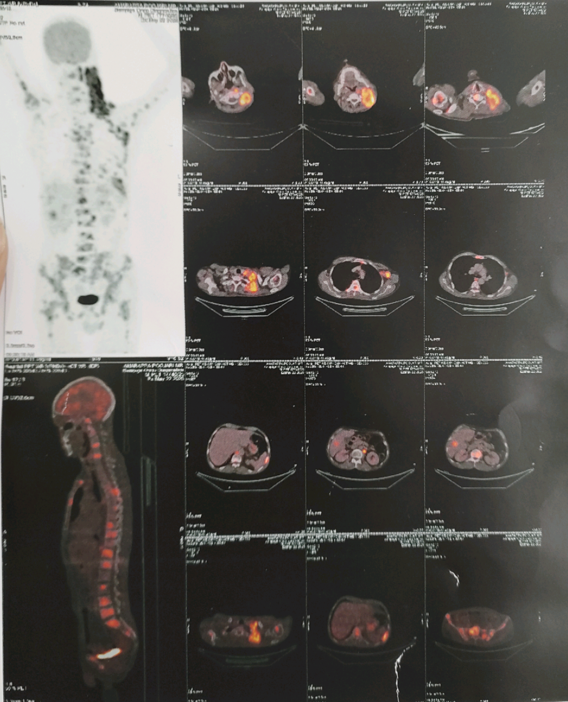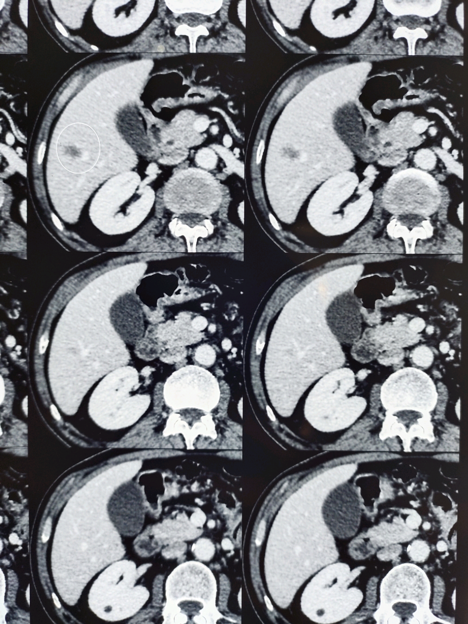
Figure 2: Histopathology (H&E stain, 40x magnification) showing malignant squamous epithelial cells arranged in nests with hyperchromatic nuclei.

Figure 1: PET-CT showing FDG-avid lesion in the right pyriform sinus with extensive cervical lymphadenopathy.

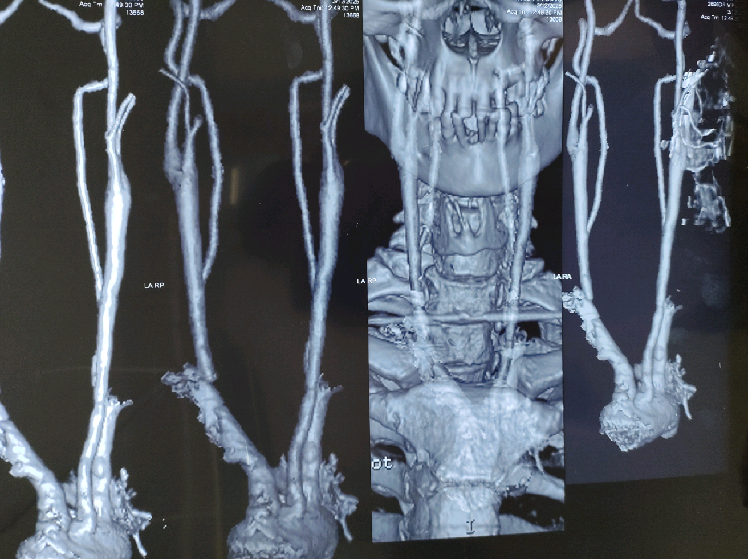
Figure 3: Clinical photograph of left-sided cervical lymphadenopathy with post-biopsy scar.

TREATMENT:
- Chemotherapy Regimen:
- Paclitaxel 260 mg IV
- Carboplatin 450 mg IV
- Premedication’s: Dexamethasone, Ondansetron, Famotidine, Domperidone
- Supportive Therapy: Antiemetics, hydration, nutritional supplementation
- Follow-up: Planned reassessment after first cycle; palliative intent given advanced disease
TABLE 1. TIMELINE OF EVENTS
Date / Timeframe | Event / Finding | Remarks
~10 months before presentation | Patient noticed swelling in the left side of neck | Gradually progressive
After ~ 6 months | Pain and mild dysphagia began | Ignored initially
March 2025 | Biopsy of left cervical lymph node | Histopathology: Moderately differentiated squamous cell carcinoma
May 2025 | PET-CT scan performed | Primary lesion in right pyriform sinus with extensive cervical and distant nodal spread
June 2025 | Chemotherapy started (Paclitaxel + Carboplatin) | Palliative intent

DISCUSSION:
Pyriform sinus carcinoma is most prevalent in males between 50–60 years, strongly linked to tobacco and alcohol use, and increasingly associated with human papillomavirus (HPV) infection.⁴ The pyriform fossa is a silent anatomical recess, and tumors here often spread submucosally and invade adjacent structures. Due to extensive lymphatic drainage, metastasis occurs early, as seen in this patient. The first symptom is often a neck mass, present in over 70% of cases.³ Histopathology remains the gold standard, while PET-CT provides whole-body staging. In this case, PET-CT revealed both locoregional spread and possible distant metastasis, classifying the disease as Stage IV. According to published studies, the 5-year survival rate for early-stage pyriform sinus carcinoma is approximately 50–60%. However, survival drops significantly in advanced disease, with less than 20% survival in Stage IV cases.^{5,1} In our patient, the presence of bulky cervical lymphadenopathy and evidence of distant metastasis further categorizes him into a poor prognostic group. Therefore, while curative therapy is not feasible, systemic chemotherapy with supportive care aims to prolong survival and improve quality of life. Traditional approaches involve surgery with neck dissection ± radiotherapy in early stages. In advanced disease, chemoradiation is the mainstay. Recently, immunotherapy (e.g., nivolumab, pembrolizumab) has shown survival benefit in recurrent or metastatic squamous cell carcinoma of the head and neck.^{6,7}

PATIENT PERSPECTIVE:
"I ignored the swelling for many months, thinking it was minor. Now that I have been diagnosed with cancer, I realize the importance of going to the doctor early. I hope others learn from my experience and do not delay seeking medical help."
LEARNING POINTS:
- Pyriform sinus carcinoma often presents with neck swelling as the first symptom.
- PET-CT is essential for staging and treatment planning.
- Most cases are diagnosed in advanced stages, limiting curative options.
- Early diagnosis and health education are crucial for improving survival outcomes.
- Palliative chemotherapy can prolong life and improve quality of life in advanced disease.

CONCLUSION:
This case illustrates the classical presentation of pyriform sinus carcinoma, where delayed diagnosis led to advanced disease with nodal and distant metastasis. Despite advances in multimodal management, prognosis remains poor in Stage IV disease. Emphasis must be placed on early detection, preventive strategies, and awareness campaigns in high-risk populations to improve long-term survival outcomes.

ETHICAL CONSENT:
Written informed consent was obtained from the patient for publication of clinical details and accompanying images in this case study.
REFERENCES:
- Global Cancer Observatory. Statistics at a glance. Global Cancer Observatory: Cancer Today. International Agency for Research on Cancer; 2024. Accessed on 2 oct 2025. https://gco.iarc.who.int/media/globocan/factsheets/populations/900-world-fact-sheet.pdf
- Takes RP, Strojan P, Silver CE, Bradley PJ, Haigentz M, Wolf GT, et al. Current trends in initial management of hypopharyngeal cancer: The declining use of open surgery. Head & Neck. 2010;34(2):270–81.
- Cancer Facts & Figures. American Cancer Society. Accessed on 2 oct 2025. https://www.cancer.org/research/cancer-facts-statistics/all-cancer-facts-figures/cancer-facts-figures-2022.html
- Garneau JC, Bakst RL, Miles BA. Hypopharyngeal cancer: A state of the art review. Oral Oncology. 2018; 86:244–50.
- National Comprehensive Cancer Network (NCCN). NCCN Clinical Practice Guidelines in Oncology: Head and Neck Cancers. Version 2.2023. Accessed on 2 oct 2025. https://www.nccn.org/guidelines/guidelines-detail?category=1&id=1437
- Ferris RL, Blumenschein G, Fayette J, Guigay J, Colevas AD, Licitra L, et al. Nivolumab for recurrent Squamous-Cell carcinoma of the head and neck. New England Journal of Medicine. 2016;375(19):1856–67.
- Vermorken JB, Remenar E, Van Herpen C, Gorlia T, Mesia R, Degardin M, et al. Cisplatin, fluorouracil, and docetaxel in unresectable head and neck cancer. New England Journal of Medicine. 2007;357(17):1695–704.

