Coprocessed terbinafine by solid dispersion in a HME: an enhanced solubility QbD approach

.
ABSTRACT

The formulation of hydrophobic drugs, such as terbinafine hydrochloride (TbHCl), presents significant challenges due to their low aqueous solubility, which severely limits oral bioavailability. This study explores the application of hot-melt extrusion (HME) to enhance the dissolution rate of TbHCl through the development of solid dispersions (SDs) employing extrusion-grade polymers, namely polyvinylpyrrolidone-vinyl acetate copolymer (PVP VA64) and Soluplus®. A Quality by Design (QbD) framework was adopted, integrating risk assessment tools and design of experiments (DoE) methodologies to identify critical material attributes (CMAs) and critical process parameters (CPPs) impacting dissolution performance. Results demonstrated that both the type and concentration of the polymer significantly influenced the dissolution behavior, with Soluplus® exhibiting superior performance attributable to its dual solubilization mechanisms. The optimized formulation, containing 42.2% Soluplus® and an extrusion residence time of 15.88 minutes, achieved a 2.03-fold increase in dissolution rate compared to the untreated drug. Solid-state characterization indicated that HME effectively reduced TbHCl crystallinity, thereby improving wettability and solubility, and resulting in the formation of a microfine solid dispersion with Soluplus®. These findings underscore the potential of HME as a viable strategy for the co-processing of active pharmaceutical ingredients, offering an effective approach to addressing the solubility limitations of poorly water-soluble drugs.

Keywords: Extrusion (HME), Solid dispersions (SDs), Dissolution rate, Quality by Design (QbD), Factorial design, Differential Scanning Calorimetry (DSC), Formulation, Glass transition(s), X-ray Powder Diffraction (XRD)

1. INTRODUCTION

Pharmaceutical compounds characterized by high hydrophobicity and, consequently, limited aqueous solubility present significant challenges in drug formulation. Their inherent physicochemical attributes—such as elongated hydrocarbon chains, nonpolar functional groups, and high molecular weight—substantially hinder oral bioavailability by restricting dissolution and subsequent absorption within the gastrointestinal tract. [1–5]
Terbinafine hydrochloride (TbHCl) is a broad-spectrum antifungal agent belonging to the allylamine class, which acts through the irreversible inhibition of the enzyme squalene epoxidase. This mechanism disrupts fungal cell membrane synthesis by preventing ergosterol formation, leading to cellular accumulation of squalene and eventual cell death. According to the Biopharmaceutics Classification System (BCS), TbHCl is classified as a Class II drug [6], characterized by low aqueous solubility (883.42 µg/mL at pH 3.0) and relatively high permeability, with an estimated absorption of approximately 70%. [7]
Due to its poor water solubility, the formulation of TbHCl for oral administration presents significant challenges in achieving optimal bioavailability. To address these limitations, several formulation strategies have been explored to improve its dissolution rate and, consequently, its therapeutic performance. These include cosolvency approaches [8], solid dispersions (SD) [9–11], inclusion complexes with cyclodextrin [12], oro-dispersible tablets [13], microemulsions [14,15], self-microemulsifying drug delivery systems (SMEDDS) [16], and lipid-based nanostructured delivery systems [17]. Additional approaches include solid lipid nanoparticles (SLNs) [18] and film-forming systems [19].
Solid dispersions are typically classified into three generations, depending on the nature of the carrier and the physical state of the drug:
•First-generation: crystalline drug in crystalline or amorphous matrices (e.g., mannitol, urea).
•Second-generation: amorphous dispersions using hydrophilic amorphous polymers (e.g., PVP, PEG).
•Third-generation: incorporation of surfactants or solubilizers into the polymer matrix (e.g., Soluplus®, Poloxamer).
•Fourth-generation: is a controlled release solid dispersion containing poorly water-soluble drugs with a short half-life (e.g. ethyl cellulose, Eudragit) [20]
In this study, two extrusion-grade polymers—Soluplus® and PVP VA64—were selected as carriers for SDs prepared by hot-melt extrusion (HME), for getting third generation solid dispersions.
In the context of solid dispersion formulations for TbHCl, various preparation techniques have been employed, such as solvent evaporation [9,10], melt fusion [9], and melt granulation [21]. Arunprasad et al. reported approximately a 40% enhancement in dissolution rate when solid dispersions were formulated using polyethylene glycol 6000 (PEG 6000) and polyvinylpyrrolidone K30 (PVP K30) [9,22]. Likewise, Kumar et al. [9] observed a 20% increase in the percentage of drug dissolved at 60 minutes compared to the pure drug, using PVP K30 as a carrier. Karekar et al. employed Poloxamer 188 as a carrier matrix by melt granulation technique, achieving a 2.6-fold enhancement in the dissolution rate relative to the pure drug, employing a 1:1 drug-to-Poloxamer 188 ratio.[21]
To date, no processes for obtaining SD of TbHCl using the hot-melt extrusion (HME) method have been reported in the literature. Additionally, the use of Soluplus or PVP VA64—two polymers extensively studied for SD fabrication—has not been explored in this context. Moreover, the effect of a polymer that combines two solubilization mechanisms, as is the case with Soluplus -which can improve solubility forming a matrix or micellar structures- has not yet been investigated. [23,24]
Both PVP VA64 and Soluplus have only recently, within the past decade, been introduced for improving drug solubility through the HME manufacturing method. [25–28]
HME is one of the most widely employed methods to produce SD. The process involves feeding raw materials at elevated temperatures into an extrusion chamber, equipped with one or two screws, where the materials are melted and subsequently formed into a matrix to obtain a uniform product. The application of high shear forces to the molten materials promotes intimate mixing, which often facilitates the dispersion of the active pharmaceutical ingredient at a molecular level. In the final stage of the process, the extrudate is cooled until solidification is achieved. [29,30]
Quality by Design (QbD) is a systematic approach to product development that relies on risk assessment (RA) and the implementation of Design of Experiments (DoE) to determine the critical process parameters and material attributes necessary to achieve the target product profile. This approach is comprehensively described in the International Conference on Harmonization guideline ICH Q8, which emphasizes knowledge management [31], RA [32], and DoE [33] as fundamental steps for its implementation. [34,35]
In the present study, critical material attributes (CMA) and critical process parameters (CPP) impacting the performance of terbinafine hydrochloride (TbHCl) extrudates were identified using RA tools. The type of polymer (A) and the polymer concentration (B) were identified as CMA, while screw speed (C) and residence time (D) were determined as CPP. High and low levels for these variables were established based on preliminary studies. Critical quality attributes (CQA) were defined as the physicochemical properties necessary, within appropriate limits, to ensure the desired quality of the product. For the HME process employed in the fabrication of the solid dispersión, dissolution rate—represented by the slope of the linear regression of the dissolution profile from 5 to 60 minutes (Y1)—and the amount of drug released at 60 minutes (Y2) were selected as key performance indicators.
The novelty of the present study lies in the exploration of HME for the development of TbHCl solid dispersions using PVP VA64 and Soluplus, two extrusion-grade polymers suitable for the formulation of third-generation SDs. The primary objective was to obtain a prototype of a co-processed active pharmaceutical ingredient with an enhanced dissolution rate, while maintaining its chemical identity and the highest possible drug loading while still achieving a significant enhancement in the dissolution rate. This balance is essential to ensure that the resulting formulation is both pharmaceutically effective and suitable for further processing into immediate-release dosage forms.
2. material and methods

2.1 Materials
Terbinafine hydrochloride (TbHCl), kindly donated by Moléculas Finas S.A. de C.V. (Mexico), was obtained as a beige-colored powder. The selected polymeric carriers were Soluplus® and polyvinylpyrrolidone vinyl acetate copolymer (PVP VA64), both generously provided by BASF de México. An overview of the key physicochemical properties of the selected polymers is provided in Table 1. Xylitol was purchased from Sigma-Aldrich. The dissolution medium was prepared using hydrochloric acid (HCl) from JT Baker.
Table 1. Key physicochemical properties of the selected polymers (BASF, 2011; Pereira et al., 2020)

Characteristic | PVP VA64® | Soluplus®
Thermoplasticity | Yes | Yes
Glass transition temperature (Tg) | 101 °C | 70 °C
Thermal stability (degradation temperature) | Yes (270 °C) | Yes (278 °C)
Hygroscopicity | Low | Low
Solubilization mechanism | Hydrophilic matrix | Hydrophilic matrix and surfactant properties
2.2 Methods
2.2.1 Risk Assessment (RA) and QTPP
A Quality Target Product Profile (QTPP) was defined to enhance the dissolution of TbHCl. Critical Material Attributes (CMAs) and Critical Process Parameters (CPPs) were identified through an Ishikawa diagram (Figure 1) and a Risk Estimation Matrix (Table 2), categorizing risk levels as high, medium, or low. High risk was assigned where scientific data were lacking or variability in outcomes was high.
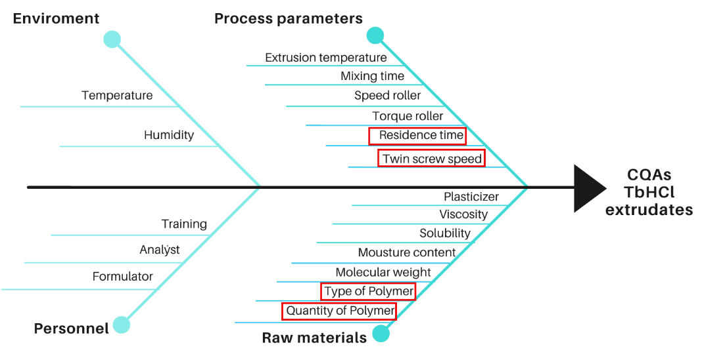
Figure 1: Ishikawa fish bone diagram for factors detection on the CQAs of TbHCl extrudates

Table 2. Risk assessment of potential factors affecting CQAs of TbHCl extrudates
CQA | Material attributes
CQA | Qty of polymer | Type of polymer | Termoplasticity | Solubility | Plasticizer | Moisture content
Dissolution rate | High | High | Low | Low | Low | Low
CQA | Process parameters
CQA | Extrusion temperature | Mixing time | Speed roller | Torque roller | Residence time | Twin screw speed
Dissolution rate | Medium | Low | Low | Medium | High | High
Qty: quantity. Low: not required research, Medium: research could be required, High: research is required
2.2.2 Design of Experiments (DoE)
Based on the initial risk assessment and preliminary feasibility studies, a 2^{k} factorial screening design with four factors at two levels was selected. The independent variables (Xs) and response variables are detailed in Table 3. This initial design comprised a total of 16 experimental runs. Following the analysis of the main effects, the experimental plan was expanded into a Central Composite Design (CCD) by incorporating axial points, resulting in 11 additional runs, which were combined with the results of the 2^{k} design. This second stage allowed the development of a predictive model -capturing non-linear and quadratic interactions- to describe the dissolution behavior and guide the selection of an optimized formulation. This two-phase design strategy allowed us to ensure efficient variable screening through the 2⁴ factorial design, followed by fine-tuning and modeling of the most relevant factors via the CCD.
The selected responses were the dissolution profile slope and the percentage of drug dissolved at 60 minutes. The experimental runs and the transition to the CCD are summarized in Table 3. Data analysis was performed using Statgraphics Centurion XIV software, and Analysis of Variance (ANOVA) was applied to assess the results.
Table 3. DoE attributes
Screening design
Independent Factors |  | Name  CMA and CPPs |  | Type |  |  | Units |  | Level 1  (-) |  | Level 2  (+)
A |  | Polymer type |  | Categoric |  |  | Nominal |  | PVPVA 64 |  | Soluplus
B |  | Qty of polymer |  | Numeric |  |  | % (w/w) |  | 20 |  | 45
C |  | Screw speed |  | Numeric |  |  | rpm |  | 25 |  | 100
D |  | Residence time |  | Numeric |  |  | min |  | 5 |  | 20
Dependent variables responses (CQAs) |  | Slope |  |  |  |  | Y1
 |  | % drug release in 60 min |  |  |  |  | Y2
Central composite design (CCD) with stars
Factor | Name |  | Type |  | Units | Level  1 |  | Level  2 |  | Level 3 | Level 4 | Level 5
A | Qty of polymer |  | Numeric |  | % (w/w) | 14.32 |  | 20 |  | 32.5 | 45 | 63.63
B | Residence time |  | Numeric |  | min | 3.39 |  | 5 |  | 7.5 | 20 | 25.1
Dependent variables | Slope |  |  |  | Y1
Dependent variables | % drug release in 60 min |  |  |  | Y2
2.2.3 Manufacturing Process
Batches of 4 g consisting of TbHCl and polymer were processed using a Thermo Scientific HAAKE Minilab co-rotating twin-screw extruder (Waltham, MA), featuring 11 cm screws and a valve to control residence time within the extrusion chamber. SD were produced at 110°C with a feeding time of 5 minutes. Other processing parameters were adjusted according to the experimental design.
In this study, xylitol was incorporated as a functional excipient to improve the processability of terbinafine–polymer blends during HME. Its low melting point (~94 °C), plasticizing effect, and non-hygroscopic nature helped reduce melt viscosity and extrusion torque, particularly when processing high-Tg polymers such as PVP VA64. Previous reports have demonstrated that polyols like xylitol act as transient plasticizers, enhancing melt flow and enabling extrusion at lower temperatures without compromising API integrity or dispersion homogeneity. [36]

Additionally, two physical mixtures of TbHCl-Soluplus® and TbHCl-PVPVA64® (1:1 w/w) were prepared for comparative analysis against the extrudates.

2.2.4 Solid Dispersion Evaluation
Differential Scanning Calorimetry (DSC): Samples (n=3) of the extrudate filaments were ground in a mortar and pestle and sieved through a US #80 mesh. Approximately 15 mg (equivalent to TbHCl content) of each sample were accurately weighed and sealed in 40 μL aluminum pans. DSC measurements were conducted using a PerkinElmer DSC 7 calorimeter (Waltham, MA) under a heating rate of 10°C/min. Data were analyzed using Pyris software.
Powder X-ray Diffraction (PXRD): X-ray diffraction patterns were obtained using a Rigaku SmartLab diffractometer (Tokyo, Japan) with CuKα radiation at 40 kV and 44 mA. Scans were performed over a 2θ range of 5° to 40°, at a scanning rate of 4°/min and a step size of 0.002°. Individual excipients, physical mixtures, and extrudates from the experimental designs were analyzed. Characteristic peaks of pure TbHCl were identified and their intensities were compared with those observed in solid dispersions.
Dissolution Studies: Dissolution testing was performed in triplicate (n=3) using the USP Apparatus I (basket method). Samples equivalent to 15 mg of TbHCl were placed in 900 mL of 0.001 N HCl solution, following the method reported by Kuminek et al. [7]. Samples (5 mL) were withdrawn at predetermined intervals (5, 10, 15, 20, 30, 40, 50, and 60 minutes) and replaced with fresh dissolution medium to maintain sink conditions. Drug concentration was determined via UV spectrophotometry at 222 nm using quartz cuvettes and quantified against a standard calibration curve. The cumulative percentage dissolved was calculated to determine the dissolution rate (slope of the dissolution profile) and the percentage dissolved at 60 minutes.
3. results and discussion

3.1 Calorimetric Studies and XRPD Patterns
The results obtained for PVP VA64 and Soluplus® are shown in Figure 2 A,B, and 2 C,D respectively. The pure TbHCl sample exhibited a melting endotherm at 213.4°C, consistent with values reported in the literature. The glass transition temperatures (Tg) of both polymers were experimentally recorded at 90°C for PVP VA64 and 91°C for Soluplus®. These values differ slightly from those reported in the literature [1,37], a discrepancy that may be attributed to residual moisture in the test polymer samples. This experimental determination was crucial in selecting the optimal processing temperature for the extrusion process.
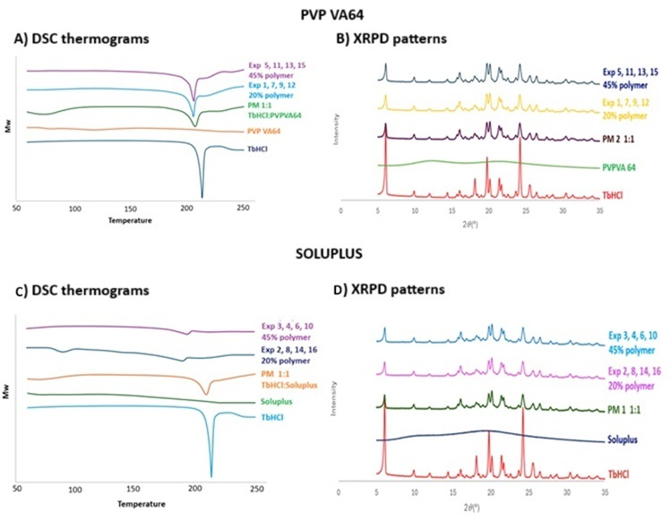
Figure 2 DSC thermograms and XRPD patterns SD (only key results are shown)
The physical mixtures (PM) displayed a reduction in the enthalpy of fusion of TbHCl, primarily due to the dilution effect from the polymer carriers. In the solid dispersions manufactured with Soluplus® (Figure 2C), the characteristic melting peak of TbHCl was absent, suggesting that the drug was either molecularly dispersed or solubilized within the molten polymer matrix. In contrast, for PVP VA64, a significant reduction in the melting point was observed; however, even after the extrusion process, a residual melting peak was detected near 193°C, representing a shift of approximately 20°C (Figure 2A).
In the X-ray diffraction (XRD) results for both polymers, the characteristic peaks of TbHCl remained present in the solid dispersions (SDs), suggesting that microcrystalline solid dispersions were obtained (Figure 2B y 2D).
Preliminary dissolution studies of physical mixtures of TbHCl and solubilizing polymers at a 1:1 ratio (w/w) demonstrated that both polymers enhanced the dissolution rate compared to the pure drug. Moreover, calorimetric studies indicated drug–polymer interactions, evidenced by a reduction and shift in the drug’s melting point within the physical mixtures [38].
Additionally, both PVP VA64 and Soluplus exhibit properties favorable for hot-melt extrusion, including a glass transition temperature (Tg) lower than the processing temperature and sufficient thermal stability. Furthermore, Soluplus offers dual solubilization mechanisms, enhancing its potential as a carrier. Results of the experimental designs (screening and central composite with star points) are presented in Table 4.
Table 4. Results from DoE
Screening design
Experiment | Polymer | % polymer  (%W/W) | Screw speed (SS)  (rpm) | Residence time (RT)  (min) | Profile slope | % release 60 min
1 | PVP VA 64 | 20 | 25 | 20 | 0.2456 | 13.67
2 | Soluplus | 20 | 25 | 5 | 0.2946 | 16.18
3 | Soluplus | 45 | 100 | 5 | 0.4401 | 24.18
4 | Soluplus | 45 | 100 | 20 | 0.3819 | 20.84
5 | PVP VA 64 | 45 | 100 | 5 | 0.2471 | 13.88
6 | Soluplus | 45 | 25 | 20 | 0.4436 | 25.04
7 | PVP VA 64 | 20 | 100 | 20 | 0.2383 | 14.41
8 | Soluplus | 20 | 100 | 5 | 0.2496 | 15.22
9 | PVP VA 64 | 20 | 100 | 5 | 0.2094 | 12.08
10 | Soluplus | 45 | 25 | 5 | 0.3890 | 19.32
11 | PVP VA 64 | 45 | 25 | 5 | 0.2287 | 10.69
12 | PVP VA 64 | 20 | 25 | 5 | 0.1732 | 17.45
13 | PVP VA 64 | 45 | 100 | 20 | 0.2206 | 13.77
14 | Soluplus | 20 | 100 | 20 | 0.2468 | 15.67
15 | PVP VA 64 | 45 | 25 | 20 | 0.2386 | 13.56
16 | Soluplus | 20 | 25 | 20 | 0.2500 | 14.06
 | TbHCl |  |  |  | 0.2161 | 14.95
 | PM 1 |  |  |  | 0.2182 | 12.10
 | PM 2 |  |  |  | 0.3123 | 18.10
Central composite design (CCD) with stars
17 | Soluplus | 45 | N/A | 5 | 0.3890 | 19.32
18 | Soluplus | 32.5 | N/A | 3.39 | 0.3719 | 20.98
19 | Soluplus | 20 | N/A | 5 | 0.2946 | 16.18
20 | Soluplus | 14.32 | N/A | 7.5 | 0.2967 | 17.28
21 | Soluplus | 45 | N/A | 20 | 0.4436 | 25.04
22 | Soluplus | 32.5 | N/A | 7.5 | 0.3839 | 23.52
23 | Soluplus | 20 | N/A | 20 | 0.2500 | 14.06
24 | Soluplus | 32.5 | N/A | 7.5 | 0.4118 | 24.41
3.2 Dissolution Studies
The dissolution rate results are presented in Table 4. As shown, there was an increase both in the percentage of drug dissolved at 60 minutes—from 14.95% to 25%—and in the dissolution rate—from 0.2161 to 0.4436—representing a 2.03-fold enhancement in dissolution rate compared to pure TbHCl.
According to the Pareto chart from the factorial analysis (Figure 3A), the dissolution rate was significantly influenced by three variables: the type of polymer, the polymer concentration, and the quadratic interaction between polymer type and concentration. Solid dispersions manufactured with Soluplus exhibited the greatest increase in dissolution rate. This effect may be attributed to the dual solubilization mechanisms inherent to Soluplus, including complex formation and micelle formation.
Regarding the percentage of drug dissolved at 60 minutes (Figure 3B), it was found that the polymer type, the quadratic effects of factors A and B, and the polymer concentration significantly increased the drug release at 60 minutes. However, when PVP VA64 was used as the carrier, an increase in polymer concentration did not significantly impact either the dissolution rate or the percentage dissolved at 60 minutes, as illustrated in Figures 5A and 5B.
The enhancement of the dissolution profiles of TbHCl can be attributed to three key factors: (a) the reduction in the crystallinity of TbHCl (Figure 2A and 2C), indicated by the significant decrease in the heat of fusion (ΔHf) of TbHCl, (b) the increase in wettability due to its embedding in a water-soluble polymer, and (c) likely, the reduction of the particle size of the TbHCl crystals to a near-molecular level. The diminished effect of PVP VA64 on the dissolution rate may be related to its high viscosity. This phenomenon could lead to the formation of a diffusion layer near the dissolution surface, thereby slowing down the drug release from the polymeric network of solid dispersion.
3.3 Optimization Through Design of Experiments (DoE)
From the screening design results, it was found that SD showed a greater increase in dissolution rate when fabricated with Soluplus. Based on this, the central composite design was continued for this polymer only. The results obtained are shown in Table 4. Regarding the calorimetric studies, the thermal event behaviors were maintained, with the disappearance of the fusion peak. In X-ray diffraction studies, the characteristic peaks of pure TbHCl remained (Figure 6B).
The increase in dissolution rate with the increased polymer concentration used during fabrication was confirmed. As shown in Figure 6A, the dissolution profiles exhibit a higher dissolution rate compared to pure TbHCl (represented in red) and the physical mixture (PM) at 45% (in cyan).
$Y1=0.392412+0.063206A+0.0163114B-{0.022291B}^{2}+0.0248AB$……..Ecuación 1
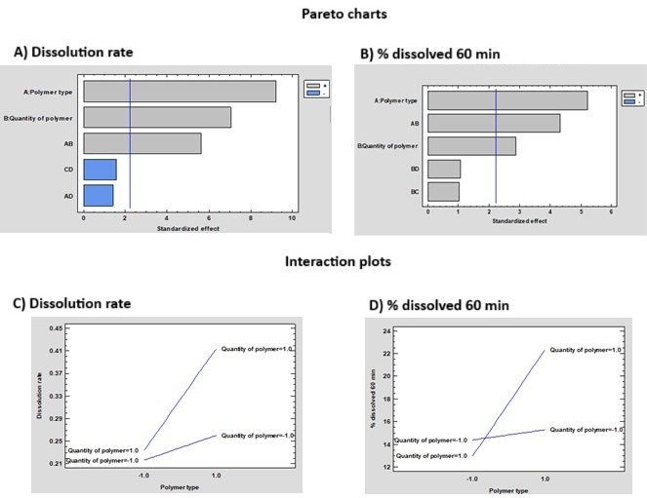
Figure 3. Factorial design results: A and B Pareto Charts and C and D Interaction Plots.
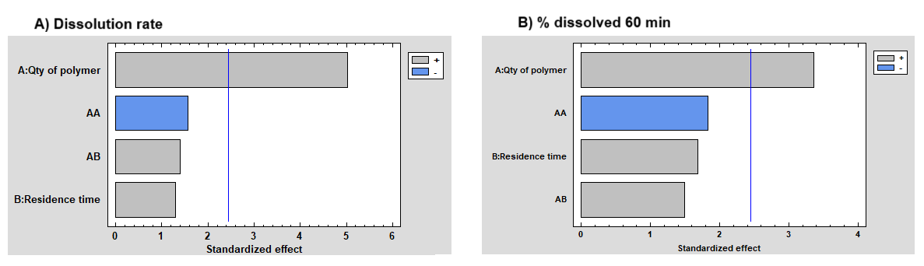
Figure 4. Pareto charts central composite design with stars
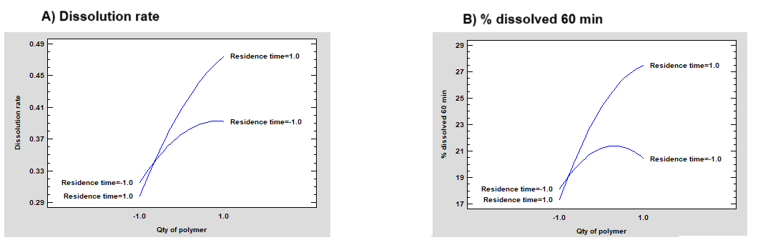
Figure 5. Interaction plots central composite design with stars

A) Dissolution profiles B) XDR patterns
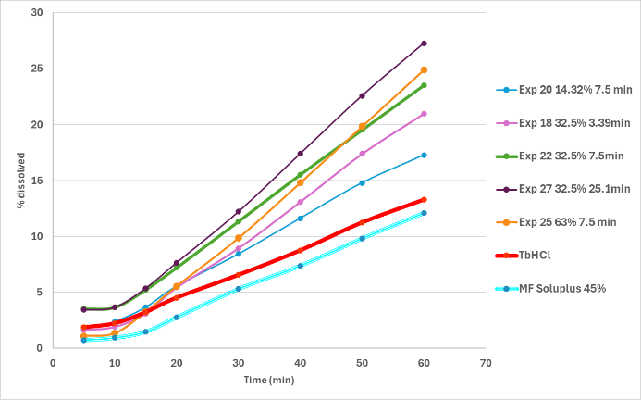 | 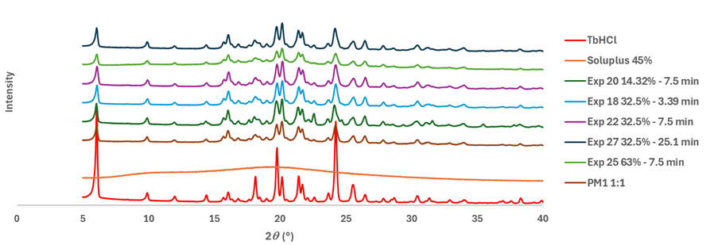
Figure 6. Representative dissolution profiles y XDR patterns for central composite design with stars
The response surfaces generated (Figures 7A and 7B) demonstrated pronounced curvature for both the dissolution rate and the percentage dissolved at 60 minutes. This nonlinearity was influenced by the main effect and the quadratic term of the polymer type, the interaction between polymer type and polymer concentration, as well as the quadratic effect of polymer concentration. The experimental data exhibited an excellent fit to the mathematical model described by Equation 1 (r²=83.9396%), supporting its predictive capability for dissolution rate behavior.

A) Dissolution rate B) % dissolved 60 min
Figure 7. Surface responses for central composite design with stars
3.4 Discussion
The present study investigated the development of terbinafine hydrochloride (TbHCl) solid dispersions (SDs) via hot-melt extrusion (HME) under a Quality by Design (QbD) approach, using Soluplus® and PVP VA64 as polymeric carriers. The results demonstrate that formulation composition—particularly polymer type and concentration—had a decisive impact on dissolution performance, whereas process parameters such as screw speed and residence time had secondary effects within the evaluated ranges.
Soluplus®-based SDs showed superior dissolution enhancement compared to PVP VA64 systems at equivalent drug loadings. This can be attributed to the amphiphilic nature of Soluplus®, which enables both micellar solubilization above its critical micelle concentration (CMC) and molecular interactions with the hydrophobic drug. The dissolution rate improvement was more pronounced at higher Soluplus® contents, consistent with previous reports for poorly soluble BCS class II drugs. In contrast, PVP VA64-based systems relied primarily on polymer erosion and wettability improvement, which translated into slower drug release under the same dissolution conditions.
Inclusion of xylitol at ≤10% w/w facilitated extrusion by lowering melt viscosity and torque, particularly for high-Tg PVP VA64 formulations. Although xylitol can improve wettability and generate aqueous channels upon dissolution, its low concentration in this study minimized its direct influence on dissolution behavior. This approach avoided confounding effects in the DoE analysis, ensuring that the observed dissolution enhancement could be attributed primarily to polymer properties.
XRPD and DSC analyses confirmed that the optimized SDs contained terbinafine in a mixed crystalline–amorphous state, rather than fully amorphous. The partial amorphization, together with improved dispersion of the drug within the polymer matrix, contributed to the observed dissolution enhancement.
The two-stage DoE strategy—initial full factorial screening followed by central composite design (CCD)—allowed systematic identification and modeling of critical factors. The CCD model predicted dissolution behavior within the studied design space, and the selected formulation fell within the region of maximum predicted dissolution rate. Although the predictive capability of Equation 1 was supported by model fit statistics (r²), explicit validation runs should be performed in future work to confirm model robustness.
The selected prototype represents an optimized compromise among key formulation and processing parameters, including elevated drug loading (to reduce tablet dimensions), substantial enhancement of dissolution rate, acceptable extrusion torque, and favorable downstream processability. Specifically, the formulation comprises 42.2% soluplus and exhibits a residence time of 15.88 minutes, resulting in a 2.03-fold increase in dissolution rate compared to the untreated drug. A high degree of API ensures uniformity, while adequate densification of the extrudate improves both flowability and compressibility during downstream manufacturing processes. Although these characteristics were not the primary focus of the present study, their consideration underscores their relevance for the successful translation of the formulation into scalable and robust production processes.
While the present study followed QbD principles by linking CMAs and CPPs to dissolution performance through risk assessment and DoE, the mechanistic understanding of crystallinity changes and particle size reduction could be expanded. Future studies should include in-line or off-line particle size characterization of the dispersed API to clarify the contributions of amorphization versus size reduction.
4. Conclusion

In summary, the optimized TbHCl SD formulation, produced via HME with Soluplus® at high drug loading, demonstrated significant dissolution rate improvement while maintaining processability. The study provides a systematic foundation for scale-up and further optimization, though additional work is required to translate these findings into final dosage form performance.

Consent (where ever applicable)
Not applicable

Ethical approval (where ever applicable)
Not applicable, all experiments where in vitro

COMPETING INTERESTS DISCLAIMER:
Authors have declared that they have no known competing financial interests OR non-financial interests OR personal relationships that could have appeared to influence the work reported in this paper.

References

[1] BASF. Solubility Enhancement with BASF Pharma Polymers. Solubilizer Compendium. Lampertheim, Germany: 2011.
[2] Gowardhane AP, Kadam NV, Dutta S. Review on Enhancement of Solubilization Process. Am J Drug Discov Dev 2014;4:134–52. https://doi.org/10.3923/ajdd.2014.134.152.
[3] Chaudhary A, Nagaich U, Gulati N, Sharma VK, Khosa RL. Enhancement of solubilization and bioavailability of poorly soluble drugs by physical and chemical modifications: A recent review 2012;2:32–67.
[4] Xiong X, Zhang M, Hou Q, Tang P, Suo Z, Zhu Y, et al. Solid dispersions of telaprevir with improved solubility prepared by co-milling: formulation, physicochemical characterization, and cytotoxicity evaluation. Mater Sci Eng C 2019;105:110012. https://doi.org/10.1016/j.msec.2019.110012.
[5] Potter C, Tian Y, Walker G, McCoy C, Hornsby P, Donnelly C, et al. Novel supercritical carbon dioxide impregnation technique for the production of amorphous solid drug dispersions: A comparison to hot melt extrusion. Mol Pharm 2015;12:1377–90. https://doi.org/10.1021/mp500644h.
[6] JENSEN JC. Clinical pharmacokinetics of terbinafine (Lamisil). Clin Exp Dermatol 1989;14:110–3. https://doi.org/10.1111/j.1365-2230.1989.tb00904.x.
[7] Kuminek G, Rauber GS, Riekes MK, Campos CEM de, Monti GA, Bortoluzzi AJ, et al. Single crystal structure, solid state characterization and dissolution rate of terbinafine hydrochloride. J Pharm Biomed Anal 2013;78–79:105–11. https://doi.org/10.1016/j.jpba.2013.02.001.
[8] Shi H, Xie Y. Solubility and thermodynamics of terbinafine hydrochloride in different neat and binary solvents: Measurement, correlation and molecular interactions. J Mol Liq 2017;243:293–301. https://doi.org/10.1016/j.molliq.2017.08.052.
[9] Arunprasad K, Narayanan N, Rajalakshmi G. Preparation and Evaluation of Solid Dispersion of Terbinafine Hydrochloride. Int J Pharm Sci Rev Res 2010;3:130–4.
[10] Kumar N, Jain A, Singh C, Kumar R. Development, characterization and solubility study of solid dispersion of terbinafine hydrochloride by solvent evaporation method. Asian J Pharm 2008;2:154. https://doi.org/10.4103/0973-8398.43301.
[11] Payghan SA, BARGIR TN, ADHAV AJ. Composition of Terbinafine Hcl Polymeric Gel for Mucosal Drug Delivery. Int J Biol Pharm Allied Sci 2016;5:2146–68.
[12] Uzqueda M, Martín C, Zornoza A, Sánchez M, Vélaz I. Physicochemical characterization of terbinafine-cyclodextrin complexes in solution and in the solid state. J Incl Phenom Macrocycl Chem 2010;66:393–402. https://doi.org/10.1007/s10847-009-9656-0.
[13] Vemula SK. Development and characterization of fast disintegrating tablets of Terbinafine hydrochloride 2011;4:2273–5.
[14] Thatai P, Sapra B. Transungual Gel of Terbinafine Hydrochloride for the Management of Onychomycosis: Formulation, Optimization, and Evaluation. AAPS PharmSciTech 2017;18:2316–28. https://doi.org/10.1208/s12249-017-0711-7.
[15] Tayel SA, El-Nabarawi MA, Tadros MI, Abd-Elsalam WH. Promising ion-sensitive in situ ocular nanoemulsion gels of terbinafine hydrochloride: Design, in vitro characterization and in vivo estimation of the ocular irritation and drug pharmacokinetics in the aqueous humor of rabbits. Int J Pharm 2013;443:293–305. https://doi.org/10.1016/j.ijpharm.2012.12.049.
[16] Baheti A, Srivastava S, Sahoo D, Lowalekar R, Prasad Panda B, Kumar Padhi B, et al. Development and Pharmacokinetic Evaluation of Industrially Viable Self-microemulsifying Drug Delivery Systems (SMEDDS) for Terbinafine. Curr Drug Deliv 2016;13:65–75. https://doi.org/10.2174/1567201812666150120153357.
[17] Gaba B, Fazil M, Khan S, Ali A, Baboota S, Ali J. Nanostructured lipid carrier system for topical delivery of terbinafine hydrochloride. Bull Fac Pharmacy, Cairo Univ 2015;53:147–59. https://doi.org/10.1016/j.bfopcu.2015.10.001.
[18] Vaghasiya H, Kumar A, Sawant K. Development of solid lipid nanoparticles based controlled release system for topical delivery of terbinafine hydrochloride. Eur J Pharm Sci 2013;49:311–22. https://doi.org/10.1016/j.ejps.2013.03.013.
[19] Wu W. The Mechanism of Improvement of Film Solubility:Design and Evaluation of Film Forming System with Terbinafine as a Model Drug 2021.
[20] Vo CLN, Park C, Lee BJ. Current trends and future perspectives of solid dispersions containing poorly water-soluble drugs. Eur J Pharm Biopharm 2013;85:799–813. https://doi.org/10.1016/j.ejpb.2013.09.007.
[21] Karekar P, Salunkhe N, Yadav A, Bangar D, Yadav D. Modulation of physico-chemical properties of terbinafine HCL by using solid dispersion technique. Res J Pharm Technol 2014;7:450–3.
[22] Kumari R, Chandel P, Kapoor A. Paramount Role of Solid Dispersion in Enhancement of Solubility. INDO Glob J Pharm Sci 2013;3:78–89.
[23] Tambe S, Jain D, Agarwal Y, Amin P. Hot-melt extrusion: Highlighting recent advances in pharmaceutical applications. J Drug Deliv Sci Technol 2021;63. https://doi.org/10.1016/j.jddst.2021.102452.
[24] Lian X, Dong J, Zhang J, Teng Y, Lin Q, Fu Y, et al. Soluplus® based 9-nitrocamptothecin solid dispersion for peroral administration: Preparation, characterization, in vitro and in vivo evaluation. Int J Pharm 2014;477:399–407. https://doi.org/10.1016/j.ijpharm.2014.10.055.
[25] Djuris J, Nikolakakis I, Ibric S, Djuric Z, Kachrimanis K. Preparation of carbamazepine–Soluplus® solid dispersions by hot-melt extrusion, and prediction of drug–polymer miscibility by thermodynamic model fitting. Eur J Pharm Biopharm 2013;84:228–37. https://doi.org/10.1016/j.ejpb.2012.12.018.
[26] Alshahrani SM, Lu W, Park JB, Morott JT, Alsulays BB, Majumdar S, et al. Stability-enhanced Hot-melt Extruded Amorphous Solid Dispersions via Combinations of Soluplus® and HPMCAS-HF. AAPS PharmSciTech 2015;16:824–34. https://doi.org/10.1208/s12249-014-0269-6.
[27] Pina MF, Zhao M, Pinto JF, Sousa JJ, Craig DQM. The Influence of Drug Physical State on the Dissolution Enhancement of Solid Dispersions Prepared Via Hot-Melt Extrusion: A Case Study Using Olanzapine. J Pharm Sci 2014;103:1214–23. https://doi.org/10.1002/jps.23894.
[28] Liu J, Cao F, Zhang C, Ping Q. Use of polymer combinations in the preparation of solid dispersions of a thermally unstable drug by hot-melt extrusion. Acta Pharm Sin B 2013;3:263–72. https://doi.org/10.1016/j.apsb.2013.06.007.
[29] Turton R, Virginia W. Cooling processes and congealing. Encycl. Pharm. Technol., 2002, p. 627–40.
[30] Jadav NB, Paradkar A. Solid dispersions. Nanopharmaceuticals, Elsevier; 2020, p. 91–120. https://doi.org/10.1016/B978-0-12-817778-5.00005-1.
[31] Harmonisation ICH. Pharmaceutical Quality System Q10. Pharm. Qual. by Des., 2008, p. 39–40.
[32] HARMONISATION ICOH. Quality Risk Management (Q9). Pharm. Qual. by Des., Wiley; 2018, p. 11–45. https://doi.org/10.1002/9781118895238.ch2.
[33] International Conference on Harmonization. ICH Q8 (R2): Pharmaceuical Development. Int. Conf. Harmon. Tech. Requir. Regist. Pharm. Hum. Use, vol. 8, 2009, p. 28.
[34] Butreddy A, Bandari S, Repka MA. Quality-by-design in hot melt extrusion based amorphous solid dispersions: An industrial perspective on product development. Eur J Pharm Sci 2021;158:105655. https://doi.org/10.1016/j.ejps.2020.105655.
[35] Simões MF, Pinto RMA, Simões S. Hot-melt extrusion in the pharmaceutical industry: toward filing a new drug application. Drug Discov Today 2019;24:1749–68. https://doi.org/10.1016/j.drudis.2019.05.013.
[36] Juluri A, Popescu C, Pimparade M, Kulkarni V, Leon Z, Murthy N, et al. Polyols as Plasticizers for Efficient Hot Melt Extrusion Processability of Maltodextrins, 2013.
[37] Pereira GG, Figueiredo S, Fernandes AI, Pinto JF. Polymer selection for hot-melt extrusion coupled to fused deposition modelling in pharmaceutics. Pharmaceutics 2020;12:1–63. https://doi.org/10.3390/pharmaceutics12090795.
[38] Alcantara-Fierro ET, Ortiz-Reynoso M. Dispersiones solidas: características, fabricación y estado de la publicación científica en 2020. El Farm. en el siglo XXI, Ser. Tópicos Sel. en ciencias y Tecnol. Farm., 2022.

