Original Research Article

FORMULATION AND EVALUATION OF ANTIBACTERIAL HERBAL GEL

ABSTRACT
Aim: Using of herbal gel has increased because of lesser side effects compared to allopathic gel. Gel having herbs with antibacterial properties has a high demand because of skin protective and skin caring action. So, purpose was to formulate and evaluate Topical Herbal Gel formulations using Organoleptic properties, Rheologic properties, pH and Stability and to assess the antibacterial efficacy of the formulated Herbal gel against common skin pathogens such as Staphylococcus aureus and Escherichia coli.
Study Design: Extraction of crude extracts from the selected herbs followed by phytochemical investigation and then development of herbal gel formulations followed by their evaluation and lastly antibacterial activity testing of best herbal formulation selected on the basis of the outcomes of evaluation.
Place and Duration of the study: Research was conducted in faculty of pharmacy, Baba Mastnath University, Asthal Bohar, Rohtak from February 2025 to May 2025.
Methodology: Maceration and decoction extraction methods were employed for the extraction of crude extracts from the herbs such as Ocimum basilicum, Vachellia nilotica and Bergera koenigii. Phytochemical screening was performed for all the extracts obtained. Formulation and of herbal gel formulations were performed. Cylindrical plate method was used for determining the antibacterial activity of best selected herbal gel formulation.
Results: Polyherbal gels were formulated with the extracts of herbs such as Ocimum basilicum, Vachellia nilotica and Bergera koenigii. These were evaluated for Organoleptic properies, Rheological properties, pH and stability. It was found that Herbal Gel Formulation (F1) is better in terms of pH and Spreadability, other parameters were almost same. Then, it was evaluated for antibacterial activity against Staphylococcus aureus and Escherichia coli bacterial strains by cylindrical plate method. Herbal gel formulation (F1) has a comparable antibacterial activity at 20 mg per ml concentration with standard antibiotic substance of Streptomycin at 15µg per ml.
Conclusion: Herbal gel is formulated and evaluated for various parameters and it having antibacterial activity also. This gel can be used for care and protection of hair and skin.
Keywords: gel; herbal; properties; antibacterial; formulation
INTRODUCTION
The therapeutic potential of herbal gels, derived from natural plant sources, has significantly increased their adoption in modern healthcare. As a safer and more holistic alternative to synthetic pharmaceuticals, these formulations are gaining popularity due to their effectiveness in treatment while minimizing adverse effects (Cowan, 1999). Their natural origin and versatility make them especially useful for addressing a wide range of skin conditions from mild irritation and inflammation to more severe bacterial or fungal infections (Azazuddin, 2010). Their broad applicability has secured a role for them in both traditional and modern medical systems. Among various types, antibacterial herbal gels stand out as particularly valuable. These topical formulations incorporate plant-based ingredients known for their antimicrobial, especially antibacterial, properties. The active constituents extracted from medicinal plants are embedded in a gel medium that promotes easy application and efficient skin absorption (Bhardwaj et al, 2018). The main goal of these gels is to either prevent or manage bacterial skin infections. They are commonly used to treat minor wounds, cuts, abrasions, and localized infections resulting from bacterial contamination (Kalra et al, 2016; Semwal et al, 2021). Compared to conventional antibiotics, herbal gels are often better tolerated, with a reduced risk of resistance or allergic reactions, thanks to their natural constituents. This makes them a suitable choice for individuals seeking gentler, non-synthetic treatments. Additionally, many plant-based agents in these gels also provide anti-inflammatory and wound-healing benefits, further enhancing their therapeutic scope (Sahu et al, 2012). With the rising demand for natural and eco-friendly healthcare products, antibacterial herbal gels are expected to become increasingly prominent in dermatological and therapeutic settings. Formulating these gels requires careful selection of plant extracts with proven antimicrobial efficacy (Cowan, 1999; Bhardwaj et al, 2018). These bioactive ingredients are then incorporated into a suitable gel base that facilitates delivery and absorption through the skin (Bhattacharjee et al, 2019). The formulation is often designed for controlled release, ensuring prolonged therapeutic action and enhanced efficacy (Ajazuddin, 2010; Mahmood et al, 2011).
One of the key advantages of gel-based formulations is their fast absorption through the skin. Unlike traditional creams and ointments, which can leave a greasy or sticky residue, gels are generally lightweight and non-oily making them particularly suitable for sensitive or inflamed skin (Ajazuddin, 2010). The gel structure also allows active ingredients to reach deeper skin layers and act directly at the site of infection. This targeted action is especially useful for localized skin problems requiring immediate intervention (Cowan, 1999; Bhattacharjee et al, 2019). Herbal antibacterial gels are widely used to treat various skin infections caused by bacteria, such as acne, wounds, burns, and abrasions (Kalra et al, 2016; Sahu et al, 2012). Their increasing usage is due to the strong therapeutic effects of the incorporated plant extracts. Well-known ingredients like neem, turmeric, aloe vera, and tea tree oil, long used in traditional medicine have been scientifically validated for their antioxidant, antibacterial, anti-inflammatory, and wound-healing characteristics (Semwal et al, 2021; Mahmood et al, 2011; Zhang et al, 2016). These botanicals not only combat infection but also soothe irritated skin, reduce redness, and promote tissue regeneration. One of the distinguishing features of these gels is their ability to offer multiple therapeutic effects within a single formulation. Many of these plant-based ingredients help retain skin moisture, stimulate collagen production, and support the restoration of the skin’s protective barrier. As noted by Bharadwaj et al, this makes herbal gels suitable for not only addressing infections but also improving overall skin health and speeding up recovery (Bhardwaj et al, 2018). Additionally, since these gels typically exclude harsh preservatives and synthetic chemicals, they are often better tolerated by individuals with sensitive or allergy-prone skin. In conclusion, antibacterial herbal gels present a promising, natural alternative for managing bacterial skin infections. By combining antimicrobial action with skin-healing benefits, these formulations offer a holistic therapeutic approach (Ajazuddin, 2010). As the shift toward clean and sustainable healthcare continues, the relevance of such herbal solutions in dermatology is set to rise. Their integration into modern skincare not only addresses consumer preferences but also aligns with global movements toward wellness and environmental sustainability (Cowan, 1999).
Medicinal Plants and Their Role in Healthcare
Medicinal plants have served as foundational elements in human health and healing practices for thousands of years. They contain bioactive compounds that can help prevent, manage, or cure various health conditions (Fabricant et al, 2001). These plants play a pivotal role in conventional practices like Ayurveda, Unani and Traditional Chinese Medicine, and continue to influence contemporary pharmacology (Heinrich et al, 2012). Their therapeutic value comes from natural compounds such as alkaloids, glycosides, polyphenols, and terpenes. These substances protect plants against environmental threats and pathogens and are utilized by humans for their medicinal benefits (Gurib-Fakim, 2006; Wink, 2015). India, one of the 17 megadiverse nations globally, is home to approximately 17,000–18,000 flowering plant species, of which over 7,000 have recognized medicinal uses across various traditional systems (Ved et al, 2008). These plants not only support traditional healthcare but also contribute to livelihoods and health security (Kala et al, 2006; Sharma et al, 2019).
Some commonly used medicinal plants include:
- Ashwagandha – Reduces stress and enhances vitality.
- Chamomile – Provides calming effects and supports digestion and sleep.
- Garlic – Offers antimicrobial and cardiovascular benefits.
- Ginger – Helps with nausea and digestion.
- Lavender – Alleviates anxiety and promotes sleep.
- Turmeric – Contains curcumin, which supports joint health due to its anti-inflammatory properties.
These herbs have been extensively studied and are used in both traditional and modern practices. However, despite their natural origin, they can produce strong biological effects and may interact with conventional drugs (Posadzki et al, 2013; Ekor, 2014). Therefore, it's essential to refer physicians, doctors before initiating herbal therapies, specifically on those patients suffering from long term disease condition or on prescribed medications (Shaw et al, 2012). The erraticism in the quality of herbal product also highlights the importance of standardization and regulatory oversight (Kunle et al, 2012; Mukherjee et al, 2017).
Extraction Methods for Herbal Compounds
Efficient extraction of biologically active components from medicinal plants is a critical step in herbal drug development. Various techniques are used, each offering unique benefits and limitations (Azwanida, 2015; Handa et al, 2008).
- Maceration: A traditional method where coarse plant material is soaked in a solvent at room temperature for several days, allowing compounds to diffuse into the liquid (Remington, 2005).
- Infusion: Similar to tea preparation, plant material is steeped in hot water for a short period. It is ideal for heat-sensitive compounds like tannins and flavonoids (Williamson, 2001; Bilia et al, 2008).
- Decoction: Involves boiling tougher plant parts such as roots or bark for 15 minutes to 2 hours to extract heat-stable compounds. Common in herbal teas and tinctures (Mukherjee et al, 2017; Sasidharan et al, 2011).
- Soxhlet Extraction: A laboratory technique using continuous cycles of solvent extraction to efficiently isolate compounds from solid plant material (Harborne, 1998; Pino et al, 2013).
Herbal Formulations and Dosage Forms
Herbal formulations are therapeutic preparations made from whole plant material or isolated active constituents. Used extensively in traditional medicine systems like Ayurveda and TCM, their effectiveness depends on the chosen herbs, method of preparation, and dosage form (Williamson et al, 2013; Mukherjee, 2002).
Common Dosage Forms Include (Panda, 2004; Calixto, 2000; Sahoo et al, 2010; Patwardhan et al, 2004):
- Powders (Churnas)
- Tablets (Vatis)
- Capsules
- Syrups
- Tinctures
- Ointments and Creams
- Essential Oils
- Ghritams (Medicated Ghee)
- Tailams (Medicated Oils)
Antibacterial Herbal Gel Formulation
Creating an effective antibacterial herbal gel involves selecting the right combination of herbal extracts, excipients, and stabilizing agents to ensure the formulation is potent, stable, and user-friendly. Key formulation components include:
- Herbal Extracts: Serve as the primary active ingredients, chosen for their antimicrobial and anti-inflammatory properties (Cowan, 1999).
- Gel Base: Determines texture and stability, aiding in the smooth delivery of actives to the skin (Bharti et al, 2012).
- Solvents: Mostly water, used to dissolve herbal actives and improve compatibility (Shirsand et al, 2009).
- Preservatives: Necessary to prevent microbial growth in water-based formulations (Ansel et al, 1999).
- pH Adjusters: Maintain skin compatibility, typically within a pH of 4.5 to 5.5 (Lachman et al, 1991).
Evaluating Antibacterial Activity
To ensure therapeutic effectiveness, antibacterial herbal gels must undergo rigorous evaluation using in vitro methods:
- Disc Diffusion (Kirby-Bauer Method): Measures zones of inhibition around discs impregnated with the test substance (Balouiri et al, 2016).
- Agar Well Diffusion: Herbal extracts are placed in agar wells to observe inhibition zones (Valgas et al, 2007).
- Minimum Inhibitory Concentration (MIC): Identifies the smallest concentration of an agent that hampers growth of microbes (CLSI, 2012).
- Minimum Bactericidal Concentration (MBC): Determines the smallest concentration required to kill the microorganism (Wiegand et al, 2008).
MATERIALS AND METHODS
Ocimum basilicum: Commonly known as basil, Ocimum basilicum is a fragrant herb from the Lamiaceae family, widely utilized in traditional medicine and culinary applications. Rich in essential oils such as linalool and eugenol, basil exhibits notable antibacterial, antioxidant, anti-inflammatory, and digestive properties. Its therapeutic benefits make it a common ingredient in products like herbal gels, creams, and mouthwashes, particularly for wound healing. In Ayurvedic medicine, basil is renowned for its effectiveness in managing digestive disorders, skin ailments, and respiratory issues like coughs. Due to its wide range of medicinal applications, both basil leaves and essential oil are extensively used in pharmaceutical and cosmetic formulations (Prakash et al, 2005; Suppakul et al, 2003; Gupta et al, 2008).
Bergera koenigii: Bergera koenigii (synonym: Murraya koenigii), popularly known as curry leaf, belongs to the Rutaceae family and holds a prominent place in Indian cuisine and traditional medicinal systems. Its aromatic leaves contain potent bioactive compounds such as flavonoids, carbazole alkaloids, and essential oils, contributing to its antioxidant, antimicrobial, antidiabetic and anti-inflammatory activities. The plant is known to support digestive health, enhance skin and hair vitality, and assist in regulating blood glucose levels. Curry leaf extracts are often incorporated into herbal formulations aimed at wound healing, liver support, and diabetes management. Its distinctive aroma, combined with its broad therapeutic potential, makes it a valued component in both natural medicine and culinary traditions (Arulselvan et al, 2006; Nadkarni, 2000; Handral et al, 2012).
Vachellia nilotica: Formerly classified as Acacia nilotica, Vachellia nilotica commonly known as babul or Indian gum arabic tree is a thorny member of the Fabaceae family native to regions of Africa, the Middle East, and India. Its bark, pods, and gum are rich in tannins, flavonoids, and saponins, endowing it with powerful antibacterial, antiviral, anti-inflammatory and astringent properties. Traditionally, it has been employed in the treatment of oral infections, wounds, cough, and gastrointestinal disturbances like diarrhea. Its bark extract is especially popular in herbal dental products such as toothpastes and mouthwashes due to its potent antimicrobial action. Highly esteemed in both Ayurvedic and Unani medicine, Vachellia nilotica continues to be a cornerstone in the formulation of multipurpose herbal remedies (Singh et al, 2011; Akinpelu et al, 2006; Shukla et al, 2009).
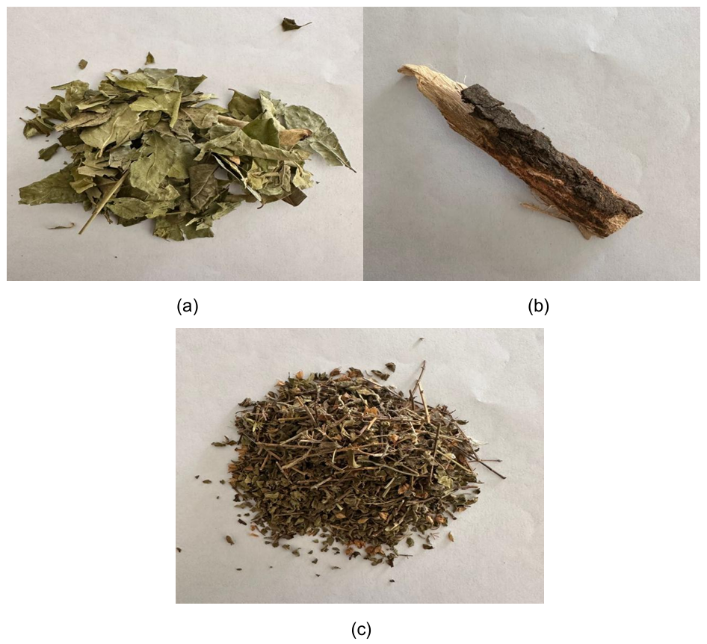
Figure 1: Selected Medicinal Plant Materials
- Leaves of Bergera koenigii; (b) Bark of Vachellia nilotica; (c) Seeds and Leaves of Ocimum basilicum

Procurement of Plant materials
- Leaves and seeds of Ocimum basilicum was collected from local market of Rohtak, Haryana. Specimen was authenticated by Dr. S. S. Yadav, Assistant Professor, Department of Botany, M. D. University, Rohtak, Haryana
- Leaves of Bergera koenigii was collected from local market of Rohtak, Haryana. Specimen was authenticated by Dr. S. S. Yadav, Assistant Professor, Department of Botany, M. D. University, Rohtak, Haryana
- Bark of Vachellia nilotica was collected from local market of Rohtak, Haryana. Specimen was authenticated by Dr. S. S. Yadav, Assistant Professor, Department of Botany, M. D. University, Rohtak, Haryana
Processing of Plant Materials
- Dried Leaves of and seeds of Ocimum basilicum were powdered by using grinder. Then, powdered material was macerated with solvent mixture of Ethanol: Water (80:20) for 3 days with intermittent stirring. After this, solution was filtered with filter paper and filtrate was dried with rota vapour and dried crude extract was collected and weighed.
- Dried leaves of Bergera koenigii were powdered by using grinder. Then, powdered material was macerated with solvent chloroform for 3 days with intermittent stirring. After this, solution was filtered with filter paper and filtrate was dried with rota vapour and dried crude extract was collected weighed.
- Bark of Vachellia nilotica were kept in boiled water for a period of 30 minutes. After this, Solution was filtered with filter paper and filtrate was dried with rota vapour and dried crude extract was collected and weighed.

Phytochemical Screening
Procedure (Pant et al, 2017 ; Sharma et al, 2020 ; Rao et al, 2023)
Carbohydrates
To detect carbohydrates in the plant extract, a few classic tests can be used:
- Molisch’s Test: Start by adding two drops of Molisch’s reagent to the extract. Then, carefully pour concentrated sulfuric acid down the side of the test tube. If a violet or purple ring appears where the two liquids meet, carbohydrates are present.
- Benedict’s Test: Mix 2 mL of Benedict’s reagent with the extract and heat the mixture in a boiling water bath for five minutes. A green, yellow, or red precipitate indicates the presence of reducing sugars.
- Iodine Test: Add a few drops of iodine solution to the extract. A blue-black coloration confirms the presence of starch.
Glycosides
Glycosides can be identified through the following tests:
- Borntrager’s Test: Boil the extract with dilute hydrochloric acid, let it cool, and then filter it. Shake the filtrate with chloroform and separate the chloroform layer. After adding ammonia, a pink to red color in the ammoniacal layer indicates glycosides.
- Keller-Killiani Test: Mix the extract with glacial acetic acid containing a trace of ferric chloride. Carefully layer concentrated sulfuric acid on top. The formation of a reddish-brown ring at the boundary confirms the presence of cardiac glycosides.
Alkaloids
To detect alkaloids, you can perform several color-based tests:
- Dragendorff’s Test: Adding Dragendorff’s reagent to the extract results in a reddish-brown precipitate if alkaloids are present.
- Mayer’s Test: When Mayer’s reagent is added to the extract, a creamy white precipitate indicates a positive result for alkaloids.
- Wagner’s Test: The presence of alkaloids is confirmed by a reddish-brown precipitate upon the addition of Wagner’s reagent.
Terpenoids
- Salkowski Test: Mix the plant extract with chloroform, then slowly add concentrated sulfuric acid along the side of the test tube. A reddish-brown color at the interface suggests terpenoids are present.
Phenols
- Ferric Chloride Test: Add 2–3 drops of a 5% ferric chloride solution to the extract. If a deep blue, green, or purple color develops, it indicates the presence of phenolic compounds.
Flavonoids
Flavonoids can be identified with simple color changes:
- Sodium Hydroxide Test: Add 10% sodium hydroxide solution to the extract. A yellow color that fades after adding dilute hydrochloric acid points to flavonoids.
- Lead Acetate Test: Mixing the extract with 10% lead acetate solution results in a yellow precipitate if flavonoids are present.
Preparation of Herbal Gel formulations
Herbal gel formulations are prepared by mixing various ingredients in step-wise manner. Dried crude extract of all three plant materials was added after preparation of gel. Crude extracts were mixed with the gel with continuous stirring until they were properly mixed.
Evaluation of Gel Formulations
- Organoleptic Properties
Homogeneity: Visual assessment of the gel's color, clarity, and uniformity to ensure it is free from any visible particles or clumps.
After feel: To assess the herbal gel's absorption characteristics, texture during application, and interaction with the skin's surface, the process entailed applying it directly to the skin.
Ease of removal: Clean, dry skin was covered evenly with the herbal gel, which was then left to sit for a predetermined amount of time. Either plain water or a moist cotton swab with light wiping motions were used for removal.
Colour: Herbal gel Formulations were checked visually for color.
Odor: Odor of the Herbal gel Formulations were examined by sensing the smell of the formulations.
Irritancy: A tiny amount of the herbal gel was applied to the hand's lateral region and left undisturbed for a full day in order to gauge skin irritancy. At regular intervals, the area was checked for any obvious symptoms of irritation, like redness, swelling, or itching. Following the 24-hour period, the area was reassessed for any delayed skin reactions and the gel was carefully removed.
- Rheological properties
Viscosity: The viscosity of the prepared herbal gels was determined using a Brookfield digital viscometer (Model LV DV–II Ultra Programmable, USA). Spindles 1 and 2 were rotated at 25 rpm for one minute in order to perform the assessment at 30 °C.
Extrudability: It was checked by applying pressure at the crimp end of the collapsible tube after filling it with herbal gel formulations with a closed cap for a period of 10 sec. Extruded herbal gel formulation was weighed.
Spreadability: It was noted by placing the herbal gel formulations between the two glass slides and keeping a weight of 100 g on the upper slide for a period of 5 minutes using a formula as:
S= m x L/T
Where S- Spreadability
m- Mass in gram placed on the upper glass slide
L- Length of the herbal gel formulation achieved after applying a pressure for a specific time
T- Time period used for the spreading of the formulation
- pH: Measurement of the gel's acidity or alkalinity using a Digital pH meter, ensuring it is within the acceptable range for topical application and won't cause skin irritation.
- Stability: Evaluating the gel's physical and chemical stability over time, including its appearance, pH, drug content, and other properties, to ensure it remains effective and safe throughout its shelf life.
Table 1: Outcomes of Phytochemical Screening

Antibacterial Activity
The antibacterial activity of the formulations was evaluated using the Cylindrical Plate method. Mueller-Hinton Agar served as the culture medium for testing against Staphylococcus aureus and Escherichia coli bacterial strains. Bacterial strains were transferred to the agar plates using spread plate method. Total of three wells were prepared on each agar plate. Concentration of herbal gel formulation was added to the one of the well on agar plate containing bacterial culture. One well was used for Standard antibacterial substance (Streptomycin sulphate) and other one for blank (containing solvent). After incubating the plates for 24 hours at 37°C, the antibacterial efficacy of the herbal gel formulation was evaluated by measuring the diameter of the zone of inhibition surrounding the well containing the formulation. These results were then compared with the inhibition zone produced by a standard reference substance.
RESULTS AND DISCUSSION
Outcomes of extraction Process
Crude extracts of plant materials were obtained after completion of extraction process. Percentage yield has been calculated for each plant material after drying and weighing of crude extract and mentioned in the Table 2.
Table 2: Percentage Yield of Crude Extract
Sr. No. | Plant Material | Solvent Used | % Yield
 | Leaves and Seeds of Ocimum basilicum | Ethanol: Water (80:20 v/v) | 3.0
 | Bark of Vachellia nilotica | Water | 0.5
 | Leaves of Bergera koenigii | Chloroform | 1.0

Outcomes of Phytochemical Screening
Phytochemical class such as Alkaloids are present in all three crude extracts. Glycosides, Flavonoids are found only in Ocimum sanctum and Acacia nilotica. Phenols are present in Acacia nilotica and Murraya koeniggi. Carbohydrates are found only in Acacia nilotica. Outcomes of Phytochemical class are mentioned in the Table 2. Photographs of Phytochemical screening outcomes are shown in Figure 2.

Phytochemicals Class | Leaves and Seeds of Ocimum basilicum | Bark of Vachellia nilotica | Leaves of Bergera koenigii
Carbohydrates | - | + | -
Alkaloids | ++ | + | +
Terpenoids | - | - | -
Glycosides | + | + | -
Flavonoids | + | + | -
Phenols | - | + | +
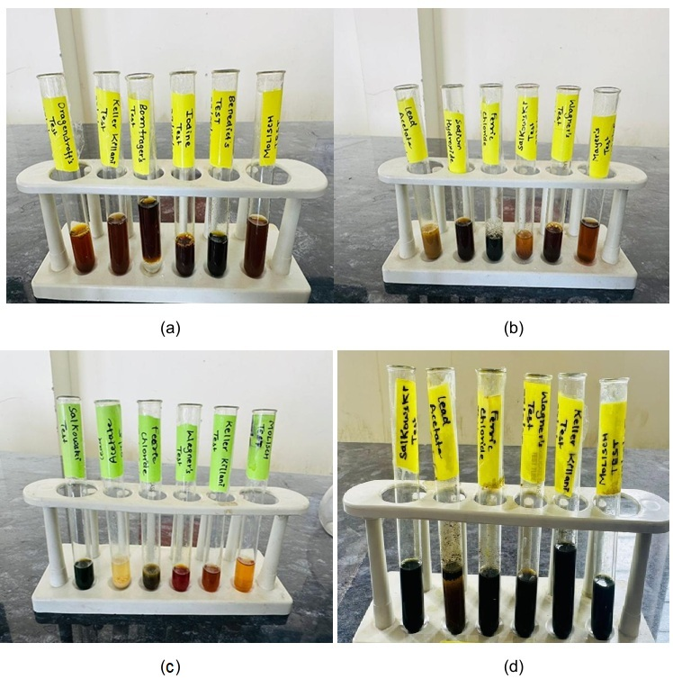
Figure 2: Phytochemical Screening of crude extracts (a), (b): Leaves and Seeds of Ocimum basilicum; (c): Bark of Vachellia nilotica; (d) Leaves of Bergera koenigii

Table 3: Composition of Herbal Gel Formulations
Ingredients | F1 (% w/v) | F2 (% w/v)
Starch | 20 | 25
Glycerin | 5 | 8
Propylene Glycol | 10 | 15
Triethanolamine | 2 | 3
Methyl Paraben | 0.05 | 0.05
EDTA | 0.2 | 0.3
Ocimum basilicum extract | 1.0 | 1.0
Vachellia nilotica extract | 0.5 | 0.5
Bergera koenigii extract | 0.5 | 0.5
Rose water | q.s. | q.s.
Water | 100 ml | 100 ml

Herbal Gel Formulations
Two Herbal gel formulations were designed by varying composition of the ingredients. Cold method was used for preparing gel formulations. Ingredients of formulations are mentioned in the Table 3. Photographs of Herbal gel Formulations are shown in Figure 3.

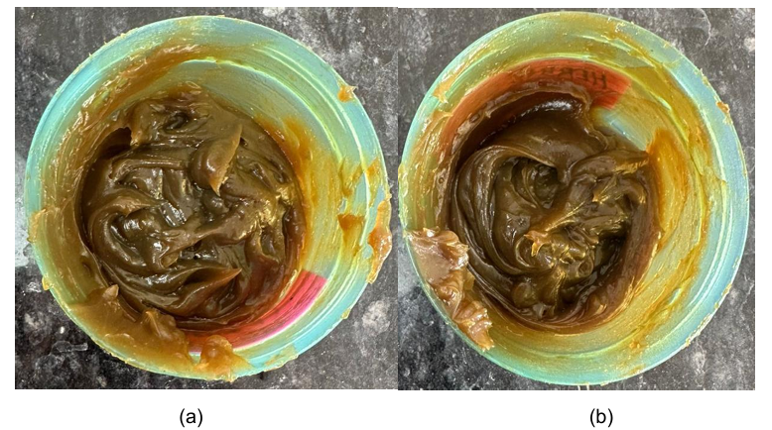
Figure 3: Herbal Gel formulations; (a) Formulation 1 (F1); (b) Formulation 2 (F2)

Evaluation of Formulations
Outcomes of organoleptic properties, Rheological properties, pH and stability testing of both Herbal paste formulations F1 and F2 are shown in Table 4.
- Organoleptic Properties

Homogeneity: Homogeneity of both formulations of Gel was found to be uniform.
After Feel: Herbal Gel formulations were absorbed quickly after application, leaving the skin feeling smooth and soft.
Ease of Removal: Using either plain water or a moist cotton swab, Herbal Gel formulations were easily removed from the skin's surface.
Color: Both Herbal Gel formulations are having Dark Brown color.
Odor: Both formulations are having a pleasant odor.
Irritancy: No erythema and oedema observed after application of Herbal Gel formulations.
- Rheological Properties
Viscosity: Viscosities of Herbal paste formulations F1 and F2 were observed 678 cps and 692 cps respectively.
Spreadability: Spreadability of Herbal paste formulations F1 and F2 were found 7.6 cm and 7.2 cm respectively.
Extrudability: Extrudability of Herbal paste formulations were observed very good to excellent.
- pH: pH values of formulations are in the range of 6.5-6.7.
- Stability: Both formulations are observed stable after testing for a period of 4 weeks at 45⁰C ± 2⁰C; 70± 5 % RH.
Table 4: Outcomes of Organoleptic, Rheological Properties, Ph and stability
Properties | F1 | F2
Homogeneity | Uniform | Uniform
After Feel | Excellent | Excellent
Color | Dark Brown | Dark Brown
Odor | Pleasant | Pleasant
Irritancy | No | No
pH | 6.5 | 6.7
Viscosity (cps) | 678 | 692
Spreadability (cm) | 7.6 | 7.2
Extrudability | Excellent | Very Good
Stability (4 weeks) | Stable | Stable

Both Herbal Gel formulations are having excellent Properties. But, Formulation (F1) was preferred in terms of pH and Spreadability for performing Antibacterial activity against G (+) and G (-) Bacterial strains.
Antibacterial Activity
Antibacterial activity of Herbal Gel formulation (F1) was performed by Cylindrical Plate method on Muller-Hinton Agar. Bacterial cultures of Staphylococcus aureus and Escherichia coli were used for ascertaining the antibacterial activity of Herbal paste formulation. Standard antibiotic (Streptomycin) was utilized as a positive control for comparison of zone of inhibition of herbal paste formulation with the standard. Dilution of Streptomycin of 15 µg/ml was prepared from stock (1mg/ml in water). Concentrations of Herbal Gel formulation was kept 10 mg/ml and 20 mg/ml in water. Water was used as a Negative control (Blank). Photographs of Diameter of Zone of Inhibition is shown in Figure 4.

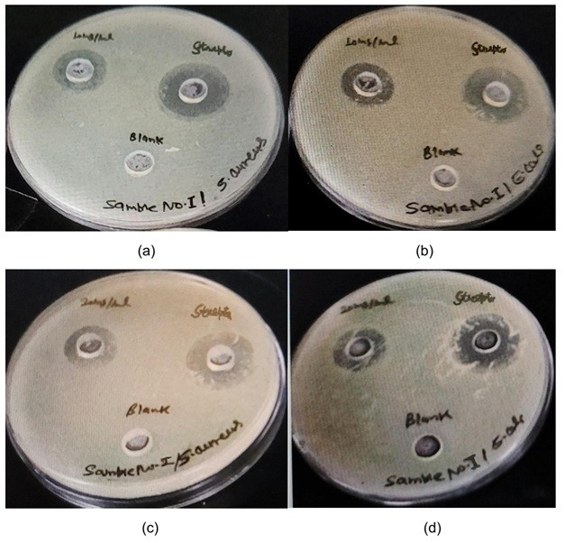

Figure 4: Diameter of Zone of inhibition of Herbal Gel formulation (F1) by Cylindrical Plate Method

Figure 5: Diameter of Zone of Inhibition (mm) of Herbal Gel formulation and Positive and Negative controls
It has been observed from the above Figure 5 that approximately 20 mg/ml of Herbal paste formulation will be equivalent to the Positive control (Streptomycin-15 µg/ml) concentration. Herbal paste formulation is showing very good antibacterial activity against G (+) Staphylococcus aureus and G (-) Escherichia coli bacterial cultures. Photographs of the diameter of Zone of inhibition has been depicted in Figure 5.
Using extracts of Leaves of Bergera koenigii, bark of Vachellia nilotica and Seeds and Leaves of Ocimum basilicum, the Herbal Gel formulation demonstrated beneficial properties for topical application. The formulation’s therapeutic potential was supported by phytochemical analysis, which identified several natural compounds known to help fight infections, reduce inflammation, and promote wound healing. On organoleptic evaluation, both Herbal Gel formulations are uniform with very good consistency, having dark brown color and pleasant odor, all contribute to its high user acceptability. Mild to Moderate viscosity, good spreadability, and ease of extrusion were confirmed by rheological evaluation. Formulations are found stable on stability testing for a period of 4 weeks. Antibacterial activity of the Herbal Gel formulation (F1) confirms that the formulation can be used for topical application for preventive and therapeutic effects in various skin ailments.

SUMMARY & CONCLUSION
Herbal Gel formulations were formulated with varying composition of ingredients. Both formulations were evaluated in terms of organoleptic properties, Rheological Properties and pH. Out of two formulation, one formulation is better than other in terms of Stability. That Formulation (F1) was assessed for Antibacterial activity against Staphylococcus aureus and Escherichia coli. It sis found that this formulation is having very good antibacterial activity against common skin pathogens.
In this study, extracts from Leaves of Bergera koenigii, bark of Vachellia nilotica and Seeds and Leaves of Ocimum basilicum, were used to formulate and evaluate a topical Herbal gel. The primary goal was to address the growing problem of antimicrobial resistance by creating a safe, efficient, and ecologically friendly substitute for synthetic topical antibiotics. Maceration and decoction techniques were used to obtain crude extracts from plant materials. Alkaloids are present in all three crude extracts. Glycosides, Flavonoids are found only in Ocimum basilicum and Vachellia nilotica. Phenols are present in Vachellia nilotica and Bergera koenigii. Carbohydrates are found only in Vachellia nilotica. These substances are known to have important antimicrobial, anti-inflammatory, and wound-healing properties. The formulated Herbal Gel formulations were investigated for Organoleptic properties, Rheological properties, pH and Stability. In terms of functionality, the formulation was readily absorbed, non-greasy, leaving a pleasant feel. Additionally, it was simple to remove with water or a moist cotton swab, leaving no discoloration or residue behind. Mild to Moderate viscosity, very good spreadability, and excellent extrudability were found by rheological analysis, guaranteeing a useful and user-friendly application. The Gels color, consistency, aroma, and structural integrity were all preserved over time on testing for stability for a period of 4 weeks as per ICH guidelines. Herbal Gel Formulation (F1) was tested against Staphylococcus aureus and Escherichia coli bacterial strains revealed the formulation's antibacterial coverage against G (+) and G (-) bacteria. The study's overall findings support sustainable and evidence-based herbal medicine practices by showing that the Herbal Gel offers a stable, economical, and natural substitute for topical antibiotics.
CONFLICT OF INTEREST
None.
ETHICAL STATEMENT
This study did not involve any animal experimentation in compliance with ethical research practices.

ABBREVIATION
MIC: Minium Inhibitory Concentration
MBC: Minimum Bactericidal Concentration
RH: Relative Humidity
EDTA: Ethylene Diamine Tetra Acetic acid

COMPETING INTERESTS DISCLAIMER:
Authors have declared that they have no known competing financial interests OR non-financial interests OR personal relationships that could have appeared to influence the work reported in this paper.

REFERENCES
- Cowan, M.M. (1999). Plant products as antimicrobial agents. Clinical Microbiology Reviews, 12(4), 564–582.
- Ajazuddin, S.S. (2010). Applications of novel drug delivery system for herbal formulations. Fitoterapia, 81(7), 680-689.
- Bharadwaj, A., Khanna, S., Srivastava, A., Sharma, B. (2018). Antibacterial activity of topical herbal gels against common skin pathogens. Pharmacogn J, 10(5), 1000-1006.
- Kalra, P., Jasuja, N.D. (2016). Formulation and evaluation of herbal antibacterial gel containing Azadirachta indica (Neem) extract. Int J Pharm Sci Res, 7(11), 4440-4446.
- Semwal, D.K., Semwal, R.B., Combrinck, S., Viljoen, A.M. (2021). Essential oils: A new horizon in combating bacterial antibiotic resistance. Fitoterapia, 152.
- Sahu, A.N., Bala, S., Verma, P., Nayak, S. (2012). Formulation and evaluation of topical herbal gel for the treatment of acne. J Drug Deliv Ther, 2(5), 132-135.
- Bhattacharjee, B., Pal, P., Chattopadhyay, A., Bhattacharyya, D. (2019). Herbal gel formulation with controlled drug release: a novel approach for skin infections. Int J Pharm Sci Invent, 8(4): 8-14.
- Mahmood, T., Akhtar, N., Khan, B.A. (2011). The morphology, characteristics, and medicinal properties of neem (Azadirachta indica). Pak J Bot, 43(3), 1413-1419.
- Zhang, L., Ravipati, A.S., Koyyalamudi, S.R., Jeong, S.C., Reddy, N., Smith, P.T. et al. (2016). Antibacterial activities of medicinal herbs in vitro. J Tradit Complement Med, 6(4), 355-361.
- Fabricant, D.S., Farnsworth, N.R. (2001). The value of plants used in traditional medicine for drug discovery. Environ Health Perspect, 109(S1), 69–75.
- Heinrich, M., Barnes, J., Gibbons, S., Williamson, E.M. (2012). Fundamentals of Pharmacognosy and Phytotherapy (2nd ed.). Elsevier Health Sciences.
- Gurib-Fakim, A. (2006). Medicinal plants: traditions of yesterday and drugs of tomorrow. Mol Aspects Med, 27(1), 1-93.
- Wink, M. (2015). Modes of action of herbal medicines and plant secondary metabolites. Medicines, 2(3), 251-286.
- Ved, D.K., Goraya, G.S. (2008). Demand and supply of medicinal plants in India. Dehradun: Bishen Singh Mahendra Pal Singh.
- Kala, C.P., Dhyani, P.P., Sajwan, B.S. (2006). Developing the medicinal plants sector in northern India: challenges and opportunities. J Ethnobiol Ethnomed, 2, 1-15.
- Sharma, R., Martins, N., Kuca, K., Kabra, A., Rao, M.M., Prajapati, P.K. (2019). Chyawanprash: a traditional Indian bioactive health supplement. Biomolecules, 9(5), 1-24.
- Posadzki, P., Watson, L.K., Ernst, E. (2013). Herb-drug interactions: an overview of systematic reviews. Br J Clin Pharmacol, 75(3), 603–618.
- Ekor, M. (2014). The growing use of herbal medicines: issues relating to adverse reactions and challenges in monitoring safety. Front Pharmacol, 4,1-10.
- Shaw, D., Graeme, L., Pierre, D., Elizabeth, W., Kelvin, C. (2012). Pharmacovigilance of herbal medicine. J Ethnopharmacol,140(3), 513–518.
- Kunle, O.F., Egharevba, H.O., Ahmadu, P.O. (2012). Standardization of herbal medicines- A review. Int J Biodivers Conserv, 4(3), 101–112.
- Mukherjee, P.K., Harwansh, R.K., Bahadur, S. et al. (2017). Development of Ayurveda- Tradition to trend. J Ethnopharmacol, 197, 10–24.
- Azwanida, N.N. (2015). A review on the extraction methods use in medicinal plants, principle, strength, and limitation. Med Aromat Plants, 4(3), 1-6.
- Handa, S.S., Khanuja, S.P.S., Longo, G., Rakesh, D.D. (2008). Extraction technologies for medicinal and aromatic plants. United Nations Industrial Development Organization and the International Centre for Science and High Technology.
- Remington, J.P. (2005). Remington: The Science and Practice of Pharmacy (21st ed.). Lippincott Williams & Wilkins.
- Williamson, E.M. (2001). Synergy and other interactions in phytomedicines. Phytomedicine, 8(5), 401-409.
- Bilia, A.R., Giomi, M., Innocenti, M., Vincieri, F.F., Casini, M.L. (2008). HPTLC analysis of flavonoids in infusion and decoction of Chamomilla recutita flowers. J Pharm Biomed Anal, 46(3), 463-470.
- Sasidharan, S., Chen, Y., Saravanan, D., Sundram, K.M., Yoga, L.L. (2011). Extraction, isolation and characterization of bioactive compounds from plants’ extracts. Afr J Tradit Complement Altern Med, 8(1), 1-10.
- Harborne, J.B. (1998). Phytochemical Methods: A Guide to Modern Techniques of Plant Analysis (3rd ed.). Chapman & Hall.
- Pino, J.A., Fuentes, V. (2013). Comparison of Soxhlet and hydrodistillation methods for the extraction of essential oils from Schinus molle L. Int J Appl Res Nat Prod, 6(1), 17-21.
- Williamson, E.M., Lorenc, A., Booker, A., Robinson, N. (2013). The rise of traditional Chinese medicine and its integration into UK health care: a review of the literature. J Altern Complement Med,19(10), 882-887.
- Mukherjee, P.K. (2002). Quality Control of Herbal Drugs: An Approach to Evaluation of Botanicals (1st ed.). Business Horizons.
- Panda, H. (2004). Handbook on Ayurvedic Medicines with Formulae, Processes & Their Uses. NIIR Project Consultancy Services.
- Calixto, J. (2000). Efficacy, safety, quality control, marketing and regulatory guidelines for herbal medicines (Phytotherapeutic agents). Braz J Med Biol Res, 33(2), 179-189.
- Sahoo, N., Manchikanti, P., Dey, S. (2010). Herbal drugs: standards and regulation. Fitoterapia 2010; 81(6): 462–471.
- Patwardhan, B., Vaidya, A.D.B., Chorghade, M. (2004). Ayurveda and natural products drug discovery. Curr Sci, 86(6), 789-799.
- Bharti, S.K. & Misra, D.N. (2012). Formulation and evaluation of topical gel of herbal extract of leaves of Moringa oleifera for antimicrobial activity. International Journal of Drug Development and Research, 4(3), 139-145.
- Shirsand, S.B., Para, M.S. & Swamy, P.V. (2009). Formulation and evaluation of ketoconazole gels using natural gums. Research Journal of Pharmacy and Technolog, 2(4), 375-377.
- Ansel, H.C., Allen, L.V. & Popovich, N.G. (1999). Pharmaceutical Dosage Forms and Drug Delivery Systems (7th ed.). Lippincott Williams & Wilkins.
- Lachman, L., Lieberman, H.A. & Kanig, J.L. (1991). The Theory and Practice of Industrial Pharmacy (3rd ed.). Lea & Febiger.
- Balouiri, M., Sadiki, M. & Ibnsouda, S.K. (2016). Methods for in vitro evaluating antimicrobial activity: A review. Journal of Pharmaceutical Analysis, 6(2), 71-79.
- Valgas, C., De Souza, S. M., Smânia, E.F.A. & Smânia, Jr. A. (2007). Screening methods to determine antibacterial activity of natural products. Brazilian Journal of Microbiology, 38(2), 369-380.
- Clinical and Laboratory Standards Institute (CLSI). (2012). Methods for Dilution Antimicrobial Susceptibility Tests for Bacteria That Grow Aerobically (9th ed.). Approved Standard. CLSI document M07-A9.
- Wiegand, I., Hilpert, K., & Hancock, R.E. (2008). Agar and broth dilution methods to determine the minimal inhibitory concentration (MIC) of antimicrobial substances. Nature Protocols, 3(2), 163-175.
- Prakash, P., Gupta, N. (2005). Therapeutic uses of Ocimum sanctum Linn (Tulsi) with a note on eugenol and its pharmacological actions: A short review. Indian J Physiol Pharmacol, 49(2), 125-31.
- Suppakul, P., Miltz, J., Sonneveld, K., Bigger, S.W. (2003). Antimicrobial properties of basil and its possible application in food packaging. J Agric Food Chem, 51(11), 3197-3207.
- Gupta, P., Sharma, A., Garg, V.K., Singh, A.K., Mondal, S.C. (2008). Antimicrobial activity of Ocimum basilicum L. against gram-positive and gram-negative bacteria. Int J Res Pharm Sci, 9(3), 112-115.
- Arulselvan, P., Senthilkumar, G.P., Sathish, K.D., Subramanian, S. (2006). Anti-diabetic effect of Murraya koenigii leaves on streptozotocin induced diabetic rats. J Clin Biochem Nutr, 40(3), 105-112.
- Nadkarni, K.M. (2000). Indian Materia Medica. Bombay: Popular Prakashan, Volume I, 805-807.
- Handral, H.K., Pandith, A., Shruthi, S.D. (2012). A review on Murraya koenigii: versatile multi-potential medicinal plant. Int J Pharm Pharm Sci, 4(1), 30-36.
- Singh, R., Singh, B., Singh, S., Kumar, N., Kumar, S., Arora, S. (2011). Anti-inflammatory and antimicrobial activities of Vachellia nilotica bark. Int J Res Pharm Sci, 2(1), 12-16.
- Akinpelu, D.A., Onakoya, T.M. (2006). Antimicrobial activities of medicinal plants used in folklore remedies in South-Western Nigeria. Afr J Biotechnol, 5(11), 1078-81.
- Shukla, S., Mehta, A., Mehta, P., Bajpai, V.K. (2009). Antioxidant ability and total phenolic content of aqueous leaf extract of Acacia nilotica (L.). Int J Food Sci Nutr, 60 (S2), 100-112.
- Pant, D.R., Pant, N.D., Saru, D.B., Yadav, U.N., Khanal, D.P. (2017). Phytochemical screening and study of antioxidant, antimicrobial, antidiabetic, anti-inflammatory and analgesic activities of extracts from stem wood of Pterocarpus marsupium Roxburgh. Journal of Intercultural Ethnopharmacology, 6 (2), 170-176.
- Sharma, T., Pandey, B., Shrestha, B.K., Koju, G.M., Thusa, R., Karki, N. (2020). Phytochemical screening of medicinal plants and study of the effect of phytoconstituents in seed germination. Tribhuvan University Journal, 35 (2), 1-11.
- Rao, A., Kumari, S., Laura, J.S. & Dhania, G. (2023). Qualitative Phytochemical Screening of Medicinal Plants Using Different Solvent Extracts. Oriental Journal of Chemistry, 39 (3), 621-626.

