CASE REPORT
Conservative management of fractured tooth segment by reattachment

Abstract: Coronal fractures of permanent dentition are the most frequent type of dental injury. If the original tooth fragment is retained following fracture, the natural tooth structures can be reattached using adhesive protocols. The development and use of fiber-reinforced composite root canal posts make it possible to reattach the crown esthetically. This case report presents a clinical technique for reattachment of the coronal fragment of a maxillary central incisor after trauma using direct fiber-reinforced post systems.
Keywords: Coronal fracture, Dental trauma, Fragment reattachment, Resin composite.

INTRODUCTION
Traumatic dental injuries refer to physical injuries of the dento-alveolar region; they are of immediate onset and may vary from mild to severe, depending on the type of trauma and the tissues involved¹. Certain types of traumatic injuries can be classified as an endodontic emergency, requiring immediate attention². Traumatic injuries are currently classified as a public health problem. They are uneventful and unanticipated events with increased incidence in age groups below 20 years; however, no age group is immune to them³. The causes of traumatic injuries can vary depending on the age group involved. In younger ages, they can be due to falls and sports, while in adolescents, they are mainly due to assaults or road traffic accidents. Whatever the cause, treatment and management are multifactorial and depend on a variety of factors such as the tissues involved, age of the patient, eruption status with apex development of the tooth, type of injury, status of underlying pulp tissue, duration between trauma and treatment, and severity; all these factors affect the prognosis or outcome of the treatment⁴.
Traumatic injuries mostly involve maxillary anterior teeth, with a varied incidence from 37% to 66.7%⁵. Trauma in the anterior region is chiefly associated with aesthetic concerns and thus can affect the emotional well-being and psychological status of the patient, requiring the earliest intervention possible⁶. The range of traumatic injuries spans from simple chipping of enamel to avulsion of the whole tooth. It may involve the pulp or spare it, ranging from complicated to uncomplicated cases. Treatment modalities range from simple restorative treatment to reimplantation or extraction of involved teeth^{6,7}. However, a general consensus is that 'the more conservative the treatment, the better the prognosis.' One of the fracture types in traumatic injuries is complicated crown fracture, and a wide variety of options are available to restore fractured teeth. Amongst the array of treatment options, reattachment has gained popularity in recent times⁸. The idea of reattachment dates back to half a century ago when Chosak and Eidelman in 1964 reattached the tooth fragment of anterior teeth using a cast post. The acid etching technique for reattachment was first reported by Tennery NT in 1978⁹. In recent times, there has been tremendous development in restorative dentistry with respect to material science and predictable bonding. Traditional composites, though widely used, have certain disadvantages, whereas newer nanocomposite materials provide adequate strength with superior aesthetics, and recent generations of bonding agents help with easy application and sufficient bond strength^{10,11}.

CASE REPORT
A 40-year-old female presented with a complaint of a broken tooth in the upper front region of the jaw, which occurred one day prior. It was associated with pain. The patient revealed a history of a fall. On clinical examination, the maxillary central incisor showed a horizontal fracture line at the junction of the middle and cervical third region, extending from mesial to distal, with exposure of the pulp, and the fractured fragment was loosely attached to the tooth (figure 1).

Investigations
To evaluate the status of the root and supporting structure, an intraoral periapical radiograph was advised. The radiograph revealed no signs of root fracture (fig. 2). Periapical tissues appeared normal. Additionally, the extent of the fracture line, if any, below the gingival tissue was examined. Periodontal examination suggested that there was no requirement to expose the fracture line surgically. Thus, based on the above examination, a clinico-radiographic diagnosis of ‘Ellis Class III’ with respect to 21 was established. Endodontic treatment was planned to relieve the symptoms, and for the fractured segment of the tooth, it was first examined and approximated. Since it did not show any gross changes, reattachment of the same fragment was planned without extracting it. The fragment was recovered and stored in normal saline to prevent discoloration and dehydration.

Endodontic Procedure
Local anesthesia with 1:100,000 adrenaline was administered. Isolation was maintained using a rubber dam. Access opening was done with a small round diamond bur (BR-45, Mani, INC) with minimal tooth structure removal. The coronal pulp was extirpated. The pulp chamber was copiously irrigated with 5.25% NaOCl (Cholraxid - 5.25%, Cerkamed) and normal saline. Patency was established with a 10 K-file (Mani, INC), and the working length was determined using an apex locator (DPEX) which was confirmed radiographically. The root canal was prepared chemico-mechanically with hand files in conjunction with irrigants, hypochlorite, EDTA 17%, and normal saline alternately. The step-back technique was used to prepare the canal, with the master apical file (MAF) size being 70 k-file. Thorough irrigation was performed with saline and hypochlorite, and then dried with paper points. Obturation was done using the lateral condensation technique with 2% Gutta percha points and AH plus sealer. The post-obturation radiograph revealed satisfactory obturation (figure 3).

Reattachment Procedure
Before proceeding to reattachment, the fractured fragment was checked for approximation, the root canal was prepared for post placement by removing the gutta percha from the coronal two-thirds of the canal with peeso reamers (fig.4). The fiber post (Reforpost, angelus) was tried in the canal and adjusted to the desired length. Space was also prepared in the pulp chamber of the fractured crown fragments to accommodate the coronal portion of the post and the core. The alignment of the coronal fragment was verified with the post in situ. A vertical groove was created in the fragment internally in the dentin, about 1.5 mm in width and 2.5 mm in depth, to adapt to the post (fig. 3). The remaining tooth structure was etched with 37% orthophosphoric acid gel for 20 seconds, then rinsed and dried, and an adhesive bonding agent was applied on the tooth structure and light-cured for 20 seconds.

The glass fiber post was etched with 9% hydrofluoric acid for 10 seconds, then rinsed and air-dried. A silane coupling agent was applied on the post surface and air-dried. Non-Rinse Conditioner was applied into the prepared post space using a brush for 30 seconds, then air-dried for 2 seconds. One drop of Adhesive A from the ParaCore kit was mixed with one drop of Adhesive B in the mixing well. The mixed adhesive components were applied into the prepared post space for 30 seconds, then air-dried for 2 seconds. The root canal post was completely coated with the mixed ParaCore material, and the post was inserted into the root canal using gentle pressure. Excess ParaCore material was removed, and light-cured for 40 seconds. The fiber post was luted, extending approximately 2.5 mm extracoronally for the fragment to engage (fig 4).
The fracture line on the labial side was then masked using composite resin (Ivoclar Vivadent Te-Econom Flow). The tooth was polished with a polishing disc. Restoration was completed by further finishing and polishing (Super Snap Minikit, Shofu) and occlusion was evaluated (figure 5). Postoperative instructions to avoid excessive forces in the anterior region were explained. The patient was recalled after 1 week, a month, and 9 months for follow-up. The patient was asymptomatic at the 1-week and 9 months follow-up periods.

DISCUSSION
Fracture of anterior teeth is not an uncommon sequela after trauma to the maxillofacial region, and it is of prime concern to the patient as it is related to aesthetic appearance. Thus, the clinician should efficiently manage such types of injuries. Management should be as conservative as possible with a maximum positive outcome¹². The present case describes a simple, conservative approach for the management of an incomplete/partial crown fracture. The goal of the treatment in this case was to alleviate the patient's pain, restore aesthetics, and reinforce the strength required for mastication.
Coronal fractures must be approached in a methodical and clinically indicated manner to achieve a successful final restoration.¹³ The remarkable advancement of adhesive systems and resin composites has made the re-attachment of tooth fragments a procedure that is no longer a provisional restoration but rather a restorative treatment offering a favorable prognosis. There are certain advantages of reattachment of fractured fragment like, the natural color and texture of tooth is preserved, maintenance of original tooth contour, conservative procedure, inexpensive procedure, less time-consuming.¹⁰ However, this technique can only be used when the intact tooth fragment is available.
Moreover, there are certain techniques for fragment reattachment: simple reattachment, enamel bevel, internal dentine groove, external chamfer, overcontour. In the present case, internal dentine groove technique has chosen as it has better bond strength and fracture resistance. According to Kulkarni et al.,²⁰ labial chamfer with lingual overcontouring (54.49%), labial and lingual double chamfer (51.31%), and simple reattachment (28.27%) showed the recovery of fracture resistance. However, the internal dentinal groove was found to have the highest fracture resistance (64.97%). Also, the internal dentinal groove technique of fracture reattachment shows more bond strength due to the groove, which may provide more fracture strength and a greater adhesion area.
In present case as tooth fragment was stored in normal saline prior to reattachment. Acc. to Hegdre et al.,⁸ the highest fracture resistance was observed for fragments stored in saline followed by milk then dry storage. Also, Yilmaz et al. have proposed that the storage media of the fragment does not affect the survival rate of the reattached tooth.
Hayashi et al. indicated when a tooth has more than 50% of its coronal structure missing, the use of a post-and-core foundation is recommended prior to restoration.¹⁴ The most common complication in the post-and-core system is debonding. Root fracture is another reason for the failure of the post-and-core system¹⁵.
Restoration with cast metal posts can cause wedging forces coronally, which may result in irreversible failure due to the fracture of an already weakened root. Fiber-reinforced composite resin posts have demonstrated negligible root fractures. A fiber post, dual-cure resin cement material were used to increase retention and provide a mono-block effect, mechanically homogeneous mass in the root canal space with similar elastic modulus. A fiber post has some advantages over a cast metal post, such as a similar elastic modulus to that of dentin and high durability. It also presents protection against root fracture.¹⁶
Studies have indicated that dentin-bonded resin post-core restorations provide significantly less resistance to failure than cemented custom cast posts and cores. In addition, fiber-reinforced posts can be used with minimal preparation because they utilize the undercuts and surface irregularities to increase the surface area for bonding^{17,18,19}. Thus, they reduce the possibility of tooth fracture during function or traumatic injury. A glass fiber reinforced post's (GFP) improved light transmission through the root and its surrounding gingival tissues provides an aesthetic benefit. Surface roughness of GFP is increased with pretreatment etching with hydrofluoric acid which helps increase micromechanical retention. GFPs are silanized to improve the adhesion between the epoxy resin matrix of fiber post and methacrylate-based luting cement¹⁴.
The luting agent ParaCore used in this case offers reliable adhesion and long-term stability. It ensures a secure bond between the post and the root canal, providing support for the final restorationis so this cement was utilized for the cementation of glass fiber posts.
Additionally, for aesthetic purposes since patient had gingival pigmentation, the application of diode laser appears to be a safe and effective alternative procedure for the treatment of gingival melanin pigmentation was used. Its benefits include ease of usage, effectiveness in the treatment of superficial benign pigmented lesions, convenience and decreased trauma for the patient.²¹ The use of natural tooth substance clearly eliminates problems of differential wear of restorative material, unmatched shades, and difficulty in contour and texture reproduction associated with other restorative techniques.

CONCLUSION
Tooth fragment reattachment procedures offer an ultraconservative, safe, fast, and aesthetically pleasing result when the fractured fragment is available. Reattachment of the dental fragment as a restorative procedure has become possible with the improvement of adhesive techniques and restorative materials. Fiber-reinforced resins allow not only the creation of aesthetic restorations but also facilitate the preservation and reinforcement of tooth structure. However, before recommending a similar treatment on a regular basis, a longer follow-up period is required.

BIBLIOGRAPHY
- Spinas, E., Mameli, A. and Giannetti, L., 2018. Traumatic dental injuries resulting from sports activities; immediate treatment and five years follow-up: an observational study. The open dentistry journal, 12, p.1.
- Moule, A. and Cohenca, N., 2016. Emergency assessment and treatment planning for traumatic dental injuries. Australian dental journal, 61, pp.21-38.
- Lam, R., 2016. Epidemiology and outcomes of traumatic dental injuries: a review of the literature. Australian dental journal, 61, pp.4-20.
- Rathi, S., Nikhade, P., Bajaj, P., Motwani, N. and Mahapatra, J., 2020. Reattaching the fractured fragment in Ellis Class 3, without extraction/removal of that fragment. Medical Science, 24(104), pp.2445-2451.
- Arhakis A, Athanasiadou E, Vlachou C. Social and psychological aspects of dental trauma, behavior management of young patients who have suffered dental trauma. The open dentistry journal. 2017;11:41.
- . Lopez D, Waidyatillake N, Zaror C, Mariño R. Impact of uncomplicated traumatic dental injuries on the quality of life of children and adolescents: a systematic review and metaanalysis. BMC oral health. 2019 Dec 1;19(1):224.
- Spinas E, Mameli A, Giannetti L. Traumatic dental injuries resulting from sports activities; immediate treatment and five years follow-up: An observational study. The open dentistry journal. 2018;12:1.
- Hegde, R.J. and Kale, S.J., 2017. Comparison of the Effect of Various Storage Media on the Fracture Resistance of the Reattached Incisor Tooth Fragments: An: In vitro: Study. Indian Journal of Dental Sciences, 9(4), pp.233-236.
- Krishna, M.J.N., Ramkiran, D., Ravichandra, P.V. and Vemisetty, H., 2013. Tooth fragement reattachment. Indian J Dent Adv, 5(3), pp.1294-8.
- . Panchbhai A. Nanotechnology in dentistry. In Applications of Nanocomposite Materials in Dentistry 2019 Jan 1 (pp. 191- 203). Woodhead Publishing.
- Sathe S, Karva S, Borle A, Dhamande M, Jaiswal T, Nimonkar S. “Comparative evaluation of the effect of three polishing agents on staining characteristics of provisional restorative material:” An in vitro study. Journal of International Society of Preventive & Community Dentistry. 2019 May;9(3):250.
- McDonald RE, Avery DR, Dean JA, Jones JE. Management of trauma to the teeth and supporting tissues. McDonald and Avery's Dentistry for the Child and Adolescent. ninth ed. Mosby Elsevier Inc. 2004:403-42
- Bourguignon, C., Cohenca, N., Lauridsen, E., Flores, M.T., O'Connell, A.C., Day, P.F., Tsilingaridis, G., Abbott, P.V., Fouad, A.F., Hicks, L. and Andreasen, J.O., 2020. International Association of Dental Traumatology guidelines for the management of traumatic dental injuries: 1. Fractures and luxations. Dental Traumatology, 36(4), pp.314-330.
- Kosan, E., Prates-Soares, A., Blunck, U., Neumann, K. and Bitter, K., 2021. Root canal pre-treatment and adhesive system affect bond strength durability of fiber posts ex vivo. Clinical Oral Investigations, 25(11), pp.6419-6434.
- Khandelwal, P., Srinivasan, S., Arul, B. and Natanasabapathy, V., 2021. Fragment reattachment after complicated crown‐root fractures of anterior teeth: a systematic review. Dental Traumatology, 37(1), pp.37-52.
- Maroulakos, G., Nagy, W.W. and Kontogiorgos, E.D., 2015. Fracture resistance of compromised endodontically treated teeth restored with bonded post and cores: An in vitro study. The Journal of prosthetic dentistry, 114(3), pp.390-397.
- Tsintsadze, N., Margvelashvili-Malament, M., Natto, Z.S. and Ferrari, M., 2024. Comparing survival rates of endodontically treated teeth restored either with glass-fiber-reinforced or metal posts: A systematic review and meta-analyses. The Journal of Prosthetic Dentistry, 131(4), pp.567-578.
- Suleiman, A.B., Desai, S., Tepperman, A., Chvartszaid, D., Malkhassian, G., Habsha, E., Barzilay, I. and Azarpazhooh, A., 2024. The outcomes of endodontically treated teeth restored with custom-made cast post-and-core restorations: a retrospective cohort study. Journal of Endodontics, 50(3), pp.316-328.
- Özyürek, T., Topkara, C., Koçak, İ., Yılmaz, K., Gündoğar, M. and Uslu, G., 2020. Fracture strength of endodontically treated teeth restored with different fiber post and core systems. Odontology, 108, pp.588-595.
- Finite element analysis for fracture resistance of reattached human tooth fragment with different types of retentive preparation techniques. Kulkarni VK, Gadhe DE, Gavade SS, Dugad S, Khavnekar SS, Karpe HB. J Clin Pediatr Dent. 2022;46:81–87.
- Murthy, M Bhanu et al. “Treatment of gingival hyperpigmentation with rotary abrasive, scalpel, and laser techniques: A case series.” Journal of Indian Society of Periodontology vol. 16,4 (2012): 614-9. doi:10.4103/0972-124X.106933.

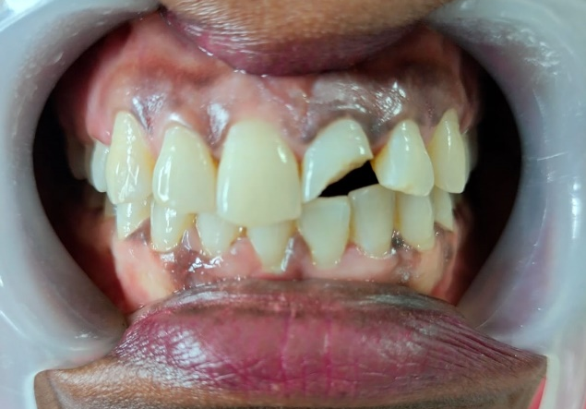
Figure 1: Maxillary central incisor showing a horizontal fracture line at the junction of the middle and cervical third.

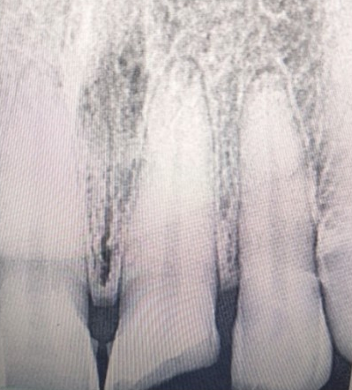

Figure 2: Intraoral periapical radiograph with no signs of root fracture

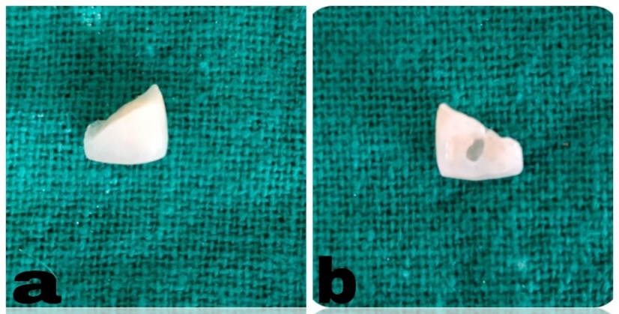
Figure 3: 3a showing broken tooth fragment. 3b. tooth fragment with vertical internal dentinal groove of about 1.5 mm width and 2.4mm depth.

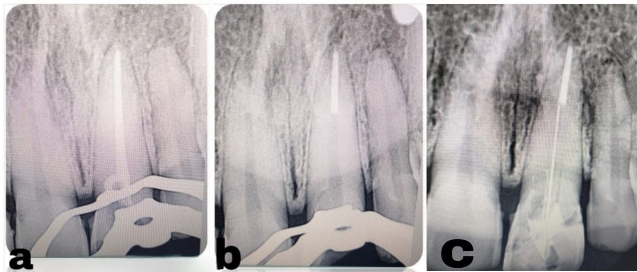

Figure 4 Intra oral periapical radiograph, 4a. showing satisfactory obturation. 4b. post space preparation using Peeso reamers (up to size 3). 4c. After fiber post luting.

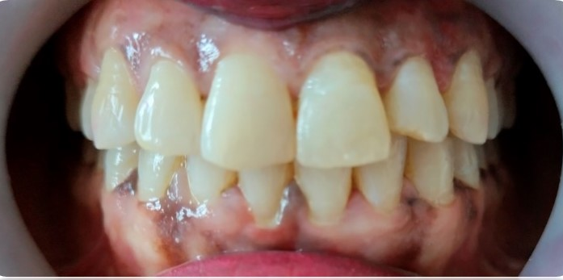
Figure 5(a): Final post operative image of the patient.

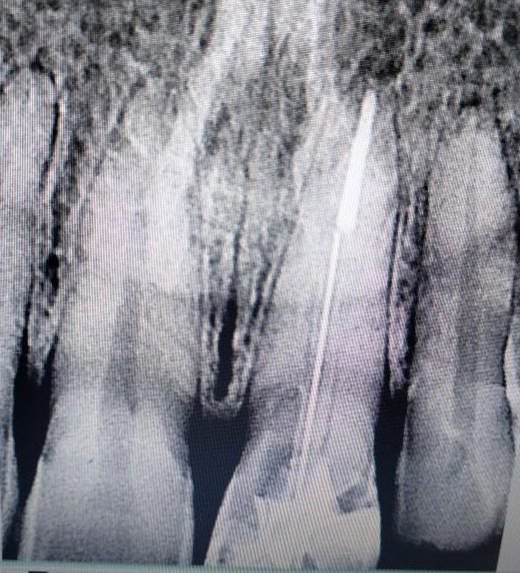
Figure 5(b): 9 months follow-up radiograph

