Hydrotherapy as a Complementary Approach in Hypertension Management: A Narrative Review

ABSTRACT
Background: Hypertension remains a leading global risk factor for cardiovascular disease. Complementary non-pharmacological therapies that reduce blood pressure (BP) and improve vascular function are of growing interest. Hydrotherapy — including warm or hot-water immersion, aquatic exercise, foot soaks, balneotherapy and local cold applications (e.g., ice massage) — is widely used in clinical and traditional settings but its role in hypertension management is not yet standardised.
Objective: To summarise mechanisms, clinical evidence, safety considerations, and practical recommendations for hydrotherapy as an adjunct in hypertension management.
Conclusions: Multiple modalities of hydrotherapy demonstrate acute and— in some studies—chronic reductions in systolic BP and improvements in vascular function and autonomic balance. Evidence is strongest for aquatic exercise and hot-water immersion, with supportive smaller trials for foot-soak and targeted cooling/ice massage methods. Heterogeneity of interventions, small sample sizes, and variable follow-up limit certainty; hydrotherapy is best considered an adjunct to guideline-directed care and lifestyle change rather than a replacement for antihypertensive medication.

1.Introduction

The hallmark of systemic arterial hypertension, often known as hypertension, is consistently elevated blood pressure (BP) in the systemic arteries. The ratio of the systolic blood pressure (the force the blood applies to the artery walls during heart contraction) to the diastolic blood pressure (the force during heart relaxation) is a typical way to express blood pressure.(1) Hypertension is a major public health problem due to its high prevalence worldwide (2)According to estimates from the Global Burden of Disease 2019 (GBD 2019), high blood pressure is the primary metabolic risk factor worldwide, accounting for 19% of all fatalities.(3) Non-communicable illnesses hypertension cause 41 million deaths annually, or 74% of all deaths worldwide. Almost one-third of all deaths, or 17.9 million deaths annually, are caused by cardiovascular disease.(4) Its rarely exhibits any symptoms in its early stages until a serious medical emergency, such as a heart attack, stroke, or chronic renal disease, hypertension is a silent killer.(5) Blood pressure must be measured by a medical specialist in order to identify hypertension. Getting your blood pressure checked is quick and easy. While automated devices are available for people to measure their blood pressure, a health professional's assessment is crucial for determining risk and related diseases.(6) Certain major risk factors have been identified for the development of hypertension in young and middle-aged Indian adults, including smoking, drinking, being overweight, having a family history of hypertension, growing older, eating a diet high in salt, developing diabetes, and having a body mass index (BMI) above 30 kg/m2. Waist-to-hip ratio, high cholesterol, central obesity, socioeconomic status, lack of exercise, bad diet, lack of education, and ignorance.(7) Only a tiny percentage of people may encounter symptoms like: Fatigue, nausea, vomiting, headaches, and blurred vision But these symptoms typically don't show up until the blood pressure reaches a potentially fatal level.(8) Myocardial infarction, atherothrombotic brain infarction, heart failure, intracerebral hemorrhage, and renal failure are the main side effects of hypertension.(9) While the other two are actually arteriosclerotic consequences that arise from long-standing, often mild hypertension, the first three are thought to be true hypertensive complications and happen in individuals with severe hypertension.(10) Pharmacological Treatment Antihypertensive drugs target a number of physiological pathways, such as the sympathetic nervous system (SNS), vascular smooth muscle tone, and the renin-angiotensin-aldosterone system (RAAS), that are important in blood pressure management.(11) Angiotensin-converting enzyme (ACE) inhibitors, angiotensin II receptor blockers (ARBs), calcium channel blockers (CCBs), beta-blockers, and diuretics are common groups of antihypertensive medications.(12) When choosing an antihypertensive treatment, considerations such the patient's age, comorbidities, cost, and medication tolerability are taken into account. 18 Reaching desired blood pressure objectives frequently necessitates combination therapy, which uses at least two antihypertensive medications with complimentary modes of action.(13)
The peripheral nervous system includes the autonomic nervous system, which controls involuntary physiological functions like heart rate, respiration, digestion, blood pressure, and sexual desire. The sympathetic, parasympathetic, and enteric nervous systems are the three anatomically separate divisions of the nervous system . Insulin resistance, altered lipid metabolism, and high blood pressure can result from autonomic nervous system dysregulation. Heart rate variability (HRV) is a measure of the different physiological elements influencing the heart's regular rhythm. The autonomic nervous system (ANS), which controls heart activity, is evaluated via HRV analysis.(14)
Naturopathy is a unique form of primary care medicine that combines modern research and technological advancements with traditional healing methods. It is founded on a distinct set of ideas that highlight illness prevention, acknowledge the body's natural ability to heal, and promote personal accountability for achieving optimal health.(15) In ancient cultures such as China, Egypt, India, and others, hydrotherapy was a common naturopathic therapeutic method, The external or internal application of water in any form—ice, steam, or water—for the purpose of promoting health or treating a variety of illnesses at different temperatures, pressures, durations, and locations is known as hydrotherapy.(16) it is a effective non-pharmacological therapeutic approaches that can be used to lower blood pressure. This method is recommended since it is easy to use and does not require certain knowledge or abilities.(17) Various temperature-based hydrotherapy techniques can enhance blood pressure, cardiac autonomic regulation, and parasympathetic dominance.(18) various hydrotherapy techniques are there to reduce blood pressure .

2.Human body and water
When the human body enters water, it confronts a medium for which it is not made and where its ability to move is constrained. Nonetheless, the biological impacts of submersion in water are linked to the basic ideas of hydrodynamics. being aware of these impacts as well as the physical characteristics of water, including buoyancy, density, and hydrostatic pressure.(19) The density (ϱ) is the ratio of a substance's mass (kg) to its volume (m3). When it comes to a fluid, the more dense it is, the more force it applies to items submerged in it or floating in it, the pathophysiology of essential hypertension as a normal response to the elevated gravitational stress brought on by frequent, extended sitting—excessive standing with a high gravitational gradient across the heart(20) Resistance offered by water is greater than that experienced during locomotion on dry land This greater resistance of water compared with that of air is due not only to its density, but also to its dynamic viscosity.(21)

3. Hydrotherapy and hypertension
3.1 Steam and sauna bath and hypertension
steam bath is a type of hydrotherapy bath where the person exposes whole body to moist heat (22)
when exposed to it the body attempts to restore homeostasis through a sequence of processes that cause peripheral vasodilation and decrease in peripheral resistance. (23)one of the previous study on similar treatment sauna bath have shown that effect on adrenal glands through aldosterone system .(24,25) the pathway implicated in the effects of saunabathing on vascular condition and reduction in systemic BP.(26) improves the endothelial function(27,28) reduction in oxidative stress (29) and modulation in the autonomic nervous system (30) both sauna and steam bath increases body temperature which causes increase in skin blood flow leading to increase in cardiac output and decrease in blood flow to internal organs While cardiac stroke volume remains unchanged, cardiac output increases by 60% to 70% in response to an increase in heart rate. Sauna use has varying effects on blood pressure.(31)

3.2 SPINAL BATH
A spinal bath is Applications of traditional hydrotherapy for the management of cardiovascular diseases like hypertension using spinal bathtub that is cool (26 ±1°C) is provided for 15 minutes.(32) spinal bath increases cardiac output (CO), central venous pressure, stroke volume, and central blood volume by bringing peripheral blood into the thoracic vasculature. It's probable that this rise in central venous pressure will raise arterial pressure and decrease cardiopulmonary pressure. Bradycardia can result from this mechanism, which is known to increase parasympathetic activity and decrease sympathetic activity . Therefore, the reduction of HR may be the primary cause of the drop in blood pressure (BP) variables. Since peripheral resistance and CO both affect blood pressure.(33–35) another mechanism of spinal bath is through Transient receptor potential cation channel subfamily M member 8 (TRPM8), a member of the transient receptor potential family, is responsible for the hypotensive impact of cold spinal baths. Specialized dorsal root ganglion (DRG) neurons in the trunk may receive a signal from the application of cold water in the form of a spinal bath. TRPM8 is activated by the DRG neurons' cell bodies, which are located in the vertebral column next to the spinal cord. Activation of TRPM8 counteracts the sympathetic neurotransmitters' contractile function, which may have a hypotensive impact. Additionally, cold-induced activation of TRPM8, which is located in the sarcoplasmic reticulum membrane, can promote the release of Ca2+ from the sarcoplasmic reticulum, depleting the Ca2+ store and perhaps inhibiting vasoconstriction activity.(36,37)
3.3 Spinal spray
Spinal spray 15°C to 19°C. Over a duration of 20 minutes, a continuous stream of water was sprayed into the spinal area through the perforated tube. reduces SBP, DBP, PP, and MAP in male hypertension patients, significant reductions in LF, LF/HF ratio, and significant improvement in HF.(38) Aortic and carotid sinus baroreceptors may be activated by Cold spinal spray potential to cause instantaneous vasoconstriction, which raises vascular pressure. By activating the vagus nucleus, this lowers sympathetic activity, resulting in vasodilation and a decrease in blood pressure.(39) as the main effect on spinal cord like spinal bath TRPM8 channel mechanism.
3.4 Immersion bath
Immersion bath is the one of the hydrotherapy measure to lower blood , 20 min vs 40 min of water immersion at temperature 36.5°C vs 40°C respectively In patients with hypertension, hot-water immersion resulted in a significant drop in systolic blood pressure.Following the three immersion treatments, the ambulatory systolic blood pressure decreased by 6–7 mm Hg in comparison to the control; the amplitude of this response remained constant throughout the day and night, Similar to the hot-water immersion, the thermoneutral immersion lowered blood pressure throughout a 24-hour period.(40) This hypotensive impact may have numerous and multiple contributing pathways. The core blood volume increases by about 700 mL as soon as the person is submerged in chest-deep water, and the stroke volume increases in tandem with the water's temperature.(41) It is unknown how this reaction varies in hypertensive individuals or older adults, as well as how long these decreases in total peripheral resistance last. Peripheral blood flow and antegrade vascular shear stress increase due to the increased cardiac output and concurrent decrease in sympathetically mediated constrictor tonic activity. This causes endothelium-mediated nitric oxide release, which causes arterial vasodilation akin to that of high-intensity exercise.(42)Other hydrostatic reactions that probably contribute to hypotensive effects include diuresis and natriuresis. Curiously, the atrial natriuretic peptide response may be higher during thermoneutral immersion than during hot-water immersion due to the increased venous return during immersion and prolonged stretch on the right atrium.(43) In addition to increasing prostaglandin E and suppressing fluid regulating hormones like vasopressin and aldosterone, atrial natriuretic peptide also causes an increase in salt and water excretion, which lowers fluid volume during immersion. Additionally, atrial natriuretic peptide exhibits moderate vasodilatory effects. It's possible that a supercompensation in plasma volume, like that seen in the post-exercise hypotensive response, follows these diuretic and natriuretic effects. Water immersion's hypotensive effects are probably caused by a multifactorial cascade that includes the subsequent decrease in resting heart rate, rise in parasympathetic activity, and arterial baroreceptor resetting.(44)
3.5 Chest pack :
The improvement of multiple cardiorespiratory variables was seen with 20 minutes of Hot chest pack When compared to the control session, the results show that 20 minutes of the hydrotherapy procedure (HCP) significantly improved peak expiratory flow rate (PEFR) and significantly decreased cardiovascular variables (such as blood pressure and heart rate). This implies that in addition to improving cardiovascular efficiency, the intervention also improved respiratory function.The improved peripheral blood circulation brought on by hydrotherapy may provide a physiological explanation for the improvement in respiratory indices. Applications of warm or alternating water encourage vasodilation, which reroutes blood toward the body's surface. By reducing excessive blood pooling in the lungs and enhancing pulmonary circulation generally, this procedure helps lessen pulmonary congestion. The results of this study showed the application of a CCP for 20 minutes affects central hemodynamics and heart rate variability; these results may be considered when using CCP therapeutically.(45) A Study shows that cold water immersion induces fast post exercise parasympathetic reactivation. Cold water immersion is a better strategy to increaseparasympathetic activity. At rest, the equilibrium between the two branches of the ANS confers a cardioprotective back ground. The sympathetic accelerates HR parasympathetic acts as brake on heart rate.(46)
3.6 Hot Foot immersion
The administration of warm water at 40°C and 25cm of water level to feet for 20 minutes considerably lowered the blood pressure.(47) (48)Dwi Uswatun Chasanah et al found the effect of warm foot immersion improves vessels microcirculation inducing vasodilation and stimulating nerves in the feet to activate the parasympathetic nervous system that contributes to change in blood pressure.(49) This can be supported by our results where reduction in LF ,LF/HF ratio and increase in HF were significant after HFI.(50) (51) (52)Previous studies have shown the effect of soaking feet warm water lowers blood pressure through a conduction process by nerve tissue in the feet during immersion.(53) The ligamentous muscles are strengthened and dilated, which increases blood vessel flexibility, reduces muscle tension, and causes vasodilation of the blood vessels.(54) Warm water can influence the baroreceptors in the arteries which send signal to the brain nerve fibers which in turn impacts on ventricular tension and ventricular muscle vasodilation resulting in decreased systolic and diastolic blood pressure.(55) The mechanism involved in the reduction of BP from the intervention HFI at 40°C.(56) possible action of HFI (Figure 1)is by increasing venous return which induces shear stress on vascular endothelium that stimulates nitric oxide production through L-arginine that further acts on cyclic guanosine monophosphate ( cGMP) in smooth muscle to dilate blood vessels,lowering peripheral vascular resistance and blood pressure.(57,58)
3.7 Ice massage
Previous studies have demonstrated a reduction in blood pressure and heart rate after 20minutes of ice massage to the head and spine, which is attributed to an increase in the R-R interval and sympathetic withdrawal through vagal modulation.(59) These findings align with our study results, where an increase in R-R interval and a decrease in heart rate were significant with an increase in PNN50, which supports vagal domination.(60) This effect is due to stimulation of baroreceptors of the aortic and carotid artery, which in turn excites the nucleus of the solitary tract, causing vagal nucleus activation leading to sympathetic suppression.(61)(62) Research indicates (Figure 2)TRPM8 channel located over the sarcoplasmic reticulum and golgi apparatus are sensitive to cold and stimulation of these channels will activate calmodulin-mediated extracellular calcium influx that prevents vasoconstriction via synthesis of Nitric oxide that results in vasodilation, thus reducing blood pressure after ice massage. (63)Another possible mechanism(Figure 3) is by activation of brown adipose tissue which causes release of vasodilators and reduction of norepinephrine from nerve endings and relaxation of smooth muscle, leading to increased peripheral blood flow and a decrease in peripheral vascular resistance, lowering the blood pressure.(64)(65)

Conclusion
Hydrotherapy appears to be a promising complementary approach in the management of hypertension. Evidence from clinical studies suggests that interventions such as hot-water immersion, foot baths, aquatic exercises, and targeted ice massage can acutely reduce blood pressure, improve vascular function, and enhance autonomic balance. While these interventions are generally safe and well-tolerated, the heterogeneity of study protocols and small sample sizes limit the generalizability of findings. Therefore, hydrotherapy should be considered as an adjunct to conventional pharmacological treatment and lifestyle modifications rather than a standalone therapy. Further large-scale, well-designed randomized controlled trials are needed to establish standardized protocols, long-term efficacy, and optimal frequency and duration of hydrotherapy interventions in hypertensive populations.

Statements
- This review is original and has not been published elsewhere.
- All sources and references are appropriately cited.
- The manuscript reflects the authors’ independent scholarly work.

REFERENCE
1. Seravalle G, Grassi G. Essential Hypertension. Primer on the Autonomic Nervous System, Fourth Edition [Internet]. 2023 Jul 20 [cited 2025 Aug 17];467–70. Available from: https://www.ncbi.nlm.nih.gov/books/NBK539859/
2. Abebe SM, Berhane Y, Worku A, Getachew A. Prevalence and Associated Factors of Hypertension: A Crossectional Community Based Study in Northwest Ethiopia. PLoS One [Internet]. 2015 Apr 24 [cited 2025 Aug 17];10(4):e0125210. Available from: https://journals.plos.org/plosone/article?id=10.1371/journal.pone.0125210
3. Global Burden of Disease Study 2019 (GBD 2019) Disease and Injury Burden 1990-2019 | GHDx [Internet]. [cited 2025 Aug 17]. Available from: https://ghdx.healthdata.org/record/ihme-data/gbd-2019-disease-and-injury-burden-1990-2019
4. Noncommunicable diseases [Internet]. [cited 2025 Aug 17]. Available from: https://www.who.int/health-topics/noncommunicable-diseases#tab=tab_1
5. Chobanian A V., Bakris GL, Black HR, Cushman WC, Green LA, Izzo JL, et al. Seventh report of the Joint National Committee on Prevention, Detection, Evaluation, and Treatment of High Blood Pressure. Hypertension [Internet]. 2003 Dec [cited 2025 Aug 17];42(6):1206–52. Available from: https://pubmed.ncbi.nlm.nih.gov/14656957/
6. Al-Makki A, DiPette D, Whelton PK, Murad MH, Mustafa RA, Acharya S, et al. Hypertension pharmacological treatment in adults: A world health organization guideline executive summary. Hypertension [Internet]. 2022 Jan 1 [cited 2025 Aug 17];79(1):293–301. Available from: https://pubmed.ncbi.nlm.nih.gov/34775787/
7. Meher M, Pradhan S, Pradhan SR. Risk Factors Associated With Hypertension in Young Adults: A Systematic Review. Cureus [Internet]. 2023 Apr 12 [cited 2025 Aug 17];15(4):e37467. Available from: https://pmc.ncbi.nlm.nih.gov/articles/PMC10181897/
8. View of Management of Hypertension with Conventional and Herbals Drugs [Internet]. [cited 2025 Aug 17]. Available from: https://jddtonline.info/index.php/jddt/article/view/3998/3135
9. Perry HM, editor. Lifelong Management of Hypertension. 1983 [cited 2025 Aug 17];26. Available from: http://link.springer.com/10.1007/978-94-009-6732-8
10. Perry HM, Neal WH. Complications of hypertension and their relation to therapy. 1983 [cited 2025 Aug 17];150–70. Available from: https://link.springer.com/chapter/10.1007/978-94-009-6732-8_11
11. WHO package of essential noncommunicable (PEN) disease interventions for primary health care [Internet]. [cited 2025 Aug 17]. Available from: https://www.who.int/publications/i/item/9789240009226
12. Elendu C, Amaechi DC, Elendu TC, Amaechi EC, Elendu ID. Dependable approaches to hypertension management: A review. Medicine [Internet]. 2024 Jun 14 [cited 2025 Aug 17];103(24):e38560. Available from: https://pmc.ncbi.nlm.nih.gov/articles/PMC11175961/
13. Rosendorff C, Lackland DT, Allison M, Aronow WS, Black HR, Blumenthal RS, et al. Treatment of Hypertension in Patients With Coronary Artery Disease: A Scientific Statement From the American Heart Association, American College of Cardiology, and American Society of Hypertension. Circulation [Internet]. 2015 May 12 [cited 2025 Aug 17];131(19):e435. Available from: https://pmc.ncbi.nlm.nih.gov/articles/PMC8365343/
14. Straznicky NE, Nestel PJ, Esler MD. Autonomic Nervous System: Metabolic Function. Encyclopedia of Neuroscience. 2009;951–9.
15. Fleming SA, Gutknecht NC. Naturopathy and the Primary Care Practice. Prim Care [Internet]. 2010 Mar [cited 2025 Aug 17];37(1):119. Available from: https://pmc.ncbi.nlm.nih.gov/articles/PMC2883816/
16. Mooventhan A, Nivethitha L. Scientific Evidence-Based Effects of Hydrotherapy on Various Systems of the Body. N Am J Med Sci [Internet]. 2014 [cited 2025 Aug 17];6(5):199. Available from: https://pmc.ncbi.nlm.nih.gov/articles/PMC4049052/
17. View of The Effect of Hydrotherapy on Lowering Blood Pressure among Hypertension [Internet]. [cited 2025 Aug 17]. Available from: https://jurnal.globalhealthsciencegroup.com/index.php/PICNHS/article/view/5752/4094
18. Abinaya S, Vijay A, Nivethitha L, Mooventhan A, Manavalan N. Effects of various hydrotherapeutic procedures on heart rate variability and blood pressure: A systematic review. Adv Integr Med [Internet]. 2025 Sep 1 [cited 2025 Aug 18];12(3):100500. Available from: https://www.sciencedirect.com/science/article/abs/pii/S221295882500059X
19. Becker BE. Aquatic therapy: scientific foundations and clinical rehabilitation applications. PM R [Internet]. 2009 Sep [cited 2025 Sep 17];1(9):859–72. Available from: https://pubmed.ncbi.nlm.nih.gov/19769921/
20. Pekarski SE. A gravitational hypothesis of essential hypertension as a natural adaptation to increased gravitational stress caused by regular, prolonged sitting typical of modern life [Internet]. Available from: http://www.MedSciMonit.com/pub/vol_10/no_6/4238.pdf
21. Dowzer CN. Effects of deep and shallow water running on spinal shrinkage. Br J Sports Med [Internet]. 1998 [cited 2025 Sep 17];32(1):44–8. Available from: https://www.researchgate.net/publication/13718604_Effects_of_deep_and_shallow_water_running_on_spinal_shrinkage
22. Pandiaraja M, Vanitha A, Maheshkumar K, Venugopal V, Poonguzhali S, Radhika L, et al. Effect of the steam bath on resting cardiovascular parameters in healthy volunteers. Adv Integr Med [Internet]. 2021 Sep 1 [cited 2025 Aug 18];8(3):199–202. Available from: https://www.sciencedirect.com/science/article/abs/pii/S221295882030118X
23. Maheshkumar K, Venugopal V, Poonguzhali S, Mangaiarkarasi N, Venkateswaran ST, Manavalan N. Trends in the use of Yoga and Naturopathy based lifestyle clinics for the management of Non-communicable diseases (NCDs) in Tamilnadu, South India. Clin Epidemiol Glob Health [Internet]. 2020 Jun 1 [cited 2025 Sep 9];8(2):647–51. Available from: https://www.sciencedirect.com/science/article/pii/S2213398419303847
24. the principle and prctice of hydrotherapy a guid to the application of water in disease for students and - Google Search [Internet]. [cited 2025 Sep 9]. Available from: https://www.google.com/search?q=the+principle+and+prctice+of+hydrotherapy+a+guid+to+the+application+of+water+in+disease+for+students+and&rlz=1C1RXQR_enIN1087IN1087&oq=the+principle+and+prctice+of+hydrotherapy+a+guid+to+the+application+of+water+in+disease+for+students+and+&gs_lcrp=EgZjaHJvbWUyBggAEEUYOdIBCjU5OTcwajBqMTWoAgiwAgHxBRu3GKSbw81u&sourceid=chrome&ie=UTF-8
25. Sawka MN, Leon LR, Montain SJ, Sonna LA. Integrated physiological mechanisms of exercise performance, adaptation, and maladaptation to heat stress. Compr Physiol [Internet]. 2011 Oct [cited 2025 Sep 9];1(4):1883–928. Available from: https://pubmed.ncbi.nlm.nih.gov/23733692/
26. Zaccardi F, Laukkanen T, Willeit P, Kunutsor SK, Kauhanen J, Laukkanen JA. Sauna Bathing and Incident Hypertension: A Prospective Cohort Study. Am J Hypertens [Internet]. 2017 Nov 1 [cited 2025 Sep 9];30(11):1120–5. Available from: https://pubmed.ncbi.nlm.nih.gov/28633297/
27. Imamura M, Biro S, Kihara T, Yoshifuku S, Takasaki K, Otsuji Y, et al. Repeated thermal therapy improves impaired vascular endothelial function in patients with coronary risk factors. J Am Coll Cardiol [Internet]. 2001 [cited 2025 Sep 9];38(4):1083–8. Available from: https://pubmed.ncbi.nlm.nih.gov/11583886/
28. Ohori T, Nozawa T, Ihori H, Shida T, Sobajima M, Matsuki A, et al. Effect of repeated sauna treatment on exercise tolerance and endothelial function in patients with chronic heart failure. American Journal of Cardiology [Internet]. 2012 Jan 1 [cited 2025 Sep 9];109(1):100–4. Available from: https://pubmed.ncbi.nlm.nih.gov/21944673/
29. Sutkowy P, Woźniak A, Boraczyński T, Mila-Kierzenkowska C, Boraczyński M. The effect of a single Finnish sauna bath after aerobic exercise on the oxidative status in healthy men. Scand J Clin Lab Invest [Internet]. 2014 [cited 2025 Sep 9];74(2):89–94. Available from: https://pubmed.ncbi.nlm.nih.gov/24304490/
30. Radtke T, Poerschke D, Wilhelm M, Trachsel LD, Tschanz H, Matter F, et al. Acute effects of Finnish sauna and cold-water immersion on haemodynamic variables and autonomic nervous system activity in patients with heart failure. Eur J Prev Cardiol [Internet]. 2016 Apr 1 [cited 2025 Sep 9];23(6):593–601. Available from: https://pubmed.ncbi.nlm.nih.gov/26152773/
31. Hannuksela ML, Ellahham S. Benefits and risks of sauna bathing. American Journal of Medicine [Internet]. 2001 Feb 1 [cited 2025 Sep 9];110(2):118–26. Available from: https://pubmed.ncbi.nlm.nih.gov/11165553/
32. Rational hydrotherapy : a manual of the physiological and therapeutic effects of hydriatic procedures, and the technique of their application in the treatment of disease : Kellogg, John Harvey, 1852-1943 : Free Download, Borrow, and Streaming : Internet Archive [Internet]. [cited 2025 Sep 10]. Available from: https://archive.org/details/rationalhydrothe00kelluoft
33. Mooventhan A. Immediate effect of ice bag application to head and spine on cardiovascular changes in healthy volunteers. International Journal of Health & Allied Sciences [Internet]. 2016 [cited 2025 Sep 10];5(1):53. Available from: https://www.researchgate.net/publication/292947097_Immediate_effect_of_ice_bag_application_to_head_and_spine_on_cardiovascular_changes_in_healthy_volunteers
34. Šrámek P, Šimečková M, Janský L, Šavlíková J, Vybíral S. Human physiological responses to immersion into water of different temperatures. Eur J Appl Physiol [Internet]. 2000 Mar 11 [cited 2025 Sep 10];81(5):436–42. Available from: https://pubmed.ncbi.nlm.nih.gov/10751106/
35. (PDF) IMMEDIATE EFFECT OF COLD SPINAL BATH ON AUTONOMIC AND RESPIRATORY VARIABLES IN HYPERTENSIVES [Internet]. [cited 2025 Sep 10]. Available from: https://www.researchgate.net/publication/321777191_IMMEDIATE_EFFECT_OF_COLD_SPINAL_BATH_ON_AUTONOMIC_AND_RESPIRATORY_VARIABLES_IN_HYPERTENSIVES
36. Johnson CD, Melanaphy D, Purse A, Stokesberry SA, Dickson P, Zholos A V. Transient receptor potential melastatin 8 channel involvement in the regulation of vascular tone. Am J Physiol Heart Circ Physiol [Internet]. 2009 Jun [cited 2025 Sep 10];296(6):H1868. Available from: https://pmc.ncbi.nlm.nih.gov/articles/PMC2716108/
37. Mourot L, Bouhaddi M, Gandelin E, Cappelle S, Dumoulin G, Wolf JP et al. Cardiovascular autonomic control during short-term thermoneutral and cool head-out immersion. Aviat Space Environ Med., 2008 Jan; 79(1): 14-20. - Google Search [Internet]. [cited 2025 Sep 10]. Available from:
38. Paily AK, Shetty GB, Shetty P, Sujatha K. Immediate Effect of Cold Spinal Spray on Autonomic Variables in Hypertensive Individuals-A Randomised Control Trial. 2020;
39. View of Effectiveness of Cold Spinal Spray on Blood Pressure and Heart Rate Variability in Patients with Hypertension—A Randomized Controlled Trial [Internet]. [cited 2025 Sep 10]. Available from: https://candjournal.ca/index.php/candj/article/view/140/250
40. Roxburgh BH, Campbell HA, Cotter JD, Williams MJA, Thomas KN. Both hot- and thermoneutral-water immersion reduce 24-h blood pressure in people with hypertension: A randomized crossover study. Temperature: Multidisciplinary Biomedical Journal [Internet]. 2025 [cited 2025 Sep 15];12(2):166. Available from: https://pmc.ncbi.nlm.nih.gov/articles/PMC12051523/
41. Weston CFM, O’Hare JP, Evans JM, Corrall RJM. Haemodynamic changes in man during immersion in water at different temperatures. Clin Sci (Lond) [Internet]. 1987 [cited 2025 Sep 15];73(6):613–6. Available from: https://pubmed.ncbi.nlm.nih.gov/3319357/
42. Amin SB, Hansen AB, Mugele H, Simpson LL, Marume K, Moore JP, et al. High-intensity exercise and passive hot water immersion cause similar postintervention changes in peripheral and cerebral shear. J Appl Physiol (1985) [Internet]. 2022 Aug 1 [cited 2025 Sep 15];133(2):390–402. Available from: https://journals.physiology.org/doi/pdf/10.1152/japplphysiol.00780.2021
43. Kissling LS, Akerman AP, Campbell HA, Prout JR, Gibbons TD, Thomas KN, et al. A crossover control study of three methods of heat acclimation on the magnitude and kinetics of adaptation. Exp Physiol [Internet]. 2022 Apr 1 [cited 2025 Sep 15];107(4):337–49. Available from: https://pubmed.ncbi.nlm.nih.gov/34957632/
44. Dietz JR. Mechanisms of atrial natriuretic peptide secretion from the atrium. Cardiovasc Res [Internet]. 2005 Oct 1 [cited 2025 Sep 15];68(1):8–17. Available from: https://pubmed.ncbi.nlm.nih.gov/15993390/
45. Manjuladevi T, Mooventhan A, Manjunath NK. Immediate effect of hot chest pack on cardio-respiratory functions in healthy volunteers: A randomized cross-over study. Adv Integr Med [Internet]. 2018 Aug 1 [cited 2025 Oct 19];5(2):63–8. Available from: https://www.sciencedirect.com/science/article/abs/pii/S2212958817300575
46. Valsakumar A, Dinesh S, Prasad G, Shetty P. Immediate effect of cold mud pack therapy on autonomic variables in primary hypertensive individuals: a randomized trial. J Complement Integr Med [Internet]. 2021 Sep 1 [cited 2025 Oct 19];19(3):799–806. Available from: https://pubmed.ncbi.nlm.nih.gov/34757704/
47. Murwidi C, Abdullah F. Effectiveness of Warm Water Foot Soak and Benson Relaxation Techniques Combination in Reducing Blood Pressure of Hypertensive Patients. International Journal of Health, Economics, and Social Sciences (IJHESS) [Internet]. 2019;1(1). Available from: https://dx.doi.org/10.31934/ijhess
48. Júnior FADM, Gomes SG, da Silva FF, Souza PM, Oliveira EC, Coelho DB, et al. The effects of aquatic and land exercise on resting blood pressure and post-exercise hypotension response in elderly hypertensives. Cardiovasc J Afr [Internet]. 2020 Jun 1 [cited 2025 Jul 27];31(3):116–22. Available from: https://pubmed.ncbi.nlm.nih.gov/31651927/
49. View of Implementation of Warm Foot Soak Hydrotherapy Reduces the Risk of Indefective Peripheral Perfusion in Hypertension Patients in the Family [Internet]. [cited 2025 Jul 29]. Available from: https://prosiding.arikesi.or.id/index.php/ICHSN/article/view/43/58
50. Pagani M, Lombardi F, Guzzetti S, Rimoldi O, Furlan R, Pizzinelli P, et al. Power spectral analysis of heart rate and arterial pressure variabilities as a marker of sympatho-vagal interaction in man and conscious dog. Circ Res [Internet]. 1986 [cited 2025 Jul 23];59(2):178–93. Available from: https://pubmed.ncbi.nlm.nih.gov/2874900/
51. Pomeranz B, Macaulay JB, Caudill MA. Assessment of autonomic functions in humans by heart rate spectral analysis. Am J Physiol Heart Circ Physiol [Internet]. 1985 [cited 2025 Jul 23];17(1). Available from: https://pubmed.ncbi.nlm.nih.gov/3970172/
52. Saeki Y, Nagai N, Hishinuma M. Effects of footbathing on autonomic nerve and immune function. Complement Ther Clin Pract [Internet]. 2007 Aug [cited 2025 Jul 23];13(3):158–65. Available from: https://pubmed.ncbi.nlm.nih.gov/17631258/
53. Putu Sudiartawan I, Made Dwi Mertha Adnyana I. Science Midwifery Efficacy of Hydrotherapy Soak Feet in Lowering Blood Pressure of Hypertension Sufferers in Dauhwaru Village, Jembrana [Internet]. Vol. 10, Science Midwifery. Online; 2022. Available from: www.midwifery.iocspublisher.orgJournalhomepage:www.midwifery.iocspublisher.org
54. Becker BE. The biologic aspects of hydrotherapy. J Back Musculoskelet Rehabil [Internet]. 1994 [cited 2025 Jul 27];4(4):255–64. Available from: https://www.researchgate.net/publication/260398052_The_Biologic_Aspects_of_Hydrotherapy
55. Brunt VE, Howard MJ, Francisco MA, Ely BR, Minson CT. Passive heat therapy improves endothelial function, arterial stiffness and blood pressure in sedentary humans. Journal of Physiology [Internet]. 2016 Sep 15 [cited 2025 Jul 27];594(18):5329–42. Available from: https://pubmed.ncbi.nlm.nih.gov/27270841/
56. Wang PC, Song QC, Chen CY, Su TC. Cardiovascular physiological effects of balneotherapy: focused on seasonal differences. Hypertension Research [Internet]. 2023 Jul 1 [cited 2025 Jul 6];46(7):1650–61. Available from: https://www.nature.com/articles/s41440-023-01248-4
57. Sartori C, Lepori M, Scherrer U. Interaction between nitric oxide and the cholinergic and sympathetic nervous system in cardiovascular control in humans. Pharmacol Ther [Internet]. 2005 May 1 [cited 2025 Jul 6];106(2):209–20. Available from: https://www.sciencedirect.com/science/article/abs/pii/S0163725804002050?via%3Dihub
58. Tei C, Horikiri Y, Park JC, Jeong JW, Chang KS, Toyama Y, et al. Acute hemodynamic improvement by thermal vasodilation in congestive heart failure. Circulation [Internet]. 1995 May 15 [cited 2025 Jul 6];91(10):2582–90. Available from: https://pubmed.ncbi.nlm.nih.gov/7743620/
59. (PDF) IMMEDIATE EFFECT OF COLD SPINAL BATH ON AUTONOMIC AND RESPIRATORY VARIABLES IN HYPERTENSIVES [Internet]. [cited 2025 Jun 5]. Available from: https://www.researchgate.net/publication/321777191_IMMEDIATE_EFFECT_OF_COLD_SPINAL_BATH_ON_AUTONOMIC_AND_RESPIRATORY_VARIABLES_IN_HYPERTENSIVES
60. Mooventhan A, Nivethitha L. Effects of ice massage of the head and spine on heart rate variability in healthy volunteers. J Integr Med [Internet]. 2016 Jul 1 [cited 2025 Jun 5];14(4):306–10. Available from: https://pubmed.ncbi.nlm.nih.gov/27417177/
61. Valsakumar A, Dinesh S, Prasad G, Shetty P. Immediate effect of cold mud pack therapy on autonomic variables in primary hypertensive individuals: A randomized trial. J Complement Integr Med [Internet]. 2022 Sep 1 [cited 2025 Jul 29];19(3):799–806. Available from: https://pubmed.ncbi.nlm.nih.gov/34757704/
62. Simon E, Kosaka M. Application of Heat and Cold: Physiological Responses and Therapeutic Implications. Thermotherapy for Neoplasia, Inflammation, and Pain [Internet]. 2001 [cited 2025 Jul 29];12–26. Available from: https://link.springer.com/chapter/10.1007/978-4-431-67035-3_2
63. Silva H. Current Knowledge on the Vascular Effects of Menthol. Front Physiol [Internet]. 2020 Apr 7 [cited 2025 Jul 28];11:523469. Available from: www.frontiersin.org
64. Daanen HAM. Finger cold-induced vasodilation: A review. Eur J Appl Physiol [Internet]. 2003 [cited 2025 Jul 29];89(5):411–26. Available from: https://pubmed.ncbi.nlm.nih.gov/12712346/
65. Lijnen PJ, Petrov V V., Fagard RH. Association between transforming growth factor-β and hypertension. Am J Hypertens [Internet]. 2003 Jul 1 [cited 2025 Jul 29];16(7):604–11. Available from: https://pubmed.ncbi.nlm.nih.gov/12850397/

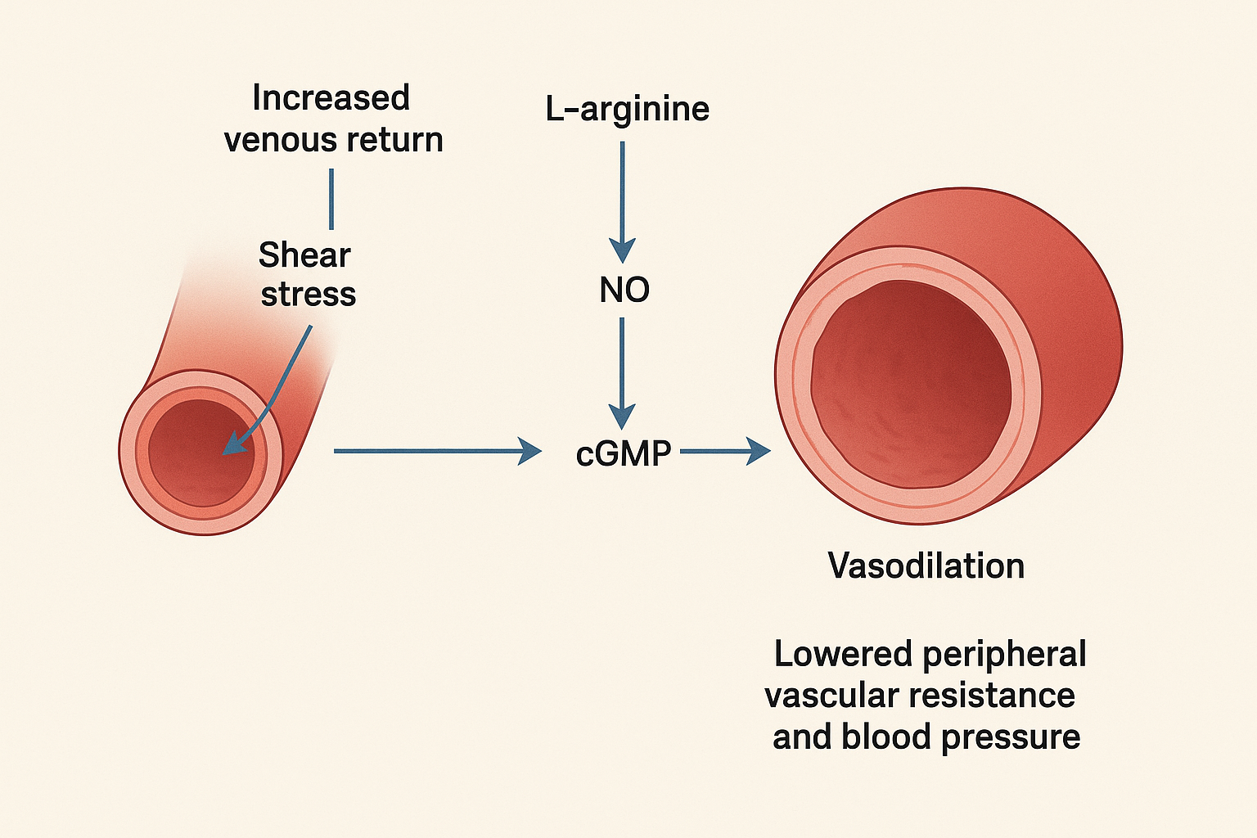
Figure 1: Mechanisam of Hot Foot imerssion

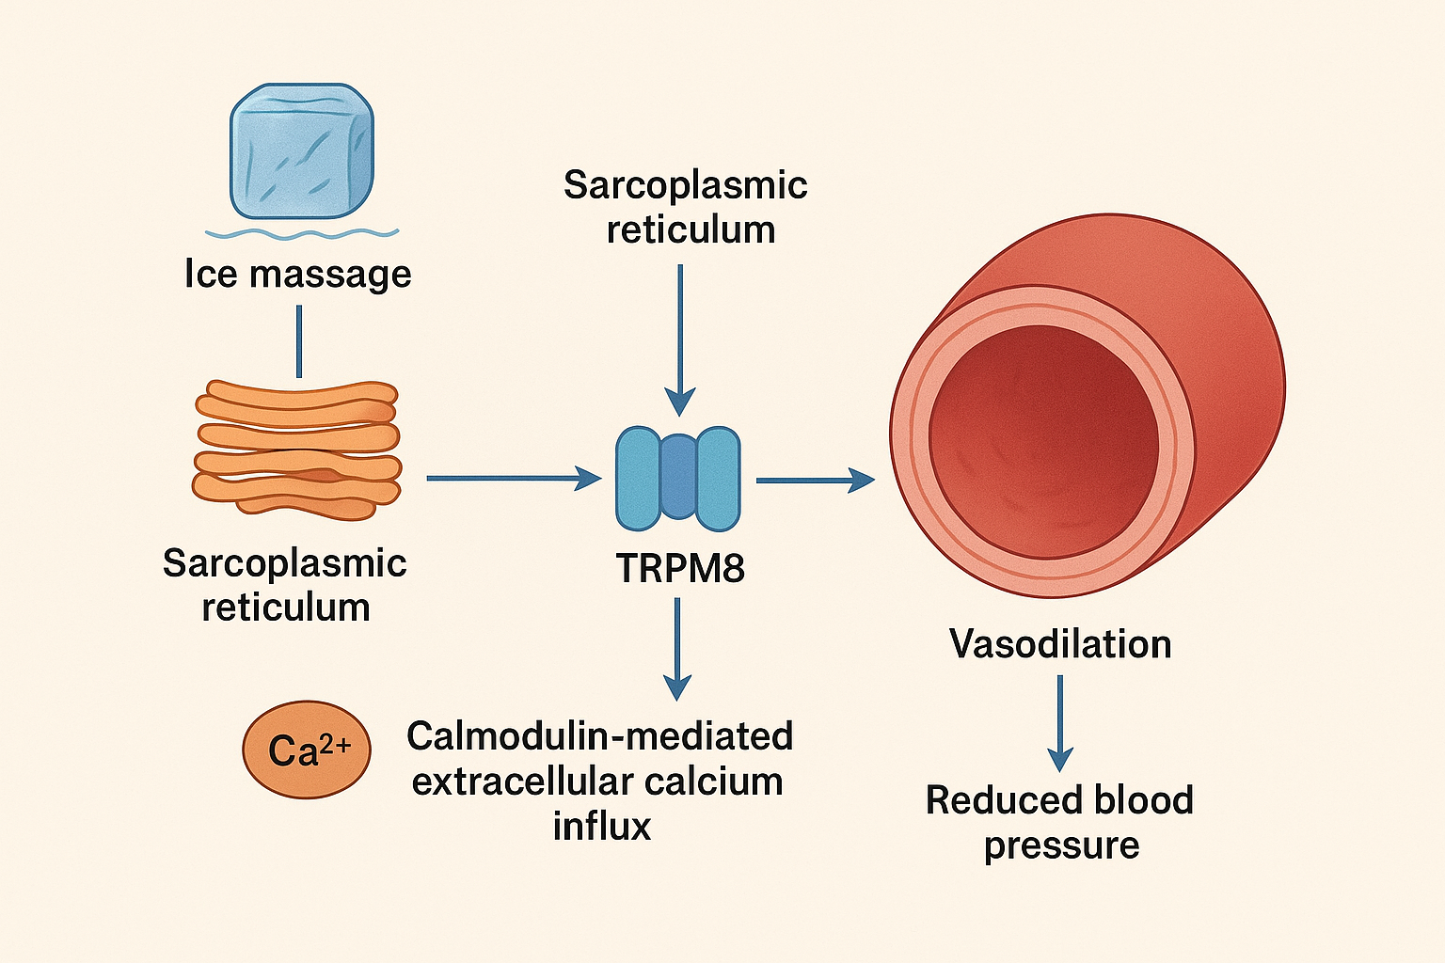
Figure 2: Ice Massage Mechanism

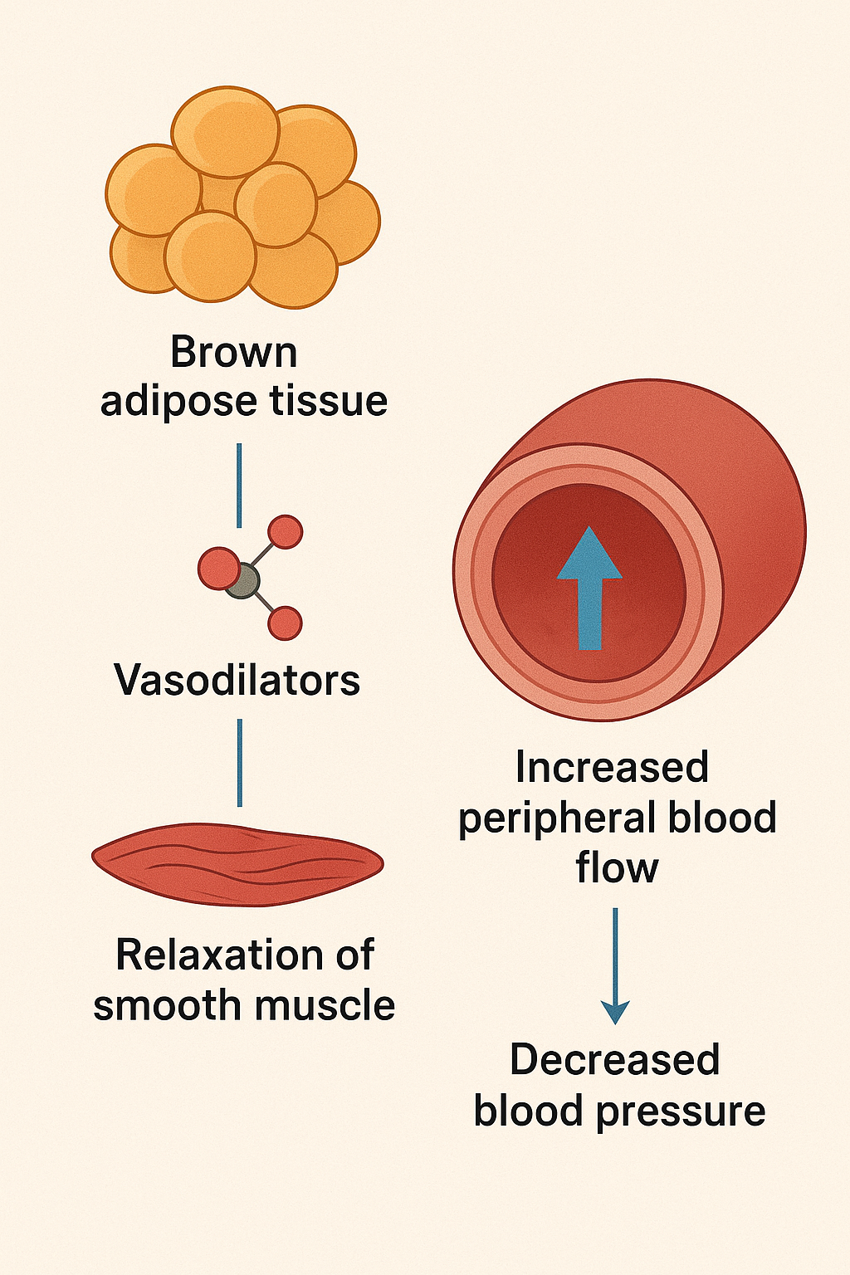
Figure 3: Ice Massage Mechanism Through adipose tissue

