FORMULATION AND PERFORMANCE EVALUATION OF A BIO- BASED HYBRID EPOXY COATING FOR METAL PROCTECTION IN AQUEOUS AGRESSIVE ENVIRONMENT

ABSTRACT
A sustainable epoxy coating was formulated using a bio-based organic – inorganic hybrid comprising of Dacryodes edulis leaf extract (DE) and precipitated amorphous silica (PAS). DE was obtained via cold extraction while PAS was synthesised by neutralization reaction between sulphuric acid and sodium silicate. FTIR and GC-MS analysis confirmed the presence of functional groups including O-H, C=C, and aromatic esters. SEM, TEM and XRD analysis validated successful DE/PAS hybridization and the amorphous nanoscale nature of PAS. Raman and FTIR on coatings confirms a well cured epoxy network. Environmental evaluation test (Salt spray and UV radiation /weathering test) in 5 wt% NaCl revealed superior barrier performance of the hybrid coating over epoxy only and single additive systems. Electrochemical studies confirmed enhanced corrosion resistance of the hybrid system, low corrosion current (1.3 × 10⁻⁶ mA/cm²), high pitting (−0.26 V) and repassivation (0.27 V) potentials, narrow hysteresis width (0.01 V) and, high charge transfer resistance (352 Ω·cm²), and lower admittance values (Yo₁ = 1.179×10⁻⁴, Yo₂ = 1.541×10⁻⁴) and stable capacitive behaviour . These findings highlight the potential of DE/PAS hybrids as eco-friendly, high performance additive for protective coatings

INTRODUCTION
The demand for eco-friendly, high-performance coatings has significantly increased due to growing environmental regulations and the need for sustainable alternatives to conventional protective systems. Traditional coatings, particularly those based on hexavalent chromium and volatile organic compounds (VOCs), have demonstrated excellent corrosion resistance and durability. However, their high toxicity and poor environmental compatibility have prompted legislative restrictions, including bans and limitations enforced by regulatory agencies such as the U.S. Environmental Protection Agency (EPA). Consequently, substantial research efforts have been redirected toward developing safer, biodegradable, and high-performance coatings (Chen, et al., 2019; Kumar et al., 2018 Askari, et al., 2016; Bakhshandeh, et al., 2014; Costa & Klein, 2006; Ashassi-Sorkhabi, et al., 2005)
Hybrid organic–inorganic coatings have emerged as a promising alternative, offering synergistic properties derived from both material classes. These hybrid systems exhibit enhanced mechanical strength, improved adhesion, anti-sagging behaviour, and superior barrier performance compared to their single-component counterparts. Organic components, typically polymeric matrices such as polyethylene, polyurethane, polyesters, and epoxy resins, contribute flexibility, chemical resistance, and adhesion. Epoxy-based coatings, in particular, are widely appreciated for their strong adhesion and chemical stability. However, they suffer from certain limitations such as hydrophobicity, which can lead to crack formation and the ingress of corrosive species. Hou, et al., 2024; Krishnapriya, et al., 2019; Behzadnasab, et al., 2017; Lamakaa, et al., 2015; Jalili, et al., 2009; Barletta, et al., 2007; Bergna,. & Roberts, 205; Galliano & Landolt, 2002; Ellis, 1993)
Inorganic fillers and nanoparticles, including silica-based materials, have been incorporated into epoxy systems to address these deficiencies. Precipitated amorphous silica (PAS), a non-toxic, eco-friendly material, has shown promise as a reinforcing agent, crack inhibitor, and corrosion-resistant additive (Music et al., 2011). Additionally, bio-based materials, particularly plant extracts derived from leaves, bark, or roots, have attracted attention as green corrosion inhibitors due to their biodegradability and effective inhibitory properties. Despite their advantages, such natural extracts often suffer from limited thermal and mechanical stability, poor adhesion, and short shelf life.(Agiriga et al., 2019; Udo & Gloria, 2016; Yasakau, et al., 2008 )
To overcome these limitations, recent studies have explored the fabrication of organic–inorganic hybrid coatings using plant extracts and inorganic fillers. Notable examples include Zinc−Cichorium intybus leaf extract hybrid coatings, Gracilaria edulis-modified epoxy systems, and silane-treated Mentha longifolia coatings, which have demonstrated enhanced corrosion protection and mechanical performance in aggressive environments (Sanaei et al., 2017; Rajan et al., 2017; Nikpour et al., 2017; canosa , et al., 2014; Ahmad et al., 2014 ).
Recent literature has demonstrated the superior performance of hybrid coatings compared to neat or single-phase systems. For example, Gasiorek et al. (2023) reported that solvent selection during sol-gel processing significantly affects polarization behaviour and coating integrity. Peter and Milošev (2015) observed excellent anodic protection using sol-gel-based hybrid coatings on AA2024-T3 and 7075-T6 aluminium alloys, with no pitting up to ~7 V in 0.5 M NaCl. Bongiorno et al. (2023), demonstrated that coatings with lower pigment volume concentrations (PVC) exhibit higher impedance and better performance on both AA2024-T3 and mild steel substrates. Similarly, Hou et al. (2023) showed that superhydrophobic coatings dramatically increase charge transfer resistance, indicating effective barrier protection.
Dacryodes edulis (African pear), a fruit-bearing tree native to West and Central Africa, has recently gained attention due to its leaf extract’s corrosion-inhibitive properties, particularly in mixed-type inhibition mechanisms (Agiriga et al., 2017; Bhawsar, et al., 2015; Oguzie et al., 2010). The integration of D. edulis leaf extract with PAS in an epoxy matrix offers a novel route toward developing high-performance, bio-based hybrid coatings.
In this study, a novel bio-based hybrid epoxy coating was developed using ethanol-extracted Dacryodes edulis leaf extract (DE) and precipitated amorphous silica (PAS) as organic and inorganic components, respectively..The hybrid coating were systematically characterized using Fourier-transform infrared spectroscopy (FTIR), Raman spectroscopy, scanning electron microscopy (SEM), transmission electron microscopy (TEM), Gas chromatography–mass spectrometry (GC–MS), and thermogravimetric analysis (TGA).
The corrosion resistance and barrier properties of the developed coatings—including neat epoxy, epoxy/PAS, epoxy/DE, and epoxy/hybrid systems—were evaluated in simulated aggressive environments containing 3.5 wt% and 5 wt% NaCl, which are relevant for applications in the marine and aviation industries. This work aims to provide insight into the structural integrity, corrosion resistance, and performance enhancement potential of bio-based hybrid coatings as sustainable alternatives to conventional protective systems
EXPERIMENTAL
Materials
The reagents (Sodium chloride (NaCl 39.34 % Na, 60.66 % Cl) , Sodium siliate (Na₂SIO₃; SiO₂/Na₂O, ratio of 3.22), 99 % ethanol (C₂H₅OH), concentrated sulphuric acid (H₂SO₄; 98 %), and acetone (70 %) were purchased from Fuchen Chemical Reagent Co., Ltd. (China, Tianjin) while polyetheroxylated, polyethylene glycol, titanium oxide, zinc phosphate, barium sulphate, hydrated magnesium silicate , hydroxyethyl cellulose, N butanol, solvent naphtha, polyamide resin and normal butanol were purchased from Sigma-AldrichSigma-Aldrich and all were used as received
Mild steel panel having a nominal composition (wt%) of C= 0.05, Si = 0.3, Mn = 0.6, P = 0.36, Fe = 98.69) and of dimension 6 cm × 10 cm × 1.5 cm was obtained from Mechanical Engineering Department, Federal University of Technology Owerri was employed as the substrate material. Daroyodes edulis was obtained locally at Ubomiri in Mbaitoli local Government Imo state area and identified at the Department of Agriculture Federal University of Technology Owerri.
Preparation and characterization of the plant extract and PAS
Ethanol extract of leaves of the plant (Dacryodes edulis) was prepared as described in our paper (Ohaegbulam et al., 2025)) and different weight percentages of the extract material were employed (0.4, 0.8 and 1.2 wt%). In addition precipitated amorphous silica was prepared using a method described by Ohaegbulam et al., 2025.
The weight percentages of the plant extract (0.4 wt%, 0.8 wt%, 1.2 wt%) were loaded on the inorganic material (PAS- 2 wt%) to obtain respectively the hybrid (DE-PAS) material; epoxy/PAS – 2 wt%, (epoxy/PAS- 2 wt%/DE- 0.4 wt%), (epoxy/PAS-2 wt%/DE -0.8 wt%), (epoxy/PAS – 2 wt%/DE- 1.2 wt%). These were prepared by dispersing required amount of PAS (2 wt%) in the ethanol extract of the plant material after which both were thoroughly mixed

Fabrication of the coating
The coating was formulated using all materials in their required amount, epoxy resin (grade KER828) was employed as the binder while polamide was used as the hardener, The pigments employed were Zinc phosphate, hydroxyethyl cellulose (thickener and stabilizer), titanium oxide, hydroxyethyl cellulose, hydrated magnesium silicate, barium sulphate were used to develop the primier to required thickness. The part B (curing agent) was formulated by incorporating polyamide as the binder, this was dissolved in N – butanol and solvent naphtha to obtain the coating thinner and solvent blend, Other materials such as polyetheroxylated fatty alcohol ether (wetting agent and dispersant), polyethylene glycol flowing and levelling agent) were also added to the primier and the mixture were thoroughly stirred using a mechanical stirrer until a homogenous mixture was obtained.
Epoxy coating /PAS (C) was formulated by incorporating 2 wt% of PAS during the synthesis as explained elsewhere, epoxy /DE coating consists of varying weight percentages of DE (0.4, 0.8 & 1.2 wt%), while the hybrid coating ( G, H, & I) contained the percentages of the plant extract (0.4, 0.8, 1.2) and PAS (2 wt%). The coatings C, D, E, F G, H, I were fabricated without Zinc phosphate as an additive
Characterization of DE and PAS by FTIR, GC-MS,TEM and SEM and XRD
The plant extract (DE) was characterised by FTIR in other to ascertain the possible functional group present (Ohaegbulam et al., 2025) while GC MS was performed to provide an insight on the major and active compounds present using BUCK M910 Gas chromatography equipped with HP-5MS column (30 m in length × 250 μm in diameter × 0.25 μm in thickness of film). The bio active compounds extracted from different extracts were identified based on GC retention time on HP-5MS column and the spectra was matched with computer software data of standards (Replib and Mainlab data of GC–MS systems). Morphological information on PAS was obtained by TEM analysis (Ohaegbulam et al., 2025) to confirm the particle size while SEM analysis was carried on both DE and PAS
More so, the thermal response of the three composite material elevated temperature was performed by thermogravimertic / differential thermal analysis (TGA.DTA) at 30 ºC to 950 ºC in pure Nitrogen environment (Ohaegbulam et al., 2025)
Characterization of hybrid coating by FTIR and Raman spectroscopy
FTIR of coated were performed similar using procedure as described elsewhere while Raman spectroscopy was performed Raman spectroscopy was performed using Bruker Handheld Bravo Raman spectrometer. The spectrometer probe was securely positioned in direct contact with the surface of the sample to ensure optimal signal acquisition . The spectra data obtained were recorded in the range of 4000- 200 cm⁻¹ with an integration time of 32 scans and a spectra resolution of 4 cm-¹ . The acquired data underwent baseline correction and was processed using a savitzky – Golay method for noise reduction and peak enhancement followed by peak identification and analysis (Hana et al., 2011)
XRD analysis was performed on PAS to verify the structure and confirm the amorphous nature/lack of crystallinity using a Rigaku MiniFlex Benchtop X-ray diffractometer equipped with a Cu Kα X-ray source (λ = 1.5406 Å). The equipment has a maximum tube power of 600 W and an 1D silicon strip detector (D/teX Ultra) or equivalent, under the control of the SmartLab Studio II software
Scans were performed over a 2θ range of 10° to 80° at a step size of 0.02° and a counting time of 1 s per step. A flat-plate sample holder was used; the sample surface was packed evenly to a smooth finish. An identical background scan using the empty holder was collected under the same instrumental settings for background subtraction.
COATING APPLICATION
The mild steel panels (6 × 10 ×1.5 cm) was prepared before coating. Firstly, MS panels were polished with silicon carbide papers of different grades (180, 320 and 500), followed by thorough rinsing with distilled water, alcohol and acetone, dried with hot air blower in air and stored in a moisture free desiccator. The as – prepared metal substrate was coated with the different coating system formulated stated elsewhere by spraying technique using a graco spray gun and allowed to cure for 48 h at room temperature
SALT SPRAY TEST
Coated panel (B to I) were loaded in standard salt spray chamber( American Standard Test method B 117-SJI (ASTM B 117-SJl), each inclined at an angle of 15-30° from the vertical and operated at 35 ± I.5⁰C and a steady state relative humidity of approximately 95-98%. About 5% wt % of NaCl was sprayed indirectly on them for 15 days. More so, in other to stimulate the effect of sunlight, moisture and temperature on the coating over time, UV degradation / weathering test (ASTM G 154) was performed on the coated panels (B to I). In the test procedure coated panels loaded into the UV chamber arranged vertically such that there were no touching between samples. The condition employed were 8 h radiation with UV-B 340 lamp at 60 oC followed by 4 h condensation in the dark at 50 oC and relative humidity of ~ 95 %. . The cycle was repeated every twelve hours for 1000 hours (Wypych, 2018; Kaczmarek & Oldak 2012; Raps, et al., 2009 & Crivello, & Bulut, 2005)
ELECTRON IMPEDANCE STUDIES
A CHI 604C electrochemical analyser (Shanghai ChenHua Instrument, China) was employed and experiment ran at a broad frequency range from 100 kHz to 10 mHz, using a 50 mV amplitude sinusoidal voltage vs open circuit potential of 15 – 30 mins. A measuring cell was placed on the coated panel (working electrode), filled with a 3.5 wt% NaCl solution. The coatings were applied on the as- prepared mild steel panel using a spray gun and the coated panels B(bare epoxy), C(epoxy/ PAS – 2 %) , F(epoxy / DE- 0.4 wt%) and G epoxy /DE-0.4 wt%/PAS- 2 wt%) were applied respectively on the as-prepared metal surfaces by spraying technique using a graco air spray gun (Graco Xtreme) and allowed to cure for 48 hours at room temperature. The experiment was ran using a three electrode system comprising of the working electrode (coated metal), reference electrode (saturated calomel electrode) while the counter electrode was Ag/AgCl cell. These were connected to Gamry electrochemical work station. Data was analysed to obtain the Nyquist plot, Bode plot, phase angle plot. The measurement was ran in triplicate to mimimize error. The EIS result was analysed with the aid of , ZPlot, ZView and CorrView software (Scribner Associates,USA). The classic equivalent circuit model for coated metals was regressed individually to each impedance spectra to calculate the following key parameters such as coating resistance (R_{c}), charge transfer resistance (R_{ct}), double layer capacitance C_{dl} and coating capacitance (C_{c}) using a constant phase element (Bongiorno, et al., 2023; Trentin, et al.,2022; Dandan, et al., 2018; Nguyen, et al., 2016; Figueri, et al., 2014; Murray,1997; Crank, & Park, 1968).
CYCLIC POLARIZATION MEASUREMENT
A reference 600+ potentiostat / Galvanostat/ZRA Gamry instrument USA was employed, the electrochemical cell was a three electrode system comprising of the working electrode (coated metal) with a exposed area of 1 cm², the reference electrode (saturated calomel electrode) and the counter electrode (platinum wire)
Mild steel panels coated with B(bare epoxy), C(epoxy/ PAS – 2 %) , F (epoxy / DE- 0.4 wt%) and G epoxy /DE-0.4 wt%/PAS- 2 wt%) were employed. The electrolyte was 3.5 wt% NaCl (stimulated sea environment) was freshly prepared using distilled water, and deareated by purging with nitrogen for 30 minutes. The measurement was ran at an initial potential of ~–250 mV vs OCP and final potential: ~+1000 mV vs OCP at a scan rate of 0.1667 mV/s . A reverse scan was run to enable it loop back to starting potential. The scan was run anodically until the maximum set potential is reached, a reverse scan was ran in the cathodic direction and the entire cycle was recorded until it is back to the initial potential. Data acquisition was carried out using Nova software to evaluate key parameters such as Corrosion potential (E_{corr}), Corrosion current density (I_{corr}),Pitting corrosion (E_{pit}) or repssivation potential (E _{rp}), hysteresis loop (Amir, 2010; ASTM G, 2015)
RESULTS AND DISCUSSION
FTIR analysis on the plant extract revealed characteristics functional group and the corresponding adsorption bands (aromatic esters, alkyl aryl ethers, hydroxyl, carbonyl, anhydride, isothiocyanate, alkyne, and alkane) (full details in our published paper, Ohaegbulam et al., 2025). The bioactive compounds extracted from the GC- MS based on retention time revealed a total

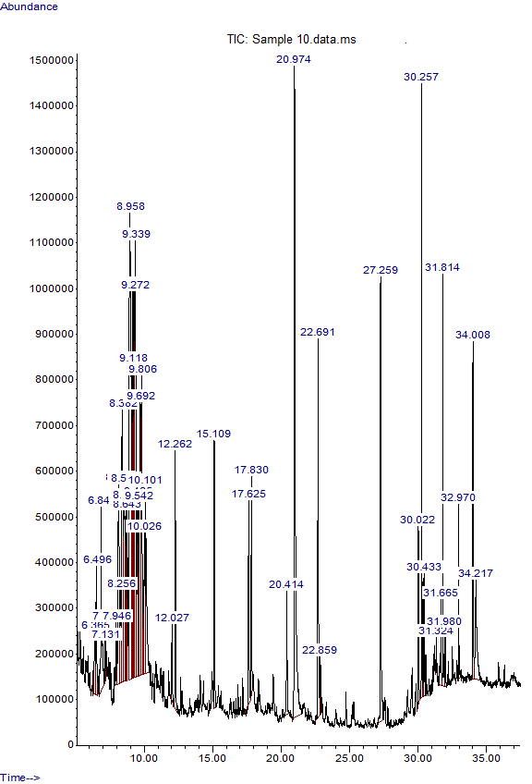

Fig 1: Spectrum of thin layer chromatography of Dacryodes edulis (DE)
of 43 peaks in the thin layer chromatography (fig 1) carried out on the plant extract.. The major active compounds present were identified as aliphatic compounds, phenols, carboxylic acid and esters confirming the functional groups present from FTIR result. In addition the major chemical compound present in the plant extract DE are presented in table 3 in increasing order of their retention time, molecular weight, structure and percentage compositions. Hence the plant extracts possesses electron deficient group such as double bonds, heteroatom possessing lone pair electron that have been proven to be the active cites inhibiting corrosion.
Table 1: Summary of the major compounds present in Dacryodes edulis from GC- MS Analysis

S/N | RT | Compounds | Molecular Weight | Structure | Percentage  Composition %
1 | 22.692 | 1-Pentadecene | 210.3987 |  |  | 8.34
2 | 20.974 | 2,4-Di-tert-butylphenol | 206.3239 | 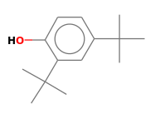 |  | 7.94
3 | 9.339 | Decane, 2-methyl- | 156.3083 | 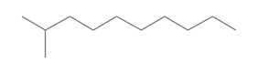 |  | 7.42
4 | 8.958 | Dodecane, 2,6,10-trimethyl-( | 212.4146 | 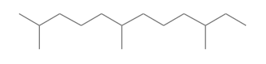 |  | 6.44
5 | 9.118 | Carbonic acid, nonyl vinyl ester | 214.3013 | 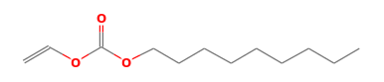 |  | 5.84

FTIR result of the coatings reveals the presence of O-H/N-H at peaks 3675 cm⁻¹ and 3351 cm⁻¹ suggesting an alcohol, carboxylic acid or amine while the peak at 2927 cm⁻¹ is indicative of an aliphatic C-H stretch suggesting an alkane. More so, the peak at 1636 cm⁻¹ suggests a C=O or C=C indicating a carbonyl compound such as ketones, amides or carboxylic acids or metal-oxygen bond likely from an inorganic component possibly from Si-O-Si bond.

Table 2 Functional groups and compounds present in epoxy/hybrid coating
Peak (cm⁻¹) | Possible Functional Group | Typical Compound Type
3675.73 | Free O-H stretch | Alcohols, Phenols
3351.86 | H-bonded O-H / N-H stretch | Alcohols, Carboxylic acids, Amines
2927.70 | C-H stretch (sp³) | Alkanes, Organic Compounds
1636.19 | C=C or C=O stretch | Alkenes, Amides, Carbonyl Compounds
1454.36 | CH₂ bending (scissoring) | Alkanes, Aromatic Compounds
1385.25 | CH₃ symmetric bending | Alkanes, Methyl Groups
1013.49 | C-O stretch | Alcohols, Esters, Ethers
879.93 | C-H out-of-plane bending | Aromatic Compounds
730.42, 696.24, 666.44 | C-H out-of-plane bending | Aromatic Compounds (e.g., Benzene Derivatives
599.06, 461.74 | Metal-Oxygen stretch | Metal Complexes, Inorganic Compounds

Fig. 2 Fourier transform infrared spectroscopy of epoxy /hybrid (epoxy/PAS/DE) coating
Conversely, result from Raman spectroscopy (fig 2 ) and table 2, the spectrum covers a wide wave number range from 800 cm⁻¹– 3000 cm⁻¹ The low-frequency (below 800 cm⁻¹), the fingerprint region ( 800–1500 cm⁻¹) and the high-frequency ( 2700–3100 cm⁻¹).

Fig. 3 Raman spectra of epoxy /Hybrid (DE/PAS) coating
The bands close to 450 cm⁻¹ are associated with skeletal vibration of a polymer backbone, suggesting an inorganic component such as silica or metal oxide which can appear as metal-oxygen (M-O) stretching vibrations. This provides evidence of the integration of an inorganic network in the epoxy matrix
At the finger print region (approximately 800 – 1500 cm⁻¹), band around 800 cm⁻¹ is often consistent with the ring breathing mode of aromatic structure which maybe derived from bisphenol –A common with epoxies, confirming presence of benzene ring. The band at 980 and 1220 cm⁻¹ is common with C-O and C –O –C stretching vibrations, these are hallmark for the formation of ether linkages formed through the cross linked network during curing process. Further more, the aliphatic content of the polymer backbone was demonstrated by the additional band observed at 1300 – 1450 cm⁻¹ common with a CH bending (scissoring) modes. More so, at the high frequency region (≈ 2700–3100 cm⁻¹), C–H stretching vibrations were observed at the bands of 2800–3000 cm⁻¹, the strong bands in this region is commonly attributed to aliphatic C–H stretching vibrations (from –CH₂– and –CH₃ groups). Similarly, the band at 3050–3100 cm⁻¹ is consistent with aromatic C–H stretching , hence, provides additional support on the presence of aromatic rings within the epoxy coating. Therefore result from Raman spectroscopy confirms successful curing of the epoxy system evident from the cross-linked network, the aromatic component was demonstrated by the ring-breathing mode. In addition, the aliphatic contribution was illustrated by the intense aliphatic C–H stretching bands which can contribute to the toughness and flexibility of the coating while the inorganic phase was demonstrated at the low-frequency region illustrating the metal–oxygen bonds (e.g., Si–O or other M–O linkages) integrated into the organic matrix, hence confirms the hybrid nature of the coating. Similar observation was demonstrated by Sandra, Alberto & Ceccato, 2012; Edward. et al., 2007 & Edward, et al., 2008; Wanrui Zhang, et al., 2004 )
Morphological information from SEM/EDS on DE. PAS and DE/PAS (fig 4 --6), SEM micrograph on DE reveals a uniform, compact and homogeneous surface with minimal clustering or agglomeration. This illustrates effective dispersion of particles in the matrix, the particle size and shape are majority submicron to a few microns in size and appear rounded or irregularly shaped. The absence of visible pores or cavities suggests a dense and continuous phase. On the other hand the EDS on the elemental composition of DE result reveals the presence of Sulphur, Phosphorous, Chlorine etc.

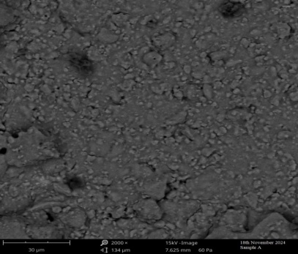
Fig 4a. SEM image of DE Fig 4b EDS result on DE
The micrograph on PAS on the other hand (fig. 5), reveals a rough and irregular surface with the presence of clusters or agglomerates distributed unevenly across the field. These agglomerated features appear globular or cauliflower-like. The presence of minor microvoids or pores was evident, especially in areas surrounding agglomerates. The micrograph hence confirms the porosity of PAS
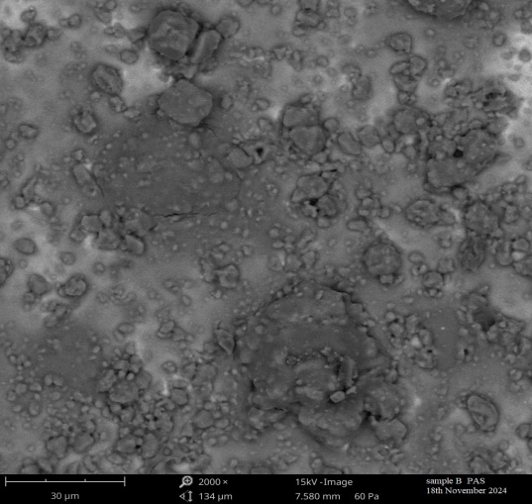
Fig 5a: SEM image of PAS Fig 5b EDS result on PAS
In contrast, the micrograph on DE/PAS (fig 5a & 5b) showed significant changes/modification on the surface morphology of DE/PAS after hybridization. A very rough, highly porous, and fibrous texture with a network-like structure and dense entanglement of fibrous and granular phases was observed. There appears to be numerous microvoids and cavities visible across the surface and the particle distribution reveals a white bright spots appearing as clusters which suggests the presence of inorganic or metallic nanoparticles. Their brighter contrast suggests higher atomic number elements (possibly Zn, Si, or Ti oxides), that could be embedded or adsorbed on organic fibers.
Fig 6a. SEM micrograph on DE/PAS Fig. 6b: EDS result on DE/PAS
Hence the SEM image on DE/PAS confirms complete grafting of the plant extract on PAS after hybridization, the result provides evidence on the formation of strong covalent bond and cross linking between the Si –O –Si and Si- OH group from PAS and the electron rich functional group in DE (–OH, –C=O ). Furthermore, the elemental composition obtained from energy dispersive spectroscopy (EDS) on DE/PAS confirmed the presence of some specific element present (C. N, & Si) with their corresponding weight percentages. A higher wt % was illustrated in Carbon, Nitrogen, Potassium and iron with Carbon having the highest wt % (26.99 %) compared to Silicon (0.77 %), hence, provides concrete evidence that the organic phase completely covered inorganic phase confirming successful hybridization thereby aligning with the micrograph obtained on DE/PAS. Similar observed was recorded in a work carried out by Singh, Verma, & Kumar, 2023. Further evidence of successful hybridization was indicated from the result of transmission emission microscopy (refer to our published work, Ohaegbulam et al., 2025) which confirms nano sized PAS (20nm-50 nm) and an increased lighter regions obtained from the hybrid (DE/PAS) consistent with a predominance of low electron density organic phases (carbon-rich matrix)
The XRD diffractogram of precipitated amorphous silica (PAS) (Fig. 7) exhibited a broad diffraction halo centered at 2θ ≈ 22°, characteristic of amorphous silica. The absence of sharp, well-defined peaks indicates a lack of long-range crystalline order, confirming the non-crystalline nature of the synthesized PAS. This pattern is consistent with reported features of amorphous silica, where short-range Si–O–Si network structures produce broad scattering rather than distinct reflections (Conradi, et al., 2014; Jesionowski & Krysztafkiewicz, 1999).
The broad halo and absence of crystalline peaks confirm that the synthesized PAS exists in an amorphous state, which is desirable for applications requiring high surface area, enhanced reactivity, and suitability as a filler or reinforcing agent in coatings and composites.
Furthermore, from Fig 8 showing the XRD profile of PAS, it demonstrates that PAS was predominantly amorphous with minor crystalline phases. The presence of tridymite (SiO₂), a high-temperature silica polymorph, indicates partial crystallinity within the amorphous matrix. In addition, secondary crystalline phases including albite (NaAlSi₃O₈), vermiculite (Na–K–Al–O–Si·12H₂O), and sodalite (Na₄Al₃ClSi₃O₁₂) were identified, suggesting incorporation of sodium and aluminum species during the neutralization of sodium silicate with sulfuric acid. A weak reflection corresponding to urea (CH₄N₂O) was also observed, likely originating from residual stabilizers such as polyvinylpyrrolidone used during synthesis. The coexistence of amorphous silica with crystalline silicate phases is consistent with earlier reports on sol–gel and precipitation-derived silica, where incomplete condensation of silanol groups and the presence of alkali ions promote structural reorganization and crystallite formation (Chen et al., 2019). These results suggest that PAS comprises a hybrid network of amorphous silica and aluminosilicate domains, which may enhance its thermal stability, surface functionality, and compatibility for hybrid organic–inorganic applications.

Fig 7. XRD Analysis on synthesised PAS

Fig 8. XRD profile on synthesised PAS
Coating performance
Environmental evaluation test (salt spray test) performed on the coated panels: B (bare epoxy), C (epoxy/PAS – 2 wt%), D(epoxy/DE-0.4 wt%), E(epoxy /DE -0.8 wt%), F(epoxy/DE-1.2 wt%), G(epoxy/PAS- 2 wt%/DE- 0.4 wt%), H (epoxy /PAS-2 wt%/DE - 0.8 wt%), I(epoxy/PAS – 2 wt%/DE- 1.2 wt%) as shown in fig 9a-9b before and after exposure time (20 days) reveals emergence of corrosion products (more evident on panel B) on all the coated panels. There appears to be evidence of pitting corrosion occurring in panel B compared to others. The coated panel G(epoxy/PAS- 2 wt%/DE- 0.4 wt%), showed more resistance to corrosion attack after exposure time, this was followed by panel H and I. In general the panels coated with the hybrid coating exhibited superior corrosion resistant in the test procedure compared to others, this demonstrates its more enhanced barrier protection property hence offers an excellent alternative to the conventional coating (bare epoxy).
.
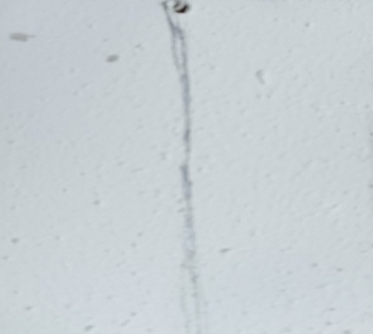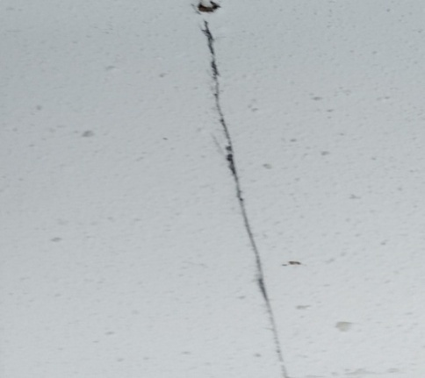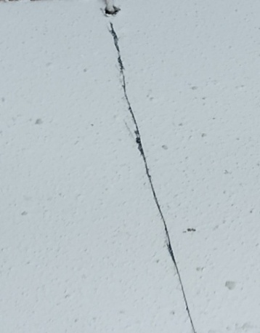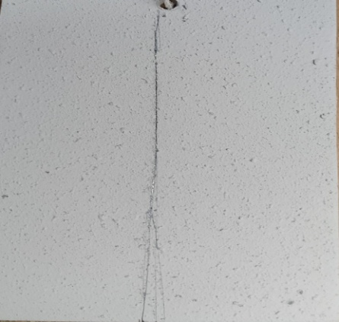
Control B Sample C Sample D Sample E
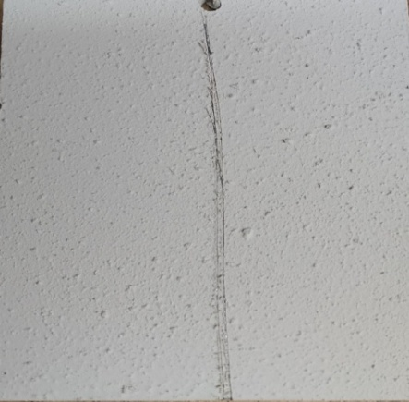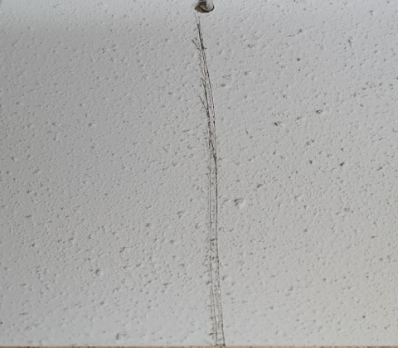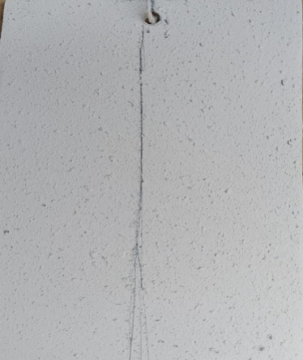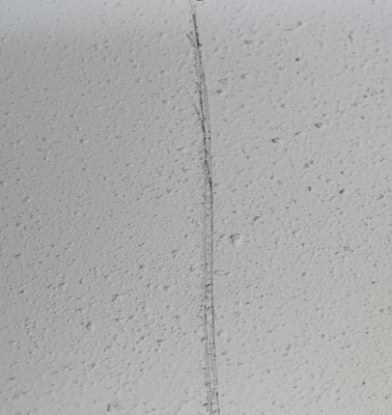
Sample F Sample G Sample H Sample I
Fig 9a:Salt Spray test before exposure

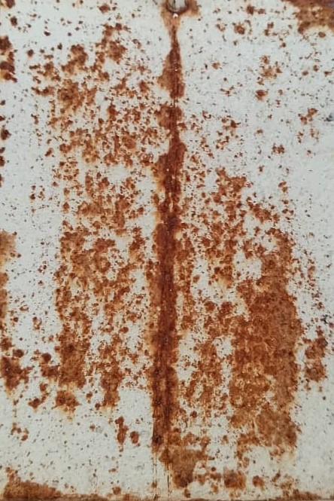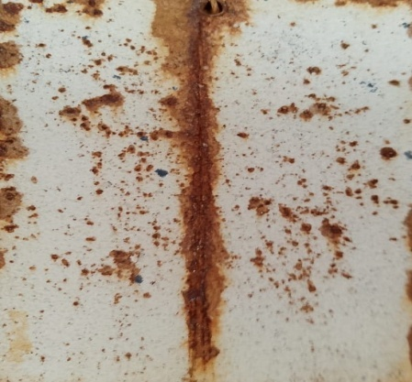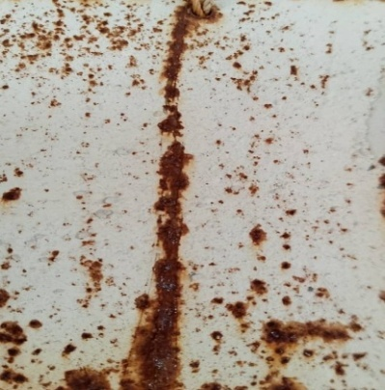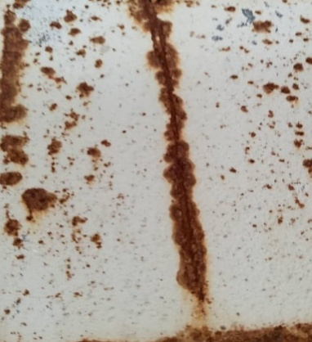
Sample B Sample C Sample D Sample E
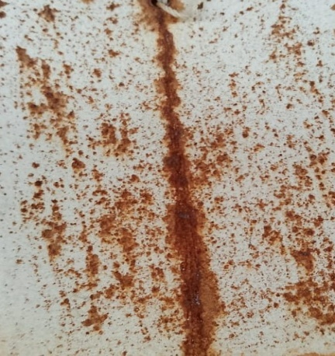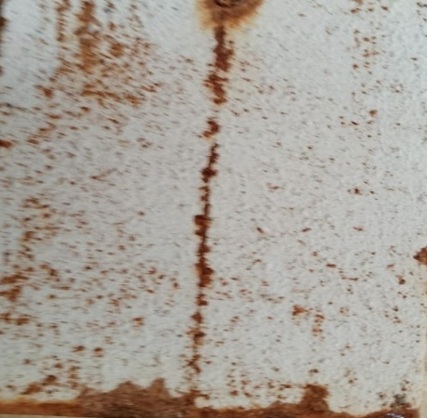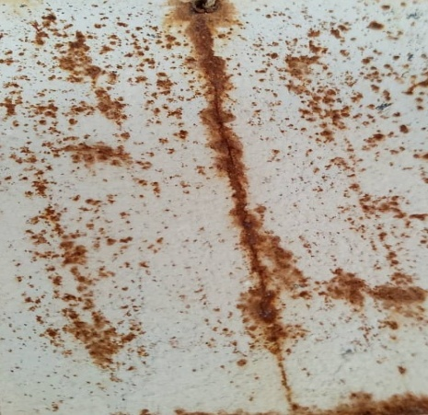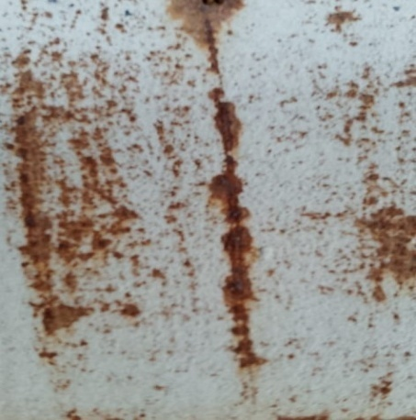
Sample F Sample G Sample H Sample I
Fig 9b: Salt spray test after expoure (20 days)

Similarly, UV degradation /weathering test performed on the coated panel after exposure time (1000 h) showed that all the panels apparently showed moderate discolouration and loss of gloss after exposure time with panels coated with the hybrig coating G, H, & I showing superior performance. Compared with panel B which showed very poor performance, this behaviour clearly illustrates the inability of the coating to withstand the extreme harsh environment which may be as a result of loss of chemical stability, breakdown of pigments or binder, polymer chain scission, loss of smoothness and reflection ability of the coating. More so, panel B showed on onset of corrosion with the emergence of tiny cracks on the surface which maybe as a result UV embrittlement. The panels coated with the hybrid coating (G to I ) exhibited good performance after the period of exposure, panels C, D, E & F showed moderate degradation while B (bare epoxy) showed severe degradation evident in the presence of the tiny cracks and on set of corrosion on the metallic surface. Similar observed were recorded by (Wypych, 2018; Kaczmarek & Oldak 2012; Crivello, & Bulut, 2005).
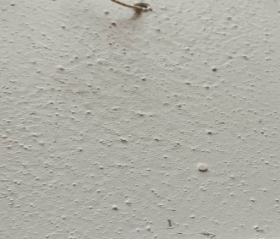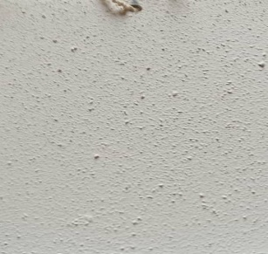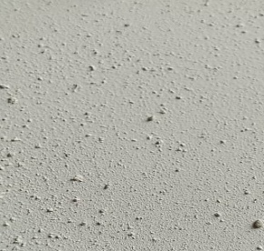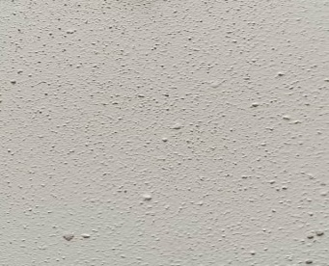
Sample B Sample C Sample D Sample E

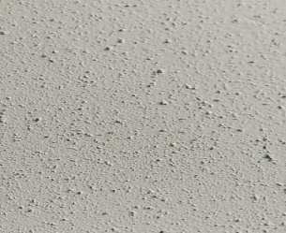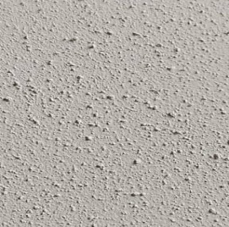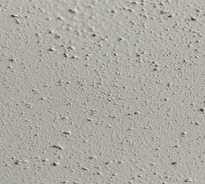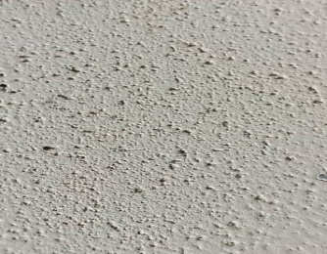
Sample F Sample G Sample H Sample I

Fig. 10a: Coated panels before exposure to UV degradation test
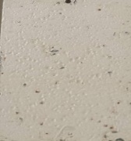
Sample B Sample C Sample D Sample E

Sample F Sample G Sample H Sample I
Fig. 10b: Coated panels after 1000 h UV degradation test
The superior performance of the hybrid coating compared to others in the test procedures can be attributed to the strong interaction existing between the organic and inorganic phase resulting from the cross linking between the Si- O –Si/Si-OH in the inorganic phase and the carbon – carbon chain of the organic phase, thus leading a strong polymer chain this further strengthens the interaction between the organic/inorganic phase and the ether linkages in the epoxy matrix. The net effect is a robust coating with more enhanced multifunctionality. Accordingly, SEM micrograph revealed complete coupling of the organic /inorganic material after hybridization while TEM micrographs shows that the organic phase completely covered the inorganic phase providing additional prove on complete hybridization. Furthermore, FTIR result reveals some active functional group present in the plant extract which have been proven to be responsible for corrosion inhibition while GC-MS confirms the presence of some of these functional groups . Therefore it can be inferred that the hybrid coating provided more protective layer over the substrate material due to its more enhanced barrier properties (Iyer, et al., 2024; Gasiorek, ,et al., 2023; ASTM G154-16, 2016)
Electrochemical studies
Cyclic polarization measurement:
The Tafel plot of the cyclic polarization measurement ( Fig. 11) obtained on the coated panels studied B(bare epoxy), C(epoxy/ PAS – 2 %) , F (epoxy / DE- 0.4 wt%) and G epoxy /DE-0.4 wt%/PAS- 2 wt%) is a plot of working electrode potential (Ewe/V) vs. reference electrode (V) for the X – axis against the logarithm of the absolute current density (log (|i|/mA), y – axis indicating corrosion rate. The plot shows the forward scan (anodic branch), where the potential increases and metal oxidation occurs, the reverse scan (cathodic branch), the potential decreases after vertex which assesses repassivation.
Fig. 11: Tafel plots of bare epoxy, epoxy/PAS, epoxy/DE & epoxy/hybrid coatings
Key corrosion parameter were employed to evaluate the coating performance by extrapolating the tafel plot (fig. 11); corrosion potential (E_{corr}), more positive (E_{corr}) indicates better corrosion protection. The trend in the value of E_{corr} of the coated panels studied is epoxy/hybrid (~ -0.35 V) ˃ epoxy /DE (~ -0.50 V) ˃ epoxy/PAS(~ -0.55 V) ˃ bare epoxy (~ -0.65 V), hence epoxy/hybrid coating appears to exhibit more enhanced performance compared to others. On the other hand, the corrosion current density (I_{corr}) provides an insight on the anti -corrosion properties of a coating on a metal substrates; lower values of I_{corr} demonstrates good corrosion resistance, epoxy /hybrid coating shows significant corrosion resistance (I_{corr} = 1.3 × 10⁻⁶ mA/cm²) with values less by two orders of magnitudes compared to bare epoxy (4.0 × 10⁻⁵ mA/cm²), this was followed by epoxy/DE (4.0 × 10⁻⁶ mA/cm²) and epoxy/PAS (1.0 ×10⁻⁵ mA/cm²). (ASTM G102-89, 2015; Mansfeld, 1981). More so, the pitting potential (E_{pit}) evaluates the coating resistance to pitting corrosion, it is the potential where the forward scan increases suddenly indicating breakdown of the passive film and onset of pitting . Higher values favours good resistance to pitting corrosion, epoxy/hybrid coating with E_{pit} value of -0.26 V shows more resistance to pitting corrosion compared to bare epoxy coating(−0.42 V), epoxy/DE coating (−0.34 V) and epoxy/PAS coating ˃ (−0.39 V). Conversely, the repassivation potential E_{(rep)} indicates the ability of the metal to repassivate after breakdown, high or more positive value indicates good ability to repassivate. Epoxy /hybrid coating showed greater tendency to repassivate as indicated by its high value of E_{rep} (−0.27 V) compared to others; epoxy/DE coating ( −0.45 V), epoxy /PAS coating (−0.51 V) and bare epoxy (−0.57 V). More so, the hysteresis loop and hysteresis width measures a material’s susceptibility to pitting corrosion. A large loop and a high width basically signify pitting corrosion and poor repassivaton tendency. The absence of hysteresis loop in epoxy/hybrid coating clearly demonstrates its good resistance to localised corrosion and a more enhanced tendency to repassivate, notwithstanding the trend in hysteresis loop observed in all the coated panels studies reveals a low width (0.01) with epoxy/hybrid coating compared to others (epoxy/DE coating -0.11 V, epoxy/PAS coating - 0.12 V, bare epoxy coating - 0.15 V), thus, provides additional evidence on its more repassivating tendency. The result obtained agrees with similar works carried out by Yao et al., 2025; El-Aonni, et al., 2024 & Mao et al., 2024

EIS measurement
The Nyquist, bode and phase angle plot obtained on the coated panels listed B, C, F and G representing bare epoxy, epoxy/PAS, epoxy/DE and epoxy /DE/PAS is shown in fig 12 . The Nyquist plot of all coatings (fig 12) did not show a clear semicircle, but instead exhibited a linear diffusion-controlled response indicating Warburg behaviour. This absence of a semicircle indicates that corrosion was governed by ionic transport through the coating rather than interfacial charge-transfer resistance.
The slope of the low-frequency region reflects the coatings’ resistance to electrolyte diffusion. For bare epoxy the slope of 1.01, confirms its weak barrier effect due to microvoids and defects. While in epoxy/PAS (0.88) and epoxy/DE (0.97) coatings slightly improved ion-blocking ability. On the other hand in epoxy/hybrid coating which displayed the highest slope (1.32), demonstrates its superior restriction to ionic transport. Hence, the hybrid coating provides the most effective barrier against corrosive species, consistent with its enhanced anti-corrosion performance. (González‐García, et al., 2007; Vu, et al., 2018; Jokar, et al., 2016; Kumaravel, et al., 2011)
Fig 13. Nyquist plot of bare epoxy, epoxy/PAS, epoxy/DE & epoxy/hybrid coatings
Similarly, the bode plot (Fig 14) compares impedance magnitude /Z/ and phase angle of the four coatings (bare epoxy, epoxy/PAS, epoxy/DE, epoxy/hybrid) across the measured frequency range. The obvious high impedance /Z/ at low frequency implies good barrier property. The hybrid coating demonstrated better barrier property revealed by its high impedance at low frequency followed by epoxy/DE, epoxy/PAS while bare epoxy was least in performance. More so, higher low-frequency /Z/ illustrates greater resistance to ionic transport, hence, long term corrosion protection. From the plot obtained the hybrid coating provides best barrier which is consistent with the cross linking filler blocking explained elsewhere and slope (1.32) obtained from the Nyquist plot. In addition, each coating showed a fail in /Z/ with increase in frequency. It is well known that the frequency at which /Z/ begins to drop (the breaking frequency) is related to the dominant time constant of the coating (high R_{ct}) and signifies a more protective coating. A low break frequency (a shift to the left) implies a large time constant (high R_{ct}) signifying more protective coating. Thus the hybrid coating with the lowest break frequency is consistent with larger effective resistance and/or capacitance of the coating layer while bare epoxy with highest break frequency is correlated with thinner or more permeable dielectric and short time constant. Notwithstanding, the coatings all show larger, broader and phase plasma near -80º to -60º at the mid frequency indicating an ideal capacitor/coating (good dielectric barrier). The hybrid coating displays the most capacitive behaviour (large phase magnitude and broadest plateau) compared to others suggesting a more homogeneous and less porous dielectric while bare epoxy and the single additive systems (epoxy/DE and epoxy/PAS) showed a smaller phase maxima and narrower capacitive plateaus demonstrating a non ideal capacitive behaviour due to surface inhomogeneity, pores and water uptake resulting to greater diffusion/ohmic contribution at low frequency.
Hence epoxy hybrid coating showed best performance proven by its highest low frequency /Z/, lowest break frequency, and largest capacitive phase, the result aligns with the lowest corrosion rate observed in polarization test. On the other hand the coatings with lower /Z/ and reduced capacitive behaviour (bare epoxy, epoxy/PAS.& epoxy/DE) are more permeable to electrolyte and diffusion controlle
Fig.14: Bode plots of bare epoxy, epoxy/PAS, epoxy/DE & epoxy/hybrid coatings
The EIS was modelled using equivalent circuit model shown in fig 14 in other to extract important corrosion parameters that provides an insight on the coating performance. The extracted parameters are shown in table 2
Table 2. Modelled circuit of EEC showing key parameters
System | R_{S} | Yo (x 10⁻⁴) (Ω^{–1} cm^{–2}) | n1 | R_{p} | Yo (x 10⁻⁴  (Ω^{–1} cm^{–2}) | n₂ | Rct  (Ω·cm²)
Bare Epoxy | 25.9±0.3 | 2.529 | 0.99 | 34 | 3.505 | 0.88 | 35.4 ±0.1
Epoxy PAS | 24.7±0.2 | 2.478 | 0.78 | 36.3 | 2.141 | 0.87 | 36.8
Epoxy/DE | 20.9±0.4 | 3.662 | 0.84 | 33.4 | 2.053 | 0.84 | 73.8 ± 0.4
Epoxy/hybrid | 20.7±0.1 | 1.179 | 0.89 | 38.3 | 1.541 | 0.86 | 352± 0.2

Fig 15. Equivalence circuit Model
Equivalent circuit Rs – (CPE₁$∥$ Rp) – (CPE₂$∥$ R_{ct}) (1)
Electrochemical impedance spectroscopy (EIS) measurements were fitted using a two-time-constant equivalent circuit shown in equation 1, comprising solution resistance (Rs), coating pore resistance (Rp) and two constant phase elements (CPE) representing coating and interfacial capacitances; the fitted parameters are summarized in Table 2. The Rs values were similar for all samples (20.7–25.9 Ω·cm²), indicating comparable electrolyte conditions. The bare epoxy exhibited Rp = 34 Ω·cm² and Rct = 36.8 Ω·cm². Incorporation of precipitated amorphous silica (PAS) led to a modest increase in pore resistance (Rp = 36.3 Ω·cm²) but no meaningful change in charge-transfer resistance (Rct = 35.4 Ω·cm²). Addition of the Dacryodes edulis extract (DE) produced a substantially higher Rct (73.8 Ω·cm²) with Rp ≈ 33.4 Ω·cm². The epoxy/Hybrid coating (PAS + DE) produced the most pronounced effect: Rp increased to 38.3 Ω·cm² while Rct rose dramatically to 352 Ω·cm². The CPE admittance (Yo) values decreased for the hybrid coating (Yo1 = 1.179×10⁻⁴, Yo2 = 1.541×10⁻⁴) compared to bare epoxy, and the CPE exponent n lay between 0.78 and 0.99 across all samples, indicating non-ideal capacitive behaviour.
The nearly constant Rs values confirm measurement consistency. The modest changes in Rp indicate that PAS slightly improves the physical barrier by filling voids and increasing tortuosity of ionic pathways, but PAS alone does not substantially alter electrochemical kinetics at the metal interface (unchanged Rct). By contrast, DE primarily increased the charge-transfer resistance (R_{ct} ≈ 74 Ω·cm²), consistent with adsorption/passivation effects at the metal/coating interface: organic species from DE likely inhibit anodic/cathodic reactions, reducing corrosion kinetics where electrolyte reaches the substrate. The hybrid system combined both effects: PAS provided structural densification (highest Rp) while DE provided chemical passivation — their synergy produced a near-tenfold increase in R_{ct} relative to DE alone and an order-of-magnitude increase versus the bare epoxy, indicating far superior protection. Lower Yo values for the hybrid indicate reduced admittance and lower ionic mobility through the coating; n values <1 reflect increased heterogeneity introduced by filler/extract dispersion. Thus, the hybrid (PAS + DE) significantly enhances epoxy corrosion protection. While PAS primarily improves physical barrier properties and DE primarily contributes electrochemical inhibition, their combination yields pronounced synergy: reduced admittance, raised pore resistance, and a dramatic increase in charge-transfer resistance (Rct = 352 Ω·cm²), indicating superior long-term protection compared to either additive alone.. Similar result were recorded by (Lopez-Campos, et al., 2024; Ismail, et al., 2023)
Proposed Barrier Protection Mechanism of the Hybrid Coating
The superior barrier performance of the organic–inorganic hybrid coating is attributed to strong interfacial bonding between the Dacryodes edulis extract and the silica network. FTIR analysis revealed functional groups such as O–H, C=O, C=C, C≡C, N=C=S, esters, and ethers, while GC–MS confirmed the presence of phenols, aliphatic compounds, carboxylic acids, and esters. These electron-deficient groups readily interact with Si–OH and Si–O–Si moieties through covalent grafting and condensation reactions, forming additional siloxane (Si–O–Si) linkages. This extensive crosslinking enhances the thermal and mechanical stability of the hybrid material.
Within the epoxy matrix, the hybrid nanoparticles interact with ether linkages (–C–O–C–) of the resin during curing, forming a dense, interconnected polymer network. The well-dispersed hybrid phase also fills microvoids, suppresses crack initiation, and promotes crack deflection, thereby improving coating integrity and mechanical performance.
The corrosion protection mechanism is governed by the formation of a compact, uniform, and impermeable barrier that restricts electrolyte ingress. This is supported by EIS data showing significantly increased charge-transfer resistance (R_{ct}) and reduced admittance, as well as cyclic polarization results indicating low corrosion current (I_{corr}), high repassivation potential (E_{rep}), and no hysteresis—evidence of resistance to pitting corrosion. Additionally, TGA/DTA analysis confirmed enhanced thermal stability, while salt spray and UV exposure tests demonstrated improved environmental durability.
Consequently, the hybrid coating's enhanced performance arises from interfacial chemical crosslinking, epoxy matrix reinforcement, and formation of a dense, defect-free barrier that effectively mitigates corrosion.
Conclusion
The bio-based silica–epoxy hybrid coatings developed in this study exhibited significantly enhanced barrier and anticorrosion performance on mild steel in simulated marine environments (3.5 wt% and 5 wt% NaCl), demonstrating strong potential for aerospace and marine applications. SEM and TEM analysis confirmed successful hybridization of plant extract–derived silica (PAS) with Dacryodes edulis (DE), while FTIR and GC–MS verified the presence of key functional groups such as aromatic ester, alkyl aryl ether, O–H, C=C, and Si–O linkages. XRD revealed the amorphous nature of PAS with a broad diffraction halo centered at 2θ ≈ 22°. FTIR and Raman spectroscopy of the coatings confirmed the formation of a well-cured, polymeric epoxy network with integrated inorganic phases (Si–O/M–O linkages), supporting the hybrid nature of the system.
Corrosion performance testing (ASTM B117) revealed that the hybrid coating G (epoxy/PAS-2 wt%/DE-0.4 wt%) exhibited the highest corrosion resistance and retained gloss and color under UV/weathering conditions (ASTM G154, 1000 h).
Electrochemical measurements demonstrated that the hybrid coating exhibited low corrosion current density (1.3 × 10⁻⁶ mA cm⁻²), high polarization resistance (Rp = 38.3 Ω cm²), and elevated charge transfer resistance (Rct = 352 Ω cm²), confirming improved barrier protection. The near-linear Nyquist plots and capacitive behavior in Bode plots further validated the coating’s intact structure and efficient corrosion resistance.
Consequently, the integration of DE/PAS hybrid into the epoxy matrix enhanced crosslinking through Si–O–Si and carbon–carbon interactions, forming a robust polymeric network that improved adhesion, thermal stability, and corrosion resistance. The resulting bio-based hybrid coating offers a sustainable and high-performance alternative to conventional epoxy systems for marine and aerospace applications.

CONFLICT OF INTEREST STATEMENT
I declare that this research work was carried out in the absence of any self benefits, commercial or financial conflict and declare the absence of conflicting interest with funders
References
Agiriga C. E , Ngozi- Olehi L.C., Chikwe R.N., and Achinihu I. O (2019).
Characterizing the protective action of Dacryodes edulis on mild steel corrosion in different environment .J. Chem Soc. Nigeria, 44(4), 744-750.
Amir Poursaee (2010. Determining the appropriate scan rate to perform cyclic polarization test on the steel bars in concrete Electrochimica Acta: 55(3), 1200–1206
ASTM G102-89 (2015) – Standard Practice for Calculation of Corrosion Rates and Related Information from Electrochemical Measurements
Askari, F., Ghasemi, E., Ramezanzadeh, B. &Mahdavian, M. (2016). Synthesis and characterization of the fourth generation of zinc phosphate pigment in the presence of benzotriazole. Dyes Pigments. (124),18-26. https://doi.org/10.1016/j.dyepig.2015.08.020.
Ashassi-Sorkhabi, H., Shaabani, B. & Seifzadeh, D. (2005). Effect of Some PyrimidinicShciff bases on the Corrosion of mild steel in hydrochloric acid solution, Electrochimica Acta, 50 (16-17), 3446- 3452.
Ashcroft W.R. (1993). Curing agents for epoxy resins. In: Ellis B. (1st. ed. pp 37 – 71) Chemistry and Technology of Epoxy Resins. Springer, Dordrecht.
ASTM G154-16 "Standard Practice for Operating Fluorescent Ultraviolet (UV) Lamp Apparatus for Exposure of Nonmetallic Materials."ASTM International, 2016.
Bakhshandeh, E., Jannesari. A., Ranjbar, Z., Sobhani, S. & Saeb, M. R. (2014). Anti-corrosion hybrid coatings based on epoxy-silica nano-composites: Toward relationship between the morphology and EIS data. Progress in Organic Coatings. 17(77), 1169–1183.
Barletta M., Lusvarghi F., Mantini P., and Rubino H. (2007). Epoxy based thermosetting powder coatings: Surface appearance, scratch adhesion and wear resistance. Surface and CoatingsTechnology. 201(16-17), 479–7504.
Bergna, H. E. & Roberts, W. O. (2005).Colloidal silica Fundamentals and applications (Surfactant Science series) CRC Press; (1st ed.).Taylor & Francis, Boca Raton, FL.
Behzadnasab,M., Mirabedini, S. M., Esfandeh, M. & Farnood, R. R. (2017). Evaluation of corrosion performance of a self-healing epoxy-based coating containing linseed oil-filled microcapsules via electrochemical impedance spectroscopy. Progress in Organic Coatings. (105), 212–224.
Bhawsar, J., Jain, P. & Jain, P. (2015). Experimental and computational studies of Nicotiana tabacum leaves extract as green corrosion inhibitor for mild steel in acidic medium, Alexandria Engineering Journal. (54), 769-775.
Bongiorno,V., Michailidou, E., Curioni, M., (2023) Evaluating organic coating performance by EIS: Correlation between long-term EIS measurements and corrosion of the metal substrate. Materials and corrosion 75 (2), 156-173
Canosa, G., Alfieri, P. V. &Giudice, C. A. (2014). High-solids, one-coat paints based on aliphatic epoxy resin-siloxanes for steel protection, Prog.Org. Coat. (77), 1459–1464..
Chen, X., Wen, S. F., Feng, T.& Yuan, X. (2019). High solids organic-inorganic hybrid coatings based on silicone-epoxy-silica coating with improved anticorrosion performance for AA2024 protection. Progress in Organic Coatings. (139), 105374.
Conradi, M., Kocijan, A., Kek-Merl, D., Zorko, M. &Verpoest, I. (2014). Mechanical and anticorrosion properties of nanosilica filled epoxy-resin composite coatings. Applied Surface Science, (292), 432–437. .
Costa, M. & Klein, C.B. (2006). Toxicity and Carcinogenicity of Chromium Compounds in Humans. Critical Review in Toxicology, 36(2), 155- 163..
Crivello, J. V., & Bulut, U. (2005). "The effects of UV light on coatings: Mechanisms and protection strategies. Progress in Organic Coatings, 53(1), 1–20.
Dandan Sun, William A. Brantley, Gerald S. Frankel, Ramin H. Heshmati & William M. Johnston (2018). Potentiodynamic polarization study of the corrosion behavior of palladium-silver dental alloys. Journal of Prosthetic Dentistry. 119(4), 650–656.
Edward L. Lee, Israel E. Wachs ( 2007) In Situ Spectroscopic Investigation of the Molecular and Electronic Structures of SiO₂ Supported Surface Metal Oxides"The Journal of Physical Chemistry C pp 14410–14425
Edward L. Lee, Israel E. Wachs (2008) In Situ Raman Spectroscopy of SiO₂-Supported TransitionMetalOxide Catalysts: An Isotopic ¹⁸O−¹⁶O Exchange Study" The Journal of Physical Chemistry C : 6487–6498​ DOI: 10.1021/jp076485w​

Ellis, B., (1993). Chemistry and Technology of Epoxy Resins, 11st, Ed, 46 – 344) Blackie Academic and Professional, London. Chapman & Hali in. ISBN 978-94-010-5302-0 ISBN 978-94-011-2932-9 (eBook).
El-Aonni, N., Dagdag, O., Amri, A.E., Amrani, B., M’hamed, B., & Yousfi, H. (2024). Hybrid/Br inhibitor in corrosion protection of steel: experimental and theoretical investigation. Environmental Science and pollution Research, (31), 1033-1049.
Fandi, M. & Li, L. (2018). Electrochemical evaluation technologies of organic coatings .Coatingand thin film technology..
Figueira, R. B., Silva, C.J.R., Pereira, E.V. & Saltaa, M. M. (2014). Alcohol-Aminosilicate hybrid coatings for corrosion protection of galvanized Steel in mortar ‘Journal of the Electrochemical Society. 161 (6), 349-362· .
Galliano, F. &Landolt, D. (2002). Evaluation of corrosion protection properties of additives for waterborne epoxy coatings on steel Progress in Organic Coatings (44), 217–225.
García-Ochoa, E. M., Suárez-Corrales, X. I., Maldonado-Rivas, P. J., Talavera-Pech, W. A., Corvo, F. (2023). Non-Linear Evaluation of Coatings Performance: Evaluation of Polyester/Melamine Coil Coating Hydrolysis in NSS Test. Coatings, 13(8), 1327..
Gasiorek, A., Babiarczuk, B., Jones, W., Simka, W., Detyna, J., Kaleta, J., & Krzak, J, (2023). Anticorrosion properties of silica-based sol-gel coatings on steel -- the influence of hydrolysis and condensation conditions, Chemical Physics. 48 (24), 37150-37163.
Gowri, S, &Balakrishnan, K. (1994). The effect of the PVC/CPVC ratio on the corrosion resistance properties of organic coatings. Progress in organic coating. (23) :363-377.
Hana Vascova & Vojitec kreselek (2011) Raman Spectroscopy of Epoxy Resin Crosslinking 13th WSEAS International Conference on Automatic Control, Modelling and Simulation (ACMOS'11) Lanzarote, Canary Island. 357–363
Hou, K., Meng, Y., Chen, X., Li, Y., Wang. R.,, (2023). High Efficient Construction and Comprehensive Evaluation of Superhydrophobic Filter Screen Coatings. Journal of Nano materials 10pgs
Ismail, N. A., Shakour, R.A., Al- Qahtani, N., & Kahraman, R. (2023). Multi layered LDH/Microcapsule Smart Epoxy Coating for corrosuion protection. ACS Omega, 8(34), 30838-30849
Iyer, A. H. S.; Løken, A.; Skilbred, A. W. B. (2024). Investigating the Trends in Coating Degradation During Long Term Accelerated Testing. AMPP Annual Conference 2024, Paper No. C2024-21021.
Jalili M., M. and MoradianS., (2009). Deterministic performance parameters for an automotive polyurethane clearcoat loaded with hydrophilic or hydrophobic Nano-silica. Progress in Organic Coatings, 66(4), 359–366.
Jayakumar, N.; Gopalan, N. k., (2025) Tailored Cerium phosphate/silica ybrid epoxy for enhanced corrosion protective RSC Applied Polymers. 3(1), 181-195
Jesionowski, T. & Krysztafkiewicz, A. (1999). Properties of highly dispersed silica precipitated in an organic medium. J. Dispersion Sci. Technol.,(20), 1609.
Jokar, M., Farahani, T. S &Ramezanzadeh, B. (2016). Electrochemical and surface characterizations of Morus alba pendula leaves extract (MAPLE) as a green corrosion inhibitor for steel in 1M HCl, J. Taiwan Inst. Chem. Eng., (63), 436-452
Kaczmarek, H., & Oldak, D. (2012). "Degradation of polymers in UV light: A short review."Polimery, 57(11-12), 800–806..
KarlFink, J. (2018). Reactive Polymers: Fundamentals and Applications (Third edition), 139-223. A Concise Guide to Industrial Polymers Plastics Design Library.
Krishnapriya, K.V., Thejus, P.K., Nithyaa, J., &Nishanth, K.G., (2019). Anticorrosive Performance of MangiferaindicaL.Leaf Extract-Base Hybrid Coating on Steel. ACS Omega. (4), 10176−10184. .
Kumar, S. R.,Latiff, S., Kumar, M.T. (2018). Corrosion protection of epoxy-coated stainless Steel by organic-oating and filler materials. SOJ Mater Sci Eng. 6(1), 1-12..
Kumaravel, M., Ramashkumar, S., Subremanion, J.S., Gown, S., Rajasekara, N., &Selavay, A. (2011). Electrochemical characterization of the positive film by the unsymmetrical Schiff’s base on mild steel surface in acid media. Electrochem., (561), 3851-3863.
Lamakaa, S.V., Xuea, H.B.,Meisb, N.N.A.H. Estevesb, A.C.C. &Ferreiraa,ca, M.G.S. (2015). Fault-tolerant hybrid epoxy-silane coating for corrosion protection of magnesium alloy AZ31. Progress in Organic Coatings. (80), 98–105
Lopez-Campos, J, E, D., Mojica-Gomez, J., Maciel-Cerda, A., Castano, V. M., & Hernandez-Padron G. (2024). Hybrid epoxy –SiO₂ /GO nanosheet anti –corrosive coating for aeronautic aluminum A16061-T5. Journal of Coatings Technology & Research, 21(1), 559-574
Mao, Y., Liu, S., Wu, G., & Du, X. (2024). Synergistic Effect of CNT and N- Doped Graphene Foam on improving the corrosion resistance of Zn Reinforced Epoxy composite Coatings. Polymer.16(24), 3513
Musić, S., Filipović-Vinceković, N. & Sekovanić, L.(2011). Precipitation of amorphous sio₂ particles and their properties Brazilian Journal of Chemical Engineering, 1 (28), 89 – 94.
Nikpour, S., Naderi, R. & Mahdavian, M. (2018). Fabrication of silane coating with improved protection performance using Mentha longifolia extract. J. Taiwan Inst. Chem. Eng. (88), 261−276.
Nguyen, A. S., Musiani, M., Orazem, M. E., Pébère, N., Tribollet, B., Vivier, V (2016). Impedance study of the influence of chromates on the properties of waterborne coatings deposited on 2024 aluminium alloy Corros. Sci., (109), 174-181.
Ma, I. A; Sharma, S., Kasi. R; Shafaamri, A; Subramanian, R. (2022). A comparative study of corrosion resistance of epoxy-based coating incorporated chitosan, silica and hybrid compound of chitosan/silica on mild steel,.Pigment and Resin Technology, 54(4), 491-501
Ohaegbulam, C. E., Akalezi, C. O., Oguzie, E. E., Enenebeaku, C. K., Adindu, C. B (2025). A Study on the Thermogravimetric and Differential Thermal Analysis of a Bio Based Silica Nano Composite Material. J. Mater. Sci. Res. Rev., 8 ( 3), 757-769.
Peter R., & Ingrid M., (2015). Electrochemical and Salt Spray Testing of Hybrid Coatings Based on Si and Zr Deposited on Aluminum and Its Alloys J. Electrochem. Soc. 162 (10), 592.
Rajan, R., Selvaraj, M., Palraj, S., & Subramanian, G. ((2017). Studies on the anticorrosive & antifouling properties of the Gracilaria edulis extract incorporated epoxy paint in the Gulf of mannar coast, Mandapam, India. Prog. Org. Coat.(90), 448−454.
Raps, D., Hack, T., Wehr, J., Zheludkevich, M. L., Bastos, A. C., Ferreira, M. G. S., &Nuyken, O. (2009). Electrochemical study of inhibitor-containing organic–inorganic hybrid coatings on AA2024, Corros. Sci.(51), 1012 – 1021.
Sanaei, Z., Bahlakeh, G. & Ramezanzadeh, B. (2017). Active corrosion protection of mild steel by an epoxy ester coating reinforced with hybrid organic/inorganic green inhibitive pigment. J. Alloys Compd. (728), 1289−1304.
Schmid, M. J. (2024). Correlation Between the Anticorrosive Performance of Protective Coatings Under Neutral Salt Spray Testing and Outdoor Atmospheric and Immersion Exposure. Corrosion Materials & Degradation, 5(4), 490-512.
Singh, M., Verma, A., Kumar, P (2022) Green synthesis of nanomaterials from sustainable materials for diverse applications​ Materials Today Sustainability Volume: 18
Trentin, A., Pakseresht, A., Duran, A., Castro, Y., Galusek, D. (2022) Electrochemical characterization of polymeric coatings for corrosion protection: a review of advances and perspectives Polymers, 14 .( 2306)
Vu, T. H., Dinh, T. M., Pham, N. T., Nguyen, T. T., Nguyen, P. T., & To T. X.. (2018). Evaluation of the corrosion inhibiting capacity of silica/polypyrrole-Oxalate nanocomposite in epoxy coatings. International Journal of Corrosion. Article ID 6395803, 10 pages.
Wang, C. S. &Shieh, J. Y. (1998). Synthesis and properties of epoxy resins containing 2-(6-oxid- 6h dibenz[c,e][1,2]oxaphosphorin-6-yl)1,4- benzenediol, Polymer 39(23), 5819–5826. .
Wanrui Zhang, Ray Smith, and Chris Lowe (2008) Confocal Raman microscopy study of the melamine distribution in polyester–melamine coil coating. Journal of Coatings Technology and Research 6(3), 315–328
Wypych, G. (2018). "Handbook of Material Weathering" (5th Ed.). ChemTec Publishing. ISBN: 978-1-927885-26-0.
Yao, Y., Huang, W., Rao, M., Cao, Y., Huang, Y., Liang, C., & Tan, Y (2025). Comparative study on the anti -corrosion performance of Epoxy coatings containing BIB and HFTC. Coatings. 15(3), 271
Yasakau, K. A., Zheludkevich, M. L., Karavai, O.V. &. Ferreira, M. G. S. (2008). Influence of inhibitor addition on the corrosion protectionperformance of sol–gel coatings on AA2024. Progress in organic coatings,(63), 352–361

