Original Research Article

Synthesis, Spectroscopic Characterization and Antimicrobial assessment of 4-Acetyl pyrazolone Schiff base and its Cobalt (II) Complex

.
ABSTRACT

This study is focused to synthesize, characterize, and evaluate the antimicrobial activities of a novel Schiff base ligand derived from a 4-acyl pyrazolone Schiff base Ligand and its cobalt(II) complex. The work aims to compare structural variantions arising from metal coordination with changes in biological activity. The research adopted an experimental design involving chemical synthesis, spectroscopic characterization, and antimicrobial screening. The Schiff base ligand was synthesized by condensing 4-acyl pyrazolone with diaminobenzene, followed by coordination with cobalt (II) chloride hexahydrate (CoCl2.H2O) to obtain the Co(II) complex. Characterization was done using elemental analysis, molar conductivity, infrared (IR), UV–Vis, 1H NMR, and GC–MS spectroscopy. Antimicrobial testing against S. typhi, E. coli, S. aureus, S. pyogenes, and C. albicans was conducted using the agar well diffusion method in accordance with CLSI guidelines. Spectral analyses confirmed Schiff base formation through the appearance of an azomethine (C=N) band at 1636 cm⁻¹ and coordination to Co(II) via N and O donor atoms, evidenced by M–L bands at 760 cm⁻¹. The Co(II) complex exhibited higher melting point and lower molar conductivity, indicating greater stability and non-electrolytic nature. Antimicrobial screening indicated that the Co(II) complex showed enhanced activity (zones of inhibition: 32–42 mm) compared to the free ligand (14–32 mm), particularly against C. albicans and S. typhi. MIC and MBC/MFC data confirmed enhanced efficacy upon complexation. Coordination of the Schiff base ligand with Co(II) significantly increased antimicrobial activity due to increased lipophilicity and membrane permeability, consistent with Tweedy’s chelation theory. The synthesized Co(II) complex shows greater potential for further development as an effective antibacterial and antifungal agent

Schiff base ligand, Cobalt(II) complex, Pyrazolone derivative, Antimicrobial activity

1. INTRODUCTION

The field of synthetic organic chemistry has undergone rapid advancement in the last two decades, driven by a persistent global demand for novel compounds with tailored chemical and biological properties. Among the most versatile and valuable structures are heterocyclic compounds, which form the largest division of organic chemistry and are immensely significant across pharmaceutical, industrial, and agricultural sectors (Poonam et al., 2015). They serve as active ingredients in pharmaceuticals, as well as crucial additives and modifiers in cosmetics, plastics, and information storage materials. A particularly important class of heterocycles is the pyrazolones: five-membered rings characterized by two adjacent nitrogen atoms and a ketonic group. Pyrazolone is essentially a special form of pyrazole, with the ketonic oxygen enhancing its molecular sophistication and properties (Pettinari et al., 2018; Marchetti et al., 2019). This scaffold is a well-established synthetic precursor and building block for numerous organic molecules, finding critical applications in functional materials, coordination chemistry, and pharmaceutical science (Pamar et al., 2015; Fabio et al. 2019).
Significantly, pyrazolone derivatives are found in numerous natural bioactive alkaloids and key synthetic pharmaceuticals. These molecules exhibit a wide array of biological activities, including antipyretic, analgesic (e.g., ampyrone, phenazone), neuroprotective (e.g., Edaravone), antitumor, antioxidant, antibacterial, and enzyme-inhibitor properties (Marchetti et al., 2019; Rainsford, 2001). Furthermore, halogenated pyrazolones have demonstrated activity as potent catalytic inhibitors of human telomerase and as fungicides. The sustained interest in this core structure underscores its potential for future drug development. The chemical and biological utility of organic scaffolds is frequently amplified upon their incorporation into coordination complexes. These complexes form when ligands—neutral molecules or ions donate electron pairs to a metal ion, forming coordinate covalent bonds (Ogbuagu et al., 2021). Schiff bases, characterized by the presence of the imine or azomethine (C=N) functional group, are classic and crucial ligands in this area (Housecroft & Sharpee, 2012). The lone pair on the imine nitrogen, often combined with other donor atoms (such as oxygen, N,O donor atoms are of special interest), allows them to act as mono- or polydentate chelators. This chelation ability is critical as it stabilizes the metal's oxidation states and significantly modulates the catalytic and biological activity of the resulting complex (Housecroft & Sharpee, 2012).
Schiff bases derived from heterocyclic precursors, such as pyrazolones are of particular interests. These compounds are prized for their excellent chelating capacity, stability, and broad spectrum of biological effects, including antifungal, antimalarial, anticancer, and notable antimicrobial activities (Przybylski et al., 2009; Kumar et al., 2019). They serve as important models for biologically relevant species and are vital in biomimetic catalytic reactions. The growing global crisis of antimicrobial drug resistance necessitates the urgent search for novel therapeutic agents (WHO, 2020). Transition metal complexes, specifically those targeting antibacterial and antitumor activity, are promising candidates for safe and efficient medicinal treatments (Ogbuagu et al., 2021). However, despite the known potential of Schiff base metal complexes, there is limited literature exploring the combined use of 4-acyl pyrazolone-derived Schiff bases and first-row transition metal ions, particularly Co(II), for antimicrobial purposes. Furthermore, comparative studies detailing the structure–activity relationships of these specific metal complexes and Schiff bases remain scarce.
The significance of this research lies in its potential to contribute novel, effective antimicrobial agents that may serve as leads in drug development. By understanding the coordination behavior and the structure–activity relationships of the resulting metal complexes, we can guide future efforts in designing therapeutically relevant compounds. Therefore, this study focuses on the synthesis and complete physicochemical characterization of a novel Schiff base ligand incorporating a 4-acyl pyrazolone moiety, coordination of this ligand with a divalent first-row transition metal, specifically Co(II), to form the corresponding complex and evaluation of the antimicrobial activities of both the newly synthesized Schiff base ligand and its Co(II) metal complex
2. material and methods
All chemicals used for this work were of analytical reagent grade and were used as supplied. Ethyl acetoacetate (C6H₁₀O₃), Phenyl Hydrazine (C₆H₈N2), Diethyl ether, Ethanol, 1.4 dioxane Acetyl chloride and Hydrochloric acid were purchased from Sigma Aldrich and were used as received. A few other reagents and metal salt were sourced from Loba chemie, distilled water also in pure form and used as purchased. Culture broth, Nutrient agar and Sabouraud’s dextrose agar were obtained from Microbiology department of Polytechnic Nekede, Imo state, Nigeria.
Elemental analysis was carried out using a 2400 Series II-Perkin Elmer Carbon, Hydrogen, Nitrogen and Oxygen Analyzer. Molar conductivity measurements were made with a Philips PW 9506 conductivity meter, the solubilities of the Schiff base ligand and its Co(II) complexes was carried out in various solvents including Water, Ethanol, Methanol, DMSO, Petroleum ether, N-hexane. IR spectra were recorded, in KBr disc, on (Agilent Cary 630 FTIR Spectrophotometer and was reported in wavenumbers (cm-1) with frequency range of 4000-650cm⁻¹. ¹H NMR spectra was recorded on a Nanalysis -X685 spectrometer operating at 60 MHz, using Deuterated DMSO d6 as solvent. GCMS was recorded with a Varian 3800/4000 GCMS spectrophotometer with 45 mins run time and high mass of 500/1000. Ultraviolet spectra data was also recorded using an Agilent Cary 630 UV Spectrophotometer between 200 to 800nm.

2.1 3 Procedure for the Synthesis of Tridentate Schiff Base Ligand (4-[(1E)-N-(2-aminophenyl)ethanimidoyl]-3-methyl-1-phenyl-1H-pyrazol-5-ol)
STEP 1: Synthesis of 3-Methyl-1-Phenyl -Pyrazol-5-one {Precursor-P}
The synthesis of precursor ligand denoted by P was done using already published method by Furniss B. S. et al,(Scheme 1) as follows; 49 ml (0.384 mol) of ethyl acetoacetate was combined with 36.5 ml (0.370 mol) of phenyl hydrazine in a large evaporating dish. The mixture was heated over a boiling water bath in a fume cupboard and stirred continuously using a glass rod for two hours. As the reaction progressed, a reddish syrup began to form. After the heating for 2 hours, the evaporating dish was removed from the water bath and allowed to cool for 60 seconds. Once cooled, 100ml of diethyl ether was then added to the mixture and stirred vigorously. The syrup gradually solidifies and was insoluble in ether, the solid product was collected, washed thoroughly with 100 ml of ether and the washing was repeated twice, and filtered to eliminate any remaining impurities. The product was recrystallized with 100 ml of ethanol yielding pale yellow crystals of the crude solid from 100 mL of ethanol yielded pale yellow crystals (Furniss B. S. et al, 1989). Mp: 127 °C: Yield: 78%, C10H10N2O(P), IR (KBr, cm-1-): 3125 (N-H Stretch), 2924 (C-H Stretch), 1697 (C=O), 1496 (C=C Stretch), 1343 (C-N Stretch), 1198 (C-N Cyclic): GC-MS (m/z): cal., 174; found, 174.0
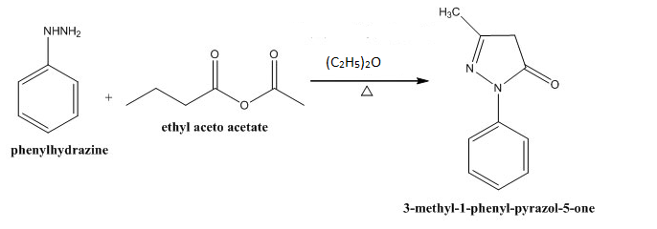
Scheme 1: synthesis of 3 methyl-1-phenyl-pyrazol-5-one (P)

STEP 2: Synthesis of Acyl Pyrazolone (4-acetyl-3-methyl-1-phenyl-5-pyrazolone)
4-acetyl-3-methyl-1-phenyl-5-pyrazolones was synthesized by reported by a slightly modified Jensen, 1959 method; 3-Methyl-1-Phenyl -Pyrazol-5-one (0.1 mol, 17.4 g) was dissolved in dioxane (80ml) contained in a three-necked flask fitted with a reflux condenser, the mixture was warmed a little and stirred with a magnetic stirrer to completely dissolved. Anhydrous calcium hydroxide (12g) was introduced and the heating continued, acetyl chloride (0.1 mol, 7.1 ml) was introduced in drops for a period of 2 minutes which led to the formation of a thick paste and the mixture refluxed for 3 hours. After refluxing, the mixture was kept to cool for 20 minutes the poured into a beaker which contained cold dilute hydrochloric acid (200ml, 2 M). This acidification step decomposed the calcium complex and, with continuous stirring, led to the formation of cream-colored crystals of 4-acetyl-3-methyl-1 -phenyl-5-pyrazolone. Mp:242 ͦ C, yield:50% (Scheme 2).
` R = CH₃
Scheme 2: synthesis of 4-acetyl-3-methyl-1 -phenyl-5-pyrazolone

STEP 3: Procedure for the Synthesis of Tridentate Schiff Base Ligand (4-[(1E)-N-(2-aminophenyl)ethanimidoyl]-3-methyl-1-phenyl-1H-pyrazol-5-ol)

The Schiff base was synthesized by reported methods (Nasridas et al., 2015). A mixture of an equal molar ethanolic hot solution (50 mL) of 1,2 diamino benzene (0.01 mol, 1.08 g) with the synthesized acyl pyrazolone (0.01 mol, 2.16g of 4-acetyl-3-methyl-1 -phenyl-5-pyrazolone) was refluxed for 3 hours in the presence of a few drops of acetic acid. After refluxing, the solution was then cooled and allowed to stand overnight at room temperature (Scheme 3). Cream coloured products of 4-[(1E)-N-(2-aminophenyl) ethanimidoyl]-3-methyl-1-phenyl-1H-pyrazol-5-ol was obtained with excellent purity, yield: 73% , M.P: 180 ͦ C C₁₈H₁₈N₄O (L), Anal. Found(%) : C, 66.99; H, 6.20; N, 18.29;O, 5.53; Calc(%): C, 70.11; H, 6.54; N, 18.17; O,5.18. IR (KBr, cm-1-): 3496 (N-H Stretch), 2961 (C-H Stretch), 1636 (azomethine C=N), 1561 (C=C Stretch), 1323 (C-N Stretch), 1073 (C-O):. UV-Vis.(DMSO) λmax(nm);298, ε (8.16 x 104), H NMR (DMSO-d6, 400 MHz) δ (ppm): 6.85–6.50 (m, 1H, Ar–H), 5.10 (s, 2H, OH or NH2), 1.23 (s, 1.5H, CH3).. GC-MS (m/z): cal., 308; found, 308.2
R = CH₃
Scheme 3: Synthesis of Tridentate Schiff Base Ligand (4-[(1E)-N-(2aminophenyl) ethanimidoyl] -3-methyl-1-phenyl-1H-pyrazol-5-ol).
2.2 Synthesis of the Cobalt Complex 4-[(1E)-N-(2aminophenyl) ethanimidoyl] -3-methyl-1-phenyl-1H-pyrazol-5-ol
5mmol (1.54g) of Schiff base ligand (4-[(1E)-N-(2aminophenyl) ethanimidoyl] -3-methyl-1-phenyl-1H-pyrazol-5-ol) was mixed in 100cm3 of ethanol, the solution was stirred for 5 minutes to attain a uniform solution, then 5mmol of metal salt (cobalt (II) chloride hexahydrate (1.185 g) was also dissolved in 20ml of ethanol. The Schiff base ligand solution and the metal salt solution were heated separately were heated for few seconds to aid dissolution and avoid evaporation of ethanol and they were mixed. The resultant solution was refluxed for 6 hours. The solution was then concentrated to half of its volume during refluxing, filtered and washed several times with hot water and finally with hot alcohol. The Grey coloured product was dried under vacuum and recrystallized from DMF (Dimethylformamide). Yield: 55%, M.p.: 250 ͦ C, C36H40CoN8O2 (CoL), Anal. Found(%) : C, 63.53; H, 5.87; N, 16.78;O, 4.95; Co, 8.72. Calc(%): C, 63.99; H, 5.97; N, 16.58; O,4.74; Co, 8.72. IR (KBr, cm-1-): 3496 (N-H Stretch), 2952 (C-H Stretch), 1684 (azomethine C=N), 1535 (C=C Stretch), 1267(C-N Stretch), 1110 (C-O), 760 (M-L):.:. UV-Vis.(DMSO) λmax(nm);280, ε (3.23 x 104). GC-MS (m/z): cal., 674.9; found, 673.2. Below (Scheme 4) is a schematic equation of the synthesis of the Metal complex (Cobalt Complex 4-[(1E)-N-(2aminophenyl) ethanimidoyl] -3-methyl-1-phenyl-1H-pyrazol-5-ol)
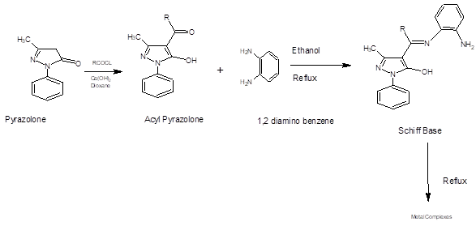
Scheme 4: Overall Equation of Reaction

2.5 Antimicrobial Analyses of the Schiff base Ligand (L) and its Co (II) Complex (CoL)
The Schiff base ligand (L) Co(II) complex (CoL) synthesized were screened for their antibacterial activity by Using Disc Diffusion method (Jayarajan,et al., 2010) against Staphylococcus aureus (Gram positive), Streptococcus pyogenes (Gram positive bacteria), Escherichia coli (Gram negative), and Salmonella typhi (Gram negative). The test compounds were prepared at a concentration of 200 μg/mL. Solvent control that is, DMSO was also maintained throughout the experiment simultaneously. Nutrient agar plates were prepared under sterile conditions and incubated overnight to detect contamination. About 0.2mL of working stock culture was transferred into separate nutrient agar plates and spread thoroughly using a glass spreader. Whatman No. 1 discs (6mm in diameter) were impregnated in the test compounds and dissolved in DMSO (200 μg/mL) for about half an hour. Commercially available drug disc (Levofloxacin 10 μg/disc) was used as positive reference standard. Negative controls were also prepared by impregnating disc of same size in DMSO solvent. The discs were placed on the inoculated agar plates and incubated at 37 ± 1◦C for about 18–24 h. Antibacterial activity was evaluated by measuring the zone of inhibition (mm) against the test organism.
2.6 Antifungal Studies of the Schiff base Ligand (L) and its Co (II) Complex (CoL)
The antifungal activity of the Schiff base ligand (L) and its Co(II) complexe were examined with a fungal strain namely Candida albicans. Drug amphotericin B was used as standard. Sabouraud’s dextrose agar (SDA) medium was used for the growth of fungi, and testing was done in Sabouraud’s dextrose broth (SDB) medium. The subculture and the viable count were carried out by the same procedure as done in antibacterial studies except the temperature was maintained at 28 ± 1◦C for about 72 h
2.7 Minimum Inhibitory Concentration (MIC)/Minimum Bactericidal/fungicidal concentration (MBC)
The tube dilution method, also known as broth macro dilution, is a fundamental technique in microbiology for determining the Minimal Inhibitory Concentration (MIC) and Minimal Bactericidal Concentration (MBC) /Minimal Fungicidal Concentration (MFC) of antimicrobial agents against microorganisms. It is considered a gold standard for susceptibility testing in some contexts due to its quantitative nature. It involves exposing a standardized bacterial inoculum to a series of decreasing concentrations of an antimicrobial agent in a liquid growth medium. The lowest concentration of the agent that inhibits visible growth is the MIC, and the lowest concentration that kills 99.9% of the bacteria and fungi is the MBC/MFC.
A series of sterile test tubes are prepared, each containing a liquid growth medium (Mueller-Hinton broth for bacterial growth or RPMI-1640 broth for fungal growth). A stock solution of the antimicrobial agent is serially diluted (typically two-fold dilutions) across these tubes, resulting in a gradient of concentrations (e.g., 256, 128, 64, ..., 0.5, 0.25 µg/mL). A control tube with no antimicrobial agent is also included for growth comparison. the standardized suspension of the test microorganism (adjusted to a specific turbidity, often 0.5 McFarland standard) is then added to each tube, the tubes are incubated under appropriate conditions (e.g., 37°C for 16-20 hours) to allow bacterial growth.
2.7.1 MIC Determination
After incubation, the tubes are examined for visible turbidity (cloudiness), which indicates bacterial/ fungal growth. The MIC is defined as the lowest concentration of the antimicrobial agent in which no visible growth (turbidity) is observed.
2.7.2 MBC/MFC Determination
To determine the MBC, a small aliquot (e.g., 0.05 mL) from each tube showing no visible growth is subcultured onto a fresh, antibiotic-free solid agar medium. These plates were then incubated. The MBC is the lowest concentration of the antimicrobial agent from which no bacterial growth is recovered on the agar plate, indicating that the bacteria have been killed rather than just inhibited, while the MFC is the lowest concentration of the antimicrobial agent from which no fungal growth is recovered on the agar plate, indicating that the fungi have been killed rather than just inhibited (Weigand, 2008).

3. results and discussion

The acylation of the precursor (3-Methyl-1-Phenyl -Pyrazol-5-one) with acetyl chloride formed an acyl pyrazolone which was condensed to form a Schiff base (4-[(1E)-N-(2aminophenyl) ethanimidoyl] -3-methyl-1-phenyl-1H-pyrazol-5-ol) .which was reacted with Cobalt (ii) chloride hexahydrate and yielded Cobalt Complex of 4-[(1E)-N-(2aminophenyl) ethanimidoyl] -3-methyl-1-phenyl-1H-pyrazol-5-ol. The Precursor (3-Methyl-1-Phenyl -Pyrazol-5-one), Schiff base Ligand and the Cobalt Complex were characterised as follows:

3.1 Physicochemical Properties of the Pyrazolone (3-Methyl-1-Phenyl -Pyrazol-5-one) Schiff base Ligands (L) and its Co (II) Complex (CoL)
The synthesized Precursor’s physicochemical properties were measured and compared with standard values from Merck index online chemical encyclopaedia and it was in agreement with standard value in melting point , colour and conductivity range. Data (Table 1) supports the formation and physicochemical characterization of the compounds: The percentage yields (78% for P, 73% for L, and 55% for CoL) are good yields, typical for multi-step organic synthesis, with a generally acceptable efficiency demonstrated for all steps. A clear change in color is observed upon complexation (from Cream for L to Grey for CoL), which is a preliminary visual indicator of metal-ligand coordination and the formation of the Co(II) complex. The melting point data show a significant increase in thermal stability from the precursor (127 ∘C) to the ligand (180 ∘C), and most notably to the complex (>250 ∘C). This substantial elevation in melting point for CoL strongly confirms the formation of a coordination compound with increased structural stability due to metal-ligand bond formation.The low molar conductivity values (ranging from 0.7 to 21.7 μs/cm) for all compounds suggest that they are non-electrolytes in the solvent of measurement. This indicates that the Co(II) complex CoL neutral and coordinates the ligand molecules in a ratio consistent with its formula C36H40CoN8O2, where the charge of the Co2+ ion is balanced by the deprotonated form of two ligand molecules.
Table 1 Physicochemical Properties of the Pyrazolone (3-Methyl-1-Phenyl -Pyrazol-5-one) Schiff base Ligands (L) and its Co (II) Complex (CoL)

Compounds | Molecular Formula | % Yield | Colour | Melting Point (∘C) | Conductivity (μs/cm)
P | C₁₀H₁₀N₂O | 78 | Pale Yellow | 127 | 0.7
L | C₁₈H₁₈N₄O | 73 | Cream | 180 | 10.8
CoL | C₃₆H₄₀CoN₈O₂ | 55 | Grey | >250 | 21.7

P- Precursor (3-Methyl-1-Phenyl -Pyrazol-5-one)
L- 4-[(1E)-N-(2aminophenyl) ethanimidoyl] -3-methyl-1-phenyl-1H-pyrazol-5-ol
CoL- Co (II) Complex 4-[(1E)-N-(2aminophenyl) ethanimidoyl] -3-methyl-1-phenyl-1H-pyrazol-5-ol

3.2 Soubility Profile of Schiff base Ligand (L) and its Co (II) Complexes (CoL) in various solvents

Table 2 details the solubility characteristics of the Schiff base Ligand (L) and its Cobalt (II) Complex (CoL) across a range of solvents varying in polarity. The results indicate how the compounds interact with different media, which is crucial for determining appropriate solvents for synthesis, purification, and biological studies. the solubility is categorized using abbreviations: s: Soluble (dissolves completely), ss: Sparingly Soluble (very little dissolution, often with residue), is: Insoluble (no noticeable dissolution). Non-Polar Solvents (Petroleum ether, N-Hexane): Both the ligand (L) and the complex (CoL) are Insoluble (Is), indicating that neither compound possesses a dominant non-polar character sufficient to dissolve in these very low-polarity hydrocarbon solvents. Aprotic Polar Solvent (DMSO):The ligand (L) is only sparingly soluble (ss).The complex (CoL) shows a significant change, being Soluble (S) in DMSO. This high solubility in the strong polar aprotic solvent Dimethyl Sulfoxide (DMSO) is typical for many metal complexes, often making DMSO the solvent of choice for coordination chemistry reactions and biological assays. Protic Polar Solvents (Ethanol, Methanol, Water):The ligand (L) is generally sparingly soluble (ss) to insoluble (is) in these protic solvents. The complex (CoL) shows increased solubility compared to the ligand: it is Slightly Soluble (s) in Ethanol and Water, and Soluble (S) in Methanol. The enhanced solubility of the complex in polar media, including water, suggests that complexation with the Co(II) ion increased overall polarity and introduce features (like ionic or strong dipole character) that favour interaction with polar protic solvent, demonstrating a change in polarity and intermolecular forces upon coordination

Table 2 Solubility Profile of Schiff base Ligand (L) and its Co (II) Complexes (CoL) in various solvents
Compounds |  |  | Solvents
 | DMSO | Petroleum  Ether | N-Hexane | Ethanol | Methanol | Water
L | Ss | Is | Is | Ss | Ss | is
CoL | S | Is | Is | S | S | s

3.3 Infrared Spectral Analysis
The characteristic infrared absorption bands of the pyrazolone precursor, the Schiff base ligand, and its cobalt(II) complex are summarized in Table 3.
The IR spectrum of the pyrazolone precursor (C₁₀H₁₀N₂O) (Fig. 1) showed a medium band at 3125 cm⁻¹, assigned to the N–H stretching vibration of the pyrazolone ring, in agreement with literature reports on pyrazolone derivatives (Nakamoto, 2009; Socrates, 2010). The bands at 2924 cm⁻¹ correspond to aliphatic C–H stretching vibrations, while a strong absorption at 1697cm⁻¹ was attributed to the C=O stretching vibration of the carbonyl group, confirming the presence of a keto functional group typical of pyrazolones (Silverstein et al., 2014). Aromatic C=C stretching appeared at 1496.5, and the band at 1343.7 cm⁻¹ was assigned to C–N stretching (Nakamoto, 2009). Additional absorptions at 1198 were due to ring skeletal or C–N vibrations, and the band at 1073.5 cm⁻¹ was attributed to C–O stretching.
In the Schiff base ligand (L) (Fig. 2), disappearance of the C=O stretching band at 1697 cm⁻¹ and appearance of a new strong band at 1636 cm⁻¹ confirmed the formation of the azomethine (C=N) group, indicating condensation between the pyrazolone carbonyl and amine moieties (Pavia et al., 2015; Alaghaz et al., 2013). Broad bands in the 3496 cm⁻¹ range correspond to N–H stretching, possibly broadened by hydrogen bonding (Socrates, 2010). C–H stretching bands appeared at 2961 cm⁻¹, and aromatic C=C stretching shifted slightly to 1561, consistent with increased conjugation in the ligand system. The C–N stretching appeared at 1323 cm⁻¹, while bands at 1110 cm⁻¹ were assigned to C–O vibrations (Silverstein et al., 2014).
For the cobalt(II) complex (CoL) (Fig. 3), the azomethine (C=N) band shifted from 1636 cm⁻¹ in the free ligand to 1684 cm⁻¹, suggesting coordination of the azomethine nitrogen to the cobalt center (Gupta et al., 2017). The broadness in the N–H stretching region (3496cm⁻¹) implied partial involvement of the N–H group in hydrogen bonding or coordination. The C–N stretching shifted to 1267.3 cm⁻¹, indicating modification upon complexation. The appearance of new bands at 760cm⁻¹, absent in the free ligand, were assigned to M–L stretching vibrations, respectively (Lever, 1984; Nakamoto, 2009), confirming coordination through the azomethine nitrogen and the deprotonated hydroxyl oxygen atoms.
Overall, the disappearance of the C=O band, appearance of the C=N band, and emergence of M–O and M–N absorptions confirm successful Schiff base formation and coordination of the ligand to the Co(II) ion through the azomethine nitrogen and oxygen donor atoms (Alaghaz et al., 2013; Gupta et al., 2017).

Table 3: Infra-red Spectra of of Schiff base Ligand (L) and its Co (II) Complexes (CoL)

 | Frequencies (cm¹)
 | C₁₀H₁₀N₂O[P] | C₁₈H₁₈N₄O [L] | CoL
N-H stretch | 3125.4 (m) | 3496.2 | 3496.2
C-H stretch | 2924.1 (w) | 2961.4 | 2952.1
C=O | 1697.2(s) | - | -
C=N stretch | - | 1636.3 | 1684.8
C=C stretch | 1496.5 (s) | 1561.8 | 1535.7
C-N stretch | 1343.7 (m) | 1323.2 | 1267.3
C-N/Ring Skeletal | 1198.3 (m) | - | -
C-O stretch. |  | 1073.5 | 1110.7
M-L | - |  | 760.1

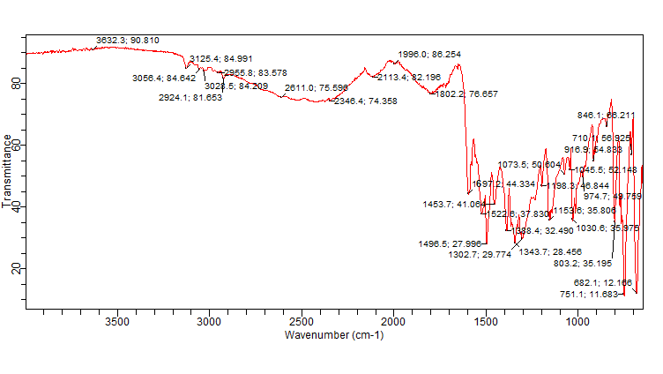
Fig 1 : IR Spectrum for P (3 methyl-1-phenyl pyrazol-5-one)

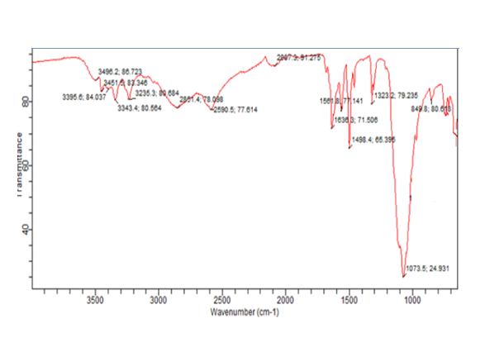

Fig 2: IR Spectrum for Schiff base Ligand -L (4-[(1E)-N-(2aminophenyl) ethanimidoyl] -3-methyl-1-phenyl-1H-pyrazol-5-ol)

Fig 3: IR Spectrum for Co (II) Complex
3.4 Percentage Elemental Analysis
The experimentally determined carbon, hydrogen and nitrogen percentages for both the ligand and complex are in very close agreement with the calculated values for the proposed stoichiometries (Table 4). For the free ligand L the largest absolute deviation is 0.35 percentage points (O), while for the Co(II) complex the largest deviation is 0.46 percentage points (C). The measured cobalt content (8.87%) is essentially identical to the calculated metal content (8.72%), supporting the proposed Co:L stoichiometry implied by the formula C₃₆H₄₀CoN₈O₂ (i.e., a bis-ligand Co(II) species). Typical analytical microanalysis reproducibility and instrument/combustion limitations commonly give acceptable deviations on the order of a few tenths of a percent. The observed deviations (≤ ~0.5% absolute) are within the normal experimental uncertainty for CHN analyses and do not indicate any gross inconsistency with the assigned formulas. The close match of the measured Co percentage to its calculated value further corroborates the chemical composition and metal:ligand ratio.

Table 4: Percentage Elemental Analysis of the Schiff base Ligand (L) and its Co(II) complex (CoL)
Compounds | Molar Mass (g/mol) |  | %C | %H | %N | %O | %M
L(C₁₈H₁₈N₄O) | 306 | 69.99  (70.11) |  | 6.20  (6.54) | 18.29  (18.17) | 5.53  (5.18) | -
CoL(C₃₆H₄₀CoN₈O₂) | 674.9 | 63.53  (63.99) |  | 5.87  (5.97) | 16.78  (16.58) | 4.95  (4.74) | 8.87  (8.72)

3.5 Gas Chromatography-Mass Spectroscopy Analysis of Schiff base Ligand (L)and its Co(II) complex (CoL)
Table 5. shows Gc-ms spectral data and a few fragments of the Precursor, Schiff base and Co(II) complex. The Precursors data (Fig 4) shows an observed molecular ion (174.0 m/z) matches the calculated mass (174 g/mol), confirming the precursor's mass. The fragment ions (41,80,146 m/z) are consistent with the structure of 3-methyl-1-phenyl-pyrazol-5-one. The loss of 28 mass units from M+ to give 146 m/z is highly characteristic of the loss of a neutral CO molecule from the pyrazolone ring, a typical fragmentation route for cyclic ketones/ketonic tautomers.

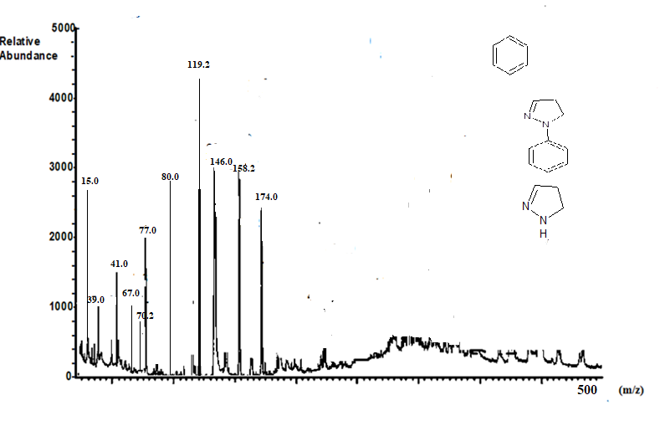
Fig 4: GC-MS spectrum of Precursor (P) with a few fragment structure
For the Schiff base Ligand (Fig 5), The observed molecular ion (308.2 m/z) is in excellent agreement with the calculated mass (308 g/mol) for C18H18N4O, confirming the synthesis of the ligand (Fig 6). The fragment ions (58.0,125.0,136.0,232.2,275.0,293.0 m/z) show stepwise losses, which are characteristic of the breakdown of the Schiff base structure. The loss of 15 mass units from M+ (308.2 - 293.0 = 15.2), likely CH3, is a common observation for methyl-substituted compounds, Loss of 33 mass units (308.2 - 275.0 = 33.2), possibly an NH2 or similar small fragment, or a more complex rearrangement, the fragment at 136.0 likely corresponds to a significant part of the pyrazole ring or the o-aminophenyl moiety.
The cobalt complex shows an observed molecular ion (673.2 m/z) which shows 2 ligand attaches to the metal to obtain a calculated mass of 674.9 g/mol. The observed mass confirms the high molecular weight structure of the complex. Which in turn suggests an octahedral geometry around the cobalt(II) ion, given the (1:2) Metal:Ligand stoichiometry (CoL2), the ligand L is tridentate (O, N, N) thus it easily achieves such coordination(Fig 7), the coordination sites are the phenol/enol oxygen from the pyrazol-5-ol, the azomethine nitrogen (C=N), and the amine nitrogen (NH2) on the diaminobenzene moiety.

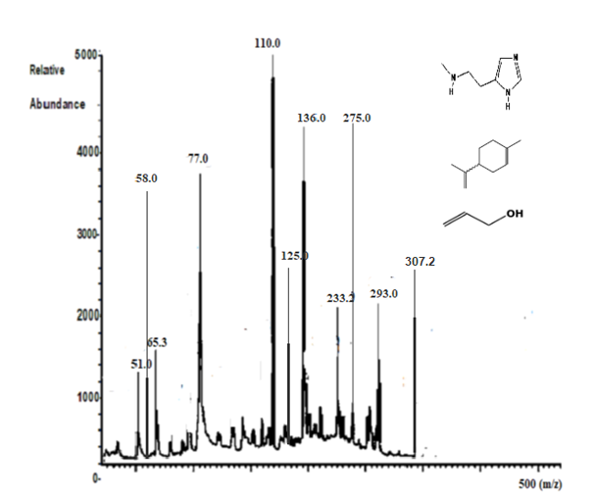
Fig 5- Mass spectrum of a mixture of histamine, p-cymene, and 3-buten-1-ol with key m/z peaks labeled and structures shown for reference
The fragmentation pattern supports the complex's structure. 658.4 m/z, which is consistent with the loss of a CH3 group from the pyrazolone core; 600.4 m/z A loss of 72.8 mass units, a larger fragment loss that might correspond to a part of the phenyl or pyrazole ring system, 302.6 m/z; This fragment is loss of mass of the ligand (308.2 m/z) minus a few mass units , suggesting a fragment corresponding to a single ligand unit with some mass loss, indicating the breakdown of the 1:2 structure into a metal-free ligand fragment.
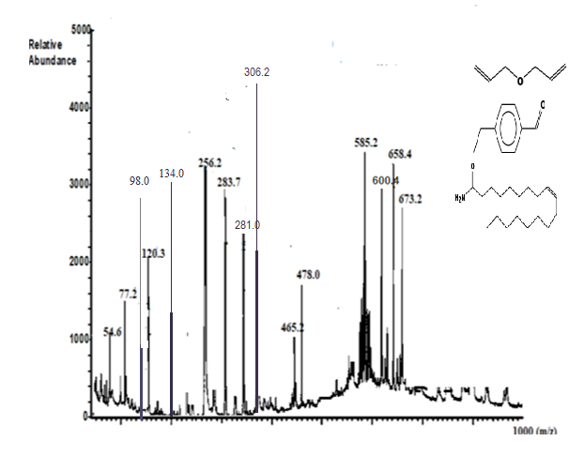

Fig 6: GC-MS spectrum of Co(II) metal complex (CoL) with a few fragment structure
(a) (b)

Fig 7: Proposed Structure of (a) Schiff base Ligand (L) (b) Co(II) complex (CoL)

Table 5: Gas Chromatography-Mass Spectroscopy Analysis of Schiff base Ligand (L)and its Co(II) complex (CoL).

Compounds | Calculated Molecular Mass (g/mol) | Observed Molecular ion  (M⁺) | Observed  Fragment ions | Coordination  Number
P (C₁₀H₁₀N₂O) | 174 | 174.0 | 41, 80, 146 | -
L (C₁₈H₁₈N₄O) | 308 | 308.2 | 58.0, 125.0, 136.0, 232.2, 275.0, 293.0 | -
CoL(C₃₆H₄₀CoN₈O₂) | 674.9 | 673.2 | 658.4, 600.4, 302.6 | 6
P- Precursor (3-Methyl-1-Phenyl -Pyrazol-5-one)
L- 4-[(1E)-N-(2aminophenyl) ethanimidoyl] -3-methyl-1-phenyl-1H-pyrazol-5-ol
CoL- Co (II) Complex 4-[(1E)-N-(2aminophenyl) ethanimidoyl] -3-methyl-1-phenyl-1H-pyrazol-5-ol

3.6 Ultra Violet -Visible Spectra Analysis of Schiff base Ligand (L) and its Co(II) complex (CoL)
Table 6 shows UV-Vis data for Schiff base Ligand and its Cobalt (II) complex. The UV–Vis spectrum of the free Schiff-base ligand (C₁₈H₁₈N₄O, L) shows a strong ligand-centred absorption at 298 nm (Fig 9) with a molar absorptivity of ε = 8.16 × 10⁴ L·mol⁻¹·cm⁻¹, which is assigned to a π → π* transition with an overlapping n → π* contribution. Coordination of L to cobalt to form C₃₆H₄₀CoN₈O₂ (CoL) produces a clear hypsochromic shift of the principal band to 280 nm (Fig 10) accompanied by a substantial decrease in intensity (ε = 3.23 × 10⁴ L·mol⁻¹·cm⁻¹). The blue shift (Δλ = 18 nm) and ~60% decrease in ε indicate that complexation perturbs the ligand π-system by withdrawal of electron density from the conjugated chromophore and a change in ligand planarity on coordination which raises the energy of the π and lowers the stabilisation of the π* level, producing a larger π–π* gap. The reduced molar absorptivity also suggests decreased oscillator strength for the ligand-centred transition, consistent with partial mixing of ligand orbitals with metal orbitals or a change in transition symmetry upon complexation. No strong visible d–d bands are apparent in the reported UV region; therefore any Co(II) d–d transitions are likely weak and outside the recorded range or masked by ligand bands.
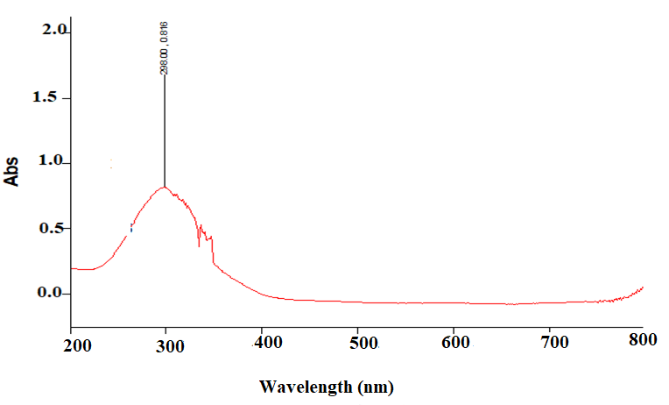
Fig 8: UV-Vis Spectrum of Schiff Base Ligand (L)
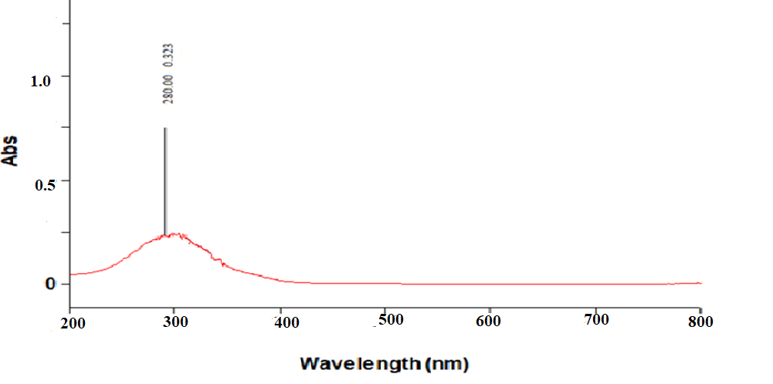
Fig 9: UV-Vis Spectrum of Co(II) Complex (CoL)

Compounds | Maximum wavelength Λ_{max} (nm) | Molar Absorptivity  ε (L mol⁻¹ cm⁻¹) | Electronic transitions
C₁₈H₁₈N₄O (L) | 298 | 8.16 x 10⁴ | π – π*  n - π*
C₃₆H₄₀CoN₈O₂ (CoL) | 280 | 3.23 x 10⁴ | π – π*  n - π*

Table 6: Ultra Violet -Visible Spectral Data Of Schiff Base Ligand (L) And Its Co(II) Complex (CoL)

3.7 H’NMR Spectral Analysis of Schiff base Ligand (L) and its Co(II) complex (CoL)
Table 7 shows H’NMR analysis in DMSO of the Schiff base Ligand, The aromatic protons are observed as three distinct peaks (6.85, 6.68, 6.50 ppm), appearing as a multiplet due to overlapping signals from the phenyl and aminophenyl rings. The integration of 0.8223 reflect the partial overlap of the aromatic region. A singlet at δ 5.10 ppm, integrating to approximately 1.78 protons, is consistent with exchangeable protons (aminophenyl moiety). Its broad nature and shift range further support this assignment.The singlet at δ 1.23 ppm is assigned to a methyl group, likely at position 3 of the pyrazolone ring, consistent with expected alkyl chemical shifts. A singlet at δ 2.50 ppm corresponds to DMSO-d₆, the solvent used.

Table 7- ¹H NMR Spectral Data (in DMSO-d₆) for a Sample Containing Aromatic, Hydroxyl/Amine, and Methyl Protons

Chemical Shift (ppm) | Multiplicity | Integration | Tentative Assignment | Proton Type
6.8491, 6.6809, 6.5013 | Multiplet (appears as three distinct peaks) | 0.8223 | Aromatic protons | Ar-H
5.1035 | Singlet | 1.7828 | -OH or N-H | Hydroxyl or Amine proton
2.5000 | Singlet | Not integrated (solvent peak) | DMSO-d6 | Solvent
1.2318 | Singlet | Appears as a small peak | CH3 | Methyl proton

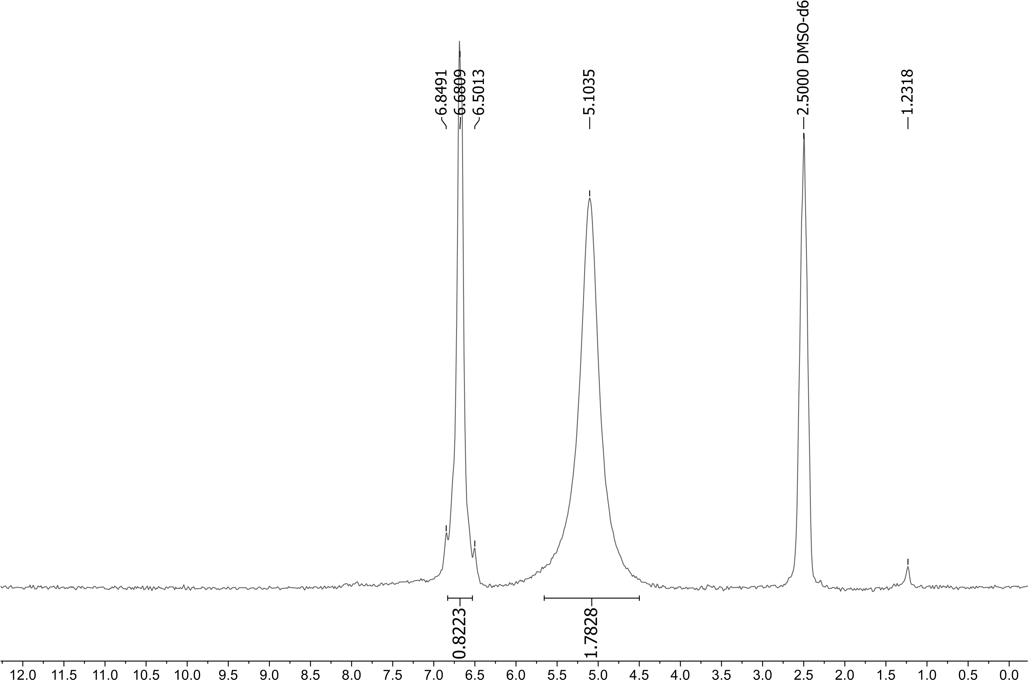

Fig 11: H’NMR Spectrum of Schiff base Ligand (L)

3.8 Antmicrobial Susceptibility Analysis of Schiff base Ligand (L) and its Co(II) complex (CoL)
The antimicrobial activity of the synthesized Schiff base ligand (L) and its cobalt(II) complex (CoL) was evaluated against selected pathogenic microorganisms using the agar well diffusion method, and the results were expressed as the diameter of the inhibition zones (mm). The activity was compared with standard antimicrobial agents—Levofloxacin (LEV) for bacteria and Nystatin (NY) for fungi—according to the Clinical and Laboratory Standards Institute (CLSI, 2020) guidelines.
The Schiff base ligand (L) exhibited moderate inhibition zones against Salmonella typhi (22 mm) and Escherichia coli (14 mm), while the cobalt(II) complex (CoL) showed significantly enhanced activity with inhibition zones of 32 mm and 34 mm, respectively. The enhancement in antimicrobial potency upon metal chelation can be attributed to the increased lipophilicity of the complex, which facilitates better penetration through the microbial cell membrane (Sharma et al., 2019; Singh & Mishra, 2021). The CoL complex demonstrated greater efficacy than the standard Levofloxacin (20 mm for S. typhi), suggesting that cobalt coordination improved the bioactivity of the Schiff base. Staphylococcus aureus and Streptococcus pyogenes, both the ligand and its Co(II) complex displayed notable activity. The ligand (L) recorded inhibition zones of 32 mm and 16 mm, respectively, while the CoL complex showed 30 mm and 30 mm, respectively. The comparable or slightly reduced activity of CoL against S. aureus relative to the ligand may result from steric hindrance around the coordination sphere, which can affect the interaction with bacterial enzymes (Kumar et al., 2018). However, against S. pyogenes, CoL exhibited a remarkable increase in activity (30 mm), exceeding that of Levofloxacin (28 mm), confirming the role of metal ion coordination in enhancing antimicrobial performance (Ali et al., 2020).
The antifungal assay against Candida albicans showed inhibition zones of 20 mm for the free ligand and 42 mm for the Co(II) complex, compared to 28 mm for the standard antifungal Nystatin. This significant enhancement in antifungal activity upon chelation supports earlier findings that metal complexes of Schiff bases exhibit improved biological performance due to the chelation effect, which enhances lipophilicity and cell permeability (Raj et al., 2019; Patel et al., 2021). The superior activity of CoL over Nystatin suggests potential application of this complex as an effective antifungal agent (Fig 12).

Fig 12: Antimicrobial Suceptibility testing of Schiff base ligand (L) and its Co(II) complex (CoL)

According to CLSI susceptibility standards (CLSI, 2020), all inhibition zones above 16 mm indicate strong antimicrobial activity. Therefore, both the Schiff base ligand and its Co(II) complex fall within the susceptible range for most tested microorganisms. However, the cobalt complex (CoL) exhibited overall superior activity compared to the free ligand (L), reinforcing the concept that complexation with transition metals enhances antimicrobial properties (Saini et al., 2020)
The MIC (minimum inhibitory concentration) which is the minimum concentration of the Schiff base (L) and metal complex CoL inhibits growth of the microbe, whilst the MBC/MFC ( Minimum Bactericidal/ fungicidal Concentration) the concentration at which L and CoL kills the microbes. Results show a clear trend: Co(II) complexation substantially improved both the inhibitory (Fig 13) and bactericidal/fungicidal properties (Fig 14) of the Schiff base ligand. This is consistent with the chelation theory proposed by Tweedy (1964), which suggests that metal-ligand coordination increases lipophilicity, enhances cell membrane permeability, and interferes more effectively with microbial enzymatic systems (Kumar et al., 2018; Raj et al., 2019).

Fig 13: Minimum Inhibitory Concentration and : Minimum Bactericidal/Fungicidal Concentration for L and CoL
Therefore, the Co(II) complex demonstrates broad-spectrum and potent antimicrobial effects, likely due to synergistic interactions between the cobalt ion and the electron-donating atoms (N and O) of the Schiff base framework. These interactions enhance the complex’s ability to chelate vital microbial enzymes or bind to DNA, ultimately leading to microbial cell death (Sharma et al., 2019; Singh & Mishra, 2021).

4.CONCLUSION
The successful synthesis and comprehensive characterization of a novel Schiff base ligand derived from 4-acyl pyrazolone and its Co(II) complex have been achieved using a combination of spectroscopic and analytical techniques. Infrared, UV–Vis, ^1H NMR, and GC–MS analyses confirmed the formation of the azomethine linkage and coordination through the nitrogen and oxygen donor sites of the ligand. Elemental and conductivity data further validated the proposed stoichiometry and non-electrolytic nature of the Co(II) complex.The significant spectral shifts, increase in thermal stability, and formation of new M–O and M–N bands collectively confirm the establishment of strong metal–ligand coordination. The enhanced antimicrobial activity of the Co(II) complex relative to the free ligand against both Gram-positive and Gram-negative bacteria, as well as the fungus Candida albicans, highlights the influence of metal chelation on biological efficacy. This improvement aligns with Tweedy’s Chelation Theory, which attributes increased lipophilicity and cellular permeability to complex formation. Overall, the results demonstrate that coordination of the Schiff base ligand with Co(II) enhances both the physicochemical and biological properties of the compound. The Co(II) complex exhibits broad-spectrum antimicrobial potential and may serve as a promising scaffold for the design of new metal-based antimicrobial agents. Further studies involving molecular docking, toxicity profiling, and extended biological assays are recommended to elucidate its mechanism of action and potential pharmaceutical applications.

DISCLAIMER (ARTIFICIAL INTELLIGENCE)
Arthors hereby declare that NO generative AI technologies such as Large Language Models (ChatGPT, COPILOT, etc.) and text-to-image generators have been used during writing or editing of this manuscript.

COMPETING INTERESTS
Authors have declared that no competing interests exist.

REFERENCES

Alaghaz, A. M. A., Ammar, R. A. A., & El-Ghamry, H. A. (2013). Synthesis, characterization, and biological studies of Schiff base metal complexes derived from pyrazolone derivatives. Journal of Molecular Structure, 1049, 326–336. https://doi.org/10.1016/j.molstruc.2013.06.019

Ali, M., Khan, M. S., & Ahmed, A. (2020). Synthesis, characterization and biological evaluation of metal complexes derived from Schiff bases. Journal of Coordination Chemistry, 73(5), 651–662. https://doi.org/10.1080/00958972.2020.1719443

Clinical and Laboratory Standards Institute (CLSI). (2020). Performance standards for antimicrobial susceptibility testing (30th ed.). CLSI document M100.

Fabio, G., Cacciatore, I., Di Stefano, A., Guzmán, J. D., Uriarte, E., & Yáñez, J. (2019). Synthesis and antiproliferative activity of novel pyrazolone-based compounds. Molecules, 24(3), 581. https://doi.org/10.3390/molecules24030581

Furniss, B. S., Hannaford, A. J., Smith, P. W. G., & Tatchell, A. R. (1989). Vogel’s textbook of practical organic chemistry (5th ed., p. 1150).

Gupta, K. C., Sutar, A. K., & Lin, C.-C. (2017). Functionalized Schiff-base transition metal complexes: Their applications in catalysis, sensors, and biological fields. Coordination Chemistry Reviews, 333, 1–26. https://doi.org/10.1016/j.ccr.2016.11.002

Housecroft, C. E., & Sharpe, A. G. (2012). Inorganic chemistry (4th ed.). Pearson.

Hung, W., & Lin, C. (2009). Preparation, characterization, and catalytic studies of magnesium complexes supported by NNO-tridentate Schiff-base ligands. Inorganic Chemistry, 48(2), 728–734.

Jensen, B. S. (1959). The synthesis of 1-phenyl-3-methyl-4-acyl pyrazol-5-ones. Acta Chemica Scandinavica, 13(8), 1668–1670.

Kumar, R., Singh, P., & Verma, A. (2018). Antimicrobial activity of transition metal complexes with Schiff base ligands. Journal of Molecular Structure, 1165, 293–302. https://doi.org/10.1016/j.molstruc.2018.03.037

Kumar, S., Singh, D. P., & Arora, S. (2019). Synthesis, characterization and biological studies of Schiff bases and their transition metal complexes: A review. Journal of Molecular Structure, 1193, 89–118.

Lever, A. B. P. (1984). Inorganic electronic spectroscopy (2nd ed.). Elsevier.

Marchetti, F., Pettinari, C., Di Nicola, C., Tombesi, A., & Pettinari, R. (2019). Coordination chemistry of pyrazolone-based ligands and applications of their metal complexes. Coordination Chemistry Reviews, 401, 213069.

Nakamoto, K. (2009). Infrared and Raman spectra of inorganic and coordination compounds: Part B—Applications in coordination, organometallic, and bioinorganic chemistry (6th ed.). John Wiley & Sons.

National Center for Biotechnology Information (NCBI). (2024). PubChem Compound Summary for CID 24749, 3-methyl-1-phenyl-pyrazol-5-one. https://pubchem.ncbi.nlm.nih.gov/compound/24749

Ogbuagu, E. O., Ogwuegbu, M. O. C., Onyedika, O. G., Akanazu, G. O., & Isemede, A. (2021). Synthesis and characterization of zinc (II) complex of 1,10-phenanthroline. SCVJ, 2(2), 148–152.

Parmar, N., Teraiya, S., Patel, R., Barad, H., Jajda, H., & Thakkar, V. (2015). Synthesis, antimicrobial and antioxidant activities of some 5-pyrazolone based Schiff bases. Journal of Saudi Chemical Society, 19, 36–41.

Patel, D. R., Joshi, K. N., & Rathod, S. B. (2021). Antifungal and antibacterial studies of Co(II), Ni(II), and Cu(II) complexes derived from Schiff base ligands. Spectrochimica Acta Part A: Molecular and Biomolecular Spectroscopy, 245, 118929. https://doi.org/10.1016/j.saa.2020.118929

Pavia, D. L., Lampman, G. M., Kriz, G. S., & Vyvyan, J. R. (2015). Introduction to spectroscopy (5th ed.). Cengage Learning.

Pettinari, R., Marchetti, F., Di Nicola, C., et al. (2018). Ligand design for N,O- or N,N-pyrazolone-based hydrazones ruthenium(II)-arene complexes and investigation of their anticancer activity. Inorganic Chemistry, 57, 14123–14133.

Poonam, G., Jitendra, K., & Halve, A. K. (2015). Synthesis and biological significance of pyrazolone: A review. International Journal of Pharmaceutical Sciences and Research, 6(6), 2291–2310.

Przybylski, P., Huczyński, A., Pyta, K., Brzeziński, B., & Bartl, F. (2009). Biological properties of Schiff bases and azo derivatives of phenols. Current Organic Chemistry, 13(2), 124–148.

Rainsford, K. D. (2001). Anti-inflammatory drugs in the 21st century. Subcellular Biochemistry, 35, 3–60.

Raj, T., Chauhan, H., & Gupta, P. (2019). Structural and biological aspects of Schiff base metal complexes: A review. Applied Organometallic Chemistry, 33(6), e4881. https://doi.org/10.1002/aoc.4881

Saini, M., Yadav, N., & Singh, K. (2020). Comparative antimicrobial studies of Schiff base ligands and their Co(II), Ni(II), and Cu(II) complexes. Journal of Inorganic Biochemistry, 208, 111092. https://doi.org/10.1016/j.jinorgbio.2020.111092

Sharma, P., Kumar, S., & Singh, B. (2019). Synthesis, spectral characterization, and antimicrobial activity of transition metal complexes with Schiff base ligands derived from 4-acylpyrazolone. Inorganica Chimica Acta, 496, 119037. https://doi.org/10.1016/j.ica.2019.119037

Silverstein, R. M., Webster, F. X., Kiemle, D. J., & Bryce, D. L. (2014). Spectrometric identification of organic compounds (8th ed.). John Wiley & Sons.

Singh, R., & Mishra, A. (2021). Antimicrobial potential of Schiff base metal complexes: A comprehensive review. Bioinorganic Chemistry and Applications, 2021, 6675984. https://doi.org/10.1155/2021/6675984

Socrates, G. (2010). Infrared and Raman characteristic group frequencies: Tables and charts (3rd ed.). John Wiley & Sons.

Tweedy, B. G. (1964). Plant extracts with metal ions as potential antimicrobial agents. Phytopathology, 55, 910–914.

World Health Organization. (2020). Antimicrobial resistance. https://www.who.int/news-room/fact-sheets/detail/antimicrobial-resistance

