Green nanotechnology for water purification: copper-oxide nanoparticles bio-assisted with neem leaves

ABSTRACT
The presence of heavy metals in wastewater is a major environmental concern due to their toxicity, persistence and bio-accumulative nature. Industrial and agricultural effluents often discharge significant levels of these contaminants, prosing risk to ecosystems and public health. In this study copper oxide nanoparticles synthesized using neem extract (CuONpNm) were explored as a green and cost -effective adsorbent for the purification of contaminated water. Batch adsorption experiment were conducted to assess the influence of pH, initial metal ion concentration and contact time on the removal efficiency of Zn²⁺ ,Cu²⁺,Ni²⁺ and Cd2+ ion. The structural and morphological features of the nanoparticles were characterized using Scanning Electron Microscopy (SEM). Transmission Electron Microscopy (TEM), and X-ray Diffraction (XRD). Assumption Isotherm were analyzed with Langmuir and Freundlich model while kinetics data were fitted to pseudo -first order and pseudo-second order equations. The neem-based CuO nanoparticles achieved maximum adsorption efficiencies of 93.715% for Zn²⁺,90.93% for Cu²⁺,89.92% for Ni²⁺ and 83.91% for Cd²⁺ at pH of 6. CuONpNm showed strong binding power, reaching up to 200mg/l adsorption. The process followed the Freundlich isotherm (R²> 0.994). and pseudo-second-order kinetics (R²> 0.961), providing its efficiency in metal ion removal. These finding highlighted the potential of neem-assisted copper oxide nanoparticles as an efficient, antimicrobial, eco-friendly material for water purification and heavy metal remediation.
Key words: Nanoparticles, Adsorption, Heavy metals, Neem Extract, Adsorption kinetics, Adsorption isotherms.

Introduction

Background of Study

Wastewater pollution by heavy metals is a serious global concern because these elements are toxic, persistent and easily enter the food chain. They originate from natural processes like soil erosion and rock weathering but human activities such as mining, industrial effluents, sewage discharge and agricultural chemicals-remain the dominant sources. Once released, metals such as cadmium, copper, lead, zinc and nickel accumulate in soil, water and crops, creating long-term risks to both ecosystems and human health.

Traditional treatment methods, although effective are costly and often create secondary waste. As a result, researchers are Turing to sustainable alternatives because of their large surface area and high reactivity, which make them effective adsorption for metal ions. Green synthesis using plant extracts has emerged as a low-cost and eco-friendly approach, where phytochemicals serve as natural reducing and stabilizing agents.

This study explores focuses on the green synthesis of copper oxide nanoparticles (CuONps) produced with neem (Azadirachta indica) leaves. The plant is widely available, low-cost and environmentally friendly. The research investigates the ability of the synthesized nanoparticles to remove zinc, copper, cadmium and nickel ions from wastewater, thereby evaluating the potential as efficient and sustainable adsorbent for heavy metal remediation.

3.0 MATERIAL AND METHODS
3.1 Materials
Copper sulphate pentahydrate (Cu(SO₄.5H₂O) (≥99%), Nickel sulphate hexahydrate (NiSO₄.6H₂O) (≥98%),Cadmium chloride pentahydrate (CdCl₂.5H₂O) (≥98%), Zinc nitrate hexahydrate (Zn(NO₃)₂.6H₂O) ) (≥98%)
Copper (ll) nitrate trihydrate (Cu(NO₃)₂.3H₂O) (≥98% Sodium hydroxide (NaOH) (≥98%), Nitric acid (HNO₃​) (≥98%) and neem leaves were used as precursors. All solution was prepared with distilled water.

Supplier:
All chemicals for the batch adsorption work were supplied by Finlab Chemical Limited, Owerri.

3.2 Preparation of neem leaves extract
Materials: Neem (Azadirachta indica) leaves was bought from botanical markets in Aba.
Cleaning: 30g of the leaves were washed with tap water to remove dust and impurities, followed by a final rinse with distilled water.
Drying and Grinding: The leaves were dried in an oven at 90°C for 2-3 hours until they turned pale yellow. They were then ground into a fine powder using a ball mill. The powder was sieved to a particle size of 10–20 micrometers, 25g of ground neem leaves was weighed into a 250ml baker. 200ml of distilled water were added to it and stirred to form a paste, then placed on hot plate to boiled at 80°C for 30 minutes, cooled to room temperature and filtered with Whatman No.1 filter paper. The filtrate was stored at 4^{O}C in a dry air tight plastic and used within 24 hrs. as the reducing and stabilizing agent.⁶

3.3 Biosynthesis of the Copper-Oxide Nanoparticles used for the Adsorption
Method Used: Aqueous solution thermal decomposition was used to prepare the copper oxide nanoparticles modified with neem leaves.

Step 1: Preparing the Copper Sulphate Solution
A 0.08 M aqueous solution of copper sulfate (CuSO₄) was prepared by mixing 20 g of copper sulphate pentahydrate (Cu(SO₄.5H₂O) ) with 100 mL of distilled water. This solution was transferred to a 250 mL Erlenmeyer flask and mixed with an additional 200 mL of distilled water then transfer to 500 ml flask to create a homogeneous liquid. The flask was then placed on a hot plate and heated to 50°C.

Step 2: Adding the Leaf Extract
25 mL of the neem leaves extract was added dropwise to the boiling copper sulphate solution in a 1:1 (v/v) ratio using a pipette with tip under continuous stirring and shaking.

Step 3: Precipitating Copper Hydroxide
8 g of sodium hydroxide (NaOH) was weighed and dissolved in 100 mL of distilled water to form a clear solution.
This NaOH solution was gradually added to the boiling mixture while stirring. This process created a deep blue-green precipitate of copper hydroxide.

Step 4: Thermal Decomposition
The mixture was heated and stirred for 15 minutes at a temperature of 90°C. The copper hydroxide precipitate then decomposed to form dark brown copper oxide nanoparticles.

Step 5: Purification and Drying of Nanoparticles
The synthesized copper oxide (CuO) nanoparticles were separated by centrifugation at 6000 rpm for 20 minutes. They were then filtered using Whatman filter paper. The nanoparticles were washed twice with ethanol to remove any unbound phytochemicals and residual ions or soluble impurities. Then washed 3-4 times with distilled water. Finally, the washed copper oxide nanoparticles were transferred into a clean porcelain crucible and dried in a hot-air oven for 10 hours at 100°C to remove residual moisture and obtain a dry powder, which was ground into a fine powder and stored in a dry container for later use (Crilaine,2018; Eid,2023; Kellary,2003; Khairy,2004; Mail,2005; Wang,2007).

3.4 Calcination
To eliminate the oily organic residual and ensure phase purity, the dried nanoparticles were calcinated in a muffle furnace. The temperature was gradually raised from 5O C/min to 450 OC and maintained for 2 hours in air. After calcination the nanoparticle appeared black, confirming the formation of copper oxide (CuO) nanoparticles.

Figure 1 Equation for the reaction:
Cu²⁺ _{(aq)} + SO₄²_{-(aq)} + 5H₂O_{(l)} CuSO_{4.}5H₂O_{(aq} 1
${CuSO}_{4}{{ .5H}_{2}O}_{(aq)}$ + 2NaOH_{(s)} [Cu (H₂O)₅]²⁺ $+ {Na}_{2}{SO}_{4(aq)}$ + 2OH⁻ 2
[Cu (H₂O)₅]²⁺⁽_{aq)} + 2OH⁻$+ { Heat Cu\left(OH\right)}_{2(aq)}$+ 5H₂O_{(l)} 3
${ Cu\left(OH\right)}_{2(aq)}{ + Heat CuO}_{(S)}$+${{ H}_{2}O}_{(g)}$ 4

3.5 Microscopy and Characterization of Structure
The synthesized nanoparticles were characterized to confirm their formation and properties:
- SEM (Scanning Electron Microscope): for morphology
- XRD (X-Ray diffraction) for crystalline structure
- TEM (Transmission Electron Microscopy) for particle size and shape

3.6. Batch Adsorption Experiments
Batch adsorption tests were carried out to study the removal of Zn^{2+,} Cu²⁺, Ni²⁺ and Cd²⁺ ions.
- Stock Solution: 1000 mg/g solutions of each metal ion were prepared and diluted as required.
- Effect of pH: Experiments were conducted at pH 2-10 using o.1 M NaOH or HNO₃ for adjustment.
- Effect of Contact Time: Solution were shaken at intervals ranging from 10- 120 minutes.
- Effect of Initial Concentration: Metal on concentration ranged from 200 mg/L - 1000 mg/L
- Procedure: 50 mL of metal ion solution was mixed with a fixed dosage of 0.1 g of CuONpNm and shaken at 150 rpm at room temperature. After adsorption, solutions were filtered and residual concentrations were measured using Atomic Adsorption Spectroscopy (AAS).

3.7 Data Analysis
- Adsorption capacity(q_{e}) and removal efficiency (%) were calculated.
- Adsorption isotherms were fitted using the Langmuir and Freundlich models
- Kinetics were analyzed using pseudo-first-order and pseudo-second-order equations.

RESULT AND DISCUSSION
4.1 Scanning Electron Microscope (SEM) Analysis
The surfaces morphology of the CuONpNm sample was analyzes using SEM (PHENOM PreoX) at a magnification at 2000×. The micrographs (plate) reveal a well-developed porous structure, with pore predominantly in the micrometer (µm) range, forming a microporous network. The figures below show the surface morphology of the CuO nanoparticles of CuONpNm, the adsorbents exhibit a heterogeneous surface and a variety of randomly distributed pore size, the surface appears to have well-defined grains, some polygonal structures and a mixture of smooth and rough regions. The bright and dark contrasts represent differences in particle size, shape and density. The image suggests a relatively heterogenous distribution of nanoparticles with possible agglomeration in some regions. Present of well-defined cavities are responsible for the increase in the surface area, adsorption capacities and efficiencies in CuONpNm. A mixture of smooth and rough regions is evident, while the bright and dark contrast correspond to variations in particle size, shape and density. The generation and formation of these pores and cavities is the result of the evolving volatiles from CuONpNm (Crislaine,2018; Kellang,2003). These porous structures are also due to the chemical reaction between NaOH, CuSO₄ and the leaves extract in formation of these adsorbents which further results in the augmentation of pores. The possible reason of the highly porous structure of CuONpNm is because of the efficient and proportionate mixing between CuSO₄ acid and Neem extract. Cavity development is much more prominent in CuONpNm due to the fact that NaOH penetrated to the inside of the surface and introduce hydroxyl ion which displace the sulphate ion in the copper sulphate of CuONpNm more due to the slight porous surface of Neem extract which resulted in the development of the cavities on the surface of CuONpNm. These observations indicate a relatively heterogenous distribution of CuO nanoparticles (Alaa,2021).

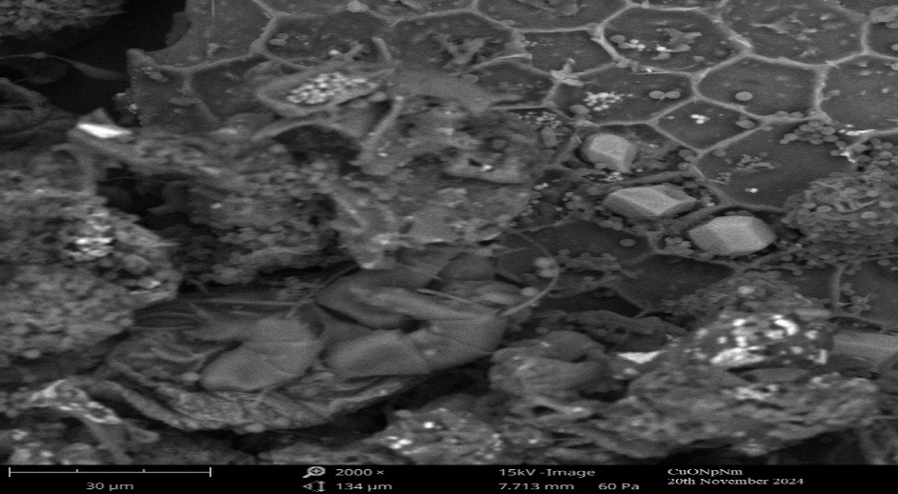
Figure 2: SEM image of CuONpNm at 2000x

4.2 X-Ray Diffraction (XRD) Spectroscopy Analysis
X-ray diffraction (XRD) was employed to investigate the crystalline structure of the synthesized CuO nanoparticles (CuONpNm). The analysis was performed using a Rigaku Miiniflex 600 diffractometer with Cu Ka radiation (λ=Ǎ).
The XRD patterns (figure 2) revealed sharp and intense diffraction peaks, confirming the crystalline nature of the nanoparticles. The characteristic diffraction peaks of CuONpNm were observed at 2θ values of${ 32.32}^{0}{35.63}^{0} , 38.{74}^{0}, 48.83^{0}, 61.85^{0}, 66.{60}^{0}$ which correspond to the plane crystal of (110), (111), (111), (202), (113), and (113) planes of monoclinic tenorite (CuO). The diffraction patterns are consistent with the standard JCPDS files (Nos. 00-005-0661,01-071-4823 and 00-001-1117) confirming the successful synthesis of CuO nanoparticles.
The average crystallite size was estimated using the Debye- Scherrer equation.
$D=\frac{Kλ}{ BCos θ}$ 5
Where D is the crystallite size (nm), K is the Scherer constant (0.94), λ is the X-ray wavelength,Ꞵ is the full width at half maximum (FWHM) in radians and θ is the Bragg angle. The average crystallite sizes of CuONpNm was calculated to be 61.08 nm. The microstrian was determined using:
$€=\frac{β}{4tanθ} 6$
Yielding values of $1.651{×10}^{-3}$
The lattice constants were further calculated as 4.531Ǎ for CuONpNm which is in good agreement with standard JCPDS data.
In addition to CuO , minor diffraction peaks corresponding to secondary phases such as hydroxyapatite [Ca₁₀(PO₄)₆(OH)₂], lamite [Ca₂Si₂O₁₀] and quartz (SiO₂) were also detected, likel arising from precursor residues. Nonetheless, the dominant peaks correspond to monoclinic CuO indicating that the nanoparticles possess a polycrystalline structure with high crystallinity. These findings agree with previous report on CuO nanostructures (Joudeh,2022; Manisha,2023).
Table 1 Calculated values of crystallite size, Macrostrain and Lattice Constant

CuONpNm
Paeameter Orientation D(hkl) Macrostrain (E) Lattice Contact (A)

Ctrystal (110) (111) (111) (202) (113) (311)
Plane -0.000851 4.531

2θ (^{O}) 35.63 35.65 38.74 48.83 61.85 66.60

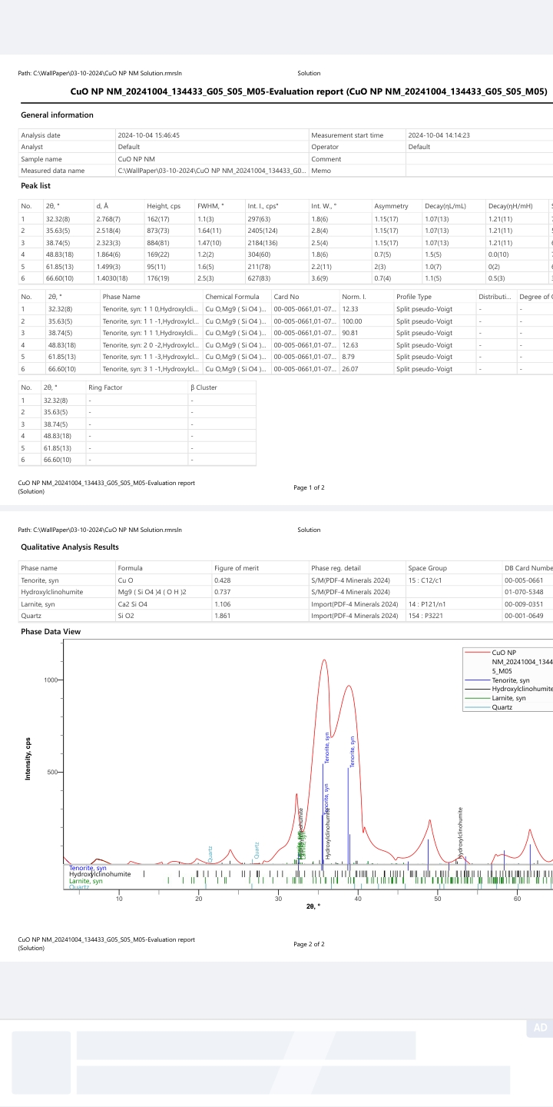
Figure 3 Closed view of XRD of CuONpNm at close view

4.3 Transmission Electron Microscopy (TEM) Analysis
The morphology and particle size of CuONpNm were examined using TEM at a scale of 100 nm (plate 1.2). The micrograph reveals that the nanoparticles are generally spherical to quasi-spherical in shape, with a relatively uniform distribution across the image. The particle sizes, as indicated in the image, range from approximately 1.47 nm to 5. 83 nm and the average grain sizes were estimated as 3.53 nm. suggesting the successful synthesis of nanosized CuO particles.
The TEM image also shows slight particle agglomeration, which is a common feature in metal oxide nanoparticles due to their high surface energy and strong van der waals interactions. Despite this the particles retain their nanoscale dimensions, consistent with the crystallite size values obtained from XRD analysis.
The presence of diffraction rings in selected area electron diffraction pattern (SAED) support the existence of a single crystallite polymer of CuO nanoparticles. All the grains of CuONpNm was separated from each other in the same highly ordered arranged polymer chain in a three-dimensional lattice plane of a monoclinic grain boundaries of normal CuO structural phases in a specific orientation. This confirms that the synthesized CuONpNm sample consists of well-dispersed, ultrafine nanoparticles with high surface area, which is advantageous for its unique applications such as catalysis, adsorption and antimicrobial activity (Eid,2023; Jacob,2021; Manisha,2023).

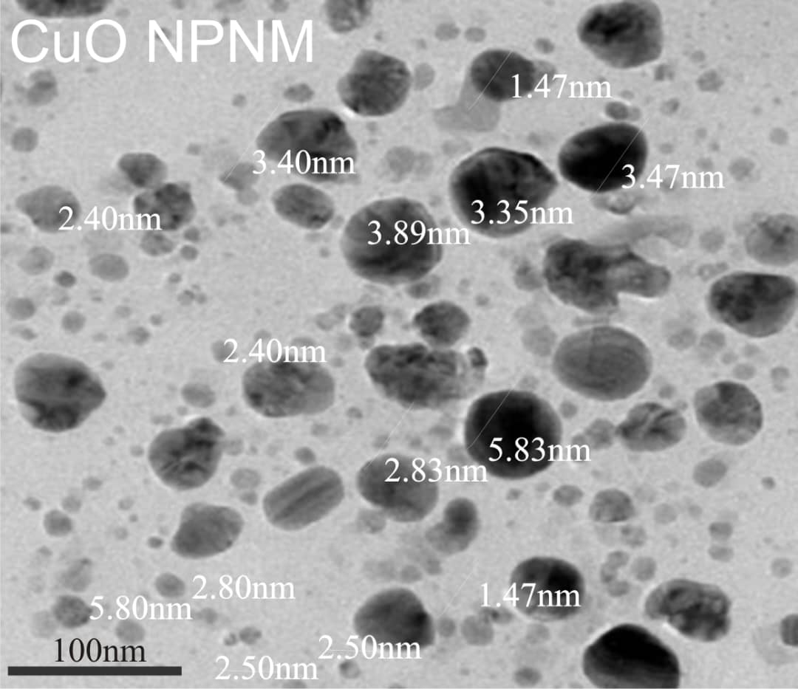
Figure 4. TEM of CuONpNm at 100nm magnification

4.4 Effect of pH on metal ion Removal using CuONpNm
The influence of the initial solution pH on the removal efficiency of Zn²⁺,Cu²⁺,Ni²⁺ and Cd²⁺ by CuONpNm was investigated within the pH rang of 2-10 (figure 4). The results reveal that metal ion removal strongly depends on the pH of the medium. At low pH values (2-4) the percentage removal was relatively low (below 40%), which can be attributed to the high concentration of H+ ion competing with the metal cations for adsorption sites on the CuONpNm surface.

As the pH increased, the removal efficiency of all tested ion significantly improved, reaching maximum values between 6 and 8. This can be explained by the increased availability of negative charge adsorption sites which enhance electrostatic attraction and surface complexation with metal ions.

Maximum adsorption was obtained at pH 6 and beyond pH 8, no substantial increase in removal efficiency was obtained, suggesting a near- saturation of available active sites. Moreover, excessively high pH value may induce metal hydroxide proportion, which complicates the adsorption mechanism and does not reflect true adsorption uptake.

Among the studded metals, Zn²⁺ and Cu²⁺ showed slightly higher removal efficiencies compared to Ni²⁺ and Cd²⁺, indicating a possible preference of CuONpNm towards ion with smaller hydrated radii and higher electronegativity.

Overall, the results confirm that CuONpNm is an effective adsorbent for multimedia ion removal under neutral pH conditions which is favorable for practical wastewater treatment applications (Alaa,2021; Ruth,2014).

Figure 5 Effect of pH on percentage removal of CuONpNm

4.5 Effect of Initial Metal Ion Concentration on Removal Efficiency
The influence of initial metal on concentration on the adsorption performance of CuONpNm was examined in range 200 mg/L-1000 mg/L (figure 6). The result indicated that percentage removal of Zn²⁺,Cu²⁺ ,Ni²⁺ and Cd²⁺ion decreased progressively with increasing metal ion concentration. At lower concentration (200-400 mg/L), the removal efficiency was relatively high (˃85%) which can be attributed to the abundance of active adsorption sites available on the CuONpNm surface relative to the metal ion present.
As the initial concentration increased beyond 600 mg/L, a gradual decline in removal efficiency was observed. The trend is likely due to the saturation of active sites on the adsorbent surface, where the limited number of binding sites becomes insufficient to accommodate the large number of metal ion in solution. Nevertheless, the absolute quantity of adsorbed ion increased with concentration despite the reduced percentage removal.
Among the tested ions Zn²⁺ and Cu²⁺ consistently exhibited slightly higher removal efficiencies compared to Ni²⁺ and Cd²⁺ion, suggesting a preferential affinity of CuONpNm towards these ions. This may be linked to their ionic radii, hydration energies and stronger interaction with surface functional groups. Overall, the finding confirm that CuONpNm is effective as removing heavy metal at relatively high concentration, although efficiency is maximized under lower initial ion concentrations (Alaa,2021: Ruth,2014).

Figure 6 Effect of Initial Concentration on percentage removal of CuONpNm

4.6 Effect of Initial Metal Ion Concentration on Adsorption Capacity
The adsorption capacity of CuONpNm for Zn²⁺,Cu²⁺ ,Ni²⁺ and Cd²⁺ion was evaluated as a function of initial ion concentration in the range of 200 mg/L – 1000 mg/L (figure 7). The result showed a steady increase in adsorption capacity with increasing metal ion concentration for all tested ions. At lower concentration (200-400 mg/L) the adsorption capacity was relatively low, reflecting the limited no number of ions available in solution relative to the abundance of vacant adsorption sites in solution relative to the abundance of vacant adsorption sites in solution relative to the abundance of vacant adsorption sites in the CuONpNm surface.
As the concentration increased, adsorption capacity rises sharply reaching value above 150 mg/L at the highest concentration tested (1000 mg/L). This behavior can be attributed to the higher driving force for mass transfer at elevated concentration which enhance the interaction between metal ions and active binding sites.
The adsorption capacity trend for the studied ions followed a similar pattern, with only minor variations between Zn²⁺,Cu²⁺ ,Ni²⁺ and Cd²⁺ion. The closeness of these values suggests that CuONpNm has a broad and non- selected affinity for divalent metal ions likely due to its higher surface area and the availability of multiple functional groups that facilitate ion binding.
Overall, the increase in adsorption capacity with concentration dominant the efficiency of CuONpNm as a versatile adsorbent capacity of handing high metal loadings in aqueous systems (Alaa,2021).
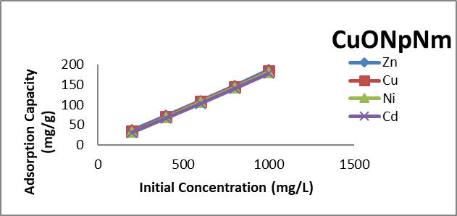
Figure 7 Effect of initial metal ion concentration on the adsorption capacity

4.7 Effect of Contact Time
The effect of contact time on the removal efficiency of Zn²⁺ ,Cu²⁺ ,Ni²⁺ and Cd²⁺ions by CuONpNm is presented in (figure 8). The removal percent increased rapidly during the initial 30-50 minutes indicating the availability of abundant active adsorption sites on the CuONpNm surface. Beyond 60 minutes, the rate of adsorption slowed down and gradually approach equilibrium with maximum removal efficiency achieved at round 120-150 minutes.
This biphasic trend characterized by a rapid initial uptake followed by a slower phase- can be attributed to the progressive saturation of available adsorption sites. During the early stages, ion-adsorbed interactions are favored by the high concentration gradient and large number of vacant sites. As the sites become occupied competition among ion increases and diffusion into deeper pores of the adsorbent governs the process, thereby reducing the adsorption rate.
At equilibrium, the removal efficiencies for all form ions covered, with Zn²⁺,Cu²⁺ showing slightly higher uptake compared to Ni²⁺ and Cd²⁺ion. This suggests that while CuONpNm demonstrates broad spectrum affinity for divalent ions, minor differences in ions radius and hydration energy may influence the extent of adsorption.
The equilibrium time of 120 may indicates that CuONpNm is an effective adsorbent with relatively fast kinetics, making it suitable for practical wastewater treatment application where rapid contaminate removal is desirable (Alaa,2021).

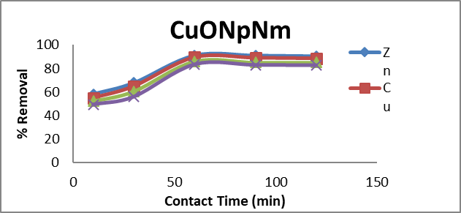
Figure 8 Effect of Contact Time on percentage removal of CuONpNm Initial metal
ion concentration 200 mg/L, 0.1 g adsorbent dose, 180 min contact time and 30 ºC.

4.8 Adsorption Equilibrium Studies
4.8.1 Langmuir Isotherm
The equilibrium adsorption data for Zn²⁺,Cu²⁺ ,Ni²⁺ and Cd²⁺ion on CuONpNm were analyzed using the Langmuir isotherm model, as presented in figure 9. The Langmuir plot of ce/qe verse Ce yielding linear relationship for all metal ions indicating that adsorption followed a monolayer coverage on a homogenous surface. The strong linearity of the plots suggests the applicability of the Langmuir model with correction coefficient (R²) approaching unity.

The calculated Langmuir constant (Q_{max} and K_{L}) confirmed the high adsorption capacity of CuONpNm for the studied ions. Among the metal Zn²⁺ and Cu²⁺ showed slightly higher adsorption capacities compared to Ni²⁺ and Cd²⁺ion reflecting their strong affinity toward the CuONpNm surface. The monolayer adsorption capacities were consistent with the nanoscale structure and high surface area of the synthesized adsorbent as evidenced by TEM and XRD results.

Adherence to the Langmuir model implies that adsorption occurs at specific homogenous sites on the CuONpNm surface without interaction between adsorbed ions This observation supports the assumption that active sites are uniformly distributed and that once a site is occupied, no further adsorption occurs at that surface
The results further highlight the suitability of CuONpNm for single layer adsorption processes in wastewater treatment application, offering predictable and efficient removal of heavy metal concentration (Alaa,202; Ruth,2014).

Figure 9 Langmuir plot CuON_{p}N_{m}

4.8.2 Freundlich Isotherm
The adsorption data were further analyzed using the Freundlich isotherm model to evaluate the heterogeneity of adsorption sites and the multilayer adsorption tendency of CuONpNm. Freundlich plot of Log qe verse Log Ce is shown in figure 10 and the linearity of the plots confirms the applicability of this model to the experimental data.
Freundlich constant (K_{f} and n) derived from the slope and intercept provide insight into the adsorption intensity and surface heterogeneity of the adsorbent. The value of n was greater than one for all the studied ions. Indicating favorable adsorption and suggesting that CuONpNm possess a heterogenous surface with sites of varying affinities. Higher K_{f} value for Zn²⁺ and Cu²⁺ compared to Ni²⁺ and Cd²⁺ion confirm that stronger interaction with adsorbents, consistent with the Langmuir result.
The Freundlich model applicability implies that in addition to monolayer adsorption, multilayer adsorption processes may also contribute to the overall uptake, especially at high concentrations. This, observation is reasonable given the nanoscale structure and porous morphology of CuONpNm, which provides diverse binding sites for heavy metal ions.
Thus the combined evaluations of Langmuir and Freundlich model reveals that adsorption Zn²⁺,Cu²⁺ ,Ni²⁺ and Cd²⁺ion onto CuONpNm occurs via a complex mechanism involving both monolayer adsorption on uniform sites and multilayer adsorption on heterogenous surfaces (Alaa,2021; Joudeh,2022; Ruth,2014).
Figure 10 Freundlich Plot of CuON_{p}N_{m}

Table 2 Langmuir and Freundlich isotherm constants for CuONpNm adsorption on different adsorbate

Parameter CuONpNm
Langmuir Isotherm Result Freundlich Isotherm Result
Zn²⁺ Cu²⁺ NI²⁺ Cd²⁺ Zn²⁺ Cu²⁺ NI²⁺ Cd²⁺

q_{L} 200.1 206.7 211.3 225.3 K_{F} 8.09 20.94 33.19 39.35

K_{L} 0.0030 0.00136 0.00311 0.00482 N 3.00 3.53 3.97 5.40

R² 0.903 0.984 0.964 0.940 R² 0.998 0.989 0.977 0.959

4.8.3 Adsorption Kinetics (Pseudo-First-Order Kinetic Model)
The kinetics data for the adsorption of Zn²⁺,Cu²⁺ ,Ni²⁺ and Cd²⁺ion on CuONpNm were first analyzed using the pseudo-first-order kinetics model as illustrated in figure 11. The model assumed that the rate of occupation of adsorption sites as proportional to the number of unoccupied sites and the linearized form of the model was applied by plotting Log (qe-qt) against time.

Although the plot produced an approximately straight lines the calculated equilibrium adsorption capacity (q_{e} cal) obtained from the pseudo -first-order model showed a poor agreement with the experimental value (qe exp). Additionally, the regression coefficient (R²) were significantly lower compare to those of the pseudo pseudo-second-order model (figure 12). The discrepancy indicates that the pseudo-first-order model does not adequately describe the adsorption process.

The weak fit of the pseudo-fist-order model suggests that the adsorption of heavy metal ions onto CuONpNm is not solely governed by physical adsorption mechanisms such as diffusion instead, the better correction with the pseudo-second-order model confirms that adsorption process is primarily chemisorption. Controlled, involving stronger interaction between the metal ions and the functional sites of the CuONpNm sites.

Therefore while the pseudo-first-order kinetics model provides some insight, it is not suitable for describing the adsorption kinetics of Zn²⁺,Cu²⁺ ,Ni²⁺ and Cd²⁺ion onto CuONpNm.

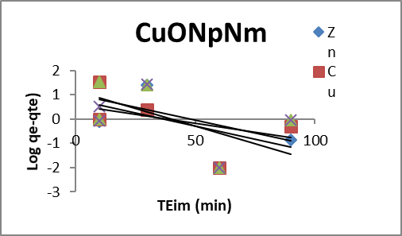
Figure 11 Pseudo-first-order plots for adsorption of CuONpNm

4.8.4 Pseudo-Second-Order Kinetic Model
The adsorption kinetics of Zn²⁺,Cu²⁺ ,Ni²⁺ and Cd²⁺ion onto CuONpNm were further analyzed using the pseudo-second-order model, as presented in figure 12. The linearized form of this model was applied by plotting $\frac{t}{q_{t}}$ versus $t$, which produced highly linear relationship for all metal ions, with regression coefficients (R²) constantly close to unity.
Unlike the pseudo-first-order model, the calculated equilibrium adsorption capacities (qe cal) derived from the pseudo-second-order model showed an excellent agreement with the experimental value (qe exp). The strong correction indicates that the adsorption is better represented by the pseudo-second -order model.
The superior fit suggests that the rate-limiting step of the adsorption process is predominantly chemisorption, involving valence force through sharing or exchange of electron between the metal ions and the active functional group present on the CuONpNm surface. This mechanism is consistent with the observed high removal efficiencies and strong interactions between CuONpNm and the tested metal ions.
Therefore the pseudo-second-order kinetics model provides the most reliable description of the adsorption behavior of Zn²⁺,Cu²⁺ ,Ni²⁺ and Cd²⁺ion onto CuONpNm, confirming that the process is primarily controlled by chemical interaction rather than physical diffusion (Alaa,2021,Mail,2005;Manisha 2023;Padamaarathy,2008).
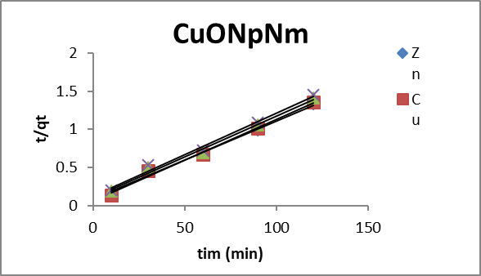
Figure 12 Pseudo-second-order plots for adsorption of CuONpNm

Table 3 Pseudo-second order parameters for the adsorption of CuONpNm on Zn²⁺ ,Cu²⁺ ,Ni²⁺ and Cd²⁺
Parameter CuONpNm
Pseudo-second-order Pseudo-first-order
Zn²⁺ Cu²⁺ NI²⁺ Cd²⁺ Zn²⁺ Cu²⁺ NI²⁺ Cd²⁺
qe (Calculated) 100.0 90.00 83.33 76.02 16.92 16.82 16.52 16.07
q_{e} (Experimental) 90.90 89.42 85.92 83.30 90.90 89.42 85.92 83.30
K_{1/2} 0.010 0.011 0.012 0.013 0.046 0.044 0.041 0.039
h_{o} 8.600 8.634 9.615 10.416 - - - -
R² 0.994 0.993 0.990 0.986 0.625 0.724 0.624 0.305

5 Conclusion
This study demonstrated that copper oxide nanoparticles modified with neem leave extract (CuONpNm) are effective, low-cost bio-sorbent for removing heavy metals (Zn²⁺,Cu²⁺ ,Ni²⁺ and Cd²⁺) ion from water. The adsorption performance was influenced by pH, contact time and initial concentric, with maximum removal efficiencies above 90%. In the order of Zn²⁺˃Cu²⁺ ˃Ni²⁺ ˃Cd²⁺.
SEM revealed that the micrographs (plate) of CuONpNm have a well-developed porous structure and cavities which enhanced the adsorption. XRD confirmed that neem coated copper oxide has higher crystallinity. TEM revealed that neem coated copper oxide has a a very small (ultrafine) nanoparticles. It phytochemicals act as reducing and stabilizing agents. The small particle size enhances the antimicrobial and adsorption properties of the nanoparticles.
The process followed the order Zn²⁺,Cu²⁺ ,Ni²⁺ and Cd²⁺ion fitted better to the Freundlich isotherm than the Langmuir model indicating heterogeneous surface interactions. Kinetics results confirmed a pseudo-second-order mechanism, suggesting chemisorption as the main pathway. Overall, CuONpNm shows strongly potential as low cost, antimicrobial and eco-friendly material for wastewater treatment.

Reference
Plant-Based Copper Oxide Nanoparticles, Biosynthesis, Characterization, Antibacterial Activity, Tanning Wastewater Treatment and Heavy Metal sorption. Catalysis,13(2),348. Dio:10.3390/catal13020348
Copper Oxide Nanoparticles Effective Tools for the Removal of Heavy Metals Journal of Chemical Health Risks 13(3),331-338.Dio:10.22034/JCHR. 2023.1973563.1416
Antibacterial activity of green synthesized copper oxide nanoparticles against multidrugs-resistant bacteria, scientific Reports, 14,18839. Dio:10.1038/s41559-024-69855-0
Adsorption of Pb2+ using biosynthesized ZnO nanoparticles derived from Azadirachta indica leaf extract Biomass Conversion and Biorefinery. Dio:10.1007/s13399-024-054119-2
Green synthesis of copper oxide nanoparticles impregnated on activated carbon using moringa oleifera leaves Extract for the removal of nitrates from water.dio:10.1590/19805373-mk-20180460. (2018)
Nanoparticles properties, applications & toxicities. Arab Journal Chem. 12 (7), 908-931. Dio.org/10.1016/j.arabjc 2017.0.5.011 (2019).

Green Copper Oxide Nanoparticle for lead, nickel & cadmium removal from contaminated water. PMCID: PMC820-6336/PMID, 11-2547 dio:10.1038/s41598-021-91093-7 (2021).
Singh J. et.al. (2018). Green synthesis of metals and their oxide nanoparticles. Applications for environmental remediation Journal Nanobiotechnol, 16,84, dio.org/101186/s12951-018-0408-4.nol, 16,84, dio.org/101186/s12951-018-0408-4. (2018).
Biogenic synthesis of copper oxide nanoparticles using plant extract and its prodigious potential for photocatalytic degradationof dyes. Environ. Res.177,108569 dio.org/10.1016/j.envres.2019.108569 (2019).

Adsorption of methylene blue dye by Calix (6) Arene-modified Lead Sulphide (Pbs): Optimisation using Response surface methodology, Int J. EnvironRes. Public Health, 18(2), 397,dio,org/103390/ijerph18020397 (2021).
Alaa, E. L., Din, M., Khairia, M.A., Sahab, O., Salma, F. A. O. & Fatan, A.A. (2021). Green Copper Oxide
Nanoparticle for lead, nickel & cadmium removal from contaminated water. PMCID: PMC820-6336/PMID,
11-2547dio:10.1038/s41598-021-91093-7.

America Public Health Association (1998). Absorption Spectrophotometric method, Standard methods for the Examination of Water & Wastewater 20th Edition Alpha AWWA WEF.

Crislaine, R., Galan, R. (2018). Green synthesis of copper oxide nanoparticle impregnated on activated carbon using moringa oleifera leaves Extract for the removal of nitrates from water.dio:10.1590/19805373-mk-20180460.

Dundar,M.,Nuhoglu,C.,Nuhoglu, Y. (2008). Biosorption of Cu(ll) ion onto the litters of natural trembling poplar forest. Journal of Hazardous Material. 151 (1): 86-95.dio:10.1016/jhazmat.2007.05.055.

Eid, A. M.,et al. (2023). Plant-Based Copper Oxide Nanoparticles, Biosynthesis, Characterization, Antibacterial Activity, Tanning Wastewater Treatment and Heavy Metal sorption. Catalysis,13(2),348. Dio:10.3390/catal13020348

Falak, S., Syed, S., Ali, G., Muhammad,S., Mhammad, B., Igra,S. (2019). Eco friendly green & biosynthesis of copper oxide nanoparticle using citrofortunella microcarpe leaves extract for efficient photocatalytic degradation of Rhodamn B-dye from textile wastewater.dio.org/10.1016/j.ijleo.2019.164053.

Gaurav, T., Rashmi, R., Sanjeer, P., Mahanta, P., Soumya, C., Dev, V. (2023). Copper oxide nanoparticles modified activated carbon nano composite towards removal of tetracycline from waste water inorganic chemistry, communication. dio.org/10.1016/j.inoche2023.110687152.

Jacob, L., Prasanna, K., Michellle, B., Margaret, M., Salma, A.S., Kit N. Eldear, G. L., Zer, V. Trace, A.C., Healthern, K. B. (2021). A universal approach to analyzing transmission electron microscopy with image. National Library of Medicine, 10(9): 2177, dio:10.3390/cells10092177.

Joudeh, N. & Linke, D., (2022). Nanoparticle classification, physiochemical properties, characterization & application: A comprehensive review for biologists. Journal Nanobiotechnol. Vol. 20, (262), dio.org/10.1186/s1251-022-01477-8.

Kellang, Z., Hao B., Zbenguo, L. (2003). A simple method for the synthesis of copper nanoparticles from metastanteral ,Natural Library of Medicine, dio10.1039/dzrao10823.

Khairy, E.,et al. (2024). Antibacterial activity of green synthesized copper oxide nanoparticles agaist multidrugs-resistant bacteria, scientific Reports, 14,18839. Dio:10.1038/s41559-024-69855-0

Kumar,S.,et al. (2004). Adsorption of Pb2+ using biosythesiszed ZnO nanoparticles derived from Azadirachta indica leaf extract Biomass Conversion and Biorefinery. Dio:10.1007/s13399-024-054119-2.

Mail, I. I. D. Srivastava, V.C., Agarwal, N. K. & Mishra, I. M. (2005). Removal of Congo Red from Aqueous Solution by Bagasse Fly Ash and Activated Carbon:Kinetic Study and Equilibrium Isotherm Analyses Chemsphere 6,492-501.dio.org/10.1016/j-chemosphere.2005.03.065.

Manisha, K., Sunita C. H., Ashok, K., Kamakhya, P. M., Devendra, S. R. & Rama, K. K. (2023). Asterarcysquadri cellulare algae-mediated copper oxide nanoparticles as a robust and recyclable catalyst for the degradation of noxious dyes from wastewater, Open Access Article, 13,28179-28196. dio:10.1039/D3RA05254K.

Nuhoglu,Y., Malkoc E. (2009). Thermodynamic & Kinetics Studies for environmentaly friendly Ni (ll) bisorption using waste pomace of olive oil factory. BioresourceTechnology.2009;100(8):2375-2380. dio:10.1016/j. biortech.2008.11.016.

Padmaarathy,V. (2008). Biosorption of Nickel (ll) Ions by Baker’s Yeast: Kinetic, Thermodynamic and Desorption Studies. Bioresource Technology,99, 3100-3109. dio.org/10.1016/j-biotech.2007.05.070.

Ruth A.C.U., Aura, R. H. V., Consuelo, J. C. P., Paul, C.M. (2014). Thermodynamic, Kinetics, Equilibrium Parameter for the removal of lead & cadmium from aqueous solution with calcium. Alginate Bead the Scientific World

Singh J. et.al. (2018). Green synthesis of metals and their oxide nanoparticles. Applications for environmental remediation Journal Nanobiotechnol, 16,84, dio.org/101186/s12951-018-0408-4.nol, 16,84, dio.org/101186/s12951-018-0408-4. Singh, J., Kumar, V. Kim, K.H. & Rawat, M. (2019). Biogenic synthesis of copper oxide nanoparticles using plant extract and its prodigious potential for photocatalytic degradation of dyes. Environ. Res.177,108569 dio.org/10.1016/j.envres.2019.108569

Theerthalgiri, J. et al. (2022). Fundamentals and comprehensive insight on pulsed laser synthesis of advanced materials for diverse photo and electrocatalytic applications Light Sci. Appl. 11,250 dio.org/10.1038/s41377-022-00904-7.

Wan, N. W. S. & Hanafiah, M. A. K. M. (2008). Adsorption of copper on Rubber (Hevea brasiliensis) Leave Powder. Kinetic, Equilibrium & Thermodynamic Studies Biochemical Engineering Journal, 39, 531-530.dio.org/10.1016/j.bej.2007.11.006.

Wang,Y.,Gao, B.Y.,Yue,W.W. & Yue,Q.Y. (2007). Adsorption Kinetics of Nirates from Aqueous solution onto Modified Wheat Residue, Colloids & Surfaces A: Physicochemical & Engineering Aspects, 308,1-5.dio.org/10.1016/j.colsurfa.2007.05.014

