Original Research Article

Synthesis, Characterization, and Antimicrobial Activities of (E)-2-(2-aminothiazol-4-yl)-N'-(2-nitrobenzylidene)acetohydrazide Ligand and Its Co(II) Complex

ABSTRACT

The biological and pharmacological applications of Hydrazone Schiff base ligands and their metal complexes have been the focus of recent research, aiming to mitigate the effects of multidrug-resistant bacterial and fungal infections. This study aimed to synthesize, characterize, and evaluate the antimicrobial activities of a hydrazone Schiff base ligand, (E)-2-(2-aminothiazol-4-yl)-N'-(2-nitrobenzylidene)acetohydrazide, and its Co(II) complex, in order to explore their potential as antimicrobial agents. The ligand was synthesized by condensing 2-(2-aminothiazol-4-yl)acetohydrazide with 2-nitrobenzaldehyde in ethanol, while the Co(II) complex was prepared in a 1:2 metal-to-ligand ratio. Both compounds were characterized by FTIR, UV–Vis, ¹H NMR, XRD, and GC–MS. Antimicrobial activities were assessed by disc diffusion, minimum inhibitory concentration (MIC), and minimum bactericidal/fungicidal concentration (MBC/MFC) methods against Escherichia coli, Salmonella typhi, Staphylococcus aureus, Streptococcus pyogenes, and Candida albicans.The ligand and its Co(II) complex were obtained in yields of 55.2% and 70%, with melting points of 150°C and 155°C, respectively. Spectroscopic and diffraction studies confirmed successful synthesis and coordination. The ligand exhibited moderate antibacterial activity but limited antifungal efficacy, whereas the Co(II) complex displayed broader activity, with zones of inhibition reaching up to 20 mm and lower MIC values (250–500 μg/mL). Neither compound demonstrated bactericidal/fungicidal effects (MBC/MFC: not detected). Coordination with Co(II) enhanced the antimicrobial spectrum of the Schiff base ligand, suggesting potential as a lead for further antimicrobial drug development.

Keywords: Hydrazone Schiff Base, Co(II) Complex, Hydrazine Hydrate, Hydrazone, ethyl-2-amino-4-thiazoleacetate, 2-nitrobenzaldehyde.

1. INTRODUCTION

Schiff base ligands have continued to attract research interest in recent years due to their established antimicrobial properties. These compounds are formed by the condensation reaction of aldehydes or ketones and amines [1]. They exhibit exceptional properties in coordination chemistry due to their ability to coordinate with metals and form stable complexes [2]. A major Schiff base derivative, hydrazones, has become a key player in the development of active drugs due to their biological and pharmacological profiles [3. The pharmacological actions of hydrazones are attributed to their unique structural features, which include the presence of the azomethine group (-NH-N-CH), making them an important player in pharmaceutical chemistry [4,5].
Recent reports have indicated that hydrazone derivatives exhibit significant antimicrobial activity, including antibacterial, antifungal, antimycobacterial, anti-inflammatory, and antiviral effects [6]. The efficacy of their metal complexes against multidrug-resistant pathogens underscores their relevance in addressing global health challenges [7]. The complexation of hydrazone Schiff bases with transition metals has led to compounds with enhanced antimicrobial activity compared to their parent ligands [4,7]. The antimicrobial properties of such compounds are influenced by the nature of the metal ion, the ligand structure, and the coordination geometry, which can be elucidated through spectroscopic and crystallographic techniques [8].
Cobalt(II) complexes, in particular, have become of research interest because several Co(II)–hydrazone complexes have demonstrated promising antibacterial and antifungal results in vitro, and in some cases, improved activity against drug-resistant strains.[9] These findings justify exploring Co(II) chelates of new hydrazone ligands as potential antimicrobial agents. This work aims to synthesize, characterize, and evaluate the antimicrobial activities of the titled ligand and its Co(II) complex, contributing to the growing body of knowledge on hydrazone Schiff base chemistry. The scope of this study encompasses a detailed investigation of the ligand's synthesis via condensation reactions, its coordination with Co(II), and an assessment of ligand and complex antimicrobial efficacy against selected bacterial and fungal strains. The findings are expected to provide insights into the structure-activity relationships and validate the potential of these compounds as candidates for further pharmaceutical development.

2. experimentals

All the reagents used in this research were of analytical grade and used without further purification. The reagents were purchased from Sigma–Aldrich Chemie GmbH, Germany, and supplied through their local distributor in Nigeria, Bristol Scientific. Metal salts were obtained from E. Merck, and distilled water was purchased from Joechem (Nig.). The proton NMR was conducted at Covenant University in Otta, Ogun State, Nigeria. The pH, electrical conductivity, GC-MS, XRD, FTIR, and UV-Vis spectroscopic analyses were performed at the Nanotechnology Research Laboratory of the Raindrops Institute of Management and Technology in Amannachi Orsu LGA, Imo State, Nigeria. While the antimicrobial was carried out at Gomecs-Evergland Limited, Nekede, Owerri, Imo State, Nigeria.
The melting points were determined using a capillary tube in the Melting Point Apparatus (HUNK-4524542). Molar conductivity was measured in deionized water at 25°C with a WTW conductivity meter. ¹H spectra (dimethyl sulfoxide DMSO-d6) were recorded on a Bruker Avance 400; the chemical shifts were referenced to residual solvent resonance external TMS (tetramethylsilane) in the ¹H; the splitting of proton resonances in the reported ¹H NMR spectra is defined as a singlet, doublet, or multiplet [10]. Infrared spectra were recorded in the frequency range of 4000 cm⁻¹ to 400 cm⁻¹ using an FT-IR spectrometer (Varian 660 MidIR Dual MCT/DTGS Bundle with ATR), with a detector set at a resolution of 4 cm⁻¹ and 200 scans per sample. Ultraviolet-visible spectra of the ligand and complexes were recorded using a UV-Vis spectrophotometer (2100 Pro) within the range of 200-800 nm. Mass spectra were obtained on a Varian 3800/4000 gas chromatograph-mass spectrometer equipped with an Agilent splitter, with split/splitless options, and a BP5 capillary column (30 m × 0.25 mm × 0.25 microns). The samples were analyzed using an X-ray diffraction diffractometer (XDS 2400H), equipped with a Mini+-9—8yyFlex2+ goniometer and detector.

2.1 Synthesis of 2-[2-[(2-nitrobenzylidene)hydrazinyl]-2-oxoethyl]thiazol-4-amine Ligand

The ligand was synthesized in a 1:1 mole ratio of the reactants according to the method used by Enedoh et al. [11] as follows:

Step 1:
2-(2-aminothiazol-4-yl)acetohydrazide (L1) was prepared from a 1:1 molar ratio of ethyl-2-amino-4-thiazoleacetate and hydrazine hydrate. 13.75 mL (0.22 moles) of N2H4·H2O was added to 40 g (0.22 moles) of ethyl-2-amino-4-thiazoleacetate in 165 mL of ethanol. The mixture was then refluxed in a 500 mL round-bottom flask on a heating mantle for 6 hours. The solution was allowed to crystallize for 24 hours. The resulting white crystals were filtered and air-dried (Yield: 36.2 g, 95%, M.P.: 142°C).

Scheme 1: Synthetic route for 2-(2-aminothiazol-4-yl)acetohydrazide (L1)

Step 2:

The 2-(2-aminothiazol-4-yl)acetohydrazide synthesized in the first step above was reacted with 2-nitrobenzaldehyde via a 1:1 molar ratio.
2-(2-aminothiazol-4-yl)acetohydrazide (10g, 0.058mol) was mixed with 2-nitrobenzaldehyde (10g, 0.06mol) in ethanol (200 mL) and refluxed for 6 hours in a 500 mL round-bottom flask on a heating mantle. The solution was left to crystallise for 24 hours. The light-yellow amorphous powder obtained was filtered, recrystallised, and dried over silica gel in a desiccator. (Yield, 9.8g, 55.2%, M.P., 150˚C C₁₂H₁₁N₅O₃S) ¹H NMR (DMSO-d₆, δ ppm): 8.09 (s, 1H, –CH=N–), 6.3–8.6 (m, Ar–H), 6.82 (br, 2H, NH₂), 11.69 (br, 1H, NH), 3.80 (m, 2H, –CO–CH₂–), IR (KBr, ѵ/cm⁻¹): 3093 (C–H, aromatic), 2596 (N–H, primary/secondary), 2479 (N–H, hydrogen-bonded), 1364 (–NO₂, symmetric stretch), 1302 (C=N), 1243 (C–N), 1099 (C–O/ring modes), 968 (C–H, out-of-plane), 600 (C–S, thiazole). XRD (2θ, Å): 39.41 (001), 44.00 (010), 46.00 (110), broad peaks — amorphous; 51.79 (111), sharp, minor quartz impurity. UV–Vis (DMSO, λmax, nm): 416 (ICT transition: thiazole-amine donor → nitrobenzylidene acceptor). GC-MS (m/z): cal., 305.06; found, 305.16

Scheme 2: Synthetic route for the (E)-2-(2-aminothiazol-4-yl)-N'-(2-nitrobenzylidene)acetohydrazide Ligand

2.2 Synthesis of Co(II) Complex of (E)-2-(2-aminothiazol-4-yl)-N'-(2-nitrobenzylidene)acetohydrazide
The metal complex was prepared by reacting aqueous solutions of the metal salt (Co(II)) with ethanoic solutions of the ligand in a 1:2 molar ratio.
The ligand (E)-2-(2-aminothiazol-4-yl)-N'-(2-nitrobenzylidene)acetohydrazide (1.0 g, 0.00328 mol) was dissolved in 10 mL of ethanol in a round-bottom flask and heated for 30 seconds on a heating mantle. The CoCl₂·6H₂O (0.390 g, 0.00164 mol) was dissolved in 10 mL of water in a separate round-bottom flask. The ligand was then carefully added, with continuous stirring, to the Co²⁺ solution, and the mixture was refluxed for 4 hours in a 250 mL round-bottom flask on a heating mantle. The solution was left to crystallize for 24 hours. The brown crystals obtained were filtered and dried over silica gel in a desiccator (Yield, 0.78 g, 70%, M.P., 155°C).IR (KBr, ѵ/cm⁻¹): 3475 (O–H), 1668 (CH₂/C–H), 1321, 1095 (C–O/C–O–C), 938 (C=C), 546 (M–O). XRD (2θ, Å ): 21.96, 30.23, 37.25, 41.97. UV–Vis (DMSO, λmax, nm): 396 (L2Co, strong band due to coordination and conjugation disruption). GC-MS (m/z): cal., 705.59; found, 705.07

Scheme 3: Synthetic Route for the Co(II) Complex

3. RESULT AND DISCUSSION

The ligand (E)-2-(2-aminothiazol-4-yl)-N'-(2-nitrobenzylidene)acetohydrazide was prepared by the condensation reaction of equimolar concentrations of 2-(2-aminothiazol-4-yl)acetohydrazide and 2-nitrobenzaldehyde (Scheme 2), while the Co(II) complex of the ligand was prepared by a 1:2 mole ratio of metal salt and ligand. The synthesized ligand and its Co(II) complex (LCo) were obtained in yields of 55.2% and 70%, respectively, demonstrating moderate to good synthetic efficiency, with a higher yield observed upon complexation. The ligand was isolated as a light-yellow amorphous powder with a melting point of 150°C, whereas LCo appeared as brown crystals with a slightly higher melting point of 155 °C, indicating improved thermal stability due to cobalt coordination (Table1). These variations in yield, colour, and melting point are consistent with reported trends for Schiff base metal complexes, where chelation typically enhances stability and alters physicochemical properties [12].

Compounds | Percentage yield (%) | Melting point (˚C) | Colour
L | 55.2 | 150 | Light yellow
LCo | 70 | 155 | Brown

Table 1: Characteristic and Physical Properties of Synthesised Compounds

From the FTIR spectral analysis of the ligand L and complex (Figure 1), the Ligand showed characteristic absorption bands at 3092.85 cm⁻¹ (O-H stretching), 2596.03 cm⁻¹ (CH₂/C-H stretching), 2478.95 cm⁻¹ (C=O stretching), 1301.90 and 1364.28 cm⁻¹ (C-O/C=O stretching), indicative of its functional group composition, while the absence of metal-oxygen (M-O) stretching confirmed its uncoordinated state. The L-Co complex exhibited a shift in the O-H stretching to 3475.21 cm⁻¹ and the emergence of new bands at 938.53 cm⁻¹ and 546.28 cm⁻¹, attributed to C=O and M-O stretching, respectively, suggesting coordination of the ligand to the Co(II) ion through the oxygen atom, with the disappearance of certain bands (e.g., CH₂/C-H at 1668.27 cm⁻¹) indicating structural changes upon complexation (Table 2).

Compound | O–H Stretching | CH₂ / C–H Stretching | C=O Stretching | C–O / C–O–C Stretching | C=C Stretching | Metal–Oxygen (M–O) Stretching
L | 3092.85 | 2596.03 | 2478.95 | 1301.90, 1364.28 | — | —
LCo | 3475.21 | 1668.27* | — | 1321.09, 1094.63 | 938.53 | 546.28

Table 2: Comparative FTIR Absorption Bands of the L and Its Co(II) Complex
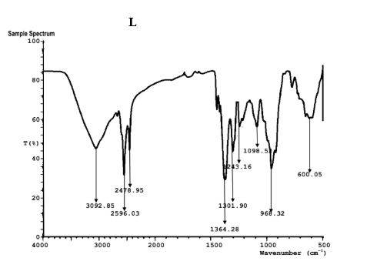

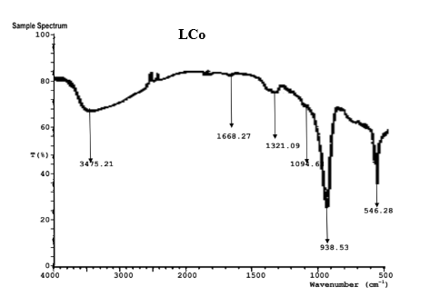
Figure 1: Comparative FTIR Absorption Spectra of the Ligand (L)and Its Co(II) Complex (LCo)

The GC–MS spectrum of the ligand L displayed a molecular ion peak at m/z 305.16, consistent with the calculated molecular mass (305.06 g/mol), confirming the successful synthesis of the compound. Fragmentation yielded a dominant peak at m/z 153.04, corresponding to 2-nitrobenzenemethanol, which confirms the presence of the nitrobenzylidene moiety in the Schiff base. Additional peaks, including a bicyclic fragment at m/z 132.02, support the presence of the thiazole unit, together providing strong analytical evidence for the proposed molecular structure. The LCo Complex showed a molecular ion peak at m/z 705.07 and a fragmentation pattern with peaks at m/z 292.00, 421.08, and 433.16, indicating the presence of multiple structural fragments.

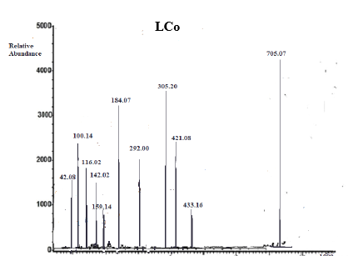
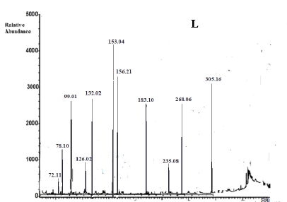

Figure 2: Comparative GC-MS Spectra of the Ligand (L)and Its Co(II) Complex (LCo)

The XRD pattern of ligand L exhibits broad peaks at 39.418°, 44.00, 46.00, and 51.79, indicating a partially amorphous structure with quartz phases, consistent with the absence of metal coordination. In contrast, the LCo complex displays sharp, distinct peaks at 21.96, 30.23, 37.25, and 41.97, which are indexed to crystalline cobalt and cobalt oxide phases, confirming successful metal complexation. This shift from amorphous characteristics in the ligand to well-defined crystalline patterns in the complex demonstrates the formation of a stable coordination compound.

Sample | Main Peaks (2θ °) | Main Identified Phases | Crystalline/Amorphous | Interpretation
L | 39.41, 44.00, 46.00, 51.79 | Amorphous + Quartz | Partially amorphous | The ligand exhibits a partially amorphous nature, with no metal complexation.
LCo | 21.96, 30.23, 37.25, 41.97 | Cobalt, Cobalt oxide | Crystalline | Strong complexation is evident by the formation of Co and CoO phases.

Table 3: Comparative Power XRD diffraction Patterns of the L and Its Co(II) Complex

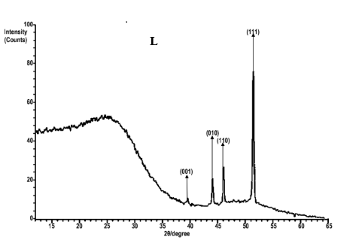
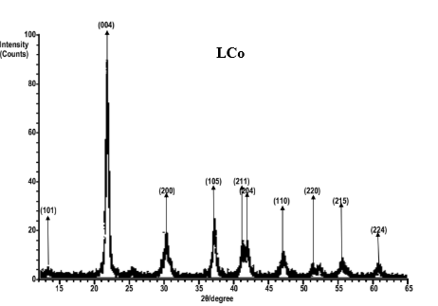
Figure 3: Comparative Power XRD diffraction Peaks of the L and Its Co(II) Complex

The UV-Vis absorption spectrum of the ligand L exhibited a maximum absorption wavelength (λ_max) at 416 nm, attributed to an intramolecular charge transfer (ICT) transition from the thiazole-amine (donor) to the nitrobenzylidene (acceptor), reflecting its electronic structure in the free state while for the LCo complex, the λ_max shifted to 396 nm, a hypsochromic shift of 20 nm, which is indicative of strong coordination and disruption of conjugation due to the metal-ligand interaction, altering the electronic environment.
Complex | λ (nm) | Shift vs. L2 (nm) | Interpretation
L | 416 | reference | ICT transition: Thiazole-amine (donor) → Nitrobenzylidene (acceptor)
LCo | 396 | -20 | Strong coordination + conjugation disruption

Table 4: UV-Vis Absorption Trends and Structural Correlations for L and LCo
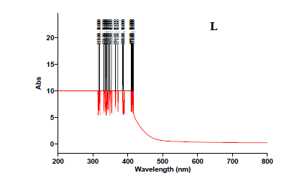
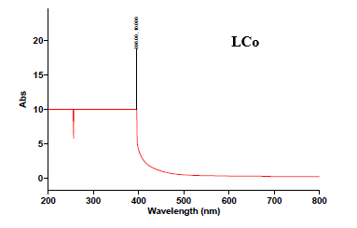

Figure 4: UV-Vis Absorption Spectra for L and LCo

Antimicrobial Activities of (E)-2-(2-aminothiazol-4-yl)-N'-(2-nitrobenzylidene)acetohydrazide Ligand and Its Co(II) Complex
The antimicrobial Susceptibility of the synthesised compounds was evaluated against five clinical test organisms, including two Gram-negative bacteria (Escherichia coli and Salmonella typhi), two Gram-positive bacteria (Staphylococcus aureus and Streptococcus pyogenes), and a fungal strain (Candida albicans). The Disc diffusion method [13] revealed varying degrees of inhibition, highlighting the structure–activity relationships between the ligand (L) and its metal complex (LCo), (Table 5).
The antimicrobial susceptibility testing showed that the ligand L exhibited varying zones of inhibition, with susceptibility (S) against Escherichia coli (20 mm), Staphylococcus aureus (16 mm), and Salmonella typhi (12 mm, intermediate), while showing no activity against Streptococcus pyogenes and limited activity against Candida albicans (12 mm, resistant). The LCo complex demonstrated enhanced activity, with susceptibility observed across all tested organisms (E. coli, 18 mm; S. aureus, 20 mm; S. pyogenes, 20 mm; S. typhi, 18 mm; C. albicans, 16 mm), suggesting improved efficacy upon coordination with Co(II). Compared to the control antibiotics levofloxacin (32–36 mm) and nystatin (30 mm), both L and LCo showed moderate activity, with LCo outperforming L, particularly against gram-positive and fungal strains, aligning with trends in metal-enhanced antimicrobial effects.
Test Organisms/Zones of Inhibition (mm)

Compounds | Escherichia coli | Staphylococcus aureus | Streptococcus pyogenes | Salmonella typhi | Candida albicans
L | 20 | 16 | - | 12 | 12
LCo | 18 | 20 | 20 | 18 | 16
Levofloxacin  (control antibiotics) | 32 | 36 | 28 | 18 | -
Nystatin | - | - | - | - | 30

Table 5: Antimicrobial Susceptibility Testing of the Synthesised Ligand (L) and Co (LCo) Complex compared to Control Drugs
Key:
- mm = Millimeter
Clinical Laboratory Standard Institute Guideline for Antimicrobial Agents
- R = Resistant (0 – 12 mm)
- S = Susceptible (16 mm and above)
- I = Intermediate (13–15 mm).
- - = No Inhibition

The minimum inhibitory concentration (MIC) results (Table 6) showed that the ligand L needed higher concentrations (250 mg/mL for E. coli, 500 mg/mL for S. aureus) to inhibit growth, with no detectable activity (ND) against S. pyogenes, S. typhi, and C. albicans, indicating its limited antimicrobial range. In comparison, the LCo complex exhibited a broader activity profile, with lower MIC values (250 mg/mL for E. coli, S. aureus, and S. pyogenes; 500 mg/mL for S. typhi and C. albicans), indicating increased potency and a wider spectrum of effectiveness following metal complexation. These results suggest that coordinating Co(II) with the ligand may enhance its ability to penetrate bacterial and fungal cell membranes, consistent with the broader zones of inhibition observed in susceptibility testing.

Test Organisms/Zones of Inhibition (mm)
Compounds | Escherichia coli | Staphylococcus aureus | Streptococcus pyogenes | Salmonella typhi | Candida albicans
L | 250 | 500 | ND | ND | ND
LCo | 250 | 250 | 250 | 500 | 500

Key:
- mg/ml = Milligram per millilitre
- ND = Not detected
Table 6: Minimum Inhibitory Concentrations (MIC) of the Synthesised Ligand and Co(II) Complex

The minimum bactericidal/fungicidal concentration (MBC/MFC) (Table 7) testing revealed no detectable bactericidal or fungicidal activity (ND) for both L and LCo across all tested organisms (E. coli, S. aureus, S. pyogenes, S. typhi, and C. albicans), indicating that neither compound is capable of killing the tested microorganisms at the concentrations tested. This lack of bactericidal/fungicidal activity suggests that both L and LCo act primarily as bacteriostatic or fungistatic agents, inhibiting growth without eradicating the pathogens, which may limit their therapeutic potential as standalone antimicrobial agents.

Test Organisms/Zones of Inhibition (mm)
Compounds | Escherichia coli | Staphylococcus aureus | Streptococcus pyogenes | Salmonella typhi | Candida albicans
L | ND | ND | ND | ND | ND
LCo | ND | ND | ND | ND | ND

Table 7: Minimum Bactericidal/Fungicidal Concentrations of the Synthesised Ligands and Complexes

Key:
- mg/ml = Milligram per millilitre
- ND = Not detected

4. CONCLUSION
This research achieved the successful synthesis and characterization of a hydrazone Schiff base ligand, (E)-2-(2-aminothiazol-4-yl)-N'-(2-nitrobenzylidene)acetohydrazide, and its Co(II) complex. The ligand was obtained in 55.2% yield (m.p. 150 °C), while the complex showed improved stability, yielding 70% (m.p. 155 °C). Spectroscopic and XRD analyses confirmed the expected structures and coordination. Antimicrobial evaluation revealed that the ligand exhibited moderate activity, with inhibition zones of 20 mm against E. coli and 16 mm against S. aureus; however, it showed limited or no activity against S. pyogenes, S. typhi, and C. albicans. In contrast, the Co(II) complex exhibited broader efficacy, producing inhibition zones of 20 mm (S. aureus and S. pyogenes) and 16 mm against C. albicans. MIC studies showed improved potency for the complex (250–500 mg/mL) compared to the ligand (250–500 mg/mL with no detectable activity against three organisms). Both compounds were bacteriostatic/fungistatic (MBC/MFC: not detected). These findings underscore the enhanced antimicrobial potential of Co(II) coordination.

References
- Rao, D. P., Gautam, A. K., Verma, A., & Gautam, Y. (2024). Schiff bases and their possible therapeutic applications: A review. Results in Chemistry, 13, 101941. https://doi.org/10.1016/j.rechem.2024.101941
- Yousri, A., Hassan, M., El-Faham, A., Barakat, A., Haukka, M., Tatikonda, R., Abu-Youssef, M. A., & Soliman, S. M. (2025). Homoleptic Co(II) and Ni(II) complexes with promising anticancer and antimicrobial activities; Synthesis, X-ray structure, and DFT studies. Journal of Molecular Structure, 1321, 139774. https://doi.org/10.1016/j.molstruc.2024.139774
- Sharma, P., Sharma, D., Sharma, A., Saini, N., Goyal, R., Ola, M., Chawla, R., & Thakur, V. (2020). Hydrazone comprising compounds as promising anti-infective agents: Chemistry and structure-property relationship. Materials Today Chemistry, 18, 100349. https://doi.org/10.1016/j.mtchem.2020.100349
- Silas C. U., Ezenweke, L.O., Ojiako E.N., & Ebosie N.P. (2025). Synthesis, Characterization, and Study of Anti-microbial Properties of Fe (III) Schiff Base Complex Derived from Hydrazone and Benzaldehyde. International Journal of Latest Technology in Engineering, Management & Applied Science
- Agili, F. (2024). Novel Hydrazide Hydrazone Derivatives as Antimicrobial Agents: Design, Synthesis, and Molecular Dynamics. Processes, 12(6), 1055. https://doi.org/10.3390/pr12061055
- Paruch, K., Popiołek, Ł., Biernasiuk, A., Malm, A., Gumieniczek, A., & Wujec, M. (2020). Novel Derivatives of 4-Methyl-1,2,3-Thiadiazole-5-Carboxylic Acid Hydrazide: Synthesis, Lipophilicity, and In Vitro Antimicrobial Activity Screening. Applied Sciences, 11(3), 1180. https://doi.org/10.3390/app11031180
- Wang, C., Wei, X., Zhong, L., Chan, C.-L., Li, H., & Sun, H. (2025). Metal-based approaches for the fight against antimicrobial resistance: Mechanisms, opportunities, and challenges. Journal of the American Chemical Society, 147(15), 12361–12380. https://doi.org/10.1021/jacs.4c16035
- Venkatesh, G., Vennila, P., Kaya, S., Ahmed, S. B., Sumathi, P., Siva, V., Rajendran, P., & Kamal, C. (2024). Synthesis and Spectroscopic Characterization of Schiff Base Metal Complexes, Biological Activity, and Molecular Docking Studies. ACS Omega, 9(7), 8123. https://doi.org/10.1021/acsomega.3c08526
- Matshwele, J. T., Odisitse, S., Mazimba, O., Demissie, T. B., Koobotse, M. O., Mapolelo, D. T., Bati, K., Julius, L. G., Nkwe, D. O., Jongman, M., & Nareetsile, F. M. (2024). Cobalt pyridyl complexes against drug-resistant bacteria: Synthesis, characterization, antibacterial properties, mode of action, and molecular docking studies. Inorganica Chimica Acta, 563, 121911. https://doi.org/10.1016/j.ica.2024.121911
- Azzouzi N. El, Fadli Z. El, & Metni M. R. (2017). Synthesis and chemical characterization of some transition metal complexes with a 6-acetyl-1,3,7-trimethylguanine ligand, J. Mater. Environ. Sci., 8,(12) 4323-4328
- Enedoh, M. C., Ibe, F. C., & Ebosie, N.P., (2016). Complexes of 2-amino-4-thiazoleacetic acid hydrazide (ATAH), 2-hydroxybenzaldehyde-2-amino-4-thiazoleacetic acid hydrazone (ATASH), and acetone-2-amino-4-thiazoleacetic acid hydrazone (ATAAH), each with nickel(II)sulphate, as proposed drugs. African Journal of Education, Science and Technology, 3(1), 143-147
- Venkatesh, G., Vennila, P., Kaya, S., Ben Ahmed, S., Sumathi, P., Siva, V., Rajendran, P., & Kamal, C. (2024). Synthesis and spectroscopic characterization of Schiff base metal complexes, biological activity, and molecular docking studies. ACS Omega, 9(7), 8123–8138. https://doi.org/10.1021/acsomega.3c08526
- Jayarajan, R., Vasuki, G., & Sambasiva Rao, P. (2010). Microwave assisted synthesis of Schiff bases and their antimicrobial studies. International Journal of ChemTech Research, 2(4), 2055–2060.

