Original Research Article
Spatial Patterns and Regional Concentration of Cash Crops in Odisha

ABSTRACT
Understanding cash crops offers insight into regional concentration, agricultural economics, market demands, and the social impacts of farming practices globally. The authors try to study the spatial patterns and regional concentration of cash crops in the state of Odisha, India. Twelve cash crops that are predominant in the state are considered under study. The study is based on secondary data collected from the Statistical Abstract of Odisha. Twelve major cash crops, primarily grown in Odisha, were taken under study. We are utilizing the crop concentration method proposed by Bhatia and Geospatial technology for this study. The cash crop area in the state of Odisha is miserable, as the major cash crops, which are under study, covered only 3.98 % of the net area shown. The highest concentration of crops above concentration index 10 are jute (20.98), Kendrapada, maize (18.89), Gajapati, til (17.54), Malkangiri, maize (15.48), Nabarangapur, nizer (14.14), Koraput, ragi (12.62), Koraput and mung (10.31), Jagatsinghpur. Agro-climatic zone wise concentration of cash crops are biri in North Western Plateau; biri, groundnut, and kulthi in North Central Plateau; patato, and sugarcane in North Eastern Central Plateau: groundnut; jute, kulthi, mung, and potato in East and South-Eastern Coastal plateau; maize, mustard, nizer, and ragi in North Eastern Ghat; kulthi, maize, potato, and ragi in Eastern Ghat High Land; nizer, til, sugarcane, and groundnut in South Eastern Ghat; mustard, and kulthi in Western Undulating Zone; biri, andmaize in Western Central Tableland: and Potato in Mid Central Table Land.
Keywords: Agriculture, Spatial pattern, Cash crops, Crop concentration, Bhatia’s method

INTRODUCTION
Crops that are grown mainly to be sold, rather than used by the people and community who grew them, are coming under the category of cash crops. These crops are essential to commercial agriculture, where maximizing profit is the primary goal, common examples of cash crops include wheat, corn, soybeans, rice, and tomatoes, among others, all of which are widely used in food products worldwide. The shift to cash cropping branches from the historical transformation from subsistence farming toward focusing on selling crops. Modern farming methods, including genetically engineered crops and industrial equipment, have significantly increased production but also raised environmental concerns. Cash crops are often linked to complex economic factors, such as labor practices, technologies used, and global markets, and underline factors which can put smaller farmers and those in developing regions at a disadvantage. Understanding cash crops offers insight into regional concentration, agricultural economics, market demands, and the social impacts of farming practices globally.

Literature Review
Agriculture depends on numerous factors, which can be broadly categorized into physical and cultural determinants. Cash crop production depends on many complex factors. A multitude of scholars identify various factors that contribute to the cultivation of cash crops. Singh & Jyoti (2021) found that geographical and climatic factors affect the production of cash in India. In developing countries, the agricultural system is mainly diversifying from food to non-food crops due to increasing vertical diversification (Yahya, 2001). Maximum temperature, minimum temperature, rainfall, and precipitation play an important role in influencing the production of some crops (Nandi et al., 2024). The main influences of commercial farming include farm size, irrigation, access to credit, technology services, and climate change (Singh & Jyoti, 2021 & MA Ji-liang et al., 2022). Odisha's favourable agro-climatic conditions and availability of underutilized land provide an excellent opportunity for cash crop production to increase productivity and farmer income. (Jena et al., 2020). The size of holding, land ownership, family size, labour, assets, and employed marginal value product (MVP) assess resource use efficiency. Human labour was being used in excess on marginal and small farms, signifying a need to reduce its use to progress earnings; in contrast, the use of area, fertilizers, and irrigation could be increased to attain determined output. (Rout et al., 2017). The degree of output and efficiency is lacking due to poor utilization of inputs, seed availability, market challenges, and inadequate extension services (Sekaran et al., 2021). Finger millet cultivation in Odisha is uneconomical, with negative returns over the total cost of production and even negative family labour income. (Shah, 2023). Large farmers diversify their cropping patterns compared to marginal and small farmers (Gupta & Kannan, 2024). The livelihood resilience of rural households is influenced by factors such as modern agricultural production systems or specialized village locations, which demonstrate higher resilience (E. Li et al., 2022). Singh & Jyoti (2021) suggest promoting cash crop production while also researching optimal crop combinations and developing off-farm livelihood choices to improve food security. Large-scale diversification in the cropping is limited to a few crops only. Small-scale diversification is growing at the fastest rate in agriculturally developing countries, such as India, Sri Lanka, Nigeria, and Brazil (UNDP, 2019). Tafida et al. (2022) revealed that most farmers had limited access to natural, human, and financial capital due to poverty. The challenges included a lack of access to formal loans, declining soil productivity, limited market access, and inadequate access to farm mechanization. Farm size, irrigation, and fertiliser consumption are the major factors that led to increased crop diversification. Agricultural intensification, simplified by protected area establishment and export cash crop price booms, affected local populations' well-being in protected area planning, as well as landscape management under cash crop price instability, which is vital (Llopis et al., 2020). Self-sufficiency is a security net for farmers; labor, land, and other resources are assigned to subsistence crops. If a household faces labor or land scarcity, it will not grow cash crops. (Roberts, 2015). Farmers' decisions are based on institutions, skills, expected returns, individual preference, available resources, socio-economic factors, government policies, and political pressure. (Meher & Sethy, 2012), Land use planning supports production and farmers' income (Meher & Sethy, 2013). Grain legumes are vital crops that contribute to Ethiopia's smallholder production, nutrition, and revenue. Production has improved due to high demand for diet and favourable prices in local and global markets (Kebede, 2020).

Ochieng et al. (2020) examine the effects of food crop commercialization, specifically banana and legume cultivation, and postulate that commercialization increases household income and significantly improves rural welfare, and the household dietary diversity score (HDDS), attributed to the income effect of cash cropping. Cash crop production, non-farm income, total arable land, and access to draft power positively influenced household food security, while household size adverse impact on food security (Rubhara et al., 2020). Commercial pulse production significantly enhances household agricultural and total income, and has limited impacts on off-farm income (Moharaj & Rout, 2020). The cultivation of cash crops affects rural livelihoods and environmental health. Cash crop cultivation enhances rural incomes, infrastructure, and employment opportunities; it instantaneously leads to landscape fragmentation, reduced forest/farmland connectivity, and deteriorations in ecosystem service values (Li J. et al., 2018). Use of fertiliser, intensity of irrigation, and rainfall have led to concentration rather than crop diversification (Dasgupta & Bhaumik, 2014).Farmers were aware about recent climate change and utilized multiple adaptation strategies through land use for cultivation, awareness, and exposure to climate change (Khan et al., 2022). Hajdu et al. (2020) have expressed that long-term receipt of South Africa's Child Support Grant investigates correlations between grant receipt and livelihood outcomes such as asset buildup, agricultural investment, and informal enterprise engagement. Sekaran et al. (2021) emphasized that integrated crop-livestock systems (ICLS) can improve resource use efficiency, reduce environmental degradation, enhance soil fertility, and provide diversified nutrition. (Pyone et al, 2024) explored the transition of community land use from traditional shifting cultivation to permanent cash crops, and 'slash-and-burn' agriculture has been replaced by a land use system dominated by permanent betel nut cultivation. Incomes and food security are seriously dependent on farm size, agroecological potential, and market access (Giller et al., 2021). A positive relationship was found between cash cropping and food security among smallholder farmers (Hashmiu et al., 2022). The impacts of cashew cultivation on the sustainable livelihoods of small farmers improve the overall well-being (MC et al., 2024 & Khatiwada et al., 2017). Zaehringer et al. (2020) explored the land use changes in southern Myanmar, focusing on the shift towards cash crop agriculture. Vongvisouk et al. (2016) in his study found that the dual focus on enhancing forest protection and increasing commercial agriculture, which leads to economic growth through cash crop production, increases forest cover and engages in REDD+. The impact of climate smart agriculture (CSA) adoption on household food security and income (Mujeyi et al., 2021). Cash crop cultivation increases farm income but decreases off-farm income. (Rupananda, 2012) & Li et al., (2020). Needless to highlight that widening the income gap between the rich and the poor leads to mass discontent and social unrest.

Cash crop production has improved women's health status, enhanced their societal recognition, and increased their decision-making powers within their households and communities, simultaneously limiting access to production resources. (Yiridomoh et al., 2021) Pinstrup & Padya (1999) specifies that cash crop production may affect national and local level food availability, the ability and desire of households to obtain food, intra-household management of food, health, and sanitation. The central role of women in rural agricultural transformation through cash crop cultivation (Meher et al, 2025).

Different researchers applied different methodologies to study the spatial pattern and regional concentration of agriculture; a few of the important ones are Esponda et al. (2024), who present a spatial modelling approach to identify optimal regions for basil cultivation by combining Geographic Information Systems (GIS), fuzzy logic, and the analytic hierarchy process (AHP). Li et al. (2018) investigate the dual impacts of socioeconomic and ecological factors for expanding cash crop cultivation using a combination of spatial analysis, landscape metrics, ecosystem service valuation (ESV), and spatial regression. Nandi et al (2024) present a comprehensive analysis of crop diversification efforts utilizing a scoping review methodology, the Herfindahl-Hirschman Index (HHI) for crop diversity measurement, and employed the Cobb-Douglas production function to measure the regression coefficients for geographical and climatic factors with respect to the production of these crops. Rubhara et al. (2020) & Pattanayak (2018) observed the impact of irrigation on agriculture using Kendall's Ranking Coefficient method and the skewed distribution for the analysis. MA Ji-liang et al. (2022) employ a Heckman two-step model and an endogenous treatment regression (ETR) model to assess both the determinants of commercial pulse farming and its economic outcomes. Mishra & Behera (2022) study the relationship between crop rotation practices and the profitability of paddy production in Odisha using descriptive statistics and independent t-tests. The location quotient method proposed by Bhatia (1965) has been used by several scholars, including Dias (2017), Kushawaha et al. (2019), Baruah et al. (2020), and Gaike and Baisane (2024), to study the crop concentration and spatial patterns. A large number of studies on cash crops are related to geographical concentration, their economy, and are limited to a smaller area. The present study has attempted to cover the cash crop concentration in Odisha.
Study Area
Odisha, located in the eastern part of India, has a geographical area of 155,707 sq. km, a coastline of 574 kilometers, and is divided into 30 districts as shown in Figure 1. The total cultivated land of the state is 61.80 lakh ha, out of which 29.14 lakh ha (47%) is highland, 17.55 lakh ha (28%) is medium land, and 15.11 lakh ha (25%) is lowland. About 65% of the cultivated land in the Kharif season is irrigated. The soil of the state is divided into eight broad soil groups; out of these, red loam, red sandy soil, and red and yellow soil cover about 81.1% of the total land area. The majority of the farmers are small and marginal and have limited access to resources. Literacy is a concern for this vulnerable group of farming communities. The acreage under the crop has touched an all-time high of 2.39 lakh hectares. The food grain production in the state is estimated to touch 143.04 lakh MT during 2023-24. Emphasis was given to low-duty non-paddy crops like millets and pulses, and accordingly, more acreage has been achieved in millets (2.83 lakh ha), maize (3.04 lakh ha), pulses (21.23 lakh ha), and cotton (2.39 lakh ha) as per the estimate, and less coverage in paddy area, indicating the adoption of crop diversification from paddy to non-paddy by farmers. (Activity Report, Department of Agriculture and Farmers’ Empowerment, Government of Odisha, 2024-25)
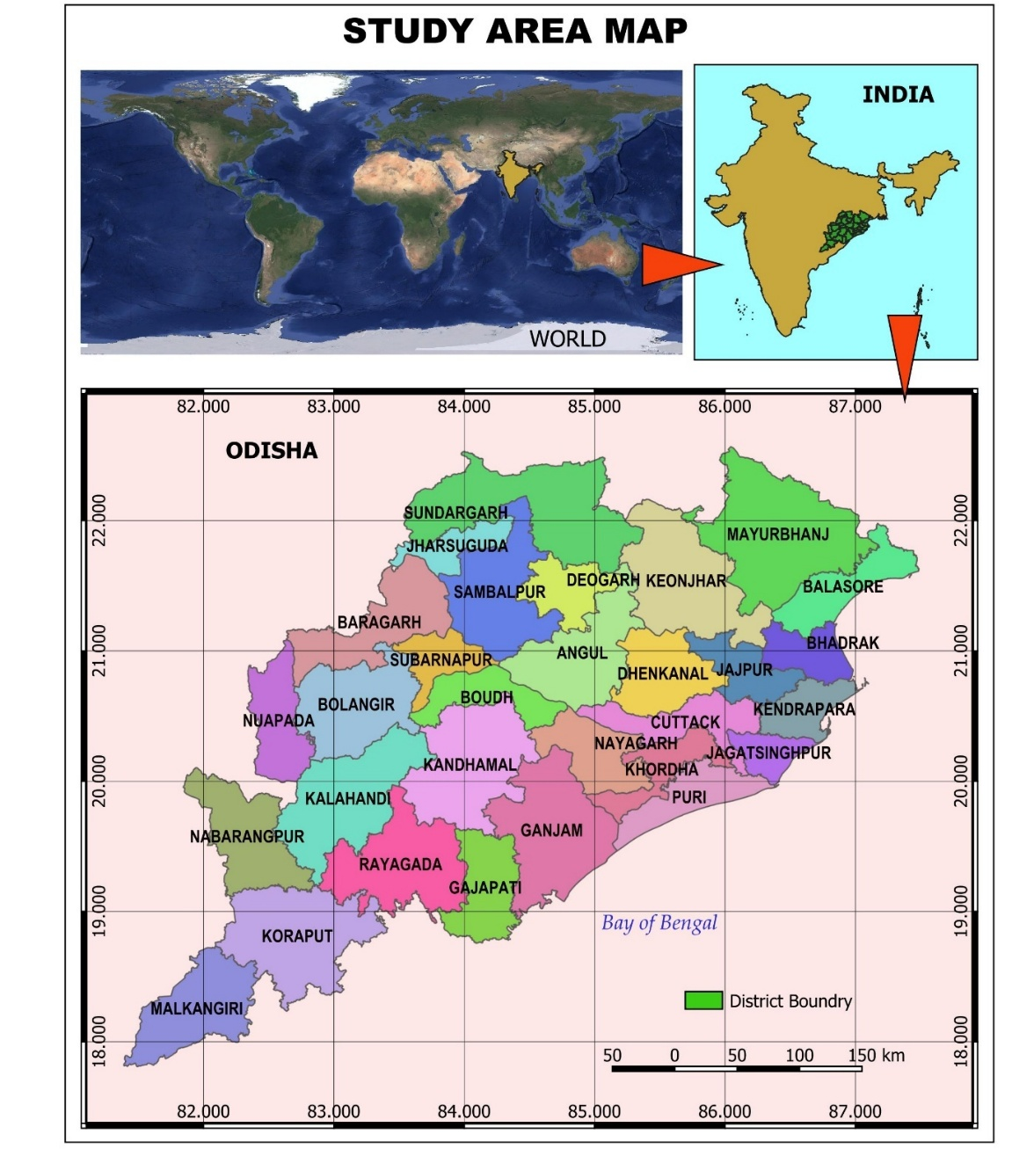
Figure 1: Study area map
The state experiences a subtropical climate, which varies from hot and dry subhumid to hot and moist. Agricultural production in different regions of Odisha mostly depends on the south-southwest monsoon. The long-term average annual rainfall of the state is 1452 mm, with a wide spatial variation from 1200 mm in the southern coastal plain to about 1700 mm in the northern plateau. 78% of total annual rainfall occurs during the kharif season, i.e., June to September, and the remaining 22% in the remaining period. The soil type, rainfall pattern, and other ecological environments favor diversified agriculture in different seasons and ecologies. Water resources of the state are augmented by the presence of several major river basins. About 54% of agricultural land is enclosed under irrigation facilities due to the expansion of several minor, medium, and major projects in different parts of Odisha. Advantageous soil type, rainfall pattern, available water resources, socio-economic condition, and food habits of people of Odisha shaped the agricultural production system of the state.
Crops and cropping patterns of different agro-climatic zones of Odisha mostly depend on the south-southwest monsoon and the irrigation potential accessible in the region. The intensity of rainfall and its distribution, prevailing temperature, types of soil, and availability of irrigation water decide the safe crop growing period of a region. In Odisha, the safe crop growing period differs from 70-90 days in rainfed unbounded uplands to 300 or more days in irrigated medium and shallow lowlands. Safe crop growing periods influence the choice of crop and the cropping sequence of a particular production system. The predominant crops and cropping systems vary with the agroclimatic zone due to variation in rainfall pattern, soil type, and available irrigation potential.
Soil types, climatic conditions, and food habits of people ensure rice is the principal food crop of the state and is grown in entire agro-climatic zones in two distinct seasons, i.e., the wet season (kharif rice) and the dry season (rabi rice), under different ecologies. The vagaries of the Southwest monsoon result in droughts in some parts of the state and floods in others at frequent intervals, causing a severe reduction in crop production. Non-availability of assured irrigation facilities further adds to the uncertain nature of the rice production system in Odisha. Climate change due to global warming further makes agricultural production more challenging.
The state is divided into the following 10 agro-climatic zones:
The state is divided into ten agro-climatic zones depending on various parameters, including soil types, topography, rainfall, and cropping patterns. the characteristics of each one are described by different authors (Hoda et al, 2017), Agronika (2005), and Liansangpuii et.al, 2019). The details are 1.)Northwestern plateau agro-climatic zone: Sundargarh and Deogarh, and some parts of the Sambalpur district, come under this zone. The zone experiences a hot and moist sub-humid climate. Red and brown forests and red, yellow, and mixed red and black soil groups are predominant in the region. The Brahmani and Baitarani River basins influence agriculture; the irrigated area is 30.4%. The land type varies from unbounded upland to shallow lowland. 2.) North central plateau agro-climatic zone: Mayurbhanj and Keonjhar districts of Odisha come under the zone. The zone experiences a hot and moist climate. Broad soil groups of the region include lateritic, red and yellow, and mixed red and black. Besides rainfall, the Subemarekha, Burhabalanga, Baitarani, and Brahmani River basins are sources of water resources of the region. The irrigation ratio of the region is 33.9%. Land types vary from upland to semi-deep-water lowlands. 3.) Northeastern coastal plain agro-climatic zone: Balasore, Bhadrak, Jajpur, and part of Kendujhar come under this zone. The zone experiences a hot and moist sub-humid climate. Board soil groups of the region are red, lateritic, deltaic alluvial, coastal alluvial, saline red, yellow, and mixed red and black. The Subarnarekha, Burhabalanga, and Baitarani River basins cover the majority of the agricultural lands. The irrigation situation of the region is comparatively better than other zones of Odisha, having an irrigation ratio of 60.7%. Drought, cyclones, and floods are major abiotic stresses that influence the cropping pattern, crop planning, and production in the region. 4.) East and southeastern coastal plain agro-climatic zone: Kendrapara, Khorda, Jagatsingpur, Cuttack, Puri, and Nayagada districts come under this zone. The zone experiences a hot and humid climate. The Baitarani, Brahmani, and Mahanadi River basin influences the agriculture and civilization of the region. Broad soil groups of the zone are saline, lateritic, alluvial, red, and mixed red. The irrigation ratio of the zone is 53.4%. 5.) Northeastern Ghat agro-climatic zone: Ganjam, Gajapati, Rayagada, and Kandhamal districts of Odisha come under this zone. The zone experiences a hot and moist sub-humid climate. The Rushikulya, Bahuda, Vansadhara, Nagabali, and Indravati river basins enrich the agricultural lands of the region. Brown forest, lateritic, lateritic alluvial, red, and mixed red and black soils are the major soils of the zone, with an irrigation ratio of 27.4%. 6) Eastern Ghat Highland Agro-Climatic Zone: Nabarangapur and part of the Koraput districts come under the zone. The zone experiences a warm and humid climate. The broad soil group of the region is red and black, mixed with yellow. The irrigation ratio of the zone is 32.0%. The land types vary from hill regions with variable slopes to plateaus that mostly come under upland and medium land. The Indravati and Kolab river basins enrich the flora and fauna of the agro-climatic zone. 7.) Southeastern Ghat agro-climatic zone: Malkangiri and parts of the Koraput districts come under the zone. The zone experiences a warm and humid climate. The Nagabali, Indravati, and Kolab river basins influence the agriculture and civilization of the zone. Red, lateritic, and black soils are major soil groups spread across the region. The irrigation ratio of the zone is 39.3%. The land types vary from hill regions with variable slopes to plateaus. 8.) Western undulating zone agroclimatic zone: Kalahandi and Nuapada districts are coming under the zone. The zone experiences a warm and moist climate. The Nagabali, Indravati, and Vansadhara river basins influence the crop production and civilization of the region. Major soil groups of the zone are red, black, and mixed red and black. The irrigation ratio of the zone is 29.4%. Based on topography, the land type varies from unbounded upland to shallow lowland. 9.) Western central tablelandagro-climatic zone: Bolangir, Baragarh, Boudh, Subarnapur, Sambalpur, and Jharsuguda districts come under this zone. The zone experiences a hot and moist climate. The Mahanadi and the Brahmani River basin mostly influence the agricultural production systems of the agro-climatic zone. Broad soil groups of the region are red and yellow, red and black, black, brown forest, and lateritic. The irrigation ratio of the zone is 38.8%. Land types vary from uplands to shallow lowland. 10.) Mid-central tablelandagro-climatic zone: Angul and Dhenkanal districts come under this zone. The zone experiences a hot and dry sub-humid climate. The soil groups of the region are red, lateritic, and mixed red and black. The irrigation ratio of the zone is 38.8%. The Brahmani and Baitarani River basin enriches the agriculture of the zone. Hill plateaus are major land features of the zone. Land type varies from unbounded upland to shallow lowland.
Objective
To study the present agricultural scenario and to analyze the spatial pattern and cash crop concentration of Odisha.
DATA AND METHODOLOGY
The study is based on secondary data, with crop data collected from the Statistical Abstract of Odisha (2023), Land Utilisation Pattern (2023-24), and District at a Glance (2025), all published by the Directorate of Economics & Statistics, Planning and Convergence Department, Government of Odisha. Average area, yield rate, and production data from the 2018-19 to 2021-22 period were used for the study. The cash crops are 1) black gram (Vigna mungo) locally known as biri, 2) groundnut (Arachis hypogaea) locally known as badam, 3) horsegram (Macrotyloma uniflorum) locally known as kulthi/kultha, 4) maize (Zea mays) locally known as Makka, 5) green gram (Vigna radiata) locally known as mug, 6) mustard (Brassica juncea) locally known as sorisa, 7) nizer (Guizotia abyssinica) locally known as alasi, 8) potato (Solanum tuberosum), locally known as alu 9) ragi known as finger millet (Eleusine coracana) locally known as mandia, 10) sugarcane (Saccharum officinarum) locally known as akhu, 11) til (Sesamum indicum) locally known as rashi, and 12) jute (Corchorus capsularis / Corchorus olitorius) locally known as Jhota. Cotton, a cash crop primarily produced in the districts of Kalahandi, Rayagada, Bolangir, and other districts of Nuapada, Ganjam, Subarnapur, Gajapati, Boudh, Bargarh, Phulbani, and Koraput, is not considered due to the non-availability of district-level data. The area (total of each session), yield & production data of the three years are normalized by averaging to remove noise in the data.
The crop concentration (Bhatia’s method) was used to analyze the crop concentration. The methods can be described as follows. The calculated crop concentration index (CCI) is grouped into three: High, Medium, and Low using equal interval methods. QGIS version 3.40.9 was used for the preparation of maps for this paper.
$$CCI=\frac{a/b}{A/B}$$
Where:
a is the area of crop ‘a’ in the component areal unit, and b is the area of all crops in the component areal unit.
A is the area of crop ‘A’ in the entire region, and B is the area of all crops in the entire region.

RESULT AND DISCUSSION
The average net area shown of Odisha state during the study period is 35.91% with the national 42.8 % net area shown (Department of Agriculture & Farmers Welfare). The district-wise data of the state shows pitiful. Districts having more than the state average are Balasore, Baragarh, Bhadrak, Bolangir, Ganjam, Jagatsinghpur, Jajpur, Kalahandi, Kendrapara, Nuapada, and Subarnapur, having more than the national net area shown. Including all the above districts and Dhenkanal is above the state average. The cash crop area in the state of Odisha is miserable, as the major cash crops, which are under study, are only 3.98 % of the net area shown for the period of study.

Figure 2: Showing the percentage of area under different cash crops to the net shown area (2023-24)
Figure 2 confirm that the area hectarage and the percentage for different crops are Kulthi 7710.59 (0.143%), Maize 65602.56 (1.218%), Mung 80606.86 (1.497%), Mustard 2393.33 (0.044%), Nizer 5330.02 (0.099%), Potato 1482.47 (0.028 %), Ragi 12005.51 (0.223%), Sugarcane 2996.29 (0.056%) and Til 16728.67 (0.311%)

Figure 3: District-wise land utilization pattern of Odisha in percentage (2023-24)
Biri is primarily cultivated in the districts of Jharsuguda, Nayagada, and Khordha, Biri in the district of Boudh, Kendrapada, Kalahandi, Puri, Kandhamal, Deogarh, Dhenkanal & Jajput. Kulthi is cultivated in all the districts except Jagatsinghpur, and mung is grown in the districts of Kendrapada, Cuttack, Puri, Jagatsinghpur, and Bhadrak. Mustard is grown in a large number of districts, which include Baragarh, Kalahandi, Sundergarh, Kandhamal, Bolangir, Sambalpur, Subarnapur, and Rayagada, whereas groundnut is grown in the Bargarh district. Potato, a common dietary crop of the state, is grown in the districts of Cuttack, Puri, Kandhamal, Karaput, Angul, Sambalpur, Subarnapur, Deogarh, and Dhenkanal. Ragi and Nizer are predominant in the Koraput and Rayagada district, and Til in the Malkangiri district. Maize in Gajapati, Nabarangapur, and Groundnut in Malkangiri are the leading cultivators. Sugarcane is mainly produced in Cuttack, Nabarangapur, Jajpur, and Cuttack district. Jute is confined to the Kendrapada and Cuttack districts. Although jute is grown on a sizable portion of the land, Keonjhar and Balasore lack considerable land dedicated to cash crops. Ganjam district does not have any important cash crop; however, til & mug are cultivated in a large area, and Mayurbhanj district reported a poor area under cash crop cultivation. Figure 4 displays the cropping area under different cash crops.
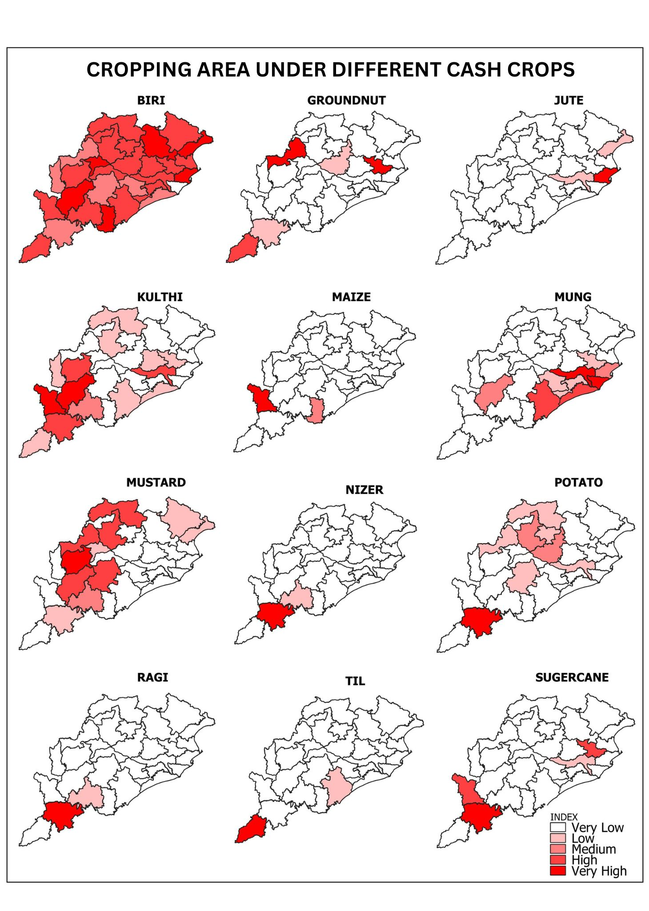Figure 4: Map showing the cropping area under different cash crop
Crop-wise concentration
District-wise crop concentration index in Odisha has been calculated and presented in Table 1 & Figure 5. Highest concentration above crop concentration index 10 are jute (20.98), Kendrapada, maize (18.89), Gajapati, til (17.54), Malkangiri, maize (15.48), Nabarangapur, nizer (14.14), Koraput, ragi (12.62), Koraput, mung (10.31). The discussions are in detail below.

Biri: High concentration (2.03 - 2.83) is found in three districts, which include Jharsuguda (2.821) followed by Gajapati (2.703) and Deogarh (2.586). In the category of Medium (1.25–2.03), .15 districts are coming, and the remaining 12 districts are coming under the Low (0.46 - 1.25) category.
Groundnut: High concentration (2.9–5.7) is found in Bargarh (5.996), followed by Malkangiri (5.791) and Jajpur (8.551). No district is coming under the Medium category (2.9-5.7). Low (0-2.9) concentration is found in 26 districts, and Bhadrak doesn’t report any crop area under cultivation.
Jute: Jute is cultivated in six districts of Odisha, which include Kendrapada (20.958), with the highest concentration in the High (14–21) category. This crop and the district have recorded the highest concentration index for the entire category. Five districts are coming under the Low (0–7) category, and no district is coming under the Medium (7–14) concentration category.,
Kulthi: High (2.2-3.2) concentration of kulthi is found in four districts, which include Cuttack (3.229), followed by Nabarangapur, Bolangir, and Puri. Medium (1.1–2.2) concentration of crop is found in eight districts. The rest of the districts, excluding Balasore, where no crop acreage was recorded, are coming under the Low (0–1.1) concentration group.
Maize: Maize is cultivated in 28 districts of the state, where two hilly districts come under the High (12.6-18.9) concentration group, namely Gajapati (18.891) and Nabarangpur (15.476) districts. In the Low (0-6.3) category, 26 districts and not a single district is Medium (6.3-12.6) observed.
Mung: High concentration (6.9-10.3) of mung is found in Jagatsinghpur district (10.309), and three districts, namely Cuttack, Puri, and Kendrapara, are coming under the Medium (3.4-6.9) category. The rest of the district is coming under the Low (0-3.4) category.
Mustard: Twenty-eight districts reported mustard cultivation during the study period. Two districts, Kandhamal (4.588), followed by Bolangir (3.845), are coming under the High (3.1-4.6) concentration category. Seven districts are coming under Medium (1.5 - 3.1), and the rest districts are coming under the Low (0-1.5) group.
Nizer: Only twelve of the hilly and plateau regions of the state where nizer is cultivated. Koraput (14.144) is coming under High ( 9.4 - 14.1), followed by Rayagada (4.847) under Medium (4.7 - 9.4), crop concentration. Ten districts fall under the Low (0 - 4.7) category.
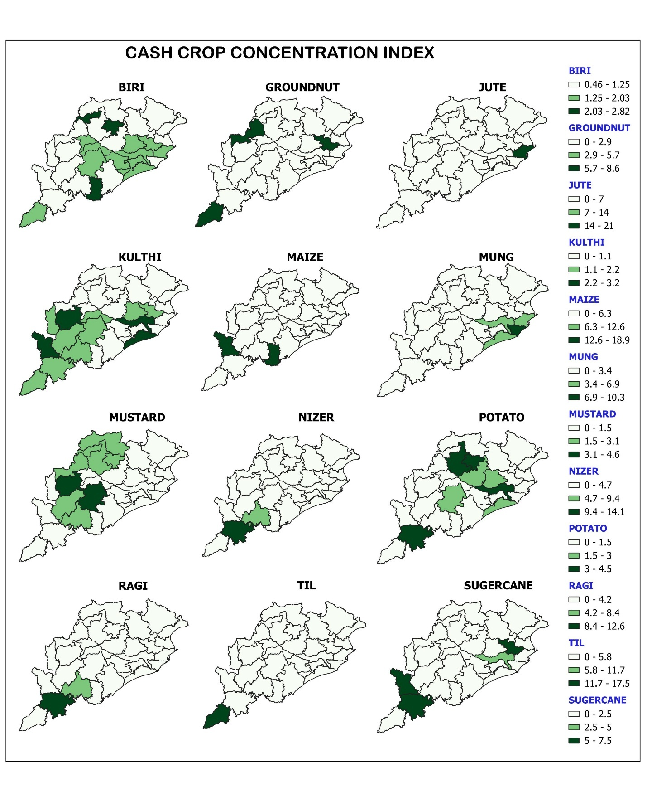Figure 5: Cash Crop Concentration Index
Potato: Out of twenty-six districts where potato is grown, three districts, Koraput (4.539), Deogarh, and Sambalpur, come under the High (3-4.5) category. Five districts, namely Cuttack, Angul, Kandhamal, Puri, and Dhenkanal, come under Medium (1.5–3), and the rest districts are under the Low (0-1.5) category.
Ragi: One of the staple foods of the tribal people of Odisha, and generally grown in the hilly tracts. 16 districts of the state where the crop is usually grown. Koraput, with a score of 12.622, falls under the High (8.4-12.6) category, while Rayagada, with a score of 5.435, falls under the Medium (4.2-8.4) category. The rest of the districts are coming under the Low ( 0 - 4.2) category.
Sugarcane: A Total of 30 district 21 districts recorded sugarcane cultivation. Three districts, Jajpur (7.534) followed by Nabarangpur (6.515), and Koraput (6.246), come under the High (5-7.5) concentration of the sugarcane district. Cuttack is the only district that falls under Medium (2.5–5), and the remaining 17 districts are under Low (0-2.5) concentration.
Til: Malkangiri with 17.543 score is the only district that comes under the High (11.7-17.5) category. The remaining 26 districts, excluding three districts, namely Nabarangapur, Jagatsinghpur, and Kandhamal district, come under the
Low (0-5.8) category.,

Table 1: District-wise crop concentration Index of Odisha in the heat map.
District | Biri | Groundnut | Jute | Kulthi | Maize | Mung | Mustard | Nizer | Potato | Ragi | Sugarcane | Til
Angul | 1.051 | 1.324 | 0.000 | 0.673 | 0.199 | 0.101 | 0.721 | 0.001 | 2.747 | 0.000 | 0.021 | 1.323
Balasore | 0.726 | 0.298 | 2.048 | 0.000 | 0.025 | 0.015 | 0.682 | 0.000 | 0.772 | 0.000 | 0.023 | 0.052
Baragarh | 0.936 | 5.996 | 0.000 | 0.421 | 0.004 | 0.898 | 2.789 | 0.000 | 1.445 | 0.027 | 0.140 | 0.353
Bhadrak | 0.590 | 0.000 | 1.501 | 0.006 | 0.152 | 0.079 | 0.112 | 0.000 | 0.062 | 0.000 | 0.076 | 0.028
Bolangir | 1.009 | 0.795 | 0.000 | 2.449 | 0.031 | 0.864 | 3.845 | 0.000 | 0.228 | 0.045 | 0.026 | 0.352
Boudh | 2.000 | 0.039 | 0.000 | 1.396 | 0.056 | 0.421 | 0.638 | 0.000 | 0.405 | 0.000 | 0.014 | 0.328
Cuttack | 1.541 | 0.653 | 6.190 | 3.229 | 0.001 | 6.436 | 0.074 | 0.000 | 3.057 | 0.000 | 4.807 | 0.001
Deogarh | 2.586 | 0.402 | 0.000 | 0.444 | 0.234 | 0.124 | 1.625 | 0.000 | 3.745 | 0.000 | 0.010 | 1.778
Dhenkanal | 1.520 | 1.310 | 0.000 | 1.398 | 0.071 | 0.386 | 0.671 | 0.000 | 1.700 | 0.000 | 0.627 | 0.418
Gajapati | 2.703 | 0.252 | 0.000 | 0.537 | 18.891 | 0.377 | 0.306 | 0.129 | 0.000 | 2.404 | 0.000 | 3.580
Ganjam | 0.460 | 0.536 | 0.000 | 0.537 | 0.115 | 1.764 | 0.031 | 0.000 | 0.118 | 0.195 | 0.324 | 1.726
Jagatsinghpur | 1.119 | 0.250 | 0.000 | 0.576 | 0.001 | 10.309 | 0.078 | 0.000 | 0.840 | 0.000 | 2.221 | 0.000
Jajpur | 1.328 | 8.551 | 3.633 | 1.468 | 0.001 | 2.035 | 0.819 | 0.000 | 1.300 | 0.000 | 7.534 | 0.003
Jharsuguda | 2.821 | 0.186 | 0.000 | 0.277 | 0.028 | 0.022 | 1.556 | 0.000 | 0.827 | 0.000 | 0.000 | 0.678
Kalahandi | 0.604 | 0.543 | 0.000 | 1.810 | 0.280 | 1.060 | 1.572 | 1.016 | 0.000 | 0.444 | 0.297 | 0.110
Kandhamal | 1.302 | 0.057 | 0.000 | 1.087 | 0.511 | 0.004 | 4.588 | 1.251 | 2.502 | 0.005 | 0.000 | 0.000
Kendrapara | 1.475 | 0.235 | 20.985 | 0.191 | 0.000 | 3.810 | 0.173 | 0.000 | 1.196 | 0.000 | 0.826 | 0.025
Keonjhar | 0.776 | 0.263 | 1.159 | 0.432 | 0.252 | 0.027 | 0.548 | 0.211 | 0.372 | 0.003 | 0.043 | 0.064
Khordha | 1.755 | 0.132 | 0.000 | 0.161 | 0.002 | 2.160 | 0.000 | 0.000 | 0.285 | 0.000 | 0.000 | 0.069
Koraput | 0.609 | 1.760 | 0.000 | 1.819 | 1.014 | 0.015 | 0.727 | 14.144 | 4.539 | 12.622 | 6.246 | 0.356
Malkangiri | 1.284 | 5.791 | 0.000 | 1.314 | 0.196 | 0.031 | 0.000 | 1.958 | 0.000 | 2.999 | 0.000 | 17.543
Mayurbhanj | 0.473 | 0.280 | 0.000 | 0.051 | 0.074 | 0.034 | 0.499 | 0.005 | 0.138 | 0.059 | 0.000 | 0.059
Nabarangpur | 0.986 | 0.257 | 0.000 | 3.202 | 15.476 | 0.037 | 0.023 | 0.078 | 0.773 | 1.058 | 6.515 | 0.000
Nayagada | 1.351 | 0.074 | 0.000 | 0.268 | 0.059 | 2.181 | 0.500 | 0.000 | 0.000 | 0.001 | 1.477 | 0.094
Nuapada | 0.908 | 0.892 | 0.000 | 1.415 | 0.772 | 0.503 | 0.293 | 0.001 | 0.016 | 0.523 | 0.057 | 1.611
Puri | 1.469 | 1.646 | 0.000 | 2.246 | 0.000 | 6.249 | 0.053 | 0.000 | 1.722 | 0.000 | 0.188 | 0.359
Rayagada | 1.111 | 0.204 | 0.000 | 2.066 | 1.315 | 0.015 | 2.208 | 4.847 | 0.162 | 5.435 | 0.000 | 2.811
Sambalpur | 1.036 | 0.008 | 0.000 | 0.730 | 0.049 | 0.167 | 2.742 | 0.000 | 3.131 | 0.002 | 0.000 | 1.060
Subarnapur | 1.702 | 0.126 | 0.000 | 0.678 | 0.013 | 0.190 | 1.194 | 0.000 | 0.022 | 0.000 | 0.000 | 0.055
Sundargarh | 0.627 | 0.352 | 0.000 | 0.681 | 0.139 | 0.052 | 1.868 | 0.020 | 1.490 | 0.013 | 0.175 | 0.455

The area under cereal cultivation is decreasing, whereas the pulses are increasing; simultaneously, food grains are decreasing, showing farmers are shifting from food grains to cash crops. (Dash et al, 2024) The same is not observed in the case of Odisha. A study on Assam state of India reveals that variation in cropping pattern across entire districts was quite significant and would seem to be indicative of either agricultural developmental activities and policies not reaching the farmers, or that policies and schemes were not implemented successfully, or that a lack of irrigation facilities and irregular rainfall are the root causes. (Baruah, et al, 2020). The estimated state-wise technical efficiency of each crop indicates that there exists a high disparity in production activities of cash crops across Indian states. Most states are found to be technically inefficient in producing optimal production, and are also incompetent to use the cropped area under cash crops proficiently. The Kerala state in the country, where agriculture is not a primary activity, despite having the highest technical efficiency in cotton, groundnut, and sesame crop production. West Bengal and Punjab are technically efficient states for producing optimum potato production. Haryana and Punjab are observed as technically efficient states to better use the cropped area under potato, cotton, groundnut, and sesame crops. All states require improvement in their technical efficiency to get better returns in cash crop farming (Singh & Bhim, 2019). Considering rural and agricultural households that primarily depend on crop production, farm size, irrigation and fertiliser consumption are the major factors that led to increased crop diversification (Kiran & Punia, 2025). Diversification to cash crops production can improve farmers economic and nutritional conditions.

Conclusion
Bhatia’s (1965) method enabled the measurement of regional crop concentration. This allowed for the identification and differentiation of areas with significance for crop distribution within the region. The crop concentration of various crops was studied across all thirty districts of Odisha, revealing the concentration index for different cash crops in various agro-climatic zones of Odisha. For example, biri is concentrated in the North Western Plateau; biri, groundnut, and kulthi are prominent in the North Central Plateau; potato and sugarcane are prevalent in the North Eastern Central Plateau; groundnut, jute, kulthi, mung, and potato are found in the East and South-Eastern Coastal Plateau; maize, mustard, nizer, and ragi are common in the North Eastern Ghat; kulthi, maize, potato, and ragi are widespread in the Eastern Ghat High Land; nizer, til, sugarcane, and groundnut are concentrated in the South Eastern Ghat; mustard and kulthi dominate in the Western Undulating Zone; biri and maize are prominent in the Western Central Tableland; and potato is mainly cultivated in the Mid Central Table Land. Policy focuses on improving income and nutrition must also consider the condition of agricultural diversification. Considering the dominance of smallholder farmers in a large part of India, with the changing cropping patterns towards high-value crops, policy needs to be designed to support them through infrastructural development and farm services, giving regional priorities in cropping patterns rather than a centralised framework. The government of Odisha has to come out with a farmer-friendly policy to promote cash crop production across the agro-ecological region, as per the cropping suitability of different cash crops.

DECLARATION OF COMPETING INTEREST
The authors declare that they have no known competing financial interests or personal relationships that could have appeared to influence the work reported in this paper.

REFERENCES
Agronika (2005), Official publication of the Government of Odisha, India for fertilizer doses. 104–108
Ankush Ramrao Gaike and Dr. Vijay Baisane (2024). Geospatial crop concentration analysis using GIS techniques in Parbhani district, International Journal of Applied Research 2024; 10(11): 17-26
Ankush Ramrao Gaike, Dr. Vijay Baisane. Geospatial crop concentration analysis using GIS techniques in Parbhani district. Int J Appl Res 2024;10(11):17-26.
Annual Report 2024-25, Department of Agriculture & Farmers Welfare, Ministry of Agriculture & Farmers Welfare, Government of India, Krishi Bhawan, New Delhi-110 001
Barik, P., & Bedamatta, R. (2024). Crop Diversification in India (1990–2016): Implications for the Eastern and Northeastern States. Asia-Pacific Journal of Rural Development, 34(1), 53-76.: doi.org/10.1177/10185291241286949
Baruah Ujjal Deka, Nitashree Mili, Manjil Basumatary, and Anup, Assessment of Spatial Pattern and Distribution of Major Crops in Assam, India Space and Culture, India 2020, 7:4 https://doi.org/10.20896/saci.v7i4.583
Baruah, U. D., Mili, N., Basumatary, M., & Saikia, A. (2020). Assessment of spatial pattern and distribution of major crops in Assam, India. Space Cult, 7, 92-108.
Bhatia, S. S. (1965). Patterns of Crop Concentration and Diversification in India. Economic Geography, 41(1), 39–56. https://doi.org/10.2307/141855
Das, M. K., Dash, S., Pattnaik, S., & Mohapatra, D. (2024). Growth and Instability in Agriculture Production in Odisha, India. Asian Research Journal of Agriculture, 17(2), 184-195.
Dasgupta, S., & Bhaumik, S. K. (2014). Crop diversification and agricultural growth in West Bengal. Indian Journal of Agricultural Economics, 69(1), 107.
Deka Baruah et al, Assessment of Spatial Pattern and Distribution Of Major Crops in Assam, India, Space and Culture, India 2020, 7:4 Page | 92 https://doi.org/10.20896/saci.v7i4.583
Department of Agriculture and Farmers’ Empowerment, Government of Odisha. (2018). AGRICULTURE STATISTICS 2018-19.
Esponda-Bernal, M. del M., Echeverri-Sanchez, A. F., Aguirre-Gonzalez, E. F., & Andrade, R. S. (2024). A biophysical suitability model to identify best areas for the cultivation of potential cash crops: The case of basil in Valle del Cauca. Agricultural Systems, 216. https://doi.org/10.1016/j.agsy.2024.103909
Giller, K. E., Delaune, T., Silva, J. V., van Wijk, M., Hammond, J., Descheemaeker, K., van de Ven, G., Schut, A. G. T., Taulya, G., Chikowo, R., & Andersson, J. A. (2021). Small farms and development in sub-Saharan Africa: Farming for food, for income or for lack of better options? Food Security, 13(6), 1431–1454. https://doi.org/10.1007/s12571-021-01209-0
Gupta, N., Kannan, E. Agricultural growth and crop diversification in India: a state-level analysis. J. Soc. Econ. Dev. 26, 709–733 (2024). https://doi.org/10.1007/s40847-023-00311-7
Hajdu, F., Granlund, S., Neves, D., Hochfeld, T., Amuakwa-Mensah, F., & Sandström, E. (2020). Cash transfers for sustainable rural livelihoods? Examining the long-term productive effects of the Child Support Grant in South Africa. World Development Perspectives, 19. https://doi.org/10.1016/j.wdp.2020.100227
Hashmiu, I., Agbenyega, O., & Dawoe, E. (2022). Cash crops and food security: evidence from smallholder cocoa and cashew farmers in Ghana. Agriculture and Food Security, 11(1). https://doi.org/10.1186/s40066-022-00355-8
Hoda, A., Gulati, A., Wardhan, H., & Rajkhowa, P. (2021). Drivers of Agricultural Growth in Odisha (pp. 247–278). https://doi.org/10.1007/978-981-15-9335-2_9
Hoda, A., Rajkhowa, P., & Gulati, A. (2017). Transforming agriculture in Odisha: Sources and drivers of agriculture growth (No. 337). Working Paper.
Jena, C., Kumar, P., & Kumar Panda, P. (2020). Prospect of cashew cultivation in Odisha: A review. ~ 430 ~ Journal of Pharmacognosy and Phytochemistry, 9(2), 430–433.
Kebede, E. (2020). Grain legumes production and productivity in Ethiopian smallholder agricultural system, contribution to livelihoods and the way forward. In Cogent Food and Agriculture (Vol. 6, Issue 1). Informa Healthcare. https://doi.org/10.1080/23311932.2020.1722353
Khan, N., Ma, J., Kassem, H. S., Kazim, R., Ray, R. L., Ihtisham, M., & Zhang, S. (2022). Rural Farmers’ Cognition and Climate Change Adaptation Impact on Cash Crop Productivity: Evidence from a Recent Study. International Journal of Environmental Research and Public Health, 19(19). https://doi.org/10.3390/ijerph191912556
Khatiwada, S. P., Deng, W., Paudel, B., Khatiwada, J. R., Zhang, J., & Su, Y. (2017). Household livelihood strategies and implication for poverty reduction in rural areas of central Nepal. Sustainability (Switzerland), 9(4). https://doi.org/10.3390/su9040612
Kiran, R., & Punia, M. (2025). Land Use Pattern, Crop Diversification and Crop Combination Regions: A District-level Study in Rajasthan. Journal of Land and Rural Studies, https://doi.org/10.1177/23210249251328842
Kushawaha, M., Yadav, A. K., & Pandey, D. C. Agricultural Regionalization through Measurement of crop concentration in Kushinagar District, Uttar Pradesh, Journal of Acharaya Narendra Dev Research Institute, Vol-27 (Jan 2019-Jun 2019), 68-77
Li, E., Deng, Q., & Zhou, Y. (2022). Livelihood resilience and the generative mechanism of rural households out of poverty: An empirical analysis from Lankao County, Henan Province, China. Journal of Rural Studies, 93, 210–222. https://doi.org/10.1016/j.jrurstud.2019.01.005
Li, J., Zhang, Z., Jin, X., Chen, J., Zhang, S., He, Z., Li, S., He, Z., Zhang, H., & Xiao, H. (2018). Exploring the socioeconomic and ecological consequences of cash crop cultivation for policy implications. Land Use Policy, 76, 46–57. https://doi.org/10.1016/j.landusepol.2018.04.009
LI, M., Gan, C., MA, W., & Jiang, W. (2020). Impact of cash crop cultivation on household income and migration decisions: Evidence from low-income regions in China. Journal of Integrative Agriculture, 19(10), 2571–2581. https://doi.org/10.1016/S2095-3119(20)63161-6
Liansangpuii, F., Panigrahi, B., & Paul, J. C. (2019). Assessment of meteorological drought by standardized precipitation index for coastal agro-climatic zones of Odisha, India. Indian Journal of Soil Conservation, 47(3), 205-212.
Llopis, J. C., Diebold, C. L., Schneider, F., Harimalala, P. C., Patrick, L., Messerli, P., & Zaehringer, J. G. (2020). Capabilities Under Telecoupling: Human Well-Being Between Cash Crops and Protected Areas in North-Eastern Madagascar. Frontiers in Sustainable Food Systems, 3. https://doi.org/10.3389/fsufs.2019.00126
MA Ji-liang, LI Fan, Zhang Hui jie, & Khan Nawab. (2022). Commercial cash crop production and households’ economic welfare: Evidence from the pulse farmers in rural China. Journal of Integrative Agriculture, 21(11), 3395–3407. https://doi.org/10.1016/j.jia.2022.09.006
Meher MK, Pattnaik S, and Digal BK. 2025. “Role of Women in Agriculture With Special Reference to WSHGs”. Archives of Current Research International 25 (6): 15–26. https://doi.org/10.9734/acri/2025/v25i61247.
MC, S. C., Chandran, R., Sahib, P. R., & Achuthan, K. (2024). Sustainable livelihoods through cashew cultivation: insights from smallholder farmers in the southern region of India. Discover Sustainability, 5(1). https://doi.org/10.1007/s43621-024-00558-y
Meher M.K. & Sethy, K.M. (2012) Farmers' Decision on Cropping Pattern: A Case Study of Bagh Barrage Command Area of Boudh District, Odisha, India, Eastern Geographer XVIII.1 151-156
Meher M.K. & Sethy, K.M. (2013) Land Use Planning for Agricultural Development in Bagh Barrage Command Area of Boudh District, Odisha, Eastern Geographer XXVI.1 167-176
Melcy Lily Dias, (2017) A Geographical Analysis of Crop Concentration in Goa, IOSR Journal of Humanities And Social Science (IOSR-JHSS) Volume 22, Issue 8, Ver. 9, 50-55
Mishra, S., & Behera, A. R. (2022). Effect of Crop Rotation on Profitability of Paddy Production in Odisha: An Empirical Analysis. Asian Journal of Advances in Agricultural Research, 19(4), 19–27. https://doi.org/10.9734/ajaar/2022/v19i4382
Mohapatra, B. K. (2016). An Overview of Irrigation Scenario in Odisha: Planning is in the Right Direction-its Effective Implementation is the Key for Agricultural Development. Indian Journal Of Research, 5(8), 75–79.
Moharaj, P., & Rout, S. (2021). Changing Climatic Conditions and Agricultural Livelihoods: An Impact Study in Jagatsinghpur District, Odisha. Social Change, 51(2), 160–179. https://doi.org/10.1177/0049085720924362
Mujeyi, A., Mudhara, M., & Mutenje, M. (2021). The impact of climate smart agriculture on household welfare in smallholder integrated crop–livestock farming systems: evidence from Zimbabwe. Agriculture and Food Security, 10(1). https://doi.org/10.1186/s40066-020-00277-3
Nandi, R., Krupnik, T. J., & Kabir, W. (2024). Crop diversification in Bangladesh: Public policy provisions, practices, and insights for future initiatives. In Journal of Agriculture and Food Research (Vol. 18). Elsevier B.V. https://doi.org/10.1016/j.jafr.2024.101486
Ochieng, J., Knerr, B., Owuor, G., & Ouma, E. (2020). Food crops commercialization and household livelihoods: Evidence from rural regions in Central Africa. Agribusiness, 36(2), 318–338. https://doi.org/10.1002/agr.21619
Pattanayak, U. (2018). A Study on Irrigation and Agricultural Productivity in Odisha. Economic Affairs, 63(2). https://doi.org/10.30954/0424-2513.2.2018.4
Pinstrup-Andersen Per and R. Padya-Lorch. 1999. Food Security: Global Perspective. In Peters G.H. and J. Von Braun, (eds.) Food Security, Diversification and Resource Management: Refocusing the Role of Agriculture. USA: Ashgate
Pretty, J. (2008). Agricultural sustainability: Concepts, principles and evidence. In Philosophical Transactions of the Royal Society B: Biological Sciences (Vol. 363, Issue 1491, pp. 447–465). Royal Society. https://doi.org/10.1098/rstb.2007.2163
Pyone, K. H. H., Crego, R. D., Ngwe, S. S., Win, S. Di, Connette, K. L. J., Songer, M., & Connette, G. M. (2024). Understanding the transition of community land use from shifting cultivation to cash cropping in southern Tanintharyi, Myanmar. People and Nature, 6(3), 1130–1142. https://doi.org/10.1002/pan3.10631
Rani, P., & Sahoo, A. K. (2023). Assessment of Productivity and Crop Diversification Pattern in Punjab Agriculture. Arthaniti: Journal of Economic Theory and Practice, 22(2), 251-270.
Ray, P. (2022). Crop Concentration and Crop Diversification in Birbhum District of West Bengal: Recent Situations. Agricultural Reviews, 43(2).
Roberts, Michelle S. "Understanding farmer decision making in Northern Lao PDR." Culture, Agriculture, Food and Environment 37.1 (2015): 14-27.
Rout, R. K., Behera, S., Padhiary, A., Nanda, P. K., Nayak, A., Behera, D., & Das, T. (2017). A Study on Resource Use Efficiency of Sugarcane Farms: Evidence from Village Level Study in Orissa, India. International Journal of Current Microbiology and Applied Sciences, 6(11), 1955–1962. https://doi.org/10.20546/ijcmas.2017.611.232
Rubhara, T. T., Mudhara, M., Oduniyi, O. S., & Antwi, M. A. (2020). Impacts of cash crop production on household food security for smallholder farmers: A case of Shamva District, Zimbabwe. Agriculture (Switzerland), 10(5). https://doi.org/10.3390/agriculture10050188
Rupananda W. (2012) "Cash Crop Cultivation and Rural Food Security: A Case Study of Agricultural Promotion Zone in Moneragala District of Sri Lanka." Asia-Pacific Journal of Rural Development 22.2: 35-56.
Sekaran, U., Lai, L., Ussiri, D. A. N., Kumar, S., & Clay, S. (2021). Role of integrated crop-livestock systems in improving agriculture production and addressing food security – A review. In Journal of Agriculture and Food Research (Vol. 5). Elsevier B.V. https://doi.org/10.1016/j.jafr.2021.100190
Shah, D. (2023). Millet Economy of Odisha: How Far It is Viable and Sustainable? Indian Journal of Agricultural Economics, 78(3), 515–526. https://doi.org/10.63040/ijae.vol.78.issue.03.014
Singh, A. K., & Jyoti, B. (2021). Projected Productivity of Cash Crops in different Climate Change Scenarios in India: Use of Marginal Impact Analysis Technique. Finance & Economics Review, 3(1), 63–87. https://doi.org/10.38157/finance-economics-review.v3i1.281
Singh, Ajay Kumar & Bhim Jyoti, (2019) Measuring the Climate Variability Impact on Cash Crops Farming in India: An Empirical Investigation, Agriculture and Food Sciences Research Vol. 6, No. 2, 155-165, 2411-6653 DOI: 10.20448/journal.512.2019.62.155.165
Tafida, A., Michael, A., & Nandagoyang, M. (2022). Analysis of Livelihood of Rural Irrigated Crop Farmers in Kano State, Nigeria. Zeszyty Naukowe SGGW w Warszawie - Problemy Rolnictwa Światowego, 22(2), 57–64. https://doi.org/10.22630/prs.2022.22.2.8
Thongdok, N. J., Satib, V. P., & Kumarc, V. The Role of Cash Crops in Enhancing Livelihood in Arunachal Himalaya, Food & Agribusiness Management (FABM) 6(1) (2025) 26-34, DOI: http://doi.org/10.26480/fabm.01.2025.26.34
UNDP (2019) https://www.undp.org/
Vongvisouk, T., Broegaard, R. B., Mertz, O., & Thongmanivong, S. (2016). Rush for cash crops and forest protection: Neither land sparing nor land sharing. Land Use Policy, 55, 182–192. https://doi.org/10.1016/j.landusepol.2016.04.001
Yahya TMBT (2001) Crop diversification in Malaysia. In: Papademetriou MK, Dent FJ (eds) Crop Diversification in the Asia-Pacific Region. Bangkok, Thailand: Food and Agriculture Organization of the United Nations, Regional Office for Asia and the Pacific, pp. 64–71.
Yiridomoh, G. Y., Der Bebelleh, F., Ziem Bonye, S., & Dayour, F. (2021). Women in ginger production and livelihood sustainability in rural Ghana: an explorative study. Local Environment, 26(9), 1051–1069. https://doi.org/10.1080/13549839.2021.1952967
Zaehringer, J. G., Lundsgaard-Hansen, L., Thein, T. T., Llopis, J. C., Tun, N. N., Myint, W., & Schneider, F. (2020). The cash crop boom in southern Myanmar: tracing land use regime shifts through participatory mapping. Ecosystems and People, 16(1), 36–49. https://doi.org/10.1080/26395916.2019.1699164

