Towards Earthquake Predictability: A Seismo-Ionospheric Approach Using TEC Anomalies and ARIMA Forecasting

Abstract
Earthquakes have always been a permanent threat to humanity. Monitoring the earthquake precursors using space-based methods can be a new introduction to earthquake studies. The promising analysis of the earthquake precursors such as Ionospheric Perturbations is based on the detection of Ionospheric electron content. Within approximately 3 weeks before an event, negative TEC anomalies have been witnessed. A careful examination of solar and geomagnetic perturbations has been done to ensure that TEC fluctuation in the ionosphere over the investigated time period can be attributed solely to the seismic activity within the earth. Major tectonic plate boundaries, 2-D maps of global ionospheric anomalies, and Earthquake Preparation Zone have all been considered in order to evaluate the TEC fluctuations in the spatial domain during the time leading up to the earthquake. Statistical ARIMA model is used in order to give the backup for the data availability which matches with the data derived from the IGS. 2-D zone-time series LLT maps show how anomaly is spreading in the nearest fault position and EPZ.
Keywords: Earthquake Precursors, Ionospheric Anomalies, Seismo-ionospheric perturbation, Total Electron Content, GIM.

Introduction
Earthquake is one of the most dangerous natural calamities, originating from surging tectonic stress; it can cause moderate to disastrous (catastrophic) widespread damages and loss of human life. A new theory for earthquake forecasting still is an immature science that can be further developed using the theory of earthquake precursor. However, several new remote sensing methods have achieved success in scientifically forecasting earthquakes. Monitoring of the earthquake precursors can be a new introduction to earthquake studies which is increasing due to the availability of satellite images and space methods rather than conventional methods (Tronin, 2005). The promising methods of the earthquake precursor studies using space-based monitoring methods as Ionospheric Perturbation Analysis based on the detection of Ionospheric electron content (Rathje & Adams, 2008). The study of seismo-ionospheric anomaly variation before large earthquakes (Mw > 5) has been treated as a new attractive technique for several years. Results from monitoring seismically endangered regions using the method of detection of Total Electron Content (Ionospheric Perturbation) are presented in this study work. The feasibility of using this method is predicated on the idea that the ionospheric total electron content are strongly connected with the seismic zone and respond to changes in the pre-seismic pattern. The main ionosphere regions are divided into various layers, like - D, E, F1 and F2 which are made up of electrons and ions. With the help of the Total Electron Content (TEC) parameter, one can calculate electron concentration. TECu is used as a TEC unit that equals 10¹⁶ Line-of-sight (LOS) of 10¹⁶ electrons in a cylinder with a base area of 1 meter square. TEC variations are used to indicate the influence of the ionosphere on the GPS satellites' signals as they travel towards Earth. The carrier phase delay of the received radio signals from satellites that are above the ionosphere essentially serves as a marker for it. The location of the receiving station, geomagnetic storm, and solar activity all have a significant impact on the TEC variation (time-space). The geomagnetic storm develops currents and energy, increasing the TEC or the quantity of ionospheric electrons. (Danilov & Berbeneva, 2021). The energy from the solar wind dissipates into the thermosphere and ionosphere during a geomagnetic storm, and the ionosphere's energy transport changes dramatically and becomes more challenging (Hargreaves, 1992). When a storm occurs, this magnetosphere-ionosphere coupling causes the electron density to vary more. As a result of the Sun's energy release and EMR's interference with ion formation in the ionosphere, which delays GPS signals in the ionospheric region, these phenomena have an impact on radio communications and navigation.
Lithosphere-Ionosphere Coupling
The extreme tectonic stress breaks the "Peroxy Bonds" and activates the "h•" charge and the electrons. These "h•" are movable and can spread from the compressed rock and to the nearby volume of unstrained rock; and the electrons are trapped at the locations of 'Peroxy bonds' that broke. (Freund, 2013). These carriers of positive charge reach the planet's surface, a powerful positive E field develops there, eventually ionising the molecules of the atmosphere. O2 creates positive airborne ions for field ionisation because it has a comparatively low ionisation threshold. The rock surface produced aerial ions. at the rate of 10⁷ – 10⁹ /s/cm² (Freund, 2013). The internal electrostatic repulsion tends the positive air bubble to expand in the upward direction which accelerates more by the prevailing E field. When this air bubble reaches the atmosphere and acts as condensation nuclei due to relative humidity. Hence, forms water droplets and clouds. During this condensation latent heat released which increases the air temperature. The risen air temperature produces thermal anomalies found in satellite infrared images (LST). Due to peroxy defect the massive portion of charged particles migrate upward as a result of air ionisation. This phenomenon causes flow of vertical current for upward migration of the charged particles. Hence, a downward pull of electrons produces electromagnetic anomalies in the lower portion of the ionosphere layer, which impact the ionosphere plasma perturbation. As this perturbation also alters due to geomagnetic activities, solar storms, and magnetic storms; these anomalies should be excluded from the detection of signals which are only due to earthquakes (Storm, 2020). The presence of a geomagnetic storm induces the TEC which reduces prior to any significant earthquake (Mw > 5). As a result, the TEC value should be associated when geomagnetic activity is present, yet the TEC value is steeply declining, which must be taken into consideration as an earthquake precursor (Kumar, 2021). So, for the ionosphere anomalies, the solar terrestrial environment must be considered and compared with the TEC. The main drawback of using the GPS (IGS) derived data is its availability. It has a delay of 3-5 days (CODG or CORG format) which may cause an unnoticed perturbation prior to an earthquake. Statistical variations confirm the reduction of TEC values prior to an earthquake, which is going to be independent of the solar-terrestrial environment (solar flare and magnetic storm). In order to overcome it, to make the data real-time statistics based ARIMA model is used to ensure the data availability backup (Saqib et al., 2021), and has proved to be very effective in monitoring the ionospheric TEC perturbation. This made it possible that without a delay of a single day, the seismo-ionospheric coupling and the degree of its variation can be ensured.
The objective of the work is the early detection of earthquake precursors over the epicentre zones by- 1) Identifying and analysing real-time Global Ionospheric Perturbation in the spatial domain (2-D GIM), 2) Real-Time TEC forecast using statistical ARIMA model prior to an Earthquake in the Earthquake Preparation Zone.
STUDY AREA
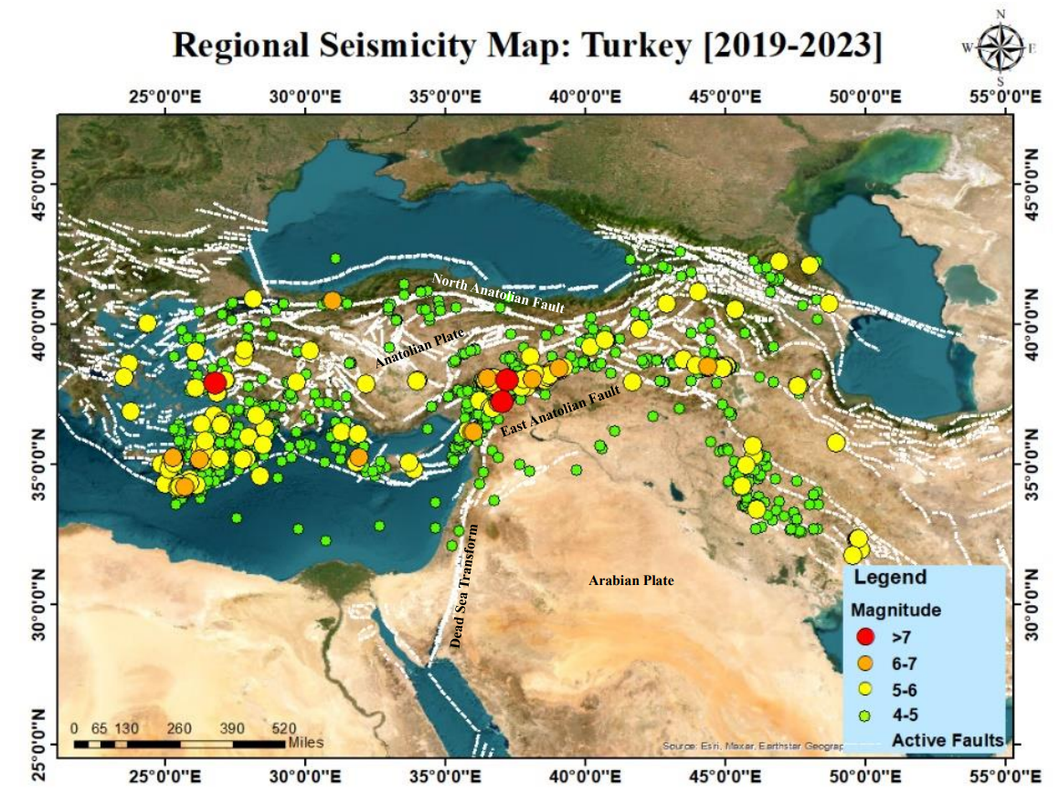
This work identified the devastating earthquake at Turkey (Gaziantep, 37.166⁰ N, 37.032⁰ E, 6th February 2023; Mw 7.8) falling under the UGSG Prompt Assessment of Global Earthquakes for Response (PAGER) criteria alert levels. The Seismic Map shows all the epicentres (Mw > 4) are concentrated within the three-active fault zone (Dead Sea Transform, North Anatolian, and East Anatolian Fault) and rest are surrounded by them between the Anatolian and Arabic Plate. As there is an interaction between three tectonic plates: prone to earthquakes. At the Marash Triple Junction, the DST and EAF come together. The North Anatolian Fault Zone is one of the most important geological factors causing earthquakes in Turkey. The fault is characterised by several strike-slip faults, which happen when the two sides of the fault slide past one another horizontally and cause earthquakes. The earthquake affected southern and central Turkey as well as northern and western Syria on February 6, 2023, at 04:17 TRT (01:17 UTC). The epicentre was located 23 miles (37 km) west-northwest of Gaziantep. At 13:24, a Mw 7.7 earthquake struck in its wake. The second quake's centre was 95 kilometres (59 miles) to the north-northeast of the first. There was significant devastation, and thousands of people died.
PICTURE 1. Regional Seismicity Map: Turkey [2019-2023]

DATASET & METHODOLOGY
Total Electron Content
As an additional GNSS observational product, global ionosphere maps (GIM) are regularly produced by analysing the so-called geometry-free linear combination, which contains data on ionospheric refraction through a series of spherical harmonics using a single-layer model in a Sun-fixed reference system (Schaer et al., 1995). It makes use of ionosphere-related range delays. The Center for Orbit Determination in Europe (CODE) GIM file exchange format, which represents TEC in

the geographical grid with a spatial resolution of 2.5° (latitude) 5° (longitude) points, with a temporal resolution of 1 hour was introduced in 1998. NASA also regularly provides the same information to an anonymous ftp server (ftp:/cddis.gsfc.nasa.gov). By interpolating all of the regional data obtained at more than 280 IGS stations utilising more than 50 GNSS (Global Navigation Satellite Systems) satellites, it is possible to obtain TEC readings for the entire planet (Thammaboribal et al., 2022). The data is presented in IONEX format and contains the TEC values for each grid point (71 X 73=5183), the grid point's geographic coordinates, and the time stamp of the observation. The work was done by using collected data continuously for forty-five days before the earthquake. The data used in the present study is accessible to the public through the server hosted at http://ftp.aiub.unibe.ch/. The data provides the ionospheric variation of TEC for the 24 epochs in a day, allowing investigation of the ionospheric TEC variations over the globe with spatial variations as well as over the near epicentre areas.
Geomagnetic storm and solar activity
TEC measurements can be significantly impacted by solar and magnetic storms. TEC variations can occur when the sun discharges a rush of charged particles, such as electrons and protons, during a solar storm. A rise in electron density may result in an increase in TEC, whereas a fall in electron density may result in a fall in TEC. While TEC measurements can also be impacted by solar winds, magnetic storms happen when the Earth's geomagnetic field is perturbed. During a magnetic storm, the Earth's magnetic field may become perturbed, which may lead to changes in the ionosphere's electron density and, as a result, changes in TEC (Dutta et al., 2019). The level of both phenomena on anomalous days must be studied in order to determine if the TEC anomaly is caused by such phenomena or the earthquake preparation process. The severity of the geomagnetic storm, the condition of the ionosphere, and the location and time of the observation are some of the variables that might affect the complex relationship between the TEC and indices. However, because of the electric field and ionospheric plasma redistribution, it is generally assumed that the TEC values will rise during a geomagnetic storm. In order to exclude the influence of geomagnetic storms and solar activities from the ionospheric disturbance, the levels of such phenomena were monitored from the server https://omniweb.gsfc.nasa.gov/. The NSSDC OMNI data set can be browsed and retrieved using OMNIWeb, a Web-based tool. The default access resolution for the data is stored as hourly averaged values (24 records per day).
CHART 1. Solar and Geomagnetic Activity Classification by Space Weather Indices
Weather | Kp Index | Dst Index | Ap Index | F10.7 Index
Quiet | 0-1 | >(-20nT) | < 5 | <70
Unsettled/  Slightly  Active | 2-3 | (-20nT) - (50nT) | 5 – 15
Active/  Moderate | 4-5 | (-50nT)-(-100nT) | 15 – 30 | 70-120
Minor  Storm | 6-7 | (-100nT)-(-250nT) | 30 – 50
Major/  High  storm | 8-9 | (-250nT)-(-400nT) | 50 – 100 | >120
Severe |  | <-400nT | > 100

CHART 2. Software Used
Software | Remarks
Notepad ++ | Data viewing, Inspection, Cleaning, Pre-processing, Extraction, Retrieve specific data points or extract subsets of TEC data for further analysis
MATLAB R2022a | Reading, writing data files: IONEX formats, Data format exchange: To import the IONEX format TEC data into MATLAB variables, Data Processing and Analysing: binding, Model Identification: autocorrelation function (ACF) and partial autocorrelation function (PACF), Model Forecasting, Visualization and Evaluation: (RMSE) Model Refinement and Iteration.
ArcGIS 10.3 | Data Interpolation and Visualization
Microsoft Excel | Data Calculations, Data Visualization: Time Series TEC visualization with confidence interval

Using the suggested datasets, the following methodology is used to detect seismo-ionospheric anomalies before earthquakes occur:
Earthquake preparation zone determination
According to the formula suggested by Dobrovosky et al. and expressed in Eq. (1), the earthquake preparation zone (EPZ) was established.
R = 10^{0.43M …………………………………………………………}(1)
where,
M; Moment magnitude of the earthquake,
R; radius of the earthquake preparation zone (in kilometres) measured from the epicenter (Sharma, 2022).
When an earthquake occurs, information on its magnitude, epicenter location, date, and time can be found online from Shakemap, a service offered by the United
CHART 3.States Geological Survey (USGS), at https://earthquake.usgs.gov/.
Date & Time | 6 Feb 2023; 04:17 TRT
Epicentre | Sehitkamil, Gaziantep
Depth | 10 km
Lat & Long | 37.166⁰ N, 37.032⁰ E
Earthquake Preparation Zone (EPZ) 100.43M | 2260 km
Magnitude | 7.8
Intensity | XII (Extreme)
TEC Anomaly Detection
The GIM files were processed one month before the occurrence of the main events. Graphical analysis of hourly TEC variation data at a grid point near the epicentre was done in relation to the median and standard deviation of the 15-day prior event. The maximum and minimum TEC variation is fixed at a confidence level of 82%. The lower (LB) and upper (UB) bounds are defined by equations 3 – 4 to state the level of the divergence:
Lower Bound = M(RM) – 1.34s ………... (3)
Upper Bound = M(RM) + 1.34s ………... (4)
where, M(RM); Running Median,
s; Standard Deviation.
According to the divergence of 1.34, anomalies are identified with a confidence level of roughly 82% for TEC values that are assumed to be distributed normally with M and s. Anomalies are classified as positive or negative depending on whether the observed TEC exceeds UB or LB. The TECs that have been seen in UB or LB point to normal circumstances. To rule out any potential contributions from magnetic storm and solar flare data, the unusual values were also cross-checked with those sources of data. To get a sense of the space weather, magnetic storm and solar storm (identified by the letters Dst, Kp, Ap and F10.7, respectively) are measured. It has been determined that the space weather can be considered quiet, meaning that there is no magnetic storm or solar storm, if the Ap < 35, the F10.7< 85, the Kp < 5, and Dst > -50. The TEC concentration was examined in relation to the nearest plate border and the earthquake epicentre for the days that were anomalous (as probable zone of earthquakes). Using the same upper and lower bounds, the anomaly is also discovered in the spatio-temporal domain, and it is typically found close to the epicentre and the nearest plate boundary. Hence, based on TEC high and gradient on anomalous days, distance to nearest plate boundary, and repetition of the anomaly on subsequent anomalous days, an attempt was made to correlate the TEC anomaly with the epicenters. The TEC data provides hourly TEC values (0-24 hour), having a data point of 5134 (Grid 71 X 73) for each day. These daily data ( 5134 X 24 hour = 129575 Data point) are then will be used for TEC time series to conclude the TEC variations considering the effect of geomagnetic and solar environment (Ap, Kp, Dst, F10.7). The TEC values which cross the lower bound will be flagged as anomaly (negative anomaly) due to earthquake, if is not correlated with the geomatic and solar environment. The TEC anomaly highlighting the EPZ zone will be focused more to attain a zone of influence which specify the epicentral zone.
Real-time TEC prediction using ARIMA Model
The goal of this project is to establish a statistical perturbation of the TEC levels prior to earthquakes, which should be independent of the solar terrestrial environment (solar flare and magnetic storm). Also, using the 2D Latitude- Longitude Time (LLT) TEC anomaly maps, an epicentral zone can be mapped with a high degree of accuracy. This model has proven to be quite successful in tracking the ionospheric TEC perturbation (Dutta et al., 2019). This allowed the seismo-ionospheric connection and the degree of its change to be guaranteed without a delay of even one day. The ARIMA model was trained on historical TEC data and used to forecast future values of TEC after the best model parameters have been identified. The anticipated TEC values and the related confidence intervals (82%), which give a sense of how certain the predictions are, are included in the model output. Time series data analysis and modelling often involve the use of autocorrelation and partial autocorrelation functions, notably for ARIMA models. The correlation coefficients between the time series and its lagged values at various time lags are plotted in the autocorrelation function (ACF), specifically. A significant ACF value at a given lag signifies that the time series and its lagged value at that lag have a strong correlation. Partial autocorrelation (PACF) measures the correlation between a time series and its lagged values while taking into consideration the influence of intermediate lags. By applying differencing techniques, seasonality in time series data is eliminated using ARIMA models. In the differencing process, the difference between the present observation and a previous observation is calculated. The autocorrelation and partial autocorrelation functions (ACF and PACF) of the differenced data can be used to calculate the values of p, d, and q

parameters for the ARIMA model after the ARIMA model has been fitted to the differenced time series data. Utilising the ARIMA model, the prediction will be based on the seasonality removed from the differenced data. The ARIMA model will train the past data and these training will forecast the Real-Time TEC, where the training data and test TEC data was
divided into 15:1 ratio. After establishing the parameter values for ARIMA, the model is trained using the training dataset and used a fitted model on the testing dataset to project TEC values for the following 15 days. In order to evaluate the performance of the ARIMA, running median (RM), a traditional anomaly detection technique for seismo-ionospheric studies, was applied to the TEC time series. In the RM approach, the distribution moments mean (M) or median (M) are used to model the TEC times series, and the standard deviation (σ) or interquartile ranges (IQR) are used to define anomalies. The medians of TEC values during the previous 15 days were computed to find the difference from the observed TECs of the 16th day. To clearly see anomalies, errors were calculated by comparing actual and predicted TEC values. An error matrix will show the RMSE error of the test statistic, which will justify the capability of the model.

RESULTS & DISCUSSIONS
The Hourly- TEC Time Series
TEC information can be displayed as a time series that illustrates how TEC values alter over the course of time at a certain location or along a specific path. Since TEC values are ranging from 0 hours (UTC 0:00 hours, TRT 03:00 AM) to 24 hours (UTC 23:00 hours, TRT 2:00 AM), only the daytime TEC is considered to justify only the true anomalies. From 25th to 1st January, the continuous TEC time series plot reveals considerably (lower) TEC values. Here, there are several negative anomalies, but the two days with the highest negative anomalies are on 27th and 28th January. These negative anomalies were found to be around -15 and -14 TECu respectively. To rule out any potential involvement of solar activity and a geomagnetic storm during 10th January to 8th February 2015 four indices were analysed (Figure). The below figure revealed the presence of high continuous solar storm is there for the entire duration as the Time-Series (Figure.) due to high value of F10.7 (>120units). No geomagnetic storm was detected except for 14th and 15th January (Ap > 30). Therefore, all the negative anomalies were considered for the entire 30-day TEC Time-Series due to the influence of solar activity was included continuously. The anomalies were showed with the grey columns corresponding with the Dst, Ap, F10.7 & Kp indices (Figure). Thus, showing a negative TEC anomaly 4, 5, 6, 7, 8, 9, 10, 11, and 12 days before the main shock on 6th February 2023. From the time series highest negatives anomalies were highlighted along with its UTC time in the Figure by considering anomalies lie below the confidence interval.
Global Ionosphere Map (Latitude-Longitude-Time Map):
The shifting of the anomalous zone is found to be in the direction of North-East; which might be correlate the present of active faults direction. The major concern for Turkey-Syria earthquake was about strike slip fault of East Anatolian Fault and Dead Sea Transform which were on a North-East direction. In a strike-slip fault the dominant movement occurs horizontally along the fault plane, with minimal vertical displacement. While the direct vertical displacement is limited, the associated stress and strain within the lithosphere can indirectly affect the ionosphere thus affecting the direction of the TEC perturbations. The stress accumulation and release along the fault plane can lead to the generation of secondary phenomena, such as aftershocks (Mw 7.8 after the main shock Mw 7.5) have a more significant impact on TEC distribution; produces larger ionospheric perturbations. Thus, the spreading of the anomalous zone towards the north and north-east of the actual epicentre is because of the North-East orientation of the Strike Slip Faults; thereby proving the theory of seismoionospheric coupling. The entire zone is revealed to be a prelude to both impending large magnitude earthquakes by the TEC anomalies that were discovered to be covering and coinciding with negative anomalies.

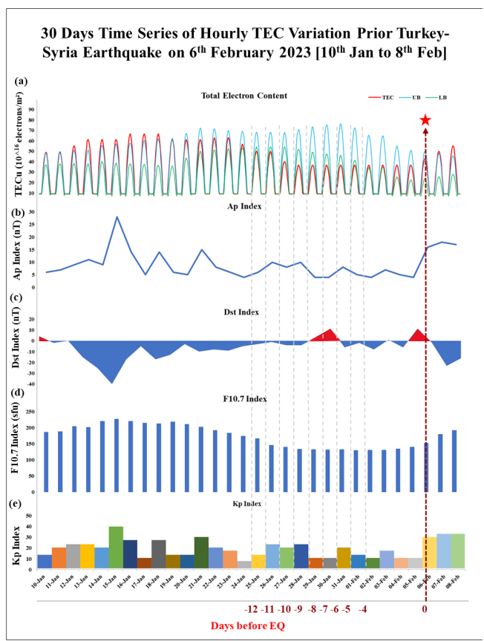
FIG 1. 30 Days Time series of Hourly TEC Variation prior Turkey-Syria Earthquake on 6th February 2023[10th Jan- 8th Feb]

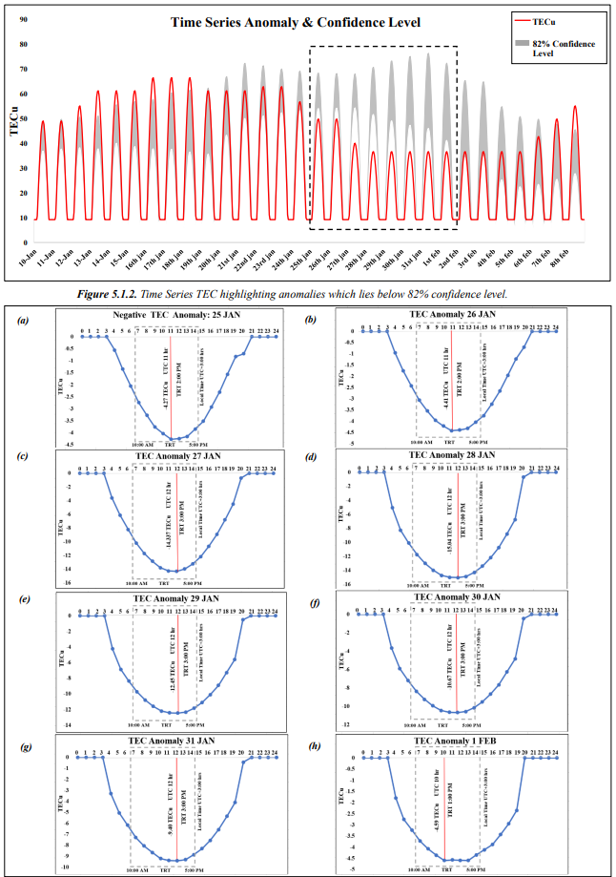
FIG 2. TEC Anomaly

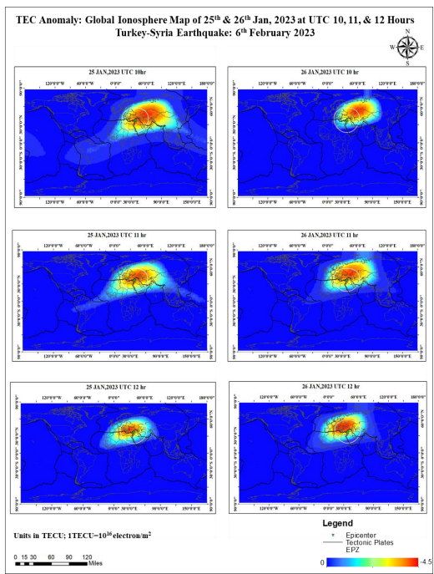

FIG 3.

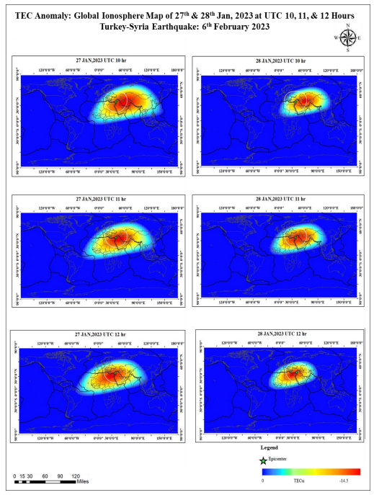
FIG 4. TEC Anomaly: Global Ionosphere

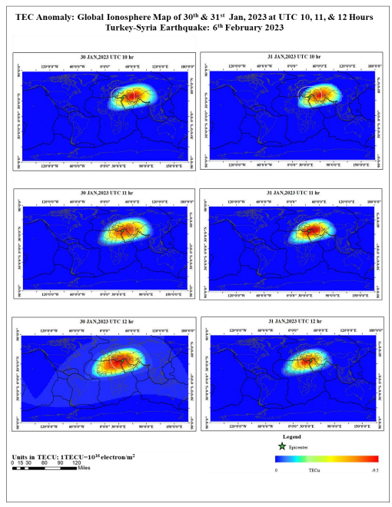
FIG 5. Global Ionosphere TEC Anomaly Maps for 30th and 31st January 2023

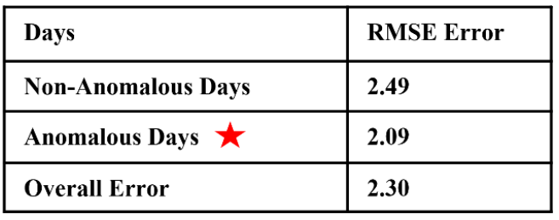

Real-Time TEC forecast using ARIMA Model
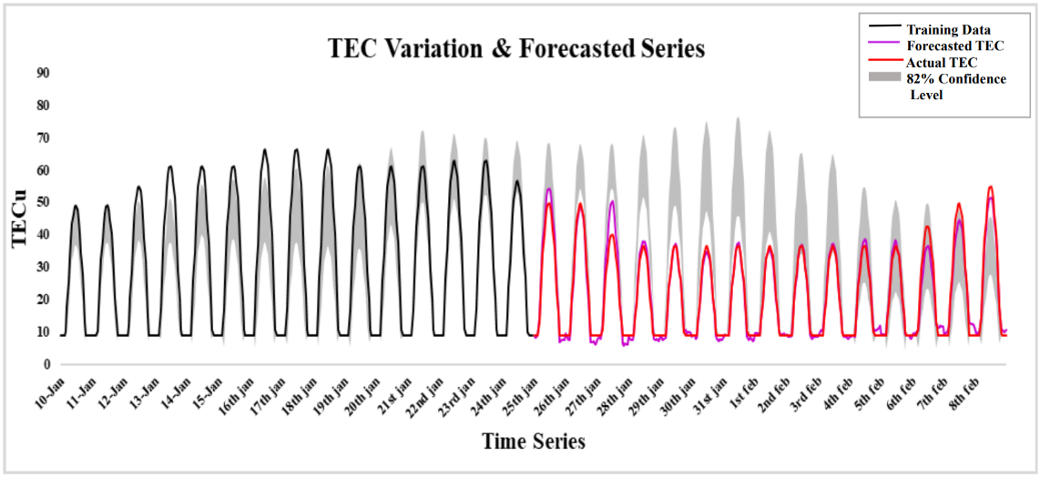
This statistical ARIMA model is used to analyse the devastating Turkey-Syria earthquake that occurred on February 6, 2023. I also attempted to correlate the global ionospheric TEC anomaly map (LLT) in spatial domain considering the closest plate boundaries utilising both the TEC data from GPS (IGS) produced as well as statistics based ARIMA Model with a high degree of accuracy. Below figure (Figure ) represents the training data from where the forecasted TEC is deducted using ARIMA Model.
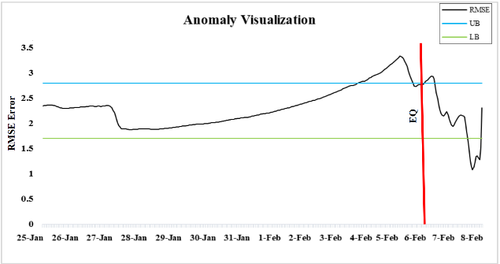

Fig.7 Anomaly Visualization
TABLE 1

The forecasted TEC data plotted with the training data shows a good correlation with the actual TEC value with a RMSE error calculated as 2.09 for anomalous days and 2.49 for the non-anomalous days (Figure). The average RMSE error for forecasted TEC value is found to be 2.30, which justifies a good result with a 15:1 dataset ratio. The Figure . shows the RMSE error along with upper and lower bound and found to be crossed the upper bound on 4 th,5th, and 6th February and lower bound at 8
th February. The error ranges show in below table .

Fig.6: TEC Variation & Forecasted series

Result shows,
E (Non-anomalous Days) > E (Anomalous Days)
E: Error

CONCLUSION
The goal of this paper was to find a possible correlation between the earthquake and TEC anomalies, and to forecast the TEC data using ARIMA Model. It has been observed that the ionospheric abnormalities covered in this research work typically occurred one to two weeks before the events. The ionospheric anomalies (in the F2 region) discussed in this work occurs in between afternoon and evening (~10:00 LT-17:00 LT) when the electron concentration is supposed to be at its peak. It has been further noted that the ionospheric disturbances were mostly directed along the major fault line confined to the earthquake preparation zone. The observational findings have shown striking correlation among the plate boundaries, spatial 2-D TEC anomalies, within the earthquake preparation zone. 2D spatial profiles of the TEC anomalies were successfully able to establish the correlation of both the precursors across and away from the epicentres within the Earthquake Preparation Zone. This allowed us to better visualise the trend of both anomaly within its earthquake preparation zone surrounding the epicentre. Thus, the Continuous TEC monitoring based on the continuous GPS networks provided a practical tool for tracking the ionosphere before an earthquake and found a rough correlation in the EPZ, which strengthened the case for using TEC as a promising earthquake precursor. To overcome the problem of delay in TEC data, statistics based ARIMA model has been used to forecast the TEC data and subsequently monitor the ionospheric TEC perturbation using a ratio of 15:1; the ARIMA model successfully was able to accurately identify and forecast significant evidence for pre-seismic ionospheric TEC anomalies with a good RMSE error range. This allowed for a one-day delay-free monitoring of the seismo ionospheric connection and the extent of its change. The research carried out here may be pursued further with more earthquakes, and the future researchers may try to draw concrete correlations among various earthquake precursors.
DATA AVAILABILITY
The datasets analyzed during the current study are derived from publicly accessible repositories. All datasets used in this study are open access. However, processed datasets generated and analyzed during the current work are available from the corresponding author on reasonable request.

REFERENCES
Alizadeh, M. M., Schuh, H., Todorova, S., & Schmidt, M. (2011). Global Ionosphere Maps of VTEC from GNSS, satellite altimetry, and formosat-3/COSMIC data. Journal of Geodesy, 85(12), 975–987. https://doi.org/10.1007/s00190-011-0449-z
Alvan, H. V., & Azad, F. H. (2011). Satellite remote sensing in earthquake prediction. A review. 2011 National Postgraduate Conference - Energy and Sustainability: Exploring the Innovative Minds, NPC 2011. https://doi.org/10.1109/NatPC.2011.6136371
Bhardwaj, A., Singh, S., Sam, L., Bhardwaj, A., Martín-Torres, F. J., Singh, A., & Kumar, R. (2017). MODIS-based estimates of strong snow surface temperature anomaly related to high altitude earthquakes of 2015. Remote Sensing of Environment, 188, 1–8. https://doi.org/10.1016/j.rse.2016.11.005
Bhatia, A., Pasari, S., & Mehta, A. (2018). Earthquake forecasting using artificial neural networks. International Archives of the Photogrammetry, Remote Sensing and Spatial Information Sciences - ISPRS Archives, 42(5), 823–827. https://doi.org/10.5194/isprsarchives-XLII-5-823-2018
Cicerone, R. D., Ebel, J. E., & Britton, J. (2009). A systematic compilation of earthquake precursors. Tectonophysics, 476(3–4), 371–396. https://doi.org/10.1016/j.tecto.2009.06.008
Console, R., Murru, M., & Lombardi, A. M. (2003). Refining earthquake clustering models. 108(March), 1–9. https://doi.org/10.1029/2002JB002130
Danilov, A. D., & Berbeneva, N. A. (2021). Some Applied Aspects of the Study of Trends in the Upper and Middle Atmosphere. 61(4), 578–588. https://doi.org/10.1134/S0016793221040046
Dutta, B., Mondal, I., Champatiray, P. K., & Agrawal, M. (2019). Forecasting of global ionospheric perturbation maps using GIM and ARIMA as a precursor of earthquake. 81st EAGE Conference and Exhibition 2019, June. https://doi.org/10.3997/2214- 4609.201901068
Freund, F. (2002). Charge generation and propagation in igneous rocks. Journal of 68 Geodynamics, 33(4–5), 543–570. https://doi.org/10.1016/S0264-3707(02)00015-7
Freund, F. (2013). Earthquake forewarning - A multidisciplinary challenge from the ground up to space. In Acta Geophysica (Vol. 61, Issue 4). https://doi.org/10.2478/s11600-013- 0130-4
Hargreaves, J. K. (1992). Principles of the ionosphere at middle and low latitudes. In The SolarTerrestrial Environment (pp. 208–248). Cambridge University Press. https://doi.org/10.1017/CBO9780511628924.007
Hargreaves, J. K. (2010). Principles of the ionosphere at middle and low latitudes. The SolarTerrestrial Environment, 208–248. https://doi.org/10.1017/cbo9780511628924.007
Hassini, A., & Belbachir, A. H. (2014). Thermal method of remote sensing for prediction and monitoring earthquake. 2014 1st International Conference on Information and Communication Technologies for Disaster Management, ICT-DM 2014. https://doi.org/10.1109/ICT-DM.2014.6917790
Holzer, T., & Savage, J. (2013). Global Earthquake Fatalities and Population. Earthquake Spectra, 29, 155–175. https://doi.org/10.1193/1.4000106 Kumar, A. (2021). Investigation of the Ionosphere TEC Anomalies for Earthquake Precursor detection using Machine Learning Models. December, 1–2. https://doi.org/10.1002/essoar.10509852.1
Marano, K. D., Wald, Æ. D. J., & Allen, Æ. T. I. (2010). Global earthquake casualties due to secondary effects : a quantitative analysis for improving rapid loss analyses. 319–328. https://doi.org/10.1007/s11069-009-9372-5
Pavlidou, E., van der Meijde, M., van der Werff, H., & Hecker, C. (2019). Time series analysis of land surface temperatures in 20 earthquake casesworldwide. Remote Sensing, 11(1). https://doi.org/10.3390/rs11010061
Pulinets, S. A., Gaivoronska, T. B., Leyva Contreras, A., & Ciraolo, L. (2004). Correlation analysis technique revealing ionospheric precursors of earthquakes. Natural Hazards and Earth System Sciences, 4(5/6), 697–702. https://doi.org/10.5194/nhess-4-697-2004

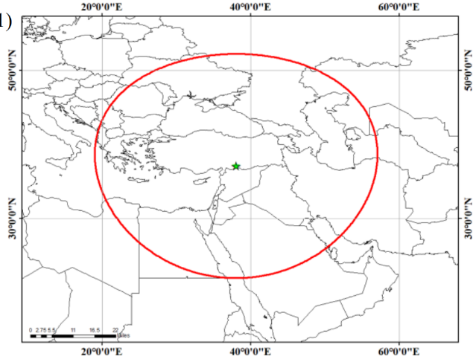
PICTURE 2.

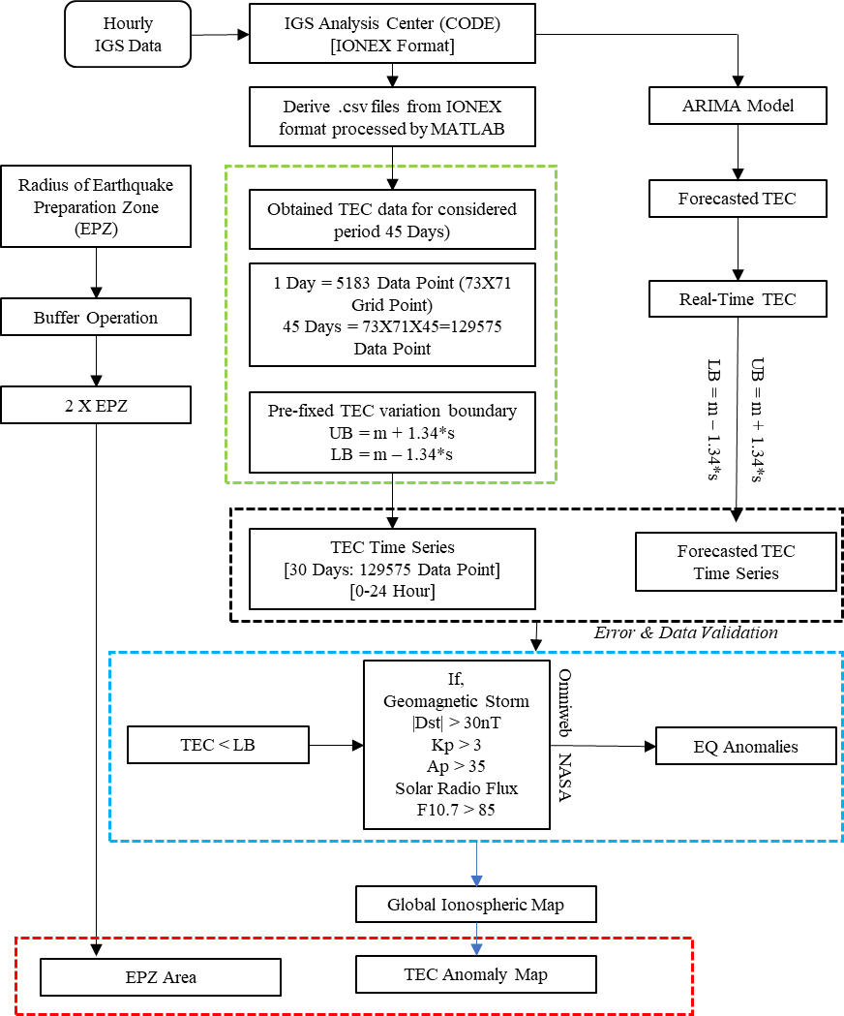
FIGURE 8.

