Impact of Urbanization on Land Use and Land Cover in Pune and Pimpri-Chinchwad, India: A Geospatial Assessment

ABSTRACT:
Urban growth in rapidly developing Indian cities has profound implications for environmental sustainability and resource management. This study examines the impact of urbanization on land use and land cover (LULC) in Pune and Pimpri-Chinchwad, Maharashtra, from 1990 to 2020 using multi-temporal satellite imagery and Geographic Information System (GIS) techniques. Landsat datasets were classified through a supervised Maximum Likelihood algorithm, and classification reliability was evaluated through overall accuracy (89-92%) and Kappa statistics, ensuring robust mapping of LULC categories. Six major classes i.e. built-up area, vegetation, agriculture, fallow land, waterbodies, and barren land were delineated and compared using post-classification change detection.
Results reveal a dramatic expansion of built-up land, rising from 9.76% in 1990 to 35.42% in 2020, reflecting intense residential, commercial, and industrial development. Vegetation declined from 38.26% to 31.42%, while agricultural land shrank to 3.67%, indicating a progressive conversion of green and agrarian landscapes into urban fabric. Fallow land showed minor fluctuations (6.17-4.68%), and barren land decreased substantially from 41.87% to 24.01%, suggesting reuse of previously unproductive areas. Waterbodies remained a small but stable fraction (~0.75-0.78%), underscoring their vulnerability amidst urban sprawl.
The findings highlight rapid urban encroachment on ecological and agricultural spaces, emphasizing the urgency of integrated land management and sustainable urban planning to conserve vegetation and water resources. This geospatial assessment provides a scientific basis for policymakers and planners to balance development with environmental resilience in fast-growing metropolitan regions.
Keywords:

Land Use and Land Cover; Urbanization; Satellite imagery; GIS; Change Detection; Pune Metropolitan Region; Vegetation Loss; Sustainable Urban Planning

1. INTRODUCTION:

Urbanization is a major driver of environmental transformation worldwide, profoundly altering land use and land cover (LULC). Rapid growth of cities, especially in developing nations, has led to unprecedented conversion of vegetation, agricultural land, and open terrain into built-up areas, often at the cost of biodiversity, hydrological balance, and carbon storage (Seto et al., 2011; Liu et al., 2014; Santra, 2025; Deb et al., 2025). India is experiencing one of the fastest rates of urban expansion, with its metropolitan regions showing marked landscape transitions over the last three decades (Zewdu et al., 2025; Bairwa et al., 2025; Rimal et al., 2025).

Pune and Pimpri-Chinchwad, located in western Maharashtra, exemplify this trend. Together they form the Pune Metropolitan Region (PMR), a hub for education, information technology, automotive manufacturing, and service industries. Rapid population growth and infrastructure development have exerted intense pressure on land resources, leading to the conversion of forests, orchards, agricultural tracts, and rocky uplands into residential, commercial, and industrial zones (Kantakumar et al., 2016; Bhailume, 2012; Koparde & Chalke, 2025). Comparable patterns of agricultural land loss and expansion of impervious surfaces have been observed in Patna, where urban growth between 1988 and 2022 significantly altered land surface temperature (Akram et al., 2024). Urban fringes and hill ecosystems in Pune are particularly vulnerable, with grasslands and savanna patches being replaced by construction and encroachment (Choudaj et al., 2024); similar vegetation decline and waterbody shrinkage were reported in Jamshedpur between 1987 and 2016 (Deb et al., 2025). Decline in carbon sequestration and intensification of urban heat islands have been linked with the loss of green cover in Pune (Koparde & Chalke, 2025).

Mapping and quantifying such transformations require robust, repeatable approaches. Remote sensing and Geographic Information System (GIS) techniques provide cost-effective tools for synoptic, multi-temporal monitoring of LULC dynamics (Dhorde et al., 2014; Khan, 2024). Multi-decadal satellite datasets, such as Landsat and Sentinel, combined with supervised classification algorithms like the Maximum Likelihood Classifier, have proven effective in delineating built-up areas, vegetation, agriculture, fallow land, barren terrain, and waterbodies (Zubair et al., 2023; Bairwa et al., 2025). Global initiatives, including the GLC_FCS30D 30 m land-cover product (Zhang et al., 2024), now facilitate consistent monitoring of LULC changes at fine resolution, enhancing detection of gradual landscape conversions. Accuracy assessment through confusion matrices, user’s and producer’s accuracy, and Kappa coefficients ensures reliability in such mapping efforts (Congalton & Green, 2019; Gabisa et al., 2025).

Earlier investigations in Pune and PCMC have documented significant growth of built-up areas between 1997 and 2011, accompanied by declines in vegetation and agriculture (Dhorde et al., 2014). However, most studies have focused on short time spans or selected pockets, such as river corridors or urban hills (Bhailume, 2012; Choudaj et al., 2024), leaving limited understanding of the long-term, city-wide LULC trajectory. Projections using CA-Markov models in Kathmandu and parts of PMC suggest that without intervention, prime farmlands and open spaces may continue to decline under urban pressure (Rimal et al., 2025). Comprehensive, accuracy-assessed analyses integrating multiple decades of data are thus essential to inform sustainable land management and climate resilience strategies.

This study aims to examine the spatio-temporal dynamics of land use and land cover (LULC) in Pune and Pimpri-Chinchwad over a 30-year period (1990-2020) using multi-temporal Landsat data and Geographic Information System (GIS) techniques. The specific objectives are to map and classify major LULC categories-built-up area, vegetation, agriculture, fallow land, barren land, and waterbodies for selected time points; to assess the accuracy of the classified maps; and to analyze the nature, extent, and rate of changes through post-classification comparison. By documenting the patterns and trends of urban expansion and associated landscape transformations, the study seeks to provide a scientific basis for sustainable land-use planning and the conservation of ecological resources in one of India’s fastest-growing metropolitan regions.

By integrating quantitative evidence with geospatial techniques, this research provides a comprehensive account of how urbanization has reshaped the landscape of Pune and Pimpri-Chinchwad. The findings offer a scientific basis for planners and policymakers to balance developmental imperatives with conservation of vegetation, agricultural heritage, and fragile water ecosystems in one of India’s fastest-growing metropolitan regions.

2. STUDY AREA:

Pune and Pimpri-Chinchwad are located in the western part of Maharashtra, India, between approximately 18°25′-18°40′ N latitude and 73°45′-73°58′ E longitude. Together they constitute the Pune Metropolitan Region (PMR), covering about 400 km². The area comprises dense urban cores, industrial estates, peri-urban agricultural lands, hill slopes, and small waterbodies. Pune lies on the leeward side of the Western Ghats at an elevation of ~560 m, while Pimpri-Chinchwad occupies the north-western fringe. The region has a tropical wet-dry climate, with average annual rainfall of ~700 mm concentrated during June-September. Over the past three decades, industrialization and population growth have exerted heavy pressure on natural and agricultural landscapes.

3. MATERIAL AND METHODS:

Data Sources:

Multi-temporal Landsat images were obtained to map and monitor land use/land cover (LULC) changes across Pune and Pimpri-Chinchwad. Four temporal epochs i.e. 1990, 2000, 2010, and 2020 were selected to capture decadal variations in urban growth and landscape dynamics. Landsat-5 TM scenes were used for 1990 and 2000, Landsat-7 ETM+ for 2010, and Landsat-8 OLI for 2020. All images were acquired from the United States Geological Survey (USGS) Earth Explorer archive, were cloud-free (<10%), and had a spatial resolution of 30 m. Table 1 summarizes the key characteristics of the satellite datasets, including sensor type, path/row numbers (as per USGS index), and the post-monsoon acquisition season.

To complement the satellite data, Survey of India (SOI) topographic sheets at 1:50,000 scale were used for geo-referencing and delineating the study area boundary. High-resolution Google Earth imagery, municipal land-use maps, and field observations were also employed to support the selection of representative training sites for classification and to validate the final outputs.

Methodology:

All satellite images were subjected to standard pre-processing to ensure consistency and reliability of results. Radiometric and geometric corrections were applied to each scene, and atmospheric effects were minimized using the Dark Object Subtraction (DOS) method. The images were clipped to the study boundary and stacked into multispectral composites bands 1-5 and 7 for TM/ETM+, and bands 2-7 for OLI. Histogram equalization and false-colour composites (bands 4-3-2 for TM/ETM+ and 5-4-3 for OLI) were generated to enhance spectral contrast and assist visual interpretation.

Land use/land cover (LULC) classification was performed through a supervised approach using the Maximum Likelihood Classifier (MLC) in ERDAS Imagine 2015. Six major LULC categories were identified: built-up area, vegetation (including forests, plantations, and urban greens), agriculture, fallow land, barren land or rocky outcrops, and waterbodies. Approximately 300-350 training samples were collected for each epoch, drawing on high-resolution Google Earth imagery, Survey of India maps, and field GPS observations (Garmin eTrex 30x, 2020). Spectral separability among classes was tested using the Transformed Divergence index, with all values exceeding 1.9, ensuring adequate distinction. Classified images were further refined using a 3×3 majority kernel filter to reduce ‘salt-and-pepper’ noise.

The accuracy of the classified maps was assessed using confusion matrices, along with Overall Accuracy, Producer’s Accuracy, User’s Accuracy, and the Kappa coefficient (Congalton & Green, 2019). Reference data were obtained from approximately 250 ground-truth points for each epoch field-verified for 2020 and sourced from historical high-resolution imagery for earlier years. Overall accuracies of 92% (1990), 89% (2000), 90% (2010), and 90% (2020) confirmed the robustness of the classification outputs.

To evaluate landscape dynamics, post-classification comparison was employed for change detection. The classified maps were cross-tabulated to derive transition matrices, highlighting gains, losses, and persistence within each category. Decadal conversion rates were calculated, and thematic maps were prepared to visualize spatial trends, particularly the expansion of built-up land, reduction of vegetation, and the re-utilization of barren areas.

The software suite comprised ERDAS Imagine 2015, ArcGIS 10.8, and QGIS 3.34 for image classification, accuracy assessment, and cartographic design. Statistical computations were performed in MS Excel 2021 and R 4.3.1, while final maps were projected to UTM Zone 43 N (WGS-84) for standardization.

4. results and discussion:

4.1 Land Use/Land Cover in 1990:
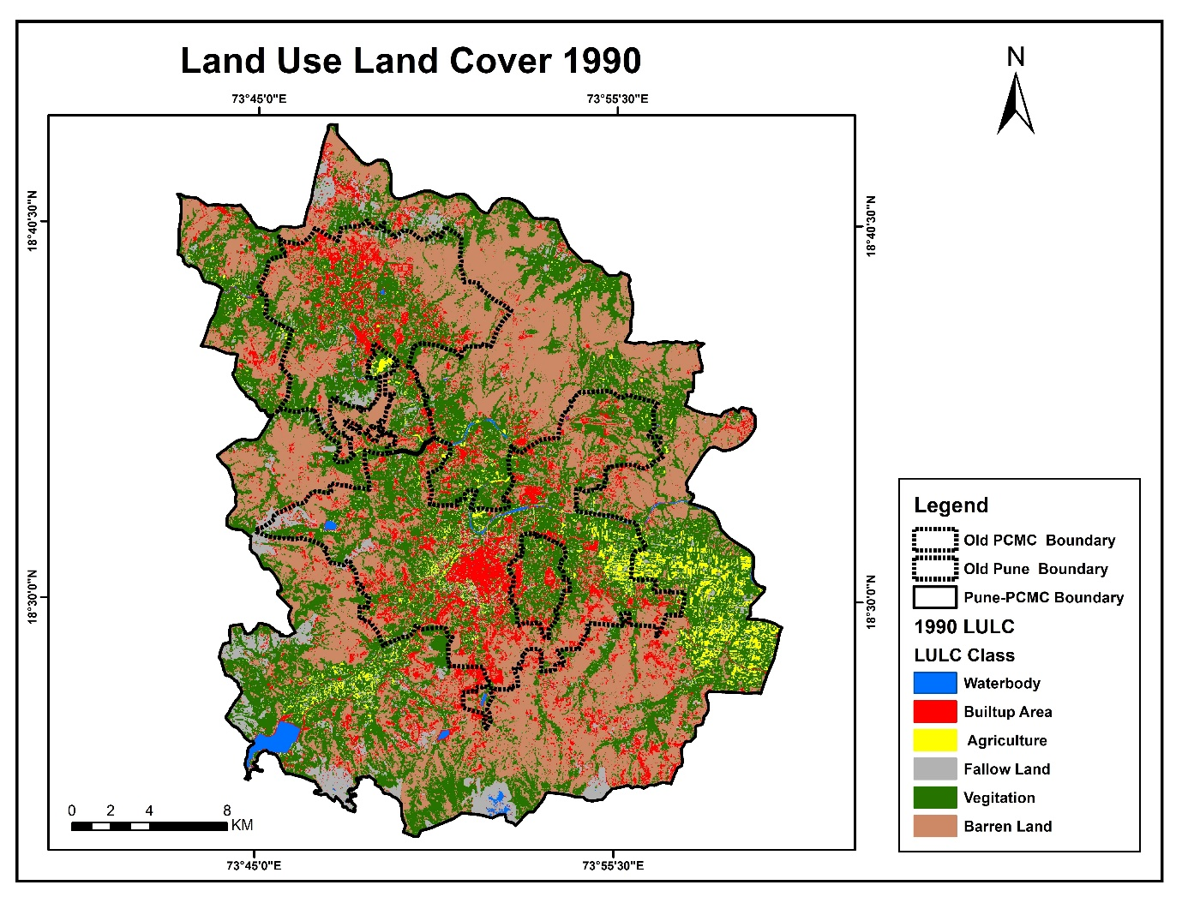
The spatial distribution of land use and land cover (LULC) for the year 1990 (Fig. 1) reveals a heterogeneous landscape in Pune and Pimpri-Chinchwad, reflecting the early stages of urban expansion. Six major LULC classes were identified: waterbodies, built-up area, agriculture, fallow land, vegetation, and barren land. Their areal extents and environmental significance are discussed below.

Fig. 1. Land Use/Land Cover map of Pune and Pimpri-Chinchwad for the year 1990, depicting the spatial distribution of six major LULC classes

Waterbodies
Waterbodies accounted for only 0.75% of the total area, represented by rivers, small lakes, ponds, and a few artificial reservoirs (Fig. 1). Despite their small share, these aquatic features were critical for sustaining local ecosystems and providing domestic and industrial water resources. The limited extent also highlights the vulnerability of surface water to reclamation and pollution pressures as urban growth accelerates.
Built-up Area
Built-up land occupied 9.76% of the region in 1990, concentrated mainly in the historic core of Pune city and the industrial clusters of Pimpri-Chinchwad. Residential neighbourhoods, commercial establishments, transport corridors, and early industrial estates were already evident, indicating a well-established urban economy. This proportion of built-up area reflects the early footprint of urban sprawl, laying the groundwork for subsequent decades of expansion driven by population increase, education hubs, and manufacturing growth (Fig. 1).

Agriculture
Agricultural land covered only 3.20% of the study area, confined largely to peripheral plains and river valleys. The small share suggests that agriculture had already receded by 1990 due to encroachment by residential layouts, industrial estates, and transportation infrastructure (Fig. 1). Although some cultivation persisted along fertile tracts, the dominance of non-agricultural uses foreshadowed further reductions in arable land.
Fallow Land
Fallow land comprised 6.17% of the area. These patches were mostly scattered near agricultural fields and in peri-urban zones, representing land left temporarily uncultivated or in transition to other uses. Their presence may reflect soil exhaustion, changing cropping practices, or speculation on land awaiting conversion to urban or industrial use. Fallow areas thus illustrate the interface between traditional agriculture and the pressures of urban land markets (Fig. 1).
Vegetation
Vegetation was a prominent class, covering 38.26% of the landscape. It included forest patches, scrub, tree plantations, urban parks, and roadside greenery. These green assets played a vital role in supporting biodiversity, improving air quality, and moderating microclimates (Fig. 1). Even in 1990, vegetation served as an environmental buffer around the urban nucleus, underscoring the importance of conserving hills, riparian belts, and urban open spaces to maintain ecological resilience.
Barren Land
Barren land dominated the scene, occupying 41.87% of the total area (Fig. 1). These tracts were largely composed of rocky plateaus, steep hill slopes, exposed soils, and disturbed sites unsuitable for intensive agriculture or dense settlement. Some areas likely correspond to future development zones or conservation lands. The prevalence of barren land indicates the physical constraints imposed by geology and terrain, as well as the scope for later transformation through quarrying, infrastructure, or re-vegetation initiatives.
The 1990 LULC configuration portrays a landscape in transition. Although vegetation still covered over one-third of the region, the growing share of built-up surfaces and the marginal status of agriculture point to the onset of strong urbanization forces. The extensive barren areas reflect both environmental limitations and the availability of undeveloped land, which later facilitated outward city growth. Protecting waterbodies and vegetation, while guiding development away from ecologically sensitive barren zones, emerges as an early lesson for sustainable urban planning.

4.2 Land Use/Land Cover in 2000:
The land use/land cover (LULC) scenario for the year 2000 (Fig. 2) demonstrates a decade of progressive urbanization in Pune and Pimpri-Chinchwad. Six major classes such as waterbodies, built-up area, agriculture, fallow land, vegetation, and barren land were identified, showing clear evidence of change compared with 1990.

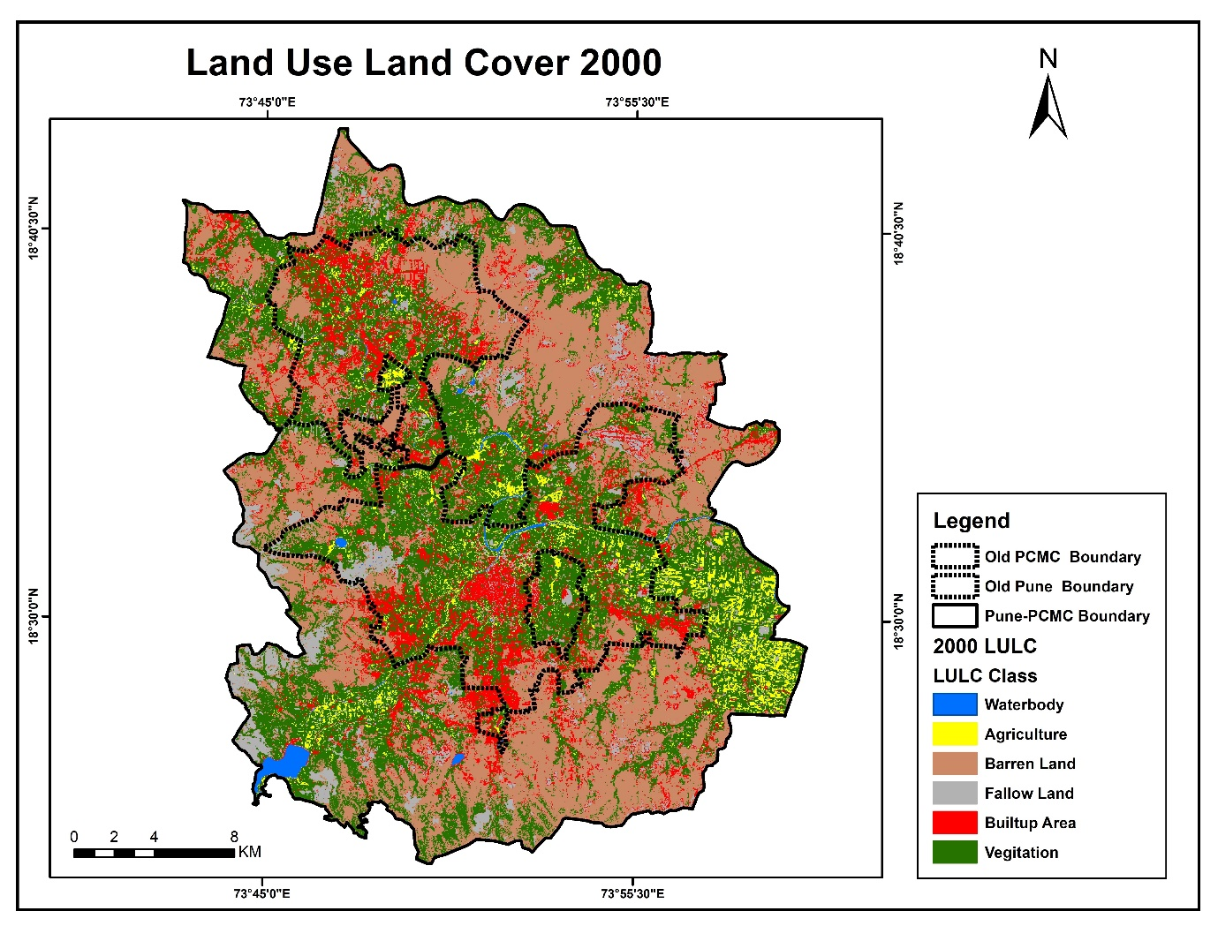

Fig. 2. Land Use/Land Cover map of Pune and Pimpri-Chinchwad for the year 2000.
Waterbodies
Waterbodies continued to occupy a very small proportion of the area, remaining close to 0.75% of the total land. While key rivers and lakes persisted, increasing urban pressure around their margins is evident, suggesting potential risks of encroachment and water quality degradation as development intensifies (Fig. 2).
Built-up Area
Built-up land expanded significantly, rising to 13.85% of the region by 2000. Urban growth spread beyond Pune’s historic core into peripheral wards and consolidated in the industrial belts of Pimpri-Chinchwad (Fig. 2). This increase reflects sustained population growth, industrialization, and the emergence of new residential neighbourhoods, all of which contributed to the strengthening of the Pune Metropolitan Region as an economic hub.
Agriculture
Agricultural land contracted further, declining to 2.85% of the area. Remaining fields were mostly located along river valleys and in isolated tracts on the urban fringe. The continued loss of agricultural space underscores the challenges in maintaining farming activities amid intensifying real-estate development and industrial land conversion (Fig. 2).

Fallow Land
Fallow land showed a marginal reduction to 5.80%, indicating that some previously idle plots were brought under cultivation or incorporated into construction zones (Fig. 2). The presence of fallow patches nonetheless highlights the transitional nature of peri-urban landscapes, where land is often left unused before being developed or reclaimed for short-term agricultural purposes.
Vegetation
Vegetation cover declined slightly to 37.10%, but it remained an important component of the landscape. Forested slopes, scrublands, plantations, and urban parks continued to provide ecological functions, such as biodiversity support, air purification, and microclimate regulation. However, the scattered reduction in green patches suggests growing encroachment due to settlement expansion and infrastructure projects (Fig. 2).
Barren Land
Barren land remained the largest category, occupying 40.65% of the area. These lands, comprising rocky plateaus, hilltops, and degraded surfaces, continue to act as buffers between urban clusters (Fig. 2). While their relative share decreased slightly, barren areas still dominate the landscape, offering potential sites for future development but also serving as important ecological zones, particularly on hilly terrain.
By 2000, Pune and Pimpri-Chinchwad had entered a phase of more pronounced urbanization. The expansion of built-up surfaces at the expense of agriculture and vegetation highlights the economic dynamism of the region but also raises concerns about the sustainability of land resources. The persistence of large barren tracts provides opportunities for carefully planned development or ecological restoration, while the protection of remaining vegetation and waterbodies remains crucial to safeguarding environmental health.

4.3 Land Use/Land Cover in 2010:

The land use/land cover (LULC) configuration for 2010 (Fig. 3) reflects an accelerated phase of urban expansion across Pune and Pimpri-Chinchwad. Six LULC categories i. e. waterbodies, built-up area, agriculture, fallow land, vegetation, and barren land show clear trends of transformation over the previous decade.
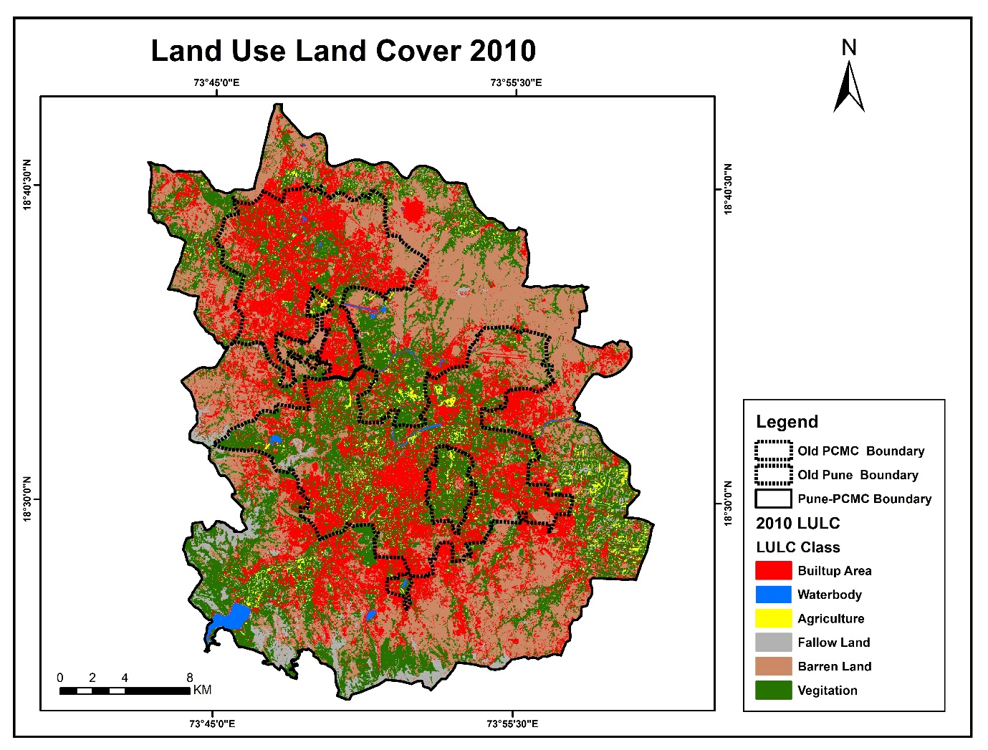

Fig. 3. Land Use/Land Cover map of Pune and Pimpri-Chinchwad for the year 2010.

Waterbodies
Waterbodies continued to occupy a very limited portion of the landscape, remaining around 0.76% of the total area. Major rivers, reservoirs, and lakes persisted, but several smaller ponds and tanks were increasingly surrounded by urban settlements, suggesting rising risks of siltation, pollution, and encroachment (Fig. 3).

Built-up Area
Built-up land experienced substantial growth, expanding to 24.65% of the total area (Fig. 3). Urban sprawl intensified in the southern and north-western sectors, engulfing peri-urban agricultural land and green tracts. The rapid expansion of housing colonies, transport corridors, and commercial hubs reflects a decade of robust industrial and service-sector growth in the Pune Metropolitan Region.

Agriculture
Agricultural land shrank to 2.45%, continuing its downward trend. The decline was most evident in areas adjacent to road networks and industrial estates, indicating that agricultural activities were progressively displaced by urban land demands (Fig. 3).

Fallow Land
Fallow land decreased slightly to 5.10%. Many parcels previously lying idle were converted into residential layouts, small-scale industrial zones, or reclaimed for short-term cultivation (Fig. 3). This reduction underscores the shrinking transitional buffer between agriculture and urban uses as city limits pushed outward.

Vegetation
Vegetation cover diminished to 34.25%, reflecting gradual encroachment on forests, scrublands, and urban parks (Fig. 3). Green patches survived mainly on hilly terrain, along riverbanks, and in designated parks or institutional campuses. The loss of vegetation highlights a growing imbalance between built-up surfaces and ecological assets, raising concerns about urban heat island effects and declining biodiversity.

Barren Land
Barren land accounted for 32.79% of the study area, marking a notable decrease from previous decades. Parts of these lands, particularly low-lying rocky plains and degraded areas, were converted into industrial estates, transport infrastructure, or residential neighbourhoods (Fig. 3). However, steep hills and rugged plateaus remained largely undeveloped, continuing to serve as ecological buffers.

By 2010, Pune and Pimpri-Chinchwad had transitioned into a mature stage of urbanization, with built-up areas occupying nearly one-quarter of the region. The steep decline in barren land and vegetation illustrates the increasing dominance of construction and infrastructure projects. While waterbodies remained relatively stable in area, their surroundings showed intensified anthropogenic pressure. This decade underscores the urgent need for proactive planning to preserve ecological corridors, sustain water resources, and integrate green infrastructure into the fast-changing urban fabric.

4.4 Land Use/Land Cover in 2020:
The LULC scenario for 2020 (Fig. 4) reflects an advanced stage of urbanization in Pune and Pimpri-Chinchwad, with built-up areas dominating the landscape. Six land cover categories i.e. waterbodies, built-up area, agriculture, fallow land, vegetation, and barren land show significant changes compared with earlier decades.
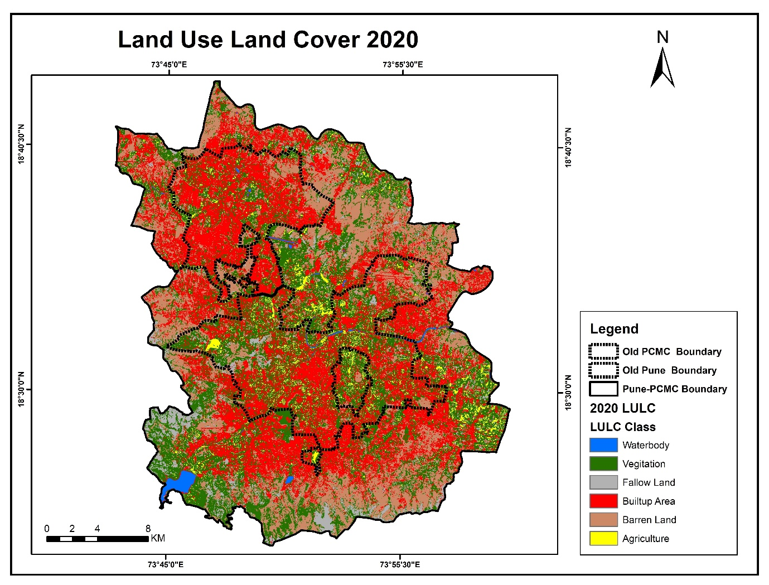

Fig. 4. Land Use/Land Cover map of Pune and Pimpri-Chinchwad for the year 2020.

Waterbodies
Waterbodies remained limited, covering 0.78% of the total area. Key lakes and reservoirs continued to exist, but many smaller wetlands were increasingly encircled by settlements, raising concerns about shrinking surface water and deteriorating quality due to rapid urban encroachment (Fig. 4).

Built-up Area
Built-up land increased dramatically, reaching 35.42% of the region. Residential colonies, commercial hubs, industrial estates, and road networks spread across nearly every part of the study area (Fig. 4). The expansion was most pronounced around the old cores of Pune and Pimpri-Chinchwad, extending into once-rural fringes. This surge reflects intense population growth, thriving service and manufacturing sectors, and large-scale infrastructure projects, underscoring the city-region’s emergence as a major urban agglomeration.

Agriculture
Agricultural land declined further to 3.67% of the total area, indicating that only limited pockets of cultivation persist, mainly along river valleys and on the outskirts. Farming is increasingly marginalized due to rising land prices, industrialization, and competition for space from residential layouts (Fig. 4).

Fallow Land
Fallow land reduced to 4.68%, suggesting that much idle land from earlier decades has been either built over or converted to short-term cropping. This decline highlights the narrowing availability of transitional open land as urban footprints consolidate (Fig. 4).

Vegetation
Vegetation cover was reduced to 31.42%, continuing its downward trajectory. Urban forests, parks, roadside plantations, and scrublands were under pressure from encroachment and infrastructure development. Remaining vegetation clusters were largely confined to hill slopes, institutional campuses, and riparian belts, making them vital for maintaining ecological balance and mitigating urban heat.

Barren Land
Barren land decreased substantially to 24.01%, reflecting large-scale conversion of previously unutilized or rocky terrain into developed areas (Fig. 4). While some rugged hillsides and ecologically sensitive plateaus remain intact, much of the barren land base has been transformed to meet urban demands, suggesting an overall reduction in natural buffers.

By 2020, Pune and Pimpri-Chinchwad had become a highly urbanized metropolitan landscape, with built-up land covering over one-third of the area. The sharp fall in barren land and vegetation illustrates an intensification of urban sprawl and declining natural cover. Although waterbodies maintained a small but stable share, their surroundings face significant anthropogenic stress. The marginal persistence of agriculture and fallow areas reflects the near-complete dominance of urban functions. These trends emphasize the urgent need for integrated land management, strict protection of green and blue infrastructure, and climate-resilient urban planning to counterbalance rapid growth.

4.5 Accuracy Assessment of LULC Data (1990-2020):
The accuracy assessment of the land use/land cover (LULC) classifications for 1990, 2000, 2010, and 2020 provides an evaluation of the reliability of the mapped classes and their correspondence with reference data. Overall accuracies were consistently high, ranging from 89% to 92%, confirming that the classification outputs are robust and suitable for temporal change analysis.
For 1990, the classification achieved an overall accuracy of 92%, indicating excellent agreement between the mapped categories and ground-truth information. This high accuracy reflects the relatively well-defined land-use boundaries and minimal spectral confusion among classes such as waterbodies, vegetation, agriculture, and built-up land during that period.
In 2000, accuracy declined slightly to 89%, though it remained within an acceptable threshold for LULC studies. The decrease may be attributed to an increase in urban complexity and fragmentation, which can reduce spectral separability between built-up, agricultural, and barren lands. Variability in the quality or acquisition conditions of the imagery may also have contributed.
The classification for 2010 recorded an accuracy of 90%, representing a marginal improvement over 2000. This stability is likely a result of enhancements in satellite data quality and the availability of higher-resolution reference imagery, as well as refinements in classification techniques. The results demonstrate that the method was able to reliably capture the substantial urban growth and associated landscape modifications during this decade.
For 2020, the accuracy remained steady at 90%, underscoring the effectiveness of the classification procedures even in a highly urbanized setting. Despite rapid land-use transitions and further reduction of natural cover, built-up areas, vegetation, and other classes were delineated with a high degree of precision.
Overall, the accuracy assessment demonstrates that the LULC maps for 1990-2020 maintain a consistently high level of reliability, with variations of only ±3% across the study period. Such stability supports the validity of subsequent change-detection analyses and ensures that the documented land-use transformations in Pune and Pimpri-Chinchwad are based on dependable spatial data.

4.6 Change Detection Analysis (1990-2020)
The temporal analysis of Land Use and Land Cover (LULC) dynamics from 1990 to 2020 (Fig. 5) reveals pronounced transformations in the landscape of Pune and Pimpri-Chinchwad. Over three decades, the study area experienced substantial urban expansion, contraction of natural vegetation, and a decline in barren lands, accompanied by fluctuations in agricultural and fallow areas. The following subsections summarize the trajectories of individual classes.

Fig. 5. Change in land use/land cover categories in Pune and Pimpri-Chinchwad between 1990 and 2020.

Waterbodies
Waterbodies consistently occupied a minor proportion of the total area throughout the study period. In 1990, they accounted for 0.75%, with a slight increase to 0.76% in 2000 and 0.79% in 2010, followed by a marginal reduction to 0.78% in 2020. These modest changes suggest that the overall extent of rivers, lakes, and reservoirs remained relatively stable, although pressures from urban encroachment and potential climate variability may have contributed to the slight decline after 2010 (Fig. 5).

Built-up Area
Built-up land displayed the most striking growth among all categories, reflecting rapid urbanization and infrastructure development. The share of built-up area rose from 9.76% in 1990 to 13.20% in 2000, marking the initial phase of expansion. A sharp surge occurred between 2000 and 2010, when the proportion increased to 28.84%, underscoring intense industrialization, population growth, and real-estate activity. By 2020, built-up land covered 35.42% of the region, indicating continued urban sprawl, albeit at a slightly slower pace compared with the previous decade (Fig. 5).

Agriculture
Agricultural land exhibited a mixed trend. It covered 3.20% in 1990 and registered a modest rise to 4.60% in 2000, possibly due to short-term cultivation on marginal lands. However, between 2000 and 2010, agriculture declined sharply to 2.54%, coinciding with widespread conversion of farmland to urban uses (Fig. 5). A minor recovery to 3.67% was observed in 2020, which may reflect localized efforts to maintain cultivation or the reclamation of temporarily unused land.

Fallow Land
Fallow land showed notable temporal variability. It comprised 6.17% of the area in 1990, increasing to 7.06% by 2000, likely due to seasonal abandonment or changing cropping practices. The share dropped steeply to 4.09% in 2010 as many idle plots were incorporated into urban or agricultural uses. By 2020, fallow land slightly increased to 4.68%, indicating a limited resurgence of uncultivated parcels, possibly linked to soil fatigue, economic considerations, or land speculation (Fig. 5).

Vegetation
Vegetation, encompassing forests, scrub, plantations, and urban greenery, declined steadily over the study period. It accounted for 38.26% of the area in 1990, decreased to 37.01% in 2000, and dropped markedly to 31.77% in 2010. By 2020, vegetation further declined to 31.42%, revealing persistent loss of natural cover despite localized conservation efforts. The major reduction between 2000 and 2010 aligns with rapid urban encroachment on hills, riparian belts, and peri-urban greens (Fig. 5).

Barren Land
Barren land recorded a continuous decline, reflecting the transformation of previously unutilized or rocky surfaces into developed or managed areas (Fig. 5). In 1990, barren terrain comprised 41.87% of the landscape, falling to 37.37% in 2000 and 31.97% in 2010. By 2020, barren land had decreased substantially to 24.01%, indicating progressive utilization of these areas for construction, agriculture, or conservation initiatives.

Overall, the change detection analysis demonstrates a profound shift in land use patterns over three decades. The most prominent trend is the expansion of built-up land at the expense of vegetation, agriculture, and barren areas, driven by industrialization, migration, and infrastructure growth. Although waterbodies remained relatively stable, their proximity to expanding settlements suggests potential ecological stress. The sustained reduction in barren land and vegetation highlights the importance of safeguarding green infrastructure and planning development within environmental thresholds. These findings emphasize the urgent need for integrated urban management strategies to balance growth with the preservation of ecological assets in Pune and Pimpri-Chinchwad.

5. Conclusion:
This study employed multi-temporal Landsat data and GIS techniques to examine the impact of urbanization on land use and land cover (LULC) in Pune and Pimpri-Chinchwad over a 30-year period (1990-2020). The analysis, supported by accuracy assessments ranging from 89% to 92%, demonstrates a consistently high reliability of the derived LULC maps and provides robust evidence of landscape transformation across the metropolitan region.
The findings reveal that built-up land expanded dramatically, from 9.76% in 1990 to 35.42% in 2020, underscoring the intensity of urban growth driven by population increase, industrial development, and large-scale infrastructure projects. This expansion occurred at the expense of vegetation, which declined from 38.26% to 31.42%, and barren land, which was reduced from 41.87% to 24.01%. Although waterbodies remained stable at around 0.75–0.78%, their proximity to expanding settlements indicates mounting pressure on surface-water resources. Agriculture and fallow land showed fluctuating but overall diminishing shares, reflecting the marginalization of farming activities and the progressive consolidation of urban land use.
The results highlight the profound environmental implications of rapid urbanization. Loss of green cover and conversion of open or rocky terrain to built-up areas threaten biodiversity, reduce carbon sequestration, and intensify the urban heat island effect. Stable yet vulnerable waterbodies emphasize the need for effective protection of hydrological assets. At the same time, the shrinking extent of barren and agricultural lands calls for strategies to balance economic development with ecological stability.
To ensure sustainable urban growth, future planning in Pune and Pimpri-Chinchwad must integrate green infrastructure, conservation of riparian corridors, and protection of hill ecosystems into land-use policies. Strengthening the monitoring of land-use change through high-resolution remote sensing, coupled with participatory urban governance, will be vital to maintaining environmental resilience while meeting the needs of a growing population. The methodological framework and findings presented here provide a valuable reference for other rapidly urbanizing regions seeking to harmonize development and ecological sustainability.

REFERENCES
Akram, W., Wasim, A., et al. (2024). Urban expansion and its influence on land surface temperature in Patna, India (1988-2022). Journal of Landscape Ecology, 17(1), 1-14.

Bairwa, B., Sharma, S., Meena, P., & Singh, R. (2025). Predicting changes in land use and land cover in Indian metropolitan regions using machine learning and remote sensing. Frontiers in Environmental Science, 13, 1540140.

Bhailume, S. (2012). Assessment of urban sprawl using GIS and remote sensing: A case study of Pune and Pimpri-Chinchwad region, Maharashtra, India. International Journal of Geomatics and Geosciences, 2(3), 611-621.

Choudaj, K., Shaha, C., & Wankhade, V. (2024). Geospatial analysis of land use change and grassland degradation in Pune’s urban hills. Journal of Environmental Geography, 17(2), 89-101.

Congalton, R. G., & Green, K. (2019). Assessing the Accuracy of Remotely Sensed Data: Principles and Practices (3rd ed.). Boca Raton, FL: CRC Press.

Deb, P., et al. (2025). Analyzing land use land cover dynamics under rapid urbanization in Jamshedpur, India (1987-2016). Science of The Total Environment, 934, 173854.

Dhorde, A., et al. (2014). Assessment of spatio-temporal variations in land use/land cover over Pimpri-Chinchwad Municipal Corporation using remote sensing data. International Journal of Remote Sensing Applications, 4(3), 45-52.

Gabisa, M., Kabite, G., & Mammo, S. (2025). Land use and land cover change trends, drivers and its impacts on ecosystem services in Burayu Sub-City, Ethiopia. Frontiers in Environmental Science, 13, 1557000.

Kantakumar, L. N., Neelamsetti, P., & Kumar, T. A. (2016). Spatiotemporal urban expansion analysis in Pune metropolis, India, using geospatial tools. Applied Geography, 69, 1-10.

Khan, D. (2024). Spatio-temporal analysis of urbanization effects on land surface temperature in South Asia. GeoJournal, 89(4), 1673-1687.

Koparde, P., & Chalke, P. (2025). Pune sees 34% decline in carbon sequestration as urban sprawl reduces green cover. The Times of India, Feb 18, 2025.

Liu, X., Liang, X., Li, X., & Xu, X. (2014). Urban land expansion and environmental sustainability: A global perspective. Current Opinion in Environmental Sustainability, 5, 141-147.

Rimal, B., et al. (2025). Prediction of urban growth and sustainability challenges in Kathmandu and PMC using CA-Markov model. Land, 14(8), 1675.

Santra, A. (2025). Urban growth dynamics and land surface temperature in Indian cities: A remote sensing assessment. Sustainable Cities and Society, 115, 105006.

Seto, K. C., Güneralp, B., & Hutyra, L. R. (2011). Global forecasts of urban expansion to 2030 and direct impacts on biodiversity and carbon pools. PNAS, 109(40), 16083-16088.

Zewdu, D., Kumar, R., & Singh, S. (2025). Interactions of land use, land cover, and climate change from 1985 to 2023 in Raichur district, India. Environmental Challenges, 13, 100241.

Zhang, X., Zhao, T., Xu, H., Liu, W., Wang, J., Chen, X., & Liu, L. (2024). GLC_FCS30D: The first global 30 m land-cover dynamics monitoring product (1985–2022). Earth System Science Data, 16, 1353-1381.

Zubair, O., Adepoju, K., & Alade, B. (2023). Machine learning approaches for land use/land cover mapping in urban landscapes. Remote Sensing Applications: Society and Environment, 29, 101047.

