Study on the Influence of Injection Timing from Fuel Injectors on In-Cylinder Gas Flow in Dual-Fuel Free-Piston Engines

Abstract: Injection duration is a key factor in regulating in-cylinder mixing and combustion in dual-fuel free-piston engines.This study employs a coupled numerical model to analyze the impact of injection duration within the 0.05–0.25 ms range.Simulations reveal that a short duration (0.05 ms) significantly enhances in-cylinder swirl and turbulence by improving fuel atomization quality and mixing rate. The peak turbulent kinetic energy (20 m²/s²) increases by 51% compared to the 0.25 ms condition.This optimization results in more complete combustion,achieving optimal indicated thermal efficiency and heat release rate, while simultaneously increasing the heat transfer coefficient and heat flux by 16.7% and 33.2%, respectively. Conversely, extending the injection duration enlarges the rich fuel zone and increases soot emissions.Comprehensive evaluation identifies 0.05 ms as the optimal injection duration.
Keywords: Injection duration; Free-piston engine; In-cylinder swirl; Soot emissions

Introduction
For more than a century, traditional internal combustion engines have served as the primary power units for propulsion systems. This long-term dependence on fossil fuels, however, has raised significant concerns regarding energy sustainability and exacerbated environmental pollution, thereby driving the demand for clean and efficient power technologies^{[1-2]}.The dual-fuel free-piston engine is an innovative configuration that decouples the piston from a mechanical crankshaft by eliminating the traditional crankshaft-connecting rod mechanism^{[3]}. It converts the energy from combustion directly into linear motion, representing a fundamental breakthrough in operational principle.A key advantage of this design is its ability to dynamically adjust the compression ratio in response to operating conditions^{[4]}. Furthermore, the engine can operate on multiple fuels (e.g., diesel-natural gas, hydrogen) either individually or in combination. This flexibility paves the way for significantly enhancing thermal efficiency and reducing emissions^{[5-7]}.
Research from Chongqing Jiaotong University^{[8]} has shown that pilot ignition can enhance mixture quality by advancing the fuel injection timing, thereby improving efficiency and suppressing knock.Complementary work from the Beijing Institute of Technology^{[9]} demonstrated that a shorter combustion duration increases indicated power and thermal efficiency, enabling performance closer to the ideal Otto cycle. Furthermore, a research team from Chongqing Jiaotong University^{[10]} developed a coupled model incorporating a variable ignition position (IP) to elucidate its role in regulating engine performance. Their study found that retarding the ignition timing extends the fuel-air mixing time, which improves the homogeneity of the in-cylinder mixture. This effect is particularly beneficial at high engine speeds, where a strategically delayed ignition position synergistically increases in-cylinder temperature, pressure, and gas flow velocity. Consequently, these conditions enhance hydrogen mixing and diffusion.

Working Principle and Operation of Internal Combustion Engines

1.1 Main Components and Working Principle
The dual-fuel free-piston engine featuresan opposed-piston configuration with symmetrically arranged combustion chambers at both ends and a linear generator positioned at the center. The cylinder head​incorporates specialized fuel and hydrogen injectors. The fuel injectors are optimized for efficient air-fuel mixing, particularly with minimal fuel doses. The shallow bowl-shaped combustion chamber in the piston crown interacts with the porous injector to synergistically enhance fuel atomization and mixture uniformity. The piston is connected to a conductor (the mover of the linear generator) via connecting rods. This assembly reciprocates within a magnetic field. As it moves, the conductor cuts the magnetic flux lines, directly converting the mechanical energy into electrical energy. The engine's primary parameters are listed in Table 1.
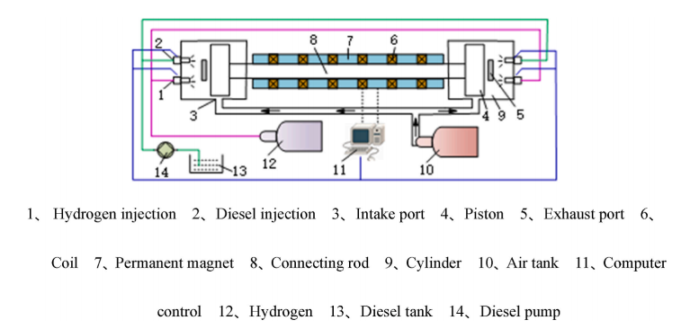
Fig. 1 Engine Schematic Diagram
Table.1: Linear Generator Engine Specifications
Specifications | Value | Unit
Nominal stroke | 93 | mm
Max effective stroke | 62 | mm
Stroke length | 82-92 | mm
Cylinder bore diameter | 60 | mm
Exhaust port height | 30 | mm
Scavenging port height | 18 | mm
Exhaust port length | 4 | mm
Compression ratio | Variable | -
Moving parts mass | 5.4 | kg
Internal coil inductance | 10.1 | mH
Internal coil resistance | 3.6 | Ω
Generator load | 262 | N/(m/s)
Friction load | 29 | N/(m/s)
Electromagnetic coefficient | 90 | N/A

The dual-fuel free-piston engine is initiated by an external linear motor. This motor drives the piston assembly to perform the initial compression strokes, achieving the first successful fuel ignition. Subsequently, the high-temperature combustion gases drive the opposing piston. The linear motion of the piston assembly is then converted into electricity by a linear generator. This electricity charges the battery, enabling the engine to transition to self-sustaining operation. The engine operates on a two-stroke cycle with a uniflow scavenging system. In this system, the intake and exhaust ports, located at specific heights on the cylinder liner, are sequentially uncovered and covered by the piston movement, thereby ensuring efficient gas exchange.

1.2 Internal Combustion Engine Operating Parameters and Conditions
The effective stroke of the dual-fuel free-piston engine is 86.3 mm, with an equivalent operating speed of 2222 r/min. This study focuses on the in-cylinder processes within the 256.5°–468.6°ECA range. The experiment employs a composite combustion method where diesel ignites hydrogen. Diesel compression ignition indirectly ignites premixed hydrogen, effectively avoiding detonation and backfiring issues potentially caused by spark ignition. Hydrogen is injected into the cylinder at 260°ECA with a mass of 4.3 mg, and the injection lasts for 10°ECA. This allows the hydrogen fuel to mix thoroughly during the piston's upward stroke, achieving uniform lean combustion. Specific parameter configurations are shown in Table 2.
Table.2 Operating Conditions of Dual-Fuel Free-Piston Engine
Boundary conditions | Dual-fuel Free-Piston Engine
Equivalent rotational speed r/min | 2222
Intake pressure /Pa | 125000
Intake Air Temperature /K | 310
Exhaust vent open/°ECA | 256.5
Exhaust vent closed/°ECA | 468.6
Hydrogen Injection Mass /mg | 4.3
Diesel Injection Quality /mg | 1.2
Diesel injection position/°ECA | 367
Diesel injection duration /ms | Variable
The diesel injection quantity was set at 1.2 mg per cycle. The injection timing was fixed at 367°crankshaft angle (CA) before top dead center (TDC), corresponding to a piston position 2 mm from TDC. Five different injection durations—0.05 ms, 0.10 ms, 0.15 ms, 0.20 ms, and 0.25 ms—were compared. Analysis of the relationship between the cumulative injection quantity and the crankshaft angle (Figure 2) revealed that, for a constant total injection quantity, a shorter injection duration substantially increased the slope of the curve, indicating a higher injection rate. This observation is consistent with a fundamental characteristic of fuel injection systems: a trade-off exists between injection duration and injection rate, where a shorter duration necessitates a higher rate to maintain the total fuel quantity.
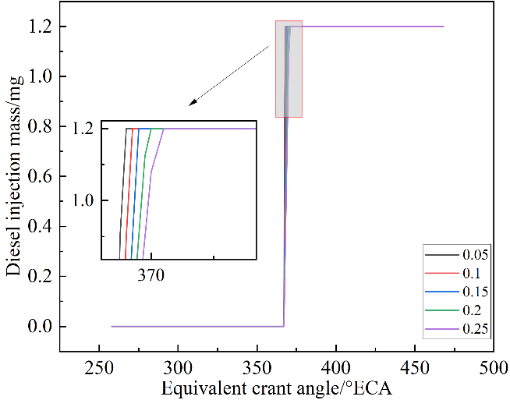
Fig.2 Diesel Injection Quality Curve

1.3 oupled Iteration
In free-piston engines, the piston motion is governed by the dynamic equilibrium between the in-cylinder gas pressure and the external mechanical load. The in-cylinder gas pressure, in turn, is critically influenced by thermodynamic processes, particularly the heat release rate of combustion and the heat transfer to the working fluid. To model this interaction, a co-simulation framework coupling a piston dynamics model with a thermodynamic model was established.This framework was implemented within a numerical analysis environment to achieve an iterative solution for the piston trajectory. The underlying computational principle is illustrated in Figure 3.
Figure 3. Iterative Computation Method for Piston Motion

2 Establishment of 3D Models

2.1 Partitioning Network Grids
The numerical model of the dual-fuel free-piston engine was developed following a systematic procedure. It began with constructing the engine's three-dimensional geometry using CAD software. This geometry was then imported into a simulation platform for static mesh generation. To enhance computational accuracy, critical regions such as the combustion chamber and the area near the fuel injector underwent local mesh refinement, increasing grid density in zones with high flow gradients or significant chemical activity. A dynamic mesh model was subsequently developed to capture the unique piston motion, which is not constrained by a crankshaft but is determined by a coupled dynamic-thermodynamic iterative solution that provides boundary conditions for the mesh movement. For the mesh structure itself, hexahedral (hex) elements were selected because of their key advantages: they maintain high quality with fewer elements, demonstrate superior convergence for solving coupled physics like fluid flow and combustion, and have characteristics conducive to accurate flow-field calculations . The final computational mesh, illustrated in Figure 3, comprised 42,318 hexahedral elements, all uniformly sized at 1mm×1mm×1mm to ensure consistency and control the aspect ratio. This structured mesh served as the foundation for the transient simulation of the engine's operation.
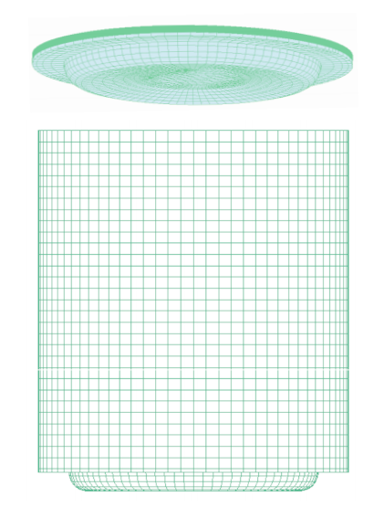
Fig.4 Mesh Model
2.2 Piston Dynamic Model
In the model construction, this study assumes that the left and right pistons possess identical structures and loading conditions. Figure 5 illustrates the force analysis schematic of the piston. Given the model's symmetry, mechanical analysis can be performed on a single piston only. Based on Newton's Second Law, its equations of motion can be derived as follows ^{[11.12]}:
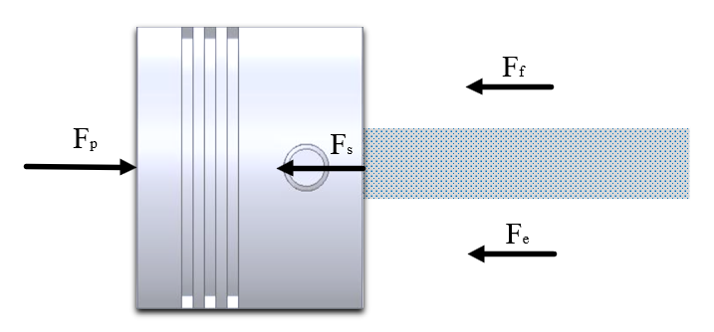
Figure 5. Force Diagram of Piston Assembly
^{[13]}：
^{[14]}:
In the equation, m represents the piston mass; x represents the displacement of motion; t represents the piston motion time;$F_{p}$ represents the gas thrust generated after fuel combustion; $F_{f}$ represents the friction force between the piston and cylinder wall during the piston's work cycle;$F_{e}$ represents the electromagnetic force generated by the motor;$F_{S}$ represents the piston scavenging force; $C_{f}$ represents the coefficient of viscous friction; $K_{f}$ denotes the thrust parameter; $K_{V}$ denotes the back-EMF parameter.

2.3 Multi-dimensional Simulation Model
For the computational fluid dynamics (CFD) simulation of dual-fuel engines, the appropriate selection of combustion and sub-models is critical for obtaining authentic and accurate results. The Extended Coherent Flame Model with three zones (ECFM-3Z) is particularly suitable for simulating multi-fuel combustion. This model describes the flow field by dividing it into unburned, burned, and mixing zones, demonstrating high computational efficiency and stability under complex flow conditions. Studies have indicated that the ECFM-3Z model provides a uniform temperature distribution within the combustion chamber and offers improved predictions for key emissions, such as nitrogen oxides (NOx), leading to better agreement with experimental data .For near-wall flow simulations, the hybrid wall treatment (HWT) method is employed to predict turbulent characteristics and heat transfer. The in-cylinder heat transfer is simulated using the Han-Reitz model, which accounts for variations in gas density within the boundary layer. The formation of nitrogen oxides (NO) is predicted by applying the extended Zeldovich mechanism.Regarding fuel spray simulation, the walljet0model is applied to characterize droplet-wall interactions, which is suitable for conditions involving lower injection velocities and shorter impingement distances.The evaporation process is modeled using the Multi-componentmodel to handle the multi-fuel combination. The secondary breakup of fuel droplets is simulated with the Wavemodel, based on the principle of aerodynamic wave instability at the gas-liquid interface. Additionally, turbulence induced by piston motion is addressed using a turbulent diffusion model.

3 Model Validation and Verification
To validate the accuracy of the simulation model, experiments were performed on a dual-fuel free-piston engine under the operating conditions specified in Table 2. A comparison between the experimental measurements and simulation results for in-cylinder pressure and heat release rate is presented in Figure 6, showing that their trends are in close agreement across the entire operating cycle. Although minor deviations are observed at the peak values, these fall within an acceptable margin of error , demonstrating that the simulation model reliably predicts the in-cylinder combustion process
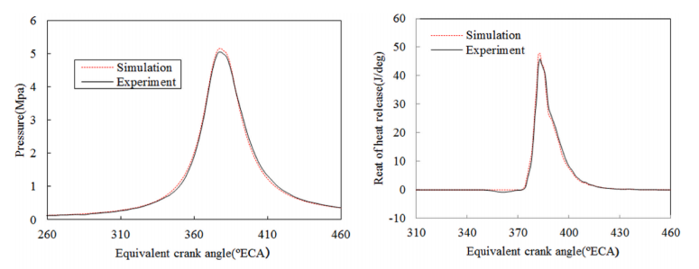
Figure 6. Experimental validation

4 Results and Discussion

4.1 Airflow Characteristics Inside the Tank
Figure 7 depicts the evolution of in-cylinder flow patterns in a dual-fuel free-piston engine from the start of injection to top dead center (TDC, 376°ECA) across different injection durations. The streamline diagrams reveal that the primary vortex is concentrated in the central region and near the injector, while secondary vortices form in the near-wall area. The velocity contours indicate significant flow separation following wall impingement of the fuel spray. Fuel with higher momentum contributes to a strong swirling motion near the injector, which enhances fuel-air mixing, whereas lower-momentum fuel becomes entrained in local vortices, improving mixture homogeneity via turbulent diffusion.Compared to longer injection durations (0.20–0.25 ms), the shorter duration of 0.05 ms generates stronger in-cylinder flow structures and a more uniform fuel distribution. The higher initial kinetic energy associated with the 0.05 ms duration intensifies vortex formation and turbulent mixing, thereby achieving superior fuel-air homogeneity at specific crank angles (372°and 376°ECA). In contrast, extended injection durations lead to a reduction in vortex intensity and spatial coherence, resulting in uneven mixture preparation and, consequently, lower combustion efficiency.
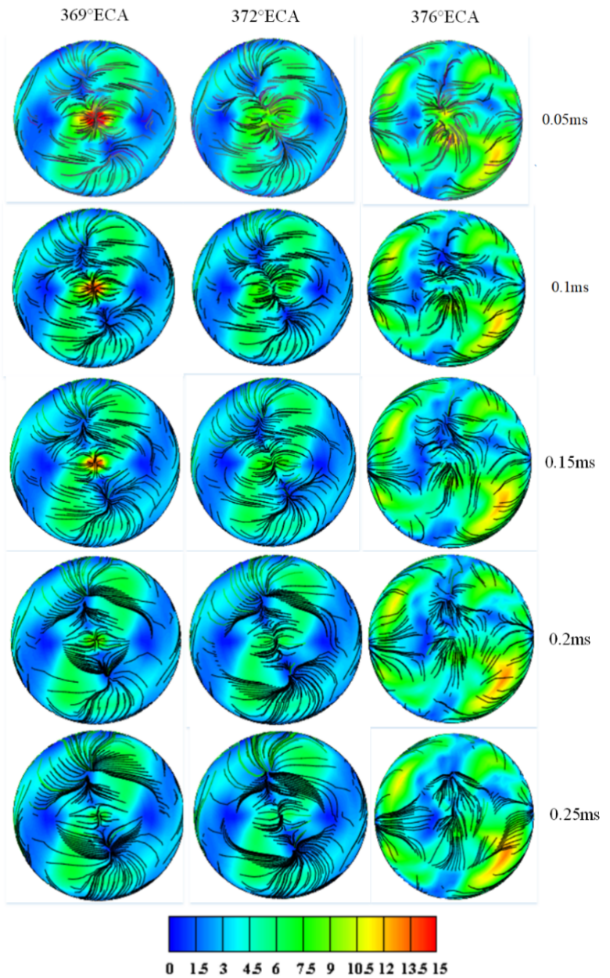
Fig.7 Airflow Velocity Streamline Diagram

Figure 8(a) shows the variation in-cylinder turbulent kinetic energy as a function of crankshaft angle, exhibiting a typical double-peak structure corresponding to hydrogen and fuel injection processes. Following the start of fuel injection at approximately 367°ECA, the turbulent kinetic energy rises, reaching a peak near 380°ECA. The timing of this peak remains consistent across all conditions. As the injection duration increases, the peak turbulent kinetic energy decreases. The 0.05 ms condition demonstrates the most rapid rise and the highest amplitude, attaining a peak value of approximately 20 m²/s².This represents increases of about 40% and 51% compared to the 0.10 ms and 0.25 ms conditions, respectively. This intensified flow motion improves mixture homogeneity and spatial distribution, thereby enhancing combustion efficiency. As shown in Figure 8(b), the 0.05 ms condition yields the highest mixture fraction. The curves for durations of 0.05, 0.10, and 0.15 ms all peak near top dead center (TDC) before gradually declining, indicating efficient mixing and uniform distribution. In contrast, the 0.20 and 0.25 ms conditions, due to their longer injection times, fail to form distinct peaks, which reflects incomplete mixing and hinders the combustion heat release process.
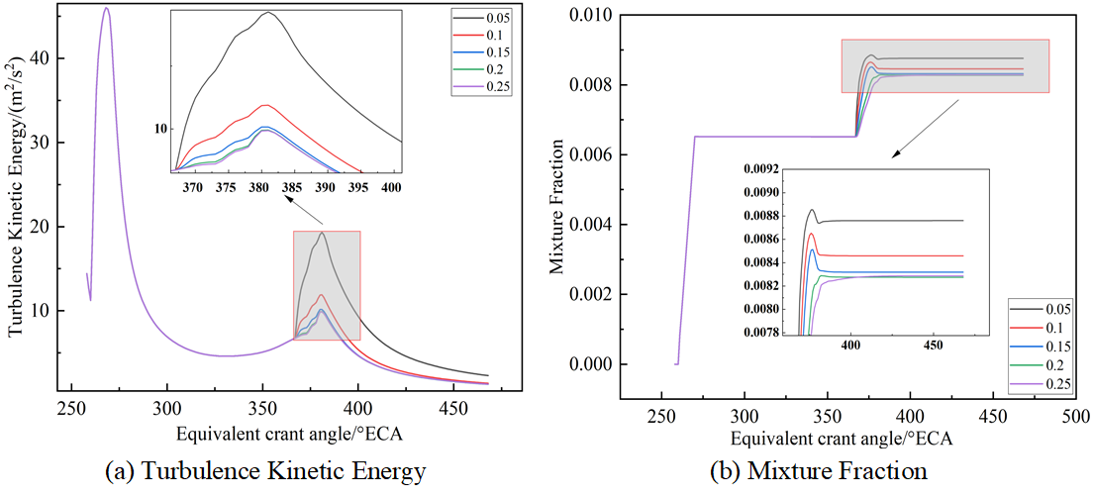
Fig.8 Turbulent kinetic energy and mixing fraction

4.2 Heat Transfer Characteristics in the Tank
Figure 9(a) and (b) depict the heat transfer coefficient and heat flux under different injection durations. Both parameters peak near 380°ECA, with phases slightly advancing as injection duration increases. The 0.05 ms condition achieves the highest values—a peak heat transfer coefficient of 3127 W/m²·K​(approximately 16.7% higher than 0.25 ms) and a peak heat flux of -24,316.2 W(approximately 33.2% higher than 0.25 ms). These elevated values indicate intensified gas-wall heat exchange but also higher heat transfer losses. The enhanced heat transfer under the 0.05 ms condition is attributed to sustained high turbulent kinetic energy, which promotes flow turbulence and prolongs heat exchange effectiveness.
Fig.9 Heat Transfer Coefficient and Heat Flux

Figure 10 reveals the combustion characteristics under different injection durations. The pressure and temperature curves diverge near 379°ECA: shorter injections (0.05–0.15 ms) sustain higher rise rates, while longer ones (0.20–0.25 ms) cause significant deceleration. Peak pressures occur around 380°ECA, with a maximum difference of ~7 MPa. The highest combustion temperature (1552.39 K) is observed at 0.1 ms. The heat release rate and cumulative heat release peak near 379°ECA, reaching 110 J/°CA and 664 J, respectively. Fluctuations between 385–400°ECA indicate afterburning, most pronounced at the 0.05 ms condition.
Based on a comprehensive evaluation of key performance indicators—including turbulent kinetic energy, heat release rate, and indicated thermal efficiency—the 0.05 ms injection duration is identified as the optimal condition for the dual-fuel free-piston engine, as it promotes superior mixture formation, combustion completeness, and overall efficiency compared to the 0.1 ms condition.
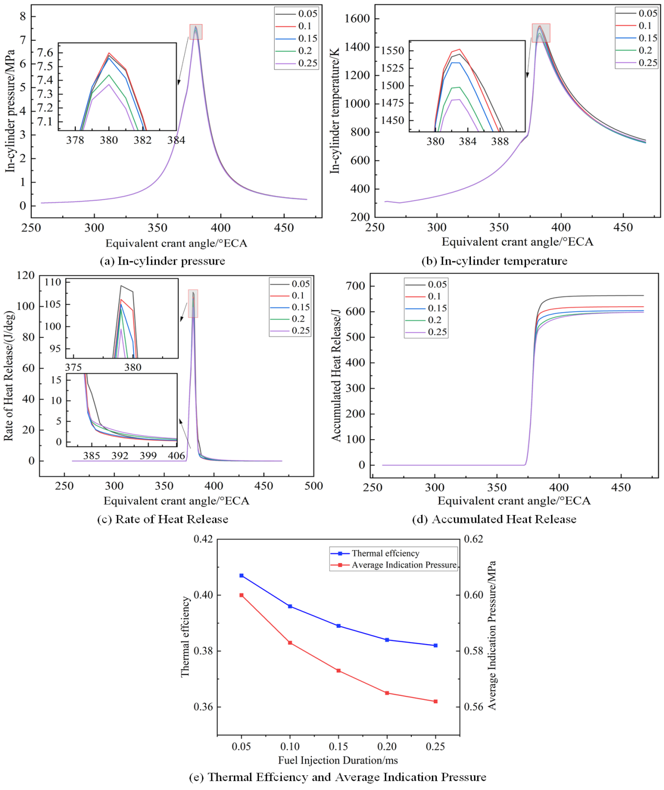
Fig.10 Relevant Performance Parameters

Figure 10(e) shows that longer fuel injection durations decrease indicated thermal efficiency and average indicated pressure. The highest efficiency of about 40.7%​occurs at 0.05 ms, compared to 38.2% at 0.25 ms—a reduction of 2.5 percentage points. Shorter injection durations thus improve combustion and energy conversion, supporting better engine economy.

4.4 Combustion Emissions Analysis
As shown in Figure 11(a), different injection durations significantly affect nitrogen oxide (NO) emissions. Near 376°ECA, as cylinder temperature and pressure approach their peaks, the NO mass fraction begins to rise rapidly. This is primarily due to the intensified oxidation reaction of nitrogen under high-temperature and high-pressure conditions. Specifically, NO emissions peaked at 0.00020821 when the injection duration was 0.05 ms, while the NO mass fraction dropped to a minimum of 5.80027×10⁻⁵ when the injection duration was extended to 0.25 ms. This clearly demonstrates a pronounced negative correlation between injection duration and NO emissions.
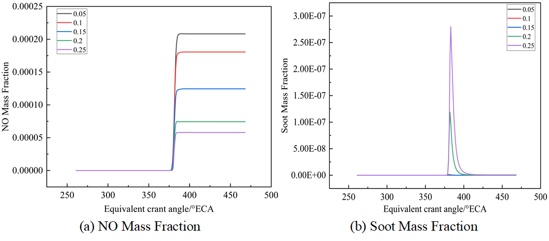
Fig.11 Mass fraction of NO and Soot
Figure 10(b) presents the influence of injection duration on the in-cylinder soot mass fraction. Soot formation primarily stems from incomplete fuel combustion. As the injection duration increases, the fuel-air mixing time is extended, which delays the ignition timing and postpones the combustion process. Following the rapid combustion phase, the in-cylinder oxygen concentration drops significantly.Under these oxygen-deficient conditions, unburned fuel undergoes pyrolysis, leading to soot formation.The results indicate that soot generation is concentrated around 390°ECA. At an injection duration of 0.25 ms, the soot mass fraction reaches a peak value of 2.80×10⁻⁷and exhibits the longest duration of formation compared to other conditions. In contrast, the 0.05 ms condition results in minimal soot production due to more uniform mixture preparation and more complete combustion.

- Conclusion

Injection duration is a critical parameter affecting the performance of dual-fuel free-piston engines. By optimizing injection duration, it is possible to promote the formation of the in-cylinder mixture, improve the spatial distribution and uniformity of the fuel, enhance airflow dynamics and turbulence intensity, and optimize the heat transfer process. This ultimately leads to improved combustion efficiency and overall engine performance optimization. The following are the specific analysis results:
（1）Shorter injection durations (e.g., 0.05 ms) intensify in-cylinder vortex formation and turbulent kinetic energy (TKE), which peaks at approximately 20 m²/s²—an increase of about 51% compared to the value under the 0.25 ms condition. This enhanced TKE improves fuel-air mixing uniformity, thereby promoting more efficient and cleaner combustion.Conversely, longer injection durations retard vortex development, confine its spatial distribution, and ultimately lead to a less homogeneous mixture.
（2）At an injection duration of 0.05 ms, the intensified in-cylinder airflow promotes more intensive contactbetween the high-temperature combustion gases and the chamber walls. This results in a peak heat transfer coefficient of 3127 (a 16.7% increase) and a maximum heat flux of -24,316.2 (a 33.2% rise) compared to the 0.25 ms condition. Consequently, heat transfer losses are greater due to the improved thermal exchange efficiency.
（3）Shorter fuel injection durations (e.g., 0.05 ms) enhance engine thermal efficiency by increasing the in-cylinder pressure and temperature, thereby producing higher heat release rates. These conditions yield a peak indicated thermal efficiency of 40.7% and an average indicated pressure of approximately 0.61 MPa.However, the elevated temperatures and pressures also intensify NOx formation due to the more intense combustion . This inverse relationship between injection duration and thermal efficiency exists because shorter durations improve fuel-air mixing and combustion completeness.

References

[1]Meng H, Ji C, Su T, et al. Analyzing characteristics of knock in a hydrogen-fueled Wankel rotary engine[J]. Energy, 2022, 250: 123828.
[2]Numerical study of the effect of injection timing on the knock combustion in a direct-injection hydrogen engine.
[3]Jing-Ding L, Ying-Qing L, Tian-shen D. Improvement on the combustion of a hydrogen fueled engine[J]. International Journal of hydrogen energy, 1986, 11(10): 661-668.
[4]Liu S, Xu Z, Chen L, et al. Comparison of an opposed-piston free-piston engine using single and dual channel uniflow scavenging[J]. Applied Thermal Engineering, 2022, 201: 117813.
[5]Huang F, Kong W. Effects of hydrogen addition on combustion characteristics of a free-piston linear engine with glow-assisted ignition[J]. International Journal of Hydrogen Energy, 2021, 46(44): 23040-23052.
[6]Lei Q, Feng H, Liu C, et al. Numerical investigation of the impact of dual spark plug coordinated ignition strategy on the combustion process in a free piston engine generator[J]. Energy, 2024, 290: 129880.Huang
[7]Huang F, Kong W. Effect of hydrogen addition on the operating characteristics of a free piston linear engine[J]. International Journal of Hydrogen Energy, 2020, 45(30): 15402-15413.
[8]Ngwaka U, Smallbone A, Jia B, et al. Evaluation of performance characteristics of a novel hydrogen-fuelled free-piston engine generator[J]. international journal of hydrogen energy, 2021, 46(66): 33314-33324.
[9]Qin Z, Wang X, Liang Y, et al. A coupling dynamics and thermodynamics study of diesel pilot-ignition injection effect on hydrogen combustion of a linear engine[J]. International Journal of Hydrogen Energy, 2022, 47(67): 29102-29112.
[10]Yuan C, Xu J, Feng H. In-cylinder heat transfer and gas motion of a free-piston diesel engine generator[J]. Proceedings of the Institution of Mechanical Engineers, Part A: Journal of Power and Energy, 2017, 231(8): 739-752.
[11]Cao J, Jia M, Niu B, et al. Establishment of an improved heat transfer model based on an enhanced thermal wall function for internal combustion engines operated under different combustion modes[J]. Energy conversion and management, 2019, 195: 748-759.
[12]Benim A C, Korucu A. Computational investigation of non-premixed hydrogen-air laminar flames[J]. International Journal of Hydrogen Energy, 2023, 48(38): 14492-14510.
[13]Yuan C, Han C, Yang M, et al. Numerical investigation into the fuel evaporation and mixture formation characteristics of a free-piston diesel engine[J]. International Journal of Engine Research, 2020, 21(7): 1180-1192.
[14]Liu A B, Mather D, Reitz R D. Modeling the effects of drop drag and breakup on fuel sprays[J]. SAE Transactions, 1993: 83-95.

