Original Research Article

Optimization of Hybrid Renewable Energy Systems for Sustainable Rural Electrification in Kwara State, Nigeria: A Techno-Economic and Environmental Assessment

ABSTRACT

Access to reliable and affordable electricity remain a major challenge for rural communities in Nigeria, particularly in Kwara State, where weak grid infrastructure and dependence on costly fossil fuels limit socio-economic development. Despite Nigeria’s abundant renewable resources (solar, wind, hydro, and biomass), they remain underutilized, leaving millions without dependable power. This study addresses the rural energy gap by designing and optimizing Hybrid Renewable Energy System (HRES) for three off-grid communities: Owode, Ila-Oja Aboto, and Abe-eya. A mixed-method approach was adopted, combining household energy demand surveys, field-based resource assessments, and advanced simulation tools. HOMER Pro software was used to model and optimize hybrid configurations integrating solar photovoltaic (PV), wind turbines, and biomass generators with storage units and converters. RETScreen was applied to evaluate techno-economic and environmental performance, focusing on net present cost (NPC), levelized cost of electricity (LCOE), payback period, and greenhouse gas (GHG) emissions. Results indicate that all sites possess strong solar potential (~5.85 kWh/m²/day). Abe-eya showed moderate wind speeds suitable for solar–wind hybridization, while Owode and Ila-Oja Aboto had abundant biomass resources, making solar–biomass configurations more viable. Optimized systems delivered 24-hour electricity coverage, meeting household and community loads such as lighting, refrigeration, and small enterprises. Financial analysis confirmed strong viability, with total system costs of NGN 22–25 million per site, payback periods of 3–3.5 years, and positive net present values. Environmental assessment revealed GHG reductions of 63–70% compared to diesel baselines, demonstrating significant sustainability benefits. The findings confirm that community-specific HRES offer reliable, cost-effective, and environmentally sustainable solutions for rural electrification in Kwara State. This research provides a replicable framework for extending clean, decentralized energy access across Nigeria and sub-Saharan Africa, supporting national energy transition goals and the achievement of Sustainable Development Goal 7 on affordable and clean energy.

Keywords: Hybrid Renewable Energy Systems (HRES), Rural Electrification, Techno- Economic Optimization, Renewable Energy Integration, Sustainable Development

1. INTRODUCTION

1.1 Background of the Study
Nigeria, the most populous nation in Africa with a population over 235 million, possesses a wealth of both renewable and non-renewable energy resources. Notwithstanding this considerable potential, the nation persists in facing a persistent electricity supply issue, with less approximately fifty percent of the population enjoying dependable access to electricity [1]. The primary renewable resources accessible are sun, biomass, wind, and hydropower, each of which can substantially address the nation's increasing energy requirements. The use of these resources is regrettably limited, resulting in the energy system's inability to satisfy demand and hindering socio-economic development [2]; [3].
The issue of power availability is especially severe in rural regions where infrastructure is inadequate, population density is little, and the expenses associated with grid expansion are exorbitant. In Kwara State, located in north-central Nigeria, numerous rural and semi-urban villages endure ongoing energy poverty. Despite grid extension being the national strategy for electrification, the cost and logistical challenges of extending transmission lines to rural villages render it impracticable [4]. As a result, rural homes and small businesses rely on expensive and unsustainable options like diesel or petrol generators and kerosene lamps, which are ecologically harmful and inadequate for contemporary energy requirements. The International Energy Agency [5]. Predicts that more than 600 million individuals in Sub-Saharan Africa lack electricity access, with many depending on harmful energy sources.
Hybrid Renewable Energy Systems (HRES) have emerged as a possible answer to these difficulties. By integrating two or more renewable resources such as solar, wind, hydro, and biomass alongside storage technologies, HRES can supply reliable, continuous, and sustainable electricity. These systems reduce the intermittency associated with single renewable technologies, lower dependence on fossil fuels, and promote energy security [6]. Importantly, HRES disperse investment among several energy sources, giving cost-effective, environmentally sustainable, and socially acceptable energy solutions suitable for rural areas (Sinha and [7].

1.2 Energy and Electricity Situation in Nigeria
Despite being endowed with fossil and renewable resources, Nigeria continues to have one of the lowest per capita energy access rates internationally. Only 55.4% of the entire population and roughly 24.6% of the rural population are connected to the grid [8]. The energy supply chain suffers from inadequate generation capacity, weak transmission infrastructure, and high distribution losses, leading to frequent outages and unstable supply [9]. Although capacity has risen in recent years, most upgrades have favored metropolitan centers, leaving rural regions neglected. Nigeria’s national grid is dominated by natural gas and hydropower, while solar and biomass make up a tiny share of supply. Heavy reliance on fossil fuels is unsustainable due to price volatility, resource depletion, and environmental implications [10]. In contrast, renewable resources provide tremendous potential: solar radiation averages 5–7 kWh/m²/day across the country, while biomass wastes from agriculture are abundant and unused. However, grid development remains capital demanding, requiring investments that Nigeria struggles to organize. This fact underscores the necessity for decentralized solutions such as microgrids and HRES that can offer reliable, off-grid electricity in rural communities.

1.3 Rural Electrification in Nigeria
Rural electrification remains one of Nigeria’s most serious development concerns. Less than 30% of rural families have dependable electrical connection, and many areas are fully off-grid [11]. Energy poverty disproportionately affect women and vulnerable groups who depend on traditional biomass for cooking, heating, and lighting, leading to severe health concerns and perpetuating cycles of poverty. Moreover, the lack of consistent power constrains agricultural mechanization, irrigation, agro-processing, healthcare delivery, and education, driving rural–urban migration.
Government efforts to encourage rural electricity have been modest. Institutions such as the Rural Electrification Board (REB) have begun initiatives, however challenges such as limited finance, poor infrastructure, vandalism, and lack of qualified labor have hampered sustainability [12]. As a result, rural electrification efforts must look beyond conventional grid extension to decentralized renewable energy options. Globally, decentralized systems powered by renewables are now widely recognized as cost-effective, scalable, and sustainable choices for rural areas.

1.4 Profile of Kwara State and Energy Potentials
Kwara State, located in north-central Nigeria, encompasses 33,773 km² and has an estimated population of 3.2 million (NPC, 2016). The state is largely agrarian, with farming, small-scale industry, and trading as the main economic activity. Its meteorological characteristics, governed by the Inter-Tropical Convergence Zone, generate an average annual rainfall of 1700 mm and high solar radiation, making it favorable for renewable energy deployment [11]. Despite this promise, electricity remains a big barrier, particularly in rural populations. Many households and companies rely extensively on diesel generators, which increase expenses, harm the environment, and hamper sustainable development. Although programs such as the “Light Up Kwara” project have tried to boost renewable energy adoption, implementation has been delayed, and many rural villages remain neglected.

1.5 Renewable and Non-Renewable Energy Resources in Nigeria
Nigeria’s energy mix is still dominated by crude oil, natural gas, and coal, which together generate over 80% of electrical generation [12]. While hydropower produces roughly 38.5% of grid electricity, minor hydro resources remain mostly unexploited despite potential surpassing 3,500 MW [13]. Solar energy offers the most promise, with theoretical annual potential surpassing 1.8 × 10¹⁵ kWh [6]. Yet adoption has been limited to small-scale applications. Wind speeds average 2–5 m/s in most places, whereas agricultural biomass and urban garbage might create millions of cubic meters of clean energy everyday [14]. In contrast, prolonged dependency on fossil fuels entails hazards of carbon emissions, resource depletion, and global price shocks [15]. Transitioning towards renewable energy is consequently vital to Nigeria’s long-term energy security and climate change obligations.
1.6 Hybrid Renewable Energy Systems and Optimization
HRES integrate different renewable energy resources frequently backed with storage or backup systems to provide dependable and steady power supply in contexts where grid extension is not viable [16]. Solar–biomass and solar–wind hybrids are particularly successful in rural environments, as they combine complimentary resources to assure constant supply. Optimization plays a major part in HRES design. Traditional trial-and-error procedures often lead to overdesign or inefficiency. By contrast, optimization methods like as genetic algorithms, simulated annealing, and particle swarm optimization systematically discover the best cost-effective mix of resources, storage, and backup capacity [17]; [18]. Commercial tools like HOMER Pro give sophisticated platforms to simulate, optimize, and evaluate alternative hybrid configurations, while RETScreen offers thorough evaluation of life-cycle costs, environmental consequences, and greenhouse gas (GHG) emission reductions.
Studies across Sub-Saharan Africa demonstrate that improved HRES may produce energy at levelized costs competitive with diesel generators while decreasing GHG emissions by over 70% [19]. Yet in Nigeria, and Kwara State especially, deployment of such techniques remains limited due to finance hurdles, lack of demand resource data, and insufficient governmental support.
The launch underlines Nigeria’s chronic energy access issues, particularly in rural areas where electrification rates remain low. Kwara State, despite its vast renewable resource base, has seen little implementation of HRES. Existing studies indicate the technical feasibility and sustainability of optimized hybrid systems internationally, but empirical evidence from Nigeria remains rare. This work tries to solve that gap by employing HOMER Pro for hybrid system modeling and optimization and RETScreen for economic and environmental evaluation. Focusing on three rural towns in Kwara State Owode, Ila-Oja Aboto, and Abe-Eya, the research intends to demonstrate that correctly constructed HRES can offer reliable, inexpensive, and clean electricity for rural homes and enterprises. By aligning with Nigeria’s energy access targets and global climate commitments, our work adds to scalable frameworks for rural electrification in Sub-Saharan Africa.

2. material and methods

This work adopts a mixed-method research strategy, combining primary data collecting, secondary data gathering, and advanced modeling tools to develop and optimize a hybrid renewable energy system (HRES) for rural electrification in Kwara State, Nigeria. Primary data were acquired through standardized questionnaires delivered to families and small companies to examine energy demand patterns, appliance usage, and willingness to embrace renewable energy solutions. Physical site inspections were done to examine land use, accessibility, and availability of renewable resources. Secondary data, including solar irradiance, wind speed, temperature, and clearness index, were collected from the National Aeronautics and Space Administration (NASA) database. Together, these records supplied the baseline for resource evaluation and load demand modeling.
Three rural communities were selected, each representing one of the three senatorial districts of Kwara state: Owode (Kwara south), Ila-Oja Aboto Kwara central), and Abe-Eya (Kwara north). These places were chosen for their agricultural relevance, socio-economic activities, and lack of connection to grid electricity. Field surveys included load estimation for households, small-scale enterprises, and public facilities such as schools and health clinics. The survey also documented locally available biomass feedstock, such as crop residues, animal waste, and organic garbage, to estimate their potential for energy generation. The inclusion of varied sites enabled a comparative evaluation and ensured representativeness of rural energy concerns across the state.
Resource assessment for sun, wind, and biomass was accomplished using a combination of meteorological data analysis and field assessments. Solar potential was analyzed using monthly average global horizontal irradiance (GHI) and clearness index, whereas wind potential was derived from site-specific wind speed distributions at 10 m height. Biomass availability was estimated using household-level agricultural residue quantification and calculation of livestock waste suitable for biogas production. These characteristics were integrated into the hybrid optimization of multiple energy resources (homer pro) software to model various hybrid configurations. The program was used to optimize system components solar PV, wind turbines, biogas systems, storage units, and converters based on cost, technical reliability, and resource availability.
For economic and environmental evaluation, the RETScreen software was applied to analyze key performance measures, including net present cost (NPC), levelized cost of electricity (LCoE), internal rate of return (IRR), and payback period. The tool also gave estimates of greenhouse gas (ghg) emission reductions relative to baseline diesel-powered alternatives. This dual-software method ensured both technical optimization and feasibility assessment of the proposed HRES. By merging household-level demand surveys, resource assessments, and simulation-based optimization, the methodology creates a strong framework for constructing replicable rural electrification models in Nigeria and other Sub-Saharan African contexts

3. results and discussion

3.1 Feasibility Assessment Results
This study investigated the feasibility of establishing Hybrid Renewable Energy Systems (HRES) in three strategically selected off-grid rural communities in Kwara State, Nigeria: Owode (8°22′N, 5°20′E), Ila-Oja Aboto (4°55′N, 8°15′E), and Abe-eya (9.0719°N, 4.5075°E). These sites represent the three senatorial districts and were chosen owing to their lack of grid connectivity, renewable resource availability, and diverse energy demand characteristics. The feasibility evaluation was based on expected load profiles, renewable energy potentials (solar, wind, and biomass), and local environmental conditions. The three villages have similar demand patterns dominated by domestic and agricultural applications, including lights, mobile phone charging, radio, television, refrigeration, and small appliances. As demonstrated in Figures 1–.3, load demand continuously peaks between 7:00 PM and 10:00 PM due to nighttime household activities, decreases steeply between 11:00 PM and 6:00 AM, and exhibits minor comeback between 7:00 AM and 10:00 AM before stabilizing at low levels during farming hours (11:00 AM–6:00 PM).
The matching of load demand with renewable energy availability improves the rationale for hybrid systems. Abe-eya offers tremendous potential for a solar–wind hybrid system, with average wind speeds of 3.8–4.2 m/s complementing high solar irradiation. In contrast, Owode and Ila-Oja Aboto are better suited for solar–biomass hybrids, utilizing consistent solar resources and ample agricultural residues, animal waste, and home organics estimated at 1.5–2.2 tons per household annually.
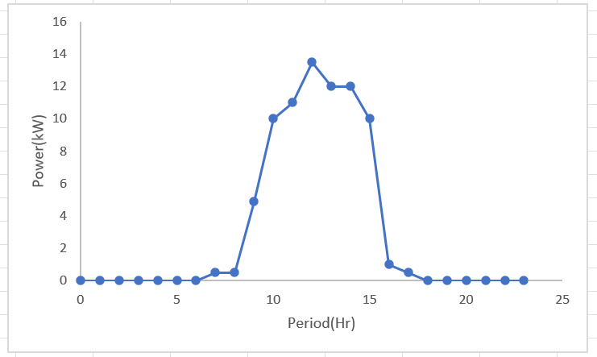
Average solar exposure across the three locations is roughly 5.85 kWh/m²/day, closely coinciding with nighttime and daytime loads. High clearness indices and moderate ambient temperatures (25–34 °C) boost photovoltaic (PV) efficiency and durability. Wind at Abe-eya provides extra electricity throughout early morning and nighttime hours when solar output drops. Furthermore, community surveys verified ample rooftop space on schools, health centers, and marketplaces (≈230 m² per village) for PV installation, avoiding competition with farming.

Figure 1a: Hourly Load Demand Profile of Owode

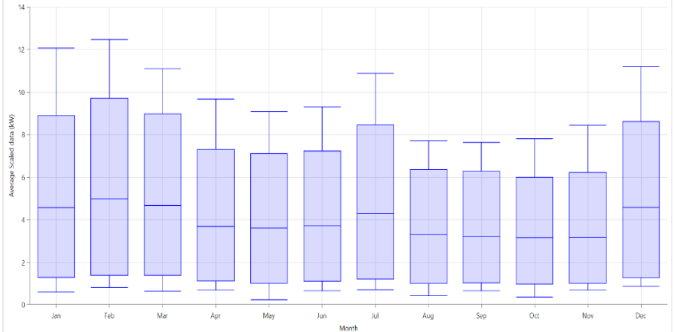

Figure 1b: Seasonal Load Demand Profile of Owode
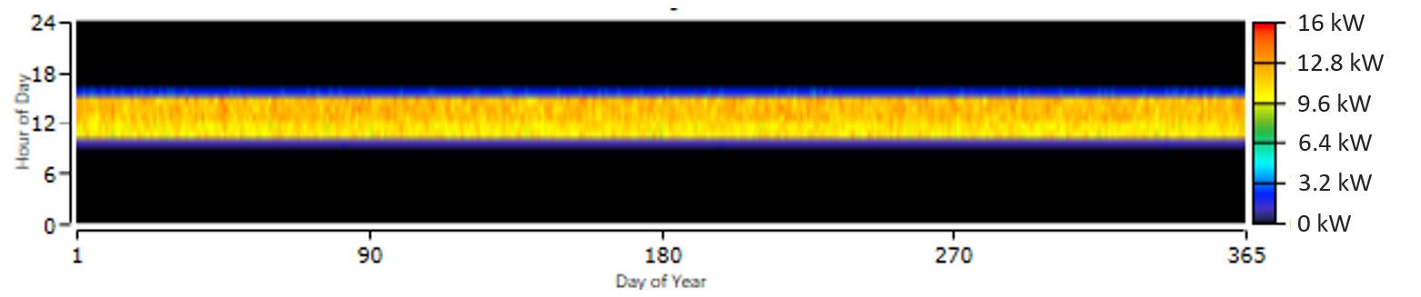
Figure 1c: Yearly Load Demand Profile of Owode
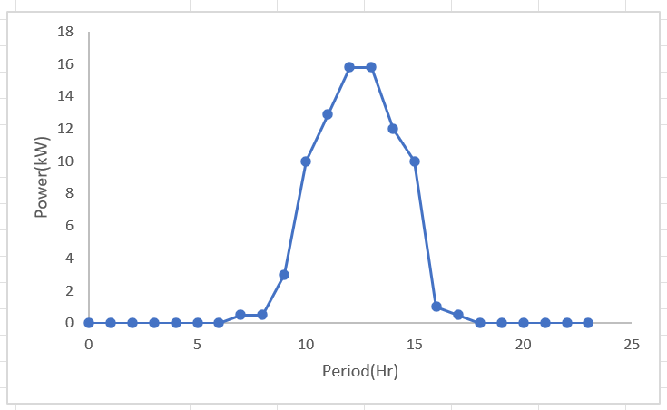
Figure 2a: Hourly Load Demand Profile of Abe-eya
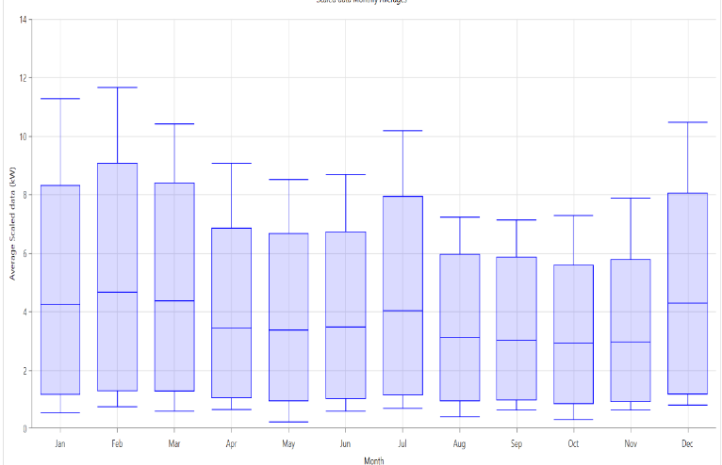
Figure 2b: Seasonal Load Demand Profile of Abe-eya
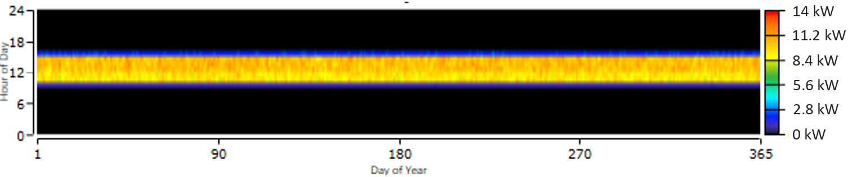
Figure 2c: Seasonal Load Demand Profile of the Abe-eya
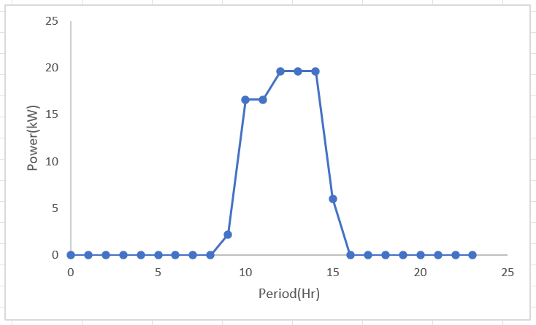
Figure 3a: Hourly Load Demand Profile of Ila-Oja Aboto
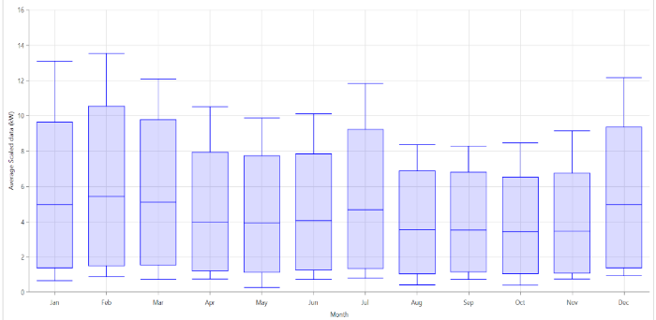

Figure 3b: Seasonal Load Demand Profile of Ila-Oja Aboto

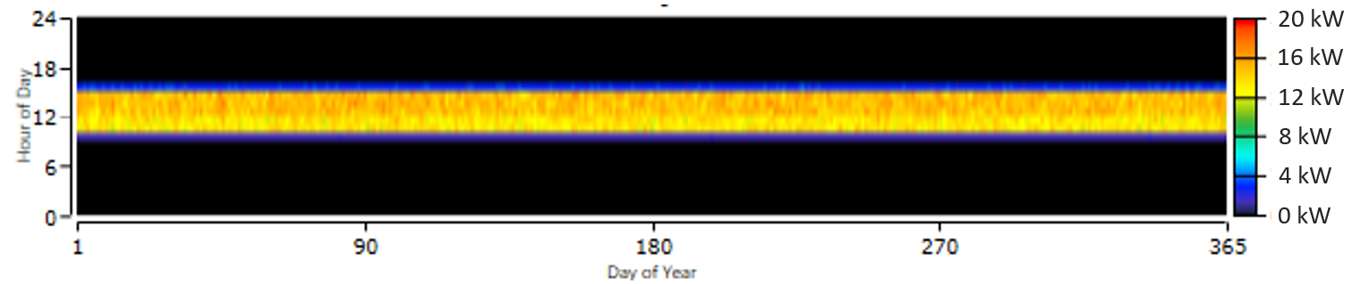
Figure 3c: Yealy Load Demand Profile of the Ila-Oja Aboto
Overall, the analysis indicates the technological and spatial viability of deploying HRES in all three communities. Each area has distinct capabilities that justify different renewable resource combinations, delivering reliable, site-specific energy solutions capable of increasing rural electrification, raising living standards, and promoting socio-economic growth.
3.2 Optimized Hybrid Renewable Energy System
The hybrid systems were optimized in HOMER Pro (v3.14.2) considering solar PV panels, wind turbines, biomass generators, battery storage, and converters. Optimal component sizes are summarized in Tables 1–3. For Abe-eya, the HOMER simulation recommends 54 units of 215 W PV modules, two 1 kW wind turbines, four 1 kW lead-acid batteries, and a 34 kVA converter. Owode and Ila-Oja Aboto, optimized as solar–biomass hybrids, require the same amount of PV modules and batteries, supported by one 5 kW biomass gasifier generator each.
Table 1: Optimal Sizes of the Main Components of Owode
Component | Specification | Quantity
Solar PV Panel  Wind Turbine | Sunpower215PL-SUNP-SNR-215 (215 W)  Bergey Excel 1 (1 Kw, cut in speed 3.5m/s) | 54 units  2 units
Battery | Generic 1kW Lead Acid | 4 units
Power Converter  Charge Controller | Generic system converter (34 kVA)  MTTP Hybrid Controller (solar/wind compatible | 1 unit  1 unit
Table 2: Optimal Sizes of the Main Components of Abe-eya
Component | Specification | Quantity
Solar PV Panel  Biomass Generator | Sunpower215PL-SUNP-SNR-215 (215 W)  5 KW Biomass Gasifier Generator (using agricultural residue) | 54 units  1 unit
Battery | Generic 1kW Lead Acid | 4 units
Power Converter  Charge Controller | Generic system converter (34 kVA)  MTTP Hybrid Controller (solar/wind compatible | 1 unit  1 unit
Table 3: Optimal Sizes of the Main Components of Ila-Oja Aboto
Component | Specification | Quantity
Solar PV Panel  Biomass Generator | Sunpower215PL-SUNP-SNR-215 (215 W)  5 KW Biomass Gasifier Generator (using agricultural residue) | 54 units  1 unit
Battery | Generic 1kW Lead Acid | 4 units
Power Converter  Charge Controller | Generic system converter (34 kVA)  MTTP Hybrid Controller (solar/wind compatible | 1 unit  1 unit

In Abe-eya, the PV array is expected to operate for ~4,313 hours yearly, far exceeding the community’s requirement (~2,555 hours). The wind turbine, albeit modest in energy production, maintains supply stability during low-solar periods and minimizes battery stress as depicted in Figure 4. In Owode and Ila-Oja Aboto, solar generation ranges from 25,754 to 31,643 kWh/year, constantly surpassing local demand. Surplus electricity may support agro-processing, water pumping, or other profitable uses as indicated in Figure 5. Biomass generators provide stable backup during extended cloudy circumstances, ensuring resilience without fossil fuel reliance.

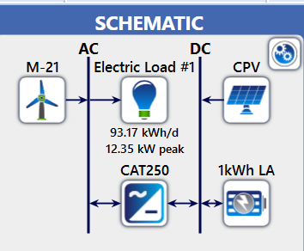

Figure 4: Schematic Diagram of the Proposed Hybrid Renewable Energy System in Abe-eya
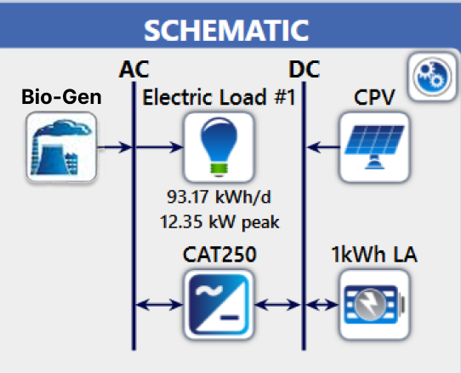

Figure 5: Schematic Diagram of the Proposed hybrid renewable energy system in Owode and Ila-Oja Aboto
In all locations, Battery Energy Storage Systems (BESS) manage short-term swings and secure supply during peak demand periods. This personalized method provides reliability, scalability, and cost-effectiveness, while drastically lowering dependence on diesel generators and associated greenhouse gas (GHG) emissions.

3.3 Comprehensive Analysis of the Proposed System
Financial Analysis
RETScreen software was used to evaluate financial viability. Key assumptions included a discount rate of 9%, inflation rate of 34.2% (current Nigerian figure), a 20-year project life, and 70% debt financing at 7% interest as shown in Table 4.
Table 4: Financial Parameters of the Proposed Design
Parameters | Values
Fuel cost escalation rate | 25%
Inflation rate | 34.2%
Discount rate | 9%
Reinvestment rate | 9%
Project life | 20
Debt ratio | 70%
Debt interest rate | 7%
Debt payment | 10

Initial investment requirements are projected at NGN 22.32 million for Owode, NGN 24.48 million for Abe-eya, and NGN 24.96 million for Ila-Oja Aboto. Annual operating costs, including O&M and debt servicing, mirror these values. Despite high upfront costs, the system produces significant savings: NGN 11.4 million (Owode), NGN 12.1 million (Ila-Oja Aboto), and NGN 11.9 million (Abe-eya) annually, assuming Band A electricity rate of NGN 209/kWh. Cumulative cash flow analysis indicates profitability across all sites, with considerable positive inflows beginning in year 2. Replacement of important components (e.g., batteries, inverters) momentarily reduces inflows in certain years, but long-term trends remain significantly favorable. By year 20, cumulative cash flows exceed NGN 2.1 billion in each community. Financial parameters as indicated in Table 5 affirm excellent viability: Internal Rates of Return (IRR) on equity surpass 140% in all sites; simple payback timeframes average 3.2–3.5 years; and equity payback is less than one year. Net Present Values are highly positive, and Benefit–Cost ratios (>115) demonstrate profitability.

Table 5: Financial Viability of the Proposed Designs
Parameters | Values
 | Owode | Abe-eya | Ila-Oja Aboto
Internal Rate of Return on Equity | 158% | 149% | 142%
Internal Rate of Return on Asset | 61.4% | 60.9% | 62.1%
Simple Payback Period | 3.5 years | 3.2 years | 3.3 years
Equity Payback | 0.79 | 0.86 | 0.85
Net Present Value | NGN 554223639.10 | NGN  554223639.10 | NGN  554223639.10
Annual Life cycle saving | NGN 80,713,653.07/yr | NGN  78,784,246.33/yr | NGN  79,700,246.00/yr
Benefit-Cost (B-C) ratio | 115 | 117 | 116
3.4 Emission Analysis
RETScreen emission study demonstrates that the suggested hybrid systems cut GHG emissions by 63–70% compared to baseline fossil-fuel usage. Estimated annual emissions are 959.17 kg (Owode), 613.30 kg (Abe-eya), and 7569.00 kg (Ila-Oja Aboto), compared with >6,000 – 7,500 kg under traditional systems. These reductions underscore the environmental benefits of hybridization, particularly in rural regions where biomass and PV can directly supplant diesel generators.
Sensitivity and Risk Analysis
Sensitivity analysis demonstrates that Net Present Value drops when starting costs and grid electricity prices grow. Conversely, reductions in these factors boost NPV and shorten payback periods. Nonetheless, NPVs remain robust even under inflationary scenarios, with minimum values exceeding NGN 550 million across all sites.
Monte Carlo-based risk analysis as presented in Table 6 confirmed system resilience to cost and parameter uncertainty. At a 10% risk level, NPVs were between NGN 498 million and NGN 805 million, with equity payback durations between 0.56 and 0.84 years. These results illustrate the strong investment security of the suggested solutions, especially under uncertain economic conditions in Nigeria.

Table 6: Risk Analysis Report
Parameter | Value | Minimum | Maximum
Initial Costs (NGN) | 16,223,297.00 | 12,167,472.75 | 20,279,121.25
O&M (NGN) | 43,645.00 | 32,733.75 | 54,556.25
Fuel cost-proposed case (NGN) | 3,525,306.88 | 2,643,980.16 | 4,406,633.60
Fuel cost-base case (NGN) | 9,642,827.03 | 7,232,120.27 | 12,053,533.80
Debit rate (%) | 70.00 | 52.50 | 87.50
Debit interest rate (%) | 7.00 | 5.25 | 8.75
Debt term (year)  Net Present Value (NGN)  Equity Payback Period (Years)  Discount Rate (%)  Inflation Rate (%) | 10.00  554,223,639.10  0.8150  6.00  13.00 | 7.50  450,737,356.72  0.4882  4.50  9.75 | 12.50  657,709,921.48  1.2661  7.50  16.25

4. Conclusion
This study investigated and optimized Hybrid Renewable Energy System (HRES) for off-grid electricity in three rural communities in Kwara State, Nigeria Owode, Ila-Oja Aboto, and Abe-eya. The results suggest that personalized hybrid systems, constructed around locally available renewable resources and demand patterns, are both technically feasible and economically viable. With an average daily sun irradiation of 5.85 kWh/m² across all sites, solar energy constitutes the backbone of the system, while moderate wind speeds in Abe-eya justify solar–wind hybridization, and rich biomass in Owode and Ila-Oja Aboto promotes solar–biomass integration. The optimized arrangements allow 24-hour electrical access, successfully eliminating fossil fuel–based alternatives and decreasing greenhouse gas emissions. By fulfilling important residential and community loads such as lighting, refrigeration, mobile charging, and small appliances the system fulfills critical rural energy demands while decreasing costs and environmental implications. The findings demonstrate that community-specific HRES can dramatically improve living conditions, education, healthcare, and economic production in underserved places. The successful demonstration in these three villages gives a reproducible paradigm for other rural locations in Nigeria and sub-Saharan Africa. Overall, the study emphasizes the transformative impact of optimized hybrid renewable systems in bridging the rural electrification gap and promoting Nigeria’s sustainable development and energy transition agenda.

4. RECOMMENDATION
Based on the results, the following recommendations are recommended for politicians, development agencies, researchers, and local stakeholders:
1. Community-Specific Deployment: Tailored HRES should be deployed in the examined communities, with solar–biomass systems favored in Owode and Ila-Oja Aboto, and solar wind systems in Abe-eya. These approaches should be included into Nigeria’s broader rural electrification strategy.
2. Institutional and Financial Support: Federal and state governments, in conjunction with private investors and donor organizations, should offer enabling frameworks including as subsidies, tax incentives, and concessional financing to expedite rural HRES adoption and assure long-term sustainability.
3. Capacity Building and Community Engagement: Training programs should establish local competence in installation, operation, and maintenance, while active community participation should be fostered to enhance ownership and sustainability. Continuous monitoring of solar, wind, and biomass resources is also recommended to enhance performance.
4. Replication and Scale-Up: The demonstrated success in Kwara State should be scaled to other rural communities in Nigeria and across sub-Saharan Africa. Future research should focus on sophisticated storage integration, smart monitoring technologies (IoT, AI), and improved hybrid optimization models to enhance efficiency and resilience

References

[1] Fasina E.T., Hassan A.S., (2020). Cipcigan L.M., "Impact of localised energy resources on electric power distribution systems. 2020 50th International University Power Engineering Conference, pp. 1–5, 2020, doi: 10.1109/UPEC.2015.7339793
[2] Jelili Aremu Oyedokun, Emmanuel Taiwo Fasina, Bankole Adebanji, and Adewale Abe, “Electricity Challenges in Nigeria: Renewable a way forward.” Global Journal of Engineering and Technology Advances, Vol.11 (3), (2022): 016-023
[3] Olusola Bamisile, Mustafa Dagbasi, Akinola Babatunde and Oluwaseun Ayodele (2022). A review of renewable energy potential in Nigeria; Solar power development over the years, Energy Systems Engineering Department’’ Cyprus International University, Haspolt Lefkosa, Mersin 10, Turkey.
[4] Oyedokun Jelili Aremu, Emmanuel Taiwo Fasina, Bankole Adebanji. (2023) ‘’Design and Viability Assessment of Grid-Integrated Solar PV System for Electric Power Supply Enhancement: A Case Study of Idofian.’’ Nigeria, European Journal of Electrical & Computer Engineering, Vol. 7 (3), : 30-34
[5] International Energy Agency (IEA). (2021). "Africa Energy Outlook 2021." International Energy Agency. Retrieved from https://www.iea.org/reports/africa-energy-outlook.
[6] Ariyo, B. O. M.F. Akorede, A. K. Adebayo (2020). Optimization of Hybrid Energy Mix for Rural Electrification in Nigeria. International Research Journal of Engineering and Technology (IRJET) e-ISSN: 2395-0056 Volume: 05 Issue: 08 | Aug 2018 www.irjet.net p-ISSN: 2395-0072 2018, IRJET | Impact Factor value: 7.211 | ISO 9001:2008 Certified Journal | Page 743
[7] Chendo, M. A. C (2022). Factors Militating Against the Growth of the Solar-PV Industry in Nigeria and their Removal. Nigerian Journal of Renewable Energy Vol. 10, Nos. 1and 2 pp. 151-158.
[8] The World Bank (2023, May). World Development Indicators, Access to electricity. (% of population), from World bank data: htpp://dx.doi.org/10.1016/j.solener.2016.07.036
[9] Araoye Timothy Oluwaseun, Mgbachi, C. A., Muniru Olajide Okelola, and Ganiyu Adedayo Ajenikoko (2018). A Comparative Analysis of Renewable Energy Using Biogas and Solar Photovoltaic Systems: A Case Study of Ajaba, In Osun State. Control Theory and Informatics www.iiste.org ISSN 2224-5774 (Paper) ISSN 2225-0492 (Online) Vol.7, 2018
[10] Fasina E.T., Adebanji B, Abe A., and Ismail I. (2023). Localised energy system in Nigeria power network IEEE 15TH International Conference on Industrial information (INDI 2023) PP. 458-461 Emden, Germany
[11] Fasina E.T., Adebanji B. and Oyedokun J.A. (2023). ‘’Microgrids for Rural Electrification in Nigeria: Prospects and Challenges.’’ Global Scientific Journal, Vol. 11, Issue 9, Pg 537-544
[12] Lal, S., Raturi, A., and Reddy, K. S. (2021). "Optimization of PV/wind/micro-hydro/diesel hybrid power system in HOMER for the study area." International Journal on Power System Optimization, 12(4), 567-573.
[13] Oyedokun J. A., Adikwu J. P., Abiodun L. O., Salman S. I., and Fasina E. T. (2022). Development of a Multiple Linear Regression Model for Rainfall Distribution on other Metrological Parameters: A Case Study of Idofian, Kwara State Nigeria, Global Scientific Journal Pp 609-620
[14] Araoye Timothy Oluwaseun, C.A. Mgbachi, Muniru Olajide Okelola, and Ganiyu Adedayo Ajenikoko. A Comparative Analysis of Renewable Energy Using Biogas and Solar Photovoltaic Systems: A Case Study of Ajaba, In Osun State Control Theory and Informatics www.iiste.org ISSN 2224-5774 (Paper) ISSN 2225-0492 (Online) Vol.7, 2018
[15] Energy Commission of Nigeria (2020). Draft of National renewable energy and energy efficiency policy (internet). Cited October 2023. Available on http://www.energy.gov.ng
[16] Abdullahi, D. Suresh, S. Renukappa S. and Oloke, D. (2020). Key Barriers to the Implementation of Solar Energy in Nigeria: A Critical Analysis, 2nd International Conference on Green Energy Technology (ICGET 2020) IOP Publishing IOP Conf. Series: Earth and Environmental Science 83, 012015 do i :10.1088/1755-1315/83/1/012015
[17] Gafari Abiola Adepojua, Muniru Olajide Okelolaa, Muhammed Adekilekun Tijani Hybrid Optimization Technique for Solving Economic Dispatch Problem: A Case Study of Nigerian Thermal Power System African Scientific Reports 1 (2022) 81–87
[18] Sinha, S. and Chandel, S. S. (2023). "Review of software tools for hybrid renewable energy systems." Renewable and Sustainable Energy Reviews, 42, 792-803. https://doi.org/10.1016/j.rser.2014.10.034.
[19] Koutroulis, E., Kolokotsa, D., and Potirakis, A. (2006). "Methodology for optimal sizing of stand-alone photovoltaic/wind-generator systems using genetic algorithms." Solar Energy, 80(9), 1072-1088. https://doi.org/10.1016/j.solener.2005.10.002.
[20] Khan, M. J., and Iqbal, M. T. (2021). Pre-feasibility study of stand-alone hybrid energy systems for applications in Newfoundland. Renewable Energy, 30(6), 835-854.
[21] M. A. Tijani, G. A. Adepoju, and M. O. Okelola, “Optimization approaches to generation dispatch: Review of Nigerian power system, ” Niger. J. Technol. Dev., vol. 19, no. 2, pp. 156–163. [CrossRef]

