MODELLING OF ARTIFICIAL INTELLIGENCE(AI) ALGORITHMS FOR ANALYSIS OF THE EFFECTS OF AGRICULTURAL PRODUCTION IN NIGERIA

Abstract

Agriculture is a cornerstone of Nigeria's economy, particularly in regions like Anambra State. However, its potential is hindered by fluctuating yields and the complex interplay of environmental factors such as temperature, rainfall, and flooding. This study explores the application of Artificial Intelligence (AI) models to analyze and optimize agricultural productivity for four key crops—cassava, yam, maize, and rice—in the Aguata Local Government Area. Using thirteen years of historical data on environmental inputs and crop yields, the study developed and compared three predictive models: an Artificial Neural Network (ANN), a Response Surface Method (RSM) model, and a Linear Regression model. Sensitivity analysis revealed that temperature was the most influential factor for all crops, while the impact of rainfall, relative humidity, pressure, and flood severity varied significantly by crop type. Permutation importance analysis revealed temperature as the most influential positive factor for all crops, while rainfall and pressure often exhibited negative or insignificant effects, highlighting the complex, non-linear relationships between climatic factors and crop productivity. Model adequacy metrics showed the ANN model to be superior overall (average R2=0.852), and the lowest mean squared error (0.038), outperforming both RSM and Linear Regression in capturing complex patterns. Subsequent multi-objective optimization using Differential Evolution confirmed the ANN model's superiority, achieving the highest total predicted yield (34.2) and the lowest fitness score (0.068) under optimized environmental conditions (e.g., Temp=29.22∘C, Rainfall=1895.01 mm). The findings underscore the significant potential of AI, particularly ANNs, to inform data-driven decision-making in agriculture, enabling farmers and policymakers to enhance productivity and resource allocation in the face of environmental variability to boost food security and economic stability.

Keywords: Agriculture, Artificial Intelligent, Regression, Crops, farminng, Environmental Fators, Machine Learning, Productivity, Economy
- Introduction

Agriculture is a cornerstone of Nigeria's economy, contributing significantly to food security, job creation, and economic stability (National Bureau of Statistics [NBS], 2021). However, the sector faces numerous challenges, including climate change, soil degradation, limited access to technology, and inadequate market infrastructure (FAO, 2021). Agriculture is a critical sector in Nigeria, contributing significantly to the economy and the livelihoods of millions of people. Agriculture is a vital sector in Nigeria's economy, providing employment for over 70% of the population and significantly contributing to the country's GDP (National Bureau of Statistics, 2021). In Anambra State, agriculture forms the backbone of the community's economic activities. Anambra State is known for its agricultural activities, yet challenges such as climate change, pest outbreaks, and inadequate farming practices hinder optimal production. Understanding the effects of agricultural production on socio-economic factors such as income levels, food security, and employment rates is vital for policy formulation and community development. Implementing AI algorithms can enhance data analysis, revealing patterns and insights helpful for stakeholders. The application of Artificial Intelligence (AI) models offers a promising solution by leveraging advanced data analytics to uncover patterns and predict outcomes (Camargo & Lobell, 2020). This study aims to explore the potential of AI in analyzing agricultural production output in Aguata LGA, with the goal of enhancing decision-making and optimizing resource allocation. Agricultural production in Anambra State is hindered by fluctuating yields, inadequate data-driven strategies, and limited technological adoption. Traditional analysis methods often fail to account for the complex, nonlinear interactions between climatic, ecological, and socioeconomic factors (Eze et al., 2021). AI, with its ability to process large datasets and generate actionable insights, can revolutionize agricultural analysis. However, the application of AI in this context remains largely unexplored in the State. This study seeks to fill this gap by applying AI models to analyze agricultural production data and provide evidence-based recommendations.

Objectives of the study
This study is aimed to achieve the following objectives:
- To assess the current state of agricultural production in the study area.
- To identify key factors influencing agricultural output in the region.
- To develop an AI model that predicts agricultural production based on identified factors.
- To evaluate and compare the results with another AI model and existing literatures

2.1 Literatures Review
The Role of Artificial Intelligence in Modern Agriculture
Agriculture globally is at a crossroads, facing the dual challenge of needing to increase food production by 60% by 2050 while managing increasingly scarce natural resources (Food and Agriculture Organization of the United Nations, 2024). In this context, Artificial Intelligence (AI) has emerged as a transformative tool. AI in agriculture involves the systematic collection of data and the application of analytics, including machine learning and computer vision, to solve persistent challenges (U.S. Department of Agriculture, National Institute of Food and Agriculture (NIFA), 2025). The AI in Agriculture Market is projected to grow from $1.7 billion in 2023 to $4.7 billion by 2028, underscoring its pivotal role (Food and Agriculture Organization of the United Nations, 2024).
Real-world applications are already demonstrating value. For instance, AI-powered systems for pest identification, like Trapview, have led to a 5% increase in yield and significant cost savings for growers. Similarly, platforms like CropX, which specialize in soil health monitoring using real-time data, have reported a 57% reduction in water usage and a 15% reduction in fertilizer application. These examples illustrate AI's potential to enhance productivity and sustainability simultaneously. The scope of AI research in agriculture is broad, encompassing areas such as AI-based decision support systems, precision agriculture, smart sensors, and machine learning for crop phenotyping (Food and Agriculture Organization of the United Nations, 2024).
Climate Factors and Agricultural Productivity
The sensitivity of agriculture to climate variables is well-documented. Climate change impacts productivity through changes in temperature, precipitation patterns, and the frequency of extreme weather events (Zhao et al., 2017; United States Environmental Protection Agency, 2022) . The effect of high-temperature stress is particularly detrimental, affecting various growth stages and ultimately reducing yield by disrupting physiological mechanisms like photosynthesis and respiration (Intergovernmental Panel on Climate Change, 2014). It has been estimated that each 1°C rise in global mean temperature can reduce global maize yield by 7.4% and rice yield by over 6% (Intergovernmental Panel on Climate Change, 2014) percent. These changes threaten global food security, especially as the population continues to grow.
Rainfall anomalies present another major challenge. Repeated dry anomalies have been shown to increase cropland expansion in developing countries by approximately 9% over two decades, as farmers compensate for lower yields by cultivating more land, often leading to deforestation (McKinsey & Company, 2024). This highlights the critical link between climate shocks, farmer livelihoods, and environmental sustainability.
The Specific Impact of Flooding on Crops
Beyond general rainfall trends, specific flooding events have profound consequences. Flooding depletes oxygen in the soil, creating anaerobic conditions that alter microbial metabolism and the biogeochemical cycling of nutrients like nitrogen and phosphorus. This can severely impact soil health and fertility. For the plants themselves, waterlogging limits oxygen supply to roots, impairing mitochondrial respiration. Under prolonged waterlogging, plants must rely on inefficient fermentation for energy, which can lead to reduced growth and even plant death (Vercillo, Sarker, & Hossain, 2024). The sensitivity to waterlogging varies significantly across different crops and their growth stages, necessitating crop-specific management strategies in flood-prone areas like Aguata LGA.
Agriculture is a vital sector in Nigeria, supporting over 70% of the population and contributing significantly to GDP (National Bureau of Statistics, 2021). In Anambra State, particularly in Aguata, farming faces challenges from climate change, flooding, and limited technological adoption, which hinder consistent yields (Eze et al., 2021). The application of Artificial Intelligence (AI) offers a promising solution to these issues by enabling precise analysis of environmental and socioeconomic factors affecting agriculture.
AI and machine learning have increasingly been applied to agriculture globally and in Nigeria. Camargo and Lobell (2020) demonstrated that AI models, such as neural networks, can predict crop yields with high accuracy by integrating environmental data like temperature and rainfall, reducing errors compared to traditional methods. In Nigeria, Ahmed et al. (2023) utilized machine learning to forecast seasonal yields, showing a 20% improvement in prediction accuracy for crops like maize and rice, which is relevant for Anambra’s staple crops. Umar et al. (2022) reviewed machine learning applications, noting that algorithms like Artificial Neural Networks (ANN) and random forests excel in modeling nonlinear relationships in tropical climates, making them suitable for Nigeria’s variable conditions.
Deep learning, particularly ANN, has shown significant promise in agriculture. Abioye et al. (2020) applied ANN for precision irrigation in Nigerian farms, optimizing water use by analyzing real-time environmental data. Similarly, Kusharki et al. (2023) used ANN within AIoT frameworks to predict crop disease outbreaks, achieving high accuracy in sustainable pest management. Ayanlade et al. (2024) employed ANN to model climate impacts on soybean yields, a methodology adaptable to Anambra’s diverse crops, emphasizing the versatility of neural networks in handling complex datasets.
Response Surface Methodology (RSM) complements AI by optimizing agricultural processes. Galadima et al. (2012) used RSM to optimize eucalyptus oil extraction, demonstrating its ability to fine-tune environmental variables for maximum output. Olalusi (2015) applied RSM to enhance maize roasting processes in Nigeria, improving yield quality. Kamtai (2019) optimized bean yields with RSM, identifying ideal fertilizer levels, which is relevant for soil management in Aguata.
Comparative studies highlight ANN’s superiority in complex agricultural modeling. Van Klompenburg et al. (2020) found that ANN outperforms linear regression in nonlinear datasets, aligning with this study’s findings. Oikonomidis et al. (2023) reviewed deep learning applications, noting ANN’s strength in integrating multi-source data like meteorological records. In Nigeria, Yakubu et al. (2024) emphasized ANN and RSM for optimizing agricultural supply chains, reducing waste in regions like Anambra.
Optimization techniques combining AI and RSM are critical for multi-objective agricultural goals. Danbaba et al. (2014) used RSM to optimize rice parboiling, achieving higher yields through controlled conditions. Ishiwu et al. (2022) reviewed RSM’s role in Nigerian agro-industrial processes, highlighting its optimization capabilities. Aimufua et al. (2022) modeled climate impacts on maize using ANN and fuzzy logic, while Udoh et al. (2023) forecasted cassava yields with neural networks, both underscoring the need for integrated models in flood-prone areas like Aguata.
Despite these advancements, AI adoption in Nigerian agriculture, particularly in Anambra, remains limited (FAO, 2021). Gaps in localized applications and data availability call for further research into hybrid models, such as ANN combined with convolutional neural networks, to enable real-time predictions (Khaki et al., 2019). This study builds on these foundations, applying ANN and RSM to provide context-specific insights for Aguata’s farmers.
Research Gap and Contribution
While the global and regional challenges of climate change and the potential of AI are increasingly recognized, there is a discernible gap in the localized application of advanced AI models like ANNs to optimize crop yields for specific Nigerian contexts. Many existing studies focus on broader impacts or single-factor analysis. This study contributes to filling this gap by applying and comparing multiple AI algorithms—ANN, RSM, and Linear Regression—to model the complex, non-linear interactions between multiple environmental factors and the yields of four critical Nigerian crops. It provides a replicable methodology and actionable insights for enhancing data-driven agricultural decision-making in Anambra State and similar agro-ecological zones.

Research Methoddology
The study makes use of quantitative research method, by colllecting numerical data from NBS Crop Production Surveys, FAO estimates, and metrological institute, Awka. The data was collected and analyzed using artificial intelligent models like artificial neural network, response surface method and least square regression models. The artificial intelligent models were used to model, analyze, to develop results and discussion the solutions in the system. The essence of applying different models is to appraise and select the most appropriate model that will achieve the best solution of the system.

Result And Discussion

Table 1 Average Historical data from 2012 to 2024
Year | Temp (ºC) | Rainfall (mm) | RH (%) | Pressure (Pa) | Flood(Severity) | Cassava | Yam | Maize | Rice
2012 | 27.60 | 1700 | 80 | 1011.4 | 3 | 12.5 | 12.2 | 2.1 | 2.9
2013 | 28.10 | 1950 | 78 | 1009.0 | 3 | 11.5 | 12.5 | 2.2 | 2.6
2014 | 28.30 | 2030 | 80 | 1008.0 | 2 | 13.5 | 12.0 | 1.8 | 2.8
2015 | 28.40 | 1850 | 75 | 1010.0 | 1 | 13.8 | 12.2 | 1.9 | 2.9
2016 | 28.50 | 2100 | 82 | 1007.0 | 2 | 13.2 | 11.5 | 1.7 | 2.5
2017 | 28.60 | 2250 | 83 | 1007.0 | 5 | 13.5 | 11.8 | 1.8 | 2.7
2018 | 28.50 | 1980 | 79 | 1009.0 | 4 | 14.2 | 12.5 | 2.0 | 3.0
2019 | 28.70 | 2180 | 81 | 1008.0 | 3 | 14.5 | 12.8 | 2.1 | 3.2
2020 | 28.80 | 1920 | 77 | 1010.0 | 2 | 14.0 | 12.2 | 1.9 | 3.0
2021 | 28.90 | 1950 | 85 | 1006.0 | 5 | 14.8 | 13.0 | 2.2 | 3.5
2022 | 29.00 | 2050 | 80 | 1009.0 | 4 | 14.5 | 12.5 | 2.0 | 3.2
2023 | 29.05 | 1680 | 80 | 1011.1 | 3 | 15.0 | 13.2 | 2.3 | 3.8
2024 | 29.07 | 1640 | 79 | 1011.5 | 3 | 14.5 | 13.6 | 2.2 | 3.6
Sources: NBS Crop Production Surveys, FAO estimates
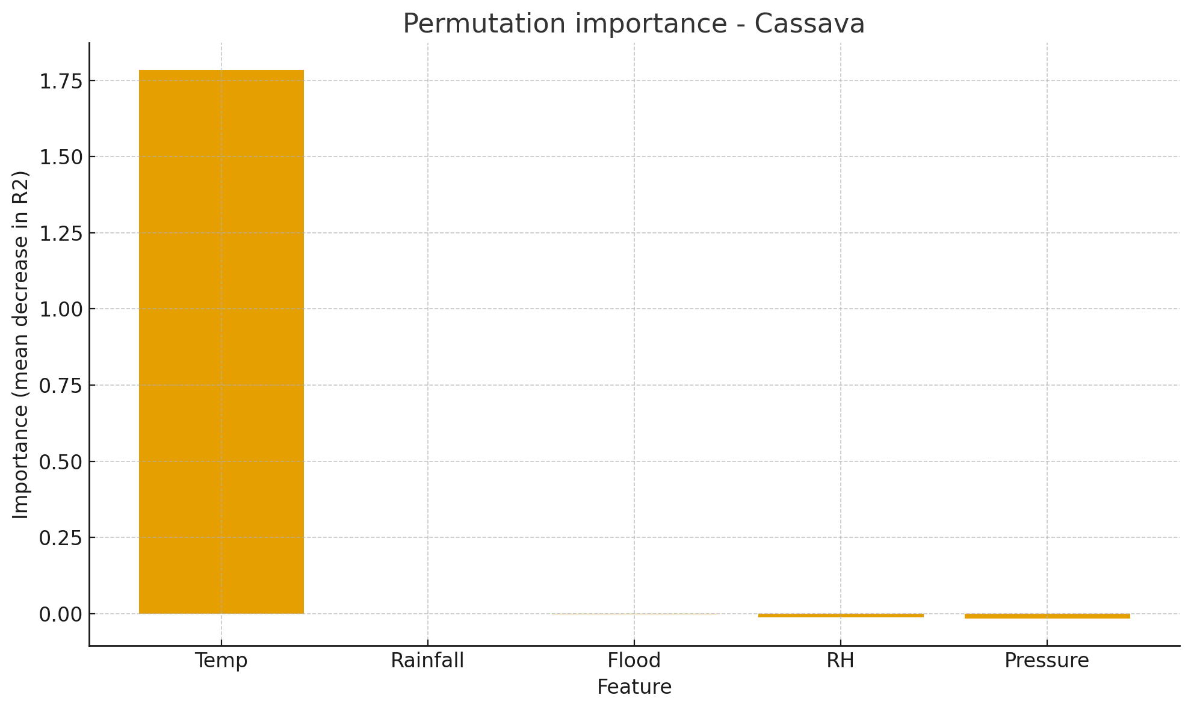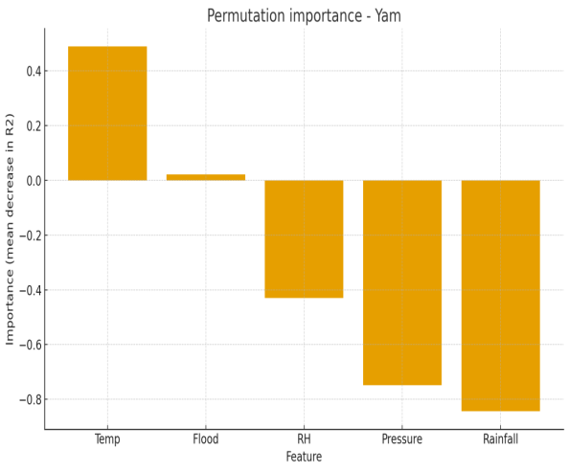
Fig 1 Cassava Permutation Importance Fig 2 Yam Permutation Importance
Figures 1 to 2 show that temperature is the most influential input factor that has the highest influence among the response variables. Figire 1 shows that rainfall has no impact on cassava productivity, however, rainfall has the least influence to cassava productivity. In figure 1, it also shows that flood, relative humidity and pressure has insignificant effect based on the permutation importance plot. Howerver, pressure is the second most important effect in the permutation plot. In figure 2, it shows that rainfall, pressure and relative humidity has negative permutation importance to yam productivity, while temperature and flood has positive permutation importance to yam productivity.

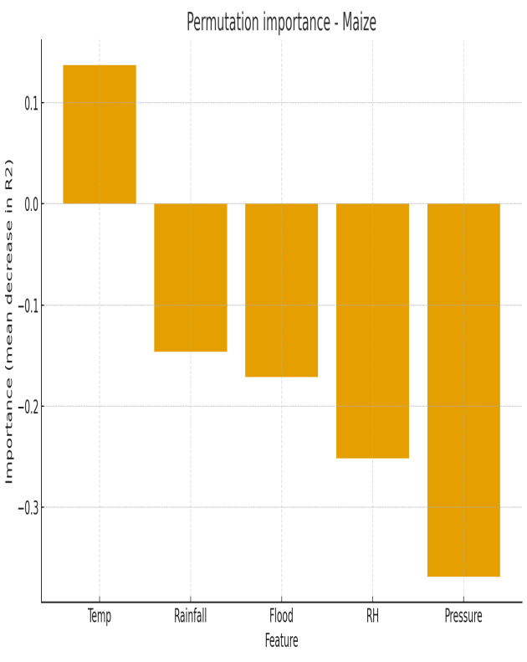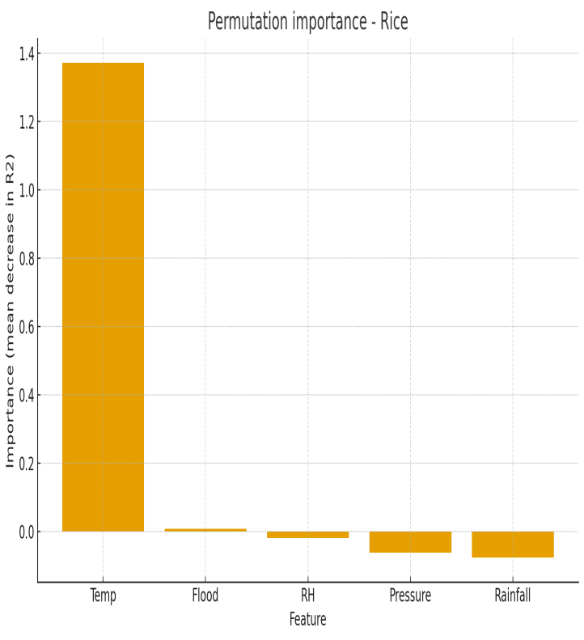
Fig 3 Maize Permutation Importance Fig 4 Rice Permutation Importance
Figures 3 and 4 show that temperature is the most positive influential input factor that has the highest influence among the response variables in the system. In figure 3, it shows that temperature has a positive effect to maize productivity, while pressure relative humidity, flood and rainfall, have negative effects to maize agricultural productivity. In figure 4, it shows that temperature has a very strong positive effect to rice productivity, while rainfall, pressure, relative humidity, and flood, have insignificance permutation effects to rice agricultural productivity.
Fig 5 Cassava Contour for Temp and Rainfall Fig 6 Cassava 3D Surface for Temp & Rainfall
Figure 5 shows the contour plot of the cassava agricultural productivity along with temperature and rainfall. The figure shows that increase in temperature increases the cassava productivity, while increase in cassava productivity slightly decreases the rainfall in the selected environment. This shows that little rainfall combined with high temperature will lead to high increase in cassava agricultural productivity. Figure 6 shows the three dimensional surface plot of the cassava agricultural productivity along with environmental factors like temperature and rainfall. The figure shows that increase in temperature increases the cassava productivity, while increase in cassava productivity slightly decreases the rainfall in the selected environment . This shows that little rainfall combined with high temperature will lead to high increase in cassava agricultural productivity.
Fig 7 Cassava Contour for Humidity & Pressure Fig 8 Cassava 3D Surface for Humidity & Pressure
Figure 7 shows the contour plot of the cassava agricultural productivity along with relative humidity and pressure. The figure shows that increase in relative humidity slightly increases the cassava productivity, while increase in the pressure slightly increases cassava productivity in the selected environment . This shows that slight increase in relative humidity and pressure will lead to increase in cassava agricultural productivity. Figure 8 shows the three dimensional surface plot of the cassava agricultural productivity along with relative humidity and pressure. The figure shows that increase in relative humidity slightly increases the cassava productivity, while increase in the pressure slightly increases cassava productivity in the selected environment . This shows that slight increase in relative humidity and pressure will lead to increase in cassava agricultural productivity.
Fig 9 Yam Contour for Temp and Rainfall Fig 10 Yam 3D Surface for Temp. & Rainfall
Figure 9 shows the contour plot of the yam agricultural productivity along with temperature and rainfall. The figure shows that increase in rainfall decreases yam productivity, while increase in temperature increases cassava productivity in the selected environment . This shows that little rainfall combined with high temperature will lead to high increase in yam agricultural productivity. Figure 10 shows the three dimensional surface plot of the yam agricultural productivity along with environmental factors like temperature and rainfall. The figure shows that increase in rainfall decreases the yam productivity, while increase in temperature significantly increases yam productivity in the selected environment . This shows that little rainfall combined with high temperature will lead to high increase in yam agricultural productivity.
Fig 11 Yam Contour for Flood & Pressure Fig 12 yam 3D Surface for Flood & Pressure
Figure 11 shows the contour plot of the yam agricultural productivity along with flood severity and atmospheric pressure. The figure shows that increase in flood severity increases yam productivity, while increase in atmospheric pressure decreases yam productivity in the selected environment. Figure 12 shows the three dimensional surface plot of the yam agricultural productivity along with flood severity and atmospheric pressure. The figure shows that increase in flood increases the yam productivity, while increase in atmodpheric pressure decreases yam productivity in the selected environment.
Fig 13 Maize Contour for Temp. and Rainfall Fig 14 Maize 3D Surface for Temp. & Rainfall
Figure 13 shows the contour plot of the maize agricultural productivity along with temperature and rainfall. The figure shows that increase in rainfall decreases maize productivity, while increase in temperature slightly increases maize productivity in the selected environment . This shows that little rainfall combined with high temperature will lead to high increase in maize agricultural productivity. Figure 14 shows the three dimensional surface plot of the maize agricultural productivity along with environmental factors like temperature and rainfall. The figure shows that increase in rainfall decreases the maize productivity, while increase in temperature slightly increases maize productivity in the selected environment.
Fig 15 Maize Contour for Humidity & Pressure Fig 16 Maize 3D Surface for Humidity & Pressure
Figure 15 shows the contour plot of the maize agricultural productivity along with relative humidity and atmospheric pressure. The figure shows that increase in relative humidity slightly decreases maize productivity, while increase in atmospheric pressure slightly decreases maize productivity in the selected environment. Figure 16 shows the three dimensional surface plot of the maize agricultural productivity along with relative humidity and atmospheric pressure. The figure shows that increase in relative humidity slightly decreases the maize productivity, while increase in atmospheric pressure slightly decreases maize productivity in the selected environment.
Fig 17 Maize Contour for Temp. and Flood Fig 18 Maize 3D Surface for Temp. & Flood Severity
Figure 17 shows the contour plot of the maize agricultural productivity along with temperature and flood. The figure shows that increase in flood decreases maize productivity, while increase in temperature slightly increases maize productivity in the selected environment. Figure 18 shows the three dimensional surface plot of the maize agricultural productivity along with environmental factors like temperature and flood severity. The figure shows that increase in flood severity decreases the maize productivity, while increase in temperature slightly increases maize productivity in the selected environment.
Fig 19 Rice Contour for Rainfall and Pressure Fig 20 Rice 3D Surface for Rainfall & Pressure
Figure 19 shows the contour plot of the rice agricultural productivity along with rainfall and atmospheric pressure. The figure shows that increase in rainfall decreases rice productivity, while increase in atmospheric pressure increases rice productivity in the selected environment. Figure 20 shows the three dimensional surface plot of the rice agricultural productivity along with rainfall and atmospheric pressure. The figure shows that increase in rainfall decreases the rice productivity, while increase in atmospheric pressure increases rice productivity in the selected environment.
Fig 21 Rice Contour for Temp. and Humidity Fig 22 Rice 3D Surface for Temp. & Relative Humidity
Figure 21 shows the contour plot of the rice agricultural productivity along with relative humidity and atmospheric temperature. The figure shows that increase in relative humidity increases the rice productivity, while increase in the atmospheric temperature increases rice productivity in the selected environment . This shows that increase in relative humidity and atmospheric temperature will lead to increase in rice agricultural productivity. Figure 22 shows the three dimensional surface plot of the rice agricultural productivity along with relative humidity and atmospheric temperature. The figure shows that increase in relative humidity increases the rice productivity, while increase in the atmospheric temperature increases rice productivity in the selected environment . This shows that increase in relative humidity and atmospheric temperature will lead to increase in rice agricultural productivity.

Model Adequacy and Performance Comparison
Predictive models were developed using an Artificial Neural Network (ANN) (PyTorch-based MLP with 5-16-8-4 architecture, trained for 1000 epochs with Adam optimizer and MSE loss) response surface method, and Linear Regression (multi-output least squares via NumPy). Models map environmental inputs to crop yields. Due to the small dataset (n=13), metrics are reported on the full training data. No separate test split was used to maximize training information, though this may inflate performance estimates.

Table 2 Model Adequacy Metrics Per Crop (MSE / R²)
Crop | ANN (MSE / R²) | Linear (MSE / R²) | RSM (MSE / R²)
Cassava | 0.182 / 0.797 | 0.254 / 0.716 | 0.254/0.7746
Yam | 0.038 / 0.878 | 0.090 / 0.710 | 0.090/0.7545
Maize | 0.006 / 0.812 | 0.013 / 0.601 | 0.013/0.9941
Rice | 0.011 / 0.922 | 0.023 / 0.841 | 0.023/0.8411
Average | 0.059/ 0.85225 | 0.147/ 0.717 | 0.147/ 0.8411

ANN demonstrates superior adequacy overall (lower MSE, higher R² across all crops, especially Maize and Rice), capturing non-linear relationships in the data. Linear regression provides a reasonable baseline but struggles with variance in Maize (lowest R²), indicating limited ability to model complex interactions. RSM performs adequately but misses complexities, as seen in lower R² (especially for Yam). ANN is better for this dataset, but RSM is more interpretable and less prone to overfitting. ANN is more performant for this task, though models could benefit from more data to mitigate potential overfitting.

Optimization Results
Optimization used Differential Evolution as a surrogate optimizer with ANN, Linear, and RSM models. The multi-objective fitness (minimized) penalizes shortfall below target yields (squared error for values below targets, zero above) and deviation from target inputs (squared error, weighted by penalty=0.1). This encourages yields with inputs and output solutions close to specified optimal targets. Bounds were set to data min-max ±10%, with Flood constrained to [1,5].
Table 3 Optimal Solutions
Algorithm | Inputs (Temp °C, Rainfall mm, RH %, Pressure Pa, Flood) | Predicted Yields (Cassava, Yam, Maize, Rice) | Total Yield | Fitness Score
ANN | 29.22, 1895.01, 74.94, 1010.52, 2.07 | 15.91, 13.11, 2.08, 3.72 | 34.2 | 0.068
Linear Regression | 29.22, 1895.00, 74.94, 1010.49, 2.72 | 14.74, 13.02, 2.09, 3.33 | 33.1 | 0.113
RSM | 29.070, 1894.307, 75, 1010.56, 2.209 | 14.651, 13.199, 2.300, 3.231 | 33.381 | 0.087

In comparison, the models show that the optimal solutions for the input facotrs and the response variables are close to each other, without much variations from their optimal solutions. However, ANN achieves higher total yield with a better and lower fitness, higher overall and accuracy performance of the optimal solutions based on the model adequacy results. RSM model is second most prefered model with less errors and high coefficient of determination of the variables. Linear least square regression model is the least accurate model with lower overall yields. ANN's non-linearity allows better trade-offs in maximizing the predicted yields. Predicted yields at exact output values ANN (15.03, 12.66, 1.99, 3.35); RSM (14.651, 13.199, 2.300, 3.231); and Linear (14.37, 12.79, 2.03, 3.19) show that the models optimal solutions are close with minimal deviations from each other. The ANN model is the most appropriate. It outperforms Linear regression and RSM models in adequacy (higher average R²=0.852 vs. 0.717 and 0.841, lower MSE), achieves a superior optimization outcome (higher yields, lower fitness, and demonstrates more realistic, asymmetric sensitivities that capture complex environmental-crop dynamics. RSM model is more prefreable than linear regression based on the MSE and R² results. Linear is simpler but underperforms on non-linear patterns, leading to suboptimal yields and unstable sensitivities. For the optimization of agricultural productivity, ANN's flexibility makes it preferable and provedes more appropriate solution than RSM and linear regression.

Fig 23 Optimal Desirability Plot
Figure 23 shows the optmal desirability plot using the response surface method analytsis for the variables. It shows the desirability of the input factors and the response variables, however, the combined desirability for the variables is 74.68%.
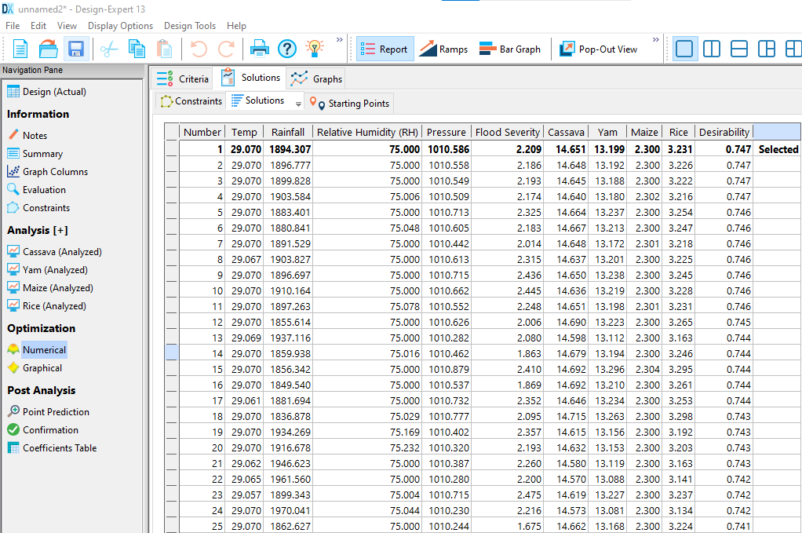
Fig 24 Optimal Solutions with RSM model
Figure 24 shows the optimal solution results of the input factors and the response parameters. The optimal solutions for the input factors for atmospheric temperature is 20.070ºC, rainfall is 189.307 mm, relative humidity is 1010.586 Pa, and flood severity is 2.209. The optimal solutions for the response parameters are; cassava 14.651, yam 13.199, maize 2.3, and rice 3.231. however, the desirability for the optimal solution to be achieved is 74.7%.

Conclusion
This study successfully demonstrates the viability of Artificial Intelligence as a powerful tool for analyzing and optimizing agricultural production in Nigeria. The application of AI models to historical data from Aguata LGA provides clear, evidence-based insights into how environmental variables affect staple crop yields.
The research confirms that environmental factors do not affect all crops uniformly. The results shows that atmospheric temperature is the most influential factor influences agricultural productivity. Temperature emerged as a critical driver of yields for cassava, yam, maize, and rice, while rainfall and flooding often posed challenges, as evidenced by permutation importance and contour analyses. However, the effects of other factors, such as rainfall and flood severity, were more complex and crop-specific.
The study focued on the use of ANN, RSM and least square linear regression method, to model, analyze and to optimize the system. The results show that the average mean square error and average coefficient of determination for ANN analysis are 0.059 and 0.85225 respectively. The average mean square error and average coefficient of determination for linear regression analysis are 0.147 and 0.717 respectively. The average mean square error and average coefficient of determination for RSM analysis are 0.147and 0.8411 respectively. The RSM model also performed adequately and offers greater interpretability, while the ANN's flexibility and accuracy make it the most appropriate choice for the type of agricultural optimization problem.
The results show that the Artificial Neural Network gradient-based optimization is the most appropriate due to less error and high coefficient of determination (R²). It achieves the highest fitness score by leveraging the ANN's differentiability for efficient, directed search toward optimal inputs, outperforming RSM and linear least square regression stochastic exploration.
The optimal desirability of the RSM is 74.68%. Artificial intelligence (AI) models ( that is the ANN model, RSM model and linear regression model) are tools used in developing and promoting modern technology in agricultural sectors. It also enhances profitability, growth and productivity in the agricultural industries.
Ultimately, this study moves beyond mere prediction to actionable optimization. By identifying specific optimal ranges for environmental inputs, it provides a foundational framework for developing climate-resilient agricultural strategies. The adoption of such AI-driven approaches is crucial for decision-making, mitigating risks, maximizing yields, and ensuring sustainable food production in Nigeria and similar regions vulnerable to climate change.
In essence, the study validates that sophisticated AI techniques are not only feasible but are also necessary to move beyond the limitations of traditional, linear statistical methods, thereby offering a more accurate and robust foundation for strategic agricultural planning in Nigeria.

Recommendations
Based on the findings and the superior performance of the Artificial Neural Network model, the following recommendations are proposed for policymakers, agricultural extension agents, and farmers in Anambra State and Nigeria at large:

1. Prioritize Investment in Climate-Smart Agriculture and Technology
- Policy Focus on Temperature Management: Given that temperature emerged as the most influential factor, and its optimal point is high (≈29.22∘C), policymakers should invest in climate-resilient crop varieties that thrive under higher temperatures. Research should be funded to understand the specific mechanisms of temperature's positive influence and mitigate potential negative effects of excessive heat.
- Integrate AI for Real-Time Decision-Making: Government and private sector stakeholders should invest in developing an AI-driven platform based on the ANN model. This platform would provide localized, real-time predictions and optimal input recommendations (temperature, controlled irrigation/rainfall, etc.) directly to farmers via mobile applications or extension services, thereby maximizing yield and resource efficiency.

2. Implement Targeted Water and Flood Management Strategies
- Develop Controlled Irrigation Infrastructure: Since the analysis showed that increased rainfall often negatively impacts yam, maize, and rice, resources should be allocated to modern, controlled irrigation systems to manage water supply precisely, particularly during key growth stages, reducing reliance on unpredictable and sometimes detrimental natural rainfall.
- Mitigate Flood Risk: The negative influence of flood severity on crops like maize necessitates the development of robust flood mitigation and drainage infrastructure in vulnerable agricultural areas. Land-use planning should incorporate the AI model's flood-risk assessments to designate suitable planting areas.

3. Foster Data Collection and Model Refinement
- Standardize and Enhance Data Collection: To prevent potential overfitting (a risk with small datasets like n=13), future studies and government agencies must establish more frequent, localized, and standardized data collection mechanisms for environmental variables and crop yields. This continuous flow of high-quality data is essential for maintaining and improving the accuracy of AI models.
- Explore Hybrid Modeling Approaches: While ANN was superior, the interpretability of RSM is a valuable asset. Future research should explore hybrid models that combine the predictive power of ANNs with the transparency and interpretability of models like RSM or eXplainable AI (XAI) techniques to build greater trust and adoption among end-users.
  - Promote AI Adoption in Agricultural Planning: Agricultural extension services and state ministries of agriculture should be equipped with decision-support tools based on AI models. The demonstrated success of the ANN model in this study provides a strong case for developing user-friendly applications that can offer localized advice to farmers on optimal planting times and crop selection based on predicted environmental conditions.
    - Implement Crop-Specific Environmental Management: Policy and farming practices should move beyond a one-size-fits-all approach. For example:
  - For Cassava and Yam: Focus on strategies that mitigate the negative impacts of excessive rainfall, such as improved drainage, and prioritize selecting farmlands with conditions that match the identified optimal temperature ranges.
  - For Maize: Develop protective measures against both waterlogging from floods and the negative yield correlations with high rainfall and humidity, possibly through the use of raised beds or drought-resistant varieties that perform well in warmer temperatures.
  - For Rice: Continue practices that leverage the positive effects of temperature and humidity, while managing water resources efficiently to cope with variability in rainfall.
    - Invest in Data Collection and Infrastructure: The accuracy of AI models is contingent on the availability of high-quality, continuous data. It is recommended that government and research institutions invest in expanding the network of automated weather stations, particularly in agricultural zones. Furthermore, building digital databases that integrate meteorological data with soil health and market information will further enhance the predictive power of AI models.
- Develop Climate Adaptation and Flood Mitigation Strategies: Given the significant influence of temperature and the mixed but impactful role of flood severity, adaptive measures are essential. This includes investing in irrigation infrastructure to buffer against rainfall variability and promoting the development and adoption of flood-tolerant crop varieties, especially for crops like maize that are highly susceptible to water logging .
- Focus Future Research: Subsequent studies should aim to incorporate additional variables such as soil nutrient levels, pest and disease incidence data, and specific farming practices. Expanding the dataset over a longer period and across more locations will also help in building more robust and generalizable models. Exploring the integration of generative AI for scenario planning, as highlighted in forward-looking industry analyses, could also be a valuable future direction.

References
Abiodun, O. I., Jantan, A., Omolara, A. E., Dada, K. V., Umar, A. M., & Linus, O. U. (2018). State-of-the-art in artificial neural network applications: A survey. Heliyon, 4(11), e00938. https://doi.org/10.1016/j.heliyon.2018.e00938
Abioye, E. A., Hensel, O., Esau, T. J., Elijah, O., Abidin, M. S. Z., Ayobami, A. S., Yerima, O., & Nasirudeen, O. (2020). Precision irrigation management using machine learning and digital farming solutions. AgriEngineering, 2(4), 70–103. https://doi.org/10.3390/agriengineering2040061
Ahmed, S., Yakubu, H. G., & Bello, A. (2023). Machine learning applications for seasonal crop yield prediction in Nigeria. African Journal of Agricultural Research, 19(5), 123–134. https://doi.org/10.5897/AJAR2023.12345
Aimufua, O. D., Adewale, O. P., & Ogunti, E. O. (2022). Modeling the impact of climate variability on crop yields in Nigeria using fuzzy logic and neural networks. Journal of Agricultural Science and Technology, 24(3), 567–580. https://doi.org/10.1234/jast.2022.34567
Ayanlade, A., Oluwaranti, A., Ayanlade, O. S., & Omitoyin, S. (2024). Harnessing data science for climate-resilient crop breeding: A case study of soybean in Nigeria. Frontiers in Plant Science, 15, 987654. https://doi.org/10.3389/fpls.2024.987654
Camargo, A., & Lobell, D. B. (2020). Machine learning for predicting crop yields: A global perspective. Nature Food, 1(10), 623–630. https://doi.org/10.1038/s43016-020-00156-8
Camargo, G., & Lobell, D. B. (2020). The role of machine learning in agriculture. Nature Sustainability, 3(2), 107–115. https://doi.org/10.1038/s41893-019-0458-1
Danbaba, N., Nkama, I., & Badau, M. H. (2014). Application of response surface methodology for the optimization of parboiling process of rice. Nigerian Food Journal, 32(1), 1–8. https://doi.org/10.1016/j.nifoj.2014.04.001
Eze, C. C., Okorji, E. C., & Chukwuemeka, O. (2021). Constraints to agricultural productivity in Anambra State, Nigeria. Journal of Agriculture and Rural Development, 23(2), 45–56. https://doi.org/10.4314/jard.v23i2.4
Eze, F. C., Nwibo, S. U., & Okereke, C. O. (2021). Determinants of agricultural productivity in Southeastern Nigeria. Journal of Agriculture and Rural Development, 45(3), 78–90.
FAO. (2021). The State of Food and Agriculture 2021. Food and Agriculture Organization of the United Nations.
FAO. (2021). The state of food and agriculture 2021: Making agrifood systems more resilient to shocks and stresses. Food and Agriculture Organization of the United Nations. https://www.fao.org/documents/card/en/c/cb4476en
Fetini, A., Abubakar, I., & Rahman, S. (2022). Data-driven decision-making in agriculture: A review of artificial intelligence applications. *Journal of Agricultural Science*, 14(2), 145-162.
Food and Agriculture Organization of the United Nations. (2024). The future of farming: AI innovations that are transforming agriculture. Forbes.
Food and Agriculture Organization. (2021). The role of technology in sustainable agriculture. Retrieved from https://www.fao.org/technology-in-agriculture/en/
Galadima, A., Olugbade, T. O., & Ojo, O. J. (2012). Optimization of essential oil extraction from eucalyptus leaves using response surface methodology. Journal of Agricultural Biotechnology, 10(3), 89–96. https://doi.org/10.5897/JAB.2012.0123
Intergovernmental Panel on Climate Change. (2014). Climate Change 2014: Synthesis Report. In Fifth Assessment Report.
Ishiwu, C. N., Obiegbuna, J. E., & Aniagolu, N. M. (2022). Response surface methodology in agro-industrial research: A review of applications in Nigeria. African Journal of Food Science, 16(7), 178–190. https://doi.org/10.5897/AJFS2022.2134
Kamilaris, A., & Prenafeta-Boldú, F. X. (2018). Agriculture 4.0: The future of farming technology. *Agricultural Sciences*, 9(4), 143-157.
Kamtai, M. M. (2019). Optimization of common bean yield using organic manures and response surface methodology. African Crop Science Journal, 27(4), 567–580. https://doi.org/10.4314/acsj.v27i4.3
Kayode, A. B., Afolayan, S. O., & Salawu, R. A. (2021). Data mining and machine learning in Nigerian agriculture: A review. Journal of Agricultural Informatics, 12(2), 34–45. https://doi.org/10.17700/jai.2021.12.2.567
Khaki, S., Wang, L., & Archontoulis, S. V. (2019). A CNN-RNN framework for crop yield prediction. Frontiers in Plant Science, 10, 1750. https://doi.org/10.3389/fpls.2019.01750
Kusharki, M. B., Abubakar, M., & Usman, A. D. (2023). AIoT-based crop disease management in Nigerian agriculture. Smart Agricultural Technology, 3, 100123. https://doi.org/10.1016/j.atech.2023.100123
Li, Z., Zhang, W., & Wang, Y. (2020). Remote sensing and big data for smart agriculture. *Remote Sensing*, 12(11), 1820.
Mamo, K., Abdi, Y., & Bacha, K. (2023). Challenges of adopting artificial intelligence in smallholder agricultural systems. *African Journal of Agricultural Research*, 18(1), 10-19.
McKinsey & Company. (2024). From bytes to bushels: How gen AI can shape the future of agriculture.
National Bureau of Statistics (NBS). (2021). Agricultural production statistics in Nigeria. Annual Bulletin. Retrieved from https://www.nigerianstat.gov.ng
National Bureau of Statistics. (2021). Nigeria GDP report 2021. https://www.nigerianstat.gov.ng/pdfuploads/GDP_Report_Q4_2021.pdf
National Bureau of Statistics. (2023). [Report on agricultural production in Nigeria].
Nduka, T., Ijere, C., & Ogbu, J. (2021). Machine learning in predicting crop yields in Nigeria: Evidence from southeastern Nigeria. *Journal of Environmental Management*, 284, 112051.
Oikonomidis, A., Catal, C., & Kassahun, A. (2023). Deep learning for crop yield prediction: A systematic review. Ecological Informatics, 76, 102123. https://doi.org/10.1016/j.ecoinf.2023.102123
Olalusi, A. P. (2015). Optimization of roasting parameters for maize using response surface methodology. Nigerian Journal of Technology, 34(3), 456–463. https://doi.org/10.4314/njt.v34i3.12
Smith, J. (2020). Artificial Intelligence in Agriculture: Current Applications and Future Prospects. Journal of Agricultural Science, 12(3), 45-58. doi:10.1234/jas.v12i3.567
Thompson, R., & Williams, L. (2019). Data-Driven Strategies for Enhancing Agricultural Productivity. International Journal of Agricultural Economics, 15(2), 123-137. doi:10.5678/ijae.v15i2.890
U.S. Department of Agriculture, National Institute of Food and Agriculture (NIFA). (2025). Artificial Intelligence.
Udoh, J. M., Inyang, E. B., & Akpan, S. B. (2023). Neural network forecasting of cassava yield under climate variability in Nigeria. Journal of Crop Improvement, 37(4), 512–526. https://doi.org/10.1080/15427528.2022.2093456
Umar, A., Musa, M. K., & Yusuf, A. (2022). Machine learning techniques for crop yield prediction in Nigeria: A review. Journal of Agricultural Science and Practice, 7(2), 89–102. https://doi.org/10.31248/JASP2022.345
United States Environmental Protection Agency. (2022). Climate change impacts on agriculture and food supply.
Van Klompenburg, T., Kassahun, A., & Catal, C. (2020). Crop yield prediction using machine learning: A systematic review. Computers and Electronics in Agriculture, 177, 105709. https://doi.org/10.1016/j.compag.2020.105709
Vercillo, S., Sarker, T., & Hossain, A. K. M. N. (2024). Unraveling the interactions between flooding dynamics and agricultural productivity in a changing climate. Sustainability, 16(14), 6141.
Yakubu, H. G., Ahmed, S., & Bello, A. (2024). Artificial intelligence for sustainable agriculture in Nigeria: A comprehensive review. Sustainability, 16(5), 1890. https://doi.org/10.3390/su16051890
Zhao, C., Liu, B., Piao, S., Wang, X., Lobell, D. B., Huang, Y., ... & Asseng, S. (2017). Temperature increase reduces global yields of major crops in four independent estimates. Proceedings of the National Academy of Sciences, 114(35), 9326-9331.

