Short Research Article
From MobileNet to ResNet: Evaluating Model Trade-offs for Cassava Disease Detection in Agricultural Robotics

.
ABSTRACT

Aim: To demonstrate the feasibility of lightweight deep learning models for cassava disease detection, emphasizing their suitability for deployment on agricultural robots where computational efficiency is critical.
Study design: Experimental benchmarking of lightweight versus heavier convolutional neural networks on a standardized cassava disease dataset.
Place and Duration of Study: Conducted as independent research by Michael Aboh at Santa Clara University, during spring 2022.
Methodology: I made use of the 2020 Cassava Leaf Disease dataset comprising ~26,000 labeled images across five categories: Cassava Mosaic Disease, Cassava Brown Streak Disease, Cassava Green Mottle, Bacterial Blight, and Healthy. The dataset was split into training (70%), validation (15%), and test (15%) sets. Three networks were trained and evaluated: EfficientNet-Lite0 (lightweight), MobileNetV3-Large (mid-range), and ResNet18 (heavier baseline). Evaluation metrics included classification accuracy, macro-averaged F1 score, model size (parameters, M), and inference speed (frames per second, FPS). Grad-CAM was applied to assess interpretability.

Results: ResNet18 achieved the highest test accuracy (85.3%) and macro-F1 (0.757) with 11.18M parameters and 106 FPS. EfficientNet-Lite0 reached comparable performance (84.3% accuracy, 0.744 macro-F1) with only 3.38M parameters and faster inference (123 FPS). MobileNetV3-Large delivered balanced results (83.6% accuracy, 0.735 macro-F1, 4.21M parameters, 108 FPS). Grad-CAM confirmed that all models attended to leaf lesions rather than background noise.

Conclusion: This article provides proof of principle that lightweight models can deliver competitive cassava disease classification accuracy while offering significant efficiency advantages for robotics deployment. These results highlight the trade-offs between accuracy and efficiency and suggest lightweight CNNs as practical candidates for integration into real-time field robotics and drone-based crop health monitoring.

Keywords: Agricultural robotics, Cassava leaf disease, ResNet18, Lightweight neural networls

1. INTRODUCTION

  - Importance of Cassava and Disease Threats
Cassava (Manihot esculenta) is a staple food crop supporting over 800 million people globally, particularly in sub-Saharan Africa and Southeast Asia. Its resilience to drought makes it a critical food security crop. However, productivity is significantly threatened by foliar diseases such as Cassava Mosaic Disease (CMD), Cassava Brown Streak Disease (CBSD), Cassava Green Mottle, and Bacterial Blight, which together account for billions of dollars in annual yield losses. Timely and accurate diagnosis is essential to prevent crop damage and ensure food security (Sambasivam et al., 2025 [1]; Kalezhi et al., 2025 [10]).

1.2 Deep Learning for Plant Disease Detection
Over the past decade, deep convolutional neural networks (CNNs) have transformed plant disease detection. Applications range from tomato and rice pathogens to cassava disease recognition, where CNNs achieve high accuracy on annotated datasets (Sharma et al., 2024 [4]; Liu et al., 2024 [5]; Ngugi et al., 2024 [6]). For cassava specifically, hybrid CNN approaches and transfer learning have demonstrated strong performance, often exceeding 85% accuracy on thousands of annotated images (Azeta et al., 2023 [3]; Costa et al., 2025 [11]; Che et al., 2025 [12]).
Recent benchmarks highlight the value of model innovation: Sambasivam et al. (2025 [1]) achieved 90% classification accuracy using hybrid CNN architectures, while Zeng et al. (2025 [2]) combined CNNs with transformers for more robust feature extraction in noisy field conditions. Similarly, reviews emphasize that lightweight CNNs such as MobileNet and EfficientNet provide promising results but require rigorous comparisons across efficiency, accuracy, and interpretability (Patel et al., 2025 [7]; Yadav et al., 2024 [13]).
1.3 Edge AI and Deployment Challenges
Beyond accuracy, practical deployment of disease detection models increasingly depends on efficiency and interpretability. Agricultural robots, drones, and mobile devices often operate in low-resource environments with limited power, bandwidth, and compute capacity. Edge AI solutions enable real-time, on-device inference, reducing latency and dependence on internet connectivity (Sun et al., 2025 [14]; Zhang et al., 2025 [8]).
Several studies have reviewed the role of edge devices and IoT systems in agriculture, emphasizing lightweight models for field-ready deployment (Li et al., 2025 [9]; Bello et al., 2025 [15]). However, comparative benchmarks of lightweight versus heavier CNNs in cassava disease detection remain scarce, particularly those that incorporate speed (FPS), parameter efficiency, and interpretability (Grad-CAM visualizations) alongside accuracy.

1.4 Scope and Contribution of This Work
In this short communication, we provide a proof-of-principle benchmark comparing three CNN architectures: EfficientNet-Lite0, MobileNetV3-Large, and ResNet18, on the Cassava Leaf Disease dataset curated for the 2020 Kaggle competition. Our evaluation goes beyond accuracy to include macro-F1 scores, parameter size, inference speed (FPS), and interpretability via Grad-CAM.
By highlighting trade-offs between lightweight and heavier CNNs, this work demonstrates that models with substantially fewer parameters can approach the performance of larger models while offering significant computational efficiency. These results are particularly relevant for real-time deployment on agricultural robots and edge devices, where efficiency and interpretability are as critical as accuracy.

2. material and methods

2.1 Dataset

The Cassava Leaf Disease Dataset released for the 2020 Kaggle competition “Cassava Leaf Disease Classification” was used. The dataset contains 26,377 labeled images across five classes: Cassava Mosaic Disease (CMD), Cassava Brown Streak Disease (CBSD), Cassava Green Mottle, Bacterial Blight, and Healthy leaves.
The dataset was curated by the Makerere AI Lab (Uganda) in collaboration with Google Research and NVIDIA and has been widely used as a benchmark in cassava disease detection research. Its credibility is supported by expert annotation, sponsorship by major research institutions, and extensive reuse in peer-reviewed studies.
We divided the dataset into 70% training, 15% validation, and 15% test sets using stratified sampling to preserve class balance.

2.2 Preprocessing

All images were resized to 224 × 224 pixels and normalized using ImageNet mean and standard deviation values. To improve model generalization, the training set was augmented with random horizontal flips, random rotations (±20°), brightness and contrast adjustments, and random cropping. The validation and test sets were only resized and normalized without augmentation.

2.3 Models

I benchmarked three convolutional neural networks representing different complexity levels:
- EfficientNet-Lite0: a lightweight variant of EfficientNet designed for mobile and edge devices.
- MobileNetV3-Large (100%): optimized for speed and accuracy trade-offs.
- ResNet18: a classical heavier CNN baseline widely used in image classification.

All models were initialized with ImageNet pretrained weights using the timm library and fine-tuned for 5-class classification.

2.4 Training Setup

Training was conducted using PyTorch (v2.0) in a Google Colab Pro environment with NVIDIA T4 GPUs. Each model was trained for up to 20 epochs with early stopping (patience = 3 epochs).
- Optimizer: AdamW with learning rate = 3e-4, weight decay = 1e-4.
- Scheduler: Cosine Annealing LR with T_max = total epochs.
- Loss function: Cross-Entropy Loss.
- Batch size: 64 for GPU training, reduced as needed to prevent out-of-memory errors.

2.5 Evaluation Metrics

I evaluated models on the held-out test set using:
- Accuracy: overall percentage of correctly classified samples.
- Macro-averaged F1 score: to account for class imbalance.
- Model size: number of trainable parameters (in millions).
- Inference speed: measured in frames per second (FPS) on GPU and CPU.

Interpretability was assessed using Gradient-weighted Class Activation Mapping (Grad-CAM) visualizations, highlighting the leaf regions most influential for model predictions.

3. results and discussion

3.1 Overall Performance

The three benchmarked models: EfficientNet-Lite0, MobileNetV3-Large, and ResNet18, achieved competitive results on the cassava leaf disease dataset. Performance metrics are summarized in Table 1, including validation macro-F1, test accuracy, parameter size, and inference speed (FPS).

Table 1. Performance comparison of EfficientNet-Lite0, MobileNetV3-Large and ResNet18 on cassava leaf disease dataset

Model | Family | Best Epoch | Val Macro-F1 | Test Acc | Test Macro-F1 | Params (M) | FPS (GPU)
MobileNetV3-Large | Light | 9 | 0.7370 | 0.8355 | 0.7351 | 4.21 | 108.35
EfficientNet-Lite0 | Light | 4 | 0.7342 | 0.8433 | 0.7435 | 3.38 | 123.26
ResNet18 | Light | 13 | 0.7488 | 0.8529 | 0.7569 | 11.18 | 106.28

ResNet18 achieved the highest macro-F1 (0.757) and accuracy (85.3%), indicating strong predictive power. EfficientNet-Lite0 closely followed with a macro-F1 of 0.744, while MobileNetV3-Large yielded slightly lower results (macro-F1 = 0.735). However, MobileNetV3 demonstrated faster inference speed (108 FPS) relative to ResNet18 (106 FPS), highlighting its computational efficiency.
3.2 Confusion Matrix Analysis

Class-specific performance is illustrated in the confusion matrices (Fig. 1). All three models showed robust classification of Cassava Mosaic Disease (CMD), which had the largest training distribution, but struggled with minority classes such as Cassava Green Mottle (CGM).

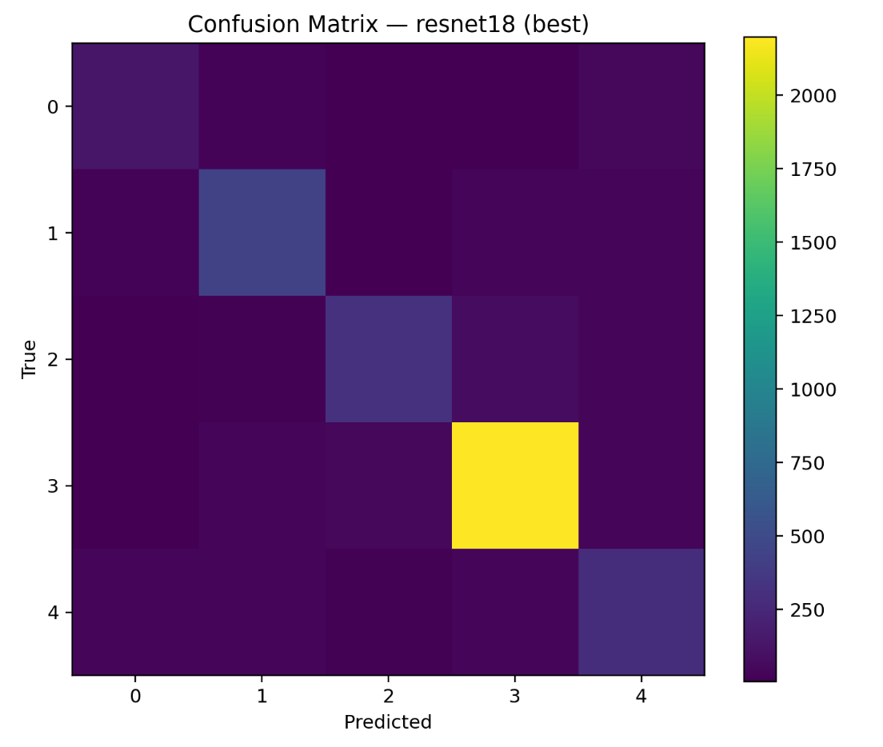

Fig. 1. Confusion matrix of ResNet18 (best-performing model) on the cassava test dataset.

The model achieved the highest accuracy and macro-F1 among the three benchmarks, with strongest performance on Cassava Mosaic Disease (CMD, class 3), but reduced performance on minority classes such as Cassava Green Mottle (CGM, class 2).
The imbalance-driven confusion highlights the necessity of balanced datasheets or class-weighting strategies in the future work.

3.3 Interpretability with Grad-CAM

Grad-CAM visualizations provided insights into model decision-making (Fig. 2). For correctly classified images, activation maps consistently highlighted symptomatic regions of the cassava leaves, such as mosaic patches or streaks, while suppressing irrelevant background features. Even in misclassified cases, the model concentrated on leaf areas rather than noise, indicating that its errors were due to subtle inter-class similarities rather than random focus. This interpretability supports confidence in potential field deployment, where transparency of automated disease detection is essential.
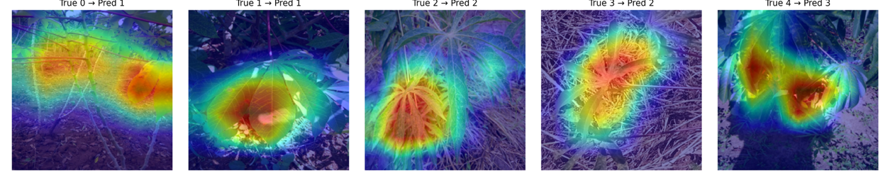
Fig. 2. Grad-CAM visualizations of ResNet18 on cassava test images.

4. Conclusion

This study presented a proof-of-principle benchmark of three convolutional neural network models: EfficientNet-Lite0, MobileNetV3-Large, and ResNet18, for cassava leaf disease classification. Results demonstrated that while ResNet18 achieved the highest test accuracy (85.3%) and macro-F1 score (0.757), lightweight architectures such as EfficientNet-Lite0 and MobileNetV3 provided competitive performance with significantly smaller model sizes and faster inference speeds.

Grad-CAM visualizations confirmed that all models focused on disease-affected regions of cassava leaves, supporting their interpretability and reliability for field applications. These findings highlight the trade-offs between accuracy and efficiency and emphasize that lightweight CNNs can offer practical advantages for deployment in agricultural robotics and edge devices.

Overall, this work establishes a foundation for future research to integrate efficiency-aware deep learning into real-time plant disease monitoring systems. Future work should explore larger-scale field validation and the integration of lightweight CNNs with low-power agricultural robotics for real-time disease monitoring.

COMPETING INTERESTS DISCLAIMER:
Authors have declared that they have no known competing financial interests OR non-financial interests OR personal relationships that could have appeared to influence the work reported in this paper.

References
[1] Sambasivam G, et al. (2025). A hybrid deep learning model approach for automated detection and classification of cassava leaf diseases. Sci Rep. 15:90646. https://doi.org/10.1038/s41598-025-90646-4
[2] Zeng Z, Li Y, Chen H. (2025). AI-driven smart agriculture using hybrid transformer-CNN models for plant disease detection. Sci Rep. 15:10537. https://doi.org/10.1038/s41598-025-10537-6
[3] Azeta A, et al. (2023). A deep learning approach for cassava leaf disease classification. SSRN. https://doi.org/10.2139/ssrn.4669543
[4] Sharma R, et al. (2024). A systematic review of deep learning techniques for plant diseases. Artif Intell Rev. https://doi.org/10.1007/s10462-024-10944-7

[5] Liu Q, et al. (2024). Deep learning and computer vision in plant disease detection: a comprehensive review. Artif Intell Rev. https://doi.org/10.1007/s10462-024-11100-x

[6] Ngugi HN, Ezugwu AE, Akinyelu AA, Abualigah L, et al. (2024). Revolutionizing crop disease detection with computational deep learning: a comprehensive review. Environ Monit Assess. 196:302. https://doi.org/10.1007/s10661-024-12454-z

[7] Patel A, et al. (2025). A review on automated plant disease detection. SN Appl Sci. https://doi.org/10.1007/s44443-025-00040-3

[8] Zhang Y, et al. (2025). Image recognition technology in smart agriculture: A review. Processes. 13(5):1402. https://doi.org/10.3390/pr13051402

[9] Li X, et al. (2025). AI-IoT based smart agriculture pivot for plant diseases detection and treatment. Scientific-Report. https://doi.org/10.1038/s41598-025-98454-6
[10] Kalezhi J, et al. (2025). Cassava crop disease prediction and localization using InceptionResNet V2. Crop Prot. 182:106606. https://doi.org/10.1016/j.cropro.2024.106606

[11] Costa D, et al. (2025). Deep learning based transfer learning for classification of cassava disease. arXiv preprint. arXiv:2502.19351. https://arxiv.org/abs/2502.19351

[12] Che C, Xue N, Li Z, Zhao Y, Huang X. (2025). Automatic cassava disease recognition
using object segmentation and progressive learning. PeerJ Comput.
Sci. 11:e2721. https://doi.org/10.7717/peerj-cs.2721

[13] Yadav S, et al. (2024). Machine learning and deep learning for crop disease diagnosis: a survey. Agronomy. 14(12):3001. https://doi.org/10.3390/agronomy14123001

[14] Sun J, et al. (2025). Emerging developments in real-time Edge AIoT for agriculture. IoT. 6(1):13. https://doi.org/10.3390/iot6010013

[15] Bello A, et al. (2025). A comprehensive survey on cassava disease detection and classification using deep learning models. Pan Afr J Interdiscip Innov. 2:377. https://doi.org/10.56294/piii2025377

APPENDIX

Fig . A1. Confusion matrix of mobilenetv3-large on cassava teST DATASET

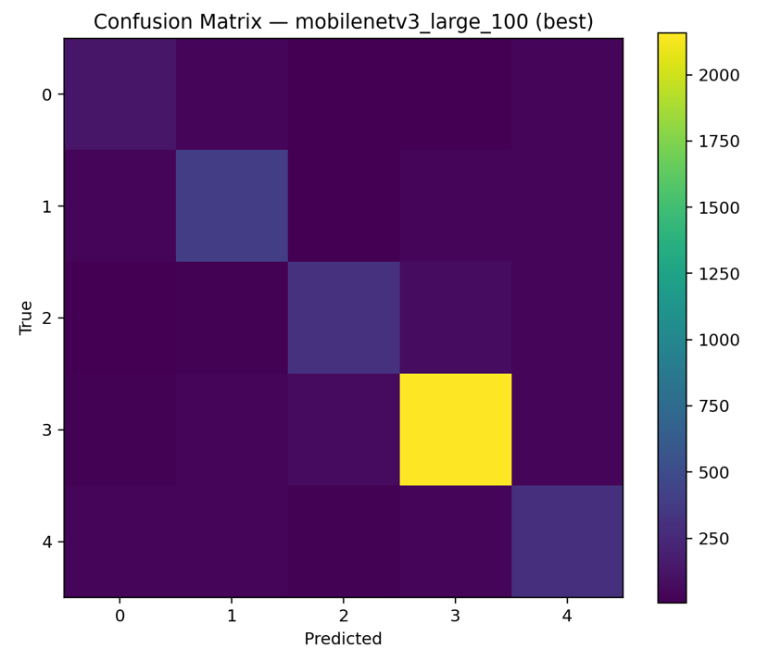

FIG A2. Confusion matrix of efficientnet-lite0 on cassava test dataset

