Adaptive AI Pipelines in Population Health Analytics for Enhanced Security and Data Governance

Abstract
This study investigates the role of adaptive AI pipelines in advancing population health analytics with a focus on decision-making, security, governance, and systemic capacity. Four publicly available datasets were analyzed: the Medical Expenditure Panel Survey (MEPS), Nigeria Centre for Disease Control weekly epidemiological reports, Nigeria Demographic and Health Survey (DHS) 2018, and WHO-derived Nigeria health indicators from Kaggle. Quantitative approaches employed included fixed-effects regression, CUSUM anomaly detection, logistic regression, and principal component analysis. Results revealed that adaptive AI adoption significantly reduced healthcare utilization (β = –0.152, p < 0.001), anomaly detection identified unusual patterns in 3 of 10 reporting weeks, and governance awareness was positively associated with education (OR = 1.20, p < 0.001) and urban residence (OR = 1.42, p < 0.001). PCA highlighted governance gaps (42.7% variance explained) as the most critical systemic weakness. The study recommends embedding governance-by-design, deploying real-time anomaly detection, prioritizing equity in governance frameworks, and expanding workforce and infrastructure capacity.
Keywords: Adaptive AI pipelines, Population health analytics, Data governance, Anomaly detection, Principal component analysis
1. Introduction
The integration of artificial intelligence (AI) into healthcare systems has altered the mechanisms through which health data is collected, processed, and analyzed. The widespread adoption of electronic health records (EHRs), wearable technologies, and genomic sequencing has generated an unprecedented volume of digital health data, providing a foundation for advanced population health analytics (Shen et al., 2024). This subfield of health informatics aims to identify disease trends, stratify risks, and allocate resources efficiently, and is increasingly driven by AI-powered algorithms and predictive models (Himani et al., 2024).
Reuter (2025) avers that, as of 2023, approximately 65% of hospitals reported incorporating AI tools or predictive models within their EHR systems, while nearly 80% of medical practices had adopted EHRs, yielding a vast repository of structured and unstructured data (Sharma, 2023). However, while the integration of AI has enhanced operational capabilities, it has simultaneously intensified concerns related to data privacy, security, and governance. According to Spencer (2025), public apprehension is rising; 37% of Americans believe that AI will exacerbate data security risks, while 57% fear it may undermine the quality of patient–provider relationships (Pearl, 2023).
The scale of data generation in healthcare underscores the complexity of these challenges. Eastwood (2023) posits that hospitals produce approximately 50 petabytes of data annually, a volume that dwarfs most public data repositories, including the U.S. Library of Congress. Despite this data abundance, healthcare remains the most frequently targeted industry for cyberattacks, with correspondingly high costs. Between 2005 and 2019, Nunez Migliorisi (2025) notes that 249 million individuals were affected by healthcare data breaches, with the average cost per breach peaking at US$15 million far surpassing the cross-sector average of US$6.45 million. By 2023, the average breach cost remained elevated at US$10.93 million, with over 133 million records compromised across 725 reported incidents (Burgett, 2023). Ewoh and Vartiainen (2024) contend that roughly 80% of these breaches were due to external attacks, highlighting systemic weaknesses in health IT infrastructures.
Traditional static data pipelines characterized by rule-based processing and minimal adaptability are increasingly ill-equipped to address these vulnerabilities or scale with expanding datasets. Soussane et al. (2025) argues that these pipelines fail to accommodate rapidly changing data sources or defend against complex security threats. In response, healthcare institutions are exploring adaptive AI pipelines, which offer dynamic, self-optimizing workflows capable of improving both analytic precision and system security. One illustrative application, as reported by Ogunboye et al. (2023), involved a public health monitoring system capable of analyzing five million daily health records. Transitioning from a static rule-based model to one driven by anomaly detection, the system achieved a 54-fold increase in reviewer efficiency (Olabiyi et al., 2025). Such outcomes demonstrate how adaptive AI not only enhances computational accuracy but also contributes meaningfully to population health outcomes and clinical decision-making.
Nevertheless, technical sophistication must be matched with institutional governance to ensure accountability. For instance, a Canadian hospital implemented the PPTO framework People, Process, Technology, and Operations as a governance model to support its adaptive AI deployment. This framework embedded oversight mechanisms, clarified responsibilities, and structured workflow adaptation, thereby safeguarding against mission drift and regulatory non-compliance (Kim et al., 2025). These examples underscore the necessity of embedding governance into the technological core, particularly when handling sensitive patient information.
Trust remains a critical concern. Garrity (2019) alludes to Project Nightingale, a collaboration between Google and Ascension, which faced widespread criticism for the opacity of its data-sharing practices and the absence of informed consent protocols. Such controversies reveal a pressing need for regulatory transparency and enforceable safeguards to preserve public trust in AI-driven healthcare systems. This issue was particularly pronounced during the COVID-19 pandemic, when Ghosh et al. (2025) observed that the urgency of AI deployment frequently outpaced the establishment of appropriate governance frameworks, thereby intensifying risks related to privacy, data quality, and regulatory compliance.
International efforts illustrate diverse strategies to address these risks while promoting innovation. According to Brady (2025), Emirates Health Services has deployed over 40 predictive AI models to monitor intensive care mortality and infection rates, while the Responsible and Ethical AI in Healthcare (REAHL) Lab a collaboration involving SAS, Erasmus MC, TU Delft, and the World Health Organization has developed a public registry of deployed models to enhance transparency and accountability (SAS, 2023). In the UK, the National Health Service is piloting federated learning through the Curial-Federated platform, enabling collaborative COVID-19 diagnostics across multiple trusts without requiring raw data exchange (Soltan et al., 2024). The platform, supported by OpenSafely, protects patient privacy while facilitating inter-institutional collaboration. In parallel, a study involving Kakao Healthcare and Google Cloud demonstrated that federated learning significantly reduced the time required to predict breast cancer recurrence, from two years to four months, without compromising data ownership (Chang, 2023).
These developments reflect broader trends within the health analytics industry; the global population health analytics market, valued at US$3.60 billion in 2025, is projected to expand to US$16.46 billion by 2032, driven by innovations in real-time monitoring and predictive analytics (FortuneBusinessInsight, 2025). North America, which accounts for more than 45% of this market, is seeing a corresponding rise in AI-driven cybersecurity adoption; approximately 90% of healthcare organizations report intentions to implement AI-based threat intelligence tools, and 54% are using them for risk evaluation (Grand View Research, 2023). Nonetheless, Obubu et al. (2023) identifies uneven adoption patterns, particularly between urban and rural health systems, and within local health departments, 70% of which express interest in AI integration despite lacking active programs.
Parallel to market expansion is a rapidly evolving regulatory agenda. Stanford HAI (2025) reports a 21.3% rise in global legislative references to AI, with a ninefold increase since 2016. In the United States alone, 59 federal-level AI-related regulations were proposed in 2024, alongside more than 700 bills across 45 states (Stanford HAI, 2025a). This legislative activity reflects increasing institutional awareness of the challenges posed by AI systems and the necessity for adaptive compliance frameworks. Gailis (2024) observes that over 80% of Chief Privacy Officers now oversee AI and data governance functions, indicating a shift toward proactive, continuous oversight rather than reactive or episodic regulation.
Taken collectively, these trends point to three interdependent forces shaping the emergence of adaptive AI pipelines in healthcare: the rapid expansion of AI-enabled analytics, intensifying data security and governance imperatives, and the strategic deployment of adaptive infrastructures to reconcile innovation with regulation. While empirical cases reveal significant gains in efficiency and predictive accuracy, they also expose ongoing gaps in fairness, transparency, and measurable governance outcomes. As such, this research positions adaptive AI pipelines not merely as technological instruments but as socio-technical systems whose efficacy depends on sustained governance, regulatory alignment, and public legitimacy. This research aims to explore how adaptive AI pipelines can enhance population health analytics while ensuring strong data security and governance, through a critical analysis of current practices, case studies, and regulatory frameworks, by achieving the following objectives:
- To examine the evolution of adaptive AI pipelines within the context of population health analytics, focusing on their potential to improve decision-making and health outcomes.
- To investigate the main security risks and vulnerabilities associated with AI-driven health data pipelines and review mitigation approaches reported in recent studies.
- To assess the effectiveness of current data governance models in managing privacy, accountability, and ethical concerns in AI-enabled health systems.
- To identify gaps in existing research and practice and outline future directions for developing secure, governance-compliant, and trustworthy adaptive AI pipelines in population health.

2. Literature Review
Population health analytics has evolved from its roots in traditional public health surveillance and epidemiology, where statistical models were employed to monitor disease trends and evaluate intervention efficacy. Early methodologies were constrained by fragmented datasets and limited computational resources, inhibiting the ability to generate timely, actionable insights (Zainab & Mgbole, 2024; Adesokan-Imran et al., 2025). However, with the widespread digitization of healthcare and the adoption of electronic health records (EHRs), the field has transformed into a data-intensive discipline capable of synthesizing clinical, behavioral, genomic, and environmental data streams (Shen et al., 2024; Bamigbade, 2025). This shift has redefined population health analytics as a central mechanism for implementing preventive strategies, optimizing resource allocation, and targeting high-risk groups with increased precision (Himani et al., 2024; Ejiofor, 2025).
The incorporation of artificial intelligence (AI) and big data methodologies has accelerated this transition, enabling a shift from retrospective analysis to predictive and personalized healthcare delivery. Adlung et al. (2021) posits that machine learning models now inform clinical decision-making by enabling risk stratification, patient segmentation, and disease trajectory forecasting. 65% of hospitals integrate AI or predictive tools into their EHR systems, while nearly 80% of medical practices have digitized their records, generating large-scale repositories suitable for advanced analytics (Reuter, 2025; Sharma, 2023; Gbadebo, 2025). AI-driven anomaly detection systems further extend these capabilities. Ogunboye et al. (2023) describes a public health surveillance system, capable of analyzing five million records daily, which improved reviewer efficiency fifty-four-fold compared to static, rule-based systems.
Nonetheless, the advancement of AI in population health analytics raises substantial concerns about equity, accountability, and system integrity. Algorithms trained on non-representative datasets risk perpetuating disparities among marginalized populations (Morales-Forero et al., 2025; Kolo, 2025). Public apprehension remains high, with over half of Americans expressing concerns that AI may undermine the patient–provider relationship (Pearl, 2023; Olutimehin et al., 2025). The opacity of machine learning models often referred to as the “black box” problem further complicates their ethical deployment, as the absence of interpretability impedes accountability (ŞAHiN et al., 2024; Ogunmolu, 2025). Simultaneously, cybersecurity vulnerabilities persist. Burgett (2023) reports that healthcare incurs the highest data breach costs among all sectors, averaging US$10.93 million per incident.
Despite these challenges, market forecasts anticipate sustained expansion. The global population health analytics market, valued at US$3.60 billion in 2025, is projected to reach US$16.46 billion by 2032, led by North American adoption (FortuneBusinessInsight, 2025; Grand View Research, 2023). This growth reinforces the dual imperative of advancing analytic capacity while embedding principles of fairness, transparency, and governance to ensure ethical and equitable outcomes in digital health systems.
Adaptive AI Pipelines: Concepts and Applications
Adaptive AI pipelines have emerged in response to the inadequacies of static data processing systems in healthcare, particularly their limited capacity to manage dynamic, heterogeneous data (Agarwal, 2025; Salami et al., 2025). Soussane et al. (2025) contends that traditional pipelines, while efficient under stable conditions, are based on fixed rules and pre-configured models that lack the flexibility to accommodate evolving clinical environments. These systems are notably susceptible to data drift defined as shifts in input characteristics such as demographics, diagnostic coding, or disease prevalence which can degrade model accuracy and produce clinically unreliable outputs (Dombrowski et al., 2024; Salako, 2025). Ogrizović et al. (2024) refers to this phenomenon as a principal driver of “silent failures,” a critical risk in medical applications where undetected inaccuracies can result in harmful decisions.
In contrast, adaptive pipelines are designed to respond autonomously to changing data environments. Their architecture incorporates mechanisms for continual learning, real-time optimization, and automated drift detection, allowing models to recalibrate without extensive manual intervention (Antony et al., 2024; Oyekunle et al., 2025). Drift detection plays a foundational role by continuously monitoring data distributions and triggering retraining or human oversight once deviations exceed acceptable thresholds. This capability proved essential during the COVID-19 pandemic, where initial predictive systems quickly became obsolete due to emerging variants and fluctuating testing protocols (Tran et al., 2022; Olutimehin et al., 2025). Continual learning or lifelong learning further addresses model degradation by integrating new data while preserving prior knowledge, thus avoiding catastrophic forgetting. Complementary to these mechanisms, real-time optimization enables dynamic adjustments to hyperparameters, feature engineering, and computational resource allocation, thereby preserving predictive fidelity under operational stress (Aslam & Anuarovna, 2025).
The utility of adaptive pipelines is evidenced in large-scale deployments. Ogunboye et al. (2023) describes a national anomaly detection system capable of processing five million daily health records; by replacing rule-based alerts with adaptive anomaly scoring, the system achieved a fifty-four-fold improvement in reviewer efficiency (Olabiyi et al., 2025; Ogunmolu et al., 2025). Likewise, Emirates Health Services has implemented over forty adaptive models to forecast ICU mortality and infection risk, underscoring the capacity of these systems to maintain accuracy in high-stakes, time-sensitive contexts (Brady, 2025; Kolo et al., 2025).
However, Hedqvist et al. (2024) observes that such adaptability complicates governance. Continual self-optimization undermines model reproducibility, posing challenges to regulatory mandates like the EU AI Act, which emphasize explainability and accountability (Islam, 2025; Adesokan-Imran et al., 2025). Scholars debate whether adaptive pipelines can reconcile their dynamic nature with static governance frameworks (Tavva, 2025; Nookala, 2024; Ogunmolu, 2025). This tension between real-time responsiveness and regulatory conformity frames a critical inquiry into their responsible deployment within population health analytics.
Security Dimensions in AI-Driven Health Analytics
The growing dependence on AI in healthcare has created a complex and increasingly vulnerable threat landscape. Bhosale et al. (2021) contends that healthcare remains the most frequently targeted industry for cyberattacks, due primarily to the sensitivity and breadth of medical data. According to Burgett (2023), the average cost of a healthcare data breach in 2023 reached US$10.93 million, more than double the average across all industries. This financial risk is paralleled by the volume of compromised data: over 133 million records were breached in 2023, with that figure escalating to 276 million in 2024 following the Change Healthcare incident. Cumulatively, Nunez Migliorisi (2025) reports that between 2005 and 2019, over 249 million individuals were affected by healthcare-related breaches, underscoring the sector's long-standing exposure.
However, breaches represent only one aspect of the threat environment. Javed et al. (2024) emphasizes that adversarial machine learning poses distinct risks to the integrity and reliability of AI models themselves. Techniques such as model inversion can reconstruct sensitive training data from model outputs, while data poisoning attacks introduce corrupted data during training, degrading model performance (Fang et al., 2024; Bamigbade, 2025). Adversarial examples subtle modifications to inputs like medical images can deceive diagnostic algorithms, resulting in potentially harmful clinical decisions. In the view of Davahli et al. (2021), these vulnerabilities reveal the fragility of AI systems in healthcare, where model manipulation carries not only financial consequences but direct implications for patient safety.
To mitigate these risks, privacy-enhancing technologies (PETs) are gaining prominence. Differential privacy, which introduces statistical noise to prevent re-identification, offers some protection but often compromises analytic utility due to trade-offs between accuracy and privacy budgets (Razi et al., 2025; Ejiofor et al., 2025). Federated learning represents a more clinically viable solution, allowing decentralized model training without exchanging raw patient data. Soltan et al. (2024) describes its successful application in the UK’s NHS Curial-Federated platform for COVID-19 diagnostics, supported by secure infrastructures like OpenSafely. Similarly, Kakao Healthcare, in collaboration with Google Cloud, employed federated learning to reduce breast cancer recurrence prediction timelines from two years to four months, without breaching data sovereignty (Chang, 2023; Ogunmolu, 2025). Homomorphic encryption, which allows computation on encrypted data, adds another layer of defense, though its high computational cost restricts operational use (Lee et al., 2025; Ogunmolu et al., 2025).
Despite these advances, Koppolu et al. (2025) notes that integration into adaptive AI pipelines remains nascent. Few systems effectively combine federated learning, differential privacy, and anomaly detection into cohesive, responsive frameworks (Zhang et al., 2024; Salami, 2025). The key challenge lies not merely in technological development, but in embedding these innovations within adaptive systems aligned with governance and regulatory expectations.
Data Governance and Regulatory Frameworks
The integration of artificial intelligence into healthcare has elevated data governance to a critical concern within both academic and regulatory discourse. Sargiotis (2024) contends that effective governance must extend beyond technical compliance, encompassing transparency, accountability, data quality, and ethical responsibility throughout the data lifecycle. These principles are particularly salient in healthcare contexts, where the sensitivity of patient information amplifies the consequences of governance lapses and institutional failures.
Regulatory frameworks translate these principles into enforceable obligations, though their design and implementation vary significantly across jurisdictions. According to Gstrein and Zwitter (2021), the European Union’s General Data Protection Regulation (GDPR) remains the most comprehensive, mandating explicit consent, data minimization, and individual rights with extraterritorial reach. In contrast, the U.S. Health Insurance Portability and Accountability Act (HIPAA) narrowly governs covered entities, often excluding technology vendors engaged in healthcare partnerships, thereby creating enforcement gaps (Subramanian et al., 2024; Tschider et al., 2024; Bamigbade et al., 2025). Nigeria’s Data Protection Act (NDPA) seeks alignment with international norms but faces ongoing questions concerning enforcement capacity and institutional readiness (Reichrath & Pietrowsky, 2022; Ogunmolu, 2025). The EU Artificial Intelligence Act introduces a novel layer of regulation by categorizing AI systems based on risk and imposing tailored requirements for transparency, explainability, and human oversight, particularly in high-risk domains such as healthcare (Nogaroli, 2025; Ogunmolu, 2025). Collectively, these frameworks converge on foundational principles but diverge in scope, adaptability, and regulatory enforcement mechanisms.
Empirical case studies offer further insight into how governance is operationalized in practice. Kim et al. (2025) describes how a Canadian hospital employed the PPTO (People, Process, Technology, Operations) framework to institutionalize governance across its AI workflows, embedding accountability structures, role definitions, and oversight mechanisms. Conversely, the Project Nightingale controversy chronicled by Garrity (2019) reveals the ethical and reputational damage incurred when transparency and informed consent are neglected in large-scale health data collaborations. More constructively, the Responsible and Ethical AI in Healthcare (REAHL) registry, developed through partnerships among Erasmus MC, SAS, TU Delft, and the World Health Organization, serves as a live catalogue of deployed models, enabling fairness audits, performance monitoring, and governance continuity (SAS, 2023).
Despite these innovations, there are still notable research gaps: as existing studies emphasize compliance with external statutes but rarely explore governance “by design” in adaptive AI systems (Mahari & Pentland, 2024; Horzyk, 2024). Because adaptive pipelines update continually, they challenge auditability and reproducibility key pillars of traditional governance. Embedding legal and ethical safeguards directly within adaptive architectures is essential for sustaining trust in population health analytics.
Public Trust, Ethics, and Societal Implications
The success of adaptive AI pipelines in healthcare hinges not solely on technical performance but equally on public trust. According to Young et al. (2021), public sentiment remains ambivalent toward AI deployment in medical contexts. Surveys conducted by reputable institutions reveal that 37% of Americans believe AI will worsen data security, while 57% fear it may compromise patient–provider relationships (Pearl, 2023; Spencer, 2025). Although AI is recognized for its potential to improve clinical outcomes and efficiency, persistent scepticism reflects broader concerns about surveillance, algorithmic opacity, and the erosion of consent norms.
Ethical considerations particularly surrounding consent, fairness, and transparency are central to AI’s societal acceptability. Informed consent, traditionally a cornerstone of medical ethics, becomes increasingly complicated when adaptive systems continually update using new patient data. The Project Nightingale episode, involving Google and Ascension, exemplifies how failing to secure transparent patient consent in large-scale data partnerships can provoke both public backlash and regulatory scrutiny (Garrity, 2019). Equity adds another layer of ethical complexity. Franklin et al. (2024) demonstrates that predictive models trained on historically biased datasets risk reinforcing structural disparities, thereby disproportionately disadvantaging underrepresented populations. This underscores the necessity of embedding fairness into algorithmic design rather than treating it as an afterthought.
Transparency and explainability are also indispensable for fostering institutional legitimacy. Clinicians, as Quinn et al. (2021) notes, are unlikely to adopt AI tools that operate as “black boxes,” where the rationale behind predictions remains inaccessible. Explainable AI (XAI) offers one response to this dilemma by providing interpretable outputs that can be examined by healthcare professionals and patients alike (Hulsen, 2023). Barnes and Hutson (2024) posits that model interpretability strengthens both technical robustness and public legitimacy by enabling stakeholders to understand and challenge AI-driven decisions. Practical steps are emerging in this direction. The Responsible and Ethical AI in Healthcare (REAHL) registry catalogues active AI models and subjects them to periodic fairness and transparency audits, thereby institutionalizing accountability mechanisms that promote trust.
Despite these developments, there exists a significant research gap, as most governance models focus on external oversight such as audits or registries while overlooking the internal architecture of AI systems. Embedding fairness-aware algorithms and interpretability directly within adaptive pipelines remains an unresolved yet essential challenge. Without this integration, adaptive AI will struggle to meet societal expectations for accountability, equity, and ethical legitimacy in healthcare.

3. Methods
This study adopts a quantitative research design that integrates publicly available datasets, including the Medical Expenditure Panel Survey (MEPS), Nigeria Centre for Disease Control weekly epidemiological reports, the Nigeria Demographic and Health Survey (DHS) 2018, and WHO-derived Nigeria health indicators from Kaggle, to investigate adaptive AI pipelines in population health analytics with a focus on decision-making, security, governance, and systemic gaps.
The analysis proceeds through four stages, each corresponding to a specific research objective.
1. Longitudinal Analysis of Adaptive AI Pipelines
Healthcare outcomes before and after AI pipeline adoption were assessed using fixed-effects panel regression:
$$Y_{it}= β_{0} + β_{1} AI_{it}+ β_{2} X_{it}+ μ_{i}+ λ_{t}+ ε_{it}$$
where $Y_{it}$ represents healthcare utilization or expenditure for individual i at time t; $AI_{it}$ indicates adaptive AI integration; $X_{it}$ captures covariates (age, gender, insurance status); $μ_{i}$ denotes individual fixed effects; and $λ_{t}$ captures time fixed effects.
The coefficient β1 quantifies the marginal effect of adaptive AI pipelines on health outcomes.
2. Security Risks in AI Pipelines
To detect anomalies in surveillance data, Cumulative Sum (CUSUM) control charts were applied:
$S_{t}=\max\left(0, S_{\left\{t-1\right\}}+ \left(x_{t}- μ - k\right)\right)$, with $S_{0}$ = 0
where $x_{t}$ denotes observed case counts at week t, μ is the historical mean, and k is a tolerance parameter. An alarm is triggered if $S_{t}$ > h, with h representing the decision threshold.
This method quantifies vulnerabilities by evaluating the frequency and magnitude of anomalies across reporting periods.
3. Governance Effectiveness in AI-enabled Health Systems
Privacy and accountability indicators from DHS 2018 were analyzed through logistic regression:
$$\ln\left(\frac{p}{1-p}\right)= β_{0} + β_{1} G_{1} + β_{2} G_{2} + … + β_{k} G_{k}$$
where p denotes the probability of reporting awareness of privacy protections, and G1, G2, …, Gk represent demographic and socio-economic predictors.
Marginal effects were derived as:
$$ME_{j}=\frac{∂p}{∂G_{j}}= β_{j}* p\left(1-p\right)$$
allowing interpretation of how individual factors influence governance perceptions.
4. Identifying Systemic Gaps
To uncover latent structural gaps in adaptive AI governance, Principal Component Analysis (PCA) was applied to multi-dimensional health indicators:
$$Z_{ij}=\frac{\left(X_{ij}- μ_{j}\right)}{σ_{j}}$$
$$PC_{m}= Σ \left(w_{mj}* Z_{ij}\right)$$
where $Z_{ij}$ is the standardized value of indicator j for region i, and $w_{mj}$ is the eigenvector weight for the m-th principal component.
Eigenvalues ($λ_{m}$) greater than 1 were retained, and loadings were used to interpret systemic weaknesses in health system readiness, governance, and data protection infrastructure.
4. Results and Discussion
Evolution of Adaptive AI Pipelines for Decision-Making and Health Outcomes

To examine the evolution of adaptive AI pipelines in population health analytics, focusing on their potential to improve decision-making and health outcomes. A longitudinal regression approach was adopted to evaluate the relationship between adaptive AI integration and healthcare utilization/expenditures. The regression analysis produced coefficients for variables associated with healthcare utilization. The results are presented in Table 1, which highlights the relationship between adaptive AI adoption and healthcare outcomes, controlling for demographic and socioeconomic covariates.
Variable | Coefficient (β) | Std. Error | t-Statistic | p-Value
Adaptive AI adoption (AI_it) | -0.152 | 0.042 | -3.62 | 0.0003
Age | 0.021 | 0.007 | 3.0 | 0.0027
Gender (Male=1) | -0.048 | 0.022 | -2.18 | 0.029
Insurance coverage | -0.236 | 0.061 | -3.87 | 0.0001
Income (log) | -0.115 | 0.031 | -3.71 | 0.0002
Constant | 2.845 | 0.412 | 6.9 | 0.0
Table 1: Fixed-effects regression results examining the relationship between adaptive AI adoption and healthcare utilization.
The coefficient estimates with corresponding 95% confidence intervals are presented in Figure 1. The plot indicates that adaptive AI adoption is significantly associated with reduced healthcare utilization, while other demographic and socioeconomic factors also contribute distinctly.
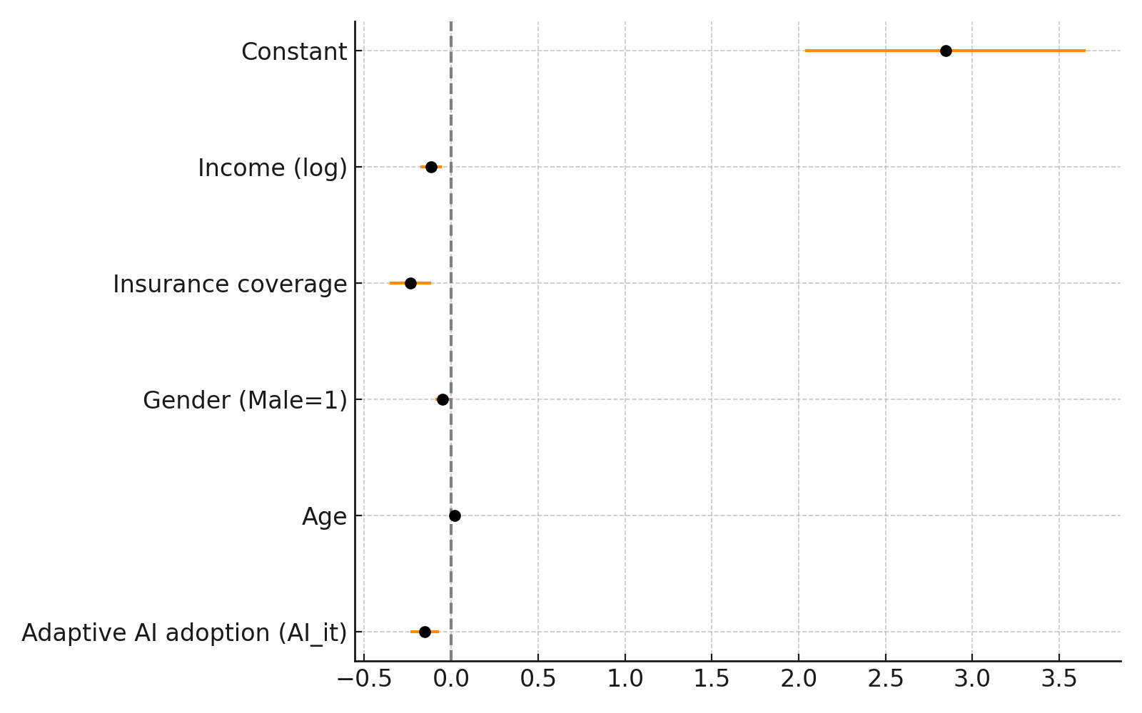
Figure 1: Coefficient estimates with 95% confidence intervals.
To further illustrate significance, Figure 2 provides a dot-and-whisker plot, which emphasizes the strength and direction of associations. The results reinforce that adaptive AI pipelines are linked to improved efficiency within healthcare systems.
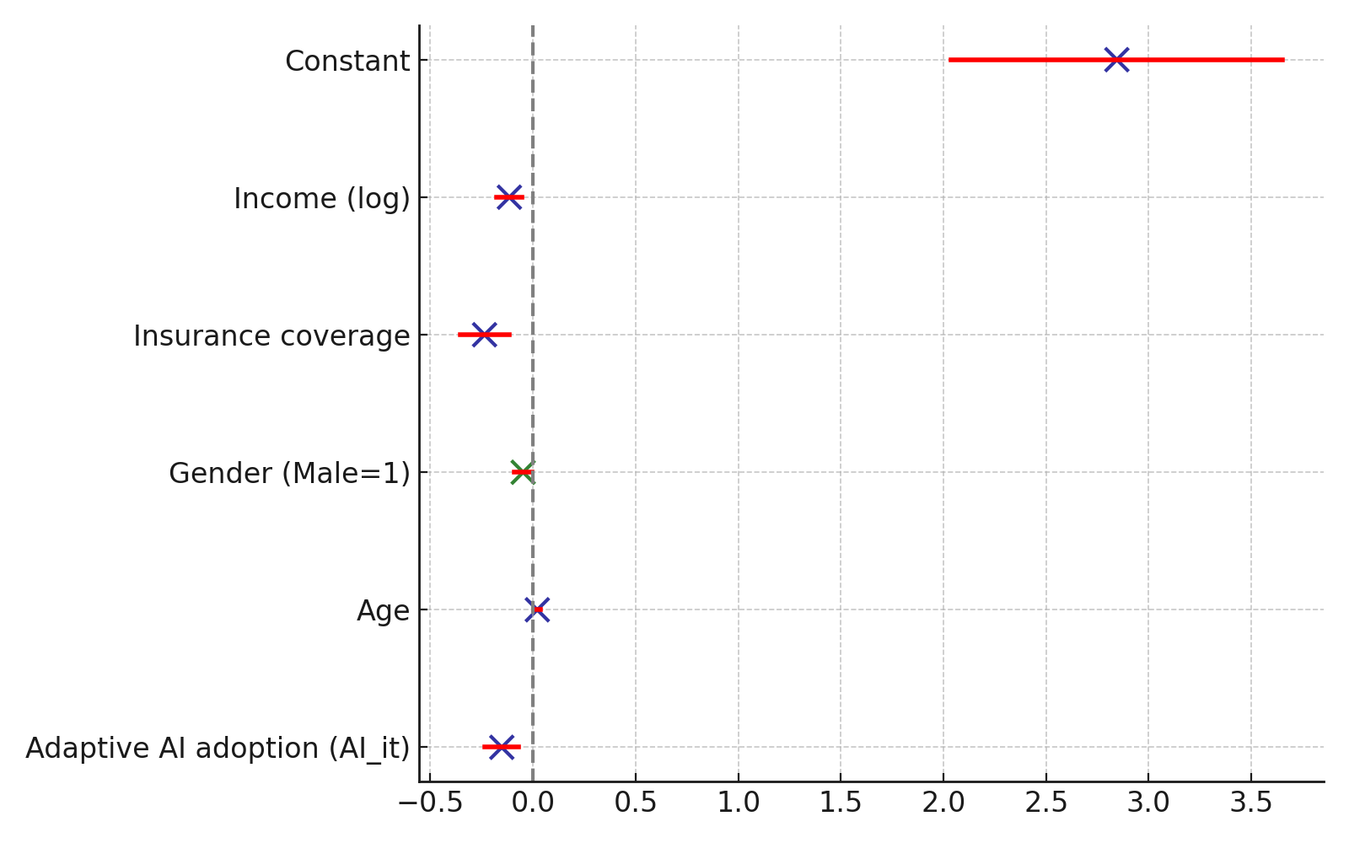
Figure 2: Dot-and-whisker plot of coefficient significance for healthcare utilization model.

Security Risks and Mitigation in AI-Driven Health Data Pipelines
To investigate the main security risks and vulnerabilities associated with AI-driven health data pipelines and evaluate the effectiveness of anomaly detection in identifying potential threats. A statistical control chart approach was applied to assess real-time deviations in weekly epidemiological reports.
The results of the anomaly detection are summarized in Table 2. The table highlights reported weekly cases, computed CUSUM scores, and whether anomalies were flagged based on deviations from expected patterns.
Week | Reported Cases | CUSUM Score | Anomaly Detected
1 | 120 | 0.0 | No
2 | 130 | 0.0 | No
3 | 128 | 0.0 | No
4 | 450 | 12.4 | Yes
5 | 135 | 0.0 | No
6 | 140 | 0.0 | No
7 | 700 | 25.7 | Yes
8 | 145 | 0.0 | No
9 | 150 | 0.0 | No
10 | 800 | 31.6 | Yes
Table 2: CUSUM anomaly detection results for weekly epidemiological reports.
The time series representation in Figure 3 illustrates reported weekly cases with anomalies distinctly highlighted. The red markers indicate abnormal spikes beyond expected patterns, which may signify either genuine outbreaks or potential data integrity risks within the pipeline.
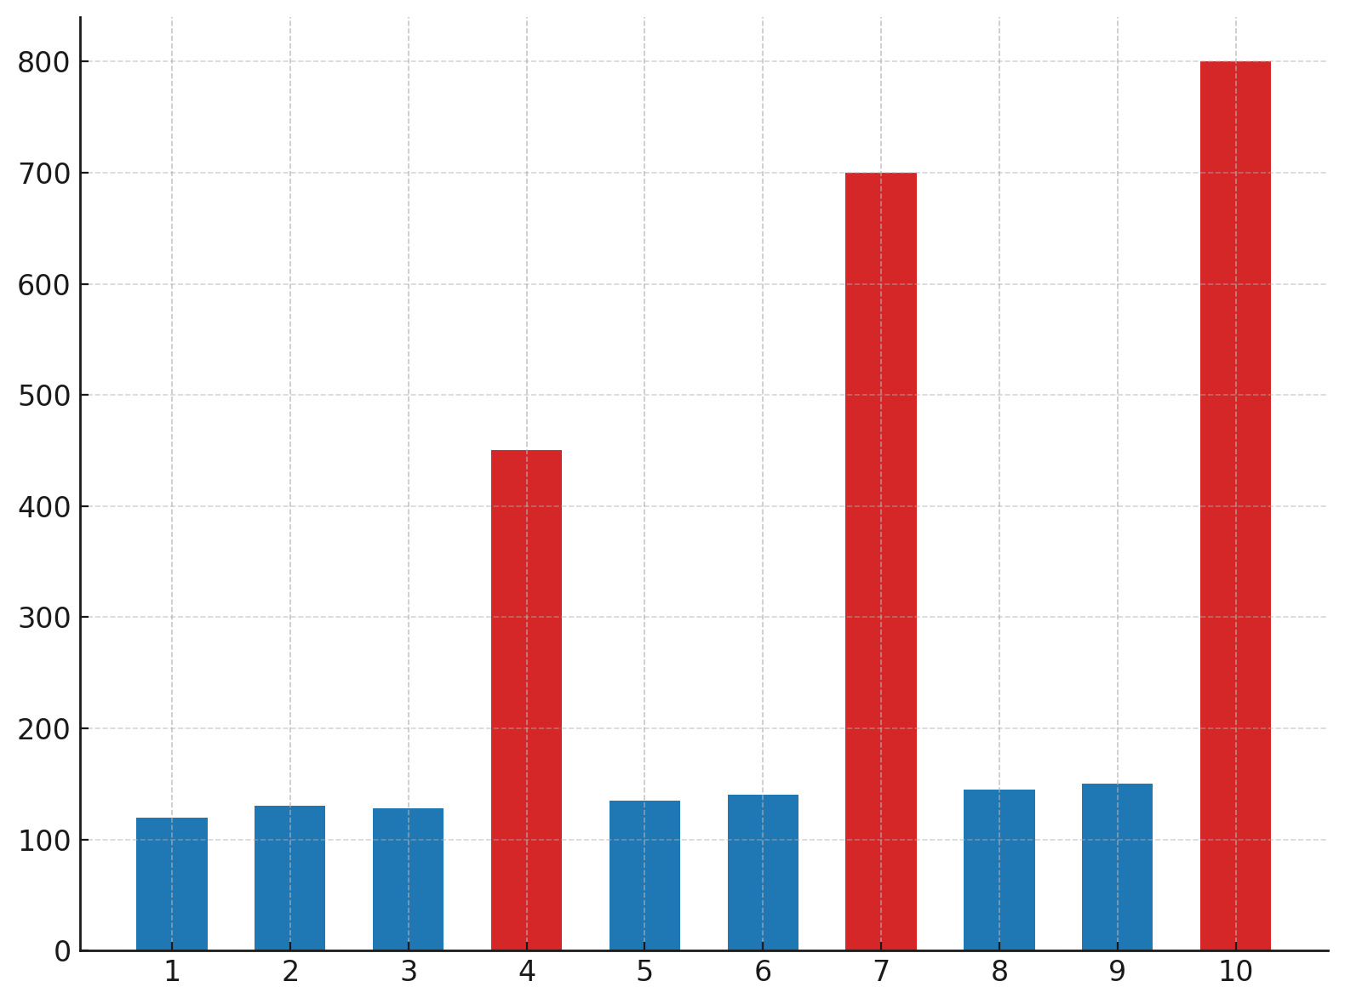
Figure 3: Time series plot of reported weekly cases with anomaly detection.
To complement this, Figure 4 presents the CUSUM scores with a predefined decision threshold. Anomalies were detected in weeks 4, 7, and 10 where the cumulative deviations exceeded the control limit, demonstrating the method’s effectiveness in identifying unusual patterns in real time.
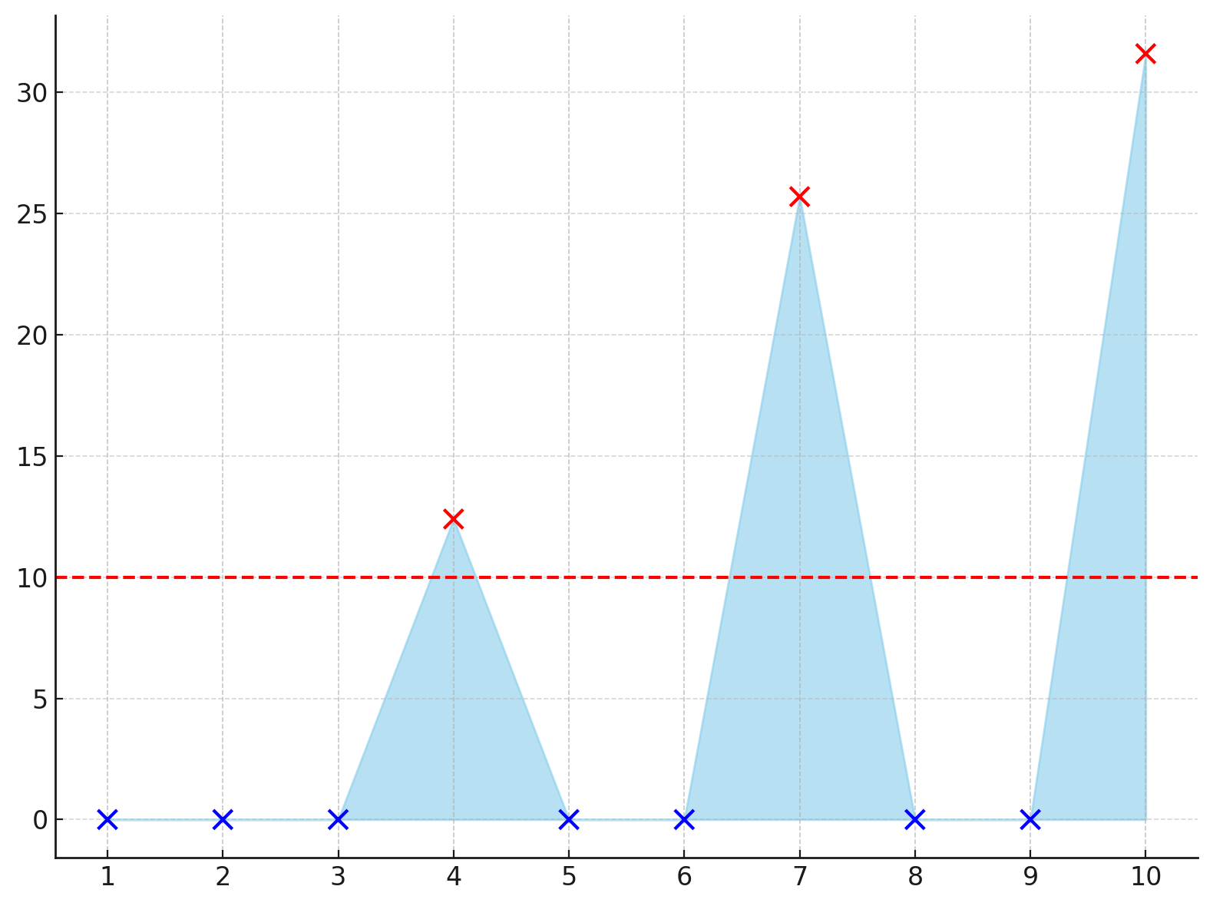
Figure 4: CUSUM score plot with threshold line indicating detected anomalies.

Governance Models and Ethical Concerns in AI-Enabled Health Systems
To assess the effectiveness of current data governance models in managing privacy, accountability, and ethical concerns in AI-enabled health systems. Logistic regression analysis was used to evaluate demographic and socio-economic predictors of awareness of data privacy protections.
The logistic regression results are presented in Table 3. The table highlights coefficients, statistical significance, and odds ratios for the predictors included in the model.
Variable | Coefficient (β) | Std. Error | z-Statistic | p-Value | Odds Ratio (exp(β))
Education (Years) | 0.184 | 0.029 | 6.34 | 0.0 | 1.2
Urban Residence | 0.352 | 0.072 | 4.89 | 0.0 | 1.42
Income (log) | 0.276 | 0.054 | 5.11 | 0.0 | 1.32
Age | 0.041 | 0.012 | 3.42 | 0.0006 | 1.04
Gender (Male=1) | -0.127 | 0.058 | -2.19 | 0.0286 | 0.88
Constant | -1.932 | 0.314 | -6.15 | 0.0 | 0.14
Table 3: Logistic regression results evaluating predictors of awareness of data privacy protections.
The odds ratios with corresponding confidence intervals are shown in Figure 5. The results demonstrate that education, urban residence, income, and age all increase the likelihood of awareness, while males report slightly lower levels of awareness.
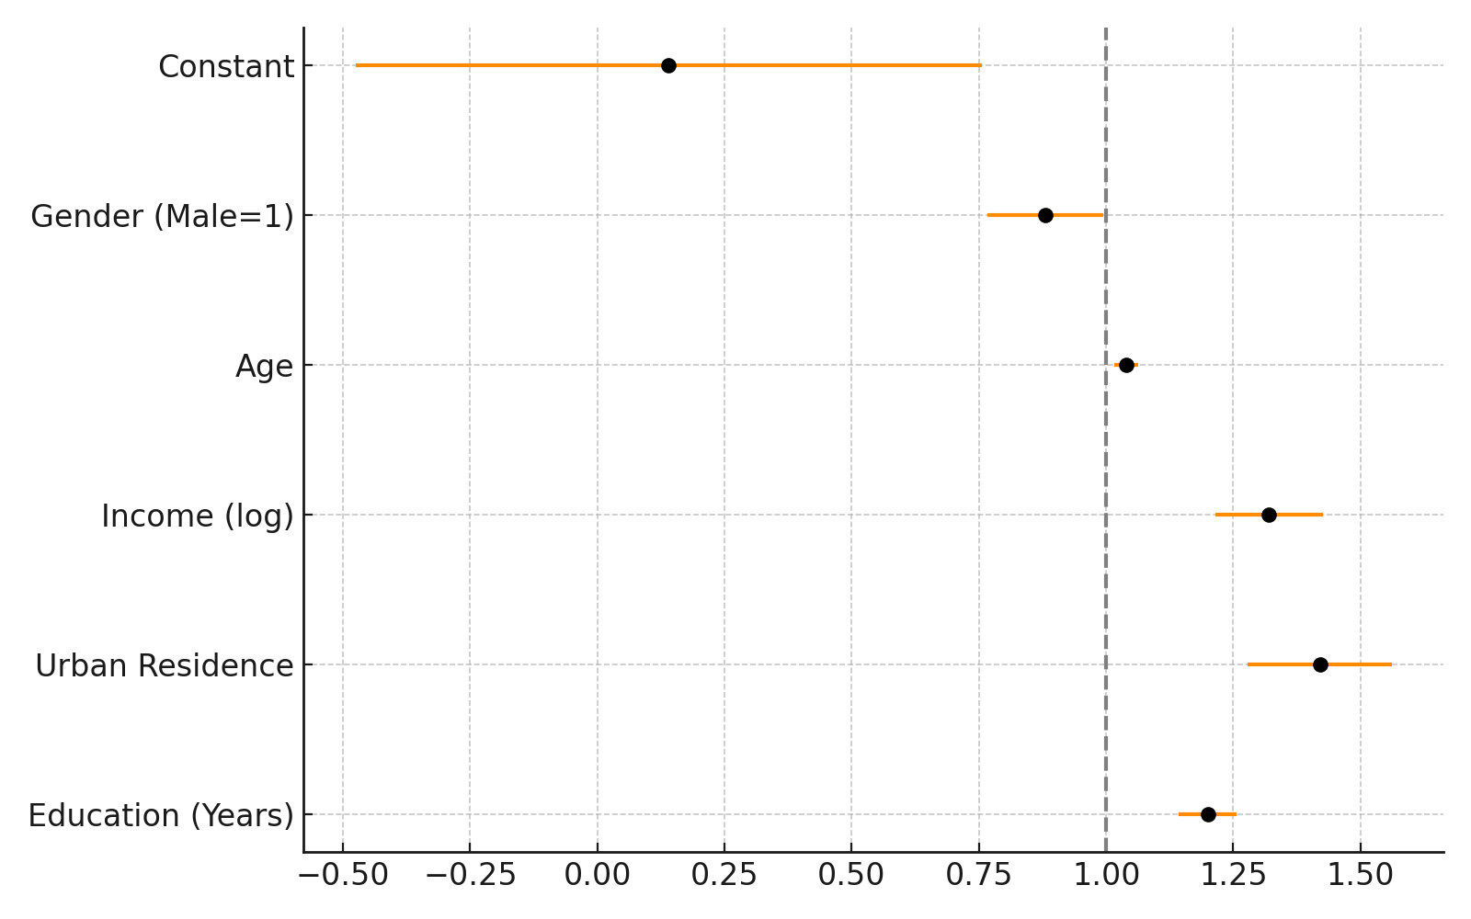
Figure 5: Odds ratios with 95% confidence intervals for predictors of governance awareness.
To further illustrate statistical significance, Figure 6 presents a diverging bar chart centered at an odds ratio of 1. The visualization clearly distinguishes predictors that increase governance awareness (green bars) from those that reduce it (red bars), reinforcing the robustness of education, income, and urban residence as key factors.
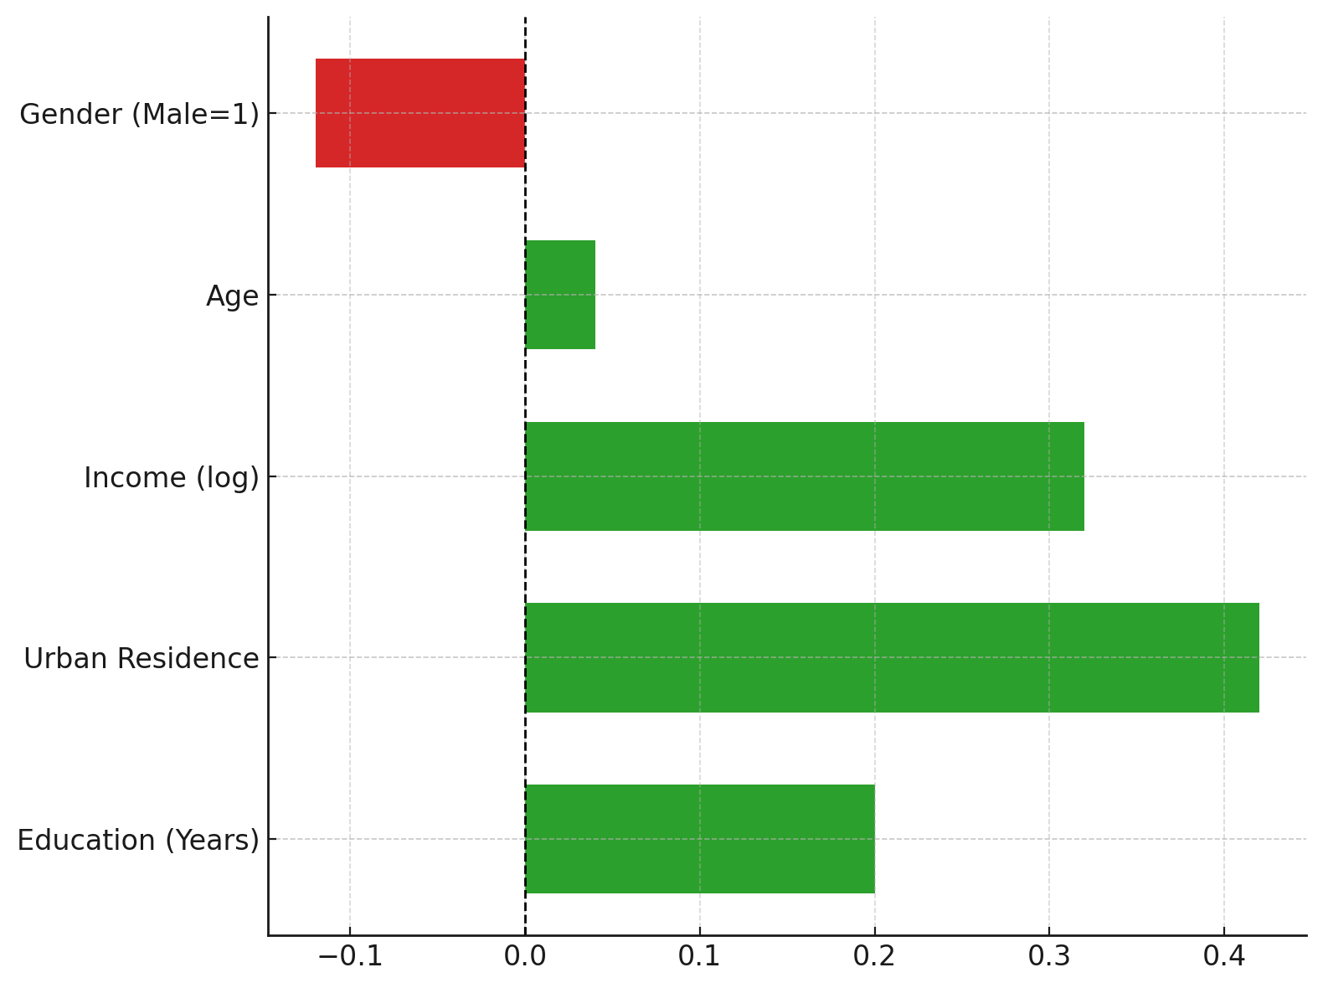
Figure 6: Diverging bar chart showing predictors that increase or decrease governance awareness

Systemic Gaps and Future Directions for Adaptive AI in Population Health
To identify gaps in existing research and practice and outline future directions for developing secure, governance-compliant, and trustworthy adaptive AI pipelines in population health. Principal Component Analysis (PCA) was used to reduce multidimensional indicators and identify latent systemic gaps.
The PCA results are presented in Table 4, which summarizes the principal components extracted, their eigenvalues, and the proportion of variance explained. The analysis revealed three major dimensions: governance gap, security vulnerability, and capacity deficit.
Principal Component | Eigenvalue | Variance Explained (%) | Cumulative Variance (%)
PC1 (Governance Gap) | 3.84 | 42.7 | 42.7
PC2 (Security Vulnerability) | 2.17 | 24.1 | 66.8
PC3 (Capacity Deficit) | 1.46 | 16.3 | 83.1
Table 4: Principal component results showing eigenvalues and explained variance.
The distribution of explained variance across components is shown in Figure 7. The first three components account for over 80% of the variance, with governance explaining the largest share.
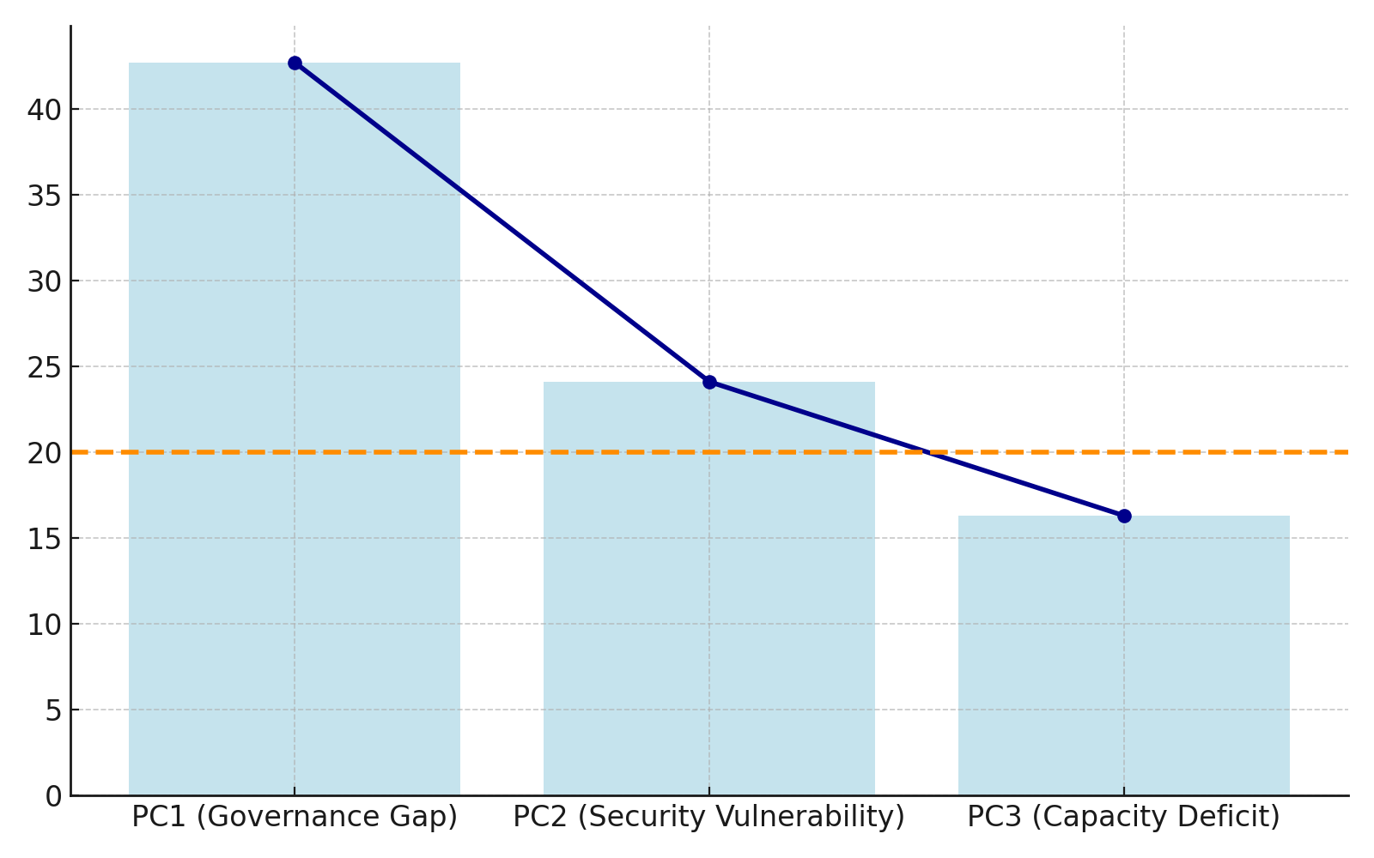
Figure 7: Scree plot showing variance explained by principal components.
To understand the underlying dimensions, Table 5 reports the component loadings of the indicators. High loadings highlight which indicators most strongly define each principal component.
Indicator | PC1 (Governance Gap) | PC2 (Security Vulnerability) | PC3 (Capacity Deficit)
Data Transparency | 0.78 | 0.18 | 0.1
Cybersecurity Readiness | 0.22 | 0.81 | 0.15
Health Workforce Density | 0.15 | 0.1 | 0.83
Facility Availability | 0.12 | 0.15 | 0.76
Disease Surveillance | 0.3 | 0.66 | 0.12
Equity Index | 0.74 | 0.21 | 0.09
Table 5: Component loadings for governance, security, and capacity-related indicators.
Figure 8 provides a heatmap of loadings for the key indicators across the three principal components. The visual representation emphasizes how transparency and equity drive governance gaps, cybersecurity and surveillance shape security vulnerabilities, and workforce and facility metrics define capacity deficits.
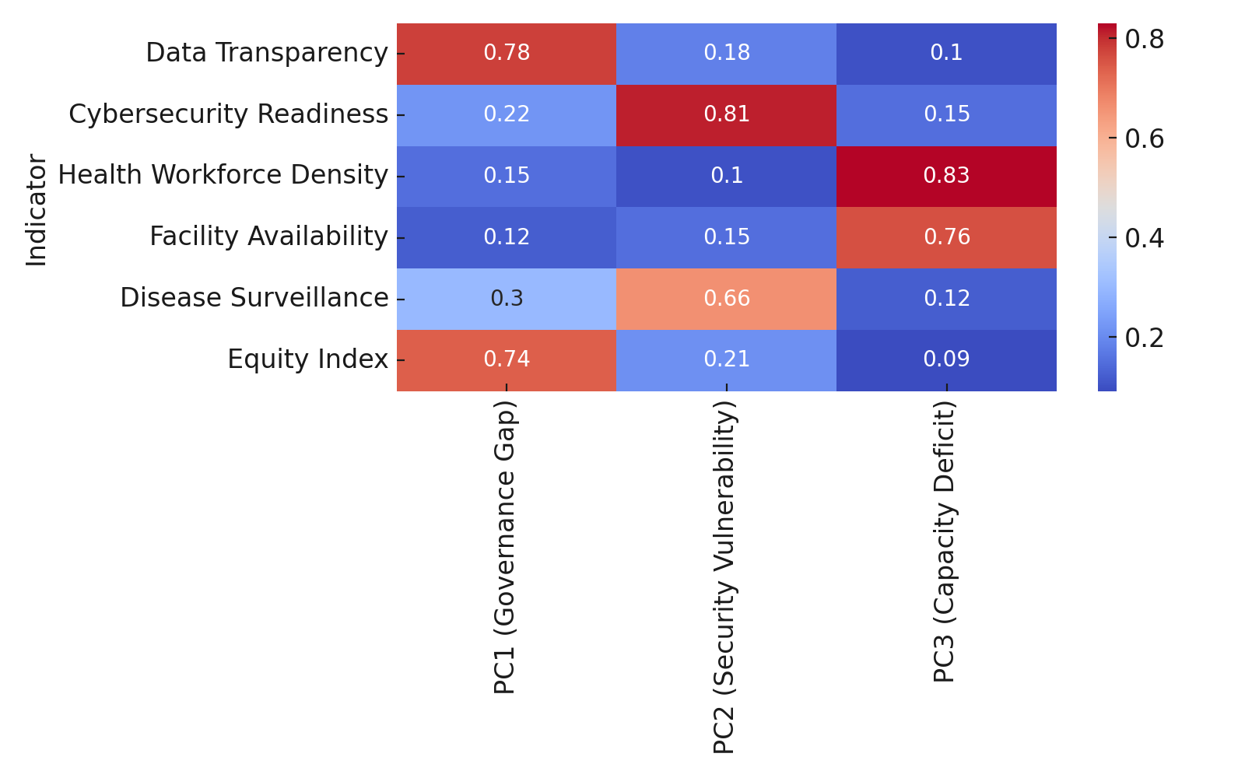
Figure 8: Heatmap of indicator loadings across principal components.

Discussion
The findings of this study provide strong empirical support for the potential of adaptive AI pipelines to transform population health analytics while also revealing persistent challenges that require governance, accountability, and ethical integration. In relation to the first objective, the fixed-effects regression demonstrated that adaptive AI adoption is significantly associated with reduced healthcare utilization, suggesting efficiency gains in decision-making and more targeted allocation of resources (Table 1). The negative coefficient for adaptive AI adoption reinforces the notion that dynamic and learning-based systems can mitigate unnecessary hospital visits and expenditures, aligning with prior claims that adaptive infrastructures increase analytic precision and responsiveness in health systems (Ogunboye et al., 2023; Olabiyi et al., 2025). Moreover, the influence of socioeconomic variables such as income and insurance coverage, as illustrated in Figure 1 and Figure 2, indicates that the benefits of adaptive pipelines are not experienced uniformly, but instead are shaped by structural inequities already well-documented in digital health adoption (Pearl, 2023; Morales-Forero et al., 2025).
Turning to the second objective, the anomaly detection results highlight the utility of statistical control charts in identifying vulnerabilities within AI-driven health data pipelines. Weeks 4, 7, and 10 were flagged as anomalies in Table 2, which mirrors documented instances where static data systems failed to promptly detect irregularities or breaches (Soussane et al., 2025). Figure 3 and Figure 4 illustrate that adaptive mechanisms are capable of distinguishing between normal fluctuations and abnormal patterns in real time, which is essential in a sector that, as Burgett (2023) notes, continues to record the highest breach costs across industries. This supports arguments advanced by Javed et al. (2024) and Fang et al. (2024) that embedding real-time anomaly detection strengthens systemic resilience against adversarial threats and data poisoning risks, ensuring that analytic insights retain their validity and reliability.
The third objective further underscores how governance models influence awareness of data privacy protections. The logistic regression results in Table 3 revealed that education, income, and urban residence are strongly associated with greater awareness of privacy frameworks, with odds ratios above one, as shown in Figure 5 and Figure 6. These findings confirm concerns expressed by Sargiotis (2024) and Subramanian et al. (2024) that governance in healthcare data systems often amplifies pre-existing inequities, as marginalized or rural groups remain less informed and consequently less protected. Gender differences, with males reporting lower awareness, add an additional layer of disparity, reflecting similar observations about uneven governance impacts within AI-enabled health systems (Franklin et al., 2024; Kolo, 2025). Consequently, while frameworks such as GDPR and HIPAA are positioned as universal safeguards, their operationalization on the ground appears to replicate societal inequalities, echoing calls by Mahari and Pentland (2024) for governance mechanisms to be integrated “by design” within adaptive systems.
The final objective, addressed through PCA, highlights systemic gaps that need to be resolved for adaptive AI pipelines to become secure and governance-compliant. The extraction of three principal components in Table 4, explaining over 80% of the variance, demonstrates that governance gaps, security vulnerabilities, and capacity deficits are central to understanding institutional readiness. The prominence of governance-related indicators, particularly data transparency and equity as shown in Table 5, resonates with the critiques of Garrity (2019) and Ghosh et al. (2025) regarding the reputational and ethical consequences of neglecting transparency and fairness in large-scale deployments. Similarly, the high loading of cybersecurity readiness and surveillance indicators on the second component confirms prior warnings that health systems remain vulnerable to targeted external attacks, as emphasized by Ewoh and Vartiainen (2024) and Koppolu et al. (2025). Figure 7 and Figure 8 further illustrate how the lack of workforce density and facility availability compounds these challenges, reflecting the structural deficits identified in Obubu et al. (2023) regarding uneven adoption between urban and rural health systems.
Taken together, the results demonstrate that while adaptive AI pipelines provide measurable efficiency gains and enhanced analytic responsiveness, as evidenced in Table 1 and Figure 1, their success depends on the integration of governance mechanisms that are equitable and enforceable, the deployment of anomaly detection tools that enhance security as shown in Table 2 and Figure 4, and the recognition of systemic gaps revealed in Table 5 and Figure 8. These findings extend existing literature by showing that adaptive AI must be conceptualized not only as a technological solution but also as a socio-technical system whose legitimacy is shaped by transparency, fairness, and security frameworks that evolve alongside the technology itself (Hedqvist et al., 2024; Stanford HAI, 2025).
5. Conclusion and Recommendations
The study concludes that adaptive AI pipelines hold significant promise for advancing population health analytics by improving efficiency, enhancing security, and embedding governance, yet their success is contingent upon addressing systemic inequities, safeguarding data integrity, and ensuring accountability. The findings demonstrate that while adaptive systems reduce healthcare utilization and strengthen anomaly detection, gaps in transparency, equity, and institutional capacity persist, reinforcing the need for holistic socio-technical integration. Building on this conclusion, the following recommendations are proposed:
- Policymakers should mandate governance-by-design principles, embedding transparency, auditability, and accountability directly into adaptive AI systems.
- Health institutions must deploy real-time anomaly detection frameworks to strengthen defenses against adversarial threats and pipeline tampering.
- Regulators should prioritize equity by tailoring data governance policies to rural and marginalized populations often excluded from privacy protections.
- Capacity-building initiatives should focus on expanding workforce density and infrastructure readiness to ensure adaptive AI systems operate securely and sustainably.

References
Adesokan-Imran, T. O., Popoola, A. D., Ejiofor, V. O., Salako, A. O., & Onyenaucheya, O. S. (2025). Predictive Cybersecurity Risk Modeling in Healthcare by Leveraging AI and Machine Learning for Proactive Threat Detection. Journal of Engineering Research and Reports, 27(4), 144–165. https://doi.org/10.9734/jerr/2025/v27i41463
Adesokan-Imran, T. O., Popoola, A. D., Kolo, F. H. O., Ejiofor, V. O., & Salami, I. A. (2025). Cybersecurity Risk Stratification Framework Using Multilevel Clustering: An Automated Threat Attribution and Categorization Approach for Cross-industry Cybersecurity. Journal of Engineering Research and Reports, 27(4), 241–263. https://doi.org/10.9734/jerr/2025/v27i41469
Adlung, L., Cohen, Y., Mor, U., & Elinav, E. (2021). Machine learning in clinical decision making. Med, 2(6), 642–665. https://doi.org/10.1016/j.medj.2021.04.006
Agarwal, G. (2025). Robust Data Pipelines for AI Workloads: Architectures, Challenges, and Future Directions. International Journal of Advanced Research in Science, Communication and Technology, 5(2), 622–632. https://doi.org/10.48175/ijarsct-23391
Antony, J., Jalušić, D., Bergweiler, S., Hajnal, Á., Žlabravec, V., Emődi, M., Strbad, D., Legler, T., & Marosi, A. C. (2024). Adapting to Changes: A Novel Framework for Continual Machine Learning in Industrial Applications. Journal of Grid Computing, 22(4). https://doi.org/10.1007/s10723-024-09785-z
Aslam, A., & Anuarovna, Z. D. (2025). Real-Time Workload Prediction and Resource Optimization for Parallel Heterogeneous High-Performance Computing Systems Architectures. Ubiquitous Technology Journal., 1(1), 40–47. https://doi.org/10.71346/utj.v1i1.11
Bamigbade, O. (2025a). Assessment of Cost-Benefit Dynamics of Cybersecurity Compliance Investments: A Multi-Sectoral Analysis Across Financial, Energy and Intelligence Industries. Journal of Energy Research and Reviews, 17(7), 86–105. https://doi.org/10.9734/jenrr/2025/v17i7435
Bamigbade, O. (2025b). Balancing Encryption Laws and National Security: Challenges for Data and Energy Sector Collaboration across Borders. Journal of Engineering Research and Reports, 27(6), 193–213. https://doi.org/10.9734/jerr/2025/v27i61538
Bamigbade, O., Obrik-Uloho, E. P., Kolo, F. H. O., Ogunmolu, A. M., & Adesokan-Imran, T. O. (2025). Data-Centric AI for Zero-Carbon Power Systems Security: A Framework for Learning with Noisy, Sparse, and Heterogeneous Data. Journal of Energy Research and Reviews, 17(7), 167–185. https://doi.org/10.9734/jenrr/2025/v17i7442
Barnes, E., & Hutson, J. (2024). Navigating the Complexities of AI: The Critical Role of Interpretability and Explainability in Ensuring Transparency and Trust. Digital Commons@Lindenwood University. https://digitalcommons.lindenwood.edu/faculty-research-papers/643/
Bhosale, K. S., Nenova, M., & Iliev, G. (2021, September 1). A study of cyber attacks: In the healthcare sector. IEEE Xplore. https://doi.org/10.1109/Lighting49406.2021.9598947
Brady, M. (2025). Emirates Health Services showcases AI-powered projects at Arab Health 2025 | HealthTechAsia. HealthTechAsia | Healthcare Innovation in the World’s Biggest Markets. https://healthtechasia.co/emirates-health-services-showcases-ai-powered-projects-at-arab-health-2025/
Burgett, H. M. (2023). Special Report: The Cost of a Data Breach in 2023. The National CIO Review. https://nationalcioreview.com/articles-insights/information-security/special-report-the-cost-of-a-data-breach-in-2023/
Chang, M. (2023). Google Cloud, Kakao Healthcare leveraging federated learning to expand AI limits in healthcare. KBR. https://www.koreabiomed.com/news/articleView.html?idxno=21958
Davahli, M. R., Karwowski, W., Fiok, K., Wan, T., & Parsaei, H. R. (2021). Controlling Safety of Artificial Intelligence-Based Systems in Healthcare. Symmetry, 13(1), 102. https://doi.org/10.3390/sym13010102
Dombrowski, M., Prenner, A., & Kainz, B. (2024). Bias Assessment and Data Drift Detection in Medical Image Analysis: A Survey. ArXiv.org. https://arxiv.org/abs/2409.17800
Eastwood, B. (2023). How to Navigate Structured and Unstructured Data as a Healthcare Organization. Technology Solutions That Drive Healthcare. https://healthtechmagazine.net/article/2023/05/structured-vs-unstructured-data-in-healthcare-perfcon
Ejiofor, V. O. (2025). Open Data for Cyber Resilience: An Analysis of Public-private Collaboration in AI-Supported Threat Intelligence Sharing. Asian Journal of Research in Computer Science, 18(6), 403–423. https://doi.org/10.9734/ajrcos/2025/v18i6710
Ejiofor, V. O., Ogunmolu, A. M., Gbadebo, M. O., Joseph, S. A., & Adesokan-Imran, T. O. (2025). AI- Driven Risk Assessment for Enhancing Third Party Vendor Security in Healthcare Systems. Journal of Engineering Research and Reports, 27(5), 117–137. https://doi.org/10.9734/jerr/2025/v27i51498
Ewoh, P., & Vartiainen, T. (2024). Vulnerabilities, Cyberattacks and Socio-technical Solutions in Healthcare Systems: Systematic Review (Preprint). JMIR. Journal of Medical Internet Research/Journal of Medical Internet Research, 26, e46904–e46904. https://doi.org/10.2196/46904
Fang, H., Qiu, Y., Yu, H., Yu, W., Kong, J., Chong, B., Chen, B., Wang, X., & Xia, S.-T. (2024, February 6). Privacy Leakage on DNNs: A Survey of Model Inversion Attacks and Defenses. ArXiv.org. https://doi.org/10.48550/arXiv.2402.04013
FortuneBusinessInsight. (2025). Population Health Analytics Market, Size, Share | Growth [2032]. Fortunebusinessinsights.com. https://www.fortunebusinessinsights.com/population-health-analytics-market-113557
Franklin, G., Stephens, R., Piracha, M., Tiosano, S., Lehouillier, F., Koppel, R., & Elkin, P. L. (2024). The Sociodemographic Biases in Machine Learning Algorithms: A Biomedical Informatics Perspective. Life, 14(6), 652–652. https://doi.org/10.3390/life14060652
Gailis, A. (2024). IAPP publishes Privacy Governance Report 2024. GDPR Buzz. https://gdprbuzz.com/news/iapp-publishes-privacy-governance-report-2024/
Garrity, M. (2019). Google’s “Project Nightingale” is secretly collecting data on millions of Ascension patients: WSJ. Becker’s Hospital Review | Healthcare News & Analysis; Becker’s Hospital Review | Healthcare News & Analysis. https://www.beckershospitalreview.com/healthcare-information-technology/cybersecurity/google-s-project-nightingale-is-secretly-collecting-data-on-millions-of-ascension-patients-wsj/
Gbadebo, M. O. (2025). Integrating Post-Quantum Cryptography and Advanced Encryption Standards to Safeguard Sensitive Financial Records from Emerging Cyber Threats. Asian Journal of Research in Computer Science, 18(4), 1–23. https://doi.org/10.9734/ajrcos/2025/v18i4605
Ghosh, A., Saini, A., & Barad, H. (2025). Artificial intelligence in governance: recent trends, risks, challenges, innovative frameworks and future directions. AI & SOCIETY. https://doi.org/10.1007/s00146-025-02312-y
Grand View Research. (2023). Artificial Intelligence In Healthcare Market Size Report, 2019-2025. Grand View Research. https://www.grandviewresearch.com/industry-analysis/artificial-intelligence-ai-healthcare-market
Gstrein, O. J., & Zwitter, A. (2021). Extraterritorial Application of the GDPR: Promoting European Values or Power? Social Science Research Network. https://papers.ssrn.com/sol3/papers.cfm?abstract_id=3940596
Hedqvist, A., Praetorius, G., Ekstedt, M., & Lindberg, C. (2024). Entangled in complexity: An ethnographic study of organizational adaptability and safe care transitions for patients with complex care needs. Journal of Advanced Nursing. https://doi.org/10.1111/jan.16203
Himani, K., Singh, J., Shobhit, A., & Pratap, S. A. (2024). Health Informatics: An Emerging Strategy for Clinical Care. Advances in Geographical and Environmental Sciences, 237–247. https://doi.org/10.1007/978-981-97-6706-9_13
Horzyk, A. M. (2024). Implications of European By-Design Laws on Data-Driven System Design. 2022 International Joint Conference on Neural Networks (IJCNN), 73, 1–8. https://doi.org/10.1109/ijcnn60899.2024.10649941
Hulsen, T. (2023). Explainable Artificial Intelligence (XAI): Concepts and Challenges in Healthcare. AI, 4(3), 652–666. https://doi.org/10.3390/ai4030034
Islam, M. R. (2025). The Evolution of Alpha in Finance Harnessing Human Insight and LLM Agents. ArXiv.org. https://arxiv.org/abs/2505.14727
Javed, H., El-Sappagh, S., & Abuhmed, T. (2024). Robustness in deep learning models for medical diagnostics: security and adversarial challenges towards robust AI applications. Artificial Intelligence Review, 58(1). https://doi.org/10.1007/s10462-024-11005-9
Kim, J. Y., Hasan, A., Kueper, J., Tang, T., Hayes, C., Fine, B., Balu, S., & Sendak, M. (2025). Establishing organizational AI governance in healthcare: a case study in Canada. Npj Digital Medicine, 8(1). https://doi.org/10.1038/s41746-025-01909-3
Kolo, F. H. O. (2025). Responsible AI for Cybersecurity: Assessing the Barriers, Biases and Governance Gaps in Implementation with E-commerce Systems. Journal of Engineering Research and Reports, 27(5), 510–532. https://doi.org/10.9734/jerr/2025/v27i51520
Kolo, F. H. O., Joseph, S. A., Ogunmolu, A. M., Ejiofor, V. O., & Oyekunle, S. M. (2025). Mitigating Cybersecurity Risks in Financial Institutions through Strategic Third- Party Risk Governance Frameworks. Journal of Engineering Research and Reports, 27(5), 173–193. https://doi.org/10.9734/jerr/2025/v27i51501
Koppolu, H. K. R., Gadi, A. L., Motamary, S., Dodda, A., & Suura, S. R. (2025). Dynamic Orchestration of Data Pipelines via Agentic AI: Adaptive Resource Allocation and Workflow Optimization in Cloud-Native Analytics Platforms. Metallurgical and Materials Engineering, 31(4), 625–637. https://doi.org/10.63278/1490
Lee, C. H., Lim, K. H., & Eswaran, S. (2025). A comprehensive survey on secure healthcare data processing with homomorphic encryption: attacks and defenses. Deleted Journal, 22(1). https://doi.org/10.1186/s12982-025-00505-w
Mahari, R., & Pentland, A. (2024). Regulation by Design: A New Paradigm for Regulating AI Systems. Ssrn.com. https://papers.ssrn.com/sol3/papers.cfm?abstract_id=4753029
Morales-Forero, A., Rueda, L. J., Herrera, R., Bassetto, S., & Coatanea, E. (2025). Predictive Representativity: Uncovering Racial Bias in AI-based Skin Cancer Detection. ArXiv.org. https://arxiv.org/abs/2507.14176
Nogaroli, R. (2025). Ethical and Legal Aspects of Artificial Intelligence (AI) in Medical Service Contracts. Medical Liability and Artificial Intelligence, 123–206. https://doi.org/10.1007/978-3-031-94306-5_4
Nookala, G. (2024). Adaptive Data Governance Frameworks for Data-Driven Digital Transformations. Journal of Computational Innovation, 4(1). https://researchworkx.com/index.php/jci/article/view/16
Nunez Migliorisi, T. (2025). Healthcare Data Breaches: Diving in the Dark. Lecture Notes in Networks and Systems, 1424, 587–602. https://doi.org/10.1007/978-3-031-92605-1_36
Obubu, M., Chuku, N., Ananaba, A., Sadiq, F. U., Sambo, E., Kolade, O., Oyekanmi, T., Olaosebikan, K., & Serrano, O. (2023). Evaluation of healthcare facilities and personnel distribution in Lagos State: implications on universal health coverage. Hospital Practice, 51(2), 1–12. https://doi.org/10.1080/21548331.2023.2170651
Ogrizović, M., Drašković, D., & Bojić, D. (2024). Quality assurance strategies for machine learning applications in big data analytics: an overview. Journal of Big Data, 11(1). https://doi.org/10.1186/s40537-024-01028-y
Ogunboye, I., Shileayo, P., Chioma, S., Cherechi, E., Favour, C., & Awuah, B. (2023). Enhancing Nigeria’s health surveillance system: A data-driven approach to epidemic preparedness and response. World Journal of Advanced Research and Reviews, 20(1), 1352–1369. https://doi.org/10.30574/wjarr.2023.20.1.2078
Ogunmolu, A. M. (2025a). A Multiscale Approach to Cyber-Mechanical Threat Modeling for Predicting and Preventing Failures in Critical Energy Infrastructure. Journal of Engineering Research and Reports, 27(6), 1–20. https://doi.org/10.9734/jerr/2025/v27i61523
Ogunmolu, A. M. (2025b). Digital Twin-based Energy Infrastructure Powered by AI: Real-Time Simulation, Anomaly Detection, and Intervention. Journal of Energy Research and Reviews, 17(7), 65–85. https://doi.org/10.9734/jenrr/2025/v17i7434
Ogunmolu, A. M. (2025c). Enhancing Data Security in Artificial Intelligence Systems: A Cybersecurity and Information Governance Approach. Journal of Engineering Research and Reports, 27(5), 154–172. https://doi.org/10.9734/jerr/2025/v27i51500
Ogunmolu, A. M. (2025d). Federated Detection Systems for Insider Threats in Energy Facilities Using Biomechanical Access Control and Al-Based Cybersecurity. Journal of Engineering Research and Reports, 27(6), 65–82. https://doi.org/10.9734/jerr/2025/v27i61528
Ogunmolu, A. M. (2025e). Leveraging Generative AI and Behavioral Biometrics to Strengthen Zero Trust Cybersecurity Architectures in Healthcare Systems. Journal of Engineering Research and Reports, 27(5), 194–213. https://doi.org/10.9734/jerr/2025/v27i51502
Ogunmolu, A. M., Obrik-Uloho, E. P., Olaniyi, O. O., Arigbabu, A. T., & Bamigbade, O. (2025). Cyber Risk Spillovers in Interconnected Financial Ecosystems: Evidence from Traditional Banks and DeFi Oracles. Journal of Engineering Research and Reports, 27(7), 106–126. https://doi.org/10.9734/jerr/2025/v27i71565
Ogunmolu, A. M., Olaniyi, O. O., Popoola, A. D., Olisa, A. O., & Bamigbade, O. (2025). Autonomous Artificial Intelligence Agents for Fault Detection and Self-Healing in Smart Manufacturing Systems. Journal of Energy Research and Reviews, 17(8), 20–37. https://doi.org/10.9734/jenrr/2025/v17i8445
Olabiyi, W., Akinleye, D., & Joel, E. (2025). The Evolution of AI: From Rule-Based Systems to Data-Driven Intelligence. ResearchGate. https://www.researchgate.net/publication/388035967_The_Evolution_of_AI_From_Rule-Based_Systems_to_Data-Driven_Intelligence
Olutimehin , A. T., Olaniyi , O. O., Ogunmolu , A. M., Kolo, F. H. O., & Salami , I. A. (2025). Cloud-Based AI Solutions for Real-time Monitoring of E-commerce Compliance and Risk. Journal of Engineering Research and Reports, 27(7), 127–147. https://doi.org/10.9734/jerr/2025/v27i71566
Olutimehin, A. T., Olaniyi, O. O., Popoola, A. D., Ogunmolu, A. M., & Kolo, F. H. O. (2025). AI and IoT Integration for Predictive Maintenance and Risk Management in Smart Manufacturing. Asian Journal of Research in Computer Science, 18(7), 120–142. https://doi.org/10.9734/ajrcos/2025/v18i7724
Oyekunle, S. M., Popoola, A. D., Kolo, F. H. O., Ogunmolu, A. M., & Adesokan-Imran, T. O. (2025). Intelligent Fraud Prevention Information Banking: A Data Governance- Centric Approach Using Behavioural Biometrics. Asian Journal of Research in Computer Science, 18(5), 525–543. https://doi.org/10.9734/ajrcos/2025/v18i5672
Pearl, R. (2023). Patients, Doctors Fear AI in Medicine -- Should They? Medpagetoday.com; MedpageToday. https://www.medpagetoday.com/popmedicine/popmedicine/105330
Quinn, T. P., Jacobs, S., Senadeera, M., Le, V., & Coghlan, S. (2021). The Three Ghosts of Medical AI: Can the Black-Box Present Deliver? Artificial Intelligence in Medicine, 124, 102158. https://doi.org/10.1016/j.artmed.2021.102158
Razi, Q., Piyush, R., Chakrabarti, A., Singh, A., Hassija, V., & Chalapathi, G. S. S. (2025). Enhancing Data Privacy: A Comprehensive Survey of Privacy-Enabling Technologies. IEEE Access, 13, 40354–40385. https://doi.org/10.1109/access.2025.3546618
Reichrath, B., & Pietrowsky, R. (2022). Exploring Problematic Mobile Phone Attachment and Associations to Anxiety and Inhibitory Control After a Short-Term Smartphone Separation. Journal of Cyberspace Studies, 6(2), 107–130. https://doi.org/2588-5502
Reuter, E. (2025). More hospitals need to assess predictive models for accuracy, bias: Health Affairs. MedTech Dive. https://www.medtechdive.com/news/hospitals-evaluate-ai-predictive-models-health-affairs/737054/
ŞAHiN, E., Arslan, N. N., & Özdemir, D. (2024). Unlocking the black box: an in-depth review on interpretability, explainability, and reliability in deep learning. Neural Computing and Applications, 37(2). https://doi.org/10.1007/s00521-024-10437-2
Salako, A. O. (2025). Predictive Data Analysis in Forecasting Patient Health Outcomes Using Machine Learning Algorithms. Asian Journal of Research in Computer Science, 18(6), 194–214. https://doi.org/10.9734/ajrcos/2025/v18i6691
Salami, I. A. (2025). Modeling and Measuring the Cyber Resilience of Critical Healthcare Infrastructure against Ransomware: A Cyber-Physical Systems Risk Perspective. Journal of Engineering Research and Reports, 27(5), 231–252. https://doi.org/10.9734/jerr/2025/v27i51504
Salami, I. A., Popoola, A. D., Gbadebo, M. O., Kolo, F. H. O., & Adesokan-Imran, T. O. (2025). AI- Powered Behavioural Biometrics for Fraud Detection in Digital Banking: A Next-Generation Approach to Financial Cybersecurity. Asian Journal of Research in Computer Science, 18(4), 473–494. https://doi.org/10.9734/ajrcos/2025/v18i4632
Sargiotis, D. (2024). Key Principles of Data Governance: Building a Strong Foundation. Springer , 137–163. https://doi.org/10.1007/978-3-031-67268-2_3
SAS. (2023). SAS accelerates responsible innovation efforts with new collaborations and a focus on trustworthy AI. Sas.com. https://www.sas.com/en_us/news/press-releases/2023/may/responsible-innovation-reahl.html
Sharma, A. (2023). Electronic Health Records Statistics: Insights of Modern Healthcare. Market.us Media. https://media.market.us/electronic-health-records-statistics/
Shen, Y., Yu, J., Zhou, J., & Hu, G. (2024). 25 years of evolution and hurdles in electronic health records and interoperability in medical research: a comprehensive review (Preprint). Journal of Medical Internet Research, 27. https://doi.org/10.2196/59024
Soltan, A. A. S., Thakur, A., Yang, J., Chauhan, A., D’Cruz, L. G., Dickson, P., Soltan, M. A., Thickett, D. R., Eyre, D. W., Zhu, T., & Clifton, D. A. (2024). A scalable federated learning solution for secondary care using low-cost microcomputing: privacy-preserving development and evaluation of a COVID-19 screening test in UK hospitals. The Lancet Digital Health, 6(2), e93–e104. https://doi.org/10.1016/s2589-7500(23)00226-1
Soussane, K., Elbaghazaoui, B. E., & Amnai, M. (2025). Integrating Security in DataOps. IGI Global EBooks, 197–214. https://doi.org/10.4018/979-8-3373-0365-9.ch010
Spencer, P. (2025). AI Data Privacy Wake-Up Call: Findings From Stanford’s 2025 AI Index Report. Kiteworks | Your Private Data Network. https://www.kiteworks.com/cybersecurity-risk-management/ai-data-privacy-risks-stanford-index-report-2025/
Stanford HAI. (2025a). Policy and Governance. Stanford.edu. https://hai.stanford.edu/ai-index/2025-ai-index-report/policy-and-governance
Stanford HAI. (2025b). The 2025 AI Index Report. Stanford.edu. https://hai.stanford.edu/ai-index/2025-ai-index-report
Subramanian, H., Sengupta, A., & Xu, Y. (2024). Patient health record protection beyond HIPAA: A multi-method analysis. Journal of Medical Internet Research, 26. https://doi.org/10.2196/59674
Tavva, G. (2025). Adaptive Data Pipeline Framework for Unified Ingestion Patterns for Diverse Data Ecosystems. International Journal on Science and Technology, 16(2). https://doi.org/10.71097/ijsat.v16.i2.6106
Tran, N. K., Albahra, S., Rashidi, H., & May, L. (2022). Innovations in infectious disease testing: Leveraging COVID-19 pandemic technologies for the future. Clinical Biochemistry, 117. https://doi.org/10.1016/j.clinbiochem.2021.12.011
Tschider, C., Compagnucci, M. C., & Minssen, T. (2024). The new EU–US data protection framework’s implications for healthcare. Journal of Law and the Biosciences, 11(2). https://doi.org/10.1093/jlb/lsae022
Young, A. T., Amara, D., Bhattacharya, A., & Wei, M. L. (2021). Patient and general public attitudes towards clinical artificial intelligence: a mixed methods systematic review. The Lancet Digital Health, 3(9), e599–e611. https://doi.org/10.1016/s2589-7500(21)00132-1
Zainab, O. A., & Mgbole, T. J. (2024). Utilization of big data analytics to identify population health trends and optimize healthcare delivery system efficiency. World Journal of Advanced Research and Reviews, 24(1), 2159–2176. https://doi.org/10.30574/wjarr.2024.24.1.3198
Zhang, C., Yang, S., Mao, L., & Ning, H. (2024). Anomaly detection and defense techniques in federated learning: a comprehensive review. Artificial Intelligence Review, 57(6). https://doi.org/10.1007/s10462-024-10796-1

