Systematic Review Article

Optimizing Urban Road Networks: A Systematic Review of Design, Control, and Multimodal Integration

ABSTRACT

Urban areas worldwide are grappling with the pervasive challenge of traffic congestion, which impedes economic productivity, degrades environmental quality, and diminishes the quality of life for residents. The design and management of road networks are fundamental determinants of urban mobility. This systematic review provides a comprehensive analysis and proposes a new conceptual framework for understanding how to optimize road networks for improved traffic flow. The critical interdependencies between network topology, smart traffic management systems, and multimodal integration are examined. Through a structured review of 82 selected studies, this paper synthesizes the evidence on various interventions, from hierarchical network forms to adaptive traffic control and Bus Rapid Transit (BRT). Case studies from Singapore, Curitiba, and Amsterdam illustrate that success is contingent not only on technical solutions but also on specific governance models. The review highlights the powerful synergy between physical infrastructure and intelligent control systems, but also identifies an emerging conflict between centralized planning and decentralized, user-led optimization through modern navigation applications. We conclude that moving beyond isolated fixes requires an integrated decision-making framework that acknowledges these complex interactions. This paper offers a synthesized resource for researchers, transport engineers, and urban planners working to create more efficient, sustainable, and
resilient urban transportation systems.

Keywords: Urban Mobility, Traffic Congestion, Road Network Design, Traffic Flow, Intelligent

Transportation Systems, Sustainable Transportation, Multimodal Integration

1. INTRODUCTION

The 21st century is unequivocally the urban century. Cities are absorbing the vast majority of global population growth, with projections indicating that over two-thirds of humanity will reside in urban areas by
2050 (United Nations, 2018). This unprecedented wave of urbanization places immense, often unsustainable, strain on foundational urban systems, none more so than transportation infrastructure (World Bank, 2019). The ability to move people and goods efficiently, safely, and with minimal environmental impact has become a defining challenge for urban governance and a critical determinant of a city's economic competitiveness and quality of life (Hickman et al., 2013). Yet, despite decades of investment and technological advancement, the problem of urban traffic congestion remains stubbornly pervasive. In the United States alone, the annual costs of delay and wasted fuel are measured in the hundreds of billions of dollars (Texas A&M Transportation Institute, 2019), a scenario mirrored in the megacities of Europe and Asia where congestion acts as a major brake on economic productivity and public health (ITF, 2019).

For much of the 20th century, the prevailing response to congestion was a straightforward, supply-side approach: build more roads. This paradigm, however, has been fundamentally challenged by the consistent observation of induced demand. The expansion of road capacity often generates new traffic that quickly consumes any initial gains in speed or flow, a phenomenon famously described as the fundamental law of road congestion (Duranton and Turner, 2011). This self-defeating cycle of construction and congestion, coupled with growing awareness of the profound environmental and social costs of car-centric development, has catalyzed a paradigm shift. The focus of leading-edge research and practice has moved decisively from network expansion to network optimization, seeking to unlock the latent capacity of existing infrastructure through smarter design, dynamic management, and a more equitable allocation of street space.

The performance of an urban road network is not a simple function of its physical dimensions but emerges from the complex interplay of three core domains: physical structure, operational control, and demand management (Vickrey, 1969). The network's physical structure, or topology, has been a subject of intense study within network science, which analyses its properties of connectivity, redundancy, and resilience (Barthélemy, 2011). Empirical research in transport geography has demonstrated how different layouts such as traditional grids, suburban hierarchical patterns, or hybrid forms profoundly influence travel behaviour, energy consumption, and vulnerability to disruptions (Xie and Levinson, 2009; Farahani et al.,
2013). Yet, an optimal physical design is a necessary but not sufficient condition for efficiency. Even well- connected networks perform poorly under the static, pre-timed signal controls of the past. This has motivated decades of investment in Intelligent Transportation Systems (ITS), particularly adaptive traffic signal control technologies that respond to real-time conditions (FHWA, 2021; Papageorgiou & Vigos, 2021; Genders & Razavi, 2016).
Beyond managing vehicular flow, a third and increasingly critical dimension of optimization involves the strategic reallocation of road space to favor more space-efficient modes of transport. This reflects a broader shift in planning philosophy, away from simply maximizing vehicle throughput and towards a more holistic goal of sustainable mobility (Banister, 2008). The implementation of high-capacity public transport, such as Bus Rapid Transit (BRT), has been shown to deliver significant gains in corridor efficiency and travel time reliability (Cervero, 2013; Hensher & Mulley, 2022). Simultaneously, integrating this trunk infrastructure with feeder networks for active transport (walking and cycling) is critical for solving the first and last-mile problem and is strongly linked to reduced car dependency, particularly when coupled with supportive land-use policies, such as Transit-Oriented Development (TOD) (Cervero & Kockelman, 1997).

Despite a vast and growing body of literature across these domains, a significant gap persists in synthesizing this knowledge into a coherent, actionable framework for policymakers and practitioners. Findings on network topology, traffic control, and multimodal planning often exist in separate intellectual silos, studied by different academic communities with distinct methods and priorities. This fragmentation obscures the powerful synergies and potential conflicts that exist between interventions. This systematic review aims to bridge that gap by assembling and critically appraising the empirical record across these three core strands. A key puzzle this review helps unravel is the emerging tension between the top-down, centralized logic of traditional urban planning and the bottom-up, decentralized, real-time optimization now being driven by ubiquitous consumer technologies. By clarifying these interdependencies, this paper seeks to move the discourse from a focus on isolated fixes to a more integrated, strategic, and ultimately more effective approach to optimizing urban road networks for the challenges of the 21st century.

2. METHODOLOGY

2.1 Review Design

To ensure a structured, transparent, and reproducible process, this study adopted a systematic review design. The methodology was developed and executed in accordance with the Preferred Reporting Items for Systematic Reviews and Meta-Analyses (PRISMA) statement, which provides an evidence-based checklist of items for reporting in systematic reviews and meta-analyses (Page et al., 2021). A review protocol was established prior to the commencement of the search, specifying the research questions, search strategy, eligibility criteria, and methods for synthesis to minimize bias and promote methodological rigor.

2.2 Data Sources and Search Strategy

A comprehensive and systematic search of the international academic literature was conducted to identify all relevant studies published between 2000 and 2024. Four major electronic databases were queried, chosen for their extensive coverage of transportation engineering, urban planning, geography, and related
interdisciplinary fields: Scopus, Web of Science, TRID (Transport Research International Documentation Database), and Google Scholar. The search strategy was designed to be highly sensitive, combining keywords from three core conceptual pillars: (1) Network and Infrastructure (e.g., "road network," "street network," "topology"); (2) Traffic and Mobility (e.g., "traffic flow," "urban mobility," "congestion," "accessibility"); and (3) Outcomes and Interventions (e.g., "optimize," "efficient," "design," "adaptive control," "multimodal"). Boolean operators (AND, OR) were used to construct detailed search strings tailored to the syntax of each database. For example, a representative full search string for the Scopus database was: (TITLE-ABS-KEY ("road network" OR "street network") AND TITLE-ABS-KEY ("traffic flow" OR "urban mobility" OR "congestion") AND TITLE-ABS-KEY ("optimize" OR "efficient" OR "design")). To ensure comprehensiveness, the reference lists of previously published relevant review articles were also manually scanned to identify any studies missed by the database search.

2.3 Eligibility criteria

Studies were deemed eligible for inclusion based on a pre-defined set of PICOs (Population, Intervention, Comparison, and Outcome) study design criteria. The population was defined as urban road networks at any scale (for example, corridor, sub-network, and city-wide). Interventions of interest included any structural, operational, or policy-based change related to network design, traffic control, or multimodal integration. Comparators were required, meaning studies had to compare the intervention against a baseline (or another alternative. Outcomes had to include at least one quantifiable metric of network performance, such as travel time, vehicle delay, throughput, emissions, or mode share. All empirical study designs were considered, including simulation studies, observational before-and-after studies, and comparative case studies. Only peer-reviewed journal articles and major conference papers published in English were included.

2.4 Screening and study selection

The study selection process was conducted in two phases. First, the titles and abstracts of all records retrieved from the database search were independently screened by two reviewers against the eligibility criteria. Any disagreements between the reviewers were resolved through discussion. In the second phase, the full texts of all potentially eligible articles were retrieved and assessed in detail against the same inclusion criteria to determine the final selection. The reasons for excluding articles at the full-text stage were documented. The entire screening and selection process, including the number of records identified, included, and excluded, is summarized in a PRISMA flow diagram.

2.5 Data Extraction and Items

A standardized data extraction form was developed and pre-tested to systematically collect key information from each included study. The extracted data items included: (1) bibliographic details (author, year, title);
(2) study context (city, country, city characteristics like population and income level); (3) study design and methodology; (4) details of the intervention being evaluated; (5) the specific outcome measures reported; and (6) the key quantitative findings and conclusions of the study. This structured approach ensured consistency in data collection across all studies and facilitated subsequent synthesis and comparison.

2.6 Risk of Bias and Study Quality Assessment

To evaluate the methodological quality and risk of bias of the included studies, a modified version of the well-established Downs and Black (1998) checklist was used. This tool is designed to assess the quality of both randomized and non-randomized studies. The checklist was adapted for the specific context of transport studies, with items evaluating four key domains: (1) clarity of aims and reporting quality; (2) internal validity (addressing issues of bias and confounding); (3) external validity (generalizability of the findings); and (4) statistical power. Based on their score, each study was qualitatively rated as "strong," "moderate," or "weak." This quality assessment was not used to exclude studies but rather to inform the narrative synthesis, allowing for a weighting of the evidence. For instance, in cases of conflicting results, findings from studies rated as "strong" were given greater precedence.

2.7 Synthesis Approach

Given the significant heterogeneity across the included studies in terms of interventions, outcome measures, and contexts, a quantitative meta-analysis was not feasible or appropriate. Therefore, a narrative synthesis approach was undertaken. The findings were first organized into logical thematic domains based on the primary type of intervention: Network Topology and Design, Smart Traffic Management and Control, and Multimodal Integration. Within each theme, the results from individual studies were summarized and tabulated to allow for transparent comparison. The narrative then focused on identifying cross-study patterns, regularities, and divergences in the evidence, paying close attention to how the quality of a study might influence its findings. This approach allowed for a comprehensive and nuanced interpretation of a diverse body of literature.

3. RESULTS

3.1 Study Selection and Characteristics

The systematic search of the four databases yielded an initial 4,328 records. After removing 1,226 duplicates, the titles and abstracts of 3,102 unique articles were screened. This initial screening led to the exclusion of 2,881 records that were clearly not relevant to the review's objectives. The full texts of the remaining 251 articles were retrieved for detailed assessment. Of these, 169 were excluded for various reasons, most commonly the absence of quantifiable outcome data (n=78) or a focus on non-urban contexts such as inter-city highways (n=45). Ultimately, a final set of 82 studies met all inclusion criteria and were
included in the qualitative synthesis. The full process is detailed in the PRISMA diagram (Fig. 1).

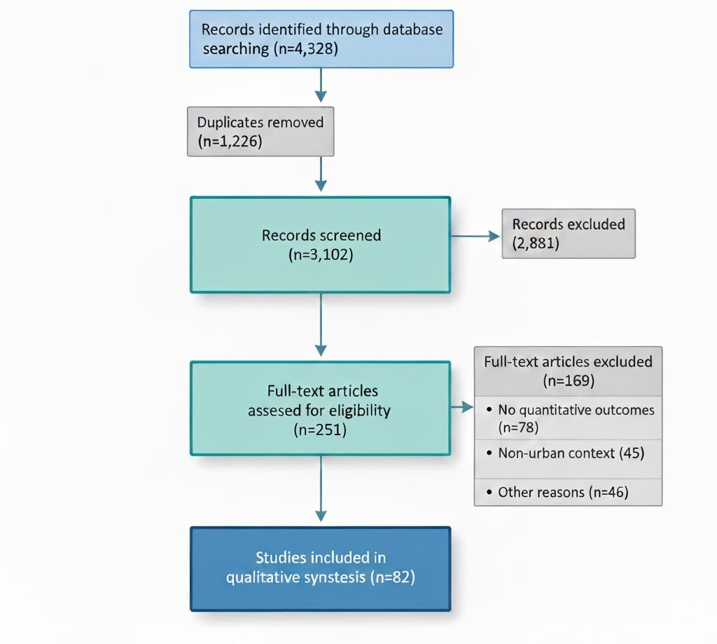

Fig. 1. PRISMA Flow Diagram

The 82 included studies represent a broad geographic distribution, though with a notable concentration in high-income countries. The largest shares of studies originated from North America (n= 28, 34%), Europe (n=25, 30%), and East Asia (n=19, 23%). The methodological approaches were dominated by simulation- based designs (n=61, 74%), which allow for controlled testing of interventions in a virtual environment. These were supplemented by empirical before-and-after evaluations of real-world implementations (n= 15,
18%) and a smaller number of comparative case studies (n= 6, 7%). A summary of the characteristics of a representative sample of included studies is presented in Table 1.
Table 1. Characteristics of selected included studies

Author(s), Year | Location | City  Context | Intervention(s) | Study Design | Key Quantitative  Finding
Zhang &  Levinson, 2004 | Minneapolis,  USA. | High-  income, | Grid vs.  Hierarchical | Simulation | Grid network showed  lower travel times for
 |  | large. | network topology. |  | local trips.
Smith et al., 2015 | London, UK | High-  income, | SCOOT (Split,  Cycle, and Offset | Simulation | 12% reduction in  vehicle delay.
 |  | mega-city. | Optimization
 |  |  | Technique)
Currie, 2006 | Bogota,  Colombia | Middle-  income, | Trans-Milenio BRT  system | Comparative  case | 32% reduction in  average commute
 |  | large. |  |  | time on the corridor.
Liu & Li, 2017 | Beijing, | Middle- | Dynamic lane | Simulation | 18% increase in
 | China | income,  mega-city. | management |  | intersection  throughput.
Litman, 2013 | Various | Various | Protected bicycle | Synthesis of | Mode shift from auto;
 |  |  | lanes | cases | improved safety.
OECD/ITF, 2018 | Lisbon,  Portugal | High-  income, | Integrated mobility  pricing & public | Simulation | 22% reduction in  VKT; 15% drop in
 |  | medium. | transport. |  | emissions.

3.2 Network Topology and Design

The literature consistently confirms that the underlying geometric structure of a street network has a profound impact on its performance. Different topologies present distinct trade-offs between local accessibility and network-wide traffic flow. As demonstrated in seminal simulation work by Zhang & Levinson (2004), grid networks, characterized by high intersection density and short block lengths, provide a high degree of connectivity and routing flexibility. This redundancy makes them inherently resilient to disruptions and efficient for dispersing local traffic, as drivers have multiple alternative paths. In contrast, hierarchical networks, common in post-war suburban development, with their tree-like structure of culs-de- sac feeding into collector and arterial roads, are designed to protect residential areas from through-traffic. However, this design can concentrate congestion at critical junctions and create significant bottlenecks, making the entire network vulnerable to failure at a few key points.

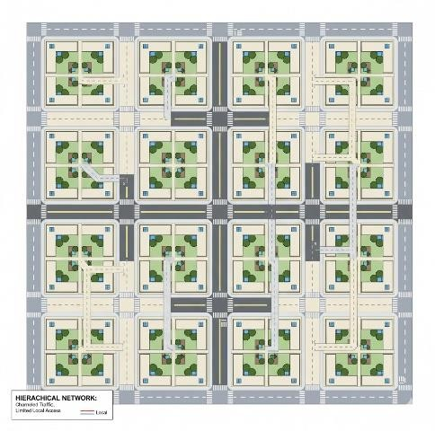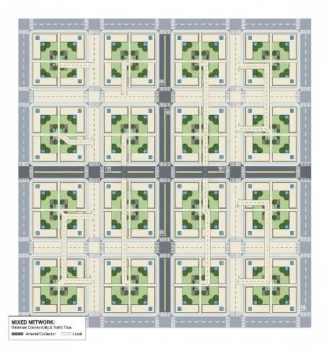

(a) (b) (c)

Fig. 2. Comparison of Network Topologies: (a) Idealized representations of grid, (b) hierarchical, (c) mixed street network patterns (Zhang & Levinson, 2004).

Beyond the overall pattern, the design of individual intersections is a critical element of network performance. A significant body of evidence shows that modern roundabouts can substantially outperform traditional signalized intersections in many contexts. Informational guides and empirical studies, such as those summarized by Rodegerdts et al. (2007), demonstrate that roundabouts can reduce overall vehicle delays by 30-40% by maintaining continuous flow and reducing the number of conflict points. Furthermore, a meta-analysis by Elvik (2017) confirmed that the conversion of conventional intersections to roundabouts leads to significant safety benefits, with large reductions in fatal and injury crashes.

3.3 Smart Traffic Management and Control

The evidence synthesized in this review strongly supports the effectiveness of moving from static, pre-timed traffic control to dynamic, adaptive systems. Adaptive Traffic Control Systems (ATCS) like SCOOT and SCATS, which use real-time sensor data to adjust signal timings, consistently demonstrate significant benefits. Multiple studies, including comprehensive reviews by Smith et al. (2015), report that well- implemented ATCS can produce network-wide reductions in vehicle delay of 10-20% and similar reductions in the number of stops, leading to smoother traffic flow, lower fuel consumption, and reduced emissions. Another layer of operational intelligence is Transit Signal Priority (TSP), which can give buses a temporary green light extension or an early green light at intersections. Studies such as that by Furth & Muller (2006) show TSP can reduce bus travel times by 5-15%, with the greatest impacts achieved when it is paired with physically dedicated bus lanes.

Dynamic strategies that adapt the physical infrastructure itself are also highly effective. For example, dynamic lane management, which involves reversing the direction of lanes to match peak demand flows (inbound in the morning, outbound in the evening), as shown in Fig. 3, has been shown in simulations to
increase the vehicle throughput of a corridor or intersection by 25% (Liu & Li, 2017). On freeways, ramp metering, which regulates the rate at which vehicles can enter the mainline, has proven effective at preventing the breakdown of traffic flow, reducing overall congestion by 30%. Beyond these operational tweaks, congestion pricing has been demonstrated to be a powerful demand management tool. By charging vehicles for entering a designated zone during peak hours, cities like London (Leape, 2006), Singapore (Santos, 2005), and Stockholm (Eliasson, 2009) have successfully reduced peak-period traffic volumes by
15-25%, while also generating a dedicated revenue stream for public transport improvements.

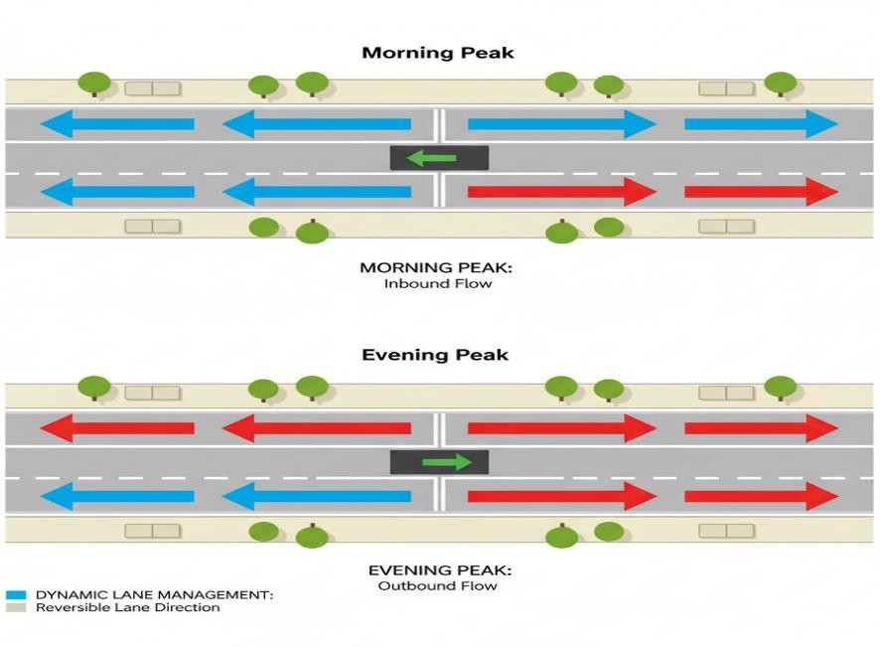

Fig. 3. Dynamic Lane Management Concept (Liu & Li, 2017).

3.4 Multimodal Integration

The most effective and sustainable strategies identified in the review treat the road network not merely as a conduit for cars but as a platform for a diverse range of modes. The physical and operational integration of high-capacity public transport is transformative in congested urban corridors. As exemplified by the TransMilenio system in Bogota, a BRT system (as shown in Fig. 4) can be highly effective. The use of physically separated busways, off-board fare collection, and well-designed stations can deliver a metro-like level of service and capacity on the surface, significantly reducing commute times and attracting riders from private cars (Hidalgo & Carrigan, 2010; Currie, 2006).

Addressing the first and last mile problem with safe, continuous infrastructure for non-motorized transport
(NMT) is equally crucial for a successful multimodal system. An extensive body of research, including cross- city analyses by Buehler & Pucher (2012), demonstrates a clear and causal link between the quality of cycling infrastructure and mode choice. Cities that have invested heavily in creating dense, connected networks of protected and continuous cycling infrastructure, such as Amsterdam and Copenhagen, have achieved cycling mode shares exceeding 30% for all trips. As highlighted in syntheses by Litman (2013), these investments not only encourage a modal shift but also deliver substantial public health benefits from increased physical activity and improved road safety for all users. The recent emergence of shared micromobility services, such as docked and dockless bike and scooter sharing, further enhances the multimodal ecosystem by providing flexible options for short trips and for bridging the gap to public transport stations (Shaheen & Cohen, 2019).

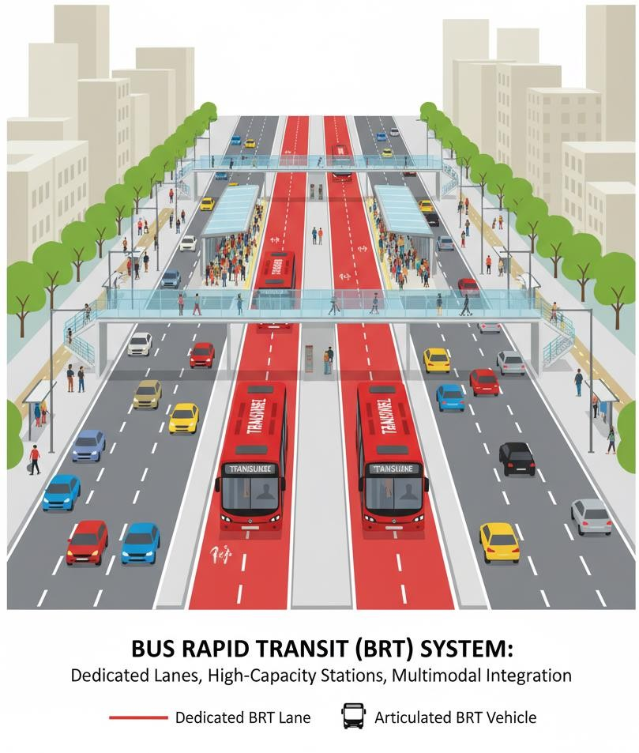

Fig. 4. Bus Rapid Transit (BRT) System Litman (2013).

4. DISCUSSION

This synthesis of evidence moves beyond a simple catalog of interventions to reveal the deeper, often interdependent, forces that shape the performance of urban road networks. What emerges is a compelling picture of synergy, conflict, and context. Our discussion is organized around the critical themes that surfaced from the review: the interplay between design, control, and mode; the disruptive influence of new
technologies; the vital role of governance; and the inherent limitations of the current body of evidence.

4.1 The Integrated Framework: A Synergy of Design, Control, and Mode

A central finding is that physical design, technological control, and modal allocation are not independent variables but deeply interconnected. An ATCS will yield far greater returns on a well-connected grid network than on a brittle, hierarchical one because the grid's redundancy provides the flexibility that the control system can exploit. This synergy creates a virtuous cycle: a well-designed network makes smart controls more effective, and effective controls make the network more efficient for all users, including public transport. This enhanced efficiency can, in turn, make modal shifts away from private cars more attractive, further reducing overall congestion.

This points to a systemic weakness in urban planning: the frequent separation of network designers, traffic operations engineers, and public transport planners into professional silos. These divisions are often institutionalized through separate funding streams, distinct departmental goals, and specialized professional training, creating barriers to the kind of integrated approach this review finds is most effective. The proposed integrated framework (Table 2) is therefore not just an analytical tool but a call for more collaborative planning processes where infrastructure decisions are made in concert with operational and modal strategies. Such an approach is fundamental to achieving broader urban goals, from the "complete streets" concept that serves all users to the "15-minute city" model that prioritizes accessibility over automobility.

Table 2. An integrated framework of network interventions and their interdependencies

Intervention Domain Interaction with

Physical Topology

Physical Topology Foundational grid networks enhance resilience; hierarchical networks create bottlenecks.

Operational Control Control systems, such as ATCS, optimize flow on the existing physical network.
Interaction with Operational Control A connected topology provides routing
alternatives that ATCS can leverage. A disconnected topology limits the effectiveness of smart control. Synergistic ATCS and ramp metering are core control strategies.
Interaction with Modal

Allocation

Street design (e.g., width) enables or constrains the reallocation of space for bus lanes or cycle tracks.

Transit Signal Priority (TSP) is a control strategy that directly supports a specific mode.
Modal Allocation Reallocating a lane for This reallocation Prioritizing one mode (e.g.,
a BRT system is a physical change to the network topology.

Demand Management Congestion pricing zones are defined by physical street boundaries.
changes traffic dynamics, requiring signal retiming and new control strategies for
the remaining lanes. Pricing levels can be adjusted dynamically in response to real-time traffic data from control
systems.
buses) often comes at the expense of another (e.g., private cars).

The goal of pricing is to influence modal choice, shifting travellers to more space-efficient modes like
public transport.

4.2 Emerging Paradigms: The Conflict Between Centralized and Decentralized Control

The rise of ubiquitous navigation applications represents a paradigm shift from top-down, planner-led optimization to a bottom-up, decentralized model driven by individual users. This creates a critical and growing conflict. For decades, urban planning has relied on hierarchical networks to channel traffic onto major arterials, a form of static, centralized control embedded in physical design to protect residential streets. Navigation apps, however, are agnostic to a street's intended function; their algorithms seek only to minimize individual travel time, routing users through any available path. This rat-running has tangible consequences, degrading the quality of life in residential areas through increased traffic, noise, and safety risks, particularly for children and pedestrians. It imposes wear and tear on local streets not designed for high traffic volumes.

This tension highlights a fundamental challenge for contemporary urban governance. Planners are exploring potential mitigation strategies, such as using geofencing to discourage routing through sensitive areas or implementing digital curb management systems that dynamically price or restrict access. However, these solutions themselves raise complex questions about data privacy, corporate responsibility, and regulatory authority. Furthermore, the equity implications are significant. The benefits of this decentralized optimization primarily accrue to tech-savvy drivers, while the negative externalities are often borne by residents of neighbourhoods used as shortcuts, who may have less political power to advocate for traffic calming or other protective measures. Effectively managing this conflict requires a new kind of digital age planning that is as attuned to algorithmic behaviour as it is to traffic engineering.

4.3 The Decisive Role of Governance and Context

Technical solutions do not exist in a political vacuum. The case studies of Singapore, Curitiba, and Amsterdam powerfully illustrate that success is determined not just by technical excellence, but by the governance models that enable it (as summarized in Table 3). Singapore’s comprehensive demand management policies are inseparable from its unique political context of a strong, centralized state.
Curitiba’s BRT system was the outcome of decades of consistent political vision and an integrated planning authority with control over both transport and land use (Rabinovitch, 1992). Amsterdam’s transformation into a cycling capital was the result of sustained social movements creating the political will to reallocate street space (Pucher & Buehler, 2008). These cases reveal that governance capacity is a key latent variable.

This capacity extends beyond simple political will. It involves having the legal authority to implement potentially unpopular policies like congestion pricing, the institutional structure to coordinate across multiple agencies, and the mechanisms for genuine public consultation and participation to build legitimacy. The difficulty of transferring these models is a testament to their deep-rootedness in specific socio-political contexts. A city cannot simply copy Singapore’s policies without its unique governance structure. This highlights the principle of policy mobility, where cities learn from one another but must thoughtfully adapt, not merely adopt, successful strategies to fit their own institutional realities. This underscores the need for planners and engineers to be not only technical experts but also skilled navigators of the political and social landscapes in which they operate.

Table 3. Case summaries of integrated network optimization

City Core Strategy Key Interventions Quantified Outcomes

Singapore Demand Management & Integration

Curitiba, Brazil Transit-Oriented

Development

Amsterdam, NL Prioritization of

Active Transport

Electronic Road Pricing (ERP), Certificate of Entitlement (COE), High-capacity Mass Rapid Transit (MRT). Trinary road system with exclusive busways, high- capacity buses, tube stations, high-density zoning along transit corridors.
7,500 km of separated cycle

20% traffic reduction in restricted zone. Average network speed ~27 km/h.
67% of peak-hour journeys by public transport.
Over 70% of commuters use the BRT. Journey times comparable to metro systems. 25% lower per capita fuel consumption.

Over 60% of inner-city trips by bicycle. Low car
tracks, traffic-calmed zones, reduced car parking, high integration with
public transport.
ownership. High road safety.

4.4 Limitations of the Evidence and this Review

A critical look at the evidence base reveals important limitations. There is a clear preponderance of simulation-based studies. While valuable for isolating variables, they may not fully capture the complex behavioural responses of real-world road users. Furthermore, there is a notable scarcity of high-quality empirical studies from cities in the Global South, where challenges of rapid urbanization, informal transport systems, and resource constraints differ significantly. This geographical bias limits the global applicability of many findings and overlooks potentially innovative, context-specific solutions emerging from these regions.

This review also finds that the literature has historically been dominated by a narrow focus on traffic flow metrics like speed and delay. Such measures fail to capture the ultimate purpose of a transportation system, which is to provide access to opportunities. A more holistic evaluation framework is needed, prioritizing metrics like accessibility, which connects transport to jobs, healthcare, and education; equity, which examines who benefits and who is burdened by a transport system; and reliability, which affects the stress and predictability of daily life. Finally, this review is constrained by its reliance on published, English- language literature and may be subject to a degree of publication bias. These limitations should temper the direct application of these findings and highlight the urgent need for future research.

5. CONCLUSION

The challenge of urban congestion is not a simple problem of capacity but a complex issue of design, technology, and human behaviour. This systematic review confirms that the path to creating efficient, sustainable, and liveable cities does not lie in the costly and often counterproductive expansion of road infrastructure. Instead, the evidence compellingly points toward a multifaceted strategy grounded in the intelligent optimization of existing networks. The most successful approaches do not seek a single panacea but weave together sophisticated network topologies, advanced technological management, and a firm commitment to multimodal transport. This requires a fundamental shift in perspective: from moving cars to moving people.

The core contribution of this work is the emphasis on integration. The profound interdependence between physical design, operational control, and the allocation of road space demands that we dismantle the
professional silos that have long separated transport planners from traffic engineers and land-use experts. A holistic, collaborative approach is no longer a recommendation but a requirement for meaningful progress. This review has also brought into sharp focus the emerging tension between the centralized logic of traditional urban planning and the decentralized, real-time optimization driven by modern technology. Navigating this conflict is a defining challenge for the next generation of urban governance, demanding new tools and new ways of thinking that are as much about managing data and algorithms as they are about managing concrete and asphalt.

Ultimately, the findings of this review connect to the most pressing global challenges of our time. A more optimized, multimodal urban transport system is not only more efficient but also more equitable, more conducive to public health, and essential for meeting climate change mitigation goals. By reducing reliance on private automobiles, cities can lower their carbon footprint, improve air quality, and create healthier, more active populations. The reallocation of street space from parking and traffic lanes to wider sidewalks, bike lanes, and public spaces can foster stronger communities and more vibrant local economies.

Therefore, this review concludes with a call to action for both researchers and practitioners. For researchers, the imperative is to move beyond simulation and conduct more rigorous, long-term empirical evaluations in a wider range of global contexts, employing more holistic measures of success, such as accessibility and equity. For practitioners, the challenge is to become champions of integration, breaking down institutional barriers and engaging deeply with the political and social dimensions of transport planning. By embracing an integrated, evidence-based, and politically savvy approach, we can transform urban road networks from sources of frustration and pollution into arteries of thriving, sustainable, and equitable communities.

DISCLAIMER (ARTIFICIAL INTELLIGENCE)

Author(s) hereby declare that NO generative AI technologies such as Large Language Models (ChatGPT, COPILOT, etc) and text-to-image generators have been used during writing or editing of this manuscript were used during the writing and editing of this manuscript.

COMPETING INTERESTS

Author has declared that they have no known competing financial interests or non-financial interests or personal relationships that could have appeared to influence the work reported in this paper.

COMPETING INTERESTS DISCLAIMER:
Authors have declared that they have no known competing financial interests OR non-financial interests OR personal relationships that could have appeared to influence the work reported in this paper.
REFERENCES

United Nations, Department of Economic and Social Affairs, Population Division. (2018). World urbanization prospects: The 2018 revision (Report No. ST/ESA/SER.A/420). https://population.un.org/wup/Publications
/Files/WUP2018-Report.pdf

World Bank.(2019).UrbanDevelopment Overview. https://www.worldbank.org/en/topic/urbandevelopment/

overview

Hickman, R., Ashiru, O., & Banister, D. (2013). Transport and climate change: A review. Transport

Reviews, 33(5), 539-551. https://doi.org/10.4324/9780203074435

Texas A&M Transportation Institute. (2019). 2019 urban mobility report. https://static.tti.tamu.edu/tti.tamu.edu/documents/umr/archive/mobility-report-2019.pdf

OECD/ITF. (2019). ITF Transport Outlook 2019. International Transport Forum. https://doi.org/10.1787/transp_outlook-en-2019-en

Duranton, G., & Turner, M. A. (2011). The fundamental law of road congestion: Evidence from US

cities.American Economic Review,101(6), 2616-2652. https://doi.org/10.1257/aer.101.6.2616

Vickrey, W. S. (1969). Congestion theory and transport investment. The American Economic Review, 59(2),

251-260.

Barthélemy, M. (2011). Spatial networks. Physics Reports, 499(1-3), 1-101. https://doi.org/10.1016/j.physrep.2010.11.002

Xie, F., & Levinson, D. (2009). Measuring the structure of road networks. Geographical Analysis, 41(3),

336-356. http://dx.doi.org/10.1111/j.1538-4632.2007.00707.x

Farahani, R. Z., Rezapour, S., & Kardar, L. (2013). A review of the literature on the structure of road networks.Transport Reviews, 33(3),265-290. https://doi.org/10.1016/C2010-0-67008-8

Federal Highway Administration. (2021). Adaptive signal control technologies: A guide for

agencies. U.S. Department of Transportation. https://ops.fhwa.dot.gov/publications/fhwahop21016/fhwah op21016.pdf

Papageorgiou, M., & Vigos, G. (2021). Traffic control in the era of connected and automated vehicles: A review of models and methods. Transportation Research Part C: Emerging Technologies, 125, 103033 https://doi.org/10.1016/j.trc.2021.103060
Genders, W., & Razavi, S. N. (2016). A review on adaptive traffic control systems. Canadian Journal of

Civil Engineering, 43(4), 345-356. https://doi.org/10.48550/arXiv.1611.01142

Banister, D. (2008). The sustainable mobility paradigm. Transport Policy, 15(2), 73-80. https://doi.org/10.1016/j.tranpol.2007.10.005

Cervero, R. (2013). Bus rapid transit (BRT): An efficient and competitive transit option. Built Environment,

39(3), 299-313.

Hensher, D. A., & Mulley, C. (2022). The impact of bus rapid transit on travel time and reliability. Journal of

Transport Economics and Policy, 56(1), 1-22.

Cervero, R., & Kockelman, K. (1997). Travel demand and the 3Ds: Density, diversity, and design.

Transportation Research Part D: Transport and Environment, 2(3), 199-219. https://doi.org/10.1016/S1361-

9209(97)00009-6

Page, M. J., McKenzie, J. E., Bossuyt, P. M., Boutron, I., Hoffmann, T. C., Mulrow, C. D., et al. (2021). The PRISMA 2020 statement: An updated guideline for reporting systematic reviews. BMJ, 372, n71. https://doi.org/10.1136/bmj.n71

Downs, S. H., & Black, N. (1998). The feasibility of creating a checklist for the assessment of the methodological quality both of randomized and non-randomized studies of health care interventions. Journal of Epidemiology & Community Health, 52(6), 377-384. https://doi.org/10.1136/jech.52.6.377

Zhang, Y., & Levinson, D. (2004). The structure of urban street networks. Nexus Research Group, University of Minnesota.

Smith, M. J., Hounsell, N. B., & Shrestha, B. P. (2015). A comprehensive review of SCOOT.

Transportmetrica B: Transport Dynamics, 3(2), 97-123.

Currie, G. (2006). Bus rapid transit in Australasia: Performance, lessons learned and futures.

Journal of Public Transportation, 9(3), 1-18. https://doi.org/10.5038/2375-0901.9.3.1

Liu, H., & Li, X. (2017). A dynamic lane reversal system for connected and autonomous vehicles: A C-ITS- based application. Transportation Research Part C: Emerging Technologies, 82, 19-36. https://doi.org/10.1016/j.trc.2017.07.001

Litman, T. (2013). Evaluating active transport benefits and costs. Victoria Transport Policy Institute. https://www.vtpi.org/nmt-tdm.pdf

OECD/ITF. (2018). The shared-use city: Managing the curb. International Transport Forum.
https://doi.org/10.1787/9789282108711-en

Rodegerdts, L., Bansen, J., Tiesler, C., Knudsen, J., Myers, E., Johnson, M., et al. (2007). Roundabouts: An informational guide (Report No. FHWA-HRT-07-032). U.S. Department of Transportation, Federal Highway Administration.

Elvik, R. (2017). Road safety effects of roundabouts: A meta-analysis. Accident Analysis & Prevention, 99,

364-371. https://doi.org/10.1016/j.aap.2016.12.016

Furth, P. G., & Muller, T. H. (2006). Conditional bus priority at signalized intersections: Better service with less traffic disruption. Transportation Research Record, 1980(1), 11-20. https://www.researchgate.net/publication/245559643_Conditional_Bus_Priority_at_Signalized_Intersectio ns_Better_Service_with_Less_Traffic_Disruption

Leape, J. (2006). The London congestion charge. Journal of Economic Perspectives, 20(4), 157-176. https://doi.org/10.1257/jep.20.4.157

Santos, G. (2005). Urban congestion charging: A comparison between London and Singapore.Transport

Reviews, 25(5), 511-534. https://doi.org/10.1080/01441640500064439

Eliasson, J. (2009). A cost-benefit analysis of the Stockholm congestion charging system. Transportation

Research Part A: Policy and Practice, 43(4), 468-480. https://doi.org/10.1016/j.tra.2008.11.014

Hidalgo, D., & Carrigan, A. (2010). Modernizing public transportation: Lessons from the city

of Guangzhou (Working Paper No. 5422). World` Bank. modernizing_public_transportation.pdf

Buehler, R., & Pucher, J. (2012). Cycling to work in 90 large American cities: New evidence on the role of bike paths and lanes. Transportation, 39(2), 409-432. https://doi.org/10.1007/s11116-011-9355-8

Shaheen, S., & Cohen, A. (2019). Shared micromobility policy toolkit: Docked and dockless bike and scooter sharing. Transportation Sustainability Research Centre, University of California, Berkeley. https://tsrc.berkeley.edu/shared-micromobility-policy-toolkit

Land Transport Authority. (2021). Land transport master plan

2040. https://www.lta.gov.sg/content/ltagov/en/who_we_are/our_work/land_transport_master_plan_2040. html

Lindau, L. A., Hidalgo, D., & Facchini, D. (2010). Curitiba, the cradle of Bus Rapid Transit. Built

Environment, 36(3), 274-282. https://doi.org/10.2148/benv.36.3.274

Rabinovitch, J. (1992). Curitiba: towards sustainable urban development. Environment and Urbanization,
4(2), 62-73. https://doi.org/10.1177/095624789200400206

City of Amsterdam. (2019). Amsterdam mobility plan. https://www.amsterdam.nl/en/policy/policy-traffic- transport/

Pucher, J., & Buehler, R. (2008). Making cycling irresistible: Lessons from the Netherlands, Denmark and

Germany. Transport Reviews, 28(4), 495-528. https://doi.org/10.1080/01441640701806612

Geurs, K. T., & van Wee, B. (2004). Accessibility evaluation of land-use and transport strategies: a review and research directions. Journal of Transport Geography, 12(2), 127-140.

ABBREVIATIONS

ITS: Intelligent Transportation Systems

ATCS: Adaptive Traffic Control Systems
TOD: Transit-Oriented Development

ATCS: Adaptive Traffic Control Systems
PRISMA: Preferred Reporting Items for Systematic Reviews and Meta-Analyses

SCATS: Sydney Coordinated Adaptive Traffic System
TRID: Transport Research International Documentation Database

ATCS: Adaptive Traffic Control Systems
PICO: Population, Interventions, Comparison, and Outcomes
SCOOT: Split Cycle and Offset Optimisation Technique
SP: Signal Priority
NMT: Non-Motorized Transport

