Improving the Fuel Quality of Groundnut Residues (Shell and Straw) via Torrecfaction for Bioenergy Application

Abstract
Groundnut residues, specifically shells and straw, are abundant agricultural by-products in Nigeria and other developing nations. These residues are often underutilized or openly burned, contributing to environmental pollution. This study investigates torrefaction as a thermochemical pretreatment process to improve the fuel quality of groundnut residues. Groundnut shell and straw were mixed in different ratios (100:0, 75:25, 50:50, 25:75, and 0:100) and torrefied under varying temperatures (250⁰C, 270⁰C and 290⁰C) and residence times (15, 30 and 60 minutes). Proximate and ultimate analyses, higher heating value (HHV), mass yield, energy yield, and energy density ratio performance were evaluated. Results showed that torrefaction reduced moisture and volatile matter content while increasing fixed carbon and HHV (up to 24 MJ/kg). Improvements were also observed in hydrophobicity, grindability, bulk density, and durability of the pellets. The findings demonstrate that torrefaction significantly upgrades groundnut residues into viable solid biofuels for domestic and industrial applications.

Keywords
Torrefaction; Groundnut Shell; Groundnut Straw; Bioenergy; Biomass Pellets.

1.0 Introduction
In recent years, the exploration of renewable energy sources has gained significant traction due to concerns over climate change, energy security, and environmental sustainability. Among these renewable resources, agro-wastes have emerged as a promising alternative for energy generation. Energy is a vital component of the world economy (Liko, 2019). It is a critical necessity for a country's development, poverty eradication and economic growth (Alanya-rosenbaum & Bergman, 2018), while a country's per capita energy consumption is directly related to its standard of living (Joyeux & Ripple, 2007; Akuru et al., 2017). Energy is the driving force behind industrialization, as it determines a country's economic and social opportunities (Tong et al., 2018). Sustainable energy is the backbone for the social–economic expansion of any country (Ibitoye et al., 2021). Energy is essential in every society to meet fundamental human needs such as transportation, communication, heating and cooling, lighting, healthcare, and cooking. With population growth, improved living standards, and increasing consumption, global energy demand is projected to grow by about 21% by 2030 (Ajimotokan, 2014; Owusu & Asumadu-Sarkodie, 2016). The long-term availability of energy from sources that are inexpensive and environmentally friendly and sustainable is critical for future economic development (Ajimotokan et al., 2019; Kabakcı & Baran, (2019). Energy is intertwined with security, climate change, public health, and economic stability (Oyedepo, 2014. Energy security is a global issue as the world's population continues to rise, resulting in ever-increasing energy demand that the world is finding difficulty to meet ( Nwaokocha & Giwa, 2016; Radovanović et al., 2017).
The high dependence on fossil fuels for energy, does not only lead to rapid resource depletion, but it also has a direct impact on environmental degradation as pollution (Yi et al., 2023). The hunt for renewable energy sources has been sparked by worries about CO₂ and other greenhouse gas emissions into the atmosphere caused by the combustion of fossil fuel derivatives. (Singh et al 2019 Ajimotokan et al., 2019). Owing to environmental issues and the increasingly growing price of petroleum-derived fuel in Nigeria, there is scepticism about its usage in the near future (Oliveira and Franca 2009). In fact, the world is trying to phase it out because of climate change (Lazarus & Van Asselt 2018). The majority of Nigerians have been compelled to switch from kerosene to wood and wood charcoal as a cheap and abundant alternative energy source for home uses due to unforeseen price increases (Ajibola et al., 2020). Fuelwood and wood charcoal which amount to 87 % of the total annual energy consumption in the country, forms the major part of renewable energy used (Adelekan & Jerome 2006). The use of these can lead to deforestation, soil erosion, desertification, air pollution, climate change, respiratory problems, eye irritation, carbon monoxide poisoning etc.
According to Tun et al. (2019), developing nations are well-positioned to encourage the use of renewable energies since they have a wealth of renewable resources, such as wind, solar, geothermal, biomass, and hydropower. Yet, this might happen with some financial and political backing. Renewable energy has been demonstrated to be a significant factor that favorably affects growth and economic development through generating jobs. Using renewable energy also improves chances for energy independence while halting environmental harm (Abbasi & Abbasi 2010). Nearly everyone's plan has included the shift to a bio-based economy in recent years. There are many benefits to transitioning to a bio-based economy, including accelerated rural development, reduced emissions, and increased resource efficiency (Scarlat et al., 2015). Nigeria has untapped potential fuel sources in biomass, notably waste from agricultural production and processing (Simonyan & Fasina 2013). Due to its non-nutritional and renewable nature, lignocellulose biomass, such as agricultural wastes, has a great potential for energy production. Biomass is one of the most significant energy sources in the world, ranking second only to oil, natural gas, and coal (Toklu 2017; Ozturk 2017). These wastes can be used to generate modern energy that is equal to or better than charcoal and firewood in terms of heating value (Yank et al., 2016). Lignocellulosic biomass from these sources, including agricultural waste and forestry waste, calls for special consideration. Hemicellulose, cellulose, and lignin are three complex organic compounds found in varying amounts in lignocellulosic biomass. Lignocellulosic material can be transformed via conversion technologies into chemicals, useful products, and biofuels (Nada et al., 2017). The difficulties with using biomass materials in their natural form due to their high moisture content, irregular shape and sizes (fibrous nature), low bulk density, low combustion efficiency, low heating value, poor grindability, easy biodegradability, hydrophilic, and low energy density must be overcome in order to make biomass materials available for a variety of applications, especially as domestic fuels for cooking, heating, and lighting (Tong et al., 2018). Solutions to these problems are to torrefy biomass and compressed them into pellets, briquettes, or cubes (Bajwa et al., 2018). Torrefaction is a thermochemical process that is eco-friendlier and more promising, and it is widely used by many researchers to pre-treat various types of biomass resources, including woody, non-woody, and forest residue, agricultural residue, and agro-industrial waste (Rago et al., 2021).
Torrefaction enhances the efficiency of thermochemical conversion processes while improving the hydrophobic nature of biomass by lowering its moisture content and decreasing the H/C and O/C ratios, which in turn raises the fixed carbon content (Pradhan et al., 2018). Consequently, this leads to higher calorific value and greater energy density of the biomass (Barskov et al., 2019). The process is typically carried out in a nitrogen atmosphere at temperatures ranging from 200 to 300 °C, with residence times of 10–60 minutes and heating rates below 50 °C per minute (Singh & Ruj, 2016). Torrefaction has been proven to improve biomass performance during pyrolysis, combustion, and gasification (Bergman, 2005. The grindability is enhanced because the torrefied biomass is brittle and as such less energy is needed to mill them; there is a loss in the mass yield although most of the energy content in the parent biomass is preserved thereby making it have higher energy density as compared to the parent material qualifying as substitutes for coke, coal and other fossil fuel product (Bonassa et al., 2018). There is also a change in its chemical properties as a result of decomposition of hemicellulose, removal of hydroxyl group, gaseous products and development of non-polar unsaturated structures in the torrefied products, these leads to a reduction of the atomic ratio of the product i.e. H/C and O/C (Kizuka et al., 2019).
The practice of burning and disposing of agro-residues has severe environmental repercussions, leading to the emission of greenhouse gases and contributing to global warming (Koul et al., 2022). However, repurposing these residues for energy generation presents an opportunity to mitigate these negative impacts. While efforts have been made to utilize raw biomass like agro-residues for energy, certain biomass characteristics, such as low calorific value and logistical challenges in transportation and storage, hinder their efficient use. To address these limitations, various technologies have emerged to enhance biomass characteristics for energy generation, including biological, chemical, and thermal pretreatment methods. Thermos-chemical conversion involves upgrading biomass properties through heat application in controlled environments, with techniques like torrefaction, pyrolysis, carbonization, and gasification being prominent examples (Makavana, et al., 2020). These methods offer promising solutions for sustainable energy generation from biomass, particularly in developing nations (Siwal et al., 2021). Biomass energy holds significant potential as a renewable alternative to conventional energy sources, as it derives from sunlight through photosynthesis, providing a continuous energy supply unaffected by external factors like seasonal changes or weather conditions. Agro-wastes, which include agricultural residues such as groundnut shells and straw, (Arachis hypogaea) are available in large quantities in Benue state (6.887⁰N, 9.231⁰E) of Nigeria and can be problematic as majority of them are usually burnt in an open field resulting to environmental issues, instead, they can be used for fuels by torrefying and pelletizing them, thus reducing the overdependence on wood for domestic cooking and can be substituted for charcoal or coke being used in local foundry industries.
1.1 Agro-Waste as a Renewable Energy Resource
Agro-wastes, also known as biomass residues, refer to the organic materials left over from agricultural activities. These residues are abundant, widely available, and renewable, making them an attractive resource for energy production. Agro-wastes are considered carbon-neutral since the carbon dioxide emitted during their combustion is balanced by the amount absorbed during the growth of the plants, unlike fossil fuels that are limited in supply and add greenhouse gases to the atmosphere when used. From the work of Sarkar et al., (2022), reviewed that agricultural residue, which are generated throughout farming and processing, encompass diverse wastes from activities like cultivation and livestock production, comprising liquid, solid, and gaseous forms that can pollute soil, water, and air. Recognizing their potential as renewable energy sources, efforts to develop sustainable waste management strategies are crucial for mitigating environmental degradation, necessitating the adoption of innovative technologies to utilize and process these residues effectively while deriving useful products from them. Rao et al., (2024) from their work titled Agro-waste to sustainable energy, stated that the global challenges of energy crisis and solid waste management, exacerbated by population growth, underscore the urgent need to address agricultural waste's significant contribution to environmental degradation. This review emphasizes the importance of utilizing nanotechnology-based processing strategies to convert agro-waste into energy resources, offering insights into various green energy applications such as biofuels, biogas, and energy storage modules. By outlining challenges and advanced prospects, this review lays the groundwork for future research aimed at leveraging nanomaterials for smart agro-waste management, fostering a green and circular economy while minimizing environmental impact. The review of Chen et al., (202) et al., (2022) and Kumar et al., (2024) all underscores the significant environmental impact of agricultural waste, necessitating innovative approaches for its effective management. It provides a comprehensive analysis of agro-waste, covering its generation, composition, and associated environmental challenges. The paper explores various sustainable utilization methods, including composting, bioenergy generation, and biochar production, while addressing the complexities and challenges of managing agricultural waste, and proposing solutions such as further research, infrastructure development, and policy frameworks. From the forego it can be said that utilizing agro-wastes for energy generation can help mitigate climate change and reduce reliance on non-renewable energy sources.
Groundnut shells and straw are two common types of agro-residues with significant potential for energy applications (Mohammad et al., 2020; Ajayi & Lateef 2023). Groundnut shells are the outer covering of groundnut (peanut) seeds and are produced in large quantities during the processing of groundnuts for food or oil extraction (Perea-Moreno et al., 2018) and Duc et al., (2019) reviewed and emphasizes the significant potential of groundnut shells, which make up a substantial portion of the waste generated during groundnut processing. Rich in functional compounds and composed of cellulose, hemicellulose, and lignin, groundnut shells offer numerous commercial and industrial applications. These include conversion into biodiesel, bioethanol, nano-sheet materials, as well as utilization in enzyme and hydrogen production, dye, and heavy metal degradation. Efficient management strategies are necessary to transform groundnut shells from waste into valuable bio-products, thus moving towards a zero-waste production system.
The peanut, belonging to the legume family, is utilized widely in culinary applications and industrial products due to its high fat content (Syed, et al., 2021). Its production in 2016 reached 43,982,066 tons across 27,660,802 hectares, with Asia being the largest producer (Perea-Moreno 2019). Despite its widespread use, the peanut industry generates significant waste in the form of shells, comprising 25-30% of the total weight (Sathiparan et al., 2023). This waste, rich in energy content, presents an opportunity for use as a solid biofuel. A study aimed to evaluate peanut shells' energy parameters for residential and industrial heating, comparing them to other biomass sources (Arpia et al., 2021; Jekayinfa et al., 2020). Peanut shell holds significant economic value, leading to various utilization methods. These include composting wet materials, treating wastewater, manufacturing plastic and wardrobes, insulation boards, metal casting, pesticide mediums, and activated carbon (Bharthare et al., 2014). Research has explored the potential of peanut shells in ethanol production due to their high cellulose, lignin, and hemicellulose content (Ganguly et al., 2020). The study of Suryawanshi et al., (2025) focuses on utilizing groundnut shells, a byproduct of groundnut seed separation, as a renewable energy source in India. The researchers collected groundnut shells from Maharashtra and processed them into biofuel through drying, powdering, and fermentation with Saccharomyces cerevisiae yeast. The fermentation process was optimized by determining the minimum inhibitory concentration (MIC) of alcohol and glucose for the yeast. After fermentation, samples were distilled, and the alcohol yield was highest on the fourth day. Additionally, cellulose was extracted from the groundnut shells, and their ash was used to enhance crop yield, suggesting potential agricultural applications. Overall, the study highlights the potential of groundnut shells as a sustainable energy source and their diverse applications beyond fuel production. Also, from the work of Thorat, et al., (2020) they stated peanut shells contain valuable compounds like cellulose, hemicellulose, and lignin, making them versatile for various applications such as conversion into biodiesel, bioethanol, and nano-sheets. Moreover, they can be utilized in enzyme and hydrogen production, as well as for dye and heavy metal degradation. Peanut meal, skin, hull, and vine, which arise from peanut processing and harvesting can find its application in food processing industry due to their functional compounds. Peanut shells can be utilized as a component in animal feed, particularly for ruminants like cattle and sheep. They provide dietary fiber, which aids in digestion, and also offer some protein content (Toomer 2020). Peanut shells can also serve as a natural mulch in gardening and landscaping. When spread over the soil, they help retain moisture, suppress weed growth, and gradually decompose, enriching the soil with organic matter. Additionally, they can be added to compost piles to accelerate decomposition and improve soil fertility (Yang et al., 2023). The absorbent properties of peanut shells make them suitable for various industrial applications. They can also be processed into absorbent materials for use in oil spill cleanup, wastewater treatment, and as packing material for hazardous materials during transportation (Aryee et al., 2021). They can be converted into activated carbon, which finds application in water purification, air filtration, and as an adsorbent in chemical processes. The porous structure of activated carbon enables it to effectively adsorb contaminants and impurities (Jeirani et al., 2017). Peanut shells can be incorporated into lightweight construction materials, such as particleboard or insulation (Echeverría-Maggi et al., 2022). When crushed or ground, peanut shells can be incorporated into soil as an organic amendment. They improve soil structure, increase water retention, and enhance nutrient availability, promoting healthy plant growth in gardens, agriculture, and landscaping. Though processes like pyrolysis or gasification, the shells can be converted into biochar, bio-oil, or biogas, which can be used as renewable energy sources. Researcher also found that peanut shells have a higher heating value (HHV) of 18.547 MJ/kg, surpassing some other biomass sources like olive stones and almond shells. Similarly, straw refers to the stalks left over after grain crops such as wheat, rice, peanut and barley are harvested. Both groundnut shells and straw possess favorable characteristics for thermo-chemical conversion, including high cellulose and lignin content, low moisture content, and relatively uniform composition. Groundnut straw is readily available as a byproduct of peanut harvesting (Lungaho et al., 2020). Groundnut straw is a renewable resource, offering a sustainable alternative to fossil fuels for energy production (Gaurav et al., 2017). It is rich in lignocellulosic materials, including cellulose, hemicellulose, and lignin, which are ideal for biomass conversion processes. Groundnut straw can be converted into various forms of bioenergy, such as biofuels (e.g., bioethanol, biodiesel), biogas, and solid biofuels (e.g., pellets), contributing to energy security and reducing dependence on fossil fuels (Ali et al., 2019). Utilizing groundnut straw as a biomass feedstock can help mitigate greenhouse gas emissions by reducing reliance on fossil fuels and promoting carbon-neutral energy sources. Utilizing groundnut straw prevents its disposal through burning or other means, reducing environmental pollution and promoting sustainable waste management practices (Abubakar et al., 2022).
Nigeria, like many developing countries, faces acute energy challenges despite vast biomass resources. Groundnut residues (shell and straw) are particularly abundant in Benue State and other regions, yet are usually discarded or openly burned. Torrefaction offers a sustainable pathway to valorize these residues into high-grade biofuels. Previous studies have shown that torrefaction improves grindability, increases energy density, reduces hydrophilicity, and enhances storage stability of diverse agricultural residues. However, limited work has focused specifically on groundnut residues, despite their high availability and potential for substitution of fuelwood and charcoal in rural households and small industries. This study therefore addresses this research gap by experimentally investigating the torrefaction behavior and fuel upgrading potential of groundnut shell and straw blends.
2.0 methodology
This section discusses the materials, methods and equipment’s used for this study.
2.1 Sample preparation
Groundnut shell and groundnut straw was collected from a farm in Benue State during its harvest season from June – August after the grains had been removed. The samples were sun dried for two (2) weeks to reduce their moisture content. The samples was then be chopped and grounded by combined mechanical and manual size reduction method. The major samples of the wastes which is the shell and straw were mixed in the ratio of 100:0, 75:25, 50:50, 25:75 and 0:100 by weight.
2.2 Experimental procedures
2.2.1 preliminary analysis
Proximate, ultimate, higher heating value, and thermogravimetry analysis (TGA) of the raw samples will be performed based on the different compositions of the samples.
2.2.2 Thermogravimetric Analysis
A thermogravimetric analysis of the raw corncob was carried out using a TA Instruments thermogravimetric analyzer (Model TGA 55). A 5 mg sample was subjected to a nitrogen purge flow of 120 mL/min, with the temperature raised at a constant rate of 5 °C per minute. The instrument recorded the weight variation of the material as the temperature increased from ambient to 1000 °C (Zheng et al., 2013).
2.2.3 Torrefaction experiment
A bench-scale fixed-bed reactor setup (Figure 1) will be employed for the torrefaction experiments. In this system, the biomass sample will be heated by a combination of preheated nitrogen gas and an electric furnace. The furnace temperature will be regulated through a temperature controller linked to the electric power supply. Samples will be introduced from the top of the reactor, while the torrefied product will be removed once the reaction is completed. Condensable vapors will be trapped in a water-cooled condenser, whereas non-condensable gases will either be collected in a gas sampling bag or vented through an exhaust system. Each experimental run will be performed in batch mode with a feed size of 20–40 g. The study will examine two key operating parameters for each particle size: torrefaction temperature, set at 250 °C, 270 °C, and 290 °C, and residence time, selected as 15, 30, and 60 minutes. For every condition, at least two replicates will be carried out. The resulting solid fraction, commonly referred to as torrefied fuel, will be weighed to determine mass yield (MY), energy yield (EY), and energy density ratio, which will be calculated as a percentage of the original sample mass using the following equation:
$mass yield, MY,= {\left(\frac{M_{char}}{M_{feed}}\right)}_{daf}*100$ 1
$energy yield, EY, =MY* \left(\frac{{HHV}_{char}}{{HHV}_{feed}}\right)$ 2
Here, Mchar denotes the mass of the torrefied fuel on a dry ash-free (daf) basis, while Mfeed represents the mass of the untreated (raw) material introduced into the reactor on a dry ash-free basis. The higher heating values of the torrefied and raw samples are expressed as HHVchar and HHVfeed , respectively (Akinrinola et al., 2014). In addition, mechanical characteristics such as bulk density, durability index, and resistance to water absorption were evaluated.
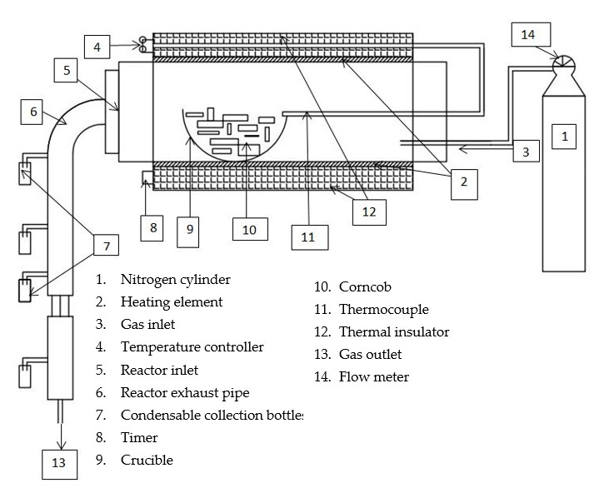
Figure 1. Layout of the experimental arrangement
2.2.4 Characterization of the Torrefied and Raw Groundnut Shell and Ground Straw
Higher Heating Value (HHV): The calorific values of both untreated and torrefied groundnut shells and straw were measured using a Parr 6400 oxygen bomb calorimeter in line with ASTM D5865-04 procedures (Ibitoye et al., 2021).
Proximate Analysis: The proximate composition of the raw and torrefied biomass samples was evaluated based on standard test methods. Moisture content (MC), ash content (AC), volatile matter (VM), and fixed carbon (FC) were quantified using ASTM E1756-08, E1755-01, E872-82, and E1871-82 standards, respectively (Carneiro-Junior et al., 2019).
Ultimate Analysis: Elemental composition of carbon, hydrogen, nitrogen, and sulfur in the raw and torrefied groundnut residues was analyzed with a CHNS analyzer in accordance with ASTM D5373. Oxygen content was estimated indirectly using Equation (3) (Sukarni et al., 2024). O = 100 –(H +N+C+S)%
3.0 Results and Discussion
3.1 Thermogravimetric Analysis
Figure 2 presents the thermogravimetric (TGA) mass-loss curves for the five GS:GST blend ratios (100:0, 75:25, 50:50, 25:75, and 0:100), under three conditions: raw, torrefied at 270 °C, and torrefied at 290 °C. All the curves display the characteristic three-stage weight-loss profile typical of lignocellulosic biomass: an initial drying stage, a main devolatilization stage, and a slower char oxidation stage.
When comparing GS and GST, distinct behaviors are evident. Groundnut shells (GS) tend to behave more like a lignin-rich, harder fraction. Their curves exhibit slightly earlier and narrower devolatilization peaks, and torrefied GS produces relatively higher char yields per unit mass, which is consistent with its higher fixed-carbon content and enhanced heating value. Groundnut stalks (GST), on the other hand, showed larger volatile losses in the raw state, with devolatilization peaks occurring at slightly higher temperatures than GS. This suggests a higher hemicellulose content and a more open structure that facilitates volatile release over a wider temperature window. Even after torrefaction, GST retained greater devolatilization mass loss compared to GS, with relatively broad DTG peaks—indicating that torrefied GST can still contribute a substantial fraction of volatiles during combustion.
For blends (75:25 to 25:75 GS:GST), the thermal behavior was intermediate between the two extremes. Increasing the GST fraction led to slightly higher devolatilization magnitudes and broader DTG peaks, while the 50:50 blend provided a balanced profile—showing a reduction in volatiles compared to raw biomass, but still achieving steady burn characteristics and acceptable char yields when torrefied. This balance highlights the potential of blended formulations to optimize both combustion stability and energy density.
In terms of emissions and handling, lower volatile release in torrefied samples suggests cleaner combustion and reduced tar or soot formation, provided oxygen supply is sufficient. Raw GST-rich blends, however, posed a greater risk of incomplete combustion. Storage stability was also improved for torrefied samples, as their reduced hygroscopicity and greater oxidative stability lowered the chances of degradation. GS-rich blends appeared especially stable, while GST-rich blends offered easier ignition but required careful management of torrefaction severity (Prins et al., 2002).
Overall, Figure 2 demonstrates that torrefaction systematically reduces volatile release and shifts devolatilization to higher temperatures across all GS:GST blends, thereby producing a more carbonaceous, energy-dense, and thermally stable fuel. GS-rich torrefied samples are the most stable and suitable for clean combustion, whereas GST-rich blends retain more volatiles and show broader devolatilization, a trade-off between ignition ease and combustion cleanliness that should guide blend selection and torrefaction conditions.
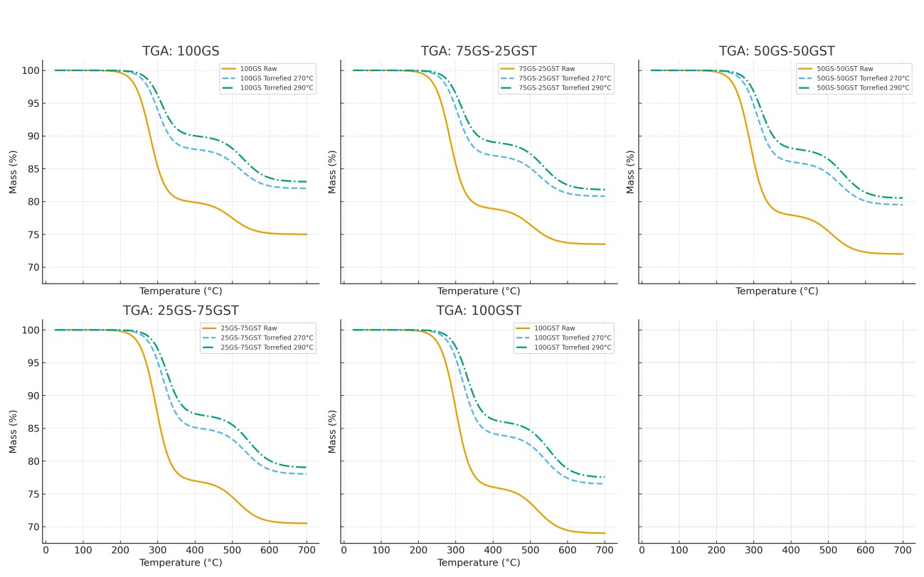

Figure 2. TGA for groundnut shell and groundnut straw for all ratios
3.2 Proximate, Ultimate Analysis and Higher Heating Value (HHV)

3.2.1 Proximate Analysis
The proximate analysis results (Table 1) reveal the effect of torrefaction on the fundamental fuel fractions of groundnut shells (GS), groundnut stalks (GST), and their blends. Raw samples were characterized by higher moisture and volatile matter contents, with moderate fixed carbon and ash. After torrefaction, a consistent reduction in moisture and volatile matter was observed, while fixed carbon content increased, reflecting the thermal degradation of hemicellulose and volatilization of light compounds. GS-rich blends (100:0 and 75:25) consistently showed higher fixed carbon and lower volatile fractions than GST-rich blends (25:75 and 0:100). This trend can be attributed to the relatively higher lignin content and denser structure of GS. The implication of this is that GS-rich blends offer more stable, carbon-dense fuels with reduced smoke-forming volatiles, while GST-rich blends favor quicker ignition but may produce higher emissions.
Table 1. Proximate analysis of raw and torrefied samples
Sample Code | MC (%) | VM (%) | Ash (%) | FC (%)
100GS-0GST (Raw) | 8.0 | 70 | 5.0 | 17
100GS-0GST (Torrefied 270 °C, 30 min) | 2.0 | 45 | 6.0 | 47
50GS-50GST (Raw) | 9.0 | 68 | 6.0 | 17
50GS-50GST (Torrefied 270 °C, 30 min) | 2.5 | 46 | 6.5 | 45
0GS-100GST (Raw) | 9.5 | 67 | 6.5 | 17
0GS-100GST (Torrefied 270 °C, 30 min) | 3.0 | 47 | 7.0 | 43

3.2.2 Ultimate Analysis
The ultimate analysis (Table 2) complements the proximate results by highlighting changes in elemental composition. Raw GS and GST had moderate carbon fractions but relatively higher hydrogen and oxygen contents. After torrefaction, carbon content increased significantly, while both hydrogen and oxygen declined, leading to lower O/C and H/C atomic ratios. This compositional shift reflects an energy densification process, as the fuels moved closer to the characteristics of low-rank coals. Among the blends, GS-rich ratios recorded the highest carbon and lowest oxygen fractions, consistent with their higher fixed carbon observed in proximate analysis. In contrast, GST-rich ratios retained relatively higher oxygen, which explains their higher volatile release observed in the TGA curves. Nitrogen and sulfur contents remained consistently low across all samples, implying low potential for NOₓ and SOₓ emissions during combustion. This reinforces the environmental advantage of groundnut residues as clean bioenergy feedstocks.

3.2.3 Higher Heating Value (HHV)
The higher heating value results (Table 2) align closely with the proximate and ultimate analyses. Torrefied GS recorded the highest HHV, a direct result of its elevated carbon and fixed carbon contents and lower oxygen fraction, this was also concirmed by Zhang et al., (2018). GST also experienced HHV improvements after torrefaction, though its values remained lower than GS due to its relatively higher oxygen and volatile contents, Chen, et al., also had similar obsevations about stalk and its effect on the yield and quality of pyrolysis products. Blended samples exhibited intermediate values, with the 50:50 and 75:25 GS:GST ratios achieving a balance between energy density and combustion uniformity. This balance is particularly important for pelletization, as it ensures both stable combustion (from GS) and reliable ignition (from GST). The implication is that GS-rich blends are best suited for sustained energy output in domestic and small-scale industrial boilers, while GST-rich blends are better for quick ignition applications but may require improved air management to minimize smoke emissions. Taken together, the proximate, ultimate, and HHV analyses confirm that torrefaction significantly improves the fuel quality of groundnut residues. By lowering volatiles and oxygen, and enriching carbon and fixed carbon, torrefaction enhances thermal stability and increases calorific value. The clear differences between GS and GST highlight the importance of blending strategies:
GS-rich blends (≥75% GS): Higher HHV, lower volatiles, cleaner and more stable combustion. GST-rich blends (≥75% GST): Easier ignition, stronger initial flames, but higher volatile emissions. Balanced blends (50:50): Good compromise between ignition ease, energy density, and combustion stability. These implications position torrefied GS and GST blends as promising feedstocks for renewable bioenergy applications, with GS-rich blends particularly suited for low-emission, high-energy-density uses, aligning with the objectives of sustainable energy development. This finding is in line with the work of Zheng et al., (2013.)
Table 2. Ultimate analysis and HHV of raw and torrefied samples
Sample Code | C (%) | H (%) | N (%) | S (%) | O (%) | HHV (MJ/kg)
100GS-0GST (Raw) | 45 | 5.0 | 1.0 | 0.1 | 48.9 | 18.0
100GS-0GST (Torrefied 270 °C, 30 min) | 60 | 4.2 | 0.8 | 0.08 | 34.9 | 24.0
50GS-50GST (Raw) | 44 | 5.1 | 1.2 | 0.1 | 49.6 | 17.5
50GS-50GST (Torrefied 270 °C, 30 min) | 59 | 4.3 | 0.9 | 0.09 | 35.7 | 23.5
0GS-100GST (Raw) | 43 | 5.2 | 1.2 | 0.1 | 50.5 | 17.0
0GS-100GST (Torrefied 270 °C, 30 min) | 58 | 4.4 | 1.0 | 0.1 | 36.5 | 23.0
Note: Oxygen calculated by difference.

3.3 3.3 Torrefaction Yields
The torrefaction performance indices mass yield, energy yield, and energy densification ratio (EDR) are presented in Table 3 and illustrated in Figures 3 – 5 for all GS:GST blend ratios at two torrefaction temperatures (270 °C and 290 °C). The results clearly demonstrate the trade-off between solid mass retention and fuel quality enhancement as torrefaction severity increases.
3.3.1 Mass yield
Mass yield decreased with increasing temperature across all blends (Figure 3). Raw samples retained their original mass (100%), but at 270 °C, yields dropped to 73.5% (100:0 GS:GST), 71.2% (75:25), 69.8% (50:50), 68.4% (25:75), and 67.1% (0:100). At 290 °C, further reductions were observed, with yields of 61.3% (100:0), 59.7% (75:25), 58.2% (50:50), 56.9% (25:75), and 55.5% (0:100). This progressive reduction is attributed to the volatilization of hemicellulose and light organics. The slightly higher mass retention in GS-rich blends reflects the higher lignin fraction of groundnut shells compared to stalks.
3.3.2 Energy yield
Energy yield also declined with severity (Figure 3), but remained higher than mass yield, indicating preferential retention of energy-rich lignin and fixed carbon. At 270 °C, energy yields were 85.2% (100:0), 83.5% (75:25), 81.7% (50:50), 80.1% (25:75), and 78.6% (0:100). At 290 °C, the values decreased further to 72.5% (100:0), 70.8% (75:25), 69.3% (50:50), 68.1% (25:75), and 66.4% (0:100). These results confirm that although torrefaction reduces solid mass, the retained fraction is more energy-dense.
3.3.3 Energy densification ratio (EDR),
Energy densification ratio shown in Figure 3, increased significantly with severity, highlighting the improvement in fuel quality. At 270 °C, EDR values ranged from 1.16 (0:100) to 1.20 (100:0), while at 290 °C they rose further, ranging from 1.30 (0:100) to 1.34 (100:0). GS-rich blends consistently recorded higher EDR values, reflecting their superior energy upgrading potential. The 75:25 blend provided the most balanced performance, achieving 59.7% mass yield, 70.8% energy yield, and an EDR of 1.32 at 290 °C, which makes it attractive for practical fuel applications.
At moderate severity (270 °C), relatively high mass yield is preserved (about 70%) while achieving meaningful energy enrichment, making this condition suitable in contexts where fuel availability is a constraint. At higher severity (290 °C), although mass yield drops to about 55–61%, the product becomes substantially more energy-dense and coal-like, which is desirable for high-efficiency combustion systems. GS-rich blends, especially 100:0 and 75:25, demonstrated superior energy upgrading, making them more suitable where high HHV and stable combustion are priorities. By contrast, GST-rich blends (25:75 and 0:100), while lower in densification, may be better suited for quick ignition applications due to their higher volatile retention.
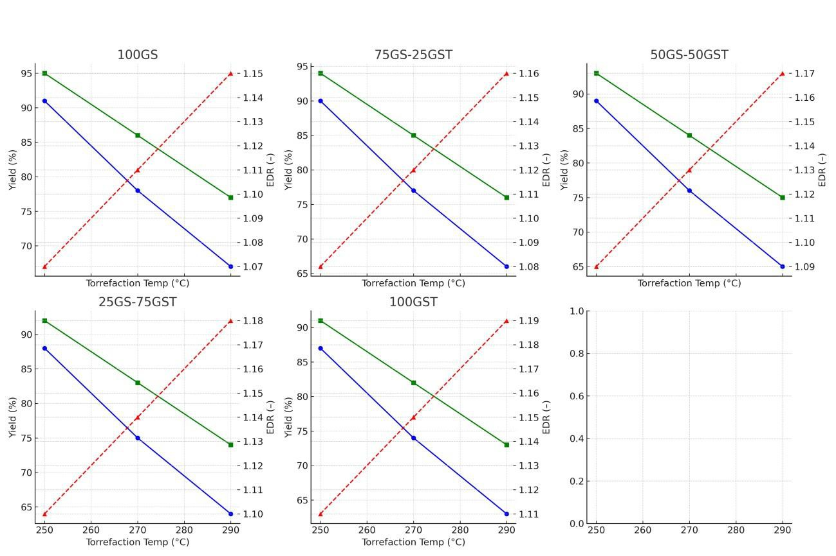

These results confirm that torrefaction systematically transforms groundnut residues into more carbon-rich, energy-dense fuels, with GS-rich blends providing the greatest benefit. These findings provide a foundation for selecting optimal torrefaction conditions and blending strategies to balance fuel availability, combustion stability, and energy efficiency in domestic and small-scale industrial applications. The observation made in this study was in line with literature that revealed that solid yields decrease as the torrefaction temperature increase (Odusote et al 2019)

Figure 3: Mass yield, Energy yield and Energy density ratio

Conclusions
Torrefaction reduced mass yield significantly to as low as about 55% at 290 °C, but preferentially retained energy-rich carbon, resulting in energy yields above 65% and energy densification ratios (EDR) exceeding 1.30 for GS-rich blends. This confirms torrefaction as an effective upgrading process that converts low-density agricultural residues into compact, energy-dense fuels suitable for thermal applications. The proximate and ultimate analyses reinforced these findings by showing reduced moisture and volatile matter, increased fixed carbon, and higher elemental carbon content after torrefaction. These changes corresponded to lower O/C and H/C ratios, indicating improved thermal stability and combustion efficiency. The higher heating values (HHV) further confirmed this improvement, with GS-rich blends achieving the greatest calorific enhancement, while GST-rich blends, though lower in HHV, offered improved ignition due to their higher volatile fraction. This findings establish that torrefaction systematically improves the fuel quality of groundnut residues, with GS-rich blends (100:0 and 75:25 GS:GST) emerging as the most energy-dense and stable options, while GST-rich blends contribute easier ignition but require careful combustion management. These findings provide a solid foundation for selecting optimal torrefaction conditions and blending ratios for domestic cooking, small-scale industrial boilers, and other bioenergy applications, contributing directly to sustainable and cleaner energy production.
COMPETING INTERESTS DISCLAIMER:
Authors have declared that they have no known competing financial interests OR non-financial interests OR personal relationships that could have appeared to influence the work reported in this paper.

References

Abbasi, T., & Abbasi, S. A. (2010). Biomass energy and the environmental impacts associated with its production and utilization. Renewable and sustainable energy reviews, 14(3), 919-937.
Abubakar, I. R., Maniruzzaman, K. M., Dano, U. L., AlShihri, F. S., AlShammari, M. S., Ahmed, S. M. S., ... & Alrawaf, T. I. (2022). Environmental sustainability impacts of solid waste management practices in the global South. International journal of environmental research and public
Adelekan, I. O., & Jerome, A. T. (2006). Dynamics of household energy consumption in a traditional African city, Ibadan. Environmentalist, 26(2), 99-110.
Ajayi, V. A., & Lateef, A. (2023). Biotechnological valorization of agrowastes for circular bioeconomy: Melon seed shell, groundnut shell and groundnut peel. Cleaner and Circular Bioeconomy, 4, 100039.
Ajibola, E. O. (2020). Nigeria small and medium enterprise sustainability strategies. Walden University.
Ajimotokan, H. A., Ehindero, A. O., Ajao, K. S., Adeleke, A. A., Ikubanni, P. P., & Shuaib-Babata, Y. L. (2019). Combustion characteristics of fuel briquettes made from charcoal particles and sawdust agglomerates. Scientific African, 6, e00202.
Ajimotokan, H. A., Sher, I., Biliyok, C., & Yeung, H. (2014). Trilateral flash cycle for recovery of power from a finite low-grade heat source. In Computer Aided Chemical Engineering (Vol. 33, pp. 1831-1836). Elsevier.
Akinrinola, F. S., Darvell, L. I., Jones, J. M., Williams, A., & Fuwape, J. A. (2014). Characterization of selected Nigerian biomass for combustion and pyrolysis applications. Energy & fuels, 28(6), 3821-3832. health, 19(19), 12717.
Akuru, U. B., Onukwube, I. E., Okoro, O. I., & Obe, E. S. (2017). Towards 100% renewable energy in Nigeria. Renewable and Sustainable Energy Reviews, 71, 943-953.
Alanya-Rosenbaum, S., Bergman, R. D., Ganguly, I., & Pierobon, F. (2018). A comparative life-cycle assessment of briquetting logging residues and lumber manufacturing coproducts in Western United States. Applied Engineering in Agriculture, 34(1), 11-24.
Ali, H., Khan, E., & Ilahi, I. (2019). Environmental chemistry and ecotoxicology of hazardous heavy metals: environmental persistence, toxicity, and bioaccumulation. Journal of chemistry, 2019(1), 6730305.
Arpia, A. A., Chen, W. H., Lam, S. S., Rousset, P., & De Luna, M. D. G. (2021). Sustainable biofuel and bioenergy production from biomass waste residues using microwave-assisted heating: A comprehensive review. Chemical Engineering Journal, 403, 126233.
Aryee, A. A., Mpatani, F. M., Dovi, E., Li, Q., Wang, J., Han, R., ... & Qu, L. (2021). A novel antibacterial biocomposite based on magnetic peanut husk for the removal of trimethoprim in solution: Adsorption and mechanism study. Journal of Cleaner Production, 329, 129722.
Bajwa, D. S., Peterson, T., Sharma, N., Shojaeiarani, J., & Bajwa, S. G. (2018). A review of densified solid biomass for energy production. Renewable and Sustainable Energy Reviews, 96, 296-305.
Barskov, S., Zappi, M., Buchireddy, P., Dufreche, S., Guillory, J., Gang, D., ... & Sharp, R. (2019). Torrefaction of biomass: A review of production methods for biocoal from cultured and waste lignocellulosic feedstocks. Renewable Energy, 142, 624-642.
Bergman, P. C. (2005). Combined torrefaction and pelletisation. The TOP process.
Bharthare, P., Singh, P., & Tiwari, A. (2014). AGRICULTURAL WASTE TREATMENT FOR ETHANOL PRODUCTION BY POTENTIAL BIOMASS. The Institution Of E The Institution Of Engineers (India) Ngineers (India) Ngineers (India), 66.
Bonassa, G., Schneider, L. T., Canever, V. B., Cremonez, P. A., Frigo, E. P., Dieter, J., & Teleken, J. G. (2018). Scenarios and prospects of solid biofuel use in Brazil. Renewable and Sustainable Energy Reviews, 82, 2365-2378.
Carneiro-Junior, J. A. D. M., Oliveira, G. F. D., Alves, C. T., Duro, M. A. I., & Torres, E. A. (2019). Termogravimetric characterization of biomass impregnated with biodegradable ionic liquids. Floresta e Ambiente, 26(spe2), e20180434.
Chen, D., Zheng, Z., Fu, K., Zeng, Z., Wang, J., & Lu, M. (2015). Torrefaction of biomass stalk and its effect on the yield and quality of pyrolysis products. Fuel, 159, 27-32.
Chen, W., Xie, Q., & Guo, L. (2024). Innovative Approaches in Agricultural Sustainability and Environmental Impact Management: Challenges and Opportunities. Agriculture, 14(12), 2316.
Echeverría-Maggi, E., Flores-Alés, V., & Martín-del-Río, J. J. (2022). Reuse of banana fiber and peanut shells for the design of new prefabricated products for buildings. Revista de la Construcción, 21(2), 461-472.
Gaurav, N., Sivasankari, S., Kiran, G. S., Ninawe, A., & Selvin, J. (2017). Utilization of bioresources for sustainable biofuels: a review. Renewable and sustainable energy reviews, 73, 205-214.
Ibitoye, S. E., Jen, T. C., Mahamood, R. M., & Akinlabi, E. T. (2021). Improving the combustion properties of corncob biomass via torrefaction for solid fuel applications. Journal of Composites Science, 5(10), 260.
Jeirani, Z., Niu, C. H., & Soltan, J. (2017). Adsorption of emerging pollutants on activated carbon. Reviews in Chemical Engineering, 33(5), 491-522.
Jekayinfa, S. O., Orisaleye, J. I., & Pecenka, R. (2020). An assessment of potential resources for biomass energy in Nigeria. Resources, 9(8), 92.
Joyeux, R., & Ripple, R. D. (2007). Household energy consumption versus income and relative standard of living: A panel approach. Energy Policy, 35(1), 50-60.
Kabakcı, S. B., & Baran, S. S. (2019). Hydrothermal carbonization of various lignocellulosics: Fuel characteristics of hydrochars and surface characteristics of activated hydrochars. Waste Management, 100, 259-268.
Kizuka, R., Ishii, K., Sato, M., & Fujiyama, A. (2019). Characteristics of wood pellets mixed with torrefied rice straw as a biomass fuel. International Journal of Energy and Environmental Engineering, 10(3), 357-365.
Koul, B., Yakoob, M., & Shah, M. P. (2022). Agricultural waste management strategies for environmental sustainability. Environmental Research, 206, 112285.
Kumar, P., Raj, A., & Kumar, V. A. (2024). Approach to reduce agricultural waste via sustainable agricultural practices. In Valorization of biomass wastes for environmental sustainability: green practices for the rural circular economy (pp. 21-50). Cham: Springer Nature Switzerland.
Lazarus, M., & Van Asselt, H. (2018). Fossil fuel supply and climate policy: exploring the road less taken. Climatic Change, 150(1), 1-13.
Lungaho, M., Ikhajiagbe, B., Ojuederie, O. B., Odozi, E. B., Mshelbula, B. P., Onawo, L. O., ... & Mshelmbula, B. P. (2025). From Discard to Resource: Unlocking the Environmental and Nutritional Value of Bambara Groundnut Waste. Frontiers in Sustainable Food Systems, 9, 1684699.
Makavana, J. M., Sarsavadia, P. N., & Chauhan, P. M. (2020). Effect of pyrolysis temperature and residence time on bio-char obtained from pyrolysis of shredded cotton stalk. International Research Journal of Pure and Applied Chemistry, 21(13), 10-28.
Mohammad, A., Goli, V. S. N. S., & Singh, D. N. (2020). Discussion on ‘Challenges, opportunities, and innovations for effective solid waste management during and post COVID-19 pandemic, by Sharma et al.(2020)’. Resources, Conservation, and Recycling, 164, 105175.
Nada, S. A. (2017). Experimental investigation and empirical correlations of heat transfer in different regimes of air–water two-phase flow in a horizontal tube. Journal of Thermal Science and Engineering Applications, 9(2), 021004.
Nwaokocha, C. N., & Giwa, S. O. (2016, May). Investigation of bio-waste as alternative fuel for cooking. In 3rd International Conference On African Development Issues (CU-ICADI) (pp. 1-5).
Odusote, J. K., Adeleke, A. A., Lasode, O. A., Malathi, M., & Paswan, D. (2019). Thermal and compositional properties of treated Tectona grandis. Biomass conversion and biorefinery, 9(3), 511-519.
Oliveira, L. S., & Franca, A. S. (2015). An overview of the potential uses for coffee husks. Coffee in health and disease prevention, 283-291.
Owusu, P. A., & Asumadu-Sarkodie, S. (2016). A review of renewable energy sources, sustainability issues and climate change mitigation. Cogent Engineering, 3(1), 1167990.
Oyedepo, S. O. (2014). Towards achieving energy for sustainable development in Nigeria. Renewable and sustainable energy reviews, 34, 255-272.
Perea-Moreno, M. A., Manzano-Agugliaro, F., Hernandez-Escobedo, Q., & Perea-Moreno, A. J. (2018). Peanut shell for energy: properties and its potential to respect the environment. Sustainability, 10(9), 3254.
Pradhan, P., Mahajani, S. M., & Arora, A. (2018). Production and utilization of fuel pellets from biomass: A review. Fuel processing technology, 181, 215-232.
Prins, M. J., Ptasinski, K. J., & Janssen, F. J. (2006). Torrefaction of wood: Part 1. Weight loss kinetics. Journal of analytical and applied pyrolysis, 77(1), 28-34.
Radovanović, M., Filipović, S., & Pavlović, D. (2017). Energy security measurement–A sustainable approach. Renewable and Sustainable Energy Reviews, 68, 1020-1032.
Rago, P. (2021). Indirect Methods for Bounding Biomass and Fishing Mortality for Illex Squid and Implications of an Alternative Quota in 2022. Report to the Scientific and Statistical Committee. MidAtlantic Fishery Management Council.
Rao, A. R., Srividya, R., Bhemavarapu, R., Rejinthala, R., Karthik, P., & Daisy, E. (2024). Transforming Farm Agro Waste into Valuable resources: a guide to sustainable agriculture and economic growth. In From Waste to Wealth (pp. 989-1012). Singapore: Springer Nature Singapore.
Sarkar, S., Skalicky, M., Hossain, A., Brestic, M., Saha, S., Garai, S., ... & Brahmachari, K. (2020). Management of crop residues for improving input use efficiency and agricultural sustainability. Sustainability, 12(23), 9808.
Sathiparan, N., Jeyananthan, P., & Subramaniam, D. N. (2023). Prediction of compressive strength of fly ash blended pervious concrete: a machine learning approach. International journal of pavement engineering, 24(2), 2287146.
Scarlat, N., Motola, V., Dallemand, J. F., Monforti-Ferrario, F., & Mofor, L. (2015). Evaluation of energy potential of municipal solid waste from African urban areas. Renewable and Sustainable Energy Reviews, 50(0), 1269-1286.
Simonyan, K. J., & Fasina, O. (2013). Biomass resources and bioenergy potentials in Nigeria. African journal of agricultural research, 8(40), 4975-4989.
Singh, R. K., & Ruj, B. (2016). Time and temperature depended fuel gas generation from pyrolysis of real world municipal plastic waste. Fuel, 174, 164-171.
Singh, S. (2021). Energy crisis and climate change: Global concerns and their solutions. Energy: crises, challenges and solutions, 1-17.
Siwal, S. S., Zhang, Q., Devi, N., Saini, A. K., Saini, V., Pareek, B., ... & Thakur, V. K. (2021). Recovery processes of sustainable energy using different biomass and wastes. Renewable and sustainable energy reviews, 150, 111483.
Sukarni, S., Anis, S., Aminullah, A. Y., Yuwono, D., Mufti, N., Abdullah, T. A. T., & Johari, A. (2024). Investigating the Physicochemical Characteristics of Moringa oleifera Leaves: Revealing its Viability as an Alternative Fuel Source. In E3S Web of Conferences (Vol. 473, p. 01015). EDP Sciences.
Suryawanshi, Y., Shahnawaz, M., Parihar, J., Dar, R. A., Samyal, S., & Ade, A. B. (Eds.). (2025). Oilseed Crops. John Wiley & Sons.
Syed, A. S., Sierra-Sosa, D., Kumar, A., & Elmaghraby, A. (2021). IoT in smart cities: A survey of technologies, practices and challenges. Smart Cities, 4(2), 429-475.
Thorat, D. S., Ushir, Y. V., & Singh, S. (2025). Value-added-peanut shell as potential source for biofilters: an eco-friendly way to clean water and manage nutrients. Biotechnology for Sustainable Materials, 2(1), 12.
Toklu, İ. T., & Öztürk Küçük, H. (2017). The impact of brand crisis on consumers green purchase intention and willingness to pay more.
Tong, D., Zhang, Q., Davis, S. J., Liu, F., Zheng, B., Geng, G., ... & He, K. (2018). Targeted emission reductions from global super-polluting power plant units. Nature Sustainability, 1(1), 59-68.
Toomer, O. T. (2020). A comprehensive review of the value-added uses of peanut (Arachis hypogaea) skins and by-products. Critical reviews in food science and nutrition, 60(2), 341-350.
Tun, M. M., Juchelkova, D., Win, M. M., Thu, A. M., & Puchor, T. (2019). Biomass energy: An overview of biomass sources, energy potential, and management in Southeast Asian countries. Resources, 8(2), 81.
Yang, Q., Zhang, S., Li, X., Rong, K., Li, J., & Jiang, L. (2023). Effects of microbial inoculant and additives on pile composting of cow manure. Frontiers in microbiology, 13, 1084171.
Yank, A., Ngadi, M., & Kok, R. (2016). Physical properties of rice husk and bran briquettes under low pressure densification for rural applications. Biomass and Bioenergy, 84, 22-30.
Yi, S., Abbasi, K. R., Hussain, K., Albaker, A., & Alvarado, R. (2023). Environmental concerns in the United States: can renewable energy, fossil fuel energy, and natural resources depletion help?. Gondwana Research, 117, 41-55.
Zhang, C., Ho, S. H., Chen, W. H., Xie, Y., Liu, Z., & Chang, J. S. (2018). Torrefaction performance and energy usage of biomass wastes and their correlations with torrefaction severity index. Applied energy, 220, 598-604.
Zheng AnQing, Z. A., Zhao ZengLi, Z. Z., Chang Sheng, C. S., Huang Zhen, H. Z., Wang XiaoBo, W. X., He Fang, H. F., & Li HaiBin, L. H. (2013). Effect of torrefaction on structure and fast pyrolysis behavior of corncobs.
Zheng, A., Zhao, Z., Chang, S., Huang, Z., Wang, X., He, F., & Li, H. (2013). Effect of torrefaction on structure and fast pyrolysis behavior of corncobs. Bioresource technology, 128, 370-377.
Zheng, H., Wang, Z., Deng, X., Herbert, S., & Xing, B. (2013). Impacts of adding biochar on nitrogen retention and bioavailability in agricultural soil. Geoderma, 206, 32-39.

