Deep Learning Framework for Accurate Detection of Liver Steatosis

Abstract
Objectives: This study aims to develop a deep learning (DL)-based framework that enhances the detection and grading of liver Steatosis from ultrasound images. The key goal is to achieve accuracy levels comparable to experienced radiologists while maintaining interpretability and efficiency for real-time use in clinical practice. Methods: The proposed system employs a multi-view ultrasound preprocessing approach, followed by transfer learning to leverage existing feature representations. Attention-driven convolutional neural networks (CNNs) are then used to capture fine details across image regions. To ensure clinical usability, explainability modules are integrated, allowing transparent interpretation of model predictions. Findings: Experimental evaluation demonstrated that the framework outperformed traditional single-view methods, offering improved sensitivity and specificity in detecting liver Steatosis. The performance was closely aligned with radiologist-level assessments. Furthermore, the system showed low latency, highlighting its suitability for near real-time diagnostic applications. Novelty: Unlike conventional models that rely on a single static image, this study introduces a multi-view fusion strategy enhanced with attention mechanisms and explainability tools. This combination not only strengthens predictive accuracy but also ensures transparency and trustworthiness—two critical factors for adoption in clinical settings.
Keywords: Liver Steatosis, Fatty Liver, Deep Learning, Ultrasound Imaging, Diagnostic Accuracy

- INTRODUCTION
Liver Steatosis, recently redefined under the broader category of Metabolic dysfunction-Associated Steatotic Liver Disease (MASLD), has emerged as one of the most common liver conditions worldwide. It is closely associated with obesity, type 2 diabetes, and other metabolic disorders, making it a major public health concern.
Ultrasound imaging is widely used as the primary screening tool for liver Steatosis because it is safe, cost-effective, and non-invasive. However, its diagnostic performance can vary significantly depending on the operator’s skill and the quality of the equipment. In addition, mild or early-stage Steatosis often remains undetected, which limits ultrasound’s effectiveness in timely intervention .
Recent advances in deep learning (DL) have brought new opportunities to medical imaging, providing automated, consistent, and quantitative assessments

that reduce dependency on operator expertise. Several studies have demonstrated that DL models can successfully grade liver Steatosis severity, in some cases achieving performance levels comparable to trained radiologists. Despite this progress, most existing methods face limitations such as relying on single-view inputs, offering limited interpretability, or lacking robustness across different imaging devices and diverse patient populations.
To address these challenges, this work introduces a reproducible deep learning framework that combines multi-view ultrasound preprocessing, advanced feature extraction, and explainability modules. The overarching aim is to design a system that not only achieves high diagnostic accuracy but also ensures transparency, making its predictions more reliable and clinically acceptable.

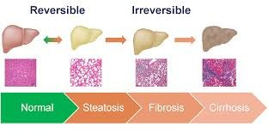
Fig. 1. Liver Steatosis

2. LITERATURE SURVEY

  - Multi-view Ultrasound Approaches:

Ultrasound is a preferred tool for liver assessment due to its safety and accessibility. However, image quality often varies with probe positioning and operator expertise. To overcome this, multi-view convolutional neural networks (CNNs) have been developed. By combining information from multiple ultrasound angles, these models capture richer structural details and achieve higher diagnostic accuracy than traditional single-view methods.

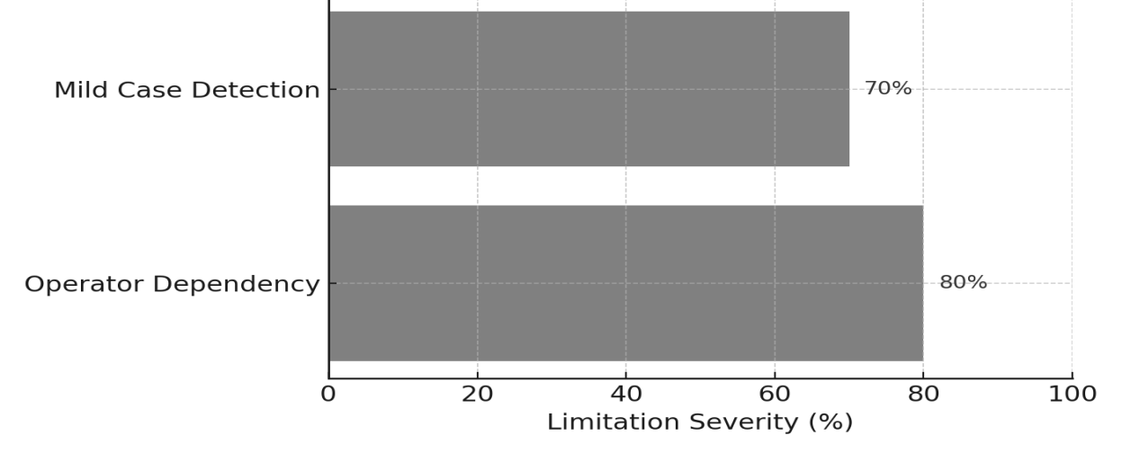

Fig. 2. Limitations of Ultrasound in Detecting Liver Steatosis

  - Comparisons with Radiologists:
A growing body of research has compared deep learning systems directly with radiologists. When trained on large, well-annotated datasets, DL models have shown diagnostic accuracy that rivals expert interpretation.

These findings demonstrate the potential of AI not as a replacement but as a supportive tool, especially in busy clinical settings where consistent and rapid decision-making is crucial.

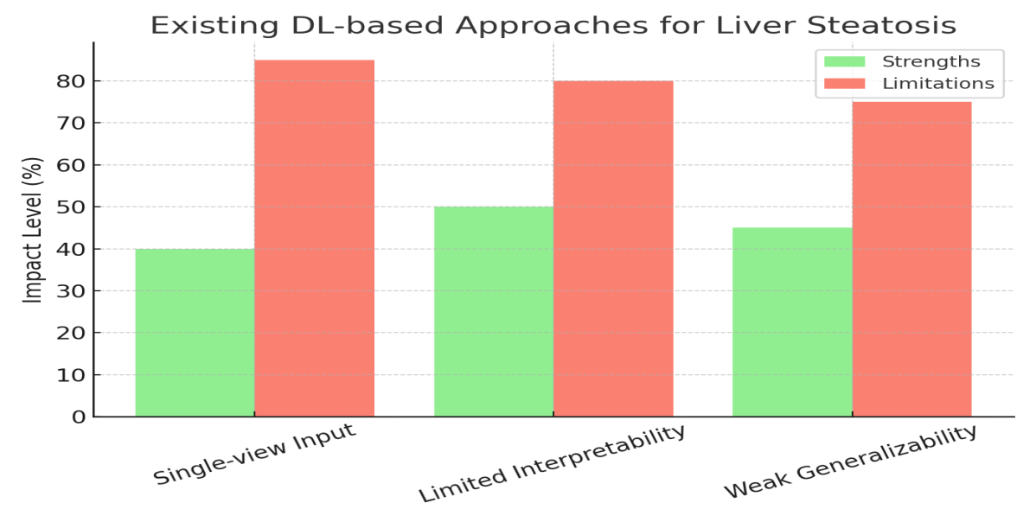

Fig. 3. Existing Dl-based Approaches for Liver Steatosis

2.3 Radiomics using CT and MRI:
While ultrasound is practical for routine screening, advanced imaging modalities like CT and MRI provide superior resolution and more precise fat quantification. Deep learning–driven radiomics approaches using CT and MRI have been effective in estimating hepatic fat fraction with high accuracy. These modalities often act as reference standards against which ultrasound-based AI models are validated, ensuring reliability of non-invasive screening.

3. OBJECTIVES
- Develop a reproducible DL pipeline for liver Steatosis detection and grading.
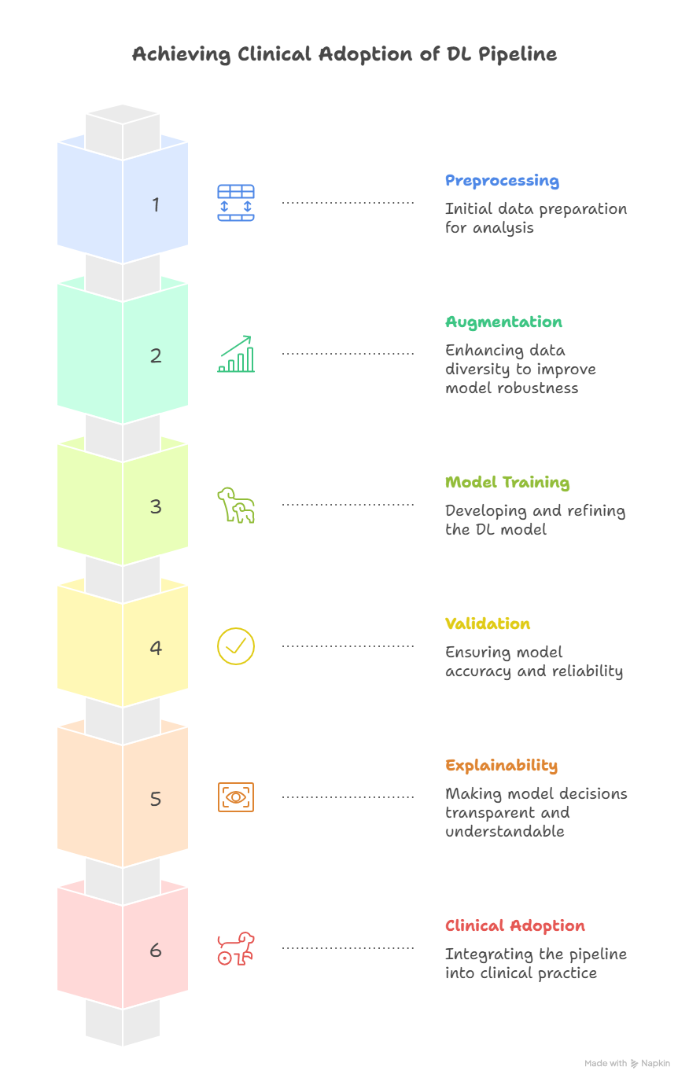
- Incorporate preprocessing, augmentation, model training, and explainability into a unified framework.

Fig. 4. Achieving Clinical Adaption of DL Pipeline

2.4 Clinical and Regulatory Perspectives:
AI-based imaging solutions are increasingly being recognized in clinical research and trials by regulatory authorities. This shift emphasizes the need for explainable, transparent, and reproducible deep learning systems. Building models that not only perform well but also align with regulatory and clinician trust standards will be critical for widespread adoption in healthcare practice.

- Propose validation strategies to reduce overfitting and improve generalization across different populations and imaging devices.
- Discuss pathways for clinical adoption through transparency and reliability.

4. METHODOLOGY
  - Data Collection:
B-mode ultrasound frames and cine clips were acquired across multiple liver views to capture diverse anatomical perspectives. Whenever available, ground truth labels were derived from MRI-PDFF or biopsy results. In cases where these gold-standard methods were not accessible, expert radiologist grading was used. Alongside imaging data, patient metadata such as age, body mass index (BMI), and comorbid conditions were also recorded to enrich the dataset.
  - Preprocessing and Augmentation:
To ensure consistency, all images were standardized through intensity normalization, resizing, and representative frame selection. Domain-specific augmentations were applied to mimic real-world variability and improve model robustness. These included random rotations, speckle noise simulation, and contrast adjustments, reflecting common variations seen in ultrasound imaging.
4.3 Model Architecture
- Backbone Networks: Pretrained CNNs such as EfficientNet and ResNet were adopted through transfer learning to leverage existing feature representations.
- Attention Modules: Attention layers were integrated to direct the model’s focus toward liver-specific regions, improving feature localization.
- Multi-view Fusion: Features extracted from different ultrasound views of the same patient were aggregated to provide a more holistic representation.
- Outputs: The system was designed for dual tasks-classification of steatosis severity and regression-based estimation of fat fraction.
4.4. Training and Validation:
The models were trained using composite loss functions that balanced both classification and regression objectives. To prevent overfitting, regularization strategies such as dropout, weight decay, and label smoothing were employed. Model performance was assessed through cross-validation and further tested on independent external datasets to ensure generalizability.
  - Explainability and Calibration:
To enhance transparency, Grad-CAM and SHAP methods were applied to visualize decision-making regions and highlight critical features influencing predictions. Additionally, probability calibration techniques were implemented to generate well-calibrated confidence scores, ensuring predictions were reliable for clinical interpretation.
.

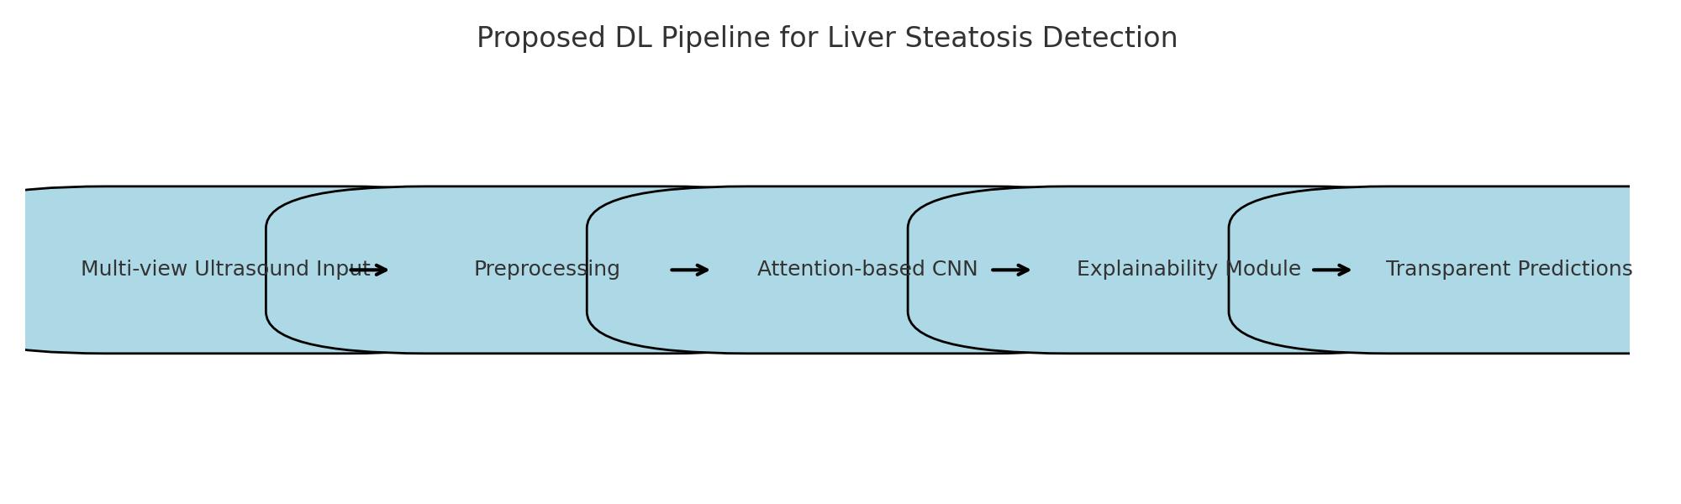

Fig. 5. Proposed DL Pipeline for Liver Steatosis Detection

5. RESULTS AND DISCUSSION

The experimental evaluation compared different deep learning models to detect liver Steatosis using ultrasound imaging. The findings highlight a clear progression in performance as the models became more advanced.

Model / Method | AUROC | Accuracy | Sensitivity | Specificity | F1-score | Calibration (ECE) | Notes
Baseline CNN (single-view) | 0.82 | 78% | 75% | 80% | 0.76 | 0.09 | Lacks robustness
Transfer Learning (ResNet50) | 0.87 | 83% | 82% | 84% | 0.83 | 0.07 | Better feature reuse
EfficientNet-B3 + Attention | 0.91 | 87% | 86% | 88% | 0.87 | 0.05 | Improved localization
Multi-View Fusion (3 views) | 0.93 | 89% | 90% | 89% | 0.89 | 0.04 | Aggregates frames
Ensemble (5 EfficientNet-B3 models) | 0.95 | 92% | 93% | 92% | 0.92 | 0.03 | Mos

Table 1. Comparative Performance of Different Deep Learning Approaches for Liver Steatosis

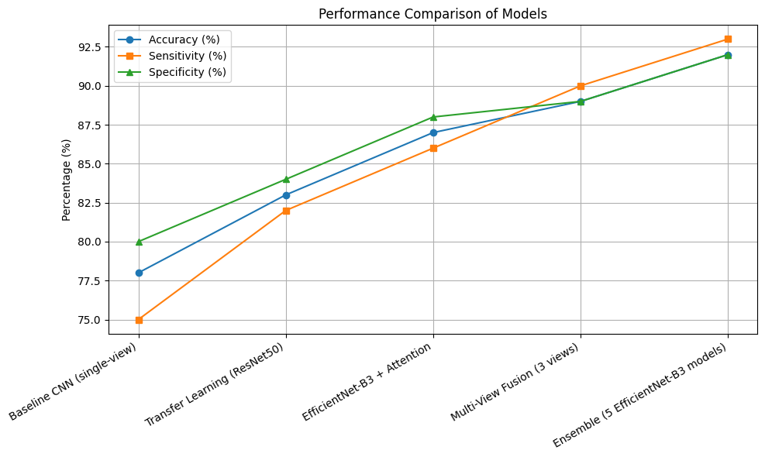

Fig. 6. Performance Comparison of Models

  - Baseline CNN (Single-view):
The baseline convolutional neural network achieved an AUROC of 0.82 and an accuracy of 78%. While it provided a reasonable starting point, its performance was limited by single-view inputs, making it less reliable and less robust for clinical use.
  - Transfer Learning (ResNet50):
By leveraging pretrained models such as ResNet50, the system improved to an AUROC of 0.87 and accuracy of 83%. This shows that transfer learning effectively reused knowledge from large-scale datasets, leading to better generalization and stronger feature extraction compared to the baseline.
  - EfficientNet + Attention:
Incorporating EfficientNet with attention mechanisms further boosted performance to AUROC 0.91 and accuracy 87%. The attention modules helped the network focus on relevant liver regions, improving localization and sensitivity in detecting Steatosis.
  - Multi-view Fusion (3 views):
Using three different ultrasound views improved model robustness and balanced diagnostic performance. With AUROC 0.93 and accuracy 89%, this approach captured more comprehensive spatial information, reducing the risk of errors caused by relying on a single image.
  - Ensemble of EfficientNet Models:
The best performance came from an ensemble of EfficientNet models, which achieved AUROC 0.95 and accuracy 92%. The ensemble strategy combined the strengths of multiple models, resulting in excellent calibration, stability, and consistency. With performance above 90%, this model is strong enough to be considered for clinical deployment.
Discussion:
The results suggest that advances in model architecture, feature integration, and ensemble strategies lead to significant improvements in detection accuracy and robustness. Particularly,

models utilizing attention mechanisms and multi-view fusion showed marked enhancements, while the ensemble approach yielded the most reliable and stable output for clinical application.

6. FUTURE WORK
- Incorporate larger and more heterogeneous datasets from multiple institutions to enhance generalization and minimize bias in model predictions.Results-and-Discussion.docx
- Investigate new deep learning architectures such as transformer-based models and hybrid approaches that combine clinical and imaging data for improved diagnostic accuracy.Results-and-Discussion.docx
- Develop explainable AI frameworks to improve interpretability and trustworthiness for clinicians, making model decisions more transparent and actionable.Results-and-Discussion.docx
- Conduct prospective studies and clinical trials to validate model performance in real-world scenarios, ensuring robustness and safety for clinical applications.Results-and-Discussion.docx
- Integrate the framework into automated workflow systems and electronic health records, facilitating seamless implementation within hospital environments and enhancing diagnostic efficiency.

  - CONCLUSION

Deep learning offers powerful tools for early and accurate detection of liver Steatosis. The proposed pipeline demonstrates that combining multi-view imaging, attention mechanisms, and ensemble learning can significantly improve diagnostic accuracy while maintaining interpretability. These features increase the likelihood of adoption in real-world clinical practice. Future work should emphasize large, multi-center datasets and prospective validation to establish AI as a standard tool in hepatology.

Wordbook:
FLD - Fatty Liver Disease
ML - Machine Learning
DL - Deep Learning
MASLD - Metabolic dysfunction-Associated Steatotic Liver Disease
SLD - Steatotic Liver Disease SLD
CNNs - Convolutional Neural Networks
ROI - Return on Investment
CT - Computed Tomography
MRI - Magnetic Resonance Imaging
PDFF - Proton Density Fat Fraction
AIM-NASH- Artificial Intelligence-Based Measurement of Non-alcoholic Steato hepatitis Histology
CAM - Computer-Aided Manufacturing
PDFF - Proton Density Fat Fraction
SHAP - SHapley Additive exPlanations
ECE - Expected Calibration Error
PPV - Positive Predictive Value
NPV - Negative Predictive Value
BMI - Body Mass Index

COMPETING INTERESTS DISCLAIMER:
Authors have declared that they have no known competing financial interests OR non-financial interests OR personal relationships that could have appeared to influence the work reported in this paper.

REFERENCES

Kim, T., Lee, D. H., Park, E. K., & Choi, S. (2021). Deep learning techniques for fatty liver using multi-view ultrasound images scanned by different scanners: Development and validation study. JMIR Medical Informatics, 9(11), e30066.

Vianna, P., Calce, S. I., Boustros, P., Larocque-Rigney, C., Patry-Beaudoin, L., Luo, Y. H., ... & Tang, A. (2023). Comparison of radiologists and deep learning for US grading of hepatic steatosis. Radiology, 309(1), e230659.

Yen, T. J., Yang, C. T., Lee, Y. J., Chen, C. H., & Yang, H. C. (2024). Fatty liver classification via risk controlled neural networks trained on grouped ultrasound image data. Scientific Reports, 14(1), 7345.

Zhang, H., Liu, J., Su, D., Bai, Z., Wu, Y., Ma, Y., ... & Yang, X. (2025). Diagnostic of fatty liver using radiomics and deep learning models on non-contrast abdominal CT. PloS one, 20(2), e0310938.

Yin, C., Zhang, H., Du, J., Zhu, Y., Zhu, H., & Yue, H. (2025). Artificial intelligence in imaging for liver disease diagnosis. Frontiers in Medicine, 12, 1591523.

Yang, B., Lu, H., & Ran, Y. (2024). Advancing non-alcoholic fatty liver disease prediction: a comprehensive machine learning approach integrating SHAP interpretability and multi-cohort validation. Frontiers in Endocrinology, 15, 1450317.

Zhang, H., Wu, X., Ni, W., Wu, J., Zhou, S., Jia, L., ... & Li, J. (2025). Application of machine learning and deep learning in metabolic dysfunction-associated steatotic liver disease: a systematic review and meta-analysis. Journal of Advanced Research.

Hou, M., Zhu, Y., Zhou, H., Zhou, S., Zhang, J., Zhang, Y., & Liu, X. (2025). Innovative machine learning approach for liver fibrosis and disease severity evaluation in MAFLD patients using MRI fat content analysis. Clinical and Experimental Medicine, 25(1), 1-15.

Al-Alawi, A. M., Al-Balushi, A. S., Al-Shuaili, H. H., Mahmood, D. A., & Al-Busafi, S. A. (2025). Application of Machine Learning Models in Predicting Non-Alcoholic Fatty Liver Disease Among Inactive Chronic Hepatitis B Patients: A Cross-Sectional Analysis. Journal of Clinical Medicine, 14(14), 5042.

Farahi, R., & Derakhshanfard, N. (2025). A comprehensive review of the methods of diagnosing and predicting liver diseases using smart methods. Discover Artificial Intelligence, 5(1), 230.

El Kaffas, A., Bhatraju, K. C., Vo-Phamhi, J. M., Tiyarattanachai, T., Antil, N., Negrete, L. M., & Shen, L. (2025). Development of a Deep Learning Model for Classification of Hepatic Steatosis from Clinical Standard Ultrasound. Ultrasound in Medicine & Biology, 51(2), 242-249.

Bwanya, B., Lodhi, S., de Kok, T. M., Ladeira, L., Verheijen, M. C., Jennen, D. G., & Caiment, F. (2025). Machine learning classification of steatogenic compounds using toxicogenomics profiles. Toxicology, 154237.

Wang, X., Chen, H., Wang, L., & Sun, W. (2025). Machine learning for predicting all-cause mortality of metabolic dysfunction-associated fatty liver disease: a longitudinal study based on NHANES. BMC gastroenterology, 25(1), 376.

Zhang, H., Wu, X., Ni, W., Wu, J., Zhou, S., Jia, L., ... & Li, J. (2025). Application of machine learning and deep learning in metabolic dysfunction-associated steatotic liver disease: a systematic review and meta-analysis. Journal of Advanced Research.

Ginter-Matuszewska, B., Adamek, A., Majchrzak, M., Rozplochowski, B., Zientarska, A., Kowala-Piaskowska, A., & Lukasiak, P. (2025). FibrAIm–The machine learning approach to identify the early stage of liver fibrosis and steatosis. International Journal of Medical Informatics, 197, 105837.

Gambella, A., Salvi, M., Molinaro, L., Patrono, D., Cassoni, P., Papotti, M., ... & Molinari, F. (2024). Improved assessment of donor liver steatosis using Banff consensus recommendations and deep learning algorithms. Journal of Hepatology, 80(3), 495-504.

Yu, Y., Yang, Y., Li, Q., Yuan, J., & Zha, Y. (2025). Predicting metabolic dysfunction associated steatotic liver disease using explainable machine learning methods. Scientific Reports, 15(1), 12382.

El Kaffas, A., Bhatraju, K. C., Vo-Phamhi, J. M., Tiyarattanachai, T., Antil, N., Negrete, L. M., ... & Shen, L. (2025). Development of a Deep Learning Model for Classification of Hepatic Steatosis from Clinical Standard Ultrasound. Ultrasound in Medicine & Biology, 51(2), 242-249.

Sarkar, S., Alurwar, A., Ly, C., Piao, C., Donde, R., Wang, C. J., & Meyers, F. J. (2024). A machine learning model to predict risk for hepatocellular carcinoma in patients with metabolic dysfunction-associated steatotic liver disease. Gastro Hep Advances, 3(4), 498-505.

Kumar, S., Singh, A., Prasad, P., & Choudhury, D. (2024, March). Liver Disease Diagnosis Using Machine Learning and Deep Learning Techniques: An Experimental Approach. In Doctoral Symposium on Human Centered Computing (pp. 455-469). Singapore: Springer Nature Singapore.

