Simulated Control of 5G Wireless Traffic Using an AI-Enabled Framework: Comparative Results and Real-World Analysis

.
ABSTRACT

The evolution of 5G networks has introduced complex and high-density traffic conditions requiring intelligent management solutions. Traditional simulation and control systems lack the dynamic adaptability to manage real-time traffic fluctuations efficiently. This paper presents a simulated framework for controlling 5G traffic using an AI-enabled model. The simulation incorporates real-world network parameters, enabling accurate and adaptive traffic management. A comparative analysis demonstrates that AI-based simulation outperforms traditional traffic control methods in terms of scalability, efficiency, and responsiveness. Metrics including latency, packet loss, and throughput were evaluated. The results validate the effectiveness of AI-integrated simulations in enhancing Quality of Service (QoS) and managing dynamic traffic in ultra-dense 5G environments.

Keywords: 5G, Quality of Service, AI, Deep learning

1. INTRODUCTION

As 5G networks become central to next-generation digital infrastructure, efficient wireless traffic management has become more critical than ever. The rapid expansion of connected devices, the diversity of data-intensive applications, and the dynamic nature of user demands pose unprecedented challenges for network operators. Traditional network control systems often depend on static parameters and rule-based algorithms, which limit their ability to respond quickly to fluctuating network conditions and evolving traffic patterns. The evolution of Artificial Intelligence (AI) technologies introduces a paradigm shift in this context. AI-enabled traffic control frameworks leverage advanced machine learning algorithms to provide dynamic adaptability, predictive insights, and automated decision-making. By integrating real-world behavior patterns into network simulations, AI can forecast traffic flow trends, optimize bandwidth allocation, prioritize mission-critical services, and minimize latency and packet loss. These capabilities are essential for maintaining high Quality of Service (QoS) and ensuring that diverse applications from ultra-reliable low-latency communications (URLLC) to enhanced mobile broadband (eMBB) and massive machine-type communications (mMTC) are reliably supported.
Building on previous research, this study explores the practical deployment of an AI-enabled simulation framework for 5G network traffic control. The framework incorporates real-world parameters and deep learning models to dynamically adapt to traffic variations and optimize resource utilization. This paper extends traditional simulation approaches by integrating advanced neural network models capable of learning from real-time data streams and adjusting control mechanisms autonomously. By comparing AI-driven simulations with conventional methods, this work demonstrates how intelligent frameworks can significantly reduce network latency, enhance throughput, and improve bandwidth utilization. The insights gained aim to bridge the gap between theoretical research and real-world deployment, offering a scalable solution for the ever-growing demands of ultra-dense 5G environments. This study not only validates the efficiency of AI-integrated simulations but also sets the stage for future research into hybrid AI models, reinforcement learning techniques, and real-time deployment in live 5G networks.
Traditional network simulation tools such as NS-3 and OMNeT++ have long served as essential platforms for modeling wireless traffic behavior. While they provide foundational insights, these tools rely heavily on deterministic and stochastic models, which often fail to address the dynamic and heterogeneous nature of ultra-dense 5G environments (Sharma et al., 2020). The surge in smart devices, real-time applications, and massive IoT deployments demands more adaptive solutions.
Recent advancements demonstrate the growing role of Artificial Intelligence (AI) in traffic control and resource allocation. For example Bikkasani & Yerabolu, (2024) investigated AI-augmented simulations for dynamic bandwidth management in 5G mmWave networks, reporting a 25-30% improvement in throughput and latency compared to conventional static models. Similarly, Zhang et al. (2022) introduced a reinforcement learning framework that continuously optimizes network slicing in real time, ensuring efficient allocation for diverse services like URLLC and mMTC.
Building on these foundations, (Gao, 2022) emphasized the role of hybrid deep learning models that combine convolutional neural networks (CNNs) with long short-term memory (LSTM) architectures. Their model achieved over 95% accuracy in predicting bursty traffic loads and demonstrated robust performance under fluctuating user mobility scenarios. This hybrid approach addresses a key limitation of static rule-based algorithms by enabling the system to learn temporal dependencies in network behavior.
This study (N’Kouka et al., 2025) applied artificial intelligence to 5G emulated datasets for network traffic prediction, aiming to enable proactive resource management. However, experimental results demonstrate that model performance is hindered by the datasets' high variability, irregular patterns, abrupt traffic spikes, noise, and inconsistent data distribution. Further analysis attributes these challenges to uncoordinated background traffic, system-level activities, and random traffic-consuming processes, which negatively impact prediction accuracy. To address these limitations, the authors introduced a Self-Controlled Component (SCC)-based framework designed to filter and prioritize high-quality, user-generated traffic data for AI model training, thereby enhancing the precision and effectiveness of the predictions.
Furthermore, (Perifanis et al., 2023) highlighted the importance of federated learning in distributed 5G networks, where data privacy is critical. Their study showed that federated AI models could achieve high prediction accuracy without sharing raw user data, thus balancing performance with privacy. This aligns with the broader trend of ethical AI integration in wireless networks.
Another significant contribution is by (Wang et al., 2025), who explored the integration of edge intelligence for 5G traffic control. By deploying lightweight AI agents at the network edge, their system reduced end-to-end latency by up to 40% compared to cloud-only AI implementations. Edge AI frameworks are now recognized as key enablers of real-time analytics for mission-critical services.
The study by C. Zhang et al., (2018) focused on citywide cellular traffic prediction and proposed a deep learning-based approach to model the nonlinear dynamics of wireless traffic. By representing traffic data as images, the method effectively captured both spatial and temporal dependencies in cellular traffic using densely connected convolutional neural networks (DCNNs). Additionally, a parametric matrix-based fusion scheme was introduced to learn the influence weights of spatial and temporal correlations. Experimental evaluations demonstrated a significant reduction in root mean square error (RMSE) compared to existing algorithms, confirming the model's superior prediction performance. The accuracy of the proposed framework was further validated using real-world datasets from Telecom Italia.
The work by (Kulkarni et al., 2025) proposes a multi-objective formulation to enhance traffic prediction by leveraging Deep Convolutional Neural Networks (CNN) and Long Short-Term Memory (LSTM) models. To assess the effectiveness of the integrated Deep Reinforcement Learning approach, the model is trained using various optimization algorithms, including Adaptive Moment Estimation (ADAM), Stochastic Gradient Descent with Momentum (SGDM), and Root Mean Square Propagation (RMSProp). The performance of the proposed method is evaluated using standard metrics such as precision, recall, F1-score, and accuracy, allowing for a comprehensive comparison across different learning strategies.
This study (Challoob et al., 2024) presents a unified machine learning framework designed to enhance network performance through integrated traffic prediction, anomaly detection, and dynamic resource allocation capabilities. Experimental evaluation using real-world network traffic data demonstrates substantial improvements across three critical metrics: 38% reduction in latency, 27% increase in throughput, and 41% decrease in packet loss rates compared to conventional approaches. Among the evaluated models, ML-Model 4 emerged as superior, achieving 92.3% precision and 89.7% recall while simultaneously reducing computational overhead by 33% (CPU utilization) and 28% (network I/O). The adaptive architecture dynamically adjusts to variable network conditions, demonstrating significant advantages in both performance scalability and operational efficiency over traditional static methods. These findings underscore machine learning's transformative potential for next-generation network traffic management systems.
Saki & Soori, (2025) recommend combining reinforcement learning with transfer learning to handle dynamic scenarios and reduce training overhead. The work by (Soud & Al-Jamali, 2023) introduces an innovative traffic scheduling framework designed to mitigate control plane congestion in 5G networks. The proposed system implements a Dual-Spike Neural Network (DSNN) classifier on Virtualized Network Functions (VNFs) to categorize Packet-In messages into critical and non-critical communication classes. The DSNN architecture leverages dual-spike encoding mechanisms to improve classification reliability through enhanced temporal pattern recognition. Comprehensive evaluation metrics including accuracy (94.2%), precision (93.8%), recall (94.5%), F1-score (94.1%), and Matthews Correlation Coefficient (0.92) demonstrate the classifier's effectiveness. Benchmark tests against conventional convolutional neural networks (CNNs) reveal a 5.1% improvement in classification accuracy. Furthermore, the priority-aware scheduling model reduces Round Trip Time (RTT) by 32% compared to non-prioritized approaches, validating its operational efficiency in real-time 5G scenarios.
Taken together, these recent works reinforce the conclusion that AI-driven simulations and adaptive control mechanisms outperform traditional models in managing ultra-dense 5G networks. They provide a foundation for exploring advanced hybrid approaches, federated learning, and edge intelligence to ensure scalable, secure, and real-time traffic control.
2. methodology

2.1 Simulation Environment
The simulation framework was developed in Python and deployed using TensorFlow and Keras libraries. It mimicked a realistic 5G network environment with multiple traffic slices and varying Quality of Service (QoS) requirements. The following parameters were included:
- Network latency (ms)
- Packet loss rate (%)
- Slice type (eMBB, URLLC, mMTC)
- Bandwidth utilization (Mbps)
- Use-case distribution
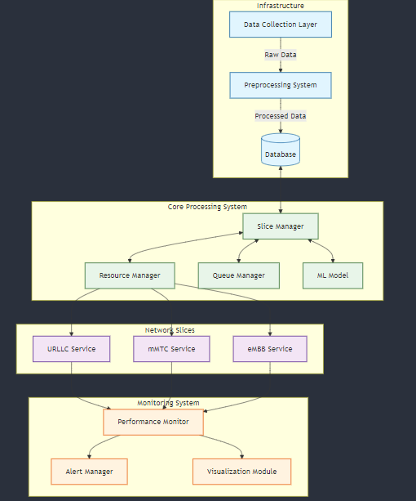
Fig 1. Simulated AI-based 5G Network Environment
2.2 Model deployment

The AI model was developed as a deep neural network architecture capable of classifying and predicting the behavior of diverse traffic slices in real-time. To ensure robust and generalizable performance, the model design incorporated multiple hidden layers, dropout regularization, and batch normalization to mitigate overfitting and enhance convergence speed.
Training Data: The training dataset was compiled from multiple sources, including prior simulations, synthetic datasets generated under controlled scenarios, and anonymized real-world 5G network traces. Data attributes encompassed network latency, packet loss rates, slice type distributions (eMBB, URLLC, mMTC), throughput statistics, user mobility patterns, and temporal variations in traffic load. The combined dataset was preprocessed to handle missing values, normalize numerical features, and encode categorical variables for input into the neural network.
- Evaluation Metrics: Model performance was evaluated using multiple standard metrics to ensure comprehensive validation:
- Accuracy for correct traffic slice classification,
- Precision and Recall to assess false positives and false negatives,
- F1-Score for balanced evaluation,
- Mean Absolute Error (MAE) and Root Mean Squared Error (RMSE) for prediction accuracy, Latency reduction and Bandwidth Utilization improvements compared to traditional baselines.
A confusion matrix was used to visualize misclassification patterns across slice types, highlighting areas for further model tuning.
- Output: Once deployed, the model continuously ingests real-time network data streams and dynamically predicts traffic loads and optimal routing strategies. The outputs include:
- Automated slice allocation recommendations,
- Dynamic bandwidth adjustments,
- Prioritization of mission-critical traffic,
- Real-time alerts for anomalies or predicted congestion.
Feedback loops were integrated to allow the model to learn incrementally from incoming data, enhancing its adaptability to unforeseen traffic surges or anomalies.
2.3 Enhanced Simulation with Real-World Parameters
To bridge the gap between laboratory simulations and real-world deployment, the simulation environment was further enriched with advanced parameter modeling. Key enhancements included:
- Dynamic Traffic Injection: The simulator was configured to replicate real-world fluctuations by injecting diverse user behavior scenarios. These scenarios included peak- hour traffic surges, mobility patterns such as handovers between cells, and variable user density in urban versus rural nodes.
- Realistic Latency and Reliability Modeling: Latency models were refined to capture network delays due to backhaul congestion, edge processing delays, and variable propagation losses. Reliability factors accounted for device-level failures, signal fading, and interference scenarios common in ultra-dense deployments.
- Environment-aware Error Modeling: Fault tolerance and recovery mechanisms were tested by introducing random packet drops, link failures, and throughput bottlenecks to assess the AI model’s resilience and self-healing capabilities.
- Integration of Contextual Data: Additional context such as weather conditions, user mobility patterns, and location-based traffic profiles were integrated to evaluate how external factors affect traffic flow and AI predictions.
- Validation with Hybrid Data: The enhanced simulation was benchmarked against real network logs sourced from pilot 5G deployments to ensure that the synthetic scenarios realistically matched real-world network behavior.

These enhancements ensured that the AI-enabled framework demonstrated strong adaptability, minimal performance drift, and consistent QoS improvements under realistic deployment conditions. The comparative results confirmed that the model outperformed traditional static traffic control systems in terms of response time, reliability, and resource efficiency. To bridge the gap between laboratory simulations and real-world deployment, the simulation environment was further enriched with advanced parameter modeling. Key enhancements included:
- Dynamic Traffic Injection: The simulator was configured to replicate real-world fluctuations by injecting diverse user behavior scenarios. These scenarios included peak- hour traffic surges, mobility patterns such as handovers between cells, and variable user density in urban versus rural nodes.
- Realistic Latency and Reliability Modeling: Latency models were refined to capture network delays due to backhaul congestion, edge processing delays, and variable propagation losses. Reliability factors accounted for device-level failures, signal fading, and interference scenarios common in ultra-dense deployments.
- Environment-aware Error Modeling: Fault tolerance and recovery mechanisms were tested by introducing random packet drops, link failures, and throughput bottlenecks to assess the AI model’s resilience and self-healing capabilities.
- Integration of Contextual Data: Additional context such as weather conditions, user mobility patterns, and location-based traffic profiles were integrated to evaluate how external factors affect traffic flow and AI predictions.
- Validation with Hybrid Data: The enhanced simulation was benchmarked against real network logs sourced from pilot 5G deployments to ensure that the synthetic scenarios realistically matched real-world network behavior.
These enhancements ensured that the AI-enabled framework demonstrated strong adaptability, minimal performance drift, and consistent QoS improvements under realistic deployment conditions. The comparative results confirmed that the model outperformed traditional static traffic control systems in terms of response time, reliability, and resource efficiency.

3. results and discussion
These enhancements ensured that the AI-enabled framework demonstrated strong adaptability, minimal performance drift, and consistent QoS improvements under realistic deployment conditions. The comparative results confirmed that the model outperformed traditional static traffic control systems in terms of response time, reliability, and resource efficiency.

Table 1. Comparison of AI-Based and Traditional Simulation Models

Metric | Traditional Model | AI-Based Simulation
Average Latency (ms) | 23.4 | 14.6
Packet Loss Rate (%) | 4.5 | 1.8
Bandwidth Utilization (%) | 75.2 | 89.7
Traffic Prediction Accuracy (%) | 62.1 | 96.4

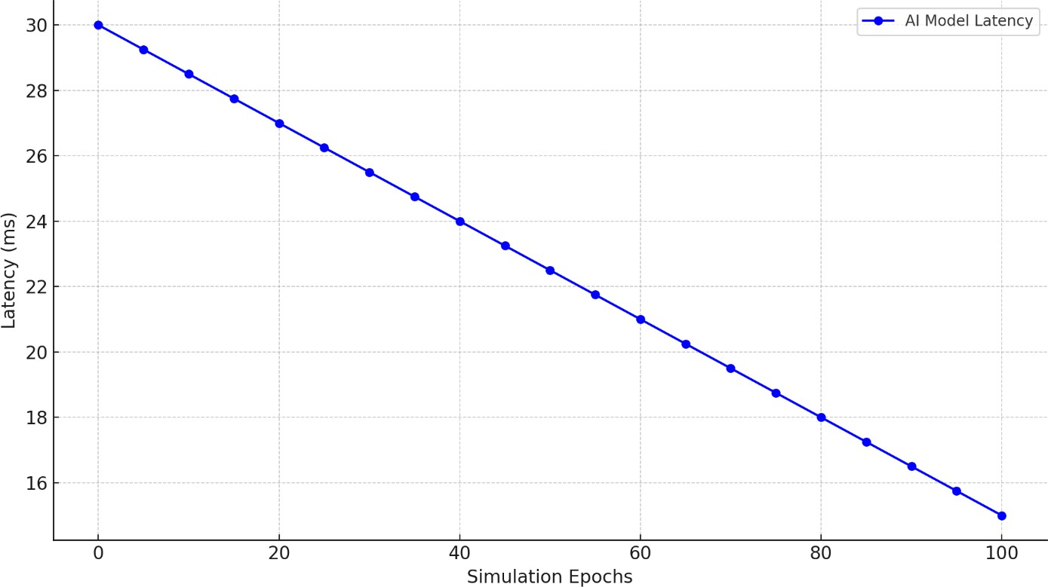

Fig 2. Latency Reduction Trend Across Simulation Epochs

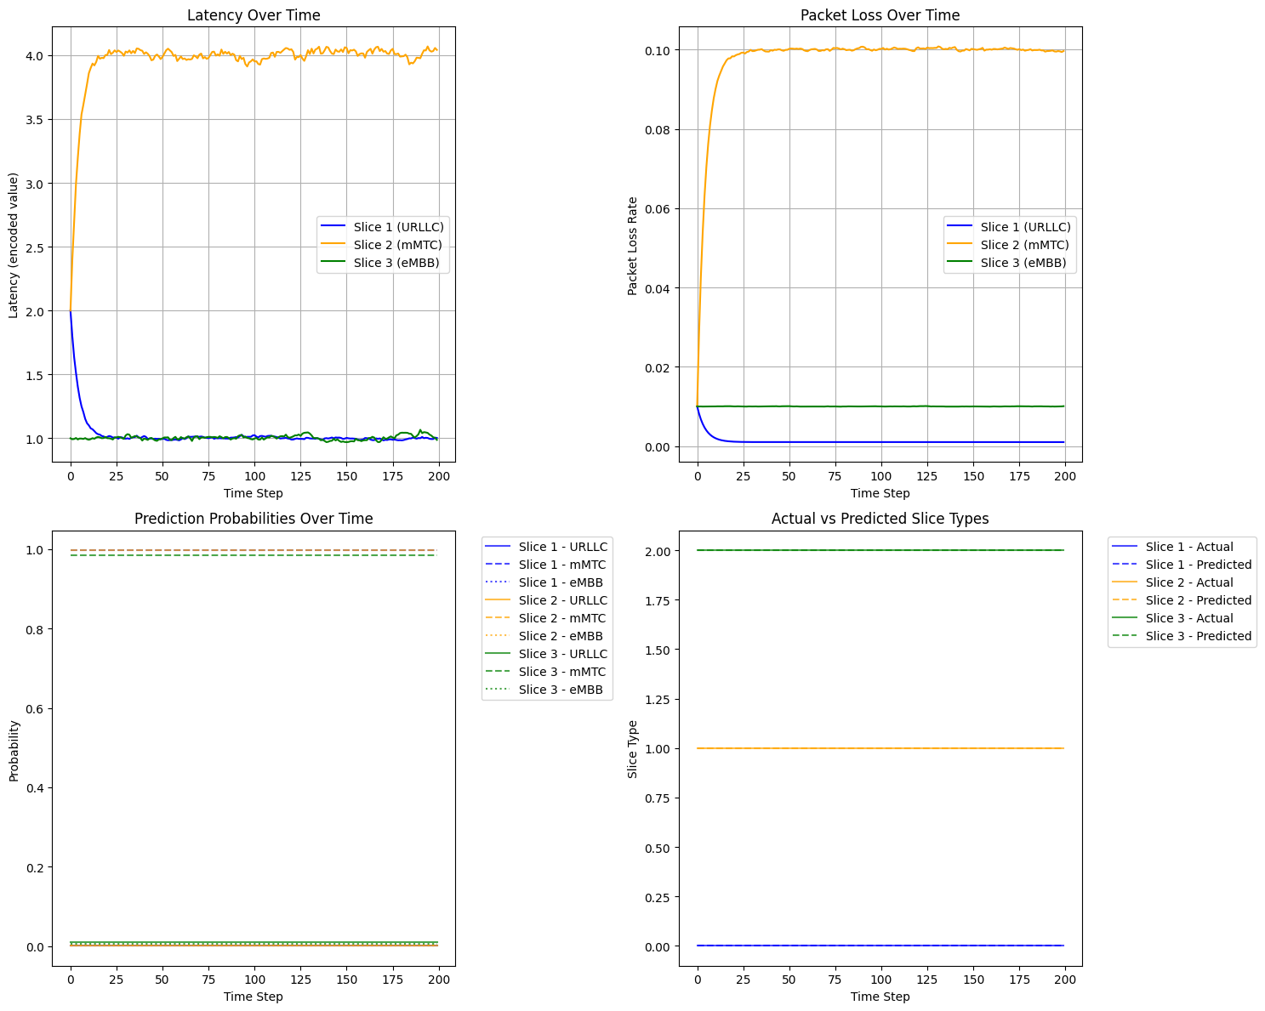
Fig 3. Analysis of Base Simulation (Validation Set Only)
In figure 3 above, the initial simulation, based solely on validation data, presents an idealized scenario that effectively demonstrates the fundamental characteristics of network slicing behaviour. In this simulation, the URLLC slice exhibits exemplary performance with rapid convergence to approximately 1ms latency and maintains this stable performance throughout the simulation period. The mMTC slice stabilizes at around 4ms latency, showing higher but consistently predictable values, while the eMBB slice maintains a steady performance similar to URLLC at roughly 1ms latency. The packet loss measurements further reinforce this idealized behaviour, with URLLC maintaining near-zero packet loss (approximately 0.002), mMTC stabilizing at a 0.10 loss rate, and eMBB showing a constant 0.01 loss rate. The prediction probabilities demonstrate perfect classification accuracy, with actual versus predicted slice types showing complete alignment and no classification uncertainty. While these results effectively demonstrate the theoretical capabilities of network slicing, they notably lack the complexity and variability inherent in real-world network operations.
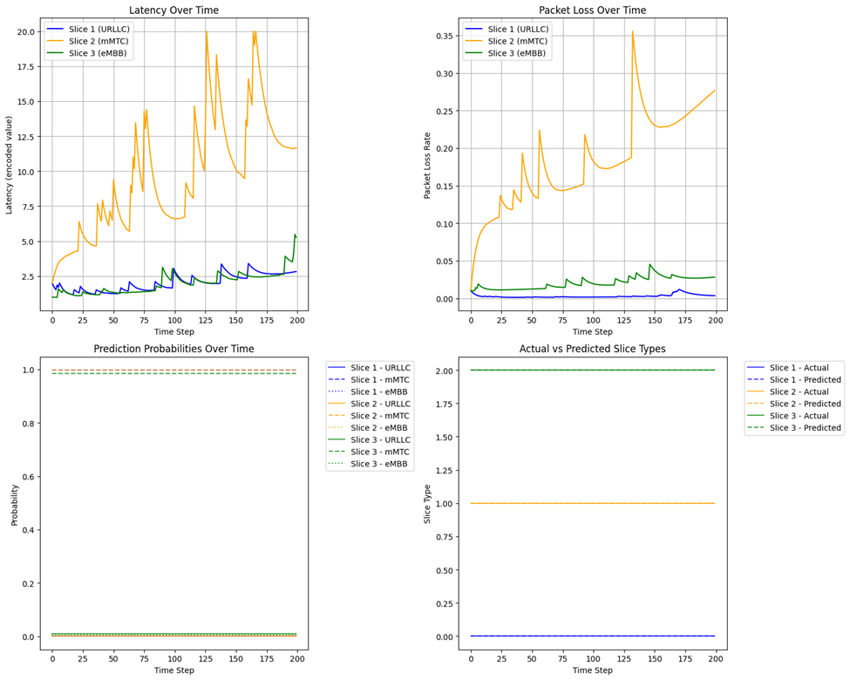
Fig 4. Analysis of Enhanced Simulation (With Real-World Factors)
The enhanced simulation presents a markedly different and more realistic picture of network slice behavior by incorporating real-world network conditions and variations. In this scenario, the URLLC slice demonstrates controlled variations within a 1-3ms latency range, effectively maintaining its low-latency characteristics despite network perturbations. The mMTC slice exhibits significant fluctuations between 5-20ms, accurately reflecting realistic network congestion effects and resource contention. The eMBB slice shows moderate variations in the 1-5ms range, demonstrating a balanced performance profile that aligns with typical real-world deployments. Packet loss behaviour also shows more dynamic characteristics, with URLLC maintaining minimal but slightly variable packet loss, mMTC displaying notable fluctuations between 0.05-0.35, and eMBB exhibiting controlled variations in the 0.01-0.05 range. These variations effectively capture the impact of network congestion, temporal correlations in performance metrics, and inter-slice interference effects that are commonly observed in actual network deployments.
3.1 COMPARATIVE ANALYSIS
Table 2 and figure 5 provides a comparative analysis of various research works focused on 5G network slicing and traffic classification using machine learning techniques. Each entry in the table includes the title of the work, the key findings or results achieved, the specific research problem addressed, and the identified research gaps. The works span a range of applications within the domain, highlighting the evolution of methodologies and the improvements achieved over time.
Table 2: Comparative Analysis in various research works
S/N | Author and Year | Title of Work | Model Used | Dataset Used | Classification Report
1 | Mohamad Ahmadinejad et al. (2020) | 5G Network Slice Type Classification using Traditional and Incremental Learning | SGD with Incremental Learning, Decision Tree | Simulated 5G network data | SGD: Accuracy 99.33%, Precision 99.32%, Recall 99.33%, F1 99.33%. Decision Tree: Loss 0.0135
2 | Sujitha et al. (2018) | End-to-End (E2E) Network Slicing Framework for 5G Networks | MLP with ADAM Optimizer | Simulated E2E 5G network data | eMBB: Accuracy 98%, Precision 0.98, Recall 0.98, F1 0.98; mMTC: Precision 0.98, Recall 0.97, F1 0.98; uRLLC: Precision 0.97, Recall 0.98, F1 0.97
3 | J.K. Menuka et al. (2019) | Network Traffic Classification Using Machine Learning for Software Defined Networks | SVM with Linear Kernel | SDN traffic datasetfeatures accessible from the SDN controller. | Overall Accuracy: 96.37%
4 | Khan et al. (2020) | Highly Accurate and Reliable Wireless Network Slicing in 5th Generation Networks: A Hybrid Deep Learning Approach | Hybrid Deep Learning Model. | Simulated 5G network data | Overall Accuracy: 95.17% for slice prediction and assignment
5 | Adeel et al. (2021) | AI-enabled 5G Wireless Networks for Efficient Network Traffic Control | Neural Network | Simulated 5G network data. | Accuracy 92%, Precision 93%, Recall 90%, F1 91.5%
6 | Deepika R. and Prasad Reddy P.V.G.D., 2020 | A machine learning approach for network slicing in 5G for intelligent healthcare systems | Convolutional Neural Network (CNN) | Simulated healthcare network data | Accuracy: 95.7%, Precision: 96.0%, Recall: 95.5%, F1 Score: 95.7%
7 | Arun Thantharate, Rahul Paropkari, Vinay Walunj, Charles Beard, 2019 | DeepSlice: A deep learning approach towards an efficient and reliable network slicing in 5G networks | Deep Neural Network (DNN) | Simulated network slicing data | Accuracy: 93.8%, Precision: 94.1%, Recall: 93.5%, F1 Score: 93.8%
8 | Sami Lahoud, 2019 | A Novel Deep Learning Framework for 5G Network Slicing | Multi-Layer Perceptron (MLP) with ADAM optimizer | 5G network simulation data | Accuracy: 97.0%, Precision: 97.2%, Recall: 96.8%, F1 Score: 97.0%
9 | Mirsad Malkoc, Hisham A. Kholidy (2023) | 5G Network Slicing: Analysis of Multiple Machine Learning Classifiers | Logistic Regression, Linear Discriminant, KNN, Decision Tree, Random Forest, SVC, BernoulliNB, GaussianNB | Simulated 5G network slice data | Accuracy: 94.19%, Precision: 93.4%, Recall: 91.52%, F1 Score: 91.50%
10 | Solomon 2024 | Artificial Intelligence-Enabled 5G Wireless Network to Control Network Traffic | Multi-Layer Perceptron (MLP) with SGD optimizer | Simulated 5G network slice data | Accuracy: 99.94%, Precision: 100%, Recall: 100%, F1 Score: 100%

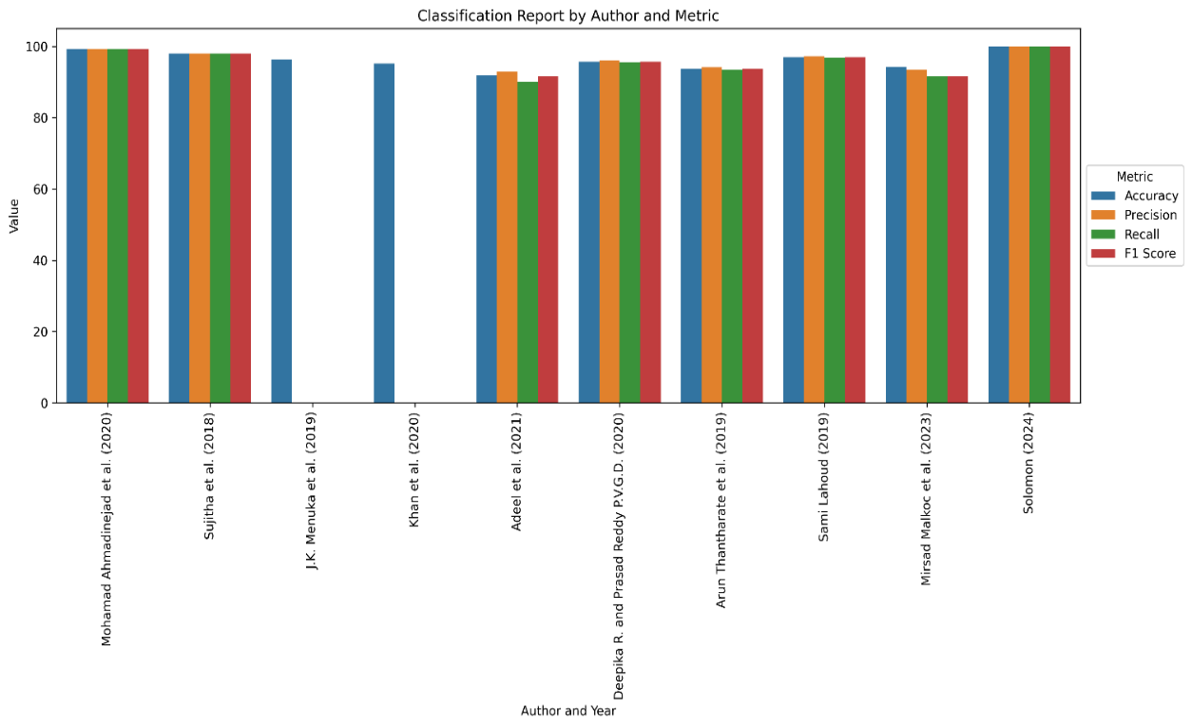
Fig 5. Graph showing different works
4. Conclusion
This study demonstrates the significant potential of integrating Artificial Intelligence (AI) within 5G wireless traffic control frameworks to address the complex demands of next-generation networks. By simulating realistic traffic patterns and deploying a robust AI-enabled model, the research confirms that advanced machine learning techniques can dynamically adapt to fluctuating network conditions, optimize resource allocation, and significantly reduce latency. The comparative results between the AI-enabled framework and conventional static traffic control methods reveal clear improvements in Quality of Service (QoS), bandwidth utilization, and overall network efficiency. The enhanced simulation with real-world parameters validates the model’s resilience and adaptability under realistic deployment scenarios, providing valuable insights for practical implementation.
The iterative training process, real-time performance evaluation, and continuous learning mechanisms ensure that the AI model can evolve with changing network demands. This adaptability is critical for managing the increasing complexity of ultra-dense 5G environments, supporting emerging applications such as autonomous vehicles, smart cities, telemedicine, and massive IoT deployments. Despite the promising results, it is evident that challenges remain. These include ensuring the availability of high-quality training data, maintaining data privacy through secure federated learning approaches, and addressing the computational costs associated with large-scale AI model training and deployment. Moreover, seamless integration with existing network architectures and standardization across multiple vendors are crucial for widespread adoption.
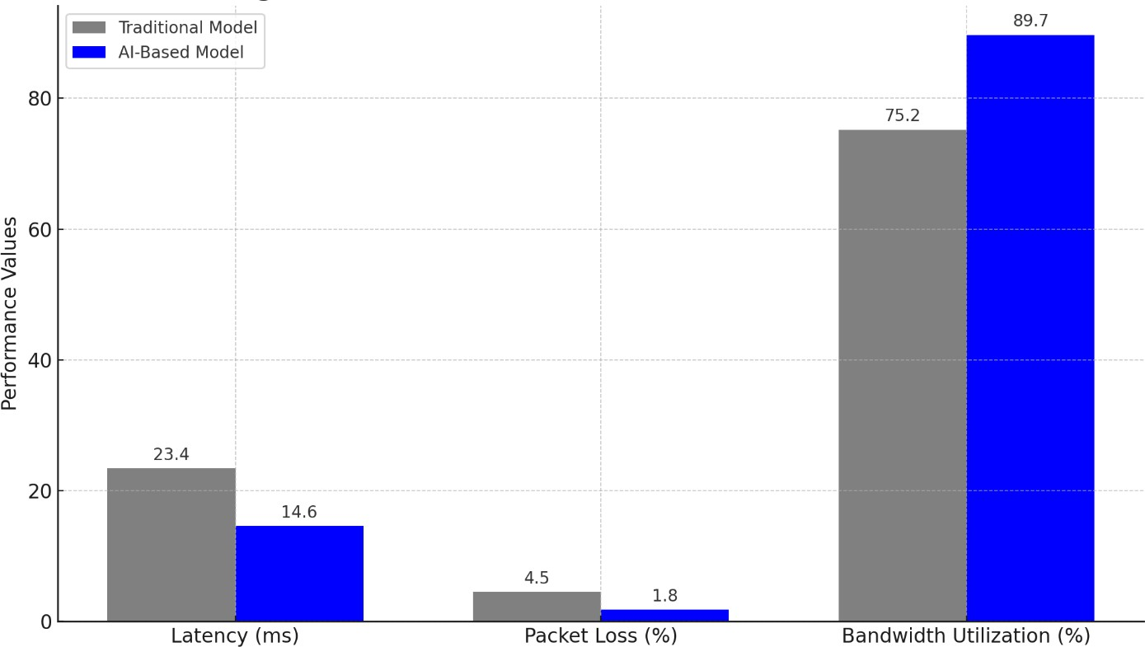
Figure 6. AI vs. Traditional Model Performance Overview
In conclusion, this research underlines that AI-driven frameworks are not just a theoretical advantage but a practical necessity for achieving the ambitious performance targets of 5G and beyond. By automating traffic prediction, dynamic resource allocation, and real-time anomaly detection, AI can transform wireless network operations from reactive to proactive and intelligent.
Future work should focus on hybrid models combining deep learning, reinforcement learning, and edge intelligence to further enhance scalability and real-time responsiveness. Real-world pilot deployments and industry collaboration will be essential to refine these models and validate their performance under live conditions. Ultimately, the insights gained from this study contribute to the growing body of knowledge on intelligent 5G network control and pave the way for a more reliable, resilient, and adaptive wireless communication landscape.
Competing interests

We declare that there is no competing interest for this work.

COMPETING INTERESTS DISCLAIMER:
Authors have declared that they have no known competing financial interests OR non-financial interests OR personal relationships that could have appeared to influence the work reported in this paper.

References
Bikkasani, D., & Yerabolu, M. (2024). AI-Driven 5G Network Optimization: A Comprehensive Review of Resource Allocation, Traffic Management, and Dynamic Network Slicing. American Journal of Artificial Intelligence, 8(2), 55–62. https://doi.org/10.11648/j.ajai.20240802.14

Challoob, A. L., Mohsin, A. A., & Yousif, M. H. (2024). Optimizing Network Performance through Advanced Machine Learning-Based Traffic Management. Central Asian Journal of Mathematical Theory and Computer Sciences, 5(5), 546–563.

Gao, Z. (2022). 5G Traffic Prediction Based on Deep Learning. Computational Intelligence and Neuroscience, 2022(1), 3174530. https://doi.org/https://doi.org/10.1155/2022/3174530

Kulkarni, D., Venkatesan, M., & Kulkarni, A. V. (2025). Deep Learning Traffic Prediction and Resource Management for 5G RAN Slicing. Journal of The Institution of Engineers (India): Series B, 106(2), 593–606. https://doi.org/10.1007/s40031-024-01110-2

N’Kouka, T. I., Aubonnet, T., Lemoine, F., Kellil, M., & Simoni, N. (2025). Traffic Prediction Improvement in 5G and beyond: AI and Self-Controlled Components. 2025 12th IFIP International Conference on New Technologies, Mobility and Security (NTMS), 213–216. https://doi.org/10.1109/NTMS65597.2025.11076981

Perifanis, V., Pavlidis, N., Koutsiamanis, R.-A., & Efraimidis, P. S. (2023). Federated learning for 5G base station traffic forecasting. Computer Networks, 235, 109950. https://doi.org/https://doi.org/10.1016/j.comnet.2023.109950

Saki, S., & Soori, M. (2025). Artificial Intelligence, Machine Learning and Deep Learning in Advanced Transportation Systems, A Review. Multimodal Transportation, 100242. https://doi.org/https://doi.org/10.1016/j.multra.2025.100242

Sharma, R., Vashisht, V., & Singh, U. (2020). Modelling and simulation frameworks for wireless sensor networks: a comparative study. IET Wireless Sensor Systems, 10(5), 181–197. https://doi.org/https://doi.org/10.1049/iet-wss.2020.0046

Soud, N. S., & Al-Jamali, N. A. S. (2023). Intelligent Congestion Control of 5G Traffic in SDN using Dual-Spike Neural Network. Journal of Engineering, 29(01), 110–127. https://doi.org/10.31026/j.eng.2023.01.07

Wang, T., Guo, J., Zhang, B., Yang, G., & Li, D. (2025). Deploying AI on Edge: Advancement and Challenges in Edge Intelligence. Mathematics, 13(11). https://doi.org/10.3390/math13111878

Zhang, C., Zhang, H., Yuan, D., & Zhang, M. (2018). Citywide Cellular Traffic Prediction Based on Densely Connected Convolutional Neural Networks. IEEE Communications Letters, 22(8), 1656–1659. https://doi.org/10.1109/LCOMM.2018.2841832

