Research on LiDAR-based SLAM Mapping in Open-pit Coal Mine Environments

Abstract: With the rapid advancement of mobile robot technology and the development of mine intelligence, SLAM has become the core technology for autonomous navigation of unmanned mine trucks and inspection robots. The open-pit coal mine environment is characterized by complex terrain, dust interference, varying lighting conditions, and numerous dynamic obstacles, which pose significant challenges to the accuracy and robustness of SLAM systems. Due to its advantages of high-precision ranging and insensitivity to lighting, LiDAR has been widely used in mapping and positioning in mining areas. This paper reviews the current status, key technologies, application cases, and future development trends of LiDAR SLAM technology in open-pit coal mine environments. It analyzes the adaptability and limitations of existing algorithms in mining areas and provides an outlook on future directions such as multi-sensor fusion, intelligence, and large-scale collaborative applications.

Keywords: Open-pit coal mine; LiDAR; SLAM; Autonomous navigation; Unmanned mining truck

1 Introduction
With the rapid development of technologies such as artificial intelligence, mobile robots, and autonomous vehicles, SLAM has gradually become a crucial component in intelligent mobile equipment. Its core task is to perform real-time localization using onboard sensors while simultaneously constructing environmental maps in unknown environments, thereby laying the foundation for subsequent path planning and autonomous navigation[1].
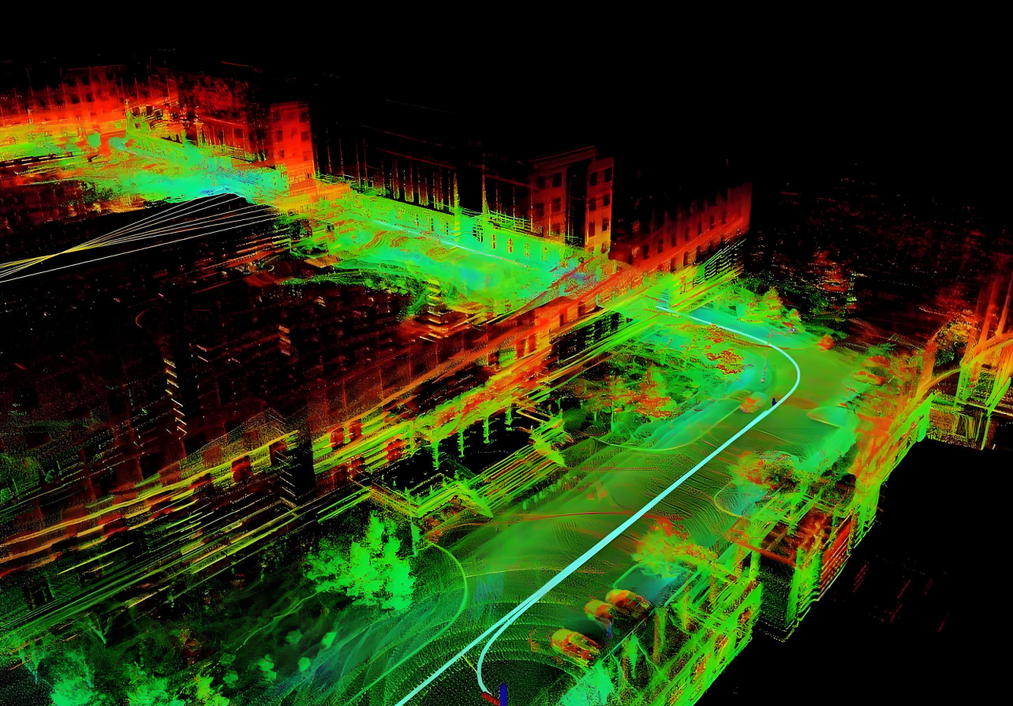
Figure 1 SLAM 3D mapping
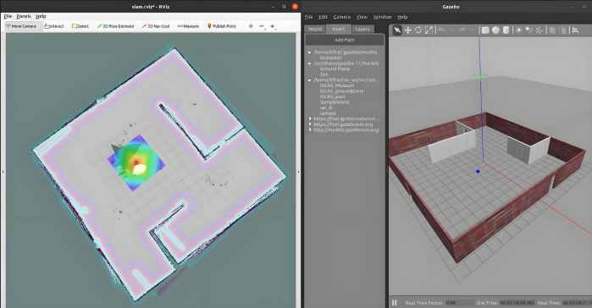
Figure 2 SLAM 2D mapping
In recent years, LiDAR-based SLAM methods have received widespread attention in robot navigation research due to their advantages such as high geometric accuracy, insensitivity to lighting conditions, and ability to generate dense point clouds. As an important energy mining scenario, open-pit coal mines have large operational areas and complex terrain conditions, urgently needing to promote intelligent transformation. Traditional mining area transportation mostly relies on manual driving, often facing problems such as high labor intensity, limited operational efficiency, and high personnel safety risks. If LiDAR SLAM technology can be applied to unmanned mining trucks and inspection robots[2], it is expected to achieve autonomous navigation, significantly improving the safety and production efficiency of mining operations.
However, compared to urban roads or indoor scenes, open-pit coal mine environments have large terrain undulations, unstructured road surfaces, high dust concentrations, and GPS signals that are susceptible to occlusion or reflection. These factors place higher demands on SLAM positioning accuracy and mapping completeness. Therefore, research on LiDAR SLAM technology for open-pit coal mine environments has important theoretical and engineering significance [13-16].
This article review the research progress of LiDAR SLAM in open-pit coal mine environments in recent years, analyze the adaptability and improvement directions of different algorithms in mining areas, discuss technical challenges, and look forward to future development trends.

2 Characteristics and Challenges of Open-Pit Coal Mine Environments
The operating environment of open-pit coal mines is complex and variable, which poses numerous challenges for SLAM technology in practical applications. Compared to the regular environments of urban roads or indoor experimental scenarios, open-pit coal mines are more open, with significant terrain undulations, high dust concentrations, and numerous dynamic targets [17-20]. These factors not only increase the difficulty of sensor perception and positioning but also place higher demands on the stability and real-time performance of SLAM systems. Overall, its main characteristics and technical difficulties can be summarized in the following aspects.

2.1 Complex and varied terrain
Open-pit mining areas often cover vast areas with complex and diverse terrain conditions, including large open areas as well as significant elevation differences, steep slopes, and stepped mining structures[3]. Mine roads are mostly unpaved, often accompanied by gravel, soil, and potholes, causing severe bumps and vibrations when mine carts or robots are moving. This unstable motion causes jitter and distortion in LiDAR point cloud data, reducing the accuracy of feature extraction and point cloud matching. At the same time, frequent changes in vehicle attitude accelerate the accumulation of odometry errors, which in turn affects the positioning accuracy and mapping consistency of SLAM. The problem of positioning drift is particularly prominent in large-scale, long-term continuous transportation operations, making it necessary to introduce high-precision inertial navigation and global constraint mechanisms for correction.
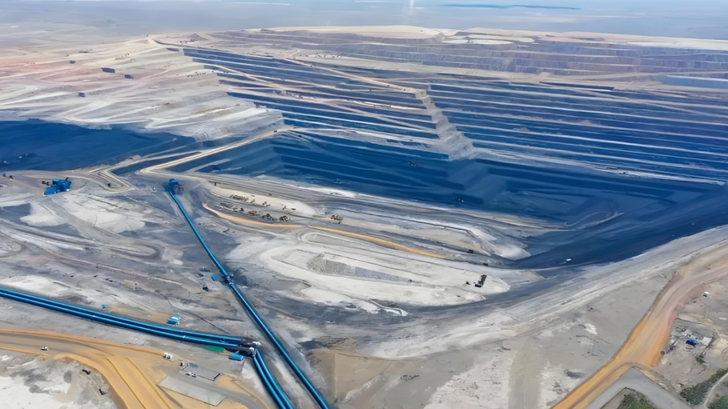
Figure 3 Open-pit coal mine topography

2.2 Dust and Environmental Interference
In the blasting, excavation, and transportation processes of open-pit coal mines, a large amount of dustates in the air, causing significant interference to the ranging and reflection signals of LiDAR[4]. High-concentration dust not only easily introduces noise points and invalid points in point cloud data but may also generate false obstacles, thereby reducing the accuracy of feature extraction and pose estimation.
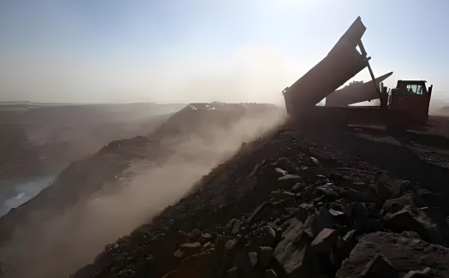
Figure 4Open-pit coal mineDust
Meanwhile, weather conditions in outdoor environments also affect sensor performance: strong sunlight on clear days enhances surface reflection, reducing detection stability; while rainy or snowy weather causes laser signal attenuation and even partial obstruction. When these environmental factors are combined, the SLAM system must have stronger point cloud filtering and data preprocessing capabilities to ensure the reliability of mapping and localization[5].

2.3 Insufficient location information
Although open-pit coal mines have better access to satellite navigation signals compared to underground mines, GPS signals often suffer from multipath effects, occlusion, and even temporary failure in deep pits, slope areas, or regions with dense large equipment, leading to unstable positioning information. If SLAM systems rely solely on LiDAR for pose estimation, they are prone to cumulative errors in large-scale operational environments and cannot provide long-term stable global constraints, causing gradual map distortion. How to effectively fuse LiDAR with multiple sensors such as GNSS and IMU to achieve high-precision multi-source information complementarity is one of the key issues that SLAM technology urgently needs to solve in open-pit coal mine environments. At the same time, clock synchronization and calibration accuracy between sensors are also important factors affecting the overall system performance.

2.4 Dynamic Target Interference
Open-pit coal mines are typical dynamic operational environments where the frequent movement of mining trucks, excavators, loaders, and personnel introduces a large amount of dynamic information into the LiDAR point cloud. If SLAM algorithms continue to operate under the assumption of static scenes, they are easily disturbed, leading to positioning drift, map distortion, and even mapping failure. For example, a moving mining truck might be mistakenly identified as a static structure in multiple laser frames and incorrectly incorporated into environmental feature points. To address this issue, it is necessary to identify and remove dynamic points in real-time, or develop SLAM methods that maintain robustness in dynamic environments. Currently, techniques combining semantic segmentation with point cloud differential are gaining attention, but their adaptability and practicality in large-scale, highly dynamic scenarios like mining areas still require in-depth research.

2.5 Security and Real-time Requirements
Mining operations require extremely strict safety standards, as any positioning error could cause mine carts to deviate from their intended routes, lead to collisions, or even trigger serious accidents. Therefore, SLAM systems must maintain high stability and reliability under complex conditions, ensuring continuous output of precise position estimates. At the same time, mine carts and inspection robots often handle transportation and operational tasks, placing high demands on system real-time performance: they must achieve high localization and mapping accuracy while ensuring low latency and rapid response. Balancing accuracy with real-time performance is both a challenge in algorithm design and a core challenge that must be addressed in the engineering application of SLAM.

2.6 Summary
Overall, SLAM technology in open-pit coal mine environments requires targeted optimization in multiple aspects. For complex terrain, IMU assistance and robust point cloud matching methods should be introduced to reduce the impact of rapid pose changes; In dusty and harsh weather conditions, point cloud filtering and data augmentation need to be relied upon to improve perception reliability; In terms of global consistency, multi-sensor fusion is an effective way to alleviate positioning drift; In dynamic scenes, dynamic point detection and semantic recognition can enhance system robustness; In terms of safety and real-time performance, lightweight algorithm design and parallel computing frameworks are needed to achieve the unification of high precision and high efficiency.

3 Current Status of LiDAR SLAM Technology Development

3.1 Filter-based SLAM
Filtering methods were the mainstream in early SLAM, with typical representatives including Extended Kalman Filter and FastSLAM. Among them, EKF-SLAM is based on state space models and jointly estimates robot pose and feature point positions in the map through recursive methods. This method performs stably in small-scale, structurally regular, and relatively static environments, possessing good theoretical integrity and implementation maturity. FastSLAM, on the other hand, is based on particle filtering ideas, decomposing robot pose estimation and feature point state estimation, thereby alleviating the computational burden brought by high-dimensional state space to some extent, making the algorithm superior to EKF-SLAM in terms of scalability and flexibility.
However, when applying filtering methods to open-pit coal mine environments, their adaptability is somewhat limited. Firstly, since filtering methods inherently rely on linear approximations and feature matching, accumulated linearization errors gradually amplify in large-scale, open mining environments, causing significant drift in global positioning results. Secondly, open-pit coal mines often feature large elevation differences and irregularly shaped obstacles, making it difficult for filters to maintain estimation accuracy and consistency under complex terrain conditions.
Additionally, the unique dust, smoke, and dynamic working vehicles in mining areas introduce numerous noise points and dynamic points into LiDAR data, further exacerbating the instability of filtering estimation. These issues cause a significant decrease in the robustness of filtering methods in mining scenarios. Overall, filter-based SLAM is more suitable as a tool for small-range inspections, local mapping, or auxiliary positioning, rather than for achieving stable real-time navigation and large-scale mapping across the entire mining area.

3.2 Graph Optimization-based SLAM
Graph optimization methods have been an important direction in SLAM research in recent years. The core idea is to construct a graph structure composed of nodes and constraint edges, where nodes typically represent robot poses or feature points in the environment, while constraint edges are provided by odometry information, sensor observation data, or loop detection results. Based on this, the algorithm uses least squares or nonlinear optimization methods to solve the entire graph globally, thereby obtaining more consistent pose and map estimates. Typical implementations include G2O, gtsam, and the Cartographer system proposed by Google, which have been widely used in both academic research and practical applications.
In open-pit coal mine environments, graph optimization methods demonstrate significant advantages. Firstly, due to their ability to uniformly optimize global constraints, they exhibit strong resistance to cumulative error in large-scale, open scenes, effectively mitigating the problem of pose drift during long-term operation. Secondly, graph optimization methods inherently support loop closure detection, allowing robots to enhance map consistency and precision when revisiting previously explored areas during矿区 cruises. Additionally, this approach can flexibly fuse multi-source sensor data, such as LiDAR, IMU, and GPS, thereby constructing more robust and accurate maps in complex mining environments.
Nevertheless, graph optimization methods still face certain challenges in open-pit mining scenarios. Firstly, they have significant computational overhead, especially when the mining area's point cloud data is dense and the map scale is large. The optimization process may lead to insufficient real-time performance, making it difficult to meet online navigation requirements. Secondly, dynamic obstacles frequently appear in mining areas, such as transport vehicles, excavation machinery, and working personnel. These dynamic targets introduce numerous unstable constraint edges, affecting the convergence and stability of the graph optimization results. Therefore, it is necessary to effectively filter or weight dynamic point cloud data in the front-end processing to ensure the accuracy and robustness of the graph optimization process.

3.3 SLAM Based on Sparse/Dense Point Clouds
In recent years, sparse/dense point cloud methods represented by LOAM (LiDAR Odometry and Mapping) have achieved high-precision mapping by extracting LiDAR point cloud features (such as edge points and plane points) for odometry estimation and combining with map optimization. Derived methods such as LeGO-LOAM and LIO-SAM further integrate IMU data to improve motion estimation stability.
Application analysis in coal mine environments: The LOAM series of algorithms demonstrate strong adaptability to terrain undulation and unstructured environments, making them suitable for scenarios with rugged mine roads and unevenly distributed rubble;They are sensitive to dust and noise, requiring additional filtering or point cloud downsampling;When fused with IMU, they can effectively mitigate positioning drift caused by high-speed movement or bumpy conditions.

3.4 Multi-sensor Fusion SLAM
To address the issues of intermittent GPS signals, numerous dynamic obstacles, and harsh environments in open-pit mining areas, scholars have proposed SLAM methods that fuse LiDAR with other sensors[6],as shown in the table below:
Table 1 Comparison of Typical Multi-sensor Fusion Schemes in Open-pit Coal Mine Environment
Integration method | Main function | Advantage | Limitations
LiDAR + IMU | Using IMU to provide high-frequency pose prediction, enhancing robustness in dynamic scenes | Improve pose estimation accuracy and mitigate laser loss caused by rapid movement or temporary occlusion | IMU has zero bias and drift, requiring long-term tight coupling correction with LiDAR
LiDAR + GNSS | Provide global constraints in open areas to reduce drift accumulation | Enables global consistent positioning, suitable for large-scale inspections and mining area map construction | Failure in tunnels, slopes, or areas with severe GNSS signal obstruction
LiDAR + Camera | Using visual semantic information to assist in feature point recognition, such as identifying dynamic obstacles like mine carts and equipment | Enhance feature recognition capabilities, improve map accuracy and environmental understanding, and support semantic-level SLAM | Greatly affected by lighting and dust; spatiotemporal calibration between camera and LiDAR is complex
Overall Advantages | Improve the system's adaptability to complex environments; enhance map accuracy and positioning stability; suitable for large-scale inspection and transportation tasks
Overall Limitations | High complexity of fusion algorithms and large computational overhead; increased difficulty in sensor calibration and synchronization; observation anomalies still occur under extreme conditions

4 Key Technologies of Laser SLAM in Open-Pit Coal Mine Environments
The environment of open-pit coal mines is complex, and SLAM systems face challenges such as dust, dynamic objects, terrain, and large-scale drift in practical applications. Therefore, achieving high-precision and robust LiDAR SLAM in mining environments requires targeted optimization of core technologies. The following provides a detailed analysis of these key technologies.

4.1 Point Cloud Filtering and Preprocessing
Raw point clouds collected by LiDAR typically contain a large number of noise points, especially in open-pit coal mining operations with high dust concentration, where this noise can significantly affect the stability and mapping accuracy of SLAM systems. Therefore, effective filtering and preprocessing of point cloud data are particularly crucial. Common methods include voxel grid filtering, statistical filtering, and dynamic region removal. Voxel grid filtering works by dividing the point cloud into voxels of fixed size and selecting the center point or mean point within each voxel, effectively reducing point cloud density while preserving the overall geometric structure and reducing computational overhead. Statistical filtering utilizes statistical properties of point neighborhoods to identify and remove isolated points and outliers, effectively filtering out noise caused by dust and environmental interference. Dynamic region removal methods, based on temporal characteristics of the point cloud, identify abnormal points caused by the movement of mining trucks, equipment, or personnel and remove them before mapping to ensure map consistency and accuracy.
Overall, point cloud filtering and preprocessing not only reduce interference from noise in feature extraction and matching, improving the stability of odometry estimation and loop detection, but also decrease the computational load during the mapping process.由此可见，point cloud filtering plays a crucial role in complex environments like open-pit coal mines, providing essential guarantees for the stable operation of SLAM systems under harsh conditions.

4.2 Loop Detection and Global Optimization
The vast area of open-pit mines can easily lead to cumulative errors in SLAM systems during long-distance inspections, while loop closure technology enables global map optimization by identifying areas the robot has already visited. Common methods include feature descriptor-based matching, such as Scan Context and SegMatch, which achieve fast loop closure by extracting and comparing point cloud feature descriptors; and graph optimization methods, which introduce detected loop closure constraints into the optimization graph and use nonlinear least squares to correct global poses[7].
Practice has shown that loop closure detection can significantly improve the consistency of large-scale mapping in open-pit mining areas, effectively suppressing the continuous accumulation of odometry errors in complex terrains with high and low elevations and curved roads, thereby enhancing the overall mapping accuracy and stability.

4.3 Dynamic Obstacle Handling
Open-pit mining areas contain numerous dynamic targets such as mining carts, excavators, and workers. These dynamic obstacles can interfere with the point cloud matching process and destroy map consistency, so they must be specially handled in SLAM systems[8]. Common methods include time-difference-based dynamic point elimination, which identifies and removes moving points by comparing consecutive point cloud frames; semantic segmentation-based dynamic object recognition, using cameras or deep learning algorithms to detect and segment dynamic objects like mining carts and personnel; and weight optimization strategies, which assign lower weights to points that may belong to dynamic objects, thereby reducing their impact on pose estimation results.
Practice has shown that these dynamic obstacle handling strategies can significantly improve the stability of mapping and positioning accuracy, providing important guarantees for the safe and efficient operation of unmanned mining trucks in complex open-pit mining environments.

4.4 Map Representation Methods
Map representation methods affect the accuracy, storage, and computational efficiency of SLAM systems. Commonly used map types in mining applications include:
Dense point cloud map: Retains high-precision point clouds, suitable for fine measurements and obstacle avoidance, but with large storage overhead.
Grid-based map representation: Uses grids to represent traversable areas, suitable for path planning and real-time obstacle avoidance.
Topology map: Only stores node and path relationships, with small storage requirements, suitable for large-scale mining area inspection tasks.

4.5 Real-time and Lightweight Optimization
Autonomous vehicles and inspection robots in mining areas have extremely high requirements for the real-time performance of SLAM systems, so algorithm design must ensure accuracy while considering computational efficiency. Common optimization strategies include point cloud downsampling and feature sparsification, which accelerate pose calculation speed by reducing the number of points involved in matching; local map update strategies that optimize only the current local area, effectively reducing the computational burden of global optimization; and hardware acceleration and parallel computing methods that leverage GPUs or multi-threading to process point clouds in parallel, significantly improving real-time performance.
Through these measures, the SLAM system can ensure high positioning accuracy in complex mining environments while meeting the strict low-latency requirements of unmanned vehicles and robots.

5 Application Cases and Research Progress
In recent years, with the development of smart mine construction, significant progress has been made in the research and application of LiDAR-based SLAM technology in open-pit coal mine environments. This chapter will provide a comprehensive review from three aspects: foreign mining areas, domestic mining areas, and typical algorithm applications.

5.1 Application of SLAM in Foreign Open-Pit Mines
Abroad, some large mining companies have pioneered the application of autonomous mining trucks and intelligent inspection systems. Among them, Caterpillar's autonomous mining trucks are equipped with a SLAM system based on the fusion of LiDAR and IMU, enabling high-precision autonomous navigation and path planning[9]. In situations where mining roads have significant elevation differences and unstructured terrain, the system maintains navigation stability through local map updates and dynamic obstacle elimination techniques. Meanwhile, the system incorporates loop detection and graph optimization mechanisms, effectively ensuring map consistency and accuracy during long-distance inspection missions.
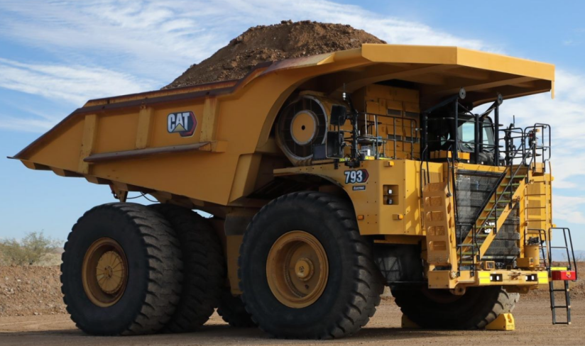
Figure 5 Caterpillar mining truck
Komatsu has developed a complete mining automation system that uses multi-sensor SLAM technology combining LiDAR, IMU, and GPS to achieve autonomous transportation capabilities in large-scale mining areas. The system can dynamically identify targets such as mining trucks and construction equipment in real-time, thereby improving the safety of mining operations. Notably, Komatsu's solution demonstrates strong robustness in the bumpy roads and dusty environments common in open-pit mining areas, proving its feasibility for engineering implementation[10].
In summary, it is evident that foreign mines have already formed relatively mature engineering solutions in the field of unmanned autonomous vehicle navigation and intelligent inspection. The application of SLAM technology in large-scale open-pit mining areas has been initially implemented and has demonstrated high practical value and application prospects, providing important references for related research and industrial development in our country.

5.2 Application of Intelligence in Open-Pit Coal Mines in China
In recent years, with the growing demand for intelligent transformation in the domestic mining industry, some mines have begun to explore the practical application of inspection robots based on LiDAR and unmanned transport vehicles. In terms of unmanned inspection robots, SLAM systems that fuse LiDAR and IMU are commonly used to perform road inspection and slope monitoring tasks in mining areas. By combining point cloud filtering and dynamic obstacle elimination techniques, the system can maintain stable operation in complex environments with high dust concentration and significant lighting variations. At the same time, these robots typically support the generation of occupancy grid maps, providing an effective data foundation for subsequent path planning and task scheduling.
In the field of unmanned mining trucks, some domestic applications are based on advanced algorithms such as LOAM or LIO-SAM, enabling high-precision mapping and autonomous navigation. In large-scale mining area transportation tasks, the system effectively suppresses the spread of cumulative errors through loop detection and graph optimization methods, thereby ensuring the reliability of long-distance transportation operations. Meanwhile, multi-sensor fusion technology has also been widely introduced, enabling the system to demonstrate better adaptability and robustness in complex scenarios such as slopes, gravel roads, and environments with dynamic obstacles.
Overall, domestic application practices indicate that as SLAM algorithms continue to be optimized and hardware performance gradually improves, the practical deployment of LiDAR-based SLAM technology in open-pit mining areas is gradually becoming feasible. However, compared to mature engineering solutions abroad, China still faces issues such as insufficient real-time performance and limited adaptability to complex environments. Future breakthroughs are needed in areas such as algorithm lightweighting, sensor fusion, and intelligent perception.

5.3 Comparison of Typical Algorithms in Coal Mine Environments
According to existing research and experimental results, common SLAM algorithms applied in open-pit coal mine environmentsapplication[11],as shown in the followingtable:
Table 2 Common SLAM Algorithms
Algorithm Category | Representative algorithm | Mining area adaptability | Advantages | Disadvantages
Filtering methods | EKF-SLAM, FastSLAM | Limited area inspection | Simple calculation | Wide drift is noticeable, sensitive to dynamic obstacles
Graph optimization methods | Graph-SLAM、Cartographer | Medium to large mining areas | Global consistency is good, supports loop closure detection | High computational load, dynamic targets require additional processing
Sparse/Dense Point Cloud | LOAM、LeGO-LOAM、LIO-SAM | The mining roads are rugged | Strong adaptability to terrain variations, high precision | Sensitive to dust, requires filtering, high computational load
Multi-sensor fusion | LiDAR+IMU/GNSS/Camera | Large-scale mining areas, dynamic environments | High robustness, minimal drift | The system is complex with high requirements for sensor calibration and synchronization

6 Development Trends and Challenges
As the intelligent transformation of open-pit coal mines advances, LiDAR-based SLAM technology is encountering new development opportunities while also facing multiple challenges in environmental complexity and engineering applications. Overall, its development trends are mainly reflected in three aspects: improved robustness, multi-sensor fusion, and intelligent and collaborative applications.

6.1 Robustness and Multi-sensor Fusion
The operating environment in open-pit mining areas is complex and variable, with dust, strong light, rain and snow, as well as unstructured roads all interfering with the mapping and localization of SLAM systems. Therefore, improving robustness is a core direction for future research. For example, adopting adaptive filtering and noise suppression algorithms can reduce the impact of the external environment on point cloud data, while dynamic obstacle detection and processing mechanisms can ensure the stable operation of the system in complex scenarios[12].
At the same time, relying solely on a single LiDAR often leads to blind spots or drift issues, so future SLAM will increasingly depend on multi-sensor fusion. The combination of LiDAR and IMU can enhance the continuity of motion estimation, while LiDAR and GNSS/RTK fusion provides global constraints to effectively solve large-scale drift problems. Additionally, the integration of LiDAR with visual sensors helps with dynamic obstacle recognition and semantic map building.

6.2 Intelligence and Semantic Mapping
Traditional SLAM systems have primarily focused on geometric mapping, but in the context of mine site intelligence, geometric information alone is no longer sufficient to meet the requirements of complex tasks.
The future trend is the deep integration of geometric maps with semantic information to achieve higher-level intelligence. Through deep learning techniques for environmental semantic segmentation, systems can identify key objects such as mining trucks, construction equipment, and personnel, thereby enhancing environmental understanding capabilities. The introduction of semantic maps not only facilitates more precise path planning and obstacle avoidance but also supports task scheduling and autonomous decision-making. This fusion of geometric and semantic SLAM will become an important foundation for promoting the intelligent development of unmanned mining trucks and inspection robots.

6.3 Collaborative and Engineering Challenges
In large open-pit mining areas, a single robot is difficult to achieve full coverage, so multi-vehicle coordination and map sharing have become the trend. Multi-robot collaborative SLAM can achieve distributed map construction and real-time sharing, thereby improving the scalability and operational efficiency of the system. However, this process also faces engineering challenges such as communication delays, data consistency, and security, which need to be addressed through methods like distributed graph optimization and local map synchronization.
Furthermore, to truly apply SLAM technology to mining production, engineering and standardization challenges must be overcome, such as algorithm stability during long-term operation, hardware platform support for real-time performance, and system interface unification and compatibility. The large-scale application of SLAM in the future will inevitably require seamless integration with mining dispatch, transportation, and other systems at the engineering implementation level, driving the technology toward industrialization.

7 Conclusion
This paper systematically reviews the current development status and application progress of LiDAR-based SLAM technology in open-pit coal mine environments. Open-pit coal mines are characterized by large terrain undulations, high dust concentrations, drastic lighting variations, and frequent dynamic obstacles. These environmental factors impose higher requirements on the robustness and positioning accuracy of SLAM systems, and also become significant challenges for the practical implementation of this technology.
In terms of algorithm development, sparse/dense point cloud methods based on graph optimization and the LOAM series demonstrate good adaptability, maintaining high accuracy and robustness in complex environments. Meanwhile, multi-sensor fusion has proven to be a key approach for dealing with environmental interference and global localization drift. Its integration of LiDAR, IMU, GNSS, and visual semantic information is gradually becoming a key focus for future research.
Key technical optimization is also a core aspect of engineering SLAM systems for mining areas. Methods such as point cloud filtering, loop closure detection, dynamic obstacle handling, map representation, and real-time optimization provide support for the stable operation of systems in complex environments. Application cases of unmanned mining trucks, inspection robots, and intelligent transportation systems both domestically and internationally demonstrate that LiDAR SLAM has already achieved a certain level of engineering application capability, but further improvements in real-time performance and environmental adaptability are still needed.

Future development will focus on five main areas: first, further enhancing robustness to ensure stable system operation in extreme environments; second, strengthening multi-sensor fusion to address the limitations of single sensors; third, advancing semantic mapping to achieve intelligent environmental understanding and decision-making; fourth, developing multi-vehicle coordination and map sharing to meet the needs of large-scale mining operations; and fifth, promoting the engineering and standardization of algorithms and systems to ensure technology can serve mining production reliably in the long term.
Overall, LiDAR SLAM technology is not only the core support for autonomous navigation of unmanned mining trucks and inspection robots, but also an important foundation for the construction of smart mines. With continuous algorithm optimization and hardware upgrades, this technology will play an even more crucial role in large-scale engineering applications in open-pit mining areas in the future.

COMPETING INTERESTS DISCLAIMER:
Authors have declared that they have no known competing financial interests OR non-financial interests OR personal relationships that could have appeared to influence the work reported in this paper.

References
- Bingqian Zou. Research on Autonomous Environmental Exploration and Map Construction Methods for UAVs Based on LiDAR[D]. Nanjing University of Aeronautics and Astronautics, 2021. DOI:10.27239/d.cnki.gnhhu.2021.000496.
- Bai Changxin. Research on Mapping and Localization Technology of Driverless Mine Trucks in Incline Roadways Based on Multi-line LiDAR[D]. Xi'an University of Architecture and Technology, 2024. DOI:10.27393/d.cnki.gxazu.2024.000534.
- Liu Ying, Fan Yahui, Yue Hui. YOLO11-DAE: A Method for Object Recognition in Complex Scenes of Open-Pit Coal Mines Using High-Resolution Remote Sensing Images[J]. Journal of Geo-information Science, 2025, 27(09): 2230-2249.
- Hu Jinliang. Research Status and Prospects of Coal Dust Hazards and Prevention in Open-pit Coal Mine Crushing Stations[J]. Clean Coal Technology, 2025, 31(S1): 760-768. DOI:10.13226/j.issn.1006-6772.24072502.
- Zhang Zunyi, Song Xiaoliang, Shi Haoqiang, et al. Research on Dust Diffusion Law and Its Influencing Factors in Open-pit Mine Truck Transportation Based on CFD Simulation[J]. Mining Technology, 2025, 25(03): 263-269. DOI:10.13828/j.cnki.ckjs.2025.03.035.
- Yan Kaihang, Zhang Yuansheng, Zhang Yingqi, et al. Research on Multi-sensor Fusion SLAM Method for Underground Mines[J/OL]. Nonferrous Metals (Mine Section), 1-16[2025-09-15].https://link.cnki.net/urlid/11.1839.TF.20250903.1505.010.
- Li Yuni. Research on Visual SLAM Loop Detection Algorithm Based on Local Regional Features[D]. South China University of Technology, 2023. DOI:10.27151/d.cnki.ghnlu.2023.001369.
- Zhong Hang, Luo Teng, Zhu Qing, et al. Dynamic Obstacle Avoidance Method for Mobile Manipulator Based on Obstacle State Classification[J/OL]. Journal of Huazhong University of Science and Technology (Natural Science Edition), 1-6[2025-09-15].https://doi.org/10.13245/j.hust.251113.
- Song Kang. Development Status and Technical Points of Unmanned Driving and New Energy Mining Trucks in China's Open-Pit Coal Mines[J]. China Strategic Emerging Industries, 2025, (02): 89-91.
- Cui Zhixiang, Jiang Song, Mao Jing, et al. Research on End-to-End Multi-Objective Detection of Road Obstacles for Autonomous Mining Trucks in Open-Pit Mines[J]. Coal Mine Safety, 2025, 56(09): 16-24. DOI:10.13347/j.cnki.mkaq.20250752.
- Feng Yingbin, Li Yawei, Wang Tianlong, et al. SLAM Algorithm Based on LiDAR in Dynamic Environments[J]. Journal of Shenyang Ligong University, 2025, 44(05): 1-7.
- Lu Chunxiao, Zhong Huan, Liu Wei, et al. Multi-sensor Fusion SLAM Technology in Complex Terrain Environments[J]. Robot, 2024, 46(04): 425-435. DOI:10.13973/j.cnki.robot.230288.

13. Wajs, J., Trybała, P., Górniak-Zimroz, J., Krupa-Kurzynowska, J., & Kasza, D. (2021). Modern solution for fast and accurate inventorization of open-pit mines by the active remote sensing technique—case study of mikoszów granite mine (lower silesia, sw poland). Energies, 14(20), 6853.
14. Abdukodirov, A., & Benndorf, J. (2025). Recent Developments in Path Planning for Unmanned Ground Vehicles in Underground Mining Environment. Mining, 5(2), 33.
15. MAO, Q., CHAI, J., CHEN, Y., XUE, X., & WANG, C. (2025). A three-dimensional reconstruction method of coal mine tunnel fused with LiDAR and IMU. COAL SCIENCE AND TECHNOLOGY, 53(2), 351-362.
16. Shrivastava, A. (2024). Unmanned aerial vehicles (UAV) in mining sector: Enhancing productivity and safety. Proceedings of the Institution of Mechanical Engineers, Part G: Journal of Aerospace Engineering, 09544100251352429.

17. Van Nam, D., & Gon-Woo, K. (2021, January). Solid-state LiDAR based-SLAM: A concise review and application. In 2021 IEEE International Conference on Big Data and Smart Computing (BigComp) (pp. 302-305). IEEE.

18. Yue, X., Zhang, Y., Chen, J., Chen, J., Zhou, X., & He, M. (2024). LiDAR-based SLAM for robotic mapping: state of the art and new frontiers. Industrial Robot: the international journal of robotics research and application, 51(2), 196-205.

19. Droeschel, D., & Behnke, S. (2018, May). Efficient continuous-time SLAM for 3D lidar-based online mapping. In 2018 IEEE International Conference on Robotics and Automation (ICRA) (pp. 5000-5007). IEEE.

20. Yagfarov, R., Ivanou, M., & Afanasyev, I. (2018, November). Map comparison of lidar-based 2d slam algorithms using precise ground truth. In 2018 15th International Conference on Control, Automation, Robotics and Vision (ICARCV) (pp. 1979-1983). IEEE.

