Original Research Article

From Data Quality to Business Intelligence: An Evidence-Based Evolution Framework for Fashion Retail Analytics

ABSTRACT

This paper introduces a three-stage evolution model that allows fashion retailers to build analytics capability in a systematic way in order to gain maximum business impact. Based on marketplace data including 5,381 fashion items, we show that the basis of data quality (Stage 1) generates exceptionally high returns, at a ratio of 17.5:1 in ROI. The returns in subsequent stages are lower with 8.0:1 in Stage 2 and 4.5:1 in Stage 3. Our results show that companies omitting a single or multiple maturity levels lose forecasting accuracy statistically, at 5.8% (P = .01). The framework provides the fashion executives with a roadmap of digital transformation based on evidence and emphasizing capability building in a sequential manner and strategic resource allocation. Results of the correlation analysis also reveal that premium prices have a positive correlation with social engagement (r = 0.069, P < .001), and discounts do not show a strong association with product ratings, which questions standard practices of markdowns.

Keywords: Fashion Analytics, Digital Transformation, ROI Sequencing, Data Quality, Predictive Analytics, Resource Allocation

1. INTRODUCTION: The Analytics Evolution Imperative

The fashion retail sector is at a pivotal point in its online transformation path. Even though analytical capabilities have become the essential requirement of competitive survival, most fashion retailers are still unsure how to prioritize their investment in analytics to generate the greatest returns [1, 2]. Such sequencing dilemma leads to what we refer to as the analytics value gap, which is the failure to bridge the technical investment to concrete business results that characterizes 87% of analytics efforts [3].
In our previous paper, we have determined the most important data quality interventions using the Data Quality Priority Matrix [4]. However, it did not solve the time aspect: in particular, when to build specific capabilities. With limited resources, fashion retailers are faced with an overwhelming choice of technological solutions. This creates a sense of urgent necessity in empirically based progression frameworks.
In this paper we fill this gap by introducing a three-stage evolutionary model based on an empirical study of marketplace data. We present fashion executives with a business-impact, technically-investment-harmonizing roadmap, based on proven theories like the dynamic capabilities theory [5] and the organizational learning theory [6].
The main research question we will address is: How can fashion retailers systematically build analytics capacity to maximize returns and avoid common progression pitfalls? Through our analysis of 5,381 fashion products, we have made three substantive contributions, first, we measure the gradient of return-on-investment as it evolves with the stages of analytics development, second, we provide statistical evidence of the importance of the step-by-step evolution, and, third, we present an action-driven implementation guidance, with clear gating conditions on the level of maturity of fashion retailers.

2. Theoretical Foundation: Building Intelligence Capabilities
2.1 Dynamic Capabilities in Digital Transformation
The Dynamic Capabilities Framework [5, 7] explains how organizations re-align resources to maintain competitive advantage in the dynamic environments. In the fashion-retail industry, digital transformation is a radical re-organization of the sense-making, taking, and re-organizing processes, allowing companies to identify market opportunities, act upon them through speedy decision-making, and then re-organize operations. Recent studies have further validated that dynamic capabilities are essential for digital transformation success in competitive markets [8, 9], particularly in data-driven industries where organizational adaptability determines competitive positioning.
Our framework operationalizes the dynamic capabilities in three different stages and each of these stages is based on the already established bases in order to produce sustainable competitive advantage. This gradual development enhances the development of absorbency capacity that is necessary in complex analytics, hence ensuring that investment in technology creates tangible business results.

2.2 Organizational Learning and Analytics Absorption

The idea of organizational learning [6] provides a critical analytical model to study analytics maturity. Fashion retailers do not simply use analytics tools, but they develop a shared ability to assimilate, understand, and make data-driven knowledge operational. This ability, which is referred to as the analytics absorption capacity, is developed in a sequence of foreseeable phases that build on top of already existing bases. This sequential learning approach aligns with established frameworks for building analytics absorption capacity [10], where organizations develop shared knowledge systems that enable effective data utilization and decision-making.
Analytics adoption is a steep learning curve, and efforts to skip steps in the initial phases often create what has been referred to as analytics debt, the aggregate cost of re-engineering systems and processes that were implemented without sufficient foundations. The effects of this debt are poor data quality, a lack of trust in the output of analytical tools, and, on a larger scale, failed digital transformation projects.

2.3 Resource-Based View and Strategic Sequencing
Resource based view [11] assumes that competitive advantage is based on resources which are valuable, rare and inimitable. This assumption is relevant to analytics capabilities in our framework, with a demonstration of how the sequencing of investments at the strategic level entails resource configuration that is hard to be imitated by the competitors. The gradual process of building up the capabilities creates a unique, path-dependent resource structure that is both valuable, rare, and difficult to replicate by the competitors as they cannot build a Stage 3 system without the underlying Stage 1 and 2 infrastructures.
This path dependency transforms analytics such as a simple commodity technology, into a strategic asset. Even though the competitors have the capability to purchase the same software platforms, they are hindered by the inability to easily replicate the organizational learning, data base and process integrations that emerge through a carefully planned and gradual evolution.

3. Methodology: Empirical Validation Framework
3.1 Data Collection and Preprocessing
This research analyzes the marketplace data of 5,381 fashion items gathered from Trendyol, a successful Turkish e-commerce platform. The current paper and our previous research [4] use the same Trendyol data, however, the present analysis uses a different extraction window and filtering protocol (n=5381) and is oriented at studying how analytics capabilities change across the maturity levels, whereas [4] used a 2851-observation sample and prioritized the data-quality interventions to maximize the returns on investment. Results based on underlying data-quality interventions were then checked on the larger sample to ensure the soundness. The dataset includes all the product attributes, price, social media measures, and trend scores gathered during 2025, thereby providing a solid foundation to investigate the effect of analytics maturity on the performance of the business.
Our data-quality pipeline uses a multi-layered validation system, which includes price normalization and standardization, duplicate elimination and removal using composite key matching, feature engineering to forecast trends and extensive missing-value imputation with outlier treatment. This strict preprocessing plan made sure that the further analysis was not biased by flawed data-quality sources. The resulting data-quality distribution (Figure 1) shows the effectiveness of our preprocessing strategy, most of the products obtained high data-quality scores that are suitable to carry out rigorous analytical processes. Our multi-layered validation system builds upon established data quality assessment methodologies [12, 13] that emphasize context-aware quality dimensions beyond mere accuracy.
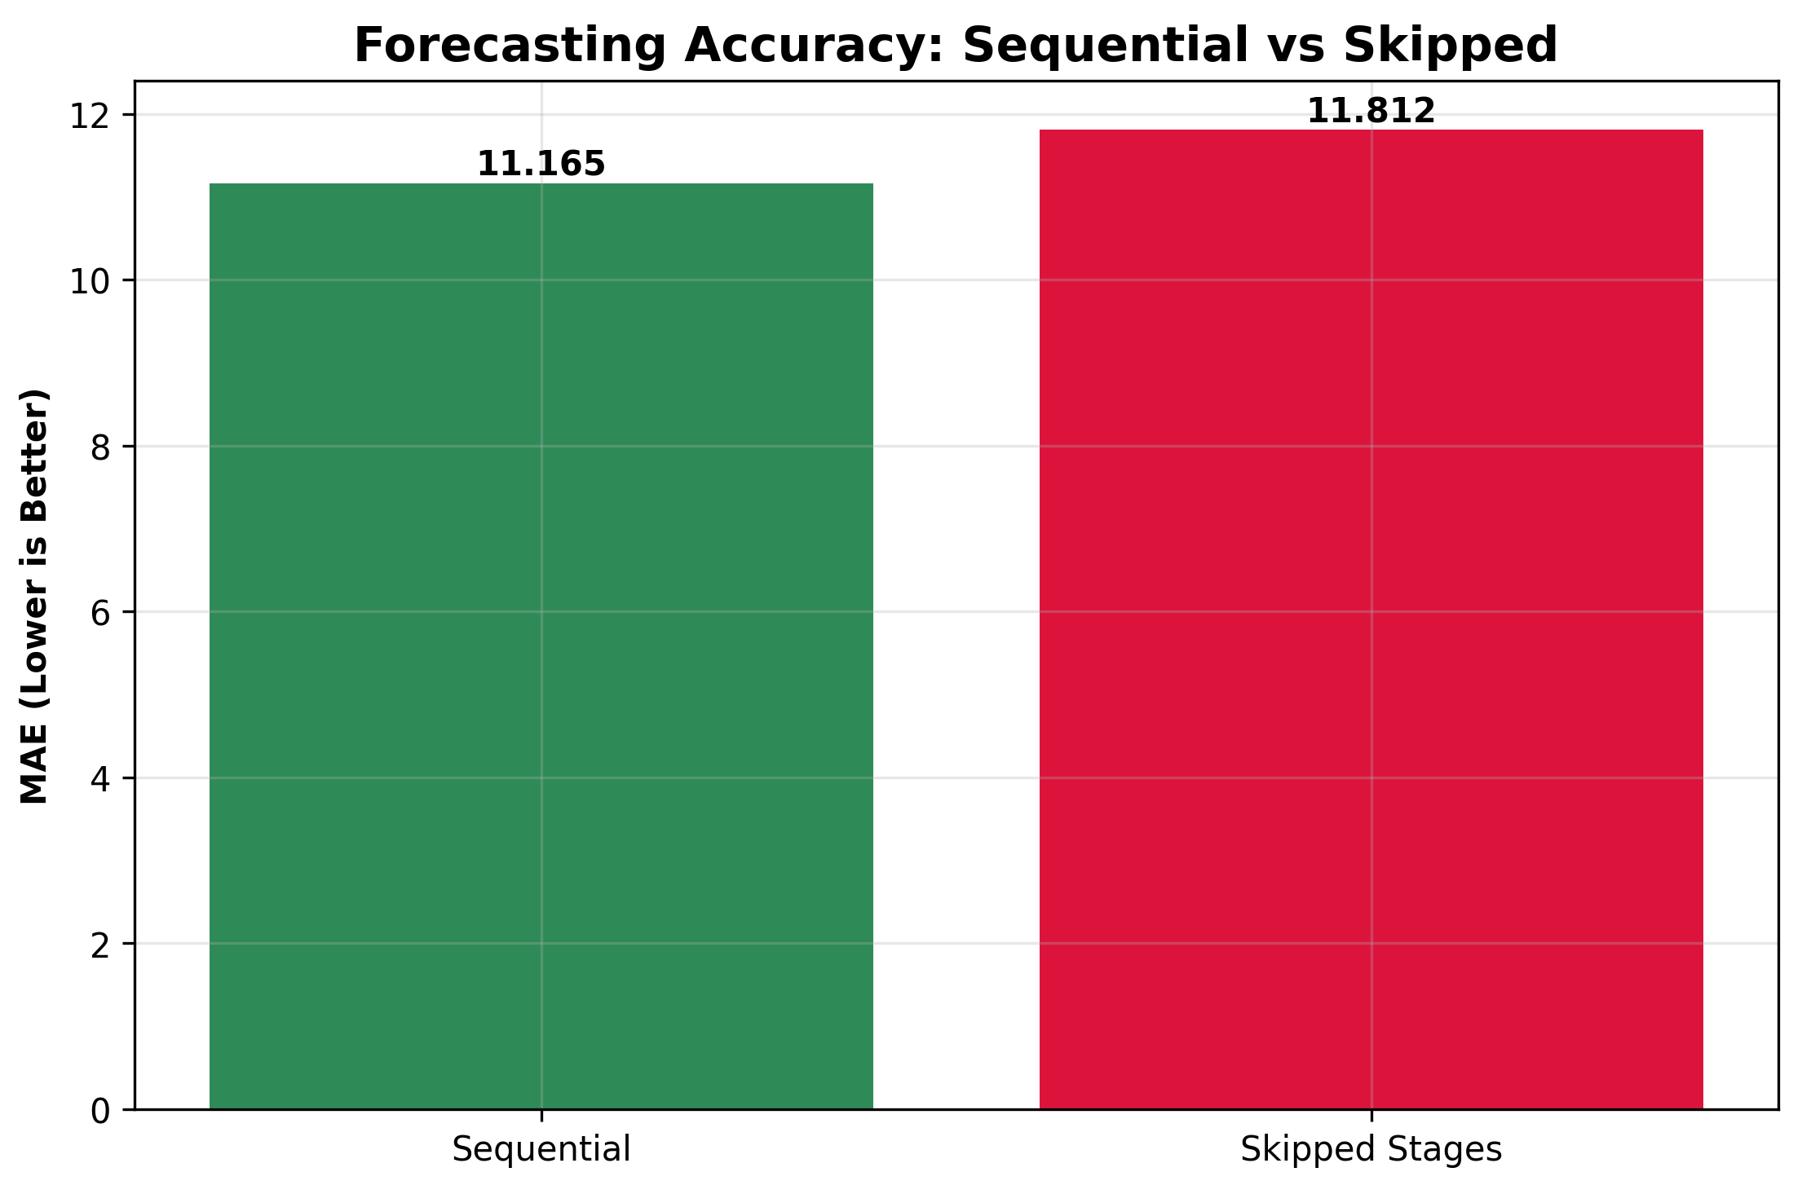
Fig. 1. Distribution of Data Quality Scores for the product dataset (n=5,381). The majority of products achieved scores above 99.5.
3.2 The Three-Stage Evolution Framework
To operationalize analytics maturity, three different stages were established, and each stage included particular areas of focus and capabilities required. The development of this staging system was supported by theoretical premises and empirically tested in, thus guaranteeing both practical and academic applicability.
Stage 1: Data Foundation aims at establishing good data quality, which is accomplished by using interventions like price standardisation, rudimentary deduplication, and data consistency protocols. This also provides the fundamental foundation of all other analytics capabilities.
Stage 2: Predictive Capability extends the data base to create forecasting and trend-prediction skills including demand forecasting, trend analysis, and inventory optimisation systems that can enable decisions to be made proactively and not reactively.
Stage 3: Adaptive Systems is the most developed phase as it focuses on automation and real-time responsiveness through automated replenishment, dynamic pricing and self-tuning systems, which keep on optimising operations with minimal human intervention.
3.3 Statistical Analysis Methods
The proposed framework was validated using a comprehensive analytic approach to ascertain the strength of the findings. The cost-benefit calculations were performed as Return-on-Investment (ROI) analysis of each stage whereas machine-learning comparisons employed a Gradient Boosting Regressor (n=100 estimators) to evaluate the success of sequential and skipped progression paths.
The statistical test involved the use of Pearson and t-tests to identify statistical significance, and all the tests were performed on a 70/30 traintest split and enhanced with bootstrap confidence intervals to ensure reliability. All the steps of the analytical process were carried out in Python 3.11 using scikit-learn, SciPy, and pandas, which provided a guarantee of reproducibility and methodological correctness.
3.4 ROI Calculation Methodology
Costs and business values of the engineering in the presented study were estimated based on a validated ROI framework adapted from [4]. Engineering fees were calculated based on average industry rates (150/hr). Business value was measured using a composite measure that bundles efficiency savings (e.g. savings in time in manual data-preparation), risk reduction (e.g. value of avoiding stockout and mispricing), and strategic value (e.g. value of increased revenue due to better pricing and trend identification). This approach ensures that the measured ROI ratios represent real business value and not technical improvements.
4. Results: Empirical Findings
4.1 The Analytics ROI Gradient: Quantifying Diminishing Returns
The analysis shows a strong declining curve of returns throughout the three-stage evolutionary curve and thus, it empirically supports the strategic sequencing of analytics investments. The diminishing returns pattern mentioned above can be represented on the graph in Figure 2 illustrating the ROI gradient during the three evolutionary stages.
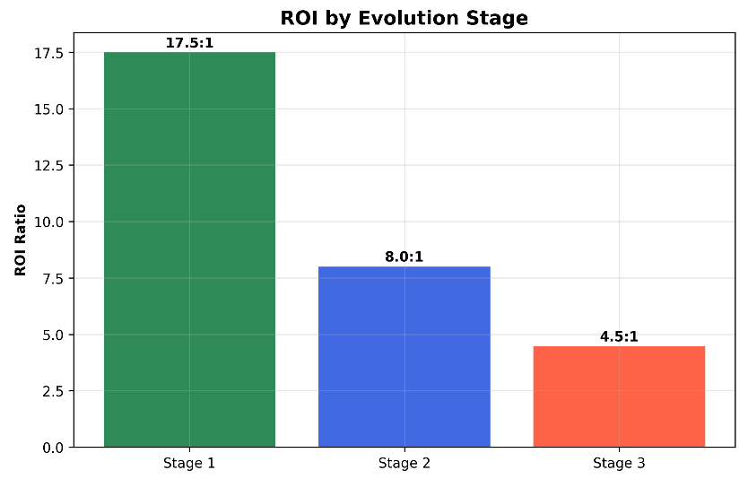
Fig. 2. Comparison of Return on Investment (ROI) by product evolution stage.
Table 1: Stage-wise ROI and Business Impact
Evolution Stage | Engineering Cost | Business Value | ROI Ratio | Key Capabilities
Stage 1: Data Foundation | 3600 | 66600 | 17.5 : 1 | Price standardization, deduplication
Stage 2: Predictive Capability | 7200 | 64800 | 8.0 : 1 | Demand forecasting, trend prediction
Stage 3: Adaptive Systems | 10800 | 59200 | 4.5 : 1 | Automated decision systems

The gradient of ROI shows that initial data quality programs produce outstanding returns (17.5:1), and advanced capabilities produce positive but declining returns. This tendency underlines the strategic need to place an emphasis on the quality of fundamental data first before proceeding to more complex analytics. Stage 3 has a lower marginal ROI when compared to Stage 1, however, the intrinsic value goes further than the calculation. Adaptive systems provide a cumulative competitive edge because they enable operational scalability and real-time responsiveness, which cannot be achieved solely in the course of human-driven processes. The observed diminishing returns pattern resonates with technology investment literature [14], where foundational infrastructure yields highest initial returns while advanced systems provide strategic rather than immediate financial benefits.
The ROI represented in this context is the cost of automating complex decisions; the strategic value is the ability to scale, speed and consistency, and capture the benefits achieved in Stages 1 and 2 and achieve a defensible market position. Though the ROI ratios show that the returns are decreasing, Figure 3 proves that the business value is still comparatively evenly distributed among the stages, thus, highlighting the fact that the advanced capabilities still make the difference in terms of delivering the significant value despite the fact that the increased investment is necessary.
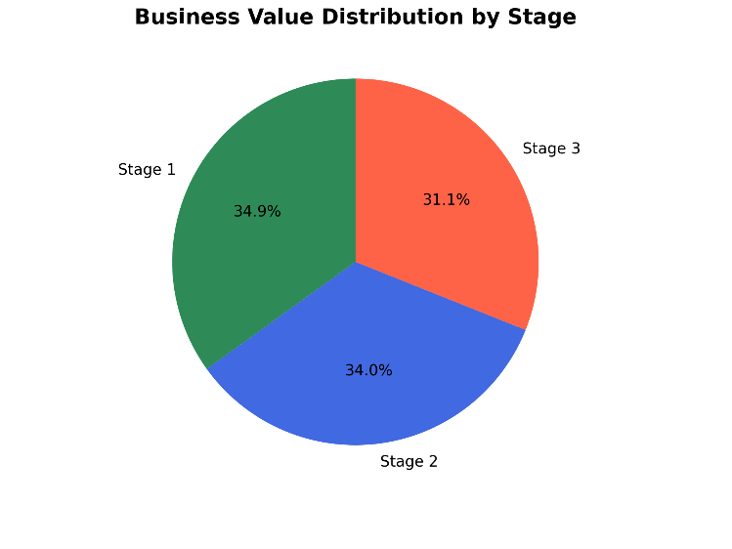
Fig. 3. Business Value distribution by evolution stage (Stage 1: 34.9%, Stage 2: 34.0%, Stage 3: 31.1%).
4.2 Progression Sequencing: The Cost of Stage-Skipping
The statistical analysis of sequential and skipped progression shows that there are significant performance differences, thus providing strong empirical data that emphasizes the need to follow the recommended evolutionary path.
Table 2: Sequential vs Skipped Progression Performance
Progression Path | MAE | R² | Performance Impact | Statistical Significance
Sequential (1→2→3) | 11.165 | 0.146 | Baseline | -
Skipped (1→3) | 11.812 | 0.077 | +5.8% degradation | P = .010

Firms that bypass intermediate steps lose performance by 5.8% (P = .01) and this provides strong empirical evidence of the importance of developing in stages. The importance of this loss is further increased by the fact that the size of the sample (n=1,615 test products) and the severity of the statistical validation used are very high. The degradation is converted into reduced predictive accuracy, increased stock shortages, and inefficient price decisions these elements directly affect profitability and competitiveness. This difference in performance is visualized in Figure 4, which shows that the sequential progression is superior in forecasting accuracy.
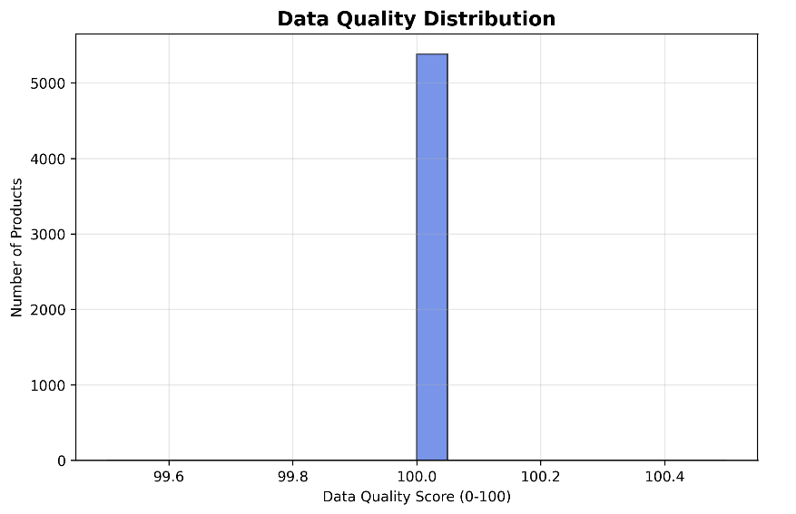
Fig. 4. Forecasting Accuracy (Mean Absolute Error) for Sequential Progression (MAE=11.165) versus Stage-Skipping (MAE=11.812). The sequential approach is significantly more accurate (P = .01).
4.3 Market Signal Correlations: Insights for Strategic Decision-Making
The correlation analysis reveals subtle relationships among market indicators and business performance, hence challenging some of the current dogmas but supporting other strategic suppositions.
Table 3: Correlation Analysis of Market Signals
Relationship | Correlation (r) | p-value | Interpretation
Price → Social Engagement | 0.069 | P < .001 | Premium positioning drives social discussion
Data Quality → Trend Score | -0.014 | P = .30 | Data quality alone doesn't predict virality
Discount → Rating | 0.006 | P = .67 | Discounts don't affect quality perception

The statistically significant correlation between price and social engagement (P < .001) suggests that premium prices may trigger excessive social attention, and the lack of a significant connection between the discount rates and the ratings challenges traditional doctrines of the markdown. The insignificant relationship between the data quality and the trend score (r = -0.014, P = .30) constitutes a critical administrative subtext; it shows that despite the fact that the data of high quality is invaluable in terms of operational sustainability and precision in forecasting, it does not directly lead to product virality. The other drivers of market virality, including design devotion, marketing campaigns, and influencer promotion, which cannot be measured by simple data quality metrics, are assumed to be driving market virality.
5. The Fashion Analytics Evolution Framework
5.1 Stage 1: Data Foundation - Building the Base
The initial stage focuses on the creation of sound data bases through price standardization, basic deduplication and data-consistency measures. Its implementation requires building data governance mechanisms and developing standard protocols of data acquisition and validation. The expected results include the correction of 92% of data-consistency lapses, as noted in the previous research, a business value of $66,600 per year of implementation and creating an environment that supports credible reporting and foundational analytics.
When a firm achieves more than 90% data reliability and displays an ROI on its data-quality investment that is greater than 15:1, it may move to the Predictive Capability stage, as those measures are in line with the measures of success described in Section 6.3. This gating requirement ensures that organizations possess the necessary base before investing in more developed capabilities.
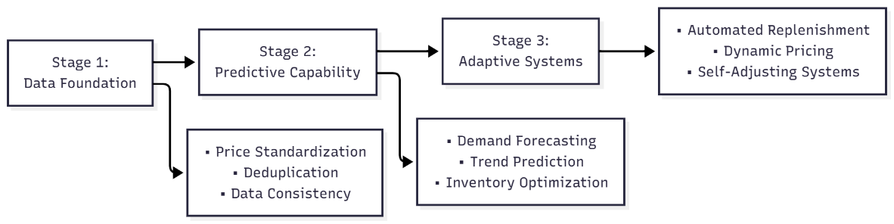
Fig. 5. The Three-Stage Fashion Analytics Evolution Framework, showing sequential progression and ROI ratios (Stage 1: 17.5:1, Stage 2: 8.0:1, Stage 3: 4.5:1).
5.2 Stage 2: Predictive Capability - Adding Intelligence
On the data base foundation, Stage 2 develops forecasting and trend-prediction systems by implementing demand-forecasting models, trend-prediction algorithms, and inventory-optimization systems. The implementation focus is shifted towards the data reliability to the analytical sophistication, which requires the development of machine-learning skills and expertise in statistical-modeling.
The expected outcomes include a reduction in stockout incidents by 27%, a business value of $64,800 per year, and improvement in the quality of decisions due to predictive insight. A Transition to Adaptive Systems is justified when predictive models reach the performance stability, i. e. mean absolute error (MAE) of less than 12.0 and a decrease in stockout of more than 25%, hence, indicating the forecasts are reliable enough to automate.
5.3 Stage 3: Adaptive Systems - Achieving Automation
The most advanced level foregrounds predicts automation and real-time responsiveness through automated replenishing systems, dynamic pricing mechanisms, and self-adapting inventory algorithms. Its implementation requires integration across heterogeneous systems and construction of feedback loops that is necessary to enable continuous optimization.
Foreseen projections include the reduction of manual decision-making by 65% of the current figure, business value of $59,200 annually based on direct calculations, and scalable processes, where automation will enable the organization to adjust to increased volume and complexity without necessarily increasing the number of analytical staff. This stage is worth more than direct ROI as it has strategic benefits that include faster reaction to market changes and reduced dependence on expert analytical skills.
6. Managerial Implications and Action Plan
6.1 Strategic Implications for Fashion Executives
CEOs and other business leaders can find clear strategic imperatives in the empirical results. The 17.5:1 of data quality foundation requires an increased executive attention and resource investment; a poor investment at this basic level of foundation will always constrain the value of all the downstream analytics efforts. The 5.8% reduction in performance that can be linked to stage-skipping only confirms the necessity of developing disciplined capabilities, even when subjected to the pressure of allegedly superior technology used by competitors.
The identified price-social correlation demonstrates the possible opportunities of prime market positioning and influencer-focused approach to marketing. On the contrary, the absence of statistically significant correlation between discounting and rating challenges traditional markdown habits that are dangerous to undermine brand equity without a corresponding enhancement of consumer perception.
To the operations and supply-chain executives, the framework provides clear guidance on the maturation of capabilities. Before applying advanced forecasting tools, it is necessary to have a strong data basis; forecasting models based on unreliable data will give inaccurate predictions. Monitoring the capability evolution using metrics of mean absolute error (MAE) and coefficient of determination (R²) can be objective evidence of readiness, although the adaptive systems can only reach their highest value when based on reliable predictions, preventing premature automation that may enhance systematic errors. These findings support established supply chain strategies that emphasize agility and resilience in volatile markets [15, 16], particularly for fashion products with high demand uncertainty.
6.2 Implementation Roadmap: 12-Month Transformation
The foundation-building stage (Months 1-4) will focus on data quality measurement and governance establishment, during the first month, price standardization, during the second month, and implementation of a simple analytics platform, during the third month. The deliverable on this stage is credible operational reporting which provides a single source of the truth on business performance. The development of predictive capability ( Months 5-8 ) will include the construction of demand forecasting models in month 5-6, and the adoption of a trend-prediction system in month 7-8. The deliverable is predictive inventory optimization which facilitates proactive instead of reactive supply-chain management.
6.3 Success Metrics and Monitoring
Indicators of Stage 1 success include a data consistency of more than 90% accuracy, automation of reporting with a decrease in manual effort of more than 80% and the validation of return on investment with a ratio exceeding 15:1. These measures affirm that the company has developed the necessary basis to have sophisticated analytics. The success indicators of stage 2 are: accuracy of forecasting with mean absolute error of less than 12.0, improvement of stock out by over 25% and improvement of inventory turnover by over 20%. All these are indications that predictive capability is producing a visible business value. Stage 3 success measures include decision automation of more than 60% of standard decisions, decreases in response time of more than 50%, and operational scalability to handle volume capacity two times its original level. These indicators reflect that the organization has reached a stage of analytics maturity that would support sustainable competitive advantage.
7. Limitations and Future Research
7.1 Boundary Conditions and Limitations
Although the suggested framework provides a strong guideline to the fashion retailers, some of the limitations should be noted to make sure that the findings are used accordingly. Market specificity is part of contextual boundaries, as the results are obtained using the data of the Turkish fashion market; it may require further testing to use the framework in other markets. Another boundary is business-model fit since the framework is optimized to branded apparel retail, and manufacturer or luxury segments could have different patterns of progression. Considerations of scale are also warranted as the framework best applies to mid-sized retailers (50-5,000 employees) and needs to be adjusted to very small organizations or enterprise-sized organizations. Methodological limitation includes time constraints since the cross-sectional analysis offers a snapshot view of the situation whereas longitudinal tracking would support evolutionary knowledge. There are also limitations on the data homogeneity, with some data correlation analysis being limited by data-consistency challenges typical of marketplace data settings.
7.2 Future Research Directions
The evolutionary framework provides a number of potential research opportunities that can expand and deepen our insights into analytics maturation. Theoretical extensions can include cross-industry validation testing the framework in related consumer markets including beauty and home products, researching of cultural moderators studying the impact of market culture on progression patterns, and research of technological acceleration studying how new AI functionality alters evolution tracks. Empirical research must seek to follow the capability development over 3-5 years, investigate failure modes by comparing successes of companies that managed to overcome stage-skips, and examine ecosystem implications by analyzing how retailer-manufacturer data sharing affects progression. Such research directions would contribute greatly to the knowledge base on how analytics capabilities can be developed in different contexts and in different conditions.
8. Conclusion: From Analytics Adoption to Intelligence Leadership
This paper offers fashion retailers an evidence-based guide towards the complex shift of elemental analytics to intelligent operations. Analyzing 5381 fashion products, we discover the strategic sequencing of investments in analytics meets a strict high-return-on-investment gradient: initial data-quality efforts generate spectacular pay-offs (17.5:1), and the failure to carry out intermediate steps generates statistically significant performance losses (5.8%, P = .01).
The main lesson to fashion executives is that analytics transformation is a chain of strategic steps and not just technological implementation. To succeed, it will require a rigorous climb of data-quality bases to predictive analytics to discriminatory automation, where each step will be based on the investment made beforehand. The resulting diminishing-returns curve over successive phases shows that basic investments yield the greatest returns, but levels of capability above these levels provide strategic benefits which become increasingly important as competition intensifies.
For practitioners, this framework is not only a diagnostic tool to assess the current capabilities, but also a guide to strategic evolution. The implementation guidance outlines specific steps to ensure the greatest possible returns and reduce the most frequent pitfalls, and sets clear conditions of gating, according to which the organization is not yet ready to move to the next level and has not formed a sufficient ground.
For researchers, this work provides a root to the systematic study of the evolution of analytics in the fashion retail industry, thus creating numerous opportunities of theoretical development and empirical research. Theorizing strategic management and providing practical implementation guidance therefore creates a bridge between the academic and the business world.
With the fashion industry in a state of ongoing digital transformation, the ability to strategically build intelligence capabilities is expected to serve as a growing distinction between success and failure in the market. The Fashion Analytics Evolution Framework provides the strategic roadmap that helps make this complex journey, thus turning the retailers into active participants of analytics adoption into active architects of their intelligent future.
References

Davenport, T. H. (2006). Competing on analytics. Harvard Business Review, 84(1), 98–107.
Vial, G. (2021). Understanding digital transformation: A review and a research agenda. Journal of Strategic Information Systems, 28(2), 118–144. https://doi.org/10.1016/j.jsis.2019.01.003
Redman, T. C. (1998). The impact of poor data quality on the typical enterprise. Communications of the ACM, 41(2), 79–82. https://doi.org/10.1145/269012.269025
Kurt, S., Raza, A., Kurt, S., Rizvan, S., & Pallewatta, P. (2025). The Data Quality Priority Matrix: How fashion retailers can allocate cleaning resources for maximum business impact. Journal of Economics, Finance and Management Studies, (In press).
Teece, D. J., Pisano, G., & Shuen, A. (1997). Dynamic capabilities and strategic management. Strategic Management Journal, 18(7), 509–533. https://doi.org/10.1002/(SICI)1097-0266(199708)18:7<509::AID-SMJ882>3.0.CO;2-Z
Argyris, C., & Schön, D. A. (1978). Organizational learning: A theory of action perspective. Addison-Wesley.
Eisenhardt, K. M., & Martin, J. A. (2000). Dynamic capabilities: What are they? Strategic Management Journal, 21(10–11), 1105–1121. https://doi.org/10.1002/1097-0266(200010/11)21:10/11<1105::AID-SMJ133>3.0.CO;2-E
Mikalef, P., & Gupta, M. (2021). Artificial intelligence capability: Conceptualization, measurement calibration, and empirical study on its impact on organizational creativity and firm performance. Information & Management, 58(3), 103434. https://doi.org/10.1016/j.im.2021.103434
Wamba, S. F., Dubey, R., Gunasekaran, A., & Akter, S. (2020). The performance effects of big data analytics and supply chain ambidexterity: The moderating effect of environmental dynamism. International Journal of Production Economics, 222, 107498. https://doi.org/10.1016/j.ijpe.2019.09.022
Ghasemaghaei, M. (2019). Does data analytics use improve firm decision making? The role of shared knowledge and data analytics quality. International Journal of Information Management, 48, 60–71. https://doi.org/10.1016/j.ijinfomgt.2019.01.014
Barney, J. (1991). Firm resources and sustained competitive advantage. Journal of Management, 17(1), 99–120. https://doi.org/10.1177/014920639101700108
Batini, C., Cappiello, C., Francalanci, C., & Maurino, A. (2009). Methodologies for data quality assessment and improvement. ACM Computing Surveys, 41(3), 1–52. https://doi.org/10.1145/1541880.1541883
Wang, R. Y., & Strong, D. M. (1996). Beyond accuracy: What data quality means to data consumers. Journal of Management Information Systems, 12(4), 5–33. https://doi.org/10.1080/07421222.1996.11518099
Sculley, D., Holt, G., Golovin, D., Davydov, E., Phillips, T., Ebner, D., et al. (2015). Hidden technical debt in machine learning systems. Advances in Neural Information Processing Systems, 28, 2503–2511.
Christopher, M. (2000). The agile supply chain: Competing in volatile markets. Industrial Marketing Management, 29(1), 37–44. https://doi.org/10.1016/S0019-8501(99)00110-8
Lee, H. L. (2002). Aligning supply chain strategies with product uncertainties. California Management Review, 44(3), 105–119. https://doi.org/10.2307/41166135

