Study the effect of artificial ageing on seed longevity and quality parameters of chilli seeds

ABSTRACT
A laboratory experiment was conducted under a Completely Randomized Design (CRD) at the Department of Seed Science and Technology, B. A. College of Agriculture, AAU, Anand, to assess the effect of accelerated ageing on seed quality of chilli. Seeds were subjected to ageing at 45°C and 95 to 100% RH for varying durations (0, 1, 2 and 3 days). Seeds without ageing (T₁ – 0 days) recorded the highest germination (96.50%), root length (3.17 cm), shoot length (4.62 cm), total seedling length (7.78 cm), fresh weight (0.47 g), dry weight (0.0321 g), vigour index I (751.01), and vigour index II (3.09). After one day of ageing (T₂), a noticeable deterioration in seed quality was recorded, which continued with prolonged ageing durations. The observed germination rate was 76.00%, with a root length (3.19 cm), shoot length (4.52 cm), total seedling length (7.72 cm), seedling fresh weight (0.45 g), seedling dry weight (0.0207 g) and vigour index I and II values (586.92) and (1.57), respectively. However, three days of ageing (T₄) reduced germination to 44.33%, root length (2.55 cm), shoot length (3.11 cm), seedling length to 5.65 cm, seedling fresh weight (0.19 g), seedling dry weight (0.0051 g), and vigour index I and II to 250.34 and 0.23, respectively.
Key words: Mirchi, accelerated ageing and seed quality parameters
Introduction
Chilli (Capsicum annuum L.) is an important vegetable-cum-spice crop of India, grown for both green fruits (vegetable) and red fruits (spice). It belongs to the family Solanaceae with a diploid chromosome number of 2n = 24 and is believed to have originated in South and Central America. The genus Capsicum includes 27 species, of which five—C. annuum, C. frutescens, C. chinense, C. baccatum, and C. pubescens—are domesticated (Bosland, 1993). The name Capsicum originates from the Greek word Kapsimo, meaning “to burn.” Pungency in chilli is due to capsaicin (C₁₈H₂₇NO₃), while capsanthin is responsible for the red colour. Capsicum annuum is an annual sub-shrub with solitary flowers and pendent fruits such as red pepper, cayenne, paprika, and bell pepper. C. frutescens is a perennial type with small, highly pungent fruits known as “bird chilli” or “Tabasco.”
Chilli is an indispensable spice and condiment in Indian cuisine, valued for its pungency, taste, colour, and flavor. Dried fruits are used in curry powders, sauces, pickles, and soups, contributing aroma, texture, and nutritional value. Capsaicin, concentrated mainly in the placenta and seeds, is responsible for the pungency. Chilli is cultivated for pungent types (hot pepper, cayenne, paprika) and non-pungent types (sweet pepper, bell pepper, Shimla mirch). Fruits are rich in vitamins A, C, and E, folic acid, and minerals like phosphorus, iron, and calcium (Bosland and Votava, 2000). Capsaicin possesses anti-cancer and medicinal properties and is used in drugs, balms, and cosmetics. Dried chillies are generally more pungent than green ones due to higher capsaicinoid content (Hoffman et al., 1983). Chilli also acts as a digestive stimulant and is beneficial for heart and rheumatic conditions.
As far as seed spices are concerned, it is very susceptible to have loss in quality in terms of seed viability and vigour during seed storage. Retention of seed viability during storage has always been of outmost concern to seedsman. Thus, it was be highly relevant to develop an insight into the basic phenomenon of seed ageing and longevity. Accelerated ageing effectively distinguishes chilli seed lots based on their storability potential. Seeds exposed to high temperature and humidity conditions experience rapid deterioration of cellular membranes and enzyme systems, similar to natural ageing during long-term storage. The decline in germination percentage and seedling vigor observed after ageing treatments reflects the seed’s inherent capacity to withstand storage stress. Thus, accelerated ageing serves as a reliable indicator for predicting the shelf life and storage behavior of chilli seeds under ambient conditions.
Material and method
The present investigation was carried out during the 2023–24 and 2024–25 at the Department of Seed Science and Technology, BACA, Anand Agricultural University, Anand. Gujarat Anand Vegetable Chilli 141 (Anand Tej) seeds were sourced from the Main Vegetable Research Station, AAU, Anand. Released in 2021, this variety is suited for irrigated conditions in Gujarat during the Kharif-Rabi season.
Accelerated Aging Test
Accelerated aging was conducted in desiccator measuring 14 x 12 x 4.5 cm. A fiber mesh screen was suspended inside the desiccator on which seeds were evenly distributed to form a thin layer. Approximately 2.0 g of seeds from each treatment in three replications were tied in a fine muslin cloth bag was used. The lower part of the desiccators were filled with water, 200 ml of water was added to each desiccator, so that there was not any direct contact between water and the seed. The desiccators were covered with the lid and sealed with paraffin wax to make it airtight. To create the desired humidity condition for the test, The desiccators were then placed in the hot air oven/ incubator maintaining set of seeds at 45°C for 0, 1, 2 and 3 days after which seeds were submitted to the germination test as previously described. Evaluation was performed 7 and 14 days and the results expressed as mean percentage of normal seedlings for each treatments.
The experiment was conducted following a Completely Randomized Design (CRD) with four treatments representing different durations of accelerated ageing, namely 0, 1, 2, and 3 days, each replicated three times. The accelerated ageing test was performed by placing the chilli seeds in perforated aluminum trays inside an ageing chamber maintained at a constant temperature of 45°C and 95–100% relative humidity (RH). After each ageing period, seeds were removed and evaluated for various quality parameters such as germination percentage, seedling vigor, and other physiological attributes to assess the extent of deterioration and storability potential under accelerated ageing conditions.
Result and discussion
Parameters recorded
Following parameters were recorded during the course of study: Germination (%), Seedling shoot length (cm), Seedling root length (cm), Seedling length (cm), Seedling fresh weight (g), Seedling dry weight (g), Seedling vigour index-I and Seedling vigour index-II
Effect of accelerated ageing on germination (%)
Seed germination percentage was found to be highest under the control condition (T₁: 0 days of ageing) and exhibited a consistent linear decline with increasing durations of accelerated ageing across both the experimental years (2023–24 and 2024–25), as well as on a pooled basis (The detailed results are presented in Table 1 and Fig. 1). Specifically, the T₁ treatment recorded significantly the highest germination percentage of 96.67, 96.33 and 96.50 during 2023–24, 2024–25 and on a pooled basis, respectively. In contrast, the T₄ treatment (3 days of accelerated ageing) resulted in significantly the lowest germination percentages of 47.33, 41.33 and 44.33 for the respective years and on pooled data. Aged chilli seeds showed a significant decline in germination compared to the control, with the reduction increasing with longer ageing durations. The accelerated ageing test simulates natural ageing by exposing seeds to high temperature and humidity, inducing rapid deterioration. These stress conditions elevate seed moisture and disrupt metabolic activity, resulting in reduced viability and vigour. The combined effect of heat and humidity accelerates biochemical and structural degradation. Similar trends were reported by Kaewnaree et al. (2011) in sweet pepper, where accelerated ageing caused a marked loss in seed germination and viability.
Effect of accelerated ageing on seedling root length (cm)
Seedling root elongation was markedly influenced by the duration of accelerated ageing across both the cropping years (2023–24 and 2024–25) as well as on the pooled dataset. The detailed observations are presented in Table 1. Treatment T₁ (0 days of ageing) exhibited significantly the maximum radicle elongation, with mean root lengths of 2.99 cm, 3.34 cm and 3.17 cm during 2023–24, 2024–25 and on pooled analysis, respectively. Conversely, treatment T₄ (3 days of accelerated ageing) recorded significantly short radicle lengths of 2.59 cm, 2.49 cm and 2.55 cm for the corresponding years and on pooled data, indicating progressive impairment in seedling root development due to age-induced physiological stress. Progressive exposure to accelerated ageing caused a significant reduction in seedling root length, indicating impaired radicle elongation and reduced seed vigour. This decline results from cumulative viability loss and metabolic disruption due to membrane degradation. Ageing leads to lipid peroxidation, increased free fatty acids, and loss of cellular integrity, which in turn inhibit hydrolytic enzyme activity required for reserve mobilization. Consequently, limited nutrient utilization hampers normal seedling growth. Similar findings were reported by Bagum et al. (2005) in chilli, confirming the adverse effects of ageing on seedling development and vigour.
Effect of accelerated ageing on seedling shoot length (cm)
Seedling shoot length was significantly affected by the duration of accelerated ageing across both the years (2023–24 and 2024–25) as well as on a pooled basis. The data are presented in Table 1. The highest shoot elongation was recorded under treatment T₁ (0 days of ageing), with mean values of 4.48 cm, 4.75 cm and 4.62 cm for the respective years and on pooled data. In contrast, treatment T₄ (3 days of ageing) exhibited significantly reduced shoot lengths of 3.03 cm, 3.18 cm, and 3.11 cm. The reduction in seedling shoot length under accelerated ageing is mainly due to stress-induced physiological and metabolic impairments. According to McDonald (1999), decreased mitochondrial activity and respiration limit energy supply for growth. Elevated oxidative stress further disrupts cell division and elongation, resulting in reduced meristematic activity and suppressed shoot elongation in aged seedlings.
Effect of accelerated ageing on seedling length (cm)
Seedling length was significantly affected by the duration of accelerated ageing across both the experimental years (2023–24 and 2024–25), as well as on a pooled basis. The results are presented in Table 1 and Fig. 1. The highest seedling length was observed under treatment T₁ (0 days of ageing), with values of 7.47 cm, 8.09 cm and 7.78 cm, respectively. In contrast, treatment T₄ (3 days of ageing) recorded significantly reduced seedling lengths of 5.62 cm, 5.68 cm and 5.65 cm across the respective datasets. Seedling length decreased progressively with longer accelerated ageing periods, while the maximum length was recorded in unaged seeds. This decline reflects the adverse effects of thermal and oxidative stress on seed metabolism and vigour. Accelerated ageing effectively predicts seed performance, as seedling length serves as a sensitive indicator of early growth potential. The loss of germination and vigour during ageing is mainly due to metabolic impairments such as reduced RNA and protein synthesis, enzyme degradation, and loss of membrane integrity. Similar observations were reported by Bagum et al. (2005) in chilli.

Effect of accelerated ageing on seedling fresh weight (g)
Seedling fresh weight declined progressively with longer ageing durations in 2023–24, 2024–25, and in pooled data (Table 2). The highest fresh weight was recorded in T₁ (0 days) at 0.47–0.48 g, while T₄ (3 days) showed a significant reduction to 0.11–0.28 g. Accelerated ageing negatively affected the fresh weight of chilli seedlings. During ageing, membrane damage, reduced enzyme activity, and lower respiration impair water uptake and metabolism, leading to decreased seedling turgidity and biomass. Consequently, seedlings from aged seeds show significantly lower fresh weight due to limited mobilization of stored reserves and impaired cell expansion. These findings are consistent with Bagum et al. (2005) and Ahamed et al. (2014) in chilli.
Effect of accelerated ageing on seedling dry weight (g)
The seedling dry weight showed significant results with different days of ageing during 2023-24, 2024-25 and on pooled basis and the results are presented in Table 2. Significantly the highest seedling dry weight (0.0331 g, 0.0310 g and 0.0321 g) was recorded by treatment T₁ (0 days) while significantly the lowest seedling dry weight was recorded by the treatment T₄ (3 days) (0.0045 g, 0.0058 g and 0.0051 g) during both the years and on pooled basis, respectively. Accelerated ageing reduces chilli seedling dry weight by impairing metabolic activity and reserve mobilization. Membrane damage and enzyme deterioration limit nutrient transport, resulting in lower biomass (McDonald, 1999). Dry weight consistently declines with longer ageing, reflecting oxidative damage and loss of cellular function (Ahamed et al., 2014).
Effect of accelerated ageing on seedling vigour index I
Seedling vigour index I was significantly affected by accelerated ageing across both the years and on a pooled basis, as shown in Table 2. The control treatment T₁ (0 days) recorded the highest vigour index I values of 722.38 (2023–24), 779.63 (2024–25) and 751.01 (pooled). In contrast, treatment T₄ (3 days) showed a significantly decline with values of 266.01, 234.67 and 250.34, respectively. Accelerated ageing rapidly simulates seed deterioration under high temperature and humidity, reducing seed viability and vigour. Aged seeds show lower germination, slower growth, and weaker seedlings compared to unaged seeds. This decline is linked to membrane damage, nucleic acid alterations, reduced enzyme activity, and prolonged germination, resulting in a lower seedling vigour index. Similar observations were reported by Keshavulu et al. (2012) in okra and Ahamed et al. (2014) in chilli.
Effect of accelerated ageing on seedling vigour index II
Significant results on seedling vigour index II were observed by different days of ageing during both the year and on pooled basis and the results are presented in Table 2. The treatment T₁ (0 days) recorded significantly the highest seedling vigour index II (3.19, 2.99 and 3.09), while significantly the lowest seedling vigour Index II was recorded in treatment T₄ (3 days), with values of 0.21, 0.24 and 0.23 during 2023–24, 2024–25 and on a pooled basis, respectively. Seed ageing triggers biochemical changes that reduce vigour and seedling development. Degradation of RNA and DNA, protein damage, and impaired enzyme activity affect germination, membrane integrity, and reserve mobilization. Consequently, aged seeds produce weak seedlings with lower dry weight and reduced vigour index. Similar results have been reported by Khan et al. (2004) in onion, Keshavulu et al. (2012) in okra, Ahamed et al. (2014) in chilli, Nigam et al. (2019) in tomato and Bhat et al. (2022) in onion.

Table 1: Effect of accelerated ageing on germination, seedling root length, seedling shoot length and seedling length
Treatments |  | Germination ( %) |  |  | Seedling root length (cm) |  |  | Seedling shoot length (cm) |  |  | Seedling length (cm)
 |  | 2023-24 | 2024-25 | Pooled | 2023-24 | 2024-25 | Pooled | 2023-24 | 2024-25 | Pooled | 2023-24 | 2024-25 | Pooled
T₁ – 0 Days |  | 96.67 | 96.33 | 96.50 | 2.99 | 3.34 | 3.17 | 4.48 | 4.75 | 4.62 | 7.47 | 8.09 | 7.78
T₂ – 1 Days |  | 74.00 | 78.00 | 76.00 | 3.14 | 3.26 | 3.19 | 4.39 | 4.64 | 4.52 | 7.54 | 7.90 | 7.72
T₃ – 2 Days |  | 53.33 | 58.00 | 55.67 | 2.99 | 3.09 | 3.04 | 4.19 | 4.49 | 4.34 | 7.19 | 7.58 | 7.39
T₄ – 3 Days |  | 47.33 | 41.33 | 44.33 | 2.59 | 2.49 | 2.55 | 3.03 | 3.18 | 3.11 | 5.62 | 5.68 | 5.65
S.Em. ± | Y | - |  | 1.35 | - |  | 0.07 | - |  | 0.02 | - |  | 0.08
S.Em. ± | T | 0.50 | 0.79 | 2.13 | 0.04 | 0.03 | 0.09 | 0.08 | 0.03 | 0.03 | 0.07 | 0.03 | 0.12
S.Em. ± | Y × T | - |  | 0.59 | - |  | 0.04 | - |  | 0.05 | - |  | 0.05
C. D. at 5% | Y |  |  | NS |  |  | NS |  |  | 0.07 |  |  | 0.37
C. D. at 5% | T | 1.66 | 2.65 | 8.37 | 0.14 | 0.09 | 0.42 | 0.27 | 0.11 | 0.10 | 0.23 | 0.10 | 0.52
C. D. at 5% | Y × T | - |  | 1.76 | - |  | 0.11 | - |  | NS | - |  | 0.16
C.V. % |  | 1.28 | 2.02 | 1.65 | 2.42 | 1.60 | 2.01 | 3.53 | 1.38 | 2.45 | 1.73 | 0.70 | 1.21

Table 2: Effect of accelerated ageing on seedling fresh weight, seedling dry weight and seedling vigour index – I & II
Treatments |  | Seedling fresh weight (g) |  |  | Seedling dry weight (g) |  |  | Seedling vigour index – I |  |  | Seedling vigour index – II
 |  | 2023-24 | 2024-25 | Pooled | 2023-24 | 2024-25 | Pooled | 2023-24 | 2024-25 | Pooled | 2023-24 | 2024-25 | Pooled
T₁ – 0 Days |  | 0.47 | 0.48 | 0.47 | 0.0331 | 0.0310 | 0.0321 | 722.38 | 779.63 | 751.01 | 3.19 | 2.99 | 3.09
T₂ – 1 Days |  | 0.45 | 0.45 | 0.45 | 0.0182 | 0.0231 | 0.0207 | 557.71 | 616.13 | 586.92 | 1.35 | 1.80 | 1.57
T₃ – 2 Days |  | 0.35 | 0.43 | 0.39 | 0.0082 | 0.0094 | 0.0088 | 383.45 | 439.83 | 411.64 | 0.44 | 0.55 | 0.49
T₄ – 3 Days |  | 0.28 | 0.11 | 0.19 | 0.0045 | 0.0058 | 0.0051 | 266.01 | 234.67 | 250.34 | 0.21 | 0.24 | 0.23
S.Em. ± | Y | - |  | 0.037 | - |  | 0.001 | - |  | 15.68 | - |  | 0.097
S.Em. ± | T | 0.005 | 0.003 | 0.053 | 0.002 | 0.002 | 0.001 | 2.61 | 5.18 | 22.18 | 0.030 | 0.021 | 0.137
S.Em. ± | Y × T | - |  | 0.004 | - |  | 0.0003 | - |  | 4.09 | - |  | 0.026
C. D. at 5% | Y | - |  | NS |  |  | NS |  |  | NS |  |  | NS
C. D. at 5% | T | 0.015 | 0.011 | 0.24 | 0.001 | 0.001 | 0.006 | 8.64 | 17.14 | 99.79 | 0.101 | 0.070 | 0.616
C. D. at 5% | Y × T | - |  | 0.012 | - |  | 0.0008 | - |  | 12.29 | - |  | 0.079
C.V. % |  | 2.06 | 1.56 | 1.81 | 3.21 | 2.58 | 2.89 | 1.01 | 1.73 | 1.37 | 4.06 | 2.63 | 3.35

CONCLUSION
The quality of chilli seeds declined progressively with increasing duration of accelerated ageing. Unaged seeds exhibited the highest physiological performance and vigour, while seeds subjected to short-term ageing showed moderate reductions in germination, seedling growth, and vigour. Prolonged ageing caused substantial deterioration in all seed quality parameters, indicating that extended exposure to high temperature and humidity severely compromises seed viability and seedling vigour.

REFERENCES
Ahamed, M. N., Channakeshava, B. C., Radha, B. N., Nagaraj, H. & Umesha. (2014). Response of chilli genotypes to accelerated ageing test. International Journal of Applied Agricultural Research, 9(1), 1-8.
Bagum, S. A., Khan, M. R., Nessa, A., Shaljm Uddin, M. & Ali, M. R. (2005). Seed quality in relation to seed deterioration under accelerated ageing conditions in different lines of chilli. International Journal of Sustainable Agricultural Technology, 1(5), 52-56
Bhat, R. M., Khan, F. A., Murtaza, I., Moinuddin, G. & Amir, M. (2022). Effects of accelerated ageing and subsequent priming on seed quality and biochemical change of onion (Allium cepa L.). The Pharma Innovation Journal, 11(4), 1969-79.
Bosland, P. W. & Votava, E. J. (2000). Peppers: Vegetable and Spice Capsicums. CABI Publishing, Wallingford, UK., Pp. 1-16.
Hoffman, P. G., Lego, M. C. & Galetto, W. G. (1983). Separation and quantitation of reds pepper major heat principles by reverse phase high performance liquid chromatography. Journal of Agriculture Food Chemistry, 31, 26-30.
Kaewnaree, P., Vichitphan, S., Klanrit, P., Siri, B. & Vichitphan, K. (2011). Effect of accelerated ageing process on seed quality and biochemical changes in sweet pepper (Capsicum annuum Linn.) seeds. Biotechnology, 10(2), 175-82.
Keshavulu, K., Reddy, N. M., Rajeswari, B., Kumar, M. A. & Ankaiah, R. (2012). Effect of seed vigour on field performance and seed yield of okra (Abelmoschus esculentus L.) International Journal of Bio Resource and Stress Management. 3(1), 26-30.
McDonald, M. B. (1999). Seed deterioration: physiology, repair and assessment. Seed Science and Technology. 27: 177-37.
Nigam, M., Mishra, A. P., Salehi, B., Kumar, M., Sahrifi-Rad, M., Coviello, E., Iriti, M. & Sharifi-Rad, J. (2019). Accelerated ageing induces physiological and biochemical changes in tomato seeds involving MAPK pathways. Scientia Horticulturae. 248, 20-28.

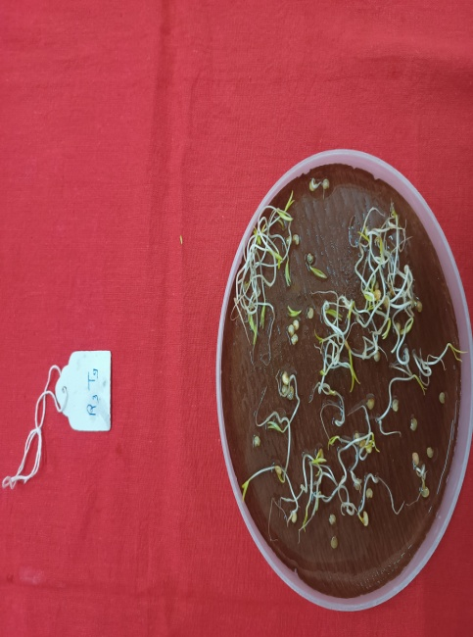
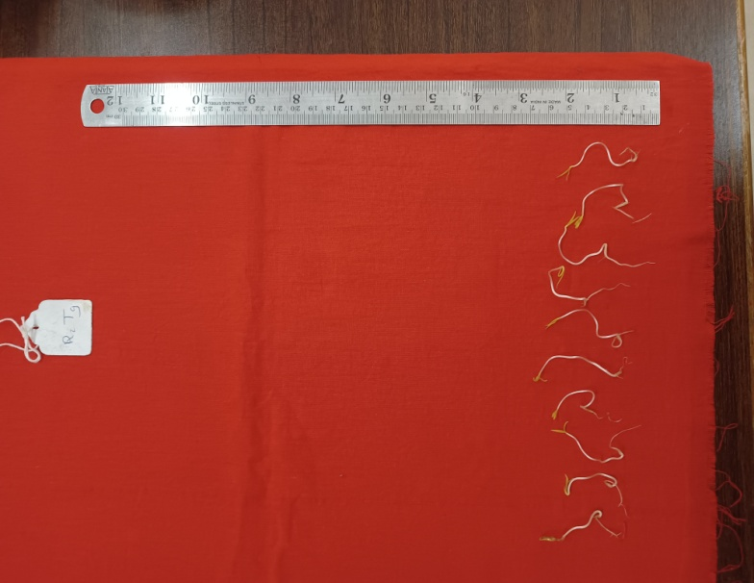
T₁- 0 Days

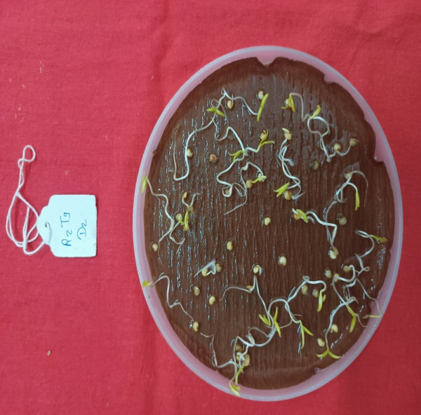
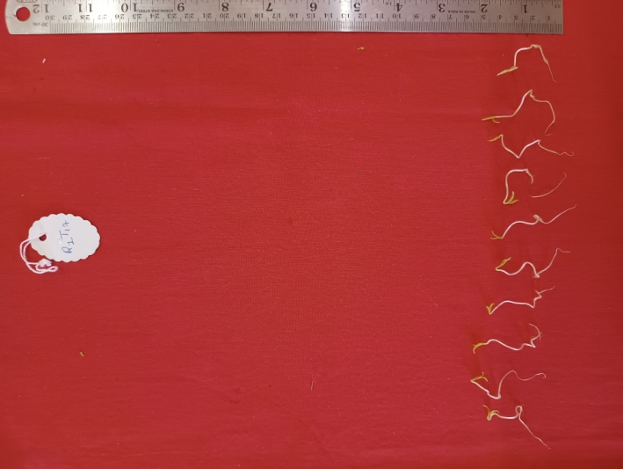
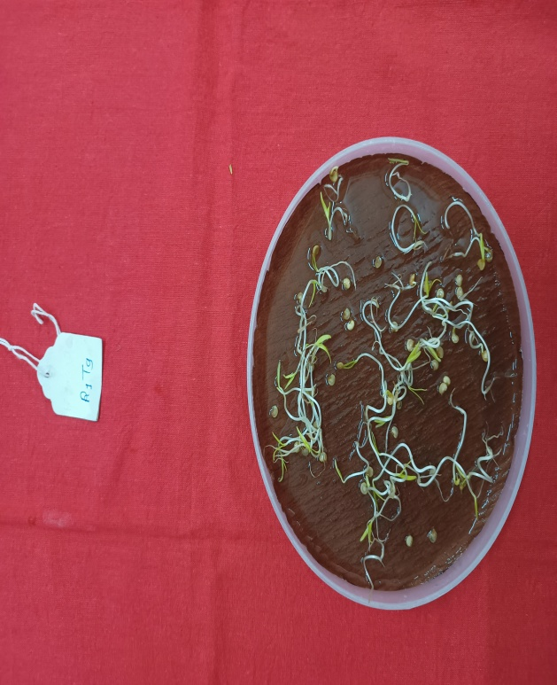
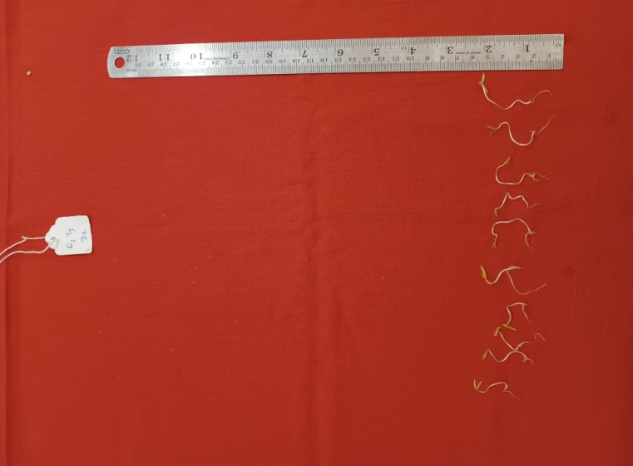
T₃- 2 Days

T₂- 1 Day

T₄- 3 Days

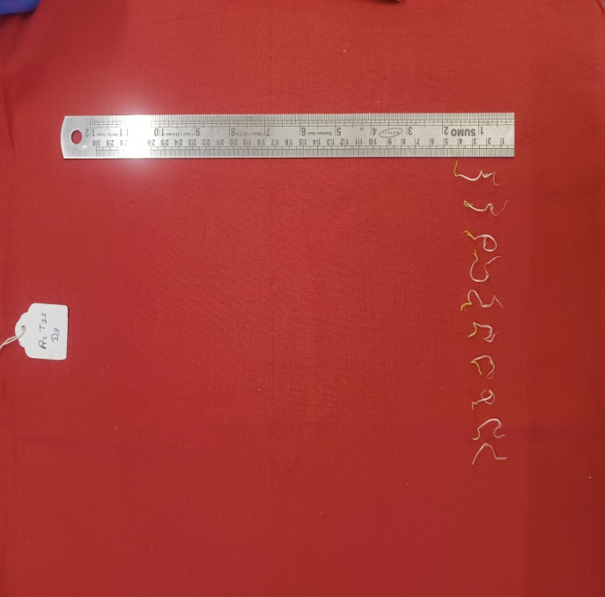
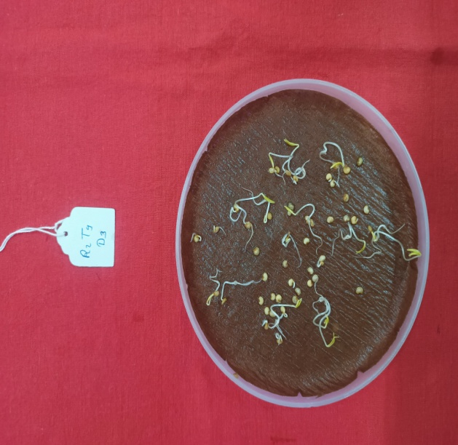
Fig. 1 : Effect of accelerated ageing on germination (%) and seedling length (cm)

