Morpho cultural characterization of post harvest fungal pathogens of onion

ABSTRACT
Three postharvest fungal pathogens, Penicillium spp., Fusarium spp., and Colletotrichum spp., were isolated from infected onion bulb samples collected during a survey in seven districts of Kalyana Karnataka. Pathogenicity tests were conducted following Koch’s postulates, Morphological characterization revealed septate, hyaline hyphae in all pathogens, with Fusarium spp. Producing falcate macro conidia. Colletotrichum spp. cylindrical conidia containing oil globules, and Penicillium spp. produced globe-shaped conidia in chains. Cultural studies showed maximum colony diameter for all pathogens on Potato dextrose agar with Fusarium spp. (89.76 mm), Colletotrichum spp. (89.40 mm) and Penicillium spp. (90.00mm). Potato dextrose agar and Richard’s agar supported abundant sporulation for Fusariumspp. and Colletotrichumspp.while Penicilliumspp. sporulated best on Potato dextrose agar. Colony colour, growth pattern and sporulation varied across media, with potato dextrose agar generally supporting highest growth and pigment development. The results confirm the pathogenic potential and cultural preferences of these fungal species.
Keywords : Onion, Cultural characters, Morphological characters, Pathogenicity test and Roving survey.
- INTRODUCTION

Onion (Allium cepa L.) is one of the most important commercial vegetable crop grown in India. Popularly known as the ‘Queen of kitchen’. It belongs to the family Alliaceae. It is an important underground vegetable bulb crop of tropical and sub-tropical countries (Thompson and Kelly, 1979). Onion originates from the region comprising of NorthWest India, Afghanistan, the Soviet Republics of Tajik and Uzbek, and Western Tien Shan. The genus Allium is notably extensive, encompassing over 500 species, predominantly comprising perennial bulbous plants. Among these, Allium cepa is the major cultivated species grown all over the world.

Onion is grown worldwide over an area of 5482.3 thousand hectares, with a total production of 1112 lakh tonnes and productivity of 19.04 t/ha. India is one of the largest producer and exporter of onion globally, and stands second in the world after China with an area of 1740 thousand hectares, a total production of 302.08 lakh tonnes and a productivity of 17.36 t/ha. The major onion producing states are Maharashtra, Karnataka, Madhya Pradesh, Gujarat, Bihar, Andhra Pradesh, Rajasthan, Haryana and Telangana. Maharashtra ranks first in onion production with a share of 35 per cent followed by Madhya Pradesh with a share of 17 per cent (Anon., 2023)

Onion is prone to many diseases, among them, Aspergillus niger (Black mold), Aspergillus flavus(Green mold) and Fusarium spp. (Basal end rot), Penicillium spp. (Blue mold) and Colletotrichum spp. (Anthracnose) (Dutta et al., 2022) causes about 35 to 40 per cent loss during storage of bulbs. Post harvest diseases deteriorate the quality and quantity of the onion crop. To properly manage the diseases in bulb onions, it is crucial to identify their causal agents. Therefore, present investigation was carried out on morphology and cultural studies of Fusariumspp., Colletotrichum spp. and Penicillium spp.

- METHODOLOGY
Collection of samples
Bulbs of onion infected by different postharvest pathogens showing typical symptoms were collected from vegetable and APMC market from seven districts of Kalyana Karnataka and stored in a polythene sampling bags. Information pertaining to the locality was obtained along with the samples. Infected samples were used for isolation of fungus
Isolation and maintenance of the pathogens
Isolation of the fungus associated with the postharvest pathogens of onion were made by following standard tissue isolation technique.The infected portions, along with some healthy parts, were cut into small pieces (5 to 6 mm size) and surface sterilized by dipping in one per cent sodium hypochlorite solution for 60 seconds. These bits were thoroughly washed thrice with sterile distilled water to remove traces of sodium hypochlorite and blot dry. These bits were then transferred on the solidified and cooled potato dextrose agar medium in Petri plates under aseptic conditions. Inoculated plates were then incubated in BOD incubator at 27 ± 1ºC temperature. After three to four days of incubation, the well developed mycelial growth, free from any contaminant was obtained. Then, apical growth of the fungus was sub cultured by using hyphal tip technique to obtain pure culture.
Pathogenicity assay
Healthy onion bulbs were surface sterilized by dipping in one per cent sodium hypochlorite solution for one minute followed by three washings of sterilized distilled water to remove traces of sodium hypochlorite and air dried.Bulbs were inoculated with fungus using the pin prick method. Inoculated bulbs were kept in the sterilized glass jar and the blotting paper was placed moist by adding required sterilized water daily along with water-soaked cotton swab to maintain humid condition (Naik and Rawal, 2002). Later, incubated at temperature of 28 - 30ºC and uninoculated bulbs were kept as a control. After the development of symptoms, re-isolation of the fungus was made from affected parts of the bulb to satisfy Koch postulates.
Morphological characterization of pathogens
For morphological identification, three fungal pathogens Fusarium (FUR) Colletotrichum spp. (COR) and Penicillium spp. (PER) were grown on potato dextrose agar media and incubated for nine daysat 25 ± 2 °C. Observations were recorded for the size of conidia, mycelial diameter and size of the resting spores by using image capturing microscope (Zeiss) using Gryphax software.
Cultural characterization of fungal pathogens on different solid media
Diversity in cultural characteristics of pathogens were studied on sevendifferent cultural media which includes Potato dextrose agar, Oatmeal agar, Malt extract agar, Richard's agar, Czapek Dox agar, Sabouraud's dextrose agar and Water agar.

Composition of media
1. Potato dextrose agar: Peeled Potatoes (200 g), Agar (20 g), Dextrose (20 g),Distilled water (1000 ml).
2. Oat meal agar : Oat meal (60 g), Agar (20 g), Distilled water (1000ml)
3. Water agar: Agar (20g), Tap water (1000 ml)
4. Richard’s agar: Sucrose (50 g), Potassium dihydrogen phosphate (5 g), Potassium nitrate(10 g), Magnesium sulphate (2.5 g), Ferric chloride (0.02 g), Agar (20 g), Distilled water(1000 ml)
5. Czapek Dox agar: Sodium nitrate (3.0 g), Potassium dihydrogen phosphate (0.5 g), Magnesium sulphate (0.5g), Potassium chloride (0.5 g), Ferrous sulphate (0.01g),Sucrose (20 g), Distilled water (1000ml)
6. Malt extract agar: Malt : (20 g), Peptone(1 g) Dextrose : ( 20 g) Agar : (20 g)Distilled water (1000 ml)
- Sabouraud's dextrose agar: Dextrose: (40 g,) Peptone (10 g) Agar : (20 g)Distilled water (1000ml)
20 ml of respective medium was poured into 90 mm Petri plate. After solidification, 5 mm disc of culture from actively growing culture were cut using a cork borer and a single disc was placed at the centre of Petri dish. Each set of experiment was replicated thrice and the plates were incubated at 27 ± 1 ºC. The cultural characteristics viz., colony colour, growth pattern and sporulation were also recorded at nine days of incubation.
RESULTS AND DISCUSSION
Isolation and pathogenicity of fungal pathogens
Three fungal pathogens Penicillium spp., Fusariums pp. and Colletotrichum spp. were isolated from infected samples collected during survey from seven districts of Kalyana Karnataka. The isolated pathogens were tested on onion bulbs to prove the Koch’s postulates to confirm their pathogenicity. Mycelia of Penicillium spp. and Colletotrichum spp. wasinoculated onto the wounded (Pin pricked) bulbs. For Fusarium inoculation was done at base of the bulb.
Bulbs inoculated with Fusarium spp. started showing symptoms after seven days of inoculation. Initially, white mycelia was seen at the base of the bulb and subsequently rotting of the bulb was observed. Colletotrichum spp. inoculation resulted in development of symptoms after seven days of inoculation characterized by sunken, circular lesions that form concentric rings with distinctive orange margins due to fungal sporulation on the bulb surface. Symptoms of Penicillium spp. inoculated bulbs, showed bluish powdery mass of spores on the surface of the bulbs after five days of inoculation. Later, disease spreads all over the surface of bulbs that could be easily rubbed off.
Similar results of pathogenicity study conducted by Muthukumar et al.(2022). reported that infection by the Fusarium extensively colonizes and breaks down the basal plate tissue, resulting in distinctive symptoms such as brown to dark discolouration, water-soaked lesions and the appearance of white mycelial growth on the bulb surface. Hasabnis (1984) reported that the development of artificial infection by Colletotichum gloeosporioides onthe bulb surface, black smudge-like spots or concentric rings often develop, especially on the outer scales, which can expand inward and cause tissue decay. Abdulsalam(2015) reported similar symptoms on onion bulb surfaces following inoculation with Penicillium. He reported that fungus produced initially water-soaked or pale-yellow areas on the outer surface of the bulb scales. As the disease progresses, a distinctive green to blue-green powdery mold develops on the affected lesions.
Morphological characterization of pathogens
Morphologicalcharacters of Fusarium spp.
Fusarium spp. colonies typically appear as white coloured mycelial growth with pink pigmentation. On potato dextrose agar, the hyphae are septate and hyaline. It produces macroconidia which are typically falcate (sickle-shaped) with a slightly curved form having 3 to 5 septa. Micro conidia are generally smaller oval to kidney shaped mostly aseptate and chlamydospores are larger than conidia, usually smooth or rough walled and formed singly or in chains either terminally or intercalary on the hyphae (Fig. 1 ).

Morphological characters of Colletotrichum spp.
Colletotrichum spp.on potato dextrose agar typically showed cottony growth with colony colour initially appeared white to light gray, gradually turning dark gray as they mature. The conidiophores are simple, short and hyaline, often arranged closely in rows. The conidia are single-celled, hyaline and thin-walled with a typical cylindrical shape. They usually contain one or two central oil globules and vary in size, generally measuring between 10.5 - 20 μm in length and 2 - 6.9 μm in width (Fig. 2).
Morphological characters of Penicillium spp.
Penicillium spp. produced light green colonies on the potato dextrose agar media. The inverse side of the colony appeared colourless to cream colour characterized by septate and hyaline hyphae.The conidia are round to slightly oval, formed in long chains measuring between 2.2 - 3.0 µm in diameter. Conidiophores have smooth walls and are relatively long, typically branched twice. The metulae, which are the secondary branches, appear in clusters of 3 - 6 and measure 10-15 µm in length. The phialides are flask shaped and range from 7 - 12 µm long (Fig. 3).
Similar observations were recorded by Naguleswaramet al.(2014). Fusarium oxysporum f. sp. cepae produces chlamydospores, macro conidia and micro conidia. Chlamydospores are round, thick walled spores that grow in large numbers in the soil. Bandgar et al. (2018)reported that conidia were hyaline, unicellular, cylindrical and the average length and width of conidia of C. gloeosporioides ranged between 10.00 - 12.33 x 3.00 - 4.33 µm. Uy et al. (2022) observed conidiophores of Penicillium spp. were biverticillate smooth to rough, phialides were flask shaped. Conidia were smooth walled, globose to sub-globose, measuring about 2.5-5 × 3.75 μm in length and width.

Cultural characterization of post harvest fungal pathogens
Different nutrient media were tested for native isolates of all the three pathogens viz., Pencillium spp. (PER) Fusarium spp. (FUR) and Colletotrichum spp. (COR)in the present investigation (Fig.4).
Colony diameter
The colony diameter of Fusarium spp. varied across the different media with the largest diameter of mycelial growth observed on potato dextrose agar (89.76 mm). In contrast, least colony diameter was exhibited by water agar (41.50 mm) (Table 1). Highest mean colony diameter of the Colletotrichum spp. was recorded on potato dextrose agar (89.40mm) followed by Richard’s (80.65mm) and Oat meal agar (75.43mm). Least colony growth was observed on water agar (44.93mm) (Table 2). The colony diameter of Penicillium spp. varied depending on the media, with the largest diameter of mycelial growth observed on potato dextrose agar (90.00 mm) followed by malt extract agar (84.93 mm) and Richard's agar (84.83 mm). In contrast least colony diameter was exhibited by water agar (51.23 mm) (Table 3).
Colony colour
The converse and inverse side of colony for Fusarium varied across the media. Potato dextrose agar and Sabouraud’s dextrose agar supported the production of white colony colour on the converse side and pinkish white on the inverse side, indicating the production of pigments typical of Fusariums pp. Conversely, malt extract agar, Richard’s agar, Czapek Dox agar and water agar showed white colonies on both sides, indicating the less pigment production on these media. Colony colour of the Colletotrichum spp. Varied from whitish to grey on the converse side of plate and grey colour colony on the reverse side of culture. In case of potato dextrose agar, Sabouraud’s dextrose agar, Malt extract and Richard’s agar shows white colour colony on both the side. Conversely, Czapek Dox agar exhibited grey colour colony on both the side of the plate.Colony colour on the upper side of the Penicillium spp. culture ranged from light green to green, while the reverse side appeared colourless to creamish. On potato dextrose agar, malt extract agar, Richard’s agar and Czapek Dox agar, the colonies exhibited a green colour on the upper side. In contrast, colonies on oat meal agar, water agar and Sabouraud’s dextrose agar displayed a light green colour on the upper side.
Sporulation and growth pattern
On potato dextrose agar and Richard’s agar, Fusarium spp. exhibited abundant sporulation (++++). In contrast, oat meal agar and Sabouraud’s dextrose agar showed comparatively low sporulation (++). Abundant sporulation of Colletotrichum spp. was seen in potato dextrose agar and Richard’s agar(++++). Poor sporulation was observed on Czapek Dox agar(+). Excellent sporulation of Penicillium spp. was observed on potato dextrose agar (++++). Good sporulation was showed by Richard's agar and Sabouraud’s dextrose agar (+++). Moderate sporulation was seen in malt extract agar, Czapek Dox agar, oat meal agar and water agar (++).
Flat colony growth pattern of Fusarium spp.was observed on oat meal agar and malt extract agar media and scattered growth pattern was exhibited by water agar. In contrast, potato dextrose agar, Sabouraud’s dextrose agar, Richard’s agar and Czapek Dox agar supported fluffy growth pattern. Growth pattern of Colletotrichum spp. varied across all the media with raised growth pattern on Czapek Dox agar. Flat and scanty growth pattern was exhibited by malt extract agar and water agar, respectively. Remaining other four media showed fluffy growth pattern. Velvety growth pattern of Penicillium spp.was exhibited by oat meal agar and scanty growth was showed on water agar. In contrast,potato dextrose agar, malt extract agar, Richard’s agar, Sabouraud’s dextrose agar and CzapekDox agar exhibited powdery growth pattern.
Similar results were obtained by Anjaneya Reddy (2002) who observed that Fusarium udum showed maximum growth on Richard’s agar and potato dextrose agar. Kumar et al. (2017), who reported that potato dextrose agar supported significantly higher growth among all12 isolates of Colletotrichum gloeosporioides compared to Richard’s agar, Czapek Dox agar and corn meal agar.This may be attributed to the fact that potato dextrose agar contains fresh potato extract and dextrose, a preferred carbohydrate source for fungi, which facilitates easier metabolism. Maximum sporulation was observed on Richard’s agar, likely due to its composition, which includes ammonium nitrate as a nitrogen source and sucrose as a carbon source. Zain et al. (2009) observed that among the various growth media tested, Harrlod's medium supported the largest colony diameter, followed by potato dextrose agar. In contrast, Czapek Dox medium resulted in the smallest colony diameter of Penicillium spp.
CONCLUSION
The study confirmed that Fusarium spp., Colletotrichum spp., and Penicillium spp. are major postharvest fungal pathogens of onion in Kalyana Karnataka. Pathogenicity tests proved their ability to cause characteristic bulb rots. Fusarium spp. caused basal rot, Colletotrichum spp. produced concentric lesions with orange margins and Penicillium spp. formed bluish green mold on bulb surfaces. Morphological characterization revealed distinct colony and spore features. Cultural studies showed maximum colony diameter for all pathogens on Potato dextrose agar with Fusarium spp. (89.76 mm), Colletotrichum spp.(89.40 mm)and Penicilliumspp. (90.00 mm). Potato dextrose agar and Richard’s agar supported abundant sporulation for Fusarium and Colletotrichum, while Penicillium sporulated best on Potato dextrose agar. Overall, Potato dextrose agar was identified as the most suitable medium and all the three fungi were confirmed as pathogenic on onion bulbs.
DISCLAIMER (ARTIFICIAL INTELLIGENCE)
Author(s) hereby declares that NO generative AI technologies such as Large Language Models (ChatGPT, COPILOT, etc) and text-to-image generators have been used during the writing or editing the manuscript.
ACKNOWLEDGEMENT
I would like to express my sincere gratitude to the University of Agricultural Sciences, Raichur, Karnataka, India for supporting and facilitating the study.
COMPETING INTERESTS
Authors have declared that no competing interest exist.
REFERENCES
Anjaneya Reddy, B. (2002). Variability of Fusarium udum and evaluation of pigeon pea (Cajanus cajan L.) genotypes. M. Sc. Thesis, Univ. Agric. Sci., Bengaluru, Karnataka.
Abdulsalam, A. A., Zakari, B. G., Chimbekujwo, I. B., Channya, F. K. and Bristone, B. (2015). Isolation and control of fungi associated with neck rot disease of onions (Allium cepa L.) in Bama, Borno State, Nigeria. Global Journal of Biology Agriculture and HealthScience, 4, 35-39.
Anonymous, (2023). Area, production and productivity of onion in India. https://www.indiastat.com

Bandgar, M .S., Barhate, B. G. and Raghuwanshi, K. S. (2018). Morphological variation among different isolates of Colletotrichum gloeosporioides isolated from various crops in Western Maharashtra, India. International Journal of Current Microbiology and Applied Sciences, 7, 2072-2084.
Dutta, R. K. J., Nadig, S. M., Manjunathagowda, D. C., Gurav, V. S. and Singh, M. (2022). Anthracnose of onion (Allium cepa L.): A twister disease. Pathogens, 11, 884.
Hasabnis, S. N. (1984). Studies on storage rot of mango (Mangifera indica L.) fruits caused by C. gloeosporioides (Penz) Penz. and Sacc. and Botryodiplodia theobromae. M. Sc. Thesis, Balasaheb Sawant Konkan Krishi Vidyapeeth, Dapoli, Maharashtra (India).
Kumar, A., Singh, T. K., Kumar, P., Bose, U. S. and Tiwari, R. K. (2017). Pathological and cultural variability in Colletotrichum gloeosporioides (Penz. and Sacc.) inciting anthracnose of mango. International Journal of Current Microbiology and Applied Sciences, 6, 2543-2550.
Muthukumar, G., Udhayakumar, R., Muthukumar, A., Muthukumaran, N. and Ayyandurai, M. (2022). Survey on disease incidence of basal rot of onion incited by Fusarium oxysporum f. sp. cepae in major onion growing tracts of Tamil Nadu. Journal of Pharmacogn and Phytochemistry11, 1445-1454.
Naguleswaram, V., Pakeerathan, K. and Mikunthan, G. (2014). Biological control: A promising tool for bulb rot and leaf twisting fungal diseases in red onion (Allium cepa L.) in Jaffna District. World Applied Sciences Journal 31, 1090-1095.
Naik, M. K. and Rawal, R. D. (2002). Disease resistance in horticultural crops. Plant Protection Association India, Hyderbad. pp. 68-84.
Thompson, H. C. and Kelly, W. C. (1979). Vegetable crops, Tata McGraw Hill Publishing Company Ltd. Bombay, India, pp. 347-368.
Uy, R. J., Kayamori, M. and Nakashima, C. (2022). Characterization of Penicillium species isolated from Dioscorea polystachya in Hokkaido, Japan. Mycoscience, 64(1): 11-18.
Zain, M. E, Razak, A. A., El-sheikh, H. H., Soliman, H. G. and Khalil, A. M. (2009). Influence of growth medium on diagnostic characters of Aspergillus and Penicillium species. African Journal of Microbioogy. Research, 3, 280-286.

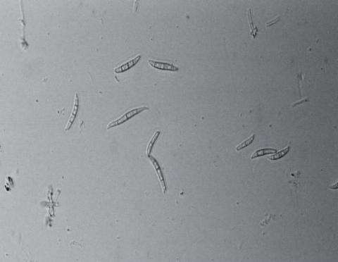
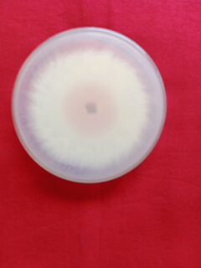
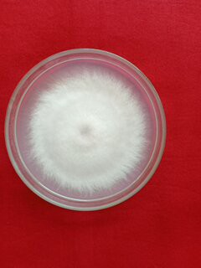
Macro conidia
Front view
Reverse view
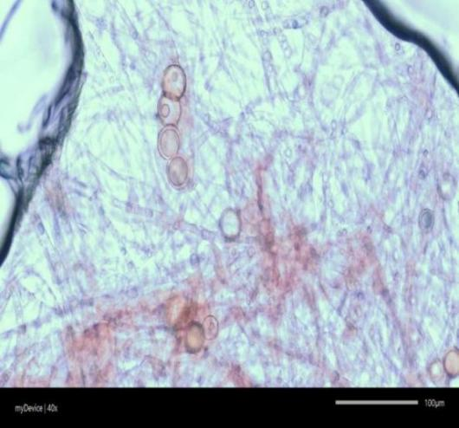
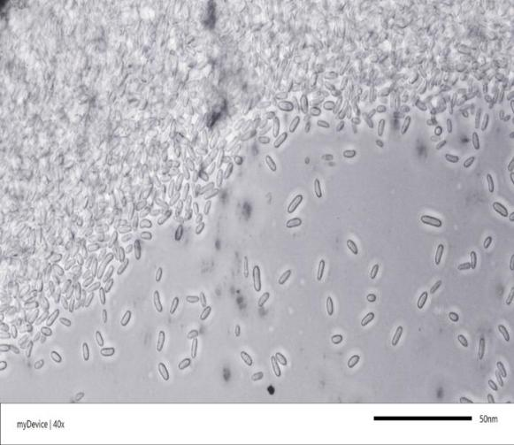

Micro conidia
Chlamydospores (40 X)

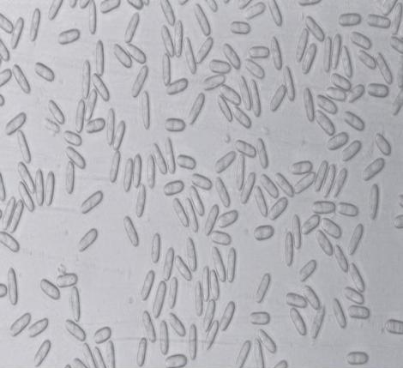
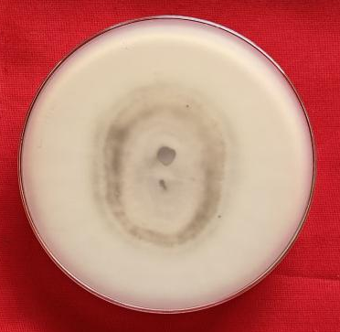
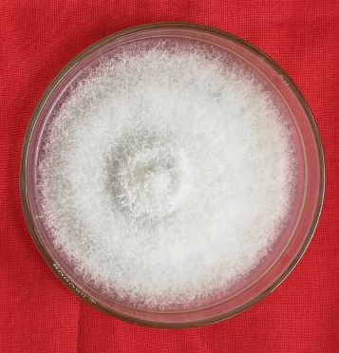
Fig.2 : Morphological features of Colletotrichum spp.

Fig.1: Morphological features of Fusarium spp.
conidia
Reverse view
Front view
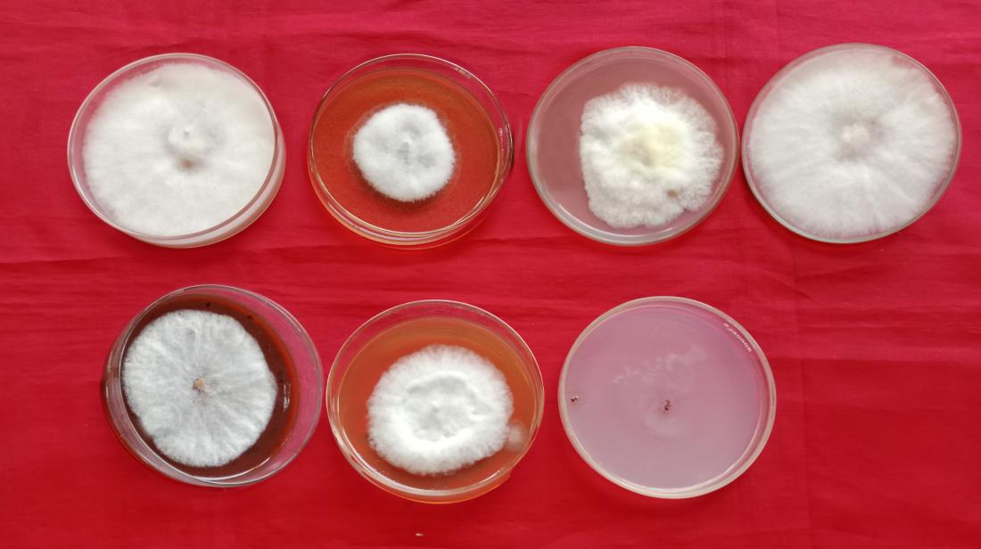
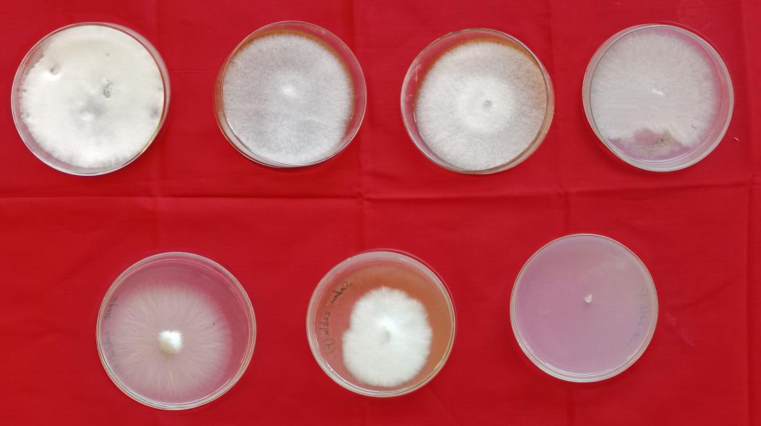
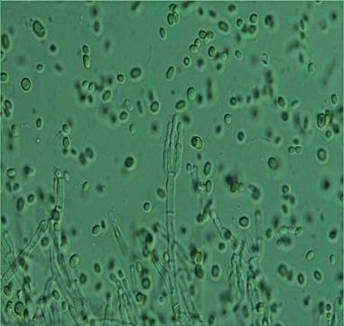
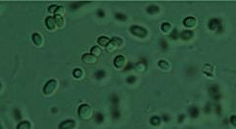
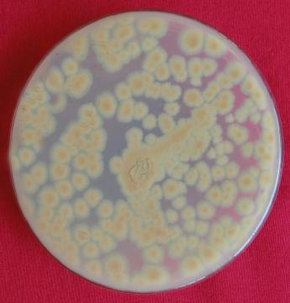
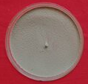
6
7
4
5
3
2
1
7
4
3
2
1
5
6
Colletotrichum spp.
Fusarium spp.
Conidiophore with philiades

Conidia
Reverse view
Front view
Fig. 3: Morphological features of Penicillium spp.

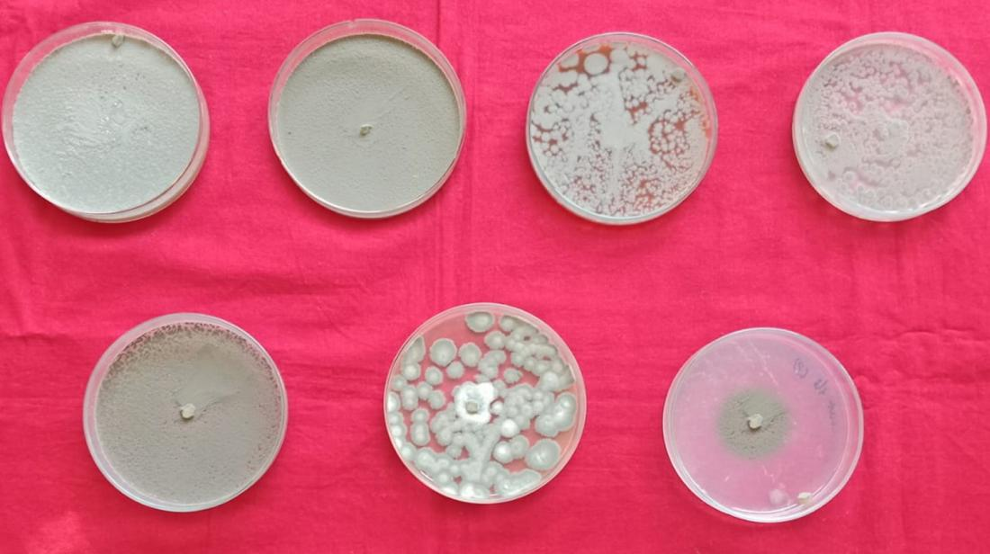

4
3
2
1

5
7
6

Penicillium spp.
Fig. 4: Cultural characteristics of post harvest fungal pathogens on different media

1. Potato dextrose agar 2. Malt extract agar 3. Oat meal agar
4. Richard’s agar 5. Czapek Dox agar 6. Sabouraud’s dextrose agar
7. Water agar

Table 1: Cultural characteristics of Fusarium spp. on different solid media

Sl. No. | Media | Colony  diameter  (mm)* | Growth  rate  (mm/day) | Colony colour |  | Growth  pattern | Sporulation
 |  |  |  | Front view | Reverse view | Growth  pattern | Sporulation
01 | Potato dextrose agar | 89.76 | 9.97 | White | Pinkish white | Fluffy | ++++
02 | Malt extract agar | 74.26 | 8.25 | White | White | Flat | +++
03 | Oatmeal agar | 84.53 | 9.39 | White | White | Flat | ++
04 | Richards's agar | 84.66 | 9.40 | white | White | Fluffy | ++++
05 | Czapek Dox agar | 70.41 | 7.82 | White | White | Fluffy | +++
06 | Sabouraud’s dextrose agar | 74.93 | 8.32 | White | Pinkish white | Fluffy | ++
07 | Water agar | 41.50 | 4.61 | White | White | Scattered | +++
 | S. Em ± | 0.70
 | C. D. at 1% | 2.93

+ (Poor), ++ (Moderate), +++ (Good), ++++ (Excellent)
* Mean of three replication

Table 2: Cultural characteristics of Colletotrichum spp. on different solid media

Sl. No. | Media | Colony  diameter  (mm)* | Growth  rate  (mm/day) | Colony colour |  | Growth  pattern | Sporulation
 |  |  |  | Front view | Reverse view | Growth  pattern | Sporulation
01 | Potato dextrose agar | 89.40 | 9.93 | Whitish to gray | Grey | Fluffy | ++
02 | Malt extract agar | 59.93 | 6.65 | White | White | Flat | +++
03 | Oatmeal agar | 75.34 | 8.37 | White | Grey | Fluffy | ++
04 | Richards's agar | 80.65 | 8.96 | White | White | Fluffy | ++++
05 | Czapek Dox agar | 70.63 | 7.84 | Grey | Grey | Raised | +
06 | Sabouraud’s dextrose agar | 70.21 | 7.80 | White to gray | Gray | Fluffy | +++
07 | Water agar | 44.93 | 4.99 | White | Gray | Scanty | ++
 | S. Em ± | 0.36
 | C. D. at 1% | 1.55

+ (Poor), ++ (Moderate), +++ (Good), ++++ (Excellent)
* Mean of three replication
Table 3: Cultural characteristics of Penicillium spp. on different solid media

Sl. No. | Media | Colony  diameter  (mm)* | Growth  rate  (mm/day) | Colony colour |  | Growth  pattern | Sporulation
 |  |  |  | Front view | Reverse view | Growth  pattern | Sporulation
01 | Potato dextrose agar | 90.00 | 10.00 | Green | Colourless | Powdery | ++++
02 | Malt extract agar | 84.93 | 9.43 | Green | Cream | Powdery | ++
03 | Oatmeal agar | 79.46 | 8.82 | Light green | Colourless | Velvety | ++
04 | Richard's agar | 84.83 | 9.42 | Green | Colourless | Powdery | +++
05 | Czapek Dox agar | 64.73 | 7.19 | Green | Cream | Powdery | ++
06 | Sabouraud’s dextrose agar | 78.33 | 8.70 | Light green | Colourless | Powdery | +++
07 | Water agar | 51.23 | 5.69 | Light green | Colourless | Scanty | ++
 | S. Em ± | 0.66
 | C. D. at 1% | 2.79

+ (Poor), ++ (Moderate), +++ (Good), ++++ (Excellent)
* Mean of three replication
Fusarium spp.
Penicillium spp.

