Original Research Article
Comprehensive Study of Sunflower Traits Through Principal Component Analysis and Character Association

ABSTRACT
This research evaluated the genetic diversity and character association among 45 sunflower inbred lines. Principal component analysis (PCA) and hierarchical cluster analysis were used to estimate diversity among the inbred lines. The PCA revealed that the first three principal components (PC1, PC2, and PC3) accounted for 64.80% of the total variation, with eigen values of 3.62, 1.96, and 1.54, respectively. The biplot analysis identified RHA-1013, CMS-249B, NDSI-3, ARM-243B, CMS-104B, NDLR-32, and NDLR-1 as the most diverse lines. Inbred lines were grouped into five clusters using Wards method, with Cluster V having the highest number of lines (13), followed by Cluster II (11). Clusters V and IV exhibited the highest mean values for most of the traits studied. Correlation analysis demonstrated a strong positive relationship between seed yield (kg ha⁻¹) and days to 50% flowering, plant height, head diameter, volumetric weight, 100 seed weight, oil yield, seed yield (g/plant) and final plant stand. Path analysis revealed that seed yield (g/plant) and oil yield (kg ha⁻¹) exhibited high and positive direct effects on seed yield (kg ha⁻¹). All the traits exhibited positive indirect effects on seed yield (kg ha⁻¹) via seed yield (g/plant) and oil yield. Therefore, simultaneous selection for these traits is suggested for improvement of seed yield (kg ha⁻¹) in sunflower.
KEY WORDS: Sunflower, genetic diversity, PCA and character association
INTRODUCTION
Sunflower (Helianthus annuus L.) is a globally cultivated crop renowned for its versatility and nutritional value. It is an annual crop of Asteraceae family, native to north America. Its genome is diploid with chromosome number 2n=34. Sunflower is a highly crosspollinated crop with high yield potential known for its adaptability to various environmental conditions. Sunflower contributes a noteworthy 3.85% to India's overall oilseed production. Sunflower seeds contain a substantial 44% of high-quality oil, rich in essential vitamins and low in cholesterol (Arshad et al., 2019). Sunflower is well known for its premium edible oil rendering abundance of oleic and linoleic acid. These fatty acids help reducing cholesterol levels and lower the risk of heart diseases. These vital polyunsaturated fatty acids often deficient in other oilseeds elevates its status as the second most important oilseed crop worldwide, following only soybean. This oil's applications extend beyond culinary use, serving as a promising raw material for biodiesel production (Baloch et al., 2016). Sunflower seeds are a valuable source of protein, minerals, and vitamins for the nutritional and pharmaceutical industries (Sarvari et al., 2017). Sunflower is globally cultivated in an area of 20.00 million hectares with production of 30.00 million tonnes and productivity of 1,500 kg ha⁻¹ (Kumar et al., 2024). In India, for the year 2022-2023, sunflower cultivation recorded a production of 2.79 lakh tonnes from 2.69 lakh ha with average productivity of 1037 kg ha⁻¹ (Reddy et al., 2024).
Despite of its various nutritional benefits, area under sunflower cultivation is reducing drastically over years which can be accounted by several factors. One among such is lack of good quality hybrids in sunflower. As modern cultivars have reached on yield plateau, there is a need for development of new hybrids with increased yield potential (Madhavilatha et al., 2017). As sunflower is highly cross-pollinated crop, hybridization plays important role in its breeding especially when variability of cultivated form has been exhausted. It is more necessary to screen for diversity among the inbred lines as most diverse inbred lines manifest high hybrid vigour in offsprings. The extent of genetic diversity among the inbred lines was assessed using principal component analysis (PCA) and hierarchical cluster analysis. PCA is a multivariate technique that reduces dimensionality of large set of variables into fewer principal components that explains main patterns. It helps finding out linear combinations that account for majority of variation of data (Reddy et al., 2024).
Seed yield is a complex trait influenced by numerous interacting factors, including both the plant's genetic makeup and environmental conditions. Understanding how yield attributing traits interact with one another and with the environment is critical for building a successful crop improvement programme. An understanding of the nature and degree of link between any two pairs of metric features can be gained from correlation studies. From this, it would be possible to bring about genetic enhancement in commercially important character like seed yield through indirect selection of component traits. Estimation of correlation coefficients provide a measure of association between yield and its contributing traits and they fail
to differentiate between direct and indirect effects (Pekcan et al., 2022). This limitation arises because associated traits are not independent but rather interconnected. Path coefficient analysis, a technique utilizing standardized partial regression coefficients, effectively addresses this by partitioning the correlation coefficients into direct and indirect effects (Mariyam et al., 2024). It offers valuable insights into the causal structure of these relationships, highlighting the relative importance of each contributing factor on the final yield. This study employs character association analysis and principal component analysis (PCA) to investigate the interrelationships among sunflower traits and to identify the key genetic factors influencing their variation.
MATERIAL AND METHODS
The current investigation was conducted with 45 sunflower inbred lines evaluated in an Alpha Lattice Design with three replications. The field experiment was carried out during the Rabi 2023-2024 at the Regional Agricultural Research Station, Nandyal, Andhra Pradesh, India, geographically located at 15⁰29’ north latitude and 78⁰29’ east longitude at an altitude of 211.76 m above mean sea level. Each genotype was cultivated in two rows with a row length of 3m, with plot size of 3.0 × 1.8 m² per genotype maintaining a row spacing of 60 cm and plant spacing of 30 cm. All the agronomic practices recommended by Acharya N.G. Ranga Agricultural University were carried to raise a healthy crop. Data were collected from five randomly selected plants per genotype in all replications for, plant height, head diameter, volume weight, 100-seed weight, seed yield (g/plant), oil content, and oil yield while for days to 50% flowering, days to maturity, final plant stand and seed yield (kg ha⁻¹) data was recorded on plot basis. Analysis of variance (ANOVA) was conducted on the Alpha Lattice Design using the Variability package in R Studio. PCA (Hotelling, 1936) and cluster analysis were used to assess genetic diversity among Inbred lines (Peeters and Martinelli, 1989). Genotypic and phenotypic correlation co-efficient were calculated using the method given by Johnson et al. (1955) to determine the association between two or more quantitative characters.
Path coefficient analysis as suggested by Dewey and Lu (1959) was employed to estimate direct and indirect effects of yield attributing traits on seed yield (kg ha⁻¹). The collected data is subjected to statistical analysis employing JMP 18.0 statistical software
(SAS Institute Inc., Cary, NC, USA) to determine genetic diversity through, PCA and hierarchical cluster analysis. INDOSTAT 9.2 software is employed for character association studies.

RESULTS AND DISCUSSION
The mean values of 45 inbred lines were subjected to analysis of variance (ANOVA), and the resulting mean sum of squares for each trait is shown in Table 1. The significant mean sum of squares across all traits highlights variability, suggesting these traits should be prioritized for further enhancement (Mariyam et al., 2024).
Principal component analysis, is a statistical method used to simplify complex data by transforming it into a smaller number of key variables, or components. This approach identifies groups of related data points, thereby capturing the essential information without losing the original dataset's meaning. Each component accounts for a certain percentage of the overall variation in the data (Das et al., 2017). In this study, 45 sunflower inbred lines were evaluated using principal component analysis (PCA) to identify key traits contributing to their phenotypic variation. PCA disclosed that among 11 principal components (PC) only three principal components PC1 (3.62), PC2 (1.96) and PC3 (1.54) are having eigen values higher than mean eigen value (0.999) and contributed 64.80% to the total diversity among the sunflower inbred lines (Table 2). In PC1, traits with the highest factor loading values (Table 3) included seed yield (g/plant) (0.920), seed yield (kg ha⁻¹) (0.919) and oil yield (0.854), while oil content had a negative factor loading value (-0.116). This suggests that inbreds in PC1 are more likely linked with high seed yield and oil yield but lower oil content. No positive factor loading was found for all traits in any PC. In PC2, traits such as plant height (0.602), days to maturity (0.574), and head diameter (0.541) showed positive factor loading values, indicating inbreds with greater height, late maturity, and larger flower heads. For PC3, days to 50% flowering (0.645) and days to maturity (0.549) had high positive factor loadings. In PC4 and PC6 highest positive factor loading value is recorded for oil content (0.404). Final plant stand (0.325), volumetric weight (0.750) and 100 seed weight (0.347) recorded higher loading factor values in PC4, PC5 and PC8 respectively. The study found that the traits contributing to higher yields and oil content were distributed across various factors. This suggests that the most promising hybrids could emerge from different population groups, reflecting the diversity of the inbred lines. Present findings support the earlier results of Meena et al. (2023). The PC1, accounting for 32.92% of the variation, significantly influences the changes in seed yield per plant, seed yield (kg ha⁻¹) and oil yield. If the selection process had prioritized this PC, it would have been the most effective concerning seed yield (kg ha⁻¹) and oil yield. The PC2 contributed 17.68% to the variation, while PC3 explained 14.02% of the total variance. These results align with the findings of Dudhe et al. (2018) and Madhavilatha et al. (2017) in sunflower.
A biplot is plotted using first two PC’s (PC1 and PC2) and depicted in Fig. 1. In this biplot, traits were distributed among 3 quadrants whereas inbred lines were scattered all over the quadrants. Days to maturity, plant height, head diameter, days to 50% flowering, final plant stand and volumetric weight were included in quadrant-1 (Q1). In the same quadrant,
RHA-1013, CMS-249B were found extreme. NDLR-32 and NDLR-1 were found extreme in Q2. Seed yield(g/plant), seed yield (kg ha⁻¹), oil yield, 100 seed weight were grouped in Q4. NDSI-3, ARM-243B and CMS-104B were found extreme in Q4. Only one trait oil content is observed in Q3 with negative values for both PC’s. The inbred lines that are found extreme can be selected for those traits present in their respective quadrants. Inclusion of lines from different quadrants as distinct parents help overall improvement of all the yield attributing traits in sunflower. Selection of inbred lines with extreme PC values in the biplot was also reported by Reddy et al. (2024).
The inbred lines were organized into five distinct clusters using hierarchical cluster analysis using Wards method. These cluster groups are detailed in the Table 4. As illustrated by the cluster diagram (Fig. 2), inbred lines that connect earlier are more similar to each other than those that join later. The cluster means represented in Table 5 shows that cluster V, with 13 inbred lines, contains the most lines, followed by cluster II with 11. The highest cluster mean was observed in cluster III (207.88), followed by cluster V (203.62), while the lowest was found in cluster II (162.84). Cluster III recorded highest mean values for 100 seed weight, seed yield (g/plant), seed yield (kg ha⁻¹), oil yield (kg ha⁻¹) this indicates that selection can be made for all these traits in this cluster. Highest cluster means recorded for final plant stand, plant height, head diameter and volumetric weight in cluster V. Cluster IV reported highest mean for days to 50% flowering and days to maturity whereas oil content showed highest cluster mean in cluster II. The hierarchal cluster analysis provides simple criteria for selecting inbred lines with diverse trait combinations based on these cluster averages, which can be utilized as parental lines to enhance heterosis in new hybrids. Hussain et al. (2017) also highlighted the importance of selecting inbred lines based on cluster mean values.
The correlations between yield and its attributes in 45 sunflower genotypes were analysed and presented in Table 6 and the correlation matrix is represented in Fig.3 and Fig.4. The results suggest that the genetic relationships between these traits are generally stronger than those influenced by environmental factors, indicating a limited impact of the environment on the inherent association between yield and its component traits. The results revealed that there was significant and positive association of seed yield (kg ha⁻¹) with days to 50% flowering, plant height, head diameter, volumetric weight, 100 seed weight, oil yield, seed yield (g/plant) and final plant stand. By focusing on these positively associated attributes, breeders can efficiently improve sunflower genotypes with higher yields. Similar kind of positive association between seed yield (kg ha⁻¹) and plant height, seed yield (g/plant) and head diameter is reported by Harshavardan et al. (2021) and lakshman et al. (2021). Gopi et al. (2023) and Mariyam et al. (2024) found similar association of volumetric weight and 100 seed weight with seed yield (kg ha⁻¹) and suggested for selecting these traits to improve seed yield
(kg ha⁻¹). Negative but non-significant relation of seed yield (kg ha⁻¹) was observed with oil content.
Inter-character associations had shown positively significant association of days to 50% flowering with days to maturity, seed yield (g/plant), plant height and oil yield ; days to maturity with plant height and head diameter; final plant stand with plant height, head diameter, volumetric weight, seed yield (g/plant) and oil yield (kg ha⁻¹); plant height with head diameter, volumetric weight, seed yield (g/plant), 100 seed weight and oil yield; head diameter with volumetric weight, seed yield (g/plant) and oil yield; 100 seed weight with seed yield (g/plant) and oil yield; volumetric weight with seed yield (g/plant) and oil yield; oil content with oil yield. Further significant negative inter character association is found for days to 50% flowering with oil content and final plant stand; days to maturity with oil content and 100 seed weight; final plant stand with days to 50% flowering and oil content; plant height with oil content; head diameter with oil content. These associations suggest that selecting for certain traits, such as plant height or head diameter, could lead to improvements in seed and oil yield. However, selecting for early flowering or increased days to maturity might reduce oil content. Balancing these traits is crucial for developing high-yielding and oil-rich hybrids. Similar findings were reported by Neelima et al. (2023) for plant height with head diameter and volumetric weight; Gopi et al. (2023) for days to 50% flowering with plant height and oil content; Kaur and Kaila. (2023) for days to maturity with plant height and oil content; Pekcan et al. (2022) for oil yield with days to maturity, plant height and 100 seed weight; Baraiya et al. (2018) for oil content with plant height and head diameter; Mariyam et al. (2024) for head diameter and volumetric weight with oil yield.
Path analysis is used to analyse all details of relationship between yield and its component traits with examining completely the direct and indirect effects for constituting of main yield traits. Therefore, to understand the direct and indirect effects of yield attributing traits on yield, path coefficient analysis is performed and the path coefficient values are displayed in Table 7. Phenotypic and genotypic path diagram for seed yield (kg ha⁻¹) are represented in Fig. 5 and Fig. 6 respectively. In the current study, the residual effect observed was 0.012 and 0.087 at both phenotypic level and genotypic levels, respectively. This implies its significance in measuring influence of unexamined independent variables. Several traits viz., days to 50% flowering, head diameter, 100 seed weight, seed yield per plant and oil yield exhibited positive and direct effects on seed yield (kg ha⁻¹), indicating their direct contribution to higher yield. These findings corroborate previous research by Kaur and Kaila (2023) for days to 50% flowering; Radic et al. (2021) for head diameter; Gopi et al. (2023) for 100 seed weight and Lakshman et al. (2021) for oil yield. In contrast, days to maturity, final plant stand, plant height, volumetric weight and oil content exhibited negative direct effects on seed yield (kg ha⁻¹). These findings align with previous research by Kaur and Kaila (2023) for plant height and volumetric weight; Radic et al. (2021) for oil content. Most of the traits showed significant positive indirect effects mediated by seed yield (g/plant) and often by oil yield as well. This highlights the importance of these traits in enhancing individual plant productivity, which ultimately drives overall seed yield (kg ha⁻¹). Seed yield (g/plant) and oil yield emerged as key drivers of total seed yield (kg ha⁻¹), with strong direct and indirect positive effects.
CONCLUSION
It is concluded that there is ample variation among the inbred lines. This study leads to identification of traits seed yield (g/plant), oil yield, seed yield (kg ha⁻¹), plant height and head diameter as major source of diversity and can be considered as selection indices in selecting most diverse inbred lines. From the PCA biplot RHA-1013, CMS-249B, NDSI-3, ARM-243B, CMS-104B, NDLR-32 and NDLR-1 were recognized most diverse and identified as promising lines for use in hybridization programmes to enhance heterotic effects sunflowers. Inbred lines from cluster V and cluster IV were found superior for most of the traits. Correlation studies reported significantly positive relation of seed yield (kg ha⁻¹) with days to 50% flowering, plant height, head diameter, volumetric weight, 100 seed weight, oil yield, seed yield (g/plant) and final plant stand. Improvement of traits such as seed yield (g/plant) and oil yield will directly enhance seed yield (kg ha⁻¹) due to their positive direct effects on seed yield (kg ha⁻¹).
REFERENCES
Arshad, M., Jan, S., Awan, S., Azam, S., Khalid, S. and Khan, M.A. 2019. Investigation of genetics divergence in newly developed local sunflower (Helianthus annuus L.) hybrids. Pakistan Journal of Agricultural Research, 32(1):33-40.
Baloch, M., Kaleri, M.H., Baloch, A.W., Baloch, T.A., Gandahi, N., Jogi, Q., Bhutto, L.A. and Hakro, J.A. 2016. Phenotypic correlation and heritability analysis in sunflower (Helianthus annuus L.) germplasm. Pure and Applied Biology, 5(3): 641-646.
Baraiya, V.K., Jagtap, P.K., Sangani, J.L. and Malviya, A.V. 2018. Correlation and path analysis in sunflower (Helianthus annuus L.). Journal of Pharmacognosy and Phytochemistry, 7(5):2730-2732.
Das, S., Das, S.S., Chakraborty, I., Roy, N., Nath, M.K. and Sarma, D. 2017. Principal component analysis in plant breeding. Biomolecule Reports, 3:1-3.
Dewey, D.R. and Lu, K.H. 1959. A correlation and path coefficient analysis of components of crested wheat grass seed production. Agronomy Journal, 51: 515-518.
Dudhe, M.Y., Rajguru, A.B., Bhoite, K.D., Kadam, S.M., Ranganatha, A.R.G., Sujatha, M. and Reddy, A.V. 2018. Characterization, evaluation and multivariate analysis of sunflower germplasm under semi-arid environments of three locations in two sunflower growing states in India. Journal of Environmental Biology, 39(6):990-996.
Gopi, V., Kalaimagal, T., Sasikala, R., Harish, S. and Senthivelu, M. 2023. Study on genetic parameters, correlation and path analysis in elite sunflower (Helianthus annuus L.) inbreds. Pharma Innovation, 12(8):1940-1944.
Harshavardan, J.H., Immadi, S. and Amandeep. 2021. Variability and correlation studies in sunflower lines (Helianthus annuus L.). Journal of Pharmacognosy and Phytochemistry, 10(3): 221-223.
Hotelling, H. 1936. Relations between two sets of varieties. Biometrica, 28(3-4):321-377.
Hussain, F., Rafiq, M., Ghias, M., Qamar, R., Razzaq, M.K., Hameed, A. and Mustafa, H.S.B. 2017. Genetic diversity for seed yield and its components using principal component and cluster analysis. Life Science Journal, 14(5):71-78.
Johnson, H.W., Robinson, H.F. and Comstock, R.E. 1955. Genotypic and phenotypic correlation in soyabean and their implication in selection. Agronomy Journal, 47: 477-483.
Kaur, B. and Kaila, V. 2023. Variability assessment and trait relationships among confectionery sunflower inbreds. Emergent Life Sciences Research, 9: 1-12.
Kumar, P.S., Dudhe, M.Y., Sabesan, T. and Saravanan, K. 2024. Study on genetic diversity in sunflower (Helianthus annuus L.) 33 elite genotypes. Plant Archives, 24(1):259-264.
Lakshman, S.S., Chakraborty, N.R., Debnath, S. and Kant, A. 2021. Genetic variability, character association and divergence studies in sunflower (Helianthus annuus L.) for improvement in oil yield. African Journal of Biological Sciences, 3(1):129-145.
Madhavilatha, K., Prasad, A.D. and Neelima, S. 2017. Genetic divergence studies for yield and its attributes in sunflower (Helianthus annuus L.). Electronic Journal of Plant Breeding, 8(4):1178-1182.
Mariyam, N., Kulkarni, V.V., Sujatha, M. and Tembhurne, B.V. 2024. Assessment of Genetic Variability and Character Associations in Sunflower (Helianthus annuus L.) Yield Related Traits. Asian Journal of Soil Science and Plant Nutrition, 10(1): 320-327.
Meena, H.P., Sujatha, M., Yadav, P., Dudhe, M.Y., Uma, M.S., Vikas, K., Sasikala, R., Ghodke, M.K., Neelima, S., Sakhare, S.B. and Vineeta, K. 2023. Multivariate analysis among indigenous and exotic advanced inbred lines of sunflower (Helianthus annuus L.) for genetic improvement. INDIAN JOURNAL OF GENETICS AND PLANT BREEDING, 83(04):535-545.
Neelima, S., Venkata Ramanamma, K., Prabhakar, K. and Venkateswarlu, N. 2023. Genetic variability and association studies in Sunflower Inbreds. Journal of Oilseeds Research, 40: 95-96.
Peeters, J.P. and Martinelli, J.A. 1989. Hierarchical cluster analysis as a tool to manage variation in germplasm collections. Theoretical and Applied Genetics, 78:42-48.
Pekcan, V., Yilmaz, M.I., Evci, G., Cil, A.N., Sahin, V., Gunduz, O., Koc, H. and Kaya, Y. 2022. Oil content determination on sunflower seeds in drought conditions. Journal of Food Processing and Preservation, 46(10):15481-15483.
Radic, V., Balalic, I., Jacimovic, G., Krstic, M., Jockovic, M. and Jocic, S. 2021. A study of correlations and path analyses of some traits in sunflower parental lines. Ratarstvo i povrtarstvo, 58(1):7-13.
Reddy, B.V.R.P., Amarnath, K., Reddy, B.C., Venkataramanamma, K., Prabhakard, K. and Venkateswarlu, N.C. 2024. Discerning genetic diversity among sunflower germplasm accessions through multivariate analysis. Electronic Journal of Plant Breeding, 15(1):194-200.

Reddy, Y.P.K., Reddy, B.R.P., Venkataramanamma, K. And Shanthi, P. 2024. Field Screening for Powdery Mildew Disease Resistance in Sunflower (Helianthus annuus L.) GENOTYPES. The Journal of Research ANGRAU, 52(2):152-157.
Sarvari, M., Darvishzadeh, R., Najafzadeh, R. and Maleki, H. 2017. Physio-biochemical and enzymatic responses of sunflower to drought stress. Journal of Plant Physiology and Breeding, 7(1):105-119.

TABLES AND FIGURES

S. No | Traits | Mean squares
S. No | Traits | Replications  (df:2) | Genotypes  (df:44) | Blocks  (df:24) | Error  (df:64)
1 | Days to 50% flowering | 1.49 | 9.60** | 1.98 | 2.63
2 | Days to maturity | 0.59 | 14.82** | 5.97 | 6.04
3 | Final plant stand | 0.77 | 5.27** | 3.28 | 2.64
4 | Plant height (cm) | 1.20 | 606.00** | 57.80 | 75.40
5 | Head diameter (cm) | 1.15 | 8.67** | 0.90 | 0.82
6 | Volumetric weight (g 100ml⁻¹) | 2.55 | 92.19** | 2.02 | 2.50
7 | 100 seed weight(g) | 0.06 | 1.22** | 0.15 | 0.14
8 | Seed yield (g/plant) | 0.29 | 30.96** | 5.27 | 3.03
9 | Seed yield (kg ha⁻¹) | 3947.00 | 109698.00** | 26871.00 | 15457.00
10 | Oil content (%) | 2.53 | 8.17** | 2.94 | 2.30
11 | Oil yield (kg ha⁻¹) | 680.00 | 13364.00** | 2724.00 | 1410.00
Table 1. Analysis of variance for yield and yield attributing traits in sunflower
*, ** Significant at 5% and 1% levels, respectively

Table 2. Contribution of different principal components to the total variance
Component | PC1 | PC2 | PC3 | PC4 | PC5 | PC6 | PC7 | PC8 | PC9 | PC10 | PC11
Eigen value | 3.62 | 1.96 | 1.54 | 0.97 | 0.82 | 0.71 | 0.61 | 0.53 | 0.23 | 0.00 | 0.00
Proportion variance % | 32.92 | 17.86 | 14.02 | 8.85 | 7.45 | 6.45 | 5.51 | 4.83 | 2.10 | 0.01 | 0.00
Cumulative variance % | 32.92 | 50.78 | 64.80 | 73.65 | 81.09 | 87.54 | 93.05 | 97.88 | 99.99 | 100.00 | 100.00

Table 3. Factor loadings of different traits in each principal component
Characters | PC1 | PC2 | PC3 | PC4 | PC5 | PC6 | PC7 | PC8 | PC9 | PC10 | PC11
Days to 50% flowering | 0.256 | 0.337 | 0.645 | -0.189 | 0.205 | 0.327 | 0.358 | -0.284 | -0.111 | 0.000 | 0.000
Days to maturity | 0.122 | 0.574 | 0.549 | 0.235 | -0.028 | 0.044 | 0.035 | 0.537 | 0.080 | 0.000 | 0.000
Final plant stand | 0.460 | 0.181 | -0.488 | 0.325 | -0.079 | -0.265 | 0.578 | 0.017 | -0.027 | 0.000 | 0.000
Plant height (cm) | 0.542 | 0.602 | -0.288 | -0.124 | -0.217 | 0.227 | -0.069 | -0.190 | 0.326 | 0.001 | 0.000
Head diameter (cm) | 0.575 | 0.541 | -0.292 | 0.126 | -0.267 | 0.181 | -0.265 | 0.001 | -0.319 | -0.001 | 0.000
Volumetric weight (g 100ml⁻¹) | 0.390 | 0.020 | -0.374 | 0.281 | 0.750 | 0.220 | -0.114 | 0.055 | 0.026 | 0.000 | 0.000
100 seed weight (g) | 0.345 | -0.242 | -0.369 | -0.700 | 0.013 | 0.213 | 0.169 | 0.347 | -0.040 | 0.000 | 0.000
Seed yield (g/plant) | 0.920 | -0.267 | 0.221 | -0.026 | 0.000 | -0.163 | -0.076 | -0.017 | 0.008 | 0.014 | 0.003
Seed yield (kg ha⁻¹) | 0.919 | -0.266 | 0.223 | -0.026 | 0.001 | -0.164 | -0.077 | -0.017 | 0.011 | 0.015 | -0.003
Oil content (%) | -0.116 | -0.654 | -0.028 | 0.404 | -0.285 | 0.546 | 0.115 | 0.045 | 0.027 | 0.009 | 0.000
Oil yield (kg ha⁻¹) | 0.854 | -0.453 | 0.208 | 0.107 | -0.086 | 0.012 | -0.037 | -0.003 | 0.033 | -0.030 | 0.000

Table 4. Cluster composition of sunflower inbred lines based on wards method

CLUSTER | NUMBER OF ACCESSIONS | ACESSIONS
1 | 8 | OPH-74, RHA-172, PS2023B, RHA-859, NDLR-1, NDLR-32, PB-110, NDLR-27
2 | 11 | RP-16, NDLB-5, CMS-302B, NDLR-40, NDSI-2, IC502039, EC-601829, COSF-7B, RSFH-11, RSFH-5, R-106
3 | 7 | NDI-50, NDI-55, RHA-95C-1, CMS-30B, R-64, RHA-6D-1, LTRR-341
4 | 6 | NDI-20, RCR-39, RHA-1096, PB-120, EC601768, R X R-2-38
5 | 13 | NDI-47, KBSH-44, CMS-104B, NDSI-3, CMS-249B, NDI-43, ARM-243B, COSF-6B, PM-81, NDLR-36, NDLR-4, RP-10, RHA-1012

Characters | Cluster I | Cluster II | Cluster III | Cluster IV | Cluster V | Mean
Days to 50% flowering | 54.29 | 52.97 | 53.67 | 55.06 | 54.46 | 54.09
Days to maturity | 89.67 | 86.79 | 86.24 | 90.11 | 88.10 | 88.18
Final plant stand | 17.64 | 17.45 | 18.35 | 18.42 | 18.93 | 18.16
Plant height (cm) | 95.19 | 84.48 | 89.17 | 92.26 | 107.24 | 93.67
Head diameter (cm) | 8.93 | 8.79 | 8.30 | 10.34 | 11.09 | 9.49
Volumetric weight (g 100ml⁻¹) | 36.89 | 35.35 | 36.18 | 37.04 | 42.63 | 37.62
100 seed weight (g) | 3.41 | 3.68 | 4.33 | 2.98 | 4.21 | 3.72
Seed yield (g/plant) | 20.16 | 19.02 | 25.62 | 24.68 | 24.59 | 22.81
Seed yield (kg ha⁻¹) | 1120.72 | 1056.09 | 1422.96 | 1371.26 | 1365.83 | 1267.37
Oil content (%) | 33.63 | 36.94 | 35.60 | 36.38 | 35.66 | 35.64
Oil yield (kg ha⁻¹) | 376.63 | 389.66 | 506.30 | 498.85 | 487.05 | 451.70
Mean | 168.83 | 162.84 | 207.88 | 203.40 | 203.62 | 189.31
Table 5. Cluster means with respect to yield and its attributes among sunflower inbred lines

 |  | Days to 50% flowering | Days to maturity | Final Plant Stand | Plant height (cm) | Head Diameter (cm) | Volumetric weight  (g 100ml⁻¹) | 100 seed weight (g) | Seed yield  (g/plant) | Oil content (%) | Oil yield (kg ha⁻¹) | Seed yield  (kg ha⁻¹)
Days to 50% flowering | r_{p} | 1 | 0.328** | -0.0074 | 0.135 | 0.0132 | -0.0265 | -0.0288 | 0.174* | -0.174* | 0.1082 | 0.174*
Days to 50% flowering | r_{g} | 1 | 0.482** | -0.231* | 0.260* | 0.1031 | -0.0185 | -0.0865 | 0.256* | -0.225* | 0.187* | 0.254*
Days to maturity | r_{p} |  | 1 | -0.0118 | 0.0876 | 0.1206 | -0.0573 | -0.178* | 0.063 | -0.185* | -0.0005 | 0.061
Days to maturity | r_{g} |  | 1 | -0.0182 | 0.245* | 0.353** | -0.0742 | -0.367** | 0.0545 | -0.332** | -0.0282 | 0.051
Final Plant Stand | r_{p} |  |  | 1 | 0.206* | 0.196* | 0.158 | 0.1085 | 0.163 | -0.0009 | 0.1503 | 0.164
Final Plant Stand | r_{g} |  |  | 1 | 0.594** | 0.628** | 0.439** | 0.1313 | 0.395** | -0.217* | 0.341** | 0.396**
Plant height (cm) | r_{p} |  |  |  | 1 | 0.607** | 0.185* | 0.1445 | 0.196* | -0.271* | 0.0984 | 0.196*
Plant height (cm) | r_{g} |  |  |  | 1 | 0.795** | 0.192* | 0.220* | 0.290** | -0.370** | 0.190* | 0.289**
Head Diameter (cm) | r_{p} |  |  |  |  | 1 | 0.207* | 0.0928 | 0.247* | -0.173* | 0.177* | 0.248*
Head Diameter (cm) | r_{g} |  |  |  |  | 1 | 0.261* | 0.0887 | 0.342** | -0.275* | 0.257* | 0.343**
Volumetric weight  (g 100ml⁻¹) | r_{p} |  |  |  |  |  | 1 | 0.0929 | 0.203* | -0.0267 | 0.189* | 0.203*
Volumetric weight  (g 100ml⁻¹) | r_{g} |  |  |  |  |  | 1 | 0.1476 | 0.256* | -0.0477 | 0.240* | 0.257*
100 seed weight (g) | r_{p} |  |  |  |  |  |  | 1 | 0.247* | 0.0304 | 0.240* | 0.249*
100 seed weight (g) | r_{g} |  |  |  |  |  |  | 1 | 0.274* | -0.0426 | 0.248* | 0.276*
Seed yield (g/plant) | r_{p} |  |  |  |  |  |  |  | 1 | -0.0458 | 0.937** | 0.743**
Seed yield (g/plant) | r_{g} |  |  |  |  |  |  |  | 1 | -0.0522 | 0.960** | 0.743**
Oil content (%) | r_{p} |  |  |  |  |  |  |  |  | 1 | 0.302** | -0.0449
Oil content (%) | r_{g} |  |  |  |  |  |  |  |  | 1 | 0.227* | -0.0502
Oil yield (kg ha⁻¹) | r_{p} |  |  |  |  |  |  |  |  |  | 1 | 0.937**
Oil yield (kg ha⁻¹) | r_{g} |  |  |  |  |  |  |  |  |  | 1 | 0.960**
Seed yield (kg ha⁻¹) | r_{p} |  |  |  |  |  |  |  |  |  |  | 1
Seed yield (kg ha⁻¹) | r_{g} |  |  |  |  |  |  |  |  |  |  | 1
Table 6. Phenotypic and genotypic correlation coefficients between yield and its attributes in sunflower inbred lines
*, ** Significant at 5% and 1% levels, respectively

 |  | Days to 50% flowering | Days to maturity | Final Plant Stand | Plant height (cm) | Head Diameter (cm) | Volumetric weight  (g 100ml⁻¹) | 100 seed weight (g) | Seed yield  (g/plant) | Oil content (%) | Oil yield (kg ha⁻¹) | Seed yield  (kg ha⁻¹)
Days to 50% flowering | p_{p} | 0.0011 | 0.0004 | 0.0000 | 0.0001 | 0.0000 | 0.0000 | 0.0000 | 0.0002 | -0.0002 | 0.0001 | 0.1740*
Days to 50% flowering | p_{g} | 0.0054 | 0.0026 | -0.0012 | 0.0014 | 0.0006 | -0.0001 | -0.0005 | 0.0014 | -0.0012 | 0.001 | 0.2540*
Days to maturity | p_{p} | -0.0006 | -0.0019 | 0.0000 | -0.0002 | -0.0002 | 0.0001 | 0.0003 | -0.0001 | 0.0004 | 0.0000 | 0.0610
Days to maturity | p_{g} | -0.0057 | -0.0119 | 0.0002 | -0.0029 | -0.0042 | 0.0009 | 0.0044 | -0.0006 | 0.0039 | 0.0003 | 0.0510
Final Plant Stand | p_{p} | 0.0000 | 0.0000 | 0.0018 | 0.0004 | 0.0004 | 0.0003 | 0.0002 | 0.0003 | 0.0000 | 0.0003 | 0.1647
Final Plant Stand | p_{g} | 0.0011 | 0.0001 | -0.0046 | -0.0027 | -0.0029 | -0.002 | -0.0006 | -0.0018 | 0.001 | -0.0016 | 0.3960**
Plant height (cm) | p_{p} | -0.0002 | -0.0001 | -0.0002 | -0.0012 | -0.0007 | -0.0002 | -0.0002 | -0.0002 | 0.0003 | -0.0001 | 0.1960*
Plant height (cm) | p_{g} | -0.0042 | -0.004 | -0.0096 | -0.0162 | -0.0129 | -0.0031 | -0.0036 | -0.0047 | 0.006 | -0.0031 | 0.2890**
Head Diameter (cm) | p_{p} | 0.0000 | 0.0002 | 0.0003 | 0.0009 | 0.0015 | 0.0003 | 0.0001 | 0.0004 | -0.0003 | 0.0003 | 0.2480*
Head Diameter (cm) | p_{g} | 0.0022 | 0.0075 | 0.0133 | 0.0169 | 0.0212 | 0.0055 | 0.0019 | 0.0073 | -0.0058 | 0.0054 | 0.3430**
Volumetric weight  (g 100ml⁻¹) | p_{p} | 0.0000 | 0.0000 | 0.0000 | 0.0000 | 0.0000 | -0.0002 | 0.0000 | 0.0000 | 0.0000 | 0.0000 | 0.2030*
Volumetric weight  (g 100ml⁻¹) | p_{g} | 0.0000 | 0.0001 | -0.0006 | -0.0003 | -0.0003 | -0.0013 | -0.0002 | -0.0003 | 0.0001 | -0.0003 | 0.2570*
100 seed weight (g) | p_{p} | -0.0001 | -0.0004 | 0.0003 | 0.0003 | 0.0002 | 0.0002 | 0.0024 | 0.0006 | 0.0001 | 0.0006 | 0.2490*
100 seed weight (g) | p_{g} | -0.0002 | -0.001 | 0.0004 | 0.0006 | 0.0003 | 0.0004 | 0.0028 | 0.0008 | -0.0001 | 0.0007 | 0.2760*
Seed yield (g/plant) | p_{p} | 0.1665 | 0.0604 | 0.1563 | 0.1880 | 0.2371 | 0.1946 | 0.2369 | 0.9589 | -0.0440 | 0.8981 | 0.7430**
Seed yield (g/plant) | p_{g} | 0.197 | 0.0419 | 0.3038 | 0.2228 | 0.263 | 0.197 | 0.2106 | 0.7695 | -0.0402 | 0.7385 | 0.7430**
Oil content (%) | p_{p} | 0.0024 | 0.0026 | 0.0000 | 0.0038 | 0.0024 | 0.0004 | -0.0004 | 0.0006 | -0.0139 | -0.0042 | -0.0449
Oil content (%) | p_{g} | 0.0151 | 0.0223 | 0.0146 | 0.0249 | 0.0185 | 0.0032 | 0.0029 | 0.0035 | -0.0673 | -0.0153 | -0.0502
Oil yield (kg ha⁻¹) | p_{p} | 0.0045 | 0.0000 | 0.0063 | 0.0041 | 0.0074 | 0.0079 | 0.0101 | 0.0393 | 0.0127 | 0.0420 | 0.9370**
Oil yield (kg ha⁻¹) | p_{g} | 0.0438 | -0.0066 | 0.0799 | 0.0446 | 0.0602 | 0.0562 | 0.0582 | 0.2251 | 0.0533 | 0.2346 | 0.9600**
Seed yield (kg ha⁻¹) | p_{p} | 0.1740* | 0.0610 | 0.1647 | 0.1960* | 0.2480* | 0.2030* | 0.2490* | 0.7430** | -0.0449 | 0.9370**
Seed yield (kg ha⁻¹) | p_{g} | 0.2540* | 0.0510 | 0.3960** | 0.2890** | 0.3430** | 0.2570* | 0.2760* | 0.7430** | -0.0502 | 0.9600**
Table 7. Phenotypic and genotypic path coefficients for yield and its attributes in sunflower inbred lines
*, ** Significant at 5% and 1% levels, respectively

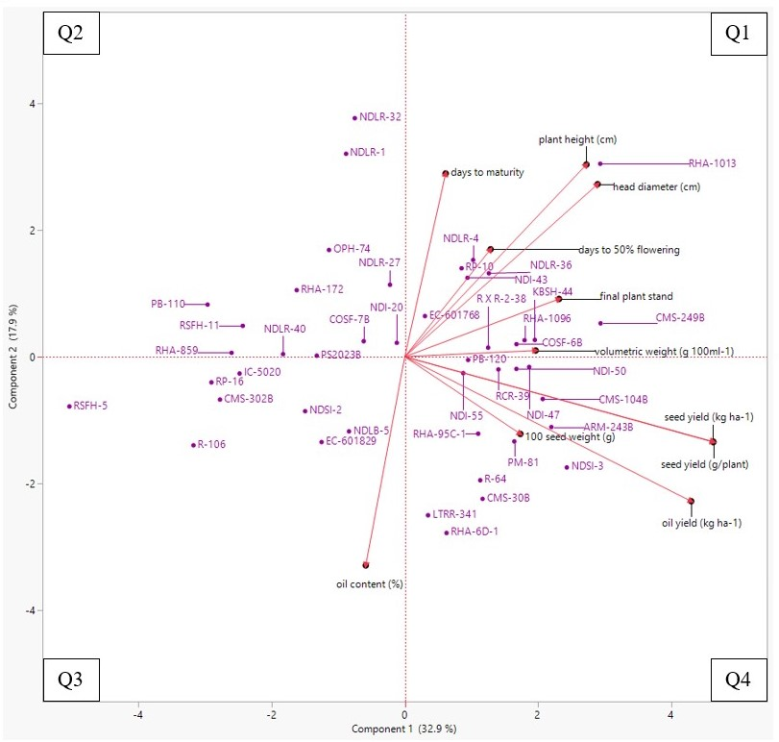
Fig. 1. Biplot comprising 45 sunflower inbred lines studied for 11 traits
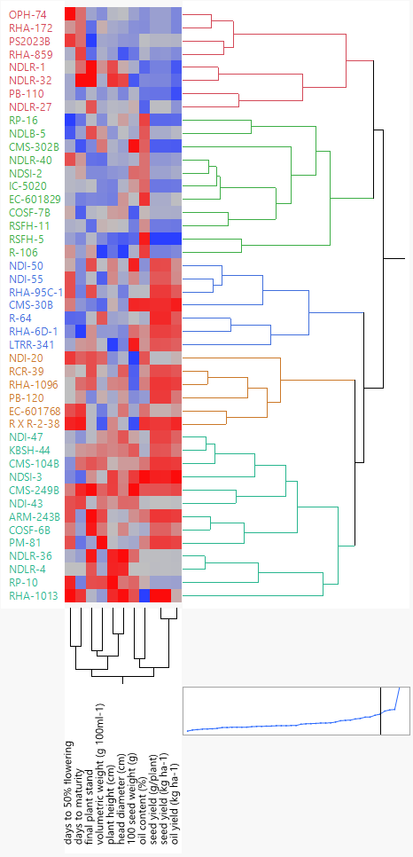
Fig. 2. Dendrogram showing clustering by wards method

Fig. 4. genotypic correlation matrix for yield and its attributes
in sunflower
Fig. 3. Phenotypic correlation matrix for yield and its attributes
in sunflower

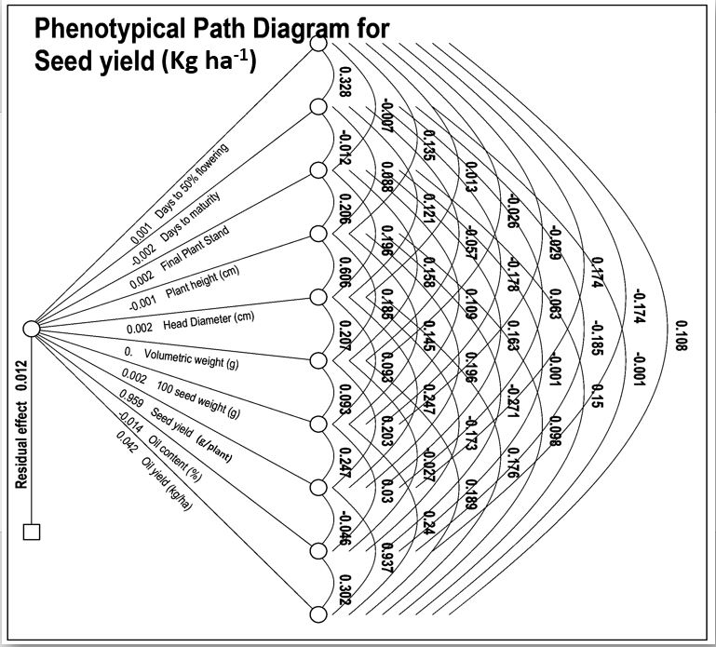
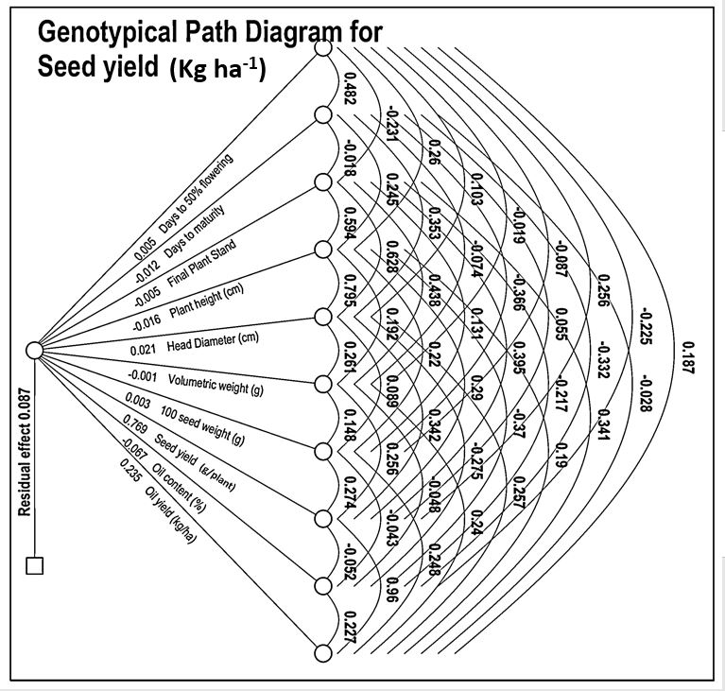

Fig. 6. Phenotypic path diagram for seed yield (kg ha⁻¹)

Fig. 5. Phenotypic path diagram for seed yield (kg ha⁻¹)

