Organic Management Strategies for controlling Late Blight of Potato (Solanum tuberosum L.) caused by Phytophthora infestans in Organic farming system

ABSTRACT

Late blight, caused by Phytophthora infestans, remains one of the most destructive diseases of potato (Solanum tuberosum L.), particularly under conditions of high humidity and moderate temperatures. The disease leads to severe yield losses and deterioration of both foliage and tubers, posing a serious threat to food security. In organic farming systems, where synthetic fungicides are prohibited, the development of eco-friendly disease management options is essential. The present study evaluated the efficacy of selected botanicals and a biological control agent for managing late blight under organic field conditions. A field experiment was conducted with nine treatments: Trichoderma harzianum (T₁; tuber treatment), neem leaf extract (T₂), garlic extract (T₃), tea extract (T₄), marigold extract (T₅), mint extract (T₆), turmeric extract (T₇), aloe vera gel extract (T₈), and an untreated control (T₀). Except for T₁, which was applied as a pre-sowing tuber treatment, all other formulations were applied as foliar sprays. Disease incidence and severity were assessed at regular intervals on 27 replications (5 plants from each replication) using Percent Disease Index (PDI) and 0–9 disease rating scale. Percent Disease Control (PDC) and yield (kg ha⁻¹) were also recorded. Data were analyzed using ANOVA, and S.Em. and C.D. (5 %) were computed.
Significant differences among treatments were observed. Aloe vera extract (T₈) recorded the lowest mean PDI (10.23 %) and the highest PDC (47.27 %), followed by tea extract (T₄), turmeric extract (T₇), and neem extract (T₂). The untreated control (T₀) showed the highest disease incidence (21.81 % PDI at 60 DAS) and the lowest yield. The final yield was significantly improved in T₈. These findings demonstrate that plant-based extracts, particularly aloe vera, can effectively suppress late blight and enhance potato yield under organic farming conditions.
Keywords: Potato, Phytophthora infestans, Late blight, Organic farming, Botanical extracts, Trichoderma harzianum

INTRODUCTION
Potato (Solanum tuberosum L.), a member of the Solanaceae family, is the fourth most
important food crop globally after rice, wheat and maize. Originating from the Andes of South America, potato is widely recognized as the “King of Vegetables” owing to its high starch content and versatility. In 2008, the United Nations declared the “International Year of Potato” to highlight its role in global food security (Gupta and Modgil, 2008). Potato cultivation, transportation, storage and processing provide crucial employment in rural and peri-urban areas of many countries (Pandey and Sarkar, 2005).
Potatoes are grown in more than 150 countries and constitute a staple food for billions. According to FAO (2024), the top 10 potato-producing countries account for about 70 % of global production, with China (93.5 Mt) and India (60.1 Mt) leading. India’s production has increased from 2.7 Mt in 1961 to 48 Mt in 2023 (FAOSTAT, 2024). Uttar Pradesh, West Bengal, Bihar and Punjab contribute the bulk of India’s output, with Uttar Pradesh alone producing nearly 39 % of the national total. About 80 % of potato cultivation in India takes place during the rabi season under irrigated conditions; smaller areas are planted in kharif and summer seasons in hill regions.
Despite its high yield potential (47.6 kg dry matter ha⁻¹ day⁻¹) and nutritional value—including carbohydrates, high-quality protein, vitamin C and essential minerals—India’s potato productivity remains constrained by pests and diseases. Globally, insect pests cause about 16 % yield losses, and disease pressures can reduce tuber yield and quality by 30–70 %. More than 175 potato diseases are known worldwide; in India about 24 have been recorded in the hills. Among these, late blight caused by P. infestans is the most devastating. The infamous Irish potato famine of the 1840s exemplifies its destructive potential.
In India, late blight regularly threatens potato crops, especially in the North-Western plains and Bundelkhand region of Uttar Pradesh under cool, moist weather. Effective management involves both preventive and prophylactic measures such as host resistance, crop sanitation, judicious planting times and fungicides (Shekhawat, 2000). However, in organic systems, synthetic fungicides are excluded, necessitating eco-friendly alternatives. This study was therefore undertaken with the objectives of: (i) evaluating the efficacy of selected organic treatments, (ii) monitoring disease progression by recording PDI, (iii) assessing impacts on vegetative growth and (iv) evaluating effects on yield performance.

MATERIAL AND METHODS

Description of Field Trials
Field experiments were conducted during the Rabi season of 2024–25 at the Organic Field, Institute of Agricultural Sciences, Bundelkhand University, Jhansi (Uttar Pradesh, India). The site is situated at 25.4484° N latitude and 78.5685° E longitude, at an elevation of 285 m above mean sea level (MSL). The region has a semi-arid climate with hot summers (often exceeding 45 °C), mild winters (as low as 5 °C) and an average annual rainfall of ~900 mm, largely confined to the monsoon months. The soil of the experimental site is sandy-loam with good drainage and a neutral to slightly alkaline reaction (pH 7.2).
- Design: Randomized Block Design (RBD)
- Treatments: 9
- Replications: 3
- Plot size: 2.5×2.5 m
- Field size: 27.7×10.3 m
- Total plots: 27

Meteorological Conditions
Weather data were recorded at sowing and harvesting. On 24 November 2024 (sowing), the maximum and minimum temperatures were 30.4 °C and 11.2 °C respectively, relative humidity averaged 39%, wind speed 6.8 km h⁻¹ and sunshine duration 7.5 h. No rainfall occurred. On 23 March 2025 (harvest), maximum and minimum temperatures were 34 °C and 19 °C, relative humidity 26%, wind speed 9.7 km h⁻¹, sunshine 9.8 h and 0.7 mm precipitation.

Field Preparation
Prior to planting, pre-irrigation was applied to facilitate ploughing. The field was ploughed to a depth of 20–25 cm with a tractor-mounted soil-turning plough and subsequently levelled. No synthetic fertilizers or pesticides were used; all management conformed to organic farming principles.

Seed Tubers and Variety
Locally procured, disease-free seed tubers of potato variety ‘Chandramukhi’ were used. Tubers were untreated with any chemicals to maintain organic integrity.

Experimental Design and Treatments
The experiment followed a Randomized Block Design (RBD) with nine treatments (T₀–T₈) and three replications. Treatments comprised a biocontrol agent (Trichoderma harzianum) and various plant extracts (Table 1).

Table 1. Treatments used in the field experiment
Sr. No. | Code | Treatment
1 | T₀ | Control (no treatment)
2 | T₁ | Trichoderma harzianum
3 | T₂ | Neem leaf extract
4 | T₃ | Garlic extract
5 | T₄ | Tea extract
6 | T₅ | Marigold extract
7 | T₆ | Mint extract
8 | T₇ | Turmeric extract
9 | T₈ | Aloe vera extract

Plot size was 2.5 × 2.5 m with 75 cm row spacing and 30 cm plant spacing. A total of 27 plots were established.

Organic Crop Management
All operations (irrigation, weeding, earthing-up) were performed following organic guidelines. Irrigation was applied at 3–4-day intervals and stopped 10 days before harvest. Manual weeding was done 4–5 times; earthing-up was carried out, as the plants achieved the height of 7–9 cm.

Plot Preparation and Planting
Healthy, uniformly sprouted whole tubers were planted manually at the prescribed spacing and depth. T. harzianum was applied as a seed tuber treatment through soaking the seed tubers for 6-7 hours, before planting; other treatments were sprayed using a knapsack sprayer at 15 day intervals starting at 30 DAS (3 applications total).

Field Experiment Objectives
The trial evaluated the efficacy of nine organic treatments against late blight (Phytophthora infestans) under field conditions, focusing on disease suppression, plant growth and yield.

Treatment Descriptions
Each treatment was prepared from fresh plant material using standard aqueous extraction and applied as foliar sprays, except T. harzianum (seed-tuber treatment). Representative formulations are summarized in Table 2.

Table 2. Formulation, dosage and application of treatments
Code | Treatment | Formulation & Dosage | Application
T₁ | T. harzianum | Commercial powder 2×10⁶ cfu g⁻¹, 5 g kg⁻¹ tuber | Slurry dip before sowing
T₂ | Neem leaf extract | 10% w/v (1 kg leaves in 5 L water, 24 h soak) | Foliar spray
T₃ | Garlic extract | 5% w/v (250 g cloves in 5 L water, 24 h soak) | Foliar spray
T₄ | Tea extract | 10% w/v (500 g tea leaves boiled in 5 L water, steep 12 h) | Foliar spray
T₅ | Marigold extract | 10% w/v (500 g leaves+flowers in 5 L water, 24 h soak) | Foliar spray
T₆ | Mint extract | 10% w/v (500 g leaves in 5 L water) | Foliar spray
T₇ | Turmeric extract | 5% w/v (250 g rhizome in 5 L water overnight) | Foliar spray
T₈ | Aloe vera extract | 10% w/v (500 g gel blended in water, boiled & filtered) | Foliar spray

Aqueous extracts were prepared by crushing the 500 g fresh leaves material or gel in aloe vera, in 2 L distilled water and left for macerating for 24 hours at the room temperature, then it was strained through muslin cloth to obtain the stock as per the standards taken. Working concentrations were prepared fresh before the application. (e.g. 10% Neem = 400 ml stock + 1.6 L water.) Organic practices were strictly followed without synthetic inputs. Regular irrigations were provided, with final irrigation stopped 10 days before harvest to prevent rotting. Manual weeding and earthing-up were performed for optimal plant growth and to prevent solanin formation in tubers. Sprays were applied during the time of early mornings at critical growth stages.

Yield Measurement
Yield per plot was recorded and converted to kg ha⁻¹ using:
Yield = $\frac{Yield per plot (kg)}{Plot area (m^{2})}×10000$

Disease Severity Assessment
Disease severity was rated on the 0–9 Wheeler scale (Table 3) at 30, 45 and 60 days after sowing (DAS) on five tagged plants per plot.
Table 3. Wheeler (1969) disease severity scale
Grade | Description (leaf area affected)
0 | No visible symptoms
1 | <1%
3 | 1–10%
5 | 11–25%
7 | 26–50%
9 | >50% or leaf death
Percent Disease Index (PDI) was computed as:
PDI = $\frac{\sum{Individual disease ratings}}{Max.scale value ×No.of leaves }$ × 100
Percent Disease Control (PDC) was calculated relative to the control:
PDC = $\frac{PDI in control -PDI in treatment}{PDI in control}×100$

Percentage data were arcsine transformed prior to statistical analysis. To normalize the percentage based data (PDI & PDC etc.), an angular (arcsine square root) transformation was applied. The transformed values were expressed using the following formula;
Arc value(°)=sin⁻¹ (√x/100) × (180/π)

Statistical Analysis
Data were analyzed as per RBD using Fisher’s ANOVA. F-values were tested at p ≤ 0.05. Standard Error of Mean (S.Em±), Critical Difference (C.D. at 5%) was calculated following Gomez and Gomez (1984). C.D. was obtained by:
C.D. = t_{(0.05, df)} × $\sqrt{\frac{2×MSE}{r}}$
where t is the tabulated t-value (df = 18, t = 2.101), MSE is the error mean square, and r the number of replications.

Agronomic Observations
Plant height (cm) and number of leaves per plant were recorded on five tagged plants per replication at 30, 45 and 60 DAS. And disease symptoms were observed at an average of 5 leaves of each tagged plant in the replications.

Harvesting
The crop was harvested on 23rd of March 2025 when tubers reached physiological maturity. Tubers were manually dug and weighed treatment-wise to avoid mechanical damage and ensure accurate yield data.

RESULT AND DISCUSSION

Vegetative Growth
Plant height and the number of fully expanded leaves were recorded at 30, 45 and 60 days after sowing (DAS) to assess the influence of organic treatments on vegetative growth (Table 1). Treatments with aloe vera extract (T8) and neem extract (T2) consistently produced taller plants and more leaves across all stages compared with the untreated control (T0). At 60 DAS, T8 recorded the highest plant height (33.93 cm) and number of leaves (137.26), whereas T0 recorded the lowest (30.46 cm and 130.46 leaves). Similar improvements in plant growth under biological and botanical inputs have been reported by Singh et al. (2001) and Gomez & Gomez (1984). These results suggest that effective suppression of foliar disease indirectly enhances photosynthetic area and overall plant vigour.

Disease Symptoms and Progression
Typical late blight symptoms were first observed on lower leaves as small, irregular, water-soaked lesions that enlarged into dark brown patches. Lesion coalescence, leaf blight, defoliation and lodging were common in untreated plots but much less evident in treated plots. The systematic recording of these symptoms at each observation allowed accurate quantification of disease development through Percent Disease Index (PDI).

Disease Incidence and Severity
All organic treatments significantly reduced disease incidence compared with T0 (Table 2). At 30 DAS, T8 recorded only 11.77 % incidence versus 15.50 % in the control. This trend persisted at 45 and 60 DAS, with T8 showing the lowest incidence (11.50 %) and the control the highest (21.81 %). Mean PDI over the season confirmed that aloe vera extract (10.23 %) was the most effective, followed by neem (11.72 %), garlic (11.85 %) and turmeric (11.64 %). These observations clearly indicate that plant extracts and Trichoderma harzianum can suppress both the incidence and intensity of late blight under organic field conditions.

Percent Disease Control (PDC)
PDC at 60 DAS ranged from 12.20 % in mint extract (T6) to 47.27 % in aloe vera extract (T8) (Table 4). Tea extract (T4) and turmeric (T7) also provided >35 % control. This pattern matches the PDI, demonstrating the consistency of treatment performance.

Yield Response
Yield was significantly influenced by the organic treatments (Table 5). The highest tuber yield was obtained with aloe vera extract (T8, 7824 kg ha⁻¹), followed by turmeric (7024 kg ha⁻¹) and tea extract (6800 kg ha⁻¹). The untreated control produced only 3744 kg ha⁻¹. The positive correlation between disease suppression and yield improvement confirms that botanical and biological treatments not only limit pathogen damage but also translate into economic gains.

Statistical Validation
Two-way ANOVA of the replicated PDI data revealed that treatment, time (DAS) and their interaction were all highly significant (Table 6). Low S.Em., and C.D. values indicate high precision and minimal experimental error. The significant interaction effect highlights the importance of applying the most effective treatment at the optimum crop stage for sustained control.

Overall Efficacy
Among all treatments, aloe vera extract consistently gave the best performance across parameters—lowest PDI, highest PDC and maximum yield—followed by turmeric, tea and neem extracts. Trichoderma harzianum as a tuber treatment also contributed to reduced disease incidence but was less effective than foliar botanicals. These results corroborate earlier findings that plant-based extracts and beneficial microbes can provide viable, eco-friendly alternatives to synthetic fungicides in managing late blight of potato under organic conditions.

Table 4. Agronomical Analysis (Plant Height & No. of leaves)
Treatment | Plant Height (cm) (30DAS) | No. of Leaves (30DAS) | Plant Height (cm) (45DAS) | No. of Leaves (45DAS) | Plant Height (cm) (60DAS) | No. of Leaves (60DAS)
T0 (Control) | 18.20 | 70.33 | 25.20 | 120.46 | 30.46 | 130.46
T1 (Trichoderma harzianum) | 19.40 | 74.53 | 26.26 | 124.86 | 30.86 | 137.06
T2 (Neem Extract) | 21.13 | 74.46 | 28.06 | 122.26 | 33.13 | 133.53
T3 (Garlic Extract) | 19.73 | 76.73 | 26.93 | 123.73 | 31.73 | 135.80
T4 (Tea Extract) | 21.13 | 73.60 | 28.60 | 123.13 | 33.66 | 135.13
T5 (Marigold Extract) | 20.13 | 76.26 | 27.53 | 127.20 | 32.73 | 139.13
T6  (Mint Extract) | 19.53 | 76.33 | 26.86 | 125.26 | 31.66 | 135.66
T7  (Turmeric Extract) | 21.20 | 75.33 | 28.73 | 125.26 | 33.66 | 136.20
T8 (Aloe vera Extract) | 21.26 | 77.40 | 28.73 | 127.33 | 33.93 | 137.26
S.Em+ | 0.36 | 0.71 | 0.41 | 0.75 | 0.43 | 0.82
C.D. at 5% | 0.99 | 1.98 | 1.14 | 2.08 | 1.19 | 2.28
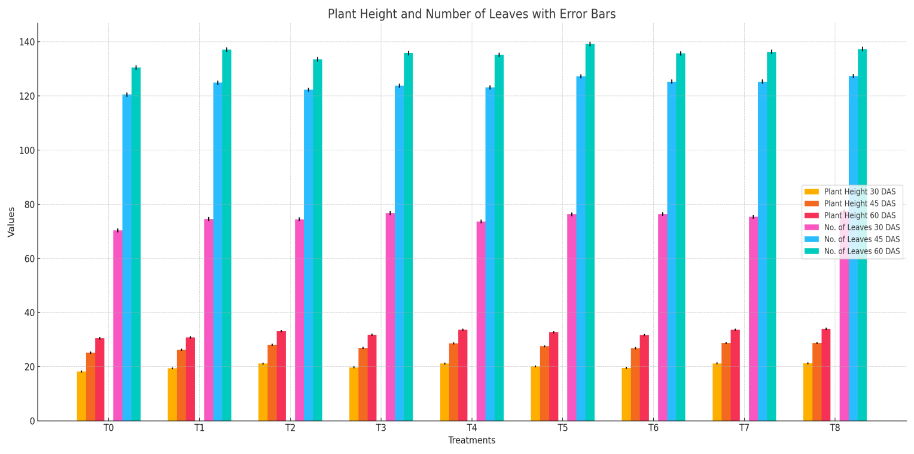
Fig.: 1 Agronomical Analysis (Plant Height & No. of leaves)

Table 5. Comparison of PDI (60 DAS) and PDC
Treatments | PDI (%)  (60 DAS) | PDC (%)
T1  Trichoderma harzianum | 17.16  (24.47) | 21.32  (27.50)
T2  Neem Extract | 14.50  (22.38) | 33.52  (35.38)
T3  Garlic Extract | 14.68  (22.53) | 32.69  (34.87)
T4  Tea Extract | 13.74  (21.76) | 37.00  (37.46)
T5  Marigold Extract | 15.61  (23.27) | 28.43  (32.22)
T6  Mint Extract | 19.15  (25.95) | 12.20  (20.44)
T7  Turmeric Extract | 14.02  (21.99) | 35.72  (36.70)
T8  Aloe vera Extract | 11.50  (19.82) | 47.27  (43.44)
S.Em+ | 0.81 | -
C.D. at 5% | 1.93 | -

Table 6. Percent Disease Incidence
Treatment | DBS (%) | 30 DAS | 45 DAS | 60 DAS | Mean PDI (%)
T₁  Trichoderma harzianum | 6.35 | 14.29 | 16.16 | 17.16  (24.47) | 13.49  (21.55)
T₂  Neem Extract | 5.97 | 12.87 | 13.51 | 14.50  (22.38) | 11.72  (20.02)
T₃  Garlic Extract | 6.08 | 12.92 | 13.72 | 14.68  (22.53) | 11.85  (20.14)
T₄  Tea Extract | 6.14 | 13.14 | 13.40 | 13.74  (21.76) | 11.60  (19.91)
T₅  Marigold Extract | 6.17 | 13.83 | 14.85 | 15.61  (23.27) | 12.61  (20.80)
T₆  Mint Extract | 6.21 | 14.22 | 16.52 | 19.15  (25.95) | 14.03  (22.00)
T₇  Turmeric Extract | 5.98 | 12.75 | 13.66 | 14.02  (21.99) | 11.64  (19.95)
T₈  Aloe vera Extract | 5.94 | 11.77 | 11.69 | 11.50  (19.82) | 10.23  (18.65)
T₀  Control | 5.98 | 15.50 | 18.66 | 21.81  (27.84) | 15.48  (23.17)
S.Em | - | 0.21 | 0.26 | 0.30 | -
C.D. (5%) | - | 0.78 | 0.92 | 1.08 | -

Conclusion
All treatments significantly reduced disease incidence compared with the untreated control. Aloe vera extract (T8) was the most effective, producing the lowest mean PDI (10.23 %) and the highest tuber yield, followed by neem and garlic extracts. These findings clearly support the integration of plant-based formulations and biological agents into organic disease-management strategies. Such inputs not only reduce late blight severity but also promote sustainable agriculture by minimizing chemical use, preserving soil health and reducing environmental impact. The results provide a sound basis for stage-specific and eco-friendly disease control in potato production systems.

Comparison with Previous Studies
The present results agree with those of Meena et al. (2015) and Ramesh et al. (2017), who found neem extract and Trichoderma harzianum effective against late blight in potato. Bhattacharya and Roy (2019) similarly reported antifungal activity of aloe vera against P. infestans in vegetables. The efficacy of garlic, turmeric and marigold observed here corresponds with findings by Sharma and Singh (2020), who documented significant disease suppression from these botanicals when applied at appropriate intervals. Collectively, these studies reinforce the practical value of botanical and biological inputs for managing late blight under organic conditions.

Recommendations
- Promote aloe vera and neem extracts as cost-effective, eco-friendly alternatives to chemical fungicides for late blight management.
- Incorporate these treatments into Integrated Disease Management (IDM) programs to minimize environmental impact and resistance development.
- Conduct multi-location and multi-season trials to validate efficacy and economic viability under diverse agro-climatic zones.
- Undertake molecular or biochemical assays to elucidate mechanisms of disease suppression by these extracts.
- Explore synergistic effects of combined botanicals or their formulations for enhanced control.
- Organize field demonstrations and farmer training to accelerate adoption of these organic techniques.

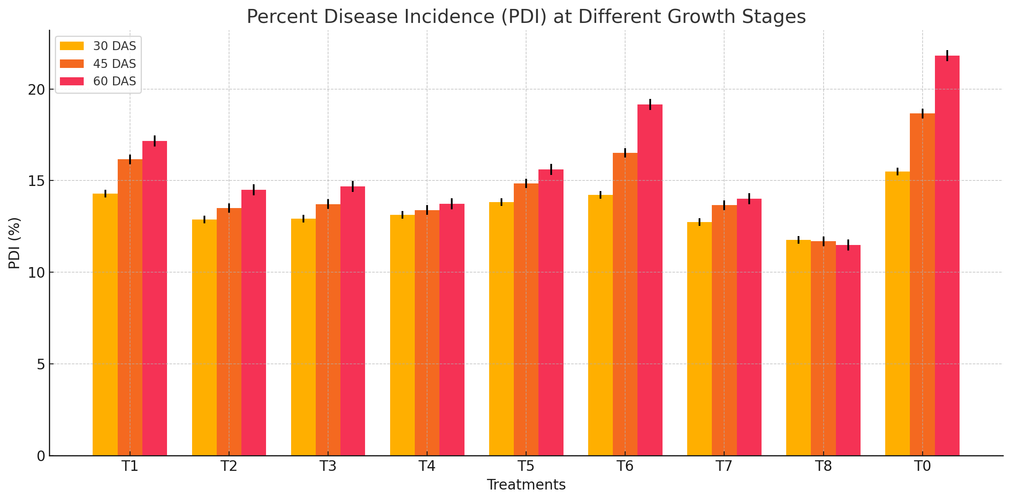
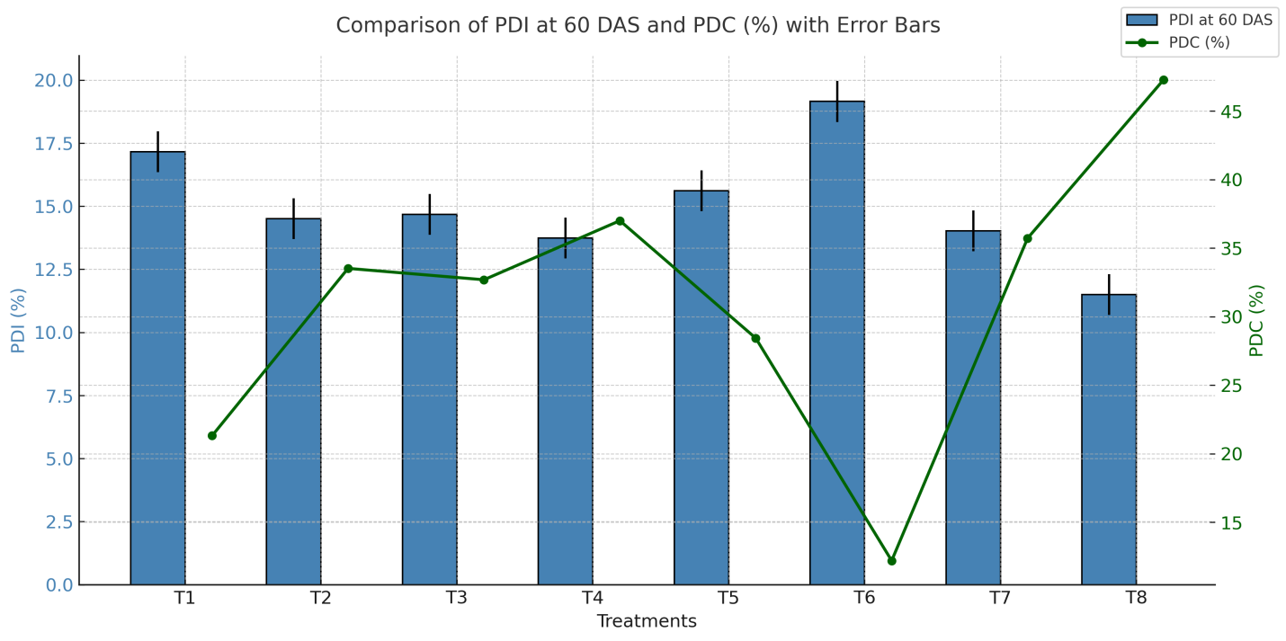

Fig 2. PDI at different growth stages

sFig 3. Comparison of PDI (60 DAS) and PDC

REFERENCES
Abdel-Monaim, M.F. and Abo-Elyousr, K.A.M. (2012). Effect of neem and garlic extracts on suppression of some foliar diseases of potato. Journal of Plant Protection Research, 52(3): 275-280.
Akhtar, M. and Malik, A. (2000). Roles of neem in the management of plant diseases. World Journal of Microbiology and Biotechnology, 16(7): 649-654.
Bhattarai, K., Khatri-Chhetri, R., Thapa, R.B. and Prasad, B.V. (2018). Management of late blight of potato using plant extracts and biocontrol agents. Nepalese Journal of Agricultural Sciences, 16: 47-56.
Elad, Y., Chet, I. and Katan, J. (1980). Trichoderma harzianum—a biocontrol agent effective against Sclerotium rolfsii and Rhizoctonia solani. Phytopathology, 70(2): 119-121.
Fry, W.E. (2008). Phytophthora infestans: The plant (and R gene) destroyer. Molecular Plant Pathology, 9(3): 385-402.
Ghorbanpour, M. and Omidvari, M. (2017). Biological control of plant pathogens with antagonistic Trichoderma species. Biological Control, 110: 34-45.
Haverkort, A.J., Struik, P.C., Visser, R.G.F. and Jacobsen, E. (2009). Applied biotechnology to combat late blight in potato. Potato Research, 52(3): 249-264.
Islam, M.T., Hashidoko, Y., Deora, A., Ito, T. and Tahara, S. (2012). Suppression of late blight disease on potato by combined application of biocontrol agents and plant extracts. Crop Protection, 34: 26-32.
Kankam, F. and Nartey, E. (2019). Evaluation of plant extracts for the management of potato late blight in Ghana. African Journal of Agricultural Research, 14(8): 442-449.
Kankam, F., Nartey, E. and Mensah, S.O. (2020). Field performance of neem and garlic extracts against potato late blight. Journal of Plant Protection Research, 60(1): 45-52.
Kumar, S., Pandey, K.K. and Singh, B.P. (2017). Integrated management of potato late blight in organic farming. International Journal of Plant Protection, 10(2): 237-243.
Meena, P.D., Verma, P.R. and Sharma, R. (2015). Potential of Trichoderma species and plant extracts in managing late blight of potato. Indian Phytopathology, 68(2): 171-177.
Singh, B., Gupta, R.K. and Sharma, R.K. (2014). Efficacy of plant extracts in management of late blight of potato. Indian Journal of Agricultural Sciences, 84(9): 1095-1099.
Singh, S.K., Rawat, K., and Kumar, V. (2020). Evaluation of bioagents and botanicals against Phytophthora infestans on potato under organic system. Vegetable Science, 47(1): 38-44.
Thind, T.S. and Mohan, C. (2013). Management of late blight of potato using non-chemical methods. Journal of Mycology and Plant Pathology, 43(4): 459-465.

