Determinants of Adoption of Indigenous Technical Knowledge in the Farming System of Kangra, Himachal Pradesh

Abstract

This study investigates the determinants influencing the adoption of Indigenous Technical Knowledge (ITK) in the farming systems of Kangra district, Himachal Pradesh an ecologically fragile region where traditional agricultural practices continue to play a vital role in ensuring sustainability and resilience. With growing concerns over the ecological impact of modern farming techniques, understanding the relevance and adoption of ITK has gained critical importance. The research employed a mixed-method approach, combining exploratory and ex-post facto designs, and was conducted among 120 randomly selected farmers across six villages in Kangra. Data were collected using structured interviews, focus group discussions, and direct observations. Descriptive statistics revealed moderate adoption of ITKs (mean = 19.28, SD = 7.27), with considerable variation among farmers. Correlation and regression analyses indicated that variables such as family size, decision-making ability, and connectedness to nature significantly and positively influenced ITK adoption. In contrast, factors like higher education, economic motivation, and occupational engagement outside agriculture negatively impacted ITK usage. The regression model showed strong explanatory power (R² = 0.728), and the ANOVA confirmed its statistical significance (F = 17.256, p < 0.01). These findings underscore that ITK adoption is not merely driven by technical know-how but is deeply rooted in socio-cultural values, psychological orientation, and family dynamics. The study highlights the importance of recognizing and preserving traditional knowledge systems as complementary to modern agricultural innovations. It calls for policies that support documentation, scientific validation, and integration of ITKs into mainstream agriculture while considering local ecological and social contexts. Empowering farmers through community participation and education can ensure that these time-tested practices contribute meaningfully to sustainable agriculture in mountain ecosystems.

Keywords: Indigenous Technical Knowledge, ITK Adoption, Traditional Agriculture, Sustainable Farming

1. Introduction

The Green Revolution, initiated in India during the 1960s, revolutionized agricultural productivity by introducing high-yielding varieties (HYVs) of seeds, chemical fertilizers, pesticides, and mechanized farming techniques (Das et.al., 2023). While this transition helped ensure national food security and increase agricultural incomes, it also led to significant environmental and socio-economic challenges. Over time, excessive dependence on synthetic inputs has resulted in soil degradation, loss of biodiversity, decline of soil microbial health, and depletion of water resources. The pressing need to enhance productivity to meet the demands of a rapidly growing population has often overlooked ecological sustainability. According to study, increasing rural population density contributes to land fragmentation and rising input dependency (Alemu et.al., 2017). However, higher input use per hectare does not translate into proportional yield gains, often resulting in declining farm incomes and worsening land degradation. These issues are exacerbated by climate change, which poses additional threats to agriculture through temperature increases, erratic rainfall, glacier retreat, and extreme weather events. In this Indigenous Technical Knowledge (ITK) has emerged as a vital, sustainable alternative to conventional modern agriculture (Kumar et.al., 2024). ITK refers to the local, community-based knowledge systems developed through generations of experience and adaptation to the local environment. These knowledge systems are transmitted orally and experientially through practices, stories, rituals, and community observation. In farming, ITKs encompass natural soil enrichment methods, biological pest control, traditional irrigation systems, and seed preservation techniques, all of which align with the principles of climate-resilient agriculture and ecological balance. The Kangra district of Himachal Pradesh, located in the northwestern Himalayan region, is an ideal setting for studying ITKs. Here, traditional practices such as Kuhl irrigation, multi-cropping systems, organic composting, and use of local seed varieties remain prevalent. These practices are closely tied to the region’s cultural and ecological heritage, collectively referred to as Himalayan wisdom a system of living in harmony with nature, emphasizing sustainability, spirituality, and resilience. Institutions like the Indian Council of Agricultural Research (ICAR) have recognized the value of ITK and have undertaken initiatives to document, validate, and integrate it into mainstream agricultural policies (Singh et.al., 2020). The concept of the Evergreen Revolution, introduced by Dr. M.S. Swaminathan, further highlights the importance of increasing agricultural productivity without causing ecological harm. It builds upon the lessons of the Green Revolution while focusing on sustainability, resource efficiency, and biodiversity conservation. However, despite their proven effectiveness and ecological benefits, ITKs are increasingly marginalized in the face of modern agricultural interventions and policy frameworks. Thus, understanding the factors influencing the adoption or discontinuation of ITKs among farmers becomes critical for promoting sustainable farming systems, especially in ecologically fragile regions like Kangra. In the evolving landscape of the global knowledge economy, a nation's development depends not only on physical and financial capital but also on its intellectual and cultural resources. Indigenous knowledge systems especially those related to agriculture represent a critical but underutilized dimension of sustainable development (Kumar et.al., 2021). The risk of marginalization and loss of this knowledge due to modernization and policy neglect highlights the need to analyze the factors determining its adoption and integration into contemporary agricultural practices. To analyze the determinants of adoption of Indigenous Technical Knowledge (ITK) in the farming systems of Kangra district, Himachal Pradesh.

2. Materials and Methods
the methodological framework followed for the study titled “Determinants of Adoption of Indigenous Technical Knowledge in the Farming System of Kangra, Himachal Pradesh.” It provides detailed information about the research design, selection of the study area and respondents, variables selected for analysis, data collection methods, and statistical tools used.

2.1 Research Design
The research design serves as the blueprint for the entire study, guiding the researcher in systematically addressing the research questions while controlling for variability (Kerlinger, 2004). For the present study, a combination of exploratory and ex-post facto research designs was employed. The exploratory design was used to document various Indigenous Technical Knowledge (ITK) practices prevalent in Kangra’s farming systems. This approach was suitable for identifying and understanding existing but under-documented phenomena. As suggested by Ray and Mondal (2011), exploratory research is useful when the objective is to gather detailed insights into a phenomenon.
To analyze the determinants influencing the adoption of ITK, an ex-post facto design was used. In such a design, the variables have already manifested, and the researcher cannot manipulate the independent variables. This design is appropriate for examining cause-and-effect relationships in situations where experimental control is not possible (Ray & Mondal, 2011).

2.2 Selection and Description of Locale of Study
Himachal Pradesh was purposively selected as the locale for this study due to its rich tradition of Indigenous Technical Knowledge in agriculture. Within the state, Kangra district was chosen for its diversity in agro-ecological zones, significant reliance on agriculture, and the strong presence of ITK in farming practices. Kangra is one of the districts most vulnerable to climate change in Himachal Pradesh, facing issues such as glacial retreat, unpredictable precipitation patterns, temperature fluctuations, and earthquakes (Ray et al., 2011). These environmental challenges have led local farmers to depend on indigenous practices that are contextually effective and ecologically sustainable. The FAO (2005) also recognizes the northwestern Himalayan region, including Kangra, as rich in traditional ecological knowledge.

Himachal Pradesh lies between 30°22′40″N to 33°12′40″N latitude and 75°45′55″E to 79°04′20″E longitude. The region is characterized by complex topography and rich biodiversity. Only 11% of the total geographical area is under cultivation, of which only 50% is irrigated (Wasteland Atlas of India, 2011). Kangra district, located in the western part of the state, features altitudes ranging from 500 to 5000 meters above mean sea level and covers an area of 5,739 square kilometers (Fig.- 1). The district has a population of approximately 1.5 million, a literacy rate of 85.67%, and comprises 3,906 villages. The climate ranges from subtropical to temperate, with average annual rainfall of 1,751 mm, most of which occurs between June and September. Major crops include wheat, rice, maize, tomatoes, peas, apples, and plums.
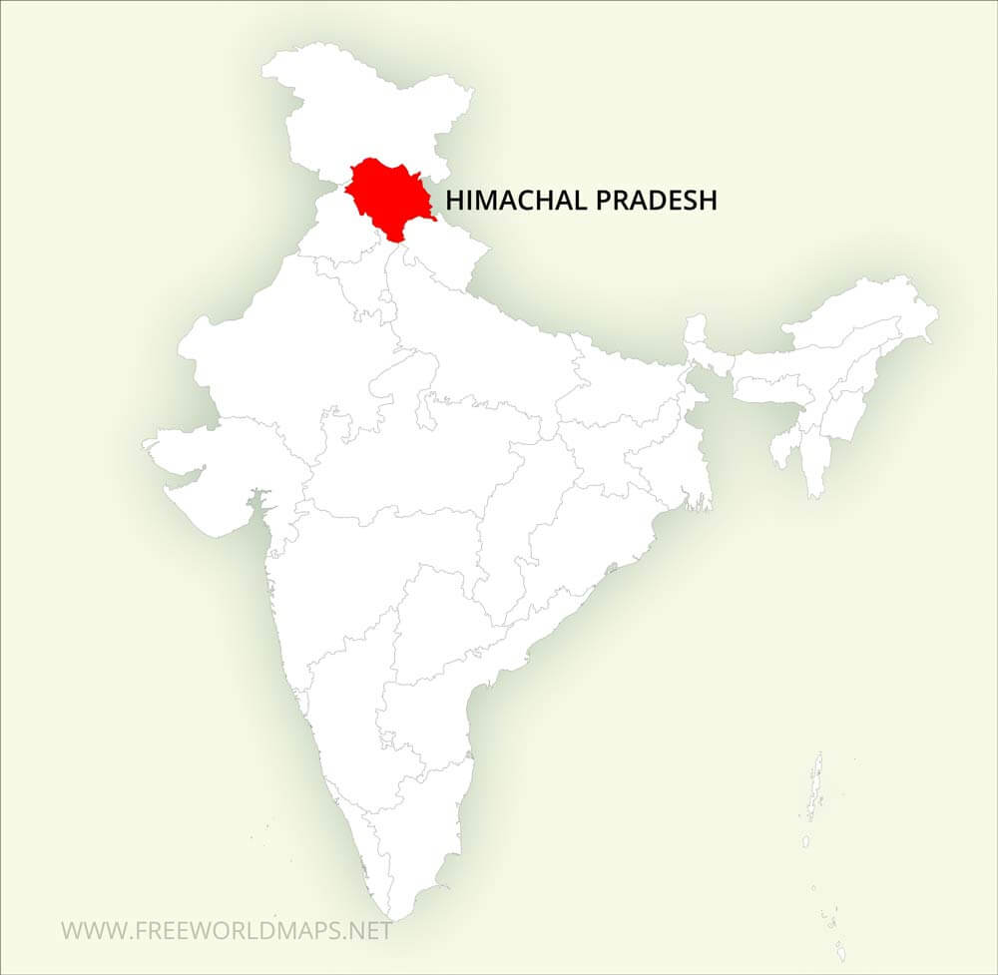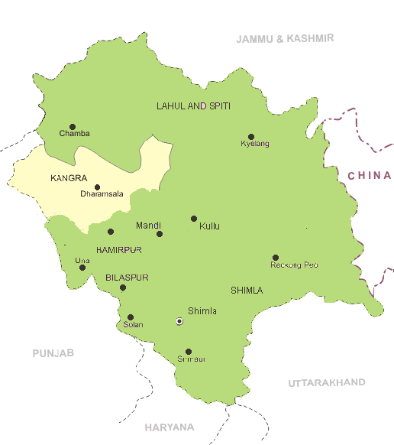
Map 1: Map of Himachal Pradesh Showing Kangra District

Table 1 Demographic profile of Kangra District
Area | 5739 Km²
Population (2011) | 1,510,075
Population (Male) | 750,591
Population (Female) | 759,484
Sex ratio (2011) | 1012
Number of municipalities | 6
Number of villages | 3906
Literacy rate (%) | 85.67

2.3 Selection of Respondents
The selection of respondents was carried out using a multi-stage random sampling technique. In the first stage, two tehsils were randomly selected from Kangra district. In the second stage, three villages were chosen randomly from each tehsil, resulting in a total of six villages. Finally, 20 farmers from each village were randomly selected, leading to a sample size of 120 respondents for the study.

2.4 Selection of Variables and Their Measurement
The variables for the study were selected based on the objectives, a review of relevant literature, consultations with experts, and preliminary field observations. The independent variables included age, gender, education, family type, size of landholding, occupation, contact with personal localite channels, contact with personal and impersonal cosmopolite channels, fatalism, connectedness to nature, risk orientation, economic motivation, decision-making behaviour, social norms, and sustainability. Variables were measured using validated scales and structured schedules developed specifically for the study. Age was measured in completed years, while gender was coded as 0 for female and 1 for male. Education was categorized as illiterate (1), primary (2), high school (3), and college (4). Family type was classified as nuclear (1) or joint (2). The size of landholding was categorized based on area: marginal (<1 ha), small (1–2 ha), medium (2–5 ha), and large (>5 ha). Occupation was identified through direct questioning and coded based on primary livelihood activities. The respondents’ exposure to various communication channels was measured using structured schedules with a four-point continuum (most often to never). Fatalism was assessed using a modified version of Leiserowitz’s (2006) scale, while connectedness to nature was measured using the scale developed by Mayer et al., 2004). Risk orientation and economic motivation were measured using modified versions of Supe’s (1969) scales. Decision-making behaviour, social norms, and sustainability were measured using structured schedules and modified scales, including Austin et al. (1998).

2.4.1 Documentation of Indigenous Technical Knowledge (ITK)
Documentation of ITK involved both qualitative and participatory approaches. Information was gathered through in-depth interviews, focus group discussions (FGDs), transect walks, and direct observations. These methods allowed for community validation and ensured that the knowledge was captured accurately and contextually. The use of open-ended questions facilitated rich and detailed responses, capturing both the practices and their cultural significance.

2.4.2 Adoption Pattern of ITK
To measure the adoption of ITK practices, each selected practice was explained to the respondents. They were then asked whether they had adopted the practice. A binary scoring system was used: 1 for “yes” and 0 for “no.” The total adoption score for each respondent was computed by summing individual scores. The ITK Adoption Index was then calculated using the formula by Sundaramari et al. (2003):

ITK wise adoption index = | Number of farmers adopted | × 100
ITK wise adoption index = | Numbers of farmers having applicability | × 100

This helped quantify adoption levels for each practice as well as across respondents.

2.5 Methods and Tools of Data Collection
Primary data were collected through semi-structured interview schedules, direct personal interviews, and focused group discussions. These methods enabled the researcher to gather both quantitative and qualitative insights. Secondary data were obtained from published reports, academic journals, and government databases relevant to the study area and ITK.

2.6 Statistical Tools Applied
The data were analysed using both descriptive and inferential statistical techniques. Descriptive statistics such as frequency, percentages, mean, and standard deviation were used to summarize the characteristics of respondents and ITK adoption patterns. Correlation analysis was conducted using Karl Pearson’s Coefficient of Correlation to examine relationships between variables. The formula used was:

This technique was used to find out the relationship between two variables. The following was used for the calculations of the ‘r’ value.
$$r = \left(∑xy -\frac{\left(∑x\right)\left(∑y\right)}{n}\right)÷ \sqrt{\left[\left(∑x^{2}-\frac{{\left(∑x\right)}^{2}}{n}\right)\left(∑y^{2}-\frac{{\left(∑y\right)}^{2}}{n}\right)\right]}$$
Where,
r = Coefficient of correlation between x and y
∑ x = Sum of scores of variables x
∑y = Sum of scores of variables y
∑x² = Sum of squares of variables x
∑ y² = Sum of squares of variables y
(∑ x)² = Squares of the sum of variables x
(∑ y)² = Squares of the sum of variables y
∑xy = Sum of the product of two variables
n = Size of the sample

The ‘r’ calculated value was verified for its significance to use ‘r’ table value for 5 per cent and 1 per cent level of significance at (n-2) degree of freedom. When the ‘r’ calculated value was equal or greater than the table value, the relationship between the selected variables was considered significant otherwise it was considered non-significant.

To assess the combined effect of independent variables on the adoption of ITK, Multiple Linear Regression (MLR) analysis was used.

The regression equation may be written as

y = a+𝑏₀ + 𝑏₁𝑋₁ + 𝑏₂𝑋₂ + 𝑏₃𝑋₃ + 𝑏_{𝑖}𝑋_{𝑖}

Where ‘a’ was the intercept or constant and b_{i} s’ were tested for their significance with the following formula

Where,

n = Number of respondents
k = Number of independent variables
S.E. (b_{i} ) = Standard error of i^{th}partial regression coefficient
b_{i} = i^{th} Partial regression coefficient
t = Test for significance
df = Degrees of freedom
Coefficient of Multiple Determination (R²) was given by
R² = Regression Sum of Squares (RSS) / Total Sum of Squares (TSS)

Where,

RSS = b₁∑x₁y + b₂∑x₂y + ...............b_{k}∑x_{k}y
TSS = ∑y²

R² value is less than unity where it was expressed in percentage. It measures the extent of variation in dependent variable (y), which can be explained by the independent variables (x_{i}) together. the independent variables are: Age, gender, education, family type, size of land holding, occupation, contact with personal localite channel, personal cosmopolite channel, impersonal cosmopolite channel, fatalism, connectedness to nature, risk orientation, economic motivation, decision making behavior, social norms and sustainability.

Data analysis was performed using SPSS software, which facilitated the computation of regression models, correlation coefficients, and descriptive statistics.
Result and Discussion
Table 1. Descriptive Statistics
Descriptive Statistics
 | Mean | Std. Deviation | N
Number of ITKS adopted | 19.28 | 7.268 | 120
Sex | 0.66 | 0.476 | 120
Age | 52.19 | 13.913 | 120
Education | 2.51 | 1.077 | 120
Family Type | 1.58 | 0.496 | 120
Family Size | 5.33 | 1.876 | 120
Years In Farming | 20.15 | 8.802 | 120
Occupation | 1.625 | 0.486 | 120
Personal Localite | 8.708 | 1.848 | 120
Mass Media Exposure | 18.091 | 3.743 | 120
Fatalism | 20.600 | 3.720 | 120
Connectedness to nature | 25.34 | 2.926 | 120
Risk Orientation | 20.81 | 3.670 | 120
Economic Motivation | 17.983 | 3.0375 | 120
Decision Making | 20.51 | 3.911 | 120
Social Norms | 28.69 | 4.647 | 120
Sustainability | 25.50 | 1.927 | 120

The descriptive statistics presented in Table 1 provide a summary of key variables related to the adoption of Indigenous Technical Knowledge (ITK) among 120 farmers in Kangra district (Khatri et.al., 2021). The mean number of ITKs adopted was 19.28 with a standard deviation of 7.27, indicating moderate variation in adoption levels. The average age of respondents was 52.19 years, with a mean farming experience of 20.15 years, reflecting a predominantly experienced farming population. The mean education level was 2.51, suggesting that most respondents had completed at least primary to high school education. Other important factors like family size (5.33), mass media exposure (18.09), risk orientation (20.81), and sustainability awareness (25.50) showed considerable influence, while psychological variables such as fatalism (20.60), economic motivation (17.98), and decision-making ability (20.51) also displayed notable variation (Jamaluddin et.al., 2024). These results align with findings, which emphasize that both socio-demographic and psychological factors significantly contribute to agricultural knowledge adoption behavior. Overall, the descriptive data suggest a diverse respondent profile with strong potential for ITK adoption, influenced by education, experience, media access, and motivational factors.

Table: 2 Correlations
 |  | Number of ITKS adopted | Sig. (1-tailed)
Pearson Correlation | Number of ITKS adopted | 1.000 | .
Pearson Correlation | Age | 0.273** | 0.001
Pearson Correlation | Education | -0.440** | 0.000
Pearson Correlation | Family Size | 0.416** | 0.000
Pearson Correlation | Years In Farming | 0.228** | 0.006
Pearson Correlation | Personal Localite | 0.538** | 0.000
Pearson Correlation | Mass Media Exposure | -0.329** | 0.000
Pearson Correlation | Fatalism | 0.632** | 0.000
Pearson Correlation | Connectedness to nature | 0.693** | 0.000
Pearson Correlation | Risk Orientation | -0.493** | 0.000
Pearson Correlation | Economic Motivation | -0.758** | 0.000
Pearson Correlation | Decision Making | -0.607** | 0.000
Pearson Correlation | Social Norms | 0.529** | 0.000
Pearson Correlation | Sustainability | 0.605** | 0.000
The correlation analysis (Table 2) revealed that adoption of Indigenous Technical Knowledge (ITK) among farmers is significantly influenced by a mix of socio-demographic, psychological, and cultural variables (Patel et.al., 2025). Positive correlations were found with age (r = 0.273), family size (r = 0.416), years in farming (r = 0.228), personal localite contact (r = 0.538), fatalism (r = 0.632), connectedness to nature (r = 0.693), social norms (r = 0.529), and sustainability (r = 0.605), indicating that older, experienced, community-rooted, and environmentally conscious farmers are more likely to adopt ITKs. Conversely, significant negative correlations were observed with education (r = –0.440), mass media exposure (r = –0.329), risk orientation (r = –0.493), economic motivation (r = –0.758), and decision-making ability (r = –0.607), suggesting that farmers with higher formal education, media influence, risk-taking attitudes, or profit-driven motives tend to adopt fewer traditional practices. These findings reinforcing that ITK adoption is not solely technical but rooted in ecological values, cultural identity, and socio-psychological traits (Bhujel et.al., 2024).
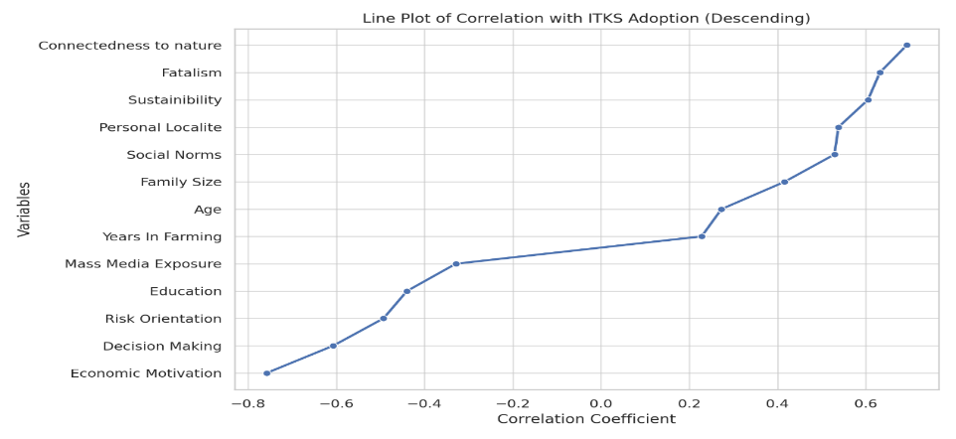
Figure 1: Line Plot of Correlation with ITKs Adoption
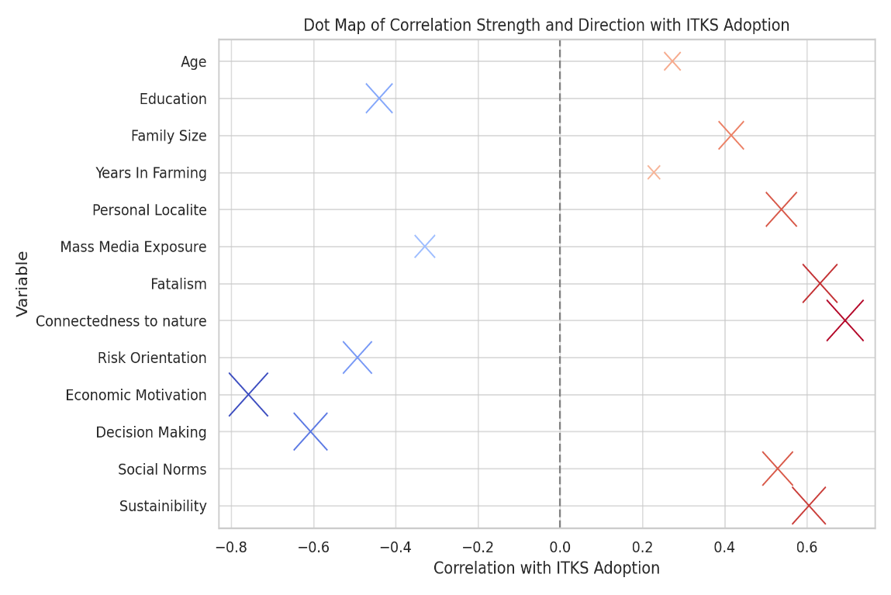
Figure 2: Dot Map of Correlation Strength and Direction with ITKs Adoption
Table 3: Results of regression output
Model |  | Unstandardized Coefficients |  | Standardized Coefficients | t | Sig.
 |  | B | Std. Error | Beta | t | Sig.
1 | (Constant) | 47.726 | 25.496 |  | 1.872 | 0.064
1 | Sex | -0.553 | 0.935 | -0.036 | -0.591 | 0.556
1 | Age | -.065 | 0.068 | -0.125 | -0.963 | 0.338
1 | Education | -2.262 | 0.890 | -0.335 | -2.541* | 0.013
1 | Family Type | -4.426 | 1.712 | -0.302 | -2.585* | 0.011
1 | Family Size | 1.548 | 0.378 | 0.400 | 4.097** | 0.000
1 | Years In Farming | 0.190 | 0.104 | 0.230 | 1.821 | 0.072
1 | Occupation | -3.574 | 1.054 | -0.239 | -3.390** | 0.001
1 | Personal Localite | -0.463 | 0.446 | -0.118 | -1.039 | 0.301
1 | Mass Media Exposure | 0.018 | 0.204 | 0.009 | 0.089 | 0.929
1 | Fatalism | 0.192 | 0.238 | 0.098 | 0.805 | 0.423
1 | Connectedness to nature | 0.583 | 0.369 | 0.235 | 1.579 | 0.117
1 | Risk Orientation | -0.298 | 0.300 | -0.150 | -0.993 | 0.323
1 | Economic Motivation | -2.005 | 0.346 | -0.838 | -5.802** | 0.000
1 | Decision Making | 0.776 | 0.353 | 0.418 | 2.197* | 0.030
1 | Social Norms | -0.746 | 0.263 | -.477 | -2.838** | 0.005
1 | Sustainibility | 0.566 | 0.470 | 0.150 | 1.205 | 0.231
The regression analysis (Table 3) reveals that several variables significantly influence the adoption of Indigenous Technical Knowledge (ITK) among farmers (Imrose et.al., 2025). Notably, education (β = –0.335, p = 0.013) and family type (β = –0.302, p = 0.011) had significant negative effects, indicating that higher education levels and joint family structures may be associated with lower ITK adoption, possibly due to preference for modern techniques or diffused decision-making. In contrast, family size (β = 0.400, p < 0.001) and decision-making ability (β = 0.418, p = 0.030) showed significant positive effects, suggesting that larger families and better decision-making skills enhance ITK adoption through knowledge sharing and coordinated actions. Occupation (β = –0.239, p = 0.001) and economic motivation (β = –0.838, p < 0.001) negatively influenced ITK use, implying that farmers engaged in non-agricultural work or driven by profit may view traditional practices as less efficient. Social norms also had a significant negative impact (β = –0.477, p = 0.005), possibly indicating that modern social pressures discourage traditional knowledge use (Man et.al., 2019). These findings emphasizing that ITK adoption is shaped by a mix of psychological, economic, and family-related factors, rather than by individual traits alone.
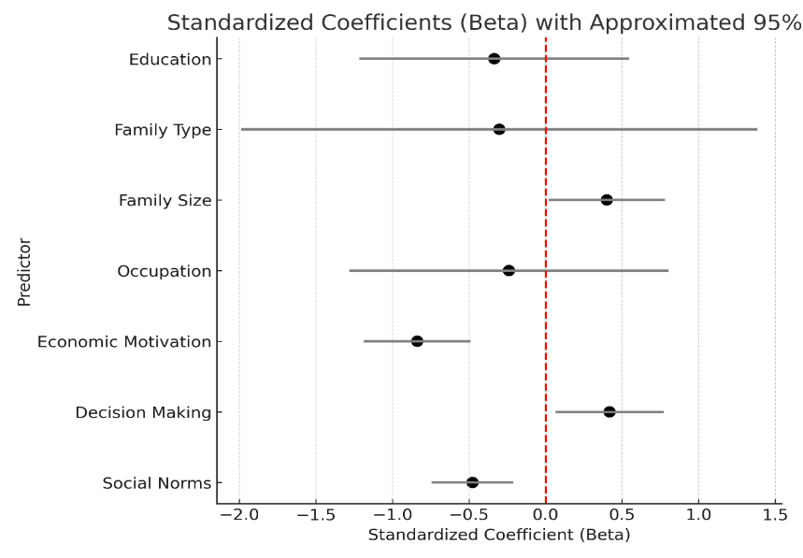
Figure 3. Dot Whisker Plot for Standardized Coefficient (Beta)
Table 4: Summary statistic for model fit
Model | R | R Square | Adjusted R Square | Std. Error of the Estimate
1 | 0.853ª | 0.728 | 0.686 | 4.072
The results from Table 4 show that the multiple regression model has a strong fit, with an R-value of 0.853 and an R Square value of 0.728, indicating that 72.8% of the variation in the number of Indigenous Technical Knowledge (ITK) practices adopted is explained by the 16 independent variables, including personal, socio-economic, psychological, and communication characteristics (Patel et.al., 2025). The adjusted R Square value of 0.686 further supports the model’s reliability, while the standard error of the estimate (4.072) indicates acceptable prediction accuracy. Significant predictors influencing ITK adoption include education, family type, family size, occupation, economic motivation, decision-making behavior, and social norms. These findings are consistent with previous studies that highlight the multi-dimensional nature of technology adoption, emphasizing the importance of both socio-economic and psychological variables in shaping farmers’ behavior toward sustainable practices (Swart et.al., 2023).
Table 5: ANOVAª
Model |  | Sum of Squares | df | Mean Square | F | Sig.
1 | Regression | 4578.044 | 16 | 286.128 | 17.256 | 0.000^{b}
1 | Residual | 1707.881 | 103 | 16.581
1 | Total | 6285.925 | 119

The ANOVA results (Table 5) reveal that the regression model explaining the adoption of Indigenous Technical Knowledge (ITK) among farmers in Kangra district is statistically significant (Sharma et.al., 2025). The total variance in ITK adoption (6285.925) is divided into the regression sum of squares (4578.044), representing the variance explained by the 16 independent variables, and the residual sum of squares (1707.881), which captures the unexplained variance. The calculated F-value of 17.256 with a significance level of p = 0.000 indicates that the model is highly significant at the 1% level. This suggests that the combined effect of socio-demographic and psychological variables such as age, education, gender, risk orientation, sustainability, fatalism, decision-making behavior, and media exposure significantly influences ITK adoption. These findings align with previous research emphasizing the importance of multiple, interrelated factors in technology adoption in agriculture. The result supports the robustness of the model and highlights the need for multi-dimensional strategies in promoting indigenous knowledge systems for sustainable farming (Pacini et.al., 2014).

Conclusion

The study on the adoption of Indigenous Technical Knowledge (ITK) in the farming systems of Kangra, Himachal Pradesh, reveals that ITK adoption is influenced by a complex interplay of socio-demographic, psychological, and cultural factors. Regression and correlation analyses show that variables such as family size, decision-making ability, and connectedness to nature positively impact ITK adoption, while higher education, economic motivation, and modern occupational roles negatively affect it. The strong model fit (R² = 0.728) and significant ANOVA results confirm that these factors collectively explain a large portion of the variation in ITK adoption. Findings suggest that ITKs remain relevant, especially among farmers who value sustainability, community norms, and ecological balance. However, exposure to modern education and media appears to reduce reliance on traditional practices. Therefore, policy efforts must aim to integrate ITKs with modern agricultural systems, promote their scientific validation, and encourage their preservation through farmer education, community engagement, and sustainable development initiatives.

References

- Das, A., Saha, S., Layek, J., Babu, S., Saxena, R., & Ramkrushna, G. I. (2023). Agricultural technologies. In Trajectory of 75 years of Indian Agriculture after Independence (pp. 57-78). Singapore: Springer Nature Singapore.
- Alemu, G. T., Berhanie Ayele, Z., & Abelieneh Berhanu, A. (2017). Effects of land fragmentation on productivity in Northwestern Ethiopia. Advances in Agriculture, 2017(1), 4509605.
- Kumar, G. A., Sujatha, G. S., Teja, K. S. S., Surekha Dasari, H. A., Aarthi Helen, P., Ramya, R., & Parida, A. K. (2024). Bridging past and present: Indigenous technical knowledge in contemporary pest management. methods, 4, 5.
- Singh, R. B., Paroda, R. S., & Dadlani, M. (2020). Indian agriculture towards 2030. World, 821(51), 151.
- Kumar, A., Kumar, S., Komal, Ramchiary, N., & Singh, P. (2021). Role of traditional ethnobotanical knowledge and indigenous communities in achieving sustainable development goals. Sustainability, 13(6), 3062.
- Khatri, S., Khanal, S., & Kafle, S. (2021). Perceived attributes and adoption of Indigenous Technological Knowledge on agriculture-a case study from Bhirkot municipality of Syangja District, Nepal. Cogent Food & Agriculture, 7(1), 1914384.
- Jamaluddin, A. B., & Pratiwi, A. C. (2024). Exploring the impact of educational background, spiritual beliefs, and media exposure on environmental knowledge and attitudes. Eurasia Journal of Mathematics, Science and Technology Education, 20(11), em2537.
- Patel, A., Sachan, R., Singh, S., Singh, H. C., & Singh, S. K. (2025). An Analytical Study of the Relationship between Farmer Characteristics and the Use of Indigenous Technical Knowledge in Agriculture. Asian Journal of Agricultural Extension, Economics and Sociology, 43(6), 99-104.
- Bhujel, R. R., & Joshi, H. G. (2024). Unveiling sustainable agriculture dynamics: a socio-psychological exploration among smallholder farmers in Sikkim, India. Cogent Social Sciences, 10(1), 2350118.
- Imrose, S., Islam, M. M., & Ahmed, M. B. (2025). Identification of indigenous technical knowledges (ITKs) as climate smart agriculture (CSA) technology. Bulgarian Journal of Agricultural Science, 31(2).
- Man, N., Shehu, N. I., Kamarulzaman, N. H., & Sulaiman, Z. (2019). The influence of attitude, social norms on adaptation practices of oil palm smallholders, and mediation role of intention towards climate change impact in Malaysia. Int J Sci Eng, 8, 1821-1825.
- Patel, A., Sachan, R., Singh, S., Singh, H. C., & Singh, S. K. (2025). An Analytical Study of the Relationship between Farmer Characteristics and the Use of Indigenous Technical Knowledge in Agriculture. Asian Journal of Agricultural Extension, Economics and Sociology, 43(6), 99-104.
- Swart, R., Levers, C., Davis, J. T., & Verburg, P. H. (2023). Meta-analyses reveal the importance of socio-psychological factors for farmers’ adoption of sustainable agricultural practices. One Earth, 6(12), 1771-1783.
- Sharma, J. C., Thakur, J., Chandel, R. S., Soni, S., Singh, A., & Acharya, C. L. (2025). Blending Traditional Knowledge of Farmers in Agriculture with Modern Scientific Technologies in the Lower, Mid and Upper Regions of Himachal Pradesh. In Blending Indian Farmers' Traditional Knowledge in Agriculture with Modern Scientific Technologies: A Way Forward (pp. 265-294). Singapore: Springer Nature Singapore.
- Pacini, G. C., Colucci, D., Baudron, F., Righi, E., Corbeels, M., Tittonell, P., & Stefanini, F. M. (2014). Combining multi-dimensional scaling and cluster analysis to describe the diversity of rural households. Experimental Agriculture, 50(3), 376-397.
- Ray, G.L. & Mondal, S. (2011). Research Methods in Social Sciences and Extension Education. 3rd ed. Kalyani Publishers.
- Ray, M., Doshi, N.. Alag, N.. & Sreedhar, R. (2011). Climate Vulnerability in North Western Himalayas. Indian Network on Ethics and Climate Change.
- Leiserowitz, A. (2006). Climate change risk perception and policy references: the role of affect, imagery, and values. Climate Change, 77, 45-72.
- Mayer, F.S. & Cynthia M.F. (2004). The connectedness to nature scale: A measure of individual feelings in community with nature. Journal of Environmental Psychology, 24(4), 503-515. doi:10.1016/j.jenvp.2004.10.001
- Supe, S.V. (1969). Factors related to different degrees of rationality in decision making among farmers in Buldana district. Ph.D. Thesis, Indian Agricultural Research Institute, New Delhi.
- Austin, E.J., Wilock, J. & Gibson, I.J. (1998). Empirical model of farmer behavior using psychological, social and economic variables. Agricultural Systems, 58, 203-224.
- Sundaramari, M. & Ranganathan, T.T. (2003). Indigenous agricultural practices for sustainable farming. Agrobios (India) Publishers, Jodhpur, India.

