COMPARATIVE PERFORMANCE ANALYSIS OF ARIMA, GARCH, ANN AND WAVELET-BASED MODELS IN FORECASTING MAIZE PRICES IN ANDHRA PRADESH

ABSTRACT

Accurate forecasting of prices of agricultural commodities has paramount importance, as it enables farmers, policymakers, and the government to make well-informed decisions. Agricultural commodity prices datasets often exhibit characteristics such as nonlinearity, nonstationarity, non-normality, and heteroscedasticity. While stochastic models like autoregressive integrated moving average (ARIMA) and its components have gained popularity in modeling linear dynamics, they fall short when it comes to capturing the inherent nonlinearity in these datasets. Machine learning (ML) techniques, such as artificial neural networks (ANNs), have rapidly gained prominence in the field of forecasting, as they are better suited to handle the nonlinearity present in the data. However, the high chaotic nature and complex nonlinear structure of these agricultural time series can sometimes pose challenges in modeling. Therefore, a crucial step considered was the preprocessing of the time series data to extract the underlying signal. Wavelet transformation emerges as an effective tool in this scenario. By decomposing and denoising the components through wavelet transformation, it becomes possible to model them using ANN to create wavelet-based hybrid models. Subsequently, an inverse wavelet transform was applied to obtain predictions for the original time series data. The hybrid models combination of wavelet transformations with ARIMA, GARCH and ANN were predominant in handling of nonstationarity, nonlinearity and non-normality present in agricultural datasets. The present study discusses the above approach envisaging monthly prices of maize in Andhra Pradesh. Empirical evidence clearly demonstrates that substantial improvements over conventional techniques were achieved by implementing a wavelet-based combination approach in conjunction with machine learning (ML) techniques. This approach capitalizes on the strengths of both wavelet transformations and ML algorithms, resulting in enhanced forecasting performance and accuracy. The models used for the study were ARIMA, GARCH, ANN, waveletARIMA, waveletGARCH and waveletANN models were employed to compare the accuracy performance of different models in prices forecasting. The study revealed that the maize price forecasting the best model identified was waveletANN with least MSE and RMSE values.
Key words: ARIMA, ANN, GARCH, Maize, WaveletARIMA, WaveletANN and WaveletGARCH.

INTRODUCTION:
Maize (Zea mays), commonly known as corn, is cultivated worldwide and ranks among the most important cereal crops. Owing to its exceptionally high genetic yield potential, it is often referred to as the "queen of cereals." Every component of the maize plant including the grain, leaves, stalk, tassel, and cob holds significant economic value and is utilized in the production of a wide range of food and non-food products. Renowned for its versatility, maize is cultivated in over 166 countries, underscoring its global importance in agriculture and industry. Maize is a staple crop in Andhra Pradesh, contributing significantly to the state's agrarian economy. Maize is one of the significant foreign exchange earners in the commodities covered under the Agricultural and Processed Food Products Export Development Authority. As per statistics, the country’s maize exports stood at $816 million during April-January 2023-24. India produced 23.10 million tonnes in an area of 9.68 million hectares in kharif 2022-23 as per 1st advance estimates. (agricoop.nic). According to 1 st advance estimates during 2022-23, in Andhra Pradesh maize was grown in 1.21 lakh hectares with a production of 5.08 lakh tonnes and productivity was 4195 kg/ha. The prices of maize are ruling in the range of Rs 1,900 to Rs. 2,100 per quintal against the minimum support price of Rs. 2,090 a quintal. Accurate forecasting of various prices hold crucial importance in agriculture agricultural commodity prices, which enabling the farmers, government as well as to make policy decisions. Its price volatility has direct implications for farmers' livelihoods and food supply chains. Accurate price forecasting can enable better planning and resource allocation. Traditional statistical models have been widely used for price prediction, but with advancements in computing, machine learning models and hybrid approaches are gaining prominence. This research explores various forecasting methodologies to identify the most accurate and robust model for predicting maize prices.. With the comparison of the performance accuracy of different conventional models i.e., linear ARIMA, non-linear models i.e., GARCH, ANN and Wavelet-based decomposition models i.e., waveletARIMA, waveletGARCH and waveletANN models the best fit model was identified for the price series. The wavelet models make it possible to describe the useful pattern of the series from both global as well as local aspects and found to be highly proficient in denoising and capturing the inherent pattern of the series through a distinctive approach. Besides, wavelet method can also be used as a tool for function approximation. The improvement upon time-delay neural network also be made up to a great extent through using wavelet-based approaches as exhibited through proper empirical evidence.
The Box-Jenkins ARIMA system has been a driving force behind the exploration of time series data. The realm of literature is replete with instances showcasing its diverse applications of the ARIMA model (Paul et al. 2014, 2015, 2020; Paul and Das 2013; Paul 2015; Swarnalatha et al. 2024). Nonetheless, it's essential to acknowledge that the ARIMA model operates under the assumption that the underlying processes governing the time series datasets are linear in nature. The appeal of linear models lies in their analytical tractability and pragmatic implementation compared to alternative approaches. However, making a preconceived assumption about the linear nature of time series generation might not always be justified. The GARCH (Generalized Autoregressive Conditional Heteroskedasticity) model is a widely used technique in time series analysis, particularly for prices data. It's designed to capture and model the varying volatility or variance over time that's often observed in financial and economic data that can have periods of high volatility (large price swings) followed by periods of low volatility (small price changes). Traditional models assume a constant variance over time, which doesn't reflect this reality. GARCH models, on the other hand, allow the variance to change over time based on past information. Different parts of the GARCH model mean: Autoregressive Component (AR), it captures the past squared returns, indicating the past volatility's influence on the current volatility. Moving Average Component (MA), This part captures the past conditional variances, indicating how past volatility deviations affect the current volatility. Conditional Heteroskedasticity Component (ARCH), is the essence of the model. It represents the variability that changes over time. It takes into account past squared returns' effect on the current conditional variance. Generalized Component (G), allows for more flexibility in modeling the volatility by incorporating additional explanatory variables if needed. The GARCH model is a tool that acknowledges that volatility was not static but changes over time.
Over the past few decades, a myriad of innovative nonlinear models harnessing Machine Learning techniques, such as Artificial Neural Networks (ANNs), have emerged. In stark contrast to conventional model-centric methodologies, ANNs epitomize data-centric nonparametric approaches that avoid imposing strong a priori assumptions about the underlying models governing the phenomena of interest. The model captures intricate functional relationships that exist amongst data points while being less concerned with intricately delineating the complexities of data generation. The potency of the formidable tool finds resonance across diverse domains including engineering, economics, business, and industry (Freeman and Skapura 1991; Zhang and Qi 2005).
Further, the hybrid models address the non stationarity, non-linearity tackle with these features simultaneously. In a comparative study conducted by Anjoy and Paul (2019), they explored the effectiveness of the Haar filter in onion price forecasting using a neural network technique based on wavelet analysis. Li et al. (2020) extended this approach by integrating wavelet transformation with a conventional artificial neural network, leading to improved long-term concentration predictions for heavy metals. Building upon this, Paul et al. (2020) introduced an innovative algorithm that combines wavelet and machine learning techniques to model subdivisional rainfall patterns in India. Liu et al. (2020) introduced an innovative adaptive wavelet transform model and assessed its performance using the S&P500 stock dataset. They observed that the proposed model exhibited superior prediction accuracy in comparison to other advanced models. In a different domain, Li and Wang (2020) put forward a hybrid neural network prediction model, asserting its robust forecasting capability and the delivery of precise predictions in energy price series forecasting. Expanding the scope, Guo and Wozniak (2021) illustrated the application of wavelet denoising to effectively eliminate noise from single-frame character images, enhancing the method's resistance to interference. A striking characteristic shared by numerous time series pertaining to various significant agricultural products, particularly perishables, is the presence of nonlinear patterns, non-normal distributions, nonstationarity, and heteroscedasticity. Paul and Garai (2021) compared the performance of wavelets-based machine learning technique for forecasting agricultural commodity prices four filters mainly Haar, D4, D6 and LA8 have been used at two different levels for decomposition of the series under consideration. Empirical comparison has been carried out for the forecast performance of different models with respect to MSE and RMSE. Moreover, the waveletANN combination method obtained accurate forecasts than the individual stochastic model like ARIMA, GARCH, ML techniques. The present studies focus on the application of the hybrid models and also analyze the prediction accuracy of different models in forcasting monthly prices of maize in Andhra Pradesh.

METHODOLOGY
Data source
To assess the performance criterion of different models to forecast the monthly maize price series of Andhra Pradesh. The secondary time series data from the period January 2002 to April 2025 was collected from AGMARKNET, enam and Agricultural Market Intelligence Centre (AMIC), Lam, Guntur. Total of 280 data series were collected out of 268 observations were used for training sample and 12 observations for validation purpose. The models applied were ARIMA, GARCH, ANN, waveletARIMA, waveletANN and waveletGARCH models for comparison of performance criterion of different models by using R software.
ARIMA
Autoregressive process of order (p) is,
Y_{t} = μ + Ø₁ Y_{t-1} + Ø₂ Y_{t-2} +…………. + Ø_{p} Y_{t-p} + et …………………….(1)
Moving Average process of order (q) is,
Y_{t} = μ – q₁ e_{t-1} - q₂ e_{t-2}……. -q_{q} e_{t-q} + et ………………………(2)
and the general form of the ARIMA model of order (p, d, q) is
Yt = Ø₁ Y_{t-1} + Ø₂ Y_{t-2}…....+ Ø_{p} Y_{t-p} + μ - q₁ e_{t-1} - q₂ e_{t-2} -……- q_{q} e_{t-q} + e_{t ….…….……………(3)}
Where,
Y_{t} is pigeon turmeric prices, e_{t}’s are independently and normally distributed with zero mean and constant variance for t = 1, 2,.......n;
d is the fraction differenced while interpreting AR and MA and Ø_{p} and q_{q} are coefficients to be estimated.
Justification:
In an AR(p) model, the current value Yt depends linearly on its own past p values. Yt​ is influenced by Y_{t−1}
Role of the Coefficients (ϕ): Each past value Y_{t−I} is multiplied by a coefficient ϕ_{i}​, which measures how strongly the past value influences the present.
Constant Term (μ): μ represents a constant (like a long-term mean level around which the process fluctuates).
Error Term (e_{t}​): e_{t}​ is the white noise error at time t, capturing random shocks. It has zero mean, constant variance, and no autocorrelation.
Purpose of the Model: The AR(p) model is used because many real-world time series (like stock prices, temperature, etc.) show persistence the past influences the future. Instead of assuming random behaviour, AR(p) models introduce structure and predictability into the data.
Auto Regressive Conditionally Heteroscedastic (ARCH) model:
The general Regression and time series models can be used based on the assumption that the errors are independent and identically distributed with mean zero and constant variance. However, it is fairly common to observe the violation of this assumption. If the data has high volatility, it is very difficult to fit the linear trend models, an exponential smoother or even an ARIMA model to capture these volatility phenomena. ARCH and GARCH models have become important tools in the analysis of time series data, particularly in volatility data applications. These models are especially useful when the goal of the study is to analyse and forecast volatility.
$∈_{t}$ = $σ_{t}z_{t}$ ……………..(4)

$∈_{t}$ denote the error terms i.e., the series terms. These $∈_{t}$ are split into a stochastic piece $z_{t}$ and a time-dependent standard deviation $σ_{t}$ characterising the typical size of the terms so that the random variable $z_{t}$ is a strong process. The series $σ_{t}$² is modelled by Engle (1982).
$σ_{t}^{2}$ = $α_{0}$ + $α_{1}ϵ_{t-1}^{2}$ + . . . + $α_{q}ϵ_{t-q}^{2}$ = $α_{0}+ \sum_{i=1}^{q}{α_{i}ϵ_{t-i}^{2}}$ ………………..(5)

Where, $α_{0 }$> 0 and $α_{i}$ > 0, i > 0.
It ensures that the variance of the error term is non-negative (due to the constraint α>0,α_{i}>0 and i>0 allows for dynamic modeling of variance based on past information.
Generalized Auto Regressive Conditionally Heteroscedastic (GARCH) Model
GARCH (p, q) model (where p is the order of the GARCH terms σ² and q is the order of the ARCH terms$∈$² ) is given by
$σ_{t}^{2}$ = $α_{0}$ + $α_{1}ϵ_{t-1}^{2}$ + . . . + $α_{q}ϵ_{t-q}^{2}$ + $β_{1}σ_{t-1}^{2}$ + . . . + $β_{p}σ_{t-p}^{2}$ ……………………(6)
= $α_{0}$+ $\sum_{i=1}^{q}{α_{i}ϵ_{t-i}^{2}}$ + $\sum_{i=1}^{p}{β_{i}σ_{t-i}^{2}}$ ……………………(7)
The GARCH model contains an ARCH term because GARCH model is advanced to ARCH model. ARCH, GARCH models are also time series models to locate the variance of a time series. These models are used to describe a changing and possibly volatile variance. Although an ARCH model could possibly be used to describe a gradually increasing variance over time.
Artificial neural networks (ANNs)
Neural systems of modelling have been applied to take care of numerous issues of forecasting over past few decades. The fundamental hypothetical guideline in tackling problematic issues utilizing ANNs depends on the hypothesis of learning (Valiant 1984). The learning phase comprises of demonstrating input datasets and corresponding target values to the system so that it can identify inherited correlated patterns and iteratively modify inner boundaries until providing the significant results (Hagan et al. 1996). Neural network system copies the procedure of learning of the human brain and can solve nonlinear data. Nonlinearity is a common feature of agricultural datasets, so they can be precisely modelled using ANNs (Haykin 1999). Numerically, the functioning of a neuron can be shown with formulae:
Y= θ$(\sum_{i=1}^{n}{w_{i} x_{i}+b)}$ (8)

X_{i}’s are the inputs in the network, w_{i}’s is the weightage related to each input, b is the bias added to the output of a neuron, h is the activation function related to the neuron, and y is the output. The bias can at times be overlooked. After the network is ready, the connection between the source and the destination node, which might be nonlinear and incredibly confounded, is encoded in the system. The system is then ready to create output dependent on the input supplied to the input nodes. ANN offers some additional points of interest: (1) the utilization of ANN does not require earlier information on the fundamental procedure behind the system; (2) all the current complex connections between different parts of the procedure under scrutiny need not to be known and ANNs are information driven contrasted with customary methodologies which are model driven.

Wavelets
Wavelets are brief oscillations with an amplitude that begins at zero, increases, and then decreases back to zero. Through the convolution procedure, wavelets combine with a known portion of the damaged waveform to extract information from the unfamiliar part. The word Wavelet comes from the French word ‘‘Ondelette,’’ which means small wave. Wavelets are defined by wavelet function or mother wavelet; scaling function or father wavelet. Wavelet transform is the representation of a function by wavelets. Wavelets are scaled and translated copies, i.e., daughter wavelets of a finite-length or fast-decaying wavering form. Wavelets are advantageous over the Fourier transform for deconstructing and reconstructing finite, non-periodic, and non-stationary signals. There are two main waves of wavelets. The first wave is known as the continuous wavelet transform (CWT), to work with time series defined over the entire real axis; the second is the discrete wavelet transform (DWT), which deals with series demarcated essentially over a range of integers. DWT of a time series observation is used to capture high- and low-frequency components. This, in turn, would enable the modelling of time series data through the computation of inverse DWT. But here the transform is shift variant and requires the fixed series X of length 2^{j}, where j is an integer value. Therefore, maximal overlap discrete wavelet transform (MODWT) is considered, which is well defined for all sample sizes N and translation invariant too Vidakovic, 1999). In recent decades, the wavelet has been widely used for time series forecasting (Percival and Walden 2000). Zhang et al. (2017) demonstrated the effectiveness of wavelet decomposition in time series forecasting. Lee et al. (2020) reported that, for time series forecasting, wavelet is a viable alternative.
The Haar filter
The simplest wavelet filter is the Haar. The Haar function is a bonafide wavelet, though not used much in practice, uses a mother wavelet given by
Ψ (x) = $\left\{\begin{aligned}1 0≤x< 1/2 \\ -1 1/2≤x≤1, \\ 0 otherwise \end{aligned}\right.$ …….. (9)
The Haar wavelet is piecewise constant over intervals of length one-half and can be expressed as follows (Fig. 2). Haar wavelets possess the property of compact support, i.e., it vanishes outside of a finite interval. The Haar wavelets are not continuously differentiable. Due to these drawbacks, these are less useful in data analysis. Replacing the scaling function in the Haar system by a more regular function produces a system with a much better behavior with respect to smooth functions. Daubechies (1992) proposed such a family of smooth wavelet basis.
PERFORMANCE MEASURES

Forecasting accuracy is crucial for finding out the practicability of developed different combinations of models. To compare the model accuracy of these models with the conventional models, the following evaluation criterion has been used:
Root mean squared error (RMSE)
RMSE is defined as:
RMSE=$\sqrt{\frac{\sum_{i=1}^{N}{{(yi-ŷi)}^{2}}}{N}}$ ………..(10)
here yi and $ŷi$are the actual and predicted values of the response variable, respectively.

Mean squared error (MSE)

MSE= $\frac{1}{n}\sum_{i=1}^{n}{{(yi-ŷi)}^{2}}$ …….(11)
n is the number of data points (observations).
here yi and $ŷi$are the actual and predicted values of the response variable, respectively.

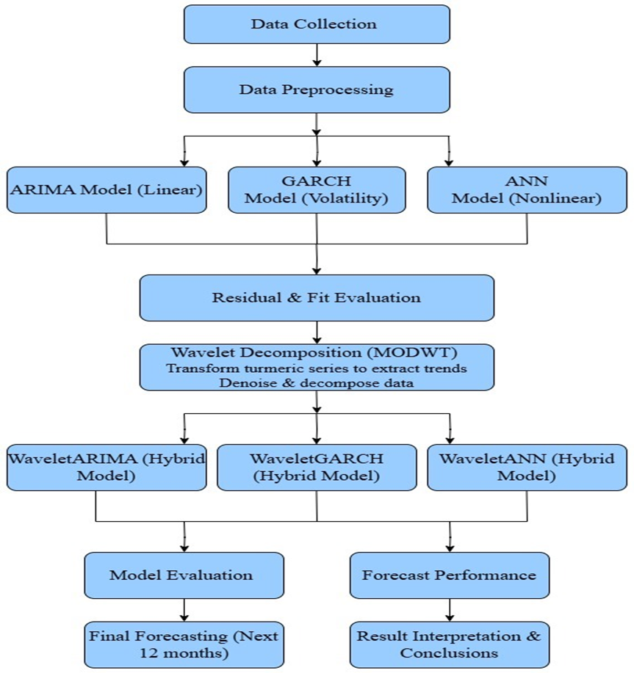

Fig. 1. Methodology flow chart

RESULTS AND DISCUSSIONS:
Data description: Secondary data on monthly price of maize in Andhra Pradesh were collected from AGMARKNET, enam and AMIC for the period January 2002 to April 2025 and the data contains 280 data points. In the study, first 28 data points are used for model identification and parameter estimation purpose and rest of 12 data points are used for model validation purpose.

Fig. 2. Maize prices original series
A perusal of Fig. 2 reveals a positive trend over time which indicates the non-stationary nature of series. The descriptive statistics for monthly price data of maize, maximum and minimum price were depicted in Table 1. The coefficient of variation (CV %) 41.62 per cent for the price data of maize in Andhra Pradesh were is indicative of the presence of moderate to high chaotic nature in the data, A negative kurtosis indicates platykurtic, meaning the distribution has lighter tails and a flatter peak than a normal distribution, it implies that the dataset has fewer extreme values. The BDS (Brock, Dechert and Scheinkman) test is a statistical test used to detect nonlinearity or chaotic behavior in time series data. The null hypothesis of the BDS test is that the data follows a linear or Gaussian white noise process, indicating linearity and absence of chaos or significant nonlinear patterns. The BDS test in Table 2., yielded a p-values zero, indicating that the maize price series follows a nonlinear pattern. Similarly, the Shapiro–Wilk and Jarque–Bera tests also produced p-values of zero, confirming a significant departure from normality. Hence, it can be concluded that the maize price series is non-normal.
Table 1. Descriptive statistics
Statistic | Maize price (Rs./Q)
data points (n) | 280
Mean | 1225
Median | 1266
Mode | 1178
Standard deviation | 509.88
Skewness | 0.15
Maximum | 2445
Minimum | 500
Kurtosis | -0.95
CV(%) | 41.62
Jarque-BeraTest:
χ²statistic | 2537.48
P - value | <0.001
Shapiro-WilkTest:
W- statistic | 0.87
P – value | <0.0001

Table 2. BDS test for non-linearity in Maize price series of Andhra Pradesh

Sample | Dimension | Bengalgram
Sample | Dimension | Statistics | Probability
eps (1) | m=2 | 139.02 | p<0.0001
eps (1) | m=3 | 244.20 | p<0.0001
eps (2) | m=2 | 139.90 | p<0.0001
eps (2) | m=3 | 178.20 | p<0.0001
eps (3) | m=2 | 82.69 | p<0.0001
eps (3) | m=3 | 91.22 | p<0.0001
eps (4) | m=2 | 56.06 | p<0.0001
eps (4) | m=3 | 56.68 | p<0.0001

The Autocorrelation (ACF) and Partial Autocorrelation Function (PACF) plots of monthly maize price data were enumerated in Fig 3, confirmed that the data exhibited non-stationary, as autocorrelations decayed very slowly. Augmented Dickey Fuller (ADF) test was applied on the prices series to verify the stationarity of data series and the p value for the test was 0.51 indicates that the acceptance of null hypothesis that data series was non-stationary.

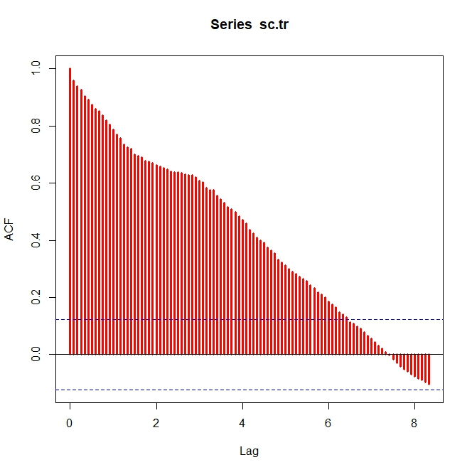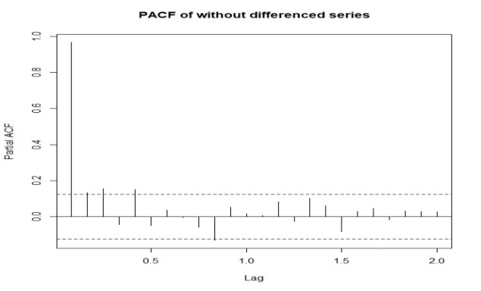
Fig. 3. ACF and PACF plots of maize prices
ARIMA Model:
ARIMA (2, 1, 1) model was identified as one of the appropriate models to forecast the prices of maize in Andhra Pradesh, after fixing d=1, as per auto correlation and partial autocorrelation considerations, possible ARIMA (p, d, q) models were formulated in Table 3. and diagnostic criterion namely, MSE and RMSE were presented in Table 7.
Table 3. Parameter estimation of ARIMA model for Maize monthly prices
Model | Parameters | Estimation | S.E. | Z-value | Probability
ARIMA (2,1,1) | AR1 | -0.99 | 0.08 | -11.65 | < 0.0001
ARIMA (2,1,1) | AR2 | -0.39 | 0.05 | -6.96 | <0.0001
ARIMA (2,1,1) | MA1 | 0.74 | 0.07 | 9.67 | < 0.001

ARCH- GARCH model:
ARCH Lagrange Multiplier (LM) test, a heteroscedastic test developed by Engle (1982), was used to determine the presence of ARCH effect in the residuals. The significant p- value indicates that the strength of evidence against the null hypothesis. A small p-value (0.00045) reveals the presence of conditional heteroskedasticity. GARCH (1, 1) models are designed to capture the changing volatility in a time series. Volatility refers to the variation or fluctuations in the data. GARCH model suggested that the volatility at a given time depends on past squared observations (residuals or squared returns) from the series. If the GARCH model's parameters are statistically significant, it implies that the past squared observations have a significant impact on the current volatility. This suggests that periods of high volatility tend to be followed by periods of high volatility, and vice versa. The parameters in a GARCH model help describe the characteristics of the volatility pattern. The ARCH term (α) captures the short-term effect of past squared observations on volatility, while the GARCH term (β) captures the long-term effect. The sum of these terms represents the total impact on current volatility; the results obtained these parameters sum is less than 1 and it is positive. Here, a well-fitted GARCH model should have parameters that are statistically significant and align with the characteristics of the data was presented in Table 5. and model performance metrics was shown in Table 7. The model should capture the observed volatility patterns. A perusal of Fig. 4 reveals Garch model with ACF of squared standard residuals.
Table 4. ARCH-LM Heteroscedasticity test for residuals of Maize prices of Andhra Pradesh

Order | LM | p-value
4 | 302.30 | p<0.0001
8 | 131.30 | p<0.0001
12 | 83.80 | p<0.0001
6 | 60.10 | p<0.0001
20 | 46.20 | p<0.0001
24 | 35.20 | p<0.0001

Table 5. Parameter estimation of GARCH of Maize prices of Andhra Pradesh

Model | Parameters | Estimation | S.E. | t value | Probability
ARMA (1,1)+ GARCH (1,1) | µ | 1.59 | 11.51 | 0.14 | p<0.0001
ARMA (1,1)+ GARCH (1,1) | AR1 | 1.37 | 0.01 | 137.80 | p<0.0001
ARMA (1,1)+ GARCH (1,1) | MA1 | -0.02 | 0.06 | -0.33 | p<0.05
ARMA (1,1)+ GARCH (1,1) | ω | 0.98 | 0.16 | 6.13 | p<0.0001
ARMA (1,1)+ GARCH (1,1) | α | 0.03 | 0.01 | 2.77 | p<0.0001
ARMA (1,1)+ GARCH (1,1) | β | 0.94 | 0.01 | 94.23 | p<0.0001
Box-Pierce test for residuals ~ χ² = 0.028 , p = 0.53 (>0.05)

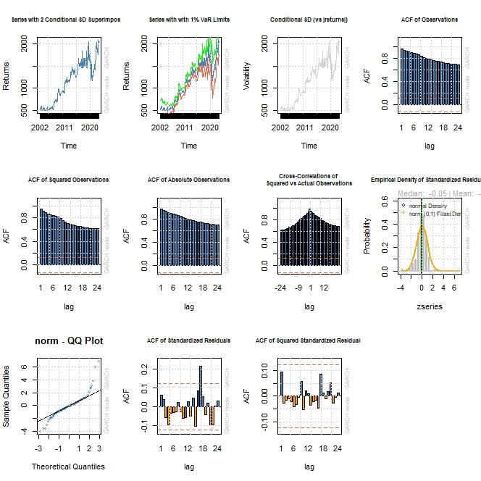
Fig. 4. GARCH model.
ANN model:
Neural network is popularly known to be used in predicting or forecasting time series with nonlinear behaviour. In the present study, on confirming the nonlinearity pattern in the monthly price series of maize in Andhra Pradesh, feed-forward back-propagation algorithm has been applied for fitting of ANN model. The non-linear time series, NNAR (3-10-1) model was identified as the best model, 51 weights with linear output units. The MSE and RMSE values were computed and presented in Table 3. Moreover, Ljung-Box test provided high p-value is 0.84, suggested that there is no strong evidence to reject the null hypothesis.

Table 6. Parameter specification of ANN model for Maize prices of Andhra Pradesh
Parameter | Specification
Input lag | 3
Output variable/dependent | 1
Hidden nodes | 10
Hidden layers | 1
Model | 3:10S:1L
Total number of parameters | 51
Network type | Feed Forward
Activation function (I:H) | Sigmoidal
Activation function (H:O) | Identity
Box-Pierce test for residuals ~ χ² =0.045, p = 0.84(>0.05)

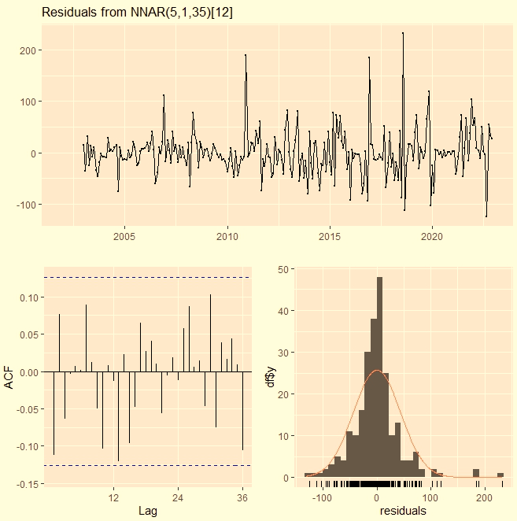
Fig. 5. Schematic representation of NNAR Model
Wavelet decomposition techniques:
WaveletARIMA, waveletGARCH and waveletANN combination, price series were first decomposed using MODWT implementing Haar wavelet filter. The maximum possible level of decomposition is computed accord with the formula J≤ log₂ (N). For the maize price series, decomposition levels have been considered. Figure 6. displays the MODWT plot for the price data of studied at both the decomposition levels by implementing Haar wavelet filter. The coefficients at the top (below) are ‘‘high-frequency’’ (low frequency) information. The wavelet coefficients do not remain constant over time and reflect the changes of the data at various time epochs. The locations of abrupt jumps can be spotted by looking for vertical (between levels) clustering of relatively large coefficients. From the wavelet coefficients plotted, the original function can be reconstructed by using inverse discrete wavelet transform (IDWT). After fitting with each and every decomposed subseries of given price series in the ARIMA, GARCH and ANN model, forecasts have been computed for individual subseries. The final forecast of original series was computed by combining the forecast from individual subseries by means of inverse wavelet transform. Multi-step ahead forecast is obtained in an iterative way. The forecasting performance of waveletARIMA, WaveletGarch and waveletANN models were computed for an out-of-sample cross-validation period of 12 months in terms MSE and RMSE values in Table 7., Shown that the WaveletANN has the high prediction accuracy when compared with other model as it yielded lowest MSE and RMSE values.
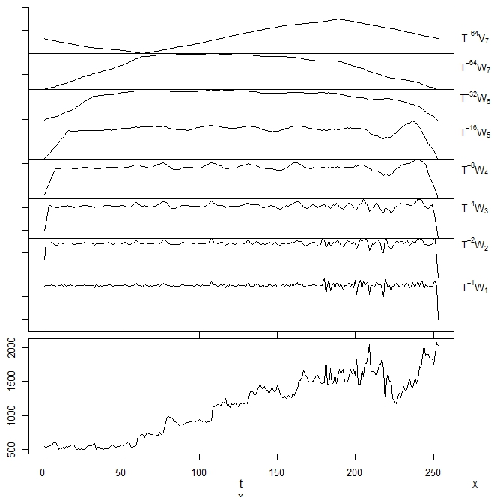
Fig. 6. The figure depicting wavelet decomposition

Table 7. Forecasting performance of different models
 | Training data set |  | Testing data set
MODEL | MSE | RMSE | MSE | RMSE
ARIMA | 6773.29 | 82.30 | 16543.10 | 128.62
GARCH | 5622.00 | 74.98 | 12647.25 | 112.46
ANN | 1907.94 | 43.68 | 7458.05 | 86.36
WaveletARIMA | 1053.00 | 32.45 | 3275.27 | 57.23
WaveletGARCH | 809.40 | 28.45 | 2341.59 | 48.39
WaveletANN | 425.59 | 20.63 | 1337.36 | 36.57

CONCLUSIONS:

The present study forecasting of maize price series performance comparison of wavelets-based machine learning techniques. The main focus of this study is to present a simple, stable forecasting approach for nonlinear and nonstationary maize prices in Andhra Pradesh. As we know ARIMA model handle linearity in the dataset and GARCH, ANN models only handle non linearity feature of a time series but when a series contains non stationary character also then it is unable to handle such situation. For such series wavelet decomposition techniques were employed as it was identified as an effective technique which decomposes the components through wavelet transformation. We have modeled them using ARIMA, GARCH, ANN and wavelet based models like waveletARIMA, waveletGARCH and WaveletANN to compare the performance wavelet-based models. WaveletANN model obtained with least RMSE, MAE and MAPE values compared with other models were presented in Table 3. Moreover, the Wavelet combination methods like waveletARIMA, waveletGARCH and waveletANN has been proved to be more accurate in forecasting the price series than the individual stochastic model like ARIMA, GARCH and ANN.
COMPETING INTERESTS DISCLAIMER:
Authors have declared that they have no known competing financial interests OR non-financial interests OR personal relationships that could have appeared to influence the work reported in this paper.

REFERENCES

Adhikari, R., & Agrawal, R. K. (2014). A combination of artificial neural network and random walk models for financial time series forecasting. Neural Computing and Applications, 24(6), 1441–1449. https://doi.org/10.1007/s00521-013-1376-z

Anderson, J. A. (1995). An introduction to neural networks. MIT Press.

Anjoy, P., & Paul, R. K. (2017). Wavelet-based hybrid approach for forecasting volatile potato price. Journal of the Indian Society of Agricultural Statistics, 71(1), 7–14.

Anjoy, P., & Paul, R. K. (2019). Comparative performance of wavelet-based neural network approaches. Neural Computing and Applications, 31, 3443–3453. https://doi.org/10.1007/s00521-017-3282-5

Anjoy, P., Paul, R. K., Sinha, K., Paul, A. K., & Ray, M. (2017). A hybrid wavelet-based neural networks model for predicting monthly WPI of pulses in India. Indian Journal of Agricultural Sciences, 87(6), 834–839.

Antoniadis, A. (1997). Wavelets in statistics: A review. Journal of the Italian Statistical Society, 6(2), 97–144. https://doi.org/10.1007/BF03176804

Bollerslev, T. (1986). Generalized autoregressive conditional heteroskedasticity. Journal of Econometrics, 31(3), 307–327. https://doi.org/10.1016/0304-4076(86)90063-1

Box, G. E. P., & Jenkins, G. M. (1970). Time series analysis: Forecasting and control (2nd ed.). Holden-Day.

Conejo, A. J., Plazas, M. A., Espinola, R., & Molina, A. B. (2005). Day-ahead electricity price forecasting using the wavelet transform and ARIMA models. IEEE Transactions on Power Systems, 20(2), 1035–1042. https://doi.org/10.1109/TPWRS.2005.846054

Daubechies, I. (1992). Ten lectures on wavelets. SIAM.

Diebold, F. X., & Mariano, R. S. (1995). Comparing predictive accuracy. Journal of Business & Economic Statistics, 13(3), 253–263. https://doi.org/10.1080/07350015.1995.10524599

Farda, K. A., & Akbari-Zadeh, M. R. (2014). A hybrid method based on wavelet, ANN and ARIMA model for short-term load forecasting. Journal of Experimental & Theoretical Artificial Intelligence, 26(2), 167–182. https://doi.org/10.1080/0952813X.2013.784133

Freeman, J., & Skapura, D. (1991). Neural networks: Algorithms, applications, and programming techniques. Addison-Wesley.

Gao, R., Du, L., Duru, O., & Yuen, K. F. (2021). Time series forecasting based on echo state network and empirical wavelet transformation. Applied Soft Computing, 102, 107111. https://doi.org/10.1016/j.asoc.2021.107111

Guo, L., & Woźniak, M. (2021). An image super-resolution reconstruction method with single frame character based on wavelet neural network in internet of things. Mobile Networks and Applications, 26(1), 390–403. https://doi.org/10.1007/s11036-020-01677-y

Hagan, M. T., Demuth, H. B., & Beale, M. (1996). Neural network design. PWS-Kent Publishing.

Haykin, S. (1999). Neural networks: A comprehensive foundation (2nd ed.). Prentice Hall.

Lee, H. W., Beh, W. L., & Lem, K. H. (2020). Wavelet as a viable alternative for time series forecasting. Australian Journal of Statistics, 49(1), 38–47.

Li, X., & Tang, P. (2020). Stock index prediction based on wavelet transform and FCD-MLGRU. Journal of Forecasting, 39(8), 1229–1237. https://doi.org/10.1002/for.2658

Li, J., & Wang, J. (2020). Stochastic recurrent wavelet neural network with EEMD method on energy price prediction. Soft Computing, 24, 17133–17151. https://doi.org/10.1007/s00500-020-05059-4

Li, P., Hua, P., Gui, D., Niu, J., Pei, P., Zhang, J., & Krebs, P. (2020). A comparative analysis of artificial neural networks and wavelet hybrid approaches to long-term toxic heavy metal prediction. Scientific Reports, 10, 13439. https://doi.org/10.1038/s41598-020-70475-1

Liu, X., Liu, H., Guo, Q., & Zhang, C. (2020). Adaptive wavelet transform model for time series data prediction. Soft Computing, 24, 5877–5884. https://doi.org/10.1007/s00500-019-04169-5

Ogden, T. (1997). Essential wavelets for statistical applications and data analysis. Birkhäuser.

Paul, R. K. (2015). ARIMAX-GARCH-WAVELET model for forecasting volatile data. Model Assisted Statistics and Applications, 10(3), 243–252. https://doi.org/10.3233/MAS-150344

Paul, R. K., & Das, M. K. (2013). Forecasting of average annual fish landing in Ganga Basin. Fish Chimes, 33(3), 51–54.

Paul, R. K., & Garai, S. (2021). Performance comparison of wavelet-based machine learning techniques for forecasting agricultural commodity prices. Soft Computing, 25(20), 12857–12873. https://doi.org/10.1007/s00500-021-06087-4

Paul, R. K., Alam, W., & Paul, A. K. (2014). Prospects of livestock and dairy production in India under time series framework. Indian Journal of Animal Sciences, 84(4), 130–134.

Paul, R. K., Gurung, B., & Paul, A. K. (2015). Modelling and forecasting of retail price of Arhar dal in Karnal, Haryana. Indian Journal of Agricultural Sciences, 85(1), 69–72.

Paul, R. K., Paul, A. K., & Bhar, L. M. (2020). Wavelet-based combination approach for modeling sub-divisional rainfall in India. Theoretical and Applied Climatology, 139(3–4), 949–963. https://doi.org/10.1007/s00704-019-03011-4

Percival, D. B., & Walden, A. T. (2000). Wavelet methods for time series analysis. Cambridge University Press. https://doi.org/10.1017/CBO9780511841040

Valiant, L. G. (1984). A theory of the learnable. Communications of the ACM, 27(11), 1134–1142. https://doi.org/10.1145/1968.1972

P. Swarnalatha, V. Srinivasa Rao, G. Raghunadha Reddy, Santosha Rathod, D. Ramesh, and K. Uma Devi. 2024. “Application of Machine Learning Techniques Models for Forecasting of Redgram Prices of Andhra Pradesh, India”. Journal of Scientific Research and Reports 30 (7):252–271. https://doi.org/10.9734/jsrr/2024/v30i72142.

Vidakovic, B. (1999). Statistical modeling by wavelets. Wiley.

Wang, J., & Li, X. (2018). A combined neural network model for commodity price forecasting with SSA. Soft Computing, 22(17), 5323–5333. https://doi.org/10.1007/s00500-017-2742-1

Woźniak, M., & Połap, D. (2018). Adaptive neuro-heuristic hybrid model for fruit peel defects detection. Neural Networks, 98, 16–33. https://doi.org/10.1016/j.neunet.2017.10.010

Woźniak, M., Siłka, J., Wieczorek, M., & Alrashoud, M. (2021a). Recurrent neural network model for IoT and networking malware threat detection. IEEE Transactions on Industrial Informatics, 17(8), 5583–5594. https://doi.org/10.1109/TII.2020.3047698

Woźniak, M., Wieczorek, M., Siłka, J., & Połap, D. (2021b). Body pose prediction based on motion sensor data and recurrent neural network. IEEE Transactions on Industrial Informatics, 17(3), 2101–2111. https://doi.org/10.1109/TII.2020.3004392

Wu, D., Wang, X., & Wu, S. (2021). A hybrid method based on extreme learning machine and wavelet transform denoising for stock prediction. Entropy, 23(4), 440. https://doi.org/10.3390/e23040440

Zhang, G. P. (2003). Time series forecasting using a hybrid ARIMA and neural network model. Neurocomputing, 50, 159–175. https://doi.org/10.1016/S0925-2312(01)00702-0

Zhang, G. P., & Qi, M. (2005). Neural network forecasting for seasonal and trend time series. European Journal of Operational Research, 160(2), 501–514. https://doi.org/10.1016/j.ejor.2003.08.037

Zhang, K., Gençay, R., & Yazgan, M. E. (2017). Application of wavelet decomposition in time-series forecasting. Economics Letters, 158, 41–46. https://doi.org/10.1016/j.econlet.2017.06.034

Zhang, D., Chen, S., Ling, L., & Xia, Q. (2020). Forecasting agricultural commodity prices using model selection framework with time series features and forecast horizons. IEEE Access, 8, 46421–46433. https://doi.org/10.1109/ACCESS.2020.2971591

