Original Research Article
Preparation and dietary evaluation of fortified yoghurt

ABSTRACT
The study aimed to develop fortified yoghurt made with snail shell powder, a natural and non-toxic compound and rich in calcium carbonate (approximately 95% inorganic minerals) other essential minerals like manganese, iron, copper, zinc, sodium in order to increases its nutritional benefits. It also contains chitosan, a valuable carbohydrate. The yoghurt was enhanced with additional ingredients like strawberry, cinnamon, cardamom, honey is more important than control yoghurt because it combines traditional dairy nutrition with added functional benefits from natural ingredients. These additions enhance the yoghurt's nutritional value, improve health benefits, and creates a more appealing sensory profile. Strawberries contribute natural antioxidants and vitamins, cinnamon and cardamom offer anti-inflammatory and digestive-supporting compounds, honey brings antimicrobial and energy-boosting properties. Cinnamon and cardamom have been associated with improved blood sugar regulation and lipid metabolism, which can aid in the prevention of metabolic syndrome. Chia seeds, rich in omega-3 fatty acids, fiber, and essential minerals, support heart health and help maintain healthy cholesterol levels. Honey adds antimicrobial properties and promotes gut health in combination with the probiotics found in yoghurt. Snail shell, as a natural source of calcium and other trace minerals, contributes to bone health and helps in preventing deficiencies that could lead to conditions like osteoporosis. Three distinct experimental versions of the fortified yoghurt have been created to added varying the amount of snail shell powder, accompanied by various analyses, including proximate analysis, mineral content evaluation, antioxidant, total polyphenol, flavonoid assessment and microbial analysis. The fortified yoghurt exhibited a superior nutritional profile, boasting high levels of carbohydrates, proteins, and essential minerals like sodium, calcium, and iron. Notably, it demonstrated enhanced antioxidant activity, with increased polyphenol and flavonoid content compared to control(plain) yoghurt. Additionally, the fortified yoghurt contained beneficial bacteria, further contributing to its potential health benefits.
Keywords: Snail shell powder; calcium carbonate; strawberries; digestive-supporting; chia seeds

1. INTRODUCTION
Snail shells are a natural source rich in calcium carbonate, making them a valuable resource for the food industry due to their non-toxic, low-cost, and eco-sustainable nature. They contain essential minerals like phosphorus, manganese, iron, copper, zinc, sodium, and potassium, as well as organic compounds such as proteins, lipids, and polysaccharides. Snail shells are also a rich source of chitosan, a natural carbohydrate with antibacterial and antifungal properties, which has been shown to inhibit the growth of Staphylococcus aureus and reduce diabetic ulcers caused by the bacteria. The use of chitosan can also reduce the need for synthetic food preservatives. Furthermore, chitosan has demonstrated significant immune-modulating responses against cancer and anti-tumor activity, with an efficacy rate of 87-96%. The calcium carbonate in snail shells can help prevent multiple chronic diseases and reduce the risk of cancer. As a result, snail shells are used as a calcium supplement to prevent osteoporosis. The calcium carbonate in snail shells can also synthesize hydroxyapatite, which has high binding activity to proteins and other materials, and has been shown to reduce tumor size and inhibit the proliferation of cancer cells, particularly in human breast cancer [Joice Junita Imelda Rompas et al.2003]. The use of snail shell powder can lead to the development of new healthy food products, such as fortified yoghurt with enhanced nutritional value. [Angela Giorgia Potortiet et al.2024].
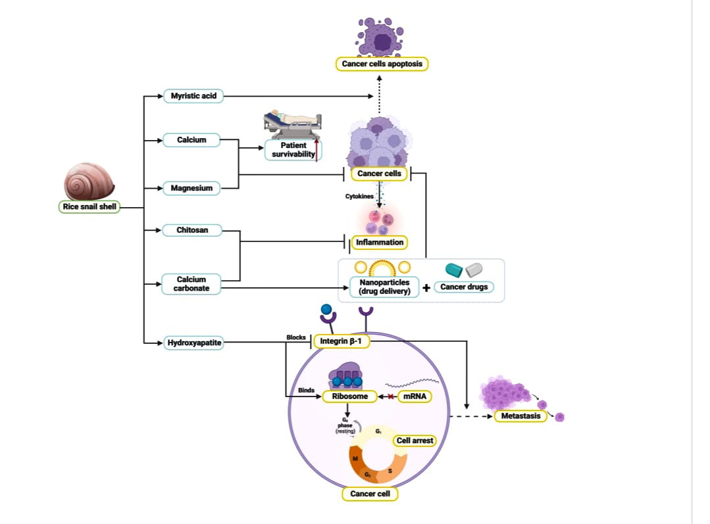
Figure 1: Beneficial role of snail shell powder [Joice Junita Imelda Rompas et al.2003]
Cow's milk is a nutrient-dense liquid rich in macronutrients (protein, fat, carbohydrates) and micronutrients, including calcium, vitamin D, B vitamins, phosphorus, and potassium. It contains high-quality proteins like casein and whey, supporting muscle protein synthesis and recovery. Additionally, low-fat and fermented dairy products may help reduce hypertension due to their calcium, potassium, magnesium, and bioactive peptides [Elliot et al., 2006; Elwood et al., 2004; Soedamah-Muthu et al., 2011].
Yoghurt is a fermented milk product containing probiotics like Streptococcus thermophilus and Lactobacillus bulgaricus, which support gut health, lower cholesterol, and prevent diarrhea. Rich in protein, calcium, B vitamins, and probiotics, yoghurt offers numerous health benefits, including improved digestion, balanced gut microbiota, and potential alleviation of symptoms of irritable bowel syndrome (IBS) and lactose intolerance [Roberfroid et al., 2010]. The regular yoghurt consumption has been associated with lower blood pressure and improved cholesterol profiles, particularly when consuming low-fat varieties [ Marteau et al., 2001]. It is an excellent source of calcium, phosphorus, and vitamin D (in fortified varieties), all essential for maintaining strong bones and preventing osteoporosis [Weaver et al., 2013].
Strawberries are rich in phenolic compounds, serving as a valuable source of antioxidants, particularly anthocyanin. The addition of strawberries enhances the sensory properties of products, such as texture, color, aroma, and taste. Strawberries also contain essential fatty acids and are an excellent source of manganese, providing a significant amount of potassium, thereby contributing to their nutritional value [Forentina Maria Titin Supriyanti et al,2022]. Strawberries ware rich in essential nutrients and bioactive compounds, particularly vitamin C, folate, fiber, and phenolic compounds such as anthocyanin and elegiac acid. These compounds contribute to several health-promoting effects. It was high in antioxidants, which help neutralize free radicals and reduce oxidative stress-a factor in chronic diseases like cancer and cardiovascular diseases and have anti-inflammatory effects. The regular consumption of strawberries may reduce inflammatory markers such as C-reactive protein (CRP), potentially lowering the risk of chronic inflammation-related conditions [Basu et al., 2010]. Dietary intake of strawberries has been associated with improved lipid profiles, blood pressure regulation, and endothelial function [Erlund et al., 2008; Cassidy et al., 2011]. The flavonoids in strawberries may help slow cognitive decline and improve memory by reducing neuroinflammation and oxidative damage [Krikorian et al., 2010]. Polyphenols in strawberries, such as elegiac acid and anthocyanin, have demonstrated anti-carcinogenic properties in both in vitro and in vivo studies [Seeram et al., 2006]. Strawberries may improve insulin sensitivity and help regulate blood glucose levels, which is beneficial for metabolic syndrome and type 2 diabetes management [Edirisinghe et al., 2011].
Chia seeds, derived from Salvia hispanica L., are a rich source of alpha-linolenic acid (ALA), fiber, and antioxidants. They may support heart health by reducing inflammation, improving cholesterol profiles, and lowering blood pressure and triglycerides. Chia seeds are also rich in essential minerals like calcium, phosphorus, and magnesium, promoting bone strength and density. Their incorporation into products can enhance nutritional value, support lactic acid bacteria growth, and improve characteristics like viscosity, color, and antioxidant effects. Chia seeds are small edible seeds from the plant Salvia hispanica L., native to Central America. Chia seeds are among the richest plant sources of alpha-linoleic acid (ALA), which may support heart health, reduce inflammation, and improve cholesterol profiles [Ayerza & Coates, 2005].Due to their combination of fiber, ALA, and antioxidants, chia seeds may help lower blood pressure, triglycerides, and LDL cholesterol [Nieman et al., 2009].It is rich in calcium, phosphorus, and magnesium, essential for bone strength and density [Ullah et al., 2016].The seeds are added to the fortify products, offering a rich content of crude protein, dietary fiber, antioxidants such as phenolic compounds, and omega-3 fatty acids, particularly alpha-linolenic acid. The incorporation of chia seeds can enhance the growth of lactic acid bacteria and improve product characteristics, including viscosity, color, syneresis, and antioxidant effects [Jussara Kowaleski et al., 2020].
Spices like cinnamon and cardamom serve as excellent functional flavoring agents, offering health benefits such as antioxidant, antimicrobial, anti-inflammatory, and anti-carcinogenic properties. When combined with yoghurt, these spices may enhance therapeutic properties, impact probiotic viability, and inhibit pathogens [Vijayalakshmi V et al.,2013]. The cinnamon contains high levels of polyphenols that help neutralize free radicals, reducing oxidative stress that contributes to chronic diseases [Ranasinghe et al., 2013]. It suppresses inflammatory cytokines and enzymes such as COX-2, aiding in the management of inflammation-related conditions [Shan et al., 2005]. It enhances insulin sensitivity and lowers fasting blood glucose, which is beneficial for type 2 diabetes management [Khan et al., 2003; Akilen et al., 2010]. Regular intake of cinnamon has been shown to reduce total cholesterol, LDL (bad cholesterol), and triglycerides, while increasing HDL (good cholesterol) [Qin et al., 2010]. It has antimicrobial activity. Cinnamon exhibits antibacterial and antifungal properties, particularly against E. coli, Candida albicans, and Listeria monocytogenes [Gomez-Estaca et al., 2010]. Cardamom has traditionally been used to relieve indigestion, gas, stomach cramps, and nausea. It stimulates gastric secretions and acts as a carminative [Jamal et al., 2006]. Cardamom contains flavonoids and terpenes that exhibit strong antioxidant activity, reducing oxidative stress and suppressing pro-inflammatory markers [Majdalawieh & Carr, 2010]. Clinical trials have shown that regular cardamom intake can reduce systolic and diastolic blood pressure, likely due to its diuretic effect and antioxidant activity [Verma et al., 2009]. It has essential oil which effective against a wide range of pathogens including E. coli, Staphylococcus aureus, and Candida albicans [Ravindran et al., 2004]. Preclinical studies suggest that cardamom can inhibit cancer cell proliferation, induce apoptosis, and prevent chemically induced tumour in animal models [Khan et al., 2011]. It is use in Ayurveda and Unani medicine, cardamom helps relieve cough, asthma, and bronchitis due to its expectorant and bronchodilator properties [Jamal et al., 2006].
Honey is a natural sweet substance produced by honeybees (Apis mellifera) from the nectar of flowers. It contains a complex mixture of sugars (mainly fructose and glucose), enzymes, amino acids, vitamins, minerals, and potent bioactive compounds such as flavonoids and phenolic acids. That is scavenge free radicals and reduce oxidative stress, which may help prevent chronic diseases [Alvarez-Suarez et al., 2010]. Although high in natural sugars, honey has a lower glycaemic index than refined sugar and may improve glycaemic control when used moderately [Yaghoobi et al., 2008]. Unliked many probiotic-fortified yoghurts that use artificial sweeteners and flavoring agents [Vijayalakshmi V et al,2013], this dissertation explores the use of natural sweeteners like honey. Honey, composed of water, fructose, glucose, and sucrose, offers anti-mutagenic, antibacterial, and antioxidant properties. Adding honey to yoghurt can enhance its physicochemical, microbiological, and sensory properties, making it a suitable food option, particularly for children [Fatma Coskun., et al.2019]. This natural approach to sweetening yoghurt is beneficial for both manufacturers and consumers [Vijayalakshmi V et al., 2013].
The aim of the study is to formulate a fortified yoghurt with added snail shell powder, strawberry, chia seeds, spices and honey. It is considered innovative because it integrates underutilized and culturally unique ingredients like snail shell powder into a familiar food matrix. Using such non-traditional sources of minerals reflects a novel approach to food fortification. The product also aligns with growing trends in functional foods, clean-label ingredients, and natural fortification strategies, making it a unique and forward-thinking contribution to the field of dairy innovation and nutrition
2. METHODOLOGY
2.1 Raw material
Fortified yoghurt making raw materials are purchased from the local market which includes milk, yoghurt, strawberry, chia seeds, cinnamon, cardamom, honey. The novel ingredient snail shell was collected from pond.
2.2 Pre-preparation of snail shell powder
The snail shell was rinsed under running distilled water and then soaked in distilled water for 1-2 hours. After that, an acetic acid solution was prepared to wash the snail shell to prevent contamination. It was dried and ground, and lastly, it was strained using a strainer. It is a rich source of calcium. Snail shells are composed mainly of calcium carbonate (CaCO₂), making them an excellent natural source of calcium, useful in treating calcium deficiencies and as a supplement in food and feed [Eze et al., 2012]. The Snail shell-derived calcium carbonate has shown potential in bone graft materials and bio ceramics due to its biocompatibility and similarity to human bone composition [Onwubu et al., 2016]. When processed into nano-form or used as powders, snail shells may contribute to wound healing and display antimicrobial activity against common pathogens [Eze et al., 2012]. Snail shell powder is used for wastewater treatment, particularly in the removal of heavy metals and acid neutralization [Adewoye et al., 2014]. Researchers have developed toothpaste and oral care formulations incorporating snail shell-derived calcium, which has shown promise in enamel remineralization and reducing hypersensitivity [Onwubu et al., 2016; Onwubu et al., 2018].
Snail shell is rinse under running distilled water then soaked in distilled water for 1-2 hours. The detailed method of preparation of snail shell powder is mentioned in Figure 2.
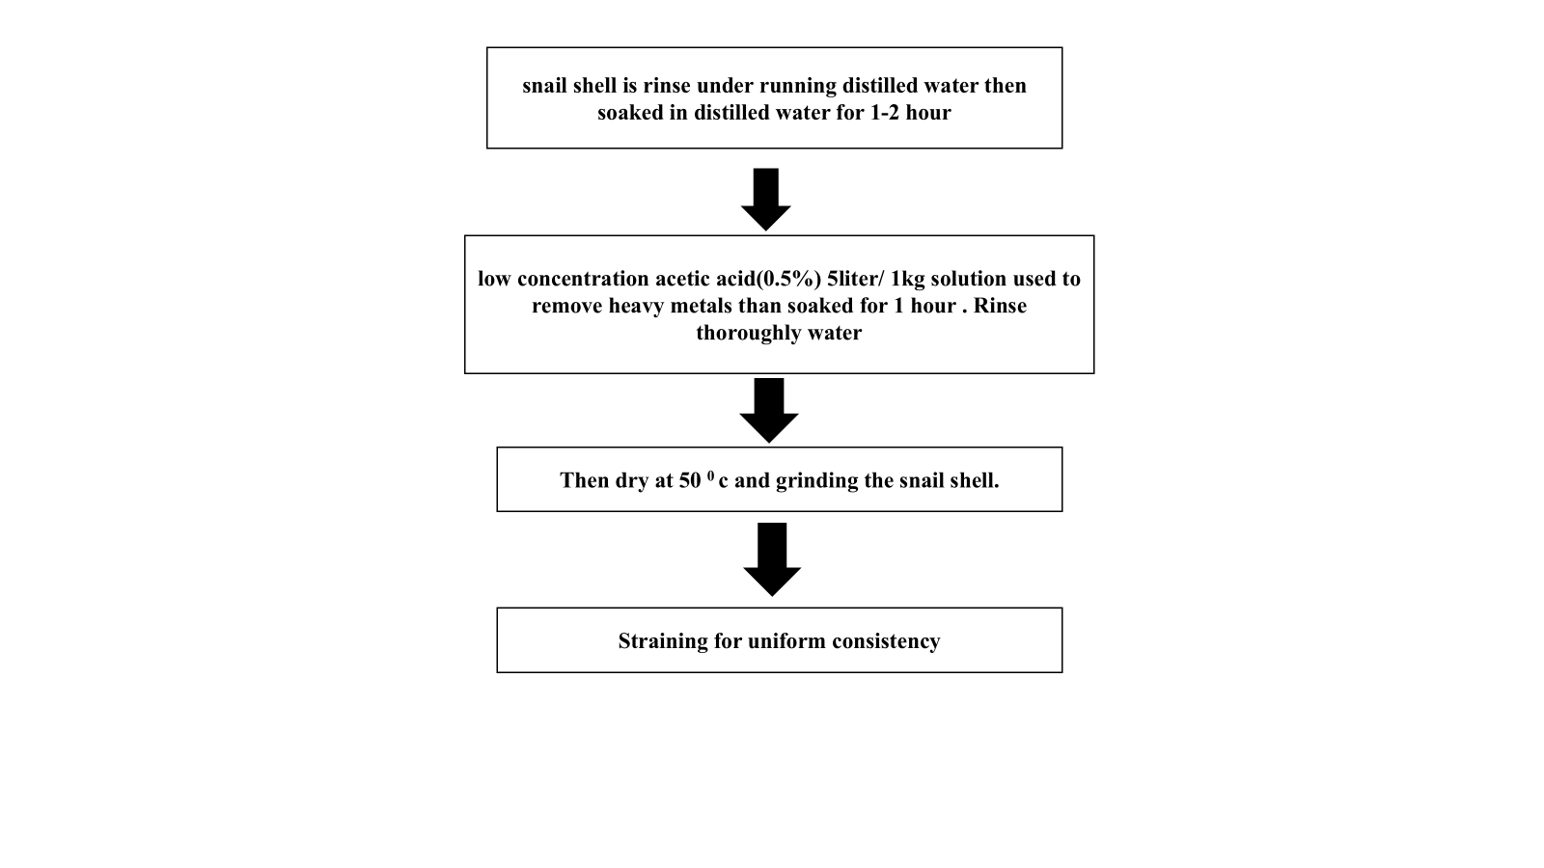
Figure 2: Prepared snail shell powder

2.3 Pre-preparation of the others ingredients
Pasteurized milk at 63°C (145°F) for 30 minutes using an induction cooktop, provided you can maintain a precise temperature control. Induction cooktops can heat liquids quickly and efficiently, making them suitable for pasteurization. When heating milk on an induction cooktop, it's best to use lower temperatures to prevent scorching or boiling over, as milk can easily burn or stick to the bottom of the pan. A lower temperature setting can help to maintain a gentle simmer, preserving the milk's texture and flavour thereafter cooling at room temperature to maintain the milk quality.
Fresh strawberries are washed and hulled, with stems and leaves removed. They are then blended in a mixer or food processor until smooth. The seeds can be strained. The puree is used immediately or stored in airtight containers in the refrigerator or freezer.
Cinnamon sticks and cardamom seeds are dried in a low-temperature oven (150°F - 200°F) for 1-2 hours. The dried cinnamon sticks and cardamom seeds are then ground separately into fine powders using a spice grinder or mortar and pestle. The seeds are removed from the cardamom pods before drying. Finally, the cinnamon and cardamom powders are combined in desired proportions and the mixture is stored in an airtight container to preserve flavor and aroma.
Table 1: Ingredient composition of different fortified yoghurt sample
Product name | Milk (ml) | Yoghurt (gm) | Strawberry (gm) | Chia seeds(gm) | Cinnamon (gm) | Cardamon (gm) | Honey (gm) | Probiotic capsule (gm) | Snail  Shail powder (gm)
A | 76.91 | 3.84 | 15.38 | 1.92 | 0.007 | 0.0007 | 1.98 | 0.5107 | 0.007
B | 76.91 | 3.84 | 15.38 | 1.92 | 0.007 | 0.0007 | 1.98 | 0.5107 | 0.003
C | 76.91 | 3.84 | 15.38 | 1.92 | 0.007 | 0.0007 | 1.98 | 0.5107 | 0.0007
D | 76.91 | 3.84 | 15.38 | 1.92 | 0.007 | 0.0007 | 1.98 | 0.5107 | 0.0003

2.4 Formulation of fortified yoghurt
The glass bowl, measuring cylinder and spatula were placed in the autoclave and under UV lights for 15 minutes for sterilization. After UV sterilization, the laminar flow was activated. The milk is measured by sterilized measuring cylinder and the other ingredients - yoghurt, strawberry puree, cinnamon-cardamom powder, honey, and snail shell powder, probiotic capsule ware weighted desirable weight by the weighing machines are typically called balances or scales. The weighed ingredients were then taken to the laminar flow for yoghurt preparation. Firstly, the yoghurt was spread to the bowl inner wall by the sterilized spatula. Then, the pasteurized milk, strawberry puree, cinnamon-cardamom powder, snail shell powder, honey, and probiotic capsule were added and mixed. The bowl was transferred to a bacteriological incubator at 34°C for overnight, where the yoghurt was allowed to form. The next day, the yoghurt was poured into the refrigerator for chilling. The preparation method is demonstrated in Figure 3 below.

The glass bowl, measuring cylinder and spatula were placed in the laminar flow and under UV lights for 15 minutes for sterilization. After UV sterilization, the laminar flow was activated
Spread the yoghurt to the bowl inner wall by the sterilized spatula
Taken sterilized glass bowl

The next day, the yoghurt was form and poured into the refrigerator
Added the pasteurized milk, strawberry puree, cinnamon-cardamom powder, snail shell powder, honey, and probiotic capsule, chia seed to the bowl
The bowl was transferred to a bacteriological incubator at 34°C for overnight

Figure 3: Formulation of fortified yoghurt
2.5 Process of control yoghurt
Plain yoghurt was prepared by having milk fermented with specific bacterial cultures under controlled conditions. The process begins with fresh milk, which was first heated to approximately 85–90°C, by which whey proteins ware denatured and unwanted microbes are eliminated. This step is taken to improve the final texture and stability of the yoghurt. After the milk has been heated, it was cooled to around 42–45°C, at which the yoghurt cultures can grow optimally. At this stage, a starter culture typically containing Lactobacillus delbrueckii, L.bulgaricus and Streptococcus thermophilus was added to the milk. The inoculated milk was then incubated at the same temperature for several hours, usually between 4 to 8 hours, until the desired acidity and consistency (pH around 4.5) are reached. Once fermentation has been completed, the yoghurt is cooled to refrigeration temperature (around 4°C), by which bacterial activity is halted and quality is preserved. It can then be stored and consumed as plain yoghurt. Careful control of temperature and culture activity has been noted to be essential for achieving consistent product quality and microbiological safety in yoghurt production.
2.6 Evaluation of proximate composition:
Proximate composition of fortified yoghurt was established as per “A Laboratory Manual Of Food Analysis” total ether extract as fat, ash, moisture, and crude fibre. Carbohydrate content was calculated by Anthrone method, total protein content was calculated by Biuret method, total fat content by Soxhlet method [Shalini Sehgal, 2016].
2.7 Estimation of mineral content:
Using ICPOES and Flame Photometer mineral content was detected. All the chemicals used for the study were of AR grade [Jussara Kowaleski et al., 2020].
2.8 Estimation of physical analysis
pH analysis A Kent EIL 7020 type pH meter was used to measure the pH level. The pH meter was analysed pH of the control sample and each fortified yoghurt sample upon maturation were obtained. Titratable acid (as percentage w/w tartaric acid) Various types and concentrations of each fortified yoghurt were identified using the Association of Analytical Chemists' (1990) methodology. Titration using a 0.1N NaOH solution was used to measure acidity, which was then represented as a percentage of tartaric acid. The indicator that was used was phenolphthalein [Shalini Sehgal, 2016].
2.9 Estimation of total phenolic content
1 gram of sample is filtered with distilled water and 1 ml of these filtered sample is taken and 2.5 ml of folin reagent and 2.5 ml sodium carbonate solution is added and vortexed. Then it is kept in a dark place for 30 minutes and the absorbance is measured at 765 nm [Forentina Maria Titin Supriyanti et al,2022]

2.10 Estimation of antioxidant activity
0.5gm of sample is filtered with distilled water. than vortex 15-20 mins and filer the samples. And taken 1 ml of filter water added 1 ml of methanol and 1 ml of DPPH. The disappearance of the DPPH (1, 1-Diphenyl-2-picryl hydrazyl) radical absorption at 517 nm by the action of antioxidant is measured spectrophotometry in a methanolic solution until the absorbance remains constant [Forentina Maria Titin Supriyanti et al,2022].
2.11 Estimation of flavonoid activity
1 gram of sample is filtrate with distilled water and 2 ml of these filtrate sample is taken and ethanolic AlCl₃ is add and vortex. Then incubate for 60 minutes in dark room and the absorbance is measured at 420 nm [Forentina Maria Titin Supriyanti et al,2022].
2.12 Sensory evaluation
Sensory evaluation of fortified yoghurt was involves assessing it quality based on appearance, colour, flavour and so on. This helps to determine its freshness, shelf life, stability. The judgement was made by rating product on a 9 points hedonic scale with corresponding descriptive terms ranging from “like extremely” to “dislike extremely” as shown below. The panelists were instructed to rinse their mouths with water after analysed each sample and not to make comments during evaluation to prevent influencing other panelists [Forentina Maria Titin Supriyanti et al.,2022].
Table 2. Score card
9. like extremely | 6.like slightly | 3. Dislike moderately
8. like very much | 5. neither like not dislike | 2. Dislike very much
7.like moderately | 4, Dislike slightly | 1.Dislike extremely

2.13 Microbial load
Microbial load was analysed by using standard protocols. The sample(1gm) are serial diluted by distilled water(9ml) and that is repeated 5 times. Then, it was followed the spread plate method for estimation of microorganisms. This analysed used Nutient Agar (NA) for bacteria. Microbial load was analysed on initial day [Elie Al-Kadamany et al.,2003].
2.14 Statistical Analysis
All the experiments were performed in triplicates and completely randomized design was carried out for the experimental values in order to know the significant difference [Elie Al-Kadamany et al.,2003].
3. RESULTS AND DISCUSSION
Figure 4 shows the pictures of control and formulated yoghurt.

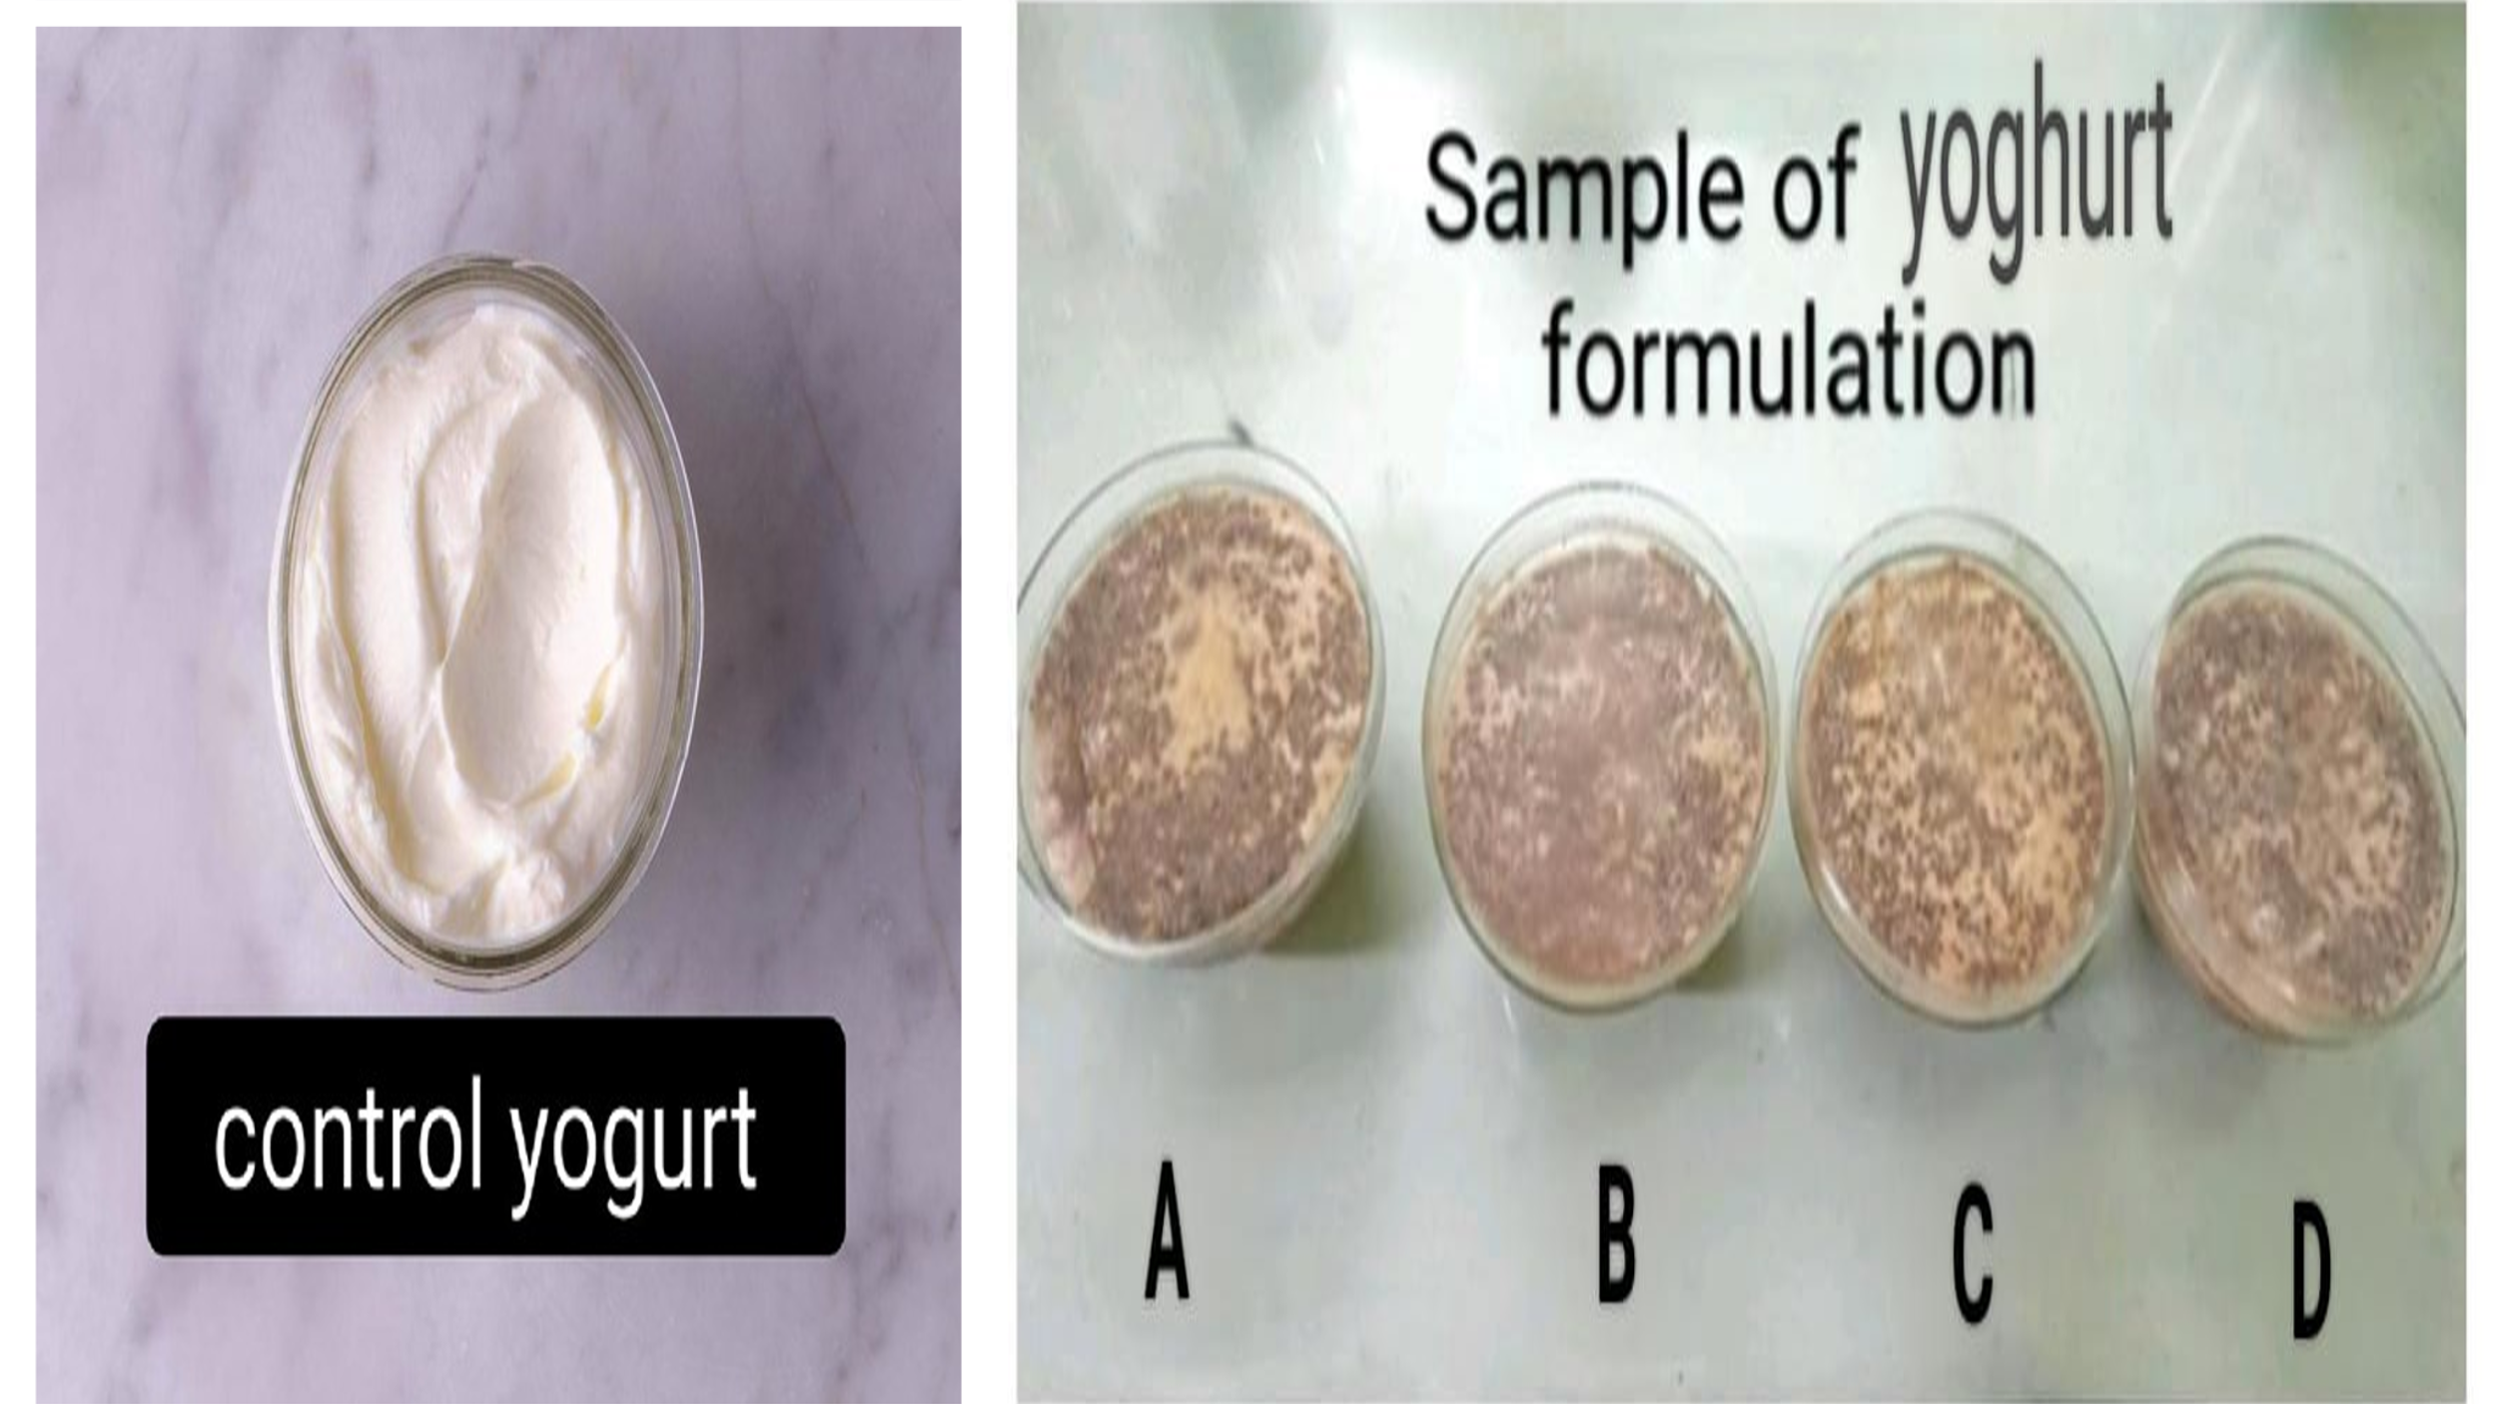
Figure 4: Control and Formulated Yoghurt

3.1 Changes in proximate composition
Table 3: Proximate Values of fresh & storage fortified yoghurt
Sl. No. | Parameters | Control |  | A |  | B |  | C |  | D
Sl. No. | Parameters | Fresh | Stored | Fresh | Stored | Fresh | Stored | Fresh | Stored | Fresh | Stored
1 | Carbohydrate (g/100g) | 4.40±  0.02 | 4.45±  0.03 | 7.59±  0.06 ^{a, c, d, e} | 7.66±  0.12 ^{a, c, d, e} | 7.33±0.06 ^{a, b, d, e} | 7.12 ±0.03 ^{a, b, d, e} | 7.29±  0.11 ^{a, b, c, e} | 7.08 ±0.06 ^{a, b, c, e} | 7.30 ±  0.09 ^{a, b, c, d} | 7.20 ±0.07 ^{a, b, c, d}
2 | Protein  (g/100g) | 4.00±  0.003 | 3.89±0.02 | 4.85±  0.04 ^{a, c, e} | 4.66±  0.07 ^{a, c, d, e} | 4.82±0.03 ^{a, b, d, e} | 4.70±  0.02 ^{a, b, d, e} | 4.85±  0.04 ^{a, c, e} | 4.60 ±  0.03 ^{a, b, c, e} | 4.88 ±  0.06 ^{a, b, c, d} | 4.30 ±  0.05 ^{a, b, c, d}
3 | Fat (g/100g) | 3.10 ±0.005 | 3.22 ±0.01 | 3.52 ±0.03 ^{a, c, d, e} | 3.62 ±0.04 ^{a, c, d, e} | 3.83 ±0.05 ^{a, b, d, e} | 4.06±0.04 ^{a, b, c, d, e} | 3.65±0.05 ^{a, b, c, e} | 3.87±0.09 a^{, b, c, d, e} | 3.55±  0.02 ^{a, b, c, d} | 3.72±0.08 ^{a, b, c, d}
4 | Moisture (g/100g) | 85.55±0.05 | 85.65±0.11 | 79.78±0.99 ^{a, c, d, e} | 80.12±0.77 ^{a, c, d, e} | 79.48±0.22 ^{a, b, d, e} | 79.79±0.12 ^{a, b, d, e} | 80.00 ±0.18 ^{a, b, c, e} | 80.13 ±  1.19 ^{a, b, c, e} | 79.23 ±  1.33 ^{a, b, c, d} | 81.56 ±  0.99 ^{a, b, c, d}
5 | Total Ash  (g/100g) | 1.80 ±0.01 | 1.70 ±0.01 | 2.40 ±0.04 ^{a, d, e} | 2.40 ±0.05 ^{a, d, e} | 2.40 ±0.05 ^{a, d, e} | 2.40±0.05 ^{a, d, e} | 2.50±0.56 ^{a, b, c, e} | 2.40 ±0.07 ^{a, b, c} | 2.90±  0.01 ^{a, b, c, d} | 2.40±0.07 ^{a, b, c}
6 | Crude Fiber  (g/100g) | 1.15 ±0.02 | 1.09 ±0.01 | 1.86 ±0.03 ^{a, c, d, e} | 1.44 ±0 .02 ^{a, c, d, e} | 2.05 ±0.03 ^{a, b, e} | 1.93±0.04 ^{a, b, d, e} | 2.01±0.01 ^{a, b, e} | 1.92±  0.05 ^{a, b, c, e} | 2.14±  0.05 ^{a, b, c, d, e} | 1.84±  0.04 ^{a, b, c, d}
7 | Energy (kcal) | 61.50 ±0.67 | 61.20 ±1.09 | 84.32±0.99 ^{a, c, d, e} | 84.66 ±  1.22 ^{a, c, d, e} | 84.30±0.45 ^{a, b, d, e} | 84.35±0.45 ^{a, b, d, e} | 84.32 ±1.34 ^{a, b, c, e} | 84.30 ±  2.13 ^{a, b, c, e} | 84.31 ±  1.33 ^{a, b, c, d} | 84.22 ±  0.09 ^{a, b, c, d}
Values are Mean±S.D. (n=3)
ª Comparison between Control and Fortified Samples
^{b} Comparison between A and other samples
^{c} comparison between B and other sample
^{d} comparison between C and other sample
^{e} comparison between D and other sample

Table 3presents the proximate composition of total carbohydrates in fresh and 15-day stored yoghurt samples. The fresh fortified yoghurt samples had carbohydrate contents ranging from 7.29% to 7.59%, significantly higher than the fresh control yoghurt (4.40%). This difference is attributed to the addition of strawberry and honey, rich in natural sugars like fructose and glucose. After storage, the carbohydrate contents of the fortified yoghurt samples ranged from 7.08% to 7.66%, while the control yoghurt's carbohydrate content remained relatively stable at 4.45%. Notably, storage affected the carbohydrate levels differently across samples, with Sample A showing an increase and the others exhibiting a decrease.
Table 3 presents the results of the proximate composition analysis for total protein. The protein content of fresh fortified yoghurt samples varied from 4.88 % to 4.82 % and the stored fortified yoghurt sample varied from 4.70 % to 4.30%. The fresh and stored control yoghurt sample contain 4.00 % & 3.89 % respectively. Protein content was higher in the fortified yoghurt sample than control yoghurt because the adding ingredients like chia seeds (rich in protein and also contain essential amino acids), strawberry (small amounts of protein) that naturally boost the protein level beyond the control yoghurt.
Table 3 displays the proximate analysis of total fat content. The fat content of the fresh fortified yoghurt samples ranged from 3.52 % to 3.83 %, while the stored fortified yoghurt samples had a slightly higher range of 3.62 % to 4.06 %. In contrast, the control samples had lower fat content, with the fresh control sample at 3.10 % and the stored control sample at 3.22 %. The higher fat content in the fortified yoghurt samples can be attributed primarily to the addition of chia seeds, which are rich in omega-3 fatty acids (ALA), monounsaturated, and polyunsaturated fats. The inclusion of spices also contributed to the increased fat content. These ingredients contain significant amounts of healthy fats, which control yoghurt typically lacks in large amounts.
Table 3 displays the proximate analysis of total moisture content. The moisture content of the fresh fortified yoghurt samples ranged from 79.23 % to 80.00 %, whereas the stored fortified yoghurt samples had a range of 79.79% to 81.56%. In contrast, the control samples exhibited higher moisture content, with the fresh control sample at 85.55 % and the stored control sample at 85.65 %. The lower moisture content in the fortified yoghurts compared to the control yoghurt can be attributed to the addition of chia seeds, which can absorb 10-12 times their weight in water, forming a gel-like texture. Additionally, honey's hygroscopic properties allow it to attract and bind water, while the snail shell and spices contribute to increased solids, further reducing moisture content.
Table 3 presents the proximate composition of total ash and crude fiber ware found the fresh and 15 days stored yoghurt samples. The fresh fortified yoghurt samples total ash content was varied from 2.40 % to 2.90%. In contrast, the fresh control yoghurt was found total ash content of 1.80 %. After storage, the carbohydrate contents of the fortified yoghurt samples ware 2.40% while the control yoghurt's carbohydrate content remained low at 1.70%. The crude fiber contents of fresh and storage fortified yoghurt samples varied from 1.86% to 2.14 % & 1.44 % to 1.93 %. Compared to the control yoghurt is fresh and storage value of crude fiber content is lower than the fortified yoghurt due to added chia seeds (rich in soluble and insoluble fiber) & Strawberries (natural fruit fiber contains pectin and cellulose).
Table 3 presents the results of the proximate composition analysis for energy. The energy content of fresh fortified yoghurt samples varied from 84.32% to 84.30% and the stored fortified yoghurt sample varied from 84.66 % to 84.22%. The fresh and stored control yoghurt sample contains 61.50 % & 61.20% respectively. Energy content was higher in the fortified yoghurt sample than control yoghurt because the added ingredients contribute additional calories from natural sugars, carbohydrates, and fats. Honey is a significant source of natural sugars, which increases the calorific value. Strawberries, while relatively low in calories, still provide natural fruit sugars and carbohydrates. Cinnamon and cardamom contain small amounts of fats and carbohydrates, which contribute modestly to the energy content.

3.2 Estimation of mineral content
Table 4: Mineral content (mg/100g) of fresh & stored fortified yoghurt
Sample | Sodium |  | Potassium |  | Calcium |  | Phosphorous |  | Iron
Sample | Fresh | Storage | Fresh | Storage | Fresh | Storage | Fresh | Storage | Fresh | Storage
Control | 37.00 | 36.98 | 94.73 | 93.44 | 138.00 | 136.77 | 93.00 | 92.39 | 0.12 | 0.10
A | 39.00 | 38.77 | 89.20 | 89.00 | 152.40 | 152.00 | 73.85 | 73.09 | 0.42 | 0.41
B | 39.02 | 38.78 | 89.23 | 88.05 | 152.44 | 152.10 | 73.44 | 73.00 | 0.42 | 0.41
C | 39.02 | 38.69 | 89.24 | 88.89 | 152.46 | 151.33 | 73.90 | 73.29 | 0.42 | 0.41
D | 39.04 | 39.00 | 89.24 | 89.01 | 152.50 | 152.30 | 73.67 | 73.22 | 0.43 | 0.41

Table 4 (Figure 5-7) presents the was found the mineral content fresh and 15 days stored yoghurt samples. The fresh fortified samples show sodium contents varied from 39.00 mg to 39.04 mg, potassium contents varied from 89.20 mg to 89.24 mg, calcium contents varied from 152.40 mg to 152.50 mg, phosphorus content varied from 73.44 mg to 73.90 mg, iron contents varied from 0.42 mg to 0.43 mg. The sodium, potassium, calcium, phosphorus content of control yoghurt are 37.0, 94.73 mg, 138.00 mg, 93.00 mg, 93.00 mg/100g respectively. During storage, the fortified yoghurt samples showed mineral content variations as follows: sodium (38.77-39.00 mg), potassium (88.05-89.01 mg), calcium (151.33-152.00 mg), phosphorus (73.00-73.29 mg), and iron (0.41 mg). The levels of sodium, calcium and iron are higher in the fortified yoghurt samples compared to control yoghurt because the added ingredients are naturally rich in these essential minerals. Chia seeds are a particularly valuable source, contributing significant amounts of calcium and iron due to their dense nutritional profile. Snail shell, primarily composed of calcium carbonate, is a direct and concentrated source of calcium. Cinnamon and cardamom, though used in small amounts, are known to contain notable levels of minerals such as iron which enhance the overall mineral content of the yoghurt. Strawberries add further value of iron. Honey, while mostly composed of sugars, can also contribute trace minerals depending on its floral origin. The control yoghurt contains natural levels of these minerals from milk, but without the enrichment from plant-based and mineral-rich ingredients, its overall mineral content remains lower. Potassium and phosphorus levels may be lower in the fortified yoghurt samples than the control yoghurt because the addition of these ingredients can reduce the proportion of milk, which is the primary natural source of both potassium and phosphorus in yoghurt. While some of the added components contain minerals, they may not supply these two in sufficient quantities to match the levels found in control yoghurt.

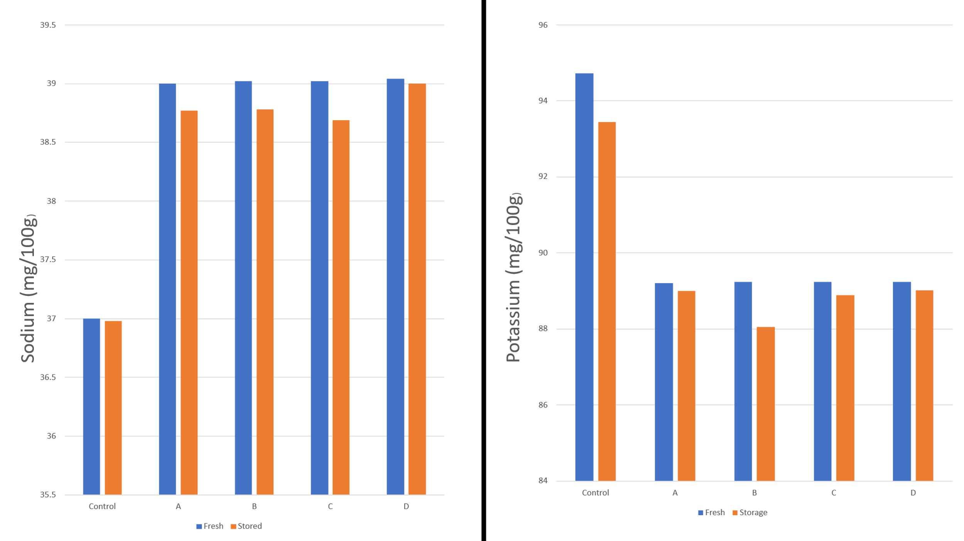
Figure 5: Difference in sodium & potassium content between control and samples both prepared fresh and of stored samples
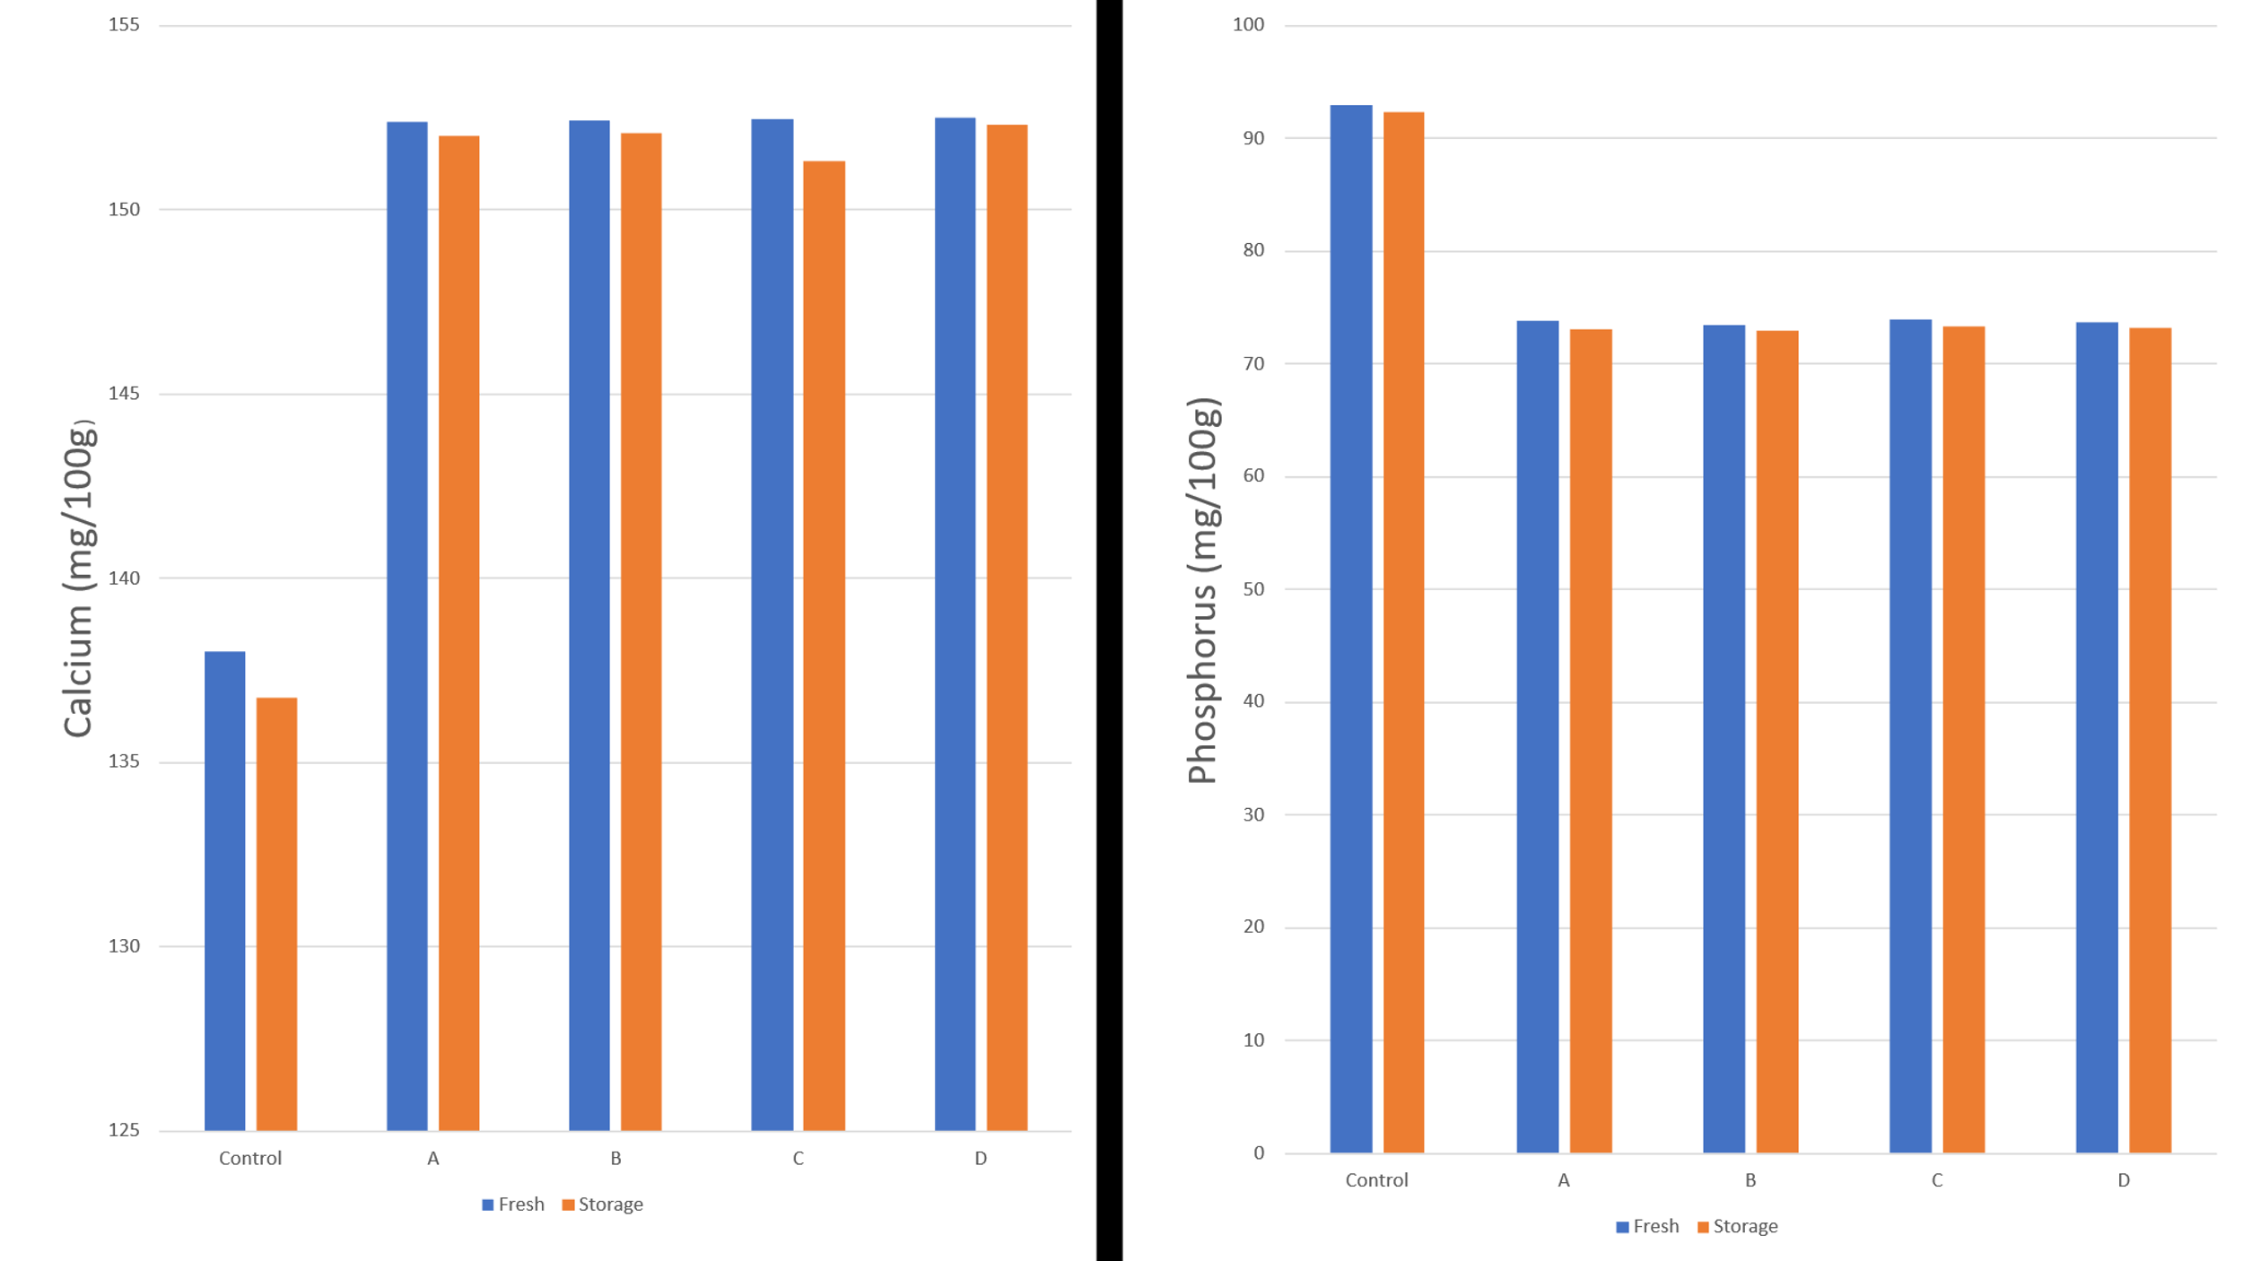
Figure 6: Difference in calcium & phosphorus content between control and samples both prepared fresh and of stored samples

Figure 7: Difference in iron content between control and samples both prepared fresh and of stored samples

3.3 Estimation of physico-chemical properties
Table 5: Estimation of physical analysis of new fortified yoghurt
Sl. No. | Parameters | Control |  | A |  | B |  | C |  | D
Sl. No. | Parameters | Fresh | Storage | Fresh | Storage | Fresh | Storage | Fresh | Storage | Fresh | Storage
1 | pH | 4.38 ±0.11 | 5.57±0.12 | 5.19±0.08 ^{a, c, d, e} | 5.84 ±0.22 ^{a, c, d, e} | 5.45±0.12 ^{a, b, d, e} | 5.79 ±0.28 ^{a, b, d, e} | 5.09±0.04 ^{a, b, c, e} | 5.70 ±0.09 ^{a, b, c, d, e} | 4.93±0.11 ^{a, b, c, d, e} | 5.80±0.10 ^{a, b, c, d}
2 | Acidity (%) | 10.00±0.11 | 8.30±0.22 | 9.10±0.11 ^{a, c, d, e} | 7.67±0.05 ^{a, c, d, e} | 8.21±0.04 ^{a, b, d, e} | 6.30±0.12 ^{a, b, d, e} | 8.00±0.23 ^{a, b, c, e} | 5.60±0.04 ^{a, b, c, e} | 7.62±0.05 ^{a, b, c, d} | 5.61±0.08 ^{a, b, c}  ^{, d}

Values are Mean±S.D. (n=3)
ª Comparison between Control and Fortified Samples (p<0.05)
^{b} Comparison between A and other samples (p<0.05)
^{c} Comparison between B and other sample (p<0.05)
^{d} Comparison between C and other sample (p<0.05)
^{e} Comparison between D and other sample (p<0.05)
Table 5 presents the physical analysis of pH and acidity of the fresh and 15 days stored yoghurt samples. The pH value of fresh fortified yoghurts varied from 4.93 to 5.45 & storage fortified yoghurts varied from 5.57 % to 5.84. The fresh and stored control yoghurt sample contain 4.38 % & 5.57 respectively. The pH is higher in the fortified yoghurt than the control yoghurt mainly because some of the added ingredients — especially snail shell — have alkaline (basic) properties that neutralize acidity and raise the pH. The acidity value of fresh fortified yoghurts varied from 7.6 % to 9.1 % & storage fortified yoghurts varied from 5.6 % to 7.67 %. The fresh and stored control yoghurt sample contain 10 % & 8.3% respectively.

3.4 Estimation of antioxidant activity
Table 6: Estimation of % radical scavenging activity of Fresh & Storage fortified yoghurt
Sample | % Radical Scavenging Activity
Sample | Fresh | Storage
Control | 24.56 ±0.09 | 23.59 ±0.67
A | 43.22 ±1.22 ^{a, c, d, e} | 42.09 ±0.05 ^{a, c, d, e}
B | 43.89 ±1.08 ^{a, b, d, e} | 42.33 ±0.11 ^{a, b, d, e}
C | 43.67 ±0.06 ^{a, b, c, e} | 42.04 ±0.13 ^{a, b, c, e}
D | 44.03 ±0.33 ^{a, b, c, d} | 43.55 ±0.99 ^{a, b, c, d}
Values are Mean±S.D. (n=3)
ª Comparison between Control and Fortified Samples (p<0.05)
^{b} Comparison between A and other samples (p<0.05)
^{c} Comparison between B and other sample (p<0.05)
^{d} Comparison between C and other sample (p<0.05)
^{e} Comparison between D and other sample (p<0.05)
Table 6 presents the antioxidant activity of the fresh and 15 days stored yoghurt samples. The antioxidant activity value of fresh fortified yoghurts varied from 43.22 % to 44.03 % & storage fortified yoghurts varied from 43.55% to 42.04 %. The fresh and stored control yoghurt sample contain 24.56 % &23.59 % respectively. The antioxidant activity is higher in the fortified yoghurt samples compared to control yoghurt due to the presence of several natural ingredients that are rich in bioactive compounds with strong antioxidant properties. Strawberries are well known for their high content of vitamin C, anthocyanin, and other phenolic compounds, all of which are effective in scavenging free radicals. Cinnamon and cardamom also contribute significantly through their essential oils and flavonoids, which have been scientifically shown to exhibit strong antioxidant effects. Honey adds to this activity through its polyphenols and enzymes that possess mild antioxidant properties. Chia seeds are particularly important as they are abundant in polyphenols such as chlorogenic acid and caffeic acid, as well as omega-3 fatty acids, which help in reducing oxidative stress. On storage the radical scavenging activity reduced slightly.
3.5 Estimation of total polyphenol activity
Table 7: Estimation of polyphenol activity of fresh & Storage fortified yoghurt
Sample | mg GAE/g
Sample | Fresh | Storage
Control | 0.525 ±0.002 | 0.501 ±0.003
A | 0.600 ±0.001 ^{a, c, d, e} | 0.533 ±0.004 ^{a, c, d, e}
B | 0.704 ±0.006 ^{a, b, d, e} | 0.644 ±0.010 ^{a, b, d, e}
C | 0.736 ±0.012 ^{a, b, c, e} | 0.717 ±0.012 ^{a, b, c, e}
D | 0.774 ±0.040 ^{a, b, c, d} | 0.728 ±0.005 ^{a, b, c, d, e}
Values are Mean±S.D. (n=3)
ª Comparison between Control and Fortified Samples (p<0.05)
^{b} Comparison between A and other samples (p<0.05)
^{c} Comparison between B and other sample (p<0.05)
^{d} Comparison between C and other sample (p<0.05)
^{e} Comparison between D and other sample (p<0.05)
Table 7 shows the polyphenol activity of fresh & Storage fortified yoghurt. The polyphenol activity value of fresh fortified yoghurts varied from 0.600 mg GAE/g to 0.774 mg GAE/g & storage fortified yoghurts varied from 0.533 mg GAE/g to 0.728 mg GAE/g. The fresh and stored control yoghurt sample contains 0.525 mg GAE/g &0.501 mg GAE/g respectively. The polyphenol activity is higher in the fortified yoghurt samples compared to control yoghurt because the added ingredients are naturally rich sources of polyphenolic compounds. Strawberries contribute significantly due to their high content of phenolic acids such as ellagic acid and gallic acid, which are known for their strong polyphenol activity. Cinnamon and cardamom also enhance this effect, as they contain a variety of polyphenols that contribute to the yoghurt's overall antioxidant potential. Honey further adds to the polyphenol activity through its plant-derived phenolic constituents. Chia seeds play an important role as well, as they are naturally rich in polyphenolic acids that are retained even after processing.

3.6 Estimation of flavonoid activity
Table 8: Estimation of flavonoid activity of new fresh & Storage fortified yoghurt
Sample | mg quercitin/g
Sample | Fresh | Storage
Control | 0.09 ±0.001 | 0.09 ±0.002
A | 2.41 ±0.01 ^{a, c, d, e} | 1.11 ±0.06 ^{a, c, d, e}
B | 2.43 ±0.02 ^{a, b, d, e} | 1.13 ±0.01 ^{a, b, e}
C | 2.44 ±0.01 ^{a, b, c, e} | 1.16 ±0.02 ^{a, b,}
D | 2.45 ±0.05 ^{a, b, c, d} | 1.21 ±0.03 ^{a, b, c}
Values are Mean±S.D. (n=3)
ª Comparison between Control and Fortified Samples (p<0.05)
^{b} Comparison between A and other samples (p<0.05)
^{c} Comparison between B and other sample (p<0.05)
^{d} Comparison between C and other sample (p<0.05)
^{e} Comparison between D and other sample (p<0.05)
Table 8 shows the flavonoid activity of fresh & Storage fortified yoghurt. The flavonoid activity value of fresh fortified yoghurts varied from 2.45 mg quercitin/g to 2.4 mg quercitin/g & storage fortified yoghurts varied from 1.11 mg quercitin/g to 1.21 mg quercitin/g. The fresh and stored control yoghurt sample contain 0.09 mg quercitin/g & 0.09 mg quercitin/g respectively. The flavonoid activity is likely higher in the fortified yoghurt made with strawberry, cinnamon, cardamom, honey, snail shell, and chia seeds compared to plain yoghurt due to the inherent properties of the ingredients like – strawberry, cinnamon, cardamom, honey. Strawberry was rich in flavonoids like anthocyanin and quercetin. Cinnamon contains flavonoids like pro-anthocyanin. Cardamom has flavonoids like kaempferol and quercetin. Honey may also contained flavonoids.
3.7 Organoleptic changes
Table 9: Sensory evaluation changes of different samples
Characteristics | Control | A | B | C | D
Color | 6.80 ±0.22 | 8.11 ±0.23 ^{a, c, d, e} | 8.12 ±0.20 ^{a, b, d, e} | 7.90 ±0.08 ^{a, b, c, e} | 8.10 ±0.02 ^{a, b, c, d}
Flavor | 6.90 ±0.03 | 7.50 ±0.22 ^{a, d, e} | 7.48 ±0.99 ^{a, b, d, e} | 7.39 ±0.90 ^{a, b, e} | 7.30 ±0.05 ^{a, b, d}
Taste | 6.81 ±0.09 | 8.19 ±0.10 ^{a, c, d} | 8.15 ±0.04 ^{a, b, d, e} | 8.10 ±0.12 ^{a, b, c, e} | 8.00 ±0.09 ^{a, c, d}
Odor | 6.00 ±0.11 | 7.82 ±0.09 ^{a, c, d, e} | 7.56 ±0.19 ^{a, b, d, e} | 7.89 ±0.19 ^{a, b, c, e} | 7.55 ±0.10 ^{a, b, c, d}
Texture | 6.85±0.10 | 7.09 ±0.11 ^{a, d, e} | 7.23 ±0.03 ^{a, d, e} | 7.16 ±0.05 a^{, b, c, e} | 7.08 ±0.03 ^{a, b, c}
Appearance | 6.21 ±0.08 | 8.54 ±0.19 ^{a, c, d, e} | 8.66 ±0.11 ^{a, b, d, e} | 8.59 ±0.19 ^{a, b, c, e} | 8.44 ±0.03 ^{a, b, c, d, e}
Overall acceptability | 6.05 ±0.02 | 8.63 ±0.06 ^{a, c, d, e} | 8.45 ±0.19 ^{a, b, d, e} | 8.54 ±0.11 ^{a, b, c, e} | 8.44 ±0.11 ^{a, b, c, d}
Values are Mean±S.D. (n=3)
ª Comparison between Control and Fortified Samples (p<0.05)
^{b} Comparison between A and other samples (p<0.05)
^{c} Comparison between B and other sample (p<0.05)
^{d} Comparison between C and other sample (p<0.05)
^{e} Comparison between D and other sample (p<0.05)
Table 9 shows the organoleptic properties of control and fortified yoghurt. The sensory evaluation is higher in the fortified yoghurt samples compared to control yoghurt because the added ingredients enhance the flavor, aroma, texture, and visual appeal of the final product. The natural sweetness and vibrant colour of strawberries make the yoghurt more visually attractive and palatable, while cinnamon and cardamom contribute warm, pleasant aromas and a mild spiced flavor that enrich the overall sensory experience. Honey adds a smooth sweetness that balances the tartness of the yoghurt, creating a more enjoyable taste profile. Chia seeds improve the texture by introducing a slight crunch or gel-like consistency that adds interest to the mouthfeel. Although snail shell does not contribute to flavor or aroma, its mineral content may subtly influence texture and perception of richness. In contrast, plain yoghurt has a simpler, more acidic taste with a uniform, less dynamic sensory profile. The combination of these tasty and aromatic natural additives results in a more appealing product, leading to higher overall acceptability of the products.
3.8 Microbial Load Data
The microbiological analysis of the fortified yogurt (Sample A) assessed its safety, quality, and shelf life by evaluating the total viable count and bacterial colony distribution, with results presented in Table 10 and Figure 8.
Table 10: Estimation of Microbial load of fresh fortified yoghurt
Sample A | Microbial count (CFU/ml)
10⁻³ | 505
10⁻⁴ | 152
10⁻⁵ | 42

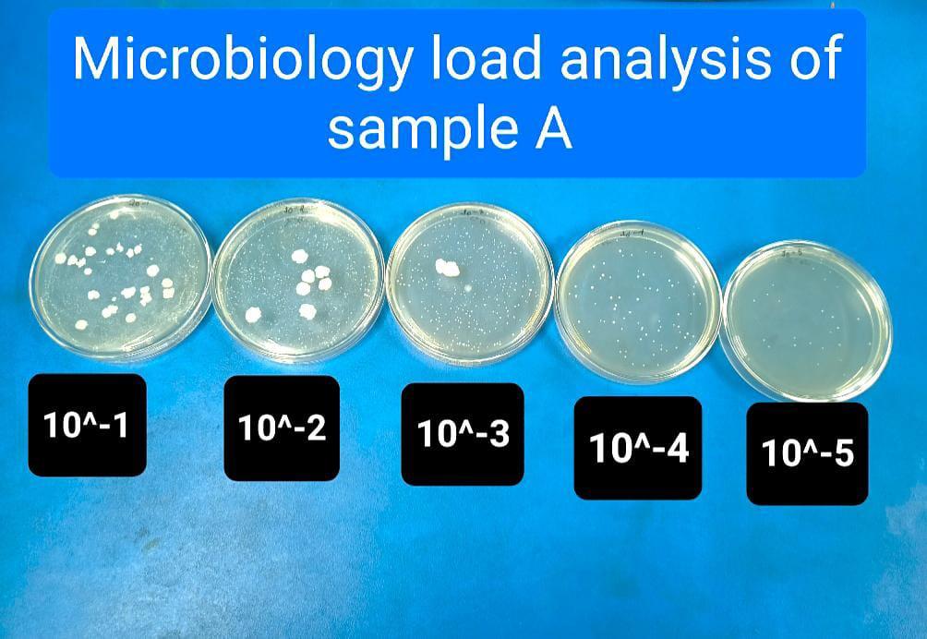
Figure 8: Microbial load data of Sample A
4. CONCLUSION
The fortified yogurt, enriched with strawberries, cinnamon, cardamom, honey, and snail shell powder, exhibited superior nutritional and health-promoting properties compared to plain yogurt. Notably, each of experiment (like – proximate, mineral content, physio-chemical, antioxidant, polyphenol, flavonoid activity) the fresh stage of the control &fortified yogurt showed better values than the 15-day storage stage. The synergistic effects of these ingredients provided enhanced antioxidant, anti-inflammatory, and antimicrobial properties, which can help prevent chronic diseases like cardiovascular disorders, diabetes, and certain cancers. Additionally, it supported immune function, bone health, and heart health, making it a valuable health-promoting food option for overall well-being.
COMPETING INTEREST
Authors have declared that no conflict of interest exists.

COMPETING INTERESTS DISCLAIMER:
Authors have declared that they have no known competing financial interests OR non-financial interests OR personal relationships that could have appeared to influence the work reported in this paper.

Reference

Adewoye S. O., Fapohunda J. B., & Olaniyan A. A. (2014). The nutritional and therapeutic values of snail shell calcium. International Journal of Biological and Chemical Sciences, 8(1), 300–306.
Akilen, R., Tsiami, A., Devendra, D., et al. (2010). Glycated hemoglobin and blood pressure-lowering effect of cinnamon in type 2 diabetes: A randomized clinical trial. Diabetic Medicine, 27(10), 1159–1167.
Al-Kadamany E., Khattar M., Haddad T., Toufeili I. (2001). Estimation of shelf-life of concentrated yogurt by monitoring selected microbiological and physicochemical changes during storage. Leben-Wiss U-Technol, 36, 407–414.
Alvarez-Suarez, J. M., Giampieri F., & Battino M. (2010). Honey as a source of dietary antioxidants: Structures, bioavailability, and evidence of protective effects against human chronic diseases. Current Medicinal Chemistry, 17(31), 3898–3913.
Ayerza R., & Coates W. (2005). Chia: Rediscovering a forgotten crop of the Aztecs. University of Arizona Press.
Basu A., Rhone M., & Lyons T. J. (2010). Berries: Emerging impact on cardiovascular health. Nutrition Reviews, 68(3), 168–177.
Cassidy A., Rogers G., Peterson J. J. (2011). Higher intake of flavonoids associated with reduced risk of death due to cardiovascular disease. The American Journal of Clinical Nutrition, 93(2), 338–347.
Coskun F., Dirican L. K. (2019). Effects of pine honey on the physicochemical, microbiological and sensory properties of probiotic yoghurt. International Journal of Agriculture and Natural Sciences, 24(2). DOI: intang/10.1500/24018.
Edirisinghe I., Banaszewski K., Cappozzo J. (2011). Strawberry anthocyanin and its effect on postprandial inflammation and insulin response. British Journal of Nutrition, 106(6), 913–922.
Elliot T. A., Cree M. G., Sanford A. P. (2006). Milk ingestion stimulates net muscle protein synthesis following resistance exercise. American Journal of Clinical Nutrition, 83(4), 1033–1040.

Elwood P. C., Pickering J. E., Fehily A. M. (2004). Milk drinking, ischaemic heart disease and ischaemic stroke II: Evidence from cohort studies. European Journal of Clinical Nutrition, 58(5), 718–724.
Erlund I., Koli R., Alfthan G. (2008). Favorable effects of berry consumption on platelet function, blood pressure, and HDL cholesterol. The American Journal of Clinical Nutrition, 87(2), 323–331.
Eze J. I., Omeh Y. N., & Oze R. N. (2012). The antimicrobial effect of snail shell extract on some selected pathogenic bacteria. African Journal of Pharmacy and Pharmacology, 6(23), 1682–1686.
Gomez-Estaca, J., Lacey A. (2010). Antimicrobial properties of cinnamon essential oil in food packaging. Food Control, 21(7), 865–872.
Illupapalayam V. V., Smith S. C., Gamlath S. (2013). Consumer acceptability and antioxidant potential of probiotic-yogurt with spices. LWT – Food Science and Technology, 55(2), 255–262.
Jamal A., Javed K., Aslam M. (2006). Cardamom: A traditional remedy with modern pharmacological potential. Journal of Pharmacy and Pharmacology, 58(5), 587–596.
Khan A., Safdar M., Khan A. (2003). Cinnamon improves glucose and lipids of people with type 2 diabetes. Diabetes Care, 26(12), 3215–3218.
Khan A., Vaibhav V., Javed K. (2011). Protective effect of cardamom extract against chemically induced colon carcinogenesis. Asian Pacific Journal of Cancer Prevention, 12(9), 2209–2213.
Kowaleski J., Quast L. B., Steffens J., Lovato F., dos Santos L. R., da Silva S. Z., de Souza D. M., Felicetti M. A. (2020). Functional yogurt with strawberries and chia seeds. Food Bioscience, 36, 100726.
Krikorian R., Shidler M. D., Nash T. A. (2010). Blueberry supplementation improves memory in older adults. Journal of Agricultural and Food Chemistry, 58(7), 3996–4000.
Majdalawieh A. F., & Carr R. I. (2010). In vitro investigation of the potential immunomodulatory and anti-cancer activities of black pepper and cardamom. Journal of Medicinal Food, 13(2), 371–381.
Marteau P., Minekus M., Havenaar R. (2001). Survival of lactic acid bacteria in a dynamic model of the stomach and small intestine. International Journal of Food Microbiology, 70(1–2), 189–202.
Nieman D. C., Gillitt N. D., Jin, F. (2009). Chia seed supplementation and disease risk factors in overweight women: A metabolomics investigation. Journal of Alternative and Complementary Medicine, 15(7), 700–708.
Onwubu S. C., Mdluli P. S., Singh S. (2016). Physico-chemical properties of snail shell powder and its effects on enamel remineralization. Journal of Clinical and Diagnostic Research, 10(5), ZC58–ZC62.
Onwubu S. C., Mdluli P. S., & Singh S. (2018). A study on the antimicrobial properties of snail shell-based toothpaste. Journal of Applied Biomaterials & Functional Materials, 16(3), 163–170.
Potortì A. G., Messina L., Licata P., Gugliandolo E., Santini A., Di Bella G. (2024). Snail shell waste in food industries. Sustainability, 16(2).
Qin, B., Panickar K. S., & Anderson, R. A. (2010). Cinnamon: Potential role in the prevention of insulin resistance, metabolic syndrome, and type 2 diabetes. Journal of Diabetes Science and Technology, 4(3), 685–693.
Ranasinghe P., Pigera S., Premakumar G. A. S. (2013). Medicinal properties of ‘true’ cinnamon (Cinnamomum zeylanicum): A systematic review. BMC Complementary and Alternative Medicine, 13, 275.
Ravindran, Babu P. N., Shylaja M. (2004). Cardamom: The genus Elettaria. CRC Press.
Roberfroid M., Gibson G. R., Hoyles L. (2010). Prebiotic effects: Metabolic and health benefits. British Journal of Nutrition, 104(S2), S1–S63.
Rompas J. J. I., Laatung S., Gunawan W. B., Widayanti I. S., Yusuf V. M., Yusuf T. W., Salindeho N., Samtiya M., Nurkolis F. (2023). Rice field snail shell anticancer properties: An exploration opinion. Frontiers in Oncology, 13(1).
Seeram N. P., Adams L. S., Zhang Y. (2006). Blackberry, black raspberry, blueberry, cranberry, red raspberry, and strawberry extracts inhibit growth and stimulate apoptosis of human cancer cells in vitro. Journal of Agricultural and Food Chemistry, 54(25), 9329–9339.
Sehgal S. (2016). A laboratory manual of food analysis. Department of Food Technology, Bhaskaracharya College of Applied Science, University of Delhi. I.K. International Publishing House Pvt. Ltd.
Shan B., Cai, Y. Z., Sun M. (2005). Antioxidant capacity and antimicrobial activity of cinnamon extracts. Food Chemistry, 92(4), 749–755.
Supriyanti F. M. T., Roslina D, Zackiyah Z, Hanifa I. (2022). Strawberry-fortified yogurt: Production, sensory, antioxidant activity test, and model for practicum. Indonesian Journal of Science and Technology, 7(3), 551–564.
Ullah R., Nadeem M., & Khalique A. (2016). Nutritional and therapeutic perspectives of chia (Salvia hispanica L.): A review. Journal of Food Science and Technology, 53(4), 1750–1758.

Verma S. K., Singh M., Jain P. (2009). Effect of Elettaria cardamomum on blood pressure in essential hypertension. Indian Journal of Biochemistry & Biophysics, 46(6), 503–506.
Weaver C. M., Gordon C. M., Janz K. F., et al. (2016). The National Osteoporosis Foundation’s position on peak bone mass development and lifestyle factors: A systematic review and implementation recommendations. Osteoporosis International, 27(4), 1281–1386.
Yaghoobi N., Al-Waili N., Ghayour-Mobarhan M. (2008). Natural honey and cardiovascular risk factors: Effects on blood glucose, cholesterol, and body weight. Journal of Medicinal Food, 11(2), 300–303.

