Original Research Article

Ovarian Voyage: Sonographic Evaluation Of The Ovaries In Infertile And Fertile Women Of Reproductive Age Group At UBTH

ABSTRACT
Background and Objectives: The ovary is a very important part of the female reproductive system; therefore, ovarian abnormalities are implicated as factors in female infertility. Ultrasound is a reproducible, safe, and affordable modality for assessing the ovary. This study aimed to sonographically evaluate the ovaries in infertile women of reproductive age group and compare the same with age-matched apparently healthy fertile women.
Materials and methods: 215 women of reproductive age group with infertility who had just registered with the Human Reproduction and Research Programme (HRRP) clinic at the University of Benin Teaching Hospital (UBTH) and were yet to commence any form of therapy were recruited for the study with an equal number of age-matched fertile women were recruited as control, making it a total number of 430 women. A transvaginal transducer with a frequency range of 7 – 10 MHz from a SONOACE X6 (MEDISON INC, Korea 2010) ultrasound machine was used for this study.
Results: The mean age of the study participants was 34.76 ± 6.56years and 34.52 ± 6.15years for the infertile and fertile groups, respectively. Mean ovarian volume among the infertile group (6.64 ± 6.50cm³) was significantly higher than that of the fertile group (4.90 ± 2.60cm³) (p<0.001). The infertile group had significantly higher prevalence of endometriotic cysts 15 (7.0%), polycystic (3.3%), and multicystic ovaries 6 (2.8%). There were no such abnormalities in the fertile group.
Conclusion: Mean ovarian volume was significantly higher among infertile women compared to their fertile counterparts, with the majority of the infertile women having a high prevalence of ovarian abnormalities.
Key words: Ovarian volume, Infertility, Transvaginal ultrasound.
INTRODUCTION
Infertility is a disease of the reproductive system characterized by the failure of a couple of reproductive age group to achieve a clinical pregnancy after one year or more of regular unprotected sexual intercourse¹. Infertility is divided into primary and secondary types². Primary infertility is the inability to achieve any prior pregnancy, while secondary infertility is the inability to achieve a subsequent pregnancy².
Infertility is a global health problem with varied prevalence according to the socioeconomic, cultural, and prevailing conditions³. It has been said to affect about 8 – 15% of couples in their reproductive age globally⁴.
It places substantial psychological pressure as well as socioeconomic demand on the couple, especially the woman⁵.
Some of the common complications resulting in infertility are polycystic ovarian syndrome (PCOS), sexually transmitted diseases (STDs), septic abortions, postpartum infections as well as male factor infertility such as oligospermia or azospermia⁵.
Ovarian volume evaluation has also been reported to be important in detection of ovarian ageing or failure⁶⁻⁸. The transvaginal ultrasound assessment of antral follicular counts (AFCs) is important in evaluating ovarian function as well as reserve⁹. It also has the advantage of being relatively safe, available, relatively affordable and does not use ionising radiation as compared with computed tomography which employs ionising radiation. Transvaginal ultrasound is preferred to magnetic resonance imaging which is presently relatively unavailable in our environment and rather expensive where available. Furthermore, ultrasonography has the advantage of possible serial monitoring where indicated.
MATERIALS AND METHODS
Study Setting
This study was carried out in the Ultrasound Unit of the Department of Radiology, UBTH, Benin-City.
Study Population
The infertile subjects were of reproductive age and were randomly selected from the Human Reproduction and Research Programme (HRRP) clinic before management for infertility was commenced. The fertile subjects were randomly selected from consenting apparently healthy women of reproductive age group who were attending the family planning clinic, especially those whose last delivery was six months prior to presentation. Those who met the inclusion criteria in both study groups were recruited.
Study Design
This was a comparative ultrasound study of the ovaries in women of reproductive
age with female factor primary or secondary infertility and age-matched apparently healthy fertile women.

METHODOLOGY
Subjects who met the inclusion criteria were recruited. Informed consent was obtained from each respondents and questionnaire was administered to the subjects to obtain socio-demographic data. Existing co-morbidities of each patient and other clinical information such as the menstrual phase and parity of the patients were recorded from their case note.
Anthropometric measurements including height and weight were measured using a height and weight scale and recorded in metres (M) and kilograms (kg) respectively. The body mass index (BMI) of each subject was calculated using the metric BMI formula:
BMI = Weight (in kilograms)/Height² (in metres)¹⁰
Ultrasound Technique
Ultrasound evaluation was done between days 7 and 9 of menstrual cycle. The patients were asked to empty the urinary bladder thereafter, each subject was made to lie supine and the buttocks were elevated with pillow, the transducer was sheathed with a latex condom containing acoustic gel and then gently passed into the vagina angling laterally until the ovary comes in view, this was repeated for the contralateral side. The length and anteroposterior (AP) dimensions of the ovaries were obtained in the longitudinal view (Figure 1a), while the width was obtained in the transverse view (Figures 1b). The ovarian volume was generated from the machine software using the prolate ellipsoid formula (L x H x W x 0.523).
The subjects were handed tissue paper to clean up after scanning and the probe was disinfected after every examination.
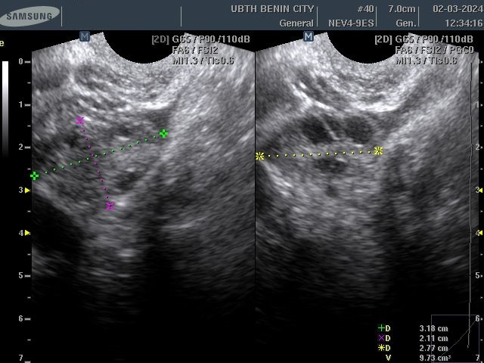

Figure 1a: Transvaginal Sonogram of the ovary and the point of measurement of ovarian length (green line), anteroposterior (AP) diameter (purple line).
Figure 1b; Width (yellow line)

DATA ANALYSIS
Data collected from each subject was recorded in the ultrasound worksheet of the questionnaire and entered into the computer spreadsheet, Microsoft Excel (Microsoft Corporation, USA). Data analysis was done using the IBM SPSS statistics for windows, (version 20.0.Armonk, NY: IBM Corp). Parametric data was summarized using means and standard deviation. Descriptive statistics including the distribution, mean values of anthropometric and sonographic measurements comparing each group was displayed as tables and charts.
Data analysis was carried out using Pearson’s correlation analysis to assess the relationship between the continuous variables. Chi-square and Fisher’s Exact (as appropriate) were used to assess the relationship between the categorical variables. The differences between the group means of continuous variables was assessed using the student t-test or Analysis of variance (ANOVA) as appropriate. Two tailed p-values less than or equal to 0.05 at 95% confidence interval was considered to be statistically significant.
RESULTS
SOCIO-DEMOGRAPHIC CHARACTERISTICS OF PARTICIPANTS
A total of 430 subjects consisting of 215 infertile patients with an equal number of age matched fertile controls participated in this study.
The age range of the infertile and fertile women in this study was 20 – 45 years with mean ages of 34.76±6.56 years and 34.52±6.15years for the infertile and fertile controls respectively. The difference in age was not statistically significant (p = 0.694).
The mean parity for the infertile group with secondary infertility was 1.9±2.1, as compared to that of the fertile group which was 7.1±2.5. The difference in means was statistically significant (p <0.001)
In the infertile group, 94 (43.7%) respondents were Benin, 29 (13.5%) were Ibos, 25 (11.6%) were Esan, 12 (5.6%) were Yoruba and other tribes made up the remaining 55(25.6%). While in the control group, 54(32.0%) were Benin, 27(16.0%) were Esan, 25 (14.8%) were Ibo, 26(15.4%) were Yoruba and 37 (21.9%) constituted other tribes.
A higher percentage of the respondents 208 (96.7%) and 190 (88.4%) respectively in both groups were Christians while 4(1.9%) and 25(11.6%) respondents respectively in both groups were Muslims. The difference was statistically significant (p < 0.001).
More than half of the infertile respondents, 133(61.9%) had tertiary education, 55(25.6%) had secondary education and 27 (12.6%) had primary education. In the fertile group, majority of the respondents 106 (49.3%) had secondary level of education while 70 (32.6%) had tertiary education and 39(18.1%) had primary education. The difference in proportion was statistically significant (p<0.001).
A higher percentage of the infertile respondents were business owners 82 (38.1%), while 72 (33.5%) were civil servants. However, among the fertile group, a higher percentage were civil servants 105(48.8%) while 65(30.2%) were business owners. The difference in proportion was statistically significant (p = 0.005).
All respondents in both groups, 215(100.0%) and 215(100.0%) respectively were married. These findings are shown on Table 1.

Table 1: Socio-demographic Characteristics of Study Population
Variables | Infertile N = 215 (%) | Fertile  N = 215 (%) | Chi-square (χ²) | p-value
Age group
18 – 24 | 12 (5.6) | 11 (5.1) | 1.053 | 0.788
25 – 31 | 59 (27.4) | 51 (23.7)
32 – 38 | 87 (40.5) | 89 (41.4)
39 – 45 | 57 (26.5) | 64(29.8)
Mean age (years) | 34.76±6.56 | 34.52±6.15 | 0.394† | 0.694
Parity
Nulliparous | 183(85.1) | 0 (0.0) | 352.020 | <0.001*
- Multiparous | 25 (11.6) | 26 (12.1)
- Grand multiparous | 7 (3.3) | 189 (87.9)
Mean parity | 1.9±2.1 | 7.1±2.5 | –21.397† | <0.001*
Ethnicity
Benin | 94 (43.7) | 54 (32.0) | 14.562 | 0.006*
Esan | 25 (11.6) | 27 (16.0)
Ibo | 29 (13.5) | 25 (14.8)
Yoruba | 12 (5.6) | 26 (15.4)
Others | 55 (25.6) | 37 (21.9)
Religion
Christianity | 208 (96.7) | 190 (88.4) | 19.654§ | <0.001*
Jehovah witness | 3 (1.4) | 0 (0.0)
Islam | 4 (1.9) | 25 (11.6)
Level of Education
Primary | 27 (12.6) | 39 (18.1) | 37.889 | <0.001*
Secondary | 55 (25.6) | 106 (49.3)
Tertiary | 133 (61.9) | 70 (32.6)
Occupation
Civil servants | 72(33.5) | 105 (48.8) | 12.785 | 0.005*
Business owner | 82 (38.1) | 65 (30.2)
Others | 61 (28.4) | 45 (20.9)
Marital Status  Married | 215 (100.0) | 215 (100.0)
§ Fisher’s Exact Test † Independent t-test, *Statistically significant
MEAN OVARIAN MEASUREMENTS OF RESPONDENTS
Table 2 shows the mean ovarian measurements. The mean ovarian lengths, widths and heights for both ovaries were significantly higher in the infertile group compared to the fertile group (p < 0.001)
The mean right ovarian volume of the infertile group (7.01±7.51cm3) was significantly higher than that of the fertile group (4.85±3.52cm3; p <0.001). Also, the mean left ovarian volume (6.33±6.44cm3) for the infertile group was significantly higher than that of the fertile group (4.94±3.02cm3; p <0.001). The difference in means was statistically significant (p = < 0.001).
Table 2: Mean ovarian measurements of respondents
Variables |  | Infertile (N = 215)  Mean ± SD |  | Range |  | Fertile (N = 215)  Mean ± SD |  | Range |  | t-test |  | p-value
Right
ovary
Length (cm) | 3.19±1.18 |  | 1.50 – 7.90 |  | 3.07±0.61 |  | 2.00 – 4.90 |  | 1.353 |  | <0.001*
Width (cm) | 1.73±0.73 |  | 0.90 – 5.50 |  | 1.31±0.32 |  | 0.80 – 2.10 |  | -1.405 |  | <0.001*
Height (cm) | 2.05±0.93 |  | 0.90 – 7.50 |  | 2.15±0.53 |  | 1.00 – 4.00 |  | 7.596 |  | <0.001*
Volume (cm³) | 7.01±7.51 |  | 0.84 – 53.38 |  | 4.85±3.52 |  | 0.84 – 17.99 |  | 3.816 |  | <0.001*
Left ovary
Length (cm) | 3.08±0.95 |  | 1.70 – 8.50 |  | 2.96±0.44 |  | 2.00 – 4.50 |  | 1.761 |  | <0.001*
Width (cm) | 1.72±0.77 |  | 0.80 – 5.80 |  | 1.39±0.31 |  | 0.90 – 2.50 |  | -2.486 |  | <0.001*
Height (cm) | 2.03±0.82 |  | 0.90 – 6.00 |  | 2.19±0.39 |  | 1.50 – 3.30 |  | 5.772 |  | <0.001*
Volume (cm³) | 6.33±6.44 |  | 0.80 – 55.02 |  | 4.94±3.02 |  | 1.55 – 19.42 |  | 2.860 |  | <0.001*
Mean ovarian volume
Volume (cm³) | 6.64±6.50 |  | 0.89 – 54.20 |  | 4.90±2.60 |  | 1.20 – 12.24 |  | 3.650 |  | <0.001*
*Statistically significant

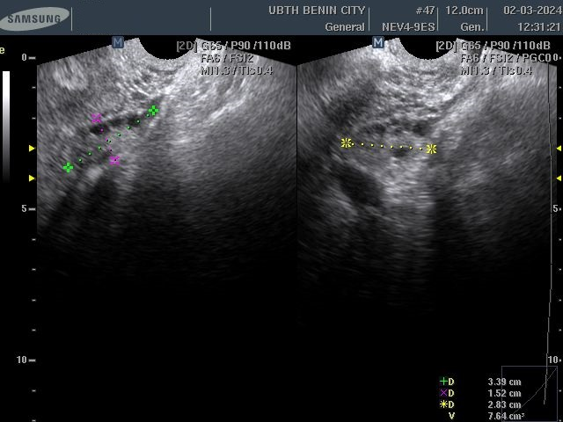

Figure 2: Transvaginal Sonogram of the ovary and the point of measurement of ovarian length (green annotation), anteroposterior (AP) diameter (purple annotation) and width (yellow annotation)

OTHER PELVIC SONOGRAPHIC FINDINGS IN RESPONDENTS
Table 3 showed that among the infertile subjects 26 (12.1%) had uterine fibroids, while in the fertile group 25 (11.6%) had uterine fibroids. This was not statistically significant (p = 0.881). Simple ovarian cysts were found in 6 (2.8%) of the infertile respondents and 18 (8.4%) of the fertile group (p = 0.013). All cases of endometriotic cysts (endometriosis localized within the ovaries, presenting as cystic ovarian lesions with degenerated blood products following cyclical haemorrhage), polycystic ovaries [enlarged ovary with multiple (≥ 10) peripherally sited similar small-sized (2-9mm) follicles with thickened stroma] and multicystic ovaries [ovary with multiple various sized (3-12mm) follicles distributed in no particular order within the ovary] encountered in this study were found in the infertile group: 15 (7.0%); 7 (3.3%) and 6 (2.8%) respectively (p <0.001; 0.008; 0.014 respectively).
Table 3: Other pelvic sonographic findings in respondents
Variable | Infertile | Fertile | (χ²) | p value
 | n (%) | n (%)
Uterine fibroids | 26 (12.1) | 25 (11.6) | 0.022 | 0.881
Simple ovarian cyst | 6 (2.8) | 18 (8.4) | 6.238 | 0.013*
Endometriotic cyst | 15 (7.0) | 0 (0.0) | 14.471 | <0.001*
Polycystic ovaries | 7 (3.3) | 0 (0.0) | 7.116 | 0.008*
Multicystic ovaries | 6 (2.8) | 0 (0.0) | 6.057 | 0.014*
* Statistically significant

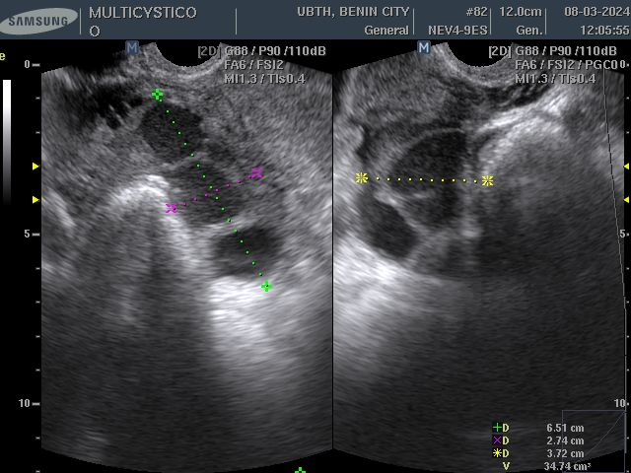

Figure 3: Longitudinal and Tranverse Sonograms of the ovary showing multicystic lesion.
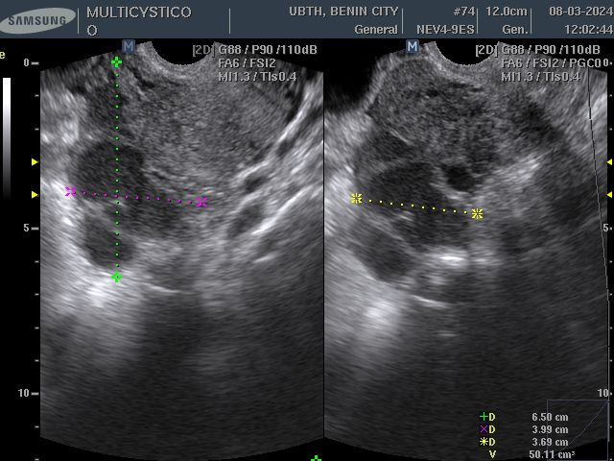

Figure 4: Longitudinal and Tranverse Sonograms of the ovary showing multicystic lesion with low level echoes within.
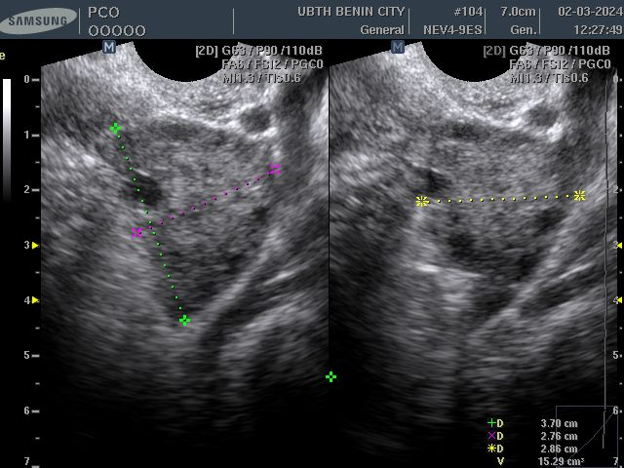

Figure 5a: Longitudinal and Tranverse Sonograms of the ovary showing polycystic ovary.
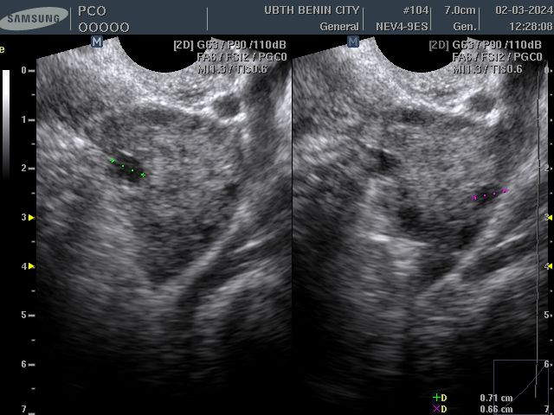

Figure 5b: Longitudinal and Tranverse Sonograms of the ovary showing polycystic follicles, the largest diameters are 7.1mm and 6.6mm.
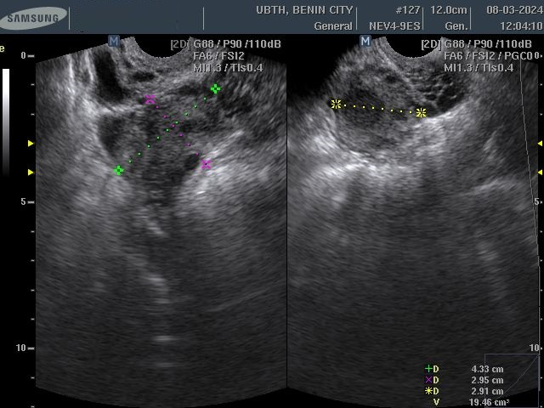

Figure 6: Longitudinal and Tranverse Sonograms of the ovary showing a cystic lesion with low level echoes within.

DISCUSSION
Infertility is a common health problem and a socially destabilizing condition for couples. It is also the commonest presenting complaint in the gynaecological outpatient clinics in our environment, with reported prevalence of 14.8% - 38.8%29. B-mode transvaginal ultrasound assessment of the ovary has been shown to be a useful tool for ovarian assessment.
In this study, the mean age of patients with infertility was 34.76 ± 6.56 years. However, lower mean ages were reported in previous studies carried out in Nigeria. Akpata et al¹² in Benin reported mean age of 30.9.± 5.91 years while Ikpeme et al¹³ in Calabar and Bello et al¹⁴ in Ibadan, South-West of Nigeria reported similar lower mean ages of 27.3 ± 3.65 and 27.6 ± 5.7 years respectively. On the other hand, Lass et al¹⁵ in London, reported similar finding with mean age of 34.4 ± 5.5 years. While Erdem et al¹⁶ in Turkey reported a higher mean age of 38.8 ± 3.0 years. These variations may be due to cultural and religious factors which promote early marriages and educational factor which usually cause delay in marriage. The mean ovarian volumes among fertile subjects in this study was 4.85 ± 3.52cm3 (range of 0.84 – 17.99cm3) and 4.94 ± 3.02cm3 (range of 1.55 – 19.42cm3) for the right and left respectively. This finding was statistically significant (p<0.001). Several investigators have reported a variation in the mean ovarian volume in fertile reproductive aged women. Eze et al¹⁷ in South-East Nigeria, investigated 141 fertile women of reproductive age group using transabdominal ultrasound scan and reported values ranging from 5.3cm3 – 13.9cm3 with mean of 9.5cm3 and 10.0 cm3 for the right and left respectively. These values are higher than the mean ovarian volumes found among fertile respondents in the index study. The methodology used in Eze et al¹⁷ study was transabdominal while that used in the index study was transvaginal. This may explain the differences in the mean ovarian volumes in both studies. Another study by Mohammed et al¹⁸ in Makurdi evaluated 207 apparently healthy fertile women using TVS. They found mean ovarian volume of 6.4 ± 3.8 cm3 and 6.5 ± 3.3 cm3 for the right and left respectively. These findings are higher than the values found in the index study. However, Erdem et al¹⁶ in Turkey using TVS reported mean ovarian volume of 6.1 ± 3.4 cm3 which is similar to that reported by Mohammed et al¹⁸. Danjem et al¹⁹in Jos studied 347 healthy women using TVS also reported a higher mean ovarian volume of 7.9 ±2.1 cm3 with the average volume of the left and right ovaries of 8.0 ± 2.0 cm3 and 7.7 ± 2.2 cm3 respectively. These variations could be explained on the basis of variation in the sample population size and methodology. Also, variations in ovarian volume with age and ethnicity or racial differences may account for some of these differences.
The mean ovarian volume observed among infertile subjects in this study was 6.64 ± 6.50cm3 which was significantly higher than that of the fertile subjects which was 4.90 ± 2.60cm3 (t = 3.650, p < 0.001). This finding of significantly higher mean ovarian volume in infertile women compared to fertile women is in agreement with the study carried by Ikpeme et al¹³. In contrast, Erdem et al¹⁶ in their study reported a lower mean ovarian volume among infertile women compared to the fertile women. The difference in the mean ages in the Erdem et al¹⁶ study and the index study might be the reason for this discrepancy as ovarian volume is known to reduce with increase in age^{15,20}. The mean ages for the Erdem et al¹⁶ are 38.8 ± 3.0 years (infertile) and 37.6 ± 2.7 years (fertile) while that in the index study was 34.76 ± 6.56 years (infertile) and 34.52 ± 6.15 years (fertile).
In this study, all the respondents with endometriotic cyst (15) 7.0%, polycystic ovaries (7) 3.3% and multicystic ovaries (6) 2.8% were in the infertile group. The finding of a significantly higher mean ovarian volume among infertile women in this study may be attributable to the multicystic and polycystic ovaries as well as endometriotic cysts which occurred only among the infertile patients when compared to the fertile respondents in this study. However, the prevalences of endometriotic cysts, PCO and multicystic ovaries in this index study is significantly lower than that reported by Bello et al¹⁴, Akpata et al¹² and Kanwal et al²¹ who reported substantial prevalence of PCO among infertile women in their studies. Bello et al¹⁴ reported the prevalence of 15.6% among young patients with PCO while Akpata et al¹² reported a similar prevalence of 13.8%. Furthermore, Kanwal et al²¹ reported significantly higher prevalence of 44.9%, 33.3% and 23.1% for PCOS, endometriosis and ovarian cysts respectively. These variations maybe due to the significant difference in the population sample size and younger age group in the other studies.
CONCLUSION
The burden of infertility is enormous; this study has provided significant insight into some important ovarian factors that are contributory to the higher ovarian volume among infertile respondents. Therefore, while evaluating women with infertility, proper assessment of those with enlarged (>10cm3) ovary (ies) with TVS should be made to ascertain the cause of the ovarian enlargement to better guide the clinicians on effective management of such women.

REFERENCES
1. The International Committee for Monitoring Assisted Reproductive Technology (ICMART) and the World Health Organisation (WHO) Revised Glossary on ART- Terminology. Hum Reprod. 2009; 24(11): 2683-2687.
2. Adegbola O and Akindele MO. The pattern and challenges of infertility management in Lagos, Nigeria. Afr Health Sci. 2013; 13(4): 1126-1129.
3. Belsey MA. The epidemiology of infertility: A review with particular reference to sub-Saharan Africa. Bulletin of the WHO. 1976; 54: 319-341.
4. Odunvbun WO, Oziga DV, Oyeye LO, Ojeogwu CL. Patterns of infertility among infertile couple in a secondary health facility in Delta State, South-South Nigeria TJOG 2018; 35(3): 244-248.
5. Okonofua FE, Harris D, Odebiyi A, Kane T, Snow RC. The social meaning of infertility in Southwest Nigeria. Health Transit Rev. 1997; 7(2): 205-220.
6. Kelsey TW, Dodwell SK, Wilkinson AG, Greve T, Anderson CY, Anderson RA. Ovarian volume throughout life: A validated normative model. PLoS ONE. 2013; 8(9): e71465.
7. Wallace WH, Kelsey TW. Ovarian reserve and reproductive age maybe determined from measurement of ovarian volume by transvaginal sonography. Hum Reprod. 2004; 19(7): 1612-1617.
8. Zaidi S, Usmani A, Shokh IS, Alam SE. Ovarian reserve and BMI between fertile and sub-fertile women J Coll Physicians Surg Pak. 2009; 19(1): 21-24.
9 La Marca A, Sighinolfi G, Radi D, Argento C, Baraldi E, Artenisio AC, et al Hum Reprod Update. 2010; 16(2): 113-130.
10. Keys A, Fidanza F, Karvonan M, Kimura N, Taylor H. Indices of relative weight and obesity. J Chronic Dis.,1972; 25: 329-43.
11. Rae L, Pham TN, Carrougher G, Honari S, Gibran NS, Arnoldo BD et al. Differences in resuscitation in morbidly obese burn patients may contribute to high mortality. Journal of Burn Care and research. 2013 Sept 1;34(5):507-14.
11. Bello FA, Odeku AO. Polycystic ovary a common feature in transvaginal scan of gynaecological patients. Annals of Ibadan Postgraduate Medicine. 2015; 13(2): 108- 109.
12. Akpata CB, Uadia PO, Okonofua FE. Prevalence of Polycystic ovary syndrome in Nigerian women with infertility: A prospective study of the three assessment criteria. Open J Obstet Gynaecol, 2018; 8(12): 1109-1120.
13. Ikpeme AA, Udo AE, Ani NE. TVS assessment of women presenting with infertility and menstrual irregularity in Calabar, Nigeria.The Nigerian Postgraduate Medical Journal. 2014 Sep 1;21(3):262-5.
14. Bello FA, Odeku AO. Polycystic ovary a common feature in transvaginal scan of gynaecological patients. Annals of Ibadan Postgraduate Medicine. 2015; 13(2): 108- 109.
15. Lass A, Silye R, Abrams D, Krausz T, Havatta O, Margara R et al. Follicular density in ovarian biopsy of infertile women: a novel method to assess ovarian reserve. Hum Reprod 1997; 12(5): 1028-1031.
16. Erdem M, Erdem A, Biberoglu K, Arslan M. Age-related changes in ovarian volume, antral follicle counts and basal follicle stimulating hormone levels: comparison between fertile and infertile women. Gynecol Endocrinol. 2003; 17(3): 199-205.
17. Joseph E, Chukwuka UA, Christian N. Sonographic Quantification of Ovarian Volumes in an adult Nigerian population. Internet Journal of Medical Update. 2009 Jan 1;4(1): 15-18.
18. Mohammed H, Ngwan SD, Utoo BT, Swende TZ. Transvaginal ultrasound evaluation of ovarian volume among normal adults in Markurdi. North-Central Nigeria. J Reprod Biol Health. 2013; 1 – 2.
19. Danjem SM, Ibinaiye PO, Salaam AJ. Transvaginal Ultrasound Assessment of Normal Ovarian volume among women of reproductive Age in Jos, Nigeria. Journal of Medical Research. 2016 Apr 5: 1-6.
20. Kupesic S, Kurjak A, Bjelos D, Vujisic S. Three-dimensional ultrasonographic ovarian measurements and invitro fertilization outcome are related to age. Fertility and Sterility. 2003; 79(1): 190-197.
21. Kanwal HI, Shahid M, Bacha R. Sonographic Evaluation of Various Causes of Female Infertility: A Literature Review. Journal of Diagnostic Medical Sonography. 2022 Mar; 38(2):155-9.

