ASSESSMENT OF THE EFFECT OF DIFFERENT INSTRUMENTATION TECHNIQUES ON APICAL SEAL

Abstract
Background: Success in root canal therapy is dependent on effective cleaning, shaping, and establishment of a fluid tight apical seal. Instrumentation techniques significantly influence canal morphology and the quality of obturation.
Aim: To evaluate and compare the apical sealing ability of obturations after canal preparation with different instrumentation techniques.
Materials and Methods: Forty extracted mandibular premolars with single canals were standardized to 14 mm root length and randomly assigned to four groups (n=10 each). Group 1 – Step back technique with stainless steel hand files; Group 2 – Modified step back technique with hand files; Group 3 – Crown down technique with greater taper manual NiTi files; Group 4 – Crown down technique with greater taper rotary NiTi files. Following cleaning and shaping, all canals were obturated with gutta-percha and bioceramic sealer by lateral condensation. Coronal access was sealed with glass ionomer cement, and samples were stored at 37°C for 24 hours. Root surfaces were coated with varnish except for the apical 3 mm and immersed in 1% methylene blue dye for 72 hours. Longitudinal sections were examined under stereomicroscope at 30× magnification, and dye penetration was measured using ImageJ software. Data were statistically analyzed with ANOVA and Tukey’s test.
Results: Mean dye penetration was highest in Group 1 (1.37 ± 0.24 mm), followed by Group 2 (1.06 ± 0.32 mm), Group 3 (0.78 ± 0.18 mm), and lowest in Group 4 (0.62 ± 0.16 mm). Significant differences were observed between step back and crown down groups (p < 0.05). No significant difference was noted between manual and rotary crown down groups.
Conclusion: Crown down instrumentation using greater taper NiTi files provided superior apical sealing compared to step back methods. Incorporating coronal pre-flaring and progressive taper preparation enhances obturation quality. Both manual and rotary crown down techniques are effective, though rotary instruments improve efficiency.
Keywords: Apical seal, crown down technique, step back technique, nickel–titanium files, microleakage, endodontics.
Introduction
Endodontic therapy has evolved remarkably over the past few decades, yet the fundamental objectives remain unchanged: elimination of microorganisms from the root canal system and the prevention of reinfection through a fluid-tight seal [1]. Clinical success of root canal treatment is largely determined by how effectively these two objectives are achieved. While irrigation and disinfection ensure microbial control, the creation of an adequate canal shape and its three-dimensional sealing are critical to achieving long-term periapical health [2].
Importance of Apical Seal in Endodontics
The apical seal plays a pivotal role in determining treatment success. Microleakage through the apical foramen or dentinal tubules allows bacterial ingress or leakage of bacterial by-products into periapical tissues, leading to persistent or recurrent periradicular disease [3]. Studies have demonstrated that apical leakage is a leading cause of endodontic failure [4]. Hence, the primary goal of chemo-mechanical preparation is not merely to remove infected dentin and shape the canal, but also to prepare a morphology that permits optimal adaptation of obturating materials [5].
Schilder [6] introduced the concept of “cleaning and shaping,” emphasizing that shaping facilitates cleaning, and both together enhance the effectiveness of obturation. His principles underscored the biological necessity of shaping canals in such a way that instruments and irrigants can access the apical third, while also producing a form conducive to achieving a hermetic seal.
Evolution of Root Canal Instrumentation Techniques
Historically, endodontic instrumentation was performed using stainless steel hand files with limited flexibility [7]. Early techniques included the “step back” method, introduced by Clem in 1969 [8]. This method advocated establishing an apical stop first, followed by gradual coronal flaring. While effective in enlarging canals, the rigidity of stainless steel instruments often resulted in procedural errors such as ledging, transportation, or zipping, particularly in curved canals [9].
To address these shortcomings, the modified step back technique was introduced, which altered file sequencing to maintain canal integrity and reduce procedural errors [10]. Although more controlled, both traditional and modified step back techniques still often failed to create a consistently tapered preparation that is ideal for obturation.
A major paradigm shift occurred with the advent of the crown down technique. First described by Marshall and Pappin in 1980 [11], this approach involves initial coronal enlargement, followed by progressive instrumentation toward the apex. This sequence offers several advantage s: it reduces coronal interferences, allows irrigants deeper penetration, facilitates removal of debris coronally, and reduces apical extrusion [12]. With the crown down technique, the apical region can be shaped more conservatively, minimizing distortion of the natural anatomy.
The introduction of nickel–titanium (NiTi) instruments further revolutionized root canal preparation. Owing to their superelasticity and shape memory, NiTi instruments can negotiate curved canals with fewer iatrogenic errors compared to stainless steel files [13]. In particular, greater taper NiTi instruments have improved the crown down concept by creating consistently flared preparations that enhance the adaptation of obturation materials [14].
Biological Rationale Behind Different Instrumentation Techniques
The step back technique, by prioritizing apical enlargement early, risks packing debris into the apical third and potentially compromising the apical seal [15]. In contrast, the crown down approach removes coronal restrictions first, improving irrigant access and reducing the bacterial load before apical preparation [16]. By shaping canals progressively, crown down techniques also create a more favorable taper for lateral or vertical condensation techniques, promoting better adaptation of gutta-percha and sealer [17].
The choice of instrumentation technique therefore not only influences mechanical shaping but also biological outcomes. Enhanced irrigant efficacy, improved apical centering, and reduced extrusion of debris in crown down approaches may translate to a superior apical seal compared to step back methods [18].
Assessment of Apical Seal
Several methodologies have been employed to evaluate apical microleakage, including dye penetration, fluid filtration, bacterial leakage, and radioisotope tracing [19]. Among these, dye penetration remains the most widely used due to its simplicity, reproducibility, and cost-effectiveness [20]. Methylene blue is a preferred dye because its molecular size approximates bacterial toxins such as butyric acid, and it provides clear visualization under microscopy [21].
Although dye penetration studies are limited by potential methodological variability, they remain a reliable means of comparing sealing abilities between groups in controlled in vitro conditions [22]. Wu et al. reported that over 80% of microleakage studies in endodontics employed dye penetration or radioisotope penetration, highlighting its importance in research [23].
Literature Gap and Rationale of the Study
While numerous studies have compared step back and crown down techniques, results remain contradictory. Majida et al. [24] reported better apical sealing ability with step back preparation, whereas others demonstrated superior sealing with crown down approaches [25,26]. Such inconsistencies may stem from variations in instrumentation systems, taper designs, operator skills, and evaluation methodologies.
With the increasing popularity of NiTi systems and greater taper instruments, it becomes clinically relevant to reassess how modern crown down preparations compare with conventional stainless steel step back methods. Furthermore, despite the abundance of studies on shaping ability and canal cleanliness, fewer have focused specifically on the quality of apical seal in relation to different instrumentation techniques.
Therefore, this study aims to evaluate and compare the effect of step back, modified step back, and crown down instrumentation techniques—both manual and rotary—on apical sealing ability, using dye penetration as a microleakage assessment tool.
Materials and Methods
Sample Selection and Preparation
Forty freshly extracted human mandibular premolars were collected for this study. The teeth were extracted for orthodontic or periodontal reasons and obtained with informed consent. Ethical approval was obtained from the institutional review board.
Inclusion criteria:
- Single-rooted mandibular premolars with single canals.
- Fully formed apices without resorption.
- Straight canals with less than 10° curvature, measured using Schneider’s method [27].
Exclusion criteria:
- Teeth with calcified canals, cracks, fractures, or previous endodontic treatment.
- Teeth with carious lesions extending beyond the cementoenamel junction.
After extraction, all teeth were cleaned of soft tissue and calculus using ultrasonic scalers and stored in 0.1% thymol solution at 4°C until use. To standardize the length, crowns were sectioned at the cementoenamel junction using a low-speed diamond disc under copious water cooling, maintaining a uniform root length of 14 mm.
Working Length Determination
A size #10 K-file (Dentsply Maillefer, Ballaigues, Switzerland) was inserted into the canal until its tip was visible at the apical foramen. The working length was determined by subtracting 1 mm from this measurement, standardizing it to 13 mm for all samples [28].
Grouping of Samples
Samples were randomly assigned into four groups (n = 10 per group) according to the canal instrumentation technique used:
- Group 1: Step back technique using stainless steel hand K-files.
- Group 2: Modified step back technique using stainless steel hand K-files.
- Group 3: Crown down technique using greater taper NiTi hand files.
- Group 4: Crown down technique using greater taper NiTi rotary instruments.
Instrumentation Protocols
Group 1 – Step Back Technique
Instrumentation was performed manually using stainless steel K-files (Mani Inc., Japan). A size #15 file was introduced up to working length, and the canal was enlarged sequentially up to size #40 at the apex. Successively larger files were used, each withdrawn 1 mm short of the previous working length, creating a gradually tapered canal [29].
Group 2 – Modified Step Back Technique
Instrumentation followed the same approach as Group 1 but incorporated intermediate file sizes between successive enlargements. This modification was aimed at producing a smoother taper and minimizing abrupt changes in canal diameter [30].
Group 3 – Crown Down with Manual NiTi Files
Preparation was initiated using greater taper (0.06–0.08) NiTi hand files for coronal enlargement, followed by progressively smaller files toward the apex. The final apical preparation was standardized to size #40, creating a continuous taper from coronal to apical third [31].
Group 4 – Crown Down with Rotary NiTi Files
Rotary ProTaper Universal NiTi files (Dentsply Maillefer, Ballaigues, Switzerland) were used with a torque-controlled motor (X-Smart, Dentsply). The shaping sequence began with larger taper instruments for coronal flaring, followed by progressively smaller taper finishing files for apical shaping. The final apical size was standardized to F4 (size 40, 0.06 taper) [32].
Irrigation Protocol
Throughout instrumentation, canals were irrigated with 2.5% sodium hypochlorite (NaOCl) using a 27-gauge side-vented needle (Monoject, USA) inserted 1–2 mm short of working length. After completion of instrumentation, 5 ml of 17% ethylenediaminetetraacetic acid (EDTA) was used for one minute to remove the smear layer, followed by a final rinse with 5 ml of distilled water. The irrigation regimen was standardized across all groups [33,34].
Obturation Procedure
Canals were dried with sterile paper points and obturated using the cold lateral condensation technique with standardized gutta-percha cones (Dentsply Maillefer) and a bioceramic sealer (EndoSequence BC Sealer, Brasseler USA). Excess gutta-percha was seared off with a heated instrument at the orifice, and the access cavity was sealed with glass ionomer cement (Fuji II, GC Corporation, Tokyo, Japan) [35].
Storage and Dye Penetration Method
Following obturation, all specimens were stored at 37°C and 100% humidity for 24 hours to ensure complete setting of the sealer. Each root was then coated with two layers of nail varnish, leaving the apical 3 mm uncoated.
The teeth were immersed in 1% methylene blue dye for 72 hours at room temperature. After immersion, samples were rinsed under running water for 15 minutes, and the nail varnish was carefully removed. Each root was sectioned longitudinally along its long axis using a diamond disc under water cooling to obtain two halves for examination [36].
Microscopic Evaluation
The extent of dye penetration was evaluated under a stereomicroscope (Leica Microsystems, Germany) at 30× magnification(Fig 1-4). Digital images were captured, and the linear extent of dye penetration was measured in millimeters using ImageJ software (National Institutes of Health, Bethesda, USA) [37].
Statistical Analysis
All data were recorded and expressed as mean ± standard deviation.
Statistical analysis was performed using SPSS version 20.0 (IBM Corp., Armonk, NY, USA).
The differences among the four groups were analyzed using one-way ANOVA, and intergroup comparisons were carried out using Tukey’s post hoc test.
A p-value less than 0.05 was considered statistically significant [38].

Results
The mean depth of dye penetration varied across the groups, with the highest leakage observed in canals prepared with the step back technique and the least leakage in canals prepared with the crown down technique using rotary NiTi instruments.(Table 1)
- Group 1 (Step back): 1.37 ± 0.24 mm
- Group 2 (Modified step back): 1.06 ± 0.32 mm
- Group 3 (Crown down with manual NiTi): 0.78 ± 0.18 mm
- Group 4 (Crown down with rotary NiTi): 0.62 ± 0.16 mm
The results demonstrated a progressive reduction in dye penetration from step back to modified step back, to crown down manual, and finally crown down rotary.(Graph 1)
Comparative Analysis
Statistical analysis using one-way ANOVA revealed a significant difference among the four groups (p < 0.05). Further pairwise comparison using Tukey’s post hoc test showed:
- Group 1 vs Group 2: Significant difference, indicating that the modified step back technique provided a better apical seal than the conventional step back technique.
- Group 1 vs Group 3/4: Highly significant differences, confirming that crown down methods (manual and rotary) performed better than step back.
- Group 2 vs Group 3/4: Significant differences, suggesting superiority of crown down techniques even over the modified step back approach.
- Group 3 vs Group 4: No statistically significant difference, although Group 4 showed slightly lower mean leakage values.
Interpretation of Findings
The step back technique showed the highest degree of apical leakage, which may be attributed to the lack of coronal pre-flaring and the greater potential for canal irregularities created during preparation. The modified step back technique improved the seal compared to the conventional approach, likely due to its improved taper and file sequencing.
The crown down groups, particularly those instrumented with greater taper NiTi instruments, provided the most favorable results. These findings suggest that progressive tapering of canals from coronal to apical and the inherent flexibility of NiTi instruments result in more centered canal shaping, improved adaptation of obturating materials, and thus, better apical sealing ability.
Summary of Results
- Among all groups, Group 1 (step back) exhibited the highest mean dye penetration (1.37 ± 0.24 mm), indicating the poorest apical seal.
- Group 4 (crown down rotary NiTi) demonstrated the least dye penetration (0.62 ± 0.16 mm), reflecting the best apical seal.
- Both crown down groups (manual and rotary) significantly outperformed step back groups in terms of apical sealing.
- No statistically significant difference was noted between manual and rotary crown down groups, although rotary instruments provided slightly improved sealing.
Discussion
The present study was conducted to evaluate and compare the effect of different instrumentation techniques—step back, modified step back, crown down with manual NiTi, and crown down with rotary NiTi files—on the apical sealing ability of obturated root canals. The results clearly demonstrated that canals prepared using crown down techniques exhibited superior apical sealing compared to step back techniques, with the least dye penetration observed in the crown down group using rotary NiTi files.
These findings reinforce the fundamental principle that the quality of obturation is directly dependent on the quality of canal shaping and preparation. As Schilder [39] emphasized, cleaning and shaping are interdependent processes; adequate shaping creates the form necessary for efficient irrigation and proper adaptation of obturation materials, thereby contributing to a fluid-tight apical seal.

Interpretation of Results in the Context of Literature
In the current study, the step back technique (Group 1) exhibited the highest apical leakage (mean dye penetration: 1.37 ± 0.24 mm). This observation aligns with earlier studies reporting that conventional step back preparation may compromise canal taper and promote accumulation of debris in the apical third [40]. Walton [41] noted that step back techniques can result in less centered apical preparations, increasing the likelihood of gaps between the canal wall and obturating material.
The modified step back technique (Group 2) performed better than the conventional step back method, as reflected in reduced leakage values (1.06 ± 0.32 mm). This is likely due to more refined file sequencing and gradual enlargement, which reduce abrupt changes in canal taper [42]. Although improved, the modified step back still did not match the efficiency of crown down techniques in producing a fluid tight seal.
Crown down groups (Groups 3 and 4) showed significantly better sealing ability, with mean leakage values of 0.78 ± 0.18 mm and 0.62 ± 0.16 mm, respectively. These results support the findings of Buchanan [43] and Schäfer et al. [44], who reported that crown down instrumentation promotes more predictable tapering, better centering, and reduced extrusion of debris. By enlarging the coronal and middle thirds before apical shaping, irrigants can penetrate deeper, ensuring better removal of the smear layer and microorganisms. This biological advantage contributes directly to improved adaptation of obturation materials.
Notably, no statistically significant difference was observed between manual and rotary crown down groups. Although rotary instruments showed slightly less leakage, both groups were superior to step back preparations. This corroborates findings by Schäfer and Vlassis [45], who reported that both manual and rotary NiTi crown down techniques produce centered, tapered preparations, with rotary instruments offering the advantage of reduced operator fatigue and time efficiency rather than improved sealing alone.

Biological Rationale for Superiority of Crown Down Techniques
Several biological and mechanical factors may explain the superior sealing ability observed with crown down approaches:
- Coronal Pre-flaring: Removing coronal interferences early enhances irrigant delivery and reduces the risk of apical blockage by dentinal debris [46]. Effective irrigation ensures a cleaner apical third, which is critical for sealer penetration and adaptation.
- Improved Canal Taper: The crown down approach produces a continuously tapering preparation, which is more conducive for lateral condensation or warm vertical compaction techniques. A consistent taper ensures better adaptation of gutta-percha cones and uniform distribution of sealer along the canal walls [47].
- Reduction of Procedural Errors: NiTi instruments used in crown down techniques are more flexible than stainless steel files, reducing the risk of canal transportation, ledge formation, or apical zipping. A centered apical preparation allows for more predictable obturation [48].
- Debris Removal and Smear Layer Control: Studies have shown that crown down preparations extrude significantly less debris apically compared to step back methods [49]. This reduces the risk of packing necrotic debris into the apical constriction and enhances the seal.

Our results align with those of Gambarini [50], who demonstrated superior cleaning and shaping efficiency with crown down techniques under scanning electron microscopy. Similarly, Wu and Wesselink [51] reported improved obturation quality in oval canals when coronal flaring was performed prior to apical enlargement.
Contradictory results have also been reported. Majida et al. [52] observed better apical sealing with step back techniques compared to crown down, attributing this difference to variations in file taper and operator technique. This highlights that the efficacy of any preparation method may depend on the specific instruments used and the clinician’s skill. In the present study, the use of greater taper NiTi files may have contributed to the superior performance of crown down groups, explaining the divergence from earlier findings.

Clinical Relevance
The clinical significance of these findings lies in the fact that achieving a reliable apical seal is essential for long-term success of root canal therapy. While obturation materials and sealers play a role, the foundation for an effective seal is laid during canal shaping. By providing a more favorable canal geometry, crown down techniques increase the likelihood of obtaining a dense, void-free obturation, thereby reducing the risk of microleakage and reinfection.
Furthermore, rotary crown down instrumentation offers practical advantages such as reduced chairside time, standardized tapering, and enhanced efficiency. For clinicians, these attributes not only improve treatment outcomes but also increase patient comfort and compliance.

Conclusion
In conclusion, this study provides compelling evidence that the crown down technique, with both manual and rotary NiTi files, produces a superior apical seal compared to step back techniques. Adoption of crown down preparation strategies may contribute to improved obturation quality, reduced microleakage, and enhanced long-term success of root canal therapy.
The superior performance of the crown down technique can be attributed to its coronal pre-flaring, improved canal taper, better irrigation dynamics, and the mechanical advantages of NiTi instruments in maintaining canal curvature and reducing procedural errors. These features collectively enhance the adaptation of gutta-percha and sealer to the canal walls, thereby minimizing voids and microleakage.
Clinical Implications
From a clinical standpoint, crown down preparation provides a biologically and mechanically favorable root canal shape that facilitates superior obturation quality. For practitioners, the use of NiTi rotary systems further improves efficiency and reduces operator fatigue, though manual NiTi crown down preparation remains a reliable alternative in situations where rotary systems are unavailable.
Future Scope
While the results of this study favor the crown down approach, they must be interpreted within the limitations of an in vitro design. Future research should involve:
- Long-term in vivo studies to confirm the durability of apical seals in clinical settings.
- Comparative evaluations involving contemporary rotary and reciprocating systems, including newer heat-treated NiTi instruments.
- Advanced imaging modalities such as micro-CT to assess canal shaping, void formation, and sealer penetration in three dimensions.
- Studies exploring the interaction between different obturation techniques (e.g., warm vertical compaction, carrier-based obturation) and instrumentation methods.
Limitations of the Study
Several limitations of the present study must be acknowledged:
- In Vitro Nature: Being an in vitro study, it does not replicate the dynamic biological environment of the oral cavity. Factors such as blood contamination, periapical tissue pressure, and host immune response cannot be simulated [53].
- Sample Size: Although standardized, the sample size of 40 teeth may not be sufficient to account for anatomical variability seen in clinical practice.
- Assessment Method: Dye penetration, while widely used, has limitations such as dye diffusion through dentinal tubules and potential variability in sectioning. Fluid filtration and bacterial leakage methods could provide complementary evidence [54].
- Instrumentation Systems: Only one rotary system (ProTaper) was evaluated. Other contemporary rotary or reciprocating systems may produce different outcomes.
Future Directions
Further research should focus on:
- Conducting in vivo clinical trials to validate laboratory findings and assess long-term treatment outcomes.
- Comparing a broader range of rotary and reciprocating systems, including newer heat-treated NiTi files, to determine their impact on apical sealing.
- Incorporating advanced methods such as micro-CT analysis to evaluate canal morphology and obturation adaptation in three dimensions.
- Evaluating the influence of different obturation techniques (lateral condensation vs. warm vertical compaction vs. carrier-based obturation) in canals prepared by crown down and step back methods.

COMPETING INTERESTS DISCLAIMER:
Authors have declared that they have no known competing financial interests OR non-financial interests OR personal relationships that could have appeared to influence the work reported in this paper.

References
- Sjögren U, Hägglund B, Sundqvist G, Wing K. Factors affecting the long-term results of endodontic treatment. J Endod. 1990;16(10):498–504.
- Nair PNR. Pathogenesis of apical periodontitis and the causes of endodontic failures. Crit Rev Oral Biol Med. 2004;15(6):348–81.
- Swanson K, Madison S. An evaluation of coronal microleakage in endodontically treated teeth. J Endod. 1987;13(12):571–4.
- Friedman S, Mor C. The success of endodontic therapy—healing and functionality. J Calif Dent Assoc. 2004;32(6):493–503.
- Ørstavik D, Pitt Ford TR. Essential Endodontology: Prevention and Treatment of Apical Periodontitis. 2nd ed. Oxford: Blackwell Munksgaard; 2008.
- Schilder H. Cleaning and shaping the root canal. Dent Clin North Am. 1974;18(2):269–96.
- Grossman LI. Endodontic Practice. 11th ed. Philadelphia: Lea & Febiger; 1988.
- Clem WH. A standardized technique for root canal preparation. J Am Dent Assoc. 1969;79(5):1171–5.
- Thompson SA, Dummer PMH. Shaping ability of ProFile.04 Taper Series 29 rotary nickel–titanium instruments in simulated root canals. Int Endod J. 1997;30(1):8–15.
- Ingle JI, Bakland LK, Baumgartner JC. Ingle’s Endodontics. 6th ed. Hamilton: BC Decker; 2008.
- Marshall FJ, Pappin JB. Crown-down pressureless preparation. Dent Clin North Am. 1984;28(4):639–50.
- Reddy SA, Hicks ML. Apical extrusion of debris using two hand and two rotary instrumentation techniques. J Endod. 1998;24(3):180–3.
- Walia HM, Brantley WA, Gerstein H. An initial investigation of the bending and torsional properties of Nitinol root canal files. J Endod. 1988;14(7):346–51.
- Schäfer E, Oitzinger M. Cutting efficiency of five different types of rotary nickel–titanium instruments. J Endod. 2001;27(5):398–400.
- Walton RE. Histologic evaluation of different methods of enlarging the pulp canal space. J Endod. 1976;2(10):304–11.
- Gambarini G. Shaping and cleaning the root canal system: a scanning electron microscopic evaluation of a new instrumentation technique. Int Endod J. 1999;32(3):165–71.
- Wu MK, Wesselink PR. A primary observation on the preparation and obturation of oval canals. Int Endod J. 2001;34(2):137–41.
- Buchanan LS. The standardized-taper root canal preparation—Part 1. Concepts for variably tapered shaping instruments. Int Endod J. 2000;33(6):516–29.
- Camps J, Pashley D. Reliability of dye penetration studies. J Endod. 2003;29(9):592–4.
- Oliver CM, Abbott PV. Correlation between clinical success and apical dye penetration. Int Endod J. 2001;34(8):637–44.
- Wu MK, De Gee AJ, Wesselink PR. Leakage of four root canal sealers at different thicknesses. Int Endod J. 1994;27(6):304–8.
- Barthel CR, Zimmer S, Trope M. Bacterial leakage in obturated root canals after exposure to saliva. J Endod. 1999;25(9):583–6.
- Wu MK, Fan B, Wesselink PR. Leakage along apical root fillings in curved root canals. Int Endod J. 2000;33(4):326–32.
- Majida F, Qureshi R, Jabeen N. Comparative evaluation of apical seal in step-back and crown-down techniques. Pak Oral Dent J. 2011;31(1):69–72.
- Schäfer E, Vlassis M. Comparative investigation of two rotary nickel–titanium instruments: ProTaper versus RaCe. Int Endod J. 2004;37(4):239–48.
- Weine FS, Kelly RF, Lio PJ. The effect of preparation procedures on original canal shape and on apical foramen shape. J Endod. 1975;1(8):255–62.
- Schneider SW. A comparison of canal preparations in straight and curved root canals. Oral Surg Oral Med Oral Pathol. 1971;32(2):271–5.
- Peters OA. Current challenges and concepts in the preparation of root canal systems: a review. J Endod. 2004;30(8):559–67.
- Walton RE, Torabinejad M. Principles and Practice of Endodontics. 4th ed. Philadelphia: Saunders Elsevier; 2009.
- Weine FS. Endodontic Therapy. 6th ed. St. Louis: Mosby; 2004.
- Schilder H. Cleaning and shaping the root canal. Dent Clin North Am. 1974;18(2):269–96.
- Sattapan B, Nervo GJ, Palamara JE, Messer HH. Defects in rotary nickel–titanium files after clinical use. J Endod. 2000;26(3):161–5.
- Zehnder M. Root canal irrigants. J Endod. 2006;32(5):389–98.
- Torabinejad M, Handysides R, Khademi AA, Bakland LK. Clinical implications of the smear layer in endodontics: a review. Oral Surg Oral Med Oral Pathol Oral Radiol Endod. 2002;94(6):658–66.
- Al-Haddad A, Che Ab Aziz ZA. Bioceramic-based root canal sealers: a review. Int J Biomater. 2016;2016:9753210.
- Wu MK, Wesselink PR. Endodontic leakage studies reconsidered. Part I. Methodology, application and relevance. Int Endod J. 1993;26(1):37–43.
- Camps J, Pashley D. Reliability of the dye penetration studies. J Endod. 2003;29(9):592–4.
- Altman DG. Practical Statistics for Medical Research. London: Chapman and Hall; 1991.
- Schilder H. Cleaning and shaping the root canal. Dent Clin North Am. 1974;18(2):269–96.
- Gutmann JL, Lovdahl PE. Problem Solving in Endodontics: Prevention, Identification, and Management. 5th ed. St. Louis: Mosby; 2011. p. 122–45.
- Walton RE. Histologic evaluation of different methods of enlarging the root canal space. J Endod. 1976;2(10):304–11.
- Goerig AC, Michelich RJ, Schultz HH. Instrumentation of root canals in molar using the step-down technique. J Endod. 1982;8(12):550–4.
- Buchanan LS. The standardized-taper root canal preparation—Part 1. Concepts for variably tapered shaping instruments. Int Endod J. 2000;33(6):516–29.
- Schäfer E, Vlassis M. Comparative investigation of two rotary nickel–titanium instruments: ProTaper versus RaCe. Part 1. Shaping ability in simulated curved canals. Int Endod J. 2004;37(4):229–38.
- Schäfer E, Vlassis M. Efficiency of rotary nickel-titanium K3 instruments compared with stainless steel hand K-Flexofile. Int Endod J. 2006;39(10):768–76.
- Pécora JD, Capelli A, Guerisoli DMZ, Spanó JCE, Estrela C. Influence of cervical preflaring on apical file size determination. Int Endod J. 2005;38(7):430–5.
- Peters OA. Current challenges and concepts in the preparation of root canal systems: A review. J Endod. 2004;30(8):559–67.
- Walia H, Brantley WA, Gerstein H. An initial investigation of the bending and torsional properties of Nitinol root canal files. J Endod. 1988;14(7):346–51.
- Al-Omari MA, Dummer PMH. Canal blockage and debris extrusion with eight preparation techniques. J Endod. 1995;21(3):154–8.
- Gambarini G. Shaping and cleaning the root canal system: a complex interplay of different factors. Aust Endod J. 2009;35(2):82–8.
- Wu MK, Wesselink PR. A primary observation on the preparation and obturation of oval canals. Int Endod J. 2001;34(2):137–41.
- Majida M, Khan FR, Fareed MA. Comparison of apical microleakage in step-back and crown-down instrumentation techniques. Pakistan Oral Dent J. 2018;38(2):151–5.
- Camps J, Pashley D. Reliability of the dye penetration studies. J Endod. 2003;29(9):592–4.
- Siqueira JF Jr, Rôças IN, Favieri A, Lima KC. Chemomechanical reduction of the bacterial population in the root canal after instrumentation and irrigation with 1%, 2.5%, and 5.25% sodium hypochlorite. J Endod. 2000;26(6):331–4.

TABLES AND GRAPHS
TABLE 1 :- Comparison of mean depth of dye penetration (in mm) b/w 4 groups using One-way ANOVA Test
Groups | N | Mean | SD | Min | Max | p-value
Group 1 | 10 | 1.37 | 0.24 | 1.0 | 1.7 | <0.001*
Group 2 | 10 | 1.06 | 0.32 | 0.6 | 1.5 | <0.001*
Group 3 | 10 | 0.78 | 0.18 | 0.5 | 1.1 | <0.001*
Group 4 | 10 | 0.62 | 0.16 | 0.4 | 0.9 | <0.001*

G
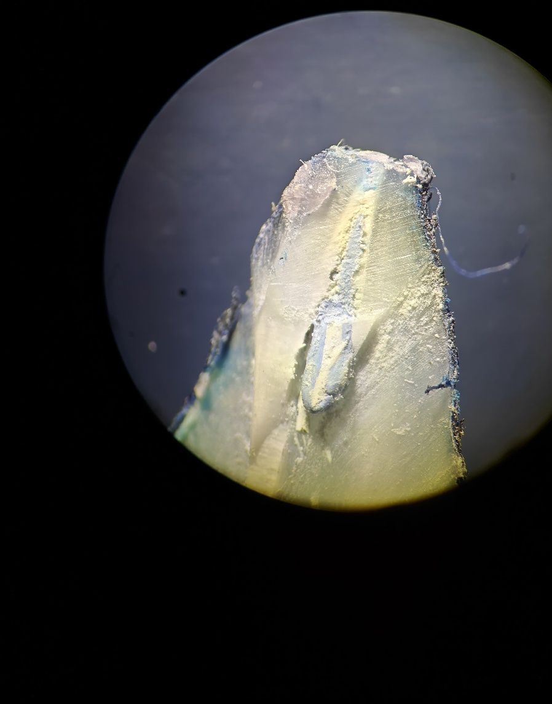
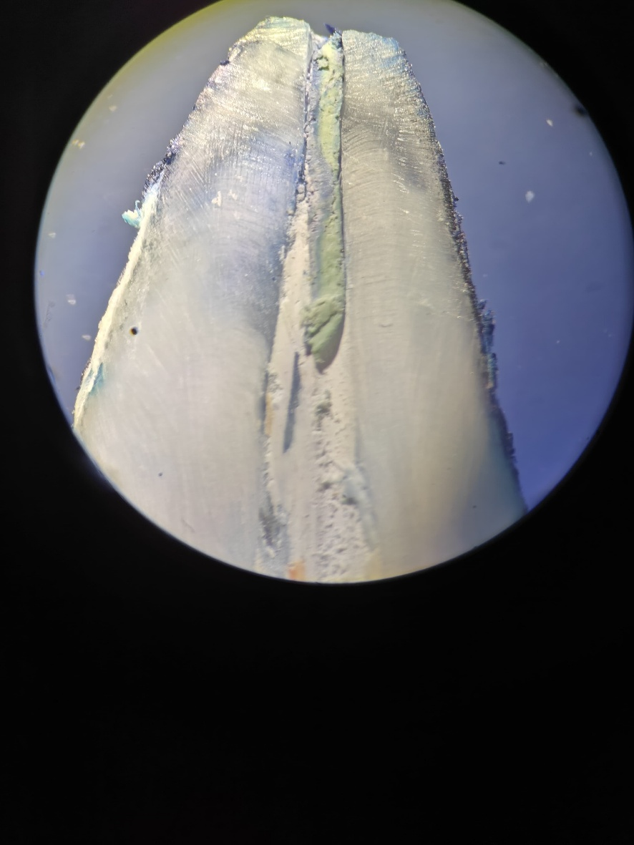
FIG 1. Stereomicroscopic Images Of Dye Penetration at 30x Mangification
Group:-2 Modified step back technique
Group 1:- Step back technique

Group 4:- Crown down technique (Rotary instruments with greater taper)

Group 3:- Crown down technique (Manual NiTi with greater taper)

