Case report

Enamel Opacity Management: A Case for Tailored Resin Infiltration and Diagnostic Precision

.
ABSTRACT

Aims: This case addresses an adolescent's aesthetic concerns from dental fluorosis (DF) white spots and molar incisor hypomineralization (MIH) lesions. The goal was to restore smile aesthetics via a conservative, adapted approach.
Presentation of Case: A healthy 14-year-old male presented to a dental school with aesthetic dissatisfaction from irregular DF and MIH on anterior and posterior teeth. Lesion depth and Icon resin infiltrant application were guided by transillumination. Therapy involved selective enamel reduction and 15% hydrochloric acid cycles exclusively for MIH, followed by resin infiltration (RI) for all areas. Immediate post-treatment evaluation showed significant aesthetic improvement, including reduced opacity, improved color uniformity, and masking of dyschromias.
Discussion: Aesthetic outcomes highlight RI's efficacy as a minimally invasive approach for DF and MIH. Selective enamel reduction was essential for deeper MIH lesions where RI alone was insufficient. This technique preserves tooth structure, enhancing aesthetics with less structural loss than traditional restorative treatments. Success relies on meticulous case selection, evaluation, and precise clinical technique.
Conclusion: This case demonstrates successful multimodal treatment of an adolescent's aesthetic concerns. MIH lesions were the primary complaint; coexisting DF lesions were addressed. The combination of selective enamel reduction for deeper MIH and resin infiltration for all defects promoted aesthetic improvement and high patient satisfaction. Selective enamel reduction was not required for DF lesions.

Keywords: Molar hypomineralization; Fluorosis, Dental; Developmental Defects of Enamel; Esthetics; Resin infiltration.
- INTRODUCTION

The aesthetic perception of a smile holds paramount importance for adolescents, frequently serving as a primary motivator for seeking dental treatment. Beyond superficial concerns, the structural integrity of dental enamel is critical for oral health. Developmental defects of enamel (DDE), such as molar-incisor hypomineralization (MIH) and dental fluorosis (DF) (Martins et al., 2024), can significantly compromise both aesthetic appearance and, more importantly, dental function and durability, thereby impacting their self-esteem and willingness to seek intervention.
Molar-incisor hypomineralization (MIH) is clinically characterized by asymmetric, demarcated opacities, with a color spectrum encompassing white, yellow, and brown (Costa-Silva et al., 2011). Enamel affected by MIH exhibits a substantial reduction in both mineral content and quality, evidenced by lower concentrations of calcium and phosphorus, decreased hardness and elastic modulus, increased porosity, and higher levels of carbon and proteins when compared to healthy enamel (Elhennawy et al., 2017). Conversely, dental fluorosis, while also a hypomineralization condition, is clinically differentiated from MIH by its predilection for homologous teeth and its manifestation as diffuse, opaque stains. These stains vary in severity from subtle, fine lines to extensive areas, exhibiting diverse degrees of surface and subsurface porosity; in severe cases, this can lead to post-eruptive structural surface loss (Thylstrup & Fejerskov, 1978) and underscore the critical need for clinicians to effectively manage the severity and progression of these defects. This structural compromise drives the continuous search for effective therapeutic approaches.
For the management of DDE, the Icon system (DMG, Hamburg, Germany) is a widely accepted microinvasive option, frequently combined with dental bleaching and enamel microabrasion when clinically indicated (Casaña-Ruiz et al, 2023, Gupta et al., 2017; Garg et al., 2022). Its efficacy is contingent upon strict adherence to the manufacturer's guidelines for the sequential application of Icon-Etch, Icon-Dry, and Icon-Infiltrant, crucial for achieving optimal penetration and clinical efficacy. Despite growing clinical interest and research into MIH and various therapeutic approaches, a recent umbrella review (Gevert et al., 2022) highlighted a critical gap in the quality of existing evidence, thereby impeding the establishment of a definitive clinical protocol.
Given this absence of a definitive protocol and the diverse clinical manifestations of DDE, this case report aims to detail the application of resin infiltration (RI) treatment for intrinsic stains caused by DF and MIH in a 14-year-old adolescent.

2. Presentation of Case

A 14-year-old male patient, in good systemic health, presented to the Western Paraná State University, School of Dentistry, Cascavel, Brazil, reporting aesthetic concerns with his smile. Clinical examination revealed mild fluorosis white spots (Dean, 1934) and irregularly distributed post-orthodontic white spots. Additionally, lesions consistent with enamel hypomineralization (HMI) were identified on teeth: 23 (HMI-TNI_1), 12 (HMI-TNI_1), 13 (HMI-TNI_1), 16 (occlusal and mesial surfaces) (HMI-TNI_2), 43 (buccal surface) (HMI-TNI_1), and 46 (occlusal surface) (HMI-TNI_2) (Fig. 1) (Cabral et al., 2020).
To assess stain depth and aid in diagnosis, teeth were transilluminated in a darkened environment using a Radii Plus LED light source (SDI Limited, Victoria, Australia) with a diagnostic LED probe (SDI Limited, Victoria, Australia). A monochromatic white light beam was directed onto the lingual/palatal surface of the teeth (Marouane & Chtioui, 2020). As it traversed the buccal surface, the light revealed fluorosis defects and deep defects in the hypomineralized teeth (46, 43, 23, 13, and 12) (Fig. 2).
The single-session treatment strategy was tailored to defect severity and location, addressing the mandibular arch first, followed by the maxillary arch. Prior to treatment, prophylaxis was performed using the Air-Flow® Prophylaxis Master and Air-Flow® Powder Soft (E.M.S. Electro Medical System S.A., Nyon, Switzerland). Subsequently, the entire dental arch consistently received a rubber dam; however, teeth 17, 27, 37, and 47 were excluded due to their ongoing eruption. Given the alterations caused by DF, the rubber dam was firmly retracted throughout the acid etching and subsequent Icon® system application (DMG, Hamburg, Germany) phases.
Initially, the treatment focused on the mandibular arch. Enamel microabrasion was conducted on teeth 43 using a multi-bladed bur to address deeper stain. Icon-Etch (15% hydrochloric acid) was applied to teeth 46 through 36 using a microbrush. After a 2-minute application, the acid was removed by suction, followed by 30 seconds of copious rinsing with ligature retraction. An equivalent period of oil/water-free drying was then performed. Subsequently, Icon-Dry (99% ethanol) was applied for 30 seconds under transillumination, utilizing a VALO™ Grand Cordless light and VALO Grand White Light Lens (Ultradent Products Inc., South Jordan, UT USA). Post-treatment, only cervical fluorosis stains and hypomineralized areas on teeth 43 and 46 persisted.
Following, acid was reapplied solely to the defect on tooth 43 (Fig. 3). Subsequently, Icon-Infiltrant was applied to all treated cervical areas under intense ligature retraction and with the operatory light off. After 3 minutes, the infiltrant effectively masked stains and was then light-cured for 40 seconds. For tooth 43 specifically (abraded earlier), the infiltrant was applied to its body for an extended duration of 20 minutes to maximize infiltration depth. This extended infiltration was monitored via transillumination using a VALO™ Grand Cordless light and VALO Grand White Light Lens (Ultradent Products Inc., South Jordan, UT, USA), after which it was light-cured. Concurrently, infiltrant application and subsequent curing proceeded on other treated teeth as per standard protocol. Finally, any excess interproximal material was removed with dental floss, followed by a final light-curing of these areas. Upon completing all procedures for the mandibular arch, the rubber dam was removed.
Upon completion of the lower arch treatment, attention was then directed to the upper one. Teeth 12 and 13 underwent multi-bladed bur abrasion owing to their deeper hypomineralized defects. The entire arch received the standard etching, which included a 2-minute acid application, rinsing, and drying, followed by a 30-second application of Icon-Dry, all steps performed in accordance with previously detailed protocol. As this application revealed persistent defects, Icon-Etch was reapplied for an additional 4 minutes (12 e 13). This reetching successfully masked most fluorosis stains, except of those in the molars cervical-buccal regions which was left as is, with the achieved aesthetic being considered satisfactory.
The hypomineralized defects on teeth 13, 12, and 23, though less pronounced, remained noticeable (Fig. 4); consequently, a third 4-minute etching was exclusively performed. Satisfactory camouflage was ultimately achieved only after a fourth, additional 2-minute application, extending the total etching time to 10 minutes. The ethanol testing step (Icon-Dry) was performed between each acid application. Thereafter, Icon-Infiltrant was applied to all teeth in the arch, followed by a 22-minute wait period. The subsequent steps (monitoring, interproximal excesses removal, light-curing, and rubber dam removal) was previously described for the lower arch.
The teeth were polished using the Twist Gloss CA Diamond Spiral Polishers system in conjunction with Eagle Diamond nanodiamond paste (American Burrs). The immediate outcome is depicted in Figure 5. Subsequently, the abraded teeth (12, 13, and 43) were restored with composite resin during the next appointment, followed by a final polishing procedure to achieve optimal surface finish.

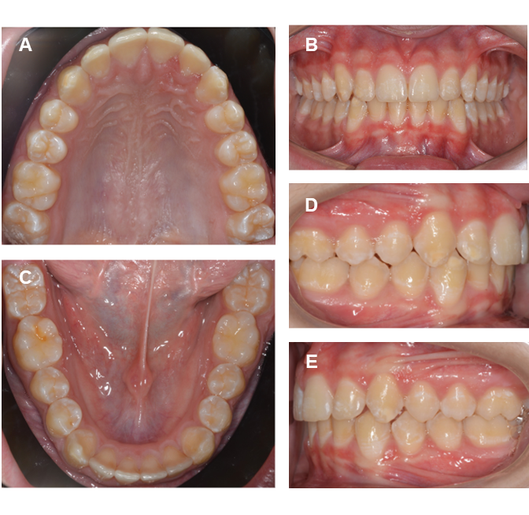
Fig. 1. Initial. A) Occlusal view of upper arch; B) Front view; C) Occlusal view of lower arch; D) Right view; E) Left view.

Fig. 2. Transillumination. A) Tooth #12; B) Tooth #13; C) Tooth #43.

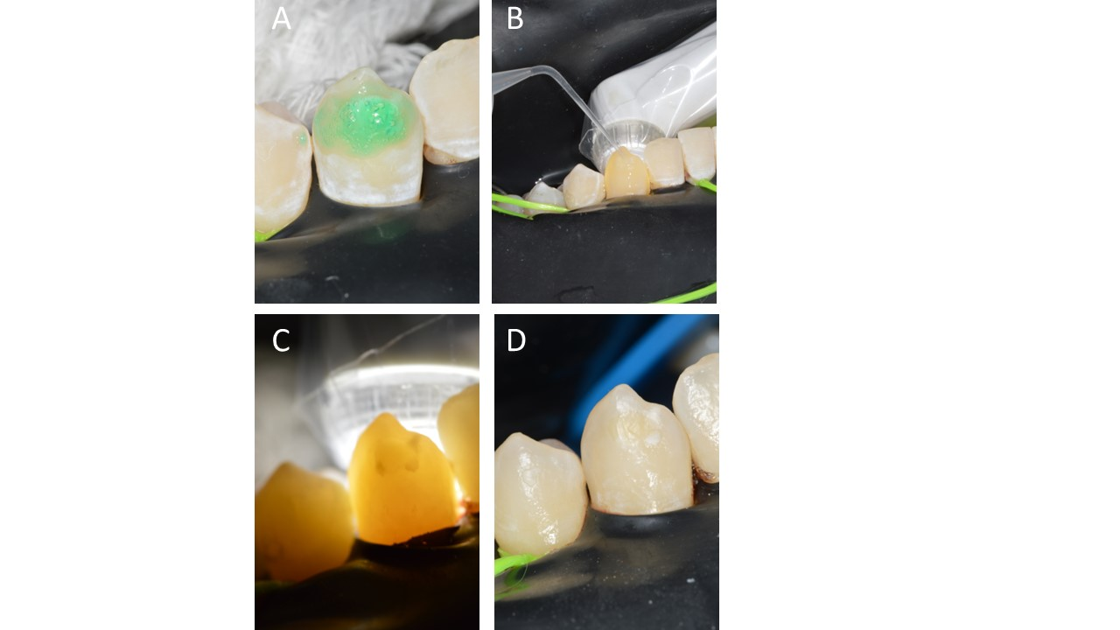

Fig. 3. Tooth #43. A) The fourth cycle of Icon Etch precisely targets the defect; B) Icon Dry under transillumination with white light; C) Result applying Icon Dry under transillumination; D) Result applying Icon Infiltrant under transillumination. D) Result after application of Icon Infiltrant. Arrows: Remnant composite resin after debracketing.

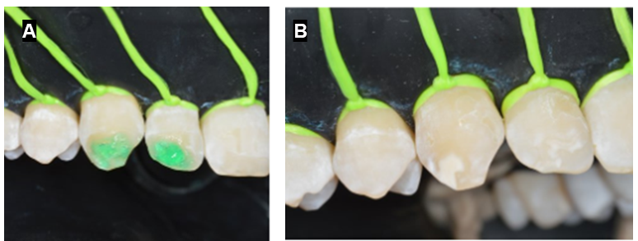
Fig. 4. Teeth #12 and #13; A) The second cycle of Icon Etch; B) Result after application of Icon Etch.
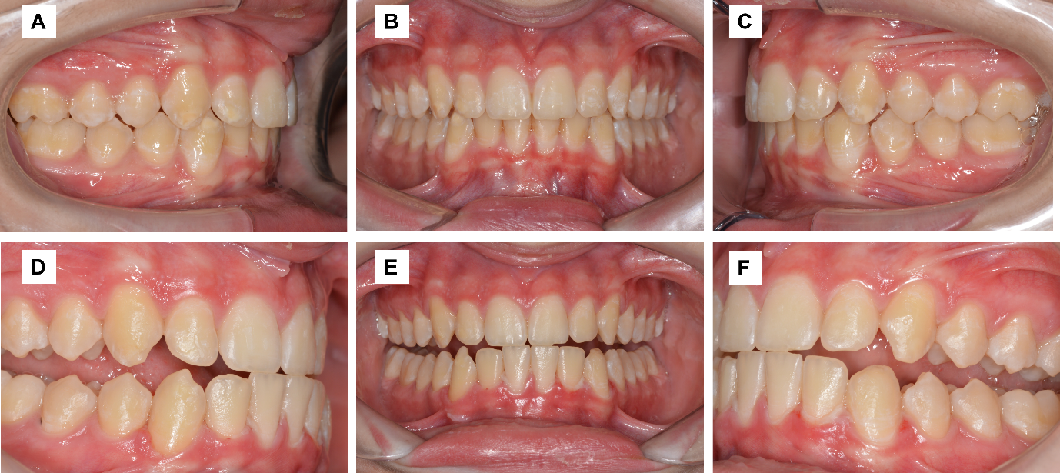

Fig. 5. Initial. A) Right view; B) Front view. C) Left view. After’s result. D) Right view; E) Front view. F) Left view.

- discussion

A comprehensive, severity-tailored treatment strategy is essential for managing MIH and its manifestations. Resin infiltration can be systematically combined with other dental treatments, such as microabrasion, dental bleaching, and composite resin restoration, to optimize aesthetic and functional outcomes. However, an overview of systematic reviews assessing the quality of evidence for molar-incisor hypomineralization (MIH) treatment revealed that the available evidence is of low to moderate quality for most interventions. This finding indicates that, for treatments such as resin infiltration (RI) for developmental enamel defects, a limited high-quality evidence base currently exists to support its standalone efficacy for masking (Gevert et al., 2022). Consequently, treatment decisions necessitate a patient-centered approach, considering the patient's age, expectations, and guardian concerns. This approach was exemplified as the patient's primary aesthetic concern focused solely on hypomineralization defects, not overall tooth shade. Therefore, at-home dental bleaching, that could offer considerable improvement (Wittich et al., 2024), was declined by both the patient and parents due to associated procedural risks, prioritizing specific defect resolution and risk avoidance.
Despite a double acid application, cervical DF stains and hypomineralization persisted on teeth 12, 13, 23, 43, and 46, aligning with Alghawe & Raslan's (2024) findings regarding the influence of opacity coloration on acid application numbers. Yellowish stains, such as those on tooth 46, may require multiple acid cycles for complete masking (Kabeel et al., 2024). This outcome supports the removal of altered enamel, in conjunction with two reconditioning procedures, to achieve aesthetic recovery.
Resin infiltration (RI) is a key treatment for demineralized enamel, particularly in developmental defects and hypomineralization. Deeper lesions demand intensified protocols, including extended etching, abrasion, or longer infiltration times for full enamel saturation (Srikumar et al., 2024; Marouane & Manton, 2021). Crucially, monitoring RI to complete saturation, often taking 20-22 minutes for specific teeth (43 and other maxillary teeth), is vital (Marouane & Chtioui, 2020). Controlled diagnostic methods (Blanchet et al., 2023), especially white light transillumination, enable real-time visualization of resin penetration without premature polymerization. The Icon-Dry test, under white light, further aids in predicting outcomes and monitoring saturation (Marouane & Chtioui, 2020). Ultimately, a personalized approach is essential, with Shahroom et al. (2019) suggesting fluorosis dentata may require considerably longer infiltration times, underscoring the need for tailored strategies to achieve optimal esthetic results.
Beyond aesthetic considerations, resin infiltration (RI) reinforces hypomineralized enamel, thereby enhancing its mechanical properties (Zhao & Ren, 2016) and diminishing the risk of fractures (Crombie et al., 2014). However, this treatment necessitates long-term monitoring.

4. Conclusion

This case demonstrates successful multimodal treatment of an adolescent's aesthetic concerns. MIH lesions were the primary complaint; coexisting DF lesions were addressed. The combination of selective enamel reduction for deeper MIH and resin infiltration for all defects promoted aesthetic improvement and high patient satisfaction. Selective enamel reduction was not required for DF lesions.

Consent

All authors declare that ‘written informed consent was obtained from the patient (or other approved parties) for publication of this case report and accompanying images. A copy of the written consent is available for review by the Editorial office/Chief Editor/Editorial Board members of this journal.

Ethical approval

This case report followed the guidelines of Resolution 466/12 (National Health Council/MS, December 12, 2012) and was approved by the Human Research Ethics Committee at the State University of Western Paraná (UNIOESTE) (Approval Number: 5,976,302). The patient and their legal guardians were thoroughly briefed on the study's purpose, associated risks, and potential benefits, with an emphasis on their right to voluntary participation and withdrawal. Written informed consent was then secured from the patient and their parents. Furthermore, specific permission for image utilization was also acquired.
DISCLAIMER (ARTIFICIAL INTELLIGENCE)

Linguistic and stylistic revision of this manuscript was performed using the "Adapta-developed AI model One", enhancing clarity, fluency, and conciseness. The revision process was guided by the following specific prompts:
- "Revise the English text to enhance its fluency and cohesion while maintaining the central idea and references. The final text should be slightly more concise than the original while preserving key content and meaning. Include specific suggestions for: - Improving sentence structure and flow. - Enhancing vocabulary precision. - Eliminating redundant information. - Strengthening logical connections between paragraphs. - Maintaining essential references and context. Provide the revised text with tracked changes to show the original content and the modifications made. Ensure that the final version is clear, concise, and effectively communicates the intended message.”
- "Improve the linguistic quality of the provided text, enhance its cohesion and fluency, while maintaining its original structure, including numbering. Subsequently, translate the revised text into English, ensuring adherence to scientific writing conventions and the clarity typical of academic discourse in English, with particular attention to technical terminology in dentistry."
To ensure the originality and integrity of the work, the final manuscript was subjected to plagiarism detection using the Turnitin platform. The results confirmed that the content meets academic standards for originality.
No AI text-to-image generators were used in the preparation of this manuscript.

References

Martins D. D. S., Ionta F. Q., Pompermaier Garlet G., Lima R. R., & Neves A. A. et al. (2024), Developmental Defects of Enamel. Monogr Oral Sci. 32:10-34. https://doi.org/10.1159/000538850
Costa-Silva C. M., Ambrosano G. M. B., Jeremias F., Souza J. F., & Mialhe F. L. (2011), Increase in severity of molar-incisor hypomineralization and its relationship with the colour of enamel opacity: a prospective cohort study. Int J Paediatr Dent., 21(5):333-341. https://doi.org/10.1111/j.1365-263X.2011.01128.x
Elhennawy K., Manton D. J., Crombie F., Zaslansky P., Radlanski R. J., & Jost-Brinkmann P. G. et al. (2017). Structural, mechanical and chemical evaluation of molar-incisor hypomineralization-affected enamel: A systematic review, Arch Oral Biol., 83:272-281. https://doi.org/10.1016/j.archoralbio.2017.08.008
Thylstrup A., & Fejerskov O. (1978). Clinical appearance of dental fluorosis in permanent teeth in relation to histologic changes. Community Dent Oral Epidemiol, 6(6): 315-328. https://doi.org/10.1111/j.1600-0528.1978.tb01173.x
Casaña-Ruiz M. D., Marqués Martínez L., & García Miralles E. (2023). Management of hypoplastic or hypomineralized defects with resin infiltration at pediatric ages: systematic review. Int J Environ Res Public Health, 20(6):5201. https://doi.org/10.3390/ijerph20065201
Gupta A., Dhingra R., Chaudhuri P., & Gupta A. (2017). A comparison of various minimally invasive techniques for the removal of dental fluorosis stains in children. J Indian Soc Pedod Prev Dent., 35(3):260-268. https://doi.org/10.4103/jisppd.jisppd_138_16
Garg I., Kumar A., & Kumar A. (2022). Comparative Evaluation of Esthetic Improvement of Resin Infiltration (RI), In-office Bleaching (B), Enamel Microabrasion (M) and Resin Infiltration with Double Application of Infiltrant (2RI) on Non-pitted Fluorosis Stains: A Randomized Six-month Interventional Study. Int J Clin Pediatr Dent., 15(1):20-34. https://doi.org/10.5005/jp-journals-10005-2140
Gevert M. V., Soares R., Wambier L. M., Ribeiro A. E,. Avais L. S., & de Souza J. F. et al. (2022). How is the quality of the available evidence on molar-incisor hypomineralization treatment? An overview of systematic reviews. Clin Oral Investig., 26(10):5989-6002. https://doi.org/10.1007/s00784-022-04612-9
Dean H. T. (1934). Classification of mottled enamel diagnosis. J Amer Dent Assoc.; 21(8):1421-1426.
Cabral R. N., Nyvad B., Soviero V. L. V. M., Freitas E., & Leal S. C. (2020). Reliability and validity of a new classification of MIH based on severity. Clin Oral Investig., 24(2):727-734. https://doi.org/10.1007/s00784-019-02955-4
Marouane O., & Chtioui F. (2020). Transillumination-aided infiltration: A diagnostic concept for treating enamel opacities. J Esthet Restor Dent., 32(5):451-456. https://doi.org/10.1111/jerd.12602
Wittich F. K, Cebula M., Effenberger S., Schoppmeier C. M, Schwendicke F., & Barbe A. G. et al. (2024). Masking efficacy of bleaching and/ or resin infiltration of fluorotic spots on anterior teeth - a systematic review and meta-analysis. J Dent., 149:105276. https://doi.org/10.1016/j.jdent.2024.105276
Alghawe S., & Raslan N. (2024). Management of permanent incisors affected by Molar-Incisor-Hypomineralisation (MIH) using resin infiltration: a pilot study. Eur Arch Paediatr Dent., 25(1):105-116. https://doi.org/10.1007/s40368-024-00861-2
Kabeel D. G., Nour K. A., & Sedky R. A. (2024). The effect of resin infiltration technique on the calculated color change of demineralized lesions of different severities. Oper Dent., 49(4):443-454. https://doi.org/10.2341/23-126-L
Srikumar G. P. V., Ghosh M., Kumar A. A., Bardia S., Wasule A., & Beautlin J. S. (2024). An in vitro evaluation of Icon resin infiltrant penetration into demineralized enamel lesions using an indirect staining technique with confocal laser scanning microscope analysis in dual fluorescence mode. J Conserv Dent Endod., 27(4):366-372. https://doi.org/10.4103/JCDE.JCDE_3_24
Marouane O., & Manton D. J. (2021). The influence of lesion characteristics on application time of an infiltrate applied to MIH lesions on anterior teeth: An exploratory in vivo pilot study. J Dent., 115:103814. https://doi.org/10.1016/j.jdent.2021.103814
Blanchet I., Camoin A., Tardieu C., & Jacquot B. (2023). Microabrasion in the management of enamel discolorations in paediatric dentistry: a systematic review. J Clin Pediatr Dent., 47(1):17-26. https://doi.org/10.22514/jocpd.2022.015
Shahroom N. S. B., Mani G., & Ramakrishnan M. (2019). Interventions in management of dental fluorosis, an endemic disease: A systematic review. J Family Med Prim Care., 8(10):3108-3113. https://doi.org/10.4103/jfmpc.jfmpc_648_19
Zhao X., & Ren Y. F. (2016). Surface properties and color stability of resin-infiltrated enamel lesions. Oper Dent., 41(6):617-626. https://doi.org/10.2341/15-319-L
Crombie F, Manton D, Palamara J, & Reynolds E. Resin infiltration of developmentally hypomineralised enamel. Int J Paediatr Dent 2014; 24: 51-55.

