Original Research Article

Impact of the Covid-19 Pandemic on the Epidemiology and Diagnosis of Meningococcal Meningitis with Meningococcemia in Children and Adolescents in Brazil (2015–2024)

.
ABSTRACT

Aims: To describe the temporal distribution of meningococcal meningitis with meningococcemia in Brazil and to examine changes in diagnostic criteria over time.
Study design: Ecological study based on secondary data analysis.
Place and Duration of Study: Brazil, using data from the Notifiable Diseases Information System (SINAN), covering the period from 01 January 2015 to 31 May 2024.
Methodology: We included confirmed cases of meningococcal meningitis with meningococcemia in individuals aged 0–18 years. Data were analyzed using R version 4.4.2. Pearson’s chi-square test and logistic regression models were applied to assess associations, with a significance threshold of p < 0.05. Diagnostic methods were categorized as polymerase chain reaction (PCR), culture, clinical criteria, or others, and their relative frequencies were compared across three periods: pre-pandemic (2015–2019), pandemic (2020–2021), and post-pandemic (2022–2024).
Results: A total of 1,186 cases were reported. From 2015 to 2019, cases declined progressively (75.3% of total), ranging from 228 in 2015 to 162 in 2019. During the COVID-19 pandemic (2020–2021), there was a sharp reduction, with only 32 and 35 cases reported, representing 5.7% of the total. From 2022 onwards, cases increased again, totaling 17.3% over three years, peaking at 93 in 2023. Regarding diagnostic methods, in the pre-pandemic period (n = 917), PCR accounted for 35.99% of diagnoses, followed by culture (24.97%) and clinical criteria (22.14%). During the pandemic (n = 128), PCR use rose to 50%. In the post-pandemic period (n = 131), PCR predominated with 69.47%, indicating a clear shift in diagnostic practices.
Conclusion: COVID-19 temporarily reduced the incidence of meningococcal meningitis with meningococcemia in Brazil, but a gradual resurgence was observed post-pandemic. Diagnostic practices evolved, with PCR increasingly replacing traditional methods, reflecting improved laboratory capacity and changing clinical guidelines.

Keywords: Meningococcal Meningitis, Meningococcal Infections, Clinical Laboratory Techniques, Children, Adolescents.

1. INTRODUCTION

Meningitis, an inflammation of the meninges typically of infectious origin, is characterized by acute onset and high morbidity and mortality rates, particularly among children and adolescents. Bacterial agents represent the most severe form of the disease, with Neisseria meningitidis, Streptococcus pneumoniae, and Haemophilus influenzae type b (Hib) accounting for over half of all meningitis-related deaths worldwide¹. Of these, Neisseria meningitidis is particularly notorious for its potential to cause meningococcemia, an invasive and rapidly progressive clinical presentation characterized by hematogenous dissemination and a severe systemic inflammatory response². This manifestation is especially concerning in children under five and adolescents due to its high case-fatality rate and frequent neurological sequelae³.
Globally, meningitis resulted in more than 236,000 deaths in 2019, with the highest burden observed among children under five⁴. While vaccination has led to a substantial reduction in cases in high-income countries, significant challenges persist in low- and middle-income regions, including suboptimal vaccine coverage, emerging antimicrobial resistance, and limited access to healthcare services⁵,⁶. Invasive meningococcal disease (IMD) occurs in both endemic and epidemic patterns, with serogroups A, B, C, W, and Y being the primary drivers of outbreaks worldwide⁷.
In Brazil, despite advances in surveillance and immunization programs, IMD remains a significant public health challenge that requires continuous monitoring to inform preventive and control policies. The Brazilian surveillance system relies on mandatory notification, where laboratory confirmation is essential for identifying the etiological agent and implementing timely response measures, such as vaccination campaigns, chemoprophylaxis of contacts, and intensified surveillance in high-risk regions⁸. Diagnosis is based on cerebrospinal fluid (CSF) analysis, culture (of blood or CSF), polymerase chain reaction (PCR), and, increasingly, genomic sequencing. These tools are fundamental for both clinical management and public health actions, including genomic surveillance and antimicrobial resistance monitoring⁹,¹⁰. Rapid identification is crucial, as meningococcemia can progress fulminantly, with death occurring within hours of symptom onset.
Despite a robust surveillance framework, temporal trends in the diagnosis and epidemiology of pediatric meningococcemia in Brazil, particularly in relation to major disruptive events such as the COVID-19 pandemic, remain underexplored.
Therefore, this study aims to describe the epidemiological characteristics and analyze the profile of confirmed cases of meningococcal meningitis with meningococcemia in the pediatric population (0–18 years) in Brazil between 2015 and 2024, utilizing data from the national Notifiable Diseases Information System (SINAN). Specifically, we will examine trends in incidence, distribution by diagnostic method, and explore potential shifts in case profiles across pre-pandemic, pandemic, and post-pandemic periods.

2. material and methods

An observational, cross-sectional epidemiological study was conducted using data from the Brazilian Notifiable Diseases Information System (SINAN) on confirmed cases of meningococcal meningitis with meningococcemia (ICD-10 A39.2) reported in Brazil between January 1, 2015, and May 31, 2024. The study included individuals aged 0 to 18 years residing in all federal units. The variables extracted and analyzed included: year of notification (annual distribution from 2015 to 2024), COVID-19 pandemic period (categorized into pre-pandemic: 2015–2019, pandemic: 2020–2021, and post-pandemic: 2022–May 2024), and diagnostic confirmation criteria (classified as clinical, culture, PCR, and others).

Statistical Analysis
Data were summarized using descriptive statistics, presented as frequencies (n) and proportions (%) of cases by year, diagnostic criteria, and pandemic period. The Chi-square test of independence was employed to assess differences in the distribution of diagnostic methods across the pre-pandemic, pandemic, and post-pandemic periods. The strength of this association was quantified using Cramer’s V, reported with its 95% confidence interval (CI).
To identify factors associated with the outcome, univariate analyses were conducted using Pearson’s Chi-square test for categorical variables. The magnitude of these associations was expressed as unadjusted odds ratios (OR) with their corresponding 95% confidence intervals. A significance level of α = 0.05 was adopted for all tests. Subsequently, variables showing a significant association in the univariate analysis (or those deemed clinically relevant) were entered into a multivariable logistic regression model to calculate adjusted odds ratios, controlling for potential confounders and identifying independent associated factors.
A script in R language version 4.4.2 (R Core Team, Vienna, Austria) was developed to extract, organize, and analyze individual-level microdata from investigation forms stored on the Datasus server. Missing data for variables included in the study were retained and reported in the epidemiological profile table.

3. results and discussion

The annual distribution of confirmed cases of meningococcal meningitis with meningococcemia among individuals aged 0 to 18 years in Brazil, from 2015 to 2024, demonstrated a continuous decline between 2015 (228 cases) and 2019 (162 cases). This was followed by a more pronounced decrease in 2020 (32 cases), coinciding with the onset of the COVID-19 pandemic. From 2020 to 2022, case counts remained low, with a slight increase in 2022 (61 cases) and a peak in 2023 (93 cases). In 2024, up to the date of data collection, 39 cases had been reported (Figure 1).

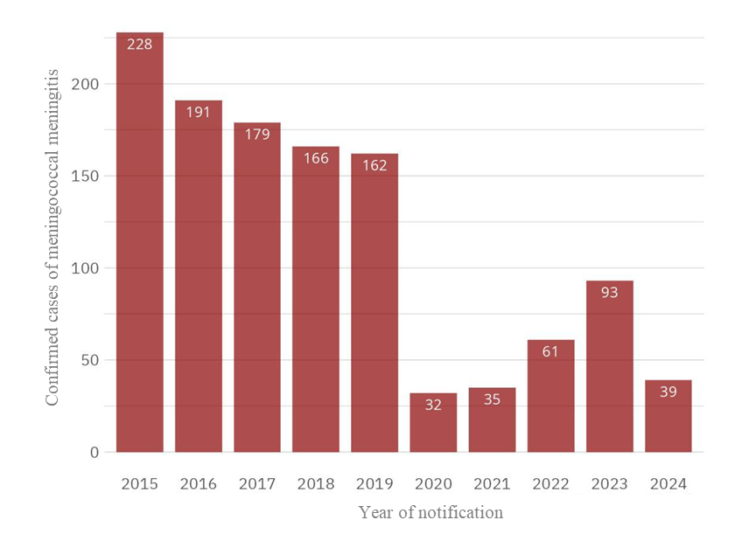
Figure 1. Yearly distribution of confirmed meningococcal meningitis with meningococcemia cases in individuals aged 0–18 years in Brazil.

A significant variation was identified across the three analyzed periods (pre-pandemic, pandemic, and post-pandemic), as indicated by the chi-square test (χ² = 61.38; p < 0.0001), with a moderate association (Cramer’s V = 0.15; 95% CI: 0.10–0.19). In the pre-pandemic period, among 917 confirmed cases, clinical criteria were the most frequently employed diagnostic method (35.99%), followed by culture (24.97%), PCR (22.14%), and other methods (16.96%). During the pandemic period, with a sharp decline in the overall number of cases (n = 128), the proportion of diagnoses based on clinical criteria increased to 50%, while culture use decreased substantially to 11.72%. PCR remained relatively stable (14.84%), whereas methods categorized as “other” accounted for 23.44%. In the post-pandemic period (n = 131), there was a marked rise in the proportion of cases confirmed by clinical criteria (69.47%), accompanied by a notable reduction in the use of other diagnostic approaches, with culture representing only 7.63% and PCR decreasing to 6.11%. The “other” category remained comparable to the preceding period (16.79%) (Figure 2).
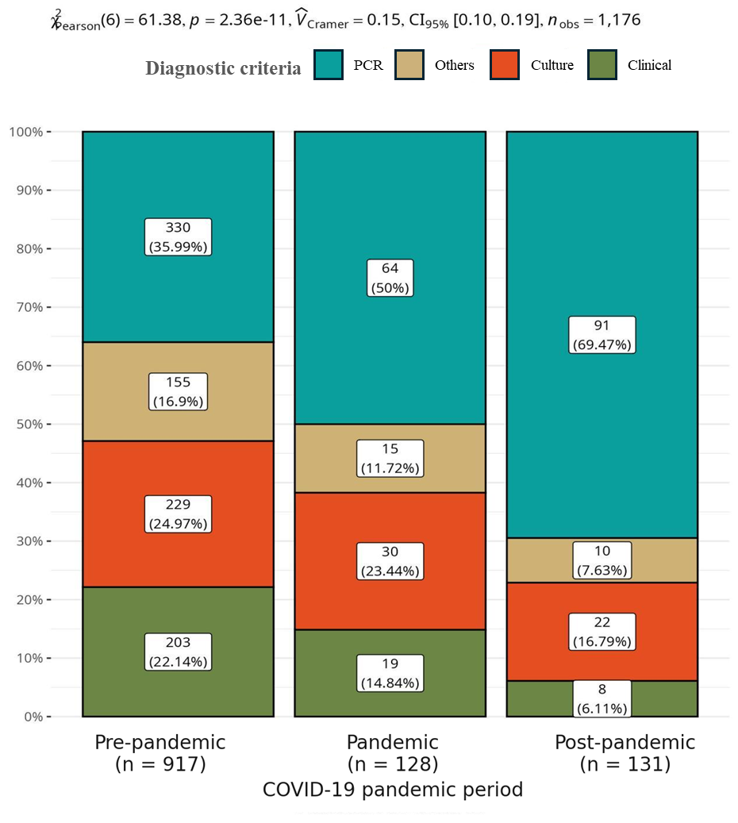
Figure 2. Yearly distribution of diagnostic criteria among confirmed meningococcal meningitis with meningococcemia cases in individuals aged 0–18 years in Brazil, January 2015–May 2024.

Discussion
The analysis of the annual distribution of confirmed cases of meningococcal meningitis with meningococcemia among individuals aged 0 to 18 years in Brazil from 2015 to 2024 revealed distinct temporal trends. Between 2015 and 2019, a progressive decrease in cases was observed, consistent with the introduction and expansion of the meningococcal conjugate vaccine against serogroup C (MenC) in the childhood immunization schedule in 2010 and its extension to adolescents in 2017¹¹,¹². These findings align with previous studies demonstrating the effectiveness of vaccination strategies in reducing disease incidence.
The sharp reduction in cases observed in 2020 coincides with the onset of the COVID-19 pandemic and can be partially attributed to non-pharmaceutical interventions, including social distancing, mask use, school closures, and changes in healthcare-seeking behavior, which affected the circulation and reporting of infectious agents such as Neisseria meningitidis¹³,¹⁴. Underreporting during this period has been documented in Brazil and other countries and should be considered when interpreting these data.
Following 2020, a gradual increase in cases was noted from 2022, peaking in 2023. This resurgence likely reflects the relaxation of sanitary measures, the return to in-person school activities, and potential vaccination gaps accumulated during the pandemic¹⁵,¹⁶. The emergence of serogroups W and B in certain regions remains a public health concern due to their association with severe disease and higher case-fatality rates¹⁶,¹⁷.
Meningococcemia, the systemic manifestation of invasive meningococcal disease, remains associated with high mortality and frequent need for intensive care¹⁸. International studies have reported in-hospital case-fatality rates ranging from 7% to 10%, with higher severity among children under five and older age groups¹⁹.
This study also highlights a notable shift in diagnostic practices over time. In the pre-pandemic period, traditional methods such as cerebrospinal fluid culture and clinical evaluation predominated, though the use of PCR was gradually increasing²². From 2020 onward, there was a progressive reliance on clinical criteria and molecular methods, particularly PCR, driven by healthcare system overload, prioritization of rapid diagnostics, and temporary reductions in laboratory capacity²¹⁻²³. PCR offered higher sensitivity, specificity, and faster turnaround, particularly valuable in cases with prior antibiotic use²⁴.
However, reliance on syndromic diagnosis without laboratory confirmation raises concerns regarding diagnostic accuracy, underreporting, and misclassification, potentially compromising epidemiological surveillance and vaccine effectiveness monitoring²²,²⁵. The World Health Organization recommends integrating clinical and laboratory findings, prioritizing rapid methods such as PCR and genomic sequencing while preserving culture as the gold standard²⁶.
Limitations of this study include the use of secondary data from SINAN, which may be affected by reporting delays, incomplete records, and underreporting, especially during the pandemic. Nevertheless, these results provide valuable insights into the impact of COVID-19 on diagnostic pathways and underscore the importance of strengthening surveillance and laboratory capacity in the post-pandemic context.

4. Conclusion

This study demonstrates important temporal and diagnostic changes in meningococcal meningitis with meningococcemia among children and adolescents in Brazil. A significant reduction in cases was observed following the onset of the COVID-19 pandemic, followed by a gradual resurgence, likely associated with relaxation of sanitary measures and resumption of in-person activities. Concurrently, there was a progressive shift from traditional laboratory-based diagnostics to clinical criteria and molecular methods, reflecting both structural limitations and changes in healthcare workflows. These findings highlight the need to reinforce epidemiological surveillance, maintain laboratory infrastructure, and ensure timely, accurate diagnostics to guide vaccination strategies, allocate healthcare resources effectively, and control meningococcal disease. Future research should focus on serogroup-specific incidence, the long-term impact of diagnostic shifts on reporting, and evaluating vaccine effectiveness in post-pandemic contexts.

Consent

This study utilized secondary, aggregated data from the Notifiable Diseases Information System (SINAN) panel (Brazil). As such, individual patient data was not identifiable. Consequently, the analysis did not involve primary data collection or interventions. Due to the retrospective design and the use of aggregated, anonymized data, this study poses no risk of violating participants' privacy or integrity, nor does it contravene current legislation.”

Ethical approval

According to Brazilian National Health Council Resolution No. 510/2016, the data used in this study were considered public access and did not require submission to the Research Ethics Committee. The data were presented in aggregate form, without allowing the identification of individual participants, ensuring privacy and confidentiality.

References

- Global Burden of Disease 2019 Meningitis Collaborators. Global, regional, and national burden of meningitis and its aetiologies, 1990–2019: a systematic analysis for the Global Burden of Disease Study 2019. Lancet Neurol. 2022;21(1):60–89.
- Rausch-Phung EA, Siddiqui JA, Gulick PG. Meningococcemia. In: StatPearls [Internet]. Treasure Island (FL): StatPearls Publishing; 2025 Jan.
- Hersi K, Gonzalez FJ, Kondamudi NP. Meningitis. In: StatPearls [Internet]. Treasure Island (FL): StatPearls Publishing; 2023 Aug.
- World Health Organization. Meningitis [Internet]. Geneva: WHO; 2025 [cited 2025 Jul 14]. Available from: https://www.who.int/news-room/fact-sheets/detail/meningitis.
- Global Burden of Disease Collaborative Network. Burden of disease scenarios for 204 countries and territories, 2022–2050: a forecasting analysis for the Global Burden of Disease Study 2021. Lancet. 2024;403(10440):2204–56.
- Brasil. Ministério da Saúde. Meningite [Internet]. Brasília: Ministério da Saúde; [citado 2025 jul 14]. Disponível em: https://www.gov.br/saude/pt-br/assuntos/saude-de-a-a-z/m/meningite
- Chhabria D, Anjankar A. An Overview of Meningococcal Disease's Recent Diagnostic and Treatment Model. Cureus. 2023;15(11):e48509.
- Brasil. Ministério da Saúde. Secretaria de Vigilância em Saúde e Ambiente. Departamento de Ações Estratégicas de Epidemiologia e Vigilância em Saúde e Ambiente. Guia de vigilância em saúde: volume 1 [Internet]. 6. ed. rev. Brasília: Ministério da Saúde; 2024 [citado 2025 jul 14].
- Ciftci E, Ocal D, Somer A, et al. Current methods in the diagnosis of invasive meningococcal disease. Front Pediatr. 2025;13:1511086.
- Rausch-Phung EA, Hall WA, Ashong D. Meningococcal Disease (Neisseria meningitidis Infection). In: StatPearls [Internet]. Treasure Island (FL): StatPearls Publishing; 2025 Jun.
- Guedes JC, Carvalho IP, Barbosa JJ, et al. Doença meningocócica: situação epidemiológica atual no Brasil. Rev Med Minas Gerais. 2018;18(2):24-27. doi:10.31365/issn.2595-1769.v18i2p24-27.
- Nunes A, Abreu AJL, Cintra O, et al. Meningococcal disease epidemiology in Brazil (2005–2018) and impact of MenC vaccination. Vaccine. 2021;39(3):605-616. doi:10.1016/j.vaccine.2020.11.067.
- Presa J, de Almeida R, Spinardi J, et al. Epidemiological burden of meningococcal disease in Brazil: A systematic literature review and database analysis. Int J Infect Dis. 2019;80:137-146. doi:10.1016/j.ijid.2019.01.009.
- Middeldorp M, Steens A, Lagerweij G, et al. The burden of invasive meningococcal disease in the Netherlands, 2011–2020. Vaccine. 2023;41(16):2664-2670.
- Htar MTT, Jackson S, Balmer P, et al. Systematic literature review of the impact and effectiveness of monovalent meningococcal C conjugated vaccines when used in routine immunization programs. BMC Public Health. 2020;20(1). doi:10.1186/s12889-020-09946-1.
- McMillan M, Chandrakumar A, Wang HLR, et al. Effectiveness of meningococcal vaccines at reducing invasive meningococcal disease and pharyngeal Neisseria meningitidis carriage: a systematic review and meta-analysis. Clin Infect Dis. 2021;73(3):e609-e619. doi:10.1093/cid/ciaa1733.
- Silveira MM, Crespo da Silva PA, Conrad NL, Oliveira TL, Hartwig DD, Trotter C. Surveillance of invasive meningococcal disease in the south of Brazil: considerations of immunization programme. J Med Microbiol. 2021 Mar;70(3). doi: 10.1099/jmm.0.001323. Epub 2021 Feb 5. Retraction in: J Med Microbiol. 2021 Oct;70(10). doi: 10.1099/jmm.0.001425. PMID: 33544069.
- Chhabria D, Anjankar A. An Overview of Meningococcal Disease's Recent Diagnostic and Treatment Model. Cureus. 2023 Nov. doi:10.7759/cureus.48509.
- Walter S, Gil-Prieto R, Gil-Conesa M, et al. Hospitalizations related to meningococcal infection in Spain from 1997 to 2018. BMC Infect Dis. 2021;21(1). doi:10.1186/s12879-021-06916-9.
- Blanco B, Branas P, Yoshioka C, et al. Pediatric bacterial meningitis and meningococcal disease profile in a Brazilian General Hospital. Braz J Infect Dis. 2020;24(4):337-342. doi:10.1016/j.bjid.2020.06.001.
- Ciftci E, Ocal D, Somer A, et al. Current methods in the diagnosis of invasive meningococcal disease. Front Pediatr. 2025;13:1511086. doi:10.3389/fped.2025.1511086.
- Millar BC, Banks L, Bourke TW, et al. Meningococcal Disease Section 3: Diagnosis and Management. Ulster Med J. 2018;87(2):94–98.
- Machado AV, Ferreira WE, Vitória MA de Á, Magalhães Júnior HM, Jardim LL, Menezes MAC, et al.. COVID-19 e os sistemas de saúde do Brasil e do mundo: repercussões das condições de trabalho e de saúde dos profissionais de saúde. Ciênc saúde coletiva [Internet]. 2023Oct;28(10):2965–78. Available from: https://doi.org/10.1590/1413-812320232810.10102023
- Gomes HR. Cerebrospinal fluid analysis: current diagnostic methods in central nervous system infectious diseases. Arq Neuropsiquiatr. 2022;80(5 Suppl 1):290–295. doi:10.1590/0004-282X-ANP-2022-S114.
- Ciftci E, Ocal D, Somer A, et al. Current methods in the diagnosis of invasive meningococcal disease. Front Pediatr. 2025;13:1511086. doi:10.3389/fped.2025.1511086.
- WHO. Guidelines on meningitis diagnosis, treatment and care. Geneva: World Health Organization; 2024. Available from: https://www.ncbi.nlm.nih.gov/books/NBK614844/

