Original Research Article

Traumatic Sub axial Cervical Facet Subluxation and Dislocation: Comparison Between Surgical Approaches and Outcome

Abstract
Background: Subaxial cervical spine fractures and dislocations are comparatively uncommon but potentially fatal injuries. Because of their inherent instability, they are often linked to neurologic impairment that necessitates immediate surgical intervention. This work aim was to compare between different surgical approaches, and their outcome in Traumatic sub axial cervical facet subluxation and dislocation
Methods: This prospective clinical study was conducted on 52 cases aged from 11 to 75 years old, both sexes, with traumatic sub-axial cervical sub-laxation or dislocation “unilateral or bilateral. All patients underwent a general examination, clinical assessment, and history-taking., examination of associated injuries utilizing ASIA grading and ISNCSCI standards for neurological, and spinal examination, routine laboratory investigations, and neuroimaging [Multi-slice CT cervical spine, and MRI cervical evaluation].
Results: There was significant difference regarding the relation between the surgical approaches and the ASIA (p=0.012). After 6 months, total mortalities of patients operated via combined approach was 4 (33.3%), 4 (12.5%) of patients operated via anterior approach, no mortalities in patients operated via posterior approach, this is statistically significant (P = 0.049). There was statistically significant difference regarding the relation between ASIA score and laterality, and late mortality and morbidity with p value (p=0.001)
Conclusions: Regarding Surgical approaches include all approaches are safe and sufficient in reduction and fixation of the dislocated facets with very close clinical & radiological successful rates. When selecting an approach, it is crucial to consider the sagittal alignment of the cervical vertebrae.
Keywords: Traumatic Subluxations, Spine Fractures, Dislocation, Surgical Approaches

Introduction
The traumatic subluxations account for about (45%) of cases among the cervical spinal injuries. Ranging from facet sub-laxation, unilateral facet fracture or dislocation “locked facet”, reaching to bilateral facet dislocation (Munakomi and Das,2020).
Patients clinical picture is variable from being neurologically intact, having root deficit, incomplete cord injuries, reaching to complete quadriplegia which have a very high incidence with bilateral locked facet (Greenberg,2016).
An injury of the flexion-rotational or flexion-distraction variety results in cervical spine locked facets. This mechanism of injury causes the rostral vertebra's inferior facets to slide forward over the caudal vertebra's superior facets, and it can happen unilaterally or bilaterally. (Bunyaratavej & Khaoroptham 2011).
The majority of locked facets occur at the cervical level, where they account for more than half of total cervical injuries. The thoracic and lumbar spines also have locked facets. (Reddy et al, 2008).
It is a very unstable, having disco-ligamentous three column injury that needs rupture of inter and supra-spinous ligaments, facets capsules, anterior longitudinal ligament ligamentum flavum, and posterior longitudinal ligament, and/or disc. The spinal cord compressed by bilateral locked facets . Nerve roots injury is produced by neural foramina and spinal canal constriction (Kim et al, 2004).
Realignment of cervical spine and decompression of spinal cord should provide the patient with the greatest opportunity for repair neurologically and decrease subsequent spinal cord damage, however the optimal procedures for reduction remain controversial (Yu et al, 2007).
Treatment of these injuries involves attempted awake closed reduction with skull traction. After successful reduction, surgical fusion and fixation are typically done using anterior and/or posterior approach (Fazl and Pirouzmand, 2001).
One-third to one-half of patients with cervical locked facet injuries exhibit impacted or herniated intervertebral discs on cervical magnetic resonance imaging (MRI). This results in neurological deterioration in awake patients following closed traction a decrease due to the impugned ventral compression of the spinal cord by displaced disc material. (Gelb et al, 2013).
This work aim was to make comparison between different surgical approaches, and their outcome in Traumatic sub axial cervical facet subluxation and dislocation

Patients and Methods
This prospective clinical study was conducted on 52 cases aged from 11 to 75 years old, both sexes, with traumatic sub-axial cervical sub-laxation or dislocation “unilateral or bilateral
The patient or their relatives provided written consent that was informed. The research was conducted from July 2021 to December 2023 with the approval of the Ethical Committee Cairo University Hospitals (approval code: ).
Exclusion criteria were non traumatic sub-laxation.
All patients underwent a general examination, clinical assessment, history-taking., examination of associated injuries using ASIA grading and ISNCSCI standards for neurological, and spinal examination (Inspection, palpation of the cervical spine, sensory examination, motor examination (With determination of ASIA impairment grades), and reflexes evaluation), routine laboratory investigations, neuroimaging [MRI cervical evaluation, and Multi-slice CT cervical spine ]
Surgery:
Surgery was done to all cases, the appropriate surgical approach (anteroposterior-combined) had been selected according to patient’s clinical and radiological criteria, reduction, and stabilization of the cervical spine had been accessed in all cases. Many factors may favour’s specific approach than another, presence of traumatic disc herniation favours anterior approach. The existence of vertebral body fractures, on the other hand, would support a posterior approach, presence of posterior comminution may necessitate posterior or combined approach. When comminution prevents firm fixation or in situations of severe ligamentous avulsion, combined anterior-posterior operation are needed. The surgeon's preference and familiarity with approaches play's role in cases does not have a strong reason to prefer one approach over another.
Postoperative assessment: The surgical procedure efficacy in decompression, reduction of cervical alignment, and fixation was determined by clinical and radiological evaluations of all patients postoperatively (CT cervical spine).
Follow up:
Follow-up periods varied from three months to one year. A monthly neurological and general evaluation is conducted on all patients for a period of three months to one year following the operation. (In addition to radiological exams such as X-ray and/or CT cervical spine), with the determination of ASIA Impairment grades. MRI of the cervical spine, if necessary
The primary outcome was the effectiveness rate of surgical anterior, posterior approaches for traumatic subaxial cervical sublaxation and dislocation management
Sample Size Calculation
Using Epi-calc 2000, the sample size was determined to be 46 participants, with an estimated proportion of 85%, a 0.05 level of significance, a 67% null hypothesis value, and 80% power. The ultimate sample size was 52 participants, as assumed a 10% dropout rate.
Statistical analysis
By SPSS v27 (IBM©, Armonk, NY, USA) statistical analysis was done. Shapiro-Wilks test and histograms were used to evaluate the normality of the distribution of data. The analytical method employed was the unpaired student t-test, and the quantitative parametric data were presented as mean and standard deviation (SD). Mann Whitney-test was employed to analyze quantitative non-parametric data, which were presented as the median and interquartile range (IQR). When applicable, qualitative variables were analyzed using the Chi-square test or Fisher's exact test and presented as frequency and percentage (%). A two-tailed P value of less than 0.05 was regarded as statistically significant.

Results
The mean age of the studied cases were 40 ± 14 years, The age group for which the most patients were found was 31-40 years (38.5%). The majority of patients were male (84.6%), while 15.4% were female. Regarding trauma mode, Road traffic accidents (RTAs) were the leading cause of trauma (69.2%), followed by falls from height (FFH, 23.1%) and head trauma from heavy objects (7.7%). Most patients (96.2%) presented with neurological deficits, with 42.3% having quadriparesis and 19.2% having quadriplegia. 57.7% had disturbed sphincter control. Only 3.8% were neurologically intact. Regarding facet dislocation levels: The most common level was C6/7 (42.3%), while the least was C3/4 6 (11.5% ). The average anterior translation was 36 ± 25%. Table 1
Regarding MRI findings, (100.0%) had ligament injuries, 73.1% had traumatic disc herniation, and 57.7% had cord contusions. ASIA Grading and SLIC Scores among patients with spinal cord injury (SCI, 73.1%), 26.3% had complete motor and sensory loss (ASIA grade A), while 31.6% had some motor function preserved (ASIA grades C and D). The most common SLIC scores were 9 (34.6%) and 10 (15.4%). In terms of surgical aproaches and instrumentation (65.4%) underwent anterior surgical approaches, while 23.1% required combined approaches. The most common instrumentation used was cage and plate (65.4%). Table 1.
Table 1: Patient characteristics, incidence of different modes of trauma, clinical presentations, neurological assessment, level of facet dislocation, Anterior translation, MRI findings, SLIC scale, intraoperative reduction maneuver, and instrumentation used, and data postoperatively of the studied patients (n = 52)
 |  | Patients (n = 52)
Age (years) |  | 40 ± 14
Age group | 11-20 | 4(7.7%)
Age group | 21-30 | 6 (1.5% )
Age group | 31-40 | 20 (38.5%)
Age group | 41-50 | 12 (23.1% )
Age group | 51-60 | 6 (11.5% )
Age group | More than 60 | 4 (7.7%)
Sex | Male | 44 (84.6 % )
Sex | Female | 8 (15.4 % )
Mode | RTA | 36 (69.2% )
Mode | FFH | 12 (23.1% )
Mode | Heavy objects fall on head | 4 (7.7% )
Neck pain |  | 52 (100.0% )
Neurological | Intact | 2 (3.8% )
Neurological | Affected | 50 (96.2%)
Neurological manifestations
Sensory | Intact | 2 (3.8% )
Sensory | Brachialgia | 22 (42.3% )
Sensory | Sensory level | 28 (53.8% )
Motor | Intact | 6 (11.5% )
Motor | Monoparesis | 12 (23.1% )
Motor | Diparesis | 2 (3.8% )
Motor | Quadriparesis | 22 (42.3% )
Motor | Quadriplegia | 10 (19.2% )
Sphincters | Intact | 22 (42.3%)
Sphincters | Disturbed | 30(57.7%)
neurological assessment
Patients without spinal cord injury | Intact | 2 (3.8%)
Patients without spinal cord injury | Root injury | 12 (23.1 %)
Patients with spinal cord injury SCI | Total | 38 (73.1% )
ASIA grade | A | 10 (26.3%)
ASIA grade | B | 4 (10.5%)
ASIA grade | C | 12 (31.6%)
ASIA grade | D | 12 (31.6%)
ASIA grade | E | 0 (0.0% )
Level of facet dislocation
Level | C3/4 | 6 (11.5% )
Level | C4/5 | 8 (15.4%)
Level | C5/6 | 16 (30.8%)
Level | C6/7 | 22 (42.3%)
Anterior translation | mean ± SD | 36 ±25
Anterior translation | IQR | 35 (45 - 10)
MRI findings
Ligament injury |  | 52 (100.0%)
Traumatic Disc Herniation |  | 38 (73.1%)
Cord Contusion |  | 30 (57.7%)
SLIC scale | 5 | 4 (7.7%)
SLIC scale | 6 | 8 (15.4%)
SLIC scale | 7 | 6 (11.5%)
SLIC scale | 8 | 8 (15.4%)
SLIC scale | 9 | 18 (34.6%)
SLIC scale | 10 | 8 (15.4%)
Surgical approaches | Anterior | 34 (65.4%)
Surgical approaches | Posterior | 6 (11.5%)
Surgical approaches | Combined | 12 (23.1%)
Intraoperative reduction maneuver | Traction & manipulation | 4 (7.7%)
Intraoperative reduction maneuver | Inter body spreader | 22 (42.3%)
Intraoperative reduction maneuver | Vertebral body posts | 8 (15.4%)
Intraoperative reduction maneuver | Posterior open reduction | 18 (34.6%)
Instrumentation | Cage & plate | 34 (65.4%)
Instrumentation | Cage, plate & lateral mass screws | 4 (7.7%)
Instrumentation | Lateral mass | 6 (11.5%)
Instrumentation | Pyra-mesh & plate | 8 (15.4%)
post
Postoperative data
Complications | Temporary dysphagia | 6 (11.5%)
 | system failure | 4 (7.7%)
 | Temporary paraparesis | 2 (3.8%)
Prognosis | Improved | 42 (80.8%)
 | Stationary | 10 (19.2%)
Early mortality |  | 2 (3.84%)
Late morbidity | UTI
 | Chest infection | 14 (70%)
 | Bed sores | 8 (40%)
 | Chronic neck pain | 6 (30%)
 | DVT | 2 (10%)
 | Depression | 2 (10%)
Data are presented as mean ± SD, frequency (%), and IQR: interquartile rang. ASIA: American Spinal Injury Association, SLIC : Subaxial Injury Classification and Severity Scale

Regarding relation between laterality, anterior translation percentage, and SLIC scale there was significant difference. Bilateral facet dislocation was associated with higher SLIC scoring while unilateral cases was associated with lower scores with statistically significance (P >0.001). the relation between the surgical approaches and the ASIA was significantly difference (p=0.012)Table 2.

Table 2: Relation between laterality, anterior translation percentage, and SLIC scale, between anterior translation & SLIC scale, between surgical approaches and preoperative ASIA grade the studied patients
 |  | Unilateral(N=28) |  | bilateral(N=28) |  | P value
anterior translation |  | 20.79± 14.154 |  | 54.25± 22.485 |  | * <0.001
SLIC scale | 5 | 4 (14.3%) |  | 0 (0.0%) |  | * <0.001
SLIC scale | 6 | 8 (28.6%) |  | 0 (0.0%) |  | * <0.001
SLIC scale | 7 | 6 (21.4%) |  | 0 (0.0%) |  | * <0.001
SLIC scale | 8 | 4 (14.3%) |  | 4(16.7%) |  | * <0.001
SLIC scale | 9 | 4(14.3%) |  | 14 (58.3%) |  | * <0.001
SLIC scale | 10 | 2 (7.1%) |  | 6 (25.0%) |  | * <0.001
 |  | anterior translation
 |  | N |  | mean ± SD |  | * <0.001
SLIC scale | 5 | 4 |  | 8.50 ±.577 |  | * <0.001
SLIC scale | 6 | 8 |  | 13.25 ±3.655 |  | * <0.001
SLIC scale | 7 | 6 |  | 21.00 ±15.047 |  | * <0.001
SLIC scale | 8 | 8 |  | 27.75 ±14.150 |  | * <0.001
SLIC scale | 9 | 18 |  | 53.33 ±23.975 |  | * <0.001
SLIC scale | 10 | 8 |  | 54.50 ±16.501 |  | * <0.001
 |  | surgical approaches
 |  | Anterior | Posterior |  | Combined
ASIA pre | A | 6 (17.64%) | 0 (0.0%) |  | 4 (33.33%) | * <0.001
ASIA pre | B | 4 (11.76%) | 0 (0.0%) |  | 0 (0.0%) | * <0.001
ASIA pre | C | 4 (11.76%) | 2 (33.33%) |  | 6 (50.0%) | * <0.001
ASIA pre | D | 12 (.35.29%) | 0 (0.0%) |  | 0 (0.0%) | * <0.001
Patients without cord injury |  | 8 (23.52% ) | 4 (66.67 %) |  | 2 (16.66 %) | * <0.001
Data are presented as mean ± SD, frequency (%). ASIA: American Spinal Injury Association, SLIC : Subaxial Injury Classification and Severity Scale. * significant p value (P < 0.001)

After 6 months, total mortalities of patients operated via combined approach was 4 (33.3%), 4 (12.5%) of patients operated via anterior approach, no mortalities in patients operated via posterior approach, this is statistically significant (P = 0.049). Regarding the relation between ASIA score and laterality, and late mortality and morbidity statistically significant difference was observed with p value (p=0.001), meanwhile statistically insignificant difference in complications post-operatively between different surgical approaches (P = 0.077). Table 3.
Table 3: The relation between different surgical approaches and post-operative complications, and 6month mortality, between laterality & ASIA score after 3 months, ASIA grade & late mortality, and morbidity, and late mortality & surgical approach
 |  | Anterior | Posterior | Combined | p-value
Complications | Temporary dysphagia | (0.0%) | 2 (33.3%) | 2 (16.7%) | 0.077
 | system failure | 4 (11.8%) | 0 (0.0%) | 2 (16.7%) | 0.077
 | Temporary paraparesis | 2 (5.9% ) | 0 (0.0% ) | 0 (0.0%) | 0.077
6month mortality |  | 4 (12.5%) | 0 (0.0% ) | 4 (33.3% ) | 0.049 *
 |  | Unilateral | Bilateral
ASIA score after 3 months | A | 0 (0.0%) | 4 (16.7%) |  | <0.001 *
ASIA score after 3 months | B | 0 (0.0%) | 2 (8.3%) |  | <0.001 *
ASIA score after 3 months | D | 2 (7.1%) | 6 (25.0%) |  | <0.001 *
ASIA score after 3 months | C | 0 (0%) | 0 (0%) |  | <0.001 *
ASIA score after 3 months | E | 12 (42.9%) | 8 (33.3%) |  | <0.001 *
ASIA score after 3 months | Intact | 14 (50.0%) | 0 (0.0%) |  | <0.001 *
 |  | Late mortality
ASIA grade | A | 8 (100.0%) |  |  | * 0.001
ASIA grade | B | 0 (0%) |  |  | * 0.001
ASIA grade | C | 0 (0%) |  |  | * 0.001
ASIA grade | D | 0 (0%) |  |  | * 0.001

Late morbidity
ASIA grade | A | 8 (40.0%) |  |  | * 0.001
ASIA grade | B | 4 (20.0%) |  |  | * 0.001
ASIA grade | C | 6 (30.0%) |  |  | * 0.001
ASIA grade | D | 2 (10.0%) |  |  | * 0.001
Data are presented as mean ± SD, frequency (%). ASIA: American Spinal Injury Association, SLIC : Subaxial Injury Classification and Severity Scale. * Significant p value (P < 0.005).

Cases:
Case1:A male patient (M.F.M.), 38 years old, married, with on special habits. He is a worker. He came to the hospital with history of RTAs , presented with neck pain, left upper limb pain, numbness and weakness since the trauma, with no sphincteric disturbance. On examination there was tender cervical spine, left shoulder weakness Grade 4, hypothesia along left shoulder (C4 dermatome).
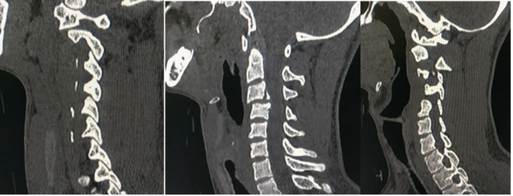 | 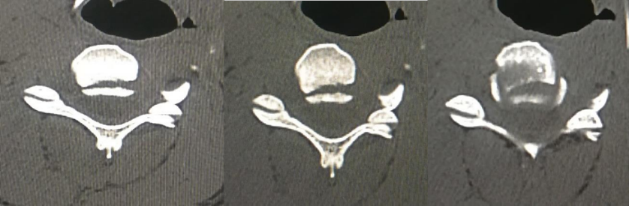
A | B
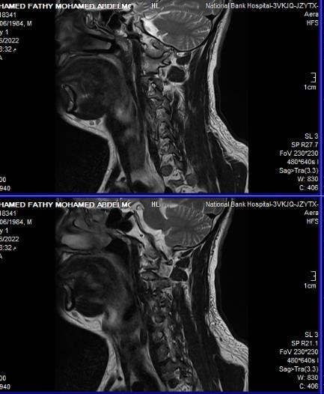 | 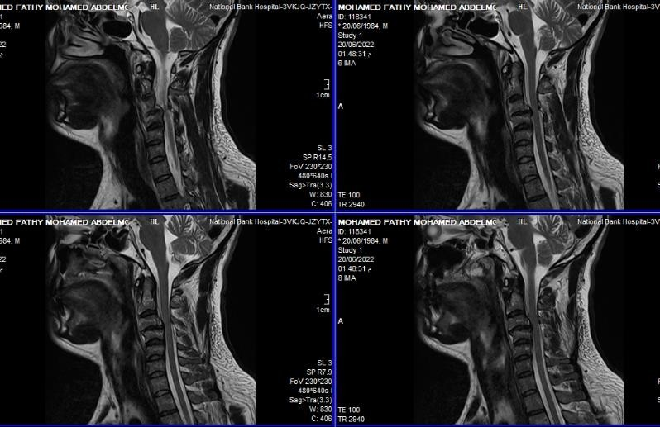
C | D
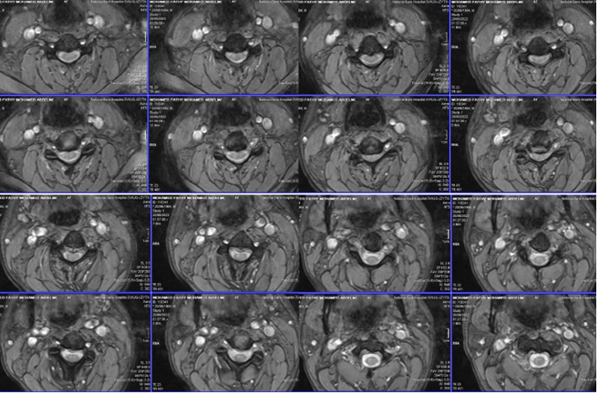
E
Figure 1: Preoperative CT cervical spine (A- Rt parasagittal, - Midsagittal, and- Lt parasagittal,(B)- Axial view, c(C)Preoperative T2 WI MRI cervical spine (A- Lt parasagittal,( D)- Midsagittal, (E) Rt parasagittal, D- Axial) views
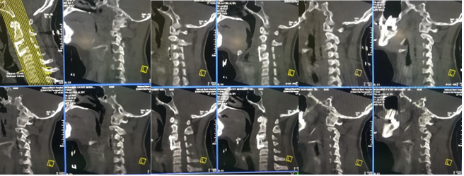
A |  | B |  | C
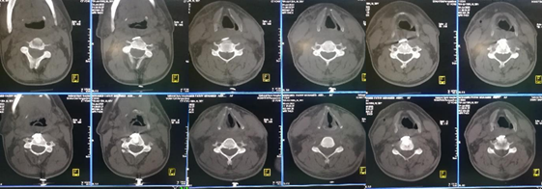
D
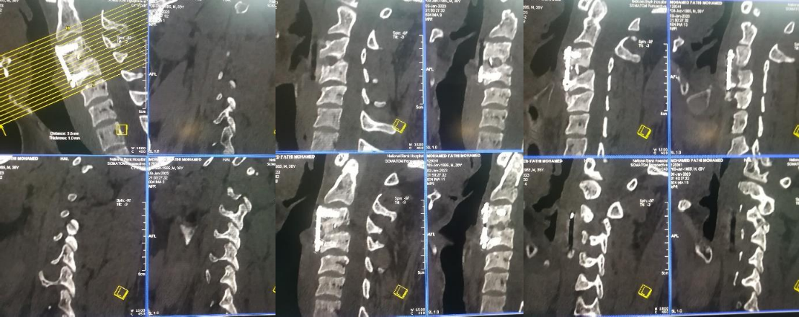
E | F |  | G
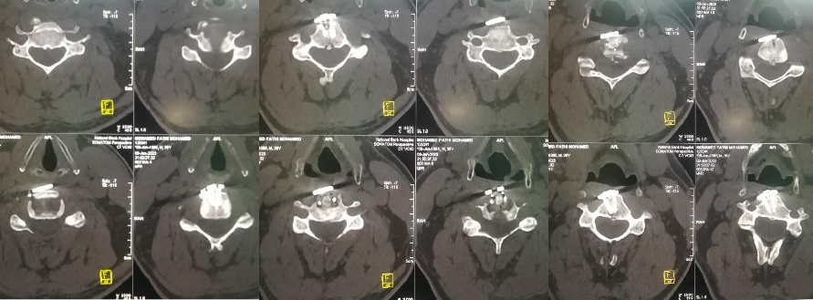
H
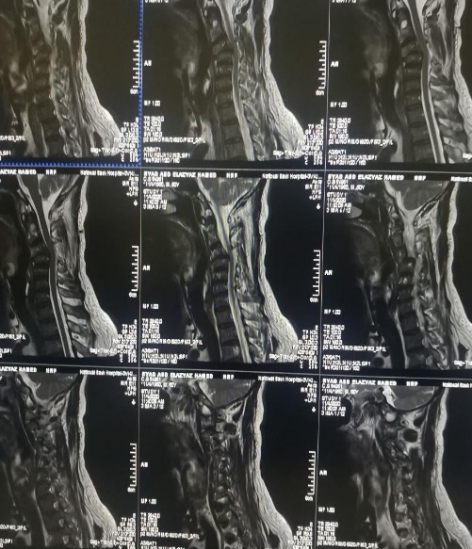 |  | 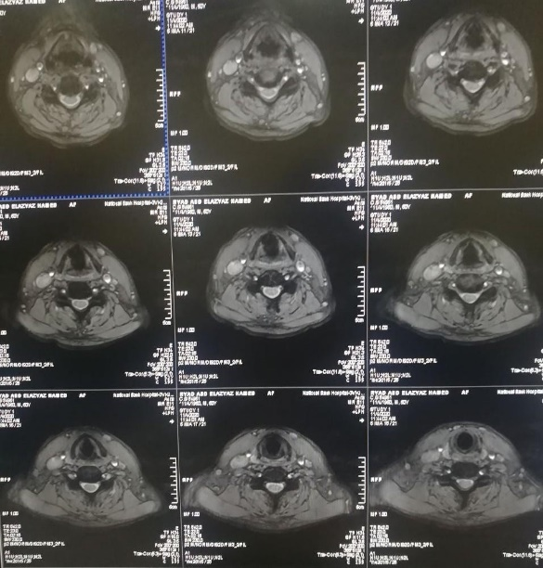
I
Figure 2: Postoperative CT cervical spine (A- Lt parasagittal, B- Midsagittal, C- Rt parasagittal D- Axial, and Follow up CT cervical spine after 6 months E- Lt parasagittal,( F)- Midsagittal, (G) Rt parasagittal( H)- Axial) views, (I) Preoperative MRI cervical spine (A- sagittal, B- Axial) veiws

Discussion
In the spinal column, the cervical spine is the most frequently injured and most vulnerable spinal segment. In this study, among 52 cases, Males comprised the majority (44 males and 8 females, with a female-to-male ratio of 1:5.5)., and the average ages of patients in this study were in the 4rh decade of life (38.5%), ranged from 11 to 60 years
This aligns with a study by Younis et al, ^{[1]} Male were predominant also in several investigations on sub-axial cervical locked facet as in study on 10 patients (7 male versus 3 females), and the cases ranged in age from 18 to 50 years (average 34.75 years).
The most frequent cause of trauma in this study was traffic accidents, which accounted for 36 patients' admissions (69.2%), which is much greater than the rates of other trauma modes (such as falling from a height or hitting one's head with a heavy object).in Du Toit and Dunn, ^{[2]} study, 26 patients were involved in motor vehicle accidents (72%), 5 were injured in falls (13.88%), 4 in sports or diving accidents (11%) and one was due to assault. In Ordonez et al, ^{[3]} study Two patients suffered injuries in a fall, while eight patients were engaged in auto accidents.
Spinous discomfort and neck pain were present in every subject in this investigation. There were 50 (96.2%) individuals with neurological symptoms, which was significantly more than the 2 (3.8%) patients who were neurologically intact.
Neurological manifestations including sensory, motor and visceral manifestations all neurologically affected patients 50 (96.2%) have sensory manifestations, 46 (88.4%) have sensory and motor manifestations & less number 22 (42.3 %) have sensory, motor and visceral manifestations .
In 46 individuals, motor affection was present (88.4%). Compared to other motor manifestations such as upper monoparesis in 12 patients (23.1%), upper diparesis in 2 patients (3.8%), and quadriplegia in 10 cases (19.2%), quadriparesis was more common in 22 individuals (42.3%).
All (24) bilateral cases presented with sensory & motor affection. In between them the commonest motor manifestations was Quadriparesis 12 (50%). While in unilateral cases (28) were either neurologically intact 6 (21.4%), mono-paresis 12 (42.9%) or quadriparesis 10 (35.7). The sensory & motor affection is higher in occurrence & severity in bilateral than unilateral cases with statistically significant value (P = 0.014, P >0.001), bilateral cases also associated with higher percentage of sphincteric disturbance (83%) while only (35.7) of unilateral cases have sphincteric disturbance, with statistically significant value (P = 0.001) .
Preoperative neurological evaluation in the trial was based on whether or not SCI symptoms were present. While 38 patients (73.1%) exhibited SCI manifestations of them (10 (6.3%), 4 (10.5%), 12 (31.6%), and 12 (31.6%) with ASIA grades A, B, C, and D, respectively, 14 patients (26.9%) did not have SCI signs (2 (3.8%) intact & 12 (23.1%) with root injury).. Half patients with unilateral facet dislocation presented without SCI manifestations 14 (50%), twelve of them have root injury manifestations and two are neurologically intact. While all bilateral cases 24 (100%) presented with SCI manifestations 10 patients (41.7%) with ASIA impairment grade A, 4 patients (16.7%) with grade B & C, 6 patients (25%) with grade D.
More severe neurological injury is associated with bilateral facet dislocation in statistically significant value. (P > 0.001).
In Sahoo et al, ^{[4]} found that 15 patients (80%) had complete SCI (ASIA grade A) and 15% had incomplete SCI whereas no neurological deficit was noted in one patient had
In Nakashima et al, ^{[5]} study, preoperative ASIA grades were A, 25 cases; B, 1 case; C, 5 cases; D, 6 cases; and E, 3 cases. In this study all patients undergo radiological investigations CT cervical spine with 3D reconstruction. If facet sub-laxation or dislocation is documented radiologically, The MRI was conducted to address soft tissue disruption, cord condition, and interbody disc, as the C6-7 level was the most frequently injured level in 22 patients (42.31%). followed by C5-6 in 15 (30.77%), while C3-4 was the least affected level in 6patients (11.54%).
in Park et al, ^{[6]} study C6-7 level also was most affected level in literatures as , 10 patients injured at the C6–7 level and other levels were as follows: 4 at the C3–4; 2 at the C4–5; 5 at the C5–6.
Bilateral facet dislocation patients were marginally outnumbered by patients with unilateral facet injury in this study (53.8% versus 46.2%, respectively).
Park et al, ^{[6]} reported that unilateral facet dislocation outnumbered bilateral facet dislocation (16 and 5 respectively)
in our study the highest SLIC score (10) was associated with the higher percentage of mean anterior translation (54.5%) & the least SLIC score in our study (5) as associated with the least percentage of mean anterior translation (8.5%) with statistically significant value (P > 0.001) . Bilateral facet dislocation was associated with higher SLIC scoring while unilateral cases was associated with lower scores with statistically significance (P >0.001) .
Belirgen et al ^{[7]}The conclusion was reached that posterior cervical fixation involves a greater number of fused segments in patients with reducible cervical sub-axial locked facet. Significantly reduced blood loss and shorter operative periods are associated with anterior surgery. This subgroup of patients may benefit from anterior instrumentation with interbody transplantation as their initial treatment option for stabilization. The indication for posterior surgery is the presence of failure on radiographs following anterior instrumentation..
In this study no intraoperative complications recorded (Dural teat, tracheal or esophageal injury, nerve root or spinal cord injury, vagal nerve injury, recurrent laryngeal nerve injury or vascular injury "carotid artery, jugular vein, vertebral artery"). Regarding postoperative complications, temporary dysphagia occurred in 6 patients (11.5%) and disappeared in 2 to 5 days postoperative, 4 patients (7.7%) have system
failure, 2 (3.8%) have temporary paraparesis. No statistically significant difference in occurrence of post-operative complications between different approaches (P = 0.077), anterior approach has the least percentage of incidence, only 6 of 34 patients (17.6%), both posterior & combined approaches are associated with higher incidence rate (33.3%) .
In Reindl et al, 2006 ^{[8]} study, one patient had a transient neurological deterioration. At the most recent follow-up, 20% of patients experienced persistent moderate to severe neck pain, while 20% experienced transient dysphagia postoperatively..
Belirgen et al, ^{[7]} Only four (12%) patients experienced surgical complications. Two patients experienced transient hoarseness and dysphagia that resolved on follow-up, while one patient experienced implant failure and required additional posterior stabilization within one week. The anterior group consisted of three patients. In one case in the posterior group, a hematoma developed in the surgical site and necessitated evacuation.
The study included 14 patients who did not exhibit symptoms of SCI.No deterioration detected of preoperative intact patients (2) and improvement of the (12) patients with preoperative root manifestations to be intact. Other 36 patients with initial SCI manifestations After 3 months of rehabilitation 2 patients (20%) of home received ASIA grade A progressed to grade B, 4 patients (40%) didn’t improve, 4 patients (40%) die, the 4 patients (100%) home received grade B improved to receive grade D. 8 patients (66.7%) of home received grade C improved to grade E & 4 (33.3) to grade D. All 12 patients (100%) home received grade D improved to grade E .
Twelve (42.9%) of cases with unilateral facet dislocation & 8 (33.3%) of cases with bilateral facet dislocation had regained full neurological functions to have ASIA grade E, this is significant statistically (p < 0.001) .
Younis et al, , ^{[1]} on their study on 10 patients with single level cervical locked facet, treated with anterior approach. Neurological function that was present prior to surgery did not decline. A subsequent clinical evaluation demonstrated enhancements in three of the following: A critical factor to consider when selecting an approach is sagittal alignment in the cervical vertebrae. The normal physiologic lordosis is typically lost as a consequence of cervical injuries, and the cervical spine is more susceptible to kyphosis..
This was also demonstrated in the study conducted by Belirgen et al. ^{[7]} at the six-month follow-up; patients who were treated anteriorly exhibited a greater degree of lordosis than those who were treated posteriorly. This was statistically significant. Instrumentation failure occurred in only four of the patients analyzed, and there was no malalignment during the postoperative radiological follow-up.
Younis et al, , ^{[1]} in their study. The subsequent radiological evaluation demonstrated that all patients had a reasonable alignment of the spine and had experienced a successful reduction..
Early mortality was recorded in 2 patients (3.84%) both of them (100%) received ASIA grade A pre & post operatively .
Follow up showed late mortality of 8 patients (15.38%), also all of them (100%) with ASIA grade A pre & post-operative with statistically significance (P value > 0.001). Total mortalities of patients operated via combined approach after 6 months was 4 (33.3%), 4 (12.5%) of patients operated via anterior approach, no mortalities in patients operated via posterior approach, this is statistically significant (P = 0.049).
In Younis et al, , ^{[1]} study. The respiratory failure that resulted from diaphragmatic paralysis that was present prior to the procedure fatally affected one patient..
In Sahoo et al, ^{[4]} In-hospital mortality was 26% (5/19), while overall mortality was 37% (7/19).
Thietje et al, 2011^{[9]}, examine the causes of death in 100 patients who were ≤50 years old at the time of traumatic spinal cord injury, with 38 and 62 surviving for <10 and ≥10 years, respectively. Septicemia (n = 14) and ischemic heart disease (n = 10) were the primary causes of mortality.

Conclusions
Flexion-distraction injuries of the sub axial cervical spine comprise a broad spectrum of injury ranging from mild axial neck pain to complete SCI. Surgical approaches include, Anterior, posterior, or combined approaches. all approaches are safe and sufficient in reduction and fixation of the dislocated facets with very close clinical and radiological successful rates.
When selecting an approach, it is crucial to consider the sagittal alignment of the cervical vertebrae.

References:
1. Younis WA, Maaty HI, Adawi MM. The Techniques of Ventral Reduction and Stabilization for Cervical Facet Dislocation: Early Experience and Review of Literature. 2015.
2. du Toit AB, Dunn R. Bifacet dislocations of cervical spine: acute management and outcome. SA Orthopaedic Journal. 2008;7:30-6.
3. Ordonez BJ, Benzel EC, Naderi S, Weller SJ. Cervical facet dislocation: techniques for ventral reduction and stabilization. Journal of Neurosurgery: Spine. 2000;92:18-23.
4. Sahoo SS, Gupta D, Mahapatra A. Cervical spine injury with bilateral facet dislocation, surgical treatment and outcome analysis: A prospective study of 19 cases. The Indian Journal of Neurotrauma. 2012;9:40-4.
5. Nakashima H, Yukawa Y, Ito K, Machino M, El Zahlawy H, Kato F. Posterior approach for cervical fracture–dislocations with traumatic disc herniation. European Spine Journal. 2011;20:387-94.
6. Park JH, Roh SW, Rhim SC. A single-stage posterior approach with open reduction and pedicle screw fixation in subaxial cervical facet dislocations. Journal of Neurosurgery: Spine. 2015;23:35-41.
7. Belirgen M, Dlouhy BJ, Grossbach AJ, Torner JC, Hitchon PW. Surgical options in the treatment of subaxial cervical fractures: a retrospective cohort study. Clinical neurology and neurosurgery. 2013;115:1420-8.
8. Reindl R, Ouellet J, Harvey EJ, Berry G, Arlet V. Anterior reduction for cervical spine dislocation. Spine. 2006;31:648-52.
9. Thietje R, Pouw M, Schulz A, Kienast B, Hirschfeld S. Mortality in patients with traumatic spinal cord injury: descriptive analysis of 62 deceased subjects. The journal of spinal cord medicine. 2011;34:482-7.

