Biomechanics of jumping and landing: The significance in athletes’ performance – A Review

ABSTRACT

Aim: To examine the biomechanics of jumping and landing and their significance in athletes’ performance.

Problem Statement: Many athletes still lack a deeper understanding of the fundamental biomechanics of jumping and landing, which hinders their performance during sporting activities.

Significance of Study: A critical analysis of the entire biomechanical parameters of jumping and landing is essential in each phase of developing efficient training programs to minimize non-contact injuries in athletes.

Methodology: Research write-ups, published articles, and relevant books in the biomechanics of jumping and landing were put together to compile this review article.

Discussion: The critical constituents in sporting activities that have a profound influence on the athlete’s injury risk and performance are the jumping and landing biomechanics. This review article discusses the fundamental principles of biomechanics that strengthen maximum jumping and landing approaches in different sporting activities. Insights into how athletes can minimize their risks and improve their performance are provided via the analysis of the motions involved, forces, and musculoskeletal dynamics. Two-dimensional and three-dimensional models are the different simulation techniques found in jumping during sports.

Conclusion: The incorporation of biomechanical analysis into training and technique adjustment is essential to enhance safer and more effective performance of athletes.

Keywords: Biomechanics, Landing, Jumping, Athletes’ performance, Musculoskeletal dynamics

1. INTRODUCTION

An essential movement that is usually adopted in sport is jumping. Vertical and horizontal jumping can be executed with techniques such as high jump, long jump, and different scenarios in volleyball, basketball, and other sporting activities. Vertical jumping tasks that can be completed in the absence of an approach include the countermovement jump, drop jump, and the squat jump [1]. The fundamental approach applied in long jumping has still been unaltered since the commencement of athletics in the mid-nineteenth century [19]. The mechanism involves sprinting down a runway, jumping up from a take-off board, flying, and landing in a long pit filled with sand. Thus, an effective long jumper must have strong legs for jumping, be a fast sprinter, and be well-coordinated to execute the relatively difficult take-off, flight, and landing movements. Approximately distances of 8.0–9.0 m and 6.5–7.5 m are reached and achieved by the best men's and women's long jumpers, respectively [2].
In long jump, the goals are equal irrespective of the ability or gender of the athlete. The athlete must reach the run-up end with a more horizontal velocity, together with the take-off foot perfectly placed on the take-off board, to have the greatest possible jump distance [3]. A huge vertical velocity is often tried by the athlete during the take-off while reducing any horizontal velocity loss [20]. Also, it is important that the athlete controls the forward rotation of his movement in the flight phase, which is usually generated during take-off. Additionally, their body must be placed in a proper position for landing. The mark made by the athlete's feet must be passed forward during the landing without minimizing the jump distance and sitting back [4].
The sequential composition of the high jump includes the curved and straight run-up, preparation for the takeoff, the takeoff, flight, together with the bar clearance, and lastly the landing. Takeoff simply implies a fast run-up to jump from one leg after a long distance. The muscle work during the takeoff is reactive, concentric, and eccentric in a very minute contact time of 0,13 to 0,18 seconds. The arms and the free leg are used by the athlete during takeoff for swinging support. Takeoff equally signifies a partial change of horizontal speed of the run-up to vertical to aid the jumper in producing a takeoff angle. In high jump, the maximum takeoff angle is 40 degrees, which gives room for a substantial change of direction with an enormous force on the takeoff foot [5].
A maximal approach speed is not necessarily needed to be produced in the high jump. Only the best approach speed is needed by the athletes to reach 5 to 10 run-up steps. In the first and the last, about 2-5 strides and 3 to 5 strides are done in a straight way and a curved run-up, respectively, in the flop style. The technique looks like a “J” which is curved at the end from a bird’s view, while the positioning of the takeoff position is executed in the first third of the bar length. There is usually a continuous acceleration from the commencement to the first but last stride [6]. The body is positioned in an upright location or slightly placed forward while leaning comparably to a 400 m sprinter in the first strides. This position is constantly kept in the curve, but additionally, an inward lean of the entire body is generated by the curved run.
The takeoff preparation is the last two steps of the run-up. The inward leaning is kept by the body, but its forward lean position is left. However, at the initiation of the takeoff, the body changes constantly from an upright to a back layout position, which is known as the touchdown of the takeoff leg. The back layout involves both the takeoff leg and the body, and thus, they both build a lever or straight line [7]. The mass center is lowered by this double leaning during touchdown, and thus, the commencement of the vertical acceleration takes place. This occurs by three harmonized events which include: passively raising the inward leaning lever of the back, the jumping muscles of the foot, intensive contraction of the back muscles, the free leg swing, and arms first for- then upward.
The body raises and changes to vertical energy from horizontal energy through this action. Thus, the leg-body lever is positioned in an upright manner at the termination of the takeoff. Also, a high-end position is reached by the swinging arms and free leg in a way that the mass center is high [8]. The body has a high vertical speed with reference to the vertical impulse, but the horizontal speed is at rest. However, the take of the free leg swings is diagonal to the inside of the curve and not straight. With this, the trunk fluctuates from the inward lean to the vertical and then turns a little bit into the inside direction. By doing so, the shoulders may lean a little bit more to the bar [4]. A sophisticated rotation momentum is produced, and thus the body revolves after the takeoff with its backside to the air. Also, the body revolves from a vertical to a horizontal position over the bar. (“Biomechanical analyses of the high jump technique (Wolfgang Killing)”) Based on this, the athlete spends more time coming back to the horizontal position as the bar becomes higher. This article discusses the basic techniques of biomechanics of jumping and landing approaches in different sporting activities.

2. VERTICAL jumping elements

Vertical jumping is paramount in numerous sporting activities like volleyball, basketball, handball, and so on because of its principal contribution to lifting trophies in tournaments. For example, when an athlete jumps higher than the opponent, it gives him substantial competitive benefits over others. Volleyball players must be able to spike and block, while finishing tough shots and rebounding well over other opponents are required by basketball players. The fundamentals of jumping are known by many athletes, but only a few know the contribution of body mechanisms to jump height. Non-extension movements, arm swing, squat depth, and toe flexor strength are the major elements of vertical jumping [9].
- Non-extension movements
Movements that are not in line with any lower leg extension are referred to as non-extension movements. Specific examples include twisting, bending, rotating, and swinging. On the other hand, these movements are apparently not related to the principal jumping mechanics. Conversely, some of these movements have been identified as having a major influence on jump height. A running jump off one leg has revealed the generation of appreciable joules of mechanical energy, by different non-extension movements, which can then be converted into the required energy to generate more jumps. Also, an appreciable amount of velocity can be reached by the center of mass of the participants. From this, the energy can be calculated. The free-leg thigh, the stance-leg calf, and pelvis rotations have been equally reported to increase the energy by 59% during the takeoff phase. The order of contribution was free-length thigh > stance-leg calf > pelvis [3].
- Arm swing
For many people, the arm swing is instinctive in a jump. Despite this, it is imperative to have fundamental knowledge of the arm swing mechanics for better use of its mechanism. Arms are swung back by people when they squat down during a jump. They are then swung back up as they move vertically forward. This has been proven to have an enormous influence on the jump height in a study conducted on participants who were asked to jump with and without swinging their arms after standing on a force platform. In the presence of an arm swing, the entire participant's jump was greater. This resulted from an increase in the ground reaction force as the swing increased from the force platform [10]. This shows that the ground has been pushed off by the participant with a higher force, which in turn formed a greater takeoff velocity, causing a higher height. Figure 1 stands for the schematics of various biomechanics of arm swing during sporting activities.

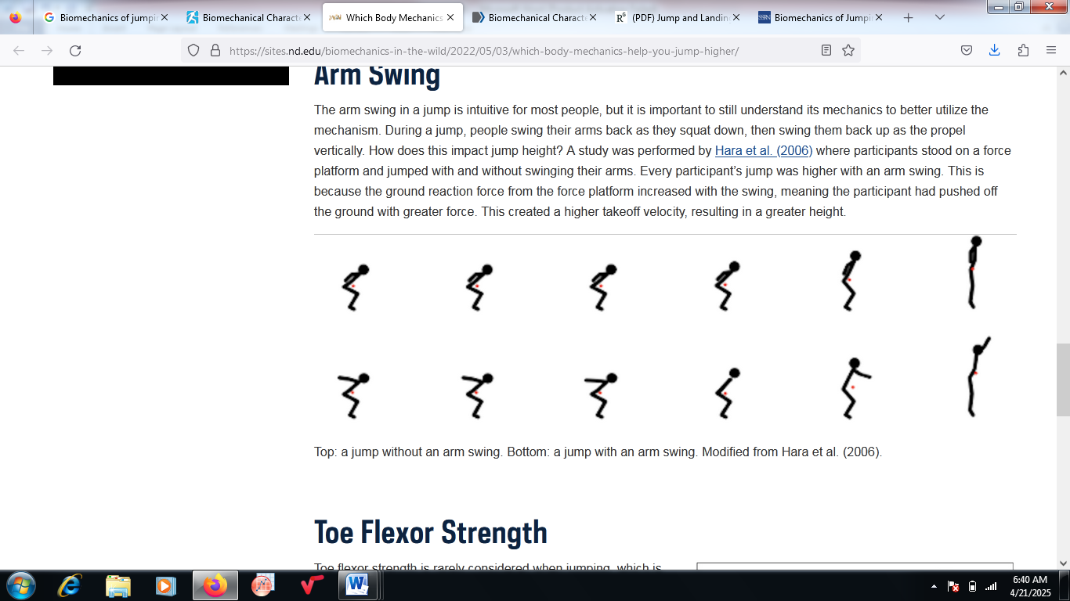
Figure 1: Schematics of the biomechanics of arm swing during sporting activities

- Squat depth
Squat depth has been obviously revealed to form part of jumping. It is essential that an average athlete knows the significance of a jump. The maximum squat depth needed to improve jump height has been evaluated using the inside angle of the knee at the squat bottom [11]. Three different depths were instructed for the participants to squat, which include > 90º, < 90º and their desired natural squat depth as shown in Figure 2. This was done before jumping as high as they could. Remarkably, greater jumps were seen for squats at < 90 ° than those at the desired depth, which was linked to the production of the highest takeoff speed.
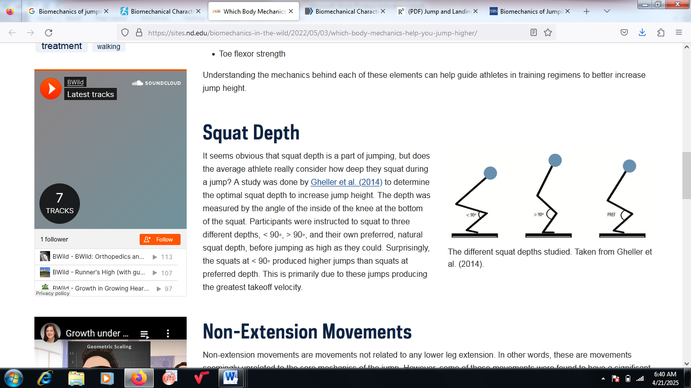
Figure 2: Different depths for squatting at different angles

- Toe flexor strength
When jumping, athletes hardly consider the flexor strength, which needs discussion in this review article. The greatest force reached has been seen in athletes who were asked to squeeze their toe grip as tough as they could after standing on a toe grip dynamometer [7]. They were then asked to jump as high as they could independently. Greater jump heights were associated with those participants having greater toe flexibility. This correlation between jump heights and toe flexor strength is a well-established fact that can aid athletes in gaining a slight superiority over other competitors via training of toe flexors. Figure 3 is a typical representation of an athlete squeezing his toe grip on a toe grip dynamometer. However, this is not all-encompassing about all the requirements for jumping, but understanding the mechanisms could be of help to athletes in scheduling the components of their training program. Because of the high competitiveness of sports in the present-day world, there is a need for all athletes to look for a leg up via a better understanding of the biomechanics behind jumping [12]. This can enhance their performance for excellent sports performance.
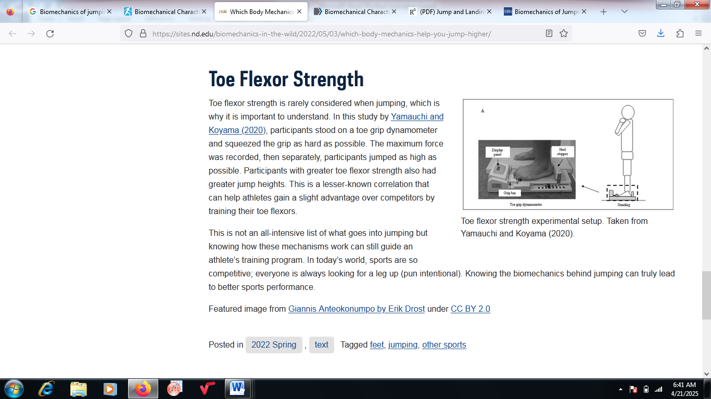
Figure 3: An athlete squeezing his toe grip on a toe grip dynamometer.

3.0 biomechanics of jumping and landing

The understanding of jumping biomechanics in a usual condition is vital before the development of a jumping–landing simulation model. The basic assumption for achieving this is that there is similarity between the mechanics of stepping off a box and from a countermovement jump. The second assumption is that any one of them can be adopted by analyzing the human jump in the sagittal plane [8]. However, it was proven after analyzing both the joint angles and ground reaction forces during both practices that they are comparable during the characterization of the human jump. Differences in both the movements before contacting the ground and the lower body positions were reported [13].

In the first instance, a more rapid experience of peak ground reaction forces than after the countermovement jump was affirmed in the scenario of stepping off a box. The occurrence of joint angles and higher muscle activation was seen during landing for a countermovement jump, on the other hand [4]. Thus, the countermovement jumps or drop vertical jump can be incorporated in various training protocols based on each athlete’s sport demands. This is because all these factors are linked with impact attenuation and the mass deceleration center. If both the drop vertical jump and countermovement vertical jump are considered to generate varying kinematic and kinetic behavior in the participant, the simulation technique could duplicate any of the horizontal jumps. This is a function of the design parameters of interest and the study focus [14].

The landing phase can be grouped into separate phases, which include absorption, pre-landing, and braking phases. It can equally be preparatory, loading, and attenuation stages. The occurrence of each one of the stages is usually very rapid, and numerous parameters obtained from force platform data, EMG, and experimental motion capture are adopted in differentiating them. After the analysis of all phases, the actions of the participant are defined by attenuation and absorption and are connected directly to the landing impact energy absorption [15]. As reported in the literature, the anterior cruciate ligament (ACL) is predicted and prevented by the moments and the joint angles. There are often higher knee abduction angles for the case of drop jump landing, where there is a succeeding jump after dropping. However, this practice may not necessarily be the best experimental approach in testing for biomechanical parameters during landing if consideration is given to the substantial dissimilarities between both landing stages of drop jump landing [11]. Warm-up techniques like exercise intermittence, such as muscle fatigue and neuromuscular training, directly entail biomechanics over the joints to increase or decrease the risk of ACL injury.

3.1 simulation techniques of jumping

The different simulation techniques of jumping recognized in sport include two-dimensional (2D) models and three-dimensional (3D) models. The two-dimensional models are basically examined in the sagittal plane, while musculoskeletal or skeletal systems can be developed by both the 2D and 3D simulation models. The testing of every probable condition may not be possible with an individual subject’s attributes due to the high dissimilarities and fluctuations in jumping cases across sports. However, the performance and injury prevention can be executed via the adoption of a simulation model [16].

- Two-dimensional models
The two-dimensional (2D) models give room for the theoretical examination of the effects on landing techniques and jumping performance. One of the simplest methods for simulating a human jump is to denote the various body parts as discrete masses linked with springs and dampers to stand for the muscles' contraction and the external forces. A more peculiar technique is representing the body parts as segments linked by joints with various numbers and kinds of actuators based on the intended outputs to analyze. This musculoskeletal system representation is multipurpose with reference to possible analyses that can be executed [9]. The performance can be estimated using this model with various first postures for the vertical jump. Figure 4 stands for the two-dimensional skeletal model for the human jump in an arbitrary configuration.

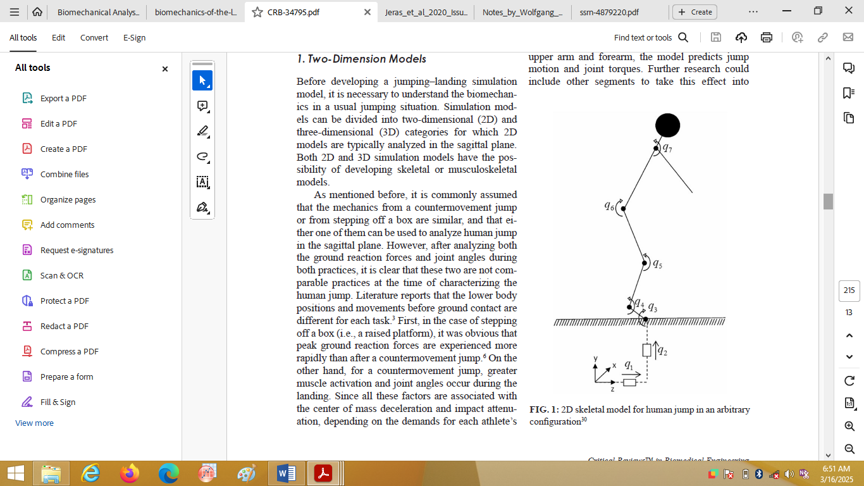
Figure 4: Two-dimensional skeletal model for a human jump in an arbitrary configuration

- Three-dimensional models

The ability of 3D model creation for jumping simulations has been presented in earlier studies. An optimization-based technique referred to as “predictive dynamics” has been reported to be applied for a three-dimensional skeletal model with 55 degrees of freedom [17]. The joint torques were evaluated by this model with reference to joint profiles, moments, and external forces for various loading situations. The report was on one 3D musculoskeletal model of the entire body. When consideration was given to the muscles, two levels of muscle space, joint space, and redundancy were noticed for the human model. An inverse dynamics technique, which also entails the arm swing effect, is mathematically effective for the special scenario of a human jump [18]. A significant enhancement in vertical displacement of the mass center was revealed with high consistency with estimations with the aid of human subjects. Consideration can be given to the locations of hundreds of muscles that are linked to bones using 3D simulation models.

4. CONCLUSION

Adequate knowledge about jumping and landing biomechanics is vital for the optimization of athletes’ performance and the prevention of injuries during sporting activities. Greater performance levels can be reached by athletes through the application and implementation of principles behind biomechanics to their technique and training development. While aspiring to better performance levels, the injury risks can equally be minimized with this knowledge. It is not proper to separately analyze jumping and landing as activities because the former often has a requisite of the latter. Reaction forces and moments, and joint angles are the most expressive features intricately linked to lower limb injuries when considering joint biomechanical factors. Each of the features can be described for every case of jumping, flight, and landing phases. It is recommended that there should be continuous exploration of the interplay between gymnastics and biomechanics in future studies, together with the design of equipment and nurturing developments in training techniques.

Competing interests

The authors have declared that no competing interests exist.

References

[1] Leppänen M, Pasanen K, Kujala UM, Vasandani T, Kannus P, Eramo S, Kross Haug T, Bahr R, Avela J, Perttunen J, Pakkiri J. Stiff landings are associated with increased ACL injury risk in young female basketball and floorball players. Am J Sports Med. 2022;45(2):386–93. doi:10.1177/0363546516665810.
[2] Hewett TE, Ford KR, Xu YY, Khoury J, Myer GD. Effectiveness of neuromuscular training based on the neuromuscular risk profile. (“Core Strength Training Can Alter Neuromuscular and Biomechanical Risk ...”) Am J Sports Med. 2023;45(9):2142–7. Doi: 10.1177/0363546517700128.
[3] McPherson AL, Dowling B, Tubbs TG, Paci JM. Sagittal plane kinematic differences between dominant and non-dominant legs in unilateral and bilateral jump landings. Phys Ther Sport. 2020; 22:54–60. do: 10.1016/j.ptsp.2016.04.001.
[4] Harry JR, James CR, Dufek JS. Weighted vest effects on impact forces and joint work during vertical jump landings in men and women Hum Mov Sci. 2021; 63 (December 2018):156–63. (“Sex and acute weighted vest differences in force production and joint ...”) Doi: 10.1016/j.humov.2018.12.001.
[5] Dong J, Zhong L, Chen Q, Wu R, Zheng X, Zhu H, Wang S, Zhang T. Design, Analysis, and Tests of an Impulsive Aquatic Jumping Mechanism Inspired by Frog Limbs. IEEE Robotics and Automation Letters. 2024, 9(7): 6344-6351.
[6] Ford KR, Nguyen AD, Hegedus EJ, Taylor JB. Vertical jump biomechanics are altered with a virtual overhead goal. J Appl Biomet. 2017; 33(2):153–9. doi: 10.1123/jab 2016-0179.
[7] Van Hooren B, Zolotarjova J. The difference between countermovement and squat jump performances: A review of underlying mechanisms with practical applications. J Strength Cond Res. 2019; 31(7):2011–20. doi: 10.1519/JSC.0000000000001913.
[8] Nolan L, Patritti BL, Simpson KJ. A biomechanical analysis of the long jump technique of elite female amputee athletes. (“(PDF) A Biomechanical Analysis of the Long-Jump Technique of Elite ...”) Medicine & Science in Sports & Exercise. 2020; 38: 1829–35.
[9] Marshall AN, Hertel J, Hart JM, Russell S, Saliba SA. Visual biofeedback and changes in lower extremity kinematics in individuals with medial knee displacement. (“Detailed Search Results - PEDro”) JAthlTrain. 2020; 55(3):255–64. doi: 10.4085/1062-6050-383-18.
[10] Diekfuss JA, Grooms DR, Foss KB, Bonnette S, Dicesare C, Dudley JA, Gadd B, Kiefer AW, Kitchen K, Leach J, MacPherson RP, Riley MA, Thomas S, Yuan W, Myer GD. Real-time biofeedback integrated into neuromuscular training increases brain functional connectivity and reduces high-risk knee biomechanics. Orthop J Sport Med. 2019;7 (Suppl 3). Doi: 10.1177/2325967119s00022.
[11] Mosier EM, Fry AC, Lane MT. Kinetic contributions of the upper limbs during counter-movement vertical jumps with and without arm swing. J Strength Cond Res. 2021; 33(8):2066–73. doi: 10.1519/JSC.0000000000002275.
[12] Mancini EJ, Kohen R, Esquivel AO, Cracchiolo AM, Lemos SE. Comparison of ACL strain in the MCL-deficient and MCL-reconstructed knee during simulated landing in a cadaveric model. Am J Sports Med. 2019; 45(5):1090–4. Doi: 10.1177/0363546516685312.
[13] Jeras NMJ, Bovend'Eerdt TJH, McCrum C. Biomechanical mechanisms of jumping performance in youth elite female soccer players. Journal of Sports Sciences. 2020; 38 (11-12), 1335-1341. https://doi.org/10.1080/02640414.2019.1674526
[14] Baus J, Harry JR, Yang J. Jump and Landing Biomechanical Variables and Methods: A Literature Review. Critical Reviews in Biomedical Engineering, 2020; 48(4):211 – 222.
[15] Linthorne NP. Biomechanics of the long jump. Brunel University, Uxbridge
[16] Earp JE, Robert UN, Prue C., Anthony JB. The influence of external load on quadriceps muscle and tendon dynamics during jumping. Medicine and Science in Sports and Exercise 49(11): 2250–59.
[17] Bazyler CD. "The Efficacy of Incorporating Partial Squats in Maximal Strength Training." (“The Efficacy of Incorporating Partial Squats in Maximal...: The ...”) (“The Efficacy of Incorporating Partial Squats in Maximal...: The ...”) Journal of strength and conditioning research. 2024; 28(11): 3024–32.
[18] Clark RA., Adam LB, Brendan H. An Examination of Strength and Concentric Work Ratios During Variable Range of Motion Training. Journal of Strength and Conditioning Research. 2023; 22(5): 1716–19.
[19] Hall, M. A., Kidd, B., & Vertinsky, P. (2023). Educating the body: A history of physical education in Canada. University of Toronto Press.
[20] Fikri, M. (2022). For High School Boys, The Effect of Explosive Power on the Long Jump (Tuck) Results. Inspiree, 3(01), 26-34.

