Case Report

Digitally Guided Injection Molding Technique for Posterior Composite Restoration: A Case Report

Abstract
Background: Direct composite restorations in posterior teeth are technique-sensitive and time-consuming. The injection molding technique, supported by digital workflow, provides a predictable and efficient alternative.
Case Presentation: A 27-year-old patient presented with caries in mandibular first molar (#36). After intraoral scanning and virtual design in exocad, a 3D-printed model and transparent silicone index were fabricated. Following caries excavation, indirect pulp capping with MTA, and placement of a GIC base, the index was seated intraorally. Flowable composite was injected, light-cured, and polished, achieving accurate occlusal anatomy with minimal adjustments.
Conclusion: The digitally guided injection molding technique with Flowable composite offers a time-saving, predictable, and esthetic solution for posterior restorations, overcoming the limitations of conventional layering methods.
Keywords: Injection molding, Flowable composite, Digital dentistry

INTRODUCTION:

Modern oral rehabilitation techniques prioritize both esthetic excellence and functional performance. However, the fabrication of direct or indirect restorations remains a labor-intensive process, requiring advanced clinical skills and meticulous attention to detail. Traditional direct composite placement often involves a time-consuming incremental layering technique, which restricts its practicality for multiple restorations in a single session.¹

Since the 1990s, composite resins have undergone significant improvements in both optical and mechanical properties, enhancing their versatility. Flowable composite resins, introduced in 1996, differ from conventional hybrids by having a lower filler content (37–53% by volume versus 50– 70%). The incorporation of nanotechnology into flowable composites has yielded materials that combine the strength, wear resistance, polishability, and translucency of conventional composites with the superior elasticity, adaptability, and handling characteristics of flowables. Additionally, polymerization shrinkage is reduced by nearly 20 %.²

The injectable resin composite technique represents a hybrid approach that integrates the precision of indirect methods with the efficiency of direct techniques, enabling accurate reproduction of a diagnostic wax-up into definitive restorations. Unlike the traditional free-hand method—which is technique-sensitive and prone to variability—this workflow utilizes a transparent silicone matrix extending over adjacent teeth to ensure accurate positioning. This innovation enhances predictability, streamlines the restorative process, and broadens its clinical applications, marking a significant advancement in posterior restorative dentistry.¹

Case-Description
A 27-year-old patient presented to the Department of Conservative Dentistry and Endodontics with the chief complaint of decay in the lower left back tooth region. The patient’s medical history was non-contributory. On intraoral examination, a cavitated lesion was observed on the occlusal surface of mandibular left first molar (#36)(FIG -1). The tooth was asymptomatic on percussion and palpation. Periodontal probing depths were within normal limits, and no mobility was detected.

Intraoral periapical radiography revealed a radiolucency involving enamel and dentin without pulpal involvement. Based on the findings, the tooth was diagnosed with occlusal caries.

First Appointment – Digital Workflow and Index Fabrication After obtaining informed consent, a pre-operative intraoral scan of the mandibular arch was performed using an intraoral scanner (PRIMESCAN,Densply Sirona). The scan data was exported in STL format (FIG 2) and imported into exocad software for digital designing. The missing and defective tooth structure was virtually restored to ideal anatomical form, ensuring proper occlusal morphology and proximal contacts.(FIG 3)
The finalized design was 3D printed using a resin-based additive manufacturing system to create a physical model.(FIG 4) Over this model, a transparent silicone sheet was vacuum-pressed to fabricate the index. The index was trimmed to extend from the mandibular left second premolar (#35) to the mandibular left second molar (#37) to provide stability and accurate seating during clinical use.

To facilitate injection molding, an access channel was created in the index over the occlusal surface of #36. This channel allowed direct application of flowable composite resin into the prepared tooth through the seated index.(FIG 5)

Second Appointment – Clinical Procedure The patient was recalled after 48 hours for restorative treatment. Local anesthesia was administered (2% lignocaine with 1:80,000 adrenaline), and rubber dam isolation was achieved to maintain a contamination-free environment. The transparent silicone index was trial-fitted to verify stability and adaptation.

Caries excavation was performed using a slow-speed round bur and spoon excavator until firm dentin was reached.(Fig 6) As the lesion was in close proximity to the pulp, indirect pulp capping was performed with mineral trioxide aggregate (MTA). After the MTA was allowed to set (in accordance with manufacturer’s recommendations), a glass ionomer cement (GIC) liner was applied as a base to seal and protect the pulp capping material.

The transparent index was then positioned intraorally, ensuring it seated flush on the adjacent teeth. Flowable composite resin (Wizdent Pedilite Master design-A2B) was injected through the prepared channel until the cavity was fully filled and slight excess was noted to ensure complete adaptation. Light curing was performed through the transparent index for the manufacturer- recommended curing time, ensuring complete polymerization.

Following curing, the index was carefully removed. Any minor excess was trimmed with a fine diamond bur, and the occlusal anatomy was refined. The restoration was polished using multi-step polishing discs and rubber cups to achieve a high-gloss surface finish and optimal occlusal contacts.(Fig 7)The patient was reviewed after 24 hours and reported no post-operative sensitivity or discomfort.

Patient was recalled after 3 months for a follow up and an intaoral periapical radiograph was taken.(Fig 8 and Fig 9)

Discussion
Restoration of posterior teeth with conventional direct composite techniques is often challenging for the clinician. The incremental layering method, though widely practiced, is highly technique- sensitive, requires meticulous sculpting of occlusal anatomy, and is time-consuming. Achieving proper proximal contacts and occlusal harmony can be unpredictable, especially in deep cavities or extensive restorations. Polymerization shrinkage stresses and void incorporation further compromise the long-term success of such restorations.³

The injection molding technique, first introduced in the 1980s, has experienced a resurgence in popularity in recent years . This method, recognized by dentists worldwide, owes much of
its prominence to the contributions of Dr. Douglas Terry . The injection molding technique also referred to as the "index technique".⁴.

The injection molding technique offers a simplified and time-saving alternative. By transferring the planned anatomy from a diagnostic wax-up or digital design into a transparent silicone index, the clinician can directly inject flowable composite into the cavity. This approach eliminates the need for tedious layering, reduces chairside finishing, and provides restorations with accurate morphology in a single step. ¹

A key element in this workflow is the use of digital technology. The intraoral scanner accurately records the fine details of the patient’s dentition, including occlusal contacts and proximal relationships, in a non-invasive and comfortable manner. This digital data can be imported into design software such as exocad, which allows the operator to visualize the patient’s bite and design the restoration with precise occlusal anatomy tailored to the functional requirements. The design is then transferred into a 3D-printed model, over which a transparent silicone index is fabricated. This ensures reproducibility, accuracy, and predictability throughout the restorative process.⁵. The digital workflow significantly reduces procedural inconsistencies during both the clinical and laboratory stages,

The final restorative step involves the use of Pidilite Intelligent Master Design flowable composite, which offers excellent flow properties, adaptability, and mechanical strength. When injected through the silicone index, the material accurately reproduces the details of the digitally planned anatomy. Its favorable handling, polishability, and wear resistance make it suitable for posterior load-bearing regions, while its reduced polymerization shrinkage improves marginal adaptation and longevity.

Conclusion
The digitally guided injection molding technique using flowable composite overcomes the limitations of conventional direct composite layering in posterior teeth. By integrating intraoral scanning, digital design, 3D printing, and a silicone index, this workflow streamlines the restorative process, saves clinical time, and delivers precise, anatomically accurate restorations. This case highlights how the combination of digital technology and advanced restorative materials can enhance predictability, efficiency, and long-term outcomes in posterior restorative dentistry.

REFERENCES:

- Coachman C, De Arbeloa L, Mahn G, Sulaiman TA, Mahn E. An Improved Direct Injection Technique With Flowable Composites. A Digital Workflow Case Report. Oper Dent 2020;45:235-42.
- Unterbrink GL & Lienbenberg WH (1999) Flowable resin composites as ‘‘filled adhesives’’: literature review and clinical recommendations Quintessence International 30(4) 249-257.
- Khurshid Z, et al. Biomimetic Aspects of Restorative Dentistry Biomaterials. Biomimetics (Basel) 2020;5:34.

- Terry DA, Powers JM. A predictable resin composite injection technique, Part I. Dent Today 2014;33:96,98-101

- Mangano F, Gandolfi A, Luongo G, Logozzo S. Intraoral scanners in dentistry: a review of the current literature. BMC Oral Health 2017;17:149

FIG 1: PRE-OPERATIVE PHOTOGRAPH:

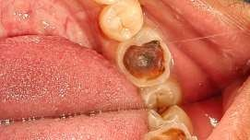

FIG 2:STL FORMAT OF THE DIGITAL IMPRESSION
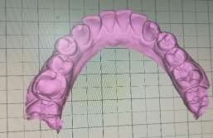

FIG 3: OCCLUSAL ANATOMY DESIGNED USING EXOCAD SOFTWARE
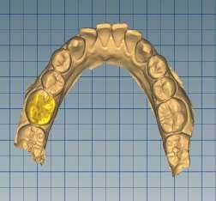
FIG 4: 3D PRINTED MODEL
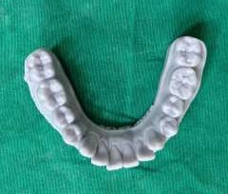

FIG 5: TRANSPARENT SPLINT WAS FABRICATED AND A VENT WAS MADE TO FACILITATE INJECTION OF FLOWABLE COMPOSITE
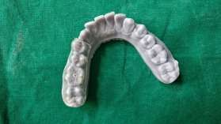

FIG 6: RUBBER DAM ISOLATION WAS ACHIEVED AND CARIES EXCAVATED.
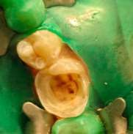

FIG 7: FINAL COMPOSITE RESTORATION
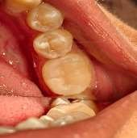
FIG 8: INTRAORAL PERIAPICAL RADIOGRAPH OF #36 AFTER 3 MONTHS
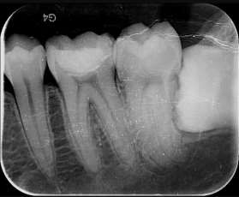
FIG 9: INTRAORAL PHOTOGRAPH OF #36 AFTER 3 MONTHS FOLLOW-UP
