Macro and Micro Morphological Study of Three Species of the Genus Datura Collected from Tutti Island, Khartoum, Sudan

Abstract
This study aimed to inventory the macro and micro features of three species belong to the genus Dtura in Sudan. Macro morphological features are observed and listed. Microscopic characteristics are investigated using light microscope (Leica DM 750) equipped with a Qwin system and video camera (Leica ICC50 HD). The obtained macro-features provided descriptive power that could facilitate the identification of the three species of Datura. The study provided a distinctive dichotomous key for the studied species through which can easy discriminate them. The cell wall patterns of the studied species were quite distinct. Type and location of calcium crystals provided taxonomic value of the species. The study provided anatomical dichotomous key can ease differentiate between the studied species. The findings of current study provided a descriptive power for identification of the three species of Datura.

Keywords: Datura; Datura ferox; Datura innoxia; Datura stramonium; macro-micro morphological; Khartoum; Sudan. .

1. Introduction
Perhaps no plants on Earth have been more famous—and infamous—throughout history than those in the genus Datura (Cinelli and Jones, 2021). Datura is a genus of nine species of flowering plants belonging to the solanaceae family (the nightshade family). They are herbaceous annuals and short-lived perennials. Commonly known as thorn apples or jimsonweeds, also known as devil's trumpets or mad apple. They are found in tropical and subtropical regions. All parts of the plant are poisonous and may cause dizziness, vomiting, dermatitis, permanent mental disorder and death (Bye, 2001).
Datura plants contain numerous phytochemicals, with their primary constituents being toxic tropane alkaloids like atropine and scopolamine (Herrera et al., 2025; Thawabteh et al., 2025; Lian et al., 2022; Sharma et al., 2021; Cinelli Jones, 2021; Ally and Mohanlall 2020; Krenzelok ,2010; Shonle and Bergelson, 2000; ). Other important constituents include phenolic compounds, tannins, flavonoids, cardiac glycosides, and amino acids (Assidqi et al., 2025; Céspedes-Méndez et al., 2021; Sharma et al., 2021; Benabderrahim et al., 2019; Al-Snafi,2019; ).
The different species of the genus Datura have been used traditionally to treat numerous of illness. Many of authors reported their uses in traditional medicine (Yin et al., 2025; Islam et al., 2023; Bonde, 2021; Benítez et al 2018; Ibrahim et al., 2018; Maheshwari et al., 2013).
Datura species classification always remained complex. Authors reported that, hybridization of Datura species frequently hybridize, creating a complex genetic landscape that blurs species boundaries. Also, a complex evolutionary history of the genus, including the likely human-mediated transfer of species like Datura metel from the Americas to the old world, which further complicates its distribution and taxonomy. Moreover, many species have a very similar appearance, making it difficult to differentiate them based solely on morphology, such as leaf shape, flower characteristics, or stem structure. Besides that, Datura species are found worldwide, but their presence and dominance in different habitats can vary, such as Datura stramonium in temperate regions or Datura innoxia in semi-arid, sandy soils, adding to the confusion (Krishnan and Gopi, 2018; Singh and Singh, 2013; Luna-Cavazos et al., 2009 )
Genus Datura naturally occurs in the Sudanese flora. They are represented by only three species Datura innoxi, Datura metel and Datura stramonium. Datura forex is additional species recently added to the Sudanese flora as new record. This species may remains confused with D.stramonium because of their closeness. so that not classified as separate species since then.
The accurate identification of the Datura species in Sudan is always remained confused. Especially by local healers and even the researches who are not familiar with plant taxonomy. So, this study is an attempt to provide insights into the macro and microscopic characteristics of three species of the genus. Such integrative characterization is crucial for accurate taxonomic identification. Moreover, the study will provide conservation planning for establishing a baseline for the potential biotechnological and pharmaceutical applications of the genus of Datura in Sudan. Furthermore, the study offers valuable reference data that can support future comparative studies on the genus.

2. Material and Method
2.1. The study area
Three species of the genus Datura; Datura ferox (D. ferox), Datura innoxia (D.innoxia) and Datura stramonium (D.stramonium) were collected from tutti island, Tutti Island is situated approximately between 15.37 latitude and 32.29 longitude, with an area of less than 8 sq. Km. Tutti is completely surrounded by water as the Blue Nile flows on the Eastside and the White Nile on the South and West to the island.

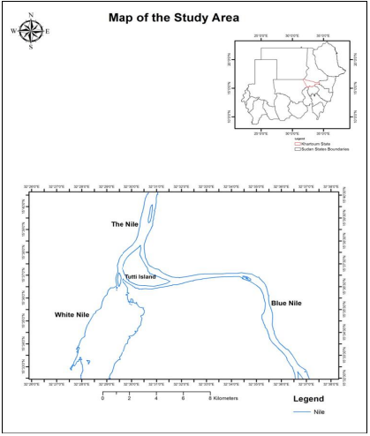
Figure1: Map illustrates the location of the study area.

Table 1: Coordination of the site of collection
Plant species | Site of collection | Coordination
D.ferox | Tutti island- Khartoum-sudan | 15° 37' 0" N 32° 31' 0" E.
D. innoxia | Tutti island- Khartoum-sudan | 15° 37' 0" N 32° 31' 0" E.
D.stramonium | Tutti island- Khartoum-sudan | 15° 37' 0" N 32° 31' 0" E.

2.2. Macro-morphological structure Analysis.
Fresh samples of the selected Datura species were identified according to Darbyshire et al., (2015) and compared with samples already deposited in the Herbarium of Botany Department, Faculty of Science, university of Khartoum. Except for D.ferox which is not recorded in Sudanese flora. The author of this study consulted different regional floras (El-Beheiry et al., 2020; Boulos, 1999 ; Hedberg, 1995; Stapf and Hubbard 1934) to confirm the record. A detailed morphological description of the plant was given to provide a clear picture for identification the plant. The digital photos of the plant in its natural habitat were taken and a Garmin GPS map 62s was used for the geographic coordinates of the collecting site.
The updated names of the studied species were extracted from websites (https://powo.science.kew.org and https://www.ipni.org.)
2.3. Micro-morphological structure Analysis
Fresh leaves of the species under investigation were collected, and epidermal peels were obtained directly from the leaves without the application of any chemical treatments. This process was executed by manual peeling using a razor blade. Epidermal peels were stained with ethanol safranin for duration of one minute. Subsequently, excess safranin stain was removed, and the peels were temporarily mounted in an aqueous glycerol solution. The morphology and dimensions of epidermal cells, stomata, and trichomes were examined. Observations and photomicrographs were captured using a light microscope (Leica DM 750) equipped with a Qwin system and video camera (Leica ICC50 HD) for image acquisition.

3. Results
3.1. The Accepted name and Synonyms of the Selected Species.
3.1.1. Datura L. (1753).
3.1.2. Datura ferox L.

Synonym: Datura laevis Bertol.

3.1. 3. Datura innoxia Mill. Gard. Dict. ed. 8 5 1768.

Synonyms: Datura guayaquilensis Kunth, Nov. Gen. Sp. 3: 8 1818; D.meteloides DC. ex Dunal. Prodr. 13(1): 544 1852.

3.1.4. Datura stramonium L. Sp. Pl. 179 1753.

Synonyms: Datura bernhardii Lundstr. Acta Horti Berg. 5(3): 89 1914; D. cabanesii P.Fourn.Monde Pl. 35: 14 1934; D.ferocissima Cabanès & P.Fourn. Monde Pl. 35: 14 1934; D. hybrida Ten. Fl. Napol. Suppl. 4: 34 1829; D. inermis Juss. ex Jacq. Hort. Bot. Vindob. 3: 44 1777; D. laevis L.f. Suppl. Pl. 146 1782; D. microcarpa Godr. Mém. Acad. Stanislas IV, 5: 202 1872 publ. 1873; D. pseudostramonium Sieber ex Bernh. Neues J. Pharm. Aerzte 26: 151 1833; D.tatula L. Sp. Pl. ed. 2 256 1762; D.wallichii Dunal. Prodr. 13(1): 539 1852; Stramonium spinosum Lam. Fl. Franç. 256 1778; S. vulgatum Gaertn. Fruct. Sem. Pl. 2: 243, t. 132 .

3.2. Macro-Morphological Descriptions of the Studied Species
The macro- morphological description of the selected datura species are listed in table ( 2, 3, 4).

Table 2: The Macro-Morphological characteristics of D. ferox
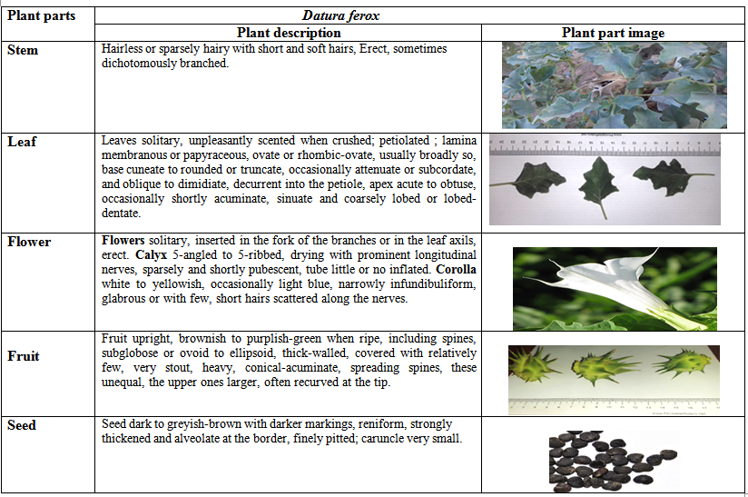

Table 3: The Macro-Morphological characteristics of D. innoxia

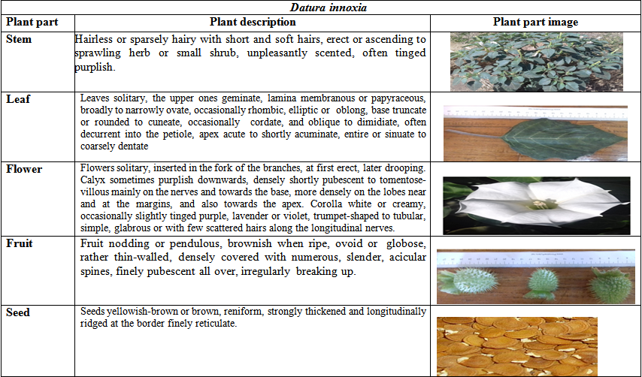

Table 4: The Macro-Morphological characteristics of D. stramonium
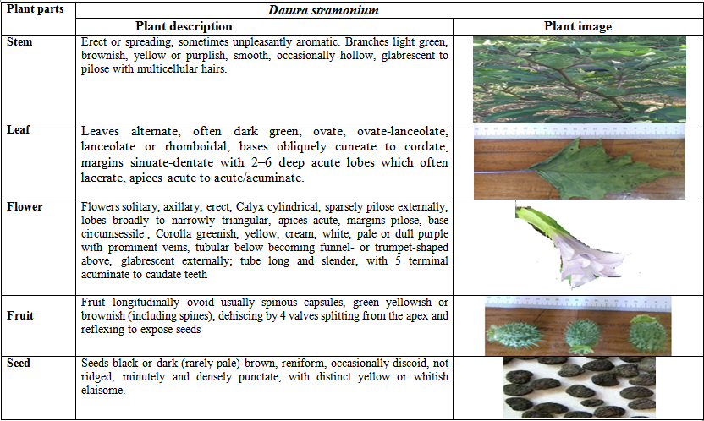

3.3. Macro- Morphological Dichotomous Key to the Studied Species
1. a. Capsule nodding, irregularly dehiscent………..……. D.innoxia.
1. b. Capsule erect, dehiscent by 4 valves………………………….2.
2. a. slender spines numerous and equal………………..D.stramonium
2. b. slender spines fewer and unequal ……….………………D.ferox.

3.4. Micro-morphological structure
3.4.1. D.ferox
The transverse section of the lamina of D.ferox is presented in Figure (2). On the adaxial surface, epidermal cells are irregular in shape, with sinuous wall. It is observed that the epidermis layer is composed of a single layer of cells. Trichomes are unicellular non-gladular and stellate in shape. The mesophyll is differentiated into two equal layers of palisade mesophyll parenchyma and spongy mesophyll parenchyma both of them are composed from one layer. The mesophyll tissue of D.ferox is bifacial.the Crystal of calcium oxalate in the species is divided into two types: crystal sand and druse crystal.
The collenchymaous cells under the epidermis are bigger than the parenchymaous cells. The vascular bundle type is bicollateral.

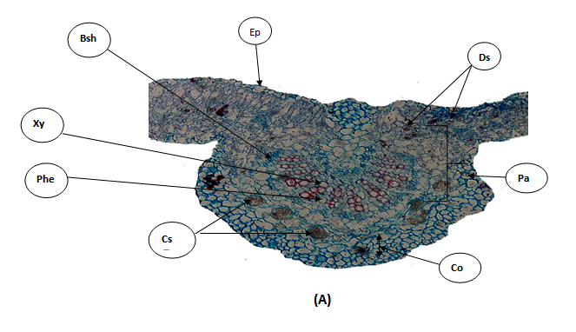

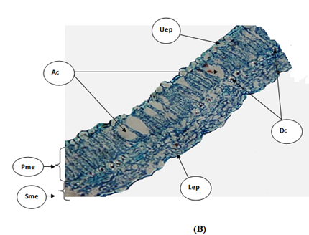

Figure 2: Transfer section (T.S.) of the lamina of D.ferox ; (A): T.S. throuth The mid-rib region: Bsh= Bundle sheath; Cs= crysta sandl ; Dc= Druse crystal ; Ep=Epidermis ; Ph= Pholem and Xy=Xylem; Pa= Parenchema cells ; Co=Collenchem cells. (B):T.S. through te lamina: Ac=Air cavity; Dc= Druse crystal; Uep= Upper epedermis ; Lep=Lower epidermis ;Pme=Palisade mesophyll;Sme=Spongy mesophyll.
3.4.2. D. innoxia
The transverse section of the lamina of D.innoxia is presented in Figure (3). Epidermal cells on the adaxial surface are irregular with sinuous anticlinal walls. The epidermis is composed of a single layer of cells. Amonotetracytic and anisocytic stomata complex types were occurred in the adaxial and abaxial surface of D. innoxia. Trichomes are unicellular with gland. Mesophyll tissue consists of upper layer of palisade mesophyll parenchyma cells and 3-4 layers of lower spongy mesophyll parenchyma cells. The mesophyll of D. innoxia is bifacial. The crystal of calcium oxalate is present in the spongy mesophyll in druse type. The parenchyma cells occupy the most region of the mid-rib. The vascular bundle in mid-rib is bicollateral type.
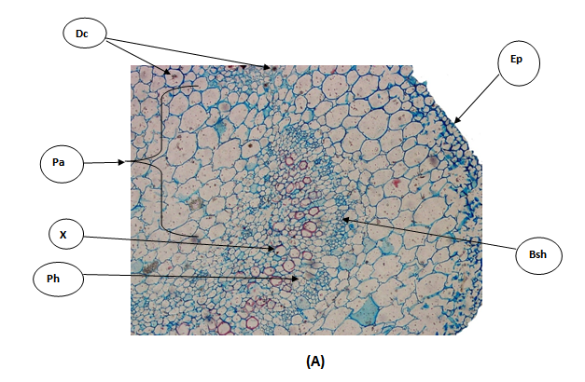

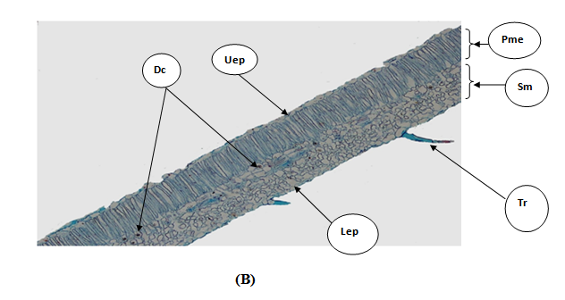

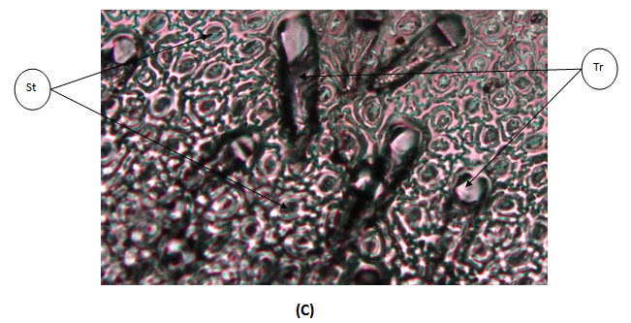

Figure3 : Transfer section (T.S.) of the lamina of D.innoxia ; (A) T.S. throuth The mid-rib region:Bsh= Bundle sheath; Dc= Druse crystal ; Ep=Epidermis ; Ph= Pholem; Xy=Xylem; Pa=Parenchyma cells. (B) T.S. through the lamina: Dc= Druse crystal; Uep= Upper epedermis ; Lep=Lower epidermis ;Pme=Palisade mesophyll;Sme=Spongy mesophyll, (C) T.S through the peel: St= stomat; Tr= trichome.

3.4.3. D.stramonium
The transverse section of the lamina of D.stramonium is presented in Figure 4. On the adaxial surface, epidermal cells are irregular in shape, with sinuous to wavy wall.
Amonotetracytic and anisocytic stomata type is characterized the the adaxial and abaxial surface of D. stramonium. Trichome are multicelluar and nonglandular. Epidermis layer is composed of one single layer of cells. Mesophyll tissue consists of upper layer of palisade mesophyll parenchyma cells of 2 layers and 3-4 lower spongy mesophyll parenchyma cells. The mesophyll type is bifacial. The parenchyma cells occupy the most region of the mid-rib. The vascular bundle in mid-rib is region is classified as bicollateral type. The crystals of calcium oxalate are present in druse type which deposited in the spongy mesophyll reegion.
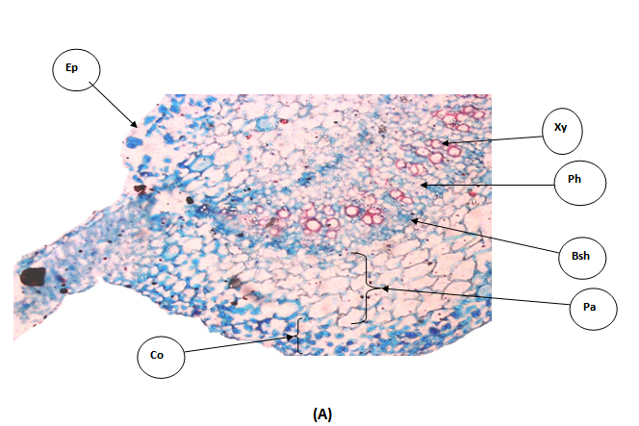

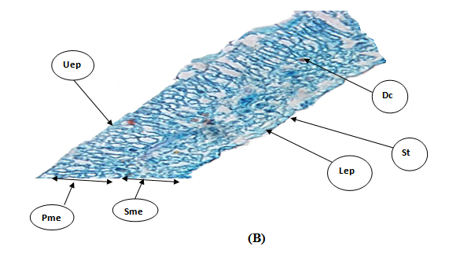
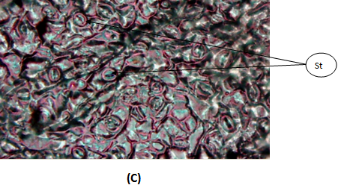
Figure 4: Transfer section (T.S.) of lamina of D.stramonium ; (A) T.S. throuth The mid-rib region: Bsh= Bundle sheath; Ep=Epidermis ; Ph= Pholem; Xy=Xylem; Co=Collenchyma cells; Pa=Parenchema cells. (B) T.S. through the lamina: Dc= Druse crystal; Uep= Upper epedermis ; Lep=Lower epidermis ;Pme=Palisade mesophyll;Sme=Spongy mesophyll; St=Stomata, (C) T.S through the Peel: St=stomata.

3.5. Anatomical Dichotomous key of the studied species
1. a. The mesophyll is differentiated into two equal layers........….D. ferox
1. b. The mesophyll is differentiated into two unequal layers ………….2
2. a. Trichomes are unicellular with gland…………………..….D.innoxia
2. b. Trichomes are multicelluar and non-glandular…...…..D.stramonium.
4. Discussion
Diagnostic characters in taxonomic studies have being used to identify plant groups from several others of similar ranking (Arama et al., 2017). The shapes of leaves, petals and whole plants are of great significance to plant science, as they can help to distinguish between different species. The leaf shape has perhaps the most discriminative power to identify the plant species (Cope et al., 2012). Identification of plant species based on flowers or fruits features also provide a distinctive resolution to discriminate plant species. Yoshioka et al., (2004) studied the shape of the petals of Primula sieboldii. Also, Lo and Mirabella (2018) Used of Leaf and Fruit Morphometric Analysis to identify and Classify White Mulberry (Morus alba L.) Genotypes. The morphological structures characteristics identified in the present study offer significant descriptive utility for the accurate identification of the three genus of Datura, particularly in instances where it may be confused with the closely to each others as the taxonomic status of the genus always remained confused (Al-Andal et al., 2025; Krishnan and 2018; Luna-Cavazos and Bye, 2011). Also, the study provided a distinctive dichotomous key for the studied species through which can easy discriminate the studied species. Understanding dichotomous keys as a means of classification enables researchers to better comprehend large amounts of information and understand how to organize, compare and contrast, and analyze that information (Watson and Miller, 2009). In dichotomus key the user makes a series of choices between contrasting statements, finally reaching a species name.
Anatomical characteristics have an important role in taxonomy and determining the number of plant genera and species (Scatena et al., 2005).The foliar epidermis is one of the important taxonomic characters from the systematic point of view. The taxonomic studies of a number of families and genera have been made on the basis of leaf epidermis (Adedeji and Illo, 2004; Adedeji et al., 2007; Adedeji and Jewoola 2008).
The cell-wall pattern is one of those epidermal features of taxonomic importance at specific level (Barthlott, 1981; Saheed and Illoh 2010). The cell-wall patterns of the epidermis can be taxonomically employed to delimit members of the studied species. D. innoxia is quite distinct in the surface view of the epidermis, with a sinuous anticlinal wall on both surfaces. Sinuous wall was characterized the wall of D.ferox while sinuous with wavy wall characterized the wall of D.stramonium. Anomocytic type of stomata was common in various members of the studied species which is followed by anisocytic type of stomata. These results are consistent with the study conducted by (Krstić et al., 2002 ;Awan and Murtaza, 2016; Hameed and Hussain, 2011; Wahua and Edwin-Wosu, 2016; Bello et al., 2017) who investigated the anatomical stomata of solanaceae. High density of stomata was observed in the D.innoxia and D.stramonium. This can be attributed to that they always inhabits the moist habitats. Type and location of calcium crystals are often used in plant taxonomic classification. Based on crystals of calcium oxalate , the studied species were classified into two categories , D.ferox is distinguished by presence of both druse and crystal sand type while D.innoxia and D.stramonium are only distinguished by the presence of druses crystal type. Gómez-Nucamendi et al., (2016) reported that druse crystal was mainly found in the leaves of datura species. This result is consistent with what was found in this study except for what was found in D.ferox which contains both druse and crystal sand.
5. Conclusion
The accurate identification of the Datura species in Sudan is always remained confused. Especially by local healers and even by the researches who are not familiar with plant taxonomy. This study aimed to conduct morphological (macro and micro-scopic) investigation to establish reliable information that can aid in the identification of the three specie belong to the genus Datura. The obtained finding of the study offer a comprehensive understanding that facilitates the identification of the studied species.

6. References
Adedeji, O., Ajuwon, O. Y., & Babawale, O. O. (2007). Foliar epidermal studies, organographic distribution and taxonomic importance of trichomes in the family Solanaceae.
Adedeji, O., and Illoh, H. C. (2004). Comparative Foliar Anatomy of Ten Species in the Genus Hibiscus Linn. in Nigeria.
Adedeji, O., and Jewoola, O. A. (2008). Importance of leaf epidermal characters in the Asteraceae family.
Al-Andal, A., Ewas, M., Abd El Raheim, M. D., Radwan, A. M., Suliman, M. N., Nishawy, E., ... & Khames, E. (2025). A three-sided story: a biosystematic revision of genus Datura reveals novel tropane alkaloids for the first-time in certain species. Frontiers in Plant Science, 16, 1555237.
Ally, F., & Mohanlall, V. (2020). An overview of tropane alkaloids from Datura stramonium L. J Pharmacogn Phytochem, 9(3), 5-13.
Al-Snafi, A. E. (2017). Medical importance of Datura fastuosa (syn: Datura metel) and Datura stramonium-A review. IOSR Journal of Pharmacy, 7(2), 43-58.
Arama, P., Jeruto, P., Anyango, B., Nyunja, R., Taracha, C., and Opiyo, S. (2017). Morphometric study of Senna didymobotrya (Fresen.) HS Irwin and Barneby in Kenya.
Assidqi, K., Sianipar, N. F., Mangindaan, D., & Enyi, C. U. (2025). Genus Datura: An Exploration of Genetic Alterations, Bioactive Compounds, and Pharmacological Activity. Plants, 14(14), 2244.
Awan, A. A., and Murtaza, G. (2013). Ethnobotanical uses of plants of family Solanaceae muzaffarabad division Azad Jammu and Kashmir, Pakistan-13100. Int Pharm Sci Invent, 2, 5-11.
Barthlott, W. (1981). Epidermal and seed surface characters of plant: Systematic applicability and some evolutionary aspects. – Nord. J. Bot., 1: 345-355.
Bello, A. O., Oladipo, O. T., and Saheed, S. A. (2017). Leaf epidermal studies of some Solanum (Solanaceae) species in Nigeria. Phytologia balcanica, 23(1), 55-63.
Benabderrahim, M. A., Sarikurkcu, C., Elfalleh, W., & Ozer, M. S. (2019). Datura innoxia and Dipsacus laciniatus: Biological activity and phenolic composition. Biocatalysis and Agricultural Biotechnology, 19, 101163.
Benítez, G., March-Salas, M., Villa-Kamel, A., Cháves-Jiménez, U., Hernández, J., Montes-Osuna, N., ... & Cariñanos, P. (2018). The genus Datura L.(Solanaceae) in Mexico and Spain–Ethnobotanical perspective at the interface of medical and illicit uses. Journal of ethnopharmacology, 219, 133-151.
Bonde, K. (2001). The genus Datura: from research subject to powerful hallucinogen. Ethnobotanical Leaflets, 1998(1), 10.
Boulos, L. (1999). Flora of egypt.
Bye, R. (2001). Solanaceae Potato Family. Part One: Datura L. Journal of the Arizona-Nevada Academy of Science, 58-64.
Céspedes-Méndez, C., Iturriaga-Vásquez, P., & Hormazábal, E. (2021). Secondary metabolites and biological profiles of Datura genus. Journal of the Chilean Chemical Society, 66(2), 5183-5189.
Cinelli, M. A., & Jones, A. D. (2021). Alkaloids of the genus datura: Review of a rich resource for natural product discovery. Molecules, 26(9), 2629.
Cinelli, M. A., & Jones, A. D. (2021). Alkaloids of the genus datura: Review of a rich resource for natural product discovery. Molecules, 26(9), 2629.
Cope, J. S., Corney, D., Clark, J. Y., Remagnino, P., and Wilkin, P. (2012). Plant species identification using digital morphometrics: A review. Expert Systems with Applications, 39(8), 7562-7573.
Darbyshire, I., Kordofani, M., Farag, I., Candiga, R., & Pickering, H. (2015). The plants of Sudan and South Sudan: an annotated checklist.
El-Beheiry, M., Hosni, H., Sharaf El-din, A., Shaltout, S. K., & Ahmed, D. (2020). Updating the checklist of the alien flora in Egypt. Taeckholmia, 40(1), 41-56.
Gómez-Nucamendi, O. L., Hernández-Sandoval, L., Figueroa-Cabañas, M., and Martínez, M.(2016). Leaf anatomy of four species and one variety of Datura (Solanoidea, Solanaceae).
Hameed, I., and Hussain, F. (2011). Stomatal studies of some selected medicinal plants of family Solanaceae. Journal of medicinal plants research, 5(18), 4525-4529.
Hedberg, I. (1995). Flora of Ethiopia and eritrea. In The Biodiversity of African Plants: Proceedings XIVth AETFAT Congress 22–27 August 1994, Wageningen, The Netherlands (pp. 802-804). Dordrecht: Springer Netherlands.
Herrera, B. I., Rabellino, L. C., & Rotter, M. C. (2025). Tropane Alkaloid Variation in the Genus Datura and its Consequences for Cultural Practices. Economic Botany, 79(1), 100-107.
Ibrahim, M., Siddique, S., Rehman, K., Husnain, M., Hussain, A., Akash, M. S. H., & Azam, F. (2018). Comprehensive analysis of phytochemical constituents and ethnopharmacological investigation of genus Datura. Critical Reviews™ in Eukaryotic Gene Expression, 28(3).
International Plant Names Index
Islam, T., Ara, I., Islam, T., Sah, P. K., de Almeida, R. S., Matias, E. F. F., ... & Islam, M. T. (2023). Ethnobotanical uses and phytochemical, biological, and toxicological profiles of Datura metel L.: A review. Current Research in Toxicology, 4, 100106.
Krenzelok, E. P. (2010). Aspects of Datura poisoning and treatment. Clinical Toxicology, 48(2), 104-110.
Krishnan, V., & Gopi, M. (2018). Microscopical investigation of three Datura species. Indian Journal of Economics and Development, 6(5), 1-9.
Krishnan, V., & Gopi, M. (2018). Microscopical investigation of three Datura species. Indian Journal of Economics and Development, 6(5), 1-9.
Krstić, L. N., Merkulov, L. S., and Boža, P. P. (2002). The variability of leaf anatomical characteristics of Solanum nigrum L.(Solana-les, Solanaceae) from different habitats. Zbornik Matice srpske za prirodne nauke, (102), 59-70.
Lian, W., Wang, Y., Zhang, J., Yan, Y., Xia, C., Gan, H., ... & Zhang, W. (2022). The genus Datura L.(Solanaceae): A systematic review of botany, traditional use, phytochemistry, pharmacology, and toxicology. Phytochemistry, 204, 113446.
Lo Bianco, R., and Mirabella, F. (2018). Use of leaf and fruit morphometric analysis to identify and classify white mulberry (Morus alba L.) genotypes. Agriculture, 8(10), 157.
Luna-Cavazos, M., & Bye, R. (2011). Phytogeographic analysis of the genus Datura (Solanaceae) in continental Mexico. Revista mexicana de biodiversidad, 82(3), 977-988.
Luna-Cavazos, M., Bye, R., & Jiao, M. (2009). The origin of Datura metel (Solanaceae): genetic and phylogenetic evidence. Genetic resources and crop evolution, 56(2), 263-275.
Maheshwari, N. O., Khan, A., & Chopade, B. A. (2013). Rediscovering the medicinal properties of Datura sp.: A review. Journal of medicinal plants Research, 7(39), 2885-2897.
Plants of the World Online. (n.d.). Royal Botanic Gardens, Kew. Retrieved April 20, 2025, from https://powo.science.kew.org
Saheed, S.A. and Illoh, H.C. (2010). A taxonomic study of some species of Cassiinae (Leguminosae) using leaf epidermal characters. – Notul. Bot. Horti Agrobot. Cluj-Napoca Inst., Agron. “Dr. Petru Groza”, 38: 21-27.
Scatena, V. L., Giulietti, A. M., Borba, E. L., a Van dnden Berg, C. (2005). Anatomy of Brazilian Eriocaulaceae: correlation with taxonomy and habitat using multivariate analyses. Plant systematics and evolution, 253(1), 1-22.
Sharma, M., Dhaliwal, I., Rana, K., Delta, A. K., & Kaushik, P. (2021). Phytochemistry, pharmacology, and toxicology of Datura species—A review. Antioxidants, 10(8), 1291.
Sharma, M., Dhaliwal, I., Rana, K., Delta, A. K., & Kaushik, P. (2021). Phytochemistry, pharmacology, and toxicology of Datura species—A review. Antioxidants, 10(8), 1291.
Shonle, I., & Bergelson, J. (2000). Evolutionary ecology of the tropane alkaloids of Datura stramonium L.(Solanaceae). Evolution, 54(3), 778-788.
Singh, L. R., & Singh, O. M. (2013). Datura stramonium: An overview of its phytochemistry and pharmacognosy. Research Journal of Pharmacognosy and Phytochemistry, 5(3), 143-148.
Stapf, O., & Hubbard, C. E. (1934). Flora of tropical Africa.
Thawabteh, A. M., Sulaiman, S., Alabed, I. O., Scrano, L., Karaman, D., Karaman, R., & Bufo, S. A. (2025). Bioorganic Chemistry, Toxinology, and Pharmaceutical Uses of Datura Metabolites and Derivatives. Toxins, 17(9), 469.
Wahua, C., and Edwin-Wosu, N. L. (2016). Morphological characters, occurrence and distribution among members of the family Solanaceae in parts of the Niger Delta Ecological Zone. Journal of Applied Sciences and Environmental Management, 20(3), 583-590.
Watson, S., and Miller, T. (2009). Classification and the Dichotomous Key. The Science Teacher, 76(3), 50.
Y. Yoshioka, H. Iwata, R. Ohsawa, and S. Ninomiya. (2004) Anaylsis of petal shape variation of Pimula sieboldii by elliptic Fourier descriptors and principal component analysis, Annals of Botany .
Yin, S., Hu, J., Mohamed, K. H., Hu, X., Gao, W., Li, Y., ... & Ding, C. (2025). Ethnobotany, phytochemistry, pharmacology, and toxicology of the genus Datura (Solanaceae). Natural Product Research, 1-16.

