ECONOMIC FEAIBLITY ANALYSIS OF SORGHUM HARVESTER

ABSTRACT:
An economic feasibility analysis of the developed sorghum harvesting machine was carried out, and it was determined that investment in mechanical harvesting is financially sound by comparing it to manual methods. The performance of the developed sorghum harvester was compared with the manual method in the sorghum field in terms of cost and time per hectare. We determined that harvesting one hectare of sorghum with a developed sorghum harvester takes between 2.78 and 2.9 hours. The effective field capacity and field efficiency of the sorghum harvester were found in the range of 0.322 to 0.357 ha/h and 76.50 to 82.67%. The average cost of operation of a sorghum harvester was found to be Rs.752 per h and Rs.2199 per ha. The manual cost of operation by using sickle was found to be Rs.3000 per ha. It was found that there was a saving cost of Rs. 801 per ha. (26.70%) over manual sorghum harvesting. The saving in time of 77.08 h per ha (96.35%) was achieved for sorghum crop by tractor operated sorghum harvester. The breakeven point, payback period and benefit-cost ratio of the developed tractor operated sorghum harvester was worked out as 216.25 h per year, 397 h and 6.04 respectively.
Keywords: Cost, fixed, variable, Breakeven Point, Pay Back Period, Benefit Cost Ratio
INTRODUCTION
Sorghum, known as jowar in India, is a vital crop with significant importance for the country's food security, agriculture, and industry. Its resilience to harsh climates and its diverse applications make it a cornerstone of the economy in semi-arid regions, especially for marginalized farmers.It is a crop of significant importance in Maharashtra, and particularly in the drought-prone Vidarbha region, especially in rural areas where it is consumed as unleavened bread called bhakri. Climate change is leading to more intense, unpredictable rainfall events. Harvesting crops before heavy rains or flooding can prevent the devastation of entire fields, protect standing grains from washing away, and minimize crop spoilage from waterlogging. Wet conditions during harvest can also promote fungal diseases and make mechanical harvesting difficult. With climate change increasing the frequency and intensity of extreme weather events, timely harvesting is more important than ever for ensuring crop yield, quality, and food security. Proper sorghum harvesting is critical for maximizing yield, preserving grain quality, and ensuring profitability for farmers. The correct timing and technique directly influence the crop's nutritional value, storability, and marketability.
The traditional method of sorghum harvesting is labor-intensive and expensive and requires a large number of laborers; however, it is widely practiced by small and marginal farmers, particularly in regions like Vidarbha and other semi-arid areas of Maharashtra, due to the availability of suitable sorghum harvesters. Continuous and frequent bending posture leads to pain in the back for the majority of laborers during the harvesting. The cost is 8000 to 10000 per acre of harvest (Rathinavel S et al., 2019).
The development of sorghum harvesters in India has significant potential due to the importance of sorghum (jowar) as a staple crop. The development of a sorghum harvester involves designing a machine that is particularly intended to efficiently and successfully harvest sorghum crops. The idea behind developing this kind of harvester is making a specialized sorghum harvester with adaptive cutting mechanisms, which will make harvesting of sorghum much more efficient and lower the crop losses and operational costs compared to the traditional methods. The hypothesis states that developing the harvester to be highly efficient will minimize the time and effort needed for sorghum harvesting, resulting in lower operational costs and higher profitability for the farmers. Mechanization reduces workers' physical strain by eliminating the need for manual labor. Ultimately farmers will be shifted to sorghum cultivation for getting the dual profit of grain and fodder, and with more area under the sorghum crop.
By keeping all those facts, limitations in harvesting and today’s need present investigations has been undertaken to evaluate and analyze financial feasibility of sorghum harvester.
REVIEW OF LITRATURE
Scientific research findings on the economics of sorghum harvesting were reviewed below after critical evaluation.
Prakash, (2003) reported savings of Rs. 851.10/- (33.25%) for maize and Rs. 481.60/- (18.81%) for sorghum crops. The adoption of a power tiller mounted fodder harvester resulted in time savings of 91.31% and 89.60% for maize and sorghum crops, respectively.
Nalawade et al., (2009) studied economics of developed tractor operated Jowar reaper and they reported that the average cost of operation by using a tractor-mounted Jowar reaper was found to be Rs. 429 per hectare. The savings of Rs. 237 over the traditional method of Jowar harvesting were found. The percent saving was 35.57% over the traditional method.
Butle (2011) reported that the overall saving on cost of operation per ha of tractor operated sorghum harvester was 19.10 per cent when compared with manual harvesting i.e 2184.08 Rs. per ha and 2700 Rs. per ha respectively.
Thakare and Saraf (2014) evaluated tractor operated sorghum harvester. They reported that, the total saving on labour and cost requirement in mechanical harvesting over traditional was 80% and 82.66% respectively.
Sahay et. al., (2017) studied cost economics of tractor operated fodder harvester, cost of harvesting one hectare fodder using tractor operated fodder harvester was found Rs.3571/- whereas, it was Rs. 2510/- with engine operated riding type fodder harvester. The profit with tractor operated fodder harvester was Rs.1629 per hectare and in case of engine operated riding type fodder harvester it was Rs.2690 per hectare; as compared to manual harvesting.
Alandkar (2017) studied the cost economics of a two-row bullock-drawn engine-operated sorghum stalk cutter. He reported that 82.05% saving in total labor cost Rs. per ha. when compared to traditional method of sorghum harvesting.
Mareppa (2017) reported that harvesting with a self-propelled reaper cum binder cost Rs. 1720 per ha, compared to Rs. 5400 per ha for harvesting using the conventional method. When comparing to the traditional manual harvesting method, there were savings of 68.14 and 86.67% in terms of cost and time, respectively.
Nikam et. al, (2017) studied economics of manual and mechanical harvesting methods of sorghum crop and reported that total man hours required per hectare in mechanical harvesting were 6.8 hrs where as in manual harvesting it was around 150 hrs. So, net saving in man hour’s requirement in mechanical harvesting over manual harvesting was around 95.47 per cent. Total cost of operation for harvesting by tractor operated sorghum harvester was found to be Rs. 3318.12/ha. In manual harvesting it was found to be Rs. 5000/ha. The net saving in the cost of operation per hectare was found to 33.64 per cent over manual harvesting.
Rathinavel S et. al., (2020) reported the cost expenditure in manual method 20000 to 34000 Rs/ha whereas 7500 to 16500 Rs/ha with tractor operated reaper in sorghum harvesting.
Jalu et al., (2020) studied cost economics of developed manually drown engine powered fodder crop harvester. The total cost savings of the developed fodder crop harvester was found to be 58.07% as compared to manual harvesting.
Veerammanavara (2022) studied the economics of tractor operated sorghum harvester. The cost of operation of tractor operated sorghum harvester was found to be Rs. 372.50 per hour against Rs.660 per hour required for harvesting of sorghum crop by manual method. The breakeven point and payback period of harvester was 268 h per annum and 1.92 years respectively. The savings in cost and time were found to be 31.26 and 94.00%, respectively as compared to manual harvesting of sorghum crop.
MATERIAL AND METHODS
The tractor operated sorghum harvester was developed at the Department of Farm Power and Machinery, Dr. PDKV, Akola. The developed sorghum harvester's major parts include the cutting unit, conveyor unit, power transmission system and frame. When the sorghum harvester moves through the sorghum field, crop row divider first penetrates in to standing sorghum crops and divides the crops. The star wheel through star wheel arms push sorghum stalks towards the cutter bar. The cutter bar cuts the sorghum stalks the few centimeter above the ground using a slider crank mechanism to reciprocate sets of knives moving between ledgers and the harvested sorghum stalks are conveyed through a canvas conveyor lugged belt at the desired speed. Finally, windrow harvested the sorghum crop at a right angle to the direction of operation.
The performance of the developed sorghum harvester was evaluated sorghum field. The testing and evaluation methodology outlined in IS: 11467(1985): test code for cereal harvesting machines was properly followed for evaluating the performance of the developed sorghum harvester. The working of developed tractor operated sorghum harvester shown in Pate 1 and 2.
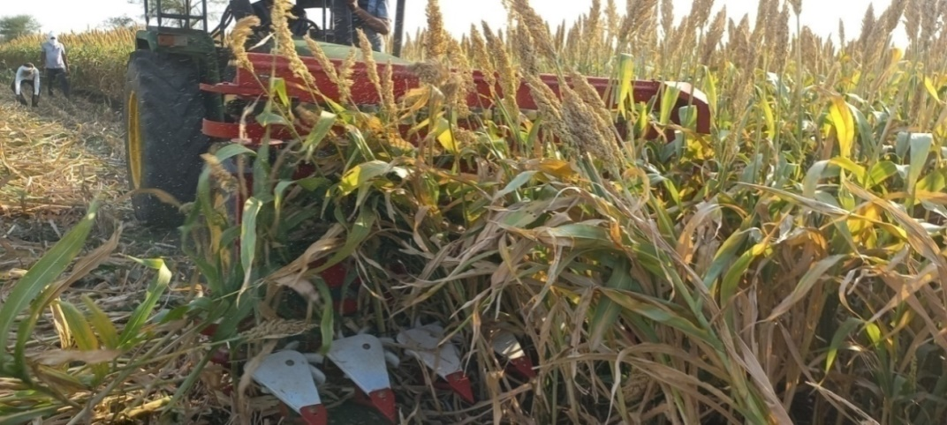

Plate 1 Working front view tractor operated sorghum harvester in field

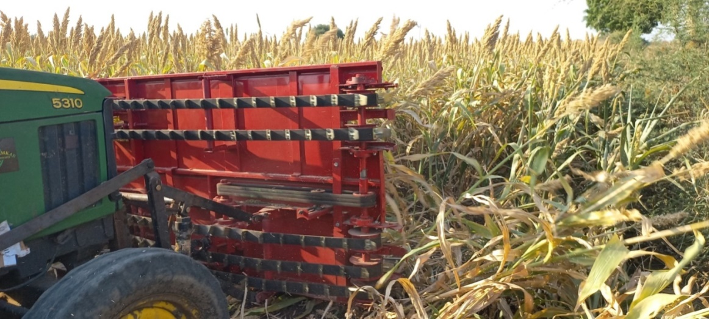

Plate 2 Working rear view of tractor operated sorghum harvester in field
The cost of operation was determined in accordance with test code IS: 9164 (1979): guide for estimating cost of farm machinery operation.
a) Fixed cost
Depreciation:
It is the loss of value of machine with the passing of time and use.The cost of a machine depreciates over time due to wear, tear age and obsolescence. Depreciation may be estimated using several computational approaches; however, it ultimately depends on the machine's market price after usage. Before estimating annual depreciation, the machine's economic life and salvage value must be given. The economic life of a machine is the number of years over which costs may be estimated. Salvage value is an assessment of the machine's market value at the end of its useful life. The depreciation cost determined by straight line method of depreciation given below.
Where,
D - depreciation per hour
C - capital investment
S - salvage value (10 % of capital)
H - number of working hours per year
L - life of machine in year
Interest cost
Interest is the biggest cost associated with agricultural machinery after depreciation. It is a direct expense item for borrowed capital. Annual interest costs are computed based on the actual interest rate due. If this information is not available, 12% of the average purchase price should be used. Interest is calculated on the average investment of the machine taking into consideration the value of machine in first and last year.
Where,
I - interest per hour
i - % rate of interest per year
Housing charges
Housing costs were computed based on local rates, however they may be generally estimated as 1% of the machine's initial cost every year.
Insurance charges
Insurance charges are calculated based on actual payments to the insurance company, although they may be approximated as 1% of the initial cost of the machine every year.
Taxes
Taxes were computed based on actual taxes paid every year, but in general, it may be assumed to equal 1% of the machine's initial cost annually.
b) Operating cost
Annual operating expenses include fuel, lubricant, repairs and maintenance and labour cost. These expenditures are directly proportional to the number of hours consumed on the equipment. Hourly operational expenses are assumed constant.
Fuel cost
Fuel consumption is also a difficult issue, as it varies widely between test areas, machinery, operation and operator. Fuel cost was calculated on the basis of actual fuel consumption of tractor during sorghum harvesting operation.
Lubricants cost
Charges for lubricants should be calculated on the basis of actual fuel consumption, the lubricant cost varies between 30-35% of fuel cost.
Repair and Maintenance cost:
Repair and maintenance expenses are required to keep a machine in working condition due to wear, part failure, and accidents. Repair and maintenance costs must be determined at 5-10% of the machine's initial cost per year.
Wages Wages varied with region to region generally calculated on the basis of actual wages paid to operator or labour. To get the average cost per hour, divide the total cost by the number of hours the operator performed the task.
Total cost per hour:
The entire operating cost of a machine for harvesting sorghum crop was calculated by adding the fixed and variable costs per hour.
Total costs per hectare:
The cost per hectare was determined based on the field capacity of the sorghum harvester. Data collected during field evaluation of a sorghum harvester included machine type, working width, average speed of travel, field size and shape, and travel circumstances to correct the estimation of cost per hectare.
Comparison of cost of operation by using sorghum harvester with manual method
The cost of harvesting by machine was compared to manual harvesting. The percentage of time and cost savings over the traditional method also worked out.
Financial feasibility analysis
A financial feasibility analysis was conducted to determine the viability of investing in a sorghum harvester. In this study used discounted and non-discounted cash flow approaches to evaluate long-term financial viability. To assess the financial and economic viability of the sorghum harvester investment, (Alam et al., 2018) used many feasibility evaluation approaches.
The study evaluated the financial feasibility of investing in a sorghum harvester using the following techniques:
- Break-Even Point (BEP)
- Pay Back Period (PBP)
- Benefit Cost ratio (B-C ratio)
Breakeven even point
The break-even point is where there is no profit or loss. At this point, the project's revenues equal its overall costs and the contribution margin equals the total fixed cost. It is computed using the following formula (Rahaman et al., 2022, Kumar, et al., 2019)
Where,
- breakeven point, h/yr,
- annual fixed cost, Rs. /yr
- total operating cost, Rs./h
- custom hiring charges, Rs./h
Investing in a sorghum harvester is only profitable if its yearly usage level is above the break-even threshold, according to the break-even point measurement for investment assessment.

Payback period
In this study, the payback period was computed by deducting the initial investment from the net return until it was completely paid back. Investing in sorghum harvesters is more feasible with a shorter payback period. It is defined as the time it takes for the initial investment in a project to be refunded through the realization of benefits. The study uses the following payback period formula: (Venkat, et al., 2021, Rahaman, et al., 2022, Kumar, et al., 2019)
Where,
- payback period, yr
- initial cost of machine, Rs
- average net annual profit, Rs./yr
- (CHC-TOP) × annually used in hours

Average net annual profit, Rs. = (Custom hiring charges (Rs./h) Total operating cost (Rs./h)) × Annual usage
TOP - Total operating cost, Rs./h
Benefit cost ratio
The benefit-cost ratio (BCR) is defined as the ratio of the present worth of benefits to the present worth of cost. A BCR is greater than one indicates that an investment is profitable. The benefit-cost ratio can be mathematically represented as follows:
$BCR=\frac{\sum_{t=1}^{t=2}{B_{t}}}{\sum_{t=1}^{t=2}{C_{t}}}$ …(5)
Where,
$C_{t}$ - cost in each year
$B_{t}$- benefit in each year
RESULT AND DISCUSSION
The performance trials of the sorghum harvester were carried out in the matured sorghum field. The testing and evaluation of the machine was undertaken as per the BIS test code. The effective field capacity and field efficiency of the developed sorghum harvester were found in the ranges of 0.344 to 0.360 ha/h and 75.05 to 82.67%, respectively. The time to accomplish one-hectare sorghum harvesting with the developed harvester was observed to be between 2.78 and 2.9 hours. The fixed cost of the tractor and sorghum harvester was estimated to be 107.42 Rs. per h and 55.95 Rs. per h, respectively. The variable cost of the sorghum harvester was computed to be about 24 Rs. per h., whereas the variable cost of the tractor was found to be in the range of 547.9 to 587.5 Rs. per h. The average cost of operation of a sorghum harvester was Rs.752.25 per hour and Rs. 2199 per hectare.
Comparison of cost of operation by using sorghum harvester with traditional practice
The cost of harvesting by machine was compared to human harvesting. The percentage of time and cost savings over the traditional method also worked out. The details of comparison of sorghum harvesting cost discussed below. From table 1, it was revealed that 80 man-h were required to complete the harvesting operation in one hectare. According to Nikam et al. (2017), the total number of man-hours required per hectare for mechanical harvesting was 6.8 hours, whereas traditional harvesting required around 150 hours. The manual cost of operation with a sickle was determined to be Rs. 3000 per acre. In accordance with Veerammanavara (2022), the cost of operating a tractor-operated sorghum harvester was Rs. 372.50 per hour, compared to Rs. 660 per hour for harvesting sorghum crops manually. Butle (2011) revealed that the cost of operating a tractor-operated harvester was 2184.08 Rs. per ha and 2700 Rs. per ha, respectively, using the manual method. Mareppa (2017) reported that harvesting with a self-propelled reaper-cum-binder costs Rs. 1720 per ha, compared to Rs. 5400 per ha for harvesting using the conventional method. Mareppa (2017) reported that harvesting with a self-propelled reaper cum binder cost Rs. 1720 per ha, compared to Rs. 5400 per ha for harvesting using the conventional method.
Table. 1 Cost analysis for manual harvesting of sorghum
Sr. No. | Particulars | Observation
1 | Labour required for harvesting, labour-hour per ha | 80
2 | Labour wages, Rs. per day | 300/-
3 | Total work hours per day | 8
4 | Total number of labour required per ha | 10
5 | Cost of harvesting, Rs. per ha. | 3000/-

Table 2 Comparison of sorghum harvester with manual harvesting
Sr. No. | Particulars | Harvesting by developed machine | Sickle harvesting
1 | Cost of harvesting, Rs per ha | 2199/- | 3000/-
2 | Actual time required per ha, h/ha | 2.92 | 80
3 | Saving in Rs. per ha | 801/- | --
4 | Saving in cost per ha, % | 26.70 | --
5 | Saving in time per ha, h | 77.08 | --
6 | Saving in time per ha, % | 96.35 | --

From the Table 2 it was found that there was a saving of Rs. 801 per ha (26.70%) for sorghum crop. The saving in time of 77.08 h per ha (96.35 %) were achieved for sorghum crop by tractor operated sorghum harvester According to Thakare and Saraf (2014), mechanical harvesting saves 80% of labor and 82.66% of costs compared to traditional harvesting. Similar studies by Nalawade (2009) revealed a Rs. 237 savings over the conventional Jowar harvesting method. The percentage saved was 35.57% compared to the manual method. According to Nikam et al. (2017), the net cost of operating a tractor-operated sorghum harvester per hectare was determined to be 33.64 percent lower than hand harvesting. Prakash (2003) stated savings of 18.81% on sorghum crops. Figures 1 and 2 indicate the time (hours per ha) and cost (Rs./ha) necessary for sorghum harvesting using a sorghum harvester and traditional methods. Moreover the labour shortage felt during harvesting season which often coincides with sowing and threshing operations can easily be tackled.

Fig 1Time required for harvesting by sorghum harvester and manual method

Fig 2 Cost of operation for harvesting by sorghum harvester and manual method

Financial feasibility analysis
A financial feasibility analysis was conducted to determine the viability of investing in a sorghum harvester. The study evaluated the financial feasibility of investing in a sorghum harvester using the Break-Even Point (BEP), Pay Back Period (PBP) and Benefit-Cost Ratio (BCR).
Breakeven point
An attempt was made to calculate break-even point of sorghum harvester for harvesting operation for the service providers based on fixed cost and variable cost of machine which are calculated from field trials data, machine price, depreciation cost, interest on investment, machine life, and income from machine operation, etc. The breakeven point of the developed tractor operated sorghum harvester was calculated as 216.25 ha per year. Similar finding reported by Veerammanavara (2022) The breakeven point and payback period of harvester was 268 h per annum.
Payback period
The payback period of the developed tractor operated sorghum harvester was calculated as 397 h. Similar finding reported by Veerammanavara (2022) payback period of harvester was 1.92 years respectively. PBP< economic life of machine therefore developed sorghum harvester will be Profitable.
Benefit-Cost ratio
The benefit-cost ratio of developed sorghum harvester was found to be 6.04. As the BCR>1 which is implies that investment on developed sorghum harvester will be profitable.
CONCLUSIONS
Based on the field testing of the sorghum harvester, the following conclusions could be drawn.
- The time required to accomplish one-hectare sorghum harvesting with a developed sorghum harvester was determined and found between 2.78 and 2.9 hours.
- The average cost of operation of sorghum harvester was found Rs.789.5 per h and Rs.2244 per ha.
- The manual cost of operation by using sickle was found to be Rs.2700/-per ha.
- It was found that there was a saving cost of Rs. per ha 456/- (16.88%) over manual sorghum harvesting.
- The saving in time of 69.16 h per ha (96.05 %) were achieved for sorghum crop by tractor operated sorghum harvester.
- The breakeven point, payback period and benefit-cost ratio of the developed tractor operated sorghum harvester was worked out as 216.25 ha per year, 397 h and 6.04 respectively. As PBP< economic life of machine and BCR>1 implies that investment on developed sorghum harvester is profitable.
- Thus developed sorghum harvester is feasible to reduce the harvesting cost, time, drudgery and efforts.
- On summarizing, the achievement in decreasing labor and cost through the adoption of tractor-operated harvesters showed a feasible solution for mechanical sorghum and fodder harvesting.

REFERENCES
Alam, M. A., A. Hossen, A. S. Islam and M. Alam, 2018.Performance evaluation of power-operated reapers for harvesting rice at farmer’s field. J. Bangla. Agril.Uni., 16(1):144-150.
Allandkar, N.A, 2017. Development and performance evaluation of sorghum stalk cutter. M. Tech. Thesis (unpub.). Vasantrao Naik Marathwada Krishi Vidhyapeeth, Parbhani.
Butle V. R. (2011) Modification and performance evaluation of sorghum harvester. M. Tech. Thesis (unpub.),Dr. PDKV, Akola.
IS:11467-1985 (Reaffirmed in 2012). 2012. Test code for cereal harvesting machines. Bureau of Indian Standards, New Delhi.
IS:9164-1979 (Reaffirmed in 2002). 2002. Guide for estimating cost of farm machinery operation. Bureau of Indian Standards, New Delhi.
Jalu, M. V., V. K. Tiwari and V. S.Vala, 2020. Development of manually drawn engine powered fodder crop harvester. Int. J. Curr. Microbiol. App. Sci., 9(10):2126-2132.
Kumar, A., A. Kumari and S. K. S. Chandra, 2019. Performance evaluation and economics of the reaper-cum-binder machine for the mechanized harvesting of wheat crop at Madhubani district of Bihar. J. Pharmacognosy and Phytochemisrty, 8(4): 63-68.
Mareppa, 2017. Design, refinement and development of reaper cum binder for sorghum and bajra crops. Ph.D. Thesis (unpub.), UAS, Raichur.
Mehta, M. L., S. R. Verma, , S. R. Mishra and V. K. Sharma, 2005.Testing and Evaluation of Agricultural Machinery. Daya Publishing House, Delhi-100 035.
Nalawade, S. M., P. A. Turbatmath, A. V.Gajakos, 2009. Design and development of tractor operated Jowar reaper windrower. New Agriculturist, 20(1/2):75-81.
Nikam, M. D., S. H. Thakare, V. P. Khambalkar and S. S. Karhale, 2017. Study of economics of manual and mechanical harvesting method of sorghum crop.Int. J. Curr. Microbiol. App. Sci.,6(6): 1211-1217.
Rahaman, S., C. Ramana, A. S. Rao and B. R. Reddy, 2022.Field evaluation and economic analysis of manual drawn rotor weeder for small farms. Economic Affairs, 67(4):415-421.
Rathinavel S and S Saimohan, 2019. Tradional sorghum cultivation and mechnaization practices- A case study of Elavanthi village, 2019. National conference on doubling farmer income through the specific approaches, AEC &RI, Kumulur
Rathinavel S and S Saimohan, 2019.Sorghum harvesting methods and its cost analysis in Palladam regeion of Tamil Nadu. Proceedings of 4th Agriculture graduate student conference 2020 on multi-dimensional approaches in transforming agriculture. 430-431.
Sahay, C. S., P. K. Pathak, B. Narsimlu, C. R. Mehta, 2017. Semi-mechanized harvesting solutions for cultivated fodder crops. The XXIII International Grassland Congress (Sustainable use of Grassland Resources for Forage Production, Biodiversity and Environmental Protection) took place in New Delhi, India.
Thakare, S. and V. V. Saraf, 2014. Performance evaluation of cutting unit of tractor operated Sorghum harvester. 3rd International conference on Agriculture & Horticulture, Hyderabad International Convention Centre, India.
Venkat, R., S. S. Mohan, P. Mohnot and M. Vinayak, 2021.Economic analysis and feasibility of rotary weeder-cum-fertilizer drill. Economic Affairs, 66(3): 451-457.
Veerammanavara, R., 2022. Design, development and evaluation of sorghum harvester. Ph.D.thesis (unpub.) UAS, Raichur.

