Original Research Article

Constraints in Popularizing Nutri-Sensitive Agriculture in Home Gardens of Kerala: A Regional Comparative Study

.
ABSTRACT

Aims: The study aims to identify and prioritize the key constraints hindering the adoption of Nutri-Sensitive Agriculture (NSA) in home gardens across Kerala.
Study design: An ex-post facto research design was adopted to assess the constraints perceived by farmers.
Place and Duration of Study: The study was conducted in three representative districts of Kerala: Kasaragod (north), Thrissur (central), and Thiruvananthapuram (south) during the year 2024-2025.
Methodology: Data were collected from 180 farm households using a multistage random sampling method. A structured, pre-tested interview schedule was used to gather data on 20 potential constraints categorized under ecological, economic, institutional, and socio-personal domains. The constraints were ranked using Garrett’s ranking technique to assess their relative severity.
Results: The findings revealed notable regional variations. In Kasaragod, lack of financial support (mean score: 53.98) and climatic variability (53.35) were the most critical constraints. In Thrissur, wild animal attacks (72.77) and climatic stress (58.25) were significant. In Thiruvananthapuram, lack of financial support (65.18), climatic variability (64.85), and land fragmentation (64.37) were most severe. At the state level, lack of financial support (58.94), climatic variability (58.82), and wild animal menace (57.26) were identified as top constraints. Socio-personal factors such as literacy, irrigation, and family support were less influential.
Conclusion: The study highlights the role of ecological pressures, financial barriers, and knowledge gaps in hindering NSA adoption. It recommends region-specific interventions, including irrigation support in the north, wildlife management in the central region, and land-use planning in the south, alongside statewide efforts to improve credit access, reduce input costs, and promote climate-resilient farming practices.

Keywords: Nutri-Sensitive Agriculture, Home Gardens, Kerala, Constraints, Regional Variations, Financial Support, Climatic Variability, Sustainable Agriculture

1. INTRODUCTION

Agriculture is fundamental to food and nutrition security, especially in regions facing malnutrition and dietary imbalances. Nutri-Sensitive Agriculture (NSA) focuses on linking agricultural production with improved dietary outcomes, emphasizing diversification, year-round availability of nutrient-rich foods, and farming practices that enhance resilience (FAO, 2017; Pingali, 2015).
Home gardens are a practical approach to NSA, integrating vegetables, fruits, tubers, spices, and small livestock within limited spaces to ensure a continuous food supply and ecological benefits (Galhena et al., 2013). In Kerala, home gardens are a long-standing cultural feature, supporting household nutrition and supplementing farm income (Jose & Shanmugaratnam, 1993).
Despite their benefits, several challenges impede the sustainability of home gardens. Climatic variability and water scarcity reduce productivity (Tomatis, Leal Filho, & Pauleit, 2023), and wild animal damage and pest pressures further constrain yield (Du Toit et al., 2022). Economic barriers, such as high input costs and limited credit access, further restrict improved practices (Kumar, Turvey, & Kropp, 2013). Weak integration of policies and limited extension support remain major barriers to the wider adoption of NSA. In addition, increasing urban development and the gradual fragmentation of homestead lands reduce the scope for maintaining diverse and resilient garden systems (Andrews & Kannan, 2016).
Kerala's ecological diversity means the impact of these constraints varies regionally. The northern, central, and southern districts differ in climate, landholding structures, and institutional support. This study aims to identify and prioritize the key constraints hindering NSA adoption in Kerala’s home gardens, providing evidence for region-specific and statewide interventions.
2. material and methods

2.1 Locale of the Study
The study was conducted across three districts in Kerala, each representing a different agro-ecological zone. Kasaragod, located in the north, was chosen for its diverse cropping systems and exposure to climatic variations. Thrissur, in central Kerala, represents a region with traditional homestead farming practices. Thiruvananthapuram, in the southern part of Kerala, was selected for its higher population density, urban pressures, and fragmented landholdings, which challenge the sustainability of home gardens. The geographical coverage of the study districts is presented in Figure 1.

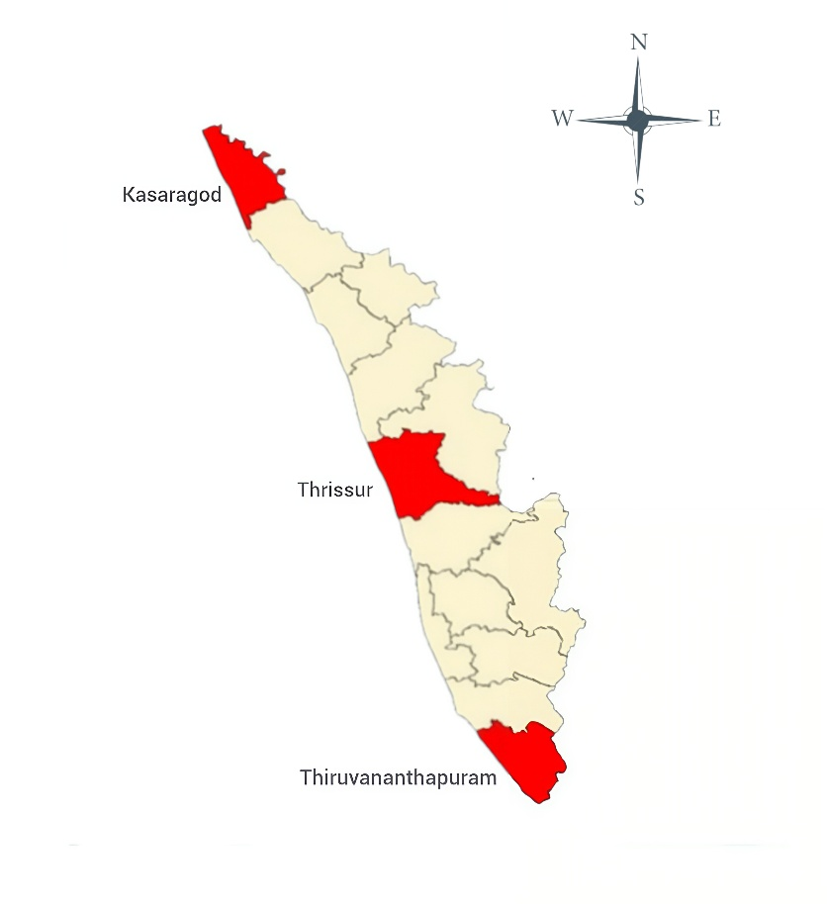
Fig. 1. Map of Kerala showing the selected study districts: Kasaragod (north), Thrissur (central), and Thiruvananthapuram (south).

2.2 Study Design

An ex-post facto research design was adopted, since the variables of interest had already occurred and were beyond the researcher’s control. This design was well-suited for understanding the constraints farmers face in adopting Nutri-Sensitive Agriculture, particularly when those constraints are perceived after they’ve already impacted the farming systems (Kothari, 2017).

2.3 Sampling Procedure

A multistage random sampling technique was employed for the study. Two blocks were purposively chosen from each district, and within each block, 30 farm households were randomly selected. This resulted in 60 respondents per district and a total of 180 across the three regions. The sample size was deemed adequate to capture regional variability, consistent with established sampling principles (Cochran, 1977).

2.4 Data Collection

Primary data were collected during 2024–2025 using a structured and pre-tested interview schedule. The instrument was developed based on literature review, consultation with subject experts, and pilot testing. It included socio-economic characteristics of respondents and twenty potential constraints grouped into ecological, economic, institutional, and socio-personal categories. Pre-testing with 15 households outside the sample area ensured clarity and reliability of the tool.

2.5 Analytical framework

Constraints were prioritized using Garrett’s Ranking Technique, which allows farmers’ perceptions to be systematically quantified (Garrett & Woodworth, 1969). Respondents ranked the constraints based on severity, and these ranks were then converted into percent positions using the following formula:

Percent Position = 100 (Rij - 0.5)

Nj
Rij = rank given for the I th factor by the j th respondent
Nj = total number of factors ranked by the j’th respondent

The percent positions were then converted into Garrett scores using a standard conversion table. The mean score for each constraint was calculated, and constraints were ranked accordingly. Higher mean scores indicated greater severity as perceived by respondents.

3. results and discussion

3.1 Constraints in NSA Adoption in Kasaragod (North Kerala)

The analysis revealed that in Kasaragod, lack of financial support (mean score 53.98) was perceived as the most pressing constraint. Farmers reported that limited access to institutional credit reduced their capacity to diversify crops and invest in inputs for home gardens. Similar evidence was reported by Jacob et al. (2021), who highlighted that financial exclusion remains a serious challenge for smallholders in Kerala. In line with this, Kumar (2012) observed that limited access to formal credit constrains farm investment and slows down the adoption of improved agricultural practices among rural households in India.
Climatic variability (53.35) emerged as the second most severe issue. Erratic rainfall and extended dry periods pose serious threats to home garden productivity. Fox et al. (2017) observed that, even as home gardens remain widespread in Kerala, their crop diversity and productivity are declining under the pressure of climate variability and land-use change. Small-scale farming systems in humid tropics face heightened risks from unpredictable monsoon patterns.
Limited integration of agricultural and nutrition policies (51.88) was another significant challenge, Farmers frequently observed that government programmes tend to emphasize production rather than nutrition, leaving gaps in achieving intended dietary outcomes. This observation is consistent with broader Indian policy analyses, where Dev and Kadiyala (2019) argue that weak convergence between agricultural and nutrition sectors constrains the effectiveness of nutrition-sensitive initiatives at the national level. Farmers also reported inadequate guidance on pest and disease management, which reduced yields. Earlier studies have shown that lack of technical knowledge is one of the key reasons for yield reduction in diversified homestead farming systems (Prasad et al., 2020).

Table 1. Ranking of Constraints in NSA Adoption in Kasaragod
Sl No. | Statements | Mean score | Rank
A. Operational Constraints
1 | Insufficient land holding for adoption of NSA | 49.53 | 13
2 | Lack of irrigation facilities | 51.4 | 4
3 | Wild animal attack | 50.73 | 8
4 | Climatic factors | 53.35 | 2
B. Socio- Personal Constraints
5 | Low literacy of the farmer | 48.33 | 16
6 | Less networking among NSA farmers | 48.33 | 15
7 | Lack of family support in adopting NSA | 49.13 | 14
8 | Less priority to NSA than other farm activities | 46.13 | 20
C. Technological Constraints
9 | Lack of adequate sensitization about nutritional security among key persons in the village | 47.9 | 18
10 | Lack of knowledge on dietary diversification | 49.93 | 11
11 | Lack of knowledge on pest and disease identification and their management | 50.98 | 7
12 | Lack of extension agent support | 50.62 | 9
D. Economic Constraints
13 | Lack of marketing at village level | 49.88 | 12
14 | Poor economic condition of people | 51.33 | 5
15 | Lack of reasonable support price for farm produce | 48.28 | 17
16 | High cost of agricultural inputs | 51.2 | 6
E. Policy gap and institutional constraints
17 | Limited integration of agricultural and nutrition policies | 51.88 | 3
18 | Negative attitude towards government programs | 50.2 | 10
19 | Lack of financial support for smallholder farmers to adopt nutrition-sensitive practices | 53.98 | 1
20 | Lack of adequate publicity programmes on NSA | 46.85 | 19

* Greater Garrett mean shows higher severity; top score gets Rank 1, others in descending order.

3.2 Constraints in NSA Adoption in Thrissur (Central Kerala)

In Thrissur, wild animal depredation (mean score 72.77) was the most serious constraint. Farmers frequently reported crop damage by wild boars, monkeys, and porcupines. In central Kerala, frequent crop damage caused by wild animals has become a pressing concern, and many small-scale homestead farmers are giving up cultivation as a result of ongoing human–wildlife conflicts (Greeshma, Jayson, & Govind, 2016).

Climatic variability (58.25) was another critical factor, as Thrissur is highly exposed to both floods and droughts. Evidence from Kerala shows that the 2018 floods had long-lasting effects on farm resilience and household livelihoods (Beyer et al., 2022). At the same time, farmers emphasize that access to timely credit is crucial—when credit is limited, they are less able to invest in resilient practices, but when it is available, households can sustain more diverse and productive home gardens.
Farmers further noted that pest and disease management gaps (56.95) reduced yields. Diversified farming systems face challenges when farmers lack technical expertise. In Kerala, Thomas and Nithish Babu (2020) showed that innovative extension approaches, including crowdsourced advisory services, strengthened home garden farming and helped address pest and disease problems.

Table 2. Ranking of Constraints in NSA Adoption in Thrissur

Sl No. | Statements | Mean score | Rank
A. Operational Constraints
1 | Insufficient land holding for adoption of NSA | 50.92 | 10
2 | Lack of irrigation facilities | 35.22 | 20
3 | Wild animal attack | 72.77 | 1
4 | Climatic factors | 58.25 | 2
B. Socio- Personal Constraints
5 | Low literacy of the farmer | 38.12 | 19
6 | Less networking among NSA farmers | 48.7 | 13
7 | Lack of family support in adopting NSA | 41.85 | 17
8 | Less priority to NSA than other farm activities | 46.48 | 14
C. Technological Constraints
9 | Lack of adequate sensitization about nutritional security among key persons in the village | 53.23 | 6
10 | Lack of knowledge on dietary diversification | 49.1 | 12
11 | Lack of knowledge on pest and disease identification and their management | 56.95 | 4
12 | Lack of extension agent support | 46.33 | 15
D. Economic Constraints
13 | Lack of marketing at village level | 44.58 | 16
14 | Poor economic condition of people | 51.33 | 9
15 | Lack of reasonable support price for farm produce | 51.73 | 8
16 | High cost of agricultural inputs | 49.15 | 11
E. Policy gap and institutional constraints
17 | Limited integration of agricultural and nutrition policies | 54.75 | 5
18 | Negative attitude towards government programs | 41.22 | 18
19 | Lack of financial support for smallholder farmers to adopt nutrition-sensitive practices | 57.65 | 3
20 | Lack of adequate publicity programmes on NSA | 53.1 | 7

* Greater Garrett mean shows higher severity; top score gets Rank 1, others in descending order.

3.3 Constraints in NSA Adoption in Thiruvananthapuram (South Kerala)

The findings from Thiruvananthapuram revealed lack of financial support (mean score 65.18) and climatic variability (64.85) as the most severe constraints. Land fragmentation (64.37) was also identified as a key challenge. Aslam and Fazal (2025) reported that fragmented holdings reduce farm efficiency and discourage investment in household farming. This finding is echoed by Deininger et al. (2014), who argued that small and fragmented plots are one of the biggest structural bottlenecks in Indian agriculture.
Pest and disease management issues (61.53) were another major concern. Farmers also expressed negative perceptions of government programmes (56.00), stating that schemes often do not reach smallholder households. This lack of effective outreach often prevents farmers from accessing critical support and resources needed for sustainable agricultural practices. Rising input costs (55.80) added to the strain. High costs of seeds, fertilizers, and labour have been identified as major barriers that discourage diversification in homestead farming systems (Srivastava, Chand, & Singh, 2017). Further evidence from FAO (2020) also confirms that rising production costs have been a persistent barrier to sustainable smallholder agriculture worldwide.

Table 3. Ranking of Constraints in NSA Adoption in Thiruvananthapuram

Sl No. | Statements | Mean score | Rank
A. Operational Constraints
1 | Insufficient land holding for adoption of NSA | 64.37 | 3
2 | Lack of irrigation facilities | 40.88 | 19
3 | Wild animal attack | 48.27 | 7
4 | Climatic factors | 64.85 | 2
B. Socio- Personal Constraints
5 | Low literacy of the farmer | 47.48 | 10
6 | Less networking among NSA farmers | 44.53 | 17
7 | Lack of family support in adopting NSA | 45.48 | 15
8 | Less priority to NSA than other farm activities | 48.98 | 6
C. Technological Constraints
9 | Lack of adequate sensitization about nutritional security among key persons in the village | 47.72 | 9
10 | Lack of knowledge on dietary diversification | 46.82 | 12
11 | Lack of knowledge on pest and disease identification and their management | 61.53 | 4
12 | Lack of extension agent support | 46.52 | 13
D. Economic Constraints
13 | Lack of marketing at village level | 45.17 | 16
14 | Poor economic condition of people | 47.97 | 8
15 | Lack of reasonable support price for farm produce | 47.23 | 11
16 | High cost of agricultural inputs | 45.75 | 14
E. Policy gap and institutional constraints
17 | Limited integration of agricultural and nutrition policies | 44 | 18
18 | Negative attitude towards government programs | 56 | 5
19 | Lack of financial support for smallholder farmers to adopt nutrition-sensitive practices | 65.18 | 1
20 | Lack of adequate publicity programmes on NSA | 39.42 | 20

* Greater Garrett mean shows higher severity; top score gets Rank 1, others in descending order.

3.4 Statewide Synthesis of NSA Adoption in Kerala

At the state level, the analysis showed that lack of financial support (58.94), climatic variability (58.82), wild animal attack (57.26), and pest and disease management gaps (56.49) were the most critical barriers. Land fragmentation (54.94) and high input costs (54.25) also ranked highly. These findings suggest that ecological and economic pressures are more significant than socio-personal constraints like literacy or family support.

The challenges of unpredictable weather and financial struggles resonate deeply with many smallholder farmers. Studies have shown that small-scale farming systems, especially in vulnerable regions, face increasingly severe risks from climate change (Sathyan & Prasad, 2018). Financial instability further limits many households’ ability to absorb shocks, making it difficult for farmers to sustain home gardens, even though these systems have proven potential to enhance household nutrition (Sharma, Mina, & Kumar, 2022).

Table 4. Overall ranking of constraints across Kerala

Sl No. | Statements | Mean score | Rank
A. Operational Constraints
1 | Insufficient land holding for adoption of NSA | 54.94 | 5
2 | Lack of irrigation facilities | 42.5 | 20
3 | Wild animal attack | 57.26 | 3
4 | Climatic factors | 58.82 | 2
B. Socio- Personal Constraints
5 | Low literacy of the farmer | 44.64 | 19
6 | Less networking among NSA farmers | 47.19 | 14
7 | Lack of family support in adopting NSA | 45.49 | 18
8 | Less priority to NSA than other farm activities | 47.2 | 13
C. Technological Constraints
9 | Lack of adequate sensitization about nutritional security among key persons in the village | 49.62 | 8
10 | Lack of knowledge on dietary diversification | 48.62 | 11
11 | Lack of knowledge on pest and disease identification and their management | 56.49 | 4
12 | Lack of extension agent support | 47.82 | 12
D. Economic Constraints
13 | Lack of marketing at village level | 46.54 | 16
14 | Poor economic condition of people | 50.21 | 7
15 | Lack of reasonable support price for farm produce | 49.08 | 9
16 | High cost of agricultural inputs | 48.7 | 10
E. Policy gap and institutional constraints
17 | Limited integration of agricultural and nutrition policies | 50.21 | 6
18 | Negative attitude towards government programs | 49.14 | 15
19 | Lack of financial support for smallholder farmers to adopt nutrition-sensitive practices | 58.94 | 1
20 | Lack of adequate publicity programmes on NSA | 46.46 | 17

* Greater Garrett mean shows higher severity; top score gets Rank 1, others in descending order.

3.5 Comparative Analysis of Regional Constraints in Kerala

A comparative view of the three districts revealed both common and region-specific issues. Financial exclusion and climatic variability were consistently identified as major constraints, underscoring their importance across the state. However, each region showed unique challenges. In Kasaragod, irrigation scarcity was more pronounced, impacting crop production significantly. In Thrissur, wild animal attacks were a major concern, causing severe damage to crops. In Thiruvananthapuram, land fragmentation stood out as the most pressing issue, hindering efficient farm management.
These differences make it clear that solutions
need to be tailored to each region. Strengthening
irrigation infrastructure and providing technical support are critical for northern Kerala, while effective wildlife management and farmer-friendly insurance schemes are essential in the central region. In the south, addressing land fragmentation through better land-use planning and consolidation strategies is urgently needed. Alongside these targeted efforts, statewide actions like expanding institutional credit, stabilizing farm prices, and promoting climate-resilient farming practices are essential. This combination of local and state-level interventions reflects the growing consensus that nutrition-sensitive farming must be adapted to specific local contexts while also supported by broader reforms (WHO, 2020).

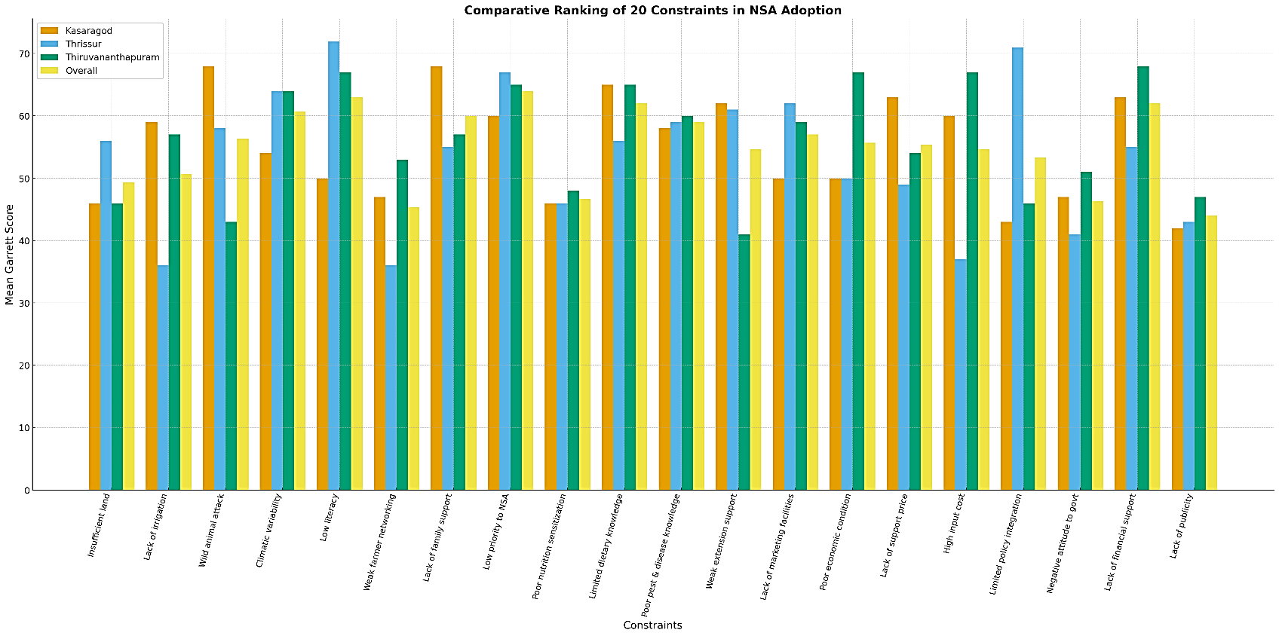

Figure 2. Comparative mean Garrett scores of NSA constraints across Kerala region

4. Conclusion

This study identified the key constraints hindering the adoption of Nutri-Sensitive Agriculture in home gardens across Kerala. The most significant barriers included lack of financial support for farmers, climatic variability, and wild animal depredation, with regional variations observed in the north, central, and southern districts of Kerala.

In northern Kerala, limited access to irrigation and financial exclusion emerged as critical factors, making it difficult for farmers to diversify their agricultural practices. In central Kerala, wild animal attacks were a major threat to the sustainability of home gardens, while in southern Kerala, land fragmentation reduced the efficiency of farming systems. Limited integration of agricultural and nutrition policies further weakens the scope of nutri sensitive interventions across regions.
To address these challenges, this study recommends region-specific strategies: improving irrigation infrastructure and credit access in the north, focusing on wildlife management in the central region, and implementing land-use planning and consolidation strategies in the south. At the statewide level, policies that improve access to finance, reduce input costs, and promote climate-resilient farming practices are essential for enhancing the adoption of NSA.

This research provides valuable insights for policy makers, extension agents, and farmers to develop targeted interventions that can improve the sustainability of home gardens and contribute to food security and nutrition in Kerala. Further research is needed to explore climate-smart agricultural practices and alternative sources of income for farmers, especially in the context of climate change and economic challenges. By tackling these multi-dimensional constraints, home gardens in Kerala can be strengthened to contribute more effectively to dietary diversity, household food security, and resilience against climate and market shocks, thereby advancing progress toward the Sustainable Development Goals.

REFERENCES
- FAO. (2017). Nutrition-sensitive agriculture and food systems in practice: Options for intervention. Food and Agriculture Organization of the United Nations. Available from: https://www.fao.org/3/i7848e/i7848e.pdf
- Pingali, P. (2015). Agricultural policy and nutrition outcomes: Getting beyond the preoccupation with staple grains. Food Security, 7(3), 583–591. https://doi.org/10.1007/s12571-015-0461-x.
- Galhena, D. H., Freed, R., & Maredia, K. M. (2013). Home gardens: A promising approach to enhance household food security and wellbeing. Agricultural Food Security, 2(1), 8. https://doi.org/10.1186/2048-7010-2-8.
- Jose, D., & Shanmugaratnam, N. (1993). Traditional home gardens of Kerala: A sustainable human ecosystem. Agroforestry Systems, 24(2), 203–213.
- Tomatis, F., Leal Filho, W., & Pauleit, S. (2023). Urban gardening in a changing climate: A review of effects and adaptation strategies. Agriculture, 13(2), 502. https://doi.org/10.3390/agriculture13020502.
- Du Toit, M. J., Rendón, O., Cologna, V., Cilliers, S. S., & Dallimer, M. (2022). Why home gardens fail in enhancing food security and dietary diversity. Frontiers in Ecology and Evolution, 10, 804523.
- Kumar, C. S., Turvey, C. G., & Kropp, J. D. (2013). The impact of credit constraints on farm households: Survey results from India and China. Applied Economic Perspectives and Policy, 35(2), 264–285. https://doi.org/10.1093/aepp/ppt002.
- Andrews, S., & Kannan, E. (2016). Land use under homestead in Kerala: The status of homestead cultivation from a village study. Working Paper 369, Institute for Social and Economic Change (ISEC), Bangalore. Retrieved from https://www.isec.ac.in/wp-content/uploads/2023/07/WP-369-Sheeba-Andrews-Final.pdf.
- Kothari, C. R. (2017). Research methodology: Methods and techniques (3rd ed.). New Delhi: New Age International Publishers.
- Cochran, W. G. (1977). Sampling techniques (3rd ed.). New York: John Wiley & Sons.
- Garrett, H. E., & Woodworth, R. S. (1969). Statistics in psychology and education (6th ed.). Bombay: Vakils, Feffer & Simons Ltd.
- Jacob, R. T., Narayanankutty, R., & Rajeev, M. (2021). Financial inclusion and indebtedness: A study of rural households in Kerala. IIM Kozhikode Working Paper Series, WP No. 430/ECO/2021/02. Indian Institute of Management Kozhikode. Retrieved from https://iimk.ac.in/uploads/publications/33733365IIMK_WPS_430_ECO_202102_Upload.pd.
- Kumar, A. G. (2012). Access to credit and technical efficiency in Kerala agriculture. SSRN Working Paper No. 2034487. Social Science Research Network. Retrieved from https://papers.ssrn.com/sol3/papers.cfm?abstract_id=2034487
- Fox, T. A., Rhemtulla, J. M., Ramankutty, N., Lesk, C., Coyle, T., & Kunhamu, T. K. (2017). Agricultural land-use change in Kerala, India: Perspectives from above and below the canopy. Agriculture, Ecosystems & Environment, 245, 1–10. https://doi.org/10.1016/j.agee.2017.05.002
- Dev, S. M., & Kadiyala, S. (2019). Agriculture-nutrition linkages and policies in India: Key entry points and policy options for nutrition-sensitive agricultural development. Gates Open Research, 3, 897.
- Prasad, G., Reddy, S., & Devi, M. (2020). Knowledge gaps and extension needs in pest management among small farmers. Indian Research Journal of Extension Education, 20(2), 75–80.
- Greeshma, P., Jayson, E. A., & Govind, S. K. (2016). The impact of human-wildlife conflict in Peechi-Vazhani Wildlife Sanctuary, Thrissur, Kerala. International Research Journal of Natural and Applied Sciences, 3(1), 32–41. Retrieved from https://www.aarf.asia/current/YBeYaIBJY48dWzQ.pdf.
- Beyer, R. M., Krieger, T., & Stöckl, T. (2022). Floods and agricultural productivity: Evidence from Kerala, India. World Development, 151, 105743.
- Thomas, A., & Nithish Babu, M. (2020). Crowdsourcing knowledge: An extension approach for remunerative and sustainable home garden farming systems in Kerala. Journal of Extension Education, 32(1), 6429–6440.
- Aslam, A., & Fazal, S. (2025). Exploring the impact of land fragmentation on the performance of agriculture: A systematic review. Discover Sustainability, 5, 207.
- Deininger, K., Monchuk, D., Nagarajan, H. K., & Singh, S. K. (2014). Does land fragmentation reduce efficiency? Micro evidence from India. Policy Research Working Paper 7085, World Bank, Washington, DC.
- Srivastava, S. K., Chand, R., & Singh, J. (2017). Changing crop production cost in India: Input prices, substitution and technological effects. Agricultural Economics Research Review, 30 (Conference Number), 171–182. https://doi.org/10.5958/0974-0279.2017.00032.5.
- FAO. (2020). The State of Food and Agriculture 2020: Overcoming water challenges in agriculture. Rome: Food and Agriculture Organization of the United Nations. Available from: https://www.fao.org/publications/sofa/2020/en/.
- Sathyan, A. R., & Prasad, C. S. (2018). Climate vulnerability in rainfed farming: Analysis from southern India including Kerala. Sustainability, 10(9), 3357.
- Sharma, R., Mina, U., & Kumar, B. M. (2022). Homegarden agroforestry systems in achievement of Sustainable Development Goals: A review. Agronomy for Sustainable Development, 42(3), 44. https://doi.org/10.1007/s13593-022-00781-9.
- WHO. (2020). Healthy diet fact sheet. World Health Organization. Available from: https://www.who.int/news-room/fact-sheets/detail/healthy-die.

