Effect of Silkworm Pupae Meal on Proximate Composition and Nutritional Quality of Tilapia Flesh

Abstract
Silkworm pupae (Bombyx mori), a by-product of the sericulture industry, are generated in large quantities annually, posing disposal and environmental issues despite their high nutritional value. This study investigate the effect of incorporating silkworm pupae meal into the diet of tilapia (Oreochromis mossambicus) with respect to growth performance, feed utilization, and body composition. A 90-day feeding trial was conducted using diets containing 0% (control), 25%, and 50% silkworm pupae meal. This study showed a progressive increase in protein (16.8% to 19.7%) and lipid content (4.5% to 6.1%) of fish flesh with higher pupae inclusion, while moisture and carbohydrate content decreased. Ash content also increased slightly, indicating enhanced mineral deposition. These findings demonstrate that silkworm pupae improve nutrient deposition, muscle quality, and feed efficiency in tilapia. Beyond nutritional benefits, utilizing locally available silkworm pupae can reduce fish feed costs, support circular economy, and promote sustainable aquaculture. Overall, silkworm pupae meal represents a cost-effective and eco-friendly alternative to conventional fishmeal in aquaculture.
Keywords: Fish nutrition, Proximate composition, Protein source, Aquaculture, Sustainability

Introduction
The silkworm (Bombyx mori) is an economically important insect’s species worldwide and has co-evolved with mulberry, Morus spp., its main food source. The silkworm being oligophagous, depends entirely on mulberry leaves, which reach peak nutritional quality during spring (Altomare et al., 2020). Silkworms reared during spring produce good quality cocoons, while those reared in autumn yield lower quality cocoons due to the poor nutritive value of mulberry leaves available during the autumn season. The feeding behavior of B. mori represents a major constraint to sericulture growth.
Globally, more than 200,000 tonnes of discarded silkworm pupae are generated annually and derived from four types of discarded silkworm pupae namely mulberry, eri, tasar, and muga. Large populations of mulberry silkworm pupae are often found in China and India, with Brazil, Thailand, Indonesia, Vietnam, and South Korea following closely after. It has long been known that silkworm pupae are a valuable food source for both humans and animals because of their high protein, fat, vitamin, mineral, and bioactive chemical contents (Meyer-Rochow & Jung, 2020; Mishra et al., 2003). However, most of the pupae discarded after silk reeling are vulnerable to bacteria and fungi degradation, leading to nutrient loss. Traditionally, these are either discarded or sun-dried for future use, resulting in inconsistent nutritional quality. According to Rodríguez-Ortiz et al. (2024), spoiled pupae are mainly used as fertilizer and as feed for the fish. However, when the pupae are immediately dried in hot-air ovens or refrigerated, their nutritional value is well preserved. Such good-quality discarded pupae can be utilized as an animal feed for fish, poultry and pigs (Sharma et al., 2022).
Mulberry silk (B. mori) accounts for around 90% of global silk production, with India being the world's second-largest producer. Approximately 60% of cocoon weight is either thrown as garbage or used as fertiliser (Altomare et al., 2020). When the silkworm pupae are disposed in greater quantities in the environment, it can cause serious environmental pollution even though it is a highly biodegradable product. Hence, converting this by-product pupae into fish feed ingredients offers a sustainable approach to reducing feed costs while mitigating environmental hazards in aquaculture. Fish feed constitutes the largest share of operational costs of more than 50 %, plays an important role in determining the overall growth, health, and productivity of the fish (Khangembam et al., 2025; Meetei et al., 2025; Tacon, 1987; Tacon & Metian, 2015). The current study was conducted to evaluate the effects of incorporating silkworm pupae meal into the diet of tilapia (O. mossambicus) with respect to growth performance, feed utilization, and body composition.

Materials and Methods

Silkworm pupae were collected from Silk Reeling and Spinning Factory, Sangaipat, Wangkhei, Manipur during June 2024 (Pic. 1). The fingerlings of tilapia (O. mossambicus) with an average weight of 3.5 g, were acclimated for seven days before the start of the trial. The fingerlings were then randomly distributed into three replicates of 10 fingerlings each. The feeding trial lasted for 90 days, during which fish were fed twice daily to apparent satiation.
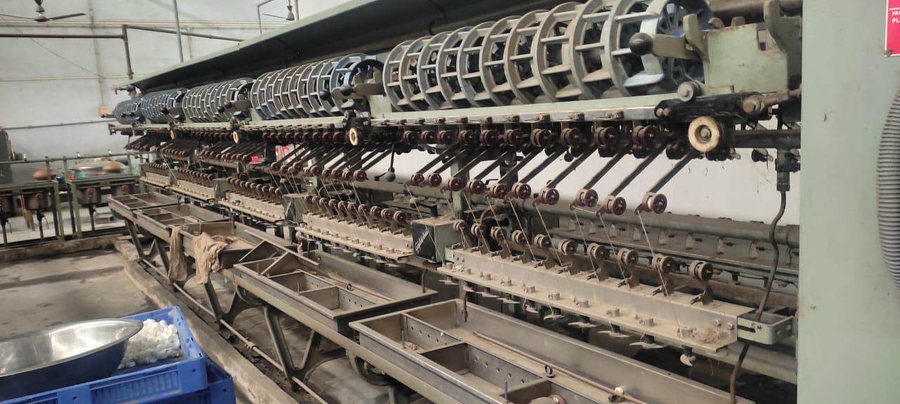
Pic. 1. Collection of silkworm pupae from Silk Reeling and Spinning Factory, Sangaipat, Manipur.
The proximate composition (moisture, protein, fat, ash, and carbohydrate content) of tilapia fed with silkworm pupae was analysed following the standard procedures of the Association of Official Analytical Chemists (AOAC) (AOAC, 2005; Baur & Ensminger, 1977).
Moisture Content
A 12 g fish sample was placed in a hot-air oven at 100°C, dried, and then weighed. To ensure complete drying, the sample was reheated in the oven for 1 hour, cooled, and reweighed.

Initial weight of silkworm pupae − Final weight of silkworm pupae silkworm pupae
× 100
(%) of moisture =
Initial weight of the sample

Ash Content
Six gram of the dried fish sample was accurately weighed into a pre-heated and cooled crucible. The crucible was placed in a muffle furnace at 600 °C for approximately 6 hrs. After cooling in a desiccator, it was weighed again. This heating, cooling and weighing cycle was repeated until constant weight was obtained.
× 100
Weight of Ash
(%) of Ash content =
Weight of the sample taken

Protein Content
Crude protein of the fish sample was estimated by determining nitrogen content using the Micro-Kjeldahl method. The nitrogen value obtained was multiplied by a conversion factor of 6.25 to estimate crude protein.
Protein (%) = Nitrogen (%)×6.25
Fat Content
Fat content of the fish sample was determined gravimetrically and expressed as grams of fat per 100 g of sample.
Carbohydrate Content
For carbohydrate estimation, 1.0 g of dried fish sample was extracted twice with 10 mL of 80 % ethanol. The supernatant was collected and evaporated on a water bath at 80 °C. The dried residue was dissolved in 1.0 ml of 0.01% formic acid and further extracted two to three times with ethyl acetate. Ethyl acetate was removed completely by evaporation on a water bath at 60 to 70 °C for 30 minutes, and the final volume was adjusted to 1.0 ml.

Results
The inclusion of silkworm pupae meal in the diet of tilapia had a marked effect on the proximate composition of fish flesh (Table 1; Fig. 1 and 2). A progressive increase in protein and lipid levels was observed with higher pupae incorporation, while moisture and carbohydrate (NFE) contents showed a gradual decline.
Table 1. Proximate composition of formulated diets used for tilapia feeding trial.
Parameter | Control | 25% Pupae | 50% Pupae
Moisture (%) | 75.2 | 74.6 | 74.0
Protein (%) | 16.8 | 18.3 | 19.7
Lipid (%) | 4.5 | 5.3 | 6.1
Ash (%) | 1.2 | 1.4 | 1.6
NFE (%) | 2.3 | 2.0 | 1.6

Fig. 1. Proximate composition of tilapia flesh under control, 25% pupae, and 50% pupae diets.

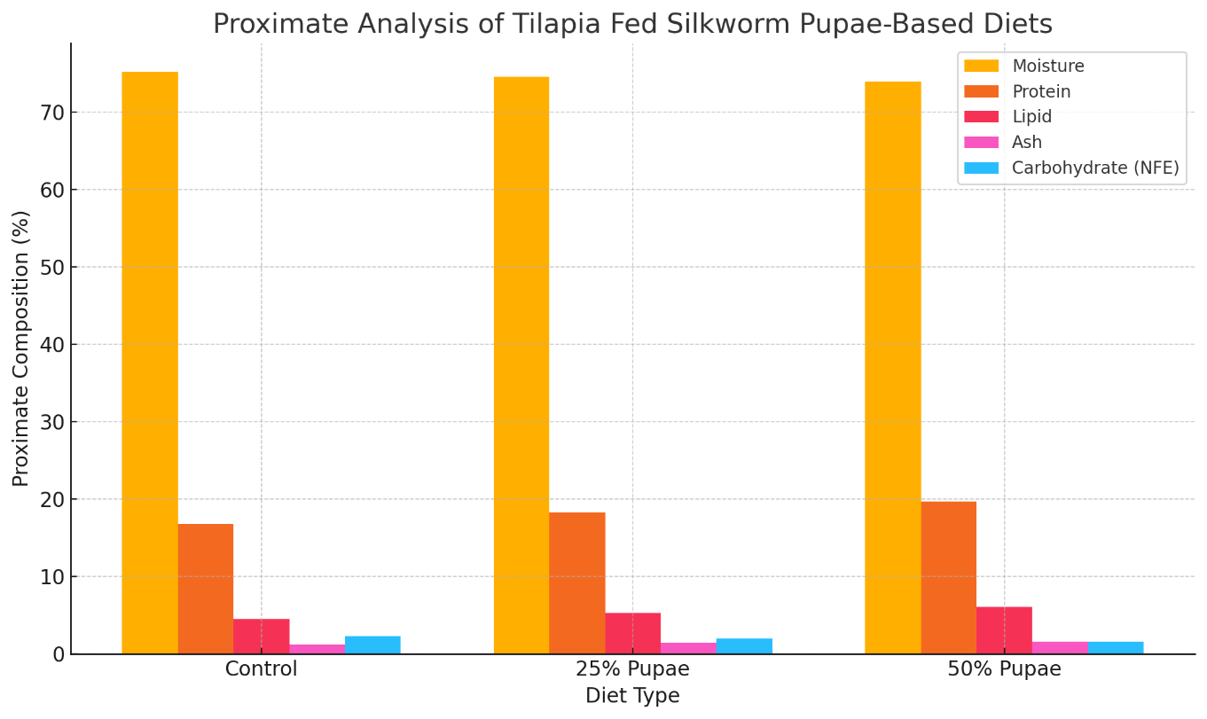
Fig. 2. Proximate composition of formulated feeds (mean ± SD of three replicates).
Fish in the control group showed protein and lipid levels of 16.8% and 4.5%, respectively. With 25% pupae group, protein content increased to 18.3% and lipid to 5.3%. The 50% pupae diet showed the highest values, with protein at 19.7% and lipid at 6.1%. This increased trend highlights the positive role of silkworm pupae in enhancing the nutritional quality of fish muscle.
Moisture content decreased from 75.2% in the control group to 74.0% at 50% pupae, highlighting denser and more nutrient-rich fish flesh. Similarly, carbohydrate content declined steadily from 2.3% in the control to 1.6% in the 50% pupae group, indicating improved energy utilization efficiency. Ash content increased slightly across treatments (1.2% to 1.6%), suggesting enhanced mineral deposition in the fish muscle. Figure 1 and 2 further illustrates these patterns, showing clear increase in protein and fat with increasing levels of pupae inclusion. The formulated feed’s proximate composition also demonstrated consistency across replicates, with low standard deviations, validating the reliability of the results.
Overall, the incorporation of silkworm pupae meal significantly improved the fish muscle consistency, nutrient composition, and growth efficiency of tilapia, supporting its potential as a sustainable and protein-rich alternative fish feed ingredient in aquaculture.

Discussion
This study demonstrated that the inclusion of silkworm pupae in tilapia feed significantly improved the proximate composition of fish flesh. Protein and lipid levels increased with higher pupae content, while moisture and carbohydrate (NFE) decreases. This trends indicate enhanced nutrient deposition and energy utilization efficiency.
Silkworm pupae are rich in protein and fat and contain vital amino acids such as lysine, methionine, and leucine (Altomare et al., 2020). This nutritional profile explains the observed rise in crude protein (from 16.8% to 19.7%) and lipid content (up to 6.1%) in tilapia. These nutrients enhance muscle synthesis, growth performance, and flesh quality of the fish. The higher lipid content is favourable, as silkworm pupae are rich in unsaturated fatty acids, which improve energy storage and nutritional value (Meyer-Rochow & Jung, 2020; Tomotake et al., 2010). The moderate increase in ash content suggests improved mineral availability, especially calcium and phosphorus, which are essential for bone formation and metabolic processes (Hăbeanu et al., 2023). The decrease in moisture, combined with increased protein and fat, indicates denser and higher-quality fish flesh, while the lower NFE suggests more efficient utilization of protein and fat as energy sources. Although feed conversion ratio (FCR) were not measured in this study, the improved flesh composition suggests better feed efficiency and muscle quality. Earlier studies in tilapia confirm that replacing fishmeal with pupae not only supports growth but also reduces feed costs (Salem et al., 2008).
From a practical point, these findings have particular importance in Manipur, where commercial fish feeds are expensive and mainly imported. Using locally available silkworm pupae waste can substantially cut the fish feed costs for farmers while converting a sericulture by-product into a value-added resource. This integration benefits both aquaculture and sericulture sectors, strengthening rural livelihoods. Incorporating agricultural and sericulture byproducts into aquaculture aligns with circular economy principles, minimizing waste and improving sustainability.

Conclusion
The incorporation of silkworm pupae meal into tilapia diets significantly increased protein, and lipid content of fish flesh, while reducing moisture and carbohydrate levels. These highlight its role in improving flesh quality, nutrient deposition, and feed efficiency. Given its local availability, cost-effectiveness, and sustainability, silkworm pupae meal offers a promising alternative to conventional fishmeal, benefiting both aquaculture productivity and rural livelihoods. Overall, this study support silkworm pupae meal as a sustainable, cost-effective alternative to fishmeal, with potential to enhance growth performance and nutritional quality in tilapia aquaculture.

References
- Altomare, A. A., Baron, G., Aldini, G., Carini, M., & D'Amato, A. (2020). Silkworm pupae as source of high-value edible proteins and of bioactive peptides. Food Science & Nutrition, 8(6), 2652–2661. https:// doi.org/10.1002/fsn3.1546

- AOAC. (2005). Association of Official Analytical Chemist, Official Methods of Analysis. 18th Edition, AOAC International, Suite 500, 481 North Frederick Avenue, Gaithersburg, Maryland 20877-2417, USA.

- Baur, F. J., & Ensminger, L. G. (1977). The association of official analytical chemists (AOAC). Journal of the American Oil Chemists’ Society, 54(4), 171-172.

- Hăbeanu, M., Gheorghe, A., & Mihalcea, T. (2023). Nutritional value of silkworm pupae (Bombyx mori) with emphases on fatty acids profile and their potential applications for humans and animals. Insects, 14(3), 254.

- Khangembam Brajamani Meetei, Bijayalakshmi Devi Nongmaithem, and Ajit Kumar Ngangbam (2025). Nonconventional Feed Resources for Sustainable Aquaculture: A Review. Biological Forum, 17(3): 73-77.

- Meetei, K. B., Nongmaithem, B. D., & Ngangbam, A. K. (2025). Aquafeed Innovation: Utilization of Molluscan and Crustacean By-Products for Sustainable Fish Nutrition. Journal of Experimental Agriculture International, 47(3), 349-356.

- Meyer-Rochow, V. B., & Jung, C. (2020). Insects used as food and feed: Isn’t that what we all need?. Foods, 9(8), 1003.

- Mishra, N., Hazarika, N. C., Narain, K., & Mahanta, J. (2003). Nutritive value of non-mulberry and mulberry silkworm pupae and consumption pattern in Assam, India. Nutrition Research, 23(10), 1303-1311.

- Sharma, A., Gupta, R. K., Sharma, P., Duwa, A. K., Bandral, R. S., & Bali, K. (2022). Silkworm as an edible insect a review. The Pharma Innovation Journal, 11(2S): 1667-1674.

- Salem, M., Khalafalla, M. M. E., Saad, I. A. I., & El-Hais, A. M. A. (2008). Replacement of fish meal by silkworm Bombyx mori pupae meal in Nile tilapia, Oreochromis niloticus diets. Egyptian Journal of Nutrition and Feeds, 11(3), 611-624.

- Rodríguez-Ortiz, L. M., Hincapié, C. A., Hincapié-Llanos, G. A., & Osorio, M. (2024). Potential uses of silkworm pupae (Bombyx mori L.) in food, feed, and other industries: a systematic review. Frontiers in Insect Science, 4, 1445636.

- Tacon, A. G. (1987). The nutrition and feeding of farmed fish and shrimp; a training manual. 2: Nutrient sources and composition. FAO. https://openknowledge.fao.org/handle/20.500.14283/ab468e

- Tacon, A. G., & Metian, M. (2015). Feed matters: Satisfying the feed demand of aquaculture. Reviews in Fisheries Science & Aquaculture, 23(1), 1-10.

- Tomotake, H., Katagiri, M., & Yamato, M. (2010). Silkworm pupae (Bombyx mori) are new sources of high quality protein and lipid. Journal of nutritional science and vitaminology, 56(6), 446-448.

