Case report

Severe Subaortic Stenosis in a Six-Year-Old Pug

.

ABSTRACT

Aims: Subaortic stenosis (SAS) is the most frequently diagnosed form of aortic stenosis in dogs, typically identified in large breeds during early life. However, its manifestation in atypical breeds or adult animals is less commonly described. This case report highlights the diagnostic approach, clinical course and medical management of SAS in a Pug, emphasizing its relevance in older small-breed dogs.
Presentation of Case: A six-year-old intact male Pug was presented with exertional intolerance and syncopal episodes. Clinical examination revealed a grade V/VI systolic murmur at the left heart base. Hemato-biochemical parameters, including liver and renal function tests were within normal ranges. Thoracic radiography demonstrated cardiomegaly, while electrocardiography showed sinus rhythm with ST slurring. Echocardiography identified a broad fibromuscular ridge in the left ventricular outflow tract (LVOT), concentric left ventricular hypertrophy and a peak aortic velocity of 5.41 m/s, corresponding to a transvalvular gradient of 117.12 mmHg, consistent with severe SAS. Diastolic dysfunction was evidenced by a reversed E/A ratio on pulsed-wave Doppler. The dog was managed with atenolol (6.25 mg PO q12h) alongside exercise restriction. At five-month follow-up, the owner reported improved tolerance to activity with no recurrence of syncope.
Discussion and Conclusion: This case underscores the clinical importance of considering SAS in adult dogs of any breed presenting with exertional collapse. Echocardiography remains indispensable for definitive diagnosis and grading severity. While the prognosis of severe SAS is guarded, medical therapy with beta-blockers may provide symptomatic relief and short-term improvement.

Keywords: Subaortic stenosis; Echocardiography; Pug; Atenolol.

1. INTRODUCTION

Aortic stenosis (AS) is among the most frequently diagnosed congenital cardiac malformations in dogs. Based on the anatomic location of the obstructive lesion, AS can be classified as supravalvular, valvular or subvalvular. Of these, subvalvular or subaortic stenosis (SAS) is the most common form (Boon, 2011). It accounts for approximately 24% of all canine congenital heart diseases, with a reported prevalence of 0.3% in the general canine population (Ontiveros et al., 2019; Schrope, 2015; Bonagura and Twedt, 2014; Oliveira et al., 2011). The condition is most commonly characterized by the development of a fibromuscular ridge within the left ventricular outflow tract (LVOT), resulting in obstruction to systolic blood flow and subsequent pressure overload of the left ventricle. Over time, this hemodynamic burden leads to compensatory concentric left ventricular hypertrophy, diastolic dysfunction, myocardial ischemia and increased risk of arrhythmias (Beijerink et al., 2017). The condition is reported predominantly in large-breed dogs such as the Newfoundland, Golden Retriever, German Shepherd, Rottweiler and Boxer. Affected animals may present with clinical signs including exercise intolerance, syncope, arrhythmias, left-sided congestive heart failure or in severe cases, sudden cardiac death (Eason et al., 2021). Continuous-wave (CW) Doppler echocardiography provides a reliable, non-invasive method for assessing aortic flow velocity in dogs without the need for anesthesia. By applying the modified Bernoulli equation, the peak velocity obtained can be converted into the maximum instantaneous pressure gradient (ΔP = 4v²) across the stenotic region, allowing accurate hemodynamic evaluation of the lesion (Boon, 2011). This Doppler-derived pressure gradient correlates closely with invasive aortic pressure measurements (Petrič et al., 2019; Beijerink et al., 2017). This case report describes the clinical presentation, diagnostic evaluation and therapeutic management of a 6-year-old male Pug diagnosed with subaortic stenosis, highlighting the clinical significance of this uncommon presentation and also the successful medical management of the condition for 5 months.

2. PRESENTATION OF CASE

A 6-year-old intact male Pug dog, weighing 9 kg, was presented at Small Animal Multi-Speciality Veterinary Hospital, Guru Angad Dev Veterinary and Animal Sciences University, Ludhiana with a history of exertional fatigue for 1 year and 2 episodes of syncope in last one month. The dog was reported to be eating, drinking, and behaving normally, with no history of medication use. On examination, the patient was bright, alert and responsive with a good body condition (body condition score 3/5), rectal temperature was 102.4°F, heart rate was 120 beats/min and pulse was strong and synchronous. Respiratory assessment revealed panting with a shallow breathing pattern. Mucous membranes appeared pink with a capillary refill time of less than 2 seconds. Cardiac auscultation revealed a grade V/VI holosystolic murmur, most prominent at the left heart base with precordial thrills. The dog was prehypertensive with systolic blood pressure of 150 mmHg, which was measured by Doppler method (Vet-dop2, Model BF2, Vmed technology, USA). Hemato-biochemical parameters, including liver and renal function tests were within normal ranges.

Electrocardiography (ECG) was performed with the dog positioned in right lateral recumbency using a six-channel electrocardiograph (Cardiart 8108; BPL Medical Technologies, Bangalore, India). The tracing revealed normal sinus rhythm alongside ST slurring (Fig. 1). Lateral thoracic radiographs showed cardiomegaly, with the cardiac silhouette occupying 4 intercostal spaces, a vertebral heart score of 12v and elevation of the carina was also observed (Fig. 2).
Echocardiographic evaluation was performed using a GE Logiq P5 color Doppler ultrasound system (GE Healthcare, Chicago, IL, USA). The right parasternal left ventricular outflow tract (LVOT) view demonstrated a broad fibromuscular ridge protruding into the outflow tract. The right parasternal short-axis view revealed marked concentric hypertrophy of the left ventricular walls and interventricular septum, consistent with severe compensatory remodeling. M-mode variables have been presented in Fig. 3. The left atrium-to-aorta (LA/Ao) ratio was within the normal range (1.20). Continuous-wave and color Doppler echocardiography obtained from the left apical five-chamber view (Fig. 4) demonstrated a peak aortic velocity of 5.41 m/s, corresponding to a transvalvular pressure gradient of 117.12 mmHg, findings consistent with severe aortic stenosis. Pulsed-wave Doppler assessment at the level of the mitral valve demonstrated diastolic dysfunction, evidenced by a reversed E/A ratio of 0.61 (Fig. 5). The dog was managed medically with the beta-blocker atenolol (6.25 mg PO every 12 hours) and the owner was advised to restrict the dog’s physical activity. At the recent 5-month follow-up, owner feedback obtained via telephone indicated normal activity and exercise tolerance by the dog with the absence of any recurrent syncopal episodes.

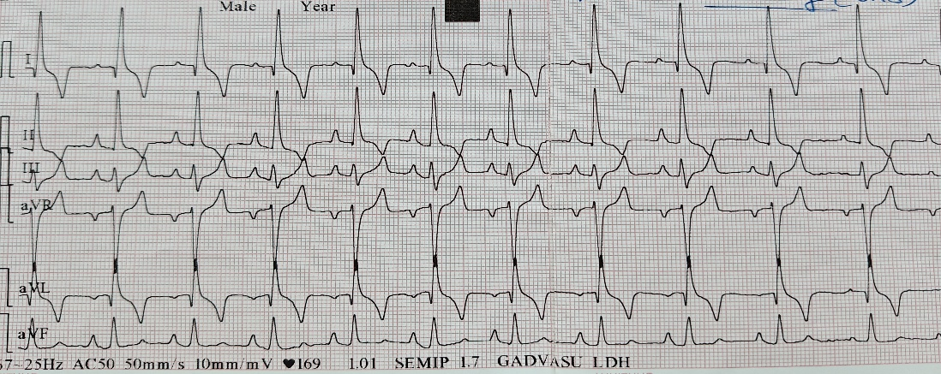

Fig. 1. Electrocardiogram at 50 mm/sec velocity and 10 mm/mV sensitivity depicting normal sinus rhythm and ST slurring

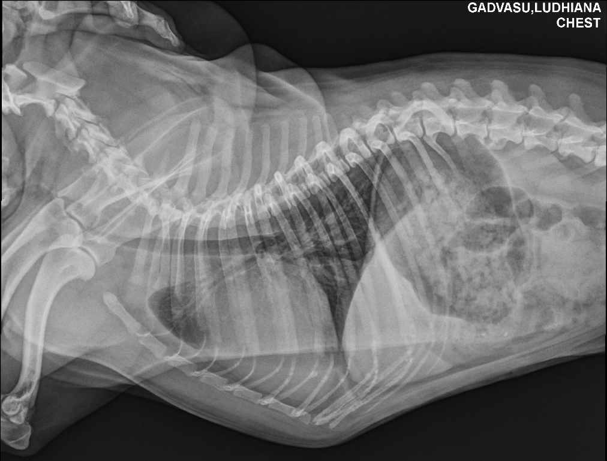

Fig. 2. Lateral thoracic radiograph showing cardiomegaly (heart occupying 4 Intercostal spaces with increased sternal contact) and lifting of trachea is seen at the level of carina

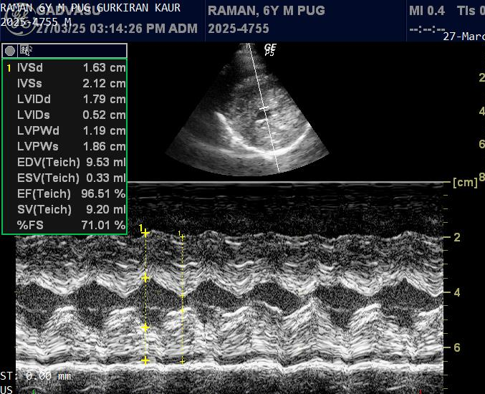

Fig. 3. Right parasternal short-axis view depicting the M-mode variables showing markedly thickened Left ventricular wall and Interventricular septum

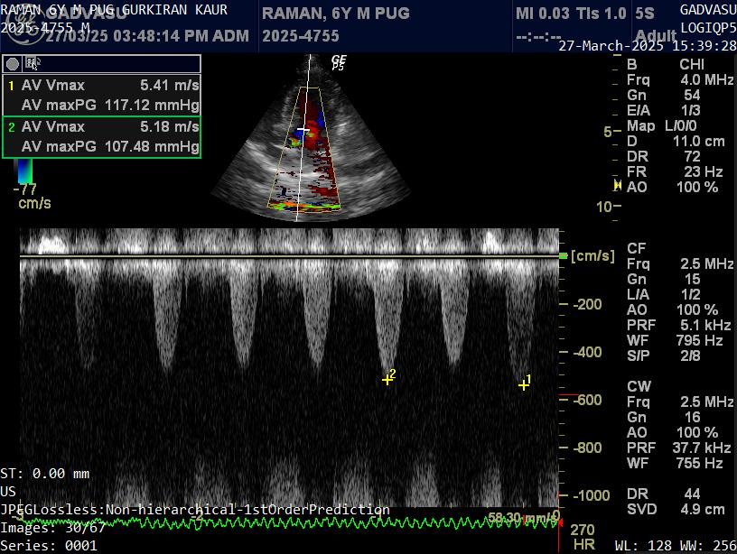

Fig. 4. Transvalvular aortic pressure gradient through left apical five-chamber view

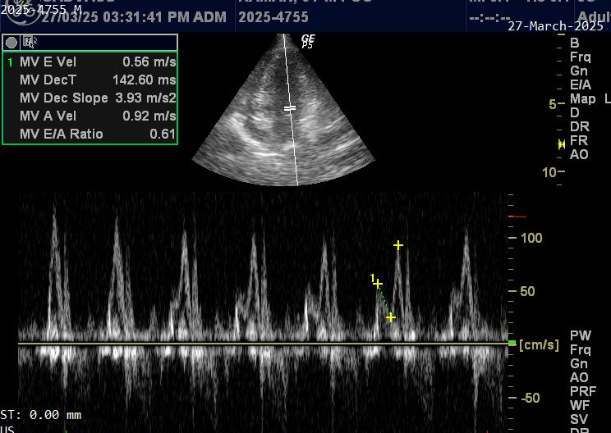

Fig. 5. Diastolic dysfunction as represented by reversal of Mitral E to A ratio

3. discussion

Subaortic stenosis (SAS) represents the predominant form of canine aortic stenosis, most often arising from a fibrous or fibromuscular ridge that partially obstructs the left ventricular outflow tract (LVOT) (Beijerink et al., 2017). This anomaly is responsible for approximately 95% of reported cases, whereas valvular stenosis remains uncommon, occurring in only 2.4–5.7% of affected dogs (Petrič and Cvetko,2009). Although SAS is well recognized in breeds such as the Newfoundland, Boxer, Golden Retriever, German Shepherd, English Bulldog and Rottweiler (Strickland and Oyama, 2016), this report emphasizes its occurrence in the Pug. This emphasizes the importance of including SAS as a differential diagnosis in any small-breed dog presenting with relevant signs.

SAS is most frequently detected in young dogs, yet the timing of recognition may range from early puppyhood to as late as ten years of age. Such variability is attributed to the gradual progression of fibrous proliferation within the LVOT, which may remain subclinical for years before reaching a clinically relevant threshold (Strickland and Oyama, 2016; Beijerink et al., 2017). The present case is noteworthy because the dog developed overt signs in adulthood, illustrating that SAS cannot be excluded in older small-breed dogs with unexplained exercise intolerance or syncope. Clinical signs are closely linked to the severity of the pressure gradient. Dogs with mild stenosis often show no outward abnormalities, whereas those with moderate to severe obstruction frequently experience syncope, weakness or even sudden death (Petrič et al., 2019; Eason et al., 2021). The patient described here demonstrated weakness, lethargy and exertional syncope, which are typical of a moderate-to-severe hemodynamic burden. Such syncopal episodes may be explained by a fall in forward stroke volume during activity, potentially worsened by ventricular arrhythmias (Beijerink et al., 2017). While no arrhythmia was documented on a single ECG tracing, the possibility of transient fatal arrhythmias cannot be excluded; extended 24-hour Holter monitoring would have provided better diagnostic sensitivity. Thoracic radiographs in dogs with aortic stenosis are frequently unremarkable; however, in advanced or severe cases, evidence of left ventricular hypertrophy and generalized cardiomegaly may be observed (Petrič et al., 2019; Watson et al., 2019), as also observed in this case.

Echocardiography remains the diagnostic standard for SAS, permitting both visualization of the subvalvular ridge and quantification of hemodynamic compromise. In this case, a LVOT pressure gradient of 117.12 mmHg confirmed severe disease. Clinically, gradients above 80 mmHg are considered severe, and values greater than 130 mmHg are strongly correlated with reduced survival (Eason et al., 2021; Petrič et al., 2019; Boon, 2011). Auscultation of a harsh systolic ejection murmur over the left heart base remains a valuable clinical indicator with murmur intensity generally reflecting disease severity, thus highlighting the enduring diagnostic value of physical examination.
Prognosis in severe SAS is poor once clinical signs emerge. Many dogs die within the first three years of life, especially those with gradients exceeding 80 mmHg (Petrič et al., 2019; Beijerink et al., 2017). Nonetheless, survival times remain variable which are influenced by the severity of hypertrophy, arrhythmia frequency and therapeutic response (Tjostheim et al., 2023; Eason et al., 2021; Eason et al., 2014).

Management strategies for SAS are largely palliative. Beta-blockers, particularly atenolol, are commonly employed to improve diastolic filling, lower myocardial oxygen demand and limit arrhythmic risk (Tjostheim et al., 2023; Bonagura and Twedt, 2014; Eason et al., 2014). Interventional options such as balloon valvuloplasty are less effective in SAS due to the fixed fibrous ridge, while surgical resection remains rarely performed and has yielded inconsistent outcomes in veterinary medicine (Beijerink et al., 2017). In this case, atenolol combined with exercise restriction provided marked clinical improvement during the five-month follow-up period.

4. Conclusion

This report documents an unusual case of severe subaortic stenosis in an adult Pug, highlighting that SAS should not be excluded solely based on age or breed. The combination of thorough clinical evaluation and Doppler echocardiography remains central to diagnosis and risk stratification. Although the long-term prognosis of severe SAS is poor, medical management with beta-blockers such as atenolol may improve clinical outcomes and quality of life in the short to medium term. Continued monitoring, 24-hour Holter assessment for arrhythmias and echocardiographic follow-up are essential to guide therapeutic adjustments and better define survival patterns in this disease.

Competing interests

Authors have declared that no competing interests exist.

References

Boon, J.A. (2011). Veterinary Echocardiography (2nd ed.). Ames, Iowa: Wiley Blackwell.

Ontiveros, E. S., Fousse, S. L., Crofton, A. E., Hodge, T. E., Gunther-Harrington, C. T., Visser, L. C., & Stern, J. A. (2019). Congenital cardiac outflow tract abnormalities in dogs: prevalence and pattern of inheritance from 2008 to 2017. Frontiers in Veterinary Science, 6, 52. https://doi.org/10.3389/fvets.2019.00052

Schrope, D. P. (2015). Prevalence of congenital heart disease in 76,301 mixed-breed dogs and 57,025 mixed-breed cats. Journal of Veterinary Cardiology, 17(3), 192-202. https://doi.org/10.1016/j.jvc.2015.06.001

Bonagura, J. D., & Twedt, D. C. (2014). Kirk’s Current Veterinary Therapy XV. Philadelphia, Pennsylvania: Saunders.

Oliveira, P., Domenech, O., Silva, J., Vannini, S., Bussadori, R., & Bussadori, C. (2011). Retrospective review of congenital heart disease in 976 dogs. Journal of Veterinary Internal Medicine, 25(3), 477-483. https://doi.org/10.1111/j.1939-1676.2011.0711.x

Beijerink, N.J., Oyama, M.A., & Bonagura, J.D. (2017). Congenital heart disease. In: S.J. Ettinger, E.C. Feldman, & E. Côté (Eds.), Textbook of Veterinary Internal Medicine: disease of the dog and the cat (8th ed., pp. 2952-3032). St. Louis, Missouri: Elsevier.

Eason, B. D., Fine-Ferreira, D. M., Leeder, D., Stauthammer, C., Lamb, K., & Tobias, A. (2021). Natural history of subaortic stenosis in 166 dogs (1999–2011). Journal of Veterinary Cardiology, 37, 71-80. https://doi.org/10.1016/j.jvc.2021.08.005

Petrič, A. D., Perovič, A., Švara, T., & Dovč, P. (2019). Aortic Stenosis in Dogs and Cats: Past, Present and Future. In: P. Magnusson (Ed.), Aortic Stenosis-Current Perspectives. IntechOpen. https://doi.org/10.5772/intechopen.84891

Petrič, A. D., & Cvetko, S. (2009). Aortic stenosis in dogs: clinical characteristics and survival in 80 cases. Slovenian Veterinary Research, 46(4), 125-131.

Strickland, K.N., & Oyama, M.A. (2016). Congenital Heart Disease. In: F.W.K. Smith, L.P. Tilley, M.A. Oyama, & M.M. Sleeper (Eds.), Manual of Canine and Feline Cardiology (5th ed., pp. 218-236). St. Louis, Missouri: Elsevier.

Watson, C. E., Payne, J. R., & Borgeat, K. (2019). Valvular aortic stenosis in three cats. Journal of Veterinary Cardiology, 25, 1-6. https://doi.org/10.1016/j.jvc.2019.06.005

Tjostheim, S. S., Showers, A., Obernberger, C., & Shear, M. (2023). Association of sotalol versus atenolol therapy with survival in dogs with severe subaortic stenosis. Journal of Veterinary Cardiology, 48, 19-30. https://doi.org/10.1016/j.jvc.2023.05.003

Eason, B. D., Fine, D. M., Leeder, D., Stauthammer, C., Lamb, K., & Tobias, A. H. (2014). Influence of beta blockers on survival in dogs with severe subaortic stenosis. Journal of Veterinary Internal Medicine, 28(3), 857-862. https://doi.org/10.1111/jvim.12339

