Floral Biology and Pollination behaviour in Caygua ( Cyclanthera pedata L. Schrad.)

ABSTRACT
A total of six genotypes collected locally were raised in randomized complete block design (RCBD) and replicated four times for conducting this investigation. Floral traits such as flower diameter, flower length, pedicel length days to first male and female flowering, sex ratio, pollen germination, pollen viability were observed at the Vegetable and Demonstration Block, College of Horticulture, VCSG, UUHF, Bharsar during 2021. The minimum days taken to first male flowering were 26.750 and minimum days to first female flowering took 27.750 days. In terms of sex ratio genotype L.C. Dooni Pak had minimum sex ratio 17.250 male per female, which is desirable. Flowers started to open from 4.00 a.m. and continued to till 9 a.m. in all the 6 genotypes observed. The peak period of anther dehiscence was recorded between 5.00 am to 7.00 am. The maximum pollen germination obtained was 66.66% while maximum pollen viability was 94.370%. Hand pollination has given better result as compared to insect pollination. Stigma receptivity determined by fruit set method was recorded maximum during full bloom stage followed by bud stage and least in withering stage. Knowledge of floral biology is important to carry out successful plant breeding programme as it helps in understanding and determining the breeding behaviour of particular plant species.

Key words: Caygua, Floral Biology, Pollination

INTRODUCTION
Caygua / Stuffing Cucumber (Cyclanthera pedata L. Schrad.), belongs to the family Cucurbitaceae. It is a herbaceous vine cultivated as fruit vegetable crop. In Uttarakhand it is commonly called as Ram Karela or Meetha Karela. It is thought to be originated from Andean region or “Sierra” (Dietschy, 1953; Popenoe, 1989; Macbride, 1937; Montoro et al., 2001). The growing habit is annual, climbing plants having tendrils, leaves are palmate and flowers are small, unisexual and are borne at leaf axillary buds. Fruit is ovoid in shape and fruit type is pepo (Cappelletti, 1976; Macbride, 1937). Flowers pale yellow; male flowers in 20-50-flowered panicle on up to 20 cm long peduncle, pedicel filiform, less than 1 cm long, calyx with linear segments, corolla with triangular ovate segments, filaments connate, anthers circular; female flower with similar calyx and corolla, ovary 2-3 mm long. Seeds black, 10-12 mm long, margin dentate, not exploding when mature. (Grubben and Denton, 2004)
Knowledge of floral biology is important to carry out successful plant breeding programme as it helps in understanding and determining the breeding behaviour of particular plant species. If the crop is naturally homozygous, a homozygous line would be developed as a variety, where as if the crop is heterozygous, a heterozygous population has to be developed as a variety. Consequently, the breeding methods have to be vastly different for the two groups of plants. Thus, the knowledge of floral biology plays an important role for development of intraspecific or interspecific hybrids between diverse and desirable plants.
So, objective of this investigation was to study the various components of floral biology of six different genotypes of Cyclanthera pedata L. Schrad.

MATERIALS AND METHODS

A total six genotypes collected locally from different altitudes and they were raised with a spacing of 1m×1m in randomized complete block design (RCBD) and replicated four times for conducting this investigation. Days to first flowering was recorded for both male and female flowers by counting the days from transplanting until the day on which first flower opened on the selected plants of each treatment and averaged over replications. Length and diameter of different floral parts were measured using digital vernier caliper when the flowers were freshly opened and bloomed. Sex ratio was determined by counting male and female flowers on five different nodes and internodes of each plant from each treatment and averaged over replications. The sex ratio was determined by using ratio formula. For anthesis data was collected consecutively for 5 days from 14/06/2021 till 18/06/2021 at hourly intervals from 4.00 hrs to 10.00 hrs. As soon as anthesis was observed, the bud was removed so as to avoid counting the same bud again. Anther dehiscence was noted by tapping the anther tip on slide. For observing pollination percentage by insects 10 flower buds from each plant of different genotypes of each replication were selected and allowed to openly pollinate and for observing pollination percentage by hand 10 flower buds from each plant of different genotypes of each replication were selected and pollinated by hand and bagged. The percentage of fruit set was recorded. For pollen germination, pollen grains were placed on a slide consisting of the germination medium and incubated for 24 hours. The pollen viability and longevity was determined by acetocarmine test. Data analysis was done using GRAPES, KAU using multiple comparision test (“Tukey’s HSD test”).

RESULT AND DISCUSSION
Mean performance for floral biology components of all the six genotypes is presented in Table 1 and 2. Anthesis started from 4.00 a.m. and continued till 9 a.m. in all the 6 genotypes observed. The peak period of anthesis and anther dehiscence for all the genotypes was recorded in between 5 am to 7 am. The data displays a variety of days to first female flowering and days to first male flowering values, suggesting that the various Cygua genotypes vary in flowering time. The days to first female flowering ranged between 27.75 days to 33.12 days among six different genotypes while days to first male flowering ranged between 26.75 days to 31.62 days. Due to genetic or physiological variations in how they react to environmental stimuli, this dispersion implies that certain genotypes have quicker floral induction than others. Breeding cycles that seek for quick generation turnover may benefit more from genotypes with earlier flowering (Gwanama et al., 2001 and Singh et al., 2018). Female flower diameters vary greatly between genotypes, ranging from 6.11 mm to 7.41 mm. Male flower diameter ranges from 6.40 mm to 7.38 mm, with less variation. Some genotypes may have larger flower dimensions, which might improve pollination success by contributing to pollen dispersal efficiency. In order to increase pollination rates and facilitate insect visits to flowers, breeding programs may favour genotypes with bigger flowers. The length of female flowers varies greatly between genotypes, ranging from 2.05 mm to 2.85 mm. Male flower lengths, which range from 1.99 mm to 2.33 mm, are comparatively less varied. Given the higher diversity in female bloom length, it is likely that genotype has a more significant impact on this feature in females. Because it may affect pollinator attractiveness or reproductive fitness, selection based on female flower length may be advantageous for qualities associated with reproductive success in breeding programs. Unless certain pollination qualities are sought, male flower length might not need intentional selection. Compared to male pedicel lengths, which range from 4.27 mm to 5.38 mm, female pedicel lengths vary less and are more narrowly ranged among genotypes, ranging from 0.71 mm to 1.47 mm. This suggests that pedicel length variability is higher in male blooms. Breeding may benefit from selection based on male pedicel length, particularly to improve pollinator access or flower placement features. Style length ranges from 2.61 mm to 3.29 mm, depending on the genotype. One genotype has a noticeably longer style at 3.29 mm, while other genotypes cluster around comparable lengths (2.61 to 2.75 mm). Because style length influences pollen compatibility and reach, it can have an effect on effective fertilisation. Breeding techniques that aim to increase reproductive efficiency may benefit from genotypes with longer styles since they may have reproductive benefits under specific circumstances. There is tremendous variation among genotypes, as evidenced by the sex ratio, which ranges from 17.25 to 23.75. Male-to-female flower ratios are more noticeable in genotypes with the greatest ratios (e.g., 23.75 and 23.00), whereas a more balanced or female-biased flowering tendency is suggested by genotypes with lower ratios. A lower sex ratio could lead to a higher yield by producing more fruits per plant (Kumari et al. 2017). Compared to insect pollination, which has a success percentage ranging from 55.00% to 68.75%, hand pollination typically has a success rate between 78.75% and 91.25%. This suggests that hand pollination works better and is more reliable for all genotypes. For consistent outcomes in controlled breeding, hand pollination is the favoured method due to its greater and steadier success rates. However, for open-field production systems, insect pollination optimisation is still essential. The results were in accordance with Deyto et al., 2009. Variability in pollen germination rates is moderate, ranging from 57.77% to 66.66% between genotypes. In breeding, higher pollen germination rates are advantageous because they guarantee better fertilisation and more fruit set. Breeding programs aimed at increasing production may find it essential to choose genotypes with greater pollen germination rates. All genotypes exhibit strong potential on the first day, with pollen viability ranging from 90.05% to 94.37% (Rathod et al. 2018). As pollen lifetime declines, pollen viability drops by the third and fifth days. Viability ranges between 53.75% and 62.63% by third and further declines to 16.13% to 25.38% by fifth day. Breeding programs benefit from genotypes with higher pollen viability and longer viability (longevity) at the third and fifth days, particularly in controlled or open-pollinated settings where longer pollen viability can increase fertilisation success. Maximum fruit set was observed at the full bloom stage, followed by the bud and withering stages across all genotypes. L.C. Buransi recorded the highest fruit set (90%) at full bloom, while L.C. Sainji and L.C. Pauri had the lowest (70%). At the bud stage, L.C. Bharsar, L.C. Pauri, and L.C. Pabau showed the highest (40%) and L.C. Dooni Pak the lowest (20%). During the withering stage, L.C. Bharsar and L.C. Pauri had the highest (30%), while L.C. Dooni Pak had none. The full bloom stage is optimal for fruit set, indicating peak pollination efficiency. Genotypic variations suggest inherent reproductive differences affecting yield potential. This result is in partial accordance with Naik et al. (2013).
Conclusion
The study conducted in the temperate region of Uttarakhand revealed significant variations among genotypes in flowering behavior, floral traits, and reproductive efficiency. L.C. Dooni Pak exhibited the earliest male flowering, while L.C. Sainji had the earliest female flowering. L.C. Bharsar recorded the longest male flowers, whereas L.C. Sainji had the longest female flowers. L.C. Buransi showed the highest female pedicel length and flower diameter, while L.C. Dooni Pak had the largest male flower diameter and style length. The best sex ratio was observed in L.C. Dooni Pak. Anthesis and anther dehiscence peaked between 5:00–7:00 a.m., indicating an optimal pollination window. Stigma receptivity, assessed through fruit set, was highest during the full bloom stage, followed by the bud and withering stages. L.C. Bharsar exhibited superior pollen viability and germination, whereas L.C. Pauri had the highest pollen longevity. L.C. Sainji demonstrated the highest fruit set under both hand and open pollination, reinforcing the importance of full bloom for reproductive success. These findings provide valuable insights into genotype selection and pollination strategies of Caygua for optimizing fruit set and yield in temperate conditions.

REFERENCES
Cappelletti, C. 1976. “Trattato di botanica”. 3rd ed., UTET: Torino Italy.
Deyto, R., and Cervacia, C. R. 2009. Floral biology and pollination of ampalaya (Momordica charantia L.). Philippine Agricultural Scientist. 92(1): 8-18.
Dietschy, H. 1953. L’antica medicina peruviana. Ciba. Milano. 40: 1318-1345.
Gomez, K. A., and Gomez, A. 1984. Statistical Procedure for Agricultural Research- Hand Book. John Wiley and Sons, New York. 680p.
Gopinath, P. P, Parsad, R, Joseph, B, Adarsh, V. S.,(2020). GRAPES: General Rshiny Based Analysis Platform Empowered by Statistics. https://www.kaugrapes.com/home. version 1.0.0. DOI: 10.5281/zenodo.4923220.
Grubben, G. J. H., and Denton, O. A. (Editors). 2004. Plant resources of tropical Africa. 2 Vegetables. PROTA Foundation, Wageningen, Netherlands /Backhuys Publishers, Leiden, Netherlands /CTA,Wageningen, Netherlands. 668pp.
Gwanama, C., Botha, A. M., & Labuschagne, M. T. (2001). Genetic effects and heterosis of flowering and fruit characteristics of tropical pumpkin. Plant Breeding, 120(3), 271-272.
Kumari, P., Kumari, R., Rani, N., Verma, R. B., and Verma, R. K. 2017. Genetic divergence of bitter gourd (Momordica charantia L.) for sixteen important yield attributing traits. Current Journal of Applied Science and Technology. 23:2,1-11.
Macbride, J. F., 1937. Cucurbitaceae flora of Peru. Field Museum of Natural History, Botanical Series, 13(6/2): 321–383.
Montoro, P., Carbone, V., De Simone, F., Pizza, C. De Tommasi N. 2001. Studies on the
constituents of Cyclanthera pedata fruits: isolation and structure elucidation of new flavonoid glycosides and their antioxidant activity. Journal of Agriculture Food Chemistry 49(11): 5156-5160.
Naik, A., Akhtar, S., Thapa, U., Chattopadhyay, A., and Hazra. P. 2013. Floral biology and interspecific and intergeneric crossibility of teasle gourd. International Journal of Vegetable Science.1:263-273.

Nepi, M., and Pacini, E. 1993. Pollination viability and pistil receptivity in Cucurbita pepo. Annals of Botany. 72: 527-536.
Popenoe, H. 1989. Lost crops of the incas: little known plants of the Andes with promise for worldwide cultivation. 428: 206-209.
Rathod, V. K., Behera, T. K., Munshi, A. D., Kumar, D., Jat, G. S., Krishnan G, B., and Sharma, N. 2018. Pollen viability and in vitro pollen germination studies in Momordica species and their intra and interspecific hybrids. International Journal of Chemical Studies. 6(6): 32-40.
Singh, J., Singh, M. K., Kumar, M., Kumar, V., Singh, K. P., & Omid, A. Q. (2018). Effect of integrated nutrient management on growth, flowering and yield attributes of cucumber (Cucumis sativus L.). International Journal of Chemical Studies, 6(4), 567-572.

Sr. No. | Genotypes | DFFF | DFMF | FDF (mm) | FDM (mm) | FLF (mm) | FLM (mm) | PLF (mm) | PLM (mm)
1 | L.C. Bharsar | 29.25^{b} | 27.12 ^{b} | 6.11 ^{c} | 7.18 | 2.06^{b} | 2.33 | 1.28 ª | 4.60^{bc}
2 | L.C. Sainji | 27.75 ^{b} | 28.12 ^{b} | 7.41 ^{ab} | 6.69 | 2.85ª | 2.04 | 0.71^{b} | 4.74 ^{abc}
3 | L.C. Buransi | 33.12 ª | 30.87 ª | 7.73 ª | 6.84 | 2.55^{ab} | 2.16 | 1.47 ª | 4.27 ^{c}
4 | L.C. Dooni Pak | 29.00 ^{b} | 26.75 ^{b} | 6.33 ^{bc} | 7.38 | 2.05 ^{b} | 1.99 | 1.31 ª | 5.24^{ab}
5 | L.C. Pauri | 29.62 ^{b} | 27.75 ^{b} | 7.09^{abc} | 6.40 | 2.25 ^{b} | 2.19 | 1.23 ª | 4.53 ^{bc}
6 | L.C. Pabau | 32.37ª | 31.62 ª | 6.87 ^{abc} | 6.97 | 2.18 ^{b} | 2.20 | 1.31 ª | 5.38ª
 | CV | 4.48 | 4.29 | 10.52 | 6.12 | 14.22 | 7.24 | 18.46 | 9.95
 | CD @5% | 2.03 | 1.85 | 1.09 | NS | 0.49 | NS | 0.33 | 0.71
 | SEm | 0.67 | 0.61 | 0.36 | 0.29 | 0.16 | 0.07 | 0.11 | 0.23
Table 1: ANOVA of different floral characters of Caygua.

DFFF- Days taken to first female flowering, DFMF- Days taken to first male flowering, FDF- Flower diameter female, FDM- Flower diameter male, FLF- Flower length female, FLM- flower length male, PLF- Pedicel length female, FLM- Pedicel length male

Table 1 : Continue
Sr. No. | Genotypes | SL (mm) | SR | HP (%) | IP (%) | PG (%) | PV1 (%) | PV3 (%) | PV5 (%)
1 | L.C. Bharsar | 2.71^{b} | 23.00^{ab} | 86.25^{ab} | 67.50^{ab} | 66.66 ª | 94.37 ª | 59.00^{ab} | 22.38^{ab}
2 | L.C. Sainji | 2.61 ^{b} | 19.00^{bc} | 91.25 ª | 68.75 ª | 64.89^{ab} | 93.21^{ab} | 55.00 ^{bc} | 20.25^{bc}
3 | L.C. Buransi | 2.75 ^{b} | 18.00 ^{c} | 78.75 ^{b} | 65.00^{ab} | 58.76 ^{c} | 91.05 ^{bc} | 54.88 ^{bc} | 20.00^{bc}
4 | L.C. Dooni Pak | 3.29 ª | 17.25 ^{c} | 80.00 ^{b} | 58.75^{bc} | 57.77 ^{c} | 90.05 ^{c} | 56.88 ^{bc} | 23.88^{ab}
5 | L.C. Pauri | 2.69 ^{b} | 19.00^{bc} | 80.00 ^{b} | 65.00^{ab} | 64.58^{ab} | 92.99^{ab} | 62.63 ª | 25.38 ª
6 | L.C. Pabau | 3.00 ^{ab} | 23.75 ª | 81.25 ^{b} | 55.00 ^{c} | 61.38 ^{bc} | 92.10^{abc} | 53.75 ^{c} | 16.13 ^{c}
 | CV | 10.29 | 14.42 | 6.75 | 9.15 | 5.12 | 1.71 | 4.86 | 14.56
 | CD @5% | 0.44 | 4.34 | 8.44 | 8.73 | 4.81 | 2.37 | 4.18 | 4.68
 | SEm | 0.14 | 1.44 | 2.80 | 2.89 | 1.59 | 0.78 | 1.38 | 1.55
SL- Stigma length, SE- Sex ratio, HP- Hand pollination, IP- Insect pollination, PG- Pollen germination, PV1, PV2 and PV3- Pollen viability at day 1, 2 and 3 respectively

Table 2: Stigmatic receptivity per cent of Cyclanthera pedata L. Schrad. flower based on fruit set method at different stages of stigma.
Sr. No. | Genotypes | Age of stigma | Number of buds pollinated | Number of fruit set | Per cent of fruit set (%)
1. | L.C. Bharsar | A | 10 | 4 | 40
1. | L.C. Bharsar | B | 10 | 8 | 80
1. | L.C. Bharsar | C | 10 | 3 | 30
2. | L. C. Sainji | A | 10 | 3 | 30
2. | L. C. Sainji | B | 10 | 7 | 70
2. | L. C. Sainji | C | 10 | 2 | 20
3. | L. C. Buransi | A | 10 | 3 | 30
3. | L. C. Buransi | B | 10 | 9 | 90
3. | L. C. Buransi | C | 10 | 2 | 20
4. | L.C. Dooni Pak | A | 10 | 2 | 20
4. | L.C. Dooni Pak | B | 10 | 8 | 80
4. | L.C. Dooni Pak | C | 10 | 0 | 0
5. | L.C. Pauri | A | 10 | 4 | 40
5. | L.C. Pauri | B | 10 | 7 | 70
5. | L.C. Pauri | C | 10 | 3 | 30
6. | L.C. Pabau | A | 10 | 4 | 40
6. | L.C. Pabau | B | 10 | 8 | 80
6. | L.C. Pabau | C | 10 | 2 | 20
Where, A = bud stage, B = full bloom and C = withering stage.

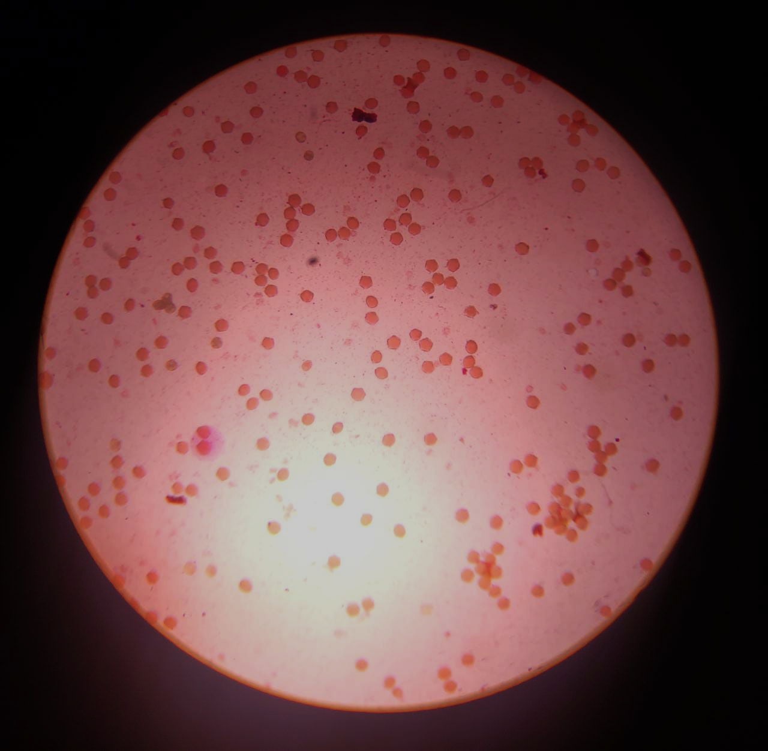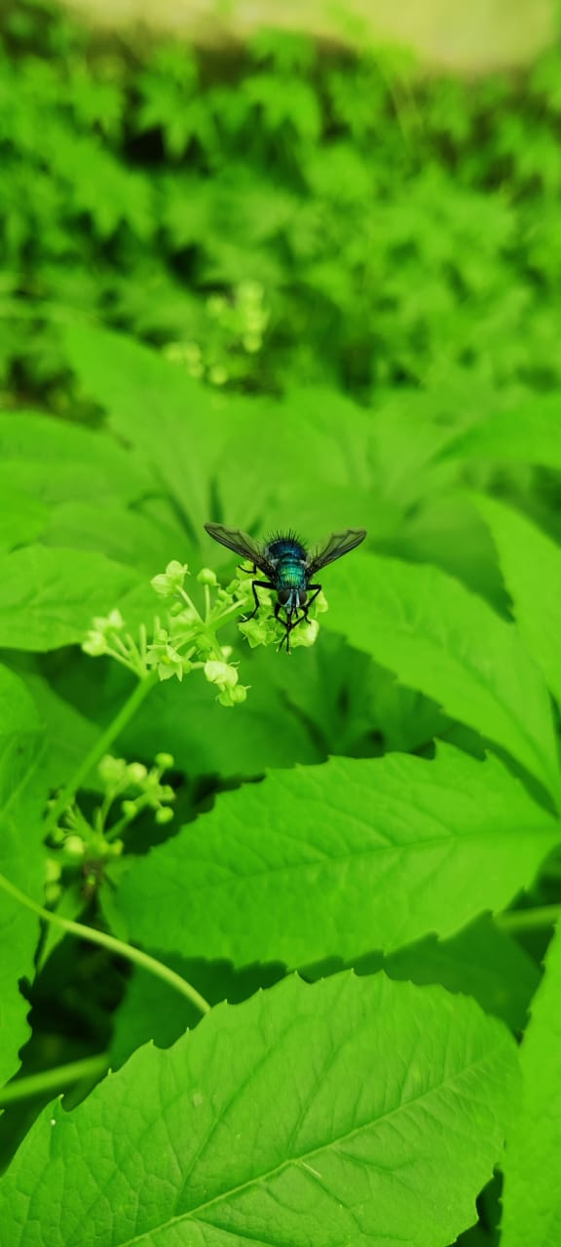
Non-viable pollen
Viable Pollens

Image 1: Pollen viability in Cyclanthera pedata L. Schrad.
Image 2: Pollination by insects in Cyclanthera pedata L. Schrad.

