CIS - Novel media supplement for invitro culture of coconut (Cocos nucifera)

ABSTRACT
Coconut exhibits recalcitrance to in vitro regeneration due to its distinct morphological, anatomical, and physiological characteristics. Type of explant and culture media composition are two major factors influences embryogenic callus and somatic embryo induction. Immature inflorescence explants show greater responsiveness for somatic embryogenesis compared to plumule explants, which are less vegetative and represent a single embryo. Despite extensive evaluation of medium formulations, success has been limited. This study evaluated the effect of unfermented coconut inflorescence sap (CIS) on somatic embryogenesis from immature inflorescence explants in vitro. Explants at various developmental stages were cultured on a standardized callus induction medium supplemented with CIS alone or combined with phytohormones. Explants at stages i3 (5–10 cm) and i4 (0–5 cm) exhibited superior morphogenic response and reduced browning with 10 mL L⁻¹ CIS. Among treatments, a medium containing 5.38 μM NAA, 4.5 μM TDZ, 66 μM 2,4-D, and 10 mg L⁻¹ CIS yielded the highest embryogenic callus induction (80.79%), while somatic embryo maturation peaked (72.93%) in medium with 4.54 μM 2,4-D, 20 μM BA, and 10 mg L⁻¹ CIS. These findings highlight CIS as a beneficial additive for improved somatic embryogenesis in coconut tissue culture.

Keywords: Coconut Inflorescence Sap, Nurse plant syndrome, Immature inflorescence, Coconut tissue culture

INTRODUCTION

Cocos nucifera L., the sole extant species of the genus Cocos within the family Arecaceae is cultivated extensively in over 93 countries. Despite global advances in plant tissue culture, the establishment of a consistent and reliable protocol for clonal propagation in coconut remains a major challenge in plant biotechnology. The initial attempt at somatic embryogenesis in coconut was undertaken by Eeuwens (1976), who explored the mineral requirements of rachis and rachillae explants from mature palms for callus initiation and proliferation. This was later followed by the development of nodular structures, somatic embryo formation, and eventual plant regeneration through the reduction of 2,4-D concentrations in the medium (Branton and Blake, 1983). Although numerous protocols for coconut somatic embryogenesis have been reported since these foundational studies, a reproducible and fully optimized system is yet to be realized. This continued lack of consistency highlights the inherent recalcitrance of coconut to in vitro culturing, which is likely linked to the complex morphological, physiological, and genetic characteristics of the species. Several factors have been proposed to underlie this recalcitrance. Histocytological studies in the early 1990s pointed to hormonal imbalances (Dublin et al. 1991), nucleocytoplasmic asynchrony in cells (Jesty and Francis, 1992), and chromatin condensation in nuclei (Verdeil et al.1992), all of which are believed to impair the activation of totipotent somatic cells and inhibit morphogenic transitions. As a result, considerable research was focused on identifying and overcoming the biological constraints limiting coconut regeneration.

Both intrinsic and extrinsic factors influence the success of in vitro morphogenesis. Among these, the explant type and culture medium are particularly critical (Tripathi et al.2012). While plumular explants which originate from the zygote, have shown high efficiency and reproducibility in somatic embryogenesis (Saenz et al.2018), their use in tissue culture of coconut palm -a highly cross-pollinated species- is limited due to the heterogenous and heterozygous nature of zygotic tissues (Kong et al. 2024). Consequently, attention has shifted back to somatic explants—especially immature inflorescences, which contain numerous meristematic sites (Sandoval-Cancino et al.2016; Belt, 2019; Shareefa et al. 2019), despite their technical difficulty. The most common basal medium reported for coconut is Y3 medium (Eeuwens 1978) and BM72 (Karunaratne and Periyapperuma 1989). A multitude of hormonal combinations have been reported by various researchers with different explant ((Karun et al.1993; Siny, 2006; Sáenz et al.2018; Shareefa et al.2016).

Recent investigations have highlighted the utility of undefined organic additives in enhancing in vitro responses. Despite their variable composition, such supplements can supply essential organic constituents that facilitate morphogenesis (George et al.2007). In a related ecological context, Cavieres et al. (2006) introduced the concept of the "nurse plant syndrome," referring to the facilitative effect of adult plants on seedling establishment. Drawing a parallel to this ecological interaction, a similar "nurse effect" was hypothesized in vitro through the incorporation of coconut inflorescence sap (CIS) into the culture medium, given that the explants were also derived from inflorescence tissue. Coconut inflorescence sap is a complex additive which contain numerous nutritional and hormonal substances. Owing to its endogenous origin and biochemical compatibility with coconut reproductive tissues, unfermented coconut inflorescence sap (CIS) was investigated as a natural supplement to the Y3 basal medium for in vitro culture. This study specifically evaluated the efficacy of CIS in enhancing somatic embryogenesis from immature coconut inflorescences. The supplementation aimed to improve embryogenic callus induction, reduce phenolic browning, and increase overall regeneration efficiency by utilizing the sap’s intrinsic phytohormones, antioxidants, various minerals and organic compounds that may support cellular reprogramming and morphogenic competence.

MATERIALS AND METHOD

Explant collection and preparation

Immature inflorescences were collected by destructive sampling from the axils of the top four unopened fronds of West Coast Tall (WCT) palms aged over 20 years. These were grouped into four categories based on length: i₁ (15-20cm), i₂ (10-15cm), i₃ (5-10cm) and i₄ (0-5cm) (Fig. 3a). The inflorescences were initially surface-sterilized by swabbing or dipping in absolute alcohol for 1 minute in the laminar airflow cabinet, followed by flame sterilization for 1-2 minutes depending on the developmental stage of explant. Rachillae were carefully dissected from the inflorescences and sliced into 0.3–0.5 mm thick sections for inoculation (Fig. 3b)

Coconut Inflorescence Sap as media additive

Freshly collected inflorescence sap from WCT palms at Instructional farm I, Nileshwar, Kerala Agricultural University was utilised in the study. The total sugar content of coconut inflorescence sap was estimated using refractometer. Callus induction media (CIM) was Y3 basal medium with 2 μM picloram, 5.38 μM NAA and 0.45 μM TDZ and 300 μM 2,4-D, 0.1 g/L of myo-inositol, 0.2 g/L of casein hydrosylate, 0.2 g/L of L- glutamine and 4% sucrose. This was standardised based on the previous study conducted by one of the authors on coconut tissue culture (Sujatha, unpublished data, 2011; unreferenced). To test the effect of coconut inflorescence sap, CIM were supplemented with three concentrations (5 mL/L, 10 mL/L, and 15 mL/L). The pH of the media was adjusted to 5.8. The control medium contained all the supplements except the CIS. The explants were inoculated for callogenesis and maintained in dark for 7-8 weeks.

CIS and phytohormones on callogenesis and regeneration

In an independent experiment immature inflorescence was cultured into five media containing different combination and concentrations of plant growth regulators and 10ppm CIS (based on the result of above experiment). The experiment consisted of five treatments, with the Y3 basal medium – T0 (2 μM picloram, 5.38 μM NAA and 0.45 μM TDZ and 300 μM 2,4-D + 10 mgL⁻¹ CIS), T1 ( 5.38 μM NAA+ 4.5 μM TDZ + 66 μM 2,4-D + 10 mgL⁻¹CIS), T2(5.38 μM NAA+ 4.5 μM TDZ + 66 μM 2,4-D + 49.42 μM Spermine +10 mgL⁻¹CIS) T3(5.38 μM NAA+ 4.5 μM TDZ + 66 μM 2,4-D + 61.9 μM Putrescene+ 10 mgL⁻¹CIS) T4(5.38 μM NAA+ 4.5 μM TDZ + 66 μM 2,4-D + 4 μM Picloram + 10 mgL⁻¹CIS). Each treatment was replicated three times. The cultures were incubated in complete darkness at 26 ± 2 °C for 16 -20 weeks with subsequent sub-culturing on depletion of media for further callus proliferation and multiplication until adequate amounts of calli were obtained.

The embryogenic callus was transferred to Y3 media supplemented with hormones and CIS as S1(5 μM BA + 1mgL-1 2ip + 10 mgL⁻¹CIS); S2(4.54 μM 2,4-D + 4 μM picloram + 10 mgL⁻¹CIS); S3 (4.54 μM 2,4-D + 5 μM BA + 10 mgL⁻¹CIS); S4(4.54 μM 2,4-D + 10 μM BA + 10 mgL⁻¹CIS); S5(4.54 μM 2,4-D + 15 μM BA + 10 mgL⁻¹CIS); S6(4.54 μM 2,4-D + 20 μM BA + 10 mgL⁻¹CIS). During the induction and maturation of somatic embryos, the cultures were kept in the dark at 26 ± 2°C. For somatic conversion, the cultures were kept at 26 ± 2°C under a 16-h light photoperiod provided by cool-white fluorescent tube.

RESULT

Influence of developmental stage of explant on callus induction and browning

In the present study, among the four stages, explants in i4 stage which represent the most immature tissue exhibited the highest frequency of callus induction (85.71%), which was statistically superior to the responses recorded in i3 (82.00%), i2 (78.57%), and i1 (74.42%). This indicates a declining trend in callus formation with increasing developmental maturity of the inflorescence. Browning of explants, indicative of oxidative stress and tissue necrosis, was first observed approximately 60 days post-inoculation. The i4 stage showed the lowest browning response (4.76%), significantly differing from i3 (6.00%), i2 (11.90%), and i1 (13.95%) (Fig. 1). Taken together, explants at the i3 (5–10 cm) and i4 (0–5 cm) stages demonstrated superior morphogenic responsiveness and reduced tissue browning, suggesting these developmental stages are more amenable for in vitro culture and callus induction under the tested conditions.

Fig. 1 Influence of developmental stage of explant on callusing and browning

Optimizing CIS concentration for callusing

In the present investigation, to optimize the concentration of coconut inflorescence sap (CIS) for evaluating its embryogenic potential and applicability as a culture medium additive, immature coconut inflorescence were cultured on CIM media supplemented with varying concentrations of unfermented CIS with total sugar content of 12.92 Brix: 5 ml L⁻¹ (Treatment A), 10 ml L⁻¹ (Treatment B), and 15 ml L⁻¹ (Treatment C) (Table 1). Among these, the medium containing 10 ml L⁻¹ CIS (Treatment B) demonstrated superior performance relative to the control, suggesting a potential “nursing effect” or buffering capacity of CIS that may enhance nutrient bioavailability under suboptimal culture conditions. Additionally, phenolic browning—a common inhibitory response in tissue culture—was significantly reduced in Treatment B, with only 10.30% of explants affected. Browning incidence differed among treatments, with values of 21.5% (A), 10.30% (B), and 12.57% (C), all of which were lower than that observed in the control (21.73%). These findings indicate that CIS not only enhances morphogenetic responses but may also mitigate phenolic exudation, particularly at the optimized concentration of 10 ml L⁻¹
.

Table 1 Effect of different CIS concentration on callogenesis and proliferation
Response  (%) | Control | A | B | C | CD Value  (P=0.05) | CV Value  %
Callus induction & proliferation | 79.67 | 63.96 | 84.67 | 74.97 | 1.96 | 1.38
Phenolic contamination | 21.73 | 21.5 | 10.30 | 12.57 | 1.29 | 1.29

Callus induction and proliferation

Initial signs of response indicating the onset of callogenesis, as floral bud swelling from rachillae bits appeared around 45-55 days after culture initiation (Fig 2). By 90 days post-inoculation, this response progressed to the formation of callus tissue characterized by pearly white structures. Of all the explants cultured in different media combination, 71.12% successfully formed callus from 76.58% responsive cultures, whereas 23.41% remained unresponsive and contamination loss. Callus formation showed a steady increase over time, rising from 37.29% at three months to 55.54% at six months, and ultimately reaching 71.12% by the ninth month. Supplementation of the culture medium with 10 ppm coconut inflorescence sap (CIS) was notably effective in suppressing phenolic browning and promoting enhanced callus induction and proliferation. Three distinct morphological types of callus were observed. The first type was soft, friable, creamy in colour, and easily separable, typically differentiating into globular somatic embryos (Fig. 3c). The second type exhibited a medium-compact, dense texture and developed structures resembling shoot primordia (Fig. 3d). The third type was a hard, rough, and compact callus that failed to differentiate into somatic embryos or initiate any organogenic structures (Fig. 3e)

Fig 2 Effect of additives on callusing from explant
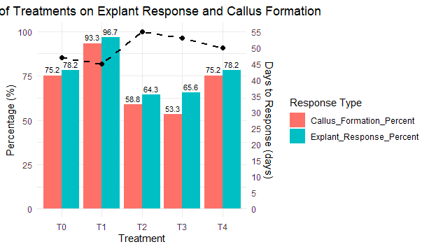

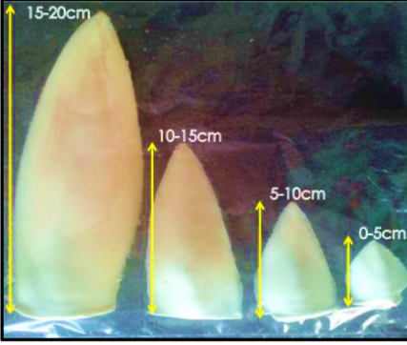
a
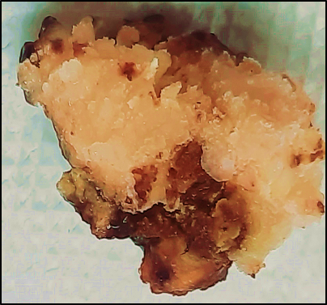
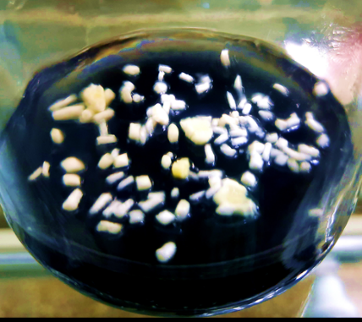
c
b

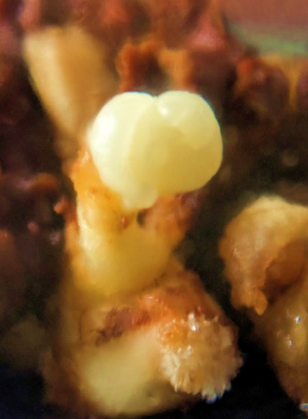
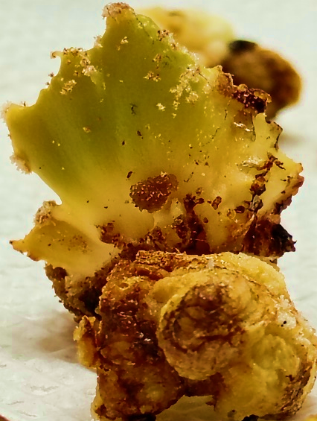
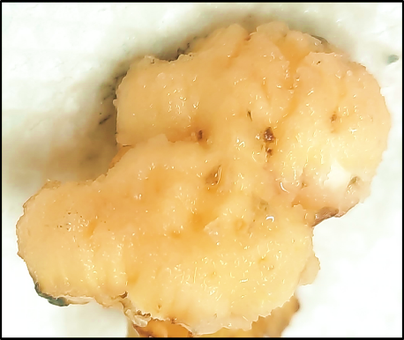
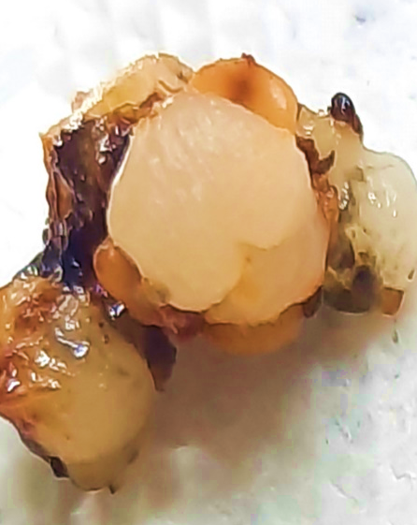
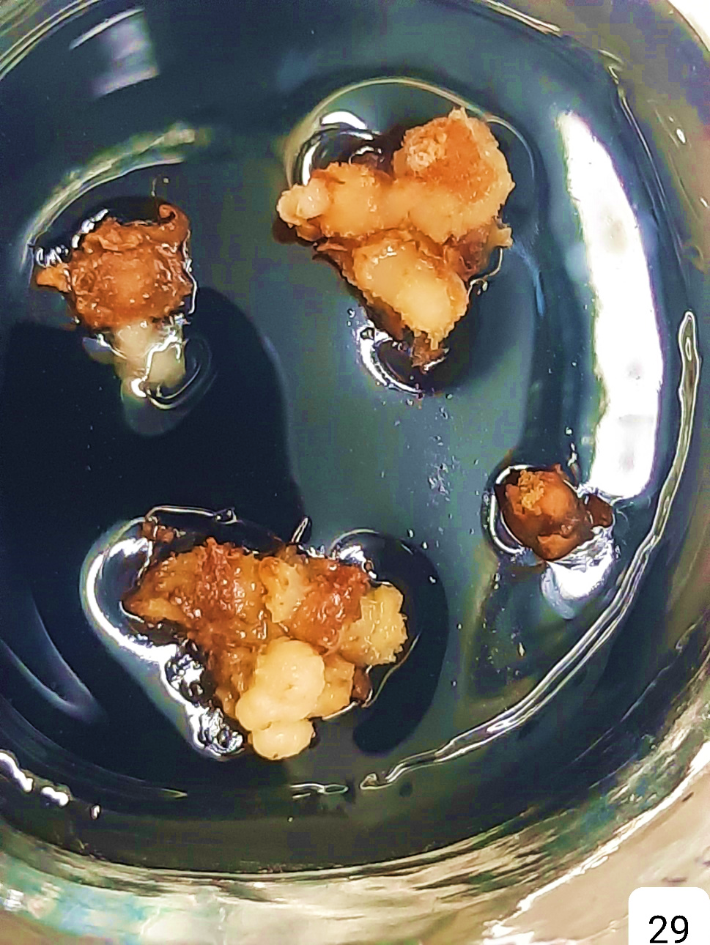
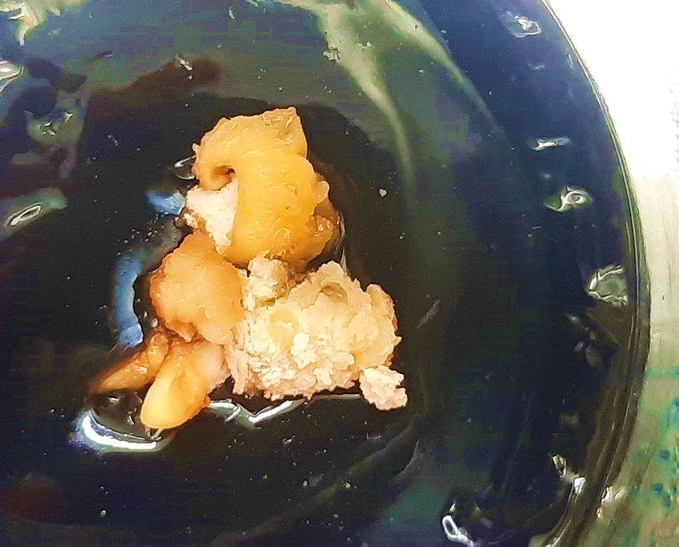
i
h
g
f
e
d
Fig. 3 Morphogenic progression during in vitro culture of immature inflorescence (a) developmental stages of immature inflorescence (b) 0.3–0.5 mm thick sliced sections of rachilae (c) soft, friable, creamy embryogenic callus (d) medium-compact, dense texture organogenic callus resembling shoot primordia (e) hard, rough, and compact non-embryogenic callus (f) somatic embryo initiation (g) globular embryo (h) heart shaped embryo (i) shoot regeneration from embryo

The response of coconut explants to different additive treatments was assessed based on the nature of callus formed (Table 2). Among the tested treatments, T1 (5.38 μM NAA, 4.5 μM TDZ, 66 μM 2,4-D, and 10 mg L⁻¹ CIS) induced the highest frequency of embryogenic callus formation (80.79%), which was significantly superior (P ≤ 0.05) to other treatments. This indicates the effective synergism between phytohormones and CIS in promoting embryogenic competence. The control treatment (T0), incorporating a higher concentration of 2,4-D (300 μM), low TDZ (0.45 μM), and 2 μM picloram, yielded a moderate embryogenic response (47.30%) but was associated with relatively elevated levels of non-embryogenic (9.67%) and organogenic calli (6.33%). In contrast, the addition of polyamines—spermine (T2) and putrescine (T3)—to the T1 combination resulted in a substantial decline in embryogenic callus formation (36.81% and 43.89%, respectively), along with increased frequencies of non-embryogenic and organogenic calli, particularly in T2, suggesting a deviation from somatic embryogenesis.

The inclusion of picloram at a concentration of 4 μM (T4) in the T1 background, resulted in a moderately high embryogenic response (59.39%), which was statistically comparable to T1 and markedly superior to T2 and T3 and also reduced phenolic exudation compared to the high-dose picloram treatment (T0). This suggests that picloram, in combination with CIS, may act synergistically to promote embryogenic competence. Notably, the differences in non-embryogenic and organogenic callus proportions were not statistically significant across treatments. Collectively, these findings demonstrate that the combination of NAA, TDZ, 2,4-D, and CIS (T1) without additional polyamines provides the most conducive environment for embryogenic callus induction with minimal contamination and physiological stress in coconut, while the incorporation of polyamines may interfere with the embryogenic pathway. The results also highlight the potential of picloram as an effective adjuvant to enhance embryogenesis when used at optimal concentrations in conjunction with CIS.

Table 2. Effect of additives on type of callus response

Treatment | Type of callus response
Treatment | Embryogenic callus (%) | Non-embryogenic callus (%) | Organogenic callus (%)
T0 | 47.30ª | 9.67 | 6.33
T1 | 80.79ª | 2.00 | 2.00
T2 | 36.81^{b} | 14.53 | 7.90
T3 | 43.89^{b} | 6.00 | 3.33
T4 | 59.39^{ab} | 3.33 | 6.36
CD Value | 33.60 | NS | NS

The embryogenic calli were transferred to regeneration media with series of 2,4-D and BA concentration (Table 2). The efficiency of somatic embryo maturation varied significantly depending on the composition of the regeneration media. The embryogenic callus after proliferation produce somatic embryo (Fig. 3f) by six months and gradually mature to globular (Fig. 3g) and heart shaped embryos (Fig. 3h). Among the six media tested (S1–S6), the highest percentage of somatic embryo maturation (72.93%) was observed in S6, which contained 4.54 μM 2,4-D and 20 μM BA in combination with 10 mgL⁻¹ CIS. This indicates that a higher concentration of BA, when combined with 2,4-D, substantially enhances embryogenic response. Medium S2, containing 4.54 μM 2,4-D + 4 μM picloram + 10 mgL⁻¹ CIS, also supported a relatively high somatic embryogenesis rate of 59.74%, suggesting that the inclusion of picloram as an auxin analogue can effectively promote embryo induction. The combination of 4.54 μM 2,4-D and increasing concentrations of BA, particularly at 20 μM , along with 10 mgL⁻¹ CIS, appears optimal for maximizing somatic embryo maturation in this system. The results underscore the synergistic role of auxins and cytokinins, modulated by CIS, in promoting embryogenic competency. The lowest embryogenic response was recorded in S1 (33.23%), which lacked any auxin (2,4-D or picloram) and included only cytokinins (BA and 2iP), indicating the necessity of auxin presence for efficient somatic embryo induction.

The factorial effect of callus induction media and regeneration media was evaluated for somatic embryo maturation and morphogenic responses (Fig. 5). Though CIM T1 gave highest embryogenic callus formation, embryogenic callus produced from treatment T4 showed highest somatic embryo maturation percentage when transferred to S6 regeneration medium (88.60%) though in par with T1-S6 combination. T4 showed superior performance across most media suggesting T4 has a strong inductive effect, especially when paired with BA-rich or auxin-cytokinin balanced media. These results highlight the critical role of callus induction pre-conditioning and balanced auxin-cytokinin ratios, particularly with high BA and CIS supplementation, in promoting embryogenic potential. The suboptimal outcomes observed in other treatment media combinations further emphasize the synergistic role of exogenous hormonal and nutritional cues in governing both callus responsiveness and somatic embryo maturation. Some cultures exhibited shoot regeneration (Fig. 3i); however, the frequency was low, inconsistent, and no root formation was observed. In contrast to the typical indirect pathway of somatic embryogenesis in coconut, direct translucent outgrowths were observed emerging from rachillae explants, which produced shoot-like structures when transferred to BA-enriched regeneration medium; however, root formation was absent and the response was too limited and inconsistent to be statistically analyzed.

Fig. 4 Effect of regeneration media in somatic embryo formation and maturation

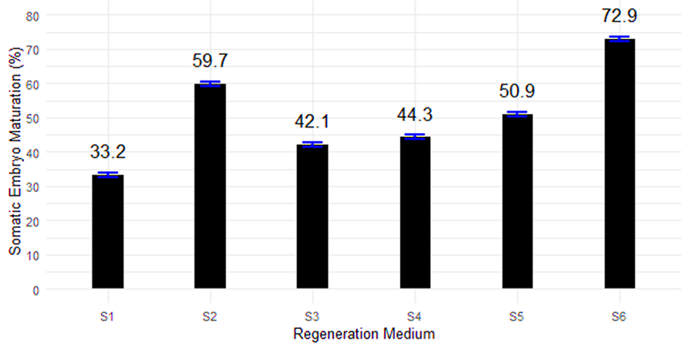

Fig 5. Interaction effect of media on somatic embryo maturation
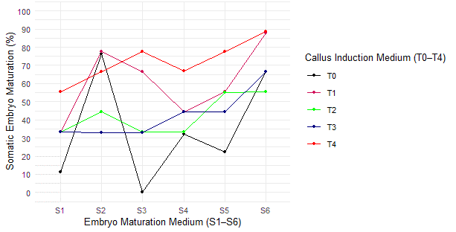

DISCUSSION

Developmental stage of explant

Morphogenic competence and a high rate of cell division are fundamental prerequisites for successful in vitro regeneration (Su, 2002). Although various plant tissues have been utilized as explants, juvenile, actively dividing meristematic and undifferentiated tissues are generally recognized as the most responsive and reliable sources for coconut culture initiation. This developmental-stage-dependent response is primarily attributed to the cumulative genetic, epigenetic, and physiological modifications that accompany cellular maturation, which progressively reduce the explant’s plasticity and regenerative potential under in vitro conditions (Thorpe, 1994). Physiologically immature tissues generally exhibiting a higher capacity for dedifferentiation in response to exogenous phytohormones.

In the present study, inflorescences measuring 1–5 cm in length consistently showed superior morphogenic responses compared to longer segments (5–10 cm, 10–15 cm, and 15–20 cm). ). This enhanced responsiveness in younger tissue is attributable to the fact that in later stages of floral primordia, a shift in the expression of ‘floral meristem identity genes’ and in various hormonal combinations is happening. These findings are consistent with the previous reports that compared with immature explants or embryonic tissues, more reprogramming is required in mature tissues to transform them into somatic embryos (Merkle et al., 1995). Sugimura and Salvana (1989) reported enhanced callus induction and reduced browning in coconut inflorescences ranging from 0.8 to 4.1 cm. Similarly, Sandoval et al. (2016) observed that younger inflorescences formed pearly white callus, while mature explants failed to respond. In contrast, Verdeil et al. (1994) reported optimal callus induction from longer inflorescences (10–25 cm), indicating that genotype, explant source, or culture conditions may influence the optimal developmental stage. Furthermore, earlier reports by Karunaratne and Periyetapperuma (1989) and Vidhanaarachchi and Weerakoon (1997) also emphasized the superiority of immature tissues for embryogenic callus formation and micropropagation, whereas mature inflorescence explants exhibited limited or no embryogenic response. Collectively, these observations underscore the importance of selecting appropriately staged explants to maximize embryogenic outcomes in coconut tissue culture.

Optimizing CIS concentration for callus induction
Coconut inflorescence sap is a nutritionally rich substance, as reported by Devdas et al. (1969), with a neutral pH and containing a diverse profile of 16 amino acids, water-soluble vitamins (including vitamin C and the B-complex, notably nicotinic acid; Aalbersberg et al., 1997), as well as substantial levels of minerals such as sodium (6.95 mg/100 ml) and potassium (3.16 mg/100 ml) (Barh and Mazumdar, 2008), along with sucrose (Ysidor et al., 2014). The promotory effect, with regard to morphogenesis, is related to its growth regulator content. While coconut water has been extensively utilized as a natural additive in micropropagation protocols for several economically significant crops including passion fruit (Hall et al., 2000), coffee (Ismail et al., 2003), orchids (Santos-Hernandez et al., 2005) This study represents the first documented use of unfermented coconut inflorescence sap in micropropagation protocols.

Although CIS alone is generally insufficient to induce consistent and robust callus formation, our results indicate that its supplementation at an optimal concentration (10 mg/L), in conjunction with exogenous phytohormones, significantly enhances calloid induction, proliferation, and somatic embryogenesis. This synergistic effect suggests that the bioactive constituents of CIS may potentiate or modulate the activity of externally supplied growth regulators. A dose-dependent response was evident, with improved morphogenic outcomes observed up to 10 mg/L CIS, beyond which a decline in efficacy suggested a threshold beyond which inhibitory effects may occur. The positive influence of organic additives on in vitro culture has been well-documented, aligning with the results of the present study. Blake and Eeuwens (1982) demonstrated that supplementing culture media with coconut water improved the growth of endosperm tissues, highlighting the potential role of naturally occurring growth-promoting compounds. Similarly, Al-Khayri (2010) reported enhanced callus development and somatic embryogenesis in date palm shoot tip explants following the addition of coconut water. In his study, low callus growth was observed at 5% coconut water, while optimal responses occurred at 10–15%, beyond which (at 20%) a decline in both callus formation and embryogenic potential was noted. These patterns closely mirror the trends observed in the present study with coconut inflorescence sap (CIS), where an optimal concentration (10 mg/L) significantly enhanced morphogenic responses, but higher concentrations resulted in reduced efficacy. Taken together, these findings accentuate the necessity of carefully optimizing the concentration of organic supplements to harness their positive effects while avoiding potential inhibitory outcomes in in vitro culture systems.
Callus induction and proliferation

Callusing was evident in all the experiments performed in the Y3 medium for tissue culture coconut. Differential response in callusing demonstrates that the balance and type of plant growth regulators (PGRs), along with the inclusion of specific additives, critically influence somatic embryogenesis, callus quality, and contamination dynamics in cultured explants. Characteristically, the route of coconut somatic embryogenesis is indirect and has to pass through callogenesis stage (Verdeil and Buffard, 1995) making the induction of embryogenic callus a fundamental requirement for effective plant regeneration. Cells must first acquire embryogenic competence through a specific induction treatment to initiate the somatic embryogenesis pathway. Once induced, somatic embryogenesis originates from embryogenically determined cell. Although high concentrations of auxins such as 2,4-D are commonly employed for callus induction, the optimal concentration varies depending on the cultivar and explant type. In Sri Lankan Tall, a low concentration of 2,4-D (24 μM) was sufficient to induce callus formation from zygotic embryos. In contrast, higher concentrations (125 μM) were effective for callus induction in Malayan Yellow Dwarf and Buta Layar Tall cultivars. Moreover, very high levels of 2,4-D (450–600 μM) were necessary to induce callus from immature inflorescences and plumular tissues. Similar variability was also reported by Vidhanaarachchi and Weerakoon, 1997. Similarly, a low concentration of 2,4-D (12μM- 24 μM) was required for young leaves (and immature zygotic embryo (Karunaratne and Periyapperuma 1989; Fernando and Gamage 2000), a medium concentration for mature zygotic embryo (125μM) (Samosir 1999) and a high concentration for immature inflorescence and plumule (500 μM- 600 μM) (Verdeil et al., 1994; Magnaval et al., 1995) for callus formation. Under our media preparations with 300 μM 2,4-D showed 84.67% callus induction and proliferation in combination with NAA, TDZ, picloram and 10 mgL⁻¹ CIS from immature inflorescence of West Coast Tall cultivar.

The study was further extended through a separate experiment to evaluate the effect of reducing 2,4-D concentration on callusing in combination with other supplements in West Coast Tall cultivar with Immature Inflorescence explant. The result showed a superior performance of treatment T1—comprising NAA (5.38 μM), TDZ(4.5 μM), 2,4-D(66 μM), and coconut inflorescence sap (CIS 10 mgL⁻¹)—in promoting embryogenic callus formation (80.79%) and reduced response to embryogenic callus formation in high 2,4-D (T0) media suggested that although auxin is essential for initiating somatic embryogenesis, 2,4-D acts not only as an auxin but also as a stress signal leading to oxidative stress, impairing cell viability and differentiation potential and may increase phenolic compound production. TDZ on the other hand was reported to be effective in callusing (Mweu, 2019) at a concentration of 9 µM using the ovary explants (Perera et al., 2009;). This agreed with the present study that increased concentration of TDZ (4.4 μM) in T1 compared to T0 showed highest frequency of callusing. The addition of picloram (T4), a potent synthetic auxin structurally similar to 2,4-D, resulted in moderate embryogenic callus induction (59.39%) with reduced phenolic exudation compared to the high-dose picloram control (T0). While picloram is often effective in inducing somatic embryogenesis in recalcitrant tissues like palm (Scherwinski-Pereira et al., 2010) its performance is highly dose-dependent. In T0, the high concentration of 2,4-D (300 μM) combined with low TDZ and picloram resulted in lower embryogenic callus formation, possibly due to hormonal imbalance or cytotoxic effects associated with high auxin levels.

In contrast to the cent percent somatic embryogenesis response reported with the inclusion of putrescine (7.5 mM) and spermine (1 μM) in coconut cultures (Adkins et al., 1997), the present study observed a reduction in embryogenic potential and increased non-embryogenic callus formation in the West Coast Tall cultivar under similar treatments (T2 and T3). Although polyamines such as spermine and putrescine are implicated in somatic embryogenesis through roles in DNA stabilization, reactive oxygen species (ROS) signalling, and stress modulation (Jiménez, 2014), excessive exogenous levels may disrupt endogenous polyamine homeostasis or interact antagonistically with PGRs, leading to altered developmental fates. Additionally, polyamines may serve as nitrogen sources for contaminating microbes, which could explain the elevated levels of contamination and phenolic oxidation observed in these treatments. Rajesh and Karun (2014) highlighted the genotype-specific effects of polyamines on somatic embryogenesis in coconut. Zygotic embryos of Chowghat Green Dwarf (CGD) and Malayan Yellow Dwarf (MYD) cultured on Y3 medium with 100 µM spermine and 1000 µM putrescine showed significant interactions between variety and regeneration medium. In MYD, spermine enhanced somatic embryogenesis, while in CGD, putrescine was more effective. Additionally, in CGD, spermine improved embryogenic callus and meristemoid formation, whereas putrescine promoted rhizogenesis.

In contrast, the West Coast Tall (WCT) cultivar in the present study exhibited lower embryogenic response to these treatments. Putrescine (T3) induced a higher percentage of embryogenic callus compared to spermine (T4), which led to increased non-embryogenic callus formation. These results emphasize the role of polyamines in modulating morphogenic responses in a genotype-dependent manner, likely through their interactions with phytohormones and organic component.

While auxin is essential to initiate somatic embryogenesis, its continuous presence in the culture medium can be detrimental to optimal development. Therefore, a gradual reduction or complete elimination of 2,4-D from the culture medium is recommended to facilitate the transition of undifferentiated callus into somatic embryogenic callus (Buffard-Morel et al., 1995). Cytokinins can be co-supplemented with auxins during the callus induction and maturation phases to enhance embryogenic potential. Commonly used cytokinins for callus proliferation and maturation include 6-benzylaminopurine (BAP), thidiazuron (TDZ), kinetin, and 2-isopentenyl adenine (2iP). Study by Bett (2019) recorded highest callus (100%) and embryogenic callus induction (100%) were observed in media containing 2,4-D (150–250 µM and 125 µM, respectively) combined with 5 µM BAP while maximum shoot formation in 10 µM BAP media. Similarly result was reported by Shareefa (2019) that shoot regenerated in media containing 4μM 6-BAP and 10 μM 2,4-D. These studies give ground for our findings that embryogenic callus treated with 20 μM BA, 4.5 2,4-D and 10mg/L CIS showed more highest percentage of somatic embryo maturation and regeneration. Direct shoot like regeneration as translucent outgrowth was observed as reported by Vidhanaarachchi and Weerakoon (2008) from the rachillae bits when initial culturing was done in a medium auxin concentration media followed by culturing in a high BA (20 μM ). This observation was in line with the finding of Shareefa (2019) that direct in vitro regeneration was possible from immature inflorescence of West Coast Tall cultivar.

CONCLUSION
The study highlights the importance of genotype-specific responses and plant growth regulator combinations in coconut somatic embryogenesis, with a particular focus on the potential of coconut inflorescence sap (CIS) as a promising bioactive additive. While conventional media supplemented with 2,4-D and BAP supported embryogenic callus induction and shoot regeneration in selected cultivars, the inclusion of CIS offers a natural and potentially more effective alternative due to its inherent mix of phytohormones and organic nutrients.

REFERENCE

Aalbersberg B, Rohinee S, Praveen R (1997) Nutrient analysis of coconut toddy. Trop Sci 37(3):160-163
Adkins SW, Samosir YM, Ernawati A, Godwin ID, Drew RA (1997) Control of ethylene and use of polyamines can optimise conditions for somatic embryogenesis in coconut (Cocos nucifera L.) and papaya (Carica papaya L.). In: International Symposium on Biotechnology of Tropical and Subtropical Species Part 2, 461:459-466
Al-Khayri JM (2010) Somatic embryogenesis of date palm (Phoenix dactylifera L.) improved by coconut water. Biotechnol 9(4):477-484.
Barh D, Mazumdar BC (2008) Comparative nutritive values of palm saps before and after partial fermentation. Res J Med Med Sci 3(2):173-176
Bett CC, Mweu CM, Nyende AB (2019) In vitro regeneration of coconut (Cocos nucifera L.) through indirect somatic embryogenesis in Kenya. Afr J Biotechnol 18(32):1113-1122. https://doi.org/10.5897/AJB2019.16699
Blake J, Eeuwens CJ (1982) Culture of coconut palm tissues with a view to vegetative propagation. In: Proc COSTED Symp Tissue Culture Economically Important Plants, Singapore, pp 145-148
Branton RL, Blake J (1983) Development of organized structures in callus derived from explants of Cocos nucifera L. Ann Bot 52(5):673-678.
Buffard-Morel J, Verdeil JL, Dussert S, Magnaval C, Huet C, Grosdemange F (1995) Initiation of somatic embryogenesis in coconut (Cocos nucifera L.). In: Oropeza C, Howard FW, Ashburner GR (eds) Lethal Yellowing: Research and practical aspects. Kluwer Academic Publishers, Dordrecht, pp 217-223
Cavieres LA, Badano EI, Sierra-Almeida A (2006) Positive interactions between alpine plant species and nurse cushion plant Laretia acaulis do not increase with elevation in Andes of Central Chile. New Phytol 169:59-69. https://doi.org/10.1111/j.1469-8137.2005.01572.x
Devdas RP, Sundari K, Susheela A (1969) Effects of supplementation of two school lunch programmes with neera on nutritional status of children. J Nutr Diet 6:29-36.
Eeuwens CJ (1976) Mineral requirements for growth and callus initiation of tissue explants excised from mature coconut palms (Cocos nucifera) and cultured in vitro. Physiol Plant 36(1):23-28. https://doi.org/10.1111/j.1399-3054.1976.tb03123.x
Fehér A, Pasternak TP, Dudits D (2003) Transition of somatic plant cells to an embryogenic state. Plant Cell Tissue Organ Cult 74:201–228. https://doi.org/10.1023/A:1024883421127
George EF, Hall MA, De-Klerk G (2008) The components of plant tissue culture media II: Organic additions, osmotic and pH effects, and support systems. In: George EF, Hall MA, De-Klerk G (eds) Plant Propagation by Tissue Culture, 3rd edn. Springer, pp 115-173
Jesty JHF, Francis D (1992) Cellular responses of leaf explants of Cocos nucifera L. in vitro. Plant Cell Tissue Organ Cult 28:235-244. https://doi.org/10.1007/BF00033558
Jiménez-Bremont JF, Marina M, Guerrero-Gonzalez MDLL, Rossi FR, Sánchez-Rangel D, Rodríguez-Kessler M, Ruiz OA, Gárriz A (2014) Physiological and molecular implications of plant polyamine metabolism during biotic interactions. Front Plant Sci 5:95. https://doi.org/10.3389/fpls.2014.00095
Karunaratne S, Periyapperuma K (1989) Culture of immature embryos of coconut, Cocos nucifera L: Callus proliferation and somatic embryogenesis. Plant Sci 62(2):247-253. https://doi.org/10.1016/0168-9452(89)90079-4
Merkle SA, Parrott WA, Flinn BS (1995) Morphogenic aspects of somatic embryogenesis. In: Thorpe TA (ed) Plant Tissue Culture Manual. Springer, Netherlands. https://doi.org/10.1007/978-94-011-0485-2_5
Mweu CM, Nyende A, Onguso J (2016) Efficient somatic embryogenesis of Jatropha curcas L. from petiole and leaf discs. Int J Biotechnol Mol Biol Res 7(3):29-35
Perera PI, Vidhanaarachchi VRM, Gunathilake TR, Yakandawala DMD, Hocher V, Verdeil JL, Weerakoon LK (2009) Effect of plant growth regulators on ovary culture of coconut (Cocos nucifera L.). Plant Cell Tissue Organ Cult 99(1):73-81. https://doi.org/10.1007/s11240-009-9548-3
Rajesh MK, Radha E, Sajini KK, Anitha K (2014) Polyamine-induced somatic embryogenesis and plantlet regeneration in vitro from plumular explants of dwarf cultivars of coconut (Cocos nucifera)
Samosir YMS, Godwin RD, Adkins SW (1998) An improved protocol for somatic embryogenesis in coconut (Cocos nucifera L.). In: Oropeza C, Verdeil JL, Ashburner GR (eds) Current Advances In Coconut Biotechnology. Kluwer Academic Publishers, Dordrecht, Netherlands, pp 341-354
Scherwinski-Pereira J, Guedes RS, Fermino PC, Dilva TL, Costa FH (2010) Somatic embryogenesis and plant regeneration in oil palm using the thin cell layer technique. In Vitro Cell Dev Biol Plant 46:378-385. https://doi.org/10.1007/s11627-010-9280-3
Shareefa M, Thomas RJ, Sreelekshmi JS, Rajesh MK, Karun A (2019) In vitro regeneration of coconut plantlets from immature inflorescence. Curr Sci 117(5):813-820
Siny CV (2006) Response of immature inflorescence for in-vitro regeneration in coconut (Cocos nucifera L.). M.Sc. (Ag) thesis, Kerala Agricultural University, Thrissur
Verdeil JL, Buffard-Morel J (1995) Somatic embryogenesis in coconut (Cocos nucifera L.). In Bajaj YPS (ed) Biotechnology in Agriculture and Forestry, Somatic embryogenesis and Synthetic Seed I, 30th Ed. Springer, Berlin, Heidelberg, pp 299-317
Verdeil JL, Huet C, Grosdemange F, Buffard-Morel J (1994) Plant regeneration from cultured immature inflorescences coconut (Cocos nucifera L.): Evidence for somatic embryogenesis. Plant Cell Rep 13:218-221. https://doi.org/10.1007/BF00232907
Verdeil JL, Huet C, Grosdemanges F, Rival A, Buffard-Morel J (1992) Coconut (Cocos nucifera L.) somatic embryogenesis: Obtention of several clone ramets. Oleagineux 47:465-469
Vidhanaarachchi VRM, Weerakoon LK (1997) Callus induction and direct shoot formation in in vitro cultured immature inflorescence tissues of coconut. COCOS 12:39–43
Ysidor KN, Rachel AR, Jean-Louis KK, Muriel OD, Prades A, Kouassi A, Marius BGH (2014) Glucide factors of the inflorescence sap of four coconut (Cocos nucifera L.) cultivars from Côte D’Ivoire. Int J Biochem Res Rev 4(2):116-127

