Review Article
COCONUT HAUSTORIUM- THE NEW FRONTIER IN HEALTH AND WELLNESS: A Review

ABSTRACT
Coconut haustorium, commonly known as the “coconut apple,” is a nutrient-dense component of the coconut which is rich in proteins, vitamins, and bioactive compounds such as flavonoids and terpenoids. It possesses significant health-promoting activities such as antioxidant, anti-inflammatory, antimicrobial, antidiabetic, anticancer, and heart-protective effects. Despite its remarkable nutraceutical and phytochemical potential, the haustorium remains underutilized due to its low economic value and processing challenges. This review highlights its compositional and functional attributes, emphasizing the need for further research and product innovation to promote its application in functional foods, cosmetics, and pharmaceuticals.
Keywords: Coconut haustorium, coconut apple, value addition, functional food, antioxidant activity, therapeutic
1. INTRODUCTION
The coconut palm, often referred to as the “tree of heaven” or Kalpavriksha, is renowned for its versatility, as nearly every part of the plant holds economic or nutritional value. In India, around 10 million people depend on coconuts directly or indirectly for their livelihood (Subramanian et al., 2024). The country ranks first globally in coconut production and third in area under cultivation, with Kerala, Tamil Nadu, Karnataka, and Andhra Pradesh contributing more than 90% of the total yield (CDB, 2025). Grown mainly in tropical areas, the coconut (Cocos nucifera L.) is an important food and oilseed crop that yields a variety of edible products, including the kernel, tender coconut, water, and sap. These components are rich in vital nutrients, vitamins, and minerals, making them valuable for use in the food, pharmaceutical, and cosmetic sectors [1-3].
Studies on the phytochemical composition of coconuts and their by-products have shown that they contain high levels of bioactive compounds such as alkaloids, flavonoids, phenols, and tannins (Arivalagan et al., 2018). These constituents are recognized for their potent antibacterial, antifungal, antioxidant, antiviral, and anti-inflammatory properties (Zeng et al., 2024). Coconut husk extract, in particular, has shown notable effectiveness against Vibrio species (Olatunde et al., 2019). Oils extracted from dried kernels and fresh coconut milk are further recognized for their therapeutic effects, including antioxidant, cytoprotective (Illam et al., 2017), anti-inflammatory [4-6], hypoglycemic, and anticancer properties [7-10].
Among the lesser-studied parts, the coconut haustorium, functions as the germinating cotyledon and is rich in minerals, amino acids, antioxidants, and other bioactive phytochemicals [11,12]. Owing to its superior nutritional and functional attributes, the haustorium demonstrates greater health potential than the endosperm. However, comprehensive and standardized studies on its phytochemical composition and biological activities under uniform experimental conditions are still lacking, highlighting the need for further research in this area.
2. COCONUT HAUSTORIUM
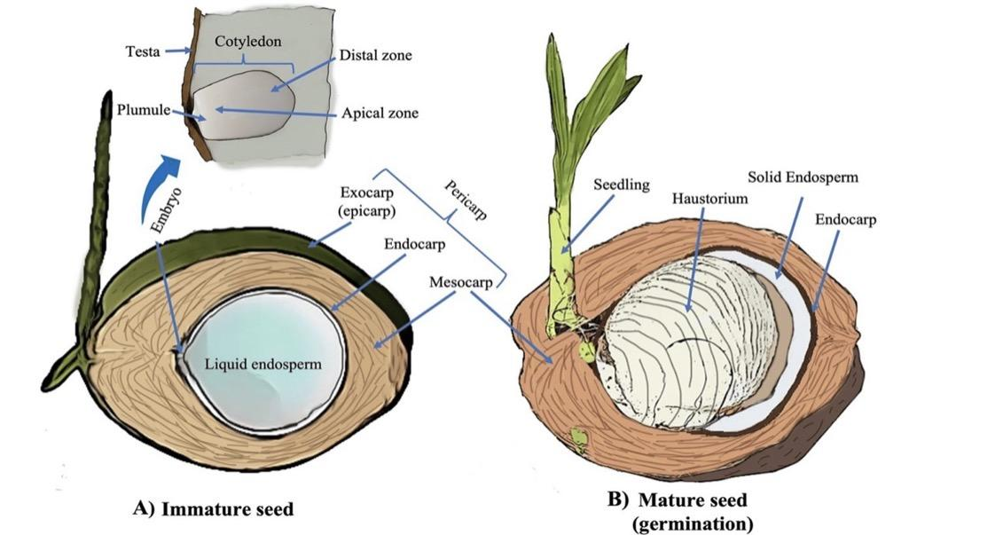
Figure 1. (A) Immature coconut (B) Mature germinating coconut (Tzec-Simá et al. 2022)
The coconut haustorium is a soft, spongy, and edible tissue that forms inside the coconut cavity during germination by absorbing coconut water and nutrients from the endosperm. It serves as the cotyledon that nourishes the developing embryo and plays a vital role in converting stored lipids into sugars, providing energy for seedling growth (Rajamohan and Archana, 2018). The haustorium is composed of two main regions: an outer layer rich in oil and an inner section predominantly made up of carbohydrates, accounting for about 66% of its composition, with sugars contributing roughly 64% of this fraction (Manivannan et al., 2018). During sprouting, it absorbs triacylglycerols from the endosperm, facilitating endosperm degradation and nutrient mobilization for embryo development (Li et al., 2019).
Coconut haustorium contains substantial amounts of proteins, minerals, polyphenols, alkaloids, and antioxidants, which collectively enhance its antibacterial, anti-inflammatory, and immunity-enhancing properties as reported by Manivannan et al., 2016. It contains essential phytoconstituents and energy-rich compounds that make it highly beneficial for health and a potential raw material in nutraceutical and functional foods. Studies have shown that the haustorium accumulates essential minerals, starch, and phenolic compounds, maintaining its nutritional consistency during germination (Job et al., 2021). The fatty acid composition of the haustorium has been linked to the glycosylation process that converts lipids into sugars, emphasizing its metabolic importance (Beveridge et al., 2022).
Despite its rich nutritional and bioactive profile, the coconut haustorium remains an underutilized byproduct of the coconut industry and is often considered waste (Manivannan et al., 2016). However, due to its crisp texture, pleasant sweetness, and nutrient density, it is increasingly recognized as a valuable functional ingredient. Recently, Ramesh and Praveen (2024) noted its potential as a nutraceutical resource and referred to it as the “coconut treasure” or “coconut heart,” highlighting its health-promoting and therapeutic potential for incorporation into value-added food products.
3. Biochemical Constituents of Coconut Haustorium: Bioactive compounds and its properties
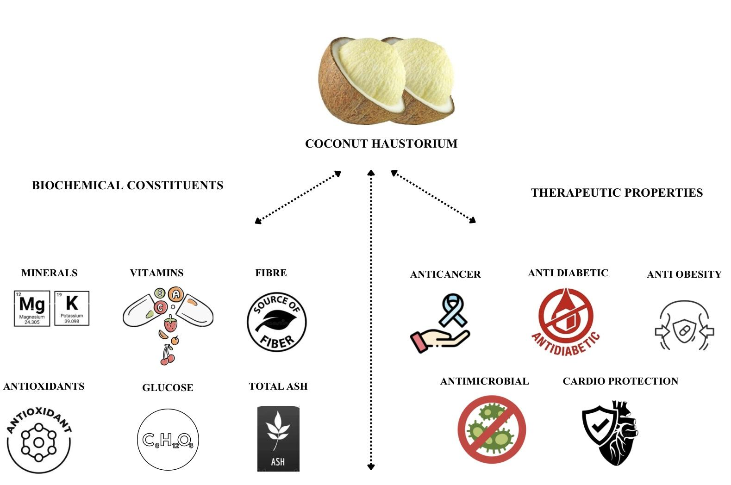
Figure 2. Biochemical and therapeutic properties of Coconut haustorium
Coconut haustorium, a lesser-known edible part of Cocos nucifera L., has recently gained attention for its biochemical composition and potential health benefits. Early studies by Syme et al. (1975) and Kumar et al. (2004) identified that coconut-derived components contain pharmacologically active substances such as alkaloids, steroids, amino acids, terpenoids, vitamins, and minerals, many of which possess antioxidant and cardioprotective properties. These compounds particularly L-arginine, potassium, and magnesium were recognized for their roles in maintaining cardiovascular health.
Balachandran and Arumughan (1995) investigated the variations in fatty acid composition during the germination of coconuts and found that lauric acid levels declined from 35.88% to 25.01%, whereas linoleic acid content rose from 3.00% to 9.86% between the 10th and 22nd weeks of germination. This indicates a shift from medium-chain to long-chain fatty acids as germination progresses. According to Manivannan et al. (2016), the coconut haustorium contains a diverse range of fatty acids, including caproic, caprylic, capric, lauric, myristic, palmitic, stearic, oleic, and linoleic acids. The haustorium was also found to contain significant quantities of proteins, amino acids, phenols, flavonoids, terpenoids, carbohydrates, steroids, saponins, and tannins. Among the amino acids, aspartic acid was the most dominant, followed by alanine, proline, and glutamic acid. The total protein content ranged between 4.95% and 6.25%, and sulfur-containing amino acids like cysteine and methionine were also present. Research by Manivannan et al. (2018) further confirmed the high phenolic acid content of haustorium extracts, identifying ferulic acid as the dominant compound. The total phenolic content was approximately 146 ± 14.3 mg GAE per 100 g (dry weight), indicating strong antioxidant potential. Similarly, Smita et al. (2018) found that unpeeled coconut haustorium contained higher total phenolics (175.5 ± 6.87 mg GAE g⁻¹) than peeled samples (166.67 ± 6.11 mg GAE g⁻¹), highlighting the contribution of the outer layer to its antioxidant capacity.
Li et al. (2019) demonstrated that during germination, the haustorium absorbs triacylglycerols from the endosperm, converting lipids into sugars that serve as energy sources for the embryo. This metabolic conversion emphasizes the haustorium’s role in nutrient mobilization. Gowrie and Valli (2021) also identified cardiac glycosides among its secondary metabolites, suggesting potential applications in managing cancer and cardiovascular diseases. Hee et al. (2020) used mass spectroscopy to identify phenolic compounds (gallic acid, p-coumaric acid, ferulic acid, and trans-cinnamic acid) and flavonoids (catechin, myricetin, hesperitin, and kaempferol) in coconut haustorium extracts. These bioactive compounds enhance its antioxidant and antimicrobial potential.
Minerals are naturally occurring nutrients in foods that play essential roles in body growth and proper physiological functioning. A deficiency in specific minerals can lead to various health issues (Maryani et al., 2021). Manivannan et al. (2018) reported that coconut haustorium contains several important minerals, including calcium, potassium, magnesium, phosphorus, manganese, iron, copper, and zinc. The mineral composition of haustorium was examined in detail by Manju et al. (2021), who reported high levels of macronutrients such as potassium, phosphorus, calcium, and magnesium, and trace elements like iron, manganese, zinc, and copper. Among these, potassium was the most abundant (approximately 5% of dry weight). The West Coast Tall variety had particularly high calcium (690 ppm) and magnesium (241.5 ppm) contents. Anti-nutritional factors such as tannins, oxalates, and phytic acid were found in minimal quantities, confirming haustorium’s suitability for human consumption. Nutrient analysis also revealed that the coconut haustorium is composed of 66% carbohydrates, with 64% sugars, making it a potential source of energy and dietary fibre. It was found especially beneficial in developing baby food formulations for lactose-intolerant children. The same study identified significant vitamin content, particularly Vitamin C (36.67–61.23 mg 100 g-1), Vitamin E (7.13–48.9 mg 100 g-1), and Niacin (0.23–21.92 mg 100 g-1), supporting its potential use in nutraceutical and cosmetic applications.
Fatty acids serve as fundamental components in numerous biological molecules such as triacylglycerols, phospholipids, and other complex lipids. In human nutrition, they represent a major source of dietary fat and play a crucial role in overall health and metabolism. Li et al. (2019) and Beveridge et al. (2022) investigated fatty acid dynamics during germination and observed that medium-chain fatty acids such as lauric and myristic acids initially increased and declined with maturity. Unsaturated fatty acids, although present, were found in smaller quantities (Narayankutty et al., 2022).
The amino acid profile of a food provides detailed information about the types and concentrations of amino acids it contains. Essential amino acids are vital dietary components since the human body is unable to produce them on its own (Yoneda et al., 2009). These nine key amino acids viz., histidine, isoleucine, leucine, lysine, methionine, phenylalanine, threonine, tryptophan, and valine, are critical for protein synthesis and support numerous physiological processes. Studies by Zhang et al. (2022) and Norma et al. (2024) confirmed the presence of 17 amino acids in haustorium, including essential ones such as lysine, methionine, leucine, and valine. Glutamic acid was the most abundant, with concentrations between 110.80 and 145.92 mg per gram of protein. Lysine-rich samples have potential applications in formulating value-added food products such as haustorium milk and syrup.
Spectroscopic analysis by Gowrie and Valli (2021) revealed diverse functional groups in coconut haustorium extracts, including esters, carboxylic acids, alkanes, and alcohols, confirming the presence of complex biochemical compounds. Similarly, FT-IR analysis of both fresh and dried haustorium indicated various antioxidant-related functional groups, further supporting its bioactivity.
Phenolic profiling by Narayankutty et al. (2022) and Kim et al. (2023) identified gallic, ferulic, cinnamic, and coumaric acids as key compounds, with ferulic acid concentrations ranging from 4.27 ± 0.50 mg 100 g⁻¹ to over 2,000 µg g⁻¹ in subsequent analyses by Archana and Lekshmi (2024). These studies demonstrated high total phenolic content (83–150 mg GAE 100 g⁻¹), confirming the haustorium’s potent antioxidant capacity. Flavonoid analyses by Narayanankutty et al. (2018) and Kannaian et al. (2020) reported total flavonoid contents ranged from 1.19 to 73.5 mg QE 100 g⁻¹, with myricetin being the most dominant compound, followed by hesperetin, kaempferol, and catechin. Valli and Sezhian (2021) further observed that terpenoids and saponins were more abundant than flavonoids and phenolics, with total terpenoid and saponin contents of 3.77 g and 3.16 g per 100 g, respectively.
4. Health Benefits of Coconut Haustorium
4.1 Anticancer property
Coconut haustorium, ferulic acid, exists in a bound form, linked to lignin and polysaccharides through ether and ester bonds, and can be released as a free compound under alkaline hydrolysis (Kim et al., 2006). This phenolic acid is widely recognized for its therapeutic potential, particularly in reducing the risk of neurodegenerative disorders such as Alzheimer’s disease, as well as diabetes, cancer, hypertension, and skin pigmentation (Zhao and Moghadasian, 2008). In addition to ferulic acid, bioactive compounds such as quinoline, flavones, acetylenic acid, and oleic acid have been identified in coconut haustorium, all of which exhibit anti-inflammatory and anticancer activities (Gopalakrishnan and Vadivel, 2011). Among these, quinoline, constituting about 15.53%, has shown efficacy against both chloroquine-sensitive and chloroquine-resistant parasites. Similarly, oleic acid contributes multiple pharmacological effects, including anti-inflammatory, anti-androgenic, anticancer, hypocholesterolemic, 5-α reductase inhibitory, and insecticidal properties, alongside roles in dermatological health and flavour enhancement. Several bioactive molecules present in the haustorium have also been reported to possess antiepileptic potential and inhibit tumor progression at various developmental stages (Wierzbicka et al., 2012). Furthermore, terpenoids, predominantly synthesized in higher plants’ vegetative tissues and floral parts, are abundant in haustorium extracts and are known for their cancer-preventive effects (Ludwiczuk et al., 2017). Likewise, saponins found in the coconut haustorium exhibit hemolytic activity, promote blood coagulation, assist in wound healing, and demonstrate anticancer potential (Parimalam et al., 2021).
4.2 Cardiovascular and digestive wellness
The coconut haustorium is a highly nutritious and bioactive part of the fruit, comprising compounds such as quinones, proteins, carbohydrates, flavonoids, cardiac glycosides, phenols, tannins, fixed oils, lipids, amino acids, and various fatty acids. Its consumption has been associated with gastrointestinal benefits, including the alleviation of peptic ulcers caused by Helicobacter pylori infections or adverse reactions to certain drugs, such as non-steroidal anti-inflammatory drugs (Bandyopadhyay et al., 2001). The presence of amino acids like L-arginine, along with potassium and magnesium, contributes to its cardioprotective properties (Kumar et al., 2009). Coconut haustorium also offers a combination of low-calorie content, high dietary fiber, and digestive enzymes, which support metabolic processes and promote efficient digestion. Notably, it exhibits cardioprotective and antioxidant effects, as demonstrated in a study by Chikku and Rajamohan (2012), where rats pretreated with an aqueous extract of coconut haustorium prior to isoproterenol-induced myocardial infarction showed reduced serum markers of heart injury, increased antioxidant enzyme activity, and lower myocardial lipid peroxidation. In addition, the triterpenoid squalene identified in coconut sprouts through mass spectrometry and molecular docking has shown anti-ulcer activity against Helicobacter pylori, suggesting a role in gastrointestinal protection and colorectal cancer prevention (Mohan et al., 2018).
Coconut haustorium is also a source of omega-3 fatty acids, which contribute to cardiovascular health by reducing low-density lipoprotein, cholesterol and mitigating risks of heart attacks and strokes. Recent research indicates its potential as an antidiarrheal agent and for improving overall gut health (Wahyu et al., 2021). Collectively, these findings highlight the multifunctional nutraceutical potential of coconut haustorium, encompassing cardioprotective, antioxidant, gastrointestinal, and metabolic benefits
4.3 Anti-inflammatory and anti-diabetic property
Lewis (1989) highlighted that excessive activation of phagocytes and overproduction of free radicals and reactive oxygen species can contribute to tissue damage in various inflammatory conditions. Fresh coconut sprouts exhibit greater anti-inflammatory activity than dried sprouts, with effects being dose-dependent (Mitchell and Cotran, 2003). Protein denaturation, which occurs during trauma or infection, triggers inflammation characterized by redness, pain, swelling, and activation of inflammatory cells, ultimately supporting cellular defense and repair (Leela and Mohan, 2011).
Bioactive compounds in coconut haustorium, such as myricetin, have been reported to possess antioxidant and anti-inflammatory properties, potentially protecting against skin photoaging (Jung et al., 2010). Coconut sprouts are rich in oleic acid, which confers multiple pharmacological effects, including anti-inflammatory, antiandrogenic, cancer-preventive, and cholesterol-lowering activities (Gopalakrishnan and Vadivel, 2011). Flavonoids present in haustorium further exhibit antibacterial, anti-inflammatory, antiangiogenic, and antiallergic properties (Hossain et al., 2013). Additionally, compounds such as gallic acid, p-coumaric acid, ferulic acid, and catechin have been identified in coconut haustorium, and methanolic extracts have been shown to protect intestinal epithelial cells from fluoride-induced toxicity by enhancing glutathione levels and reducing apoptosis (Appaiah et al., 2014; Job et al., 2021).
Flavonoids in coconut haustorium are also recognized for their anti-diabetic and antioxidant effects (Sarian et al., 2017). The haustorium demonstrates significant alpha-amylase and alpha-glucosidase inhibitory activity, indicating strong potential for blood glucose regulation (Narayankutty et al., 2022). Moreover, the potassium content in coconut sprouts contributes to vasodilation, improved circulation, and oxygen delivery, thereby reducing the risk of cardiovascular events such as heart attacks and strokes.
4.4 Anti-microbial and anti-obesity property
Coconut haustorium contains terpenoids and flavonoids, which contribute to its notable antioxidant, anti-inflammatory, antibacterial, antiviral, and antimalarial activities (Indumathi et al., 2014; Li et al., 2018). These bioactive compounds are also involved in gene regulation, antiproliferative effects, apoptosis induction, and modulation of inflammatory responses. In terms of antibacterial activity, methanolic extracts of fresh coconut haustorium at 100 µg exhibited the largest inhibition zone of 32 ± 0.6 mm against Shigella flexneri and the smallest zone of 5 ± 0.1 mm against Escherichia coli. The minimal effect on E. coli suggests that consuming fresh haustorium may not disturb the natural intestinal microbiota while effectively inhibiting pathogenic bacteria (Gowrie and Valli, 2017).
Additionally, coconut haustorium demonstrated potential anti-obesity properties. Lipase enzymes present in the haustorium hydrolyze triglycerides, diglycerides, and monoglycerides into glycerol and free fatty acids (Sana et al., 2004). The activity of lipase in coconut haustorium has been measured at 0.0581 U mg⁻¹ (Su'i et al., 2010), and these enzymes remain active in acidic environments, effectively facilitating fat hydrolysis (Almeida et al., 2016). Budyghifari et al. (2019) demonstrated that treatment of coconut haustorium at 60°C for 12 hours achieved a 97% reduction in cholesterol, confirming the presence and efficacy of lipase enzymes. These enzymes naturally exist in a stable, immobilized form, which preserves their activity at room temperature and minimizes contamination risks, enhancing the functional value of coconut haustorium for lipid metabolism and cardiovascular health
4.5 Antioxidant activity
Vitamin C plays a crucial role as a physiological antioxidant (Frei et al., 1989) and is known for its ability to restore other antioxidants in the body, such as vitamin E (Jacob and Sotoudeh, 2002). Highly reactive free radicals, including those derived from oxygen, are primarily generated through the body's metabolic activities or from external factors. Numerous cellular macromolecules, including proteins, lipids, carbohydrates, enzymes, and nucleic acids, can be oxidized by these free radicals, which can impair immune responses and cause tissue damage and cell death. Atherosclerosis, arthritis, and cancer are just a few of the human disorders that are significantly impacted by oxidative damage. According to studies, the terpenoids, phenolic compounds, and vitamin C present in coconut haustorium have a significant potential for antioxidant activity (Gowrie and Valli, 2017). Coconut haustorium's ability to scavenge free radicals was contrasted with that of regular ascorbic acid. According to Smita et al. (2018), peeled coconut haustorium flour exhibited a scavenging activity of 67.2 ± 1.25 mg TE IC50 in the DPPH radical scavenging assay.
5. Utilization of coconut haustorium in the development of functional foods and beverages
Farmers frequently encounter difficulties with coconut haustorium because of its high perishability and limited shelf life. To overcome this, adding value to coconut haustorium not only helped to minimize waste but also boosted farmers' earnings.
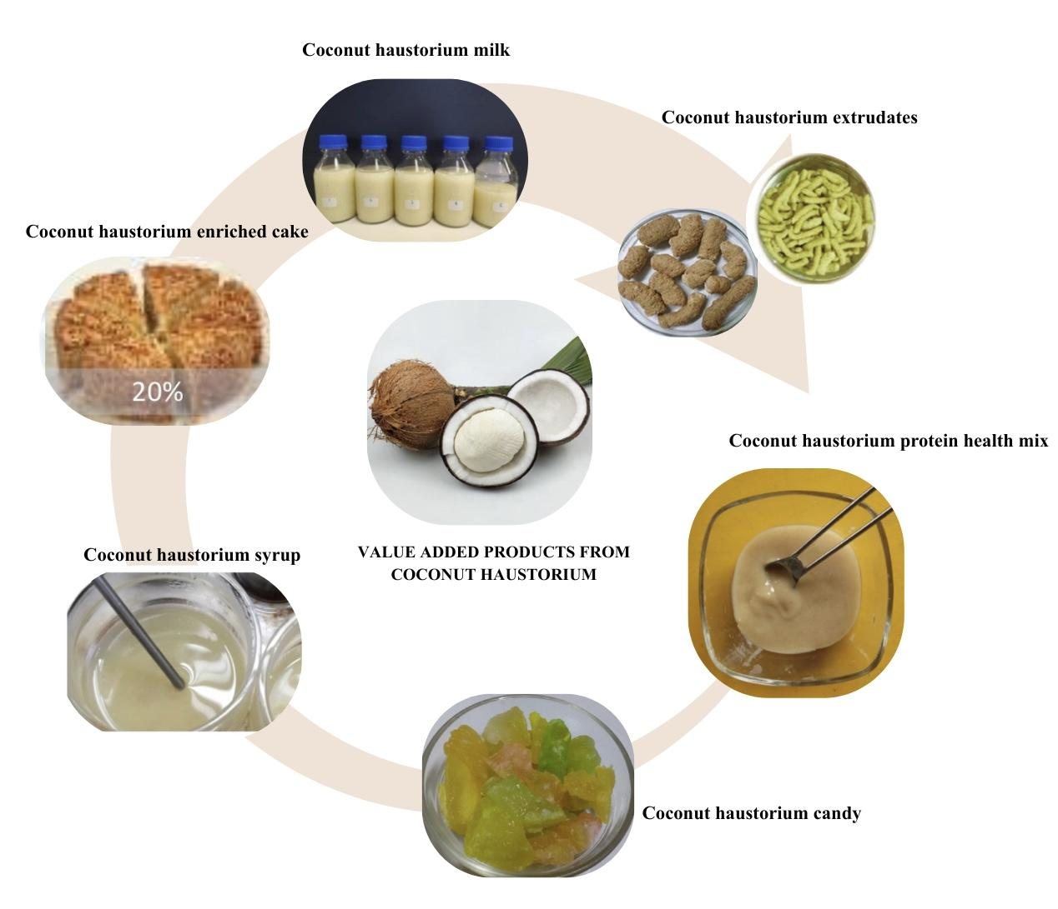
Figure 3. Value added products developed from coconut haustorium
Coconut haustorium candy: Coconut haustorium was transformed into a gelatinous candy through a structured process involving osmotic treatment and sugar infusion. Initially, the haustorium was cleaned, sliced into approximately 1-inch pieces, and pre-treated with 1% calcium hydroxide followed by 1% alum to enhance structural firmness. The slices were then rinsed and soaked in a 50° Brix sugar solution for 2–3 hours. Osmotic dehydration was continued by boiling the mixture with citric acid until the Brix level reached 65°, followed by reheating to achieve a final Brix of 70°. Any subsequent decrease in Brix was corrected through additional heating. After cooling, flavors and colors were added to enhance sensory appeal, with studies showing that flavors such as strawberry, lemon, litchi, mango, pineapple, guava, chili, chili-pepper, and lemon-mint paired well with the candy. This process highlighted the potential of coconut haustorium as a versatile ingredient in value-added confectionery products (Joy et al., 2017)
Protein health mix: A nutritious protein mix was developed using coconut haustorium and virgin coconut oil (VCO) residue as primary components. The haustorium was collected and blanched in a 0.05% potassium metabisulfite (KMS) solution before use. The formulation consisted of arrowroot powder (22%), haustorium powder (20%), VCO residue (20%), sprouted green gram powder (8%), milk powder (10%), and sugar (20%), along with added flavoring agents and a small amount of salt for taste improvement. In a hot air oven, each component was dried independently for one to two hours at 90°C. The components are dried, then pounded into a powder and sealed in pouches of laminated aluminium foil (Joy et al., 2017).
Coconut haustorium flour: Smita et al. (2018) conducted a study evaluating the physicochemical, functional, morphological, and antioxidant characteristics of coconut haustorium flour, comparing peeled and unpeeled samples. The results showed significant differences in color, flow properties, amylose content, and chemical composition between the two types of flour. Notable variations were identified in the water solubility index, swelling capacity, and pasting properties, such as pasting point, peak viscosity, hold viscosity, and final viscosity. Moreover, the starch content was found to be higher in peeled coconut haustorium flour (20.47 ± 0.57 g per 100 g) than in its unpeeled counterpart (14.62 ± 1.45 g per 100 g). Scanning electron microscope analysis of the granule morphology revealed that the granules of both flours varied in shape from oval to irregular. Similarly, Siahaya et al. (2021) determined the optimal drying parameters for producing coconut haustorium flour, reporting that drying at 50 °C for 8 hours resulted in flour containing 11.74% moisture, 8.17% fat, 11.72% protein, 7.49% ash, and 11.84% crude fibre. These compositional qualities indicated its suitability for use in food formulation.
Coconut haustorium based extrudates: Extrusion, a widely adopted technique in the snack food industry, has become increasingly significant in recent years. Adding coconut haustorium to extruded snacks offers a nutritious alternative to conventional products, as the haustorium is a rich source of phytonutrients. The inclusion of this ingredient in extruded formulations has been found to enhance the presence of beneficial compounds such as phenolics and flavonoids, contributing to the development of healthier snack options. Manivannan et al. (2018) used coconut haustorium flour instead of maize while developing extrudates with rice flour. At concentrations of 0%, 10%, 20%, and 30% (w/w), haustorium was used in place of maize in a flour blend of rice and maize (1:1). The mixture was further processed using a twin-screw extruder. Analysis was done on the effects of adding haustorium on the various chemical and physical properties of the extrudates. These properties included bulk density, expansion ratio, water absorption and solubility indices, compressive strength, hardness, breaking force, as well as color characteristics such as hue and chroma values. Based on its biochemical profile and overall sensory acceptability, a blend of 50% rice, 30% maize, and 20% haustorium was determined to be the most effective for producing healthy and nourishing extrudates. The findings showed that the inclusion of haustorium significantly affected these characteristics and that the extrudates containing haustorium were longer, darker, firmer, less expanded, and richer in minerals, protein, phenolics, and flavonoids. They also showed increased antioxidant activity.
Coconut haustorium ready to serve beverage: As a prospective substitute for coconut water, drinks derived from coconut haustorium provide a number of health advantages, including blood pressure regulation, digestive assistance, increased hydration, decreased risk of heart disease, and assistance with renal diseases (Senarath and Perera, 2018). The widely used RTS (Ready-to-Serve) drinks typically have a minimum of 10% fruit juice, 0.3% acid and not less than 10% TSS. Using coconut haustorium, a novel beverage was created by Rajashwari et al .2024 which contrasted with the popular refreshing beverage. Coconut water, sugar, citric acid, 0.2% pectin, and 18% coconut haustorium made up the most popular version of the beverage. This beverage's total phenolic content was greater than that of coconut water, according to analysis.
Coconut haustorium wine: In a study by Mohan et al. (2018), coconut sprouts were assessed as a potential substrate for wine production and found to be an excellent base for creating wine. When coconut haustorium was fermented using the yeast, Saccharomyces cerevisiae, the result was a distinctive beverage with significant health benefits. The coconut sprouts were chopped into small pieces, blended into a paste with 500ml of distilled water, and then 250ml was used as a control, while the remaining 250ml was fermented to create the sample.Ten millilitres of water were used to dissolve one gram of yeast, which was then combined with wine and allowed to sit at room temperature. A 2% starter culture was added to the prepared must to start the fermentation process. After thoroughly mixing the must, it was stored in a cold, dry location to ferment. For 20 days, fermentation was carried out. At 5-day intervals, aliquots were extracted from the sample and used for carrying out various analytical procedures. During the 20-day evaluation period of the wine, a decline in total phenolic content was observed. Other quality parameters such as electrical conductivity, yeast population, and antioxidant activity were also monitored. After 20 days of storage, the wine achieved an overall sensory rating of 7 out of 10 and had an alcohol concentration of 9.1%. The probiotics present in the coconut haustorium-based wine were found to have potential benefits for gut health and digestion. Moreover, its electrolyte content particularly sodium, potassium, and bicarbonates may help reduce the risk of heart-related ailments.
Coconut haustorium filled Tarts: Terana (2023) explored the incorporation of coconut haustorium into tart fillings at four inclusion levels (0–200 g). The formulation with 200 g of coconut haustorium achieved the highest sensory acceptance, with mean overall scores of 8.74 from experts and 8.71 from consumers. This version also exhibited enhanced nutritional value, comprising 19.8% fat, 6.16% protein, 21.3% moisture, 1.27% ash, and 51.7% carbohydrates, categorizing it as an energy-dense product.
Osmo-dehydrated coconut haustorium: Archana and Lekshmi (2024) investigated the development of osmo-dehydrated coconut haustorium by optimizing factors like immersion time and osmotic solution concentration. The study assessed its nutritional quality and consumer acceptance by analyzing mass transfer, physical characteristics, biochemical composition, and sensory properties. The findings indicated that osmotic dehydration was a highly effective method for boosting haustorium's value and prolonging its shelf life. After being dehydrated for 180 minutes at a concentration of 60° Brix, coconut haustorium was discovered to be both more nutrient-dense and well accepted by the consumers. This study showed how coconut haustorium can be used to make new and practical products for the food industry, such as a snack with a long shelf life and a lot of demand.
Coconut haustorium enriched cashew nut cake: Ashok et al. (2024) replaced cashew powder in cake formulations with 0–30% coconut haustorium. At 20% substitution, nutritional improvements were observed: protein increased to 8.8 g per 100 g (from 2.7), fibre to 2.3 g per 100 g (from 0.9), and ash to 2.1 g per 100 g (from 1.5). Fat decreased to 8.4 g per 100 g (from 13), while antioxidant activity significantly increased to 76.5% inhibition compared to 49.2% in the control. Total phenolics also increased to 5954.7 mg per 100 g from 3275.1 mg per 100 g in control. Sensory evaluation confirmed enhanced acceptability of the haustorium-enriched cake.
Coconut haustorium enriched Kodo millet extrudates: Gaikwad et al. (2024) formulated Kodo millet-based snacks enriched with coconut haustorium, which enhanced the expansion ratio from 2.69 to 3.315. The fortified snacks also showed an increase in total phenolic content to 197.8 mg gallic acid equivalent per 100 g, compared to 182.7 mg GAE per 100 g in the control, and a rise in antioxidant activity from 38.17% to 42.13%. Despite slight reductions in protein and fat content, notable improvements were observed in functional characteristics such as water absorption capacity, which rose from 4.83 g g⁻¹ to 6.87 g g⁻¹. Additionally, the treated snacks exhibited a softer texture (106.27 N) and greater porosity, enhancing their crispiness and overall consumer appeal.
Coconut haustorium milk and syrup: Coconut haustorium can be processed into a nutrient-rich, plant-based milk, which serves as a base for developing haustorium syrup with natural sweetness and a pleasant, aromatic flavor. The copra from sprouted coconuts retains a substantial amount of coconut oil, making it suitable for various food applications. The haustorium milk was recovered at a rate of 73.39%, producing an opaque liquid with 7.20 ± 0.42° Brix, resembling cow’s milk in color, with a sweet taste and fresh coconut aroma. The haustorium syrup was obtained from this haustorium milk with recovery rates of 12%, 15%, and 20%, featuring a creamy, viscous texture and a mildly sweet coconut flavor and fragrance (Norma et al., 2024).

6. Challenges in Utilizing Coconut Haustorium
The utilization of coconut haustorium faces several challenges, which have limited its commercial and nutritional applications despite its rich bioactive and nutritional profile. One major concern is the variability in nutrient composition among different coconut varieties. For instance, the West Coast Tall variety has been reported to contain high levels of anti-nutritional factors such as tannins, oxalates, and phytic acid, complicating the selection of varieties that provide balanced essential nutrients (Manju et al., 2021).
Another significant limitation is its extremely short shelf life, typically lasting only two days without refrigeration, making storage and distribution challenging. Appropriate packaging strategies are therefore critical to extend its usability (Preethi and Anil, 2023). Additionally, haustorium is relatively low in certain nutrients, such as key amino acids and calcium, necessitating external supplementation for formulating a nutritionally balanced diet (Rajeshwari et al., 2024). Nonetheless, its high carbohydrate content and lauric acid concentration make it suitable for specific populations, such as lactose-intolerant children.
From an industrial perspective, coconut haustorium remains largely underutilized due to its marginal economic value, delicate structure, and difficulties in processing and preservation. Additionally, the lack of traditional use and inadequate market development has resulted in haustorium often being discarded as waste. Although some researches have explored its potential as a functional ingredient or food additive, these initiatives are still in early stages and have not yet achieved widespread adoption (Smita et al., 2019).
Future efforts must focus on extending shelf life, improving processing techniques, and enhancing market awareness. Furthermore, in-depth molecular studies, in vivo experiments, and clinical trials are required to validate its pharmacological potential, biocompatibility, and efficacy, thereby supporting its development into sustainable functional foods, nutraceuticals, or even drug delivery systems. Comprehensive research could transform coconut haustorium from an underutilized by-product into a valuable resource with therapeutic, nutritional, and economic significance.

7. Conclusion
This review highlights the biochemical as well as therapeutic potentials of the coconut haustorium and different value-added products developed from coconut haustorium. Despite being overlooked in previous research, the haustorium is highly nutritious and a rich source of proteins, dietary fibre, essential minerals, and bioactive compounds such as alkaloids, phenolics, terpenoids, flavonoids, and saponins. It is especially notable for its high levels of vitamins C and E, which support immune function and overall health, and for its balanced fatty acid composition that varies with coconut variety and germination stage.
The bioactive constituents of coconut haustorium confer multiple health benefits, including strong antioxidant, anti-inflammatory, anticancer, cardioprotective, and antimicrobial activities. Additionally, it supports gastric and heart health, reduces oxidative stress-induced cardiac damage, aids in the management of peptic ulcers, and demonstrates potential anti-diabetic effects through enzyme inhibition and potassium-mediated blood pressure regulation. Its incorporation into functional foods, beverages, and other creative applications, such as syrup, wine, or nutrient-rich meals, underscores its versatility and commercial potential.
Despite its impressive nutritional and therapeutic profile, coconut haustorium remains largely underutilized and often discarded as a by-product. Given its affordability, availability, minimal anti-nutritional components, and rich composition of vitamins, minerals, and antioxidants, haustorium represents a valuable resource, particularly for developing countries facing food security challenges. Future research and development efforts should focus on harnessing its nutritional and pharmacological properties for functional foods, nutraceuticals, and cosmeceutical applications. By promoting its utilization, coconut haustorium could become an economically and therapeutically significant product, transforming a currently overlooked by-product into a high-value resource.

References
- Subramanian, P., Gupta, A., Gopal, M., Selvamani, V., Mathew, J., Surekha, & Indhuja, S. (2024). Coconut (Cocos nucifera L.). In Soil Health Management for Plantation Crops: Recent Advances and New Paradigms (pp. 37-109). Singapore: Springer Nature Singapore.

- Sathanya, P. S., Vignesh, S., & Baskaran, N. (2024). Palmyra and coconut haustorium: A comprehensive review on nutritional composition, bioactive potential, value-added products and its health benefits. Food Chemistry Advances, 5, 100836.

- Appukuttan Karakkatukunnel, A., Geetha Lekshmi, P. R., & Kanagarajan, S. (2024). Comprehensive biochemical profiling of coconut haustorium for innovative food industry applications. CyTA-Journal of Food, 22(1), 2441333.

- Narayanankutty, A., Job, J. T., Kuttithodi, A. M., Sasidharan, A., Benil, P. B., Ramesh, V., ... & El-Din, M. M. E. (2023). Proximate composition, antioxidant, anti-inflammatory and anti-diabetic properties of the haustorium from Coconut (Cocos nucifera L.) and Palmyra palm (Borassus flabellifer L.). Journal of King Saud University-Science, 35(1), 102404.

- Kumar, S. A., Negi, A., Santhoshkumar, P., Moses, J. A., & Sinija, V. R. N. (2025). Coconut: Expanding avenues in processing and an exposition on non‐conventional value‐added products. Journal of the Science of Food and Agriculture, 105(3), 1522-1532.

- Souza Dias, D., Monteiro Ribeiro, L., Sérgio Nascimento Lopes, P., Aclécio Melo, G., Müller, M., & Munné-Bosch, S. (2018). Haustorium–endosperm relationships and the integration between developmental pathways during reserve mobilization in Butia capitata (Arecaceae) seeds. Annals of Botany, 122(2), 267-277.

- Chaudhary, P., Agri, U., Chaudhary, A., Kumar, A., & Kumar, G. (2022). Endophytes and their potential in biotic stress management and crop production. Frontiers in microbiology, 13, 933017.

- Manivannan, A., Bhardwaj, R., Padmanabhan, S., Suneja, P., Hebbar, K. B., & Kanade, S. R. (2018). Biochemical and nutritional characterization of coconut (Cocos nucifera L.) haustorium. Food Chemistry, 238, 153-159.

- Zhang, Y., Kan, J., Tang, M., Song, F., Li, N., & Zhang, Y. (2022). Chemical composition, nutritive value, volatile profiles and antioxidant activity of coconut (Cocos nucifera L.) haustorium with different transverse diameter. Foods, 11(7), 916.

- Li, J., Htwe, Y. M., Wang, Y., Yang, Y., Wu, Y., Li, D., ... & Wang, R. (2019). Analysis of sugars and fatty acids during haustorium development and seedling growth of coconut. Agronomy Journal, 111(5), 2341-2349.

- Arivalagan, M., Manikantan, M. R., Yasmeen, A. M., Sreejith, S., Balasubramanian, D., Hebbar, K. B., & Kanade, S. R. (2018). Physiochemical and nutritional characterization of coconut (Cocos nucifera L.) haustorium based extrudates. Lwt, 89, 171-178.

- Chaudhary, P., Agri, U., Chaudhary, A., Kumar, A., & Kumar, G. (2022). Endophytes and their potential in biotic stress management and crop production. Frontiers in microbiology, 13, 933017.

